Why does the relationship between benthic primary production and lake morphometry vary regionally?

D Seekell^{1,*}, BB Cael²

- Stockholm, Sweden
- National Oceanography Centre, Southampton, United Kingdom
* Corresponding author, email: david.seekell@gmail.com

Research Article in press at Aquatic Sciences

Abstract
Benthic primary production varies among lakes from 1 to 2,000+ mg C m⁻² d⁻¹, in part due to variations in basin shape. First principles predict an inverse correlation between benthic primary production and mean to maximum depth ratio, an index of basin shape, but reports of positive correlations suggest that current understanding is incorrect or incomplete. We develop a hypsometric (area-depth) model for littoral area that accounts for habitat disruption due to ice scouring at the lake margin. When this disruption is incorporated, the direction of the relationship between benthic primary production and depth ratio depends on water clarity – regions with clear lakes should have positive correlations whereas regions with less water clarity should have inverse correlations. Empirical analysis of benthic primary production measurements from four eco-regions characterized by different levels of water clarity supports this prediction. Collectively, our analyses demonstrate how first principles can be used to explain heterogenous patterns of benthic primary production at broad-geographic scales.

Keywords
Primary production, benthic algae, lake morphometry, hypsometry; water clarity

Introduction
Benthic primary production varies among lakes from 1 to 2,000+ mg C m⁻² d⁻¹ (Seekell et al. 2015; McCormick et al. 2021; Puts et al. 2022a). This variation primarily reflects the variations in light availability caused by patterns of lake morphometry and light attenuation (Vadeboncoeur et al. 2008; Seekell et al. 2015a; Puts et al. 2022a; Cael and Seekell 2023). In general, deeper lakes are less productive than shallower lakes (Vadeboncoeur et al. 2008; Ask et al. 2009a; Puts et al. 2022a). Lakes with low light penetration are less productive than lakes with high light penetration (Vadeboncoeur et al. 2008; Ask et al. 2009a; Puts et al. 2022a). Basin shape also contributes to variations in benthic primary production (Vadeboncoeur et al. 2008; Klaus et al. 2022). First principles predict that convex basins have larger littoral zones than concave basins, and therefore should be more productive (Carpenter 1983; Vadeboncoeur et al. 2008; Seekell et al. 2021). The mean to maximum depth ratio is a widely used index of basin shape that varies between 0 and 1, with lower values describing more convex basins and higher values describing concave basins (Carpenter 1983; Seekell et al. 2021). Based on first principles, benthic primary production and depth ratio should be inversely correlated because concave basins have less shallow littoral habitat than convex basins (Carpenter 1983; Seekell et al. 2021; Klaus et al. 2022). However, a recent study of clear-water Arctic and alpine lakes reported the opposite pattern (Klaus et al. 2022). This observation suggests that current understanding of the relationship between basin shape and benthic primary production is either incorrect or incomplete.
Many Arctic and alpine lakes have rocky margins that are inhospitable to benthic algal communities (Figure 1; Öjebrandt 2021). In particular, the margins are subject to disturbance from ice scouring, which is a major constraint on algal establishment (Quesada et al. 2008; Ask et al. 2009b; Bégin et al. 2020). However, the first principles used to predict the relationship between benthic production and lake morphometry do not reflect that the lake margins may be unproductive (e.g., Carpenter 1983; Vadeboncoeur et al. 2008; Seekell et al. 2021). Lakes with low depth ratios have a disproportionately large amount of habitat disrupted compared to those with high depth ratios, and Klaus et al. (2022) hypothesized this as the reason why they observed a positive correlation between depth ratio and benthic primary production. However, this explanation is incomplete because lakes outside their study region (e.g., north temperate, boreal) are also seasonally ice covered, but do not exhibit the positive correlation (Carpenter 1983).
In this study, we present a hypsometric (area-depth) model of lake morphometry for predicting the size of littoral habitats. The novel feature of our hypsometric model is the inclusion of terms that account for habitat disruption at the lake margin due to ice scouring, which reduces the effective size of the littoral zone. With habitat disruption, the direction of the relationship between basin shape (depth ratio) and productive area depends on light penetration - there is a positive correlation for clear water lakes and a negative correlation for darker waters. We test this prediction using a benthic primary production model formulated based on first principles, and previously published benthic primary production measurements from four eco-regions. Our analyses support the hypothesis that the relationship between benthic primary production and basin shape depends on light penetration for seasonally ice-covered lakes. Light penetration varies primarily at the between-region scale; hence our analysis explains why the relationship between basin shape and benthic primary production varies between regions.

Theory
The littoral zone is the area between the shoreline and the compensation depth—the maximum depth of significant photosynthesis by rooted vascular plants and epilithic algae—which is generally operationalized as the depth where photosynthetically active radiation (400–700 nm) is 1% of surface irradiance (taxa-specific compensation depths vary around the 1% benchmark) (Seekell et al. 2021). Based on this definition, relative size of the littoral zone can be calculated from measurements of compensation depth, mean depth, and maximum depth, using hypsometric analysis. Specifically,

$$\frac{A_{P}}{A_{T}}=\left\{ \begin{aligned} 1 z_{c}≥z_{max} \\ {\left[\frac{z_{c}}{z_{max}}\right]}^{ζ} z_{c}<z_{max} \end{aligned}\right.$$

where, A_{P} is the littoral area (m²), A_{T} is the surface area of the lake (m²), z_{c} is the compensation depth (m), z_{max} is the maximum depth (m), and ζ is a dimensionless parameter that describes the relationship between relative depth and relative area for a vertical cross section through the center of the lake (Seekell et al. 2021).
Assuming that the basin is a quadric surface, the shape is convex when ζ < 1, which describes basins with large littoral zones and relatively small deep euphotic zones, whereas the basin is concave when ζ > 1, which describes basins with steeper nearshore areas and relatively small littoral zones (Figure 2A). The parameter ζ is calculated:

$$ζ=\frac{{z_{mean}}/{z_{max}}}{1-{z_{mean}}/{z_{max}}}$$

where z_{mean} is the mean depth (m) (Seekell et al. 2021). Empirical deviations from the quadric assumption are typically minor and more complex models of basin morphometry are not necessary for most lakes (Carpenter 1983; Devlin et al. 2016).
To account for lake margins disrupted by ice or other factors, the size of the margin is subtracted from the size of the littoral zone, as indicated by the following hypsometric equation:

$$\frac{A_{P}}{A_{T}}=\left\{ \begin{aligned} 1-{\left[\frac{z_{ice}}{z_{max}}\right]}^{ζ} z_{c}≥z_{max} \\ {\left[\frac{z_{c}}{z_{max}}\right]}^{ζ}-{\left[\frac{z_{ice}}{z_{max}}\right]}^{ζ} z_{c}<z_{max} \end{aligned}\right.$$

where z_{ice} is the depth (m) of the disturbed zone that falls in the interval $0≤z_{ice}≪z_{max}$.
We evaluated patterns of littoral area using our proposed hypsometric model and typical values for the parameters reported in the literature (Table 1) to generate hypotheses about the relationship between benthic primary production and lake morphometry. When there is no unproductive margin, the lakes are characterized by two boundary conditions: 1) when there is no light penetration (z_{c} : z_{max} = 0) there is no productive benthic habitat regardless of basin shape, 2) when light penetration meets or exceeds maximum depth (z_{c} : z_{max} ≥ 1) the entire lake area is productive benthic habitat regardless of basin shape. Within these bounds, lakes with convex shapes (ζ < 1) always have more productive benthic habitat than concave basins (ζ > 1) of the same depth and light penetration (Figure 2A).
The hypsometric model with unproductive margin (z_{ice}:z_{max} = 0.1) (Figure 2B) is characterized by very different patterns than the model without disruption (z_{ice}:z_{max} = 0). Regardless of lake shape, there is no productive littoral zone if the depth of light penetration is less than or equal to the relative depth of ice. There are three different regimes when light penetration exceeds the depth of the margin:

- For lakes with low light penetration, convex basins (ζ < 1) have the most (by area) productive benthic habitat and concave basins have the least – the same qualitative pattern as without ice disruption. In the context of mean to maximum depth ratios, this corresponds to an inverse correlation with productive area.

- For lakes with moderate light penetration, paraboloid basins (ζ= 1) have the most productive benthic habitat. In the context of mean to maximum depth ratios, this corresponds to a unimodal relationship with productive area.

- For lakes with high light penetration, concave basins (ζ > 1) have the most productive habitat and convex basins (ζ < 1) have the least. In the context of mean to maximum depth ratios, this corresponds to a positive correlation with productive area.

Methods
We evaluated the patterns predicted by the hypsometric model using two approaches that integrate different advantages and limitations. First, we incorporated the unproductive margin into a model benthic primary production to evaluate how patterns of littoral area translate to productivity. In addition to the size of the littoral zone, benthic primary production reflects the non-linear relationships between photosynthesis, irradiance, and depth, and the model allows us to evaluate the net effect of these interactions. Second, we conducted an empirical analysis based on previously reported benthic primary production rates. Specifically, we tested the correlation between benthic primary production and depth ratio for four regions characterized by different water clarities and expected to have contrasting patterns based on our analysis of the hypsometric model.

Model Analysis
We modeled benthic primary production (P, mg C m⁻² h⁻¹) based a photosynthesis-irradiance curve without photoinhibition – photoinhibition is rarely observed in benthic algae in lakes – and the standard hypsometric model (Jassby and Plat 1976; Dodds et al. 1999; Vadeboncoeur et al. 2003; Godwin et al. 2014; Devlin et al. 2015):

$$P=\frac{A_{P}}{A_{T}}\int_{z_{ice}}^{min\left(z_{c},z_{max}\right)}{P_{max}}\tanh\left({I_{z}}/{I_{k}}\right)A_{z}dz$$

where P_{max} is the maximum rate of benthic primary production (mg C m⁻² h⁻¹) and I_{k} is the light intensity at the onset of saturation (μmol m⁻² s⁻¹). In this implementation, the lake margin is incorporated by adjusting the limits of integration, which gives the same effect as our proposed hypsometric model. Additionally, the integrand is multiplied by the proportion of surface area covering productive benthic habitat to recast the rate in terms of total surface area (e.g., Puts et al. 2022a). The light intensity at depth z is (I_{z}, μmol m⁻² s⁻¹) is calculated based on the Beer-Lambert Law

$$I_{z}=I_{0}{100}^{{-z}/{z_{c}}}$$

where I₀ is insolation of photosynthetically active radiation (μmol m⁻² s⁻¹) at the lake surface. The area at depth z (A_{z}) is:

$$A_{z}=\frac{d}{dz}{\left[\frac{z}{z_{max}}\right]}^{ζ}=ζz^{ζ-1}z_{max}^{-ζ}$$

We evaluated the model with (z_{ice} = 1 m) and without (z_{ice} = 0 m) ice-scouring to understand patterns that emerge when accounting for shoreline disruption. The ice scouring depth z_{ice} = 1 m is typical of the rocky margins of lakes in alpine and Arctic Sweden, as well as for the depth of ice pack for northern lakes more generally (Table 1). Additionally, field measurements confirm that there is little to no benthic primary production within the first meter (Ask et al. 2009b). We assume I₀ = 230 μmol m⁻² s⁻¹ and P_{max} = 46 mg C m⁻² h⁻¹, based on field measurements from northern Sweden where most of the data for our empirical analysis (below) were collected (Klaus et al. 2022; Norman et al. 2022). We assumed the light intensity at the onset of saturation is 300 μmol m⁻² s⁻¹ based on previous analyses in the region (e.g., Norman et al. 2022; Puts et al. 2022a).

Empirical Analysis
We analyzed patterns of benthic primary production previously reported from 27 lakes, equally distributed between Sweden’s boreal, alpine, and Arctic landscapes (Puts et al. 2022a, 2022b). Additionally, we analyzed patterns of benthic primary production previously reported for 11 temperate lakes in the forests of northern Wisconsin and the Upper Peninsula of Michigan in the United States (Godwin et al. 2014). For each region, we tested the partial correlation between the benthic primary production (log_{e}-transformed) and depth ratio, controlling for the ratio of compensation to maximum depth. For the Arctic, the partial correlation was calculated based a quadratic relationship between depth ratio and compensation to maximum depth, because a non-linear pattern was evident in the data. We visualize the relationships using partial plots (Velleman and Welsch 1981).
The boreal and temperate lakes generally have high rates of light attenuation due to high concentrations of colored dissolved organic matter (boreal lakes and some temperate lakes) or high phytoplankton biomass (temperate lakes) (Godwin et al. 2014; Seekell et al. 2015b; Seekell et al. 2018b). We expect inverse correlations between benthic primary production and depth ratio in these regions. The Arctic and alpine lakes are characterized by very clear waters due to lack of human impact and little catchment vegetation development (Seekell et al. 2018a; Riley and Seekell 2021; Klaus et al. 2021). These lakes are notable for their low depth ratios, typical of lakes formed by glacial scour, and large littoral zones (Seekell et al. 2021).
Two different methods were used to measure benthic primary production. Rates in the temperate and alpine regions were measured based on changes in dissolved oxygen recorded by high frequency sensors within a clear plastic measurement dome placed on the lake bottom (Godwin et al. 2014; Puts et al. 2022a). Rates in the boreal and Arctic regions were measured based on changes in dissolved inorganic carbon during in situ sediment core incubations (Puts et al. 2022a). Hence one clear-water and one dark-water region were measured with each technique, and consistent results should indicate that the overall patterns are robust to methodological uncertainties.

Data availability
The data used in this study are previously published and are available from the original sources: Godwin et al. (2014) and Puts et al. (2022a). Benthic primary production rates for temperate lakes were extracted from figures in Godwin et al. (2014) using WebPlotDigitizer (Drevon et al. 2017).

Results
Model Analysis
Patterns of benthic primary production without ice (z_{ice} = 0) are qualitatively similar to patterns of littoral area (Figure 3). Specifically, convex basins have the highest rates of benthic primary production across the full range of light penetration, and concave basins have the lowest rates.
Like patterns of littoral area, patterns of benthic primary production are dramatically different with shoreline disruption than without (Figure 4). For relatively shallow lakes (z_{max} = 5m), there is an inverse correlation when the compensation depth exceeds maximum depth (Figure 4A). A unimodal pattern is predicted for shallow but less clear lakes (Figure 4A). For moderately deep lakes (z_{max} = 10 m), there is a negative relationship between depth ratio and GPP for lakes with low light penetration, a unimodal relationship for lakes with moderate light penetration, and a positive relationship for lakes with deep light penetration (Figure 4B). For deeper lakes (z_{max} = 15 m), there is an inverse correlation between depth ratio and primary production for all but the clearest lakes, for which there is a unimodal relationship (Figure 4C).

Empirical Analysis
The partial correlation between benthic primary production and depth ratio is negative for the temperate (r = -0.56) and boreal (r = -0.67) regions (Figure 5). This is consistent with our expectations for seasonally ice-covered lakes with relatively low light penetration. The partial correlation was positive for the alpine (r = 0.38) and Arctic (r = 0.37), consistent with our expectations for relatively clear lakes with seasonal ice-cover (Figure 6).

Discussion
The direction of the relationship between benthic primary production and basin shape varies regionally. Our observation is part of a growing body of evidence of regional heterogeneity of lake patterns and processes relates to regional vegetation patterns and the supply of organic matter (e.g., Seekell et al. 2014; Seekell et al. 2015a; Seekell et al. 2015b; Lapierre et al. 2015; Lapierre et al. 2017; Seekell et al. 2018a). The major contribution of our study is explaining this heterogeneity within the context of existing first principles.
At the global scale, total lake primary productivity is controlled by surface area and insolation (Cael and Seekell 2023). When rates are normalized by lake area, basin shape and depth become explanatory factors. For example, Klaus et al. (2022) reports that variation in mean depth between 0.5m and 10.9 m explains an 8-fold variation in volumetric primary production rates, whereas variations in depth ratio between 0.2 and 0.5 create 2-fold variation in primary production. For our study, the ratio of compensation to maximum depth has a larger effect size than depth ratio for boreal and temperate lakes. We observed the opposite pattern for the relatively clear Arctic and alpine lakes where basin shape is dominant. However, the limited range of variation for drainage ratios within regions limits that absolute variation that can be attributed to this factor.
We did not evaluate the statistical significance of our correlation analysis because of the small sample size in each region. Other approaches to evaluating correlations, for example by calculating Bayes factors, are also of limited use for these sample sizes. Despite this, our results are strong because they are consistent with predictions from first principles, as well as the results from the larger sample analyzed by Klaus et al. (2022). Additionally, even if the positive correlations from the Arctic and alpine regions are not significantly positive, they are also not negative, which is the typical assumption and the pattern seen for boreal and temperate lakes in our study.
The hypsometric and primary production models suggest that unimodal patterns are possible in some regions. For example, the alpine region in our empirical analysis has morphometric characteristics and light penetration that would predict a unimodal pattern. We did not observe this, rather we observed a positive monotonic pattern. This is because the typical lake in this region has a low depth ratio, and the overall range of depth ratios isn’t sufficient for the unimodal pattern to emerge (Table 2). Depth ratio is related to formation process, and because lakes in the same region typically share similar formation processes, depth ratios can have limited range (Seekell et al. 2021). Because of this, it is possible that the unimodal pattern is not observed in practice unless data are aggregated from different regions (e.g., an analysis that aggregates glacial scour lakes with low depth ratios and doline lakes with high depth ratios).
Our model assumes that light availability is the primary factor limiting benthic primary production. Our results might not generalize to lakes where other factors, such as nutrient availability or herbivory are the primary regulators of production. It is difficult to assess the proportion of lakes where the light limitation assumption does not hold, in part because light, grazing, and nutrients are rarely measured together when testing limiting factors of periphyton growth (e.g., Darcy-Hall 2006; Danger et al. 2008). Light limitation has substantial support as a primary limiting factor from comparative, experimental, and theoretical studies in temperate, boreal, alpine, and Arctic regions (e.g., Ask et al. 2009a; Vadeboncoeur et al. 2001; Vadeboncoeur et al. 2008; Daniels et al. 2015; Norman et al. 2022). The extent to which nutrients limit benthic algal growth is less clear, with some experiments finding that nutrient additions stimulate benthic algal growth while others not (e.g. Daniels et al. 2015; Fork et al. 2020; Puts et al. 2023). Based on the balance of evidence, it is reasonable to assume that the results are applicable to most lakes and northern regions.
Benthic primary production is rarely measured compared to phytoplankton production, probably because benthic production measurements are logistically challenging. Benthic primary production estimates incorporate measurement errors related to 1) the extent to which measurements represent gross versus net primary production, and 2) the upscaling of measurements from the sensor/chamber to ecosystem scale (Puts et al. 2022a). A merit of our empirical analysis is that it included two measurements based on two different methods. The consistency of patterns among mechanisms suggests that the results are robust and strengthens previous results that used singles methods (e.g., Klaus et al. 2022).
Even though half of Earth’s lakes are seasonally ice-covered, limnologists have historically focused on patterns and processes during the summer open-water season (Block et al. 2018). Only in the last few years has there been an increasing focus on winter limnology and connections across seasons (e.g., Salonen et al. 2009; Powers and Hampton 2016; Block et al. 2018). Our study is an example of a winter processes (ice) impacting summer-time patterns and processes (benthic primary production). A particular merit of our study is that we incorporate the winter process into existing first principles, which has benefits for the generality of the result and provides a basis developing testable hypotheses. For example, our results predict that long-term declines in ice thickness (e.g., Stefanidis et al. 2022), will cause the positive correlation between benthic primary production and depth ratio in clear-water regions to transition to an inverse correlation in the future. This prediction can be tested in the future though long-term monitoring, or by comparing patterns of benthic primary production in clear-water regions with and without seasonal ice-cover.

Conflict of Interest Statement
The authors have no relevant financial or non-financial interests to disclose.

Data Availability
All data analyzed during this study are included in this published articles Godwin et al. (2014) and Puts et al. (2022a) or their supplemental materials.

References
Ariano SS, Brown LC (2019) Ice processes on medium-size north-temperate lakes. Hydrological Processes 33:2434-2448. doi: 10.1002/hyp.13481

Arp CD, Jones BM, Lijedahl AK, Hinkel KM, Welker JA (2015) Depth, ice thickness, and ice-out timing cause divergent hydrologic responses among Arctic lakes. Water Resources Research 51:9379-9401. doi: 10.1002/2015WR017362

Ask J, Karlsson J, Persson L, Ask P, Bystöm P, Jansson M (2009a) Terrestrial organic matter and light penetration: Effects on bacterial and primary production in lakes. Limnology and Oceanography 54:2034-2040. doi: 10.4319/lo.2009.54.6.2034

Ask J, Karlsson J, Persson L, Ask P, Byström P, Jansson M (2009b) Wole-lake estimates of carbon flux through algae and bacteria in benthic and pelagic habitats of clear-water lakes. Ecology 90:1923-1932. doi: 10.1890/07-1855.1

Bégin PN, Rautio M, Tanabe Y, Uchida M, Culley AI, Vincent WF (2020) The littoral zone of polar lakes: Inshore-offshore contrasts in an ice-covered high Arctic lake. Arctic Science 7:158-181. doi: 10.1139/as-2020-0026

Block BD, et al. (2018) The unique methodological challenges of winter limnology. Limnology & Oceanography: Methods 17:42-57. doi: 10.1002/lom3.10295

Cael BB, Seekell D (2022) A theory for the relationship between lake surface area and maximum depth. Limnology and Oceanography: Letters 7:527-533. doi: 10.1002/lol2.10269

Cael BB, Seekell D (2023) How does lake primary production scale with lake size? Frontiers in Environmental Science 11:1103068. doi: 10.3389/fenvs.2023.1103068

Carpenter SR (1983) Lake geometry: Implications for production and sediment accretion rates. Journal of Theoretical Biology 105:273-286.

Daniels WC, Kling GW, Giblin AE (2015) Benthic community metabolism in deep and shallow Arctic lakes during 13 years of whole-lake fertilization. Limnology and Oceanography 60:1604-1618.

Danger M, Lacroix G, Oumardou C, Benest D, Meriguet (2008) Effects of food-web structure on periphyton stoichiometry in eutrophic lakes: A mesocosm study. Freshwater Biology 53:2089-2100. Doi:10.1111/j.1365-2427.2008.02031.x

Darcy-Hall TL (2006) Relative strengths of benthic algal nutrient and grazer limitation along a lake productivity gradient. Oecologia 148:660-671. Doi: 10.1007/s00442-006-0405-4

Devlin SP, Vander Zanden MJ, Vadeboncoeur Y (2016) Littoral-benthic primary production estimates: Sensitivity to simplifications with respect to periphyton productivity and basin morphometry. Limnology and Oceanography: Methods 14: 138-149, doi: 10.1002/lom3.10080.

Dodds WK, Biggs BJF, Lowe RL (1999) Photosynthesis-irradiance patterns in benthic microalgae: Variations as a function of assemblage thickness and community structure. Journal of Phycology 35:42-53. doi:10.1046/j.1529-8817.1999.3510042.x

Drevon D, Fursa SR, Malcom AL (2017) Intercoder reliability and validity of WebPlotDigitizer in extracting graphed data. Behavior Modification 41:323-339. doi:10.1177/0145445516673998

Egerton FN (2014) History of Ecological Sciences, Part 50: Formalizing Limnology, 1870s to 1920s. Bulletin of the Ecological Society of America 95:131-153.

Fork ML, Karlsson J, Sponseller RA (2020) Dissolved organic matter regulates nutrient limitation and growth of benthic algae in northern lakes through interacting effects on nutrient and light availability. Limnology and Oceanography Letters 5:417-424. doi: 10.1002/lol2.10166

Godwin SC, Jones SE, Weidel BC, Solomon CT (2014) Dissolved organic carbon concentration controls benthic primary production: Results from in situ chambers in north-temperate lakes. Limnology and Oceanography 59:2112-2120. doi:10.4319/lo.2014.59.6.2112

Hampton SE, et al. (2017) Ecology under lake ice. Ecology Letters 20:98-111.

Jassby AD, Platt T (1976) Mathematical formulation of the relationship between photosynthesis and light for phytoplankton. Limnology and Oceanography 21:540-547. doi: 10.4319/lo.1976.21.4.0540

Klaus M, Karlsson J, Seekell D (2021) Tree line advance reduces mixing and oxygen concentrations in arctic-alpine lakes through wind sheltering and organic carbon supply. Global Change Biology 27:4238-4253. doi: 10.1111/gcb.15660

Klaus M, Verheijen HA, Karlsson J, Seekell DA (2022) Depth and basin shape constrain ecosystem metabolism in lakes dominated by benthic primary productions. Limnology and Oceanography 67:2763-2778. doi: 10.1002/lno.12236

Kritzberg ES (2017) Centennial-long trends of lake browning show major effect of afforestation. Limnology and Oceanography: Letters 2:105-112.

Lapierre J-F, Seekell DA, del Giorgio PA (2015) Climate and landscape influence on indicators of lake carbon cycling through spatial patterns in dissolved organic carbon. Global Change Biology 21:4425-4435. doi: 10.1111/gcb.13031

Lapierre J-F, Seekell DA, Filstrup CT, Collins SM, Fergus CE, Soranno PA, Cheruvelil KS (2017) Continental-scale variation in controls of summer CO₂ in United States lakes. Journal of Geophysical Research: Biogeosciences 122:875-885. doi: 10.1002/2016JG003525

Lapierre J-F, Collins SM, Seekell DA, Cheruvelil KS, Tan P-N, Skaff NK, Taranu ZE, Fergus CE, Soranno PA (2018) Similarity in spatial structure constrains ecosystem relationships: Building a macroscale understanding of lakes. Global Ecology and Biogeography 27:1251-1263. doi:10.1111/geb.12781

McCormick AR, Phillips JS, Botsch JC, Ives AR (2021) Shifts in the portioning of benthic and pelagic primary production within and across summers in Lake Mývatn, Iceland. Inland Waters 11:13-28. doi:10.1080/20442041.2020.1859868

Norman S, Nilsson KA, Klaus M, Seekell D, Karlsson J, Byström P (2022) Effects of habitat-specific primary production on fish size, biomass, and production in northern oligotrophic lakes. Ecosystems 25:1555-1570. doi: 10.1007/s10021-021-00733-6

Powers SM, Hampton SE (2016) Winter limnology as a new frontier. Limnology and Oceanography: Bulletin 25:103-108. doi: 10.1002/lob.10152

Puts IC, Bergström AK, Verheijen HA, Norman S, Ask J (2022a) An ecological and methodological assessment of benthic gross primary production in northern lakes. Ecosphere 13:e3973. doi:10.1002/ecs2.3973

Puts IC, Ask J, Siewert MB, Sponseller RA, Hessen DO, Bergström A-K (2022b) Landscape determinants of pelagic and benthic primary production in northern lakes. Global Change Biology 28:7063-7077. doi:10.1111/gcb.16409

Puts IC, Ask J, Myrstener M, Bergström A-K (2023) Contrasting impacts of warming and browning on periphyton. Limnology and Oceanography Letters. doi: 10.1002/lol2.10317

Quesada A, Fernández-Valiente E, Hawes I, Howard-Williams C (2008) Benthic primary production in polar lakes and rivers. Pages 179-196 in WF Vincent and J Laybourn-Parry, eds. Polar Lakes and Rivers: Limnology of Arctic and Antarctic Aquatic Ecosystems. Oxford University Press.

Riley B, Seekell D (2021) Stream diatom assemblages in an Arctic catchment: diversity and relationship to ecosystem-scale primary production. Arctic Science 7:762-780. doi: 10.1139/as-2020-0060

Salonen K, Leppäranta M, Viljanen M, Gulati RD (2009) Perspectives in winter limnology: Closing the annual cycle of freezing lakes. Aquatic Ecology 43: 609-616. Doi: 10.1007(s10452-009-9278-z

Seekell DA, Lapierre J-F, Pace ML, Gudasz C, Sobek S, Tranvik LJ (2014) Regional-scale variation of dissolved organic carbon concentrations in Swedish lakes. Limnology and Oceanography 59:1612-1620. doi:10.4319/lo.2014.59.5.1612

Seekell DA, Lapierre J-F, Ask J, Bergström A-K, Deininger A, Rodriguez P, Karlsson J (2015a) The influence of dissolved organic carbon on primary production in northern lakes. 60:1276-1285. doi:10.1002/lno.10096

Seekell DA, Lapierre J-F, Karlsson J (2015b) Trade-offs between light and nutrient availability across gradients of dissolved organic carbon concentration in Swedish lakes: Implications for patterns in primary production. Canadian Journal of Fisheries and Aquatic Sciences 72:1663-1671. doi: 10.1139/cjfas-2015-0187

Seekell DA, Lapierre J-F, Cheruvelil KS (2018a) A geography of lake carbon cycling. Limnology and Oceanography: Letters 3:49-56. doi: 10.1002/lol2.10078

Seekell DA, Byström P, Karlsson J (2018b) Lake morphometry moderates the relationship between water color and fish biomass in small boreal lakes. Limnology and Oceanography 63:2171-2178. doi: 10.1002/lno.10931

Seekell D, Cael B, Norman S, Byström P (2021) Patterns and variation of littoral habitat size among lakes. Geophysical Research Letters 48:e2021GL095046. doi: 10.1029(2021GL095046

Stefanidis K, Varlas G, Papaioannou G, Papadopoulos A, Dimitriou E (2022) Trends of lake temperature, mixing depth and ice cover thickness of European lakes during the last four decades. Science of the Total Environment 830:154709. doi: 10.1016/j.scitotenv.2022.154709

Vadeboncoeur Y, Lodge DM, Carpenter SR (2001) Whole-lake fertilization effects on distribution of primary production between benthic and pelagic habitats. Ecology 82:1065-1077. Doi:10.1890/0012-9658(2001)082[1065:WLFEOD]2.0.CO;2

Vadeboncoeur Y, Jeppesen E, Vander Zanden MJ, Schierup H-H, Christoffersen K, Lodge DM (2003) From Greenland to green lakes: Cultural eutrophication and the loss of benthic pathways in lakes. Limnology and Oceanography 48:1408-1418. doi:10.4319/lo.2003.48.4.1408

Vadeboncoeur Y, Peterson G, Vander Zanden MJ, Kalff J (2008) Benthic algal production across lake size gradients: Interactions among morphometry, nutrients, and light. Ecology 89:2542-2552. doi: 10.1890/07-1058.1

Vadeboncoeur Y, Devlin SP, McIntyre PB, Vander Zanden MJ (2014) Is there light after depth? Distribution of periphyton chlorophyll and productivity in lake littoral zones. Freshwater Science 33:524-536. doi:10.1086/676315

Vellema PF, Welsch RE (1981) Efficient computing of regression diagnostics. The American Statistician 35:234-242.

Vesterinen J, Devlin SP, Syväranta J, Jones RI (2017) Influence of littoral periphyton on whole-lake metabolism relates to littoral vegetation in humic lakes. Ecology 98:3074-3085. doi: 10.1002/ecy.2012

Öjebrandt A (2021) The effect of DOC levels on benthic bacterial growth – in northern Swedish Lakes. Bachelors Thesis, Umeå University. http://www.diva-portal.org/smash/record.jsf?pid=diva2%3A1562574&dswid=-6711



Figure 1. A typical lake in Arctic/alpine Sweden where positive correlations between primary production and depth ratio were reported by Klaus et al. (2022). The lakes are characterized by a large littoral zone (low depth ratio and clear water) with rocky margin.

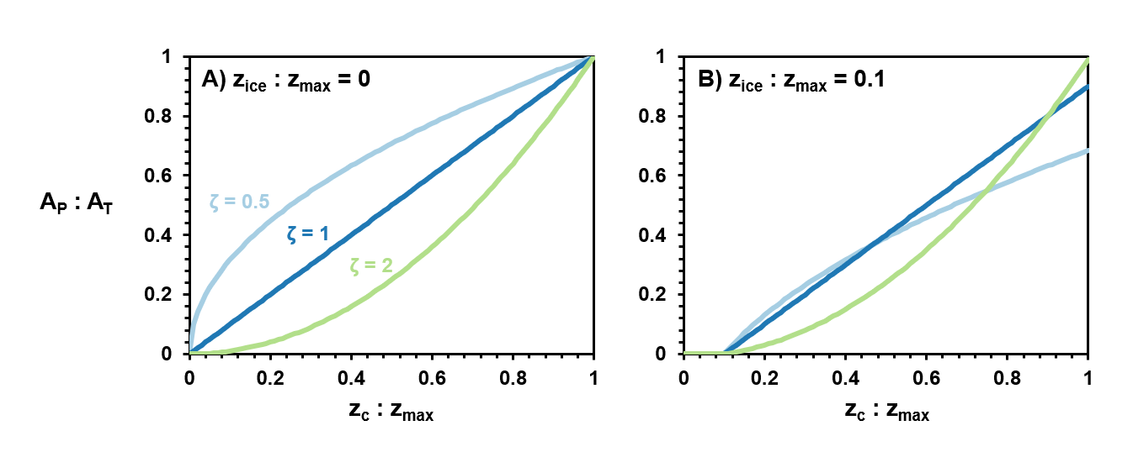
Figure 2. A) The hypsometric without shoreline habitat disruption is characterized by convex basins having more productive benthic habitat than concave basins. B) The hypsometric model with shoreline habitat disruption is characterized by three different regimes depending on the depth of light penetration. These correspond to positive, negative, and unimodal relationships between productive habitat area and mean to maximum depth ratio.

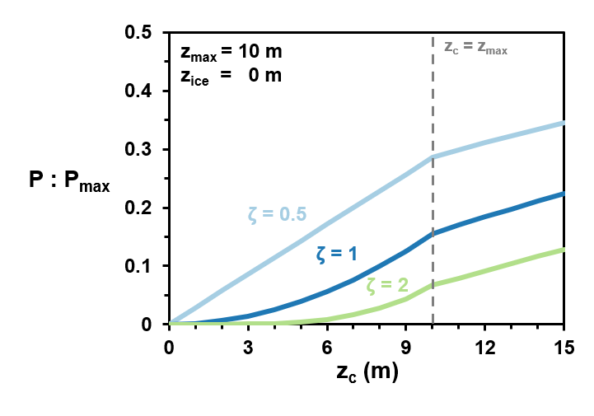
Figure 3. Primary production (relative to P_{max}) for 10 m deep lakes with different basin shapes and compensation depths. Convex shaped basins have higher rates of primary production than concave shaped lakes across the full range of compensation depths.

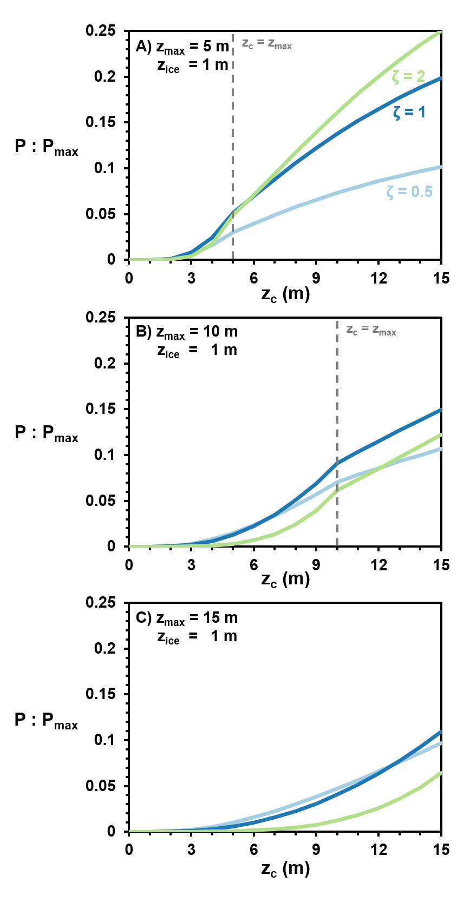
Figure 4. Patterns of benthic primary production for convex, paraboloid, and concave shaped lakes with no production at the lake margin due to ice scour.

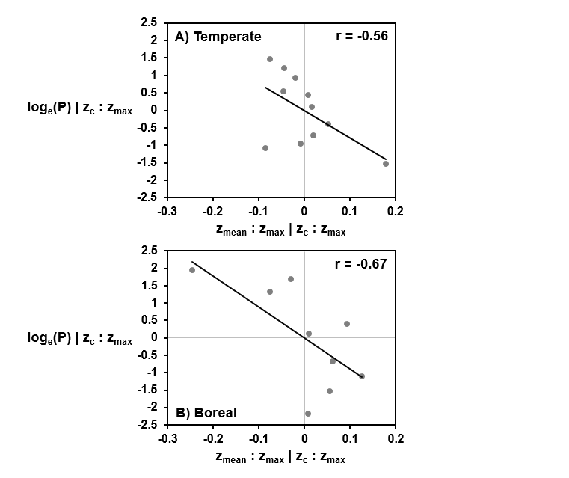
Figure 5. Partial correlation plots for the logarithm of benthic primary production and depth ratio, controlling for the ratio of compensation to maximum depth. A) Temperate Lakes, B) Boreal lakes.

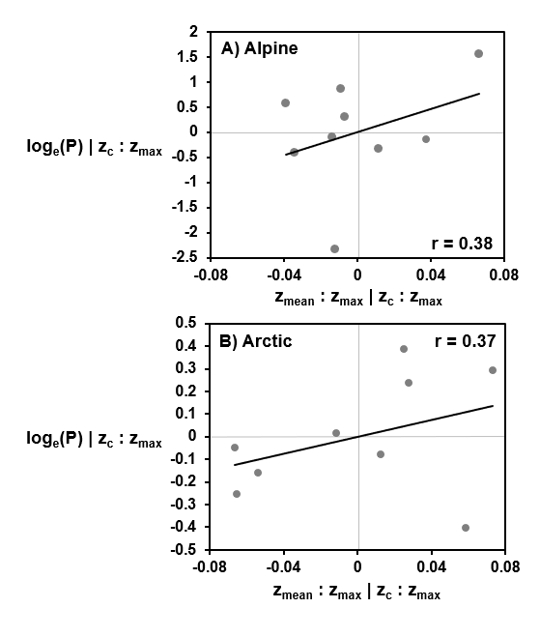
Figure 6. Partial correlation plots for the logarithm of benthic primary production and depth ratio, controlling for the ratio of compensation to maximum depth. A) Alpine lakes, B) Arctic lakes.

Table 1. Typical values for parameters in the hypsometric model
Parameter | Typical Values | References
Maximum depth (z_{max}) | < 20 m | Seekell et al. (2021);  Cael and Seekell (2022)
Compensation depth (z_{c}) | 1.5 – 15 m | Seekell et al. (2015b);  Seekell et al. (2018b);  Seekell et al. (2021)
Ice thickness (z_{ice}) | 0.5 – 1.5 m | Arp et al. (2015);  Ariano and Brown (2019);  Öjebrandt 2021;  Klaus et al. (2022)
Basin morphometry (ζ) | 0.5 – 2 (dimensionless) | Vadeboncoeur et al. (2008);  Seekell et al. (2021)

Table 2. The characteristics of lakes used in the empirical analysis. The values are means with ranges in parentheses.
Characteristic | Temperate (n=11) | Boreal (n=9) | Alpine (n=9) | Arctic (n=9)
z_{c}:z_{max} (dimensionless) | 0.32 (0.06-0.74) | 0.42 (0.14-0.96) | 0.52 (0.29-0.96) | 1.30 (0.71-2.74)
z_{mean}:z_{max} (dimensionless) | 0.37 (0.16-0.56) | 0.49 (0.24-0.62) | 0.32 (0.27-0.37) | 0.38 (0.3 – 0.53)
A_{P}:A_{T} (dimensionless) | 0.53 (0.17-0.68) | 0.45 (0.04-0.95) | 0.73 (0.52-0.98) | 0.97 (0.83-1)
z_{c} (m) | 2.8 (0.8-5.1) | 4 (1.1-11.5) | 5.3 (3.3-11.5) | 10.2 (3.1-15.4)
z_{mean} (m) | 3.4 (2.4-5) | 4.5 (2.0-7.5) | 3.8 (1.3-10.5) | 3.1 (1.5-4.7)
z_{max} (m) | 10.7 (4.9-18.5) | 9.1 (5.3-13.0) | 12.4 (3.7-35.9) | 8.7 (4.3-15.8)
GPP (mg C m⁻² d⁻¹) | 119 (10-294) | 63.8 (0.6-183.1) | 123.6 (8.5-396.0) | 121 (75-253)

