Lin, M., Lin, T., Sun, C., Jones, L., Sui, J., Zhao, Y., Liu, J., Xing, L., Ye, H., Zhang, G. and Li, X., (2020). Using the Eco-Erosion Index to assess regional ecological stress due to urbanization–A case study in the Yangtze River Delta urban agglomeration. Ecological Indicators, 111, p.106028.
DOI: https://doi.org/10.1016/j.ecolind.2019.106028

This is an author-created post-print version. The final published version can be found at: https://www.sciencedirect.com/science/article/pii/S1470160X19310246

Using Eco-Erosion Index to Assess Regional Ecological Stress due to Urbanization-Taking Yangtze River Delta Urban Agglomeration as an example

Meixia Lin^{a,b}, Tao Lin^{a,b,}*, Caige Sun^{c}, Laurence Jones^{e}, Jinling Sui^{a,b}, Yu Zhao^{a,b}, Jiakun Liu^{a,b}, Li Xing^{a,d}, Hong Ye^{a,b}, Guoqin Zhang^{a,b}, Xinhu Li^{a,b}
ª Key Lab of Urban Environment and Health, Institute of Urban Environment, Chinese Academy of Sciences, Xiamen 361021, China
^{b} University of Chinese Academy of Sciences, Beijing 100049, China
^{c} School of Geography, South China Normal University, Guangzhou 510631, China
^{d} College of the Environment and Ecology, Xiamen University, Xiamen 510631, China
^{e} Environment Centre Wales, Centre for Ecology & Hydrology, Bangor LL57 2UW, UK

Using The Eco-Erosion Index to Assess Regional Ecological Stress due to Urbanization
-A Case Study in the Yangtze River Delta Urban Agglomeration

Abstract: Urban agglomeration (the spread of cities into large agglomerations) has become the main form of urbanization in China, and natural ecosystems surrounding the urban areas are becoming degraded and fragmented as a result. Although ecological indicators have been widely used to assess the regional ecological stress resulting from urbanization, few of them consider spatial adjacency relationships between urban and natural landscapes. From this perspective a novel ecological indicator, the Eco-Erosion Index (EEI), was developed and applied to assess the regional ecological stress caused by urban agglomeration development across 26 cities in the Yangtze River Delta, China (YRD). We analyzed: i) temporal change in land use and land cover (LULC) and ecosystem services value (ESV) in YRD from 1990 to 2010, ii) spatiotemporal dynamics of EEI of YRD at different scales: provincial, municipal, and 5 km-grid, iii) inter-relationships between EEI and LULC and ESV to explore its effectiveness as an indicator. The results showed that urban agglomeration in YRD has led to increasing regional ecological stress from 1990 to 2010. EEI values increased from 0.197 in 1990 to 0.321 in 2010. The closer to Shanghai City, the greater the EEI values of the cities become. EEI is highly related with LULC and ESV but integrates these two variables as it represents both the spatial occupation and landscape adjacency effects. The EEI values demonstrate some scale effects, and EEI at fine scale provides useful information to guide sustainable urban landscape management.
Keywords：Land use change; Fragmentation; Ecological security; Urban agglomeration; Urbanization.

- Introduction
Urbanization is arguably the most dramatic form of land transformation, and profoundly influences the structure and function of ecosystems at a wide range of scales (Luck and Wu, 2002; Eigenbrod et al., 2011; Peng et al., 2018), as well as the ecosystem services they provide (Alberti et al., 2003; Millennium Ecosystem Assessment, 2005). It is projected that 66% of the human population will live in urban areas by 2050 (United Nations, 2014), with urban extent growing twice as fast as urban populations (Elmqvist et al., 2013). Moreover, 95% of urban expansion in the next decades will take place in the developing world (Grimm et al., 2008; Hák et al., 2016). Inevitably, urban development will substantially alter the natural ecosystems surrounding or within the cities since it fragments, isolates and degrades natural habitats, and causes a range of ecological damage including biodiversity loss and environmental pollution (Lin and Grimm, 2015; Lin et al., 2016). There is therefore an urgent need to monitor and assess the ecological consequences of urban spatial expansion, especially in areas experiencing rapid urbanization.
As the biggest developing country in the world, China is suffering severe ecological and environmental challenges as a result of its rapid urbanization (Bryan et al., 2018), especially from urban sprawl (Seto et al., 2011; Sun et al., 2019). In 1978, China’s urbanization rate was only 17.92 %, but increased to 58.5 % in 2017, with more than a three-fold increase in the past forty years. Meanwhile, urban agglomeration has become the major mode of spatial urbanization in China (Fang et al., 2017). An urban agglomeration is a highly integrated cluster of cities and is an outcome of widespread industrialization and urbanization (Fang and Yu, 2017). Cities within the same urban agglomerations are more likely to develop into each other’s footprints, occupying and eroding natural ecosystems surrounding the cities (Caniani et al., 2016; Du et al., 2016; Sun et al., 2018). The natural landscapes where the urban agglomeration is located have become increasingly fragmented and the connectivity of the remaining natural ecosystems has been dramatically reduced. As a result, the functions and services they provide such as climate regulation and disaster prevention have also been reduced (Weng, 2001; McKINNEY, 2002; Alberti and Marzluff, 2004). In this study we describe this as regional ecological stress by urbanization. In China, the ecological effects of urban agglomerations have received considerable attention and the National Key Research and Development Program (Restoration and Protection of Specific Vulnerable Ecosystems) was launched in 2016, focusing on major urban agglomerations in three areas: the Yangtze river delta (YRD) (Wang et al.,2016), the Pearl river delta (Huang et al.,2016) and Beijing-Tianjin-Hebei (Chen et al.,2016). There is an urgent need to assess regional ecological stress to evaluate the serious effects caused by rapid urbanization of the agglomerations and to enhance sustainable land use (Su et al., 2010; Wu, 2014).
Ecosystem services depend on the integrity and stability of the ecosystem (Xiao et al.,2002). Regional ecological stress assessment can judge whether the structure and function of ecosystems are damaged (Tian and Gang, 2012), and whether the dynamics of regional landscape patterns are affected (Wu et al.,2016). Landscape metrics are a valuable method to quantify the impacts of urban expansion on ecosystems (Wang et al., 2015; Feng et al., 2018). In previous studies, urban expansion indicators mainly focused on the size and shape of patches in order to measure the ecological stress intensity (Li et al., 2010; Wu et al., 2011). However, adjacency relationships and the edge effects between the urban and natural landscapes have rarely been studied. In theory, the interim or transitional landscapes can be considered as an ecotone which not only acts as a filter and barrier to some species, but can also provide important habitat for other species (Laurance et al., 2001; Hufkens et al., 2009). Urban spatial sprawl will directly damage this ecotone and further affect the survival of many species (Saunders et al., 1999). At present, landscape indices for patch adjacency are mainly used to express the overall characteristics of the patch boundary, such as the total length of boundary, boundary density and average proximity (O'Neill et al., 1988; Fei and Zhao, 2019; Qiu et al., 2019). Few indicators have been developed to describe spatial adjacency relationships between different landscapes. Xie (Xie,2013) developed the boundary adjacency index based on the common edge between adjacent patches to explore the spatial adjacency relationships of different landscapes. Lin et al. (Lin et al.,2009) developed the urbanization erosion index to describe the dynamic impact of urbanization on Xiamen Island landscapes. However, they lack an in-depth exploration of the ecological implications of urban and natural landscape adjacency, especially from the perspective of larger scale regional ecological stress caused by urban agglomerations.
In this study, we develop a landscape index of spatial adjacency (Eco-Erosion Index, EEI) to evaluate the regional ecological stress caused by urban expansion in the Yangtze River Delta Urban Agglomeration, and we explore the applicability of the EEI compared with two other popular indicators based on land use and land cover (LULC) and ecosystem service value (ESV). We attempt to answer the following two questions: 1) Whether EEI can comprehensively reflect the regional ecological stress of urban spatial expansion on surrounding natural landscapes? 2) What are the relationships between EEI, indicators of land use change and ESV?

2 Methods

2.1 Study area
Yangtze River Delta Urban Agglomeration (29°20′N to 32°34′N, 115°46′E to 123°25′E) is located in the downstream region of the Yangtze River, close to the Yellow Sea and East Sea of China. It is an alluvial plain, intersecting east coastal China and the estuary of the Yangtze River. According to the development plan for the Yangtze River Delta Urban Agglomeration issued in June 2016 (National Development And Reform Commission, 2016), YRD covers Shanghai and another 25 core cities in Jiangsu, Zhejiang and Anhui provinces. YRD is not only the most developed urban agglomeration and the most active economic development region in China, but also one of the six largest urban agglomerations in the world. Urban agglomeration is the primary carrier for socioeconomic development. Although the total land area of YRD is 211,700 km², accounting for 2.2 % land area of China, it contains around a quarter of China's economy and more than a quarter of its industrial added value. Therefore, YRD is seen as an important engine of China's economic development. However, the rapid development of industrialization and urbanization has compromised the sustainability of YRD in recent years, leading to a decrease in the resilience of urban ecosystems and climate adaptability. Drastic changes of land use caused by human activities have also exerted huge stress on the structure, process and functioning of regional ecosystems, which has adversely affected ecological fragility and caused ecosystem degradation in YRD, as well as decreasing biodiversity.

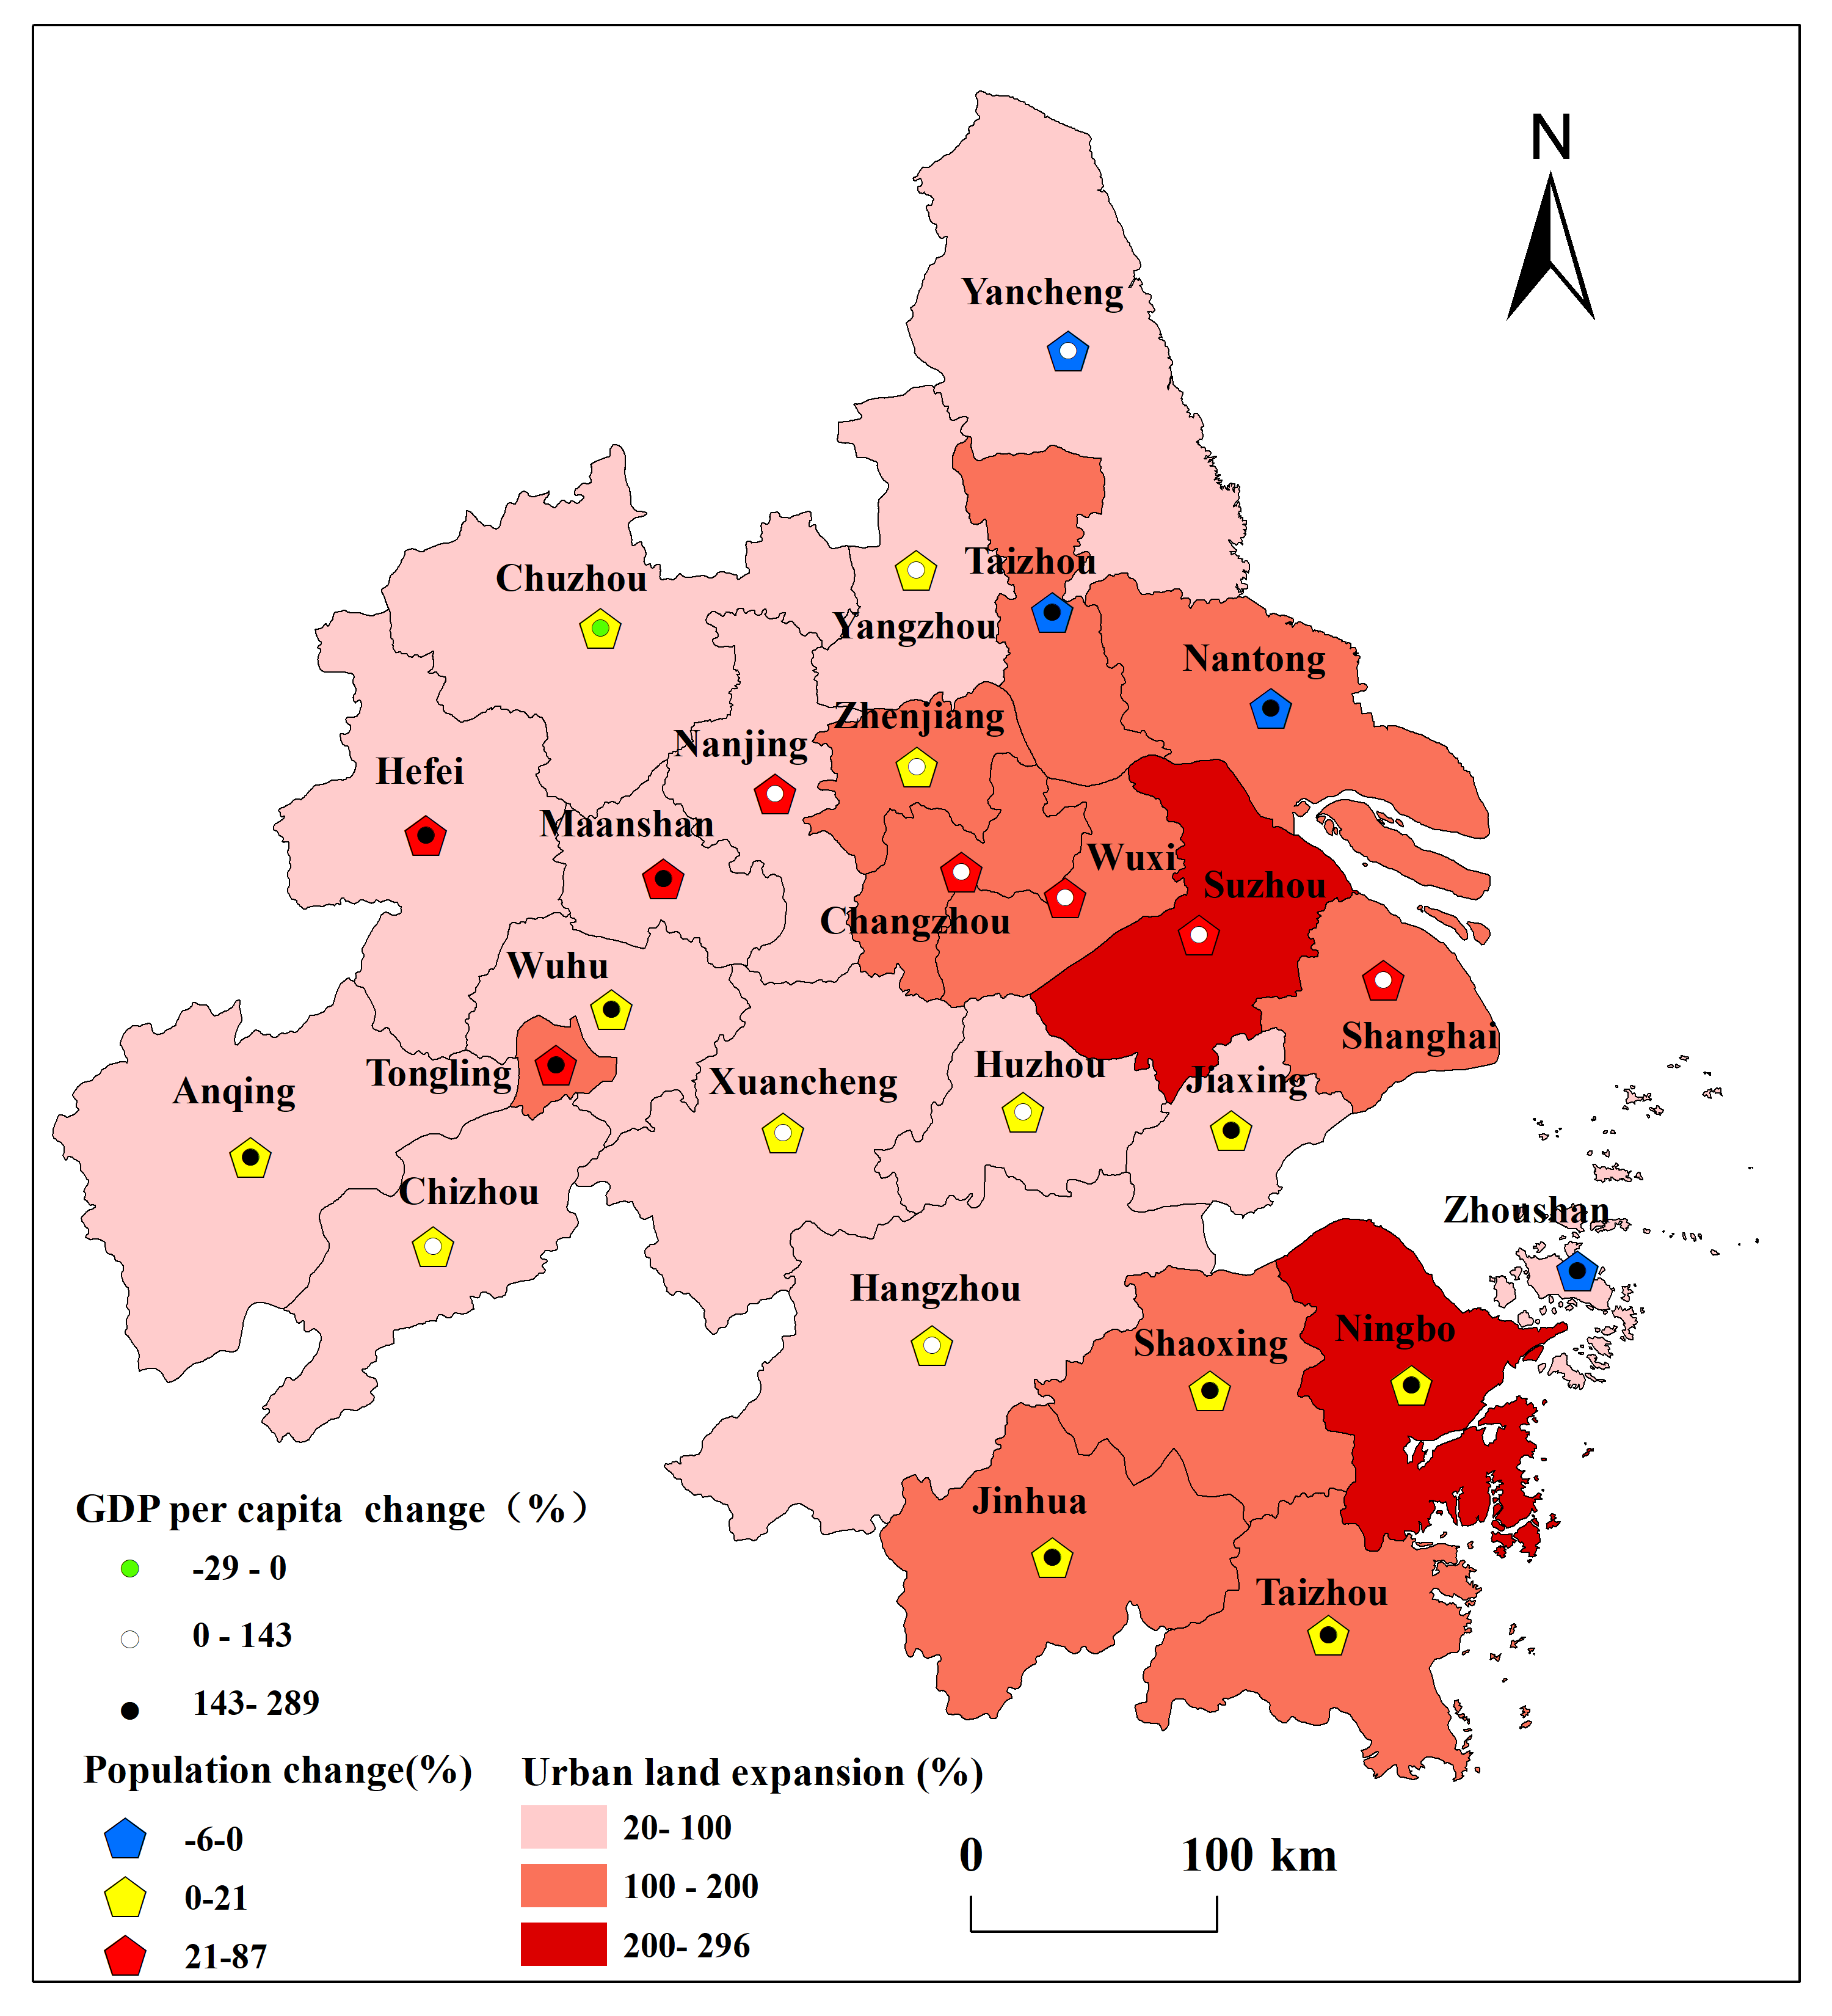
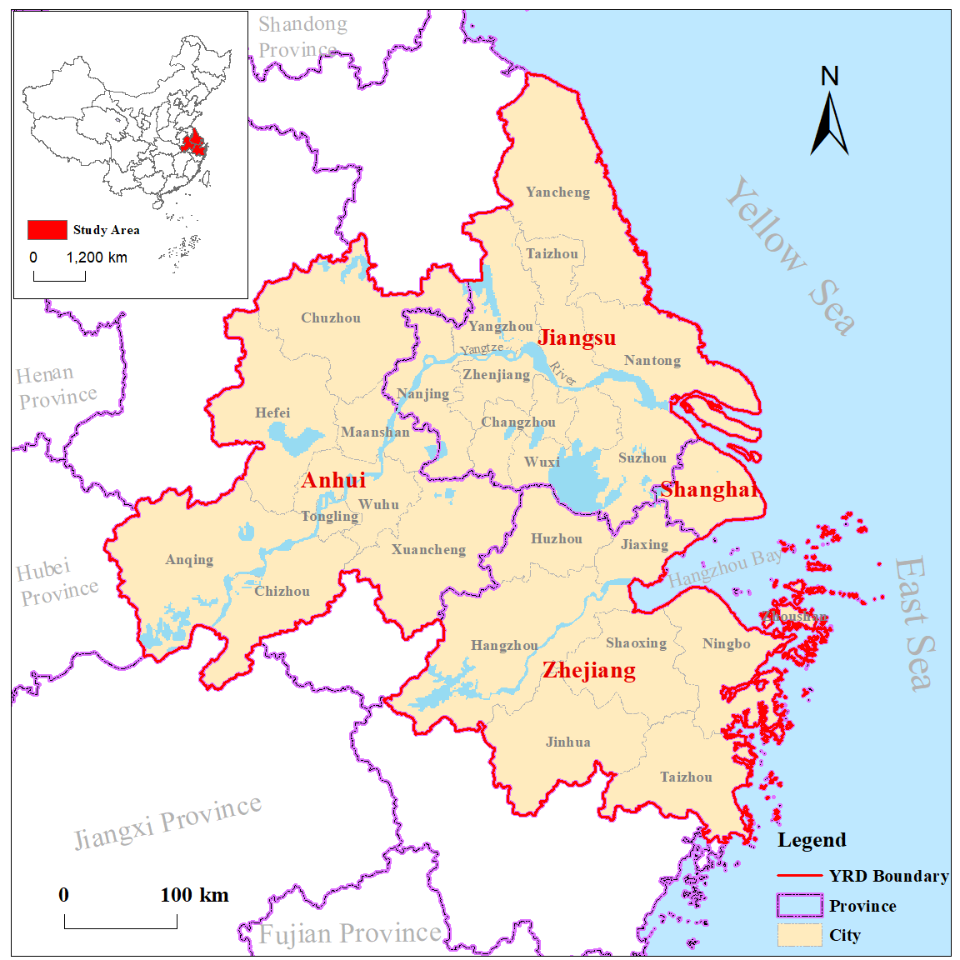
- (b)
Fig.1 (a) Location of the study area; (b) Ratios of change in urban land expansion, population and GDP per capita in 26 cities from 1990 to 2010. Change ratios are subdivided into three classes.

2.2 Data sources and pre-processing
The data involved in this study included land use and land cover data (LULC) with 30m spatial resolution from 1990 to 2010 (National Earth System Science Data Sharing Infrastructure, National Science & Technology Infrastructure of China, http://www.geodata.cn), socio-economic statistical data and geographic ancillary data. All data were geo-registered to WGS-84 coordinate system in ArcGIS. LULC data were clipped and reclassified into seven categories including cultivated land, woodland, grassland, waterbodies, wetland, built-up area and unused land. LULC data were further processed into 5km grid cells to investigate the quantity of built-up area. Each 5 km grid cell has a unique ID and holds attributes about the grid unit, such as ecosystem service value (ESV), percentage of build-up area (PB), landscape threat index (Vi) and eco-erosion index (EEI), described in the following sections.

2.3 Methods
To explore the applicability and ecological significance of EEI, we first analyzed the spatial and temporal dynamics of EEI within YRD from 1990 to 2010, at three scales of urban agglomeration: provincial, municipal and the 5km-grid respectively. Secondly, we analyzed the characteristics of EEI at different scales and explored scale effects and the applicability of EEI through geospatial statistical analysis and correlation analysis. Thirdly, we compared EEI with PB, Vi and ESV, based on the 5km-grid scale, to verify its effectiveness at assessing land use and land cover change (LUCC) and ecosystem service value change caused by urban expansion (see Fig. 2).
Fig. 2 Research methods and processing pathways

2.3.1 Landscape classification
There are 25 landscape classes in the original LULC data. In order to quantify the influence of urban sprawl on ecosystems, the landscapes of the study area are divided into urban landscapes and natural landscapes. Urban landscapes refer to built-up area, and natural landscapes included cultivated land, grassland, woodland, waterbodies, wetland and unused land. Using spatial analysis and ArcGIS software, we developed an integrated tool set to quickly extract the common edges between urban landscape and natural landscape and calculate attribute information automatically, including the length of common edges, area, perimeter and the number of adjacent natural landscape patches. In addition, this tool set also provides modules to calculate ecosystem service value and eco-erosion index.

2.3.2 Eco-Erosion Index
Landscapes are the spatial mosaic of patches, and landscape adjacency is one of the most important features of landscape pattern. Landscape patches that are spatially adjacent are expected to be closely related in their structure and function. EEI is developed from the perspective of landscape spatial adjacency, to evaluate the degree of stress of urbanization on regional ecosystem health. It is based on land use data (Lin et al., 2009). The ecological process reflected by EEI mainly refers to horizontal transformations of the natural landscape into semi-natural or semi-artificial ecotones. There are three patterns of urban expansion: 1) variation of urban landscape area alone; 2) variation of urban landscape perimeter alone; 3) variation in both urban landscape area and perimeter. Therefore, the EEI should represent both spatial occupation and landscape adjacency effects of urban landscapes on natural landscapes. The calculation of EEI considers the area of urban landscape and the length of common edges, area and the number of adjacent patches between urban landscapes and natural landscapes, see formula (1) and (2).
$EEI=A+\frac{1}{n}\sum_{i=1}^{n}{V_{i}}$ (1)
$V_{i}={\left(L_{i}+U_{i}\right)}/2={(\frac{\sum_{j=1}^{m}{l_{ij}}}{\sum_{g=1}^{k}{L_{ig}}}+\frac{m}{k})}/2$ (2)
Where, EEI is a metric at landscape level and denotes the eco-erosion degree of urban landscape to natural landscape; A is urban landscape area as a proportion of total landscape area, which quantifies the spatial occupation of urban landscape on natural landscapes; n represents the number of natural landscape types. V_{i} (landscape threat index) is a metric at class level and refers to the degree of spatial adjacency between natural landscape and urban landscape; L_{i} represents the proportion of the spatial adjacent length between natural landscape ’i’ and urban landscape in the total patch perimeter of natural landscape ’i’. Note that the spatial adjacent length only counts the length of common edges between natural landscape ’i’ and urban landscape, not the total perimeter of spatial adjacent natural landscape ’i’（See Fig.3）. U_{i} represents the proportion of the number of spatially adjacent patches between natural landscape ’i’ and urban landscape in the total number of patches of natural landscape ‘i’. l_{ij} is the length of common edges of patch ij; L_{ig} is the perimeter of patch ig; k is the total number of patches of natural landscape ‘i’; m is the number of spatially adjacent patches between urban landscape and natural landscape ’i’ , 0≤ m≤k.
The greater the value of EEI, the higher is the regional ecological stress by urbanization. The theoretical maximum value of EEI tends to a maximum of 2, at which almost all the landscapes are urban landscapes and A approaches 1. When A is not equal to 1, the greater the value of EEI, the smaller the space left for urban landscape to erode and expand, and the smaller the space for natural landscapes to evolve spontaneously.
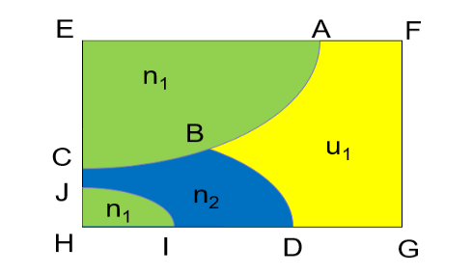
Fig 3. schematic diagram for the spatial adjacent length（n₁, n₂=two different types of natural landscapes；u₁=urban landscape；AB=the common edge between n₁ and u₁=spatial adjacent length； BD= the common edges between n₂ and u₁=spatial adjacent length；ABCEA =the total perimeter of spatial adjacent natural landscape n₁≠spatial adjacent length；ABCEA+JIHJ= the total perimeter of natural landscape n₁≠spatial adjacent length；BDIJCB= the total perimeter of natural landscape n₂≠spatial adjacent length）

2.3.3 ESV assessment
Ecosystem services, which are the benefits human populations derive directly or indirectly from ecosystem functions, play an important part of the total economic value of the Earth (Costanza et al., 1997) . ESV can be estimated by using the method of equivalent value per unit ecosystem area, which multiplies the unit values by the surface area of each ecosystem (Xie et al.,2015). See formula (3),
$ESV=\sum{\left(A_{k}×{VC}_{k}\right)}$ (3)
Where, ESV (yuan) is the total value of ecosystem services. A_{k} (ha) is the area for LULC class ’k’. VC_{k} (yuan/ha) is the monetary value per unit area of each ecosystem service for LULC class ‘k’. This study summarizes ecosystem services as four types: supply service, regulation service, support service and cultural service. According to our literature review, the equivalent value per unit area of each ecosystem service for each ecosystem type determined by Xie et al (Xie et al.,2015) has been widely applied in the evaluation of China’s ecosystem services. For example, Liu et al (Liu et al.,2014) referred to Xie’s study and obtained VC_{k} table based on the average grain yield and grain price of YRD from 1980 to 2010. In this paper, we adopted the VC_{k} table of Liu et al. to calculate the ecosystem service value at 5km-grid scale from 1990 to 2010. Values were divided into five classes: extremely low (ESV less than 10,000 yuan/ha), low (10,000-30,000 yuan/ha), medium (30,000-50,000 yuan/ha), high (50,000-70,000 yuan/ha) and extremely high (more than 70,000 yuan/ha).

3 Results and discussion

  - LUCC and ESV variations
With the rapid development of urbanization, a large quantity of natural landscapes including grassland and cultivated land in YRD have been converted to built-up area from 1990 to 2010, see Fig. 4. The expansion of built-up area centered primarily on Shanghai City and then rapidly expanded westwards along the Yangtze River and southwards along Hangzhou Bay. The area of natural landscapes (grassland and wetland), and cultivated land all showed a significant decrease, with a total loss of 1,603.36×10³ ha. The area of woodland increased first in 2000 and then decreased again in 2010 but showed a net gain of 226,690 ha compared to 1990. Built-up area, unused land and waterbodies all showed an increasing trend. The most substantial land use change occurred from 2000 to 2010 when built-up area nearly doubled. Urban spatial expansion was the major cause for the substantial reduction of natural landscapes in the YRD from 1990 to 2010. At the same time, the total value of ecosystem services in the Yangtze River Delta in the 20 years increased slightly by 0.31% compared to 1990, because the increase of woodland and waterbodies has offset the reduction of other natural landscapes such as wetland and grassland, see Table 1.
The topography of YRD directly influences the pattern of urban spatial expansion. The northern part of the YRD and both sides of the Yangtze river are flat and easily affected by urban expansion. From 1990 to 2010, 1,171,306 ha of cultivated land was converted into built-up area in YRD, accounting for 86.78% of the cultivated land change in 20 years. By contrast, the southern regions which are mostly high mountain areas are unsuitable for urban development and large areas of woodland remain. In 2010, the forest cover in Zhejiang and Anhui province was 60.50% and 27.53%, respectively.
Fig.4 Land use and cover changes (top) and the spatial distribution of ESV (bottom) in YRD
from 1990 to 2010

Table 1. Land use area and its changes in YRD from 1990 to 2010
（Area unit：×10³ ha，ESV unit：billion yuan）
Year | Cultivated land | Woodland | Grassland | Waterbodies | Built up | Unused land | Wetland | ESV
1990 | 11474.12 | 5459.47 | 946.49 | 1340.77 | 1259.46 | 4.79 | 175.69 | 120.25
2000 | 11023.41 | 5731.67 | 723.65 | 1384.13 | 1621.14 | 3.32 | 173.56 | 121.58
2010 | 10126.48 | 5686.16 | 700.56 | 1506.95 | 2461.51 | 18.86 | 165.9 | 120.62
Absolute variation in 20 years | -1347.64 | 226.69 | -245.93 | 166.18 | 1202.05 | 14.07 | -9.79 | 0.37
Change rate in 20 years | -11.75% | 4.15% | -25.98% | 12.39% | 95.44% | 293.74% | -5.57% | 0.31%

  - Spatiotemporal dynamics of EEI
From 1990 to 2010, the urban ecological stress in YRD showed an increasing trend. At the scale of the whole urban agglomeration (Fig.5), the EEI value increased from 0.197 to 0.321 from 1990 to 2010, with an overall increase of 62.94%. The spatial distribution of EEI at provincial, municipal and 5km-grid scales all show significant spatial heterogeneity. According to the range of EEI value in various provinces and cities (0-1), the EEI values were divided into five grades with an equal interval value of 0.2 (0~0.2 extremely low, 0.2~0.4 low, 0.4~0.6 medium, 0.6~0.8 high and 0.8~1.0 extremely high), see Fig.6.

Fig.5 The variation of EEI values in YRD, provincial (boxed) and city scales from 1990 to 2010
(Taizhou1 belongs to Jiangsu province, Taizhou2 belongs to Anhui province)

At provincial scale, the EEI values of all the four provinces (including Shanghai City) are increasing over time, with Shanghai City with the largest values, changing from median to extremely high from 1990 to 2010. A similar spatial pattern occurred at the municipal scale, the EEI value of all cities did not exceed 0.6 in 1990, and the cities with a median value (0.4<EEI<0.6) were separately distributed. However, with the rapid development of urbanization, the number of cities with high EEI quickly increased from 4 to 12 by 2010, forming a clear gradient in distribution from Shanghai with extremely high EEI to the surrounding cities. The closer to Shanghai, the higher the EEI values of the cities.
At 5km-grid scale, although the EEI values of the grids increase quickly in a similar way to provincial and municipal scales, the spatial distribution of grids with extremely high EEI value have a distinct pattern. A great number of grids with high value EEI were found in the cities with median and even low EEI. Obviously, the finer scale assessment provides more details about the regional ecological stress of YRD for sustainable urban landscape management.
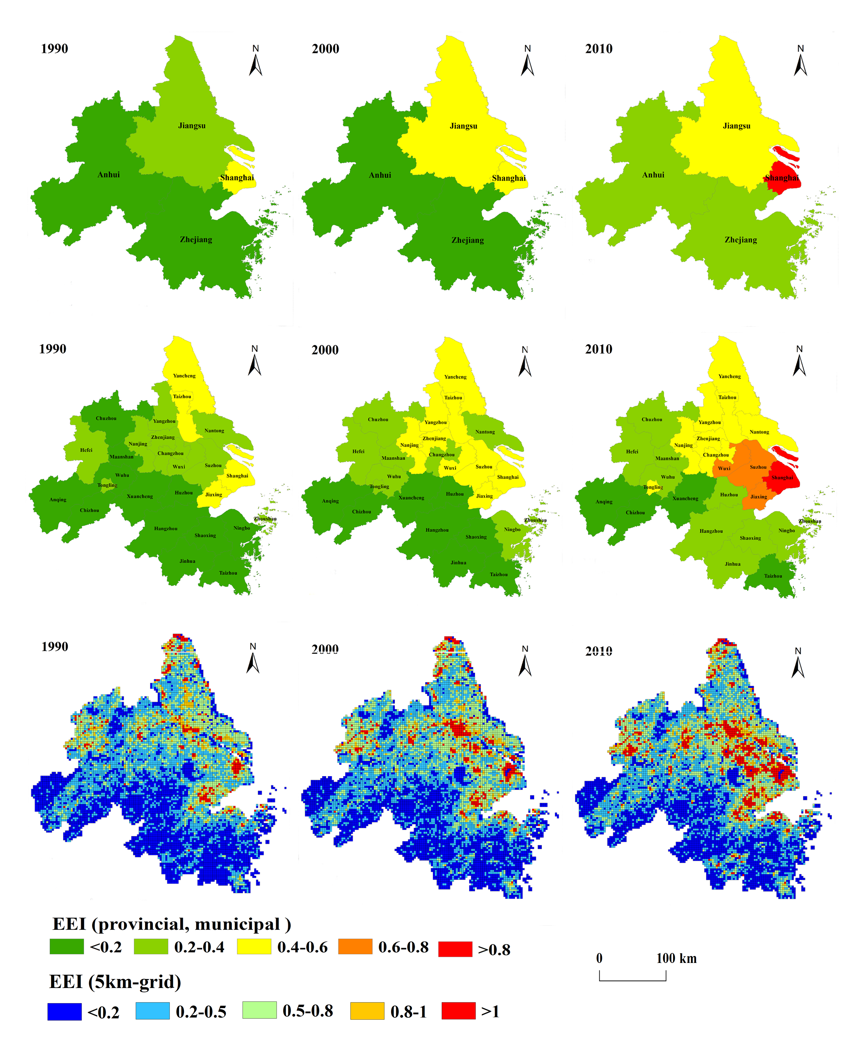

Fig.6 The spatial distribution of EEI values at three different scales from 1990 to 2010
Showing: provincial (top), municipal (middle) and 5km-grid scale (bottom)

  - Evaluation of EEI
According to formula (1), the theoretical value range of EEI is 0-2. We found that the value range of EEI varies with the spatial scale. The larger scales have a smaller EEI value, for example in our study, the value ranges in 1990 are 0-0.5, 0-1, and 0-2 at the provincial, municipal and 5 km-grid scales respectively, see Table 2. Obviously, the built-up area ratio is relatively larger at the smaller scales and has more likelihood to reach 100%, when the EEI values tend to a maximum of 2. By integrating EEI values at different scales (Table 2), although the EEI values obtained at large scale are not equal to the arithmetic mean value of EEI values at small scale, the trends of change in EEI values over time are consistent.

Table 2. The values of EEI in YRD at different scales
Scale  Year | Urban agglomeration |  | Provincial |  | Municipal |  | 5km-grid
 | mean value | range | mean value | range | mean value | range | mean value | range
1990 | 0.197 | - | 0.280 | （0.146,0.453） | 0.243 | （0.064,0.516) | 0.348 | (0,1.835)
2000 | 0.238 | - | 0.337 | （0.170,0.572） | 0.282 | （0.079,0.594） | 0.380 | (0,1.945)
2010 | 0.321 | - | 0.459 | （0.229,0.819） | 0.370 | （0.115,0.819） | 0.435 | (0,1.970)

We compared the ESV and EEI based on the 5 km-grid scale and found that there was considerable overlap between those grids with extremely low ESV and those with the highest EEI value from 1990 to 2010. Those grids are mainly in or surrounding the built-up area. Furthermore, significant negative correlations were found between ESV and PB, Vi and EEI, and those correlations become greater from 1990 to 2010. Obviously, with the increase of PB, Vi and EEI, the ESV of the grid will decrease. The EEI has a higher correlation coefficient with ESV than Vi and PB, see Table 3, indicating that EEI is more sensitive to regional ecological stress by urbanization than PB and Vi.

Table.3 Correlation analysis between ESV and PB/Vi/EEI based on 5km-grid scale from 1990 to 2010
 | ESV
 | 1990 | 2000 | 2010
PB | -0.312** | -0.348** | -0.380**
Vi | -0.414** | -0.417** | -0.419**
EEI | -0.428** | -0.444** | -0.456**
(** p<0.01，PB: the percentage of build-up area )

Correlations between EEI and PB and Vi were studied at different scales, see Table 4. The correlation coefficients of (EEI, PB) and (EEI, Vi) were all significant at the three different scales. The correlation coefficients of (EEI, Vi) remained more stable at finer scale compared with that of (EEI, PB), although both the coefficients decrease at finer scales.

Table 4. The correlation between EEI, PB and Vi at different scales
Scale | correlation coefficient type | 1990 | 2000 | 2010 | annual average
provincial | (EEI, PB) | 0.948** | 0.960** | 0.988** | 0.965
 | (EEI, Vi） | 0.983** | 0.981** | 0.989** | 0.985
municipal | (EEI, PB) | 0.887** | 0.892** | 0.951** | 0.910
 | (EEI, Vi） | 0.981** | 0.974** | 0.975** | 0.977
5km-grid | (EEI, PB) | 0.725** | 0.740** | 0.810** | 0.758
 | (EEI, Vi） | 0.970** | 0.957** | 0.932** | 0.953

The negative correlation between PB and ESV confirms that expansion of urban land exerts a strong stress on the surrounding natural ecosystems. The correlations between EEI, Vi, PB and ESV indexes (EEI > Vi > PB) indicate that the spatial mosaic relationships between urban landscapes and natural landscapes have great potential to help explore the regional ecological impact of urbanization. Besides the spatial occupation or fragmentation by the urban landscape, we suggest that there is another way by which urban landscape affects the natural landscapes via spatial adjacency. The landscapes fragmented by urban sprawl will cause new ecotone areas to emerge between the urban and natural landscapes. Although urban landscapes remain unchanged over short timescales, the human interference and reduced ecological connectivity may exert continual stress on the neighboring natural landscapes. The human interference is well represented by PB while reduced connectivity is better indicated by Vi. Thus, EEI has higher correlation coefficients with ESV than PB and Vi as it combines the two kinds of urban ecological stresses from both spatial occupation and adjacency effects.

4 Conclusion
Urban agglomeration is a highly integrated cluster of cities. It has become the main form of spatial urbanization in China and exerts considerable stress on natural ecosystems at a regional scale. Landscape indices have great potential to explore the degree of regional ecological stress due to urbanization. However, few of these indices consider the spatial adjacency relationships between natural and urban landscapes, which is a key mechanism of impact of urban expansion on natural areas. Taking the Yangtze River Delta Urban Agglomeration in China as the research area, we developed and applied a new index EEI which considers both spatial occupation (PB) and adjacency effects (Vi) to assess the regional ecological stress from urbanization on natural landscapes, at provincial, municipal and 5 km-grid scales. We found a clear gradient away from Shanghai with the highest EEI values for the cities or areas nearest to Shanghai. In order to evaluate the validity of EEI, we compared its relationship with PB and ESV which are two widely used indicators of regional ecological impacts from urban spatial expansion. We found that PB, Vi and EEI are significantly correlated with ESV but the EEI is more sensitive to the degree of urban stress than PB and Vi as it represents both spatial occupation and adjacency effects. Furthermore, the EEI value demonstrates a strong scale effect i.e. the value obtained at coarse scales is not equal to the arithmetic mean value of EEI value at finer scale. However, the trends of change in EEI over time are consistent across scales. The EEI calculated at fine scale can provide more details about the ecological stress from urban spatial expansion than simply accounting for the LUCC and ESV changes. In summary, we demonstrate that EEI is a useful indicator with which to assess ecological stress due to urban spatial expansion at different scales and can provide additional detail to guide sustainable urban landscape management at finer scale.

Acknowledgement
The authors are grateful for the support of the National Key Research & Development Program of China (2016YFC0502702) and the National Natural Science Foundation of China (41771573, 41371540).

Reference
Alberti, M., Marzluff, J.M., 2004. Ecological resilience in urban ecosystems: Linking urban patterns to human and ecological functions. URBAN ECOSYST 7, 241-265.
Alberti, M., Marzluff, J.M., Shulenberger, E., Bradley, G., Ryan, C., Zumbrunnen, C., 2003. Integrating Humans into Ecology: Opportunities and Challenges for Studying Urban Ecosystems. BIOSCIENCE 53, 1169-1179.
Bryan, B.A., Gao, L., Ye, Y., Sun, X., Connor, J.D., Crossman, N.D., Stafford-Smith, M., Wu, J., He, C., Yu, D., Liu, Z., Li, A., Huang, Q., Ren, H., Deng, X., Zheng, H., Niu, J., Han, G., Hou, X., 2018. China’s response to a national land-system sustainability emergency. NATURE 559, 193-204.
Caniani, D., Labella, A., Lioi, D.S., Mancini, I.M., Masi, S., 2016. Habitat ecological integrity and environmental impact assessment of anthropic activities: a GIS-based fuzzy logic model for sites of high biodiversity conservation interest. ECOL INDIC, 238-249.
Costanza, R., D'Arge, R., de Groot, R., Farber, S., Grasso, M., Hannon, B., Limburg, K., Naeem, S., O'Neill, R.V., Paruelo, J., Raskin, R.G., Sutton, P., van den Belt, M., 1997. The value of the world's ecosystem services and natural capital. ECOL ECON 6630, 253-260.
Du, H., Wang, D., Wang, Y., Zhao, X., Qin, F., Jiang, H., Cai, Y., 2016. Influences of land cover types, meteorological conditions, anthropogenic heat and urban area on surface urban heat island in the Yangtze River Delta Urban Agglomeration. SCI TOTAL ENVIRON 571, 461-470.
Eigenbrod, F., Bell, V.A., Davies, H.N., Heinemeyer, A., Armsworth, P.R., Gaston, K.J., 2011. The impact of projected increases in urbanization on ecosystem services. Proceedings of the Royal Society B: Biological Sciences 278, 3201-3208.
Elmqvist, T., Fragkias, M., Goodness, J., Güneralp, B., Marcotullio, P.J., McDonald, R.I., Parnell, S., Schewenius, M., Sendstad, M., Seto, K.C., Wilkinson, C., 2013. Urbanization, Biodiversity and Ecosystem Services: Challenges and Opportunities.
Fang, C., Yu, D., 2017. Urban agglomeration: An evolving concept of an emerging phenomenon. LANDSCAPE URBAN PLAN 162, 126-136.
Fang, C., Zhou, C., Gu, C., Chen, L., Li, S., 2017. A proposal for the theoretical analysis of the interactive coupled effects between urbanization and the eco-environment in mega-urban agglomerations. J GEOGR SCI 27, 1431-1449.
Fei, W., Zhao, S., 2019. Urban land expansion in China's six megacities from 1978 to 2015. SCI TOTAL ENVIRON 664, 60-71.
Feng, Y., Yang, Q., Tong, X., Chen, L., 2018. Evaluating land ecological security and examining its relationships with driving factors using GIS and generalized additive model. SCI TOTAL ENVIRON 633, 1469-1479.
Grimm, N.B., Faeth, S.H., Golubiewski, N.E., Redman, C.L., Wu, J., Bai, X., Briggs, J.M., 2008. Global Change and the Ecology of Cities. SCIENCE 319, 756-760.
Hák, T., Janoušková, S., Moldan, B., 2016. Sustainable Development Goals: A need for relevant indicators. ECOL INDIC 60, 565-573.
Hufkens, K., Scheunders, P., Ceulemans, R., 2009. Ecotones in vegetation ecology: methodologies and definitions revisited. ECOL RES 24, 977-986.
Laurance, W.F., Didham, R.K., Power, M.E., 2001. Ecological boundaries: a search for synthesis. TRENDS ECOL EVOL 16, 70-71.
Li, Y., Sun, X., Zhu, X., Cao, H., 2010. An early warning method of landscape ecological security in rapid urbanizing coastal areas and its application in Xiamen, China. ECOL MODEL 221, 2251-2260.
Lin, T., Grimm, N.B., 2015. Comparative study of urban ecology development in the U.S. and China: Opportunity and Challenge. URBAN ECOSYST 18, 599-611.
Lin, T., Sun, C., Li, X., Zhao, Q., Zhang, G., Ge, R., Ye, H., Huang, N., Yin, K., 2016. Spatial pattern of urban functional landscapes along an urban–rural gradient: A case study in Xiamen City, China. INT J APPL EARTH OBS 46, 22-30.
Luck, M., Wu, J., 2002. A gradient analysis of urban landscape pattern: a case study from the Phoenix metropolitan region, Arizona, USA. LANDSCAPE ECOL 17, 327-339.
McKINNEY, M.L., 2002. Urbanization, Biodiversity, and Conservation. BioScience 52, 883-890.
Millennium Ecosystem Assessment, 2005. Ecosystems and Human Well-being: Synthesis, Island Press, Washington, DC.
National Development And Reform Commission,2016.The development plan for the Yangtze river delta Urban agglomeration.http://www.ndrc.gov.cn/zcfb/zcfbghwb/201606/t20160603_806390.html/（accessed 3/12/2019）.
O'Neill, R.V., Krummel, J.R., Gardner, R.H., Sugihara, G., Jackson, B., DeAngelis, D.L., Milne, B.T., Turner, M.G., Zygmunt, B., Christensen, S.W., Dale, V.H., Graham, R.L., 1988. Indices of landscape pattern. Landscape Ecology 1, 153-162.
Peng, J., Yang, Y., Liu, Y., Hu, Y., Du, Y., Meersmans, J., Qiu, S., 2018. Linking ecosystem services and circuit theory to identify ecological security patterns. SCI TOTAL ENVIRON 644, 781-790.
Qiu, L., Pan, Y., Zhu, J., Amable, G.S., Xu, B., 2019. Integrated analysis of urbanization-triggered land use change trajectory and implications for ecological land management: A case study in Fuyang, China. SCI TOTAL ENVIRON 660, 209-217.
Saunders, S.C., Chen, J., Drummer, T.D., Crow, T.R., 1999. Modeling temperature gradients across edges over time in a managed landscape. FOREST ECOL MANAG 117, 17-31.
Seto, K.C., Fragkias, M., Güneralp, B., Reilly, M.K., 2011. A meta-analysis of global urban land expansion. PLOS ONE 6, e23777.
Su, M., Fath, B.D., Yang, Z., 2010. Urban ecosystem health assessment: A review. SCI TOTAL ENVIRON 408, 2425-2434.
Sun, C., Lin, T., Zhao, Q., Li, X., Ye, H., Zhang, G., Liu, X., Zhao, Y., 2019. Spatial pattern of urban green spaces in a long-term compact urbanization process—A case study in China. ECOL INDIC 96, 111-119.
Sun, J., Li, Y.P., Gao, P.P., Xia, B.C., 2018. A Mamdani fuzzy inference approach for assessing ecological security in the Pearl River Delta urban agglomeration, China. ECOL INDIC 94, 386-396.
Tian, J., Gang, G., 2012. Research on Regional Ecological Security Assessment. Energy Procedia 16, 1180-1186.
United Nations, 2014. World Urbanization Prospects: The 2014 Revision.
Wang, Z., Zhou, J., Loaiciga, H., Guo, H., Hong, S., 2015. A DPSIR Model for Ecological Security Assessment through Indicator Screening: A Case Study at Dianchi Lake in China. PLOS ONE 10, e131732.
Weng, Q., 2001. A remote sensing GIS evaluation of urban expansion and its impact on surface temperature in the Zhujiang Delta, China. INT J REMOTE SENS 22, 1999-2014.
Wu, J., 2014. Urban ecology and sustainability: The state-of-the-science and future directions. LANDSCAPE URBAN PLAN 125, 209-221.
Wu, J., Jenerette, G.D., Buyantuyev, A., Redman, C.L., 2011. Quantifying spatiotemporal patterns of urbanization: The case of the two fastest growing metropolitan regions in the United States. ECOL COMPLEX 8, 1-8.
Chen, L., Zhou, W., Han, L., Sun, R., 2016. Developing key technologies for establishing ecological security patterns at the Beijing-Tianjin-Hebei urban megaregion. ACTA ECOLOGICA SINICA 36, 7125-7129.(In Chinese)
Huang, G., An, C., Fan, Y., Xu, L., Li, Y., Cai, Y., Li, Y., Li, F., 2016. Development of ecological security protection techniques for the urban agglomeration area in the Great Pearl River Delta. ACTA ECOLOGICA SINICA 36, 7119-7124.(In Chinese)
Lin, T., Xue, X., Cui, S., Shi, L., 2009. Study on landscape pattern changes in islands under stress of rapid urbanization. Marine Environmental Science 28, 87-91.(In Chinese)
Liu, G., Zhang, L., Zhang, Q., 2014. Spatial and temporal dynamics of land use and its influence on ecosystem service value in Yangtze Ｒiver Delta. ACTA ECOLOGICA SINICA 34, 3311-3319.(In Chinese)
Wang, X., Fan, Z., Xie, Y., Li, K., Zeng, G., Guan, Q., Ren, Y., Gao, J., 2016. Integration and demonstration of key technologies for eco-security guarantee in the urban agglomerations: a case study of Yangtze River Delta，China. ACTA ECOLOGICA SINICA 36, 7114-7118.(In Chinese)
Wu, W., Chen, M., Fan, S., Ou, M., 2016. A dynamic approach to land ecological security assessment: a case study of Su-Xi-Chang area，China. ACTA ECOLOGICA SINICA, 7453-7461.(In Chinese)
Xiao, D., Chen, W., Guo, F., 2002. On the basic concepts and contents of ecological security. CHINESE JOURNAL OF APPLIED ECOLOGY 13, 354-358.(In Chinese)
Xie, G., Zhang, C., Zhang, C., Xiao, Y., Lu, C., 2015. The value of ecosystem services in China. Resources Science, 1740-1746.(In Chinese)
Xie, Z., 2013. A new method to measure the neighboring relations of landscapes: Boundary adjacency index. Geography and Geo-Information Science 29, 60-63.(In Chinese)

* Corresponding author at: Key Lab of Urban Environment and Health, Institute of Urban Environment, Chinese Academy of Sciences, Xiamen 361021, China. E-mail address: tlin@iue.ac.cn (T. Lin)

