Supplementary Material S1: Further information on component experiments in solardomes, and parameterisations for the DO₃SE model:

Dactylis/Anthoxanthum+Leontodon hispidus 2007 (Hayes et al., 2011)
Further details of this experiment are available in Hayes et al., 2011. Briefly, communities were established using plug plants of Leontodon hispidus and either Dactylis glomerata or Anthoxanthum odoratum (purchased from British Wildflower Plants, Norfolk, UK). Fourteen litre pots (33 cm diameter, 24 cm deep) were lined with perforated plastic sheeting to deter roots from growing through the drainage holes in the base of the pot, and filled with a compost mix in the ratio (by volume) 3 parts John Innes no 2: 1 part peat: 1 part gritty sand. Each pot contained four plants of L. hispidus and three plants of either D. glomerata or A. odoratum arranged in the same pattern. Communities (6 replicates per community type per solardome) were established on 23rd March 2007, and were moved into the solardomes (at 20 ppb) on 24th April. The ozone exposure treatments started on 9th May. Eight ozone treatments were randomly allocated to the solardomes. The profiles used were based on a simulation of 1 week of ozone data from the nearby Marchlyn Mawr rural monitoring site (grid reference SH613619, 610 m.a.s.l.), using data from 31st May to 6th June 2006. This profile was repeated every week for 20 weeks. Communities were cut back to 7 cm after 10 weeks on 18th July, and the last day of exposure was after 20 weeks on the 25th September.
Stomatal conductance measurements were made on L. hispidus and D. glomerata using a porometer (AP4, Delta-T), on days of stable meteorological conditions after exposure to the ozone regime for 17 weeks. Randomly chosen leaves were measured for D. glomerata and for L. hispidus measurements of leaves in the upper canopy (mature leaves in full sunlight) and the inner canopy (younger leaves which were also more shaded) were taken, using five leaves for each canopy position of each community type in each solardome.

Dactylis glomerata +Ranunculus acris 2008 (Wagg et al., 2012)
Further details of this experiment are available in Wagg et al., 2012. Two-species communities of Dactylis glomerata and Ranunculus acris, both raised from plug plants (British Wildflower Plants, Norfolk, UK), were established in 14 litre pots containing Levington organic mix topsoil inoculated with 200 ml slurry per pot of sieved soil from an upland conservation meadow, High Keenley Fell, Northumberland (grid reference NY 7922 5586, 360 m a.s.l.). Within each community three clumps of D. glomerata and four R. acris were arranged in a pattern that was repeated for each pot. Community pots were randomly assigned to one of the eight ozone treatments and to either a well or reduced-watered regime, with 6 communities per ozone/watering treatment combination. The community pots were watered by hand 2-3 times per week depending on weather conditions to maintain soil water content of the well-watered treatments at 20-40% v/v soil water content (WW) and the reduced watered (RW) treatments at 7.5-20% v/v soil water content as measured using a hand-held theta probe (HH2 Delta T, Cambridge, UK).
The experiment exposed 96 communities of D. glomerata and R. acris to an ozone range of between 16 ppb-90 ppb within 8 hemispherical dome-shaped greenhouses (“solardomes”, 2 m tall, and 3 m diameter) at the CEH Bangor Air Pollution Facility, North Wales, UK.

Dactylis glomerata + Ranuculus acris 2009 (unpublished)
Two species communities of Ranunculus acris and Dactylis glomerata (purchased as plug plants from Naturescape, UK) were planted into five-litre pots (23cm diameter) filled with sterilised topsoil (Humax, UK). Each pot contained 4 R. acris and 3 D. glomerata in the same arrangement. An ozone profile based on measurements of ambient ozone concentrations at Keenley (Northumbria, UK. grid reference NY 7922 5586, 360 m a.s.l.) made during May 2008. The weekly profile had daily peaks of ozone for four days of the week, and background ozone concentration overnight and for the remaining three days. Eight ozone treatments were used: simulated ambient air (AA), AA-30, AA-20, AA-10, AA+10, AA+20, AA+30 and AA+40. Ozone exposure took place for 12 weeks from May 2009 to mid July 2009. Over 200 measurements of stomatal conductance were over a variety of climatic conditions during the course of the ozone exposure.

Dactylis glomerata provenances. (Wagg et al., 2013)
Three provenances of D. glomerata (Berwickshire, Shropshire and Nottinghamshire, seeds purchased from Scotia Seeds, Angus, UK, The Alpine and Grass Nursery, Lincolnshire, UK, and British Wildflower Plants, Norfolk, UK respectively) were planted directly into 13cm diameter pots each containing 2 dm³ of Levington sterilized loam topsoil and thinned to 5 plants per pot after 5 weeks growth. 250ml of fertilizer (‘Miracle Gro’, Scotts Miracle-Gro, UK) at the dilution of 1.5ml:1litre water was applied every two weeks to ensure adequate nutrient availability. Plants were established for 10 weeks before commencing ozone and watering treatments. During both seasons, plants were watered by hand 2-3 times per week depending on weather conditions to maintain soil water content of the reduced water treatments at approximately 7.5-20% v/v and well-watered treatments at approximately 20-40%v/v, as measured using a hand-held theta probe (HH2 Delta T, Cambridge, UK).
The ozone profiles used were based on a weekly profile collected from an upland conservation meadow in N.E England, Keenly Fell (grid ref 79225586, altitude 360m), which represented current ambient air (AA, 47.4 ppb) background ozone concentrations. Superimposed on this background concentration were four increases (AA+10, AA+20, AA+30, and AA+40) and three decreases (AA-10, AA-20, and AA-30), giving treatment mean ozone concentrations between 17 and 79 ppb.
The D. glomerata provenances were exposed for 14 weeks from the 8th July to the 14th October, 2009. Stomatal conductance (gs) measurements were made on a weekly basis between 10am and 4pm using a Delta – T AP4 porometer (Cambridge, UK) and were made across a range of environmental conditions. All measurements were made on upper canopy fully expanded leaves that showed < 10% ozone damage (visible injury and/or leaf surface senescence).

Parameterisations for the DO₃SE model for the species used
A total of 880 g_{s} measurements were made for D. glomerata and 546 for L. hispidus. G_{max} was determined as the 95th percentile of the contributing measurements and values for ozone were calculated using the conversion factor of 0.663 to account for the difference in the molecular diffusivity in air of water vapour to that of ozone (Massman, 1998). To derive parameterizations for the effects of light as PAR (f_{light}), temperature (f_{temp}), soil water potential (f_{SWP}) and vapour pressure deficit (f_{VPD}), the x-axis data were subdivided into segments, for each segment the 90th percentile for relative gs values was calculated. The appropriate physiologically relevant curve as described in Emberson et al. (2000) was then fitted to these datapoints to give the specific parameterisations for each species. The parameterisations used for modelling with DO₃SE are shown in Table S1.1.

Table S1.1: Parameterisations for species used, including number of data points used for parameterisation and references for the contributing studies
 | D. glomerata | L. hispidus | B. pendula
G_{max} (ozone) PLA | 263 | 408 | 196
F_{min} | 0.1 | 0.1 | 0.1
Light a | -0.01 | -0.012 | -0.0042
T_{min} | 12 | 6 | 5
T_{opt} | 24 | 21 | 20
T_{max} | 32.6 | 29 | 200*
VPD_{min} | 3.2 | 3.2 | 2.7
VPD_{max} | 1.2 | 1.2 | 0.5
SWP_{max} | 0 | -0.05 | -0.05
SWP_{min} | -0.01 | -1.25 | -0.5
Canopy height | 0.3m | 0.3m | 20m
Assumed root depth** | 0.3m | 0.3m | 1m
No of g_{s} datapoints | 880 | 546 | -
References | Hayes et al. 2011; Wagg et al. 2012; Wagg et al., 2013; unpublished data from 2009 | Hayes et al. (2011) | CLRTAP, 2014
*Set to simulate the weak response to high temperatures – the stomatal response is instead mediated by high VPD.
**As used in CLRTAP 2014

References for supplementary material S1

Hayes F, Mills G, Harmens H, Wyness K (2011) Within season and carry-over effects following exposure of grassland species mixtures to increasing background ozone. Environmental Pollution 159:2420-2426.

Wagg S, Mills G, Hayes F, Wilkinson S, Cooper D. Davies WJ (2012) Reduced soil water availability did not protect two competing grassland species from the negative effects of increasing background ozone. Environmental Pollution 165:91-99.

Wagg S, Mills G, Hayes F, Wilkinson S, Davies WJ (2013) Stomata are less responsive to environmental stimuli in high background ozone in Dactylis glomerata and Ranunculus acris. Environmental Pollution 175:82-91.

Supplementary Material S2
Site locations and descriptions, together with a summary of the meteorological conditions in 2010 for each site, are shown in Table S2.1. Hourly ozone concentration vs ozone flux for Dactylis glomerata for each site are shown in Figure S2.1.

Table S2.1: Site location and description, and 2010 climate data summary for the sites used. Data sources are documented in the text.
 | SE-Östad | UK-Strath Vaich | UK-Auchencorth | UK-Snowdon | UK-Harwell | DE-Linden | IT-Arconate | ES-Tres Cantos
Location (Latitude, Longitude) | 57.9,  12.4 | 57.73,  -4.78 | 55.79,  -3.24 | 53.14,  -4.074 | 51.574,  -1.33 | 50.53, 8.69 | 45.52, 8.83 | 40.48,  -3.73
Altitude | 60m | 266m | 260m | 610m | 126 | 172m | 178m | 705m
Description | Rural, grassland | Rural, montane | Rural, peat bog | Rural grassland | Rural, grassland | Rural grassland | Rural, grassland and forest | Rural  grassland and forest
Temperature  (mean annual), °C | --- | 3.6 | 6.6 | 6.1 | 8.9 | 8.4 | 12.9 | 12.3
Temperature  (mean May-Sept), °C | 13.0 | 8.3 | 12.0 | 10.9 | 14.3 | 15.4 | 21.2 | 21.3
Temperature  (mean Oct - April), °C | --- | 0.2 | 2.7 | 2.6 | 5.0 | 3.4 | 7.0 | 5.8
Rainfall (mm) | --- | 1042 | 649 | 977 | 678 | 519 | 1656 | 549
PAR (24h mean May-Sept) | 335 | 148 | 307 | 348 | 376 | 383 | 461 | 546
PAR (24h mean Oct - April) | --- | 60 | 102 | 86.8 | 152 | 74 | 138 | 218

Figure S2.1: Hourly ozone concentration vs ozone flux for Dactylis glomerata at selected sites across Europe

Supplementary Material S3
Plots of each site are shown in Figure S3.1, using current climate and ozone conditions, and with the soil moisture function turned on and off to show the soil moisture limitation to stomatal uptake. The year 2010 was a comparatively ‘humid’ year in ES-Tres Cantos and therefore in other years the difference between spring- and summer-time ozone fluxes could be even larger.

Figure S3.1: Monthly sum POD0 using the 2010 scenario and with the soil moisture influence on stomatal conductance ‘on’ or ‘off’ for selected sites across Europe.

Supplementary information S4

Plots of current (2010) and the scenario of 2100 hourly ozone concentration are shown in Figure S4.1. Daily mean ozone values (April to September) with the current and 2100 ozone profile at the sites used in this study are shown in Table S4.1, and modelled total annual stomatal ozone uptake for the different climate and ozone scenarios for B. pendula, D. glomerata and L. hispidus are shown in Table S4.2.

Figure S4.1: Hourly ozone concentration at selected sites across Europe using a current (2010) and future (2100) ozone scenario.
Table S4.1: Daily mean ozone values (April to September) with the current and 2100 ozone profile at the sites used in this study.
Site | Mean ozone April-September, ppb | Mean ozone April-September with 2100 profile, ppb | % increase in ozone concentration
SE-Östad | 27.4 | 31.3 | 14.2
UK-StrathVaich | 27.9 | 32.4 | 16.1
UK-Auchencorth | 27.8 | 32.4 | 16.5
UK-Snowdon | 33.8 | 37.2 | 10.1
UK-Harwell | 29.3 | 33.3 | 13.7
DE-Linden | 28.1 | 31.2 | 11.0
IT-Arconate | 38.3 | 39.4 | 2.9
ES-Tres Cantos | 38.3 | 39.8 | 3.9

Table S4.2: Modelled total annual stomatal ozone uptake (POD₀ mmol m⁻²) for the different climate and ozone scenarios for B. pendula, D. glomerata and L. hispidus, accumulated over 12 months.
 | Current (2010) | 2100 profile | Current +2°C | Current -20% rain | Current +2°C, -20% rain | 2100 profile, +2°C | 2100 profile , -20% rain
B. pendula
SE-Östad * | 31.10 | 34.00 | 32.21 | 30.91 | 31.14 | 35.33 | 33.81
UK-StrathVaich | 15.86 | 18.23 | 19.09 | 15.86 | 19.09 | 21.89 | 18.23
UK-Auchencorth | 31.43 | 36.03 | 32.33 | 28.77 | 29.46 | 37.01 | 32.90
UK-Snowdon | 25.45 | 28.33 | 29.19 | 25.45 | 29.05 | 32.49 | 28.33
UK-Harwell | 31.87 | 35.12 | 32.50 | 29.46 | 30.08 | 36.06 | 32.42
DE-Linden | 36.24 | 38.96 | 35.90 | 32.95 | 32.23 | 39.06 | 35.37
IT-Arconate | 35.75 | 36.98 | 32.87 | 35.11 | 32.68 | 34.57 | 36.36
ES-Tres Cantos | 24.33 | 25.22 | 25.10 | 23.04 | 23.75 | 26.25 | 23.86
D. glomerata
SE-Östad * | 17.22 | 18.86 | 19.96 | 16.10 | 18.57 | 21.97 | 17.65
UK-StrathVaich | 10.40 | 11.77 | 12.99 | 10.40 | 12.96 | 14.78 | 11.77
UK-Auchencorth | 14.28 | 16.36 | 15.09 | 12.73 | 13.55 | 17.36 | 14.56
UK-Snowdon | 13.46 | 14.74 | 16.56 | 13.01 | 16.07 | 18.23 | 14.23
UK-Harwell | 16.66 | 18.46 | 18.00 | 15.18 | 16.35 | 20.05 | 16.83
DE-Linden | 21.39 | 22.69 | 21.37 | 18.35 | 21.37 | 22.96 | 19.48
IT-Arconate | 24.84 | 25.16 | 24.78 | 23.54 | 23.64 | 25.56 | 23.89
ES-Tres Cantos | 15.96 | 16.31 | 16.76 | 15.05 | 15.43 | 17.19 | 15.38
L. hispidus
SE-Östad * | 29.87 | 33.09 | 30.18 | 27.54 | 28.11 | 33.58 | 30.55
UK-StrathVaich | 28.17 | 32.31 | 33.41 | 27.38 | 32.37 | 38.40 | 31.41
UK-Auchencorth | 24.28 | 27.96 | 25.83 | 21.65 | 23.34 | 29.82 | 24.89
UK-Snowdon | 30.51 | 34.14 | 32.91 | 27.79 | 30.00 | 36.92 | 31.12
UK-Harwell | 29.51 | 33.23 | 32.39 | 27.66 | 30.64 | 36.67 | 31.15
DE-Linden | 30.36 | 33.09 | 30.26 | 26.52 | 26.48 | 33.363 | 28.94
IT-Arconate | 36.70 | 38.44 | 35.61 | 35.36 | 34.35 | 37.86 | 37.06
ES-Tres Cantos | 25.36 | 26.34 | 26.28 | 23.76 | 24.73 | 27.50 | 24.71
* Data for SE-Östad was accumulated over the period April to September only.
Supplementary Material S5

Hourly ozone concentration vs modelled hourly mean stomatal ozone flux for the site UK-Harwell, using the 2010 scenario, is shown in Figure S5.1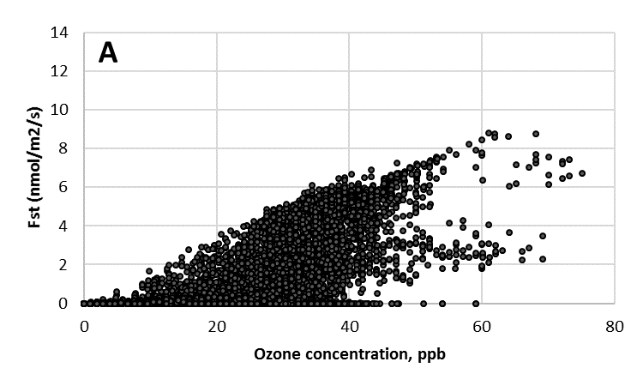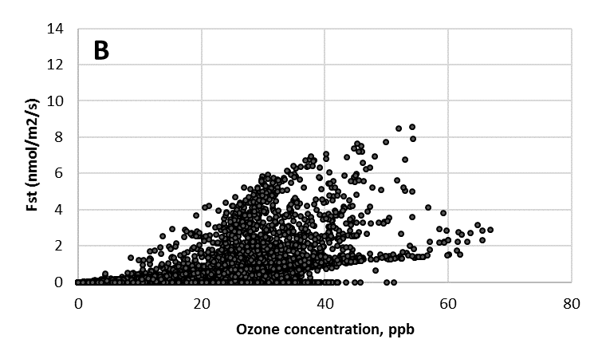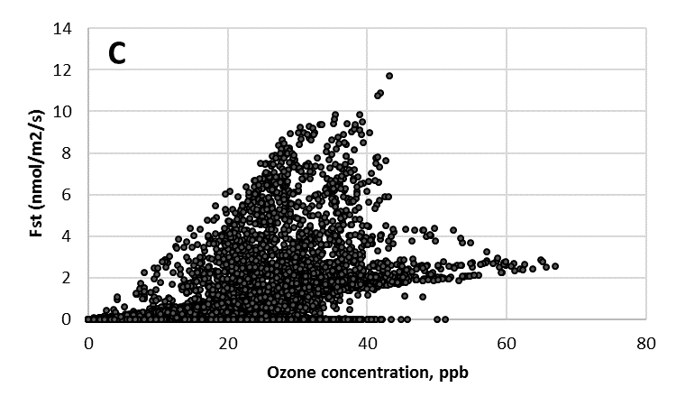
Figure S5.1: Hourly ozone concentration vs modelled hourly mean stomatal ozone flux at the site UK-Harwell (2010 scenario) for A) B. pendula, B) D. glomerata and C) L. hispidus.

