Factors influencing the habitat use of sympatric albatrosses from Macquarie Island

Running head title: Albatross habitat use

Jaimie B. Cleeland^{*1}, Rachael Alderman², Aidan Bindoff¹, Mary-Anne Lea^{1,3}, Clive R. McMahon^{1,4}, Richard A. Phillips⁵, Ben Raymond^{6,1,3}, Michael D. Sumner⁶, Aleks Terauds⁶, Simon J. Wotherspoon^{1,6}, Mark A. Hindell^{1,3}

¹ Institute for Marine and Antarctic Studies, University of Tasmania, Hobart, Tasmania, 7004, Australia
² Department of Primary Industries, Parks, Water and Environment, Hobart, Tasmania
³ Antarctic Climate and Ecosystems CRC, Hobart, Tasmania, 7001, Australia
⁴ Sydney Institute of Marine Science, Mosman, New South Wales, 2088, Australia
⁵ British Antarctic Survey, Natural Environment Research Council, High Cross, Cambridge, CB3 0ET, UK
⁶Australian Antarctic Division, Kingston, Tasmania, Australia
*Corresponding author: jaimie.cleeland@gmail.com

Abstract
Differences in habitat use of sympatric species is influenced by variability in functional morphology and life history trade-offs and is expected to shape species resilience to environmental change. To determine differences in year-round habitat use and gain insight into how morphological and life history traits influence foraging of an albatross community from subantarctic Macquarie Island (54.6° S, 158.9° E), we quantified the physical features associated with high residence time for 10 black-browed, Thalassarche melanophris; 10 grey-headed, T. chrysostoma; 15 light-mantled, Phoebetria palpebrata; and 12 wandering albatrosses, Diomedea exulans tracked in 1994-2009. Overlap among the four species was greatest close to the island during the breeding season, extending north into the Tasman Sea. Nevertheless, black-browed albatrosses ranged more locally than the other species, perhaps because they have a shorter breeding cycle and morphological traits that result in less efficient flight and greater capacity to outcompete other species for prey. Nonbreeding albatrosses showed high variability in habitat use across wide ocean expanses, but all used productive frontal regions and mesoscale eddies. Increased residence times during the breeding and nonbreeding periods were associated with moderate wind speeds for all species (excluding breeding black-browed albatrosses), indicating that birds used areas where aerodynamic performance was enhanced. Given patterns in residence time at sea, and the functional and life history adaptations of each species, we suggest that black-browed albatross breeding on Macquarie Island will be more vulnerable to expected future climate-driven changes to wind patterns in the Southern Ocean, and potential latitudinal shifts in the Subantarctic Front.

Key-words
environmental models, foraging ecology, habitat overlap, Macquarie Island, residence time, seabirds, Southern Ocean, tracking

Introduction
The functional morphology and life history traits of a species represent evolutionary trade-offs that determine the ability of individuals to exploit their environment to maximise energy acquisition and minimise energy expenditure. As oceanographic shifts drive changes in environmental structure across the distribution of an animal, its behavioural plasticity, influenced by functional morphology and life history traits, determine the extent to which it can adapt and successfully reproduce (Lescroël et al. 2010, Carneiro et al. 2015). Understanding the capacity of individuals and populations to respond to changes in the environment is critical, given the scale of recent and unprecedented ecosystem shifts driven by global climate change (Abadi et al. 2016, Descamps et al. 2016).

Variability in habitat use within a community of species reflects the diversity in functional morphology and life history adaptations (Costa 1991, Zhang et al. 2007). The ability to use alternative habitats or exploit altered environmental conditions determines the vulnerability of each species to climate change and anthropogenic threats, providing essential information for evidence-based conservation planning (Waldron et al. 2006, McGowan et al. 2016). Community-level assessments of habitat use can also reveal areas of high ecological significance where the distributions of multiple species overlap. These may indicate regions of greater biodiversity and, thus be targeted as candidate areas for protection (Raymond et al. 2015, Tancell et al. 2016, Thiers et al. 2016). Ultimately, determining the characteristics among key foraging areas of a community of species allows better quantification of links between environment, functional morphology, life history and population dynamics.

In the Southern Ocean, productivity is unevenly distributed in space and time; rather, it is concentrated in areas where available nutrients and light permit phytoplankton growth (Sullivan et al. 1993, Pakhomov & McQuaid 1996, Moore & Abbott 2000). For marine predators, macro- (100-1000s of km) and meso-scale (10s of km) oceanographic features, such as frontal regions and eddy structures, are associated with aggregated prey resources (Bost et al. 2009, Dragon et al. 2010, Scales et al. 2014). Nutrient retention and enrichment of surface waters through upwelling and mixing at frontal and mesoscale cyclonic eddy features can support greater phytoplankton concentration relative to surrounding waters (Mitchell et al. 1991, Sokolov & Rintoul 2007). As climate change continues to influence the oceanographic characteristics and productivity of the Southern Ocean (Sarmiento et al. 2004, Turner et al. 2014), understanding the constraints on distribution set by the morphological and life history traits of predators may help us to forecast climate-mediated futures for their populations (Constable et al. 2014).

Morphologically, albatrosses are adapted to fly efficiently over long distances. Their long narrow wings (high aspect ratio; the square of wingspan divided by the wing area) promote maximum flight efficiency by ensuring great aerodynamic lift and less induced drag (Pennycuick 2008). Furthermore, the high body mass, long wingspan and large wing area of albatrosses allows them to achieve high glide ratios, to enable maximum forward speed with minimum sink speed. With a high body mass and associated high wing loading, they can reach relatively fast flight speeds, enabling access to prey resources that can be far from breeding colonies (Warham 1977, Suryan et al. 2008). Behaviourally, albatrosses exploit wind shear generated by gradients between surface and low altitude winds and pockets of lighter winds between waves, to achieve dynamic soaring flight, gaining momentum with little energetic expenditure (Sachs 2005).

In terms of their life history characteristics, albatrosses are extreme K-strategists; with long life expectancy, a slow breeding cycle and low fecundity (Warham 1990). The combination of a long reproductive cycle and morphological traits that favour economic long-distant flight allows albatrosses to forage across vast areas to find patchily distributed prey (Lack 1968). Within the Southern Ocean, albatrosses are known to feed at oceanographic features that are often far from their colonies, including shelf edges (Deppe et al. 2014), mesoscale eddies (Nel et al. 2001) and frontal zones (Scales et al. 2015).

Variations in life history characteristics (e.g. longevity, breeding frequency, breeding- season duration (Fig. S1)) and morphology (e.g. body mass, wingspan, wing area) affect aerodynamic performance and reproductive costs of albatrosses, and, ultimately, their capacity to buffer the effects of environmental variability (Weimerskirch et al. 1986). Relative differences in flight costs may predispose species which expend more energy to reach distant foraging areas, to be more vulnerable to environmental stochasticity; alternatively, species that exhibit greater flexibility in foraging strategy, may be more resilient to ecosystem perturbations (Kappes et al. 2010).

Four species of albatross, representing three of the four genera of the family Diomedeidae, breed at subantarctic Macquarie Island (54.6° S, 158.9° E), black-browed Thalassarche melanophris, grey-headed T. chrysostoma, light-mantled Phoebetria palpebrata and wandering Diomedea exulans. The populations within this community have differing long-term trends; two species are increasing (black-browed and light-mantled albatrosses), one decreasing (wandering albatrosses) and one has a stable population trajectory (grey-headed albatrosses, DPIPWE 2014). With different energetic costs associated with flight and reproduction, we expected the four species show differences in habitat use and higher residence times to be associated with oceanographic features that aggregate prey. We aimed to: 1) determine the environmental features influencing habitat use and 2) understand how morphology and life history traits influence distribution and consequently, vulnerability or resilience to environmental variability.

Methods

Field data collection
Four species of albatrosses (black-browed, n = 10; grey-headed, n = 10; light-mantled, n = 15; and wandering albatrosses, n = 12) from Macquarie Island (54.6° S, 158.9° E) were tracked throughout their breeding and nonbreeding periods between November 1992 and December 2009 (Fig. 1) using global location sensing (GLS) tags (British Antarctic Survey, Cambridge, UK) or Platform Terminal Transmitters (PTTs; Microwave Telemetry, Columbia, USA). The GLS tags (4.5 g, 25x18x7 mm) sampled light each minute and stored the greatest value at the end of each ten-minute period. They also recorded the water temperature after twenty minutes of saltwater immersion. The GLS tags were calibrated at the Macquarie Island for six days before being deployed. These tags were attached to 40 mm plastic darvic bands using epoxy glue and a cable tie, and then fastened to the tarsus of each individual while holding the bird away from its nest. The PTTs (30 g, 50x15x15 mm) were attached to three small groups of feathers with Tesa® 4651 (Norderstedt, Germany) tape to the mantle region between the wings, with the antennae extending to the anterior of the bird (Wilson et al. 1997, Terauds et al. 2006). The PTTs were programmed to transmit every 90 seconds.

Data processing
The GLS tag data were extracted and decompressed using BASTrak software (Communicate and Decompressor, Fox 2010). Subsequently, twice-daily locations were estimated using the R packages, SGAT and BAStag (https://github.com/SWotherspoon/SGAT, https://github.com/SWotherspoon/BAStag). Geolocation is more accurate if it is based on unobstructed sampling of light data during the twilight periods, which allows the determination of sunrise and sunset times. However, it is common for light records from birds to exhibit shading by feathers or nesting behaviour, which may delay or advance the estimated timing of sunrise or sunset, respectively. We implemented a pre-processing step to minimise the effects of shading. By identifying the onset or end of twilight as the crossing of a set threshold light level, we could interactively assess whether the light data were shade-free or not. When shading disrupted the onset of the recorded twilight, we advanced or delayed the timing to the correct twilight time (i.e., only if the shading ceased before the end of the twilight).

Initial twilight times were determined using the threshold method applied to pre-processed light data and locations estimated at local noon and midnight (Hill & Braun 2001, Ekstrom 2004). A Bayesian framework was used to estimate the most likely location (and 95% CI) using light data and a set of three priors. The first prior (a gamma distribution of observed speeds with a maximum straight-line travel speed between two twilight locations (sunrise/sunset, set as 90 km/hr) was used to constrain consecutive locations. The second prior (a beta distribution of twilight errors, in minutes from actual twilight) addressed unresolvable shading. The third prior (a Gaussian distribution of remotely-sensed sea surface temperature with erroneous high temperatures excluded during pre-processing) increased latitudinal resolution associated with SST. Locations of tagged albatrosses that encountered 24-hour daylight during the polar summer were constrained to regions south of a maximum latitude based on predicted photoperiods. For data from GLS tags (n = 4) that showed irreconcilable noise in the light data, an alternative twilight-free method was used to estimate primary location following Bindoff et al. (2018). For both methods, the likely path represents the final posterior mean of the primary locations (Sumner, et al., 2009).

The PTT locations in Argos location class “Z” were removed, and the remainder filtered according to flight speed using a forward-backward averaging algorithm based on the maximum travel speed of 90 km/hr (McConnell et al. 1992), using the R package trip (Sumner et al. 2009). All data processing and analysis were completed within R (R Core Team 2016).

Statistical analysis
Residence time was estimated by first calculating the time spent by each tracked bird in each 100 km square cell, then taking the average of these values for each cell across all individuals. This avoids “halo” effects around breeding sites resulting from high aggregate residence times in nearby cells due to the many transits, albeit brief, by commuting birds. Prior to inclusion in the residence time analysis, the processed PTT and GLS locations were combined, and a half-hourly interpolation applied to capture use of cells corresponding to each individual track. The relatively coarse scale of the square grid cells enables PTT and GLS datasets to be integrated and analysed in the same way. We used the presence of an egg or chick in the nest to define the breeding period for each individual, with the nonbreeding period commencing at fledging or nest failure. The timing of laying, failure or fledging was established through regular nest monitoring and examination of the light data from the GLS tags (with incubation and guard periods easily identifiable from the frequent periods of shading). Tracking data from PTTs deployed on two juvenile black-browed, grey-headed and wandering albatrosses were combined with the data from nonbreeding adults in the residence time analysis, as their movements would have been similarly unconstrained by the demands of breeding. Despite differences in foraging behaviour and experience between juveniles and adults, juvenile albatrosses are likely to be similarly constrained by morphology influencing flight and foraging efficiency to adults during the nonbreeding period (Wunderle 1991, Fayet et al. 2015). Furthermore, juvenile albatrosses previously tracked following fledging (as in this study) displayed habitat overlap with adults and similar flight paths and behavioural characteristics (De Grissac et al. 2016). For comparison, tracking data from juvenile albatrosses included in the nonbreeding dataset from this study are presented in the Supporting Information, Fig. S2. Although black-browed, grey-headed and wandering albatrosses show some sexual segregation at other sites (Shaffer et al. 2001, Phillips et al. 2004, Froy et al. 2015), due to the small number of deployments in our study, tracks from male and female albatrosses were pooled in the analysis (Fig. S3). For nonbreeding black-browed, grey-headed and light-mantled albatrosses, the tracking data include in the analysis represents a small number of deployments (n = 4, n = 4, n = 2, respectively) and is unlikely to be representative of the distribution of the population.

To identify the environmental characteristics of the areas used by the albatrosses, we used generalised additive models (GAMs) with a log link, gamma distribution and maximum likelihood (ML) smoothness selection to the time spent grids. Daily oceanographic and atmospheric data (chlorophyll a concentration, eddy kinetic energy, bathymetric gradient, sea surface temperature gradient, sea surface height anomaly and wind speed) extracted from global databases and averaged over the parent grid cells from the spatial and temporal domain of interpolated tracking data for each species and period were included as the explanatory variables (Table S1). Oceanographic features such as frontal zones and eddy features were represented in the models as regions of higher sea surface temperature gradient, eddy kinetic energy and sea surface height anomaly. As the data were highly skewed, the covariate eddy kinetic energy was log-transformed. A latitude, longitude smoothed term was included as a covariate to account for spatial structure and spatial autocorrelation in the data. This method represents one of several approaches to dealing with autocorrelation in tracking datasets, which if left unaddressed can lead to errors in interpreting ecological relationships (Dormann 2007, Hawkins 2012). The trade-off for implementing this method is that some environmental relationships may remain unidentified because the spatial smoother explains a large amount of variability (Webb et al. 2014).

The correlations between predictor terms were investigated using a Pearson's correlation matrix, and a threshold of 0.8 was applied to remove highly correlated terms. Separate models were built for each species and period (breeding vs. nonbreeding season), incorporating all environmental predictors, followed by a stepwise model selection process, where the least significant terms were sequentially dropped, and the model refitted. All mean values are presented ± SE, unless otherwise indicated.

Results

Breeding period
During the breeding period, all species displayed constrained central-place foraging with a predominant north-south distribution, with the capacity to disperse limited by the demands of incubation or chick-rearing at the colony (Fig. 2a). Mean daily displacements calculated from the filtered tracking data varied among species, with the shortest distances covered by wandering albatrosses (mean: 191 ± 8 km day⁻¹) and the longest by grey-headed and light-mantled albatrosses (respective means: 427 ± 18 km day⁻¹, 404 ± 12 km day⁻¹; Tukey’s: p = 0.66; ANOVA: F_{3, 2664 =} 99.71, p < 0.001). Contrasting patterns in the daily maximum distance from the colony resulted in black-browed albatrosses (mean: 326 ± 22 km) having greater residence times closer to Macquarie Island, compared with wandering albatrosses, which typically foraged farther from the island (mean: 942 ± 21 km, ANOVA: F_{3, 2664 =} 110.1, p < 0.001; Table 1). The greatest overlap in distribution among species during the breeding period occured along the Macquarie Ridge and into the Tasman Sea (Fig. 3a, Fig. S4).

For breeding black-browed albatrosses, the optimal model explained 85% of deviance in residence time, with greater sea surface temperature gradient, greater sea surface height anomaly, and low to moderate (<10 m/s⁻¹) wind speeds best explained greater residence times during breeding (Table 2, Fig. 4) where greater residence time occurred closest to the breeding colony, primarily around the Subantarctic Front (SAF, Fig. 5) at Macquarie Ridge, and extending north into the south Tasman Sea (Fig. 2a). The mean daily displacement for black-browed albatrosses was 266 ± 13 km day⁻¹ (Table 1).

Breeding grey-headed albatrosses also had greater residence times in the Tasman Sea and the SAF to the east of Macquarie Island (Fig. 2a), with the latter used by seven of eight tracked individuals, all of which displayed directed trajectories to this area followed by greater residence times in the region (Fig. S5). The optimal model included only wind speed and explained 63% of deviance in residence time, with moderate speeds corresponding to greater residence times. No significant effects indicated for any of the oceanographic covariates (Table 2, Fig. 4).

Light-mantled albatrosses showed the most extensive breeding distribution at sea and the most southerly range. Light-mantled albatrosses concentrated their time at sea within frontal regions including the Antarctic Polar Front (APF) to the south of Macquarie Island and the southern boundary of the Antarctic Circumpolar current (ACC, Fig 5). For light-mantled albatrosses, greater chlorophyll a concentration, greater eddy kinetic energy, low bathymetric gradient and low to moderate wind speeds explained 63% of deviance in residence time (Fig. 4, Table 2).

Habitat use by wandering albatrosses during the breeding season was predominantly to the west of Macquarie Island (Fig. 2a), with greatest residence times concentrated along the APF. Wandering albatrosses used areas further from the colony (mean: 942 ± 21 km), but travelled less distance (mean: 191 ± 8 km day⁻¹) each day than any other species tracked. The optimal models for this species included only wind speed, which explained 53% of total deviance in residence time; no oceanographic covariates had a significant effect on residence time during the breeding period (Table 2, Fig. 4).

Nonbreeding period
All species dispersed more widely during the nonbreeding period and exhibited circumpolar distributions characterised by patchy, isolated areas of longer relative residence times at sea (Fig. 2b). Despite the larger overall distribution, the daily displacement distances travelled were significantly shorter than those during the breeding period for all species, except black-browed albatrosses, which displayed a mean daily flight distance of 351 ± 14 km day⁻¹ (32% greater than during the breeding period) [ANOVA: F_{3, 7143} = 49.02, p < 0.001]. Wandering albatrosses moved the shortest daily distances (mean: 153 ± 4 km day⁻¹) and black-browed albatrosses the greatest distances (mean: 351 ± 14 km day⁻¹). Overlap of all four species (corresponding use of individual 100 x 100 km grid cells), was restricted to a small region close to the breeding colony and several isolated groups of grid cells in the south-west Pacific basin and the Drake Passage (Fig. 3b).

During the nonbreeding period the best models included multiple environmental covariates and showed that despite large differences in spatial habitat use, greater residence times were associated with similar oceanographic features (Table 2, Fig. 4). For example, mesoscale eddy structures (high eddy kinetic energy) and thermal fronts (high sea surface temperature gradient). Furthermore, the relationship of residence time to wind speed was similar to the breeding period for grey-headed, light-mantled and wandering albatrosses, with a general pattern of low to moderate winds corresponding with greater residence times (Table 2, Fig. 4). Despite some similarities, environmental models did indicate differences among species in their responses to environmental covariates.

Black-browed albatrosses had greatest residence times in isolated regions with greater chlorophyll a concentration, greater eddy kinetic energy, and more pronounced sea surface temperature gradients (Table 2, Fig. 4). The optimal model was found to explain 49% of the deviance in residence time. Wind was not a significant predictor of residence time for nonbreeding black-browed albatrosses.

For nonbreeding grey-headed albatrosses, the optimal model described 41% of deviance in residence time, with areas with greater eddy kinetic energy and more pronounced bathymetric gradients (i.e., slope) corresponding with greater residence times (Table 2, Fig. 4). These results reflect the habitats characteristics of the central southern and south-east Pacific basin, south of the Subtropical Front (STF, Fig. 5). We found no significant difference in mean daily flight distances between grey-headed and light-mantled albatrosses during the nonbreeding period (respective means: 265 ± 9 km day⁻¹, 265 ± 11 km day⁻¹; Tukey’s: p = 0.66; ANOVA: F_{3, 4479 =} 128.8, p < 0.001), although they utilised quite different areas at sea. There was contrast, however, in their responses to bathymetric gradient, indicated by positive and negative linear relationships for grey-headed and light-mantled albatrosses, respectively (Table 2, Fig. 4). Of the two tracked nonbreeding light-mantled albatross, one showed a circumpolar distribution, and the other may have completed a circumpolar movement; however, the geolocator failed at approximately 10°W. The optimal model for the two tracked light-mantled albatrosses showed greatest residence times were explained by greater chlorophyll a concentration, high eddy kinetic energy and low bathymetric gradient (deviance = 52%, Table 2, Fig. 4) in the central southern Pacific and south-east Atlantic oceans (Fig. 2b).

Wandering albatrosses had the shortest mean daily distances travelled during the nonbreeding period (Table 3) with the optimal model showing greatest residence times in areas of greater eddy kinetic energy and more pronounced sea surface temperature gradients (deviance = 50%, Table 2, Fig. 4) in the south-west Pacific basin, close to the breeding colony (Fig. 2b). Six of the seven individuals tracked had a broadly resident migration strategy with greater use of the south-west Pacific basin region (Fig S3). The remaining individual circumnavigated Antarctica twice during one nonbreeding period (complete trips lasted 201 and 55 days).

Discussion
This study presents the entirety of albatross tracking data from Macquarie Island collected to date, comprising a small number of deployments over several years. Although there was some overlap among species in habitat use across both the breeding and nonbreeding periods, there was also evidence for spatial segregation and foraging niche specialisation (i.e., preferences for particular oceanographic features). This is in agreement with a previous study of at-sea activity patterns of the same four species tracked from South Georgia during the nonbreeding season (Mackley et al. 2010).

Breeding season movements and habitat associations
We evaluated environmentally-explicit models for four sympatric albatross species during the breeding and nonbreeding periods to examine the relationships between habitat use and environmental parameters (bathymetry, oceanography, and wind speed). Foraging distances of the albatrosses tracked from Macquarie Island were limited during breeding by incubation and chick rearing duties, which impose a central-place foraging constraint (Table 1, Ashmole 1963). This presumably explains the greater inter-specific overlap in habitat use at this time compared with the non-breeding period. Habitat use was predominantly associated with oceanographic features to the north of the colony, along transit corridors to the Macquarie Ridge, and north into the Tasman Sea (Fig. 2a). These features provide seasonally productive habitat (Tilburg et al. 2002, Sokolov & Rintoul 2007), which are also used by other marine predators e.g., Macquarie Ridge; southern elephants seals (Mirounga leonina, Hindell et al. 2016) and subantarctic (Arctocephalus tropicalis) and Antarctic fur seals (A. gazella, Robinson et al. 2002), Tasman Sea; Buller’s albatrosses (Thalassarche bulleri, Sagar & Weimerskirch 1996; Stahl & Sagar 2000a, 2000b) , Cook’s Petrel (Pterodroma cookii, Rayner et al. 2008) and Antipodean (Gibson’s) albatrosses (D. antipodensis gibsoni, Walker & Elliot 2006).

Although our small samples make it difficult to make population-level inferences about core distributions, the differences in habitat use at sea corresponded well with the differences among species in life-history, and their morphological adaptations. Despite greater overlap during the breeding season, we determined inter-specific differences in habitat use. Species with adaptations for more energetically efficient flight (higher glide ratio, higher aspect ratio, less induced drag, increased lift), and with longer breeding periods, travelled further from the colony. Conversely, the species with higher flight costs (lower glide ratio, lower aspect ratio) and a shorter breeding period utilized areas at sea closer to the colony during the breeding season. Differential responses indicated by the environmental modelling results provides additional evidence of resource partitioning during the breeding period.

Black-browed albatrosses made use of local neritic waters associated with the Macquarie Ridgeline and the SAF (Fig. 2a). The SAF represents a region of high sea surface temperature gradient, an important predictor of residence time for this species. However, despite high residence time detected over the Macquarie Ridgeline, bathymetry was not detected as an important predictor in the analysis. Perhaps, this result is an artefact of scale, where shelf edge waters and associated steep gradient in bathymetry occur over a smaller scale than the 100 km grid cell resolution used in the modelling. Neritic foraging is typical of this species at Macquarie Island (Terauds et al. 2006) and other colonies (Cherel & Weimerskirch 1995, Weimerskirch et al. 1997a, Wakefield et al. 2012). Their comparatively low aspect ratio results in higher drag during flight, more use of flap-gliding and increased energetic costs for long-distance travel (Pennycuick 1982). Combined with a lower wing loading, which facilitates improved manoeuvrability and aerodynamic lift at lower wind speeds, black-browed albatrosses have greater take-off performance and are known to outcompete other albatross species for prey in multi-species feeding aggregations (Table 3, Warham 1977, Pennycuick 1983, Harrison et al. 1991, Weimerskirch & Guionnet 2002). This is reflected in their at-sea activity patterns; shorter flight bouts and a larger proportion of time spent on the water compared to the other species (Mackley et al. 2010). Localised foraging by black-browed albatross is coupled with faster recovery of adult body condition, shorter incubation shifts, and a higher meal delivery rate such that the chick-rearing period is shorter than in the other species (Table 3, Huin et al. 2000, Waugh et al. 2000, Phillips et al. 2003).

In contrast, grey-headed albatrosses travel greater distances, have longer intervals between incubation shifts (Table 3, Terauds 2002) and chick feeds, and exhibit slower chick development (Huin et al. 2000, Waugh et al. 2000, Phillips et al. 2003). As at Macquarie Island, breeding grey-headed albatrosses at other sites also associated with large-scale frontal systems (which represent regions of concentrated productivity and higher prey availability) (Waugh et al. 1999, Scales et al. 2015). Despite concentrated habitat use along the SAF (Fig. 5), to the east of Macquarie Island (Fig. 2) however, no relationship between residence time and sea surface temperature gradient was evident among birds tracked from Macquarie Island, potentially due to a small sample size and individual variability in habitat use.

Among breeding light-mantled albatrosses, greater residence times were associated with lower wind speeds (~6 m/s⁻¹) compared with the other species (Fig. 4). Their lower wing loading and high aspect ratio (Table 3) provides greater aerodynamic lift, superior glide ratios and more economic flight at lower wind speeds, allowing efficient foraging south of 61°S where wind speeds are lower and less consistent (Young 1999). This is underlined by their limited use of closer waters around the APF (between 56°S and 61°S, Fig. 5), where wind velocities are greater. Similarly, breeding birds tracked from Heard Island, Crozet and South Georgia typically forage far south of the APF (Phillips et al. 2005a, Lawton et al. 2008, Delord et al. 2014). By undertaking long incubation shifts and employing a bimodal foraging strategy in chick-rearing (Terauds & Gales 2006), light-mantled albatrosses from Macquarie Island can not only exploit local foraging habitat close to the colony, but also make use of tailwinds to travel to distant, productive waters (high chla) associated with the southern boundary of the ACC (Weimerskirch and Robertson 1994; this study).

Wandering albatrosses are much larger than the other species at Macquarie Island and consequently, the adults have greater energy reserves and chicks have a longer fasting capability, enabling more distant foraging trips by parents (Table 3) (Arnould et al. 1996, Berrow & Croxall 2001). The shorter daily displacement distances of the tracked birds (Table 1) and characteristic prolonged looping flights reflect a foraging strategy that involves searching large areas, maximising encounters with patchily distributed prey (Weimerskirch et al. 1997b, Wakefield et al. 2009). Their high aspect ratio, wing loading and glide ratios support efficient dynamic soaring, enabling exploitation of distant resources at little energetic cost (Table 3, Shaffer et al. 2001). However, these traits reduce efficiency during take-off and landing (Weimerskirch et al. 1997b, Mackley et al. 2010). Consequently, wandering albatrosses land less frequently than other albatrosses and remain on the water for longer periods (Croxall & Prince 1994, Weimerskirch et al. 1997b, Mackley et al. 2010).

Nonbreeding season movements and habitat associations
Despite the small number of nonbreeding individuals tracked in our study, during the nonbreeding period, when central-place constraints disappear, residence time at sea among all species tracked from Macquarie Island indicated broadly similar responses to environmental parameters indicative of thermal fronts and mesoscale eddy structures. All four species overlapped in the south-east New Zealand Economic Exclusive Zone (EEZ), where light-mantled and wandering albatrosses, in particular, had high residence times. Here, the SAF tracks the subantarctic slope on the edge of the Campbell Plateau (Morris et al. 2001); this creates a frontal region of high current velocity that continues eastwards and results in high surface eddy kinetic energy (Sallée et al. 2011) and high biological productivity (Murphy et al. 2001). This area is also used by Antipodean albatrosses (Walker & Elliott 2006), Campbell albatrosses (Waugh et al. 1999), Chatham petrels (Rayner et al. 2012) and southern elephant seals (Pascoe et al. 2016).

Nonbreeding albatrosses from Macquarie Island concentrated at distant regions of elevated primary productivity (high chlorophyll a concentration), mesoscale eddy structures (high eddy kinetic energy) and thermal fronts (high sea surface temperature gradient, Fig. 4). Oceanic fronts were preferred by black-browed, light-mantled and wandering albatrosses, and mesoscale eddy structures by black-browed, grey-headed and wandering albatrosses. Both frontal regions and eddy structures can aggregate prey through physical structuring and concentration of primary productivity and zooplankton biomass, offering predictable resources for higher trophic-level predators (Mitchell et al. 1991, Sokolov & Rintoul 2007, Bost et al. 2009).

The annual-breeding black-browed albatrosses have a shorter nonbreeding period travelled farther overall, and flew further each day than the biennial-breeding species (grey-headed, light-mantled and wandering albatrosses, Table 1). With the lowest aspect ratio and the highest glide ratio of the four species (Pennycuick 1982), black-browed albatrosses utilise powered (flapping) flight more frequently and have shorter flight bouts (Mackley et al. 2010). Consequently, they are less reliant on consistent winds, allowing them to exploit waters associated with the STF (Fig. 5), where winds are lighter than at higher latitudes in the Southern Ocean (Young 1999). Macquarie Island black-browed albatrosses showed spatial overlap in Tasmanian and South African shelf waters with conspecifics from Kerguelen (Delord et al. 2014). Furthermore, one individual spent a long period on the Patagonian Shelf and in the Benguela Upwelling off South Africa, which are both highly productive regions and represent core foraging areas of black-browed albatrosses from the Falkland Islands (Patagonian Shelf only; Wakefield et al. 2011) and South Georgia (Phillips et al. 2005b, Mackley et al. 2010). This excursion to the Benguela Upwelling represents an unusually long nonbreeding dispersal for this species, which tend to remain within local ocean basins.

Nonbreeding grey-headed albatrosses used waters between the SAF and the STF (Fig. 5), with particularly high residence times in the south-east Pacific basin (Fig. 2). There was considerable spatial overlap in habitat use west of Chile with conspecifics from Marion Island, but little with those from South Georgia (Clay et al. 2016). Like birds from Marion Island, but not South Georgia or Campbell Island (Waugh et al. 1999, Clay et al. 2016), grey-headed albatrosses from Macquarie Island associated with steep bathymetric features such as shelf slopes, which potentially drive nutrient-rich upwelling and support high prey densities.

Nonbreeding light-mantled albatrosses favoured waters between 15°W and 45°E (Fig. 2), demonstrating their capacity to capitalise on high latitude summer productivity associated with the southern boundary of the ACC. They made circumpolar navigations, and like wandering albatrosses (this study, Weimerskirch et al. 2015) and grey-headed albatrosses exploited the consistent westerly winds to travel long distances east at low cost.

Although they also have the capacity to disperse around Antarctica, nonbreeding wandering albatrosses from Macquarie Island had highest residence times in the south-west Pacific (Fig. 2). Similarly, a proportion of birds from Crozet and Kerguelen remain resident within the breeding range during the nonbreeding season (Weimerskirch et al. 2015). The nonbreeders from Macquarie used the nearby SAF, or showed a sedentary-with-excursions strategy, making occasional movements to the Campbell Plateau, which also represents a core foraging area for nonbreeding wandering albatrosses from Kerguelen (Fig. 2, Weimerskirch et al. 2015). Other birds from Macquarie Island migrated to the Humboldt Upwelling, an area well known for its high biological productivity and diversity of seabirds, including several migrant albatross and petrel species from New Zealand (Spear et al. 2003, Nicholls et al. 2005, Walker & Elliott 2006, Landers et al. 2011), and a proportion of white-chinned petrels from South Georgia (Phillips et al. 2006). Furthermore, there was less evidence of relationships between residence time and environmental variables for nonbreeding wandering albatrosses compared to the smaller albatross species (Fig. 4); this suggests broader habitat preferences, perhaps associated with their large energy reserves and efficient flight morphology.

Resilience to climate change
For Southern Ocean albatrosses, the consequences of unprecedented global warming and consequent changes in oceanographic and atmospheric conditions are uncertain. However, differences in morphology and life history among species, and hence their behavioural flexibility, are likely to determine their resilience (Jiguet et al. 2007, Maloney et al. 2009, Ficetola et al. 2016). The consistent use of waters to the north of Macquarie Island by breeding black-browed albatrosses may increase vulnerability to climate-induced changes in the latitude of the SAF (Fig. 2). With a southerly shift in the SAF black-browed albatrosses may need to travel further and expend greater energetic resources to reach prey. The easterly meander of the SAF interacts with the Macquarie Ridge, a region of steep bathymetric gradient running northeast-southwest and generating strong upwelling, which elevates summer chlorophyll concentration (Sokolov & Rintoul 2007), generates eddies (Rintoul et al. 2014) and may support higher trophic connections through entrainment of phytoplankton (Shuckburgh et al. 2009, d’Ovidio et al. 2013). As identified by Flynn and Williams (2012), a southerly shift in the position of the SAF (Sokolov & Rintoul 2009) could result in high flow velocities to the south of the Macquarie Ridge Gap, reducing down-flow mixing and, potentially, surface productivity in the region.

For three species (not nonbreeding black-browed albatrosses), higher residence times were linked to moderate wind speed (Fig 4). This reflects the balance between enough wind to facilitate aerodynamic lift, and the avoidance of extreme wind speeds that hinder manoeuvrability, in order achieve economic flight (Jouventin & Weimerskirch 1990). Alternatively, high wind speeds may reduce the capacity of albatrosses to locate food by reducing the ability to detect olfactory cues and the visibility of surface prey. The dependence of albatrosses from Macquarie Island on moderate wind regimes may make them vulnerable to climate-induced changes in wind patterns as the Southern Annular Mode (SAM) becomes increasingly positive (Marshall 2003). In the positive SAM phase, the band of Antarctic circumpolar winds contract towards the Antarctic continent resulting in relaxed mid-latitudinal winds (Hall & Visbeck 2002). Intensified Antarctic circumpolar winds associated with a continuing positive trend in the SAM have benefited wandering albatrosses from Crozet Island by reducing the energetic cost of reaching distant foraging areas, resulting in higher breeding success and body mass (Weimerskirch et al. 2012). For light-mantled albatrosses and breeding wandering albatrosses from Macquarie Island, which target high-latitude waters, a southward shift in wind intensity may prove beneficial by lowering flight costs. However, for breeding black-browed albatrosses, which rely on the Macquarie Ridge and Tasman Sea, and nonbreeding grey-headed and wandering albatrosses that predominantly use waters north of the SAF, a reduction in meridional wind and wind speeds at lower latitudes could reduce flight efficiency and increase energetic costs, presumably with repercussions for breeding performance.

Identifying species core foraging areas from small tracking datasets of wide-ranging animals such as albatrosses is inhibited by individual variability in habitat use (Gutowsky et al. 2015). Small tracking datasets, such as the one in this study, may fail to represent important regions for the population where individual variability is pronounced. This is likely to be exacerbated during the overwintering period when home ranges increase (Gutowsky et al. 2015). For this reason we have constrained our interpretation to broad scale patterns in habitat use. Understanding how even a small number of individuals use their environment is still valuable, especially for small populations where little data exists, such as in this case.

Conclusions
The habitat use of albatrosses from Macquarie Island reflects foraging strategies that are shaped by functional morphology and life history adaptations. The two extremes are a wide-ranging search strategy (wandering albatrosses), which maximises encounter rate with dispersed prey, and a rapid-transit strategy (black-browed, grey-headed and light-mantled albatrosses), whereby individuals forage at oceanographic features associated with more predictable prey. The resulting differences in habitat use have implications for susceptibility to environmental change. For example, black-browed albatrosses, with a more northerly distribution, lower flight efficiency and greater reliance on local productivity, are predicted to be at greater risk of climate-driven shifts in wind patterns and frontal systems. Understanding the links between foraging behaviour, morphology and life history, and the vulnerability or resilience of Southern Ocean albatross species to current and predicted climate-driven atmospheric and oceanographic changes, has the potential to substantially improve forecasts of population viability for a range of seabird species, essential information for evidence-based conservation planning.

Acknowledgements
The authors would like to thank Rosemary Gales for her commitment to albatross monitoring on Macquarie Island over the last two decades, Graham Robertson for the contribution of historical light-mantled albatross tracking data, and field personnel involved in the logger deployments. We thank the four anonymous reviewers whose suggestions helped improve this manuscript. All fieldwork was conducted under Standard Operating Procedures approved by the Tasmanian Department of Primary Industries, Parks, Water and Environment Animal Ethics Committee (Permit no. TFA16195, TFA15205, TFA14205, TFA13964, TFA12198).

Literature Cited
Abadi F, Barbraud C, Gimenez O (2016) Integrated population modeling reveals the impact of climate on the survival of juvenile emperor penguins. Global Change Biology 23:1353-1359
Arnould JPY, Briggs DR, Croxall JP, Prince PA, Wood AG (1996) The foraging behaviour and energetics of wandering albatrosses brooding chicks. Antarctic Science 8:229-236
Ashmole NP (1963) The regulation of numbers of tropical oceanic birds. Ibis 103b:458-473
Berrow SD, Croxall JP (2001) Provisioning rate and attendance patterns of Wandering Albatrosses at Bird Island, South Georgia. Condor 103:230-239
Bindoff A, Wotherspoon SJ, Guinet C, Hindell MA (2018) Twilight‐Free Geolocation from Noisy Light Data. Methods in Ecology and Evolution
Bost CA, Cotté C, Bailleul F, Cherel Y, Charrassin JB, Guinet C, Ainley DG, Weimerskirch H (2009) The importance of oceanographic fronts to marine birds and mammals of the southern oceans. Journal of Marine Systems 78:363-376
Carneiro APB, Manica A, Trivelpiece WZ, Phillips RA (2015) Flexibility in foraging strategies of Brown Skuas in response to local and seasonal dietary constraints. Journal of Ornithology 156:625-633
Cherel Y, Weimerskirch H (1995) Seabirds as indicators of marine resources: Black-browed albatrosses feeding on ommastrephid squids in Kerguelen waters. Marine Ecology-Progress Series 129:295-300
Clay TA, Manica A, Ryan PG, Silk JRD, Croxall JP, Ireland L, Phillips RA (2016) Proximate drivers of spatial segregation in non-breeding albatrosses. Scientific Reports 6:1-13
Constable AJ, Melbourne-Thomas J, Corney SP, Arrigo KR, Barbraud C, Barnes DKA, Bindoff NL, Boyd PW, Brandt A, Costa DP, Davidson AT, Ducklow HW, Emmerson L, Fukuchi M, Gutt J, Hindell MA, Hofmann EE, Hosie GW, Iida T, Jacob S, Johnston NM, Kawaguchi S, Kokubun N, Koubbi P, Lea MA, Makhado A, Massom RA, Meiners K, Meredith MP, Murphy EJ, Nicol S, Reid K, Richerson K, Riddle MJ, Rintoul SR, Smith WO, Southwell C, Stark JS, Sumner M, Swadling KM, Takahashi KT, Trathan PN, Welsford DC, Weimerskirch H, Westwood KJ, Wienecke BC, Wolf-Gladrow D, Wright SW, Xavier JC, Ziegler P (2014) Climate change and Southern Ocean ecosystems I: How changes in physical habitats directly affect marine biota. Global Change Biology 20:3004-3025
Costa DP (1991) Reproductive and foraging energetics of high latitude penguins, albatrosses and pinnipeds: Implications for life history patterns. Integrative and Comparative Biology 31:111-130
Croxall JP, Prince PA (1994) Dead or alive, night or day: How do albatrosses catch squid? Antarctic Science 6:155-162
d’Ovidio F, De Monte S, Della Penna A, Cotté C, Guinet C (2013) Ecological implications of eddy retention in the open ocean: a Lagrangian approach. Journal of Physics A: Mathematical and Theoretical 46:21
De Grissac S, Börger L, Guitteaud A, Weimerskirch H (2016) Contrasting movement strategies among juvenile albatrosses and petrels. Scientific Reports 6:1-12
Delord K, Barbraud C, Bost C, Cherel Y, Guinet C, Weimerskirch H (2014) Atlas of top predators from French Southern Territories in the Southern Indian Ocean. CNRS,
Deppe L, McGregor KF, Tomasetto F, Briskie JV, Scofield RP (2014) Distribution and predictability of foraging areas in breeding Chatham albatrosses Thalassarche eremita in relation to environmental characteristics. Marine Ecology Progress Series 498:287-301
Descamps S, Tarroux A, Lorentsen SH, Love OP, Varpe Ø, Yoccoz NG (2016) Large-scale oceanographic fluctuations drive Antarctic petrel survival and reproduction. Ecography 39:496-505
Dormann CF (2007) Effects of incorporating spatial autocorrelation into the analysis of species distribution data. Global Ecology and Biogeography 16:129-138
DPIPWE (2014) The Conservation and Status of Albatrosses and Giant Petrels on Macquarie Island: Report on the 2013/14 Field Season. In: Department of Primary Industries Parks Water and Environment (ed). Australian Government, Hobart, Tasmania
Dragon AC, Monestiez P, Bar-Hen A, Guinet C (2010) Linking foraging behaviour to physical oceanographic structures: Southern elephant seals and mesoscale eddies east of Kerguelen Islands. Progress in Oceanography 87:61-71
Ekstrom PA (2004) An advance in geolocation by light. Memoirs of the National Institute of Polar Research 58:210-226
Fayet AL, Freeman R, Shoji A, Padget O, Perrins CM, Guilford T (2015) Lower foraging efficiency in immatures drives spatial segregation with breeding adults in a long-lived pelagic seabird. Animal Behaviour 110:79-89
Ficetola GF, Colleoni E, Renaud J, Scali S, Padoa-Schioppa E, Thuiller W (2016) Morphological variation in salamanders and their potential response to climate change. Global Change Biology 22:2013-2024
Flynn AJ, Williams A (2012) Lanternfish (Pisces: Myctophidae) biomass distribution and oceanographic–topographic associations at Macquarie Island, Southern Ocean. Marine and Freshwater Research 63:251-263
Fox JW (2010) Geolocator Manual v8 (March 2010) British Antarctic Survey, Cambridge
Froy H, Lewis S, Catry P, Bishop CM, Forster IP, Fukuda A, Higuchi H, Phalan B, Xavier JC, Nussey DH, Phillips RA (2015) Age-related variation in foraging behaviour in the wandering albatross at South Georgia: No evidence for senescence. PLoS ONE 10:1-19
Gutowsky SE, Leonard ML, Conners MG, Shaffer SA, Jonsen ID (2015) Individual-level variation and higher-level interpretations of space use in wide-ranging species: an albatross case study of sampling effects. Frontiers in Marine Science 2:93
Hall A, Visbeck M (2002) Synchronous variability in the Southern Hemisphere atmosphere, sea ice, and ocean resulting from the annular mode. Journal of Climate 15:3043-3057
Harrison NM, Whitehouse MJ, Heinemann D, Prince PA, Hunt GL, Veit RR (1991) Observations of Multispecies Seabird Flocks around South Georgia. Auk 108:801-810
Hawkins BA (2012) Eight (and a half) deadly sins of spatial analysis. Journal of Biogeography 39:1-9
Hill RD, Braun MJ (2001) Geolocation by light level. In: Sibert JR, Nielsen JL (eds) Electronic tagging and tracking in Marine Fisheries, Book 1. Springer, Dordrecht
Hindell MA, McMahon CR, Bester MN, Boehme L, Costa D, Fedak MA, Guinet C, Herraiz-Borreguero L, Harcourt RG, Huckstadt L, Kovacs KM, Lydersen C, McIntyre T, Muelbert M, Patterson T, Roquet F, Williams G, Charrassin J-B (2016) Circumpolar habitat use in the southern elephant seal: implications for foraging success and population trajectories. Ecosphere 7
Huin N, Prince PA, Briggs DR (2000) Chick provisioning rates and growth in Blacklbrowed Albatross Diomedea melanophris and Grey-headed Albatross D. chrysostoma at Bird Island, South Georgia. Ibis 142:550-565
Jiguet F, Gadot AS, Julliard R, Newson SE, Couvet D (2007) Climate envelope, life history traits and the resilience of birds facing global change. Global Change Biology 13:1672-1684
Jouventin P, Weimerskirch H (1990) Satellite tracking of Wandering albatrosses. Nature 343:746-748
Kappes MA, Shaffer SA, Tremblay Y, Foley DG, Palacios DM, Robinson PW, Bograd SJ, Costa DP (2010) Hawaiian albatrosses track interannual variability of marine habitats in the North Pacific. Progress in Oceanography 86:246-260
Lack DL (1968) Ecological Adaptations for Breeding in Birds. Chapman and Hall, London, UK
Landers TJ, Rayner MJ, Phillips RA, Hauber ME (2011) Dynamics of seasonal movements by a trans-pacific migrant, the Westland Petrel. Condor 113:71-79
Lawton K, Kirkwood R, Robertson G, Raymond B (2008) Preferred foraging areas of Heard Island albatrosses during chick raising and implications for the management of incidental mortality in fisheries. Aquatic Conservation: Marine and Freshwater Ecosystems 18:309-320
Lescroël A, Ballard G, Toniolo V, Barton KJ, Wilson PR, Lyver PO, Ainley DG (2010) Working less to gain more: When breeding quality relates to foraging efficiency. Ecology 91:2044-2055
Mackley EK, Phillips RA, Silk JRD, Wakefield ED, Afanasyev V, Fox JW, Furness RW (2010) Free as a bird? Activity patterns of albatrosses during the nonbreeding period. Marine Ecology Progress Series 406:291-303
Maloney SK, Fuller A, Mitchell D (2009) Climate change: is the dark Soay sheep endangered? Biology Letters 5:826
Marshall GJ (2003) Trends in the Southern Annular Mode from Observations and Reanalyses. Journal of Climate 16:4134-4143
McConnell BJ, Chambers C, Fedak MA (1992) Foraging ecology of southern elephant seals in relation to the bathyrnetry and productivity of the Southern Ocean. Antarctic Science 4:393-398
McGowan J, Beger M, Lewison RL, Harcourt R, Campbell H, Priest M, Dwyer RG, Lin HY, Lentini P, Dudgeon C, McMahon C, Watts M, Possingham HP (2016) Integrating research using animal-borne telemetry with the needs of conservation management. Journal of Applied Ecology 54:423-429
Mitchell BG, Brody EA, Holm‐Hansen O, McClain C, Bishop J (1991) Light limitation of phytoplankton biomass and macronutrient utilization in the Southern Ocean. Limnology and Oceanography 36:1662-1677
Moore JK, Abbott MR (2000) Phytoplankton chlorophyll distributions and primary production in the Southern Ocean. Journal of Geophysical Research: Oceans 105:28709-28722
Morris M, Stanton B, Neil H (2001) Subantarctic oceanography around New Zealand: Preliminary results from an ongoing survey. New Zealand Journal of Marine and Freshwater Research 35:499-519
Murphy RJ, Pinkerton MH, Richardson KM, Bradford-Grieve JM (2001) Phytoplankton distributions around New Zealand derived from SeaWiFS remotely-sensed ocean colour data. New Zealand Journal of Marine and Freshwater Research 35:343-362
Nel DC, Lutjeharms JRE, Pakhomov EA, Ansorge IJ, Ryan PG, Klages NTW (2001) Exploitation of mesoscale oceanographic features by grey-headed albatross Thalassarche chrysostoma in the southern Indian Ocean. Marine Ecology Progress Series 217:15-26
Nicholls DG, Robertson CJR, Naef-Daenzer B (2005) Evaluating distribution modelling using kernel functions for northern royal albatrosses (Diomedea sanfordi) at sea off South America. Notornis 52:223-235
Orsi AH, Whitworth IT, Nowlin WD (1995) On the meridional extent and fronts of the Antarctic Circumpolar Current. Deep-Sea Research Part I 42:641-673
Pakhomov EA, McQuaid CD (1996) Distribution of surface zooplankton and seabirds across the Southern Ocean. Polar Biology 16:271-286
Pascoe P, Lea MA, Mattlin RH, McMahon CR, Harcourt R, Thompson D, Torres L, Vinette-Herrin K, Hindell MA (2016) Assessing the utility of two- and three-dimensional behavioural metrics in habitat usage models. Marine Ecology Progress Series 562:181-192
Pennycuick CJ (1982) The Flight of Petrels and Albatrosses (Procellariiformes), Observed in South Georgia and its Vicinity. Philosophical Transactions of the Royal Society B: Biological Sciences 300:75-106
Pennycuick CJ (1983) Thermal Soaring Compared in Three Dissimilar Tropical Bird Species. Journal of Experimental Biology 102:307
Pennycuick CJ (2008) Chapter 13 Allometry. Theoretical Ecology Series, Book 5. Academic Press
Phillips RA, Green JA, Phalan B, Croxall JP, Butler PJ (2003) Chick metabolic rate and growth in three species of albatross: A comparative study. Comparative Biochemistry and Physiology - A Molecular and Integrative Physiology 135:185-193
Phillips RA, Silk JRD, Croxall JP (2005a) Foraging and provisioning strategies of the light-mantled sooty albatross at South Georgia: Competition and co-existence with sympatric pelagic predators. Marine Ecology Progress Series 285:259-270
Phillips RA, Silk JRD, Croxall JP, Afanasyev V (2006) Year-round distribution of white-chinned petrels from South Georgia: Relationships with oceanography and fisheries. Biological Conservation 129:336-347
Phillips RA, Silk JRD, Croxall JP, Afanasyev V, Bennett VJ (2005b) Summer distribution and migration of nonbreeding albatrosses: Individual consistencies and implications for conservation. Ecology 86:2386-2396
Phillips RA, Silk JRD, Phalan B, Catry P, Croxall JP (2004) Seasonal sexual segregation in two Thalassarche albatross species: Competitive exclusion, reproductive role specialization or foraging niche divergence? Proceedings of the Royal Society B: Biological Sciences 271:1283-1291
Raymond B, Lea M-A, Patterson T, Andrews-Goff V, Sharples R, Charrassin J-B, Cottin M, Emmerson L, Gales N, Gales R, Goldsworthy SD, Harcourt R, Kato A, Kirkwood R, Lawton K, Ropert-Coudert Y, Southwell C, van den Hoff J, Wienecke B, Woehler EJ, Wotherspoon S, Hindell MA (2015) Important marine habitat off east Antarctica revealed by two decades of multi-species predator tracking. Ecography 38:121-129
Rayner MJ, Hauber ME, Clout MN, Seldon DS, Van Dijken S, Bury S, Phillips RA (2008) Foraging ecology of the Cook's petrel Pterodroma cookii during the austral breeding season: A comparison of its two populations. Marine Ecology Progress Series 370:271-284
Rayner MJ, Taylor GA, Gummer HD, Phillips RA, Sagar PM, Shaffer SA, Thompson DR (2012) The breeding cycle, year-round distribution and activity patterns of the endangered Chatham Petrel (Pterodroma axillaris). Emu 112:107-116
Rintoul SR, Sokolov S, Williams MJM, Peña Molino B, Rosenberg M, Bindoff NL (2014) Antarctic Circumpolar Current transport and barotropic transition at Macquarie Ridge. Geophysical Research Letters 41:7254-7261
Robinson SA, Goldsworthy SG, Hoff Jvd, Hindell MA (2002) The foraging ecology of two sympatric fur seal species, Arctocephalus gazella and Arctocephalus tropicalis, at Macquarie Island during the austral summer. Marine and Freshwater Research 53:1071-1082
Sachs G (2005) Minimum shear wind strength required for dynamic soaring of albatrosses. Ibis 147:1-10
Sagar PM, Weimerskirch H (1996) Satellite Tracking of Southern Buller's Albatrosses from the Snares, New Zealand. Condor 98:649-652
Sallée JB, Speer K, Rintoul SR (2011) Mean-flow and topographic control on surface eddy-mixing in the Southern Ocean. Journal of Marine Research 69:753-777
Sarmiento JL, Slater R, Barber R, Bopp L, Doney SC, Hirst AC, Kleypas J, Matear R, Mikolajewicz U, Monfray P, Soldatov V, Spall SA, Stouffer R (2004) Response of ocean ecosystems to climate warming. Global Biogeochemical Cycles 18:1-23
Scales KL, Miller PI, Embling CB, Ingram SN, Pirotta E, Votier SC (2014) Mesoscale fronts as foraging habitats: Composite front mapping reveals oceanographic drivers of habitat use for a pelagic seabird. Journal of the Royal Society Interface 11:1-9
Scales KL, Miller PI, Ingram SN, Hazen EL, Bograd SJ, Phillips RA (2015) Identifying predictable foraging habitats for a wide-ranging marine predator using ensemble ecological niche models. Diversity and Distributions 22:212-224
Shaffer SA, Weimerskirch H, Costa DP (2001) Functional significance of sexual dimorphism in Wandering Albatrosses, Diomedea exulans. Functional Ecology 15:203-210
Shuckburgh E, Jones H, Marshall J, Hill C (2009) Understanding the Regional Variability of Eddy Diffusivity in the Pacific Sector of the Southern Ocean. Journal of Physical Oceanography 39:2011-2023
Sokolov S, Rintoul SR (2007) On the relationship between fronts of the Antarctic Circumpolar Current and surface chlorophyll concentrations in the Southern Ocean. Journal of Geophysical Research: Oceans 112:1-17
Sokolov S, Rintoul SR (2009) Circumpolar structure and distribution of the antarctic circumpolar current fronts: 2. Variability and relationship to sea surface height. Journal of Geophysical Research: Oceans 114:1-15
Spear LB, Ainley DG, Webb SW (2003) Distribution, abundance and behaviour of Buller's, Chatham Island and Salvin's Albatrosses off Chile and Peru. Ibis 145:253-269
Stahl JC, Sagar PM (2000a) Foraging strategies and migration of southern Buller's albatrosses Diomedea b. bulleri breeding on the Solander Is, New Zealand. Journal of the Royal Society of New Zealand 30:319-334
Stahl JC, Sagar PM (2000b) Foraging strategies of southern Buller's albatrosses Diomedea b. bulleri breeding on The Snares, New Zealand. Journal of the Royal Society of New Zealand 30:299-318
Sullivan CW, Arrigo KR, McClain CR, Comiso JC, Firestone J (1993) Distributions of phytoplankton blooms in the Southern Ocean. Science 262:1832-1837
Sumner MD, Wotherspoon SJ, Hindell MA (2009) Bayesian estimation of animal movement from archival and satellite tags. PLoS ONE 4:1-13
Suryan RM, Anderson DJ, Shaffer SA, Roby DD, Tremblay Y, Costa DP, Sievert PR, Sato F, Ozaki K, Balogh GR, Nakamura N (2008) Wind, waves, and wing loading: Morphological specialization may limit range expansion of endangered albatrosses. PLoS ONE 3:1-8
Tancell C, Sutherland WJ, Phillips RA (2016) Marine spatial planning for the conservation of albatrosses and large petrels breeding at South Georgia. Biological Conservation 198:165-176
Terauds A (2002) Population biology and ecology of albatrosses on Macquarie Island: implications for conservation status. PhD Theses, University of Tasmania, Hobart
Terauds A, Gales R (2006) Provisioning strategies and growth patterns of light-mantled sooty albatrosses Phoebetria palpebrata on Macquarie Island. Polar Biology 29:917-926
Terauds A, Gales R, Baker GB, Alderman R (2006) Foraging areas of black-browed and grey-headed albatrosses breeding on Macquarie Island in relation to marine protected areas. Aquatic Conservation: Marine and Freshwater Ecosystems 16:133-146
Thiers L, Delord K, Bost CA, Guinet C, Weimerskirch H (2016) Important marine sectors for the top predator community around Kerguelen Archipelago. Polar Biology:1-14
Tilburg CE, Subrahmanyam B, O'Brien JJ (2002) Ocean color variability in the Tasman Sea. Geophysical Research Letters 29:4
Turner J, Barrand NE, Bracegirdle TJ, Convey P, Hodgson DA, Jarvis M, Jenkins A, Marshall G, Meredith MP, Roscoe H, Shanklin J, French J, Goosse H, Guglielmin M, Gutt J, Jacobs S, Kennicutt MC, Masson-Delmotte V, Mayewski P, Navarro F, Robinson S, Scambos T, Sparrow M, Summerhayes C, Speer K, Klepikov A (2014) Antarctic climate change and the environment: an update. Polar Record 50:237-259
Wakefield ED, Phillips RA, Belchier M (2012) Foraging black-browed albatrosses target waters overlaying moraine banks - A consequence of upward benthic-pelagic coupling? Antarctic Science 24:269-280
Wakefield ED, Phillips RA, Jason M, Akira F, Hiroyoshi H, Marshall GJ, Trathan PN (2009) Wind field and sex constrain the flight speeds of central-place foraging albatrosses. Ecological Monographs 79:663-679
Wakefield ED, Phillips RA, Trathan PN, Arata J, Gales R, Huin N, Graham R, Waugh SM, Weimerskirch H, Matthiopoulos J (2011) Habitat preference, accessibility, and competition limit the global distribution of breeding Black-browed Albatrosses. Ecological Monographs 81:141-167
Waldron JL, Bennett SH, Welch SM, Dorcas ME, Lanham JD, Kalinowsky W (2006) Habitat specificity and home-range size as attributes of species vulnerability to extinction: A case study using sympatric rattlesnakes. Animal Conservation 9:414-420
Walker K, Elliott G (2006) At-sea distribution of Gibson's and Antipodean wandering albatrosses, and relationships with longline fisheries. Notornis 53:265-290
Warham J (1977) Wing loadings, wing shapes, and flight capabilities of procellariiformes. New Zealand Journal of Zoology 4:73-83
Warham J (1990) The petrels: their ecology and breeding systems. Academic Press, London, UK
Waugh SM, Weimerskirch H, Cherel Y, Prince PA (2000) Contrasting strategies of provisioning and chick growth in two sympatrically breeding albatrosses at Campbell Island, New Zealand. Condor 102:804-813
Waugh SM, Weimerskirch H, Cherel Y, Shankar U, Prince PA, Sagar PM (1999) Exploitation of the marine environment by two sympatric albatrosses in the Pacific Southern Ocean. Marine Ecology-Progress Series 177:243-254
Webb MH, Wotherspoon S, Stojanovic D, Heinsohn R, Cunningham R, Bell P, Terauds A (2014) Location matters: Using spatially explicit occupancy models to predict the distribution of the highly mobile, endangered swift parrot. Biological Conservation 176:99-108
Weimerskirch H, Cherel Y, Cuenot-Chaillet F, Ridoux V (1997a) Alternative foraging strategies and resource allocation by male and female Wandering Albatrosses. Ecology 78:2051-2063
Weimerskirch H, Delord K, Guitteaud A, Phillips RA, Pinet P (2015) Extreme variation in migration strategies between and within wandering albatross populations during their sabbatical year, and their fitness consequences. Scientific Reports 5:1-7
Weimerskirch H, Guionnet T (2002) Comparative activity pattern during foraging of four albatross species. Ibis 144:40-50
Weimerskirch H, Jouventin P, Stahl JC (1986) Comparative ecology of the six albatross species breeding on the Crozet Islands. Ibis 128:195-213
Weimerskirch H, Louzao M, De Grissac S, Delord K (2012) Changes in wind pattern alter albatross distribution and life-history traits. Science 335:211-214
Weimerskirch H, Robertson G (1994) Satellite tracking of light-mantled sooty albatrosses. Polar Biology 14:123-126
Weimerskirch H, Wilson RP, Lys P (1997b) Activity pattern of foraging in the wandering albatross: A marine predator with two modes of prey searching. Marine Ecology Progress Series 151:245-254
Wilson RP, Pütz K, Peters G, Culik B, Scolaro JA, Charrassin JB, Ropert-Coudert Y (1997) Long-term attachment of transmitting and recording devices to penguins and other seabirds. Wildlife Society Bulletin 25:101-105
Wunderle JM (1991) Age-specific foraging proficiency in birds. Current Ornithology 8:273-324
Young IR (1999) Seasonal variability of the global ocean wind and wave climate. International Journal of Climatology 19:931-950
Zhang L, Liang B, Parsons S, Wei L, Zhang S (2007) Morphology, echolocation and foraging behaviour in two sympatric sibling species of bat (Tylonycteris pachypus and Tylonycteris robustula) (Chiroptera: Vespertilionidae). J Zool 271:344-351

Figures

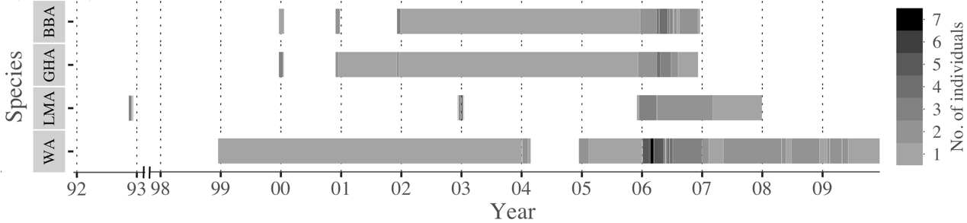
Fig. 1 Timeline of Platform Terminal Transmitters (PTT) and Global Location Sensing (GLS) tag deployments on black-browed (BBA, n = 10), grey-headed (GHA, n = 10), light-mantled (LMA, n = 15) and wandering albatrosses (WA, n = 12) from Macquarie Island showing temporal changes in the number of individuals tracked.

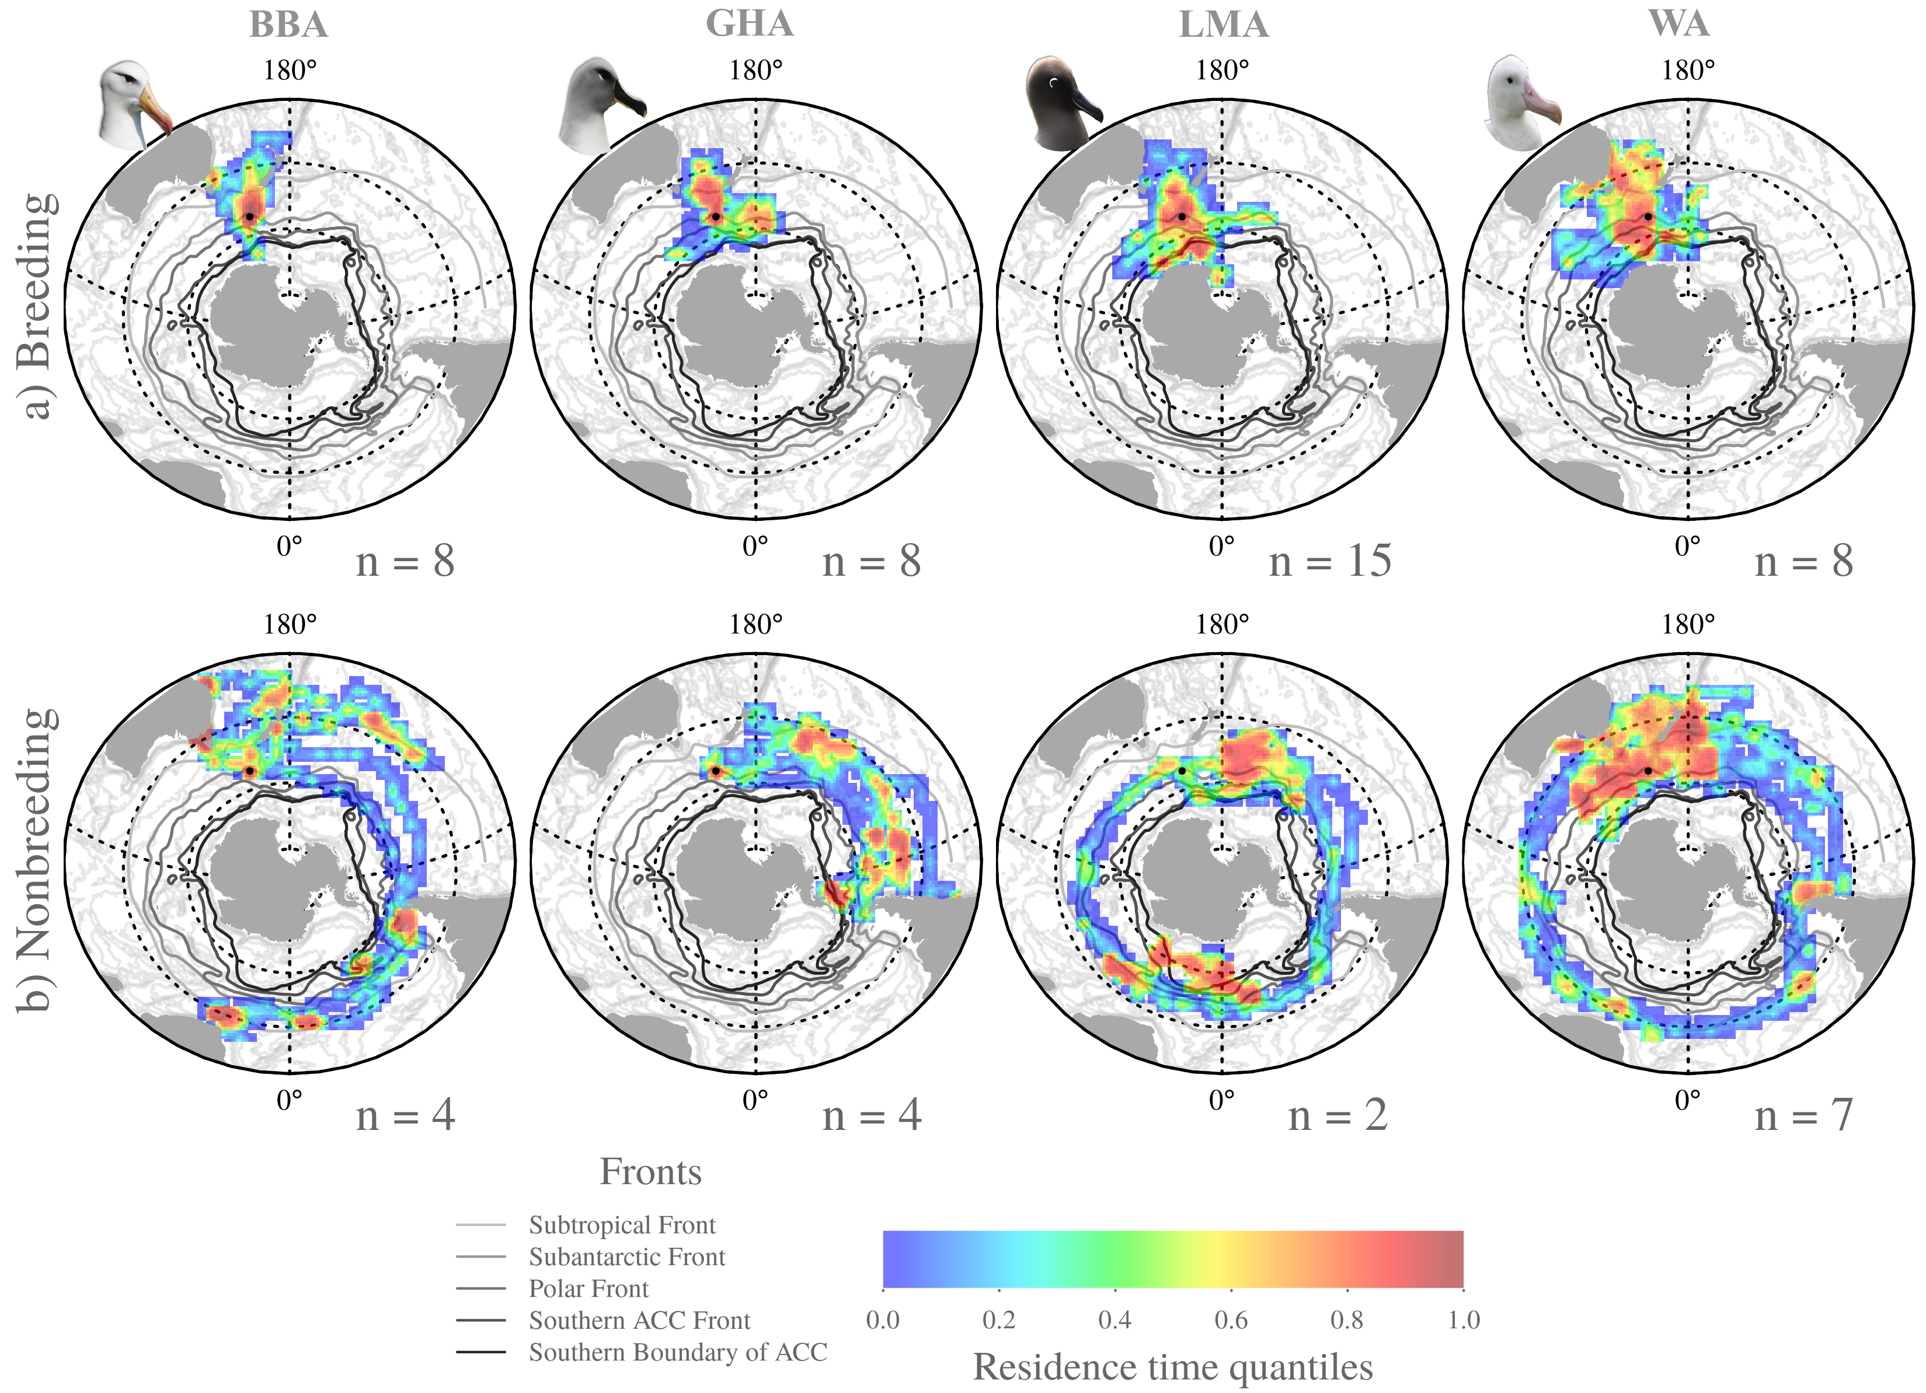
Fig. 2 Residence time quantiles of black-browed (BBA), grey-headed (GHA), light-mantled (LMA) and wandering albatrosses (WA) tracked from Macquarie Island during the a) breeding and b) nonbreeding periods. Residence time was based on a 100 x 100 km grid. The major Southern Ocean frontal features are based on Orsi et al. (1995).

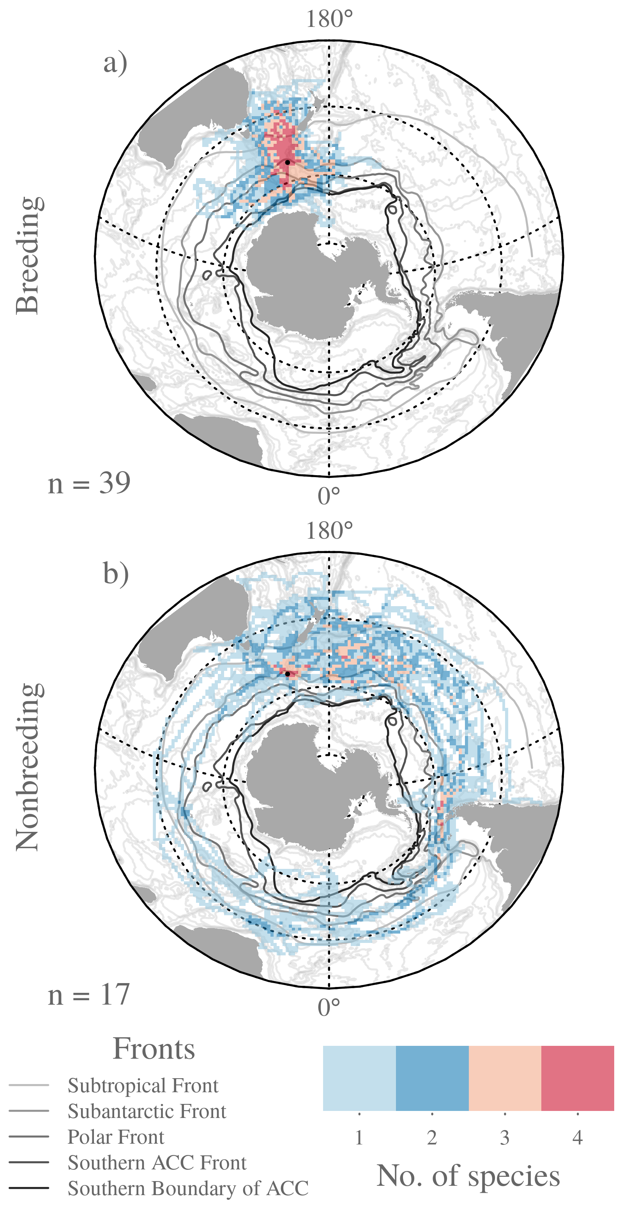
Fig. 3 Gridded (100 x 100 km) a) breeding, b) nonbreeding overlap of albatrosses tracked from Macquarie Island (black-browed, grey-headed, light-mantled and wandering albatrosses) in relation to major Southern Ocean frontal features (from Orsi et al. 1995).

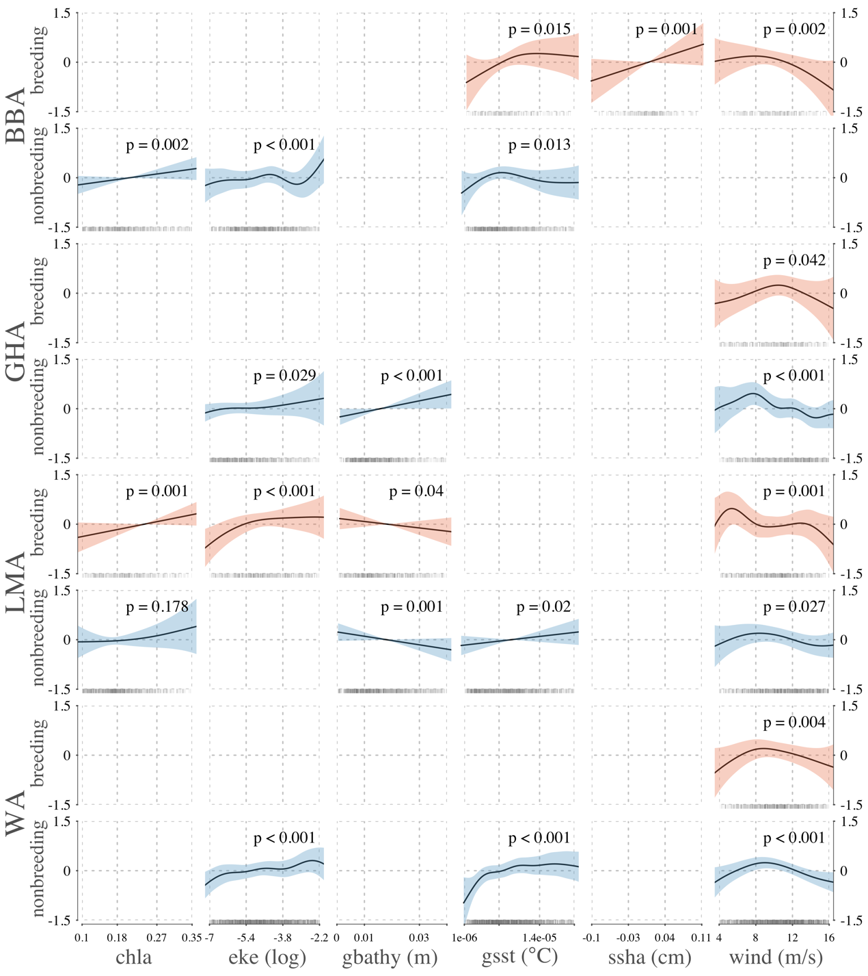
Fig. 4 General additive model response curves (with shaded standard errors) showing significant relationships between residence time (hours) of breeding (red) and nonbreeding (blue) black-browed (BBA), grey-headed (GHA), light-mantled (LMA) and wandering albatrosses (WA) tracked from Macquarie Island, and environmental variables; chlorophyll a concentration (chla), eddy kinetic energy (eke), bathymetric gradient (gbathy), sea surface temperature gradient (gsst), sea surface height anomaly (ssha) and wind speed (wind).

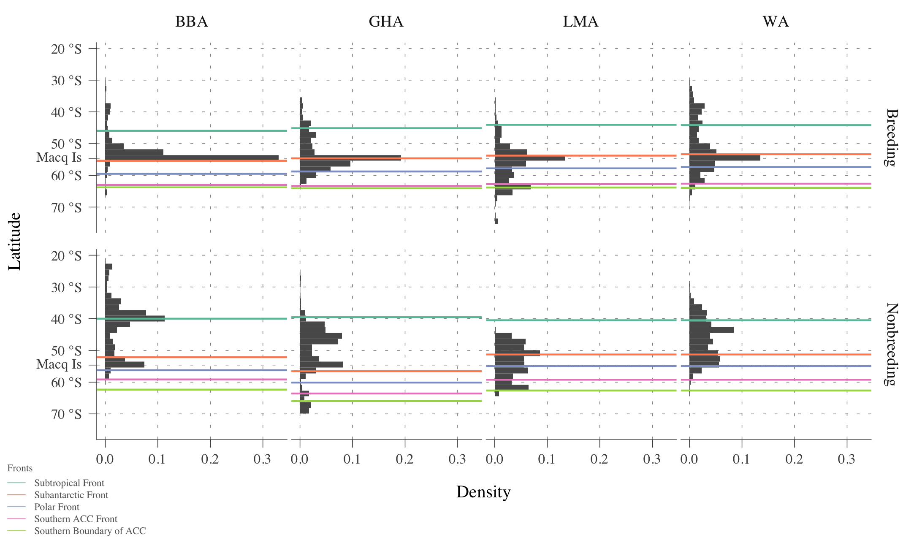
Fig. 5 Histogram of locations of tracked breeding and nonbreeding albatrosses from Macquarie Island by latitude, in relation to the mean positions of major Southern Ocean frontal systems, averaged across the species distribution (from Orsi et al. 1995).

Tables
Table 1. Summary of deployments and foraging behaviour of black-browed (BBA), grey-headed (GHA), light-mantled (LMA) and wandering albatrosses (WA) tracked from Macquarie Island between 1992-2009.
 |  | BBA | GHA | LMA | WA
Number of tracked individuals |  | 10 | 11 | 15 | 12
PTT deployed |  | 8 | 9 | 12 | 8
GLS deployed |  | 2 | 2 | 3 | 4
Number of days of tracking data | Breeding | 501 | 325 | 738 | 1081
 | Nonbreeding | 557 | 567 | 815 | 2515
Mean daily displacement (km day⁻¹) | Breeding | 266.2±12.7 | 426.5±17.5 | 403.8±12.4 | 191.1±8.1
 | Nonbreeding | 351±14 | 266±9 | 265±11 | 153±4
Mean daily maximum distance from colony (km) | Breeding | 326±22 | 812±35 | 811±23 | 942±21

Table 2. Optimal general additive model results showing significant relationships between residence time (hours) of black-browed (BBA), grey-headed (GHA), light-mantled (LMA) and wandering albatrosses (WA) tracked from Macquarie Island, and environmental variables; chlorophyll a concentration (chla), eddy kinetic energy (eke), bathymetric gradient (gbathy), sea surface temperature gradient (gsst), sea surface height anomaly (ssha) and wind speed (wind). A latitude, longitude smoothed term is incorporated to address spatial autocorrelation.
 | Species | Smoothed term | Estimate | F | t | p | R² | Deviance
BREEDING | BBA | intercept | 10.1875 |  | 186.1937 |  | 0.2706 | 0.8512
 |  | long. lat. |  | 15.5791 |  | <0.001
 |  | ssha |  | 11.0138 |  | 0.0011
 |  | wind |  | 4.8871 |  | 0.0023
 |  | gsst |  | 3.5673 |  | 0.015
 | GHA | intercept | 10.3509 |  | 175.9226 |  | 0.0233 | 0.6299
 |  | long. lat. |  | 8.7488 |  | <0.001
 |  | wind |  | 2.4716 |  | 0.0418
 | LMA | intercept | 10.6691 |  | 253.1974 |  | 0.4268 | 0.6302
 |  | long. lat. |  | 19.0563 |  | <0.001
 |  | eke (log) |  | 6.8701 |  | <0.001
 |  | chl |  | 11.9919 |  | <0.001
 |  | wind |  | 3.3481 |  | 0.0015
 |  | gbathy |  | 4.2591 |  | 0.0397
 | WA | intercept | 10.9249 |  | 213.037 |  | 0.0647 | 0.5268
 |  | long. lat. |  | 14.9203 |  | <0.001
 |  | wind |  | 3.7916 |  | 0.004
NONBREEDING | BBA | intercept | 10.0548 |  | 278.537 |  | 0.2276 | 0.4873
 |  | long. lat. |  | 13.3514 |  | <0.001
 |  | eke (log) |  | 4.8312 |  | <0.001
 |  | chl |  | 9.8216 |  | 0.0017
 |  | gsst |  | 3.0436 |  | 0.0132
 | GHA | intercept | 10.4761 |  | 295.4269 |  | 0.219 | 0.4102
 |  | long. lat. |  | 13.0776 |  | <0.001
 |  | wind |  | 5.4755 |  | <0.001
 |  | gbathy |  | 15.8203 |  | <0.001
 |  | eke (log) |  | 2.6937 |  | 0.0287
 | LMA | intercept | 10.2028 |  | 252.5517 |  | 0.2235 | 0.5247
 |  | long. lat. |  | 23.0428 |  | <0.001
 |  | gbathy |  | 11.3853 |  | <0.001
 |  | gsst |  | 5.4396 |  | 0.0199
 |  | wind |  | 2.4211 |  | 0.0273
 |  | chl |  | 1.6085 |  | 0.178
 | WA | intercept | 10.8688 |  | 376.1416 |  | 0.233 | 0.5037
 |  | long. lat. |  | 43.114 |  | <0.001
 |  | wind |  | 9.6689 |  | <0.001
 |  | gsst |  | 5.8276 |  | <0.001
 |  | eke (log) |  | 5.3217 |  | <0.001

Table 3. Summary of functional and life history parameters of black-browed, grey-headed, light-mantled and wandering albatrosses from Macquarie Island. Values are means ± SE.
 | Attribute | BBA | GHA | LMA | WA | Reference
Status | Breeding pairs (2013/14) | 44 | 88 | 2151 | 7 | (DPIPWE 2014)
 | Population trend | increasing | stable | increasing | decreasing
Functional morphology** | Mass (kg) | M: 3.67±0.23  F: 3.05±0.17 | M: 3.52±0.25  F: 3.07±0.18 | 2.84 | M: 9.44±0.59  F: 7.84±0.18 | (Pennycuick 1982, Shaffer et al. 2001, Phillips et al. 2004)
 | Wingspan (cm) | M: 228.8±5.3  F: 221.8±3.4 | M: 221.2±4.0  F: 216.0±5.5 | 218 | M: 311.0±4.0  F: 299.0±5.0
 | Wing area (cm²) | M: 3900±150  F: 3660±90 | M: 3555±130  F: 3395±135 | 3380 | M: 6260±270  F: 5860±230
 | Wing loading | M: 92.3±5.3  F: 81.7±4.0 | M: 97.1±7.0  F: 88.6±5.9 | 82.4 | M: 148.0±10.0  F: 132.0±11.0
 | Aspect ratio | M: 13.4±0.3  F: 13.4±0.3 | M: 13.8±0.3  F: 13.8±0.5 | 14.1 | M: 15.5±0.6  F: 15.3±0.6
 | Maximum glide ratio | 21.7 | 22.0 | 22.4 | 23.2
Reproduction | Breeding frequency | annual | biennial | biennial to triennial | biennial | (Terauds 2002)
 | Breeding season | late Sept – early May | early Oct – late May | mid Oct – mid June | early Dec – early Jan (13 months)
 | Laying date | 25 Sept – 31 Oct | 6 Oct – 30 Oct | Oct – 17 Nov | 8 Dec – 14 Jan
 | Early incubation shift length (days) | 3.1±0.1 | 5±0.2 | NA | 8.8±0.4
 | Late incubation shift length (days) | 3.6±2.7 | 7.5±4.0 | 10.5±4.6 | 8.8±4.9
 | Mean incubation length (days) | 68.9±0.2 | 71.7±0.1 | 66.5±0.3 | 79.2±0.2
 | Mean brood guard length (days) | 22.4±0.4 | 24.8±0.3 | 22.4±0.5 | 30.1±0.8
 | Chick rearing length (days) | 118* | 135* | 139.7±2.6 | 273.6±3.6
 | Mean breeding success (1994 – 2014, %) | 43.4±12.4 | 52.0±12.5 | 48.6±12.3 | 63.85±19.8 | (DPIPWE 2014)
*median values **data from colonies other than Macquarie Island

