Title: Acantharian cysts: high flux occurrence in the bathypelagic zone of the Scotia Sea, Southern Ocean
Anna Belcher¹, Clara Manno¹, Sally Thorpe¹, Geraint Tarling¹
¹ British Antarctic Survey, Natural Environment Research Council, Cambridge, CB3 0ET, UK
Corresponding Author: Anna Belcher: annbel@bas.ac.uk, 01223 221400

Abstract
The abundance and flux of acantharian cysts were recorded for a period of 12 months from December 2012 to 2013 in a sediment trap deployed at 1500 m in the north-eastern Scotia Sea, Southern Ocean. Acantharia (radiolarian protists) are found globally, have very dense celestite skeletons, and form cysts which can sink rapidly through the water column. However, they are highly soluble in seawater and have rarely been found to contribute significantly to fluxes of particulate organic carbon (POC) in mesopelagic or bathypelagic zones. We measured fluxes of acantharian cysts of up to 2706 ind. m⁻² d⁻¹, which we estimate to drive a POC flux of 5.1 mg C m⁻² d⁻¹. These acantharian cyst fluxes are unprecedented in the literature, and accounted for 17 % of the annual POC flux at this site (0.5 – 26.0 %). The high fluxes of acantharian cysts (and associated high POC fluxes) measured highlight the pressing need for further research into the life cycles of Acantharia to understand what drives the mass flux of their cysts, and to determine the contribution of Acantharia to the biological carbon pump.
Introduction
The biological transfer of carbon from the atmosphere to the ocean interior (the biological carbon pump (BCP), Volk & Hoffert 1985) is an important part of global carbon cycles, and the depth that material is remineralised in the ocean is tightly coupled to atmospheric levels of CO₂ (Kwon et al. 2009). Carbon can be sequestered via the BCP on timescales of centuries to millennia in the deep-sea, and it is therefore necessary to measure and understand the processes determining both the magnitude and efficiency of the BCP. One important determinant is the type of particle sinking out of the surface ocean (Turner 2015).
The diversity of particles exported out of the euphotic zone and transported to depth is high, reflecting the range of organisms producing and repackaging particles (Turner 2015). Sediment trap studies have noted large contributions of, for example, faecal pellets, diatoms and diatom resting spores (González et al. 2009; Steinberg et al. 2012; Manno et al. 2015; Rembauville et al. 2015; Belcher et al. 2017; Roca-Marti et al. 2017). More recently however, the important role of protists in marine ecosystems and particle flux has been highlighted (Biard et al. 2016; Guidi et al. 2016; Bochdansky et al. 2017). Protists are unicellular eukaryotes comprising many plant-like and animal-like organisms such as diatoms, dinoflagellates and radiolaria.
Acantharia are marine protists belonging to the Radiolaria subphylum. They are found globally and have celestite (strontium sulphate, SrSO₄) skeletons, which is the densest known organic biomineral. However, they do not typically contribute significantly to sinking particle flux in the mesopelagic zone and below (Honjo et al. 2008), likely because seawater is undersaturated in strontium sulphate, resulting in dissolution of Acantharia skeletons as they sink through the water column (Beers and Steward 1970; Bernstein and Betzer 1991). Recently however, large fluxes of acantharian cysts were measured at depths of 2000 m in the Iceland Basin, highlighting that Acantharia can also contribute to fluxes in the bathypelagic zone despite their high solubility (Martin et al. 2010). Acantharia form cysts as part of their reproductive cycle, a process in which the spicules of the skeleton are reabsorbed and a thick celestite shell is deposited (Decelle et al. 2013). Cysts are typically larger than the vegetative acantharian cell, and, due to both their size and density, have high sinking rates (103-770 m d⁻¹, Antia et al. 1993, Martin et al. 2010). These rates are high compared to those of individual diatom cells, typically <1-10 m d⁻¹ (Smayda 1970; Waite et al. 1997), and to those of diatom aggregates of a similar size (<50m d⁻¹, Iversen and Ploug 2013). Acantharian cysts sink rapidly out of the surface, and so it is thought that biflagellated swarmers (presumably gametes) are released at mesopelagic and bathypelagic depths, either through pores or upon rupture of the cyst wall (Decelle et al. 2013). The reason for the release of swarmers at depth is not yet fully understood (Martin et al. 2010; Decelle and Not 2015), but as these cysts contain particulate organic carbon (POC) and have high sinking speeds, they have the potential to ballast POC to depth if they can survive dissolution in seawater.
Unlike much of the Southern Ocean, the Scotia Sea is highly productive, with large and long lasting phytoplankton blooms particularly in the region of South Georgia (Murphy et al. 2007b; Park et al. 2010). High fluxes of sinking particles have previously been recorded in this region, with faecal pellets highlighted as one of the main contributors to the POC flux , contributing between 36 and 2534 faecal pellets m⁻² d⁻¹ (Manno et al. 2015; Belcher et al. 2016, 2017). The Southern Ocean has an important role in global ventilation and the supply of pre-formed nutrients to the global ocean (Sarmiento et al. 2004) and it is therefore particularly important to identify the drivers of high POC flux in this region. Strontium fluxes were previously measured in sediment traps in the Scotia Sea, highlighting that Acantharia can contribute to POC fluxes here (Decelle et al. 2013). In this study, we make direct counts of Acantharia cysts, reporting for the first time extremely high numbers in sediment traps deployed in the bathypelagic zone of the Scotia Sea, Southern Ocean. We determine the seasonal variability in their flux, as well as their contribution to the POC flux. We show that acantharian cysts can make a significant contribution to the POC flux to the bathypelagic waters of the Southern Ocean, highlighting the need for future research to identify the environmental factors that could drive the reoccurrence of this type of high POC flux event over long timescales.
Methods
Sediment trap deployment
A sediment trap was deployed at a long term mooring site, P2 (-55.248 °N, -41.265 °E, https://www.bas.ac.uk/project/scoobies/, Fig. 1), in the Scotia Sea on 8th December 2012 during cruise JR280 aboard the R.R.S. James Clark Ross, and recovered on 2nd December 2013 on cruise JR291. The sediment trap was deployed at 1500 m in a water depth of 3350 m and was comprised of a plastic funnel with a baffle at the top (0.5 m² surface area) and a narrow opening at the bottom, through which particles fall into 1 L sampling cups (McClane, PARFLUX Mark 78H-21). To prevent diffusion of the cup solution to the surrounding water, sodium chloride was added prior to deployment to achieve a salinity of 40 psu. Mercuric chloride (0.01%) was added to prevent microorganism induced biodegradation. Celestite is highly soluble in seawater and hence SrCl₂ can be added to sediment trap preservatives to prevent the dissolution of Acantharia (Beers and Steward 1970; Bernstein and Betzer 1991). However, this was not added as the sediment trap was not deployed with the aim of studying Acantharia, and hence we likely underestimate the flux of acantharian cysts as we cannot account for any dissolution that may have occurred. The sampling cups were programmed to rotate after 14 to 31 days, with shorter periods set to coincide with expected periods of high productivity. Upon recovery of the sediment trap, the pH in each cup was recorded and the whole cup photographed. Swimmers, defined as zooplankton that were alive and intact on entering the trap, were picked out using tweezers and removed from the sample. Swimmers were not included in flux calculations. A rotary splitter, McClane Wet Sample Divider (WSD-10), was used to split each sample into a number of equal aliquots for further analysis. Mean current velocities at the P2 site in 2013 (measured with a Nortek Aquadopp current meter deployed on the mooring just below the sediment trap) were 0.11 (±0.06) m s⁻¹. Hence we assumed that effects of lateral advection were minimal and did not affect sediment trap collecting efficiencies (Buesseler et al. 2007), and, as such, they are not considered in this study.
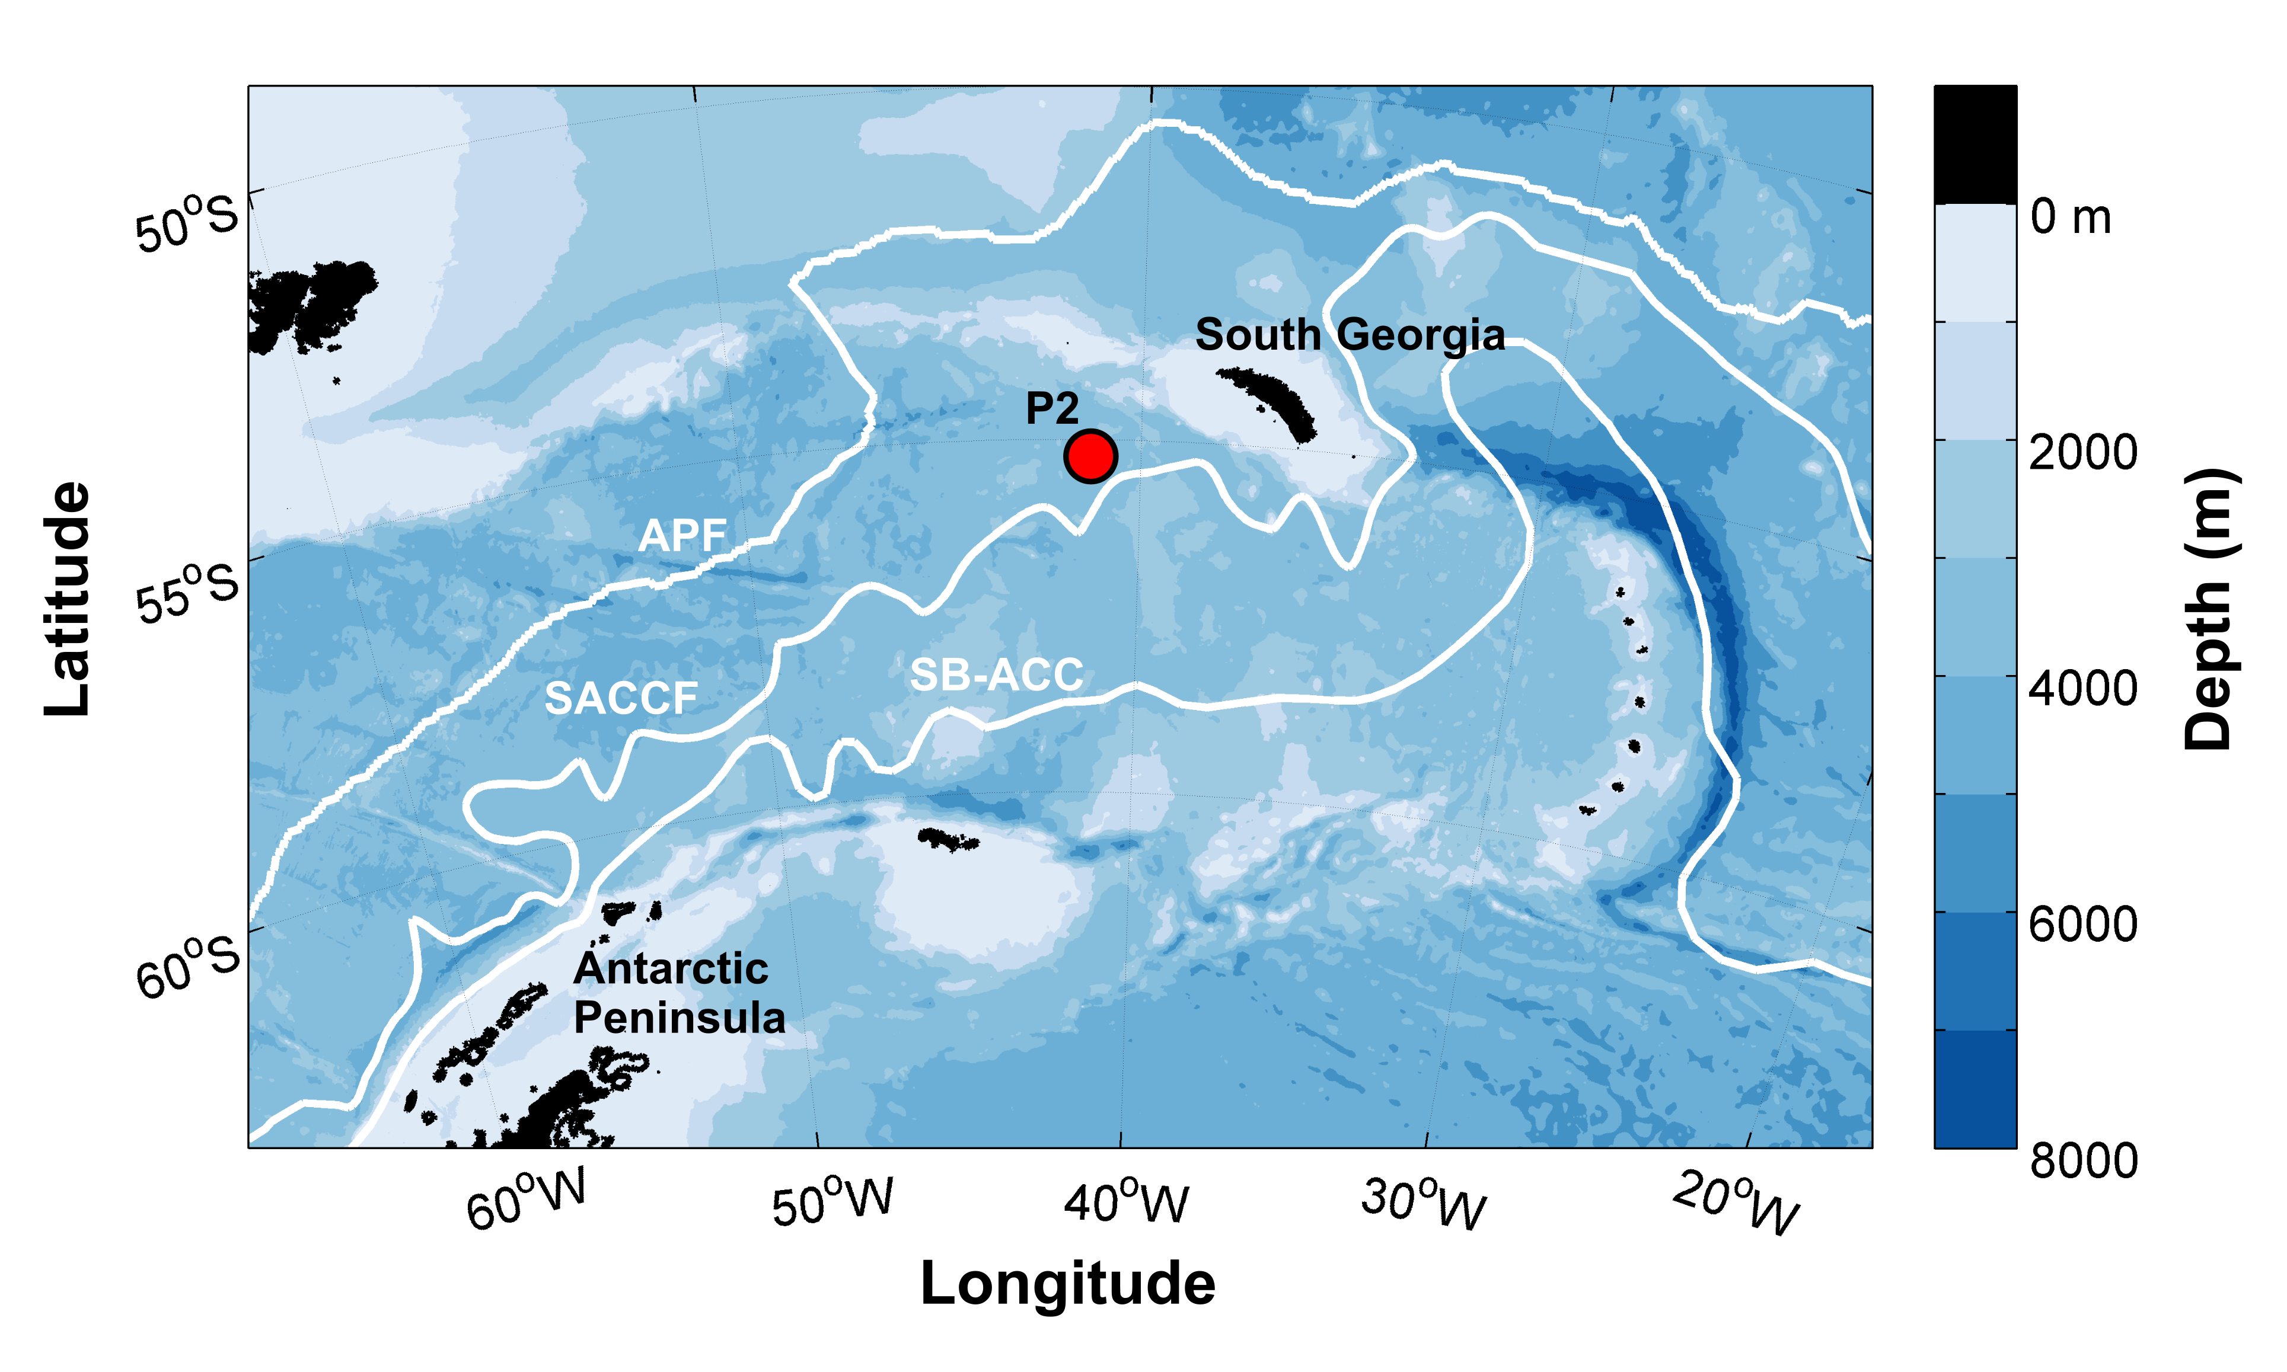
Fig. 1: Location of sediment trap mooring (P2) in the Scotia Sea, Southern Ocean. White lines display mean frontal positions of the Antarctic Polar Front (APF)(Moore et al. 1999), Southern Antarctic Circumpolar Current Front (SACCF) (Thorpe et al. 2002), and of the Southern Boundary- Antarctic Circumpolar Current (SB-ACC) (Orsi et al. 1995). Bathymetry data (v18.1, released 2014) from Smith and Sandwell (1997).

Particulate organic carbon flux
For each sediment trap sample, 2-3 splits were analysed for particulate organic carbon (POC). The material in the split was filtered onto pre-combusted (450 °C, 24 h) glass fibre filters (25 mm diameter GF/F, Whatman), and oven dried at 50 °C. Filters were then fumed with 37% HCl in a vacuum desiccator for 24 hours, and dried for 24 hours at 50 °C. Filters and filter blanks were then placed in pre-combusted (450 °C, 24 h) tin capsules (Hilton et al. 1986), and POC measured on a CE-440 Elemental analyser (Exeter Analytical.285 Inc).
The flux of POC (F) captured in each sediment trap sample cup was calculated as follows:
$F \left(mg C m^{-2}d^{-1}\right)=m/{\left(A×d\right)}$,

where m is the mass of POC in the sample cup, d is the number of days that the trap was open (14-31 days) and A is the area of the sediment trap opening (0.5 m²).
Acantharia flux and carbon contribution
Acantharian cysts were identified at the order level using a combination of light microscopy (Olympus SZX16) and scanning electron microscopy (SEM TM3000, Hitachi). In this study we focus only on acantharian cysts, and their importance for flux, as adult stages did not make a significant contribution to trap samples. Acantharian cysts were counted and visually categorized by shape into two categories (oval and round, Fig. 2). We confirm that the cysts belong to Acantharia by conducting scanning electron microscope energy-dispersive X-ray (SEM-EDX) analysis (Fig. S1). For each sample, the dimensions of each morphological type observed were measured using an ocular micrometer. Acantharian cysts were then further categorised as small (<0.2 mm) and large (>0.2 mm) on the basis of shell length. 150-200 cysts were measured for each category. Acantharian volume was calculated (mm³) by the geometrical formulae associated with the shapes using the following equations, where r_{n} is the radius along each dimension:
$$Round cyst volume= 4/{3 π r^{3}}$$
$$Oval cyst volume= 4/{3 π r_{1}r_{2}r_{2} }$$
Number fluxes of acantharian cysts (F_{AC}) were calculated using the following equation:
$F_{AC} \left(ind m^{-2}d^{-1}\right)={N_{AC}}/{\left(A×d\right)},$
where N_{AC} is the number of individual cysts (the average of 2-4 replicate counts). Volume fluxes were then calculated based on the dimensions of each class of acantharian cyst. The carbon flux associated with sinking acantharian cysts was estimated using a conversion factor of 0.048 mg C mm⁻³ based on measurements made on acantharian cysts in the East Greenland Sea (Antia et al. 1993). Although the carbon content of cysts may vary according to region and species, we believe the conversion factor of Antia et al. (1993) to be the most appropriate for our high latitude site. As dissolved Sr was not measured in the preservative, we make no correction for the possible loss of Acantharia via dissolution. The fluxes calculated here are therefore a lower bound estimate.
Environmental context
Mean monthly chlorophyll a and sea surface temperature (SST) data at 9 km resolution from the MODIS-Aqua Level-3 dataset were obtained from NASA Goddard Space Flight Center, Ocean Biology Processing Group (https://oceancolor.gsfc.nasa.gov/cgi/l3) for the period 2008-2015. Monthly values for the P2 site were derived by averaging the data values in a 55 km x 55 km box around P2.
Results and Discussion
Acantharian cyst flux
High fluxes of acantharian cysts were observed in the sediment trap samples, reaching a peak of 2706 ind. m⁻² d⁻¹ at the end of December 2012 (Table 1). Acantharian cyst fluxes decreased into January 2013, before reaching a second peak of 1029 ind. m⁻² d⁻¹ at the end of February. From March to the end of November 2013, total fluxes of acantharian cysts were low at < 45 ind. m⁻² d⁻¹. We refer to the period December 2012-February 2013 as period 1, and March-November 2013 as period 2 (Table 1).
Table 1: Fluxes of particulate organic carbon (POC) and acantharian cysts recorded in a sediment trap in the north-east Scotia Sea, Southern Ocean, Dec 2012-Dec 2013.
Cup collection period |  | Acantharian cysts  (ind. m⁻² d⁻¹) | Acantharian cyst carbon flux  (mg C m⁻² d⁻¹) | POC flux  (mg C m⁻² d⁻¹) | Period
Open | Closed
15/12/2012 | 01/01/2013 | 2706 | 5.11 | 29.58 | 1
01/01/2013 | 15/01/2013 | 1107 | 2.22 | 10.07 | 1
15/01/2013 | 01/02/2013 | 421 | 0.77 | 3.23 | 1
01/02/2013 | 15/02/2013 | 965 | 1.91 | 8.28 | 1
15/02/2013 | 01/03/2013 | 1029 | 2.74 | 10.65 | 1
01/03/2013 | 01/04/2013 | 36 | 0.01 | 1.37 | 2
01/04/2013 | 01/06/2013 | 42 | 0.03 | 2.63 | 2
01/06/2013 | 01/07/2013 | 35 | 0.02 | 0.54 | 2
01/07/2013 | 01/08/2013 | 37 | 0.03 | 0.76 | 2
01/08/2013 | 01/09/2013 | 22 | 0.02 | 0.78 | 2
01/09/2013 | 01/10/2013 | 32 | 0.02 | 0.93 | 2
01/10/2013 | 01/11/2013 | 36 | 0.02 | 4.91 | 2
01/11/2013 | 01/12/2013 | 45 | 0.05 | 1.37 | 2

The peak fluxes measured during period 1 are extremely high in comparison to observations made previously in this region. Historical observations made on sediment trap samples at our study site reveal that acantharian cyst fluxes were lower between 2008 and 2011, < 673 ind. m⁻² d⁻¹ (C. Manno unpublished data, comprising abundances only).
Our observed peak acantharian cyst fluxes are also an order of magnitude greater than have been measured previously in the bathypelagic zone in other regions (Bernstein et al. 1992; Antia et al. 1993; Martin et al. 2010; Decelle et al. 2013, Table 2). Acantharia have rarely been found to contribute significantly to sinking particle flux to the ocean interior, likely due to the high solubility of Acantharia and their cysts in seawater (Bernstein et al. 1987; Honjo et al. 2008). Prior to our study, the highest fluxes of acantharian cysts to the bathypelagic zone were measured by Martin et al. (2010) in the Iceland Basin in spring. The authors report a sedimentation event of acantharian cysts, with fluxes up to 577 ind. m⁻² d⁻¹ at 2000 m. Antia et al. (1993) measured high acantharian cyst fluxes in sediment traps deployed at 100 m depth in the East Greenland Sea (~33000 ind. m⁻² d⁻¹). However, these rapidly diminished with depth, with fluxes of ~3000, 349 and 15 ind. m⁻² d⁻¹ at 500, 1000 and 2200 m respectively. Similarly, a rapid reduction in the flux of Acantharia (primarily cysts) with depth was observed in the Sargasso Sea between 400 and 1500 m (Bernstein et al. 1992). Michaels et al. (1995) deployed sediment traps in the Sargasso Sea at 150 m for periods of 2.5-4 days, recording fluxes of acantharian cysts of <1600 ind. m⁻² d⁻¹, with the exception of one very high flux of acantharian cysts of 12676 ind. m⁻² d⁻¹. As no sediment traps were deployed deeper than 150 m in the study of Michaels et al. (1995), it is not possible to know if this exceptionally high flux of acantharian cysts reached bathypelagic depths.
Table 2: Comparison of acantharian cyst fluxes measured in the literature. NA – not measured.
Study | Location | Depth (m) | Maximum acantharian cysts  (ind. m⁻² d⁻¹) | Maximum acantharian cyst carbon flux  (mg C m⁻² d⁻¹) | Maximum contribution to POC flux (%)
This Study | Scotia Sea | 1500 | 2706 | 5.11 | 26
Martin et al. (2010) | Iceland Basin | 2000 | 577 | 0.45 | 48
Antia et al. (1993) | Greenland Sea | 100 | 33000 | 10.8 | 32
 |  | 500 | 3000 | 1.2 | 5
 |  | 1000 | 349 | 0.13 | 0.9
 |  | 2200 | 15 | 0.005 | <0.1
Michaels et al. (1995) | Sargasso Sea | 150 | 12676 | 0.74 | 0.5
Bernstein et al. 1992 | Sargasso Sea | 400 | 1420 | NA | NA
 |  | 1500 | 8 | NA | NA

We identified two different morphologies of acantharian cyst in our sediment trap samples, round and oval, and these were classified into small and large size classes (Fig. 2, Table 3). Oval acantharian cysts were identified as belonging to the order Holacanthida, and round cysts to Chaunacanthida. Cysts of similar morphology have previously been observed in the Weddell Sea, Antarctica with most occurring between 100 and 300 m (Spindler and Beyer 1990). Phylogenetic analyses by Decelle et al. (2013) suggest that orders Holacanthida and Chaunacanthida can be important to deep-sea protist communities and have a wide vertical distribution from the surface to the mesopelagic zone across sampled regions of the Indian, Pacific and Atlantic Ocean. The large acantharian cysts we measured had a mean length of 0.3 mm for both morphologies, whereas small cysts were 0.125 and 0.1 mm in length for round and oval morphologies respectively (150-200 cysts from each category were measured). In terms of numerical abundance, round acantharian cysts were dominant during period 1, whereas oval acantharian cysts were more abundant during period 2 (Fig.3 A). Larger acantharian cysts likely have higher sinking velocities (Martin et al. 2010) and hence could promote higher fluxes to the deep-sea.
Dimension (mm) | Small |  | Large
 | Round | Oval | Round | Oval
Length | 0.125 (0.018) | 0.10 (0.020) | 0.3 (0.026) | 0.3 (0.023)
Width |  | 0.05 (0.011) |  | 0.1 (0.001)
Table 3: Mean dimensions (standard deviation) of each category of acantharian cyst collected in a sediment trap in the north-east Scotia Sea, Southern Ocean, Dec 2012-Dec 2013. 150-200 cysts were measured in each category.

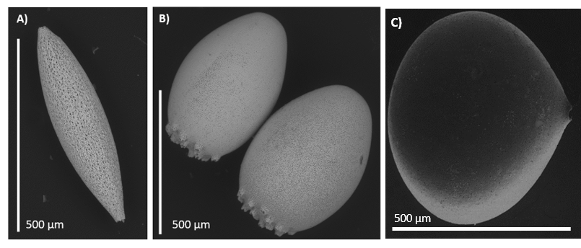
Fig. 2: Scanning electron microscope (SEM) images of acantharian cysts observed in sediment trap samples at 1500 m in the Scotia Sea. A) Oval type (order Holacanthida), B)+C) round types (order Chaunacanthida).
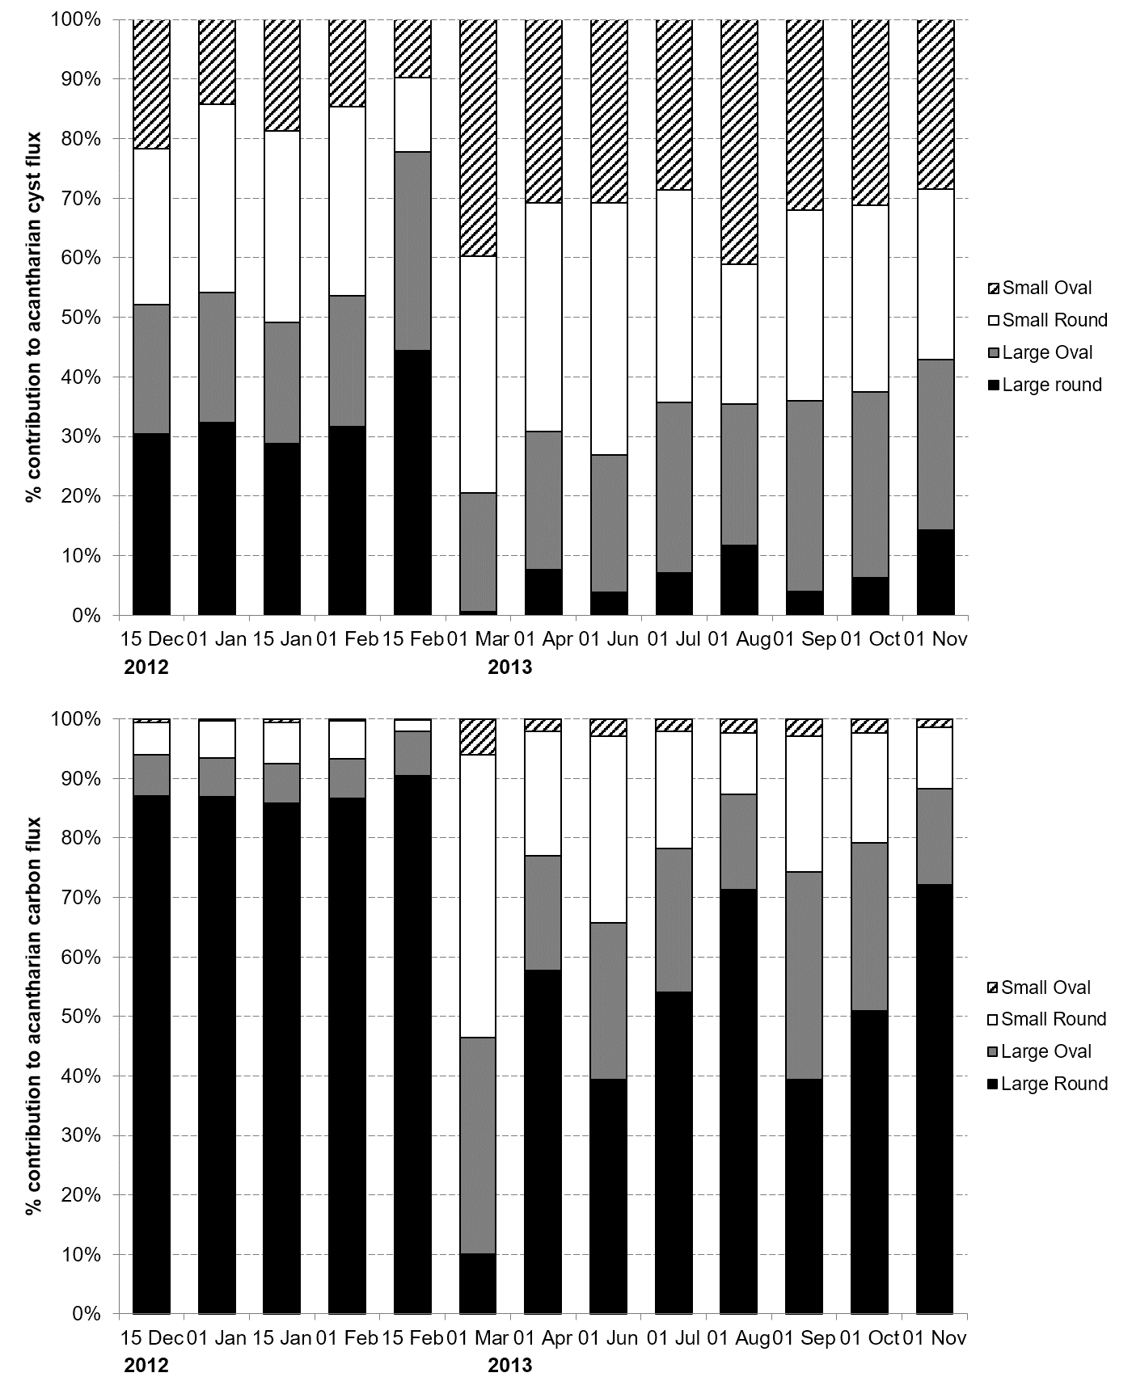Fig. 3: Composition of acantharian cyst flux. The percent contribution of large round (black), large oval (grey), small round (white), and small oval (striped) to the number flux of acantharian cysts (upper), and their contribution to the acantharian cyst carbon flux (lower). Note the increased sampling frequency between December and February.
Contribution of acantharian cysts to POC flux
POC fluxes in December 2012 were exceptionally high (29.6 mg C m⁻² d⁻¹, Table 1) greatly exceeding fluxes of <4 mg C m⁻² d⁻¹ observed at the site between 2008 and 2011 (Manno et al. 2015). During period 1, the POC flux shows the same seasonal pattern as the acantharian cyst flux (Fig. 4), with the peak POC flux of 29.6 mg C m⁻² d⁻¹ corresponding to a peak acantharian cyst flux of 5.1 mg C m⁻² d⁻¹, at the end of December 2012. However, there is also a peak in POC (4.9 mg C m⁻² d⁻¹) in October 2013 that we do not observe for acantharian cysts.
Acantharian cysts make the largest contribution to the total POC flux during period 1 when fluxes of acantharian cysts are high (Fig. 4). The peak in percent contribution (23-26%) occurred at the end of January and February, with a slightly reduced contribution at the end of December 2012 (17%) when fluxes of POC and acantharian cysts were highest. This is most likely due to the large amount of phytodetrital material in the December 2012 sample, which made a large contribution to the POC flux (author observations). During this period, large round cysts were dominant in terms of the contribution to the carbon flux (Fig. 3B). The contribution of acantharian cysts to the POC flux was <4% for period 2 due to low fluxes of acantharian cysts. The relative size of the large round cysts is such that even though their percent contribution to acantharian cyst flux decreased during period 2, they still dominated the acantharian cyst volume and POC flux (Fig. 3). Although most of the acantharian carbon flux (91%) occurred between 15th December 2012 and 28th February 2013 (period 1), there were still measureable fluxes throughout the year and the annual contribution of acantharian cysts to total POC flux was 17%.
These fluxes of acantharian cysts in the bathypelagic zone are unprecedented in the literature, highlighting that, as with other organisms such as diatom resting spores (Rembauville et al. 2016), Acantharia can make a significant contribution to the biological carbon pump during specific events. Martin et al. (2010) measured peak contributions from acantharian cysts of 48% to total POC flux but suggested that acantharian cysts did not account for more than 1-2% of total annual POC flux to their sediment traps at 2000 m in the Iceland Basin. In the Greenland Sea, acantharian cysts contributed 32% to the total POC at 100 m, but only 0.9 and <0.1% at 1000 and 2200 m respectively (Antia et al. 1993). In particular, it was the large round acantharian cysts (Fig. 2) that made the dominant contribution (>88%) to the acantharian cyst POC flux during the high sedimentation period (period 1) at our study site. This highlights the ability of an organism to have a significant impact on POC fluxes in the bathypelagic zone. Due to their composition, fluxes of acantharian cysts also contribute to the cycling of elements including strontium and phosphorous; these elements, however, were not analysed in this study.
Geographical variation in the contribution of acantharian cysts to bathypelagic zone POC fluxes may also relate to the level of celestite saturation in the water column. This depends not only on the concentration of celestite, and its ions (Sr²⁺ and SO₄²⁻), but also on ocean temperature, salinity and pressure (Rushdi et al. 2000). Indeed dissolved Sr concentrations vary both with depth and among ocean basins; de Villiers (1999) measured higher Sr concentrations in Antarctic Intermediate water (at ~450 m depth) in the South Pacific compared to the North Atlantic. Their data suggest that Sr has a ‘labile nutrient-like’ behaviour in the ocean with elevated surface values at high latitudes and areas of upwelling. Acantharian cysts are therefore less susceptible to dissolution in regions with higher dissolved Sr, and may be able to contribute more to bathypelagic zone POC fluxes in these regions.
Decelle et al. (2013) estimated the Acantharia flux at our study site in 2008 based on measurements of dissolved strontium in the sediment trap sample preservative and the C:Sr ratio of Martin et al. (2010). They estimated fluxes of only 0.005-0.008 mg C m⁻² d⁻¹ at 2000 m, with highest fluxes in December 2008, which are lower than all fluxes we measured during 2012/2013 (0.01-5.1 mg C m⁻² d⁻¹). This suggests that Acantharia did not make a large contribution to POC fluxes at the P2 study site in 2008. However, the estimates of Decelle et al. (2013) only take into account dissolved Sr so rely on the assumption that all Acantharia were dissolved in the sediment trap sample. Since the sediment traps at P2 were not buffered with SrCl₂, dissolution of Acantharia and their cysts would occur due to the high solubility of celestite in seawater (Bernstein and Betzer 1991). However, if fluxes of Acantharia are sufficiently high, then dissolution of Acantharia in the sample cup will increase the Sr concentration (essentially forming a buffer) and allow preservation of the Acantharia even in long term moorings (Michaels 1988; Antia et al. 1993). This may explain why both we and Martin et al. (2010), were able to observe acantharian cysts in sediment trap samples despite the lack of SrCl₂ buffer. Based on 8.25 µg Sr per cyst (Martin et al. 2010), ~890-1400 individual cysts would need to dissolve in one cup of sediment trap preservative to elevate the dissolved Sr concentrations to ~37-55 mg Sr L⁻¹ , i.e. the concentrations measured by Martin et al. (2010) when fluxes of acantharian cysts were high (149-577 ind. m⁻² d⁻¹). The estimates of Acantharia flux by Decelle et al. (2013) based on only dissolved Sr may therefore be an underestimate if fluxes of Acantharia were high enough to elevate the Sr concentration in the preservative to a level that would enable buffering and prevent further dissolution. Thus, our study highlights that both the particulate and dissolved fractions of sediment trap samples must be assessed to determine absolute Acantharia fluxes and their contribution to POC flux.

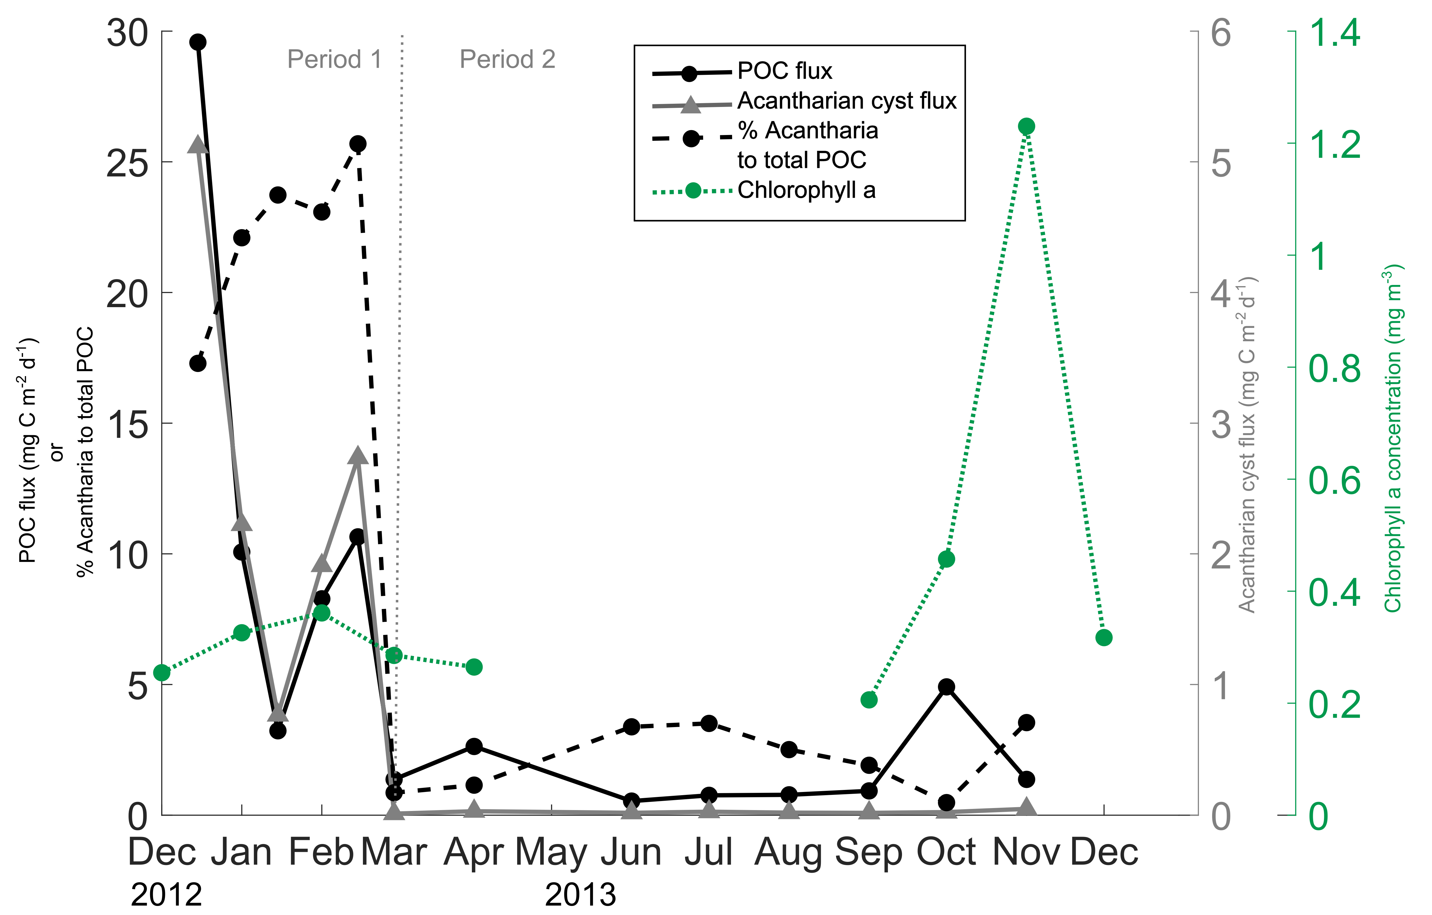
Fig. 4: Sediment trap fluxes of particulate organic carbon (POC, black solid line), carbon flux due to acantharian cysts (grey solid line, triangle markers), and the percentage contribution of acantharian cysts to the total POC flux (dashed, thick black line). Shown also (green dotted line) is the monthly mean satellite chlorophyll a concentration (mg m⁻³). The vertical grey dotted line marks period 1 and 2 defined by the magnitude of the acantharian cyst flux (see main text).
Potential environmental drivers of acantharian cyst fluxes
Our study and that of Martin et al. (2010) demonstrate that, despite the high solubility of Acantharia (Michaels 1991; Bernstein et al. 1992; Michaels et al. 1995), high fluxes of acantharian cysts can indeed reach bathypelagic depths; what drives these large flux events is however unclear. Martin et al. (2010) hypothesise that, in high latitudes, encystment could be triggered by high productivity associated with the spring bloom, resulting in rapid sinking to depth so that developing juveniles can utilise the pulse of POC following the spring bloom, whilst avoiding predation. Conversely, at lower latitudes where particle flux is typically lower and there is less seasonal variability, acantharian cyst dissolution has been observed to occur at shallower depths (Bernstein et al. 1992; Michaels et al. 1995). This difference in acantharian cyst fluxes between high and low latitudes could also be due to differences in cyst size and/or abundances of cyst forming species (Decelle et al. 2013).
It is possible that the extremely high flux of acantharian cysts that we observed in the 2012/2013 austral summer season is related to the fact that POC fluxes were also exceptionally high when compared to historical observations at this site (Manno et al. 2015). Although some Acantharia are mixotrophic through symbiosis with intracellular microalgae, cyst-forming Acantharia do not host symbiotic microalgae and hence can live in deep waters where there is no light, relying on prey and sinking organic matter for energy (Decelle et al. 2013). Very large interannual variations in POC flux were recorded in sediment traps deployed in the Northeast Atlantic, with evidence pointing to Radiolaria as key factors in the observed large pulses of highly enriched material (Lampitt et al. 2009). Like Lampitt et al. (2009), we suggest that some combination of ecological conditions drove high abundances (and/or high encystment) of, in our case Acantharia, and increased deep ocean flux.
The P2 mooring is situated in a dynamic region, lying in the path of the Southern Antarctic Circumpolar Current Front (SACCF) (Fig. 1), which separates oceanic zones with distinct water mass properties (Orsi et al. 1995). These different water masses are associated with contrasting phytoplankton community composition and food web structure (Korb et al. 2010, 2012; Ward et al. 2012). Therefore, variability, both seasonally and annually, in the position of the SACCF (Boehme et al. 2008) could cause variation in the environmental conditions (and associated phytoplankton community) at our study site on these timescales. On longer timescales, anomalies in the sea surface temperature (SST) in the Scotia Sea can be generated through atmospheric teleconnections with the El Niño Southern Oscillation (ENSO), resulting in ecosystem fluctuations (Murphy et al. 2007a; Meredith et al. 2008).
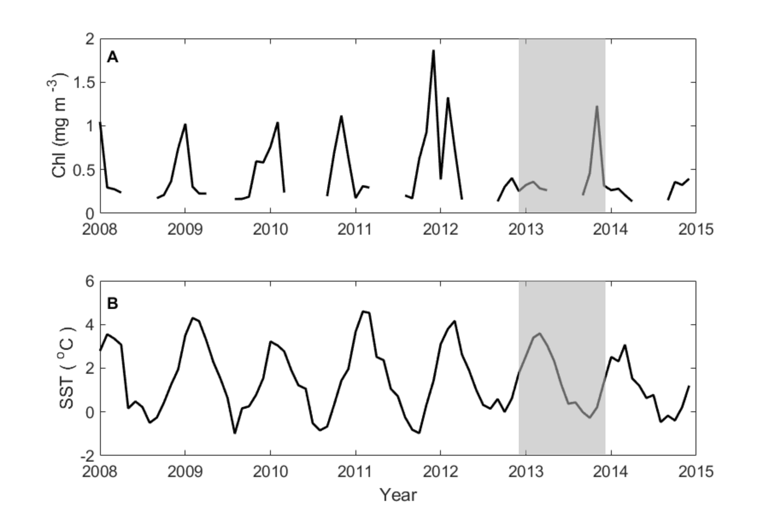
Fig. 5: A) Monthly mean satellite chlorophyll a (Chl) concentration (mg m⁻³) and B) monthly sea surface temperature (SST, °C) at the P2 site for the period 2008-2015. Data have been averaged over a 55 x 55 km box centred on the P2 site. The period of sediment trap analysis of this study is highlighted by grey shading. X-axis ticks mark January of each year.
The occurrence of peak fluxes of acantharian cysts in austral summer could be linked with productivity, as noted by previous studies (Spindler and Beyer 1990; Martin et al. 2010; Decelle et al. 2013). However, remotely sensed chlorophyll for the P2 site suggests that chlorophyll concentrations were atypically low (<0.4 mg chl a m⁻³) throughout the summer of 2012/2013 (Fig. 5). As Acantharia can feed on a variety of small particulate material including bacteria, micro and picoplankton, as well as copepods and other grazers (Caron and Swanberg 1990), in low chlorophyll years they may be able to outcompete species that are reliant on phytoplankton. Abundances of Acantharia measured by Antia et al. (1993) were high despite conditions of low algal biomass and productivity, suggesting that Acantharia can indeed thrive in low chlorophyll conditions. However, monthly remotely sensed chlorophyll data are limited by cloud cover, temporal averaging and shallow penetration depths. Therefore, we cannot rule out the occurrence of small scale, or patchy, phytoplankton blooms extending deeper in the water column. Indeed depth-integrated chlorophyll can be high in our study region (Korb et al. 2012). We observed a large amount of phytodetrital material in the December 2012 sediment trap sample, suggesting that productivity could have been higher than indicated by remotely sensed data.
Remotely sensed SST data reveals that the austral winter of 2012 was unusually warm compared to the winters of 2008-2011, with SST > 0°C (Fig. 5). Acantharia are most abundant in tropical and subtropical waters (Decelle and Not 2015), therefore the higher temperatures in our study region in austral winter 2012 may have been favourable to the growth of Acantharia.
Concluding remarks
This study is the first to document such high fluxes of acantharian cysts to the bathypelagic zone. Our data highlight that acantharian cysts can make an important contribution to POC fluxes in the bathypelagic zone, and that it is important to analyse both particulate and dissolved fractions of sediment trap samples to quantify these fluxes accurately. As we only observed one high acantharian cyst flux event, we can only hypothesise about the driving environmental conditions, and hence we are not able at present to assess the reoccurrence of such events. Our study highlights the need for further research into the life strategies and cycles of Acantharia to understand and predict the occurrence of high bathypelagic zone fluxes of Acantharia and assess their importance to the global biological carbon pump.
Acknowledgements
We would like to thank the crew, officers and scientists aboard the R.R.S. James Clark Ross during research cruises JR280 and JR291. Special thanks to Peter Enderlein, Gabrielle Stowasser and Sophie Fielding for their help in deployment and recovery of the sediment trap. In particular, we would like to thank Meltem Ok for her dedicated work supporting sediment trap sample analysis. Additionally we thank Paul Geissler for carrying out CHN analysis. We thank the reviewers and journal editor for their constructive comments on our manuscript. The work undertaken was supported by the Ocean Ecosystems programme at British Antarctic Survey. The chlorophyll a and sea surface temperature data were provided by NASA Goddard Space Flight Center, Ocean Ecology Laboratory, Ocean Biology Processing Group (2014): Moderate-resolution Imaging Spectroradiometer (MODIS) Aqua Chlorophyll Data; 2014 Reprocessing. NASA OB.DAAC, Greenbelt, MD, USA. doi: 10.5067/AQUA/MODIS/L3M/CHL/2014.
Accessed on 09/10/2014.

Compliance with Ethical Standards:
Funding
This study was supported by the Ocean Ecosystems programme at British Antarctic Survey.
Conflict of Interest
The authors declare that they have no conflict of interest.
Ethical approval
This article does not contain any studies with animals performed by any of the authors.

References
Antia AN, Bauerfeind E, Bodungen B V., Zeller U (1993) Abundance, encystment and sedimentation of acantharia during autumn 1990 in the East Greenland Sea. J Plankton Res 15:99–114. doi: 10.1093/plankt/15.1.99
Beers JR, Steward GL (1970) The preservation of acantharians in fixed plankton samples. Limnol Oceanogr 15:825–827. doi: 10.4319/lo.1970.15.5.0825
Belcher A, Iversen MH, Manno C, Henson SA, Tarling GA, Sanders R (2016) The role of particle associated microbes in remineralization of fecal pellets in the upper mesopelagic of the Scotia Sea, Antarctica. Limnol Oceanogr 61:1049–1064. doi: 10.1002/lno.10269
Belcher A, Manno C, Ward P, Henson SA, Sanders R, Tarling GA (2017) Copepod faecal pellet transfer through the meso- and bathypelagic layers in the Southern Ocean in spring. Biogeosciences 14:1–15. doi: 10.5194/bg-14-1-2017
Bernstein RE, Betzer PR (1991) Labile phases and the ocean’s strontium cycle: A method of sediment trap sampling for acantharians. In: Hurd DC, W SD (eds) Marine Particles: Analysis and Characterization. American Geophysical Union, Washington, DC, pp 369–374
Bernstein RE, Betzer PR, Feely RA, Byrne RH, Lamb MF, Michaels AF (1987) Acantharian Fluxes and Strontium to Chlorinity Ratios in the North Pacific Ocean. Science (80- ) 237:1490–1494. doi: 10.1126/science.237.4821.1490
Bernstein RE, Byrne RH, Betzer PR, Greco AM (1992) Morphologies and transformations of celestite in seawater: The role of acantharians in strontium and barium geochemistry. Geochim Cosmochim Acta 56:3273–3279. doi: 10.1016/0016-7037(92)90304-2
Biard T, Stemmann L, Picheral M, Mayot N, Vandromme P, Hauss H, Gorsky G, Guidi L, Kiko R, Not F (2016) In situ imaging reveals the biomass of giant protists in the global ocean. Nature 532:504–507. doi: 10.1038/nature17652
Bochdansky AB, Clouse MA, Hansell DA (2017) Mesoscale and high-frequency variability of macroscopic particles (>100μm) in the Ross Sea and its relevance for late-season particulate carbon export. J Mar Syst 166:120–131. doi: 10.1016/j.jmarsys.2016.08.010
Boehme L, Meredith MP, Thorpe SE, Biuw M, Fedak M (2008) Antarctic circumpolar current frontal system in the South Atlantic: Monitoring using merged Argo and animal-borne sensor data. J Geophys Res 113:C09012. doi: 10.1029/2007JC004647
Buesseler KO, Antia AN, Chen M, Fowler SW, Gardner WD, Gustafsson O, Harada K, Michaels AF, Rutgers van der Loeff M, Sarin M, Steinberg DK, Trull T (2007) An assessment of the use of sediment traps for estimating upper ocean particle fluxes. J Mar Res 65:345–416. doi: 10.1357/002224007781567621
Caron DA, Swanberg NR (1990) The ecology of planktonic sarcodines. Rev Aquat Sci 3:147–180.
de Villiers S (1999) Seawater Sr and Sr/Ca variability in the Atlantic and Pacific oceans. Earth Planet Sci Lett 171:623–634. doi: 10.1016/S0012-821X(99)00174-0
Decelle J, Not F (2015) Acantharia. In: eLS. John Wiley & Sons, Ltd, Chichester,
Decelle J, Martin P, Paborstava K, Pond DW, Tarling G, Mahé F, de Vargas C, Lampitt RS, Not F (2013) Diversity, Ecology and Biogeochemistry of Cyst-Forming Acantharia (Radiolaria) in the Oceans. PLoS One. doi: 10.1371/journal.pone.0053598
González HE, Daneri G, Iriarte JL, Yannicelli B, Menschel E, Barría C, Pantoja S, Lizárraga L (2009) Carbon fluxes within the epipelagic zone of the Humboldt Current System off Chile: The significance of euphausiids and diatoms as key functional groups for the biological pump. Prog Oceanogr 83:217–227. doi: 10.1016/j.pocean.2009.07.036
Guidi L, Chaffron S, Bittner L, Eveillard D, Larhlimi A, Roux S, Darzi Y, Audic S, Berline L, Brum J, Coelho LP, Espinoza JCI, Malviya S, Sunagawa S, Dimier C, Kandels-Lewis S, Picheral M, Poulain J, Searson S, Coordinators TO, Stemmann L, Not F, Hingamp P, Speich S, Follows M, Karp-Boss L, Boss E, Ogata H, Pesant S, Weissenbach J, Wincker P, Acinas SG, Bork P, de Vargas C, Iudicone D, Sullivan MB, Raes J, Karsenti E, Bowler C, Gorsky G (2016) Plankton networks driving carbon export in the oligotrophic ocean. Nature 532:465–470. doi: 10.1038/nature16942
Hilton J, Lishman JP, Mackness S, Heaney SI (1986) An automated method for the analysis of “particulate” carbon and nitrogen in natural waters. Hydrobiologia 141:269–271. doi: 10.1007/BF00014221
Honjo S, Manganini SJ, Krishfield RA, Francois R (2008) Particulate organic carbon fluxes to the ocean interior and factors controlling the biological pump : A synthesis of global sediment trap programs since 1983. Prog Oceanogr 76:217–285. doi: 10.1016/j.pocean.2007.11.003
Iversen MH, Ploug H (2013) Temperature effects on carbon-specific respiration rate and sinking velocity of diatom aggregates - potential implications for deep ocean export processes. Biogeosciences 10:4073–4085. doi: 10.5194/bg-10-4073-2013
Korb RE, Whitehouse MJ, Gordon M, Ward P, Poulton AJ (2010) Summer microplankton community structure across the Scotia Sea: implications for biological carbon export. Biogeosciences 7:343–356. doi: 10.5194/bg-7-343-2010
Korb RE, Whitehouse MJ, Ward P, Gordon M, Venables HJ, Poulton AJ (2012) Regional and seasonal differences in microplankton biomass, productivity, and structure across the Scotia Sea: Implications for the export of biogenic carbon. Deep Sea Res Part II Top Stud Oceanogr 59–60:67–77. doi: 10.1016/j.dsr2.2011.06.006
Kwon EY, Primeau F, Sarmiento JL (2009) The impact of remineralization depth on the air–sea carbon balance. Nat Geosci 2:630–635. doi: 10.1038/ngeo612
Lampitt RS, Salter I, Johns D (2009) Radiolaria: Major exporters of organic carbon to the deep ocean. Global Biogeochem Cycles. doi: 10.1029/2008GB003221
Manno C, Stowasser G, Enderlein P, Fielding S, Tarling GA (2015) The contribution of zooplankton faecal pellets to deep-carbon transport in the Scotia Sea (Southern Ocean). Biogeosciences 12:1955–1965. doi: 10.5194/bg-12-1955-2015
Martin P, Allen JT, Cooper MJ, Johns DG, Lampitt RS, Sanders R, Teagle DAH (2010) Sedimentation of acantharian cysts in the Iceland Basin: Strontium as a ballast for deep ocean particle flux, and implications for acantharian reproductive strategies. Limnol Oceanogr 55:604–614.
Meredith MP, Murphy EJ, Hawker EJ, King JC, Wallace MI (2008) On the interannual variability of ocean temperatures around South Georgia, Southern Ocean: Forcing by El Niño/Southern Oscillation and the Southern Annular Mode. Deep Res Part II Top Stud Oceanogr 55:2007–2022. doi: 10.1016/j.dsr2.2008.05.020
Michaels AF (1988) Vertical distribution and abundance of Acantharia and their symbionts. Mar Biol 97:559–569. doi: 10.1007/BF00391052
Michaels AF (1991) Acantharian abundance and symbiont productivity at the VERTEX seasonal station. J Plankton Res 13:399–418. doi: 10.1093/plankt/13.2.399
Michaels AF, Caron DA, Swanberg NR, Howse FA, Michaels CM (1995) Planktonic sarcodines (Acantharia, Radiolaria, Foraminifera) in surface waters near Bermuda: abundance, biomass and vertical flux. J Plankton Res 17:131–163. doi: 10.1093/plankt/17.1.131
Moore JK, Abbott MR, Richman JG (1999) Location and dynamics of the Antarctic Polar Front from satellite sea surface temperature data. J Geophys Res Ocean 104:3059–3073. doi: 10.1029/1998JC900032
Murphy EJ, Trathan PN, Watkins JL, Reid K, Meredith MP, Forcada J, Thorpe SE, Johnston NM, Rothery P (2007a) Climatically driven fluctuations in Southern Ocean ecosystems. Proc R Soc B Biol Sci 274:3057–3067. doi: 10.1098/rspb.2007.1180
Murphy EJ, Watkins JL, Trathan PN, Reid K, Meredith MP, Thorpe SE, Johnston NM, Clarke A, Tarling GA, Collins MA, Forcada J, Shreeve RS, Atkinson A, Korb R, Whitehouse MJ, Ward P, Rodhouse PG, Enderlein P, Hirst AG, Martin AR, Hill SL, Staniland IJ, Pond DW, Briggs DR, Cunningham NJ, Fleming AH (2007b) Spatial and temporal operation of the Scotia Sea ecosystem: a review of large-scale links in a krill centred food web. Philos Trans R Soc B Biol Sci 362:113–148. doi: 10.1098/rstb.2006.1957
Orsi H, Whitworth III T, Nowlin Jr WD (1995) On the meridional extent and fronts of the Antarctic Circumpolar Current. Deep Sea Res Part I Oceanogr Res Pap 42:641–673. doi: 10.1016/0967-0637(95)00021-W
Park J, Oh I-S, Kim H-C, Yoo S (2010) Variability of SeaWiFs chlorophyll-a in the southwest Atlantic sector of the Southern Ocean: Strong topographic effects and weak seasonality. Deep Sea Res Part I Oceanogr Res Pap 57:604–620. doi: 10.1016/j.dsr.2010.01.004
Rembauville M, Blain S, Armand L, Quéguiner B, Salter I (2015) Export fluxes in a naturally iron-fertilized area of the Southern Ocean – Part 2: Importance of diatom resting spores and faecal pellets for export. Biogeosciences 12:3171–3195. doi: 10.5194/bg-12-3171-2015
Rembauville M, Manno C, Tarling GA, Blain S, Salter I (2016) Strong contribution of diatom resting spores to deep-sea carbon transfer in naturally iron-fertilized waters downstream of South Georgia. Deep Res Part I 115:22–35. doi: 10.1016/j.dsr.2016.05.002
Roca-Marti M, Puigcorbé V, Iversen MH, Rutgers van der Loeff M, Klaas C, Cheah W, Bracher A, Masqué P (2017) High particulate organic carbon export during the decline of a vast diatom bloom in the Atlantic sector of the Southern Ocean. Deep Sea Res Part II Top Stud Oceanogr 138:102–115. doi: 10.1016/j.dsr2.2015.12.007
Rushdi AI, McManus J, Collier RW (2000) Marine barite and celestite saturation in seawater. Mar Chem 69:19–31. doi: 10.1016/S0304-4203(99)00089-4
Sarmiento JL, Gruber N, Brzezinski MA, Dunne JP (2004) High-latitude controls of thermocline nutrients and low latitude biological productivity. Nature 427:56–60. doi: 10.1038/nature10605
Smayda TJ (1970) The suspension and sinking of phytoplankton in the sea. Oceanogr Mar Biol Annu Rev 8:353–414.
Smith WHF, Sandwell DT (1997) Global seafloor topography from satellite altimetry and ship depth sounding. Science (80- ) 277:1956–1962.
Spindler M, Beyer K (1990) Distribution, abundance and diversity of Antarctic acantharian cysts. Mar Micropaleontol 15:209–218. doi: 10.1016/0377-8398(90)90011-A
Steinberg DK, Lomas MW, Cope JS (2012) Long-term increase in mesozooplankton biomass in the Sargasso Sea: Linkage to climate and implications for food web dynamics and biogeochemical cycling. Global Biogeochem Cycles 26:1–16. doi: 10.1029/2010GB004026
Thorpe SE, Heywood KJ, Brandon MA, Stevens DP (2002) Variability of the southern Antarctic Circumpolar Current front north of South Georgia. J Mar Syst 37:87–105. doi: 10.1016/S0924-7963(02)00197-5
Turner JT (2015) Zooplankton fecal pellets, marine snow, phytodetritus and the ocean’s biological pump. Prog Oceanogr 130:205–248. doi: 10.1016/j.pocean.2014.08.005
Volk T, Hoffert MI (1985) Ocean Carbon Pumps: Analysis of relative strengths and efficiencies in ocean driven atmospheric CO2 changes. In: Sundquist ET, Broecker WS (eds) The carbon cycle and atmospheric CO2:Natural variations Archean to Present. American Geophysical Union, Washington, DC, pp 99–110
Waite A, Fisher A, Thompson PA, Harrison PJ (1997) Sinking rate versus cell volume relationships illuminate sinking rate control mechanisms in marine diatoms. Mar Ecol Ser 157:97–108. doi: 10.3354/meps157097
Ward P, Atkinson A, Venables HJ, Tarling GA, Whitehouse MJ, Fielding S, Collins MA, Korb R, Black A, Stowasser G, Schmidt K, Thorpe SE, Enderlein P (2012) Food web structure and bioregions in the Scotia Sea: A seasonal synthesis. Deep Sea Res Part II Top Stud Oceanogr 59–60:253–266. doi: 10.1016/j.dsr2.2011.08.005

