TITLE: Growth of microalgae using nitrate-rich brine wash from the water industry

AUTHORS and AFFILIATIONS:
Christian J. A. Ridley¹
Brenda M. Parker^{1,5}
Louisa Norman^{1,+}
Beatrix Schlarb-Ridley^{1,2}
Ross Dennis¹
Alexandra E. Jamieson¹
Daniel Clark³
Stephen C. Skill⁴
Alison G. Smith¹
Matthew P. Davey^{1*}

1. Department of Plant Sciences, University of Cambridge, Downing Street, Cambridge CB2 3EA, UK
2. British Antarctic Survey, High Cross, Madingley Road, Cambridge, CB3 0ET, UK
3. Cambridge Water Company, 90 Fulbourn Rd, Cambridge CB1 9JN, UK
4. Department of Biosciences, Wallace Building, Swansea University, Singleton Park, Swansea, SA2 8PP, UK
5. Department of Biochemical Engineering, Bernard Katz Building, University College London, London, WC1H 0AH, UK
⁺ Current address: Department of Earth, Ocean and Ecological Sciences, University of Liverpool, 4 Brownlow Street Liverpool, L69 3GP, UK
* Corresponding author: Dr Matthew P Davey, mpd39@cam.ac.uk

Abstract
Safe and accepted limits for nitrates in drinking water are exceeded in around one-third of the groundwater bodies in Europe. Whilst anion exchange (AEX) is an effective technology to strip nitrates, the regeneration of AEX resins using saturated sodium chloride (brine) results in a significant quantity of nitrate-rich saline waste, which is currently disposed of at a substantial cost to the water industry. The aim of this research was to evaluate the viability of using AEX brine wash as a nutrient source to support microalgal growth. Experiments were carried out at laboratory and pilot scales to test which algal species were able to grow on brine wash, to determine the optimal nitrate concentration within modified growth media, and to identify whether the origin of the brine wash affected the nitrate uptake potential. In small scale laboratory experiments, five marine algal species were able to grow in modified f/2 growth media containing nitrate sourced from the brine wash. Further experiments showed that three species could grow on the modified media at nitrate concentrations from 5 – 274 mg L⁻¹. P. tricornutum could remediate up to 6.5 mg nitrate in 50 mL cultures in laboratory scale experiments, up to 570 mg at 10 L scale and 1700 mg at 100 L scale. We found that the origin of the brine wash did not significantly affect the growth of the cultures or the amount of nitrate removal from the modified media. The algal biomass could be used effectively in biogas production in small-scale trials, although with less than 10% the yield from P. tricornutum biomass from standard f/2 medium. Our results suggest that it may be possible to derive value from brine wash as a sustainable source of nitrate for the growth of microalgae in bulk after optimisation.

Keywords: bioreactor, bioremediation, algae, nitrate, drinking water

1. Introduction
An important source of drinking water throughout Europe is from groundwater. For example, in the UK and Scandinavia, groundwater provides up to two-thirds of the drinking water, whereas Lithuania and Austria are almost entirely dependent on groundwater (Flem et al., 2015). However, nitrate (NO₃⁻) contamination of groundwater is common, particularly in Central and Western Europe, most likely due to the use of fertilisers in the intensive farming of arable lands (Banks et al., 2015; Rivett et al., 2007; Stuart et al., 2007). As a consequence approximately 60% of all groundwater sources exceeded the EU limit (50 mg L⁻¹) in 2015 ( European Environment Agency, 2003; Eurostat 2017, World Health Organisation, 2016) and similarly in the U.S.A. 22% of domestic groundwater wells exceed local nitrate limits (Ward et al., 2005). To meet safe drinking water standards, excess nitrate must be diluted or removed from groundwater before it is fed into the drinking water supply such as anion exchange (Kapoor and Viraraghavan 1997). However, the anion exchange process yields a hyper-saline (~52 g NaCl L⁻¹), nitrate-rich (~4 – 20 g nitrate L⁻¹) wash that must be disposed of safely (Jenson et al. 2012; Samatya et al., 2006).

Due to the substantial cost and environmental impact of these methods (Bergquist et al., 2016; Schlarb-Ridley and Parker, 2013), much research has been carried out into alternative approaches for the treatment and subsequent use of the used anion exchange resin (Choe et al., 2015; Meng et al. 2014; Prüsse et al., 2000). One approach would be to use the brine wash as a nutrient source for microbial growth, such as photosynthetic microalgae (Greenwell et al., 2010; Pittman et al. 2011; Taziki et al. 2015; Jämsä et al. 2017). The microalgae cannot yet be used to desalinate or reduce the volume of the brine wash, but they could be used to remove nitrate effectively. Additionally, the algal biomass can be further valorised, for example for the production of biogas via anaerobic digestion (Abdel-Raouf et al., 2012, Gerado et al. 2015, Van Den Hende et al. 2014), or be used for higher value applications such as fertiliser, animal feed or source of natural products (Perez Lopez et al., 2014; Slade and Bauen, 2013; Kazamia and Smith, 2014).

In this study, we investigated the potential of microalgae to grow on nitrate sourced from brine wash from an industrial anion exchange system from a local water company, Cambridge Water Ltd, UK. A number of marine algal species were tested for their ability to grow on liquid growth media with the brine wash as the sole source of nitrate. Experiments were carried out at both laboratory and pilot scale, to establish the optimal concentration of brine wash for biomass production, the effectiveness of nitrate remediation, and whether the origin of the brine wash affected the nitrate uptake potential. Finally, we investigated the biogas potential of algal biomass to quantitatively evaluate the conversion of chemical energy, from CO₂ fixation via photosynthesis, to useful energy such as methane.

2. Materials and Methods

2.1. Brine wash
Material for the study was provided by Cambridge Water Ltd. who produce approximately 5.69 m³ day⁻¹ of nitrate-rich brine wash using an IONEX counter-current ion exchanger system (Puritech, Belgium). Samples (5 – 10 L) of crude brine wash were collected from two Cambridge Water Ltd. treatment plants for borehole drinking water (FDWTW and BABWTW site codes, Cambridgeshire, UK) during 2013 – 2016. The nitrate concentration of the brine wash was measured for each batch, and found to range from 5 to 42 g L⁻¹ brine wash (the nitrate concentration is dependent on when the brine was taken during the wash cycle). A detailed analysis of one batch of brine wash was undertaken by Cambridge Water Ltd., and was found to contain, in addition to the nitrate (42 g L⁻¹ as NO₃⁻-N), 52 g L⁻¹ chloride, 44 g L⁻¹, sodium, 0.29 g L⁻¹, phosphate (PO₄-P), 1.8 g L⁻¹ sulphate, 148 mg C L⁻¹ total organic carbon, pH 7.64.

2.2. Algal species selection and growth conditions
Five marine algal species were selected for use in the study: Nannochloropsis oceanica (CCAP 211/46), Phaeodactylum tricornutum (UTEX 646), Tetraselmis suecica (CCAP 66/22), Isochrysis galbana (CCAP 927/14), and Pavlova lutheri (CCAP 931/1, now referred to as Diachromena lutheri). Marine species were selected over freshwater species as they are better adapted to deal with the elevated salinities that could potentially arise from the use of brine wash in growth media. All cultures were grown on sterile f/2 medium (Guillard 1975) (details of the growth media can be found at www.ccap.ac.uk). For brine tolerance, growth and nitrate removal experiments, both standard and modified f/2 recipes were used as the basis for media formulations, without above ambient CO₂ supplementation. For the modified medium, sodium nitrate was excluded and replaced with a volume of crude brine wash to provide a range of nitrate concentrations, including the equivalent of standard growth media (f/2 media = 55 mg L⁻¹). All other components, apart from salinity remained the same as in standard growth media (Table 1 and 2). The growth media, with their nitrate sources substituted with brine wash, are hereafter referred to as “modified f/2”. Experiments carried out at the laboratory scale used modified media with nitrate sourced from the BABWTW borehole site. Algae were grown in either 6 x 10 mL well Corning® Costar® plates or 50 mL plastic Nunc Easyflasks (Thermo Scientific) using a 1:10 culture:media ratio. All laboratory experiments were conducted in INFORS HT Multitron closed incubation shakers (Infors, Basel, Switzerland) maintained at 20 °C, 100 rpm, with 150 µmol m⁻² s⁻¹ illumination (12/12 hour light/dark cycle). Experiments at the pilot scale (10 to 100 L) were conducted in the University of Cambridge Algal Innovation Centre housed at the Cambridge University Botanic Gardens, UK using nitrate sourced from either the FDWTW or BABWTW borehole sites. Algae were grown in either 10 L vertical bubble column bioreactors (Anaero Technologies, Cambridge, UK) during August and September 2015 or in a 100 L horizontal bioreactor (designed and assembled by Steve Skill, co-author) during February 2016.

2.3. Growth measurements
Algal growth was measured by optical density (OD) at 600 nm (Thermo Spectronic UV1, Thermo Fisher, Hemel Hempstead, UK) and by cell counts using a Coulter particle counter (Beckman Coulter Z2 coulter particle count and size analyser). Algal dry cell weight was obtained by gravity filtration of a known volume (50 mL) of culture through a pre-dried, pre-weighed GF/C filter (Whatman GF/C, 47 mm), followed by rinsing twice with 0.65 M ammonium formate (99 %, Acros Organics) to remove media salts whilst also preventing cell lysis due to osmotic shock. Filters were then dried at 80 °C for at least 48 hours prior to re-weighing.

Determination of nitrate and phosphate (as orthophosphate, PO₄³⁻) concentration was performed colorimetrically using a Hach Lange DR 3900 spectrophotometer with the appropriate test kits (Nitrate Kit LCK 339, range 1 to 60 mg nitrate L⁻¹; Phosphate Kit LCK 349, range 0.15 to 4.5 mg phosphate L⁻¹, Hach Lange, Manchester, UK). Algal cultures and brine wash were filtered through 0.45 µm syringe filters and the resulting filtrate was used for the analysis. For experiments where f/2 growth medium had been used, the filtrate for nitrate analysis was also treated with a chloride elimination kit (LCW 925, Hach Lange) to remove any analytical interference from the chloride ions in the media. However, untreated filtrate was used for phosphate analysis as the salts did not interfere with the reaction chemistry. Where nitrate concentrations exceeded the range of the kit, samples were diluted with deionised water. Salinity and pH were measured using a VWR CO 300 Digital Conductivity Meter and a Hach Lange Pocket Pro pH meter (Hach Lange, Düsseldorf, Germany).

2.4. Anaerobic Digestion
The Bio-Methane Potential (BMP) of Phaeodactylum tricornutum grown in standard and modified f/2 containing brine wash from two bore hole sites FDWTW and BABWTW was measured using 15 x 1-litre HDPE reactor bottles submerged in a water bath maintained at 35 °C (Anaero Technology Ltd, Cambridge, UK). The working volume in the reactors was 700 mL. Samples were pre-treated at 90 °C for 12 hours followed by an inoculum to substrate ratio of 8 g volatile solids (VS) inoculum to 1 g VS substrate. All reactors were mixed at 45 rpm by a single internal paddle mixer and gas flow was monitored and logged continuously and converted automatically to standard temperature and pressure (STP) by continuous monitoring of temperature and atmospheric pressure. Total and volatile solids were determined according to the standard methods (Clescerl et al., 1998). Samples were then processed for dry solids (DS) in a Memmert oven at 105 °C for 6 hours. Volatile solids were heated overnight at 550 °C. The biogas potential of substrates was calculated as a cumulative measure of the average daily biogas yields in L kg⁻¹ VS added, minus the biogas potential of the inoculum.

2.5. Statistical analyses
Data were analysed using Student’s t-test or One-Way ANOVA using Microsoft Excel. A p-value of < 0.05 was considered statistically significant. Growth rate was defined as the population increase over time and calculated by fitting OD₆₀₀ data and time to a logistic model in MATLAB (MathsWorks, MA, USA), as described in Goodman (2009), which produced a value for maximal growth rate and carrying capacity for each culture. The logistic function describes a population (N) that exhibits exponential growth over time (t), but that is restricted by the inclusion of a carrying capacity (K) that limits growth as the population increases.

3.0. Results

3.1. Laboratory studies
Two main experiments were performed to assess the ability of various halo-tolerant marine algae to grow in growth media in which the nitrate was sourced from brine wash from the BABWTW borehole site. Initial experiments were conducted at laboratory scale to establish the growth characteristics under optimal conditions, followed by testing in larger pilot scale cultivations to test if the brine wash nitrate could support algal growth under semi-natural illumination without temperature control.

3.1.1. Growth in crude brine wash and in media substituted with brine wash as a nitrate source
Five halotolerant marine algal species were trialled (N. oceanica, P. tricornutum, T. suecica, I. galbana, and P. lutheri) to determine if brine wash could be used for their cultivation. Using 10 mL well plates for an initial screen, none of the species were able to grow in 100% brine wash, nor in brine wash diluted 1:3 with ground water. However, when f/2 media was modified so that the nitrate source was substituted with brine wash, all five species could grow (Table 1). Indeed, there was some enhanced growth in the species grown in the modified media compared to standard f/2 media (Supplementary Figure 1).

3.1.2. Tolerance of algae to various concentrations of brine wash in growth media
Having shown that it was possible to substitute the nitrate in f/2 medium with the brine wash to the same concentration (55 mg L⁻¹ nitrate), we next investigated the tolerance of three of the algal species, P. tricornutum, T. suecica and P. lutheri, to varying amounts of nitrate by measuring OD₆₀₀ as a proxy for cell numbers (Figure 1). Algae were grown in both standard (55 mg L⁻¹ nitrate) and modified f/2 media where brine wash was added at a range of nitrate concentrations, which equated to concentrations of 5, 28, 55, 110 and 275 mg nitrate L⁻¹ (Table 1 and 2). The brine addition was between 0.04% and 2% of the total growth medium volume, depending on the nitrate concentration in different batches of crude brine wash. Even the lowest nitrate concentration (5 mg L⁻¹) supported some growth, but increasing amounts allowed all three algae to grow at least as well as in the standard f/2 medium (55 mg L⁻¹). The maximum growth rate of the algae was observed in cultures with a modified nitrate concentration of 275 mg L⁻¹, apart from T. suecica, which had a maximum growth rate in standard (55 mg L⁻¹) media (Table 3).

This observation was confirmed with P. tricornutum using an extended range of nitrate concentrations in the modified medium, up to 100 times that in standard f/2, this time measuring actual cell numbers (Figure 2A). P. tricornutum was selected not only because it performed well in the previous experiments but also because it is euryhaline, and so would likely be able to tolerate the range of salinities to which it would be exposed (Kräbs and Büchel, 2011; Liang et al., 2014). The experimental flasks were prepared as above, using modified f/2 media but with the nitrate concentration ranging from 28 to 5500 mg L⁻¹ (Table 2). There was a slight increase in the lag phase with the modified media containing 2750 mg L⁻¹ nitrate, and a severe impact on both the time of reaching lag phase and on actual final cell density at 5500 mg L⁻¹. To test if this impairment was due to the nitrate concentration or other components in the brine wash, a further experiment was conducted in which standard f/2 media was enriched with nitrate up to this concentration (5500 mg L⁻¹, using sodium nitrate rather than brine wash). Figure 2B shows there is just a slight reduction in growth compared to the standard f/2, indicating that the inhibitory effect of the highest concentration of brine wash is likely caused by another factor. This might possibly be the salinity in the modified f/2 (5500 mg L⁻¹), which is more than twice that in f/2 (Table 2).

Measurement of dry weights of the end points showed the biomass produced in the standard and modified f/2 media containing 55 mg nitrate L⁻¹ were similar. However, there was a variation in the biomass produced in cultures grown at other nitrate concentrations, with those grown at 550 mg L⁻¹ producing the least biomass, and those grown in 5500 mg L⁻¹ producing the most, despite much lower cell numbers (Figure 3). This may be due to the high salt residue from the brine wash in this condition (5500 mg L⁻¹), which despite washing the pellet, could be associated with the cell pellet.

To establish the effectiveness in nitrate drawdown, levels of nitrate remaining in the medium were determined, and these values used to calculate how much nitrate had been taken up by the cells over the time course. In 50 mL cultures containing a starting nitrate concentration of 27.5 mg L⁻¹, the nitrate concentration was below the detection limit of the kit used (1 mg L⁻¹) by day five. This correlated with the rapid switch from exponential to stationary growth phase, implying that nitrate was exhausted by this time. In cultures grown in standard f/2 and the equivalent modified media (55 mg L⁻¹), nitrate was below the detection limit by day 7, and for cultures with a starting nitrate concentration of 110 mg L⁻¹ by the end of the experiment (day 11) (Figure 4A, Supplementary figure 2A). An excess of nitrate remained at the end of the experiment in some treatments, which amounted to between 53% (in 275 mg L⁻¹ culture) to 99% (in the 5500 mg L⁻¹ culture). A reduction in the nitrate concentration in the medium was not detected in the 5500 mg L⁻¹ nitrate treatment until day four. The concentration of phosphate was below the detection limit of the method by day nine in all treatments, except in the 5500 mg L⁻¹ treatment where there were measurable amounts of phosphate up to, and including, day 11 (Figure 4B, Supplementary figure 2B).

3.2. Growth of algae at pilot-scale (10 to 100 litres)
To assess scale up of biomass productivity on brine waste and nitrate removal, two pilot experiments were conducted in the University of Cambridge Algal Innovation Centre housed at the Cambridge University Botanic Garden, UK.

In the first experiment the P. tricornutum cultures grew successfully in 10 x 10 L bubble column bioreactors when grown in standard and modified media (both at 55 mg L⁻¹ nitrate) containing brine wash from the BABWTW borehole site. After seven days growth, the cultures reached just over 4 million cells mL⁻¹ (Figure 5A) with a final dry cell mass of the 10 L culture of 7.1 g. Nitrate was almost entirely removed from the medium, from a starting amount of 600 mg nitrate only 34 mg remained after 7 days’ culture (570 mg nitrate removed; 94% removal) (Figure 5A). The second experiment tested if a similar response was seen in larger cultures, and whether the origin of the brine wash had any impact on the growth of algae and nitrate bioremediation. Starter cultures of P. tricornutum grown in 3 x 10 L bubble columns were used to inoculate 100 L horizontal bioreactors, one of which contained modified f/2 media with nitrate from the BABWTW borehole, and the other modified f/2 media with nitrate from the FDWTW borehole. To avoid dilution shock to the diatoms in the starter cultures, these were added to each 100 L reactor in batches: on day 1, 10 L of culture was added to the 100 L reactor with 30 L of modified f/2 (volume 40 L). This was repeated on day 2 and on day 3 the final 10 L of culture was added together with 10 L of modified f/2, making a total of 100 L per reactor tube. This staggered inoculation is the probable cause of the starter nitrate concentration in the large reactor being 21 mg L⁻¹. In the culture with brine wash from the BABWTW borehole site, P. tricornutum grew as well as it had for the first two days (Figure 5B) (Supplementary figure 3). There were slightly lower cell numbers in the culture grown using brine waste from FDWTW (Figure 5B). The salinity (30-32 salinity units) and pH (8.8-10) remained constant throughout the experiment. There was considerable nitrate removal from both cultures, although it was greater in the FDWTW culture, where just 370 mg nitrate remained (82% removal) in the 100 L culture at the end of the experiment compared to 1280 mg nitrate left in the 100 L BABWTW culture (42% removal) (Figure 5B).

3.3. Anaerobic digestion
To test whether the P. tricornutum grown in the 100 L reactors could be used for subsequent bioenergy purposes, the algae were tested for their biomethane potential (BMP) using anaerobic digestion (Zhao et al. 2014). After 28 days of anaerobic digestion, P. tricornutum grown in standard f/2 growth medium produced an average (n = 2) biogas yield of 286 L kg VS⁻¹, whereas the Bio-Methane Potential (BMP) of P. tricornutum grown in modified f/2 containing brine wash was significantly lower at 39 L kg VS⁻¹ (BABWTW brine wash) and 7 L kg VS⁻¹ (FDWTW brine wash).

4.0. Discussion
This study demonstrates that, in a dilute form, brine wash could be a suitable nitrate replacement for growth of marine microalgae. In small scale laboratory experiments, three species (P. tricornutum, T. suecica, P. lutheri) were able to grow in modified f/2 growth media in which the nitrate was provided by dilution of the brine wash to deliver between 5 – 274 mg nitrate L⁻¹. Similar effective denitrification, using P. tricornutum, was also seen in larger scale cultivations (Fig. 5), indicating that this approach has the potential to remediate nitrate levels in drinking water supplies. There was a linear relationship between growth and increasing concentrations of nitrate (Fig. 1), up to a maximum of 550 mg nitrate L⁻¹ (Fig. 2). However, growth was clearly inhibited in the cultures grown in modified f/2 media at the higher nitrate concentrations of 2750 and 5500 mg L⁻¹, including exhibiting an extended lag phase. As the growth of the cells in enriched f/2 media did not appear to be significantly affected by the higher nitrate concentration (Fig. 3) it is likely that the effect of the higher proportion of brine wash was not due to nitrate. Instead, the volume of brine added to provide 2750 mg nitrate L⁻¹ and 5500 mg nitrate L⁻¹ resulted in salinities of 51.5 and 70.1, respectively, which is considerably higher than would be encountered in the marine environment (salinity ~34), and this may well have a negative effect on cell function, despite P. tricornutum being a euryhaline species. Although it was not possible to dilute for salinity as well as nitrate (although the amount of seasalts used in the medium could be in principle reduced to offset the salinity of the brine), further screens of other halotolerant species or performing acclimation experiments on P. tricornutum might help to increase the growth rate and biomass in higher proportions of brine wash and the associated high salinities (Ben-Amotz and Avron 1983).

The transition into stationary phase of growth after 5 to 8 days, with no additional increase in cell numbers or biomass despite an excess of nitrate in some cultures (Fig. 4A), is likely due to limitation of other essential nutrients, such as phosphate and trace elements. Support for this comes from the fact that the phosphate was completely removed from the medium after five days during the P. tricornutum brine tolerance experiment (Fig. 4B). This limitation is unlikely to have impacted the removal of nitrate from the growth media as P. tricornutum did not exhibit ‘luxury uptake’ of nitrate when provided with higher concentrations (as reported elsewhere for phosphate – Powell et al. 2008, 2009; Zhu et al. 2015), even when phosphate was abundant at the start of the experiment. Other studies have also found that phosphate uptake is rapid, but in the bioremediation study by Kim et al. (2014), it did not coincide with the stationary phase of growth. In order to maximise remediation of nitrate from brine wash, it might be possible to extend the exponential phase of growth by supplementation of additional nutrients at higher nitrate concentrations. However, at high cell densities ‘self shading’ can inhibit growth and there would be a need to harvest all, or some (via semi-continuous culture) of the biomass. Thus, working at nitrate concentrations above that of standard growth media may not be advantageous. Additionally, we would expect semi-continuous culture conditions in industry, and this would be the most appropriate way to optimise maximum nitrate removal.

Industrial relevance
Most brine wash is diluted back into the water supply at enormous cost to drinking water suppliers (Bergquist et al., 2016; Parker and Schlarb-Ridley, 2013). The analysis presented here suggests that algae may represent a viable method for the denitrification of brine wash. However, the wash must be diluted to allow algal growth. This method reduces the burden on subsequent water treatment steps but the spent algal growth media is unsuitable for reuse in AEX. Therefore, this approach is probably most useful to derive value to offset the cost of brine disposal. Based on the results of the pilot scale experiments, average daily rates of nitrate removal measured in P. tricornutum cultures at 10 L or 100 L scale were 1.2 – 8.2 mg L⁻¹ day⁻¹ (Fig. 5). At this nitrate uptake rate, all nitrate would be depleted and therefore remediated from the brine wash after approximately five days’ growth in f/2.

In a scenario where a new algal facility were to be installed with the goal of remediating a proportion of the total daily production of nitrate-rich brine waste for the generation of biomass, we calculated the areal footprint needed for installation of photobioreactors. Based upon the 10 L pilot-scale batch experiments, where a final biomass concentration of 0.713 g L⁻¹ was achieved after a seven-day residence time, we estimate the minimum photobioreactor capacity would be 870 m³; the area footprint would depend on the type of bioreactor installed. Spent growth media would contain >5% residual nitrate after the residence time. Using 10% of the current daily brine production volume of 5690 L⁻¹ day⁻¹ and at an approximate average of 12 g nitrate L⁻¹, the facility would be able to generate a theoretical maximum of 32 tonnes of biomass per year if the average growth rate obtained in the pilot experiments were reproduced. However, with additional steps to intensify productivity and cell density, such as optimisation of nutrients and gas transfer, the footprint could be significantly reduced and the biomass quantity improved. Nonetheless, given the current high capital expenditure on cultivation and downstream processing equipment to handle large volumes of dilute algal cultures, a techno-economic analysis is essential to establish the financial viability of such an operation.

This information will help stakeholders in the water industry to decide whether such a bioremediation strategy will provide water saving (in terms of reduced volumes of water required to dilute the brine) and/or financial savings. Currently the dilution factor of the crude brine before it is disposed of safely is 1:3 or 1:4 brine to fresh ground water, whereas the dilution factor of adding the crude brine wash to the growth media is approximately 1:50 (brine to media) meaning that no overall water savings are made. However, energy savings may be made should the algal biomass be used for anaerobic digestion, or financial gains if the algae were used for other high value products or feed. The reuse of brine waste as part of an industrial symbiosis enables additional value to be created from the raw material inputs. Based on our findings, if brine wash were used to displace sodium nitrate in microalgal biomass production, there is the potential for a cost saving and sustainability gain. In the scenario where a microalgal facility is producing 20 tonnes per year of dried P. tricornutum, 1 L of brine waste would supply the equivalent nitrate for 218 L of f/2 media. Estimations using batch culture with a seven-day residence time and a final biomass concentration of 0.71 g L⁻¹ (as reported for our 10 L experiments above) mean it would be possible to use 128,565 L of brine wash a year, representing 6% of the annual brine production based on current daily generation of 5690 L⁻¹ day⁻¹ and at an approximate average nitrate concentration of 12 g L⁻¹. The source of nitrate has been previously identified as a major contributor to the environmental footprint of P. tricornutum production (Pérez-López et al. 2014), therefore the displacement of fossil-fuel based fertiliser would improve sustainability and make a contribution to process economics, if brine wash was priced more competitively than sodium nitrate. The cost of supplying brine waste, and in particular, storage and transportation, would have to be subject to further analysis. Currently anaerobic digestion is a potential outlet for the algal biomass generated from the brine wash. However, the biogas yield was significantly lower (7 – 39 L kg VS⁻¹) for algae grown on modified media compared to standard f/2 (286 L kg VS⁻¹). The observed growth inhibition might be due to the inhibitory compounds (such as heavy metals or salt) present in the brine wash used to grow the algae. If this is the case, then there is potential for optimising this by modification of the initial AEX process or the microbial consortium with the AD process.

Conclusion
Our results show that although algae were unable to grow directly on the crude brine wash, they could grow in growth media substituted with nitrate sourced from brine wash and remove up to 1700 mg nitrate at the 100 L bioreactor scale. We conclude that it may be possible to derive value from brine wash as a sustainable source of nitrate for the growth of microalgae in bulk. In order to make the whole process sustainable from a techno-economic standpoint, further optimisation is needed to reduce capital expenditure on PBRs for treatment of fixed quantities of brine waste, intensify cell densities by improving light availability (Hu et al., 2000; Kugler et al. 2015), and to move from batch to semi-continuous cultivation will be required. These experiments will in turn inform the business case and footprint requirements for a full scale plant to treat brine wash, recover nutrients, and generate revenue by producing microalgae, which can be sold as a bioenergy feedstock, or (depending on the purity of the brine) developed for food, feed and nutraceutical applications.

5.0. Acknowledgements
This work was supported by the European Union INTERREG IVB ‘Energetic Algae” (EnAlgae) program and the NERC Algal Bioenergy Special Interest Group (AB-SIG). We thank Mr Edgar Blanco and Ms Rashmi Patil (Anaero Technologies, Cambridge, UK) for the 10 L bioreactor design and construction and anaerobic digestion biogas measurements.

6.0. References

Abdel-Raouf, N., Al-Homaidan, A.A., Ibraheem, I.B.M. 2012. Microalgae and wastewater treatment. Saudi Journal of Biological Science. 19, 257–275.

Banks, D., Birke, M., Flem, B., Reimann, C. 2015. Inorganic chemical quality of European tap-water: 1. Distribution of parameters and regulatory compliance. Applied Geochemistry 59, 200–210.

Ben-Amotz, A. 1983. Accumulation of metabolites by halotolerant algae and its industrial potential. Annual Review of Microbiology. 37, 95-119.

Bergquist, A.M., Choe, J.K., Strathmann, T.J., Werth, C.J. 2016. Evaluation of a hybrid ion exchange-catalyst treatment technology for nitrate removal from drinking water. Water Research. 96, 177–187.

Choe, J.K., Bergquist, A.M., Jeong, S., Guest, J.S., Werth, C.J., Strathmann, T.J. 2015. Performance and life cycle environmental benefits of recycling spent ion exchange brines by catalytic treatment of nitrate. Water Research. 80, 267–280.

Clescerl, L.S.,‎ Greenberg, A.E., Eaton, A.D. 1998. Standard Methods for the Examination of Water and Wastewater' 20th Edition. American Public Health Association (APHA), the American Water Works Association (AWWA), and the Water Environment Federation (WEF).

European Environment Agency. 2003. Environmental assessment report No 10. Europe’s Environment: The Third Assessment. Copenhagen. Luxembourg: Publications Office of the European Union. ISBN: 92-9167-574-1 https://www.eea.europa.eu/publications

Eurostat. 2017. Agri-environmental indicator - nitrate pollution of water. Online only publication (ISSN 2443-8219) http://ec.europa.eu/eurostat/statistics-explained/index.php/Agri-environmental_indicator_-_nitrate_pollution_of_water

Flem, B., Reimann, C., Birke, M., Banks, D., Filzmoser, P., Frengstad, B. 2015. Inorganic chemical quality of European tap-water: 2. Geographical distribution. Applied Geochemistry. 59, 211–224.

Gerado, M.L., Van Den Hende, S., Vervaeren, H., Coward, T., Skill, S.C. 2015. Harvesting of microalgae within a biorefinary approach: a review of the developments and case studies from pilot plants. Algal Research. 11, 248-262.

Goodman, R. H. 2009. Fitting data to a logistic model: Algae growth. Available at: https://web.njit.edu/~goodman/Math227/matlab/algae/

Greenwell, H.C., Laurens, L.M.L., Shields, R.J., Lovitt, R.W., Flynn, K.J. 2010. Placing microalgae on the biofuels priority list: a review of the technological challenges. Interface. 7, 703–26.

Guillard, R.L. 1975. Culture of Marine Invertebrate Animals, in: Smith, W.L., Chanley, M.H. (Eds.), Culture of Marine Invertebrate Organisms. Springer US, Boston, MA, pp. 29–60.

Hu, Q., Westerhoff, P., Vermaas, W. 2000. Removal of nitrate from groundwater by cyanobacteria: quantitative assessment of factors influencing nitrate uptake. Applied Environmental Microbiology. 66, 133–139.

Jämsä, M., Lynch, F., Santana-Sánchez, A., Laaksonen, P., Zaitsev, G., Solovchenko, A., Allahverdiyeva, Y. 2017. Nutrient removal and biodiesel feedstock potential of green alga
UHCC00027 grown in municipal wastewater under Nordic conditions. Algal Research. 26, 65–73.

Jensen, V.B., Darby, J.L., Seidel, C., Gorman, C. 2012. Drinking Water Treatment for Nitrate. Technical Report 6. In: Addressing Nitrate in California’s Drinking Water with a Focus on Tulare Lake Basin and Salinas Valley Groundwater. Report for the State Water Resources Control Board Report to the Legislature. Center for Watershed Sciences, University of California, Davis. http://groundwaternitrate.ucdavis.edu

Kapoor, A., Viraraghavan, T. 1997. Nitrate removal from drinking water - review. Journal of Environmental Engineering. 123, 371-380.

Kazamia, E., Smith, A.G. 2014. Assessing the environmental sustainability of biofuels. Trends in Plant Science. 19, 618.

Kim, H.C., Choi, W.J., Ryu, J.H., Maeng, S.K., Kim, H.S., Lee, B.C., Song, K.G. 2014. Optimizing cultivation strategies for robust algal growth and consequent removal of inorganic nutrients in pretreated livestock effluent. Applied Biochemistry and Biotechnology. 174, 1668-1682.

Kräbs, G., Büchel, C. 2011. Temperature and salinity tolerances of geographically separated Phaeodactylum tricornutum Bohlin strains: maximum quantum yield of primary photochemistry, pigmentation, proline content and growth. Botanica Marina. 54, 231-241.

Kugler, F., Skarka, J., Rösch, C. 2015. Environmental life cycle assessment (LCA) of microalgae production at InCrops Enterprise Hub. Public Output report of the EnAlgae project, Swansea, December 2015, 36 pp. www.enalgae.eu.

Liang, Y., Beardall, J., Heraud, P. 2006. Effect of UV radiation on growth, chlorophyll fluorescence and fatty acid composition of Phaeodactylum tricornutum and Chaetoceros muelleri (Bacillariophyceae). Phycologia, 45, 605-615.

Meng, X., Vaccari, D.A., Zhang, J., Fiume, A. 2014. Bioregeneration of spent anion exchange resin for treatment of nitrate in water. Environmental Science and Technology. 48, 1541–1548.

Pérez-López, P., González-García, S., Allewaert, C., Verween, A., Murray, P., Feijoo, G., Teresa Moreira, M. 2014. Environmental evaluation of eicosapentaenoic acid production by Phaeodactylum tricornutum. The Science of the total environment. 466–467, 991–1002.

Pittman, J.K., Dean, A.P., Osundeko, O. 2011. The potential of sustainable algal biofuel production using wastewater resources. Bioresource Technology. 102, 17–25.

Powell, N., Shilton, A., Chistia, Y., Pratt, S. 2009. Towards a luxury uptake process via microalgae – Defining the polyphosphate dynamics. Water Research. 43, 4207-4213.

Powell, N., Shilton, A., Pratt, S., Chisti, Y. 2008. Factors influencing luxury uptake of phosphorus by microalgae in waste stabilization ponds. Environmental Science and Technology. 42, 5958–5962.

Prüsse, U., Hähnlein, M., Daum, J., Vorlop, K.-D. 2000. Improving the catalytic nitrate reduction. Catalysis Today. 55, 79–90.

Rivett, M.O., Smith, J.W.N., Buss, S.R., Morgan, P. 2007. Nitrate occurrence and attenuation in the major aquifers of England and Wales. Quarterly Journal of Engineering Geology and Hydrogeology. 40, 335–352.

Samatya, S., Kabay, N., Yüksel, Ü., Arda, M., Yüksel, M. 2006. Removal of nitrate from aqueous solution by nitrate selective ion exchange resins. Reactive and Functional Polymers. 66, 1206–1214.

Schlarb-Ridley, B.G., Parker, B . 2013. A UK Roadmap for Algal Technologies. Commissioned by the Technology Strategy Board Algal Bioenergy Special Interest Group. https://connect.innovateuk.org/documents/3312976/3726818/AB_SIG+Roadmap.pdf

Slade, R., Bauen, A. 2013. Micro-algae cultivation for biofuels: Cost, energy balance, environmental impacts and future prospects. Biomass and Bioenergy. 53, 29–38.

Stuart, M.E., Chilton, J., Kinniburgh, D., Cooper, D.M. 2007. Screening for long-term trends in groundwater nitrate monitoring data. Quarterly Journal of Engineering Geology and Hydrogeology. 40, 361-376.

Taziki, M., Ahmadzadeh, H., Murry, M.A., Lyon, S.R. 2015. Nitrate and nitrite removal from wastewater using algae. Current Biotechnology. 4, 426-440.

Van Den Hende, S., Beelen, V., Bore, G., Boon, N., Vervaeren, H. 2014. Up-scaling aquaculture wastewater treatment by microalgal bacterial flocs: From lab reactoes to an outdoor raceway pond. Bioresource Technology. 159, 342-354.

Ward, M.H., Dekok, T.M., Levallois, P., Brender, J., Gulis, G., Nolan, B.T., Vanderslice, J., Dekok, T.M., Levallois, P., Brender, J., Vanderslice, J. 2005. Research Workgroup Report: Drinking-water nitrate and health-recent findings and research needs. Environmental Health Perspectives. 113, 1607–1614.

World Health Organisation, 2016. Nitrate and nitrite in drinking-water. Background document for development of WHO guidelines for drinking water quality. Document: WHO/FWC/WSH/16.52. http://www.who.int/water_sanitation_health/dwq/chemicals/nitrate-nitrite-background-jan17.pdf

Zhao, B., Ma, J., Zhao, Q., Laurens, L., Jarvis, E., Chen, S., Frear, C. 2014. Efficient anaerobic digestion of whole microalgae and lipid-extracted microalgae residues for methane energy production. Bioresource Technology. 161, 423–430.

Zhu, S., Wang, Y., Xu, J., Shang, C., Wang, Z., Xu, J., Yuan. Z. 2015. Luxury uptake of phosphorus changes the accumulation of starch and lipid in Chlorella sp. under nitrogen depletion. Bioresource Technology. 198, 165–171.

Table 1. Initial (T0) concentrations of nitrate (mg L⁻¹) in standard f/2 growth media, crude (undiluted) brine wash and modified media at the start of preliminary brine wash tolerance experiments. The nitrate concentration range in the brine wash experimental flasks was set to provide nitrate below, above and equal to the concentration provided by standard growth media.
 | Treatment | f/2 (mg nitrate L⁻¹)
1 | Standard media – control | 55
2 | Undiluted brine wash – control | 14,000
3 | Modified media 1/10 NO₃⁻ | 5
4 | Modified media 1/2 NO₃⁻ | 28
5 | Modified media 1 × NO₃⁻* | 55
6 | Modified media 2 × NO₃⁻ | 110
7 | Modified media 5 × NO₃⁻ | 275
* Comparable to standard media

Table 2. Initial (T0) amounts of nitrate (mg L⁻¹) in standard, enriched and modified f/2 growth media together with pH, salinity and molar N:P ratio at the start of follow-on brine wash tolerance experiments using Phaeodactylum tricornutum. The nitrate concentration and salinity of the crude brine wash was 19.9 g L⁻¹ and 168, respectively.
Treatment | Expected  Nitrate (mg L⁻¹) |  | Measured  Nitrate T0  (mg L⁻¹) |  | Nitrate in flask  (mg in 60 mL) |  | pH | Salinity | N:P ratio  (T0) | N:P ratio  (Day 5)
Standard f/2 media – control | 55 | 52 |  | 3 |  | 8.08 |  | 30.4 | 20 | 580
NO₃⁻ enriched f/2 media – control | 5500 | 5390 |  | 323 |  | 8.10 |  | 30.7 | 2036 | 242539
Modified media 0.5 x NO₃⁻ | 28 | 28 |  | 2 |  | 8.08 |  | 30.1 | 11 | 11
Modified media 1 × NO₃⁻* | 55 | 57 |  | 3 |  | 8.04 |  | 30.3 | 23 | 382
Modified media 2 × NO₃⁻ | 110 | 106 |  | 6 |  | 8.06 |  | 30.9 | 41 | 18326
Modified media 5 × NO₃⁻ | 275 | 263 |  | 16 |  | 8.12 |  | 32.1 | 102 | 28674
Modified media 10 × NO₃⁻ | 550 | 512 |  | 31 |  | 8.11 |  | 34.1 | 196 | 2705
Modified media 20 × NO₃⁻ | 1100 | 1100 |  | 67 |  | 8.15 |  | 38.2 | 432 | 3271
Modified media 50 × NO₃⁻ | 2750 | 2660 |  | 160 |  | 8.16 |  | 51.5 | 1036 | 2314
Modified media 100 × NO₃⁻** | 5500 | 5520 |  | 331 |  | 8.15 |  | 70.1 | 2275 | 4053
* Comparable to standard f/2 media
** Comparable to nitrate enriched media

Table 3. Maximal growth rate of Phaeodactylum tricornutum, Tetraselmis suecica and Pavlova lutheri grown on either standard or modified f/2 growth media supplemented with nitrate sourced from brine wash.
Growth media | Maximal growth rate (change in OD per day)
 | P. tricornutum | T. suecica | P. lutheri
Standard f/2 (55 mg L⁻¹) | 0.40 ±0.01 | 0.55 ±0.06 | 0.29 ±0.03
Modified f/2 (275 mg L⁻¹) | 0.41 ±0.02 | 0.36 ±0.03 | 0.34 ±0.04
Modified f/2 (110 mg L⁻¹) | 0.39 ±0.03 | 0.33 ±0.06 | 0.23 ±0.03
Modified f/2 (55 mg L⁻¹) | 0.36 ±0.01 | 0.39 ±0.06 | 0.3 ±0.01
Modified f/2 (28 mg L⁻¹) | 0.36 ±0.02 | 0.31 ±0.02 | 0.22 ±0.05
Modified f/2 (5 mg L⁻¹) | 0.26 ±0.03 | 0.21 ±0.04 | N/A

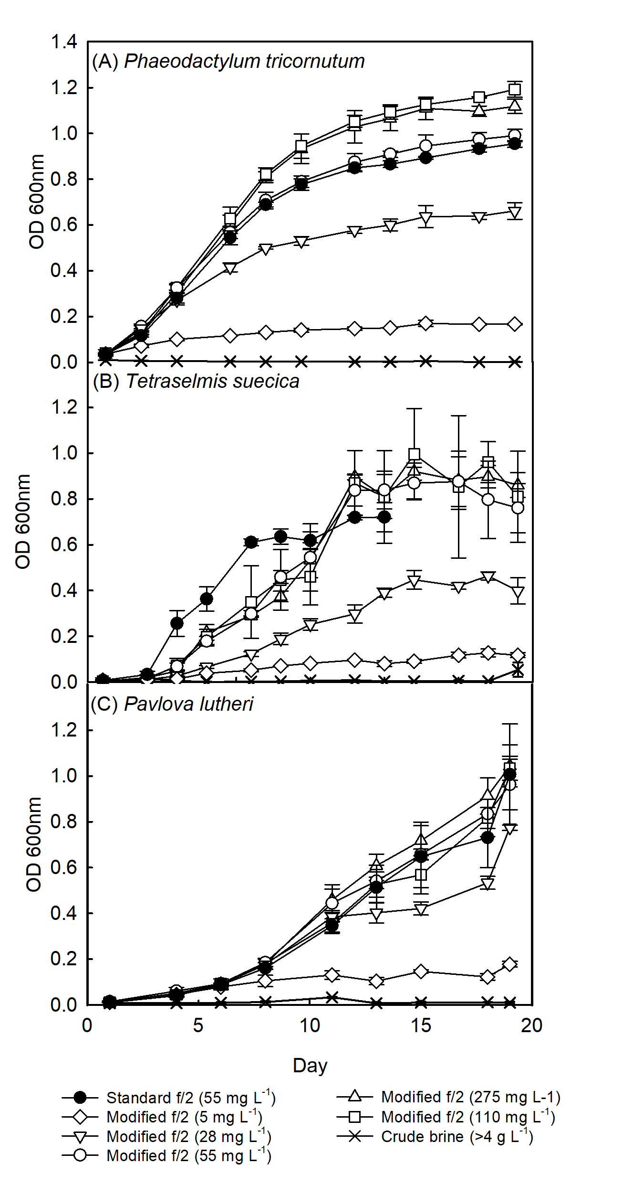
Figure 1: Nitrate from brine wash supports the growth of marine microalgae. Growth (OD₆₀₀ nm) of (A) Phaeodactylum tricornutum, (B) Tetraselmis suecica and (C) Pavlova lutheri in either standard f/2 media containing 55 mg L⁻¹ nitrate or modified media in which the nitrate was supplemented with the appropriate amount of brine wash to deliver a concentration of 5 – 275 mg L⁻¹ nitrate (n = 3 ± SD).

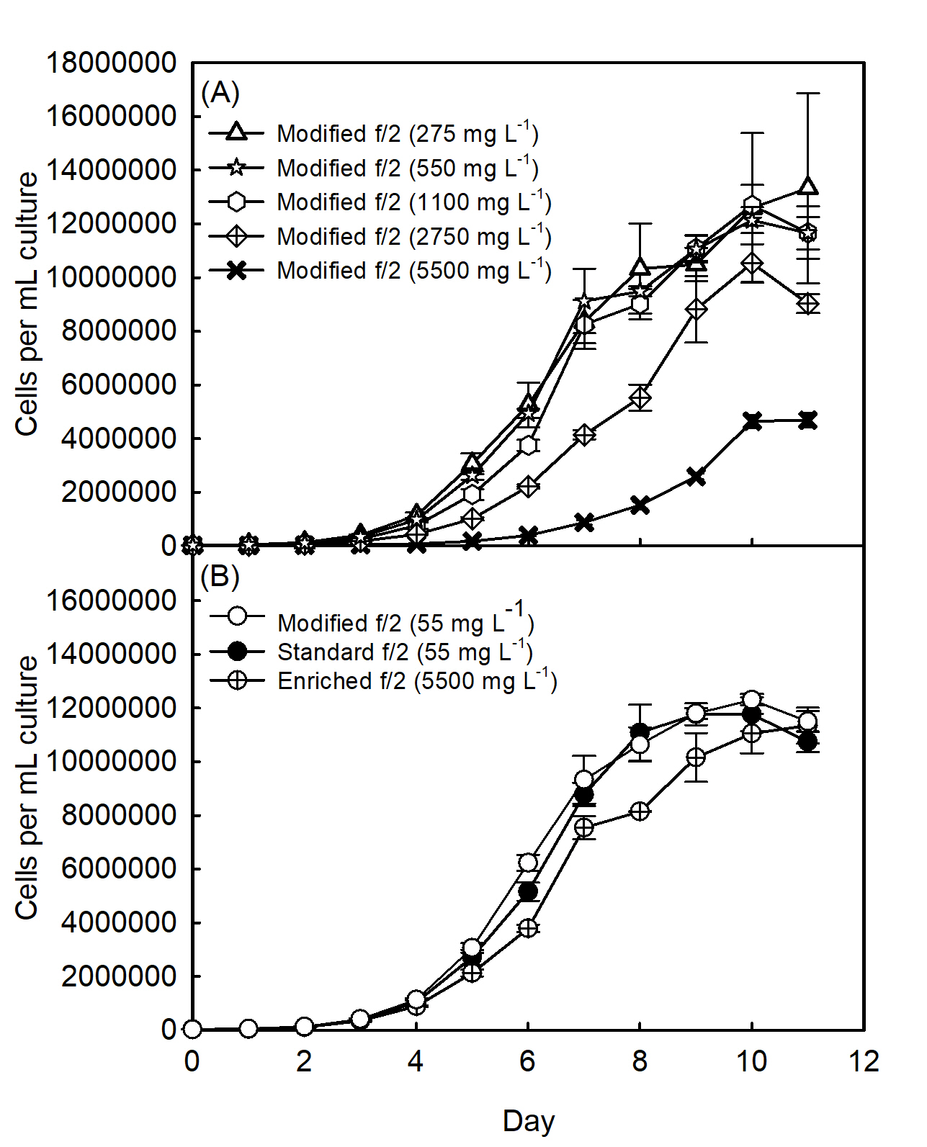
Figure 2: Growth of Phaeodactylum tricornutum in different concentrations of nitrate. Cell number of cultures grown in (A) modified f/2 media supplemented with brine wash (275 – 5500 mg L⁻¹ nitrate) and (B) standard f/2, modified f/2 supplemented with brine wash (55 mg L⁻¹) and enriched f/2 supplemented with brine wash (5500 mg L⁻¹) media (n = 3 ± SD).

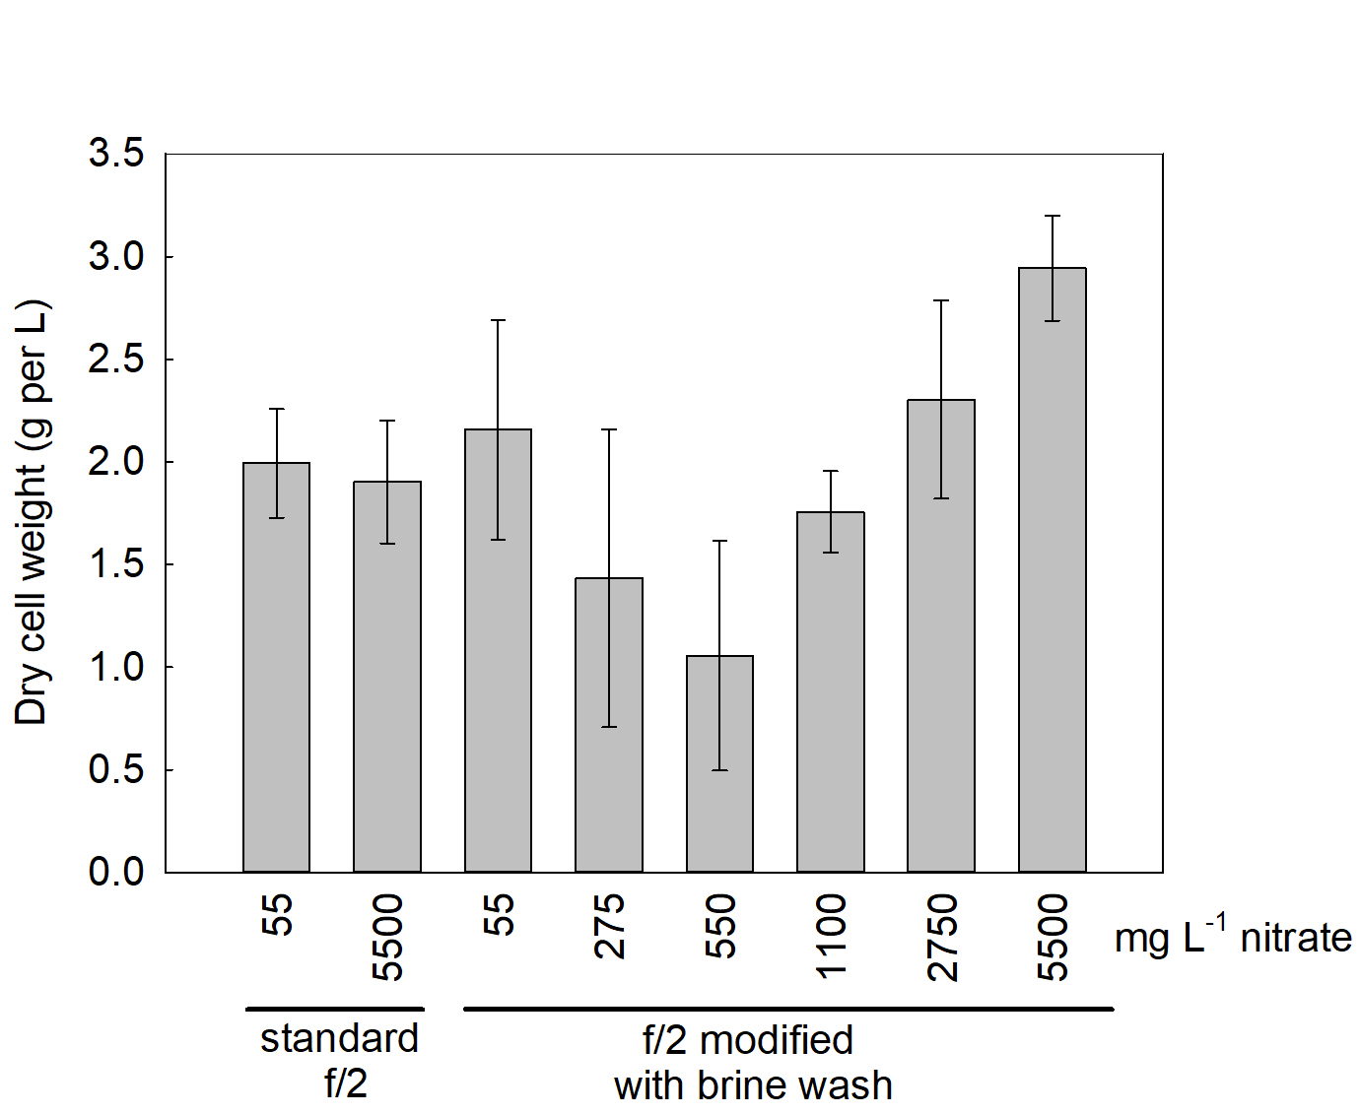
Figure 3: Dry cell weight of Phaeodactylum tricornutum grown on modified f/2 media supplemented with the appropriate amount of brine wash to deliver a concentration of 55 - 5500 mg L⁻¹ nitrate, standard (55 mg L⁻¹) and enriched f/2 (5500 mg L⁻¹) media (n = 3, ± SD).

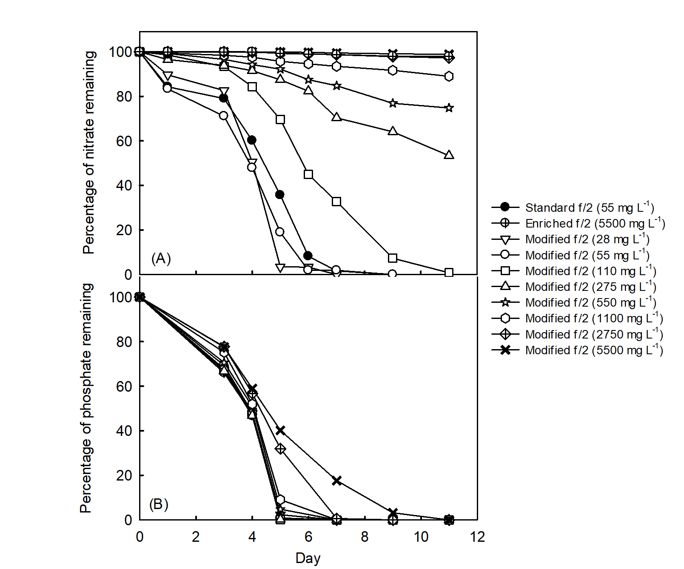
Figure 4: Percentage nitrate (A) and phosphate (B) removed in cultures of Phaeodactylum tricornutum grown on standard, enriched or modified f/2 growth media supplemented with brine wash (numbers on legend are starting media nitrate concentrations) (n = 1).

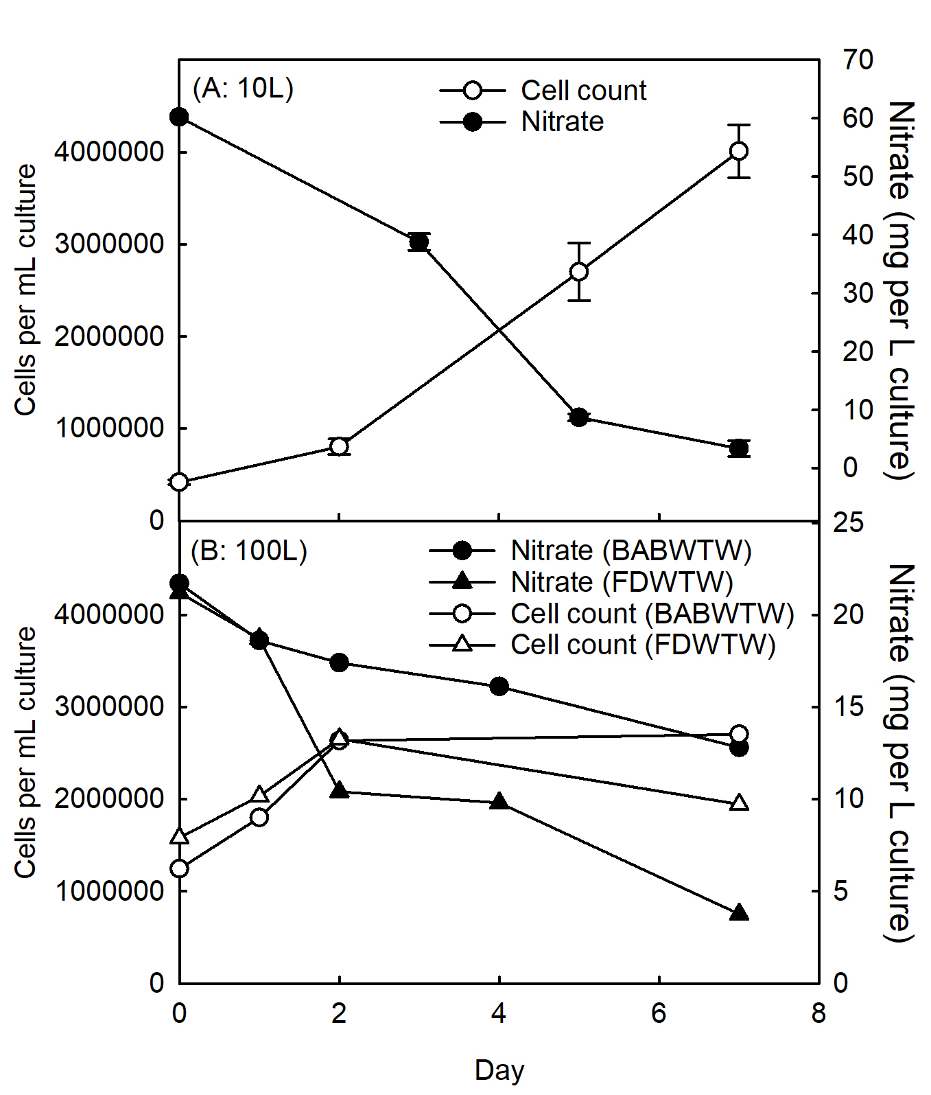
Figure 5. Cell counts per mL culture and media nitrate concentration of Phaeodactylum tricornutum. Cells were grown on modified f/2 growth media supplemented with nitrate brine wash in either (A) 10 L vertical bioreactor (sourced from BABWTW site only) or (B) 100 L horizontal bioreactors (BABWTW and FDWTW sites). Note that the 100 L was made up in 30 – 40 L batches over the first three days. n = 3 for 10 L bioreactors and due to the limited availability of large scale equipment we only have one replicate sample for the 100 L bioreactor.

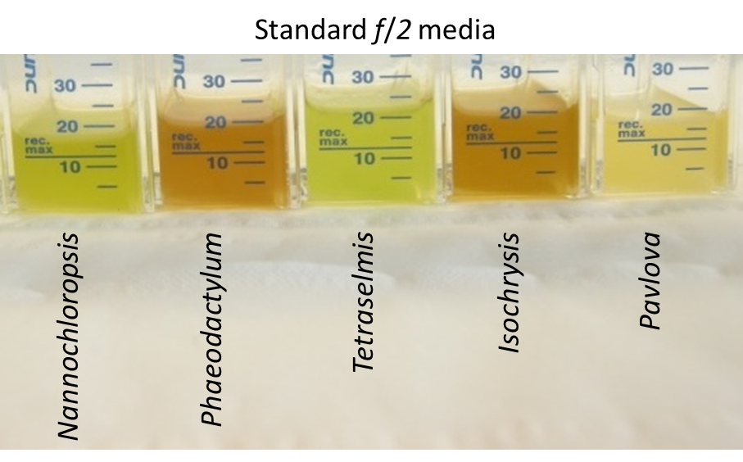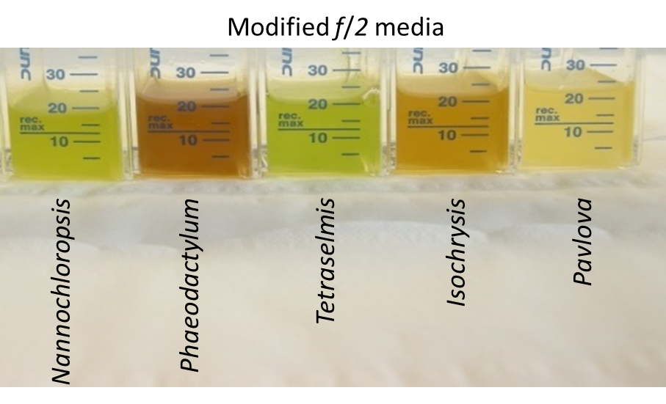
Supplementary figure 1: Cultures of Nannochloropsis oceanica, Phaeodactylum tricornutum, Tetraselmis suecica, Isochrysis galbana and Pavlova lutheri grown on standard or modified f/2 growth media supplemented with brine wash for six days.

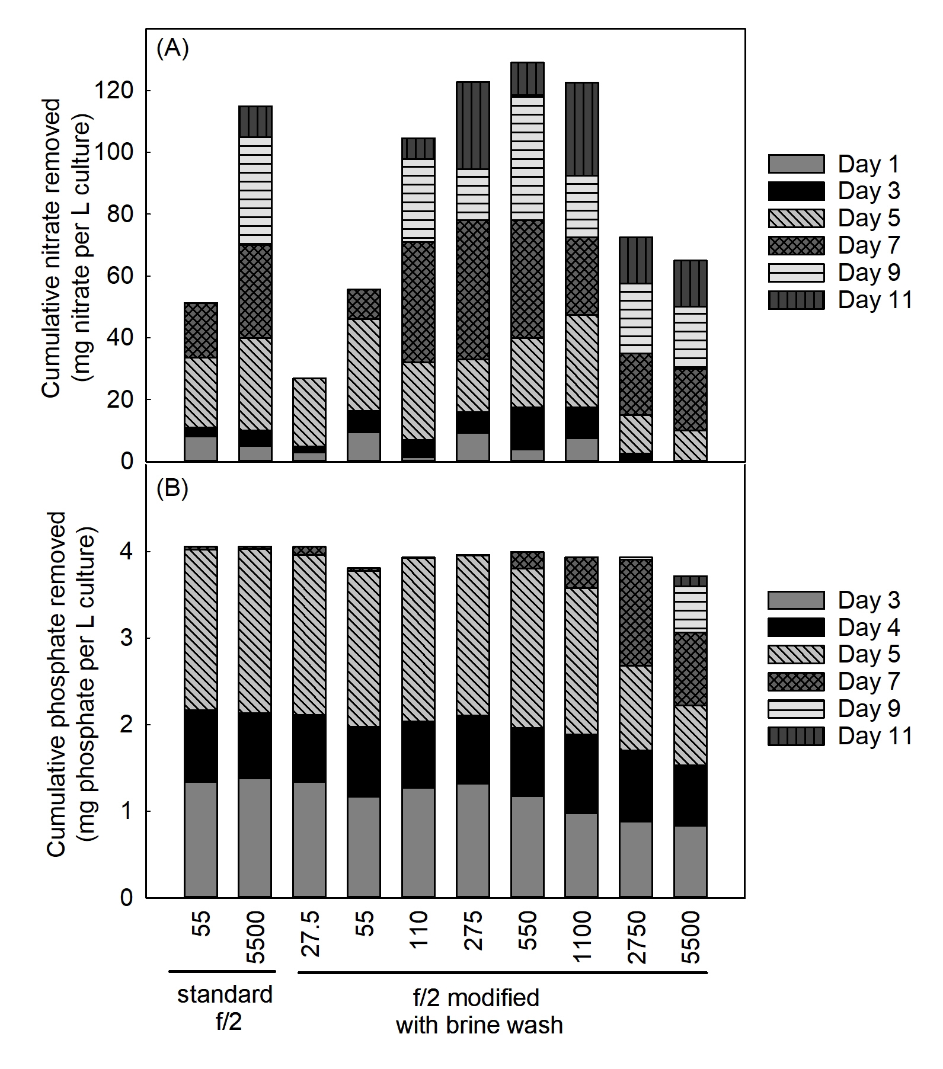
Supplementary figure 2: Cumulative amounts of nitrate (A) and phosphate (B) removed in cultures of Phaeodactylum tricornutum grown on standard, enriched or modified f/2 growth media supplemented with brine wash (numbers on legend are starting media nitrate concentrations) (n = 1).

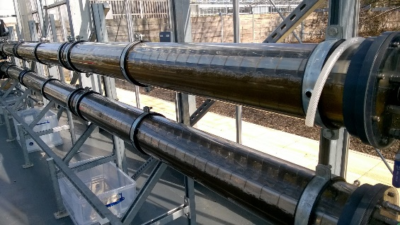
Supplementary figure 3. Phaeodactylum tricornutum growing on 100 L of modified f/2 growth media supplemented with nitrate sourced from nitrate brine wash at BABWTW (top reactor tube) and FDWTW (bottom reactor tube).

