Southern Ocean mesopelagic fish comply with Bergmann’s rule
Ryan A. Saunders* and Geraint A. Tarling

British Antarctic Survey, Natural Environment Research Council, High Cross, Madingley Road, Cambridge, CB3 0ET, UK
*Corresponding author: Email: ryaund@bas.ac.uk, Tel: +44(0)1223 221275, Fax: +44 (0)1223 362616

Key words: Mesopelagic fish; temperature; macroecology; Bergmann’s Rule, Southern Ocean

Short Note in preparation for The American Naturalist
ABSTRACT: The applicability of macroecological rules to patterns in body size varies between taxa. One of the most examined is Bergmann’s rule, which states that body size increases with decreasing temperature and increasing latitude, although the rule is not universal and the proposed mechanisms underpinning it are multifarious and lack congruence. This study considers the degree to which Bergmann’s rule applies to the Southern Ocean mesopelagic fish community. We studied patterns in body size, temperature and latitude across a 12° latitudinal gradient within the Scotia-Weddell sector. Intra-specific Bergmann’s rule was found to apply to 8 out of the 11 biomass-dominant species in the family Myctophidae. The rule was also apparent at an inter-specific level. Our study suggests that greater attainable body size in this community is a necessary attribute to reach colder regions further south. The adherence of these taxa to Bergmann’s rule enables such species to act as sentinels for identifying the drivers and consequences of ocean warming on the Southern Ocean ecosystem.
Introduction
Analysis of large-scale distributions of species has generated a number of ‘ecological rules’, with Bergmann’s rule being one of the oldest and most widely recognised (Bergmann 1847; Meiri 2011). Bergmann’s rule is defined as a geographical tendency within a clade of organisms for size to decrease as temperature increases, or as latitude or altitude decrease (Meiri 2011). Such variation in body size is known for a range of terrestrial and aquatic organisms that are distributed over broad geographic ranges, but the mechanisms underpinning it have remained elusive and controversial (Angilletta et al. 2004). Central to this complexity is the fact that Bergmann’s rule is differentially expressed across taxa, particularly between endothermic and ectothermic taxa, and that the rule has often not been applied independently of other ecological influences (Belk and Houston 2002; Fisher et al. 2010a). There is also some confusion about whether the rule applies to both intra-specific or inter-specific patterns (the former otherwise being known as James’s rule, Blackburn et al. 1999) since they may actually represent very different phenomenon (Chown and Gaston 2010). The importance for improved understanding of macroecological patterns in body size and life history is increasingly clear if we are to predict how organisms and communities will respond to global climate change (Edeline et al. 2013).

To date, only a few studies have been conducted toward understanding Bergmann’s rule in marine fishes. The rule has been found to apply globally to groundfish at a broad taxonomic level (Fisher et al. 2010a). It has also been observed in the early life stages and adults of marine and freshwater fishes, with various selection mechanisms thought to be controlling these patterns to varying degrees (Barneche et al. 2009; Perez and Munch 2010; Rypel 2014; Wilson 2009). However, many others considering adult body sizes have found little evidence of Bergmann’s rule (Choat and Robertson 2002; Macpherson and Duarte 1994; Smith and Brown 2002), which could possibly be attributed to overfishing and climate change homogenising latitudinal patterns (Fisher et al. 2010a; Fisher et al. 2010b). No studies have yet considered the application of Bergmann’s rule to mesopelagic fishes which have seldom been fished commercially. Mesopelagic fish are mainly found from the base of the surface mixed layer (~50 to 100 m) to around 1000 m in most of the world’s oceans, and are one of the most abundant and diverse groups of fish on Earth (Gjøsaeter and Kawaguchi 1980; Irigoien et al. 2014). They are an important trophic link in food webs and also provide a pathway for substantial export of carbon between the sea surface and the deep ocean through their extensive vertical migrations (Pakhomov et al. 1996).

In this study, we consider the applicability of Bergmann’s rule at both the intra- and inter-specific level to the mesopelagic fish family Myctophidae (commonly referred to as myctophids, or lanternfish) in the Southern Ocean. Myctophids, which predominantly range between ~60 and 200 mm in size, dominate the mesopelagic fish community in this region and are comprised of around 35 species in 12 genera (Hulley 1981), with an estimated biomass of between 70 and 200 Mt (Lubimova et al. 1987). Myctophids are an integral part of the Southern Ocean food web, being both prey for many higher predators (penguins, seals and cetaceans) and major consumers of zooplankton and krill. The Southern Ocean is not a region in which myctophids are fished commercially and fishery-related distortions in body sizes can be excluded as a contributory factor to any compliance with Bergmann’s rule. Virtually nothing is known about the thermal habitat preferences of this taxon in the Southern Ocean and the role of temperature on the ecology of Southern Ocean myctophids has been brought further into focus by rapid ocean warming in this region (Atkinson et al. 2004; Curran et al. 2003; de la Mare 1997; Flores et al. 2012; Hill et al. 2013; Murphy et al. 2007; Whitehouse et al. 2008) and the need to understand the impact this change will have on the structure of the local marine ecosystem.

Materials and methods
Mesopelagic fish were collected across the Scotia Sea (southwest Atlantic: 57.5 °S, 40.0 °W) during three multidisciplinary research surveys in austral spring (Oct-Dec 2006), summer (Jan-Feb 2008) and autumn (Mar-Apr 2009). Each survey spanned the entire Scotia Sea region from the Antarctic Polar Front to the seasonal sea ice zone (Collins et al. 2012), with environmental and biological data collected repeatedly at fixed stations that encompassed the predominant water masses and frontal zones of the region (Venables et al. 2012). The samples were collected using a 25 m² rectangular mid-water trawl net (RMT25), which consists of two nets (with 5 mm mesh) that can sample discrete depth layers (Piatkowski et al. 1994) and real-time environmental monitoring of depth, volume filtered, fluorescence and temperature via a SBE-3 temperature sensor that was factory calibrated prior to the surveys and was accurate to ~0.001 °C. At each station, the net was towed obliquely at ~2.5 knots for 30-60 mins such that depth-stratified hauls were undertaken between 0-200, 200-400, 400-700 and 700-1000 m. These zones were sampled by day and night during the spring and summer, and during dark hours only in autumn. A total of 146 hauls were obtained during the study.

All fish samples were sorted at sea to the lowest taxonomic level possible (Hulley 1990) and measured to the nearest mm using standard length (SL). Temperature measurements were logged for the entire duration of the depth-discrete trawls and a median temperature value was calculated for each haul. These values were then assigned to each fish length record obtained in the respective net haul and data were pooled across all surveys, regions and depths to provide a representative overview of the thermal environment occupied by each myctophid species. In this way, we were able to assign a specific temperature to each individual depending on where in the water column it was captured. The latitudinal mid-point of each net haul was also assigned to the respective fish length records.

For each species, a median temperature and latitude value was calculated for every 1 mm size class from the aggregated data sets to investigate intra-specific relationships between body size, temperature and latitude. Bergmann’s rule was evaluated by correlating body size with temperature and latitude for each species. Significant negative correlations with temperature and positive correlations with latitude were interpreted as evidence for Bergmann’s rule. Both simple linear and non-linear models were used to explore these relationships and the best model fit was selected based on R² following significant (P<0.05) outcomes. Additionally, mixed models were fitted to the raw body size and temperature data for species conforming to Bergmann’s rule. For this approach, a random slope and intercept mixed model was identified as optimal for our data, where body size was the response variable, temperature a fixed effect predictor variable and season (cruise) a random effect variable (Zuur et al. 2009). In each case, our data were significant (P<0.05) within this modelling framework. In the case of Brauer’s lanternfish Gymnoscopelus braueri, for example, temperature significantly affected body size (SL), lowering it by ~8 mm ± 3.2 (standard errors), with the random effect of seasonality accounting for a variance of 35 mm. However, the residual variance (i.e. variance outside of our measured parameters) was considerably higher (515 mm), demonstrating that the random effect of seasonality was relatively low compared to other possible factors. We therefore concluded that the simple linear model approach was sufficient in identifying the clear trends within the datasets without the need for adding further model complexity. Furthermore, the simple linear model approach could be applied to the whole myctophid community, whereas the mixed model approach could only be applied to 4 species that were sufficiently numerous for such a test.

Inter-specific relationships between body size, temperature and latitude were also investigated to examine further the validity of Bergmann’s rule in Southern Ocean myctophids. For this analysis, the maximum body size of each species was correlated with the minimum temperature and the southernmost latitude at which it occurred. We used the lower 25th percentile values of each species’ pooled temperature data set to represent the temperature minima, whilst the upper 75th percentile of the latitude data sets was used to represent the latitude maxima. Our intra-specific analyses were restricted to the 11 most abundant species caught during the surveys that had sample sizes >50. However, the inter-specific analysis was extended to include other species that had sample sizes >10. Following Rypel (2014), spatial autocorrelation was not addressed in this study in order to maintain simplicity until such time that issues concerning this subject have been sufficiently resolved (Beck et al. 2012; Hawkins 2012; Kuhn and Dormann 2012).

Results
A total of 6858 body size and concurrent temperature measurements representing 18 species of myctophid fish were obtained for the present study. The measurements were collected between 48 and 60 °S over a seasonal and latitudinal temperature range of approximately +4 to -1 °C. Data underlying figs 1-3 are deposited in the Dryad Digital Repository (location to be confirmed upon manuscript submission).

All species occupied a relatively narrow median temperature range between ~0 and 3 °C, but there were differences in range between species, suggesting species-specific thermal habitat preferences (fig. 1). Consistent with Bergmann’s rule, there were significant (P <0.01) negative correlations between intra-specific body size and temperature for Antarctic lanternfish Electrona antarctica, Fraser’s lanternfish Gymnoscopelus fraseri, Nichol’s lanternfish Gymnoscopelus nicholsi, Brauer’s lanternfish Gymnoscopelus braueri, Tenison’s lanternfish Protomyctophum tenisoni, Bolin’s lanternfish Protomyctophum bolini and gaptooth lanternfish Protomyctophum choriodon (fig. 1). Correspondingly, there was a significant (P <0.01) positive correlation with latitude for each of these species (fig. 2). Intra-specific Bergmann’s rule was not observed for Gymnoscopelus opisthopterus and Nannobrachium achirus, which resided predominantly in the thermally uniform deep water masses, or Carlsberg’s lanternfish Electrona carlsbergi that had only a limited size range in the study region. Partial Bergmann’s rule was observed for rhombic lanternfish Krefftichthys anderssoni, which showed a significant (P <0.0001) positive correlation with latitude, but no significant (P >0.05) relationship with temperature.

Bergmann’s rule was also observed among species within the Southern Ocean myctophid community, as maximum body size was significantly (P <0.01) correlated both negatively with the lowest temperature preferendum and positively with the maximum latitudinal preferendum (fig. 3). Thermal tolerance and the southernmost distributional limit of a species was therefore dependent upon the maximum size that a species can attain, such that species unable to attain a body size of more than ~100 mm cannot reside in high latitude waters <1.5 °C, whilst those only able to attain a maximum size of ~50 mm cannot inhabit waters <2.5 °C, which are characteristic of the Scotia Sea.

Discussion
We found that, in the Southern Ocean, Bergmann’s rule was obeyed by the majority of myctophid species at the intra-specific level and by the myctophid community at the inter-specific level over a 4 °C temperature range. Intra-specifically, median standard length significantly increased in 8 out 11 species for latitude and 7 out 11 species for temperature. At the inter-specific level, maximum attainable body size was found to be positively related to southernmost range, and negatively related to lowermost temperature. Myctophid species that attain a larger maximum body size therefore appear to have a greater capacity to persist in colder, higher latitude regions of the Southern Ocean. Furthermore, this study highlights that Bergmann’s rule applies to ectotherms that inhabit cold environments characterised by narrow temperature ranges, as much as to those that occur over broader thermal and latitudinal gradients.

Myctophids have life-cycles that generally last between 2 and 5 years (Gjøsaeter and Kawaguchi 1980). They are social animals that move through the oceans in schools that vary in size that can be extensive (Saunders et al. 2013). These fish are principally planktivores, feeding on copepods and euphausiids in the surface layers that they migrate into at night-time before returning to mesopelagic depths during the day (Shreeve et al. 2009). Most myctophid species that occur in the Scotia Sea appear to have their core populations centred around sub-Antarctic, or temperate latitudes, with only fractions of the populations undertaking southward migrations to waters at higher latitudes (Saunders et al. 2017). Further aspects of the behaviour of these organisms is relatively unknown, particularly with regards horizontal migration behaviour and how they locate patches of food. The Scotia-Weddell Sea area contains a number of oceanic fronts (Gordon et al. 1970; Orsi et al. 1995) where passively drifting organisms aggregate and productivity is enhanced (Kahru et al. 2007; Ward et al. 2012). Increased productivity is also apparent at the marginal ice zone because of surface layer stratification and fertilisation from melting ice (Smith and Nelson 1986). Searching for these prey hotspots is likely to be a major driver of the southward migration of myctophids.

Evidence that these individuals do not return from this journey south and form sink populations in the study region was presented by Saunders et al. (2017), who examined the length frequency structure and distribution of myctophid communities throughout the Scotia-Weddell region. With the exception of Antarctic lanternfish Electrona antarctica and rhombic lanternfish Krefftichthys anderssoni, there was no indication of any local recruitment, either through capture of larvae within large scale, multiyear plankton net surveys, or through the appearance of young cohorts in the population size structure. This is in agreement with the findings of Oven et al. (1990), who only found that any evidence of ovarian maturation in any species of Southern Ocean myctophid was rare. Furthermore, there is a lack of evidence that these populations make a northward breeding migration. Analyses of seasonal population body size frequencies did not show a decrease in the relative size of any cohort at any time of year, apart from gaptooth lanternfish Protomyctophum choriodon which was not found in the region in spring and seems to make a southward migration away from the northern Scotia Sea between summer and autumn. Therefore, the vast majority of Southern Ocean myctophids appear to be expatriates in Antarctic waters that are most likely lost to the breeding population.

Although the majority of species complied with intra-specific Bergmann’s rule, the exceptions require further scrutiny. Carlsberg’s lanternfish Electrona carlsbergi showed a relatively narrow distributional range, mainly centred between 54 and 56 °S and between 1.5 and 2 °C, from which it was difficult to establish whether any trend was apparent. Rhombic lanternfish Krefftichthys anderssoni, Gymnoscopelus opisthopterus and Nannobrachium achirus, on the other hand, spanned at least 8° of latitude over which significant relationships were observed. What was notable in each of these three species was the corresponding temperature ranges, which were comparatively narrow across these latitudes. This was particularly marked in rhombic lanternfish Krefftichthys anderssoni, which had a narrow range clustered around 2 °C. This suggests these fish maintain a vertical distribution that minimises fluctuation in temperature throughout their latitudinal range. For instance, although temperatures of around 2 °C can be found through much of the water column at latitudes of around 54 to 55 °S, this temperature still exists to around 57 °S within Circumpolar Deep Water at depths of between 300 and 700 m (Venables et al. 2012). Our data showed that these three species were predominantly distributed in this thermally stable water mass (Saunders et al. 2015). An implication of this pattern is that these organisms do not migrate into the surface layers to feed, and instead, have an alternative feeding strategy that focusses on deeper living prey, such as mesopelagic copepods, or amphipods. Overall, these exceptions to Bergmann’s rule serve to highlight that most other Southern Ocean myctophid species occupy many different parts of the water column and the need to migrate vertically and feed on the high concentrations of zooplankton in the surface layers overrides any drive to thermoregulate.

Although compliance with Bergmann’s rule has been found in many ectothermic taxa, determination of the mechanism driving the pattern is difficult and those that have been proposed have been multifarious and diverse (Watt et al. 2010). Central to the debate is whether the pattern itself is a manifestation of phenotypic plasticity or natural selection on heritable traits (Mousseau 1997; Partridge and Coyne 1997; Stillwell 2010; Van Voorhies 1996). Many reviews have concluded that the pattern is likely to result from the convergence of a number of different mechanisms that either support or counteract each other depending on the particular set of abiotic and biotic factors that are most influential to the taxon in question (Blackburn et al. 1999; Watt et al. 2010). Amongst those studies that have focussed on phenotypic mechanisms, the majority have considered the relationship between growth and temperature in the laboratory (Angilletta and Dunham 2003; Atkinson 1994), and it is rare that an example can be provided where genotypic selection can be excluded as a contributory factor to distributional trends in body size in the natural environment. Since our evidence suggests that local selection mechanisms appear unlikely to operate within these myctophid sink populations, the present case study potentially allows us to investigate the capacity for phenotypic plasticity alone to drive Bergmann’s rule in a major group of ectotherms. Furthermore, given that Southern Ocean myctophids appear to be, on the whole, non-returning, sterile expatriates, any observed plasticity in body size versus temperature and latitude is mostly likely to be non-adaptive.

Amongst phenotypic-based mechanisms to explain Bergmann’s rule, the “resource availability” hypothesis advocates that organisms reach a larger size where levels of productivity are higher (Dunbrack and Ramsay 1993) or food quality is greater (Ho et al. 2009). This has a certain resonance with the ever-southward search of myctophids for rich patches of prey, but would not equate to patterns of overall productivity which are generally greatest at intermediate latitudes (Blackburn et al. 1999; Park et al. 2010). Whether the quality of zooplankton prey is higher further south is also questionable. Alternatively, the “migration ability” hypothesis proposes that smaller individuals have a lower dispersal ability (Blackburn and Gaston 1996). Very little is known about the swimming dynamics of myctophids although it is implicit that the larger species have a higher Reynolds number and a greater ability to overcome drag (Fuiman and Batty 1997). In their journey south, these individuals will have to cross the Antarctic Circumpolar Current, with average velocities of 20 cm s⁻¹ (Klinck and Nowlin Jr 2001) which may be better negotiated by individuals with larger body sizes. The Southern Ocean is also a highly seasonal environment which may favour larger individuals with greater resistance to starvation. The “starvation resistance” hypothesis was, for example, seen to apply to body size trends in Arctic char Salvelinus alpinus, in which small individuals were seen to die before large ones when starved in a simulation of the likely overwintering scenario (Byström et al. 2006). Myctophids have a multiyear life cycle in which resource scarcity over multiple winters must be overcome, which may favour larger individuals.

In investigating the myctophid community, this study was able to consider inter-specific alongside intra-specific Bergmann’s rule. At a broad taxonomic level, it is widely accepted that mechanisms driving Bergmann’s rule at an intra-specific level may be different from those at an inter-specific level (Blackburn et al. 1999; Meiri 2011). Nevertheless, the significant relationships between body size and temperature and latitude found in our inter-specific analysis particularly favour the argument that the ability to achieve a larger body size is a precondition to myctophids being able to occupy colder, higher latitude regions. Had this not been the case, we would otherwise expect a much broader range of maximum attainable body sizes at colder temperatures and higher latitudes. Inter-specifically therefore, our evidence provides greater support to hypotheses in which body size enables persistence within colder, higher latitude regions, such as the “migration ability” and “starvation resistance” hypotheses. In all likelihood, the true suite of drivers of the observed pattern are likely to be multiple but amongst these, we suggest swimming capability and energetics as having a major influence.

Many regions of the Southern Ocean are warming rapidly, and a realistic prediction for the Southern Ocean myctophid community is that the southernmost distributional range could increase for many temperate species (e.g. Carlsberg’s lanternfish Electrona carlsbergi), but contract for true Antarctic species such as Antarctic lanternfish Electrona antarctica. Given the compliance to inter-specific Bergmann’s rule in this taxon, this biogeographic shift would be predicted to result in the overall range in species body sizes becoming smaller within the Southern Ocean. At the intra-specific level, strict adherence to Bergmann’ rule implies that the warming temperatures would allow smaller individuals to persist at increasingly high latitudes. This reduction in body size both within and between species will affect both the predation impact of this community on the size spectra of their zooplankton prey (Saunders et al. 2015; Shreeve et al. 2009) and their suitability as prey items to higher predators (Cherel et al. 1997; Olsson and North 1997). The pivotal role these species play in the Southern Ocean ecosystem means that they can act as sentinel species for identifying the drivers and impacts of change in this system (Hobday and Pecl 2014). Our identification of macroecological rules that govern the distribution and size structure of a major component of the Southern Ocean ecosystem is therefore an important step to being able to predict how this system will respond to further climatic change.

Acknowledgements
This work was undertaken as part of the British Antarctic Survey’s POETS and SCOOBIES Projects within the Ecosystems programme, funded by the UK’s Natural Environment Research Council. We thank the officers, crew and scientists of the RRS James Clark Ross for their assistance during the three research cruises. We also thank M. Collins, G. Stowasser and E. Foster for assisting with fieldwork and lab work. This manuscript was improved by constructive feedback from two anonymous reviewers.
Literature cited
Angilletta, M. J., T. D. Steury, and M. W. Sears. 2004. Temperature, growth rate, and body size in ectotherms: Fitting pieces of a life-history puzzle. Integrative and Comparative Biology 44:498-509.
Angilletta, M. J. J., and A. E. Dunham. 2003. The temperature-size rule in ectotherms: Simple evolutionary explanations may not be general. The American Naturalist 162:332-342.
Atkinson, A., V. Siegel, and P. Rothery. 2004. Long-term decline in krill stock and increase in salps within the Southern Ocean. Nature 432:100-103.
Atkinson, D. 1994. Temperature and organism size: a biological law for ectotherms? Advances in Ecological Research 25:1-58.
Barneche, D. R., S. R. Floeter, D. M. Ceccarelli, D. M. B. Frensel, D. F. Dinslaken, H. F. S. Mario, and C. E. L. Ferreira. 2009. Feeding macroecology of territorial damselfishes (Perciformes: Pomacentridae). Marine Biology 156:289-299.
Beck, J., L. Ballesteros-Mejia, C. M. Buchmann, J. Dengler, S. A. Fritz, B. Gruber, C. Hof et al. 2012. What's on the horizon for macroecology? Ecography 35:673-683.
Belk, M. C., and D. D. Houston. 2002. Bergmann's rule in ectotherms: A test using freshwater fishes. The American Naturalist 160:803-808.
Bergmann, C. 1847. Ueber die Verhaltnisseder Warmeokonomie der thiere zu ihrer grosse. Gottinger Studien 1:595-708.
Blackburn, T. M., and K. J. Gaston. 1996. Spatial patterns in the geographic range sizes of bird species in the New World. Philosophical Transactions of the Royal Society B: Biological Sciences 351:897-912.
Blackburn, T. M., K. J. Gaston, and N. Loder. 1999. Geographic gradients in body size: a clarification of Bergmann's rule. Diversity and Distributions 5:165-174.
Byström, P., J. Andersson, A. Kiessling, and L. O. Eriksson. 2006. Size and temperature dependent foraging capacities and metabolism: consequences for winter starvation mortality in fish. Oikos 115:43-52.
Cherel, Y., C. Guinet, and Y. Tremblay. 1997. Fish prey of Antarctic fur seals Arctocephalus gazella at Ile de Croy, Kerguelen Polar Biology 17:87-90.
Choat, J. H., and D. R. Robertson. 2002. Age-based studies on coral reef fishes, Pages 57-80 in P. F. Sale, ed. Coral reef fishes: dynamics and diversity in a complex ecosystem. San Diego, Academic Press.
Chown, S. L., and K. J. Gaston. 2010. Body size variation in insects: a macroecological perspective. Biological Reviews 85:139-169.
Collins, M. A., G. Stowasser, S. Fielding, R. Shreeve, J. C. Xavier, H. J. Venables, P. Enderlein et al. 2012. Latitudinal and bathymetric patterns in the distribution and abundance of mesopelagic fish in the Scotia Sea. Deep-Sea Research Part II-Topical Studies in Oceanography 59-60:189-198.
Curran, M. A. J., T. D. van Ommen, V. I. Morgan, K. L. Phillips, and A. S. Palmer. 2003. Ice core evidence for sea ice decline since the 1950s. Science 302:1203-1206.
de la Mare, W. K. 1997. Abrupt mid-twentieth-century decline in Antarctic sea ice extent from whaling records. Nature 389:387-400.
Dunbrack, R. L., and M. A. Ramsay. 1993. The allometry of mammalian adaptations to seasonal environments: a critique of the fasting endurance hypothesis. Oikos 66:336-342.
Edeline, E., G. Lacroix, C. Delire, N. Poulet, and S. Legendre. 2013. Ecological emergence of thermal clines in body size. Global Change Biology 19:3062-3068.
Fisher, J. A. D., K. T. Frank, and W. C. Leggett. 2010a. Breaking Bergmann's rule: truncation of Northwest Atlantic marine fish body sizes. Ecology 91:2499-2505.
Fisher, J. A. D., K. T. Frank, and W. C. Leggett. 2010b. Global variation in marine fish body size and its role in biodiversity-ecosystem functioning. Marine Ecology Progress Series 405:1-13.
Flores, H., A. Atkinson, S. Kawaguchi, B. A. Krafft, G. Milinevsky, S. Nicol, C. Reiss et al. 2012. Impact of climate change on Antarctic krill. Marine Ecology Progress Series 458:1-19.
Fuiman, L., and R. Batty. 1997. What a drag it is getting cold: partitioning the physical and physiological effects of temperature on fish swimming. Journal of Experimental Biology 200:1745-1755.
Gjøsaeter, J., and K. Kawaguchi. 1980. A review of the world resources of mesopelagic fish. FAO (Food and Agriculture Organization of the United Nations) Fisheries Technical Paper 193:1-151.
Gordon, A. L., R. D. Goldberg, and K. Hunkins. 1970, Circumpolar Characteristics of Antarctic Waters and Sound Channels in Antarctic waters. New York, American Geographical Society.
Hawkins, B. A. 2012. Eight (and a half) deadly sins of spatial analysis. Journal of Biogeography 39:1-9.
Hill, S. L., T. Phillips, and A. Atkinson. 2013. Potential climate change effects on the habitat of Antarctic krill in the Weddell quadrant of the Southern Ocean. PloS one 8:1-12.
Ho, C.-K., S. C. Pennings, and T. H. Carefoot. 2009. Is diet quality an overlooked mechanism for Bergmann’s rule? The American Naturalist 175:269-276.
Hobday, A. J., and G. T. Pecl. 2014. Identification of global marine hotspots: sentinels for change and vanguards for adaptation action. Reviews in Fish Biology and Fisheries 24:415-425.
Hulley, P. A. 1981. Results of the research cruises of FRV "Walther Herwig" to South America. 58. Family Myctophidae (Osteichthyes, Myctophiformes). Archiv fur Fischereiwissenschaft 31:1-300.
Hulley, P. A. 1990. Myctophidae, Pages 146-178 in O. Gon, and P. C. Heemstra, eds., Fishes of the Southern Ocean. Grahamstown, J.L.B. Smith Institute of Ichthyology.
Irigoien, X., T. A. Klevjer, A. Rostad, U. Martinez, G. Boyra, J. L. Acuna, A. Bode et al. 2014. Large mesopelagic fishes biomass and trophic efficiency in the open ocean. Nature Communications 5:3271.
Kahru, M., B. G. Mitchell, S. T. Gille, C. D. Hewes, and O. Holm-Hansen. 2007. Eddies enhance biological production in the Weddell-Scotia confluence of the Southern Ocean. Geophysical Research Letters 34:L14603.
Klinck, L., and W. Nowlin Jr. 2001. Southern Ocean-Antarctic Circumpolar Current, Pages 1-11, Encyclopedia of Oceanography. San Diego, Academic Press.
Kuhn, I., and C. F. Dormann. 2012. Less than eight (and a half) misconceptions of spatial analysis. Journal of Biogeography 39:995-998.
Lubimova, T., K. Shust, and V. Popkov. 1987, Specific features in the ecology of Southern Ocean mesopelagic fish of the family Myctophidae: Biological resources of the Arctic and Antarctic. Moscow, Nauka Press.
Macpherson, E., and C. M. Duarte. 1994. Patterns in species richness, size and latitudinal range of east Atlantic fishes. Ecography 17:242-248.
Meiri, S. 2011. Bergmann's Rule - what's in a name? Global Ecology and Biogeography 20:203-207.
Mousseau, T. A. 1997. Ectotherms follow the converse to Bergmann's rule. Evolution 51:630-632.
Murphy, E. J., P. N. Trathan, J. L. Watkins, K. Reid, M. P. Meredith, J. Forcada, S. E. Thorpe et al. 2007. Climatically driven fluctuations in Southern Ocean ecosystems. Proceedings of the Royal Society B-Biological Sciences 274:3057-3067.
Olsson, O., and A. W. North. 1997. Diet of the King Penguin Aptenodytes patagonicus during three summers at South Georgia. Ibis 139:504-512.
Orsi, A. H., T. Whitworth, and W. D. Nowlin. 1995. On the meridional extent and fronts of the Antarctic Circumpolar Current. Deep-Sea Research I 42:641-673.
Oven, L. S., M. P. Konstantinova, and N. F. Shevchenko. 1990. Aspects of of reproduction and feeding of myctophids (Myctophidae) in the southwest Atlantic. Journal of Ichthyology 30:115-127.
Pakhomov, E. A., R. Perissinotto, and C. D. McQuaid. 1996. Prey composition and daily rations of myctophid fishes in the Southern Ocean. Marine Ecology Progress Series 134:1-14.
Park, J., I.-S. Ohb, H.-C. Kim, and S. Yoo. 2010. Variability of SeaWiFs chlorophyll-a in the southwest Atlantic sector of the Southern Ocean: Strong topographic effects and weak seasonality. Deep Sea Research Part I: Oceanographic Research Papers 57:604–620.
Partridge, L., and J. A. Coyne. 1997. Bergmann's rule in ectotherms: is it adaptive? Evolution 51:632-635.
Perez, K. O., and S. B. Munch. 2010. Extreme selection on size in the early lives of fish. Evolution 64:2450-2457.
Piatkowski, U., P. G. Rodhouse, M. G. White, D. G. Bone, and C. Symon. 1994. Nekton community of the Scotia Sea as sampled by the RMT 25 during austral summer. Marine Ecology Progress Series 112:13-28.
Rypel, A. L. 2014. The Cold-Water Connection: Bergmann's Rule in North American Freshwater Fishes. The American Naturalist 183:147-156.
Saunders, R. A., M. A. Collins, G. Stowasser, and G. A. Tarling. 2017. Southern Ocean mesopelagic fish communities in the Scotia Sea are sustained by mass immigration. Marine Ecology Progress Series 569:173-185.
Saunders, R. A., M. A. Collins, A. J. W. Ward, G. Stowasser, S. L. Hill, R. S. Shreeve, and G. A. Tarling. 2015. Predatory impact of the myctophid fish community in the Scotia Sea (Southern Ocean). Marine Ecology Progress Series 541:45-64.
Saunders, R. A., S. Fielding, S. E. Thorpe, and G. A. Tarling. 2013. School characteristics of mesopelagic fish at South Georgia. Deep-Sea Research Part I-Oceanographic Research Papers 81:62-77.
Shreeve, R. S., M. A. Collins, G. A. Tarling, C. E. Main, P. Ward, and N. M. Johnston. 2009. Feeding ecology of myctophid fishes in the northern Scotia Sea. Marine Ecology Progress Series 386:221-236.
Smith, K. F., and J. H. Brown. 2002. Patterns of diversity, depth range and body size among pelagic fishes along a gradient of depth. Global Ecology and Biogeography 11:313-322.
Smith, W. O., and D. M. Nelson. 1986. Importance of ice edge phytoplankton production in the Southern Ocean. Bioscience 36:251-257.
Stillwell, R. C. 2010. Are latitudinal clines in body size adaptive? Oikos 119:1387-1390.
Van Voorhies, W. A. 1996. Bergmann size clines: a simple explanation for their occurrence in ectotherms. Evolution 50:1259-1264.
Venables, H., M. P. Meredith, A. Atkinson, and P. Ward. 2012. Fronts and habitat zones in the Scotia Sea. Deep-Sea Research Part II-Topical Studies in Oceanography 59-60:14-24.
Ward, P., A. Atkinson, H. J. Venables, G. A. Tarling, M. J. Whitehouse, S. Fielding, M. A. Collins et al. 2012. Food web structure and bioregions in the Scotia Sea: A seasonal synthesis. Deep-Sea Research Part II-Topical Studies in Oceanography 59-60:253-266.
Watt, C., S. Mitchell, and V. Salewski. 2010. Bergmann's rule; a concept cluster? Oikos 119:89-100.
Whitehouse, M. J., M. P. Meredith, P. Rothery, A. Atkinson, P. Ward, and R. E. Korb. 2008. Rapid warming of the ocean around South Georgia, Southern Ocean, during the 20th century: Forcings, characteristics and implications for lower trophic levels. Deep-Sea Research Part I-Oceanographic Research Papers 55:1218-1228.
Wilson, A. B. 2009. Fecundity selection predicts Bergmann's rule in syngnathid fishes. Molecular Ecology 18:1263-1272.
Zuur, A. F., E. N. Ieno, N. J. Walker, A. A. Saveliev, and G. M. Smith. 2009, Mixed Effects Models and Extensions in Ecology with R. New York, USA, Springer.

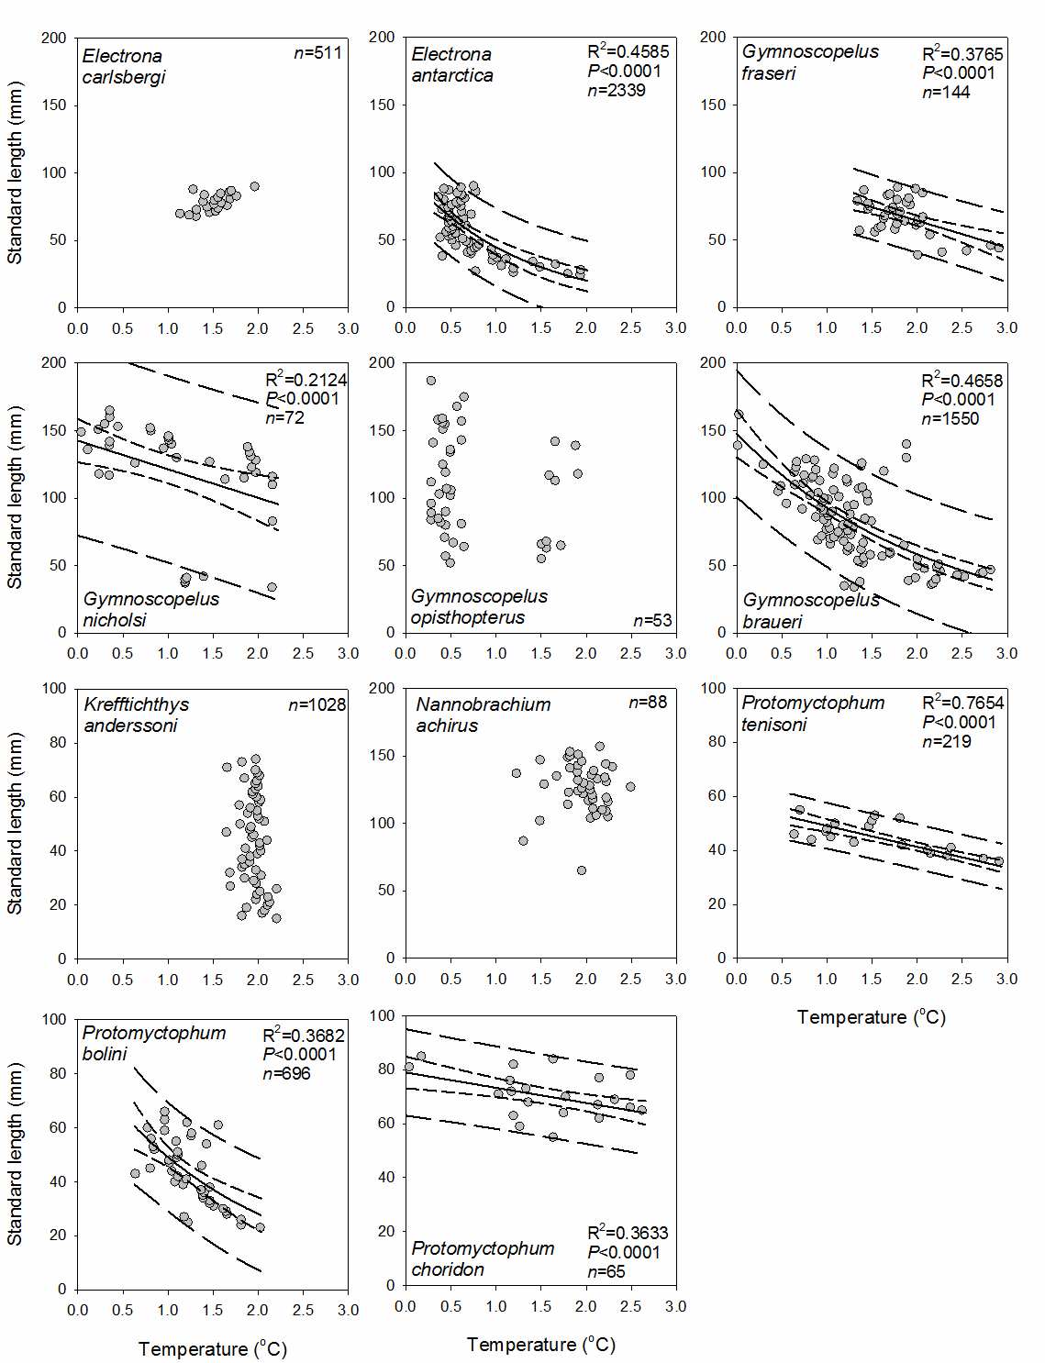
Figure 1: Relationship between body size and temperature (median temperature per 1 mm length class) for 11 species of myctophid fish in the Scotia Sea between 2006 and 2009. The solid black line is the regression fit to the observations, the small dashed lines are the ±95% confidence intervals of the regression, and the large dashed lines are the ±95% confidence intervals of the observations
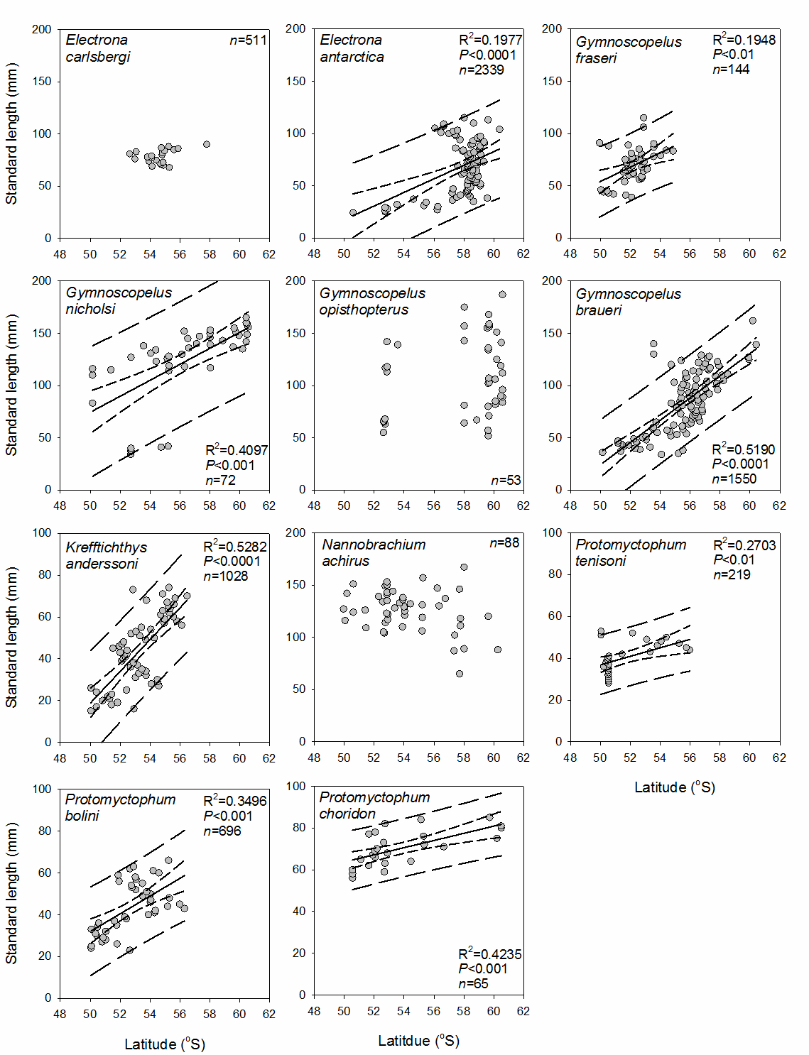
Figure 2: Relationship between body size and latitude (median latitude per 1 mm length class) for 11 species of myctophid fish in the Scotia Sea between 2006 and 2009. The solid black line is the regression fit to the observations, the small dashed lines are the ±95% confidence intervals of the regression, and the large dashed lines are the ±95% confidence intervals of the observations
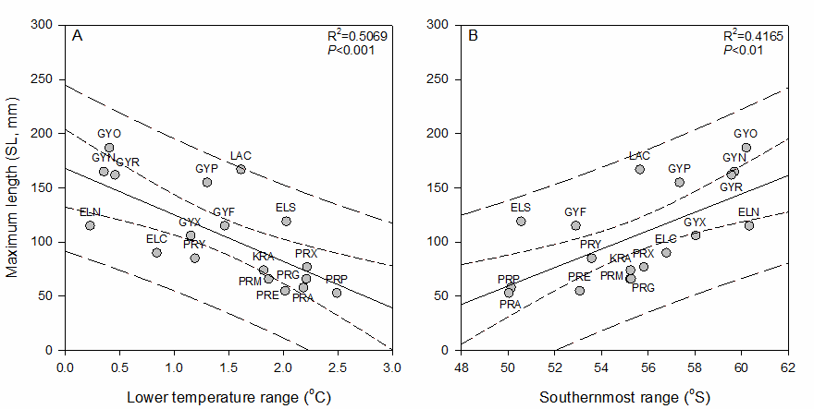
Figure 3: Relationship between the maximum attainable body size (standard length) of myctophid fish species in the Scotia Sea (A) and the lower temperature preferendum and upper latitude preferendum at which they occurred (B). The solid black line is the regression fit to the observations, with the small dashed lines representing the ±95% confidence intervals of the regression. Large dashed lines are the ±95% confidence intervals of the observations. Species are ELC: Carlsberg’s lanternfish Electrona carlsbergi (n= 511), ELN: Antarctic lanternfish Electrona antarctica (n= 2339), ELS: rough lanternfish Electrona subaspera (n= 10), GYF: Fraser’s lanternfish Gymnoscopelus fraseri (n= 144), GYR: Brauer’s lanternfish Gymnoscopelus braueri (n= 1550), GYN: Nichol’s lanternfish Gymnoscopelus nicholsi (n= 72), GYO: Gymnoscopelus opisthopterus (n= 53), GYP: southern blacktip lanternfish Gymnoscopelus piabilis (n= 10), GYX: Gymnoscopelus sp. (n= 10), KRA: rhombic lanternfish Krefftichthys anderssoni (n= 1028), LAC: Nannobrachium achirus (n= 88), PRA: Andriashev’s lanternfish Protomyctophum andriashevi (n= 14), PRE: Tenison’s lanternfish Protomyctophum tenisoni (n= 219), PRG: jewelled lanternfish Protomyctophum gemmatum (n= 10), PRM: Bolin’s lanternfish Protomyctophum bolini (n= 696), PRP: parallel lanternfish Protomyctophum parallelum (n= 29), PRY: gaptooth lanternfish Protomyctophum choriodon (n= 65) and PRX: Protomyctophum sp. (n= 10)
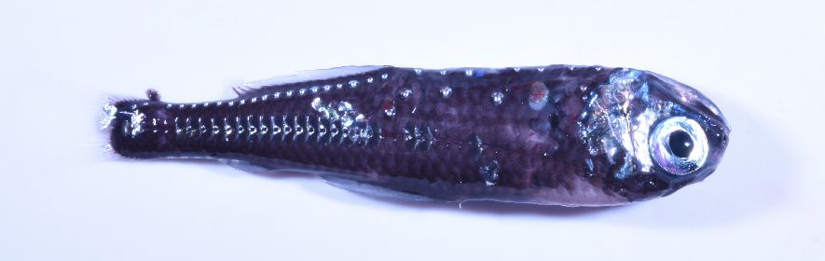
Plate 1: Example of one of the study species, Antarctic lanternfish Electrona antarctica, collected around the South Orkney Islands. The specimen measured 80 mm standard length

