Biodiversity loss from deep-sea mining

Published as:
Van Dover CL, Ardron JA, Escobar E, Gianni M, Gjerde KM, Jaeckel A, Jones DOB, Levin LA, Niner HJ, Pendleton L, Smith CR, Thiele T, Turner PJ, Watling L, Weaver PPE (2017) Biodiversity loss from deep-sea mining. Nature Geoscience 10:464-465. DOI: 10.1038/ngeo2983

To the editor – The emerging deep-sea mining industry is seen by some to be an engine for economic development in the maritime sector¹. The International Seabed Authority (ISA) – the body that regulates mining activities on the seabed beyond national jurisdiction – must also protect the marine environment from harmful effects that arise from mining². The ISA is currently drafting a regulatory framework for deep-sea mining that includes measures for environmental protection. Responsible mining increasingly strives to work with no net loss of biodiversity³. Financial and regulatory frameworks commonly require extractive industries to use a four-tier mitigation hierarchy to prevent biodiversity loss: in order of priority, biodiversity loss is to be avoided, minimized, remediated, and – as a last resort – offset^{4,5}. We argue here that mining with no net loss of biodiversity using this mitigation hierarchy in the deep sea is an unattainable goal.

The first tier of the mitigation hierarchy is avoidance. Potentially useful mitigation strategies in the deep sea include patchwork extraction, whereby some minerals with associated fauna are left undisturbed, or other means to limit the direct mining footprint. Even so, loss of biodiversity will be unavoidable because mining directly destroys habitat and indirectly degrades large volumes of water column and areas of seabed due to generation of sediment plumes enriched in bioavailable metals.

While within-mine biodiversity loss is inevitable, innovative engineering design might reduce (‘minimize”) some risks to far-field biodiversity. For example, shrouds fitted to cutting equipment might reduce dispersion of sediment plumes and the footprint of plume impacts such as burial of organisms. Similarly, vehicle design might limit compaction of seabed sediments. Of course, the efficacy of such efforts in mitigating biodiversity loss would need to be tested.

Remediation addresses the residual loss of biodiversity at and around a mine site after avoidance and minimization interventions. In the deep sea, native species are often slow to recruit and recolonize disturbed habitats. Slow recovery (measured in decades to centuries), enormous spatial scales of mines for certain mineral resources (a single 30-year operation license to mine metal-rich nodules will involve an area about the size of Austria)⁶, and the high cost of working in the deep sea mean that remediation is unrealistic⁷. Further, the science of deep-sea benthic remediation is a nascent field⁸. It is far from established that remediation of industrial mine sites in the deep sea is feasible for any mineral resource, and we know of no remediation actions that can be applied to the water column.

The last resort in the mitigation hierarchy is “in-kind” or “like-for-like” offsets within a biogeographic region. When offsets cannot be located where the affected biodiversity is found, and where the affected biodiversity is important for geographically restricted functions such as connectivity, as is the case for the deep sea, in-kind offsets are not an appropriate mitigation strategy⁹. “Out-of-kind” offsets¹⁰, such as restoring coral reefs in exchange for loss of deep-sea biodiversity, have been proposed, but this practice assumes that loss of largely unknown deep-sea species and ecosystems is acceptable. We question this assumption on scientific grounds. The relationship between any gain in biological diversity in an out-of-kind setting and loss of biological diversity in the deep sea is so ambiguous as to be scientifically meaningless. Further, compensating biodiversity loss in international waters with biodiversity gains in national waters could constitute a transfer of wealth that runs counter to the Law of the Sea, where benefits from deep-seabed mining must accrue to the international community at large, as part of the “common heritage of mankind”. Given the paucity of other industrial activities in the deep sea (except perhaps fisheries), it is difficult to imagine a scenario where “averted risk” offsets¹⁰ could apply; i.e., where a mining operation could avert biodiversity losses from other activities.

The four-tier mitigation hierarchy used so often to minimize biodiversity loss in terrestrial mining and offshore oil and gas operations thus fails when applied to the deep ocean. Residual biodiversity loss cannot be mitigated through remediation or offsets and the goal of no net biodiversity loss is not achievable for deep-seabed mining. Focus therefore must be on avoiding and minimizing harm. Most mining-induced loss of biodiversity in the deep sea is likely to last “forever” on human timescales, given very slow natural rates of recovery in affected ecosystems. It is incumbent on the ISA to communicate to the public the potentially serious implications of this loss of biodiversity and ask for a response.

Authors: C. L. Van Dover^{1*}, J. A. Ardron², E. Escobar³, M. Gianni⁴, K. M. Gjerde⁵, A. Jaeckel⁶, D. O. B. Jones², L. A. Levin⁷, H. Niner⁸, L. Pendleton^{1,9}, C. R. Smith²⁰, T. Thiele¹¹, P. J. Turner¹, L. Watling¹⁰, P. P. E. Weaver¹²
Affiliations:
¹Division of Marine Science and Conservation, Nicholas School of the Environment, Duke University, Beaufort NC 28516, USA.
²National Oceanography Centre Southampton, University of Southampton Waterfront Campus, European Way, Southampton SO14 3ZH, UK.
⁴Deep-Sea Conservation Coalition, Postbus 59681, 1040 LD Amsterdam, Netherlands.
³UNAM ICML-CU, Biodiversidad y Macroecologia, 04510 Mexico City, Mexico.
⁵Wycliffe Management and IUCN Global Marine and Polar Programme, Warsaw, Poland.
⁶Macquarie Law School, Macquarie University, NSW 2109, Australia.
⁷Center for Marine Biodiversity and Conservation, Scripps Institution of Oceanography, UC San Diego, La Jolla, CA 92093-0218 USA.
⁸University College London, Torrens Building, 220 Victoria Square, Adelaide 5000, Australia.
⁹Université de Bretagne Occidentale, UMR6308 AMURE, IUEM, Plouzané, France.
¹⁰ Department of Biology, Edmondson Hall, University of Hawaii at Mānoa, Honolulu HI 96822 USA.

¹¹LSE Institute of Global Affairs, London School of Economics, London WC2A 2AZ, UK.
¹²Seascape Consultants, Romsey, SO51 0QA UK.
*Correspondence to: clv3@duke.edu.

References
1. European Commission. Blue Growth - Opportunities for marine and maritime sustainable growth. (2012). doi:10.2771/43949
2. Levin, L. A. et al. Defining “serious harm’ to the marine environment in the context of deep-seabed mining. Mar. Policy 74, 245-259 (2016).
3. Rainey, H. J. et al. A review of corporate goals of No Net Loss and Net Positive Impact on biodiversity. Oryx 49, 232-238 (2015).
4. Ekstrom, J., Bennun, L. & Mitchell, R. A cross-sector guide for implementing the Mitigation Hierarchy. Cross Sector Biodiversity Initiative (2015).
5. IFC (International Finance Corporation). Performance Standard 6: Biodiversity Conservation and Sustainable Management of Living Natural Resources. (2012).
6. C. R. Smith, L. A. Levin, A. Koslow, P. A. Tyler, A. G. Glover, "The near future of the deep seafloor Ecosystems" in Aquatic Ecosystems: Trends and Global Prospects, N. Polunin, Ed. (Cambridge 2008), pp. 334–349.
7. Van Dover, C. L. et al. Ecological restoration in the deep sea: Desiderata. Mar. Policy 44, 98–106 (2014).
8. Strömberg, S. M., Lundälv, T. & Goreau, T. J. Suitability of mineral accretion as a rehabilitation method for cold-water coral reefs. J. Exp. Mar. Bio. Ecol. 395, 153–161 (2010).
9. Pilgrim, J. D. et al. A process for assessing the offsetability of biodiversity impacts. Conserv. Lett. 6, 376–384 (2013).
10. Business and Biodiversity Offsets Program (BBOP). Guidance Notes to the Standard on Biodiversity Offsets. (2012).
Acknowledgments:
Research leading to these findings was supported by the National Science Foundation (C.L.V.D.), Pew Charitable Trusts (C.L.V.D.), International Climate Initiative (GOBI; C.L.V.D.), Université Occidental de Bretagne and Institut Universitaire Européen de la Mer (C.L.V.D., L.P.), 7th EU Framework (MIDAS #603418; J.A.A., D.O.B.J., M.G., K.M.G., P.P.E.W.), EU Horizon 2020 (MERCES #689518, D.O.B.J.) and the J.M. Kaplan Fund (L.A.L.).

Competing Interests: CVD and LL received research support from Nautilus Minerals; CS received research support from UK Seabed Resources Development Limited.

FIGURE:
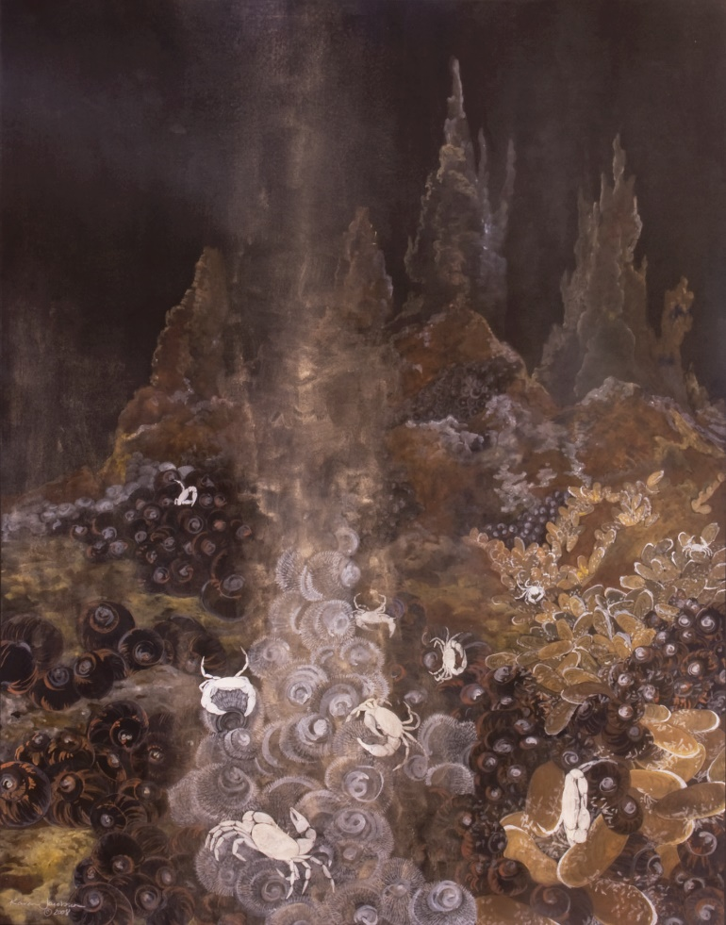
Endemic fauna at the Tahi Moana vent field (Lau Basin). Black snails (Ifremeria nautilei), Hairy snails (Alviniconcha spp.), and mussels (Bathymodiolus spetemdierum) all host chemoautotrophic, endosymbiotic bacteria and live on sulfide deposits that are a target for deep-sea mining. Photo credit: Schmidt Ocean Institute (SOI) / Cherisse Du Preez, Pennsylvania State University, and the Canadian Scientific Submersible Facility (ROPOS).

