Observations and tracking of killer whales (*Orcinus orca*) with shore-based X-band marine radar at a marine energy test site

David L. McCann1 & Paul S. Bell1

1National Oceanography Centre, Joseph Proudman Building, 6 Brownlow Street, Liverpool, L35DA, U.K.

Abstract

The Atlantic killer whale (*Orcinus orca*) is a top-level marine predator with a global range, being found in all of Earth’s oceans. The potential interaction between killer whales and marine renewable energy projects requires surveillance and monitoring efforts that call for new technologies, with marine radar showing promise in the field. Marine radar images recorded at the European Marine Energy Centre (EMEC) were used to track a pair of male killer whales undertaking Surface Active Behavior (SAB) with visual observations used as validation. Using a tidal prediction model, the tide-adjusted, radar-derived target speeds between SAB events provide estimates of swim speeds averaging 4 ms-1 and time between SAB events of 30 s. The similarities between the radar signatures of the animals and sea clutter, combined with their low occurrence compared to other imaged phenomena renders automatic detection with this system difficult. However, the combination of opportunistic radar imagery and independent visual observation has allowed the radar signature of one form of killer whale SAB to be documented. It is hoped that with a greater number of validated observations such as these that automated, radar-based identification and the benefits it will bring to long-term observations at MRE sites will be possible.

Keywords

*Orcinus orca, Marine radar, Surface active behavior, Monitoring, Marine renewable energy, Cetacean tracking, Remote sensing*

Introduction

With the interest and investment in marine renewable energy (MRE) increasing globally there has been increased concern for the potential impact of the developing industry on marine fauna, particularly marine mammals. Two common concerns surrounding the interaction between MRE developments and marine mammals are collision risk and sound pollution (either from construction or operation). At present, however, there is very little data available to quantify these concerns, particularly collision risk for any marine mammal species (Wilson *et al* 2007). Where proposed MRE sites overlap with special areas of conservation (SAC) there is a requirement for developers to conduct appropriate assessments to establish that there will be no long-term impacts on protected species within the SAC (Thompson *et al* 2013). As such there is significant emphasis placed on the need to monitor marine mammals at proposed MRE sites as part of the consenting and approval process.

The Atlantic killer whale (*Orcinus orca*) has a global range and is a frequent visitor to the waters of North Scotland, especially in the summer months (Evans 1988). The concentration of killer whales around the Orkney and Shetland Isles has been seen to peak around the months of June and July, coinciding with the seal pupping season (Bolt *et al* 2009). As there is considerable interest in developing the MRE resource in the waters surrounding the Orkney Isles there is the potential for interaction between these killer whale communities and future MRE extraction activities in the area.

Despite being a ubiquitous surveillance tool in the maritime sector there have been few published attempts to track cetaceans with X-band marine navigational radar. Results from the CEDAR experiment (CEtacean DEtection radAR) in the Mediterranean indicated the possibility of detecting whales and dolphins undertaking Surface Active Behavior (SAB) with ship-mounted, horizontally polarized X-band radar at ranges up to 8 km but only in low sea states of Beaufort 3 and below (DePropso *et al* 2004). Forsyth (2011) attempted to develop a solution for detecting marine mammals using ship-borne X-band radar and reported significant difficulties detecting mammals in the background echoes from the sea surface (sea clutter). In both instances the radar was directed by a human observer and optical equipment; neither attempted any automatic detection and identification methods.

From 2011 to 2015 the National Oceanography Centre (NOC) maintained an X-band marine radar facility overlooking the waters of the European Marine Energy Centre (EMEC) on the Isle of Eday, North Scotland, U.K. The purpose of this installation is to monitor the tidal race of the Fall of Warness, monitoring wave and tidal current activity to inform MRE research. Radar images of the ocean surface are digitized by a ‘WaMoS II’ radar computer (OceanWaves GmbH) and recorded every scan in batches 5 min long across 15–30 min survey intervals. At the time of writing the Eday data set held at the NOC spans two years of continuous data and as such contains the radar backscatter across a wide area for an extended period of time—potentially containing radar observations of marine mammals.

During one such survey interval there was a confirmed sighting of killer whales within range of the radar. At 12:15pm on the 18th June 2013 a distinctive pair of targets with high echo amplitude was observed in the data, passing close to a co-incident field deployment that was being undertaken as part of the FLOWBEC (Flow and Benthic Ecology 4D) project (Bell *et al* 2014). The researchers undertaking this deployment reported spotting a pair of killer whales at a distance of approximately 500 m swimming quickly and undertaking regular SAB, periodically porpoising with their bodies almost fully out of the water; a behavior that has been attributed to energy efficient, fast, ‘transit’ swimming (Weihs 2002). The pair were identified by the researchers to be large adult males, with dorsal fins estimated to be approximately 2 m in height, corresponding to the description of Heyning and Dahlheim (1988).

Materials and methods

The radar images were recorded using an uncoherent, uncalibrated, Kelvin Hughes 10 KW X-band marine navigation radar coupled to a 2.4 m horizontally polarized (HH) antenna rotating at 46.6 revolutions per min (or once every 1.29 s). The radar video feed was intercepted and digitized into 12 bit time-referenced polar images by a ‘WaMoS II’ radar computer at 30 MHz providing a range resolution of 4.68 m to a total range of 4 km. The unit was set to record 256 sequential images every 15 min, providing approximately five and a half minutes of data every 15-minute survey period. The raw polar images were then compressed onto a grid with a bearing resolution of 1/3 degrees and filtered to remove shared-frequency interference artefacts in the imagery. Further transformation was also performed to UTM Cartesian coordinates to produce a horizontal pixel resolution of 7.5 m. Fig. 1 shows an example of a radar snapshot in Cartesian UTM coordinates containing the backscatter echo from one of the observed killer whales. The combination of the large dorsal fin area and body size of male killer whales, when perpendicular to the radar beam, present a very large radar cross section (or equivalent scattering area) compared with the background sea surface. This is manifest as a high intensity ‘blob’ of radar energy, comparable to that of a surface vessel (B, Fig. 1). However due to the antenna rotation speed only one or two sequential radar images imaged the killer whale undertaking SAB; the rest of the time being spent under the surface and therefore invisible to the radar.

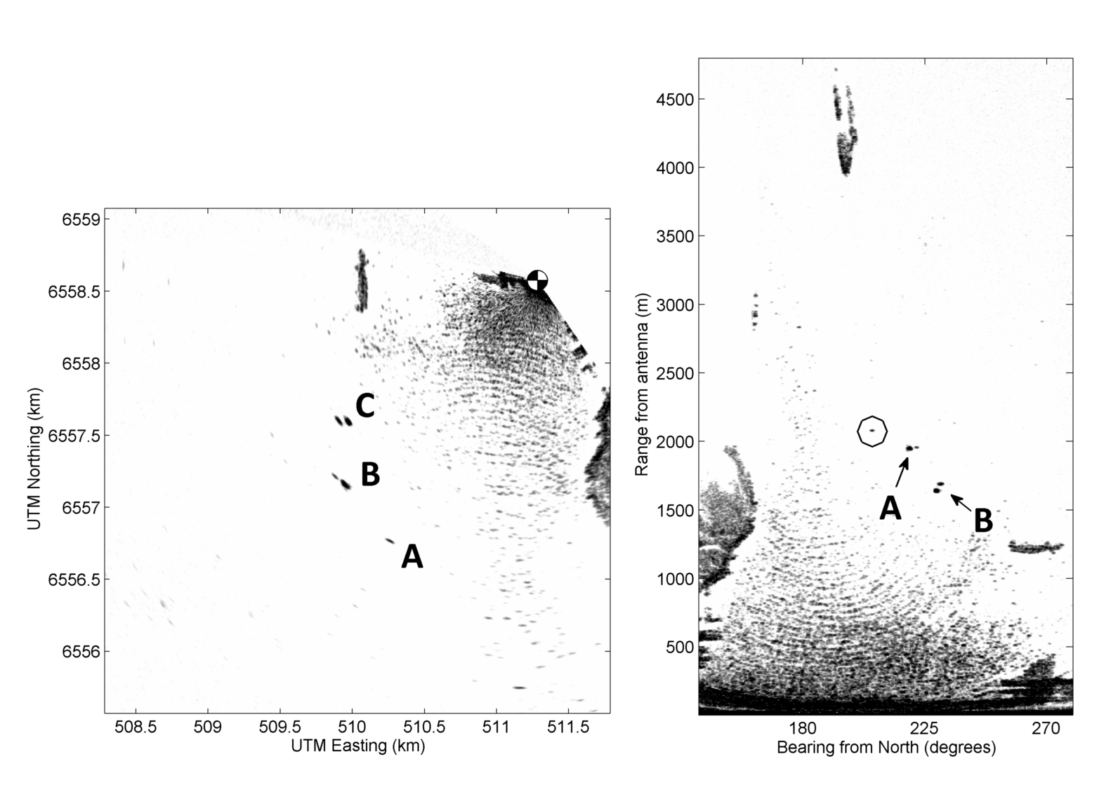

Fig. 1. Cartesian transformed snapshot radar image containing the backscatter echo from a killer whale during SAB (A), vessels involved with the FLOWBEC field deployment (B) and the ‘OpenHydro’ platform and support vessel (C). The checkered symbol marks the position of the radar antenna. The signatures from ocean waves (sea clutter) can be seen in the bay South of the radar.

A simple implementation of clutter-map constant false alarm rate (CM-CFAR) was applied to the raw radar frames to provide a degree of clutter suppression. To achieve this, a mean radar image was created with the backscatter echo for each pixel averaged in isolation across the 256 scans. This ‘clutter-map’ was then used to set a threshold for false-alarm backscatter echo by differentiating between persistent / periodic (*i.e.,* from waves) and ephemeral echoes (*i.e.,* from moving targets). Pixels identified as above the CM-CFAR threshold were then organized into clusters using connected component labelling (CCL), labelling contiguous pixels in each target cluster with an integer acting as the target identification number. Target clusters were then identified to those belonging to the killer whales manually, which was necessary as they only appeared for between one and two scans (1.28 – 2.57 s) during SAB and then disappeared (occluded) for up to 25 scans (32 s). Differentiating between sea clutter and moving targets is a nontrivial problem even when targets are regularly present between scans and the added problem of such long target occlusion times makes reliable automatic identification and tracking prohibitively complex.

Due to radiative effects at range, beam-spreading and the relationship between target size, dimensions, material composition, radar frequency and beam shape any target scattering microwave energy back to the receiver will appear to do so from more than one digitized pixel. This has the effect of spreading the target’s backscattered energy across multiple, grouped pixels in a radar image. As such it was necessary to define the target’s position as the center of mass (centroid) of the target pixel cluster. At each scan where a killer whale target was present the target’s center of mass (both bearing and range), backscatter magnitude and scan number were recorded and then converted into Cartesian coordinates (UTM projection).

To differentiate between the two targets an assumption had to be made on which targets correspond to which individual. The assumption was made that both animals kept the same separation through the record and did not cross paths. Unfortunately, the radar cannot discriminate between individuals so this assumption is necessary to make any kinematic measurements from target sightings (*e.g.,* swim speed, surfacing rate). The two individuals were discriminated using this assumption and named ‘Orca 1’ and ‘Orca 2’ for reference.

Due to the opportunistic nature of the survey and the lack of killer whale presence in preceding or subsequent recording periods (or at least a lack of SAB and therefore trackable targets) the total sample size, *n,* is small with *n1*= 16 for Orca 1 and *n2*= 15 for Orca 2. However, the determination of swim speed could only be made between periods of SAB, reducing *n* for measurements of velocity (u) to *n1*(u) = 7 and *n2*(u) = 9. The sample sizes for SAB are limited to measurements taken immediately before and after each animal dived beneath the water, reducing *n* to *n1*(SAB) = 7 and *n2*(SAB) = 9.

Results

Fig. 2 shows an image of the uncalibrated maximum radar backscatter intensity for each pixel over the 5.5 minute observation period, contrast-adjusted to enhance the presence of the radar echoes from the killer whales. Overlain are the identified target tracks for each animal with the assumption of constant spacing. A number of other targets of interest can be seen in the figure, including the echo from waves breaking at the base of the ‘OpenHydro’ test platform, the echo from the FLOWBEC research vessel on station as well as numerous bird traces. It may be noted that the low sea state (WMO Sea state 3), and therefore low sea clutter, at the time of observation aided the detection of the killer whale radar echoes considerably. A higher sea state or proximity to the sea clutter closer to the antenna may have made detection difficult or impossible.

**C:\Users\dmca.NERC\Desktop\Papers\ORCA\Paper\Figures\bigplot.tif**

Fig. 2**.** Maximum backscatter intensity image for the survey period with radar echoes and killer whale tracks marked.

The timing of the FLOWBEC co-incident vessel work that was conducted on June 18th was chosen so as to occur at slack water, and thus minimize the amount of necessary vessel station-keeping. To estimate the tidal flow within which the killer whales were swimming the NOC tidal model prediction software POLPRED was used to produce an indicative tidal flow speed and direction within the area at the time of the survey. Fig. 3 shows the modelled depth-mean tidal flow speed and direction in the area at the time of the radar record.

C:\Users\dmca.NERC\Desktop\Papers\ORCA\Paper\Figures\polpred.tif

Fig. 3. Depth-mean tidal flow speed (top panel) and direction (bottom panel) of the area, extracted from the tidal prediction software POLPRED. The dashed line represents the time of observation of the killer whales.

The measured swim speeds between periods of SAB for both killer whales relative to the radar antenna were corrected to an estimate of absolute swim speed by subtracting the tidal current vector predicted by POLPRED (Fig. 4). The mean derived swim speeds were 4.2 ms-1 (*n* = 7, σ = 0.3) and 4.0 ms-1 (*n* = 9, σ = 0.5) for Orcas 1 and 2 respectively. The measured swim speeds lie well within the bounds of the reported cruising speed range for *O. Orca* of 2.8 – 5.1 ms-1 (Fish, 1998).



Fig. 4.Radar-derived swim speeds (ms-1) between periods of SAB. The Thick horizontal bars mark the median values and the top and bottom extents of the box denote the 75th and 25th percentiles respectively. Dashed lines represent the range of killer whale cruising speeds reported in the literature.

The measured time between SAB events are shown in Fig. 5. The mean SAB times were 35.8 s(*n* = 8, σ = 16.8) and 30.9 s (*n* = 10, σ = 6.7) for Orcas 1 and 2, respectively. The two killer whales display a degree of synchronous breathing that has been reported in observations of *O. Orca* (Heimlich-Boran 1988), with a 2-sample *t*-Test of the SAB rates yielding a rejection of difference of the means (*P*=0.47).



Fig. 5.Radar-derived time between SAB events (s).

Discussion

The key findings of this work are twofold: 1) Surfacing killer whales are observable using commercial X-band marine radar to the point where kinematic measurements are possible and; 2) The form of radar echo of male killer whales undertaking a specific SAB is documented. Using the confirmed visual sightings as validation these radar observations can be used to attempt to automatically detect similar signals in radar data from the EMEC site and potentially across others. In order to transition to automated identification (and possibly tracking) of surfacing killer whales with X-band radar there are a number of caveats of the data that must be discussed.

The two adult male killer whales tracked in this study were swimming transverse to the radar beam and therefore were presenting almost all of the area of their large dorsal fins to the antenna. The scattering area of the dorsal fin will be much lower at more acute angles of incidence and will likely produce a smaller echo in these circumstances. Male and female adult killer whales differ both in total body mass and the size and surface area of their dorsal fins (Heyning and Dalheim 1988). Depending on how much of the body is out of the water (and therefore illuminated by the radar beam) during SAB male and female killer whales will therefore produce different radar echoes; most likely lower in magnitude for female specimens and even lower for juveniles (which have lower body masses and sizes)

The individuals observed during this work were also performing a specific mode of SAB; namely full-body broaching (porpoising) during fast transit swimming. This form of SAB not only produced a strong echo due to the large proportion of above-water body mass illuminated by the radar but also an interrupted radar trace consisting of high-magnitude, low-frequency targets. Therefore, if the form of targets presented in this work are solely used to identify killer whales in other data (especially automatically) the detections will be restricted to single individuals performing this mode of SAB. A pod of killer whales (containing a mixture of male and female individuals, as well as juveniles and adults) will likely produce a group of very different radar target signatures. This highlights the need to perform multiple radar measurements with concurrent visual observations to catalogue as many radar signatures of a species as possible; covering different sexes, ages and behaviors.

The data presented in this work show that X-band radar is capable of detecting (and potentially tracking) surfaced male killer whales. The echoes generated at *ca*. 1 km range are similar in magnitude to that produced by a small vessel. It is likely that a pod of surfacing killer whales will produce a similarly strong radar echo, albeit with different characteristics to the targets presented here (due to different SAB).

Acknowledgements

This work was funded through the Marine Renewable Energy Knowledge Exchange Program (MREKEP) of the Natural Environment Research Council (NERC), reference number NOC010015 with the radar observations made for the NERC-funded Flow and Benthic Ecology 4D (FLOWBEC-4D) project NE/J04332/1. Visual observations of the killer whales were made by Dr. Beth Scott and NERC/DEFRA funded Dr. Benjamin Williamson (University of Aberdeen) while undertaking fieldwork for the FLOWBEC-4D project, NERC grant number NE/J004308/1.

Literature Cited

Bolt, H.E., P.V. Harvey, L. Mandelberg, and A.D. Foote. 2009. Occurrence of killer whales in Scottish inshore waters: Temporal and spatial patterns relative to the distribution of declining harbour seal populations. Aquatic Conservation: Marine and Freshwater Ecosystems 19: 671–675.

Bell, P.S., D.L. McCann, B.E. Scott *et al*. 2014. Flow and Benthic Ecology 4D – FLOWBEC – An Overview. Proceedings of the 2nd International Conference on Environmental Interactions of Marine Renewable Energy Technologies (EIMR2014), 28 April–02 May 2014, Stornoway, Isle of Lewis, Outer Hebrides, Scotland.

DePropso, D.F., J. Mobley, W. Hom and M. Carron. 2004. Radar-based detection, tracking and speciation of marine mammals from ships. Arete Associates project report*,* award number N00014-04-1-0729. 5pp.

Evans, P.G.H. 1988. Killer whales (*Orcinus Orca*) in British and Irish waters. Rit Fiskideildar 11: 42–54.

Fish, F. 1998. Comparative kinematics and hydrodynamics of odontocete cetaceans: Morphological and ecological correlates with swimming performance. Journal of Experimental Biology 201: 2867– 2877.

Forsyth, C.P. 2011 Radar detection of marine mammals. Office of Naval Research annual report, award number N00014-07-C-0885. 5pp.

Heimlich-Boran, J.R. 1988. Behavioural ecology of killer whales (*Orcinus Orca*) in the Pacific Northwest. Canadian Journal of Zoology 66(3): 565–578.

Heyning, J. and M. Dahlheim. 1988. *Orcinus Orca*. Mammalian Species 304: 1–9.

Thompson, P.M., G.D. Hastie, J. Nedwell, *et al.* 2013. Framework for assessing impacts of pile-driving noise from offshore wind farm construction on a harbour seal population. Environmental Impact Assessment Review43: 73–85.

Wilson, B., R.S. Batty, F. Daunt and C. Carter. 2007. Collision risks between marine renewable energy devices and mammals, fish and diving birds. Report to the Scottish Executive. Scottish Association for Marine Science, Oban, Scotland, PA37 1QA. 110pp.

Weihs, D. 2002. Dynamics of dolphin porpoising revisited. Integrated and Comparative Biology 42: 1071–1078.