• News & Views •

3rd ANtarctic Gravity Wave Instrument Network (ANGWIN) Science Workshop

Tracy MOFFAT-GRIFFIN*¹, Mike J. TAYLOR², Takuji NAKAMURA³, Andrew J. KAVANAGH¹, J. Scott HOSKING¹, and Andrew ORR¹
¹Britsh Antarctic survey, High Cross, Cambridge CB3 0ET, UK

²Utah State University, Logan, UT 84322, USA

³National Institute of Polar Research, Tachikawa-shi, Tokyo 190-8518, Japan

Citation: Moffat-Griffin, T., M. J. Taylor, T. Nakamura, A. J. Kavanagh, J. S. Hosking, and A. Orr, 2017: 3rd ANtarctic Gravity Wave Instrument Network (ANGWIN) science workshop. Adv. Atmos. Sci., xxx--xxx, 34(1), doi: 10.1007/s00376-016-6197-5
1. Overview
The 3rd ANtarctic Gravity Wave Instrument Network (ANGWIN) science workshop was held on 12–14 April 2016 in Cambridge, UK. ANGWIN is a highly successful grassroots program that was started in 2011 (in the Cornish English dialect ANGWIN means “the white”). Although initially focused on the Antarctic, we now aim to develop collaborations in both polar regions. ANGWIN aims to use results from the network of instrumentation at international research stations to address the primary research goal of quantifying and understanding the dominant sources, propagation and impact of a broad spectrum of gravity waves on a continental-wide scale.
We had 33 delegates at the meeting from 10 different countries (Fig. 1 shows the workshop group photo). The workshop was sponsored by the SCAR Standing Scientific Group on Physical Sciences (SCAR SSG-PS), the International Association of Meteorology and Atmospheric Sciences (IAMAS), and the Variability of the Sun and Its Terrestrial Impact (VarSITI) program. Their sponsorship resulted in the provision of partial funding for eight students/early career scientists to attend the workshop, and travel grants for two early career scientists (one from Brazil and one from India). We had a range of topics covered by presentations at the workshop; modelling studies of gravity waves in the polar regions, observational results from all regions of the polar atmosphere, and also future instrumentation that will be deployed in the coming year. We had productive discussion sessions where content for the new ANGWIN website (www.bas.ac.uk/projects/angwin) was discussed, future ANGWIN-related publications planned, and also future collaborative projects devised.
A meeting report of the presentations and discussion sessions follows.
2. Presentations
When ANGWIN was first conceived, it was aiming to link up data and analysis techniques from all-sky mesospheric airglow imagers located in the Antarctic. In recent years, the ANGWIN community has expanded to both polar regions (although with an emphasis still on Antarctica), and includes people working on gravity wave observations from many different ground-based instruments and satellites, thereby providing information on gravity wave activity from the troposphere to the ionosphere, and also modelling of gravity waves.
2.1 Airglow data
The first talk was on the existing sites of airglow all-sky imagers in Antarctica (Mike Taylor) and where new instruments were planned to be installed. Combining these data, the variation of gravity wave properties with latitude was presented. Discussions of results using other Antarctic airglow data were also presented, with Hosik Kam, Jose Bageston and Mike Taylor all discussing gravity wave activity ranging from frontal events to wave propagation characteristics at different Antarctic sites. It was also shown that airglow temperature data can be used to study planetary wave activity, and Yucheng Zhao showed results from the South Pole and Rothera datasets identifying a strong 28-day signature.
Results from the Arctic were shown by Dominique Pautet using airglow temperatures. Evidence of a self-accelerating gravity wave event was seen, as well as lots of mountain wave activity over Scandinavia.
A new technique to extract information on the gravity wave phase velocity spectrum from airglow imager data was presented by Takashi Matsuda, opening up possibilities to compare multiple datasets with the same technique. The issue of gravity wave transmission into the airglow region was discussed by Yoshihiro Tomikawa.
Work on analyzing airglow variations observed by a scanning radiometer at Davis, Antarctica, was presented by Sharon Roarke. The gravity waves that could be observed using this instrument were shown to have a distinct horizontal propagation distribution that was attributed to critical level filtering.
The importance of not just extracting gravity wave and large-scale wave information from the airglow data, but also looking at other airglow properties, was discussed by William Ward. The importance of the need to characterize the airglow variability was emphasized.
2.2 Middle atmosphere instrument and modelling studies
Satellite observations of gravity wave activity over Davis station, Antarctica, using AURA-MLS, were presented by Frank Mulligan. He showed there was a consistent seasonal variation in gravity wave potential energy over the years, with an increase in energy density occurring in the stratosphere during late spring.
A presentation on data from the Calypso satellite was presented by Vincent Noel (invited). He explained results from the satellite lidar, which can detect polar stratospheric clouds (PSCs); and also, from the temperature data, gravity waves in the stratosphere. He showed that gravity waves generated by the Antarctic Peninsula affected the continent-wide distribution of PSCs.
Davis station was again the focus in a talk by Andrew Orr, in which he presented a study on gravity wave effects on vertical winds. He compared results from the Davis VHF radar with Unified Model simulations and showed how the higher resolution simulations were better at reducing the amplitude of vertical winds.
Modelling results were also discussed by Jonathan Snively, who investigated why more waves seen in airglow data were not ducted, especially over Halley station, Antarctica. He used full wave models to investigate the dispersion of waves from the surface to the thermosphere.
Lidar results were discussed by Mitsumu Ejiri and Masuru Kogure. Masuru presented results from the Rayleigh/Raman lidar located at Syowa station, Antarctica, and showed the gravity wave potential energy in the middle stratosphere was largest in wintertime. Mitsumu showed the new resonance scatter lidar that is to be installed this coming season at Syowa and presented preliminary results from its test phase where iron and calcium densities could be detected and gravity waves could be seen.
Results from a meteor radar system at King Sejong station, Antarctica, were presented by Changsup Lee. He showed the change in dominant propagation direction of gravity waves from summer (north to south) to winter (northeast to southwest) and investigated the likely tropospheric sources of these waves.
2.3 Thermosphere/ionosphere gravity waves
The study of travelling ionospheric disturbances (TIDs) was a topic of several talks at this meeting. Keith Groves showed results from GPS TEC observations above various Antarctic stations where he investigated the characteristics of TIDs. He was able to show wind filtering effects of these gravity waves.
Data from the Poker Flat Incoherent Scatter Radar (PFISR) were used by Mike Neagle to identify wave events with periods of less than 60 minutes. Comparisons with co-located airglow instruments suggests that PFISR is able to see longer period and longer horizontal wavelength waves.
The Incoherent Scatter Radar world day run in February 2016 was discussed by Andrew Kavanagh. This was a coordinated observation program specifically focusing on gravity wave observations in the thermosphere. Preliminary results were discussed, as were the effects of auroral contamination of the data.
Wave events seen in data from the Jang Bogo station (Antarctica) dynasonde were presented by Geonhwa Jee. Details about the Korean suite of gravity wave observing instruments in the Arctic were also presented.
2.4 Multi-instrument studies
The multi-instrument research station on Svalbard was discussed by Dag Lorentzen. He detailed the 31 different instruments from 17 different institutes that are currently located on Longyearbyen, which range from radar to optical instruments.
The South Georgia Wave Experiment (SG-WEX) results were discussed by Nick Mitchell, Tracy Moffat-Griffin and Corwin Wright. Nick and Tracy presented the first meteor radar results and radiosonde gravity wave observations from South Georgia, while Corwin explained his new satellite data analysis technique that could be used to calculate gravity wave momentum flux over the region.
A combination of radiosonde and GPS observations from the Indian Antarctic station, Bharati, were presented by Kandula Subrahmanyam. The aim is to look at a combination of instruments to study vertical coupling in the atmosphere from the troposphere to the ionosphere.
Results from the DEEPWAVE gravity wave campaign over New Zealand were presented by Martina Bramberger. The campaign used a combination of plane-based instruments, as well as lidar and radiosonde observations, to study gravity wave activity. Martina also used ECMWF reanalysis data to examine strong tropospheric forcing events and relate them to mesospheric gravity waves.
3. Discussions
The discussion sessions were an informal affair where plans for the future and collaborations were discussed.
A presentation of work at Utah Valley University, using student projects to build simpler and cost-effective airglow cameras, and then students working with the data, generated some interesting discussions about whether this model could be used elsewhere in the world, and also about how good the instruments are that they are building. Although it is unlikely they will be deployed in Antarctica, it did seem to be a good way to generate interest in our area of science and potentially yield new analysis techniques for our data.
There were discussions about gathering further TID observations with existing instrumentation, and also looking at new sites for such instrumentation. It is thought that the Antarctic Peninsula region is a hotspot for these, as well as neutral atmosphere waves.
An expansion of the airglow imager network was discussed with a joint NSF-NERC proposal to put a new IR camera at Rothera Station in Antarctica being submitted in the summer. The analysis technique developed by colleagues at NIPR can then be applied to data from even more locations, helping us to build up a picture of gravity wave activity around Antarctica.
It was agreed that the new ANGWIN website should be used more to promote our activities. The website will be developed to include lists of relevant datasets available, and also which models can be used to study gravity waves. As a link to this work, it was decided to develop a “rules of the road” document for members of our community to sign up to.
Social media was also used for the first time during this workshop, with the talks being summarized on our twitter account (@ANGWIN_2). It was not clear how effective this was as a publicity tool, but it was decided that it is useful to have the meeting summary, and it could also be used to advertise informal gatherings within the ANGWIN community at larger conferences and advertise relevant papers.
An ANGWIN JGR special issue was also decided upon, with 14 papers being proposed at the meeting. A special issue such as this will help to raise our profile and expand our networks within the academic community.
4. Summary
The third ANGWIN science workshop was well received and very successful. We intend to hold the fourth workshop in two years’ time in Brazil.
Acknowledgments. This workshop was sponsored by SCARSSG-PS, IAMAS and VarSITI. It was organized by the British Antarctic Survey and held at the Scott Polar Research Institute, Cambridge. We would like to thank all who contributed to making this a successful workshop.
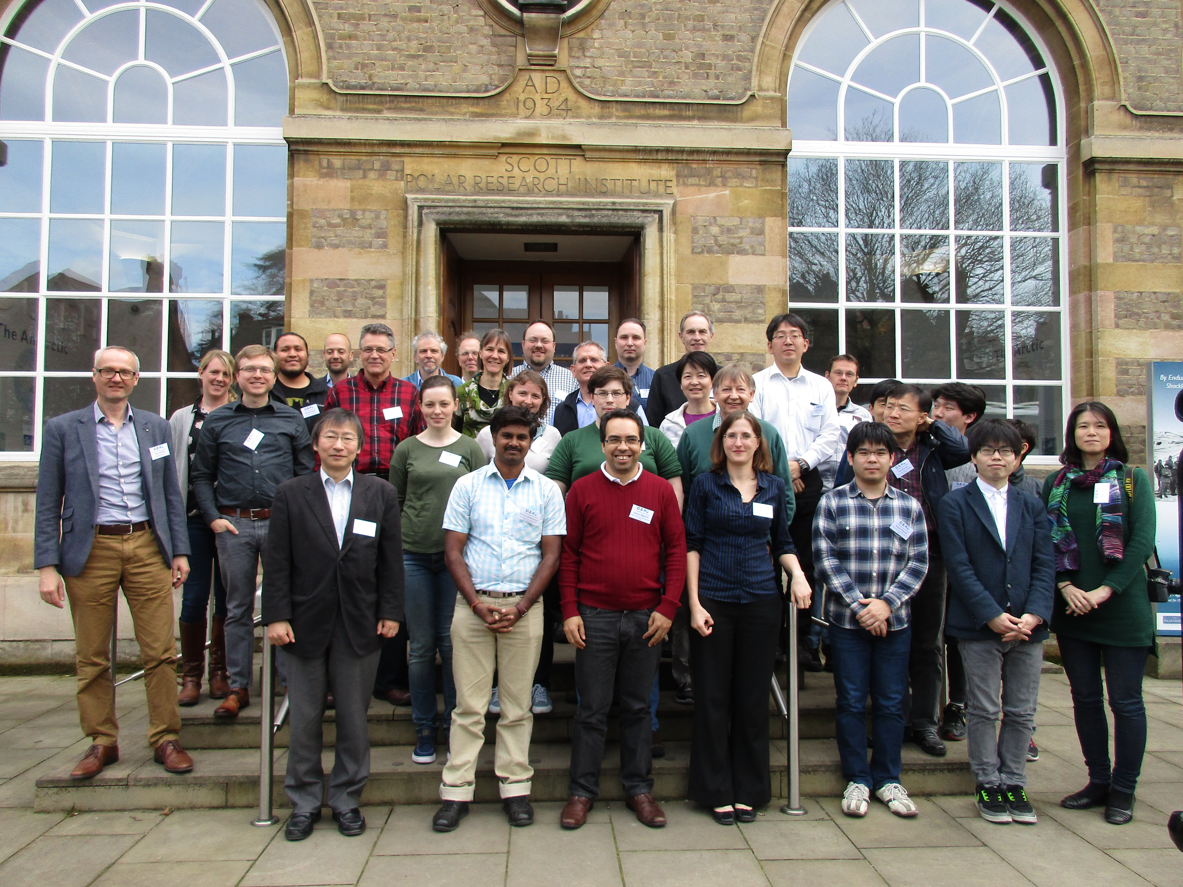

Fig. 1. The delegates of the ANGWIN science workshop gathered outside the Scott Polar Research Institute.

*Corresponding author: Tracy MOFFAT-GRIFFIN Email: tmof@bas.ac.uk

