Jumbo squid in the eastern Pacific Ocean: a quarter century of challenges and change

Paul G. K. Rodhouse^{a*} Carmen Yamashiro^{b}and Juan Arguelles^{b}

ªBritish Antarctic Survey, High Cross, Madingley Road, Cambridge CB3 0ET, UK
^{b}Instituto del Mar del Perú, Esquina Gamarra y General Valle s/n, Chucuito, Callao, Perú
*Corresponding author. E-mail address: pgkr@bas.ac.uk

- Introduction
The jumbo, or Humboldt, squid Dosidicus gigas currently accounts for about one third of total world squid landings (Arkhipkin et al., 2015). It is the largest and most abundant ommastrephid squid in the eastern Pacific, where it is endemic. It is an important predator throughout its geographical range (Markaida 2006; Field et al. 2013; Alegre et al. 2014) and is prey for large marine mammals, particularly sperm whales in the southeastern Pacific, for which it is the single most important food species (Clarke, 1988; Nigmatullin et al., 2001).

The large-scale fishery for D. gigas began in the 1980s in the Mexican northeast Pacific (Ehrhardt, et al., 1983) and this was followed in the 1990s in Peruvians waters of the southeast Pacific (Yamashiro et al., 1998). Annual catches increased from 19,000 t in the 1980s to 847,000 t in 2013 (ftp://ftp.fao.org/FI/STAT/summary/inicio.htm). It became one of the largest marine invertebrate fisheries in the world, and the first Peruvian fishery to be fully monitored by observers at sea in the Peruvian EEZ and at ports where landings are made (Guevara et al., in press).
During this period D. gigas has shown significant changes in abundance, distribution and population structure in both the northeast and southeast Pacific. These have been associated with (1) direct effects of environmental variability, (2) changes in the availability of prey, especially during the early ontogenetic stages, (3) changes in predation, disease and parasitism, and (4) possible reduction of natural mortality through the exploitation of their predators as suggested by Rodhouse (2008). The development of an artisanal fishery in Peruvian waters (2350 artisanal boats with an average capacity of 9.8 tons) and in Chilean waters, as well as an industrial fishery outside the Peruvian and Chilean EEZs (Chen et al., 2008) have taken place against the background of these changes.

- Variability of squid stocks and the importance of ENSO
D. gigas inhabits nerito-oceanic waters in the eastern Pacific, one of the most productive and variable marine environments in the world, with four upwelling areas off Peru, Costa Rica, Baja California and California subject to temporary events (ENSO) with major biotic and abiotic effects. Populations of D. gigas have shown changes in abundance and structure during and after these events which have differed north and south of the equator. Various processes drive biological variability in oceanographic regimes, but coastal upwelling seems to be the key factor that determines abundance of D. gigas (Waluda et al. 2006).

- Current research and future directions
Because cephalopods play an important role as key species in various ecosystems, and they are also important fishery resources (Xavier et al., 2015), it is imperative to better understand how the environment influences the population biology of D. gigas in the highly variable eastern Pacific. There have been recent advances such as information on the relationship between the oxygen minimum zone and D. gigas (Stewart et al., 2013) and the observation that environmental factors, particularly temperature, encountered during early ontogenesis determine whether an individual will have a 1-year life cycle and mature at small size, or a 1.5- to 2-year life cycle with delayed maturation at large size. This provides an explanation for the existence of two size groups of D. gigas (Arkhipkin et al., 2014). Nevertheless more information is needed in subject areas such as stock structure, the planktonic phase of the life cycle and environmental effects on development, spawning and migration.

Research on the effects of environmental variability on recruitment is needed for fishery forecasting and sustainable management of stocks in the face of increasing international fishing effort on D. gigas. There is a clear need for a fully integrated and adaptative system of observation, modelling and management of stocks in the eastern Pacific to derive optimum commercial and social benefit from these stocks.

- A brief history of the symposia and workshops on Pacific Squid
In response to the growing squid fishery in the southeast Pacific in the 1990s, with high levels of production in Peru, a scientific consultancy on the biology and fishery for D. gigas was undertaken in 1997 and 1998 by PGKR at Instituto del Mar del Perú, Callao. This was funded by the European Union under the VECEP (Venezuela, Colombia, Ecuador and Peru) technical cooperation programme. A framework for research on fishery biology of D. gigas was developed and it was recommended that regular international scientific meetings should take place between researchers from relevant South and Central American countries to disseminate, share and discuss new information and to link squid researchers. The main focus of these meetings was to be on the biology, ecology and management of Pacific squid fisheries, with special emphasis on environmental and fisheries driven spatial and temporal changes in squid stocks and the impact of these changes on other marine populations.

Since the recommendation was made in 1998 six international scientific symposia have been held between 1999 and 2014 in Peru, Mexico and Chile. These have focused on D. gigas because of the increasing importance of the fishery in the eastern Pacific and its growing importance in international markets. Leading scientists from research institutions in Russia, Japan, the UK, Spain, Mexico, the USA, Chile, Ecuador and Peru have participated in these symposia which all received the support of the Cephalopod International Advisory Council (CIAC). The results of the past symposia have been published in Fisheries Research (Rodhouse et al., 2001; Rodhouse et al., 2006).
At the latest symposium, held in November 2014 in Lima, there were 80 participants including scientists, students, businessmen and fishers (Figure 1). Five keynote lectures, 39 oral presentations and 26 posters were presented, focusing mainly on D. gigas but other ommastrephids and loliginids of commerial interest or potential interest were included. For the first time the potential for octopus fisheries in the eastern Pacific was considered. Of the presentations made, 9 papers are published in this special issue of Fisheries Research.

Five workshops associated with the symposia have also been held on growth and trophic ecology, tracking the industrial squid fishing fleet using satellite images, the role of squid in marine ecosystems and their impact on other commercial species, variations in life history under environmental variability, in vitro embryonic development and comparison between the operation of D. gigas fisheries on the western seaboard of the Americas. In the latest workshop, which took place following the symposium at Lima in 2014, the focus was on the effects of environmental variability on populations and methodologies for research on ommastrephid paralarvae.

The 7th International Symposium on Pacific Squid will be held in 2017 in Manta, Ecuador, and will be hosted by Eloy Alfaro University.

- Acknowledgements
We warmly thank the Contralmirante Germán Vásquez-Solis, President of the Instituto del Mar del Perú (IMARPE) for support and encouragement for us to organize the 6th International Symposium on Pacific Squids and the 5th International Workshop that were held in Lima and Callao, Perú, and the directors, scientists and administrators of IMARPE for their scientific and logistic support during the symposium. Special thanks to the Cephalopod International Advisory Council (CIAC), Ministerio de la Producción (PRODUCE), Consejo Nacional de Ciencia y Tecnología (CONCYTEC), Instituto Tecnológico de la Producción (ITP), the Korean Institute of Ocean Science and Technology (KIOST), Institute de Recherche pour le Développement (IRD) and Ministerio de Comercio Exterior y Turismo (MINCETUR) for their scientific and logistic support.

We are very grateful to the following who gave their time to peer review manuscripts for this special issue: Louise Allcock, Hugo Arancibia, Juan Arguelles, Dana Arizmendi, Sasha Arkhipkin, Mark Belchier, Augusto Crespi, Luis Cubillos, Emmanis Dorval, Angel Gonzalez, Angel Guerra, Christian Ibañez, Nadine Johnstone, Elaina Jorgensen, Annie Lindgren, Unai Markaida, Natalie Moltschaniwkyj, Graham Pearce, Iliana Ruiz-Cooley, Mitsuo Sakai, Pilar Sanchez, Gabi Stowasser, Erica Vidal, Claire Waluda.
- References
Alegre, A., Ménard, F., Tafur, R., Espinoza, P., Argüelles, J., Maehara, V., Flores, O., Simier, M., Bertrand, A. 2014. Comprehensive model of Jumbo squid Dosidicus gigas trophic ecology in the Northern Humboldt current system. PLoS One 9, e85919. doi:10.1371/journal.pone.0085919
Arkhipkin, A., Argüelles, J., Shcherbich, Z., & Yamashiro, C. 2014. Ambient temperature influences adult size and life span in jumbo squid (Dosidicus gigas). Canadian Journal of Fisheries and Aquatic Sciences, 72, 400-409.
Arkhipkin, A.I., Rodhouse, P.G.K., Pierce, G.J., Sauer, W., Sakai, M., Allcock, L., Arguelles, J., Bower, J.R., Castillo, G.,, Ceriola, L., Chen,C-S., Chen, X., Diaz-Santana, M., Downey,N., González, A.F., Granados Amores, J., Green, C.P., Guerra, A., Hendrickson, L.C., Ibáñez, C., Ito, K., Jereb, P., Kato, Y., Katugin, O.N., Kawano, M., Kidokoro, H., Kulik, V.V., Laptikhovsky, V.V., Lipinski, M.R., Liu, B., Mariátegui, L., Marin, W., Medina, A., Miki, K., Miyahara, K., Moltschaniwskyj, N., Moustahfid, H., Nabhitabhata, J., Nanjo, N., Nigmatullin, Ch.M., Ohtani, T., Pecl, G., Perez, J.A.A., Piatkowski, U., Saikliang, P.^{j}, Salinas-Zavala, C.A., Steer, M., Tian, Y., Ueta, Y., Vijai, D., Wakabayashi, T., Yamaguchi, T., Yamashiro, C., Yamashita, N. and Zeidberg, L.D. 2015. World squid fisheries. Reviews in Fisheries Science and Aquaculture, 23, 92-252.
Chen, X., Liu, B., Chen, Y. 2008. A review of the development of Chinese distant-water squid jigging fisheries. Fisheries Research 89, 211–221
Clarke, R., Paliza, O., Aguayo, A. 1988. Sperm whales of the southeast Pacific. Part IV. Fatness, food and feeding. Investigations on cetácea, 21, 53-195.
Ehrhardt, N., Jacquemin, P., García, F., González, G., López, J., Ortiz, J., Solís, A. 1983. On the fishery and biology of the giant squid Dosidicus gigas in the Gulf of California, México. FAO Fisheries Technical Paper 231: 306-340.
Field, J., Elliger, C., Baltz, K., Gillespie, G., Gilly, W., Ruiz-Cooley, R.I., Pearse, D., Stewart, J., Matsubu, W., Walker, W. 2013. Foraging ecology and movement patterns of jumbo squid (Dosidicus gigas) in the California Current System, Deep Sea Research II: 37-51
Guevara-Carrasco, R., Yamashiro, C., Mariátegui, L., Arguelles, J. 2015. Aspectos relevantes en la ordenación pesquera del calamar gigante o pota (Dosidicus gigas) en el Perú. Bol. Inst. Mar Peru (In press).
Markaida, U. 2006. Food and feeding of jumbo squid Dosidicus gigas in the Gulf of California and adjacent waters after the 1997-98 El Niño event. Fisheries Research 79:16-27
Nigmatullin, C., Nesis, K.N., Arkhipkin, A.I. 2001. A review of the biology of the jumbo squid Dosidicus gigas (Cephalopoda: Ommastrephidae). Fisheries Research, 54: 9–19.
Rodhouse, P.G., Yamashiro, C., Goss, C. 2001. Squid fishery biology in the Eastern Pacific coastal upwelling system. Fisheries Research 54(1), 143 p.
Rodhouse, P.G., Waluda, C.M., Morales-Bojorquez, E., Hernández-Herrera, A. 2006. Fishery biology of the Humboldt squid, Dosidicus gigas in the Eastern Pacific Ocean. Fisheries Research 79, 13-15.
Rodhouse, P. G. 2008. Large-scale range expansion and variability in Ommastrephid squid populations: A review of environmental links. CalCOFI Rep. 49, 83–89.
Stewart, J., Field, J., Markaida, U., Gilly, W. 2013. Behavioral ecology of jumbo squid (Dosidicus gigas) in relation to oxygen minimum zones. Deep-Sea Research II 95: 197-208.
Waluda, C., Yamashiro, C., Rodhouse, P. 2006. Influence of the ENSO cycle on the light-fishery for Dosidicus gigas in the Peru Current: An analysis of remotely sensed data. Fisheries Research 79, 56–63.
Xavier, J.C., Allcock, L., Cherel, Y., Lipinski, M.R., Gomes-Pereira, J.N., Pierce, G., Rodhouse, P.G.K., Rosa, R., Shea, L., Strugnell, J., Vidal, E., Villanueva, R. Ziegler, A. 2015. Future challenges in cephalopod research. Journal of the Marine Biological Association of the United Kingdom 95, 999-1015.
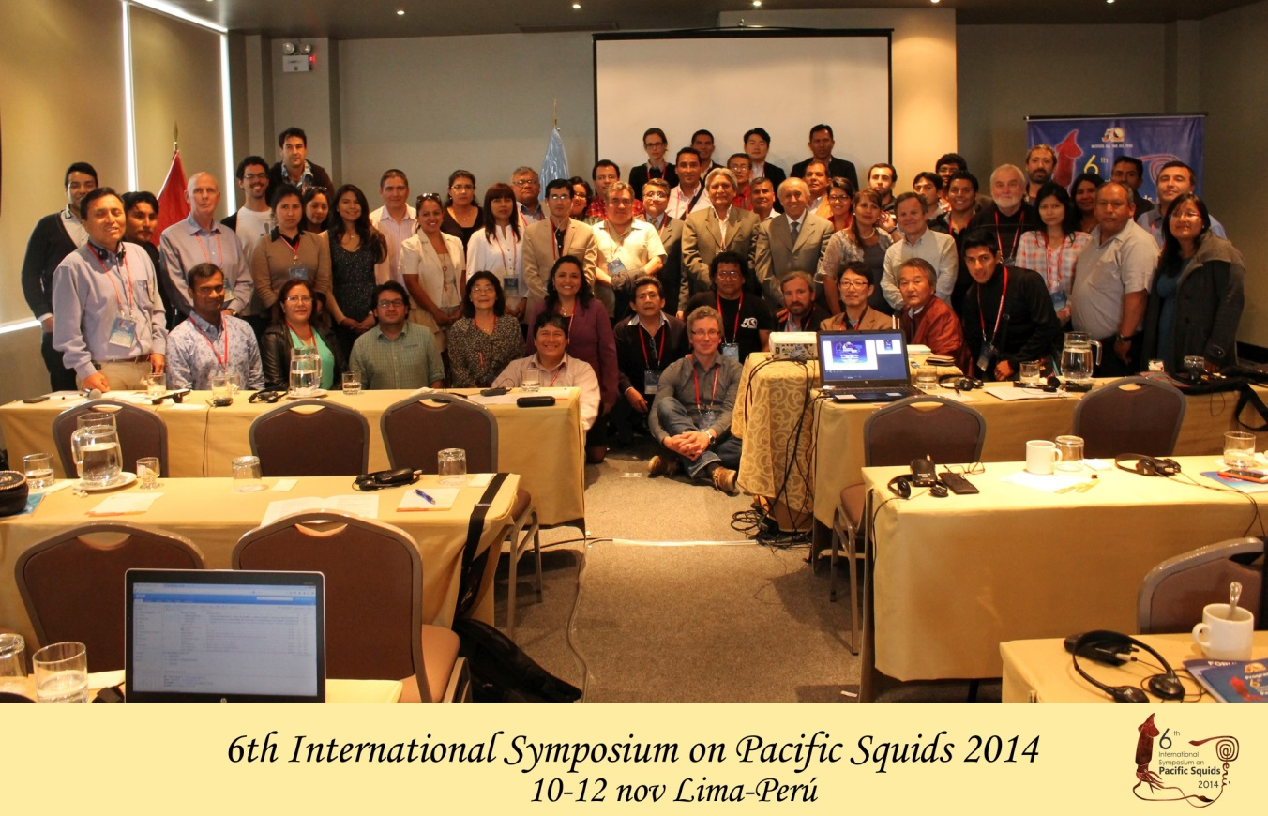
Yamashiro, C., Mariategui, L., Rubio, J., Arguelles, J., Tafur, R., Taipe A., Rabi, M. 1998. Jumbo flying squid fishery in Peru. Contributed papers to international symposium on large pelagic squids (Okutani T. Ed) Japan Marine Fishery Resources Center: 119-125
Figure 1. Participants in the 6th International Symposium on Pacific Squids held in Lima, Perú, 10-12 November 2014

