Running head: marine colonization at Ascension Island
Marine colonisation and biodiversity at Ascension I. and remote islands.
David K A Barnes
British Antarctic Survey, Natural Environment Research Council, High Cross, Madingley Road, Cambridge, CB3 OET, U.K. Tel: 01223 221613, Email: dkab@bas.ac.uk.
Little is known about colonisation of remote island coasts by marine invertebrates, other than corals. The structure of hard substrata assemblages was investigated across Ascension Island’s littoral zone in comparison with other sites. Arrays of acrylic panels were deployed at two sites for two years at Ascension Island to measure subtidal recruitment. Colonisation of panels at Ascension I. was low, though space occupation, abundance and richness varied considerably. After ~one and two years Ascension panels were <17% and <37% covered by fauna and each had <22 recruits and 54 recruits (per 100cm²) respectively, amongst the lowest density of recruits reported. Recruitment rates of corals (25.m²yr⁻¹) at Ascension I. were also similar to the lowest levels reported elsewhere (e.g. at Bermuda or Midway islands). Less dispersive animal types, e.g. cheilostome bryozoans, were poorly represented. Panels immersed in Tanzania and Scotland were >30% covered, with >76 recruits.100cm² and with bryozoans well represented after one year. Across-littoral surveys of established macrofauna at five remote islands (Ascension I., Easter I., Azores, South Georgia and Signy I., Antarctica) revealed similar trends of a rich sublittoral and lower littoral reducing drastically up-shore; molluscs dominating abundance and species numbers, whilst polychaetes, crustaceans and echinoderms were well represented. Established sessile animals occurred patchily at a mean density of 8.26 m⁻² but recruits had mortality levels >99%. Polar or remote temperate/tropical sites are typically less colonised than at non-remote, low latitudes but the lowest levels reported are at remote polar sites. Reduced colonisation at Ascension island reflects remoteness.

KEYWORDS: recruitment isolation dispersal coral latitude
Introduction
Increasing isolation and decreasing size and age of islands all represent increasing challenges for coastal organisms to reach and establish on their shores. Ascension Island is a small, young (less than 1.5 million years old, see Mitchell-Thome, 1982) mid-ocean island 1500 km from the nearest (W African) continent margin. The native megafauna on this remote volcanic rock is famously dominated by geograpsid land crabs, seabirds and green turtle migrants. The littoral and sublittoral fauna have been little studied and its shores appear quite barren (partly attributed to trigger fish grazing, see Price & John, 1978; 1980), though it is known to include many endemics. Numerous coastal amphipods, more than 15% of its shore fish, two shrimps (Procaris ascensionis Chace & Manning 1972 and Typhlatya rogersi Chace & Manning 1972) and other invertebrates have been found no-where else (Lubbock, 1980; Biernbaum, 1996). Remote Atlantic islands have been important for studies of terrestrial organism colonisation and dispersal, but such places also represent equally good opportunities to examine marine colonisation. Holmes et al. (1997) used artificial substrata (settlement panels) in the west Pacific to show that sublittoral colonisation was lower on offshore than nearshore islands, mainly due to the rarity of taxa with non-planktotrophic larvae, such as most cheilostomatid bryozoans. However, cheilostomatid bryozoans were major colonisers of panels deployed at old, remote islands, such as Signy I., Antarctica and arctic Spitsbergen (Stanwell-Smith & Barnes, 1997; Barnes & Kuklinski, 2005). These authors were unclear though, whether the low colonisation was attributable to their locations being polar or isolated. Ascension I. is an ideal study site for investigation of how dispersal opportunities of a taxon influences representation at ‘hard targets’ such as remote, young islands. Examining levels of colonisation at Ascension I. should aid interpretation of results from colonisation studies of isolated localities elsewhere.
When Barnes (1996) and Stanwell-Smith & Barnes (1997) reported very low overall levels of space occupation on settlement panels immersed at Signy I. Antarctica, they suggested that polar colonisation rates were very low. A new study of recruitment to immersed coastal panels in arctic Spitsbergen also found very little fauna compared with typically reported levels of richness, space occupation or abundance (Barnes & Kuklinski, 2005). Although old, the islands of Signy and Spitsbergen are both situated in mid-ocean archipelagos, so remoteness is also a potential explanation for reduced metrics of colonisation compared with elsewhere. Recent studies of recruitment to subtidal settlement panels around the continent margin of Antarctica have revealed much higher levels of colonisation, as well as high between site variability (Bowden et al., 2006; Stark unpublished data). Both Bowden et al. and Stark’s studies showed levels of colonisation after 2-3 years that fall within the variability reported from equivalent temperate and tropical experiments (Winston & Jackson, 1984; Todd, 1998; Maughan, 2000). Holmes et al. (1997) found the effect of isolation was much greater than latitude in the colonisation of subtidal panels along the east Australian coast and similarly Davenport & Stevenson (1998) found impoverished littoral colonisation at remote South Georgia compared with nearshore Cumbrae I. In contrast Schoener et al. (1978) found colonisation of panels submerged at isolated Hawaii to be similar to patterns in Thailand. Comparisons are difficult as there is so little data reported from remote localities, with the possible exception of coral recruitment. Surveys of faunistic richness or diversity of adult communities have been reported for some remote island coasts (e.g. Weslawski et al., 1988; Beckley & Branch, 1992; Cole et al., 1992; Bourmaud et al., 2005) but more typically such studies are restricted to one zone or group of animals (e.g. Moyano, 1973; Pugh & Mercer, 2001; Bouchet et al., 2002). Coral recruitment has been the major focus of investigations into marine colonisation of remote islands, such as at Hawaii and Bermuda (see Fitzhardinge, 1985; Smith, 1985; 1992; Friedlander et al., 2005). Few studies have ever reported rates across marine fauna for a remote tropical (or temperate) island.
In the current study the biodiversity of isolated localities (focussing on Ascension I.) was investigated using artificial substrata and surveys from the subtidal to the supralittoral. Acrylic settlement panels were deployed in the shallow subtidal for two years at Ascension I. and, for comparison, at two continent margin sites – a matched tropical latitude in Tanzania and a temperate site in west Scotland (UK). Surveys of sublittoral, littoral and supralittoral macrobenthos were conducted at Ascension I., Easter I., the Azores, and South Georgia and Signy islands in Antarctica. The aim of the current study is to determine the rates and variability of coastal colonisation at an isolated young tropical locality and its pattern of richness across the terrestrial-marine interface zone. It is hypothesised that at Ascension I.; 1) colonisation to panels will be low and that taxa with non-pelagic larvae will be poorly represented; and, 2) trends of richness from sublittoral to supralittoral zones will show similar patterns to elsewhere but with overall depressed levels.

Materials and methods
Young and established coastal communities at Ascension I. (South Atlantic) were investigated using settlement panels to measure recruitment and transect surveys to quantify established adults. Recruitment was measured at two other non-remote sites and adult communities were assessed at several other remote sites for comparison with Ascension Is. data.

Study apparatus and area
Artificial substrata in the form of settlement panels (15 cm x 15 cm x 0.5 cm) were deployed in the shallow subtidal zone at a series of sites. Each panel was cut from black acrylic sheet and machine-sanded (following Turner & Todd, 1993, Todd & Keough, 1994; Barnes & Kuklinski, 2005; Bowden et al., 2006). A central (10 cm x 10 cm) analysis area was marked out by drilling a 0.1 cm groove. Panels were attached to two Perspex rods in threes using plastic nuts and bolts (of 0.5 cm diameter). Panels were then washed and conditioned (to develop a biofilm) by immersion in local sea water for a period of 3 days. The approximate location for placement of each panel array was selected at random but within these locations, areas were selected which were most sheltered from wave action to minimise chances of dislodgement or damage. Small stainless-steel (316 marine grade) hoops were attached to rock surfaces using two-part aquarium cement and left for 2 days to harden. Each conditioned triplicate array was then attached, using cable ties, to these stainless-steel hoops. Arrays were mounted such that each was approximately horizontal and plastic spacers were used to ensure the under-surface of each panel was c. 2 cm above the substratum.
At Ascension I., two sites (~100 m apart) were selected for panel deployment at each of two localities (~ 5 km apart), English Bay and North East Bay (see figure 1). Investigation of established adult communities also encompassed a further locality of Shelly Bay. The main difference between these sites was exposure to wave action and prevailing wind. Shelly Bay was the most exposed to wind and wave and accumulated large amounts of floating volcanic rock (pumice) and other marine debris on the shore. North East Bay was mainly effected by ocean swell and English Bay was the most sheltered, but all three localities would be considered very exposed compared to most European shores (approximate to Ballantine 2-3 sensu Ballantine (1961)). The 24 panels deployed encompassed variability across the scales of km, 100 m, and replicates by this experimental design. Three areas of similar size to panels were scrubbed clean of encrusting biota at each of the two locations. The two bays were characterised by high wave energy, low tidal ranges (~1.3 m) and volcanic bedrock with few boulders. Little is known of the ecology of coastal marine invertebrates at Ascension I. (but see Irving, 1989) though a number of studies have attempted to describe the species of specific taxa (see Maddocks, 1975; Rosewater, 1975; Markham, 1978; Pawson, 1978; Manning & Chace, 1990; Biernbaum, 1996; Hoeksema et al., 2014; Zibrowius et al., 2014). During the same study period as the panel deployments at Ascension I., identical panel arrays were also deployed at two localities at each of the following locations; Oban in West Scotland (UK) and the east coast of Pemba I., Tanzania. Comparisons were also made with settlement panel studies using similar apparatus and protocol during the same time period in west Spitsbergen (Svalbard Archipelago, Arctic Norway) (Barnes & Kuklinski, 2005), Lough Hyne, South West Ireland (Watson & Barnes, 2005) and Adelaide I., Antarctica (Bowden et al., 2006). The location of the main study areas and important areas of comparison are shown in figure 2.

Protocol
Panel arrays were deployed across the years 2002 and 2003. Panels were resurveyed after 1, 3, 11 and 24 months immersion at Ascension I.; 3, 6, 12 and 24 months in W Scotland and 3, 4, 7, 8 and 13 months in Tanzania. A first deployment of panels to the intertidal and shallow subtidal zones at Ascension Is. resulted in most panels being were lost to storm damage and a series of panels experimentally deployed at 6 m depth were all carried away by wave action. New deployment using more aquarium cement around the stainless steel hoops and more sheltered microhabitats proved more successful. On retrieval all panels were photographed using a digital camera (Nikon D100 fitted with microNikkor 60 mm macro lens in an underwater housing) and stored as high-resolution JPG files (with zero compression). Panels were then replaced in the same positions and reattached using new cable ties. Each individual recruit in the central analysis area of each panel was counted (each colony was recorded as one recruit) and identified to the lowest possible taxonomic level using primary literature. The degree of space occupation (% cover) was evaluated using image analysis, and the number of recruits, genera and classes of animals were counted and recorded per panel. The data were analyzed using General Linear Model (GLM) ANOVA in the software package MINITAB 14. The dependent variables were successively percentage cover, generic richness, class richness and density (number of individuals m⁻²). The independent factors at each were spatial (locality and site) and time (duration of immersion). Per cent cover values were arcsine transformed and then all data were checked for normality and homogeneity of variance prior to ANOVA (GLM).
The richness of fauna was investigated along transects at three localities at Ascension Island; English Bay, North East Bay and Shelley Bay. Each transect was sampled at 6 and 3 m below Extreme Low Water Spring Tide level (ELWS), Lower, middle and upper shore and 3 and 6 m above Extreme High Water Spring tide level (EHWS). On each transect at each of these heights five 1 x 1 m quadrats were randomly deployed, the fauna within them examined and all macroscopic (>3mm) animals identified and counted. A similar protocol was carried out adjacent to the towns of Ponta Delgarda, Sao Miguel I. (Azores Archipelago) in 1998, Hanga Roa, Easter I. (Mid Pacific) in 2002 and in Cumberland East Bay, South Georgia in 2005 and Borge Bay, Signy Island (Antarctica) in 1993. Data were displayed as scatter plots of (mean and total) numbers of species with height across the nearshore terrestrial, intertidal and shallow subtidal zones.

Results
During the course of the study four of the 24 shallow subtidal panel arrays were destroyed at Ascension I. The first settlers on the panels were polychaete (serpulid and spirorbid) worms and solitary ascidians but eventually were also colonised by anthozoan and hydrozoan cnidarians, bivalve molluscs, cheilostome bryozoans and demosponge Porifera. At 11 months the major space occupiers were demosponges and colonial ascidians (Plate 1) and after two years the panels had developed an encrusting biota that was similar to assemblages on surrounding large boulders. ANOVA identified neither locality nor site as significant factors influencing variability in (genus or class level) richness, abundance or space occupation of assemblages recruiting to the panels at Ascension Island (All ANOVA, F₁, ₁ < 0.94, P>0.34). The space occupied by encrusting fauna reached a mean of ~36% by two years, though this varied considerably between panels (12.6% to 72.4% - Fig. 3a). Both the numbers of genera and classes of recruits increased rapidly at first but then little from 11 months to 24 months, finishing at means of 5.67 and 7.35 for these durations (Fig. 3b). Recruit abundance was very low and, especially by the end of year 2, was highly variable with a mean of 54 recruits per panel (per 100 cm²) established by the end of the experiment. Coral recruitment was highly variable both on the artificial panels (mean: 0.25 per panel/ 25 per m²) and adjacent rock surfaces (0-29 m²) experimentally cleared for comparisons.
The space occupation by encrusting fauna on panels was significantly different across regions (Table 1). Percentage cover at Pemba I., Tanzania and W Scotland were considerably higher than at Ascension I. (Fig 4a). There was little difference in space occupied after the first few months between panels at Ascension I. and other study regions. However, by the time panels had been immersed for about one year, fauna, including a diversity of cheilostomatid bryozoans, had covered 35.6% (±3.3) of panels in Tanzania and 30.0% (±2.9) of those in W Scotland compared to <20% at Ascension I. (Fig. 4a). Recruitment to the Tanzanian panels was, at 76.8 per 100 cm² (mean total) and 0.33 per 100 cm² (coral), more than double that observed at Ascension I. over a similar period but represents less than half the number recruited to the Scottish panels after 12 months (Fig. 4b).
Much of the fauna in the sublittoral, littoral and supralittoral at Ascension I. was cryptic, occurring under boulders or in crevices, resulting in all zones having a denuded appearance. Molluscs (49.5%) and polychaete worms (15.8%) dominated littoral numerical abundance though casual observation suggested echinoderms would dominate the biomass. A total of 35 macrofaunal, principally (endemic) mollusc and crustacean species, were identified along the three Ascension I. subtidal — supralittoral transects (Table 2). The pattern of mean and total species richness was similar across all three Ascension I. study localities (Fig. 5), being high in the subtidal and lower shore but drastically declined (<50% species) on the mid-shore. Macro-fauna were observed in pools with water temperatures of up to 41°C, though few macro- or mega-faunal species were obvious above the upper shore, where (colonised) rock temperatures exceeded 56°C. Transect and quadrat surveys, using the same method and apparatus, of macro- and mega-fauna across the littoral zone of other remote islands revealed similar patterns (Fig. 6). Richness at subtropical Easter Island and Sao Miguel, Azores both showed increased variability overall and more species (and individuals) in the supralittoral compared with Ascension Island. Across the littoral and supralittoral zones the mean richness of species at the Antarctic localities, Signy Island and South Georgia, were similar to that at Ascension I. (though the variability differed considerably).
Adult sessile fauna formed 69±3.2% of established individuals and 55.9±3.2% of species recorded in the shallow subtidal of Ascension I. The high level of standard deviation associated with density, 8.26±7.3 m², indicates pronounced patchiness associated with a high (5400 to 8.26 adults m² = 99.84%) post-settlement mortality. Brief observations revealed that this mortality was associated with wave action moving boulders and transient fishes.

Discussion
Colonisation of the Ascension Island coast by marine invertebrates was highly variable in scale comprising types of organism which typically recruit to hard substratum elsewhere. The mean rate of colonisation of panels deployed in the shallow subtidal was found to be very low (Fig. 3), but general levels of recruitment are, however, consistent with the few studies reported from other remote islands (Table 3). The richness and patterns in richness of established (adult) communities across the littoral zone were approximately similar to those on the other study mid-ocean islands across latitude (Fig. 6). Comparing the natural density of recruits to established adults on the panels indicates a massive post settlement mortality.

Colonisation of artificial substrata
Taxa with planktonic wide-dispersing larvae, particularly small tubicolous polychaete worms (spirorbidae) and ascidians, were the earliest recruiting taxa and were the initial major space users on subtidal panels at Ascension I. This appears typical for recruitment onto shallow hard surfaces for localities reported world-wide (Goren, 1979; Lopez-Gappa, 1989; Rauschert, 1991; Dalby & Young, 1992; Relini et al., 1994; Maughan, 2000; Barnes & Kuklinski, 2005). Despite, as reported elsewhere, considerable variability in colonisation levels between panels, variability between sites within Ascension I. was not significant and in terms of space covered after a few months, colonisation rates at Ascension I. were similar to those of the continental margin at both Tanzania and W Scotland as well as other values reported from low latitudes (Fig 4a). Though many low latitude studies have reported much higher coverage (>50%) after just a few months immersion (e.g. Jackson, 1977; Schoener & Schoener, 1981; Barkai & Branch, 1988; Maughan, 2000; Glassom et al., 2004). Ascension I. faunal cover was, after nearly one year of immersion (mean 16.2%), considerably lower than reported from most temperate and tropical sites. In the north Atlantic Maughan (2000) reported that panels immersed for a year, across a variety of depths and flow rates, were nearly completely covered by fauna while Caribbean panels immersed for similar periods can be nearly 90% covered (e.g. Winston & Jackson, 1982; Carlon, 2001). Coverage of Ascension I. panels was more comparable with some remote or polar sites (Holmes et al., 1997; Bowden et al., 2006) but higher than that reported from remote (and) polar sites (Barnes, 1996; Barnes & Kuklinski, 2005). Despite there clearly being many spatial, temporal and other (such as flow rate or predation) factors causing considerable intra-site variability, it seems that typically rate of space occupation can be ranked as temperate/tropical > polar and remote temperate/ tropical > remote polar. Geological age is likely to be superimposed over such ranking with older islands having much richer and diverse marine assemblages.
The number of taxa (genera) present on panels immersed at Ascension I. was similar to two sites at Hawaii after the same period (Schoener et al., 1978). Richness between panels varied by a factor of three, but was not linked to site. As with space occupation though, taxon accumulation overall was considerably lower than reported from most temperate and tropical studies of non-remote sites (e.g. Jackson, 1977; Goren, 1979; Schoener & Schoener, 1981; Field, 1982; Pisano & Boyer, 1985; Holmes et al., 1997). The hypothesis that richness levels would be low at isolated Ascension I. compared with reported rates of taxon accumulation onto similar panels at non-remote localities can be accepted. Also, as hypothesised, few (only three) cheilostomatid bryozoan morpho-types (identity not resolved in the current study) were found. Holmes et al. (1997) also found few bryozoans on their offshore sites, even though these were much closer to continental shelf than Ascension I. The scarcity of different bryozoans on panels at Ascension I. contrasts strongly with reported richness in early assemblage development on panels elsewhere. The essentially benthic, lecithotrophic larvae typical of most cheilostomatid bryozoans, have much reduced dispersal opportunities compared with those of the main colonising taxa (spirorbid and serpulid polychaetes, demosponges, ascidians and barnacles) at Ascension I. and elsewhere, which have mainly pelagic larvae (of various durations). Bryozoans seem to be poorly represented at young (Arntz et al., 2006) but not old isolated polar islands (Stanwell-Smith & Barnes, 1997; Barnes & Kuklinski, 2005), though no actual panel or other colonisation studies have been reported from a young remote polar island to date.
Recruit abundance or density has been one of the most measured metrics of marine colonisation to panels or natural substrata. At Ascension I. overall recruit densities were very low, lower than at other tropical, temperate or polar sites reported in the literature (Fig. 4b) (e.g. Goren, 1979; Chalmer, 1982; Pisano & Boyer, 1985; Todd, 1998; Maughan, 2000). Even some studies of single taxa, such as corals or barnacles, recruiting to panels have recorded higher densities (Fisk & Harriott, 1990). Most studies on hard-substratum recruitment of tropical and subtropical shores have focused on the hermatypic corals.

Coral recruitment
In the last two decades a large literature has developed on the spatial and temporal variability of coral recruitment rates. This includes studies from continent margins to offshore island and even a few mid ocean islands. The current study value of 25 per m² at Ascension I. is comparable with the lowest levels found elsewhere at Atlantic locations (Table 4), and similar to those reported from the other remote Atlantic island studied (Bermuda, see Smith (1985; 1992)). Coral recruitment to panels and adjacent natural substrata at Ascension I. were comparable, but were low. Smith (1992) found lower levels of coral recruitment to panels in Bermuda, but this was confounded by panel and natural substratum data being collected in different years. Most of the highest coral recruitment levels (to natural reefs rather than settlement panels) in the Atlantic have been reported from Curacao, but these have declined from 15.3 per m² in 1976 to 6.9 per m² by 2005 (Vermeij et al. 2011). Values from Pacific localities vary more than those reported from the Atlantic but are typically higher (Table 4). Nevertheless the coral recruitment measured from 2003 to 2005 at Ascension I. was higher than measured during a similar time period at the remote Pacific (Hawaiian) islands of Midway (7 per m²) and Pearl and Hermes (18 per m²) (Frielander et al., 2005). Frielander et al. (2005) reported coral recruitment levels at least an order of magnitude higher at other Hawaiian islands, levels which seemed to be little different from non-remote localities such as the Great Barrier Reef, Australia. The most recent review of coral recruitment at Ascension Island is that by Irving (2013). Current study values from Tanzania are little different to those reported from other protected areas in the region (Nzali et al., 1998), or indeed from levels at Ascension Island. The level of cover by corals was very low and may help to explain the low recruitment found on panels. Direct relationships between adult coral cover and larval recruitment are debated (Nzali et al., 1998; Hughes et al., 2000).

Mortality and links between recruitment and establishment
Price & John (1978; 1980) suggested trigger fish (Melichthys niger) to be important agents of mortality to Ascension I. benthos. They also reported high echinoid densities, which can be prolific grazers of sessile recruits on hard surfaces (see Hutchings 1986 for sea urchin grazing pressure on reef invertebrates). Fish or echinoid exclusion devices were not considered in the current study, in part because the main focus was on the down-facing surface of the panels which only had a 2 cm gap to bedrock. No M. niger observed were small enough to access this and only very small echinoids could squeeze in. Observations made during the course of this study supported M. niger predation to be important, although crushing associated with boulder movement in wave action was also clearly common. One littoral boulder (c 6 m³) observed in 2002 had either completely disintegrated or been moved in 2003. Such crushing of shore communities may have parallels to ice scour, which destroys communities (and settlement panels) in polar regions (Barnes, 1996; Bowden et al., 2006). The taxa and patchiness on the panels were similar to the established sessile taxa of the surrounding communities recorded by the surveys after two years but benthos density differences on panels (5400 ind.m²) versus the surrounding shore (82.6 ind.m²) suggests a severe (>99.8%) mortality level.

Conclusions
Ascension I. panels showing the highest levels of colonisation showed seven times more space occupancy, double the recruit density and three times as many taxa than the panels showing the lowest recruitment success. Despite such a level of variability, which is not uncommon elsewhere, the overall level of colonisation is clearly low. Even so the number of total recruits is low compared with elsewhere in the world, though coral recruitment was equivalent to the lower rates reported at other remote islands. Despite there being a substantial literature regarding the colonisation of remote oceanic islands by terrestrial taxa and hermatypic corals, there is little information on other marine taxa. Even so it is clear that littoral/sublittoral colonisation of remote islands is impoverished and particularly so at young sites. As hypothesised colonisation taxa with non-dispersive larvae were poorly represented at Ascension I. While adult community richness is essentially similar across the littoral zone on remote islands with the zone immediately above the shore being least colonised.

ACKNOWLEDGEMENTS
I would like to thank Prof Lloyd Peck, Dr Katrin Linse, Dr Keiron Fraser, Dr Daniel Smale, Dr Philip Pugh, Jenny Beaumont and the volunteers of FRONTIER TANZANIA for support of various pieces of this work. I would also like to thank Jonny Stark for use of unpublished data and Elanor Gowland for production of figure 1. This manuscript is a contribution to the BEAT team at the British Antarctic Survey (NERC).

Literature cited
Arntz, W., Thatje, S., Linse, K., Avila, C., Ballesteros, M., Barnes, D.K.A., Cope, T., Cristobo Rodríguez, F.J., De Broyer, C., Gutt, J., Isla, E., López-González, P., Montiel, A., Munilla, T., Ramos Esplá, A., Raupach, M., Rauschert, M., Rodriguez, E. &Teixidó, N., 2006. Missing link in the Southern Ocean: sampling the marine benthic fauna of remote Bouvet Island. Polar Biology 29, 83–96
Baggett, L.S. & Bright, T.J., 1985. Coral recruitment at the East Flower Garden Reef (Northwestern Gulf of Mexico). Proceedings of the 5th International Coral Reef Congress 4, 379–384
Ballantine, WJ., 1961. A biologically-defined exposure scale for the comparative description of rocky shores. Field Studies 1, 73-84
Barkai, A. & Branch, G.M. 1988. The influence of predation and substratal complexity on recruitment to settlement plates: a test of the theory of alternative states. Journal of Experimental Marine Biology and Ecology 124, 215-237
Barnes, D.K.A., 1996. Low levels of colonisation in Antarctica: the role of bryozoans in early community development. In: Gordon DP, Smith AM, Grant-Mackie JA (eds) Bryozoans in space and time. Proceedings of the 10th International Bryozoology Conference. National Institute of Water and Atmospheric Research Ltd., Wellington, NZ, p 19-28
Barnes, D.K.A. & Kuklinski, P. 2005. Low colonisation on artificial substrata in arctic Spitsbergen. Polar Biology, 29, 65-69
Beckley, L.E. & Branch, G.M. 1992. A quantitative scuba-diving survey of the sublittoral macrobenthos at subantarctic Marion Island. Polar Biology, 11, 553-563
Biernbaum, C.K. 1996. Biogeography of coastal and anchialine amphipods of Ascension Island, South Atlantic Ocean. Journal of Natural History, 30, 1597-1615
Birkeland, C., Rowley, D. & Randall, R.H., 1981. Coral recruitment patterns at Guam. Proceedings of the 4th International Coral Reef Symposium 2, 339–344
Bouchet, P., Lozouet, P., Maestrati, P. & Heros, V., 2002. Assessing the magnitude of species richness in tropical marine environments: exceptionally high numbers of molluscs at a New Caledonia site. Biological Journal of the Linnean Society 75, 421-436
Bourmaud, C.A.F., Abouïdane, A., Boissier, P., Leclère, L., Mirault, E. & Pennober, G., 2005. Coastal and marine biodiversity of La Réunion. Indian Journal of Marine Science, 34, 98-103
Bowden, D., Clarke, A., Peck, L.S. & Barnes, D.K.A. 2006. Antarctic sessile marine benthos: colonisation and growth on artificial substrata over three years. Marine Ecology Progress Series 316, 1–16
Carlon, D.B. 2001. Depth-related patterns of coral recruitment and cryptic suspension-feeding invertebrates on Guana Island, British Virgin Islands. Bulletin of Marine Science, 68, 525-541
Chalmer, P.N. 1982. Settlement patterns of species in a marine fouling community and some methods of succession. Journal of Experimental Marine Biology and Ecology 58, 73-85
Cole, R.G., Creese, R.G., Grace, R.V., Irving, P. & Jackson, B.R., 1992. Abundance patterns of subtidal benthic invertebrates and fishes at the Kermadec Islands. Marine Ecology Progress Series, 82, 207-218
Dalby, J.E. & Young, C.M. 1992. Role of early post-settlement mortality in setting the upper depth limit of ascidians in Florida fouling communities. Marine Ecology Progress Series, 80, 221-228
Davenport, J. & Stevenson, T.D.I. 1998. Intertidal colonization rates. A matched latitude, north v. south, remote v. near shore island experiment. Diversity and Distributions 4, 87-92
Field, B. 1982. Structural analysis of fouling community development in the Damariscotta River estuary, Maine. Journal of Experimental Marine Biology and Ecology 57, 25-33
Fisk, D.A. & Harriott, V.J. 1990. Spatial and temporal variation in coral recruitment on the Great Barrier Reef: implications for dispersal hypotheses. Marine Biology 107, 485-490
Fitzhardinge, R. 1985. Spatial and temporal variability in coral recruitment in Kaneohe Bay (Oahu, Hawaii). Proceedings of the 5th International Coral Reef Symposium 4, 373-378
Fox, H.E. 2004. Coral recruitment in blasted and unblasted sites in Indonesia: assessing rehabiliation potential. Marine Ecology Progress Series 269, 131-139
Friedlander, A.M., Aeby, G., Brown, E., Clark, A., Coles, S., Dollar, S., Hunter, C., Jokiel, P., Smith, J., Walsh, B., Williams, I. & Wiltse, W. 2005. The State of Coral Reef Ecosystems of the Main Hawaiian Islands. Pp. 222-269. In: J Waddel (ed), The State of Coral Reef Ecosystems of the United States and Pacific Freely Associated States: 2005. NOAA Technical Memorandum NOS NCCOS 11. NOAA/NCCOS Center for Coastal Monitoring and Assessment’s Biogeography Team. Silver Springs, MD. 522 pp.
Glassom, D., Chadwick-Furman, N.E. & Zakai, D. 2004. Coral recruitment: a spatio-temporal analysis along the coastline at Eilat, northern Red Sea. Marine Biology 144, 641–651
Gleason, M.G., 1996. Coral recruitment in Moorea, French Polynesia: the importance of patch type and temporal variation. Journal of Experimental Marine Biology and Ecology 207, 79-101
Goren, B.H., 1979. Succession of a benthic community on an artificial substratum at Eilat, Red Sea. Journal of Experimental Marine Biology and Ecology 38, 19-40
Holmes, N.J., Harriott, V.J. & Banks, S.A. 1997. Latitudinal variation in patterns of colonisation of cryptic calcareous marine organisms. Marine Ecology Progress Series 155, 103-113
Hoeksema, B., Nunes, F.L.D., Lindner, A. & Nunes de Sousa, J. 2014. Millepora alcicornis (Hydrozoa: Capitata) at Ascension Island: confirmed identity based on morphological and molecular analyses. Journal of the Marine Biological Association of the UK http://dx.doi.org/10.1017/S0025315414001283
Hughes, T.P., Baird, A.H., Dinsdale, E.A., Moltschaniwskyj, N.A., Pratchett, M.S., Tanner, J.E. & Willis, B.L. 2000. Supply-side ecology works both ways: The link between benthic adults, fecundity, and larval recruits. Ecology, 81, 2241-2249
Hutchings, P.A. 1986. Biological destruction of coral reefs. Coral Reefs, 4,239–252
Irving, R.A., 1989. A preliminary investigation of the sublittoral habitats and communities of Ascension Island, South Atlantic. Progress in Underwater Science 13, 65–78
Irving, R. 2013. Ascension Island’s hermatypic but non-reef building corals. In Coral Reefs of the United Kingdom Overseas Territories (pp. 213-221). Springer Netherlands.
Jackson, J.B.C. 1977. Competition on marine hard substrata: the adaptive significance of solitary and colonial strategies. American Naturalist, 111, 743-767
Lopez Gappa, J. 1989. Overgrowth competition in an assemblage of encrusting bryozoans settled on artificial substrata. Marine Ecology Progress Series 51, 121-130
Lubbock, R. 1980. The shore fishes of Ascension Island. Journal of Fish Biology 17, 283–303.

Maddocks, R.F. 1975. Recent Bairiidae (Ostracoda) from Ascension island. Crustaceana 28, 53-65
Manning, R. & Chace, F.A. 1990. Decapod and Stomatopod Crustacea from Ascension Island, South Atlantic Ocean. Smithsonian Contributions to Zoology, 503, 1-91
Markham, J.C. 1978. Bopyrid isopods parasitizing hermit crabs in the northwestern Atlantic Ocean. Bulletin of Marine Sciences 28, 102-117
Maughan, B. 2000. Ecology of encrusting epifaunal in Lough Hyne Marine Nature Reserve, Co. Cork, Ireland. Unpublished PhD Thesis, University College Cork, Ireland.
Mitchell-Thome, R.C. 1982. The geological settings and characteristics of the Atlantic islands. Acta Geologica Academy of Science Hung 25, 395-420
Moyano, G.H.I., 1973. Briozoos marinos Chilenos I. Briozoos de la Islas de Pascua I. Gayana Zoologia, Concepcion 25, 1-22
Nzali, L.M., Johnstone, R.W. & Mgaya, Y.D. 1998. Factors affecting scleractinian coral recruitment on a nearshore reef in Tanzania. Ambio 27, 717–722
Pawson, D. 1978. The Echinoderm fauna of Ascension Island, South Atlantic Ocean. Smithsonian Contributions to Science 2, 1-31
Pisano, E. & Boyer, M. 1985. Development pattern of an infralittoral bryozoan community in the western Mediterranean Sea. Marine Ecology Progress Series 27, 195-202
Price, J.H. & John, D.M. 1978. Subtidal ecology in Antigua and ascension: a comparison. Progress Underwater Association 3, 111-133
Price, J.H. & John, D.M. 1980. Ascension island, South Atlantic: a survey of inshore benthic macroorganisms, communities and interactions. Aquatic Botany, 9, 251-278
Pugh, P.J.A. & Mercer, R.D. 2001. Littoral acari of Marion island: ecology and extreme wave action. Polar Biology 24, 239-243
Rauschert M (1991) Ergebnisse der faunistischen arbeiten im benthal von King George Island (Sudshetlandinseln, Antarktis). Berichte Polarforschung Meeresforsch 76, 1-75
Relini, G., Amato, E. & Relini, M. 1994. Results and prospects of Italian fouling studies in Antarctic waters. Cont Anim Biol, 349-353
Rogers, C.S., Fitz, H.C., Gilnack, M., Beets, J. & Hardin, J., 1984. Scleractinian coral recruitment patterns at Salt River Submarine Canyon, St. Croix, US Virgin Islands. Coral Reefs 3, 69–76
Rosewater, J. 1975. An annotated list of the marine molluscs of ascension island, south Atlantic Ocean. Smithsonian Contributions to Zoology, 189, 1-41
Sammarco, P.W. 1980. Diadema and its relationship to coral spat mortality: grazing competition and biological disturbance. Journal of Experimental Marine Biology and Ecology 45, 245–272
Schoener, A. & Schoener, T.W. 1981. The dynamics of the species-area relation in marine fouling systems. 1. Biological correlates of changes in the species-area slope. American Naturalist, 118, 339-360
Schoener, A., Long, E.R. & DePalma, J.R. 1978. Geographic variation in artificial island colonization curves. Ecology 59, 367-382
Smith, S.R. 1985. Reef damage and recovery after ship groundings on Bermuda. Proceedings of the 5th International Coral Reef Symposium, Tahiti 6, 497-502
Smith, S.R. 1992. Patterns of coral recruitment and post-settlement mortality on Bermuda's reefs: comparisons to Caribbean and Pacific reefs. Am Zool 32: 663-673
Smith, S.R. 1997. Patterns of coral settlement, recruitment and juvenile mortality with depth at Conch Reef, Florida. Proc 8th Int Coral Reef Symp 2:1197–1202
Stanwell-Smith, D. & Barnes, D.K.A. 1997. Benthic community development in Antarctica: Recruitment and growth on settlement panels at Signy Island. Journal of Experimental Marine Biology and Ecology 212, 61-79
Todd, C.D. 1998. Larval supply and recruitment of benthic invertebrates: do larvae always disperse as much as we believe? Hydrobiologia, 376, 1-21
Todd, C.D. & Keough, M.J. 1994. Larval settlement in hard substratum epifaunal assemblages - a manipulative field study of the effects of substratum filming and the presence of incumbents. Journal of Experimental Marine Biology and Ecology 181, 159-187
Turner, S.J. & Todd, C.D. 1993. The early development of epifaunal assemblages on artificial substrata on two intertidal sites on an exposed rocky shore in St Andrews bay, NE Scotland. Journal of Experimental Marine Biology and Ecology 166, 251-272
Vermeij, M.J.A., Bakker, J., van der Hal, N., Bak, R.P.M. 2011. Juvenile Coral Abundance Has Decreased by More Than 50% in Only Three Decades on a Small Caribbean Island. Diversity, 3, 296-307
Wallace, C.C. 1985. Seasonal peaks and annual fluctuations in recruitment of juvenile scleractinian corals. Marine Ecology Progress Series 21:289–298
Watson, D. & Barnes, D.K.A. 2004. Temporal and spatial components of variability in benthic recruitment, a 5 year temperate example. Marine Biology 145, 201-214
Węsławski, J.M., Zajączkowski, M., Kwaśniewski, S., Jezierski, J. & Moskal, W. 1988. Seasonality in an Arctic fjord ecosystem: Horsunfjord, Spitsbergen. Polar Research, 6, 185-189
Winston, J.E. & Jackson, J.B.C. 1982. Ecology of cryptic coral reef communities 1. Distribution and abundance of major groups of encrusting organisms. Journal of Experimental Marine Biology and Ecology 57, 135-147
Winston, J.E. & Jackson, J.B.C. 1984. Ecology of cryptic coral reef communities 4. Community development and life histories of encrusting cheilostome Bryozoa. Journal of Experimental Marine Biology and Ecology 76, 1-21
Zibrowius, H., Wirtz, P., Nunes, F.L.D., Hoeksema, B.W. & Benzoni, F., 2014. Shallow-water scleractinian corals of Ascension Island, Central South Atlantic Journal of the Marine Biological Association of the UK http://dx.doi.org/10.1017/S0025315414001465

Table 1 ANOVA of region (Ascension Island, Tanzania and Scotland), duration of panel immersion and locality.

Source | df | Seq SS | Adj SS | Adj MS | F | P
Region | 2 | 2827.8 | 1355.8 | 677.9 | 12.5 | <0.001
Time | 1 | 25354.6 | 25057.8 | 25057.8 | 463.5 | <0.001
Locality | 3 | 251.7 | 251.7 | 83.9 | 1.6 | 0.204
Error | 135 | 7298.0 | 7298.0
Total | 141 | 35732.1

Table 2 Macro/Megafauna present in study quadrats from 6m below Extreme Low Water Spring tide level to 6 m above Extreme High Water Spring tide level at three sites on Ascension Island.

Taxa | English Bay | Mars Bay | NE Bay
Annelida
Eurothoe complanata Pallas 1766  Hermodice carunculata Pallas 1766 | ✓ |  | ✓
Pileolaria sp. | ✓ |  | ✓
Serpulidae | ✓ |  | ✓
Crustacea
Alpheus macrocheles Hailstone 1835 |  | ✓
Calcinus tubularis (Linnaeus 1767) | ✓ |  | ✓
Clibanarius tricolor (Gibbes 1850) |  |  | ✓
Cronius rubber (Lamarck 1818) |  |  | ✓
Johngarthia lagostoma (H Milne Edwards 1837) | ✓ | ✓ | ✓
Grapsus adscensionis (Osbeck 1765) | ✓ | ✓ | ✓
Paractaea rufopunctata (H Milne Edwards 1834) |  | ✓
Unknown amphipod | ✓
Echinodermata
Diadema antillarum Philippi 1845 | ✓ | ✓
Echinometra lucunter (Linnaeus 1758) | ✓ | ✓ | ✓
Eucidaris clavata Mortensen 1928 | ✓ |  | ✓
Ophiactis savignyi (Müller & Troschel, 1842) |  | ✓ | ✓
Mollusca
Arca noae Linnaeus 1758 |  |  | ✓
Cypraea lurida (Linnaeus 1758) |  | ✓ | ✓
Fissurella nubecula (Linnaeus 1758) |  |  | ✓
Mitra barbadensis (Gmelin, 1791) |  | ✓
Mitrella ocellata (Gmelin, 1791) | ✓ |  | ✓
Nassarius sp | ✓
Nerita ascensionis (Gmelin, 1791) |  | ✓ | ✓
Echinolittorina miliaris (Quoy & Gaimard, 1833) | ✓ | ✓ | ✓
Octopus vulgaris Cuvier 1797 | ✓
Saccostrea cucullata (Born 1778) | ✓ | ✓ | ✓
Stramonita rustica Lamarck 1822 | ✓ | ✓ | ✓
Platydoris cf angustipes Morch 1863 | ✓
Cnidaria
Favia gravida Verrill 1868 |  | ✓
Millepora sp. | ✓ |  | ✓
Medracis sp. | ✓ | ✓
Siderastrea radians (Pallas, 1766) | ✓ | ✓ | ✓
Porifera
Haliclona sp. | ✓ |  | ✓
Crambe sp. | ✓ | ✓ | ✓
Unknown demosponge 1 | ✓ | ✓
Unknown demosponge 2 |  | ✓ | ✓
Unknown demosponge 3 |  |  | ✓
Bryozoa | ✓ |  | ✓
Terrestrial insects | ✓ | ✓ | ✓
Table 3 Previous recruitment studies using settlement panels in the subtidal zone at remote islands.

Location | latitude | % cover | Classes/  species | duration | Depth  m | Panel size cm | Authors
Spitsbergen | 78°N | 3-11 | 3 / 20 | 1yr | 12 | 15x15 | Barnes & Kuklinski, 2005
Bermuda | 36°N | ND | Corals | 4-9mo | 5-7 |  | Smith, 1985
NW Hawaii | 25°N | ND | Corals | ~4yr | 20 | 15x15 | Friedlander et al., 2005
Hawaii | 21°N | ND | 5 / 8 | 1 yr | 16 | 15x31 | Schoener et al., 1978
Lord Howe Is. | 31°S | 1-4 | / 20 | 1.3 yr* | 6-9 | 15x15 | Holmes et al., 1997
Signy Is, Ant | 60.5°S | 0.1-3 | 3 / 22 | ~2yr | 6,12, 25 | 15x15 | Barnes, 1996
Signy, Ant | 60.5°S | 2-10 | 4 / 23 | ~2yr | 5, 8, 25 | 15x15 | Stanwell-Smith & Barnes, 1997

Table 4 Coral recruitment onto settlement panels with location and experiment duration.

Location | Coral recruits m⁻² yr⁻¹ | Duration months | Authors
Ascension I. | 25 | 24 | This study
Bermuda | 15-160 | 2-9 | Smith, 1985; 1992
Florida | 130-270 | ND | Smith, 1997
St Croix | 80-90 | 26 | Rogers et al., 1984
Jamaica | 8-370 | 11 | Sammarco 1980
British Virgin Is. | 133-333 | 24 | Carlon, 2001
Mexico | 123 | 18 | Baggett & Bright, 1985
Red Sea | 190 | 3-4 | Glassom et al., 2004
Tanzania | 1-21 33 | 24 | Nzali et al., 1998 This study
Komodo, Indonesia | 285-772 | 36 | Fox 2004
Great Barrier Reef | 22-879 | 12 6 | Wallace, 1985; Fisk & Harriott, 1990
Lord Howe I. | 0.1-1.1% | 4-8 | Holmes et al., 1997
Guam | 160 | 6 | Birkeland et al. 1981
Hawaiian archipelago | 2-230 7-270 | 6 60 | Fitzhardinge, 1985; Friedlander et al., 2005
Tahiti | 131 | 4 | Gleason, 1996

Figure legends

Figure 1

Figure 2. Sites of coastal colonisation and richness studies. The sites are Ascension Island (1), Spitsbergen Island, Arctic (2), W Scotland (3), SW Ireland (4), Miguel Island, Azores (5), Pemba Island, Tanzania (6), Easter Island (7), South Georgia (8) and Signy Island, Antarctica (9).

Figure 3. Space occupation, richness and recruit density on shallow subtidal settlement panels at Ascension Island with time. The raw data are offset (on the x axis) from mean values for clarity.

Figure 4. Mean space occupation and recruit density on shallow subtidal settlement panels with time and location. The key to locations is shown on Fig 3a. Data for Spitsbergen is from Barnes & Kuklinski (2005), for Signy Island from Stanwell-Smith & Barnes (1997) and for SW Ireland from Maughan (2000).

Figure 5. Total and mean numbers of established macro-epifaunal species across the land-sea interface zones at three sites at Ascension Island. The three sites are English bay, Northeast Bay and Shelley Bay. The littoral zone is shaded in gray and means are shown with Standard Error.

Figure 6. Mean numbers of established macro-epifaunal species across the land-sea interface zones at three sites at three low and two high latitude mid-ocean islands.

Plate 1. Variability in the level of space occupation and composition of colonisers on settlement panels at Ascension Island. Panels A and B are from English Bay and C is from North East Bay and D is recolonisation of natural rock at North East Bay.
Figure 1
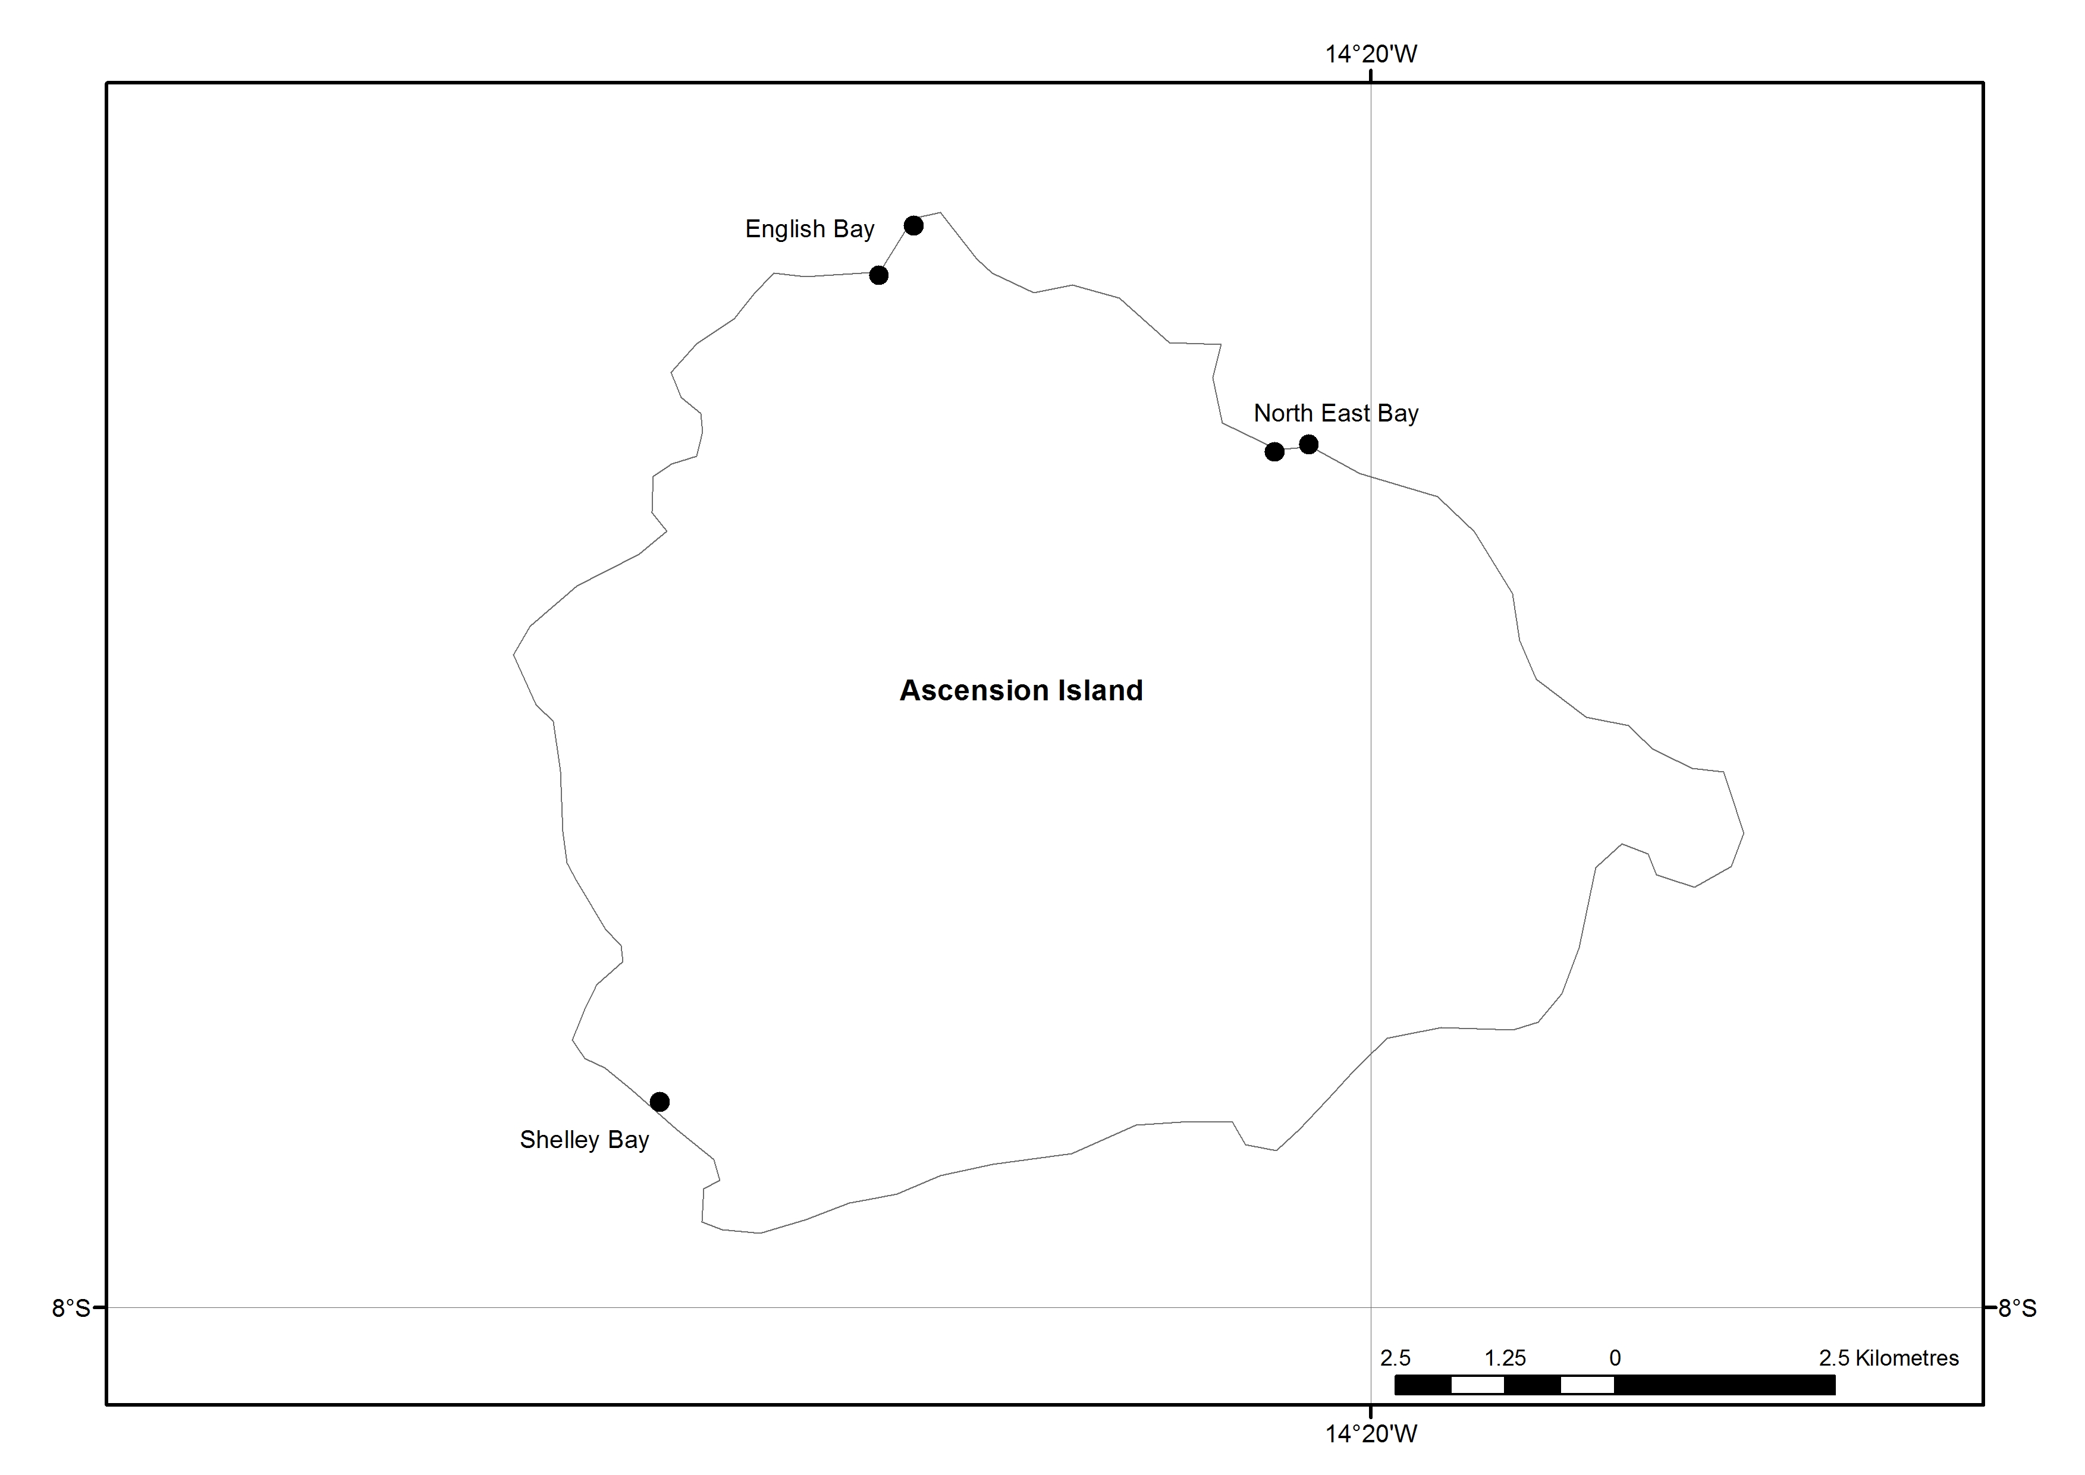
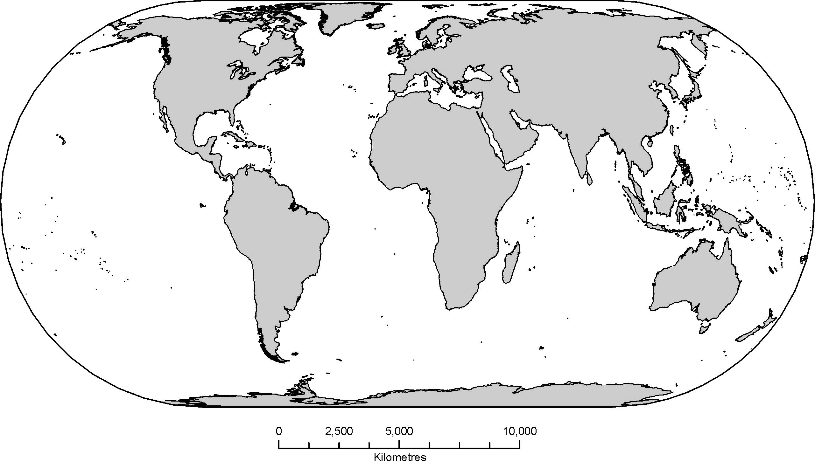
Figure 2
◆
❖
⬥






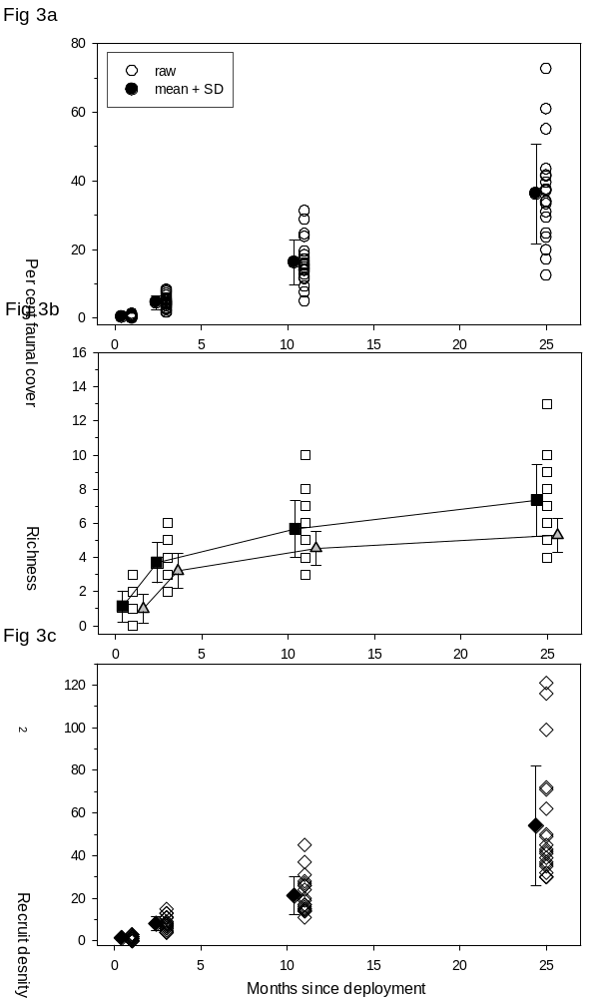
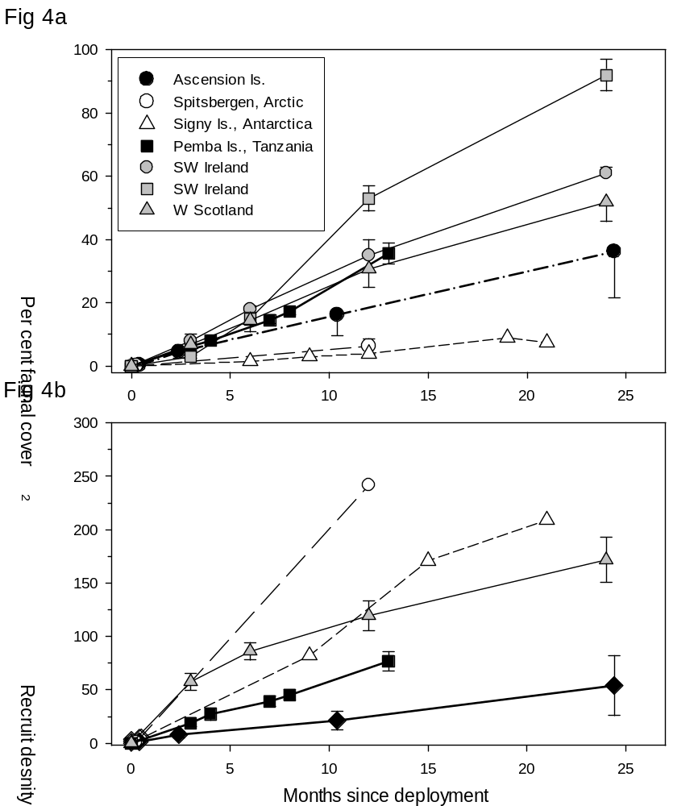
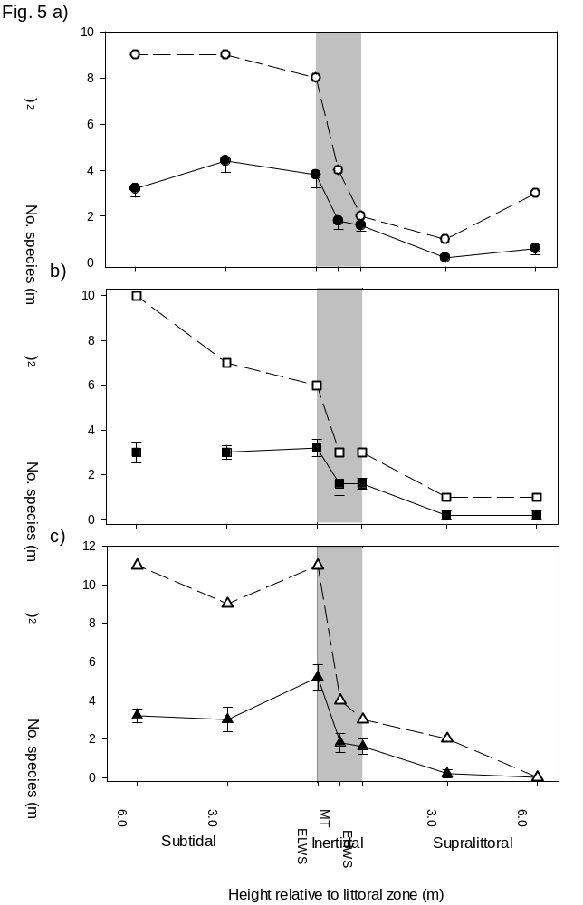
Figure 6.


