Coastal wave overtopping: New nowcast and monitoring technologies

Jennifer Brown, National Oceanography Centre, jebro@noc.ac.uk
Margaret Yelland, National Oceanography Centre, m.yelland@noc.ac.uk
Gerd Masselink, University of Plymouth, gerd.masselink@plymouth.ac.uk
Tim Poate, University of Plymouth, timothy.poate@plymouth.ac.uk
Kit Stokes, University of Plymouth, christopher.stokes@plymouth.ac.uk
Robin Pascal, National Oceanography Centre, rwp@noc.ac.uk
David Jones, National Oceanography Centre, dsj@noc.ac.uk
Christopher Cardwell, National Oceanography Centre, Chris.Cardwell@noc.ac.uk
John Walk, National Oceanography Centre, john.walk@noc.ac.uk
Barry Martin, National Oceanography Centre, barrym@noc.ac.uk
Peter Ganderton, University of Plymouth, P.Ganderton@plymouth.ac.uk
Louise Darroch, British Oceanographic Data Centre, lorr@noc.ac.uk
Tom Gardner, British Oceanographic Data Centre, thogar@noc.ac.uk

Abstract
It is projected that global mean sea level could rise up to 1 m this century with a strong regional pattern. It is estimated that 20% of England’s coastal defences could fail under just half this rise. Ambitious climate mitigation and adaptation plans may protect 400,000 – 500,000 people, but flood and coastal erosion risks cannot be fully eliminated. Building coastal climate resilience requires accurate wave overtopping prediction tools and nowcast information to prepare for and respond to coastal hazards. In Dawlish, SW England, a new monitoring system to measure concurrent beach level and wave overtopping conditions over a 1-year period was installed. The system obtains in-situ measurements of the inland wave overtopping distribution across a public walkway and railway line, and issues near real-time overtopping data to the British Oceanographic Data Centre, making it accessible online within 15 minutes of detection. This public web service also ingests near-real time wave and water level data from existing national coastal monitoring networks, providing a full dataset to validate and calibrate an operational wave, water-level and overtopping forecast system. Using these data, the numerical forecasts have been refined by incorporating recent beach levels to reduce the uncertainty in the wave overtopping predictions due to seasonal variability in the beach level at the toe of the sea wall.

Introduction
Wave overtopping of critical infrastructure is increasing in frequency at a global scale due to sea level rise. This has significant economic impacts for coastal transport networks (e.g. Dawson et al., 2018). To monitor trends in overtopping hazard, new sensors are required that measure 24/7 (Brown et al., 2021). Such field data are also vital to quantitatively validate forecast services and regularly update the environmental conditions, e.g., beach levels, which are often static or provided at most biannually (Stokes et al., 2021). New tools that incorporate the influence of wind on both the shallow water wave transformation (i.e., breaker position and breaking processes) and the vertical plume of dense spray generated at vertical sea wall (blowing it over a sea defence) are emerging (e.g., De Chowdhury et al., 2020). However, they focus on single case studies or idealised laboratory tests and still require capability assessment for use in national services before they can be adopted for hazard warning.

Methods
The Dawlish sea wall (Devon) in the SW of England has been instrumented with the novel “WireWall” (capacitance based) wave overtopping measurement system, in various configurations, and a “B-Scan” (laser based) beach profile measurement system (Figure 1). Both technologies have been engineered to provide near real-time quality-controlled observations. The WireWall system and smaller WireWand systems post data directly to the British Oceanographic Data Centre, who visually display and make the data publicly accessible within 15 minutes of detection. While the data are logged at 400 Hz, the number of wave overtopping events telemetered every 10 minutes is restricted to 100, shared between up to 6 wires, to reduce memory and on-board processing requirements. In 1 year this limit was reached on a small number of occasions (0.3% of the number of telemetered overtopping events were flagged to be at this cut-off limit).The B-Scan runs every low tide, providing the upper beach profile for the numerical daily wave overtopping hazard forecast by the Operational Waves and Water Levels (OWWL) service (Figure 2). The WireWall and WireWands were positioned along a sea to land transect to measure inland overtopping distribution. Their dimensions were designed to allow for a 2 m space on the walkway for pedestrians to pass socially distance as equipment was deployed during the Covid-19 pandemic. The height of the systems, 3m (WireWall / WireWands) and 4 m (B-scan and camera posts), was set so there was space for equipment to fall to the floor without overhanging the railway line to reduce risk to trains if equipment became dislodged during overtopping.
During southerly and easterly wind conditions, this location is vulnerable to wave overtopping (e.g., Figure 3). Observations were collected at: the crest of the sea wall, at the secondary wall seaward of the railway line (at heights both above and below the wall level) and at a security fence inland of the railway line. Together these measurements allow better understanding of the local hazard to different users (the public and rail operators, Figure 4).

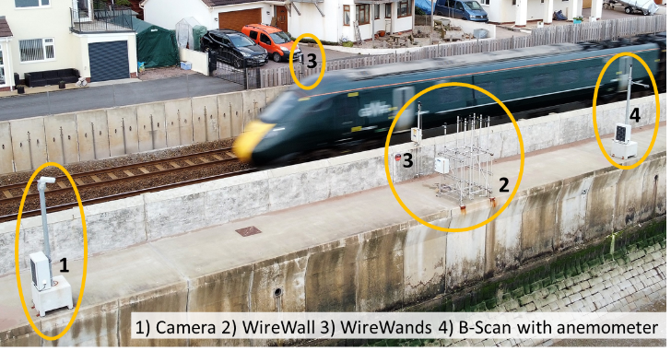
Figure 1 – The instrumented Dawlish sea wall (Devon). Photo recorded by the University of Plymouth’s drone. The numbers indicate the positions of the video camera (1), WireWall (2), the two WireWands (3) and the B-Scan, which has an anemometer positioned above it (4).

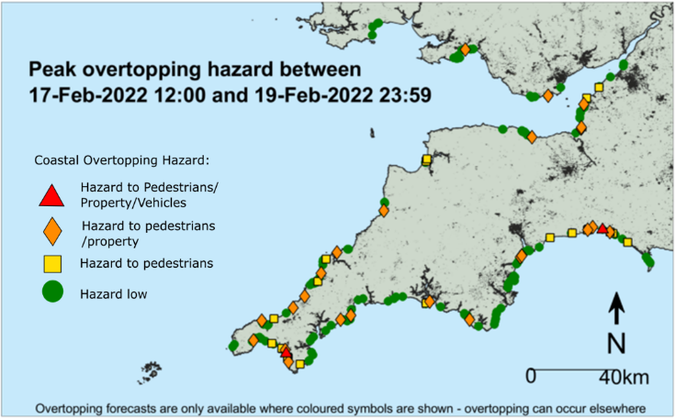
Figure 2 – Example of the Operational Waves and Water Levels (OWWL) service, alerting of the wave overtopping hazard forecast in the SW of England.

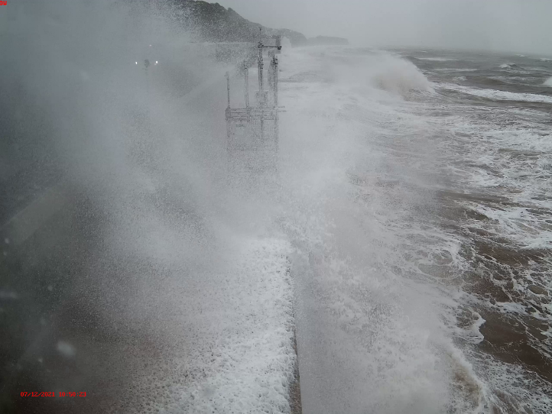
Figure 3 – Overtopping during Storm Barra. Camera image recorded 7th December 2021 at 10:50 (GMT).

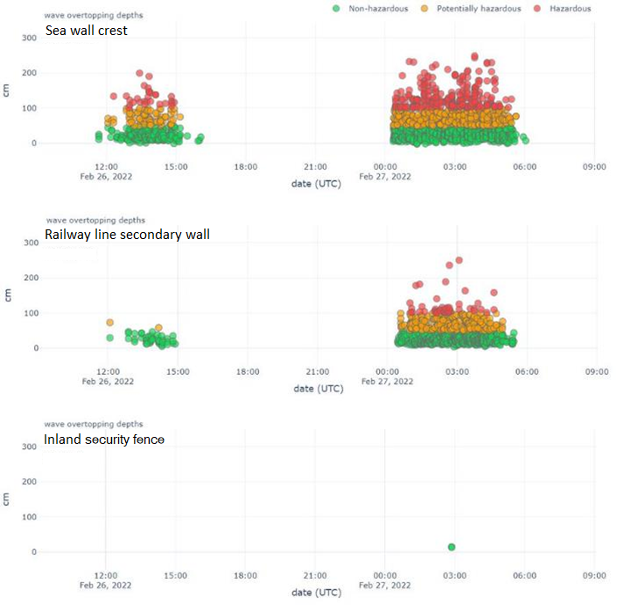
Figure 4 – Nowcast wave overtopping information at the three monitoring locations distributed at different inland locations on the coastal infrastructure. The top figure is at the sea wall crest (system 2, in Figure 1). The middle figure is at the railway line wall (the seaward system 3, in Figure 1). The bottom figure is at the security/garden fence (inland of the railway line also system 3, in Figure 1).

Results
In 1 year of telemetered observations more than 12000 wave events were measured overtopping the Dawlish sea wall crest, +/- 3 hrs either side of high water (HW). Of those waves, 35% reached the railway line wall, and are thus considered hazardous to the public using the walkway. Using the near real-time (NRT) data feeds we can compare the frequency distribution of the average environmental conditions and those associated with wave overtopping events (Figure 5). The environmental monitoring are provided at 10-minute (water level and winds) and 30-minute (wave) intervals. Here, the conditions are linearly interpolated to the times at which each individual wave overtopping event occurs to describe the coastal forcing. While the time recording interval of the individual data feeds influences the frequency of data points for the different information sources, the distributions can be compared to assess the conditions that cause overtopping against the range in conditions at the site. This method is similar to that developed by Scott et al. (2014) to assess rip current hazard. We find that swell waves can cause overtopping during water levels below mean water and that the more dominant wind wave conditions more frequently cause overtopping during water levels above mean water level. Overtopping occurs most frequently when water levels are approximately half the maximum tidal amplitude, which also represents the point at which the frequency distribution for the high water levels tails off (i.e., the lower frequency of the highest water levels reduces the probability of the required wind/wave conditions coinciding with these levels and therefore reduces the likelihood of overtopping). All overtopping events are associated with wave heights below the local (0.25-year return period) storm wave threshold (2.77 m, Dhoop & Thompson, 2018). Overtopping conditions generally occur when the wind and waves have an onshore component in their direction and the onshore wind speeds are above average. For the overtopping to reach the railway line wall the winds have to be even stronger.

Figure 5 – NRT monitoring of the environmental met-ocean conditions at Dawlish March 2021-2022 and the conditions when wave overtopping occurred. The beach faces towards 135ͦ. During the deployment the maximum and mean water levels recorded were 2.61 and 0.26 m OD, respectively, with the sea wall crest at 5.7 m OD. The maximum wave height was 3.48 m and median wind speed was 7.2 m/s.

To complement the NRT data, the wave energy period (T_{e}, s) is available in delayed mode and the wave energy and wave power can be calculated. Figure 6 shows that the shapes of the annual T_{e} distribution and distribution for wave overtopping events are very similar, while the T_{e} for overtopping events only is shifted slightly towards longer periods. This comparison shows the value of monitoring Te for hazard management purposes over Tp, see Dhoop & Thompson (2021). Since the majority of the waves are less than 1 m, most of waves are low energy ($∝$H_{m0} ²). The short periods for the larger wind waves (>1 m) also mean that most of the waves have low power ($∝$H_{m0} ²T_{e}). These latter parameters are therefore not good indicators of wave overtopping at this site.

Figure 6 – Additional wave conditions at Dawlish March 2021-2022 and the conditions when wave overtopping events occurred.

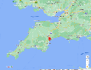
Figure 7 – Google map insert of the Dawlish study location. Wave overtopping intensity (measured by WireWall as the total length of wire wetted by the dense spray) categories for different wind-wave conditions. The data are collected at a wire 35 cm inland of the crest of the sea wall (sea wall) and 3.2 m inland of the crest of the sea wall (railway line wall). Dashed lines represent the directly onshore conditions 120ͦ-150ͦ. The diagonal line shows when the wind is following the waves and the dotted lines when the wind is within ±20ͦ of the wave direction.

The wind and wave conditions that cause overtopping are related to the site’s exposure to two wave types (Atlantic swell and wind waves generated in the channel), which can arrive at the coast due to the regional geometry (Figure 7). The English Channel influences the fetch at this site and creates bi-directional wave conditions and enables bimodal wave periods due to exposure to swell and wind waves. The landmass of England prevents waves from north to east, while there is still potential for Atlantic swell to refract into the bay. The majority of overtopping occurs when the wind is following the waves, both with a considerable onshore component. Swell waves from the SW can overtop even when the winds are alongshore or offshore, but light. Outliers in the data at the crest of the sea wall are even rarer in the data at the railway line wall, illustrating the importance of wind and wave direction on the hazard to trains due to the condition combinations required to carry the dense vertical wave plume over the walkway. From camera observations, a strong nearly alongshore wind is seen to also enhance overtopping, as the wave plume is transported diagonally inland. The intensity of the overtopping is impacted by the shape of the bay and local sheltering effects. For southerly to southwesterly wind conditions, the wave overtopping intensity reduces, unless the wind is following the waves within 20 ͦ of the wave direction influencing their growth, due to the local headland sheltering effects reducing the wind influence on the vertical plume of dense spray. While the wind speed has an influence on the overtopping, there is not a simple correlation with the overtopping intensity as the strongest winds do not create the most overtopping or even cause wave overtopping to reach the railway line wall.
The data at the crest of the sea wall can be used to better constrain site-specific uncertainties in the numerical forecasts. Figure 8 shows a sequence of overtopping tides, where the predicted overtopping is similar on each tide, while the intensity observed by WireWall and the camera is variable. From the daytime footage it is clear that on the 7th March 2022, very little water was getting on to the prom - most plumes went straight up and then fell back into the sea. Only a few plumes hit the camera - ten “hits” were counted on the camera in 10 mins, and about half of those were just spray. In contrast, a lot of water fell onto the prom on the 8th March 2022, and quite a bit on the railway line. The camera was hit by more than 50 plumes, and most of those were more than just a bit of spray. In addition, water was constantly pouring off the prom for the whole 10 minutes.

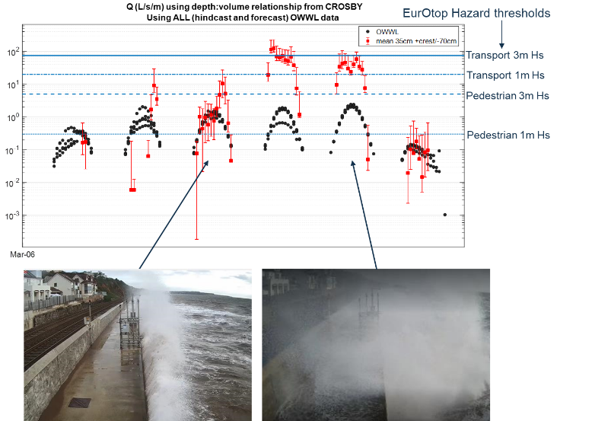
Figure 8 – Predicted wave overtopping by OWWL, using forecast (at different stages) and hindcast boundary conditions from operational services, alongside WireWall measurements 35 cm inland of the sea wall crest (with error bars showing the variability in observations from adjacent wires) and camera images in March 2022.

As an approximate validation of WireWall, 1 L/s/m is the same as 10 cm²/s, so a 1 cm depth of water on the walkway flowing off at 1 m/s would be 100 cm²/s, i.e. 10 L/s/m. To get the WireWall estimate of 35 L/s/m, a depth on the walkway of, e.g., 2 cm with a speed of 1.75 m/s would be required. It takes approximately 5 seconds for the leading edge of the return flow of the overtopped water to travel across the ~3.3 m walkway. The plate securing the inland edge of WireWall is a height of 5 cm and created a barrier to the return flow; thus, flow depth is estimated to be roughly 2.5 cm as the top is often seen in the camera image. The return flow either side of WireWall is influenced by the next incoming wave, momentum exchange during reflection off the railway line wall and the surface roughness, but as an approximate is 0.66 m/s, about half the speed required. However, the offshore flow only represents the overtopping spray returned by the railway line wall standing ~1.5 m high, which is less than half the height of the dense spray passing over it (the camera is at 4 m above the walkway and frequently covered in spray) and positioned at roughly 1/3 of the distance the plume extends inland (the spray often reaches the cliffs in the background of the footage). Although a higher proportion of overtopping water will occur closer to the crest of the sea wall, a low estimate of the volume travelling inland with up to 50% error does not seem unreasonable due to the infrastructure present. Some example images are shown in Figure 9. An alternative estimate can be calculated using the speed of falling water due to gravity, although the actual speed on the walkway would be less. The rough surface of the walkway has a drop of 15-20 mm over 1.4 m and the slope increases at the edge to a 35 mm drop. If we take the total drop of the walkway to be 5 cm, the fall speed of water due to gravity would be 1 m/s, bring the estimate closer to the required speed for a 35 L/s/m discharge.
The NRT data (Figure 10) indicated the overtopping intensity increases for a period when the wave height increases and the winds turns to onshore. The numerical wave forecast used as boundary conditions to OWWL slightly underpredicts the coastal conditions, but the overall result is acceptable. However, using the observed wave conditions as boundary forcing in OWWL, does increase the variability in the predicted overtopping (Figure 11), showing how a small change in coastal conditions can translate into a much larger impact in hazard predictions.
While uncertainty and resolution in numerical services can influence overtopping forecasts, there is greater uncertainty generated from processes often neglected in overtopping prediction tools, such as wind conditions.

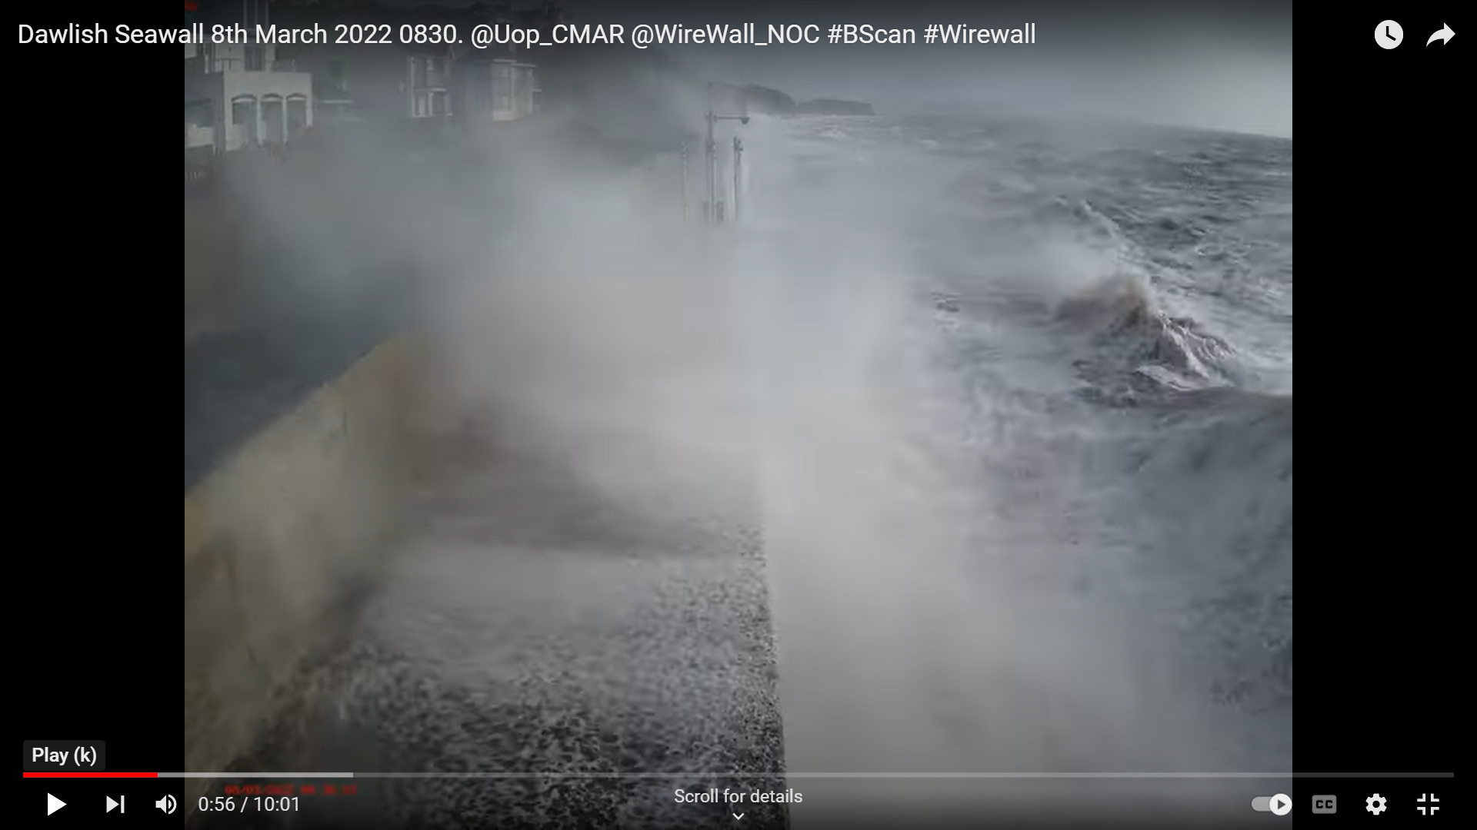
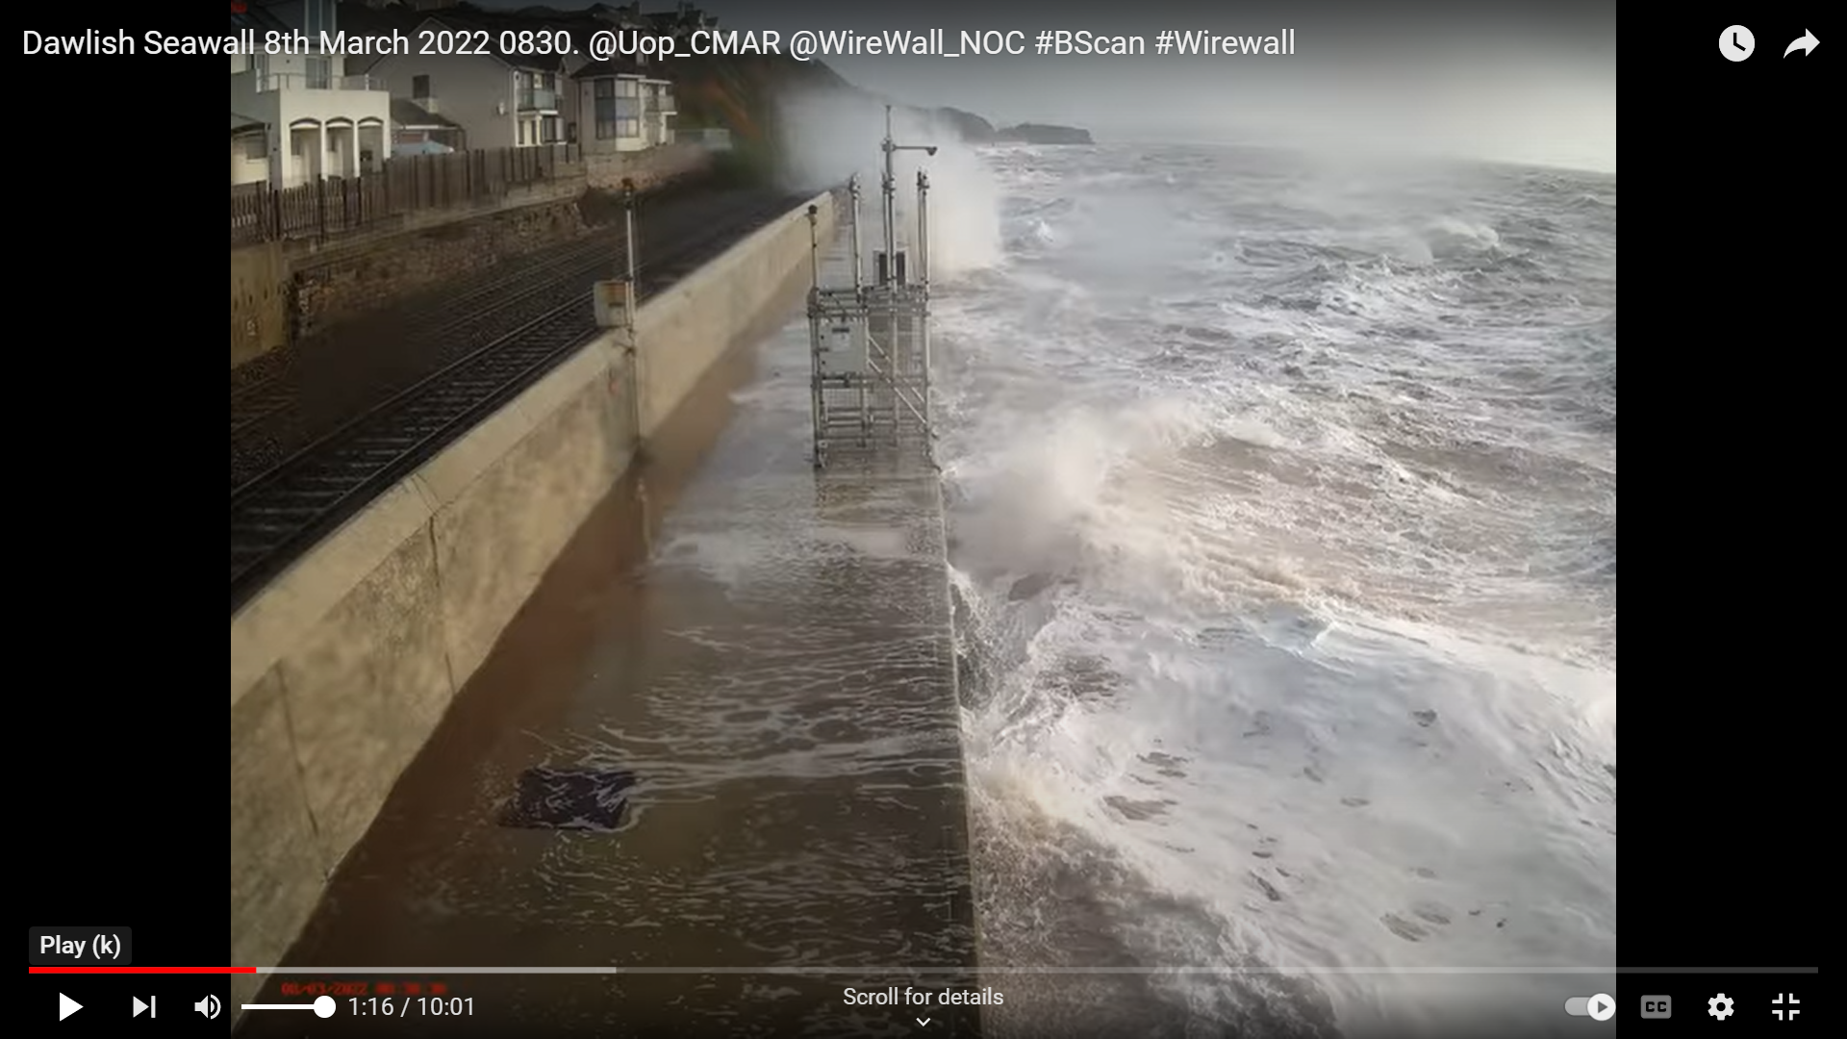
Figure 9 – Screen grabs taken from camera footage close to high tide in the morning of the 8th March 2022, see https://youtu.be/82h0HCcQLkQ.

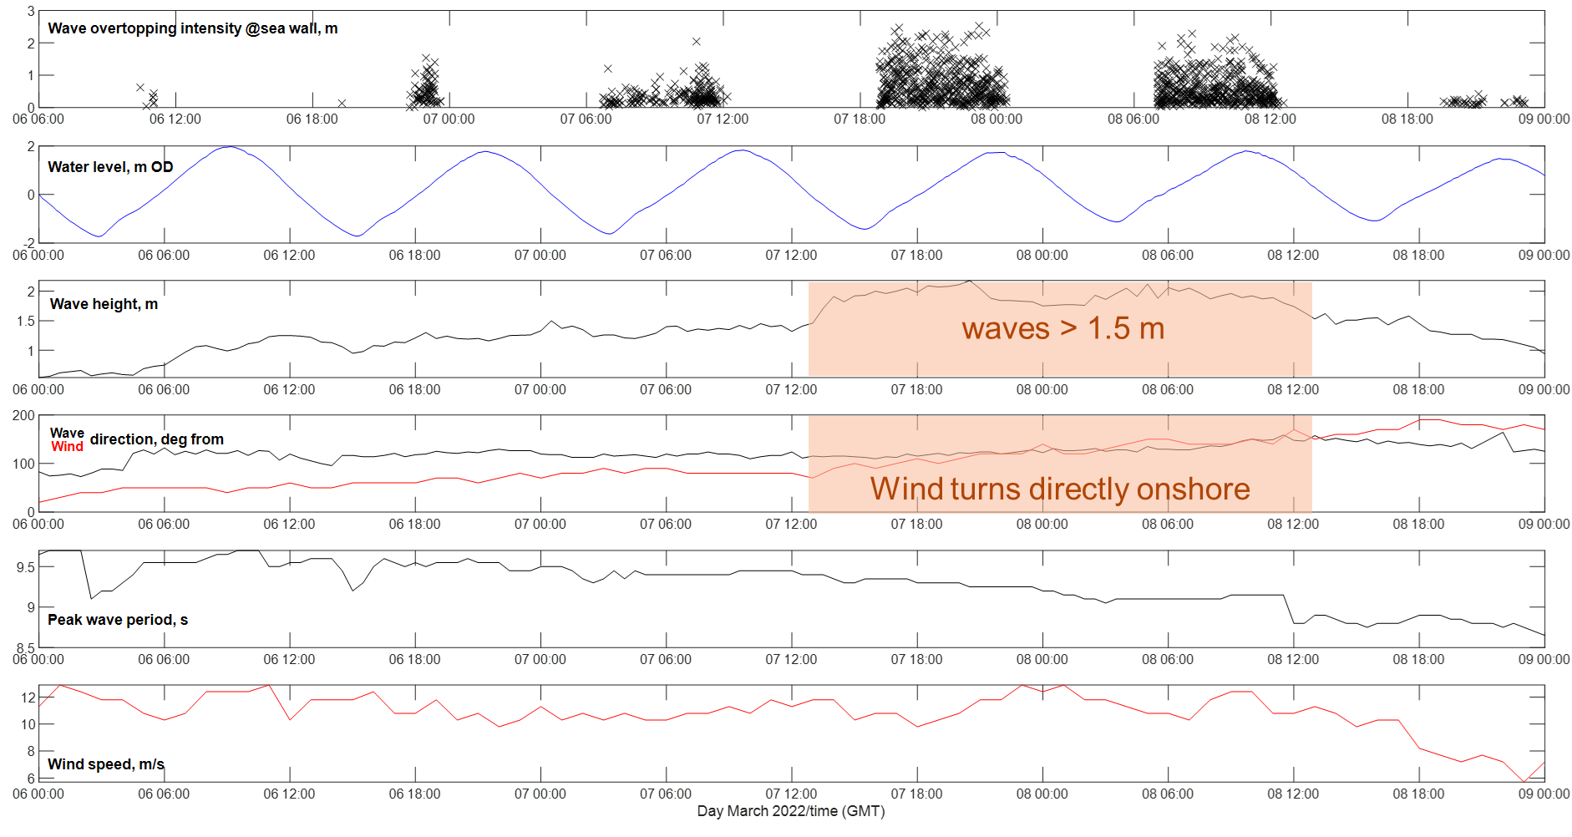
Figure 10 – The time series of met-ocean conditions during overtopping events of different intensity in March 2022.

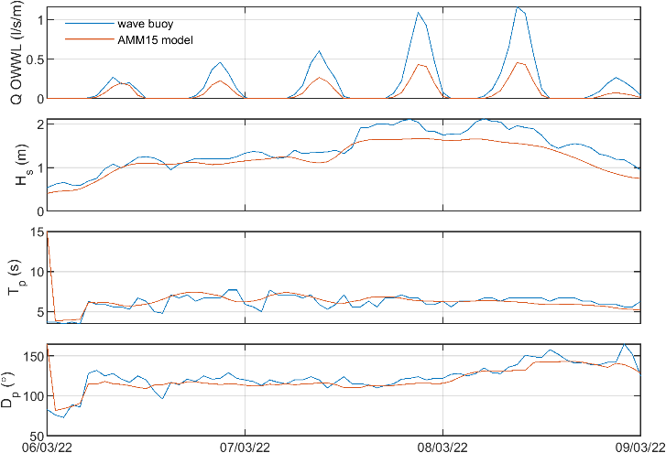
Figure 11 – The OWWL wave overtopping predictions when forced by 1-day ahead forecast and observed data. The forecast at the Dawlish wave buoy location is shown alongside the observations.

At Dawlish, a concrete ‘toe mound’ at the base of the sea wall was exposed early in the study period and was not buried with beach material during the summer months as expected. The mound limited the detectable beach area by the B-scan (Figure 12). However, the beach level in front of the toe varied by approximately +/- 0.5 m and this was enough to alter the hazard warning by at least one level on each major event. On average the overtopping discharge was up to 2 times higher when toe level was at its lowest than when it was at its highest. The uncertainty in overtopping prediction is shown in Figure 13.

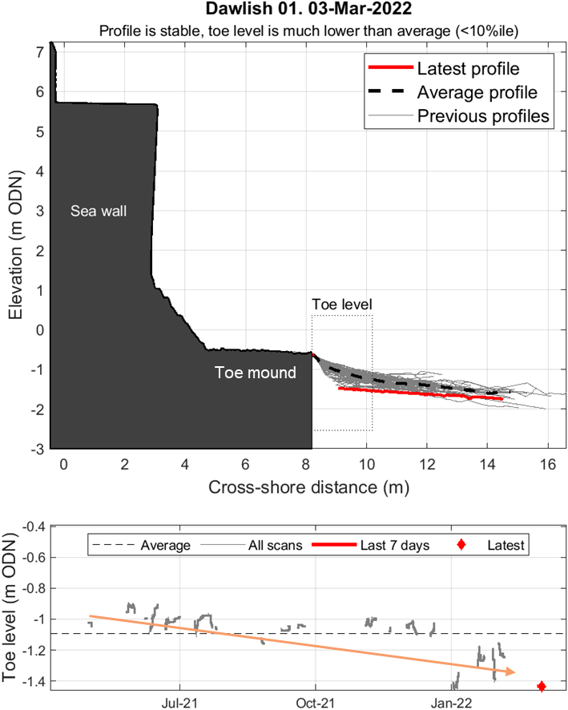
Figure 12 – An example of the near real-time beach level information measured by B-Scan and applied in the OWWL service.

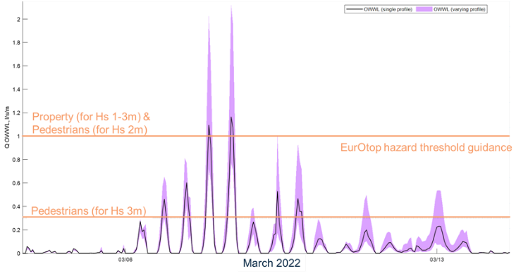
Figure 13 - The impact of beach profile change on overtopping predictions. The solid line showing the standard prediction using the most recent biannual beach survey, and the shading showing the uncertainty by capturing the range in predictions when using a range of B-Scan profiles collected during the study period.

Discussion
Observations have been collected for a full year, since March 2021, and show the time variation in wave overtopping over a tidal cycle and the roles of varying beach levels. The overtopping observations have been collected for 3 hours either side of high water, although it was found overtopping can have already started before or continue beyond this time period. It is noteworthy, that, at this site, no overtopping occurred when the local storm wave threshold was exceeded. This threshold is used by local authorities to identify when high energy events are forecast or occur to collect post event information, such as beach levels, or carry out defence inspections. These national thresholds are based on probability analysis of the nearshore wave observations. These results show how important impact data are (e.g., wave overtopping information) as hazardous conditions are driven by complex coastal process interactions and may not be associated with the extreme conditions within a single parameter, such as wave height. Data on the impacts enable assessment of local statistical thresholds to improve understanding of when response protocols should be implemented.
When overtopping occurs, the maximum discharge does not always occur at the high tide (Figure 8). Network Rail apply restrictions on train travel in response to the hazard forecast, which often implements a fixed 3-hour train cancelation for the worst conditions. At this site the protocol in response to different hazard levels is to impose speed restrictions, run trains only on the inland track and then stop services. The speed protocol is train specific as each operate differently. When a train driver reports wave overtopping the initial response is to check when high tide is to support the decision-making process. It is assumed that if high tide is close or past, then the hazard will reduce. These observations show this is not always the case. Better understanding of the timing and duration of hazardous overtopping will improve operational efficiency, reducing delay and cancelation costs.
The data will allow the re-assessment of the coastal condition combinations that most frequently pose a hazard to the railway line to support the SW Rail Resilience Programme, and enables identification of where site-specific modifications in operational predictions can be implemented to improve local hazard forecasts.
Concurrent datasets (as collected) on the source and impact of conditions that lead to wave overtopping will help develop new process parameterisations to build on existing predictive tools for hazard forecasting. This deployment shows the value of having camera information, alongside observations at the point of impact and numerical predictions. Camera installations (CCTV or webcams) are more commonly seen at beach sites with high footfall, but their positioning may not always be ideal to assess wave overtopping or erosion hazard. Unless observations are made within their field of view the hazard information is qualitative, and often based on human interpretation. The systems deployed here have low material costs and can collect data at specific points of interest, e.g., at nodes within predictive services, at vulnerable hot spots, or in the field of view of existing cameras. The time series of data offers the potential to assess uncertainty in numerical predictions and/or develop machine learning algorithms to quantify the hazard in camera images or develop new efficient predictive tools relating hazard impact to nearshore coastal conditions (modelled of observed). The added value of sensor data over cameras is that it provides continuous information at a specific location day and night, and is easy to use in information comparison tasks without additional analysis. The data storage and power requirements to run the sensors deployed here 24/7 are often lower than that of a camera, reducing maintenance requirements. There is also no public privacy issues as no information is gathered about the people onsite, which can be an issue when installing cameras at popular beach locations.
The overtopping data and coastal conditions from this study are available from the British Oceanographic Data Centre to allow others to use the data in their research (https://linkedsystems.uk/erddap/info/index.html?page=1&itemsPerPage=1000).

Acknowledgments
This work was delivered by the Coastal REsistance: Alerts and Monitoring Technologies (CreamT) project funded by NERC (NE/V002538/1, NE/V002589/1). We would like to thank the Channel Coastal Observatory, Plymouth Coastal Observatory, the Environment Agency and the Met Office for support in accessing their data in near real-time through APIs. The SW Regional Monitoring Programme and Network Rail are thanked for their support to deploy equipment and for their discussion around the results. The Met Office are also thanked for the provision of operational model data and discussion around appropriate averaging windows for model-observation comparisons.

References
Brown et al. (2021): Novel use of social media to assess and improve coastal flood forecasts and hazard alerts. Scientific Reports, 11, 13727.
Dawson et al. (2018): The economic value of climate information in adaptation decisions: learning in the sea-level rise and coastal infrastructure context. Ecological Economics, 150, 1-10.
De Chowdhury et al. (2020): Wind effects on overtopping discharge at coastal defences. Proceedings of virtual Conference on Coastal Engineering, 2020, No. 36v, 7pp.
Dhoop, Thompson, (2018): Extreme Value Analysis for CCO Coastal Wave Data. Technical Note TN 03, 11pp, www.channelcoast.org/ccoresources/stormcatalogue/
Dhoop, Thompson, (2021): Swell wave progression in the English Channel: implications for coastal monitoring. Anthropocene Coasts. 4(1): 281-305.
Scott et al. (2014): Controls on macrotidal rip current circulation and hazard, Geomorphology, 214, 198-215.
Stokes et al. (2021): Forecasting coastal overtopping at engineered and naturally defended coastlines, Coastal Engineering, 164, 103827.

