Supplementary information file
Table S1. Two-step extraction of ¹⁴C-labelled protein and ¹⁴C-labelled amino acid mixture remaining (% of total ¹⁴C-labelled substrate added) in either the topsoil (Top) or subsoil (Sub) at the end of the ¹⁴CO₂ evolution experiment following the addition of either ¹⁴C-labelled protein or amino acid mixture to soil. Values represent mean ± SEM (n = 3).
Site | Soil depth | ¹⁴C-labelled protein (% of total ¹⁴C-labelled protein added) |  |  |  |  |  | ¹⁴C-labelled amino acid mix (% of total ¹⁴C-labelled amino acid mixture added)
 |  | ¹⁴C extracted by deionised water | ¹⁴C extracted by 0.05 M Na-pyrophosphate | Total ¹⁴C extracted |  |  | ¹⁴C extracted by deionised water |  | ¹⁴C extracted by 0.05 M Na-pyrophosphate | Total ¹⁴C extracted
1 | Top | 3.3 ± 0.4 | 17.0 ± 1.5 | 20.2 ± 1.4 |  |  | 1.5 ± 0.2 |  | 2.3 ± 0.3 | 3.8 ± 0.2
 | Sub | 5.4 ± 0.6 | 13.0 ± 4.0 | 18.3 ± 3.3 |  |  | 1.6 ± 0.3 |  | 5.1 ± 0.7 | 8.2 ± 0.8
2 | Top | 3.4 ± 0.6 | 16.3 ± 1.3 | 19.6 ± 0.8 |  |  | 2.3 ± 0.4 |  | 5.0 ± 0.6 | 7.3 ± 0.4
 | Sub | 4.4 ± 0.2 | 15.3 ± 1.6 | 19.7 ± 1.4 |  |  | 3.1 ± 0.5 |  | 5.1 ± 0.1 | 8.2 ± 0.4
3 | Top | 2.6 ± 0.2 | 24.1 ± 0.9 | 26.7 ± 1.0 |  |  | 1.4 ± 0.1 |  | 4.4 ± 0.2 | 5.8 ± 0.2
 | Sub | 5.9 ± 0.8 | 21.3 ± 1.5 | 27.2 ± 1.6 |  |  | 3.8 ± 1.6 |  | 4.7 ± 1.0 | 8.5 ± 0.6
4 | Top | 6.1 ± 1.0 | 18.8 ± 0.5 | 25.0 ± 1.5 |  |  | 2.1 ± 0.1 |  | 6.1 ± 0.1 | 8.2 ± 0.1
 | Sub | 5.8 ± 0.2 | 23.1 ± 1.7 | 28.9 ± 1.6 |  |  | 3.6 ± 1.3 |  | 6.1 ± 0.4 | 9.7 ± 1.7
5 | Top | 4.3 ± 1.0 | 17.7 ± 0.5 | 22.0 ± 1.4 |  |  | 2.0 ± 0.3 |  | 4.1 ± 0.9 | 6.1 ± 0.9
 | Sub | 5.4 ± 0.6 | 16.0 ± 4.0 | 21.4 ± 4.6 |  |  | 2.7 ± 0.4 |  | 3.7 ± 0.7 | 6.4 ± 0.8
6 | Top | 7.5 ± 3.2 | 10.1 ± 2.1 | 17.6 ± 1.1 |  |  | 1.8 ± 0.4 |  | 3.8 ± 1.4 | 5.7 ± 1.3
 | Sub | 7.5 ± 0.2 | 10.1 ± 1.5 | 17.6 ± 1.5 |  |  | 4.4 ± 2.4 |  | 5.4 ± 1.6 | 9.8 ± 1.1
7 | Top | 5.0 ± 0.6 | 9.5 ± 1.9 | 14.5 ± 1.5 |  |  | 1.6 ± 0.2 |  | 1.4 ± 0.1 | 3.0 ± 0.1
 | Sub | 6.6 ± 0.4 | 17.4 ± 1.8 | 24.0 ± 1.5 |  |  | 2.4 ± 0.3 |  | 4.2 ± 0.8 | 6.6 ± 0.5
8 | Top | 2.8 ± 0.5 | 16.8 ± 0.7 | 19.7 ± 0.5 |  |  | 1.3 ± 0.6 |  | 4.2 ± 1.0 | 5.4 ± 1.2
 | Sub | 4.8 ± 0.4 | 23.2 ± 1.9 | 28.0 ± 2.2 |  |  | 1.8 ± 0.5 |  | 4.9 ± 1.0 | 6.7 ± 0.6
9 | Top | 2.7 ± 0.3 | 16.0 ± 1.9 | 18.7 ± 2.0 |  |  | 1.3 ± 0.1 |  | 4.7 ± 0.3 | 6.0 ± 0.4
 | Sub | 4.0 ± 0.6 | 10.1 ± 1.8 | 14.1 ± 1.3 |  |  | 1.7 ± 0.3 |  | 3.4 ± 0.6 | 5.1 ± 0.6
10 | Top | 4.9 ± 0.7 | 11.1 ± 1.8 | 16.0 ± 1.2 |  |  | 1.4 ± 0.1 |  | 4.1 ± 0.9 | 5.5 ± 0.8
 | Sub | 9.6 ± 2.6 | 4.9 ± 0.8 | 14.5 ± 1.9 |  |  | 0.9 ± 0.1 |  | 2.6 ± 0.1 | 2.7 ± 0.2

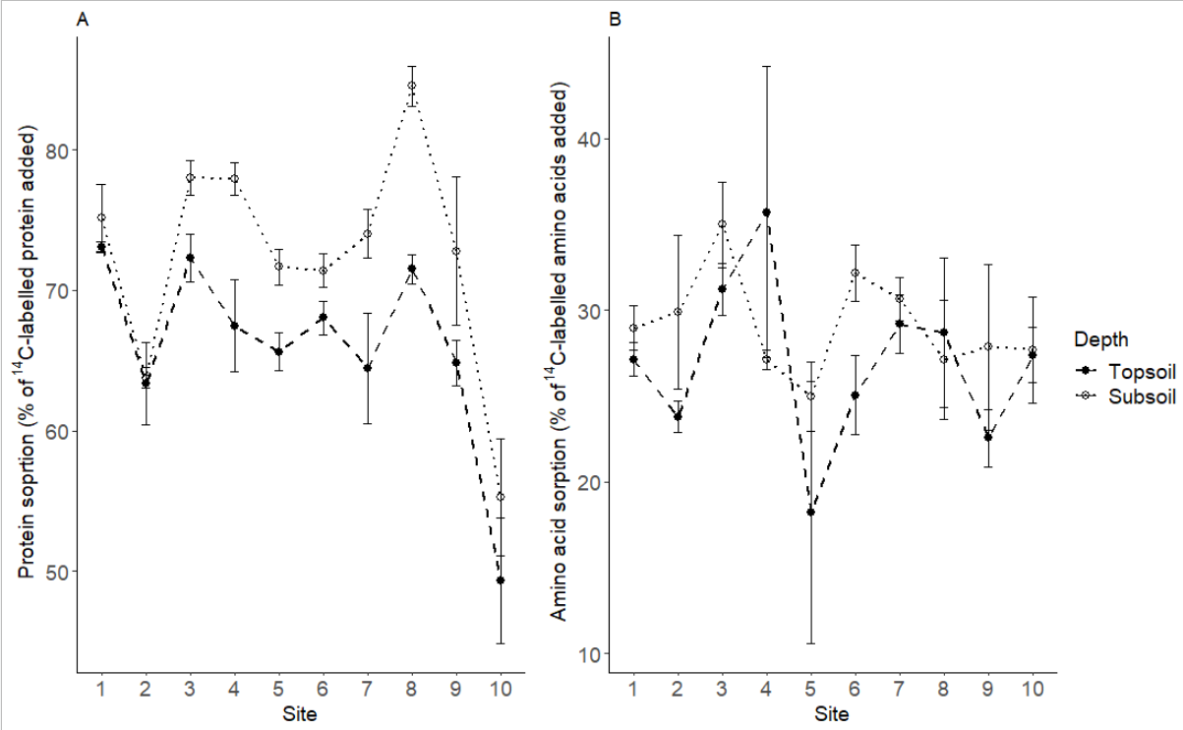
Figure S1. Sorption of either ¹⁴C-labelled protein (A) and ¹⁴C-labelled amino acid mixture (B) to either the topsoil or subsoil from across the grassland altitudinal gradient. Values are expressed as the amount of substrate sorbed to the solid phase as a percentage of the total ¹⁴C-labelled substrate added to the soil. Values represent means ± SEM (n = 3).

Supplementary Information 3
The breakdown of amino acids was generally biphasic, consistent with many previous studies investigating the turnover of low molecular weight solutes in soil (Jones et al., 2005; Hill et al., 2008; Glanville et al., 2016). Therefore, we described the process in a two-phase double first order kinetic decay model:
S = [a₁ x exp (-k₁t)] + [a₂ x exp (-k₂t)] (1)
Where S is the ¹⁴C-label remaining in the soil, k₁ is the exponential coefficient describing the initial breakdown by the microbial biomass, k₂ is the exponential coefficient describing the secondary, slower phase breakdown, a₁ and a₂ describe the proportion of ¹⁴C associated with the pools of exponential coefficients k₁ and k₂ and t is time (Boddy et al., 2008). The first rapid phase of ¹⁴CO₂ production is attributable to the immediate use of the substrate in catabolic processes (i.e. respiration; Glanville et al., 2016). The half-life (t_{½}) of the C pool a₁ can be calculated as:
t_{1/2} = ln(2) / k₁ (2)
The slower second phase (k₂) of ¹⁴CO₂ production is attributable to the subsequent turnover of ¹⁴C taken up and immobilised within the soil microbial community (i.e. C that is used in cell maintenance and growth, but which is subsequently mineralised during cell death or secondary maintenance). The half-life of C pool a₂ can be calculated as:
t_{1/2} = ln(2) / k₂ (3)
The values obtained for the half-life of C pool a₂ has some degree of uncertainty due to difficulties in quantifying the level of C pool connectivity within the microbial food web and different amounts of isotopic pool dilution (see Glanville et al., 2016 for further details). The cumulative ¹⁴CO₂ mineralisation data was transformed to give plots of ¹⁴C remaining in the soil versus time. Equation (1) was then fitted to the transformed experimental mineralisation results using a least sum of squares iteration routine with Sigmaplot 13.0 (SPSS Inc., Chicago, IL). Microbial substrate carbon use efficiency (CUE) is defined as the proportion of ¹⁴C-amino acid that is immobilised relative to the total amount taken up by the biomass. CUE was calculated as:
CUE = a₂ / (a₁ + a₂). (4)
A full description and validation of the approach used to calculate CUE is provided in the Supplementary Information of Jones et al. (2018a) while the general principles of using ¹⁴C to calculate microbial CUE are described in Jones et al. (2018b).

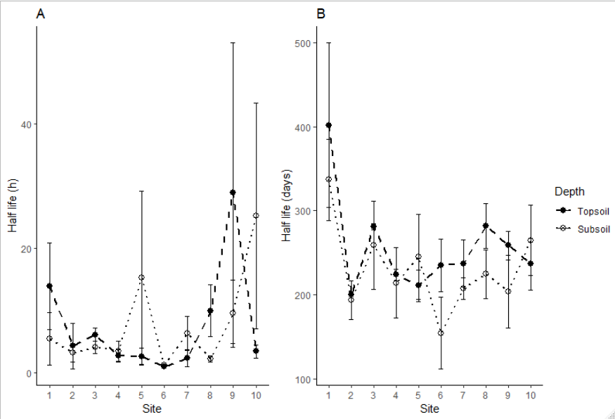

Figure S2. Half-lives of amino acid breakdown along the grassland altitudinal gradient in the topsoil and subsoil. A) Half-life of pool a₁ (h) and B) half-life of pool a₂ (days). Values represent mean ± SEM (n=3).
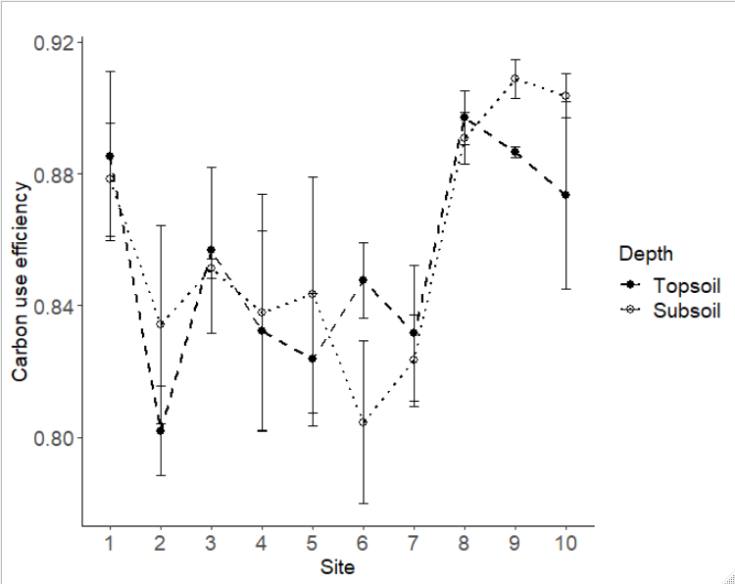
Figure S3. Microbial carbon use efficiency of amino acid-derived C along the grassland altitudinal gradient in the topsoil and subsoil. Values represent mean ± SEM (n=3).

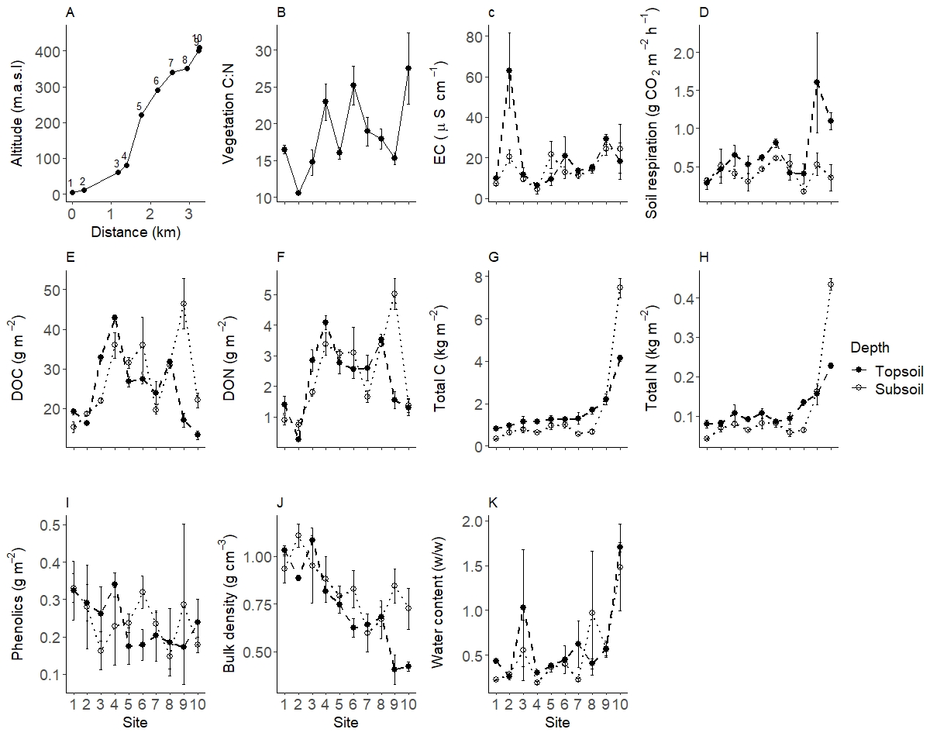

Figure S4. Soil properties of the grassland altitudinal catena sequence. A) location of sites over distance (km) and altitude (m.a.s.l), B) above-ground vegetation C:N ratio, C) electrical conductivity (EC) (µS cm⁻¹), D) soil respiration (g CO₂ m⁻² h⁻¹), E) dissolved organic C (DOC) (g m⁻²), F) dissolved organic N (DON) (g m⁻²), G) total C (kg m⁻²), H) total N (kg m⁻²), I) soluble phenolics (g m⁻²), J) bulk density (g cm⁻³), and K) volumetric water content (w/w).Values represent mean ± SEM (n = 3) and are expressed on a dry weight basis except for A.

Table S2. Two-way ANOVA results for soil properties and the one-way ANOVA result for and plant C:N net primary productivity. P values in bold are significant (p <0.05).
Soil property | Residuals | Site |  |  | Depth
 |  | df | F | P value | df | F | P value
Amino acid C* |  | 9 | 38.9 | <0.0001 | 1 | 0.06 | 0.813
Ammonium | 40 | 9 | 7.26 | <0.0001 | 1 | 14.6 | 0.0004
Bulk density | 40 | 9 | 8.35 | <0.0001 | 1 | 7.16 | 0.011
Cation exchange capacity | 40 | 9 | 15.8 | <0.0001 | 1 | 51.3 | <0.0001
C:N ratio | 40 | 9 | 26.4 | <0.0001 | 1 | 39.1 | <0.0001
DOC | 40 | 9 | 26.2 | <0.0001 | 1 | 7.79 | 0.008
DON* |  | 9 | 36.6 | <0.0001 | 1 | 1.16 | 0.281
Electrical conductivity* |  | 9 | 33.2 | 0.0001 | 1 | 0.66 | 0.416
Microbial C | 40 | 9 | 12.6 | <0.0001 | 1 | 37.4 | <0.0001
N mineralisation* |  | 9 | 11.6 | 0.245 | 1 | 5.89 | 0.015
Nitrate | 40 | 9 | 21.4 | <0.0001 | 1 | 0.006 | 0.936
pH | 40 | 9 | 94.5 | <0.0001 | 1 | 2.49 | 0.122
Phenols | 40 | 9 | 0.82 | 0.592 | 1 | 0.00 | 0.995
Plant C:N | 28 | 1 | 6.52 | 0.016 | - | - | -
Protease activity | 40 | 9 | 2.68 | 0.016 | 1 | 0.35 | 0.555
Protein C | 40 | 9 | 1.74 | 0.111 | 1 | 0.32 | 0.574
Soil respiration | 40 | 9 | 3.88 | 0.001 | 1 | 13.7 | 0.0007
Total C | 40 | 9 | 152 | <0.0001 | 1 | 0.70 | 0.407
Total N | 40 | 9 | 95.7 | <0.0001 | 1 | 0.20 | 0.655
Water content* |  | 9 | 28.2 | 0.0009 | 1 | 3.81 | 0.051
Net primary productivity | 28 | 1 | 35.2 | <0.0001 | - | - | -
*Soil properties did not have a normal distribution after transformation; therefore, a Kruskal-Wallis test was performed to determine the difference with site and depth separately. In these cases, F value refers to the chi-squared value.

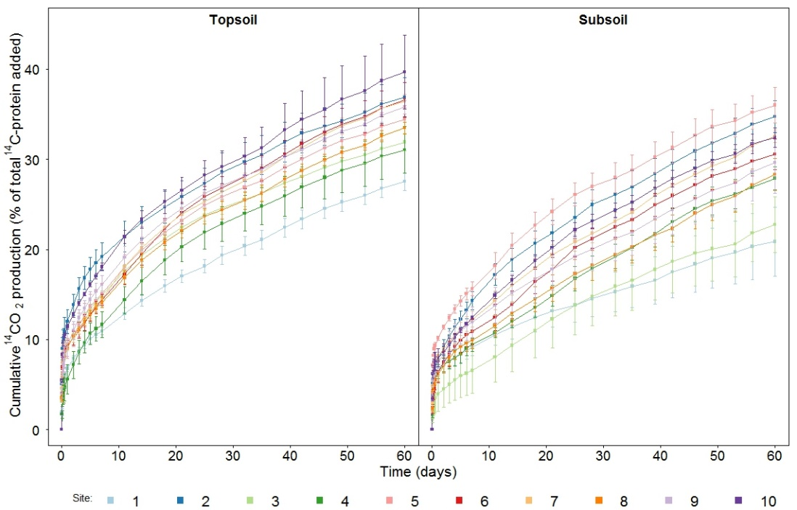
Figure S5. Cumulative ¹⁴CO₂ production arising from the mineralisation of ¹⁴C-labelled protein for ten sites along the grassland altitudinal gradient in the topsoil and subsoil. Values represent mean ± SEM (n = 3).
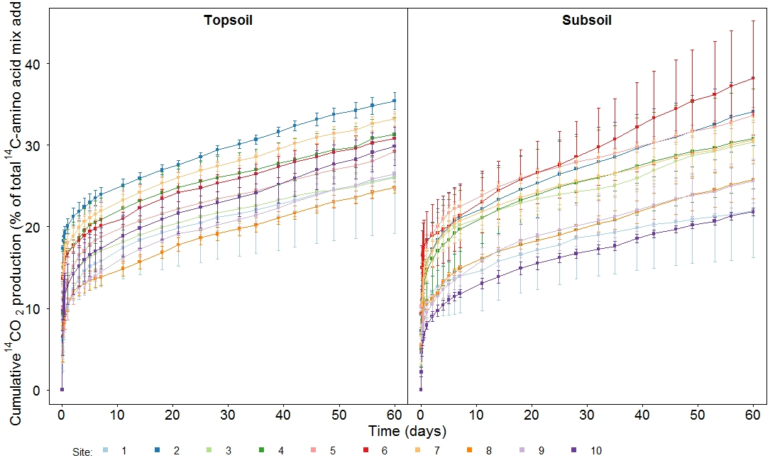
Figure S6. Cumulative ¹⁴CO₂ production arising from the mineralisation of a mixture of ¹⁴C-labelled amino acids for ten sites along the grassland altitudinal gradient in the topsoil and subsoil. Values represent mean ± SEM (n = 3).

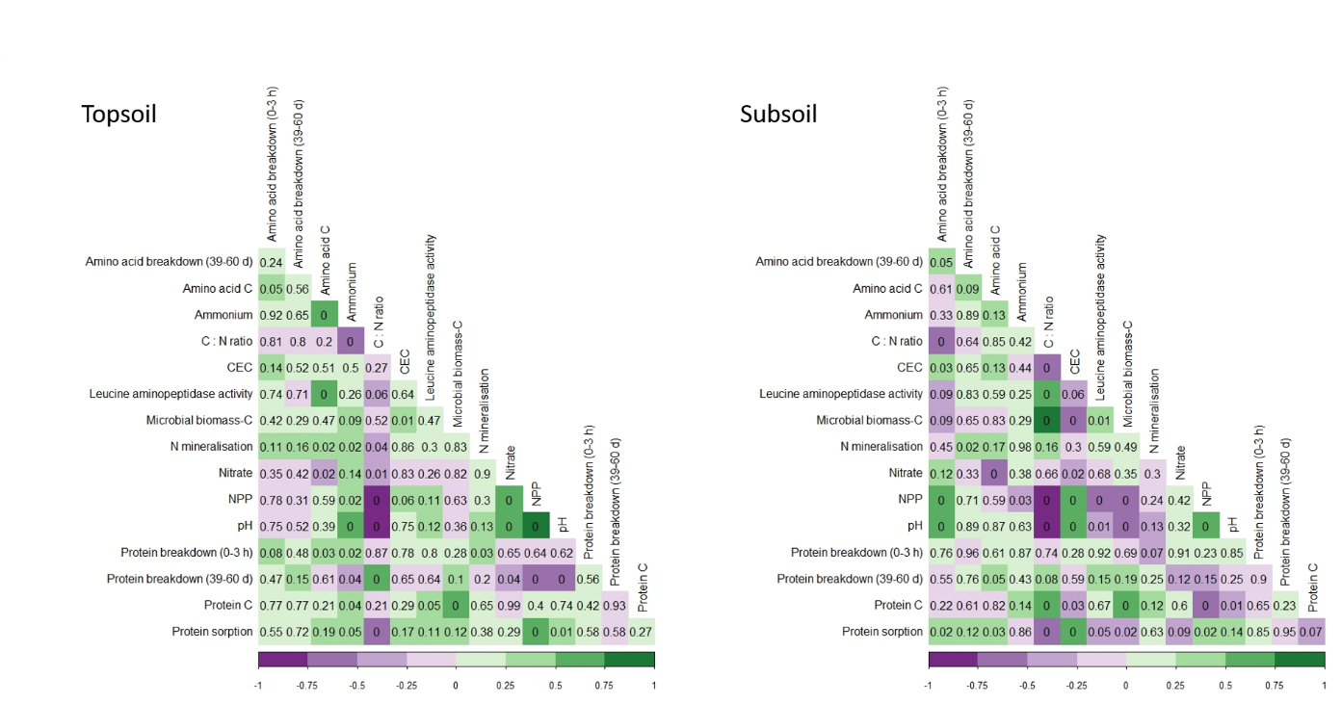
Figure S7. Correlation matrix (Corrplot) for the different measured parameters in the topsoil and subsoil of all sites along the grassland altitudinal gradient. P values are stated for each correlation and colours relate to the correlation coefficient.
References
Boddy, E., Roberts, P., Hill, P.W., Farrar, J., Jones, D.L., 2008. Turnover of low molecular weight dissolved organic C (DOC) and microbial C exhibit different temperature sensitivities in Arctic tundra soils. Soil Biology & Biochemistry 40, 1557-1566.
Glanville, H.C., Hill, P.W., Schnepf, A., Oburger, E., Jones, D.L., 2016. Combined use of empirical data and mathematical modelling to better estimate the microbial turnover of isotopically labelled carbon substrates in soil. Soil Biology & Biochemistry 94, 154–168.
Hill, P.W., Farrar, J.F., Jones, D.L., 2018a. Decoupling of microbial glucose uptake and mineralization in soil. Soil Biology & Biochemistry 40, 616-624.
Jones, D.L., Kemmitt, S.J., Wright, D., Cuttle, S.P., Bol, R., Edwards, A.C., 2005. Rapid intrinsic rates of amino acid biodegradation in soils are unaffected by agricultural management strategy. Soil Biology & Biochemistry 37, 1267-1275.
Jones, D.L., Olivera-Ardid, S., Klumpp, E., Knief, C., Hill, P.W., Lehndorff, E., Bol, R., 2018a. Moisture activation and carbon use efficiency of soil microbial communities along an aridity gradient in the Atacama Desert. Soil Biology & Biochemistry 117, 68-71.
Jones, D. L., Hill, P.W., Smith, A.R., Farrell, M., Ge, T., Banning, N.C., Murphy, D. V., 2018b. Role of substrate supply on microbial carbon use efficiency and its role in interpreting soil microbial community-level physiological profiles (CLPP). Soil Biology & Biochemistry 123, 1–6.

