Environmental benefits of leaving offshore infrastructure in the ocean
Ashley M Fowler^{1*}, Anne-Mette Jørgensen², Jon C Svendsen³, Peter I Macreadie⁴, Daniel OB Jones⁵, Arjen R Boon⁶, David J Booth¹, Robin Brabant⁷, Emily Callahan⁸, Jeremy T Claisse⁹, Thomas G Dahlgren^{10,11}, Steven Degraer⁷, Quenton R Dokken¹², Andrew B Gill¹³, David G Johns¹⁴, Robert J Leewis¹⁵, Han J Lindeboom^{16,17}, Olof Linden¹⁸, Roel May¹⁹, Albertinka J Murk²⁰, Geir Ottersen^{21,22}, Donna M Schroeder²³, Sunil M Shastri²⁴, Jonas Teilmann²⁵, Victoria Todd^{26,27}, Gert Van Hoey²⁸, Jan Vanaverbeke⁷, and Joop WP Coolen^{16,29}

¹Fish Ecology Laboratory, School of Life Sciences, University of Technology, Sydney, Australia *(ashley.fowler@uts.edu.au); ²North Sea Futures, Copenhagen, Denmark; ³National Institute of Aquatic Resources (DTU Aqua), Section for Ecosystem based Marine Management, Technical University of Denmark, Lyngby, Denmark; ⁴Deakin University, Geelong, Australia, School of Life and Environmental Sciences, Faculty of Science and Built Environment, Centre for Integrative Ecology; ⁵National Oceanography Centre, University of Southampton Waterfront Campus, European Way, Southampton, UK; ⁶Department of Ecosystem and Sediment Dynamics, Deltares, Delft, the Netherlands; ⁷Royal Belgian Institute of Natural Sciences, Operational Directorate Natural Environment, Marine Ecology and Management, Brussels, Belgium; ⁸Blue Latitudes LLC, San Diego, CA; ⁹Department of Biological Sciences, California State Polytechnic University, Pomona, CA; ¹⁰Uni Research, Bergen, Norway; ¹¹Department of Marine Sciences, University of Gothenburg, Gothenburg, Sweden; ¹²Texas Institute for Applied Environmental Research, Tarleton State University, Stephenville, TX; ¹³PANGALIA Environmental, Ampthill, UK; ¹⁴Sir Alister Hardy Foundation for Ocean Science, The Laboratory, Plymouth, UK; ¹⁵Warmond, the Netherlands; ¹⁶Wageningen University, Chair group Aquatic Ecology and Water Quality Management, Wageningen, the Netherlands; ¹⁷Royal Netherlands Institute for Sea Research, ‘t Horntje, the Netherlands; ¹⁸World Maritime University, Malmö, Sweden; ¹⁹Norwegian Institute for Nature Research, Trondheim, Norway; ²⁰Marine Animal Ecology Group, Wageningen University, Wageningen, the Netherlands; ²¹Institute of Marine Research, Bergen, Norway; ²²Centre for Ecological and Evolutionary Synthesis, Department of Biosciences, University of Oslo, Oslo, Norway; ²³Bureau of Ocean Energy Management, Camarillo, CA, USA; ²⁴ http://oceangovernance.org/; ²⁵Marine Mammal Research, Department of Bioscience, Aarhus University, Roskilde, Denmark; ²⁶Ocean Science Consulting Ltd, Dunbar, UK; ²⁷School of Media Arts and Technology, Southampton Solent University, Southampton, UK; ²⁸Flanders Research Institute for Agriculture, Fisheries and Food, Department of Aquatic Environment and Quality, Oostende, Belgium; ²⁹Wageningen Marine Research, Den Helder, the Netherlands

Published as:
Fowler, A.M., Jørgensen, A.-M., Svendsen, J.C., Macreadie, P.I., Jones, D.O.B., Boon, A.R., Booth, D.J., Brabant, R., Callahan, E., Claisse, J.T., Dahlgren, T.G., Degraer, S., Dokken, Q.R., Gill, A.B., Johns, D.G., Leewis, R.J., Lindeboom, H.J., Linden, O., May, R., Murk, A.J., Ottersen, G., Schroeder, D.M., Shastri, S.M., Teilmann, J., Todd, V., Van Hoey, G., Vanaverbeke, J., Coolen, J.W., 2018. Environmental benefits of leaving offshore infrastructure in the ocean. Frontiers in Ecology and the Environment. DOI:10.1002/fee.1827

The removal of thousands of structures associated with oil and gas development from the world’s oceans is well underway, yet the environmental impacts of this decommissioning practice remain unknown. Similar impacts will be associated with the eventual removal of offshore wind turbines. We conducted a global survey of environmental experts to guide best decommissioning practices in the North Sea, a region with a substantial removal burden. In contrast to current regulations, 94.7% of experts (36 out of 38) agreed that a more flexible case-by-case approach to decommissioning could benefit the North Sea environment. Partial removal options were considered to deliver better environmental outcomes than complete removal for platforms, but both approaches were equally supported for wind turbines. Key considerations identified for decommissioning were biodiversity enhancement, provision of reef habitat, and protection from bottom trawling, all of which are negatively affected by complete removal. We provide recommendations to guide the revision of offshore decommissioning policy, including a temporary suspension of obligatory removal.

Dwindling offshore oil and gas reserves have triggered one of the largest decommissioning operations undertaken in the marine environment. Over the next several decades, >7500 oil and gas platforms in the waters of 53 countries will become obsolete, and most will require complete removal under current regulations (Parente et al. 2006; Figure 1a). Owing to their size and weight, the removal of platforms is a complex engineering process and will require some of the heaviest lifting operations ever attempted at sea. The global cost of removal has been estimated at US$210 billion (IHS Markit 2016), with a substantial proportion of this cost imposed on the public through tax concessions (Osmundsen and Tveterås 2003).
Requirements to remove offshore infrastructure are a legacy of past policy and historical conflict. Complete removal was first mandated in the 1958 Geneva Convention on the Continental Shelf (Article 5[5]) to ensure that the oil and gas industry was liable for their infrastructure following cessation of production (Hamzah 2003). Subsequent international agreements introduced some exceptions to complete removal (the so-called “partial removal” options), provided that obligations associated with navigational safety and environmental protection were met (Osmundsen and Tveterås 2003). In 1995, a controversial attempt to dispose of an oil storage facility, the Brent Spar, in deep water in the North Sea resulted in widespread public outcry, and European nations moved swiftly to strengthen removal policies (OSPAR Decision 98/3; Jørgensen 2012). As a result, the OSPAR (an amalgam of “Oslo” and “Paris”; https://www.ospar.org/convention) Commission’s Decision 98/3 requires complete removal of offshore installations, with some exceptions that fulfill purely technical criteria. Although other regions of the world are not bound by the decision, concern over the Brent Spar controversy resulted in complete removal becoming standard practice.
Removal policy is based on the assumption that “leaving the seabed as you found it” will minimize negative impacts on the marine environment. However, the potential disturbance to offshore ecosystems caused by mass removal of infrastructure has received little consideration. We now know that platforms act like artificial reefs and can support entire ecosystems during their production phase (Macreadie et al. 2011; Figure 2). Evidence for the potential importance of these ecosystems is mounting, with research demonstrating that platforms are capable of harboring threatened species (Bell and Smith 1999), providing reef habitat (Coolen 2017), boosting recruitment of overfished species (eg 20% for Sebastes paucispinis; Love et al. 2006), producing fish biomass at a greater rate than any other marine ecosystem (by as much as a factor of 10; Claisse et al. 2014), and acting as foraging sites for top-order predators (Todd et al. 2009). Wind farms may provide similar ecosystem benefits, as research has shown that the diversity of benthic organisms (Lindeboom et al. 2011) and densities of commercially important fishes (Reubens et al. 2013) are increased around turbine foundations.
In addition to the loss of reef habitat and associated communities, removal will potentially produce substantial atmospheric emissions, re-open areas for fishing including bottom trawling re-suspend contaminated sediments, contribute to the spread of invasive species, and reduce biological connectivity (Macreadie et al. 2011; Fowler et al. 2014). Yet to our knowledge, there are no published studies that have directly investigated such impacts. Failure to account for the negative impacts of removal at the expected scale of global decommissioning activity could have serious consequences for offshore ecosystems, including biodiversity loss and further diminished fish stocks.
The North Sea is a region of considerable decommissioning activity. It supports more than 1350 production installations, including 545 fixed steel platforms that are among the largest in the world (OSPAR Commission 2017a; Figure 1c). Because of the age of the hydrocarbon fields, mass removal of offshore infrastructure has already commenced, with annual expenditures exceeding £1 billion in both the UK and Norway (Oil & Gas UK 2016). Considerations for granting rare exemptions to complete removal only include potential impacts of disposal at sea, such as “exposure of biota to contaminants” and “conflicts with the conservation of species”, for example (Annex 2, OSPAR Decision 98/3). The in situ ecosystem value of platforms and the negative impacts of removal are not factored into decommissioning decisions in the region; however, over 80% of oil structures in the North Sea are more than a decade old (OSPAR Commission 2017a) and are likely integrated to at least some extent into existing ecosystems.
Eventual decommissioning of offshore wind farms in the North Sea will involve environmental considerations similar to those of oil and gas platforms (Figure 1b). Offshore wind farms are a key component of European renewable energy strategies and are rapidly expanding in the North Sea. Over 3500 turbines have already been installed, more than double the number of oil and gas installations in the region, with hundreds more being added each year (Wind Europe 2017; Figure 1d). Existing wind turbines have a lifespan of approximately 20 years, and little consideration has been given to determining best decommissioning practices once they reach the end of their lifespans (Smyth et al. 2015).
In light of the increasing trend in removal of infrastructure and the OSPAR review of Decision 98/3 in 2018, our objective here was to provide guidance on best environmental practices for decommissioning of oil and gas installations in the North Sea. Because of the paucity of empirical data, we relied on expert opinion to (1) examine the appropriateness of the current removal policy, (2) identify viable alternatives to complete removal, (3) identify key environmental considerations and trade-offs for decommissioning decisions, and (4) compare decommissioning considerations between platforms and wind turbines.

Methods
We sent surveys to 200 experts around the world, with a focus on the North Sea, between 6 Apr and 19 Jun 2017. These experts spanned academic, government, and private organizations, and met the criteria of having a minimum of two scientific publications on offshore ecosystems or environmental impact assessments, or a minimum of 10 years professional experience in the case of non-academics. The list of experts was developed by AMJ, AMF, and JWC, who used a database from a previous project on the decommissioning of oil and gas installations in the North Sea (the Living North Sea Initiative), as well as lists of participants from INSITE Science Day 2016 and WINMON.BE (http://odnature.naturalsciences.be/winmonbe2013/participants).
Following the elicitation approach outlined in Martin et al. (2012), we designed a remote investigative mixed-methods survey consisting of 10 quantitative, categorical, and open-ended questions and posted it on SurveyMonkey (www.surveymonkey.com). The questions related to (1) country of work; (2) area(s) of expertise; (3) and (4) environmental criteria important for decommissioning decisions for offshore oil and gas installations in the North Sea (ranking of 23 criteria [Question 3] and proposal of additional criteria [Question 4]); (5) decommissioning options that should be considered for offshore oil and gas installations in the North Sea (14 options were listed, multiple choices were allowed); (6) and (7) environmental criteria important for decommissioning decisions for offshore wind farms in the North Sea (ranking of 23 criteria [Question 6] and proposal of additional criteria [Question 7]); (8) decommissioning options that should be considered for offshore wind farms in the North Sea (12 options were listed, multiple choices were allowed); (9) level of agreement with statements relating to preference of decommissioning options, the interpretation and relative weighting of various environmental criteria (46 statements, one of 5 levels of agreement allowed); and (10) respondent contact information.
Respondents were allowed to skip questions or end the survey at any time, allowing them to participate without leaving their contact details and to respond only to questions for which they felt they had sufficient expertise.
Criteria presented in Questions 3 and 6 were based on Fowler et al. (2014), with some additional criteria – designed to better reflect the context of the North Sea region – included by the researchers who organized the survey. Respondents were not allowed to rank two criteria equally, but could choose to rank fewer criteria, leaving the rest with no score. Criteria were presented to respondents in a random order.
To reduce the effect of perception biases resulting from the respondents’ native language, background, and specific area of expertise, we surveyed a broad range of experts from numerous countries, institutional types, and career levels. This reduced the likelihood of specific biases dominating the survey outcome (Burgman et al. 2011). The online nature of the survey also eliminated group-based biases, including dominant personalities, subset polarization, and groupthink (Martin et al. 2012). To limit uncertainty surrounding survey results, we designed questions to elicit relative comparisons between outcomes (eg relative rankings) rather than absolute values. To detect misinterpretation biases and uncertainty in survey outcomes, we shared survey results with all respondents and allowed them to provide feedback on perceived issues. No fundamental issues or misinterpretations were reported by any respondent. Responses were downloaded on 19 Jun 2017.

Respondent characterization and relevance
We downloaded 52 survey responses, comprising 26% of the invited experts. We eliminated 12 responses from further analysis because they only addressed the first two questions concerning country and area of expertise. Remaining experts were located in 10 countries, 80% of which bordered the North Sea, and represented 34 organizations (Figure 3a). Twenty-nine experts were academics from independent research institutes, 10 were from private research and consulting organizations, and one was from a government agency.
Respondents represented more than 23 different areas of expertise (Figure 3b), with the majority having a background in benthic ecology and habitats, environmental impact assessments, and general marine ecosystems. Some 10–20% of respondents indicated that they possessed expertise in connectivity, marine mammals, marine invasive species, or marine chemical contamination, whereas <10% indicated expertise in marine birdlife, ecosystem modeling, reuse and recycling, hydrology, or environmental economics.
Key results are presented below, with complete survey results provided in WebFigure 1 and WebFigures 3–8.

Results
Overall decommissioning approach and preferred options
Most of the experts (94.7%) agreed that a more flexible approach to decommissioning, including partial removal and deploying the obsolete structure as an artificial reef, could benefit the North Sea environment (WebFigure 1). Similarly, 91.9% agreed that if a group of installations may be ecologically interconnected, decommissioning options for these structures should be considered in combination rather than on an individual basis.
The preferred decommissioning option for platform jackets (the steel frame extending from the seabed to the water’s surface) was partial removal, leaving the lower section in place and transporting the upper section (the top 25 m) to shore for recycling (47.4% of experts; Figure 4a; WebFigure 2a). Other high-scoring options included “topping”, whereby the upper section of the jacket is removed and deployed on the seabed next to the remaining jacket (44.7% of experts); toppling the entire jacket in place (42.1% of experts); and complete removal of the platform and transporting it to shore for recycling (42.1% of experts). The least preferred option was complete removal and relocation to deep water (>200 m depth) (5.3% of experts).
For wind turbines, complete and partial removal options were equally preferred (both supported by 40.5% of experts; Figure 4b; WebFigure 2b), with the latter involving leaving foundations and scouring protection in place and transporting upper components (rotors, nacelle) to shore. Once on shore, there was no preference among reusing, recycling, or scrapping. As with platforms, the least preferred option was complete removal and relocation to deep water (>200 m depth) (13.5% of experts).

Environmental trade-offs
The majority of experts (55.3%) agreed that the choice between partial and complete removal of installations should be based on an assessment of relative net environmental benefit (WebFigure 3). Specifically, 68.4% of experts viewed relative energy use, emissions, and the feasibility of recycling as were important considerations for the decision. Also, 48.6% regarded the value of land used for the decommissioning option, both offshore and onshore, as important, relative to only 24.3% of experts who did not regard this as important.

Key environmental considerations
Experts ranked enhancement of local biodiversity and provision of reef habitat as the most important considerations when decommissioning platforms (median rank: 4.0 and 5.5, respectively; WebFigure 2c). Protection from trawling (6.5), enhancement of North Sea scale biodiversity (7.0), seabed disturbance (7.0), and loss of the developed community (7.0) were also considered relatively important. Rankings for wind turbines were similar to those for platforms, with the exception of seabed disturbance and chemical contamination, which were ranked lower, and spread of invasive, indigenous, and protected species, which were ranked higher than for platforms (WebFigure 2d).

The value of artificial reefs, including offshore installations
Most experts (78.4%) thought that artificial habitats with environmental value should be maintained and protected, and 55.3% believed that value was not reliant on the development of similar biological communities to natural reefs (WebFigure 4). However, only 21.1% agreed with the idea that it is ethically unacceptable to destroy artificial habitats (while 47.4% disagreed with this statement). The majority of experts also agreed that offshore installations have wider ecosystem value because they produce additional biomass (63.2%) and provide shelter and foraging opportunities (84.2%). Likewise, 81.6% agreed that offshore installations could effectively be used to protect valuable marine ecosystems from trawling.
When considering relative ecosystem value, a majority of experts (71.1%) disagreed with the notion that hard substrate should always be removed from soft sediment habitat because it does not “belong” there. In addition, 91.9% agreed that artificial hard substrate adds particular biodiversity and ecosystem value when located in areas where natural hard substrate was formerly present but has now disappeared.

Negative impacts of leaving structures in the marine environment (partial removal)
Many experts (64.9%) felt that more is known about what happens if established (>20 years) offshore installations are left in place than about the effects of removal (WebFigure 5), and 43.2% disagreed with the notion that established offshore installations will have new negative impacts on surrounding natural ecosystems (compared to only 18.9% agreement). However, 56.8% of experts recognized the threat of chemically contaminated sections of structures, with removal to shore considered the only option in such circumstances (WebFigure 6). Also, 44.4% recognized the potential for intertidal sections of offshore installations to act as “stepping stones” for invasive species (compared to only 22.2% disagreement).

Negative impacts of complete removal
Identified impacts of removal related to the loss of protection from fishing, spread of contamination, threats to endangered species, and noise effects. Most experts agreed that no-fishing zones around offshore installations are important to key North Sea species (81.6%; WebFigure 7), that removal of installations poses a threat to endangered species associated with the structures (76.3%; WebFigure 8), and that leaving chemical contamination undisturbed offshore would be better than risking having it spread over a larger area during removal (63.9%). In addition, 56.8% agreed that noise from decommissioning activities would have considerable negative effects on marine mammals.

Discussion
Our findings suggest that policy reform is required to ensure best environmental outcomes from decommissioning in the North Sea. Currently, disused structures in OSPAR nations must be completely removed unless they meet exceptional, purely technical criteria (Decision 98/3). Partial removal options are therefore rarely considered, and as a result few comparative assessments of environmental benefits/impacts have been conducted to evaluate alternatives to complete removal. Yet most (94.7%) experts in our study agreed that a more flexible approach to decommissioning could benefit the North Sea environment, with partial removal options scoring as high as or higher than complete removal with respect to environmental performance. The findings indicate a substantial gap between existing policy and current knowledge of decommissioning impacts, which should be considered in upcoming reviews of OSPAR Decision 98/3. Regulatory systems that facilitate partial removal options are already in place in the US, including rigs-to-reefs options (Kaiser and Pulsipher 2005). Our findings have global policy implications, given the prevalence of complete removal practices and the lack of decommissioning policy in Southeast Asia and Africa.
National and regional authorities, including OSPAR and the European Union, as well as environmental non-governmental organizations, currently protect reef habitat and the integrity of the seabed in the North Sea. Measures include the establishment of marine-protected areas (OSPAR Commission 2017b) and active restoration of reefs (eg Stenberg et al. 2013; Støttrup et al. 2017). Despite this policy, offshore installations are still considered fundamentally negative, which may be justifiable when considering new installations but not when removing existing structures. Experts in our study clearly indicated that platforms and wind turbines currently in place provide ecosystem services that support conservation goals in the region, particularly relating to the provision and protection of reef habitats. Assessments of decommissioning options should therefore consider the impacts of the loss of these ecosystem services rather than only potential “conflicts with the conservation of species, with the protection of their habitats” (OSPAR Decision 98/3, Annex 2), as rocky and coral-reef ecosystems are among the most threatened habitats both in the North Sea (OSPAR Commission 2008) and globally (Halpern et al. 2007).
The potential habitat value of offshore installations identified here highlights the need to better understand the role that these structures play in North Sea ecosystems. Experts agreed that offshore installations in the region likely perform important ecosystem functions, including biomass production, provision of reef habitat in a sediment-dominated environment, and shelter and foraging opportunities (Figure 2). Similar benefits have been confirmed for platforms in other regions, including high fish production in California (Claisse et al. 2014) and high diversity of associated reef communities in West Africa (Friedlander et al. 2014). Associations of numerous invertebrates and fishes with platforms have already been identified in the North Sea (Coolen 2017; Gates et al. 2017), and increased diversity and densities of benthic organisms have been found in offshore wind farms (Lindeboom et al. 2011; Reubens et al. 2013). The ecosystem functions and services provided by the natural seabed, and potentially by the soft sediments at post-decommissioned sites, were not evaluated by our respondents but may be substantial in particular circumstances (Heery et al. 2017). Determining the full extent of ecosystem benefits of offshore installations in the North Sea alongside those provided by the restored seabeds is essential for improving our understanding of the net environmental impacts of decommissioning.
The scale of ecosystem benefits associated with offshore installations is critical to their environmental value. Although the amount of reef habitat they represent in the North Sea is small compared to that of hard substrate of natural origin (~100,000 km²) and the ~27,000 existing shipwrecks (Coolen et al. 2016), built structures may still provide regional benefits if the habitat they offer is more productive than alternatives; in California, for instance, secondary fish production was recently estimated to be 10 times higher around platforms than in other marine habitats (Claisse et al. 2014). The relative habitat value of offshore structures is likely related to their high vertical relief and complex three-dimensional structure.
The results of our survey support a growing global concern about the environmental risks of infrastructure removal. Although negative impacts were identified for both partial and complete removal options, experts noted that relatively more is known about the impacts of leaving structures in the marine environment because in many instances they have already been there for decades. In contrast, mass removal of infrastructure represents a new large-scale disturbance, especially if structures are ecologically interconnected. The loss of no-fishing zones, habitat loss for threatened species, and noise impacts on marine mammals (and potentially other taxa) all require evaluation prior to major removal activity. Experts also indicated that decommissioning options must be evaluated against a broader suite of environmental considerations, including biodiversity enhancement, provision of reef habitat, and protection from trawling. Outcomes for these considerations are likely to be poor for complete removal. In contrast, considerations of relative energy use, emissions, and steel recycling are likely to vary greatly among installations and may be pivotal to the choice of decommissioning option.
As with other expert elicitations, our results were potentially influenced by respondent and procedural biases that cannot be fully accounted for (Martin et al. 2012). Despite the range of control measures taken (see Methods), results may be biased toward environmental areas with greater expert representation. However, we saw no evidence that decommissioning issues or environmental considerations related to well-represented specialties (eg benthic ecology) scored more highly than those with less representation (eg reuse/recycling) (WebFigure 2). The number of survey responses (n = 40) was also sufficient to distinguish environmental considerations based on separation of interquartile ranges, suggesting adequate statistical power to identify important considerations for decommissioning decisions.

Conclusions
The traditional view that artificial structures must be removed from marine ecosystems simply because they do not “belong” there has shifted to one of environmental optimization based on comparative assessment (Fowler et al. 2015). Each decommissioning option will have positive and negative impacts that must be carefully weighed, while also accounting for site-specific characteristics and the broader environmental context of the disturbance. On the basis of our findings, we developed a series of recommendations to guide the revision of current decommissioning policy and practices in the North Sea, the adoption of which will move nations in this region closer to environmentally sustainable decommissioning. These recommendations include:

- instigating a temporary suspension of obligatory removal to facilitate research into environmental impacts and the ecosystem role of offshore infrastructure;
- explicitly allowing for partial removal based on environmental considerations, followed by monitoring of the environmental impacts after partial removal;
- broadening the range of environmental considerations to include the ecosystem services provided by offshore structures;
- developing a comparative assessment framework capable of optimizing decommissioning decisions based on net environmental benefit;
- where possible, broadening the assessment scope to consider ecological connectivity among groups of structures and surrounding ecosystems, rather than single-structure evaluations.

Acknowledgements
DOBJ was funded in part for this work by the UK Natural Environment Research Council (NERC) grant “Advanced monitoring of marine infrastructure for decommissioning” (reference NE/P016561/1). A-MJ was funded for this work by the VELUX Foundations.

References
Bell N and Smith J. 1999. Coral growing on North Sea oil rigs. Nature 402: 601.
Burgman M, Carr A, Godden L, et al. 2011. Redefining expertise and improving ecological judgment. Conserv Lett 4: 81–87.
Claisse JT, Pondella DJ, Love M, et al. 2014. Oil platforms off California are among the most productive marine fish habitats globally. P Natl Acad Sci USA 111: 15462−67.
Coolen JWP. 2017. North Sea reefs: benthic biodiversity of artificial and rocky reefs in the southern North Sea (PhD dissertation). Wageningen, the Netherlands: Wageningen University.
Coolen JWP, Lengkeek W, Degraer S, et al. 2016. Distribution of the invasive Caprella mutica Schurin, 1935 and native Caprella linearis (Linnaeus, 1767) on artificial hard substrates in the North Sea: separation by habitat. Aquat Invasions 11: 437−49.
Fowler AM, Macreadie PI, and Booth DJ. 2015. Should we “reef” obsolete oil platforms? P Natl Acad Sci USA 112: E102.
Fowler AM, Macreadie PI, Jones DOB, and Booth DJ. 2014. A multi-criteria decision approach to decommissioning of offshore oil and gas infrastructure. Ocean Coast Manage 87: 20−29.
Friedlander AM, Ballesteros E, Fay M, and Sala E. 2014. Marine communities on oil platforms in Gabon, West Africa: high biodiversity oases in a low biodiversity environment. PLoS ONE 9: e103709.
Gates AR, Benfield MC, Booth DJ, et al. 2017. Deep-sea observations at hydrocarbon drilling locations: contributions from the SERPENT Project after 120 field visits. Deep-Sea Res Pt II 137: 463−79.
Halpern BS, Selkoe KA, Micheli F, and Kappel CV. 2007. Evaluating and ranking the vulnerability of global marine ecosystems to anthropogenic threats. Conserv Biol 21: 1301−15.
Hamzah BA. 2003. International rules on decommissioning of offshore installations: some observations. Mar Policy 27: 339−48.
Heery EC, Bishop MJ, Critchley LP, et al. 2017. Identifying the consequences of ocean sprawl for sedimentary habitats. J Exp Mar Biol Ecol 492: 31–48.
IHS Markit. 2016. Offshore decommissioning study report. London, UK: IHS Markit.
Jørgensen D. 2012. OSPAR’s exclusion of rigs-to-reefs in the North Sea. Ocean Coast Manage 58: 57−61.
Kaiser MJ and Pulsipher AG. 2005. Rigs-to-reef programs in the Gulf of Mexico. Ocean Dev Int Law 36: 119−34.
Lindeboom HJ, Kouwenhoven HJ, Bergman MJN, et al. 2011. Short-term ecological effects of an offshore wind farm in the Dutch coastal zone; a compilation. Environ Res Lett 6: 035101.
Love MS, Schroeder DM, Lenarz W, et al. 2006. Potential use of offshore marine structures in rebuilding an overfished rockfish species, bocaccio (Sebastes paucispinis). Fish B-NOAA 104: 383−90.
Macreadie PI, Fowler AM, and Booth DJ. 2011. Rigs‐to‐reefs: will the deep sea benefit from artificial habitat? Front Ecol Environ 9: 455−61.
Martin TG, Burgman MA, Fidler F, et al. 2012. Eliciting expert knowledge in conservation science. Conserv Biol 26: 29–38.
Oil & Gas UK. 2016. Decommissioning insight report. London, UK: Oil & Gas UK.
Osmundsen P and Tveterås R. 2003. Decommissioning of petroleum installations – major policy issues. Energ Policy 31: 1579−88.
OSPAR Commission. 2008. List of threatened and/or declining species and habitats. London, UK: OSPAR Commission.
OSPAR Commission. 2017a. OSPAR inventory of offshore installations – 2015. London, UK: OSPAR Commission.
OSPAR Commission. 2017b. 2016 status report on the OSPAR network of marine protected areas. London, UK: OSPAR Commission.
Parente V, Ferreira D, dos Santos EM, and Luczynski E. 2006. Offshore decommissioning issues: deductibility and transferability. Energ Policy 34: 1992−2001.
Reubens JT, Braeckman U, Vanaverbeke J, et al. 2013. Aggregation at windmill artificial reefs: CPUE of Atlantic cod (Gadus morhua) and pouting (Trisopterus luscus) at different habitats in the Belgian part of the North Sea. Fish Res 139: 28−34.
Smyth K, Christie N, Burdon D, et al. 2015. Renewables-to-reefs? Decommissioning options for the offshore wind power industry. Mar Pollut Bull 90: 247−58.
Stenberg C, Støttrup J, Dahl K, et al. 2013. Ecological benefits from restoring a marine cavernous boulder reef in Kattegat, Denmark. Lyngby, Denmark: Technical University of Denmark.
Støttrup JG, Dahl K, Niemann S, et al. 2017. Restoration of a boulder reef in temperate waters: strategy, methodology and lessons learnt. Ecol Eng 102: 468−82.
Todd VL, Pearse WD, Tregenza NC, et al. 2009. Diel echolocation activity of harbour porpoises (Phocoena phocoena) around North Sea offshore gas installations. ICES J Mar Sci 66: 734−45.
Wind Europe. 2017. The European offshore wind industry – key trends and statistics 2016. Brussels, Belgium: Wind Europe.

Supporting Information
Additional, web-only material may be found in the online version of this article at

Figures
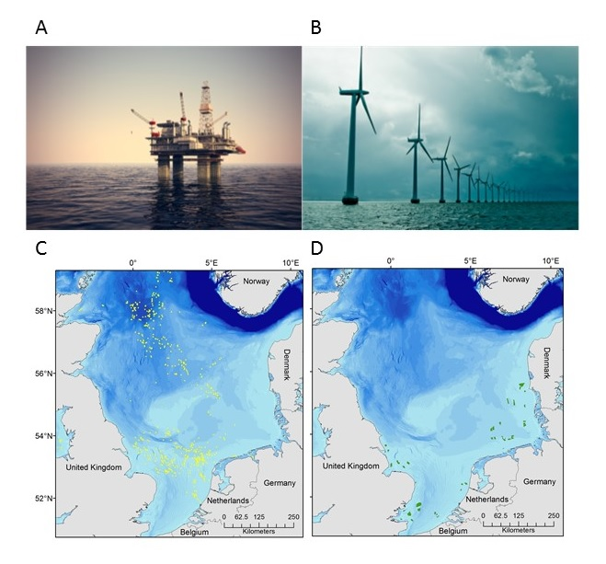
Figure 1. Thousands of offshore (a, c) oil and gas platforms and (b, d) wind turbines will be due for decommissioning in coming decades. Early consideration of the environmental impacts and appropriate policy development will be needed to minimize environmental disturbance. Maps adapted from Coolen (2017). Photo credits: Shutterstock
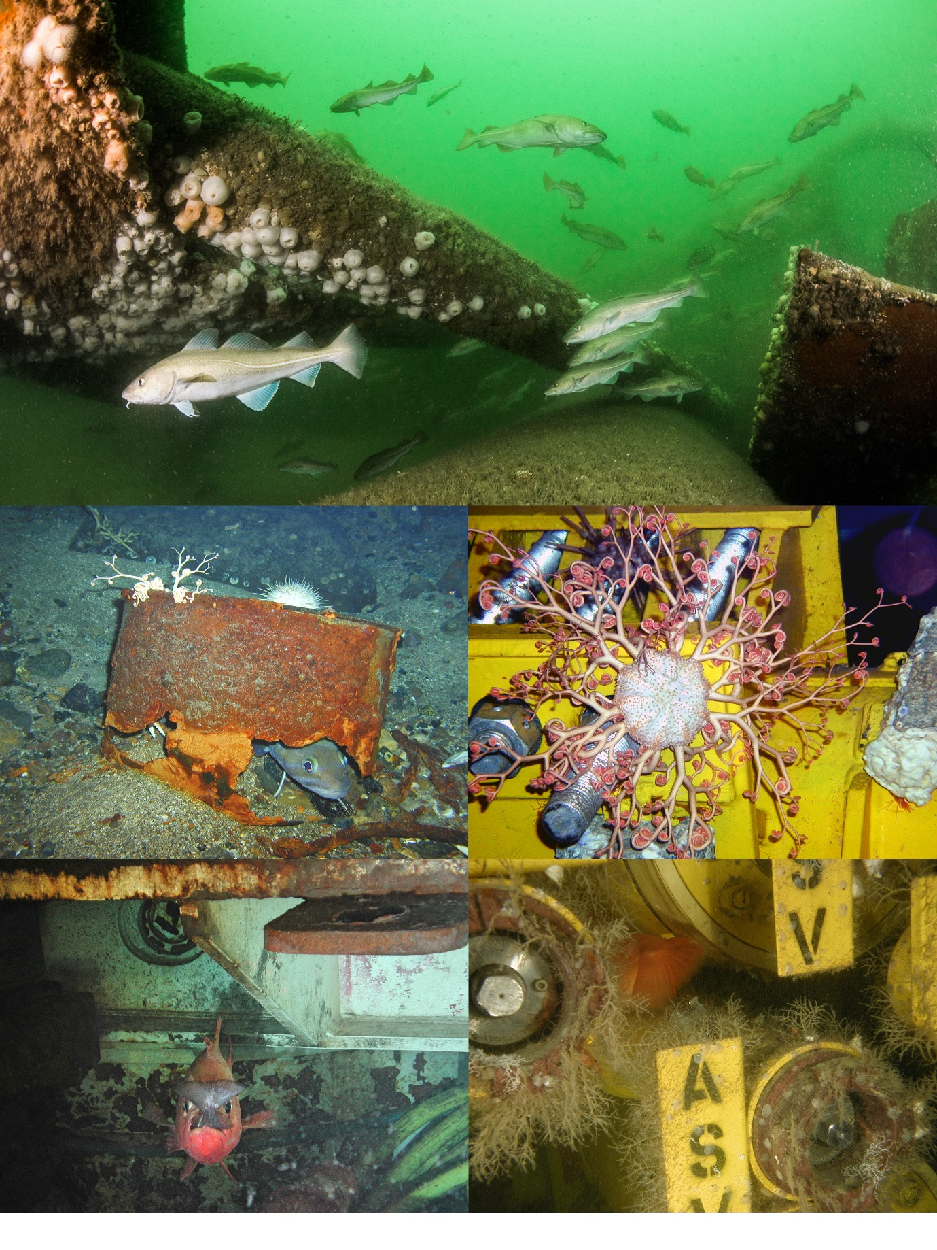
Figure 2. Marine fauna associated with oil and gas structures in the North Sea. (a) Atlantic cod (Gadus morhua) on a sunken drilling rig; (b) a ling (Molva molva) sheltering in an abandoned drum; (c) a basket star (Gorgonocephalus caputmedusae) inhabiting <1-year-old infrastructure; (d) a rockfish (Sebastes sp) with prey sheltering under a recently installed steel beam; and (e) encrusting fauna growing on subsea infrastructure. Photo credits: (a) C Kuyvenhoven, (b-e): D Jones

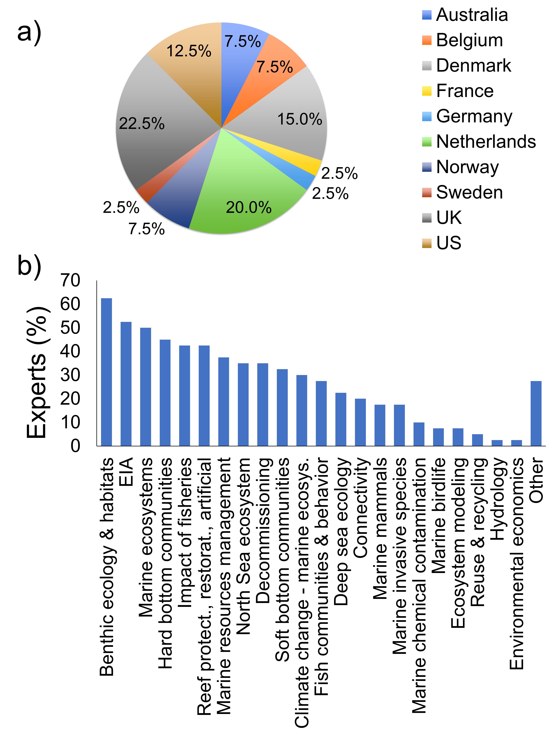
Figure 3. Categorization of surveyed experts by (a) country of origin and (b) area of expertise. EIA = environmental impact assessment.

Figure 4. Decommissioning options for (a) oil and gas platforms and (b) wind turbines in order of decreasing preference. Gray indicates the original position of the structure, black indicates the final position after decommissioning. Straight arrows indicate removal of either part or all of the structure to shore; curved arrows indicate relocation in situ. Toppling in situ and complete removal (lowest panels in [a]) were equally preferred for platforms; complete and partial removal options were equally preferred for wind turbines.

