Status and trends of albatrosses in the French Southern Territories, western Indian Ocean

Henri Weimerskirch ¹, Christophe Barbraud ¹, Karine Delord ¹, Peter Fretwell ², Fabrice Le Bouard ^{1, 3}, Cédric Marteau ³, Peter G. Ryan ⁴

¹ Centre d’Etudes Biologiques Chizé, CNRS – Université de la Rochelle, 79360 Villiers en Bois, France

² British Antarctic Survey, Madingley Road, Cambridge, UK

³ Réserve National des Terres Australes Françaises, Saint Pierre, La Réunion
⁴ FitzPatrick Institute of African Ornithology, University of Cape Town, Rondebosch 7701, South Africa

Corresponding author:
henriw@cebc.cnrs.fr
tel +33 549 09 78 15
ORCID Number: 0000-0002-0457-586X
Abstract Today albatrosses are today threatened worldwide, especially by fishing activities, and many populations are currently in decline. Albatrosses breeding at the French Southern Territories in the south western Indian Ocean, on the Crozet, Kerguelen and Saint Paul -Amsterdam island archipelagos, are monitored regularly. This monitoring has been based on a sample of species and sites, and there was a need for an assessment of the population trends for all species at each site. During the past three years most populations have been surveyed, allowing an assessment of the trends of albatrosses breeding at the archipelagos of the French Southern Territories over the past 40 years. Wandering Albatrosses show similar trends at all sites within the Crozet and Kerguelen archipelagos, with a recent recovery of colonies after strong declines in the 1970s. Amsterdam Albatrosses are increasing, albeit at lower rates during recent years. Indian Yellow-nosed Albatrosses show a global decline over the entire range. The trends among Black-browed and Grey-headed Albatrosses vary between colonies and archipelagos. Sooty Albatrosses have continuously decreased in numbers whereas Light-mantled Albatross numbers vary considerably between years, with an overall increase over the past 30 years. These results confirm that the French Southern Territories in the south-west Indian Ocean support a significant portion of the world populations of several albatross species. Several species appear to be steadily decreasing probably because of the impact of fisheries and disease outbreaks. The reasons for different trends among populations of the same species are not well understood and require further investigation.

Keywords Crozet • Kerguelen • Amsterdam • Fisheries • Monitoring
Introduction
Seabirds are of one the most threatened bird families globally (Croxall et al. 2012) and albatrosses are especially at risk, having the highest proportion of threatened species for any bird family (Phillips et al. 2016). Several factors have been identified as the causes of decreases in populations, especially accidental mortality in long-line fisheries, introduced predators at breeding sites, and diseases (Phillips et al. 2016). For these reasons, an international agreement has been set up to improve the status of albatrosses and large petrels across their range (Agreement for the Conservation of Albatrosses and Petrels, ACAP 2001). The status of albatross populations is well known from a few sites where long-term monitoring programmes were set up as early as the 1960s, but there is a need for better information on the status of many populations occurring on remote sites that are seldom visited and surveyed.
The French Southern Territories in the south western Indian Ocean include two archipelagos (Crozet and Kerguelen) and Saint Paul – Amsterdam islands that host a diverse albatross community comprising eight breeding species. Because of their uniqueness, these groups of islands were included in the National Reserve of French Southern Territories under French jurisdiction since 2006. Some albatross species have been monitored there since the early 1960s. They show varying trends, with some populations rebuilding such as the critically endangered Amsterdam Albatross Diomedea amsterdamensis (Rivalan et al. 2010), while others have declined severely. The decline of Indian Yellow-nosed Albatrosses Thalassarche carteri (Rolland et al. 2009) has been attributed to diseases (Weimerskirch 2004), whereas the decline in the numbers of Sooty Albatrosses Phoebetria fusca (Delord et al. 2008) is probably due to fisheries bycatch (Rolland et al. 2010). Due to the extent of the Crozet and Kerguelen archipelagos, many sites are rarely visited and the status of several important albatross populations has not been updated since the early 1980s. Thus it has become a priority for ACAP to update the status of these isolated populations.
The aim of this paper is to provide an update on the albatross populations in the French Southern Territories, following surveys carried out during several expeditions over recent years. We were particularly interested to compare the counts of rarely visited populations with those of regularly monitored populations in the French Southern Territories but also with those at other islands in the Southern Ocean to establish whether trends were similar or different between sites.

Material and methods
The French Southern Territories lie in the southern western Indian Ocean and include the Crozet Islands (50-52°E, 46°S), the Kerguelen Islands (68-70°E, 48-50°S) and Saint Paul and Amsterdam islands (77°E, 37-38°S)(Fig. 1). The Crozet Islands consist of five main islands, three larger islands (67, 150 and 130 km²) 10-18 km long (Ile aux Cochons, Ile de la Possession and Ile de l’Est), and two smaller (2-3 km²) islands 2-3 km long (Ile des Pingouins and Ile des Apôtres) (Fig. 1). Long-term monitoring studies have been limited to Ile de la Possession where there is a permanently occupied research station. The Kerguelen Islands comprise a large main island (6000 km²) and numerous islands ranging in size from large islands (15-27 km long) to hundreds of small islands and islets (Fig. 1). Monitoring studies are centred on the eastern part of the archipelago where the research station is located, whereas the western part of the archipelago, especially the north and southwestern part, where many albatrosses breed, is poorly known (Weimerskirch et al. 1989b). Saint Paul and Amsterdam islands are 8 and 58 km², respectively, but only Amsterdam Island has a research station.

Regularly monitored breeding sites
Long-term studies have been carried out on albatrosses since the early 1960s on the islands with research stations; some populations have been monitored annually for the past 40 years (Delord et al. 2008; Rolland et al. 2010; Weimerskirch et al. 1997) (Table 1). However, although all breeding sites have been visited at least once, there are few population estimates from the other islands of the archipelagos. The most recent counts at islands of the Crozet archipelago other than Ile de la Possession were made in 1982 (Derenne et al. 1976; Jouventin et al. 1984; Voisin 1984) and the western part of the Kerguelen Archipelago was last surveyed in 1984-85 (Weimerskirch et al. 1989b). On Amsterdam Island, some breeding colonies of Indian Yellow-nosed and Sooty Albatrosses have been monitored annually, but surveys covering the entire island are scarce. At regularly monitored colonies (reference colonies), the numbers of breeding pairs of each albatross species are counted visually or from photographs taken by observers during the early incubation period (see (Weimerskirch et al. 1997); (Delord et al. 2008); (Rolland et al. 2010) for further details).

Counts of remote populations
From 2014 to 2017, we had the opportunity to conduct counts of all remote major breeding colonies, except Ile de l’Est, Crozet, during early incubation, and to compare them with the estimates and trends on annually censused islands.
Helicopter-based photographic surveys were carried out from a number of platforms from 2014 to 2017. In November 2014, FL conducted photographic surveys from helicopter flights carried out from the RS Marion Dufresne over Iles Nuageuses off northwest Kerguelen, where the main colonies of the small, cliff-nesting albatrosses are located. In November 2016 helicopter flights from the surveillance navy ship Floreal were used to photograph albatross colonies at Ile des Apôtres and Ile des Pingouins in the Crozet Archipelago (HW). In January 2017, during the Antarctic Circumpolar Expedition (ACE), helicopter-based photographic surveys of albatross colonies were carried out from RS Akademik Tryoshnikov over Ile aux Cochons, Crozet Archipelago (PGR, FL). In February 2017, helicopter surveys from the surveillance navy ship Nivose were carried out over the southwestern coast of Kerguelen by personnel of the National Reserve. Images were taken from a helicopter at an elevation of approximately 300-500 m with one or several passes if necessary. Two observers used a Nikon D810 camera and Nikon 70-200 mm f2.8 lens, a Canon 5DS camera with a Canon 70-200 mm f2.8 lens and a Canon 5D Mark IV camera with a Canon 24-105 mm f4 lens. Images from each observer were stitched together separately using the package Autopano Giga 64bits 4.2.3 and counted using iTAG Version 0.7.0.2. Where there were discrepancies between the two sets of images, these were resolved by comparing individually-recognisable nests, and a
In addition, we used high-resolution satellite images from the WorldView-3 VHR satellite to count breeding Wandering Albatrosses Diomedea exulans, with the visible bands (2/3/5) pan-sharpened to provide 31-cm resolution colour images from Digital Globe (https://www.digitalglobe.com). Details of image analysis and the algorithm used to estimate wandering albatross numbers are given in (Fretwell et al. 2017). Satellite images were obtained for Ile des Apôtres, Crozet Archipelago on 12 February 2017 and the southwestern coast of Kerguelen on 17 March 2017. For Ile de l’Est, Crozet Archipelago we counted Wandering Albatrosses with the same technique on Pleiade Image (Airbus Defense & Space) on 8 January 2018.

Estimating population trends
From the counts of the number of breeding pairs we estimated annual population growth rates λ using the relationship:
${\left(\frac{N_{t}}{N_{0}}\right)}^{\left(\frac{1}{T}\right)}$
where N₀ is the number of breeding pairs at the time when the first count of the period was made, N_{t} the number at the end of the same period, and T the number of years elapsed between 0 and t (Caughley 1980). We also estimated the percent change in numbers of breeding pairs using the relationship:
$$\frac{N_{t}-N_{0}}{N_{0}}$$
To compare population trends between reference colonies and remote colonies we estimated annual population growth rates during similar time periods. Given that breeding albatrosses are large and conspicuous surface nesting seabirds we assumed that detection probability of breeding individuals was 1 and that counting error was negligible (Robertson et al. 2008). However from photographs there are uncertainties whether birds are breeding or not when the birds are sitting on a nest in an incubating/brooding position. Furthermore, since failures occur throughout incubation, the best period for counting breeding birds is just after laying ends. All surveys were carried out during the early incubation period for all species, i.e. in November for the small albatross species, in January for Wandering Albatrosses and in March for Amsterdam Albatrosses. The only exception was for photographs of wandering albatrosses taken over the south-western coast of Kerguelen taken one month after egg laying ended, and thus resulting in a potential underestimate of the total number due to early breeding failures.

RESULTS

Wandering Albatrosses
Numbers of Wandering Albatrosses breeding on the Crozet and Kerguelen archipelagos have overall decreased by 30-35% from the 1960s to 2017 (Table 2). At Ile de la Possession (Crozet) and on the Courbet Peninsula (Kerguelen), detailed long-term population surveys show similar trends with a steep decline from the 1970s to the mid-1980s, followed by an increase and a stabilisation of populations at lower levels than those of the 1960s (Fig. 2). Recent surveys on Ile aux Cochons and Ile des Apôtres (Crozet), and on the west coast of Kerguelen demonstrated that since the last counts in the 1980s the rates of change were similar to those of the populations monitored annually (Online Resource Table 1). The large population on Ile aux Cochons, which has been surveyed four times over the past four decades, showed a similar trend to the reference population surveyed annually at Possession Island (Fig. 2). On Ile de l’Est, whereas the decline of the population was similar to those of the other populations, the count from satellite image indicates that the population has not recovered since 1982 (Fig. 2, Online Resource Table 1). At two sites in the Kerguelen Archipelago, where satellite imagery (Online Resource Image 1) and aerial photographs were taken at the same time (March 2017), counts made from satellite imagery were 17% (Grande Coulée) and 49% (Feu de Joie) lower than counts made from the aerial photographs (Online Resource Table 1).

Amsterdam Albatrosses
The breeding population of Amsterdam Albatrosses has increased from eight pairs in 1981 to 46 pairs in 2014. The breeding population does not appear to have changed much since 2014 (Fig. 3).

Grey-headed Albatrosses
Although Grey-headed Albatrosses Thalassarche chrysostoma breed at both the Crozet and Kerguelen archipelagos, there is no annual monitoring of populations because all colonies are located on remote islands and the last surveys date back from the 1980s. All major colonies, except those at Ile de l’Est (Crozet), were counted during the past four years from helicopters in November, during the early incubation period. Whereas the Crozet colonies appear to have increased at 0.4 to 1.3% per year, the Kerguelen population has decreased by 0.5% per year (Table 2, Online Resource Table 2).
In addition to the colonies reported by (Weimerskirch et al. 1989b), a new colony of 85 breeding pairs Grey-headed Albatrosses was discovered during a ground survey at Baie Ducheyron, north-west Loranchet Peninsula, on the north-western tip of Kerguelen, in January 2012.

Indian Yellow-nosed Albatross
Indian Yellow-nosed Albatrosses breed on all three groups, although Amsterdam Island represents the major breeding ground for the species and Kerguelen has only a few breeding pairs. On Amsterdam, the main breeding colonies decreased steadily at 1.1% per year from the early 1980s to 2015 (Fig. 4), resulting in an estimated 38.6% decrease from 1983 to 2015 (Table 2, Online Resource Table 3). The rate has been faster in the reference colonies monitored annually (-5.7% per year), which decreased from 332 pairs in 1983 to 13 pairs in 2017.
At Crozet, the second most important breeding site for the species, Indian Yellow-nosed Albatrosses decreased steadily at 0.3% and 1.4% per year, similar to the rate at Amsterdam Island (Fig. 4, Online Resource Table 3). The largest colony, at Ile des Pingouins, decreased more rapidly than the colony at Ile des Apôtres (Online Resource Table 3). At Kerguelen, 23 nests were detected in photographs from 2016, whereas 50 nests were counted in 1984.

Black-browed Albatrosses
At Kerguelen, Black-browed Albatrosses Thalassarche melanophris breed on the south-eastern end of the Jeanne d’Arc Peninsula, and at the north-western extremity on Ile de Croy (Nuageuses Islands); a small colony exists at the north-western tip of the mainland (Cap Français) where 334 and369 breeding pairs were counted at all of these sites in 2012 and 2013, respectively.
At Kerguelen, long-term monitoring of the study colony at the Jeanne d’Arc Peninsula indicates that the population has decreased by 0.3% per year (Fig. 4, Table 2). At Ile de Croy, the largest population, censuses conducted in 1985 and 2014 - an interval of 30 years - gave similar numbers (Fig. 5).
At Crozet, Black-browed Albatrosses breed on Ile des Apôtres, des Pingouins and Ile de l’Est, where they declined at a rate of 1.3% per year from 1982 to 2016 (Fig. 5, Online Resource Table 4).

Salvin’s Albatross
Counts based on aerial photographs in November 2016 detected one breeding Salvin’s Albatross Thalassarche salvini on Ile des Pingouins, where three pairs were observed in 1987 (Jouventin 1990). Given their small population size in 1987, they may have been overlooked in the recent aerial survey. However, on Ile des Apôtres, where the species was not known to breed, four nests were occupied by breeding birds, together with several non-breeding individuals, among a large Indian Yellow-nosed Albatross colony (Online Resource Image 2).

Sooty and Light-mantled Sooty Albatrosses
Sooty Albatrosses breed on all three island groups, whereas Light-mantled Sooty Albatrosses Phoebetria palpebrata breed only at the Crozet and Kerguelen archipelagos. Sooty Albatross numbers have declined steadily on the reference colony of Ile de la Possession (Crozet) since 1980, and the total population on Amsterdam Island decreased by 22.6% from 2003 to 2012, mirroring trends in reference colonies from 1996 to 2013 (Fig. 6). On the east coast of Ile de la Possession, the numbers of Light-mantled Sooty Albatrosses breeding on the east coast of Possession Island have varied considerably between years. Overall, the population was stable 1980 to 2017 (Fig. 6) (Table 2). On the islands other than Ile de la Possession at Crozet, and at Kerguelen, numbers of both species are not known precisely because their dark plumage makes them hard to detect on their cliff-side breeding sites.

DISCUSSION
During the last four years it has been possible to update the status of most albatross populations in the French sub-Antarctic territories thanks to various expeditions using mainly aerial photographic counts from helicopters, augmented by satellite imagery for Wandering Albatrosses. The only site not updated for small albatrosses is Ile de l’Est in the Crozet Archipelago. The large populations of the seven main species breeding at the French Islands highlight the global importance of these islands for albatrosses (Table 3). These figures stress the value of formally protecting the sites by creating a National Reserve that includes vast Marine Protected Areas surrounding the islands. However, it is important to note that despite the protected status afforded to these islands and offshore areas, many of the study species have continued to decline. Counts from photographs taken from helicopter allowed us to observe Salvin’s Albatrosses breeding on Ile des Apôtres where it was not known to breed. Only one breeding Salvin’s Albatross was observed in 2016, whereas 4 pairs were observed from the on Ile des Pingouins in 1987 (Jouventin 1990). Salvin’s Albatross constitutes the eighth albatross species breeding on the French Southern Territories. Given their small population size it is impossible to infer whether the species is progressively colonising the Crozet Islands, or just present in small numbers. Adult Salvin’s Albatrosses are frequently observed in small numbers at sea around the western Crozet Islands.
All recent counts at remote islands were based either on oblique aerial photographs, or on satellite images. They were made during the incubation period, allowing comparisons with previous grounds counts. Aerial photographs were detailed enough to separate incubating birds from non-breeding birds not on a nest, or standing/displaying with other birds, and to separate species of the smaller albatrosses. However, the counts based on photographs probably overestimated the breeding populations slightly because of the presence of non-breeding loafing individuals appearing to sit on nests (Robertson et al. 2008; Wolfaardt and Phillips 2013). High resolution satellite images have recently been used to estimate the size of colonies of large albatrosses (Fretwell et al. 2017). However, we counted 20% less Wandering Albatrosses at two colonies along the south-western coast of Kerguelen when using satellite imagery compared to aerial photographs taken on the same day (see Online Resource Table 1). The reasons for this underestimation are not clear but often the clarity and resolution of aerial images is superior to that of satellite images. In addition, in wandering albatrosses plumage of breeding adults is variable (Weimerskirch et al. 1989a), with a significant proportion of young adults having darker plumage compared to the white plumage of mature adults that is easily detectable on satellite images (Fretwell et al. 2017)
In the south-western Indian Ocean, population trends of Wandering Albatrosses show a remarkable synchrony, not only within archipelagos, but also between archipelagos (Fig. 2, Table 2). The exception of the Ile de l’Est population where numbers have continued to decline between 1982 and 2018, with only the largest colony of Ile de l’Est (representing half of island population) declining steadily, the other colonies were stable. The specific situation of this colony may be due to adverse local conditions on land, or at sea, since on Crozet birds of different colonies have distinct foraging zones (Weimerskirch et al. 1993), and are thus potentially in contact with different fisheries and mortality risk. Trends of Wandering Albatrosses breeding at the Prince Edward Islands, 1000 km west of Crozet, show similar trends to those observed at Crozet and Kerguelen (Ryan et al. 2009). This suggests that common factors have influenced population changes in this species over the past 50 years. Demographic analyses suggest that the main causes for the earlier decline in the numbers were probably due to long-line fisheries that started in the Southern Ocean in the 1960s (Nel et al. 2003; Weimerskirch et al. 1997). The recovery of the southwest Indian Ocean populations from the mid-1980s contrasts markedly with the other major breeding grounds of Wandering Albatrosses at South Georgia (Pardo et al. 2017), where the population has decreased continuously since the 1960s (Poncet et al. 2017; Tuck et al. 2011). This regional difference is probably linked to exposure to different fisheries during the breeding and non-breeding periods. However, other demographic processes may contribute to the contrasting population trajectories, such as density dependence and climate change (Fay et al. 2015, 2017) and differential susceptibility to fisheries between age classes (Barbraud et al. 2013, Tuck et al. 2016(Pardo et al. 2017).
The French Southern Territories islands are home to more than 80% of the global population of Indian Yellow-nosed Albatrosses; Amsterdam Island is the stronghold for the species. At Amsterdam, Crozet but also Kerguelen, the species has declined rapidly over the past 30 years. Declines at Amsterdam Island have been attributed mainly to the impact of diseases, especially avian cholera that mainly affects chicks, but in the past probably also reduced adult survival (Rolland et al. 2009; Weimerskirch 2004). Through increased sea-surface temperatures and decline in productivity, climate change may also have contributed to the observed decline (Rolland et al. 2010). The origin of avian cholera at Amsterdam is still under investigation, but there is some indication that it may have been introduced with poultry that used to occur on the island (Weimerskirch 2004); (Jaeger et al. 2018). At Crozet, there has been no landing on the islands where Yellow-nosed Albatrosses breed. The decline there of similar magnitude to the decrease at Amsterdam is unlikely to have resulted from the introduction of diseases by human. Since there are no introduced predators on these islands, climate change and fisheries bycatch (Gales et al. 1998) may again be responsible for the decline at Crozet. Further analyses on the presence of diseases in the Crozet population and on the foraging distributions during and outside the breeding season are necessary to address this question. Interestingly, the population breeding at Prince Edward Island, west of Crozet, appears to have been stable over the past 10 years (Ryan et al. 2009). This period is too short to be compared with the 30 year decline at Crozet and trends may differ at Prince Edward.
Black-browed Albatrosses have declined at Crozet over the past 40 years, but numbers at Kerguelen appear to have been relatively stable, although with a decrease during the 2000s. Black-browed Albatrosses from Kerguelen winter off Australia. Climatic conditions in their winter quarters and illegal fisheries bycatch in the Kerguelen area during the late 1990s and early 2000s are probably the main causes for population fluctuations and decline during the 2000s (Michael et al. 2017; Rolland et al. 2008).
The populations of Grey-headed Albatrosses show contrasting trends at Kerguelen and Crozet, with a decline at Kerguelen and an increase at Crozet. By comparison, on the nearby Prince Edwards Islands, populations of Grey-headed Albatrosses are stable (Ryan et al. 2009), whereas at South Georgia in the southwest Atlantic Ocean, the population has decreased steadily over the past three decades (Pardo et al. 2017; Poncet et al. 2006; Poncet et al. 2017). The contrasting trends at Kerguelen and Crozet, and particularly the causes for decline at Kerguelen, are not clear because Grey-headed Albatrosses are not by-caught in significant numbers in fisheries in the Indian Ocean (Huang and Liu 2010) compared to the Atlantic Ocean where these seabirds are caught in larger numbers.
The populations of Sooty and Light-mantled Sooty Albatrosses show opposite trends on the Crozet Islands, with Sooty Albatrosses declining rapidly and Light-mantled Sooty Albatrosses being stable or increasing slightly. Among sooty albatrosses similar trends were observed at the Prince Edward Islands until 2008 (Ryan et al. 2009), but have reversed in the last decade; at Marion Island, Sooty Albatrosses have increased to their highest ever population levels in the last few years (Schoombie et al. 2016). The cause of the steady decline of Sooty Albatrosses at Crozet has been attributed to fisheries bycatch and climate change (Rolland et al. 2010). Sooty Albatrosses forage in sub-tropical waters (Pinaud and Weimerskirch 2007) where they encounter tuna long-line fisheries and are by-caught (Huang and Liu 2010; Pinaud and Weimerskirch 2007). At Amsterdam Island, their decline is mainly caused by the occurrence of avian cholera that induces high chick mortality and therefore limits recruitment into the population (Jaeger et al. in revision). Light-mantled Sooty Albatrosses have a more southern distribution than Sooty Albatrosses (Delord et al. 2013; Pinaud and Weimerskirch 2007), and this difference may put them less at risk with long-line fishing. However, in recent years their breeding success at Marion Island has been much lower than that of Sooty Albatrosses, which might account for their decrease over the last decade at this site (Schoombie et al. 2016).
Overall, for most species the results of this study strongly suggest that albatross populations of the same species nesting at various sites in the south-western Indian Ocean show similar trends, indicating that common factors may affect their populations. This is particularly true for Wandering Albatrosses and Indian Yellow-nosed Albatrosses. Although each population has a distinct foraging range (Nel et al. 2002; Weimerskirch et al. 2014) they probably move in similar water masses and encounter similar fisheries. Our results also indicate that several species appear to be declining over their entire range, such as Sooty Albatrosses and Indian Yellow-nosed Albatrosses, which is a major source of concern for the future of these populations. Decreases are probably caused by a combination of factors, including fisheries bycatch, diseases, climate change and introduced predators (Rolland et al. 2010). Some of these factors have been identified as the major cause of declines at specific sites, e.g. diseases on Amsterdam Island. Our results suggest that for a particular species, the causes of population trajectories, may differ vary between sites for the same species. Further studies should focus in trying to understand how these various factors interplay.

Acknowledgements This study was funded by the French Polar Institute (Program IPEV 109), Réserve Nationale des Terres Australes Françaises), and the Antarctic Circumpolar Expedition (ACE), a scientific expedition carried out under the auspices of the Swiss Polar Institute, supported by funding from the ACE Foundation and Ferring Pharmaceuticals. We thank the crews of the French Navy ships Floreal and Nivose and especially the helicopter pilots for their help. We thank all the fieldworkers involved in the long term monitoring programme, and Gaspard Bernard, Nicolas Moulin and Benoit Gineste for their help with the helicopter photographs and photographic counts. We thank Marc Lebouvier and Zone Atelier Antarctique for providing with the Ile de l’Est satellite image. We thank three anonymous reviewers for extensive changes and suggestions on a previous version of the manuscript.

Compliance with ethical standards
Ethical approval. The study took place in the National Reserve of ‘Terres Australes Francaises’ and was approved by the Préfet des TAAF.

References

Croxall JP, Butchart SH, Lascelles B, Stattersfield AJ, Sullivan B, Symes A, Taylor P (2012) Seabird conservation status, threats and priority actions: a global assessment Bird Conserv Int 22:1-34
Delord K, Barbraud C, Bost CA, Cherel Y, Guinet C, Weimerskirch H (2013) Atlas of top predators from French Southern Territories in the Southern Indian Ocean. CNRS, Villiers en Bois. doi:10.15474
Delord K, Besson D, Barbraud C, Weimerskirch H (2008) Population trends in a community of large Procellariiforms of Indian Ocean: potential effects of environment and fisheries interactions Biol Conserv 141:1840-1856
Derenne P, Mougin JL, Steinberg C, Voisin JF (1976) Les oiseaux de l'ile aux Cochons, archipel Crozet CNFRA:107-148
Fretwell PT, Scofield P, Phillips RA (2017) Using super-high resolution satellite imagery to census threatened albatrosses Ibis 159:481-490
Gales R, Brothers N, Reid T (1998) Seabird mortality in the japanese tuna longline fishery around Australia, 1988-1995 Biol Conserv 86:37-56
Huang H-W, Liu K-M (2010) Bycatch and discards by Taiwanese large-scale tuna longline fleets in the Indian Ocean Fisheries Res 106:261-270
Jaeger A, Lebarbenchon C, Bourret V, Bastien M, Lagadec E, Thiebot JB, Boulinier T, Delord K, Barbraud C, Marteau C, Dellagi K, Tortosa P, Weimerskirch H (2018) Avian cholera outbreaks threaten seabird species on Amsterdam Island Plos One in press
Jouventin P (1990) Shy Albatrosses Diomedea cauta salvini breeding on Penguin Island, Crozet Archipelago, Indian Ocean. Ibis 132:126-127
Jouventin P, Stahl JC, Weimerskirch H, Mougin JL (1984) The seabirds of the French Subantarctic Islands & Adélie Land, their status and conservation. ICBP Techn Publ 2:609-625.
Michael PE, Thomson R, Barbraud C, Delord K, De Grissac S, Hobday AJ, Strutton PG, N TG, Weimerskirch H, Wilcox C (2017) Illegal fishing bycatch overshadows climate as a driver of albatross population decline Mar Ecol Progr Ser 579:185-199
Nel DC, Ryan PG, Nel JL, Klages NTW, Wilson RP, Robertson G, Tuck GN (2002) Foraging interactions between Wandering Albatrosses Diomedea exulans breeding on Marion Island and long-line fisheries in southern Indian Ocean Ibis 144:E141-E154
Nel DC, Taylor F, Ryan PG, Cooper J (2003) Population dynamics of the wandering albatross diomedea exulans at marion island: longline fishing and environmental influences African J Mar Sc 25:503-517
Pardo D, Forcada J, Wood AG, Tuck GN, Ireland L, Pradel R, Croxall JP, Phillips RA (2017) Additive effects of climate and fisheries drive ongoing declines in multiple albatross species Proc Nat Acad Sc USA 114:E10829-E10837 doi:10.1073/pnas.1618819114
Phillips R, Gales R, Baker G, Double M, Favero M, Quintana F, Tasker M, Weimerskirch H, Uhart M, Wolfaardt A (2016) The conservation status and priorities for albatrosses and large petrels Biol Conserv 201:169-183
Pinaud D, Weimerskirch H (2007) At-sea distribution and scale-dependent foraging behaviour of petrels and albatrosses: a comparative study J Anim Ecol 76:9-19
Poncet S, Robertson G, Phillips RA, Lawton K, Phalan B, Trathan PN, Croxall JP (2006) Status and distribution of wandering, black-browed and grey-headed albatrosses breeding at South Georgia Polar Biol 29:772-781
Poncet S, Wolfaardt AC, Black A, Browning S, Lawton K, Lee J, Passfield K, Strange G, Phillips RA (2017) Recent trends in numbers of wandering (Diomedea exulans), black-browed (Thalassarche melanophris) and grey-headed (T. chrysostoma) albatrosses breeding at South Georgia Polar Biol 40:1347-1358 doi:10.1007/s00300-016-2057-0
Rivalan P, Barbraud C, Inchausti P, Weimerskirch H (2010) Combined impacts of longline fisheries and climate on the persistence of the Amsterdam Albatross Diomedia amsterdamensis Ibis 152:6-18
Robertson G, Moreno CA, Lawton K, Kirkwood K, Valencia J (2008) Comparison of census methods for Black-browed Albatrosses breeding at the Ildefonso Archipelago, Chile Polar Biol 31:153-162
Rolland V, Barbraud C, Weimerskirch H (2008) Combined effects of fisheries and climate on a migratory long-lived marine predator J Appl Ecol 45:4-13
Rolland V, Barbraud C, Weimerskirch H (2009) Assessing the impact of fisheries, climate and disease on the dynamics of the Indian yellow-nosed albatross Biol Conserv 142:1084-1095
Rolland V, Weimerskirch H, Barbraud C (2010) Relative influence of fisheries and climate on the demography of four albatross species Global Change Biol 16:1910-1922
Ryan P, Jones MG, Dyer B, Upfold L, Crawford RJ (2009) Recent population estimates and trends in numbers of albatrosses and giant petrels breeding at the sub-Antarctic Prince Edward Islands Afr J Mar Sc 31:409-417
Schoombie S, Crawford R, Makhado A, Dyer B, Ryan P (2016) Recent population trends of sooty and light-mantled albatrosses breeding on Marion Island Afr J Mar Sc 38:119-127
Tuck GN, Phillips RA, Small C, Thomson RB, Klaer NL, Taylor F, Wanless RM, Arrizabalaga H (2011) An assessment of seabird-fishery interactions in the Atlantic Ocean ICES J Mar Sc 68:1628-1637
Voisin JF (1984) Observations on the birds and mammals of île aux Cochons, Crozet Islands, in February 1982. S Afr J Nav Antarct Res 14:11-17.
Weimerskirch H (2004) Diseases threaten Southern Ocean albatrosses Polar Biol 27:374-379
Weimerskirch H, Brothers N, Jouventin P (1997) Population dynamics of wandering albatross Diomedea exulans and Amsterdam albatross D. amsterdamensis in the Indian Ocean and their relationships with long-line fisheries: conservation implications Biol Conserv 79:257-270
Weimerskirch H, Cherel Y, Delord K, Jaeger A, Patrick SC, Riotte-Lambert L (2014) Lifetime foraging patterns of the wandering albatross: life on the move! J Exp Mar Biol Ecol 450:68-78
Weimerskirch H, Lequette B, Jouventin P (1989a) Development and maturation of plumage in the wandering albatross Diomedea exulans J Zool 219:411-421
Weimerskirch H, Salamolard M, Sarrazin F, Jouventin P (1993) Foraging strategy of wandering albatrosses through the breeding season: a study using satellite telemetry. Auk 110:325-342
Weimerskirch H, Zotier R, Jouventin P (1989b) The avifauna of the Kerguelen Islands. Emu 89:15-29.
Wolfaardt W, Phillips RP (2013) ACAP Guideline census methodologies for albatrosses and petrels. http://www.acap.aq/en/resources/acap-conservation-guidelines/2187-census-guidelines/file.

Table 1 – Albatross species monitored on a quasi-annual basis in the French Southern Territories.

Archipelago | Island/Site | Species | Years monitored | Entire island
Crozet | Possession | Wandering Albatross | 1960-2017 | Yes
 | Possession | Sooty Albatross | 1980-2017 | No
 | Possession | Light-mantled Sooty Albatross | 1981-2017 | No
Kerguelen | Courbet Peninsula | Wandering Albatross | 1971-2017 | No
 | Canon des Sourcils Noirs | Black-browed Albatross | 1978-2017 | No
Amsterdam | Plateau des Tourbières | Amsterdam Albatross | 1981-2017 | Yes
 | Entrecasteaux | Sooty Albatross | 1997-2017 | No
 | Entrecasteaux | Indian Yellow-nosed Albatross | 1984-2017 | No

Table 2 - Population trends for albatross species breeding at different localities in the French Southern Territories. N indicates the most recent count of breeding pairs with the year of the count in parentheses. λ indicates the multiplicative population growth rate and % change indicates the percent change relative to the first year of the time period. Numbers in parentheses for λ and % change indicate the values for reference colonies when present for the same time period. ª indicates entire world population, ^{b} indicates entire island population.
Species | Archipelago | Breeding site | N | λ | % change | Time period
Wandering Albatross | Crozet | Ile de la Possession | 389  (2017) | 0.993 | -30.6 | 1960-2017
 |  | Ile aux Cochons | 1280 (2017) | 0.995 (0.993) | -22.4 (-19.4) | 1961-2017
 |  | Ile des Apôtres | 171 (2017) | 1.016 (1.010) | +50.0 (+30.7) | 1982-2017
 |  | Ile de l’Est | 284  (2018) | 0.983  (1.001) | -35.0  (+2.0) | 1972-2018
 | Kerguelen | Courbet Peninsula | 322 (2017) | 0.991 | -35.1 | 1971-2017
 |  | Anse de l’Ours | 17 (2017) | 1.028 (1.003) | +142.8 (+9.2) | 1985-2017
 |  | Grande Coulée | 700 (2017) | 1.005 (1.003) | +16.7 (+9.2) | 1985-2017
 |  | Feu de Joie | 87 (2017) | 1.003 (1.003) | +8.7 (+9.2) | 1985-2017
 |  | Teluromètre | 151 (2017) | 1.024 (1.003) | +115.7 (+9.2) | 1985-2017
 |  | Gallieni | 10 (2017) | 1.003 (1.003) | +11.1 (+9.2) | 1985-2017
 |  | All colonies south-western coast | 965 (2017) | 1.007 (1.003) | +25.9 (+9.2) | 1985-2017
Amsterdam Albatross | Amsterdam | Plateau des Tourbières | 35 (2017) | 1.042ª | +337.5ª | 1981-2017
Grey-headed Albatross | Crozet | Ile des Apôtres | 259 (2016) | 1.012 | +43.9 | 1985-2016
 |  | Ile des Pingouins | 2300 (2016) | 1.005 | +15.0 | 1985-2016
 | Kerguelen | Ile de Croy, Nuageuses | 6360 (2014) | 0.994 | -15.6 | 1985-2014
Indian Yellow-nosed Albatross | Kerguelen | Ile de Croy, Nuageuses | 23 (2014) | 0.977 | -54.0 | 1985-2014
 | Crozet | Ile des Apôtres | 1114 (2016) | 0.997 | -9.4 | 1982-2016
 |  | Ile des Pingouins | 3098 (2016) | 0.982 | -46.6 | 1982-2016
 | Amsterdam | All island | 22753 (2015) | 0.986  0.961 (0.908) | -38.6  -38.2 (-68.5) | 1981-2015  2003-2015
Black-browed Albatross | Crozet | Ile des Apôtres | 252 (2016) | 0.992 | -23.6 | 1982-2016
 |  | Ile des Pingouins | 108 (2016) | 0.970 | -64.0 | 1982-2016
 | Kerguelen | Canon des Sourcils Noirs | 1105 (2016) | 0.998 | -7.8 | 1978-2016
 |  | Ile de Croy, Nuageuses | 1290 (2014) | 1.001 (0.999) | +2.9 (-0.3) | 1985-2014
Sooty Albatross | Crozet | Ile de la Possession | 74 (2017) | 0.963^{b} | -74.7^{b} | 1980-2017
 | Amsterdam | All island | 394 (2012) | 0.980 ^{b} (0.972) | -16.9 (-22.6) | 2003-2012
Light-mantled Sooty Albatross | Crozet | East coast | 1004 (2017) | 0.990 | -29.9 | 1981-2017

Table 3 - Updated numbers of albatrosses (in numbers of annual pairs) breeding in the French Territories of the Southern Ocean in 2016-2017,
 | Crozet | Kerguelen | Amsterdam-St Paul | % World Population
Wandering Albatross | 2125 | 1327 |  | 37.4
Amsterdam Albatross |  |  | 33 | 100
Grey-headed Albatross | 5319 | 6680 |  | 15.1
Indian Yellow-nosed Albatross | 4212 | 23 | 22000 | 83.8
Black-browed Albatross | 710 | 3290 |  | 0.5
Sooty Albatross | 2040 | 10 | 394 | 20.2
Light-mantled Sooty Albatross | 2300 | 3-5000 |  | c. 30

Legends to figures

Figure 1 – Map of the south-western Indian Ocean showing the location of the French Territories, with detailed map of the Crozet and Kerguelen Islands.

Figure 2 - Observed changes in the number of breeding pairs of wandering albatrosses at Crozet (in white, Ile de la Possession, Ile aux Cochons and Ile des Pingouins) and Kerguelen (in black Courbet Peninsula and the southwestern coast) over the past 50 years.
Figure 3 – Observed changes in the number of breeding pairs of Amsterdam albatrosses from 1981.
Figure 4 – Observed Changes in the number of breeding pairs of Indian Yellow-nosed Albatrosses on Amsterdam Island (black, two main colonies and study plot), on Kerguelen (Grey, Ile de Croy) and Crozet (white, Ile des Apôtres et Ile des Pingouins) from 1982 to 2017.
Figure 5 – Observed changes in the number of breeding pairs of Black-browed Albatrosses at Kerguelen (Ile de Croy and reference colony) and Crozet (Ile des Apôtres and Ile des Pingouins) over the past 35 years.
Figure 6 – Observed change in the number of breeding pairs of Sooty and Light-mantled Sooty albatrosses at Crozet Islands (east coast and reference colony), and Amsterdam Island (whole island and reference colony).

Figure 1

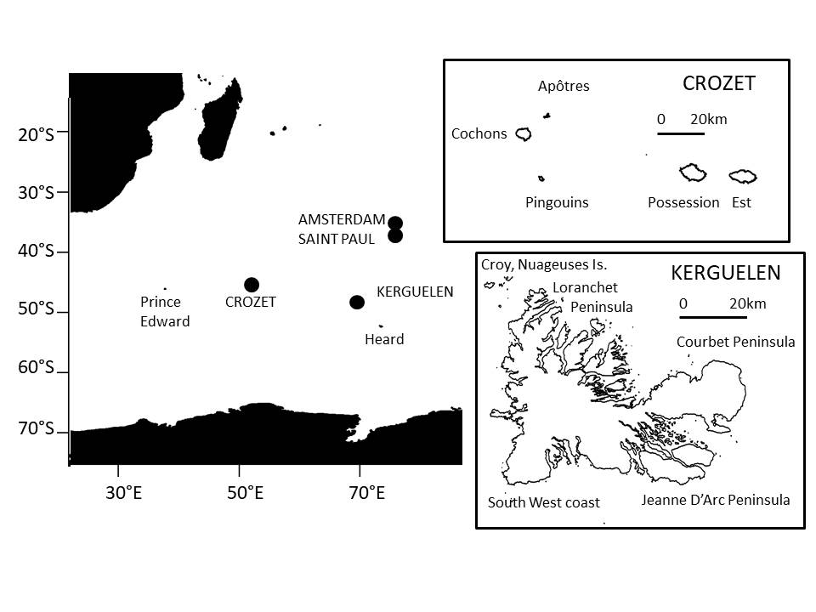
Figure 2
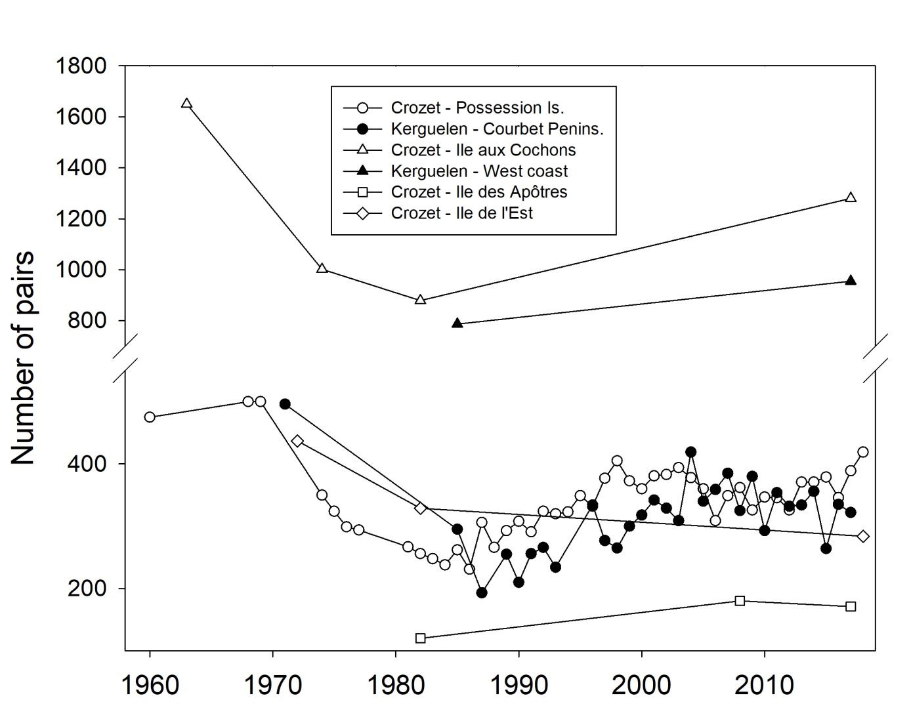

Figure 3
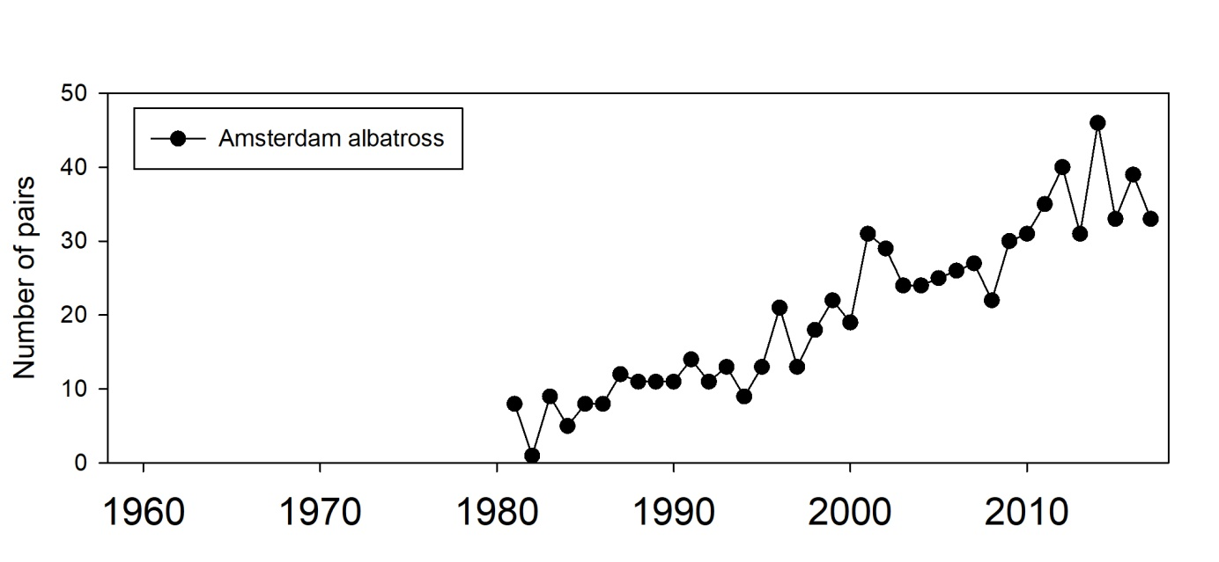

Figure 4
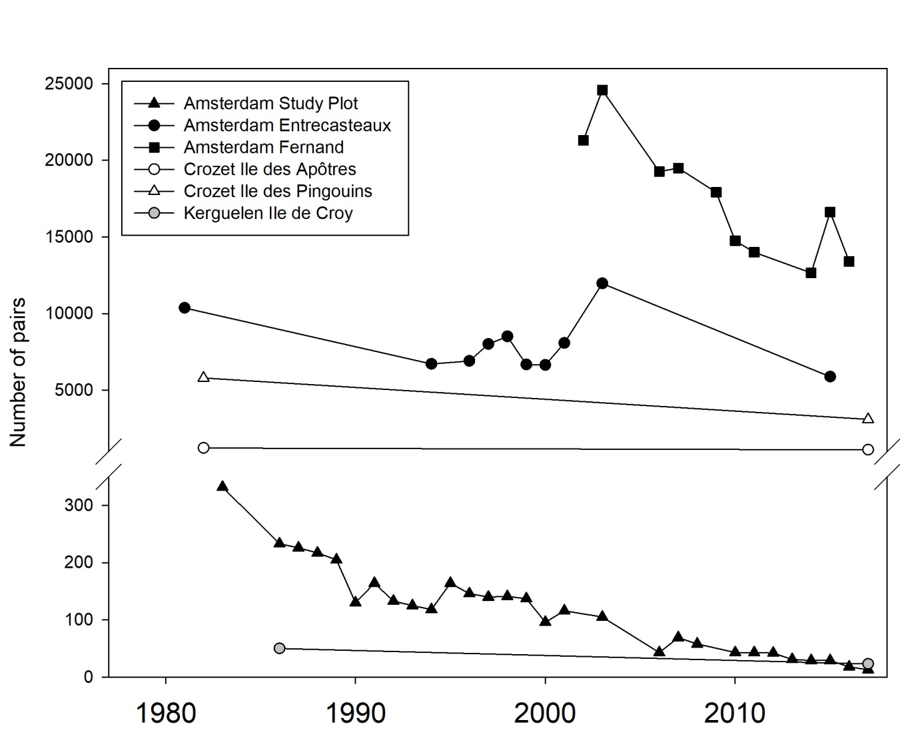

Figure 5
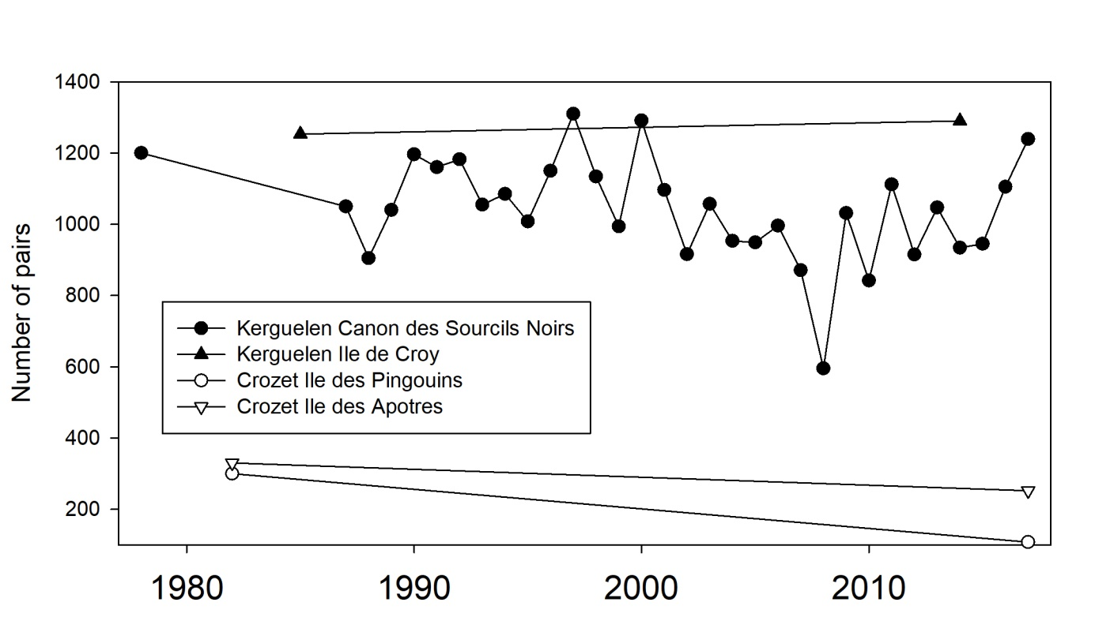

Figure 6
