Integrated analysis of intraspecific diversity in Roaldia revoluta (Mitt.) P.E.A.S. Câmara & M. Carvalho-Silva (Bryophyta) in Antarctica

P.E.A.S. Câmara¹ • D.V. Valente¹ • E.T. Amorim¹ • D.K. Henriques¹ • M. Carvalho-Silva^{1,2} • P. Convey³ • M. Stech⁴

Abstract

We investigated morphological diversity and its possible relationship with haplotype diversity in the Antarctic moss, Roaldia revoluta, and also if the geographic distribution of its morphotypes is correlates with differences in environmental variables. We obtained 49 samples from three locations in Antarctica, King George Island, James Ross Island and a number of locations on the Antarctic Peninsula, representing most of the habitats where this species is found. A Principal Component Analysis (PCA) was performed using quantitative measures of morphological characters of the gametophyte. For the molecular analyases we used DNA sequences of five molecular markers from 29 specimens. A Canonical Correspondence Analysis (CCA) was carried out to compare morphological diversity with environmental variables. Our data support the existence of two morphotypes of Roaldia revoluta, morphotype A (short apiculate and ovate leaves), more frequent in King George Island, and morphotype B (long apiculate and more lanceolate leaves), more frequent in James Ross Island. The Antarctic Peninsula location included both morphotypes. The different morphotypes no correlation with diversity of the selected markers, and indeed no sequence differences were present in any marker. The CCACanonical Correspondence Analysis supported the observed morphological variation being related to the local environmental characteristics of wind speed and minimum temperature.

Keywords

Roaldia revoluta, Hypnum revolutum, Antarctic, morphological variation, genetic diversity.

 P.E.A.S. Câmara
pcamara@unb.br

^{1.} University of Brasilia, Botany Department. Brasilia, DF. Brazil.
^{2.} Federal University of Jequitinhonha and Mucuri Valleys, Unaí, Brazil.
^{3.} British Antarctic Survey, Cambridge, UK.
^{4.} Naturalis Biodiversity Center, Leiden, Netherlands
Introduction

Only two native and one invasive species comprise the contemporary angiosperm flora of the Antarctic continent, contrasting with at least 111 species of mosses recorded from Antarctica (Ochyra et al. 2008). Of these, 17 species are pleurocarpous mosses, all from the order Hypnales (Ochyra et al. 2008). Considering that pleurocarpous mosses typically grow preferentially on substrates that do not exist in Antarctica, such as dead logs or tree bark (Buck 1998; Vanderpoorten and Goffinet 2009), this number is perhaps surprisingly high. However, all Antarctic pleurocarpous moss species are restricted to the maritime Antarctic (the Antarctic Peninsula and Scotia Arc archipelagoes). Some are quite abundant, such as Sanionia uncinata (Hedw.) Loeske, whereas others are very rare, at the extreme being reported from a single location and collected more than 100 years ago, such as Brachythecium subpilosum (Hook.f. and Wilson) A. Jaeger (Ochyra et al. 2008).
Hypnaceae is represented by three species in Antarctica, namely Hypnum revolutum (Mitt.) Lindb., Isopterygiopsis pulchella (Hedw.) Z. Iwats., and Platydictya jungermannioides (Brid.) H.A. Crum (Ochyra et al. 2008). However, molecular phylogenetic analyses have clearly shown that Hypnaceae, and Hypnum itself, are polyphyletic, with none of the Hypnum species sequenced so far being closely related to the type species, H. cupressiforme Hedw. (Goffinet et al., 2001; Tsubota et al., 2002; Gardiner et al., 2005; Cox et al., 2010; Huttunen et al., 2012). Hypnum revolutum has been resolved in Pylaisiaceae (Gardiner et al. 2005; Câmara et al. 2018) and was recently separated at the genus level as Roaldia revoluta (Mitt.) P.E.A.S. Câmara & M. Carvalho-Silva (Câmara et al. 2017).
Roaldia revoluta is a bipolar species with a circumpolar, continuous range in the Arctic, disjunct occurrences in the mountains of the southern part of the Holarctic, and Southern Hemisphere occurrences in southern South America, New Zealand and Antarctica (Ochyra et al. 2008). In the Antarctic, R. revoluta is patchily distributed,being rare in the South Orkney Islands (Signy I.) and South Shetland Islands (mostly on King George I., with one record from Livingston I.), and occurring sporadically along the western Antarctic Peninsula as far south as Alexander I. (c. 71°S), its southern geographical limit. Off the tip of the eastern Antarctic Peninsula, the species is abundant on James Ross I. (Ochyra et al. 2008). This moss typically grows in small patches on a variety of substrates, from sea level to nunataks up to approximately 500 m a.s.l. (Ochyra et al. 2008).
Roaldia revoluta is “exceedingly polymorphic”, with considerable variation in size, ramification, leaf shape, and areolation, considered to be mainly caused by habitat conditions (Ando 1973). Phenotypic plasticity induced by environmental variation has been reported in several species of bryophytes, and interpreted as an important factor in adaptation to heterogeneous habitats (Buryová and Shaw 2005; Reynolds and McLetchie 2011; Yu et al. 2012; Pereira et al. 2013; Medina et al. 2015). Nevertheless, intraspecific morphotypes have often been given formal taxonomic status. For example, 14 intraspecific taxa (one subspecies, 10 varieties, three forms) of Roaldia revoluta (www.tropicos.org) have been described. They are, however, difficult to distinguish from each other, and their taxonomic status needs to be assessed by analyses of molecular variation.
According to Ando (1973), two of the 14 intraspecific taxa occur in Antarctica, Hypnum revolutum var. dolomiticum (Milde) Mönk. (= var. ravaudii (Husn.) Ando, Ando & Matteri 1982) and var. revolutum fo. pumilium (Husn.) Ando. Ando (1973) assigned most Antarctic specimens to the latter. However, the morphological traits used to separate both taxa (leaves more or less falcate, variation in leaf plication, leaf margins more or less revolute) are highly variable and can be found even within the same patch (Ochyra et al. 2008). Consequently, Ochyra et al. (2008) suggested not to recognize these intraspecific taxa in Antarctica.
In the present paper we report a detailed study of Antarctic R. revoluta combining morphometrics and DNA sequence analyses of five molecular markers (plastid trnL-F, rps4, rpl16 and nuclear ribosomal ITS and 26S), and comparing morphological diversity with environmental variables. Specifically, we test the following hypotheses: (1) two morphotypes of Roaldia revoluta exist in Antarctica; (2) morphological diversity correlates with haplotype diversity; and (3) the geographic distribution of morphotypes correlates with differences in environmental variables.

Material and Methods

Sampling
In the present study we included representatives from all main areas where R. revoluta is known to occur in Antarctica, excepting the South Orkney Islands. Forty-nine specimens were subjected to morphological analysis, including 17 specimens from James Ross I. (J), 20 from King George I. (K), and 12 from the Antarctic Peninsula (P) (Table 1). Of these, 29 specimens could be sequenced and were included in the molecular analyses. Material originated from herbaria (AAS, S, RB, UB) as well as from fieldwork in Antarctica (King George Island and Antarctic Peninsula region) during the austral summers of 2015/2016 and 2016/2017.

Characteristics of the study areas
James Ross I. is located off the eastern tip of the Antarctic Peninsula in the north-western part of the Weddell Sea (63º47’S–64º27’S 57º05’W–58º24’W, Fig. 1), in the transition zone between the maritime Antarctic and continental Antarctic regions (Øvstedal & Smith 2001). It covers an area of 2,598 km², of which 80% is permanently covered by ice (Laska et al. 2011) and only its northern part, the Ulu Peninsula, is ice-free. The temperature is comparable to King George I. (see below), but due to lying in the wind shadow of the central mountain range of the Antarctic Peninsula, James Ross I. is less exposed to westerly winds. Consequently, it is more arid than the western side of the Peninsula and, with precipitation limited to only 150 mm/year in the northern part (Aristarain et al. 1987), it is considered semi-arid (Davies et al. 2013).
With an area of 1,150 km², King George I. is the largest island of the South Shetland Islands archipelago (Fig. 1A). Due to its location 120 km off the north-western tip of the Antarctic Peninsula (61°50'−62°15' S 58°30'−59°00' W), it is more exposed and therefore more humid than the eastern Peninsula (Aristarain et al. 1987). It has a cold oceanic climate and an average annual temperature of -1.88º C to -1.68º C, relative humidity of 89%, precipitation of 437.6 mm, and 92.7% of its area is covered by permanent ice (Simões et al. 1999).
The remaining areas where R. revoluta was collected (Fig. 1A) were located on the western side of the Antarctic Peninsula, experiencing similar maritime Antarctic weather conditions as the South Shetlands, but becoming colder and dryer with progression southwards. The western Antarctic Peninsula, however, has experienced the equal largest annual surface air warming on Earth over the second half of the Twentieth Century (Turner et al. 2005), although this warming trend has currently paused (Turner et al. 2016). Mean annual air temperature at Faraday/Vernadsky station (Argentine Islands) increased at a rate of 0.56°C per decade over the former period (Turner et al. 2005). For the purposes of this study, all these areas are categorized as ‘Peninsula’.
Adelaide I. is a heavily glaciated island covering 3,625 km², located south of the Antarctic Circle at about 67º45'−69º40'S and 67º40'−69º 00' W. Temperatures range from 0 to -20ºC and precipitation is 59 mm/year (https://www.bas.ac.uk). The only location that R. revoluta is recorded from in Marguerite Bay in the southern part of Adelaide I. Graham Land is the portion of the Antarctic Peninsula located north of Cape Jeremy (https://geonames.usgs.gov), with temperatures ranging from 2ºC to -20ºC and precipitation from 35−50 mm/year. Alexander Island (69º−72º 30' S, 68º−70' W) is a large, heavily glaciated island covering 43,250 km², which includes the southernmost point in the distribution range of R. revoluta.

Morphometric Analysis
Since gametangia and sporophytes of R. revoluta are unknown from Antarctica, only gametophytic characters could be assessed. Furthermore, leaf characters were restricted to stem leaves, as plants from King George I. usually produce very small branches, making it almost impossible to measure their branch leaves. Microscopic slides with several leaves taken from the median region of the gametophyte were prepared under a dissecting microscope and mounted using Hoyer’s solution (Anderson 1954).
Nine quantitative characters of the stem leaves were selected (Fig. 1B) (leaf length, leaf width, apex length, apex base width, apex width, length of larger costa branch, length smaller costa branch, length and width of five cells at mid-leaf). The variables apex base width, length of larger costa branch, length smaller costa branch and all cell traits measured were subsequently excluded due to low significance in the analysis. Each character was measured on five leaves per specimen using an optical microscope (Leica DM750) and a video camera (MC 170 HD) to capture the images to a computer. Leica Application Suite software (Version 4.5.0) was used for image analysis.
A matrix was constructed with the median values obtained from the five leaves measured from each specimen, and subjected to Principal Component Analysis (PCA) in PAST 3.15 (Hammer et al. 2001). Discriminant analysis (DA) was performed to ascertain the significance of the groups formed. Two analyses were carried out: The first included the representatives of James Ross I., King George I. and the Peninsula (with 49 specimens), the second included only representatives of both islands (J and K, respectively), and included 37 specimens.

Molecular analysis
Total genomic DNA was extracted using the CTAB protocol (Doyle and Doyle 1987). We amplified and sequenced the chloroplast markers trnL-F (trnL intron and trnL-trnF spacer), rps4 (trnS-rps4 spacer and rps4 gene) and rpl16 intron as well as the nuclear ribosomal markers ITS (ITS1-5.8S-ITS2) and partial 26S gene, using the primers from Taberlet et al. (1991), Hernandez-Maqueda et al. (2008), Hedenäs (2012) and Pisa et al. (2013), respectively. The PCR amplification mixture had a total volume of 50 µl and contained 5 µl of 5× thermophilic buffer, 5 µl of 50 mM MgCl₂, 0.5 µl Taq (Promega), 2 µl of BSA (10 mg/ml), 4 µl of 1 mM dNTPs, 2.5 µl of each primer (10 µM), and 2.0 µl of DNA, and the remaining volume was water. The PCR profile was: 1 min at 94°C, 1 min at 58°C, 1 min at 72°C for 35 cycles, always preceded by an initial melting step of 2 min at 94°C, and with a final extension of 7 min at 72°C. PCR products were purified and bidirectionally sequenced by Macrogen Inc. (Seoul, Korea).
Sequences were assembled using Geneious v. 6.1.6 (Biomatters, 2010), initially aligned using Clustal X (Higgins & Sharp, 1988), and manually adjusted in PhyDE (Müller et al. 2006). Since no variation was observed between the sequences (see below), no further analyses were performed.

Environmental analysis
We applied Canonical Correspondence Analysis (CCA) in order to determine the existence of relationships between the morphotypes of R. revoluta and environmental variables. This technique is a direct gradient analysis, ordering the data of species and environmental variables from two different and separate matrices (Palmer 1993). The analysis was carried out using the Vegan 2.4 package (Oksanen et al. 2016) in R version 3.3 (R Core Team 2017).
Environmental variables were extracted from WorldClim version 2 (Fick and Hijmans 2017) at 30 seconds spatial resolution ( ̴ 1 km² in this region), using Quantum Gis (QGIS Development Team 2017). We used all variables available: minimum, maximum and average temperature, precipitation, solar radiation, wind speed, and water vapor pressure. Variables were standardized through the “descostand” function, with Standardize Method (Legendre and Gallagher 2001). The variables that showed a high “variance inflation factor” (VIF 10> to >20) were eliminated gradually during analysis of the matrix (Palmer 1993). The variance inflation factor indicates that the variable is redundant with other variables in the data set. The removal of these variables promotes multicollinearity and reduces arc effect (Legendre and Legendre 2012). An ANOVA was performed to determine the significance of correlations between species and environmental variables, adopting a significance level of 95 % (p < 0.05), with 10000 permutations (Legendre and Legendre 2012).

Results
Morphometry
The PCA showed morphological differences among populations of R. revoluta when comparing the specimens from James Ross (J) and King George island (K) (Figs. 2A, 3A). The first component explained 86% of the variation and the second component 12% of the variation (Fig. 2A). The first component primarily represented leaf length and apex length, and the second variation in leaf width. The discriminant analysis (DA) corroborated the PCA results, with correct percentage of classification equal to 94.2% (Fig 3A). The two morphotypes are henceforth referred to as A (for specimens with short apiculate and ovate leaves) and B (for specimens with long apiculate and more lanceolate leaves) (Fig. 4). Morphotype A was more frequent in K and morphotype B was more frequent in J.
In the PCA analysis with all specimens included, specimens from the Antarctic Peninsula occupied an intermediate position between morphotypes A and B (Fig. 2B). The first component explained 83% of the variation and the second component 15%. As in the first analysis, the first component was strongly related to leaf length and the second component to leaf width. The DA corroborated the PCA results concerning the presence of three morphometrically distinct, yet overlapping, morphotypes in Antarctica (Fig. 3B). The first and second axes explained 68% and 31% of the variance, respectively. The biplot graph showed a higher overlap between the K and P specimens than between J and P or J and K.

DNA analysis
The quality of the DNA extracted from several herbarium specimens, especially from remote areas, was insufficient for PCR amplification and sequencing. For the 29 specimens with good quality DNA, all five markers were sequenced. Sequence lengths were 430 bp (trnL-F), 600 bp (rps4), 870 bp (rpl16), 1684 bp (ITS) and 1014 bp (26S), resulting in an alignment of 4598 positions. Sequences of all specimens were identical for all markers.

Environmental analysis
After successive elimination of environmental variables with high variance inflation factors, three variables remained: wind speed, solar radiation and minimum temperature. The eigenvalues and scores for these variable in the CCA analyses are shown in Table 2. The accumulated constrained eigenvalues showed high cumulative proportion explained by the first and second axes (99.7%). ANOVA was significant (p= 0.024, df = 3, F = 3.15), corroborating a relationship between the environmental variables and the morphotypes. The correspondence analysis showed a relationship between the morphometric variations of the specimens examind and the environmental variables (Fig 5). The CCA also provided support for the other morphometric analyses, separating the specimens into two large groups (K and J). This separation was also supported by the wind speed and minimum temperature data, which presented high scores with the first axis (Table 2). However, the morphotypes are not exclusive, as the specimens from the Antarctic Peninsula appear as intermediaries in the CCA.

Discussion
The data obtained in this study provide clear support for our first hypothesis, showing significant differences exist between two morphotypes of R. revoluta. However, our data indicated no genetic differences in any of the five markers tested, and therefore we reject our second hypothesis that morphological differences would be underlain by consistent genetic variation. The statistically significant relationships identified between morphological features and environmental variables provide strong support for our third hypothesis.
Genetic inferences in the Order Hypnales (the largest Order of mosses) are often complicated as the group is known to show little molecular variation (Buck et al. 2000; Bell and Newton 2004; Câmara and Shaw 2013), due to rapid radiation early in its evolution (Shaw et al. 2003; Huttunnen et al. 2012) which has led to short branches and little variation. Consequently, phylogenetic relationships within this Order remain largely unresolved. Even though ITS has been shown to have good variation for groups of mosses at genus level (Stech et al. 2008), and suggested as a potential barcode (Stech et al. 2013), our data indicate that this is not the case for R. revoluta, and the complete lack of variation does not allow further investigation at a population level in Antarctica. Low genetic variation among populations in Antarctica and South American population of mosses has also been reported by Biersma et al. (2018) in Chorisodontium aciphyllum (Hook. f. & Wils.) Broth., and Kato et al. (2013) in Leptobryum wilsonii (Mitt.) Broth., both species belonging to other Orders.
The lack of genetic variation in all markers in the current study indicates that further investigations using other molecular tools are required. However, at present, the lack of suitable collections restricts the application of population genetics approaches such as the use of microsatellites or next generation sequencing. This limitation is unlikely to change in the near future, as opportunities to undertake expeditions to collect mosses in remote areas such as Alexander Island are very limited due to logistic complexity and the high costs associated.
Despite the lack of genetic variation, our data indicate that distinct morphotypes of R. revoluta exist, most likely related to consistent environmental variation between the study locations. The morphological data described here support the existence of two morphotypes, A and B (Fig .4), however neither of these is consistent with Ando’s (1973) description of intraspecific Antarctic taxa of R. revoluta, and we therefore do not apply the names proposed by Ando (1973) to these morphotypes. Bryophytes generally show most infra-specific morphological variation at small spatial scales (McDaniel and Shaw 2003; Pereira et al. 2013), probably because the environmental regulators that control the colonization and establishment of the group are specific local factors (Medina et al. 2014; Amorim et al. 2017). However, even at small spatial scale, as R. revoluta does not develop sporophytes in Antarctica, this suggests that reproductive isolation is likely to exist between populations. Pereira et al. (2003) reported morphological variation in Syrrhopodon leprieurii Mont., a species widely distributed in the neotropics, suggesting that geographic and topographic elements were factors underlying the differences observed in the characters studied, such as the length of the papillae on the leaf surfaces.
The morphological differences between the two morphotypes were segregated by the temperature (minimum) and wind speed, for the majority of specimens from James Ross Island and King George Island. While both islands are technically within the maritime Antarctic, it is widely acknowledged that there are clear climatic differences between them. King George Island is typified by a moister climate, greater precipitation and higher temperatures than James Ross Island (Ochyra et al. 2008). Temperature also clearly influences patterns and timings of snow melt, directly affecting the sites where bryophytes occur (Ochyra et al. 2008; Láska et al. 2011). Buryová and Shaw (2005) demonstrated a significant relationship between leaf dimensions and water availability in Philonotis fontana (Hedw.) Brid. (Bartramiaceae), and our data indicate that similar factors are likely to underlie the two morphotypes identified in R. revoluta.
Morphological plasticity of moss gametophytes occurring in Antarctica has also been reported in Andreaea gainii Cardot, Bryum pseudotriquetrum (Hedw.) G. Gaertn., B. Mey. & Scherb. and Polytrichum juniperinum Hedw., in studies carried out on small scales (Medina et al. 2015). This plasticity, in features such as the length of gametophytes and size and length of leaves, has been interpreted as being due to the severe Antarctic conditions, and may represent an alternative strategy to genetic differentiation, enabling growth in such a range of environments.
Wind regime is another variable that directly influences the loss of water in bryophytes. Some mosses grow as tight-knit clumps or cushions, reducing the surface area-to-volume ratio and thereby surface water loss (Glime 2017). However, growth forms of R. revoluta are described as mats (Ochyra et al. 2008), which are more susceptible to desiccation (Glime 2017). In Antarctica, R. revoluta also grows as small patchy clumps, as well as in sheltered crevices (P. Camara, pers. obs., P. Convey pers. obs.), which may counteract this weakness. In some instances, the effects of wind speed can be so strong that, according to Norris (1990), after disturbances in a forest in Papua New Guinea exposing surfaces to increased frequency and intensity of wind, leading to increased dehydration stress, colonies of the moss Bruunfelsia sp. could no longer survive in the studied areas.

Acknowledgments
We are very grateful to Brazilian Navy, Brazilian Air force, Chinese Great Wall Station staff (King George Island) during the austral summer 2016/2017, and the Chilean Antarctic Institute (INACH) and its staff at Escudero station. We also thank the curators of the cited herbaria. This study was carried out with the support and under the auspices of the Brazilian Antarctic Program (PROANTAR). Funds were provided by National Advice for Scientific and Technological Development (CNPq) and Ministry of Science, Technology and Innovation (MCTI), whom we especially thank.

References
Amorim ET, Carvalho FA, Santos ND, Luizi-Ponzo AP (2017) Distribution of bryophytes in south-eastern Brazil: an approach on floristic similarity and environmental filtering. Cryptogamie, Bryologie 38:3-17
Anderson LE (1954) Hoyer's solution as a rapid permanent mounting medium for bryophytes. Bryologist 57:242-244
Ando H (1973) Studies on the genus Hypnum Hedw. (II). J Sci Hiroshima Univ Ser B Div 2 Bot 14:165-207
Ando H, Matteri CE (1982) Patagonian bryophytes. 7. Hypnum revolutum (Mitt.) Lindb. new to South America, with notes on the Hypnum species known from the Transecta zone, S Argentina. Lindbergia 8:60-64
Aristarain AJ, Pinglot JF, Pourchet M (1987) Accumulation and temperature measurements on the James Ross Island ice caps. Antarctic Peninsula, Antarctica. J Glaciol 33:357-362
Bell NE, Newton AE (2004) Systematic studies of non-hypnalean pleurocarps: establishing a phylogenetic framework for investigating the origins of pleurocarpy. Monogr. Syst Bot Mo Bot 98:290–319
Biomatters (2010) Geneious v5.3.6. http://www.geneious.com. Accessed 29 May 2017
Biersma, EM, Jackson, JA, Bracegirdle, TJ, Griffiths, H, Linse, K, Convey, P (2018) Low genetic variation between South American and Antarctic populations of the bank‑forming moss Chorisodontium aciphyllum (Dicranaceae). Polar Biol https://doi.org/10.1007/s00300-017-2221-1
Buck WR (1998) Pleurocarpous mosses of the West Indies. Memoirs of the New York Botanical Garden, 82, New York
Buck WR, Goffinet B, Shaw AJ (2000) Testing morphological concepts of orders of pleurocarpous mosses (Bryophyta) using phylogenetic reconstructions based on trnL-trnF and rps4 sequences. ‎Mol Phylogenet Evol 16:180–198
Buryová B, Shaw AJ (2005) Phenotypic plasticity in Philonotis fontana (Bryopsida: Bartramiaceae). J Bryol, 27:13–22
Câmara PEAS, Shaw J (2013) A molecular phylogeny of the moss genus Taxithelium (Pylaisiadelphaceae) based on plastid, mitochondrial and nuclear markers. Syst Bot 38:861-868
Câmara PEAS, Carvalho-Silva M, Henriques DK, Poveda DR, Gallego MT, Stech M (In review) Pylaisiaceae Schimp. (Bryophyta) revisited. J Bryol
Cox CJ, Goffinet B, Wickett NJ, Boles SB, Shaw AJ (2010) Moss diversity: A molecular phylogenetic analysis of genera. Phytotaxa 9:175–195
Davies BJ, Glasser NF, Carrivick JL, Hambrey MJ, Smellie JL Nývlt D (2013) Landscape evolution and ice–sheet behaviour in a semi–arid polar environment: James Ross Island, NE Antarctic Peninsula. In: M.J. Hambrey, P.F. Barker, P.J. Barrett, V. Bowman, B. Davies, J.L. Smellie and M. Tranter (eds) Antarctic Palaeoenvironments and Earth-Surface Processes. Geological Society of London, London: 353–395
Doyle JJ, Doyle JL (1987) A rapid isolation procedure for small quantities of fresh leaf tissue. Phytochem Bull 19:11-15
Fick SE, Hijmans RJ (2017) Worldclim 2: New 1-km spatial resolution climate surfaces for global land areas. International Journal of Climatology
Gardiner, A., M. Ignatov, S. Huttunen & A. Troitsky. 2005. On resurrection of the families Pseudoleskeaceae Schimp. and Pylaisiaceae Schimp. (Musci, Hypnales). Taxon 54:651–663

Goffinet B, Cox CJ, Shaw AJ, Hedderson TA (2001) The Bryophyta (mosses): Systematic and evolutionary inferences from an rps4 gene (cpDNA) phylogeny. Ann Bot (Oxford), n.s. 87:191–208

Glime JM (2017) Introduction. 1: 1–10. In Glime JM (ed) Bryoph. Ecol. Vol. 1. Physiol. Ecol. Ebook sponsored by Michigan Technological University and the International Association of Bryologists

Hammer O, Harper DAT, Ryan PD (2001) Past: Paleontological Statistics Software Package for Education and Data Analysis. Palaeontol Electron 4:1-9
Hedenäs, L. (2012) Global phylogeography in Sanionia uncinata (Amblystegiaceae: Bryophyta). Bot J Linn Soc 168:19–42
Hernandez-Maqueda R, Quandt D, Werner O, Muñoz J (2008) Phylogenetic relationships and generic classiﬁcation of the Grimmiaceae. Mol Phylogenet Evol 46:863–877
Huttunen S, Bell N, Bobrova VK, Buchbender V, Buck WR, Cox CJ, Goffinet B, Hedenäs L, Ho B-C, Ignatov MS, Krug M, Kuznetsova O, Milyutina IA, Newton A, Olsson S, Pokorny L, Shaw JA, Stech M, Troitsky A, Vanderpoorten A, Quandt D (2012) Disentangling knots of rapid evolution: origin and diversification of the moss order Hypnales. J Bryol 34:187–211
Kato K, Arikawa T, Imura S, Kanda H (2013) Molecular identification and phylogeny of an aquatic moss species in Antarctic lakes. Polar Biol 36:1557–1568
Láska K, Budík L, Budíková M, Prošek P (2011) Method of estimating solar UV radiation in high-latitude locations based on satellite ozone retrieval with an improved algorithm. Int J Remote Sens 32:3165–3177
Legendre P, Gallagher ED (2001) Ecologically meaningful transformations for ordination of species data. Oecologia 129: 271-280
Legendre P, Legendre L (2012) Numerical Ecology. Elsevier Science, Amsterdam.
McDaniel, SF, Shaw AJ (2003) Phylogeographic structure and cryptic speciation in the trans-Antarctic moss Pyrrhobryum mnioides. Evolution 57:205–215

Medina NG, Albertos B, Lara F, Mazimpaka V, Garilleti R, Draper D, Hortal J (2014) Species richness of epiphytic bryophytes: drivers across scales on the edge of the Mediterranean. Ecography 37:80-93

Medina RG, Barcellos SA, Victoria FDC, Albuquerque, MPD, Pereira AB, Stefenon VM (2015) Evidence of morphometric differentiation among Antarctic moss populations as a response to local microenvironment. Acta Bot. Bras. 29:383-390
Müller K, Quandt D, Müller J, Neinhuis C (2006) PhyDE®: Phylogenetic data editor. www.phyde.de. Accessed 29 May 2017
Norris DH (1990) Bryophytes in perennially moist forests of Papua New Guinea: ecological orientation and predictions of disturbance effects. Bot J Linn Soc 104:1-3
Ochyra R, Smith RIL, Bednarek-Ochyra H (2008) The illustrated moss flora of Antarctica. Cambridge University Press, Cambridge
Oksanen J, Blanchet FG, Friendly M, Kindt R, Legendre P, McGlinn D, Minchin PR, O'Hara RB, Simpson GL, Solymos P, Stevens MHH, Szoecs E, Wagner H (2016) Vegan: Community Ecology Package. R package version 2.4-0. https://CRAN.R-project.org/package=vegan
Øvstedal DO, Smith RIL (2001) Lichens of Antarctica and South Georgia: A Guide to their Identification and Ecology. Cambridge University Press, Cambridge
Palmer MW (1993) Putting Things in even better order: The advantages of canonical correspondence analysis. Ecology 74:2215-2230
Pereira MR, Dambros CdeS, Zartman CE (2013). Will the real Syrrhopodon leprieurii please stand up? The influence of topography and distance on phenotypic variation in a widespread Neotropical moss. Bryologist 116:58–64

Pisa S, Werner O, Vanderpoorten A, Magdy M, Ros RM (2013) Elevational patterns of genetic variation in the cosmopolitan moss Bryum argenteum (Bryaceae). Am J Bot 100:2000–2008
Quantum Gis Development Team (2017) Quantum GIS Geographic Information System. Open Source Geospatial Foundation Project
R Core Team (2017) R: a language and environment for statistical computing. Vienna, Austria
Reynolds LA, McLetchie DN (2011) Short distances between extreme microhabitats do not result in ecotypes in Syntrichia caninervis. J Bryol 33:148–153
Simões JC, Bremer UF, Aquino FE, Ferron FE (1999) Morphology and variations of glacial drainage basins in the King George Island ice field, Antarctica. Ann Glaciol 29:220-224
Shaw AJ, Cox CJ, Goffinet B, Buck WR, Boles SB (2003) Phylogenetic evidence of a rapid radiation of pleurocarpous mosses (Bryophyta). Evol 57:2226–2241
Stech M, Veldman S, Larrain J, Muñoz J, Quandt D, Hassel K (2013) Molecular species delimitation in the Racomitrium canescens complex (Grimmiaceae) and implications for DNA barcoding of species complexes in mosses. PLOS One 8(1):e53134
Stech M, Sim-Sim M, Esquivel G, Fontinha S, Tangney R, Lobo C, Gabriel R, Quandt D (2008) Explaining the ‘anomalous’ distribution of Echinodium (Bryopsida: Echinodiaceae): Independent evolution in Macaronesia and Australasia. Org Divers Evol 8:282–292
Taberlet P, Gielly L, Pautou G, Bouvet J (1991) Universal primers for amplification of three non-coding regions of chloroplast DNA. Plant Mol Biol 17:1105–1109
Tsubota H, Arikawa T, Akiyama H, Luna ED, Gonzalez D, Higuchi M, Deguchi H (2002) Molecular phylogeny of hypnobryalean mosses as inferred from a large-scale dataset of chloroplast rbcL, with special reference to the Hypnaceae and possibly related families. Hikobia 13:645–665

Turner J, Colwell SR, Marshall GJ, Lachlan-Cope TA, Carleton AM, Jones PD, Lagun V, Reid PA, Iagovkina S (2005) Antarctic climate change during the last 50 years. Int J Climatol 25:279–294
Turner J, Lu H, White I, Phillips T, Hosking JS, Bracegirdle TJ, Marshall G, Mulvaney R, Deb P (2016) Absence of 21st century warming on Antarctic Peninsula consistent with natural variability. Nature 535:411–415
Vanderpoorten A, Goffinet B (2009) Introduction to Bryophytes. Cambridge University Press, Cambridge
Yu J, Tang Y-X, Guo S-L (2012) Comparison of the geographical distribution of Racomitrium and Grimmia in China using ArcGis and MaxEnt software. Pl Sci J 30:443–458

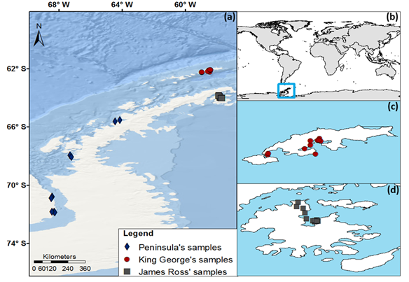
Fig. 1A. Map of Antarctic Peninsula region showing the occurrence of Roaldia revoluta on King George Island and James Ross Island and in the Peninsula region to Alexander Island. (a) and (b) Antarctic Peninsula; (c) King George Island; (d) James Ross Island.

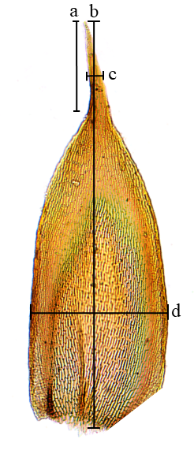
Fig. 1B. Position of the measurements performed for the morphological analyzes. (a) Apex length; (b) Leaf length; (c) Apex width; (d) Leaf width.

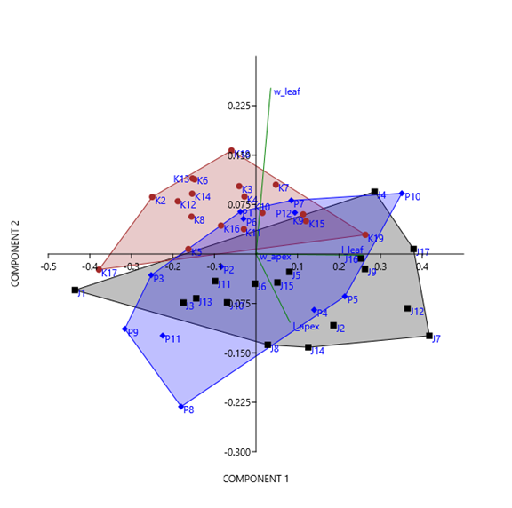
Fig. 2A. Combined PCA data between populations on James Ross Island (J) represented as squares and King George Island (K) represented as circles and the Antarctic Peninsula region (P), represented as diamonds. Specimen data are shown in Table 1. The direction and length of vectors give the relative contribution of morphological traits. L-leaf = Leaf length. L-Apex = Apex length. W-leaf = leaf width. Percentage cumulative variation = 98%, eigenvalues 0.043 and 0.006 for the first and second axes, respectively.

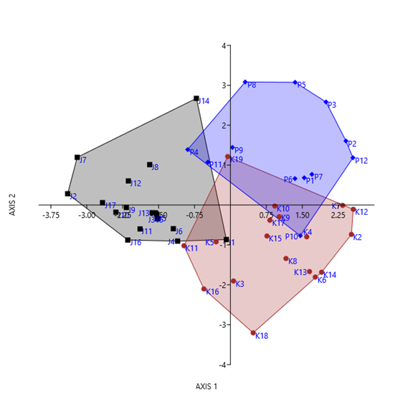
Fig.3A. Discriminant analysis (DA) including the three regions: James Ross Island (J) as circles, King George Island (K) as squares and Antarctic Peninsula (P) as diamonds.

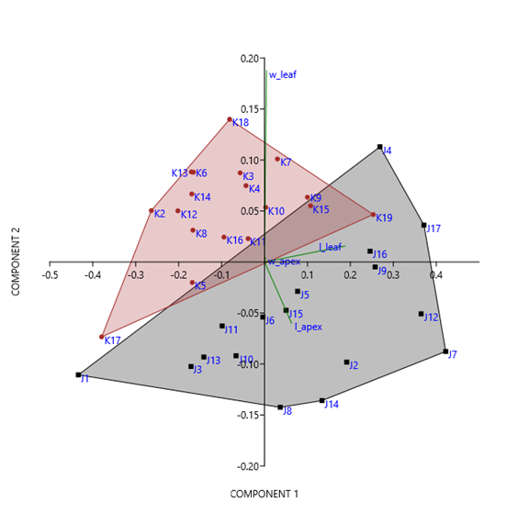
Fig. 2B. Combined PCA data between populations on James Ross Island (J) represented as squares and King George Island (K) represented as circles. Specimen data are shown in Table 1. The direction and length of vectors gives the relative contribution of morphological traits. L-leaf = Leaf length. L-Apex = Apex length. W-leaf = leaf width. Percentage cumulative variation = 98%, eigenvalue 0.043 and 0.006 for the first and the second axes, respectively.

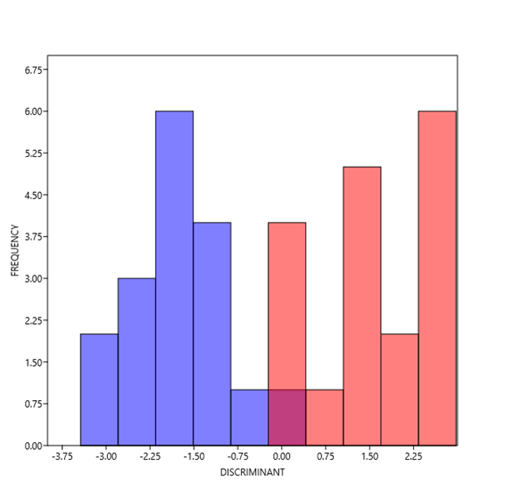
Fig. 3B. Histogram of discriminant analysis showing the separation of populations of R. revoluta. On the left, blue bars represent King George Island specimens and on the right, red bars represent James Ross Island specimens.

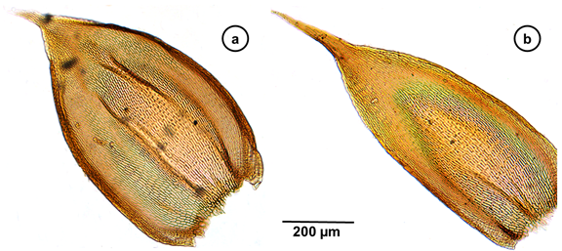

Fig. 4. The two morphotypes studied here, a = Morphotype A, with broader and more obovate leaves. B = Morphotype B with narrower and more lanceolate leaves.

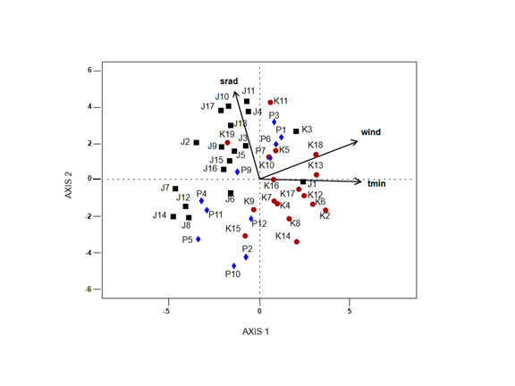
Fig. 5 Canonical Correspondence Analysis (CCA) including the three regions and the environmental variables: James Ross Island as circles, King George Island as squares and Antarctic Peninsula as diamonds. srad = solar radiation, wind = wind speed, tmin = minimum temperature.

Table 1: Samples of Roaldia revoluta used for statistical and molecular analyses in this study, with respective codes; (K) Samples from King George Island, (J) Samples from James Ross Island and (P) Samples from Antarctic Peninsula. The table indicates the collection location of each sample, collectors and herbaria where the collections are deposited. Swedish Museum of Natural History (S); Rio de Janeiro Botanical Garden (RB); British Antarctic Survey (AAS); University of Brasilia (UB).
Code | Site | Latitude | Longitude | Voucher | Herbarium
J1 | Ulu Peninsula | 64°00’S | 57°48’W | Smith, R.I.L. 7498 | UB/AAS
J2 | Ulu Peninsula | 64°01’29,6”S | 57°41’50,5”W | Kitaura, M.J. 3106 | UB
J3 | Ulu Peninsula | 64°01’29,6”S | 57°41’50,5”W | Kitaura, M.J. 3105 | UB
J4 | Ulu Peninsula | 64°01’52,6”S | 57°43’03,8”W | Kitaura, M.J. 2996 | UB
J5 | Ulu Peninsula | 64°00’36,90”S | 57°41’51,90”W | Kitaura, M.J. 2951 | UB
J6 | Ulu Peninsula | 64°01’18,5”S | 57°44’09,4”W | Kitaura, M.J. 3136 | UB
J7 | Ulu Peninsula | 64°01’05,0”S | 57°43’11,9”W | Kitaura, M.J. 2934 | UB
J8 | Ulu Peninsula | 64°01’04,98”S | 57°43’11,92”W | Kitaura, M.J. 2933 | UB
J9 | Ulu Peninsula | 64°01’29,6”S | 57°41’50,5”W | Kitaura, M.J. 3101 | UB
J10 | Ulu Peninsula | 63°56’S | 57°49’W | Smith, R.I.L. 7620 | UB/AAS
J11 | Ulu Peninsula | 63°49’S | 57°53’W | Smith, R.I.L. 7409 | UB/AAS
J12 | Ulu Peninsula | 63°53’S | 57° 50’W | Smith, R.I.L. 7339 | UB/AAS
J13 | Ulu Peninsula | 63°52’S | 57°54’W | Smith, R.I.L. 07634B | AAS
J14 | Ulu Peninsula | 64°01’21,16”S | 57°41’14,51”W | Kitaura, M.J. 2828 | UB
J15 | Ulu Peninsula | 64°00’36,90”S | 57°41’51,90”W | Kitaura, M.J. 2950 | UB
J16 | Ulu Peninsula | 64°01’37,4”S | 57°42’07,0”W | Kitaura, M.J. 3052 | UB
J17 | Ulu Peninsula | 64°01’13,43”S | 57°43’29,01”W | Kitaura, M.J. 2939 | UB
K1 | Dufayel Island | 62°10'06"S | 58°33'45"W | Dantas, T.S. 603B | UB
K2 | Keller Peninsula | 62°04’20”S | 58°25’30”W | Ochyra, R. 448/80 | S
K3 | Ore Point | 62°04'01"S | 58º24'59"W | Carvalho-Silva, M 2058 | UB
K4 | Ore Point | 62°04'01"S | 58º24'59"W | Carvalho-Silva, M 2053 | UB
K5 | Ostrov Geologov | 62°13'10.7"S | 58º56'44"W | Câmara, P.E.A.S. 4055 | UB
K6 | Ostrov Geologov | 62°13'10.7"S | 58º56'44"W | Henriques, D.K 233 | UB
K7 | Dufayel Island | 62°10'06"S | 58°33'45"W | Dantas, T.S. 603A | UB
K8 | Ore Point | 62º04'45”S | 58º23'52"W | Carvalho-Silva, M 2106 | UB
K9 | Ore Point | 62°04'45"S | 58º23'52"W | Carvalho-Silva, M 2111 | UB
K11 | Ore Point | 62º04'01"S | 58°24'59"W | Carvalho-Silva, M 2049 | UB
K12 | Admiralty Bay | 62°07’30”S | 58°30’ W | Ochyra, R. 2284/80 | S
K13 | Demay Point | 62°13’40”S | 58°27’ W | Ochyra, R. 1148/80 | S
K14 | Two Summits | 62°23’57”S | 58°95’5”W | Costa & Vandeira 6164 | RB/UB
K15 | Stenhouse Bluff | 62°04’30”S | 58°30’W | Ochyra, R. 2584/80 | AAS
K16 | Keller Peninsula | 62°03’04”S | 58°24’30”W | Ochyra, R. 442/80 | AAS
K17 | Two Summits | 62°14’S | 58°57’W | Li Xuedong 890213 | AAS
K18 | Ore Point | 62°04'01"S | 58º24'59"W | Carvalho-Silva, M 2052 | UB
K19 | Ore Point | 62°04'45"S | 58º23'52"W | Carvalho-Silva, M 2102 | UB
K20 | Ore Point | 62º04'45”S | 58º23'52"W | Carvalho-Silva, M 2015 | UB
P1 | Alexander Island | 70°54’S | 68°29’W | Smith, R.I.L. 11070 | UB/AAS
P2 | Marguerite Bay | 67°58’S | 67°19’W | Smith, R.I.L. 4637 | UB/AAS
P3 | Alexander Island | 70°54’S | 68°29’W | Harris, C.M. 11092 | AAS
P4 | Marguerite Bay | 67°58’S | 67°19’W | Smith, R.I.L. 4636 | AAS
P5 | Grahan Coast | 65°25’S | 64°14’W | Smith, R.I.L. 3334A | AAS
P6 | Ablation Valley | 79°49’S | 68°25’W | Smith, R.I.L. 8814A | AAS
P7 | Grahan Coast | 65°25’S | 64°14’W | Smith, R.I.L. 3335 | AAS
P8 | Alexander Island | 71°50’S | 68°18’W | Smith, R.I.L. 696 | AAS
P9 | Alexander Island | 70°49’S | 68°26’W | Smith, R.I.L. 9220A | AAS
P10 | Alexander Island | 71°53’S | 68°15’W | Smith, R.I.L. 10427 | AAS
P11 | Alexander Island | 70°54’S | 68°29’W | Harris, C.M. 11073B | AAS
P12 | Mars Glacier | 71°50’S | 68°26’W | Block, W. 8850 | AAS

Table 2. Estimators of the first and second axes of Canonical Correspondence Analysis (CCA) for the Roaldia revoluta morphotypes. Scores indicate the correlation of environmental variables with the first two axes of CCA.
Accumulated constrained eigenvalues | Axis 1 | Axis 2
Eigenvalue | 0.0056 | 0.0002
Proportion Explained | 0.9570 | 0.0401
Scores
Wind speed | -0.9607 | 0.01362
Minimum temperature | -0.9799 | -0.1603
Solar radiation | 0.1027 | 0.8976

