|  |  |  |
| --- | --- | --- |
|  |  |  |
|  |  |  |
|  |  |  |

|  |
| --- |
| **Figure 1**  C:\Users\Its me\AppData\Local\Microsoft\Windows\INetCache\Content.Word\1.tif  **Figure 2** |

**25°C**

**25°C 24L:00D**

**25°C 16L:08D**

**25°C 00L:24D**

**15°C 00L:24D**

**15°C 16L:08D**

**15°C 24L:00D**

**4°C 24L:00D**

**4°C 16L:08D**

**4°C 00L:24D**

**25°C 12L:12D**

**15°C 12L:12D**

**4°C 12L:12D**

**Temperature**

**L: light duration in hours**

**D: dark duration**

**Light exposure duration**

**4°C**

**15°C**

**Temperature:**

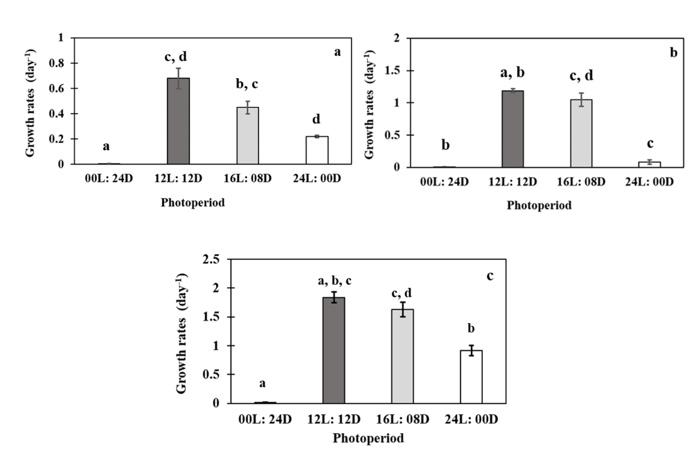

**Figure 3**

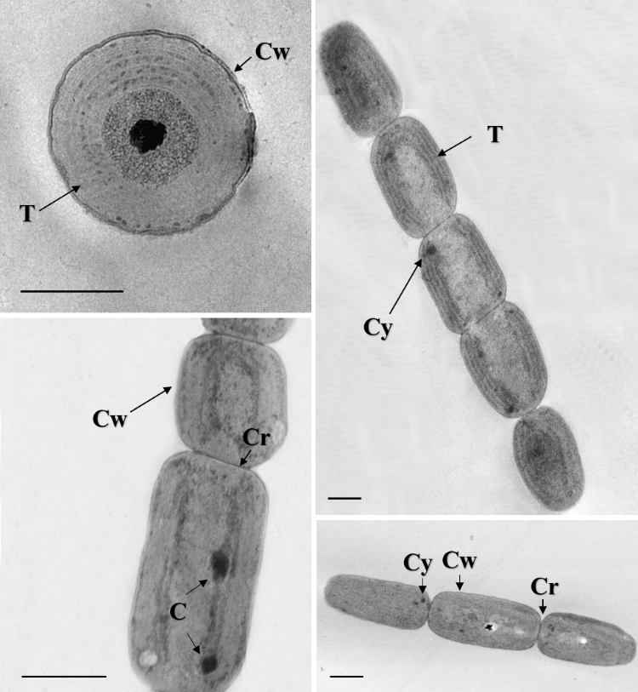

**a**

**b**

**c**

**d**

**Figure 4**

C:\Users\Its me\AppData\Local\Microsoft\Windows\INetCache\Content.Word\Picture1.tif

**Figure 5**