Evaluation of new CryoSat-2 products over the ocean
F. M. Calafat^{a,*,}, P. Cipolliniª, J. Bouffard^{b,c}, H. Snaith^{a,d}, P. Féménias^{b}
ª National Oceanography Centre, Southampton, UK
^{b} ESA/ESRIN, Frascati, Italy
^{c} RHEA-System, Frascati, Italy
^{d} British Oceanographic Data Centre, UK
* To whom correspondence should be addressed. Telephone: +44 0151 795 4971. Email: francisco.calafat@noc.ac.uk

Abstract. The CryoSat-2 satellite, primarily dedicated to precise monitoring of the Cryosphere, is demonstrating its capability to provide valuable altimetric data also over the ocean. Here we present the results of a global assessment and validation of the new Geophysical Ocean Product (GOP) distributed by the European Space Agency (ESA) since April 2014, focusing on the sea surface height anomaly (SSHA), the significant wave height (SWH), and the wind speed. Our assessment involves only Low Resolution Mode (LRM) and Pseudo LRM (PLRM) data, since full SAR processing is not already operationally implemented in the GOP. The global assessment is conducted on the basis of measurement noise and along-track spectral and crossover analysis, whereas the validation is performed against a variety of in situ observations such as tide gauges, buoys and Argo floats as well as data from the WaveWatch III (WWIII) model. The performance of the GOP is compared to that of Jason-2 and CryoSat-2 data from the Radar Altimeter Database System (RADS). The mean value of the 20-Hz SSHA noise at 2 m SWH is 6.3 cm for LRM and 10.2 cm for PLRM, and the standard deviation of the crossovers is ~5.4 cm. The mean 20-HZ SWH noise over the global oceans is 49.4 cm and 69.8 cm, for LRM and PLRM respectively. CryoSat-2 and Jason-2 show almost identical performance when SSHAs are validated against tide gauges, with a median correlation and root mean square difference (RMSD) of 0.78 and 7.1 cm for the GOP, 0.76 and 7.3 cm for Jason-2, and 0.79 and 7.8 cm for CryoSat-2 from RADS. The median correlation with Argo-derived steric heights is 0.68 for the GOP, 0.74 for Jason-2, and 0.67 for CryoSat-2 from RADS. However, the correlation shows a strong latitudinal dependence, with higher values at low latitudes (median value larger than 0.80 in the 10ºS-10ºN band). The median RMSD between the SSHAs and steric heights is 5.3 cm for the GOP, 4.6 cm for Jason-2, and 5.1 cm for CryoSat-2 from RADS. The GOP and Jason-2 show also identical performance when SWHs are compared to buoy data, with a slope and RMS error of 0.98 and 15 cm for GOP, 0.97 and 16 cm for Jason-2, and 1.05 and 17 cm for CryoSat-2 from RADS. On the other hand, the GOP wind speed exhibits a bias of about 2 m/s relative to both Jason-2 and to buoy data. Differences between the GOP and WWIII SWH are smaller than 20% of the SWH almost everywhere. In summary the GOP products are fit for oceanographic applications.
Keywords: CryoSat-2; Jason-2; satellite altimetry; validation; sea surface height anomaly; significant wave height; wind speed
1. Introduction
Satellite altimetry has become one of the standard tools in Earth sciences and has allowed a variety of geophysical parameters to be precisely measured in remote areas of the Earth where data from other sources are sparse or nonexistent. The basic principle of satellite altimetry involves accurate measurements of the time interval between the emission of a pulse and its echo from the Earth’s surface, from which one can infer, among other things, the ocean and land topography, including that of ice sheets, the extent of sea ice, the significant wave height (SWH) and the wind speed. Today Satellite altimetry is able to achieve accuracies in sea surface height (SSH) measurements of only a few centimeters thanks to the technological developments and improvements in data reprocessing brought by each new mission, since the launch of the first satellite radar altimeter on-board Skylab, in 1973. Despite these improvements, proper quality assessment of new altimetry products is essential so that they can be confidently used by the scientific community. In this paper we present the results of a global assessment and scientific validation of a new CryoSat-2 ocean product.
CryoSat-2 is a European Space Agency (ESA) Earth Explorer satellite that was launched in April 2010 and has monitoring of changes in the thickness of the sea ice and continental ice sheets as its primary goal (Drinkwater et al., 2004; Wingham et al., 2006). There are a number of features that make CryoSat-2 different from other dedicated ocean altimeters. These include a high inclination of about 92º that offers nearly global coverage reaching high latitudes of up to 88º and a repeat cycle of around 369 days, which is much longer than the standard 10-day and 35-day repeats of previous ocean-oriented altimeters. In addition, CryoSat-2’s primary instrument SIRAL (Synthetic Aperture Interferometric Radar Altimeter) operates in one of three different modes, namely Synthetic Aperture Radar (SAR) mode, Low Resolution Mode (LRM) and SAR Interferometry (SARIn) mode. LRM is based on traditional pulse-limited altimetry whereas SAR provides higher spatial resolution in the along-track direction (~ 380 m) by exploiting coherent processing of groups of transmitted pulses (Raney, 1998). In SARIn mode a second antenna is used to form a synthetic aperture interferometer across the satellite track, which allows determination of the across-track location of the surface. The mode is switched according to a dynamical geographical mask (see Figure 1), which is primarily set depending on the characteristics of the surface over which measurements are being taken as illustrated in Figure 1.
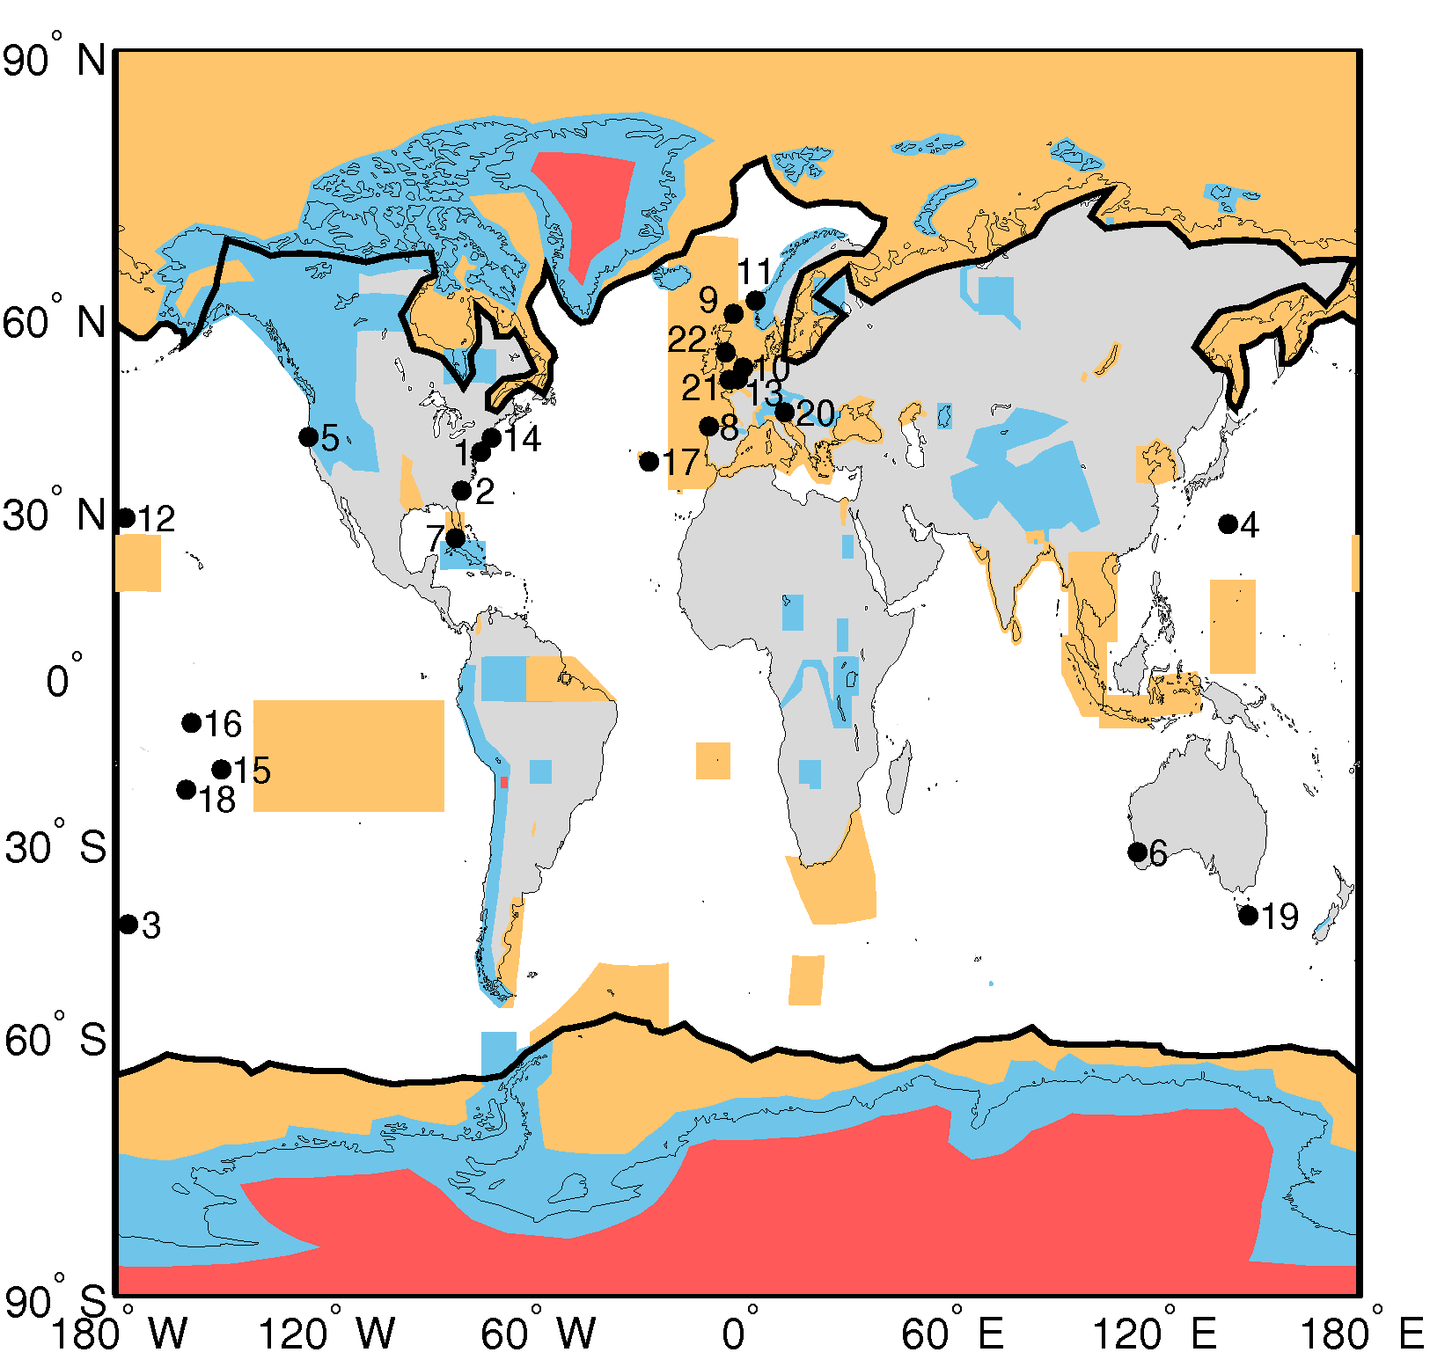
Figure 1. Extent of the regions defining the geographical mode mask for the first half of May 2015 (version 3.6 of the mask, which was in use from October 2014 to December 2015). The regions where SAR, and SARIn are operated are denoted by the orange and blue polygons, respectively. LRM is operated over areas of the continental ice sheets (red polygons) and over oceans and land not covered by other modes. The thick black lines mark the outer limit of the Arctic and Antarctic polar polygons. Numbers denote tide gauge stations used in the validation: Atlantic City (1), Charleston (2), Chatham Is. (3), Chichijima (4), Crescent City (5), Fremantle (6), Key West (7), La Coruña (8), Lerwick (9), Lowestoft (10), Maloy (11), Midway lsland (12), Newhaven (13), Newport (14), Papeete (15), Penrhyn (16), Ponta Delgada (17), Rarotonga (18), Spring Bay (19), Trieste (20), Weymouth (21), Workington (22).

Although the focus of CryoSat-2 is on the cryosphere, its applicability extends far beyond the sole framework of the Polar Regions. For instance, CryoSat-2 observations have been used in combination with data from other altimetry missions to construct a global marine gravity model with improved accuracy relative to previous models (Sandwell et al., 2014). Also, Dibarboure et al. (2012) explored and demonstrated the feasibility of using CryoSat-2 data to explore mesoscale processes in the ocean. The CryoSat Mission Management has thus approved, in the frame of the CryoSat-2 routine phase, the generation of additional ocean products, namely the Interim Ocean Product (IOP) and the Geophysical Ocean Product (GOP). These new ocean products have been generated and made available since April 2014 and the archive should be complete (i.e. with the reprocessed GOP available from the beginning of the mission in 2010) by the end of 2016 (Bouffard et al., 2016). Our focus here is on the GOP data (hereafter C2 GOP), which have consolidated orbits and are available 30 days after acquisition. It is important to note that, at present, the SAR mode data in the new IOP and GOP are processed into the so called pseudo-LRM measurements (PLRM), and no full SAR processing is yet operationally implemented. The PLRM or ‘reduced SAR’ echoes are created by grouping and summing the SAR mode echoes into LRM-like power waveforms, which are then processed as LRM waveforms (for more details see sections 2.1 and 3.1, and the CryoSat Product Handbook at https://earth.esa.int/documents). Adding full SAR mode processing will be part of a significant GOP processing upgrade, which should be in operation in mid 2017 (Bouffard et al, 2016). Therefore, our assessment and validation here involves only LRM and PLRM data over the oceans.
In this paper, we first show the results of a global assessment of the C2 GOP sea surface height anomaly (SSHA), SWH, and sigma0 in terms of measurement noise, along-track spectral analysis and crossover analysis. We then present a global validation of the new GOP SSHA, SWH and wind speed against a variety of in situ observations from tide gauges, buoys and Argo floats as well as against data from a wave model. In addition, we compare the performance of the C2 GOP to that of the Jason-2 (hereafter J2) and CryoSat-2 (hereafter C2 RADS) datasets from the Radar Altimeter Database System (RADS). The comparison is therefore both with a different altimeter altogether, and with the same altimeter but processed by a different processor (which in principle may output different values of height, SWH and sigma0 and entail a different sea state bias). Our main goal is to evaluate the ability of the new C2 GOP to capture sea level, wave, and wind signals, placing the results in the context of other altimetry datasets such as J2 and C2 RADS.
Results from the few previous studies that have conducted a validation of CryoSat-2 data already indicate good performance of SAR data as well as LRM and PLRM data. Examples of such studies include Labroue et al. (2012) who performed a validation of SSH and SWH mainly against other altimetry missions and focusing on LRM only, and Fenoglio-Marc et al. (2015) who have presented a validation of SSH, SWH and wind speed against in situ data and modeled elevations in the German Bight, for both SAR and PLRM data. Our assessment is global in scope and includes validation against both in situ observations and other altimetry datasets, which are important distinctions to Labroue et al. (2012) who performed a global assessment but did not compare with in situ data, and to Fenoglio-Marc et al. (2015) who did compare with in situ data but restricted their analysis over a relatively small area. Another important difference is that here we use steric heights derived from Argo float observations to validate the SSHA over the entire ocean, including remote areas where no in situ sea level observations are available. Although the idea of comparing SSHAs and steric heights is not new (e.g., Guinehut et al., 2006, 2009; Ivchenko et al., 2007; Dhomps et al., 2011; Calafat and Marcos, 2012), to our knowledge, this is the first time that such comparison has been performed for an altimeter with the special characteristics of CryoSat-2. Finally, it is important to remark again that in this study we evaluate LRM and PLRM data only.
The paper is organized as follows. Section 2 is dedicated to describing the data used in this study as well as the methods that we apply to compare the altimetry measurements with the in situ and model data. In Section 3 we first present the results of the noise and crossover analysis and then we move to the results of the global validation. Finally, in Section 4 we summarize and discuss the main results presented in Section 3 in the context of previous studies.
2. Data and methods
2.1. CryoSat-2 Geophysical Ocean Product
Here we use the new Level 2 GOP data, which are distributed by ESA and are available for download via ftp at ftp://science-pds.cryosat.esa.int. The GOP data are delivered approximately 30 days after data acquisition and are available for data acquired since April 2014. Our analysis is restricted to the period April 2014 to April 2016. We recall that the GOP so far do not contain full-resolution SAR mode data; the SAR mode data have been processed into PLRM, and then both LRM and PLRM are processed with an ocean retracker equivalent to the so called Ocean-3 or MLE4 algorithm for Jason-2, where the measured waveform is fitted with a 4-parameter return power model, according to weighted Least Square Estimators derived from Maximum Likelihood Estimators. The four parameters in MLE4 are waveform delay (related to range), waveform amplitude (related to sigma0, hence to wind speed), waveform rise time (related to SWH), and antenna mispointing. We refer the reader to the CryoSat Product Handbook (https://earth.esa.int/documents) for a detailed description of the GOP data.
The SWH and the wind speed are provided as two of the fields in the Level 2 GOP files, however the SSHA needs to be calculated from other fields available in the GOP, by first subtracting the corrected range from the altitude to obtain the SSH, and then subtracting the DTU10 (Andersen, 2013) mean sea surface (MSS) from this SSH to obtain SSHA. The corrected range is defined as the range corrected for tropospheric (wet and dry based on data from ECMWF) and ionospheric path delays (derived from the Global Ionospheric Map), and for sea state bias (using the same two-parameter model as for Jason-2, evolution of Gaspar and Florens 1998). The SSHA is then corrected for the solid earth (Cartwright and Edden, 1973), ocean (GOT4.8; Ray, 1999), loading (GOT4.8) and pole (Wahr, 1985) tides. The atmospheric correction is applied to the SSHAs only for the comparison with steric heights but not for that with tide gauges. To correct for atmospheric effects we use the dynamic atmospheric correction (DAC), which consists of the contribution of wind and atmospheric pressure as given by the Mog2D barotropic model (Carrere and Lyard, 2003) for periods less than 20 days and the inverse barometer (IB) effect for longer periods.
We have performed a careful quality control of the GOP data, aimed at removing anomalous records. This quality control is in fact conducted monthly as part of the activities undertaken within the CryOcean-QCV project at the National Oceanography Centre (UK), with results being summarized in regular monthly reports that are available at https://earth.esa.int/web/sppa/mission-performance/esa-missions/cryosat/quality-control-reports/ocean-product-quality-reports. Full details on the quality control procedure can be found in the reports; here we provide only a brief summary description. First, we reject all records that have been flagged as bad by the quality control flags provided within the product files (.DBL). Note that this includes rejection of records with parameters that are set to specific values in case of error (see the CryoSat product handbook). Note also that the quality control flags refer to the 20-Hz measurements while we are working with the 1-Hz data. We account for the quality control flags in the selection of the 1-Hz measurements by rejecting all measurements at 1-Hz associated with a 20-Hz block with less than 10 valid measurements. The remaining 1-Hz records are then screened according to scientific quality criteria, including the use of minimum and maximum thresholds for the range corrections as well as for sigma0, SSHA, SWH and their corresponding 20-Hz standard deviations. Editing criteria are summarized in Table 1. Note that measurements taken over ice-covered areas (polar polygons as denoted in Figure 1) are rejected.
Table 1. Editing criteria applied to C2 GOP, C2 RADS and J2.
Parameter | Min | Max
Wet tropospheric correction [m] | -0.500 | -0.001
Dry tropospheric correction [m] | -2.5 | -1.9
Ionospheric correction [m] | -0.40 | 0.04
DAC [m] | -2.0 | 2.0
Sea state bias [m] | -0.5 | 0.0
SSH anomaly [m] | -3 | 3
SWH [m] | 0 | 15
Wind speed [m/s] | 0 | 30
Sigma0 [dB] | 7 | 30
std of range [m] | 0.0 | 0.2
std of SWH [m] | 0 | 1
std of sigma0 [dB] | 0.00 | 0.23

2.2. Jason-2 and CryoSat-2 data from RADS.
For our validation, we use the 1-Hz SSHA, SWH, and wind speed data from Jason-2 and CryoSat-2 as provided by the RADS database (http://rads.tudelft.nl/rads/rads.shtml). The geophysical and atmospheric corrections applied to the SSHA are the same as those applied to the C2 GOP data (see Section 2.1), except for the sea state bias which is derived from a hybrid model. We also use a different MSS (DTU13) to compute the SSHA since the one used in C2 GOP (DTU10) was not available in RADS. As for the C2 GOP data, DAC will be applied to the SSHAs only for the comparison with steric heights. The RADS data used here have been screened based on the same editing criteria as those used for C2 GOP (Table 1).
2.3. Tide gauge data.
Tide gauge records were obtained from the UK National Tide Gauge Network archives at the British Oceanographic Data Centre (BODC) and the University of Hawaii Sea Level Center (UHSLC). The temporal resolution of the sea level data is 15 minutes for records stored at the BODC and 1 hour for those stored at the UHSLC. A set of 22 tide gauges was selected based on the following criteria: 1) they have valid hourly or more frequent data for the period April 2014 to April 2016; and 2) they do not show obvious shifts and outliers upon visual inspection of the non-tidal residuals. The tide gauge names and locations are shown in Figure 1. For consistency with the altimetry data, all tide gauge records were detided. The amplitudes and phases of the tidal constituents were estimated on a year-by-year basis by harmonic analysis using the program t-tide (Pawlowicz et al., 2002). Only constituents with a signal-to-noise ratio equal or larger than three were used to reconstruct the tidal signal.
If there was not vertical land motion at the tide gauge location, then collocated altimetry and tide gauge measurements would provide estimates of the same quantity. Note however that, in general, altimetry measurements are not taken at the tide gauge location but at some ocean point nearby nor they are collocated in time with the tide gauge observations. Moreover, CryoSat-2 measurements are hardly ever taken over the same ocean point due to the long-repeat cycle (369 days) of the satellite. Therefore, some processing is necessary to obtain altimeter/tide gauge comparison pairs. Here we use a search radius centred on the tide gauge to select the altimetry measurements that are relevant to the tide gauge observations. This approach allows us to accommodate the non-repeating CryoSat-2 ground tracks. We test for different values of the radius within the range 0 to 150 km and select the radius that minimizes the root mean square difference (RMSD) between the tide gauge and altimetry observations. Therefore, the selection of the radius is strictly based on quantitative analysis and it is tailored to represent the optimum radius for each individual tide gauge. The imposition of a maximum radius (150 km) is justified by the fact that altimetry measurements taken too far from the tide gauge may include signals different from those measured by the tide gauge. Then, for each altimetry pass falling within the selected radius, an altimetry value is obtained by computing the median of all records falling within the selected radius. The corresponding tide gauge matching value is obtained by linearly interpolating the tide gauge observations to the time of each selected altimetry pass. Values in the resulting time series with a temporal separation smaller than 3 days are averaged to form a single value (this only affects the C2 GOP and C2 RADS data).
We realize that the derived time series for CryoSat-2 and Jason-2 have different sampling intervals due to the different characteristics between the two altimeters and this may raise concerns about the consistency of the comparison. Nevertheless, it is important to note that here we obtain one comparison pair each time that an altimeter pass falls within the selected radius, and thus we are essentially comparing instantaneous values of sea level since we do not perform any averaging in time. Over timescales of few weeks sea level variability is close to white noise and thus sampling it with a certain periodicity or irregularly or at different rates results in time series that have practically the same power spectrum. We have tested for this and have found that, as expected, the C2 GOP and J2 time series have very similar power spectra and consequently the comparison is consistent. An additional issue concerns the fact that by using a search radius we are sampling different ocean points over time, which is true of both CryoSat-2 and Jason-2 since often more than one track falls within the selected radius. This may potentially introduce geoid errors if the MSS model that we use to derive SSH anomalies was not accurate enough. Such errors are expected to be larger for CryoSat-2 than for repeat-track altimetry missions such as Jason-2 due to interpolation errors in the MSS close to the coast (where MSS errors are larger). Nevertheless, previous studies (e.g., Smith and Scharroo, 2009) have found that current MSS models are of sufficient quality to be used for estimating SSH anomalies without introducing significant errors.
2.4. Hydrographic observations and steric height derivation
The set of temperature (T) and salinity (S) profiles were obtained from the EN4.1.1 data set (Good et al., 2013) made available by the Met Office Hadley Centre (http://hadobs.metoffice.com/en4/). Although the EN4 data set includes measurements collected by a number of different instruments such as XBTs, MBTs, CTDs and Argo floats, among others, here we use only Argo data because, unlike the other types of measurements, they provide nearly global coverage of T and S from surface to more than 1000 m thus allowing for a consistent comparison between different regions of the ocean in terms of altimeter performance. In addition to the observed profile data, the EN4 data set includes quality control flags for each profile. These flags allow quality control decisions on whether to accept or reject either an individual level within a profile or the entire profile and they have been applied during the profile selection process to ensure that all data used in our analysis are of the highest quality. The location of all the selected profiles is shown Figure 2a.
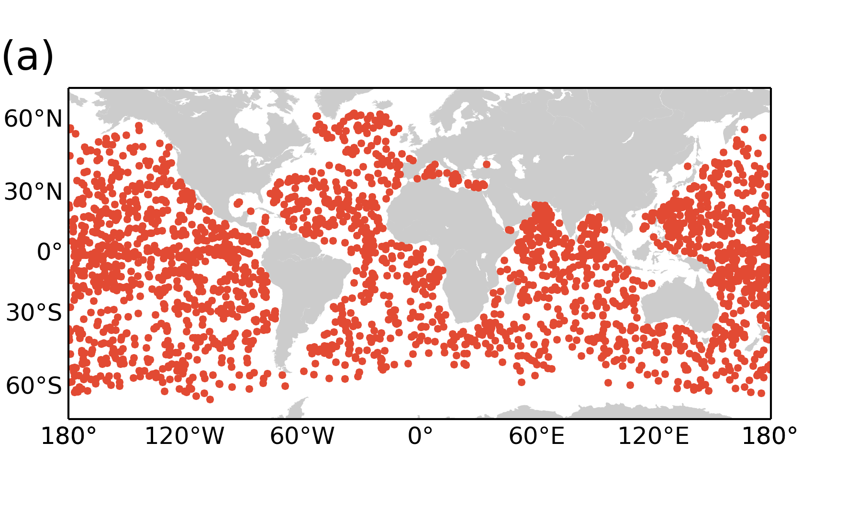
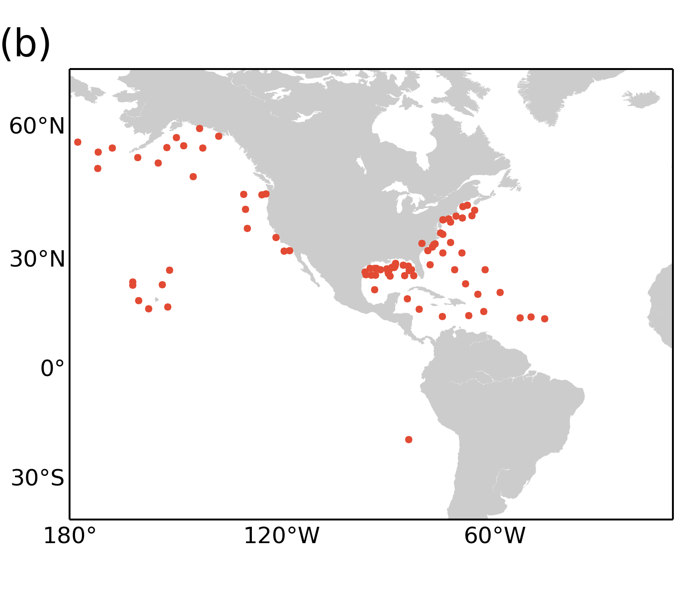
Figure 2. Map showing the location of the (a) Argo floats and (b) the buoys used in the validation.

The motivation for using steric height as derived from T and S profiles in our evaluation of the altimeter SSHAs is that it provides a useful validation tool in the open ocean where very few in situ measurements of sea level are available. This idea is appealing because it allows for an independent validation over most of the global oceans thanks to the good spatial coverage of the Argo network and avoids the issue of degraded performance affecting altimetry near the coast that commonly arises when comparing with tide gauge observations. It is not surprising, therefore, that this approach has become one of the standard altimetry validation tools (e.g., Guinehut et al., 2006, 2009; Ivchenko et al., 2007; Dhomps et al., 2011; Calafat and Marcos, 2012).
We should note, however, that the steric height is only one of several components that contribute to SSHAs. It is in general a good approximation, and certainly standard practice, to describe sea level changes as the sum of three components: i) steric changes arising from density field variations; ii) changes in ocean bottom pressure (OBP) resulting from mass redistribution within the Earth system; and iii) atmospheric pressure variations, which are usually approximated by the IB effect. Clearly, the naïve strategy of directly comparing steric heights with SSHAs will lead to unsatisfactory results if the OBP and/or the IB components are important relative to the steric one. Hence, ideally one should remove those two components prior to comparing SSHAs with ARGO-derived steric heights. In practice only the contribution of wind forcing to OBP and the effect of atmospheric pressure can be estimated with confidence, usually by a barotropic model. Here, estimates of these two contributions as provided by DAC are subtracted from the altimetric SSHAs prior to comparing with steric heights. It is important to recall that by applying DAC we are removing only a portion of the OBP component and thus the SSHAs so corrected will not represent only steric changes but also OBP variations due to factors other than direct wind forcing. Nevertheless, we expect such OBP changes to be small in most regions, with the exception of the Southern Ocean (Quinn and Ponte, 2012) and over major ocean currents.
The steric height anomalies are computed for each profile by vertically integrating the Argo-derived density anomalies (i.e., deviations from the time-mean density field) from the sea surface to 1000 m depth.
Argo floats provide T and S observations once every 10 days at a different location each time as they freely drift with the ocean currents, and thus the steric heights are hardly ever collocated with the SSHAs, either in time or space. In consequence, even if the contribution of OBP to SSHAs was exactly zero, the two data sets would still exhibit differences. The approach taken here to obtain SSHA/steric comparison pairs is as follows. For each steric height observation we find all the altimetry measurements taken within 10 days and within a preselected distance of the steric observation. Then the corresponding altimeter SSHA is computed as the median of the selected altimeter measurements. Because the length scales of the mesoscale oceanic structures (given by the internal Rossby radius) decreases as latitude increases, here the maximum distance allowed between the SSHA and the steric height is latitude dependent and is based on typical values of the internal Rossby radius (Chelton et al., 1998). In particular, for latitudes within 10º north and south of the equator we use 150 km, in the bands 10º to 20º north and south we use 100 km, 50 km in the bands 20º to 45º, and 30 km for latitudes above 45 º north and south. We compared the results obtained using a latitude-dependent maximum distance with those obtained using the same distance for all latitudes, and found that the former significantly increases the correlation between SSHAs and steric heights at most latitudes. Only floats with at least 50 observations in the period between April 2014 and April 2016 are used in our analysis, which results in a total of 2340 Argo floats.
2.5. In situ SWH and wind speed measurements
For the validation of the SWH and wind speed against in situ measurements we use hourly buoy data obtained from the National Data Buoy Center (NDBC) at http://www.ndbc.noaa.gov. In particular, we use the data in the Standard Meteorological group, where the SWH is computed as the average of the highest one-third of all of the wave heights during the 20-minute sampling period and the wind speed is averaged over an eight-minute period. In order to avoid the problem of degraded performance of altimetry near the coast the comparison is restricted to buoys located in the open ocean no closer than 40 km to the coast. We use a total of 89 buoys, the locations of which are shown in Figure 2b. Note that since NDBC provides hourly values of SWH and wind speed the maximum temporal separation between altimeter and buoy measurements is 30 minutes with a mean value of 15 minutes. The procedure to select altimeter-buoy measurement pairs is as follows. For each altimetry pass falling within 20 km of the buoy, an altimetry value is obtained by computing the mean of all records falling within the selected radius. The corresponding buoy matching value is obtained by linearly interpolating the buoy observations to the time of each altimetry pass.
Note that because the RMSD between two measurements separated by 15 minutes is expected to be only about 10 cm for SWH and 0.3 m/s for wind speed (Monaldo, 1988), we expect temporal separation to have only a small impact on the comparison between the two types of measurements. The maximum distance of 20 km has been selected based on the results of Monaldo (1988) who found that two observations separated by 20 km are expected to differ by no more than 0.2 m for SWH and 0.5 m/s for wind speed.
2.6. Wavewatch III data
SWH data from the WWIII global wave model were obtained (in December 2015) from the Pacific Islands Ocean Observing System (PacIOOS) at the University of Hawaii (http://oos.soest.hawaii.edu/erddap/griddap/NWWIII_Global_Best.html). The WWIII model provides hourly values of SWH over the global ocean at a 1/2º spatial resolution. The WWIII model is a third generation wave model developed at NOAA/NCEP, which solves the random phase spectral action density balance equation for wave-number direction spectra (Tolman, 2009). Refraction and straining of the wave field due to temporal and spatial variations of the mean water depth and of the mean current are explicitly resolved within the model, while other physical processes such as wave growth and decay due to the actions of the wind, nonlinear resonant interactions, dissipation, bottom friction, surf-breaking, and scattering due to wave-bottom interactions are parameterized. Nonlinear effects are included in the source terms. Note that the model does not perform wave data assimilation. We refer the reader to the NOAA WaveWatch III home page at http://polar.ncep.noaa.gov/waves/wavewatch/wavewatch.shtml for more details on the WWIII model.
The selection of altimetry/model comparison pairs is done in the same way as for the buoy data (see Section 2.5) where each model grid point is assumed to represent a virtual buoy.

3. Results
3.1. Global assessment of C2 GOP SSHA, SWH, and sigma0
We provide here the results derived from the quality control analysis concerning the performance of the C2 GOP SSHA, SWH, and sigma0. The 20-Hz measurement noise, determined as the standard deviation of the twenty records in a 20-Hz data block, is frequently used in satellite altimetry assessments as a standard measure of the precision of the observed parameters and, therefore, it is one of the diagnostics presented here (Figure 3). One feature that stands out in the spatial distribution of noise (Figure 3) is the higher noise levels of the SSHA and SWH in the PLRM regions. This feature is not observed in the map of sigma0 noise (Figure 3c). The higher noise in PLRM relative to LRM arises from the smaller number of statistically independent individual radar echoes that can be incoherently averaged prior to estimate of the geophysical parameters. When in LRM, SIRAL has a pulse repetition frequency (PRF) of about 2 k – normally assumed as the maximum frequency at which the looks over the ocean can still be considered statistically independent (Walsh, 1982); the instrument measures continuously at this PRF in LRM. When in SAR mode (from which the PLRM mode waveforms are generated) SIRAL instead sends out ‘bursts’ of 64 pulses with a PRF of 18.18 k. This higher PRF is needed for SAR-mode processing but gives virtually no advantage for pulse-limited observations, as the echoes are not independent. SIRAL switches to reception mode between bursts and so over a burst repetition interval of 11.8 ns the instrument is in transmission mode only for ~30% of the time. Hence there are only about 1/3 as many ‘looks’ available per unit time in PLRM as compared to LRM. Averaging echoes (needed to reduce the speckle noise) with only 1/3 of those available for LRM in theory yields a higher noise by a factor $\sqrt{3}$. In practice the PLRM to LRM noise ratio is slightly less than $\sqrt{3}$, as speckle noise still has a degree of decorrelation at frequencies higher than 2 KHz, especially for high state seas.
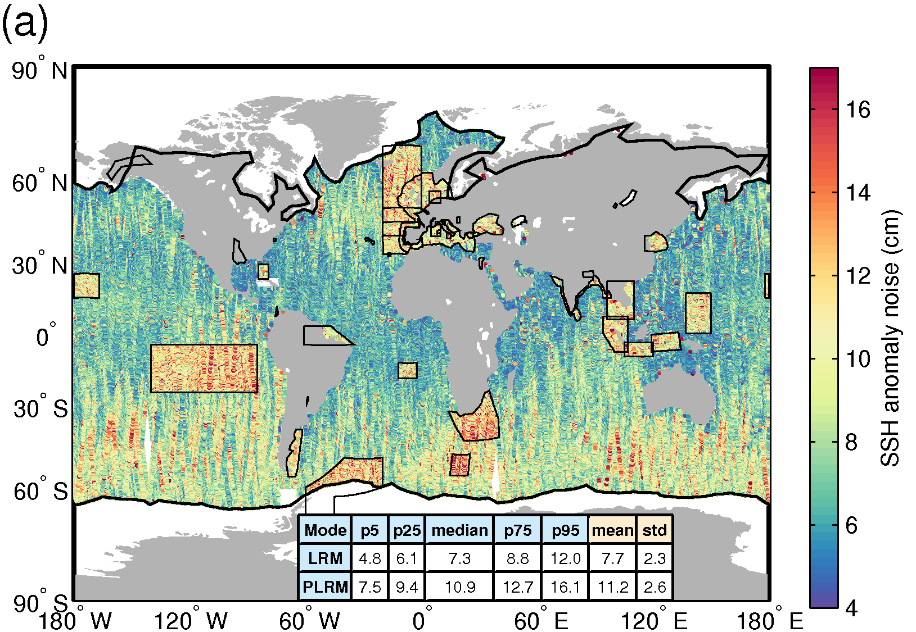
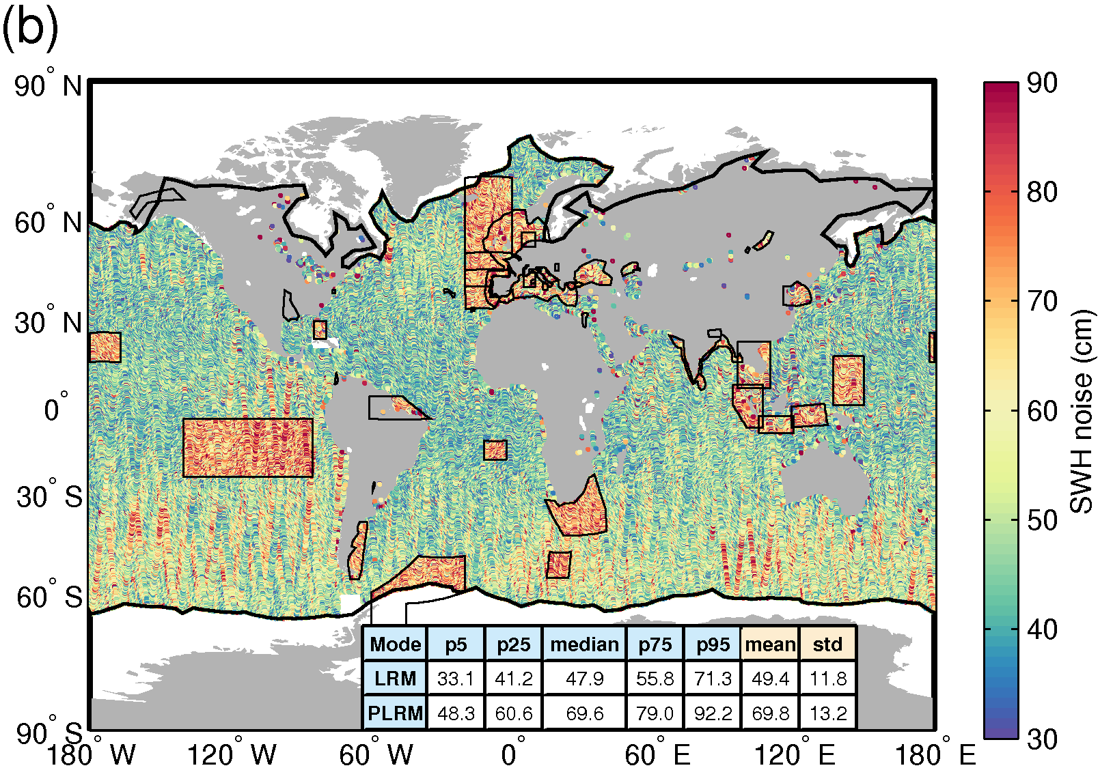
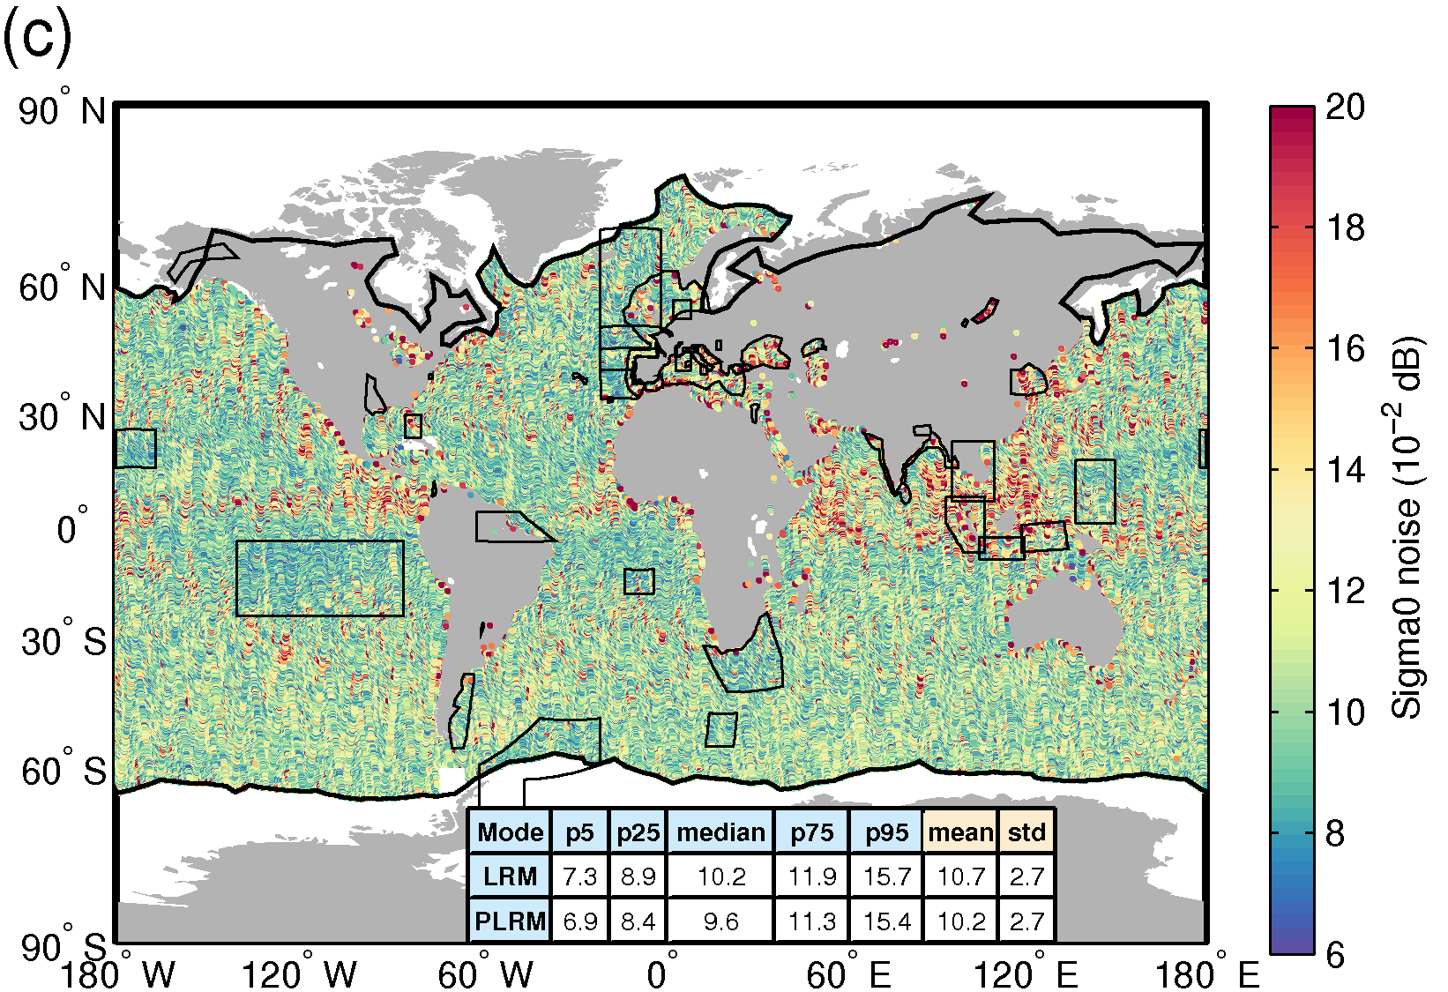
Figure 3. Geographical distribution of the 20-Hz measurement noise for the C2 GOP (a) SSHA, (b) SWH, (c) and sigma0 over oceans and lakes for May 2015. The statistical values shown in the table are calculated separately for LRM and PLRM regions. The tables show the 5% (p5), 25% (p25), 50% (median), 75% (p75), and 95% (p95) percentiles together with the mean and the standard deviation (std). The thick black lines mark the outer limit of the Arctic and Antarctic polar polygons whereas the thin black lines denote regions where SAR mode is operated.

For the SSHA the mean measurement noise over the global oceans is 7.7±2.3 cm for LRM and 11.2±2.6 cm for PLRM, representing a PLRM to LRM noise ratio of 1.5. We find a similar ratio for the SWH noise with mean values of 49.4±11.8 cm and 69.8±13.2 cm, for LRM and PLRM respectively. Sigma0 noise values show no difference between LRM and PLRM, with mean values of 0.11±0.03 dB and 0.10±0.03 dB respectively. Note the relatively small values of the standard deviation associated with the mean noise values, reflecting the high spatial uniformity of the noise within LRM and PLRM regions, which is also apparent in the noise maps.
Assuming that noise in the 20-Hz measurements is independent, a noise of 7.7 cm at 20 Hz corresponds to a value of about 1.7 cm when averaging to 1 Hz, which reflects a very high precision for the altimeter. Note however that because of the relatively low energy associated with small length scales this level of noise can corrupt signals with spatial scales of up to 100 km (Kim et al., 2011; Dibarboure et al., 2014). In order to further illustrate this we show the along-track SSHA power spectrum density (PSD) over May-June 2015 for the 20-Hz C2 GOP data explicitly separating LRM and PLRM (Figure 4a) and for the 1-Hz CryoSat-2 and Jason-2 data (Figure 4b). The PSDs have been computed based on Welch’s algorithm (Welch, 1967) using a window of about 800 km and a 50% overlap. The PSD for the 20-Hz data shows that energy decreases with wavenumber until a plateau is reached at wavelengths of about 3 km both for the LRM and PLRM data. The flat power spectrum corresponds to a white noise floor of 7.5 cm and 10.4 cm for the 20-Hz LRM and PLRM data respectively, which are consistent with the values of the mean altimeter noise shown in Figure 3. Another interesting feature is the spectral hump that appears in the 20-Hz LRM data at wavelengths between 3 km and 50 km. This spectral hump is well documented in the altimetry literature and reflects one of the main limiting factors of satellite altimetry in resolving small-scale features (Faugère et al., 2006; Dibarboure et al., 2014). As expected, the spectral hump is not visible in the 1-Hz data (Figure 4b) since the sampling rate is insufficient to sample the relevant wavenumbers. We note that the noise floor for the 1-Hz data is about 2.3 cm and 2.9 cm for C2 GOP and J2, respectively. If the errors associated with the 1-Hz data were Gaussian then the 1-Hz and 20-Hz noise levels for LRM should differ by roughly a factor of , however we note that they differ by about a factor of . The reason for this is that the 2.3 cm noise of the 1-Hz data derived from the spectrum represents not only Gaussian noise but also a contribution from the spectral hump affecting the PSD of the 20-Hz data.
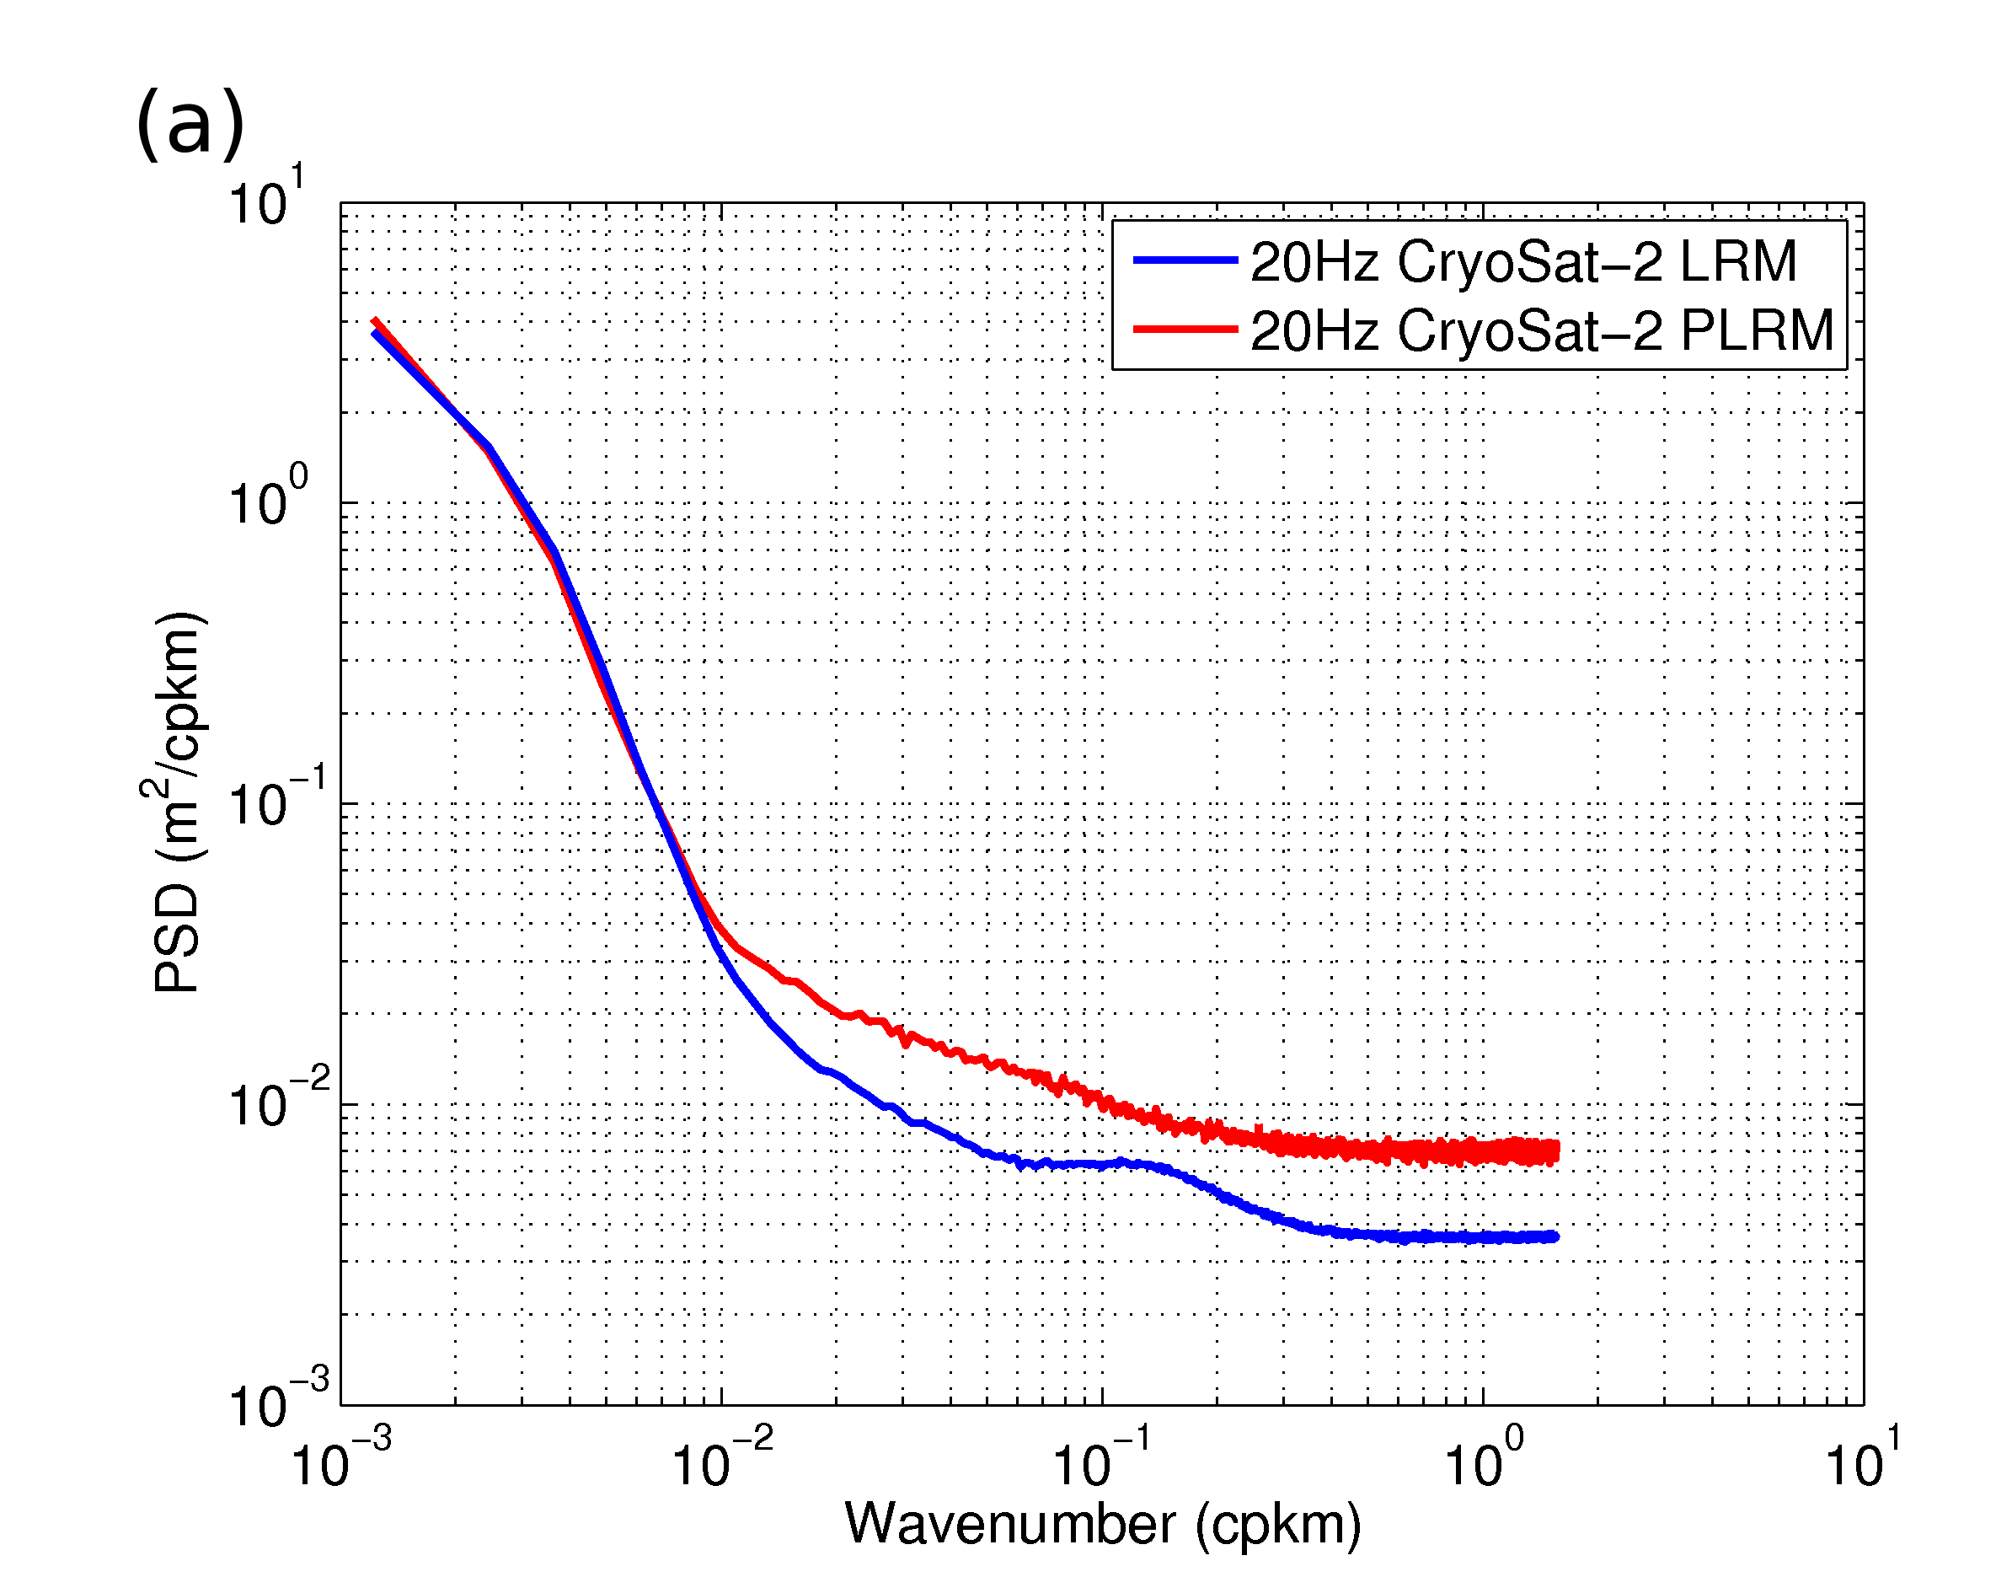
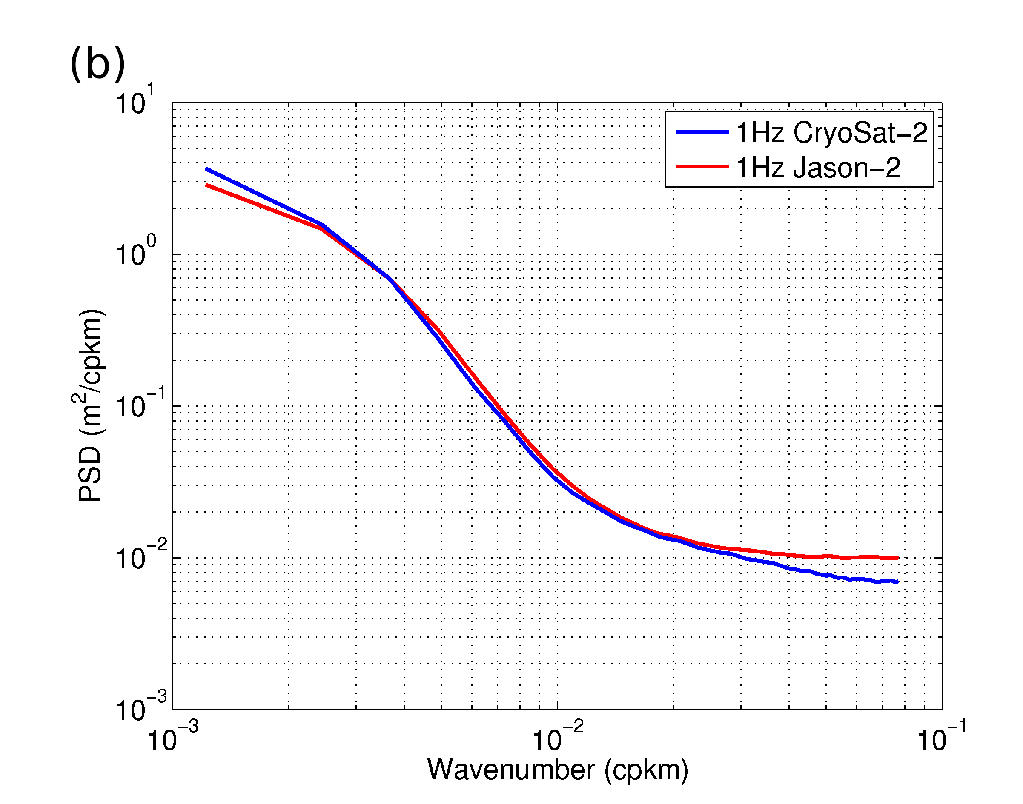
Figure 4. Along-track SSHA PSD over May-June 2015 for: (a) the 20-Hz C2 GOP data explicitly separating LRM and PLRM; and (b) the 1-Hz C2 GOP and J2 data.

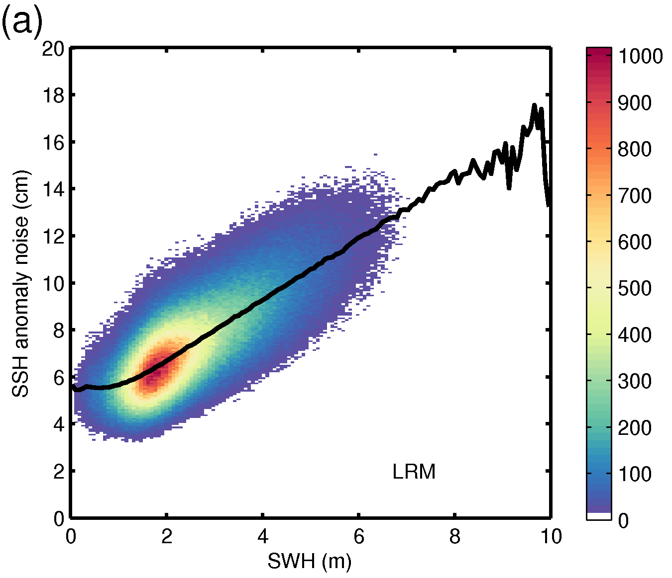
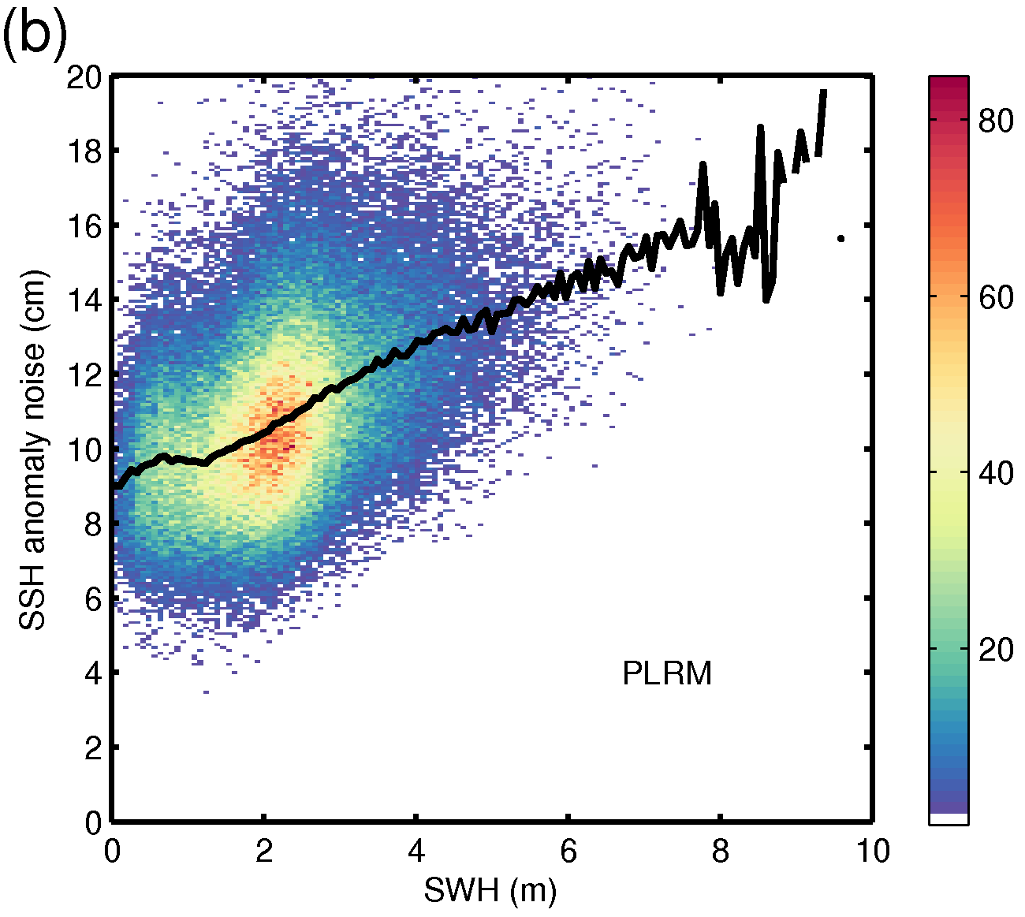
Figure 5. 2D histogram showing the C2 GOP 20-Hz SSHA noise as a function of SWH for (a) LRM and (b) PLRM for May 2015. The black line denotes the median SSHA noise as a function of SWH whereas colors indicate number of points within each histogram bin.

In the light of such differences in noise level between LRM and PLRM measurements, one may suspect continuity issues in the parameters at the edges delimiting regions of distinct operational modes. We have investigated this possibility by quantifying the differences in SSHA and SWH for each altimeter pass between pairs of consecutive points where one of the points is outside the Pacific PLRM box (see Figure 1) while the other is inside. The resulting differences have been compared with the differences between consecutive points both just outside the PLRM box. The mean RMSD for pairs of points in/out of the PLRM box over the entire period (April 2014 to June 2015) is 3.59 cm and 20.96 cm for the SSHA and the SWH, respectively. Such values are not statistically different from the values of 3.92 cm and 21.42 cm found for pairs of points both just outside the PLRM box, indicating that despite the differences in noise level the parameters do not exhibit any shifts at the transition between LRM and PLRM regions.
Because the SSHA noise generally increases with SWH (which can be understood intuitively by noting that when the slope of the leading edge decreases, i.e. the SWH increases, then the precision in the timing of the leading edge mid-point is also reduced), it is informative to show such dependency in the form of a 2D histogram of SSHA noise against SWH (Figure 5). We show this dependency for LRM and PLRM data separately. In agreement with the values shown in Figure 3, PLRM measurements are significantly noisier than LRM. The median of the measurement noise corresponding to a SWH of 2 m is about 6.3 cm for LRM and 10.2 cm for PLRM. As expected the SSHA noise increases (almost linearly; see fig 12 of Walsh, 1982) with the SWH for both modes. Note that the rate of increase is more pronounced for the LRM than for the PLRM and the noise medians for the two modes converge for high SWH values. This is expected, as for high sea states the uncertainty originated by the widened distribution of the elementary scatterers at the surface becomes predominant over the noise intrinsic to the instrument measurement mode.
Another quantity that is commonly used as a measure of the quality of the SSH observed by an altimeter is the difference at crossovers between ascending and descending passes. Figure 6 shows the SSH crossover differences for May 2015. Note that because the crossovers are computed with a maximum temporal separation of 10 days (following the Validation and Cross Calibration annual reports from Aviso), measurements acquired in late April 2015 and early June 2015 are included in the computation. The data gaps in the latitudinal bands 10ºS-10ºN and 45º-60º north and south are related to the CryoSat-2 orbit characteristics and the use of a 10-day window (i.e., no crossovers occur in those regions). The median and the mean of the crossover differences is roughly zero as expected. The vast majority of the values (90%) fall within the range -10 cm to 10 cm, whereas 50% of the values lie in the range -3.8 cm to 3.5 cm. The standard deviation of all crossover differences is 6.7 cm. If we exclude crossover differences larger than 20 cm as well as those corresponding to measurements located in shallow waters (<1000 m) (e.g., Labroue et al., 2012), the standard deviation of the crossovers is reduced to 5.4 cm. We have also computed the standard deviation of the crossover differences for LRM and PLRM separately and found that there is no statistical difference.
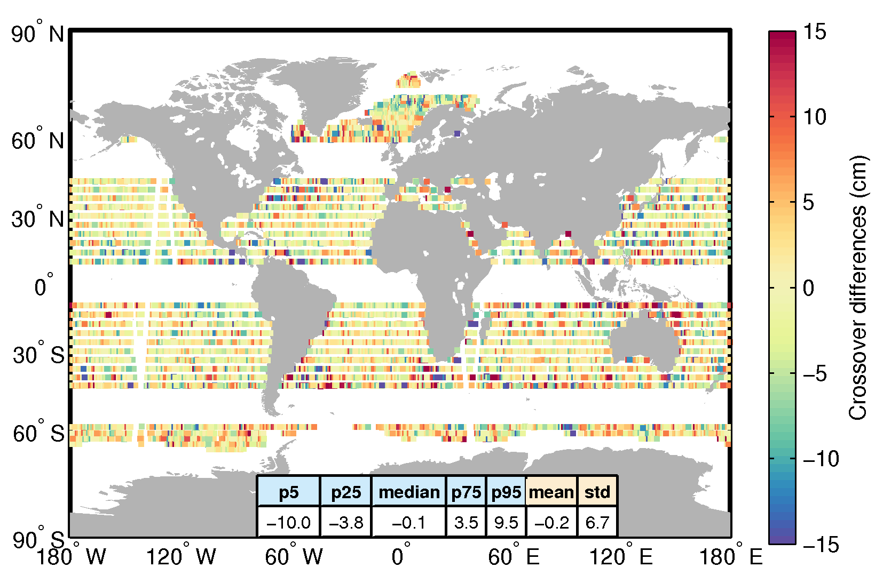
Figure 6. Crossover differences for the C2 GOP SSH for May 2015. The difference at each crossover is computed as the difference between median values over 2-s windows centered about the crossover and for passes within a 20-day window (maximum time separation of 10 days). The table shows the 5% (p5), 25% (p25), 50% (median), 75% (p75), and 95% (p95) percentiles together with the mean and the standard deviation (std).
Although the statistics presented in this section refer to May 2015, we computed the same diagnostics for each month from April 2014 to April 2016 as part of the quality control and validation performed within the CryOcean-QCV project and have found very similar values for each month, indicating a very good and consistent performance of CryoSat-2 over time.
3.2. Validation of the SSHA
3.2.1. Comparison with tide gauge observations
In this section we compare C2 GOP SSHAs with tide gauge sea levels and evaluate the results in the context of J2 and C2 RADS by including these two datasets in the comparison. Time series of SSHAs from C2 GOP and tide gauge observations are shown in Figure 7 for the 22 stations. Although there are some differences in detail between the two time series, the major features are consistent. We note that the variance of the time series varies significantly across stations, with Lowestoft and Workington showing the largest variations and Papeete showing the smallest ones. Both the magnitude and the phase of the variability shown by the tide gauge records are well captured by the C2 GOP SSHAs. At some stations such as Chatham Island and Spring Bay the agreement is so good that the two time series are almost indistinguishable.
Figure 7. Comparison of SSHA from C2 GOP with non-tidal tide gauge sea levels.
The good agreement between the C2 GOP and tide gauge measurements apparent from Figure 7 is quantified by computing the correlation and RMSD between the altimeter and tide gauge time series for all stations (Figure 8). The same comparison with the tide gauges is performed also for J2 and C2 RADS. The correlation and RMSD are very similar across the three altimetry datasets (Figure 8), with median values of 0.78 and 7.1 cm for C2 GOP, 0.76 and 7.3 cm for J2, and 0.79 and 7.8 cm for C2 RADS. Correlations are statistically significant (95% confidence level) at all tide gauge stations, reflecting the good agreement between the time series shown in Figure 7. We also note that there is significant variability in the correlation and the RMSD values across stations, with correlations ranging from 0.50 to 0.95 and RMSDs ranging from 3.4 cm to 17.9cm. Note, however, that such variability is very consistent across the three altimetry datasets. For instance, all three altimetry datasets show relatively high correlations at Chatham, Lowestoft, and Spring Bay and relatively low correlations at Newhaven, Papeete and Penrhyn. These results indicate that CryoSat-2 and Jason-2 have a similar ability to capture sea level signals.

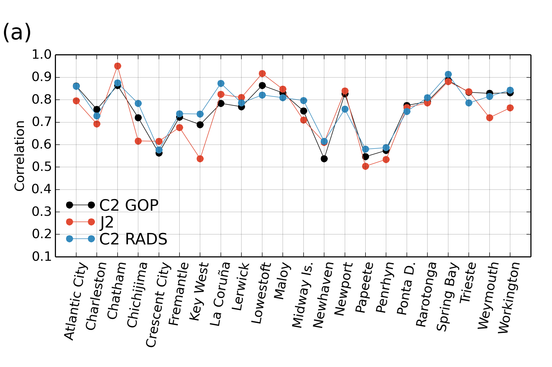
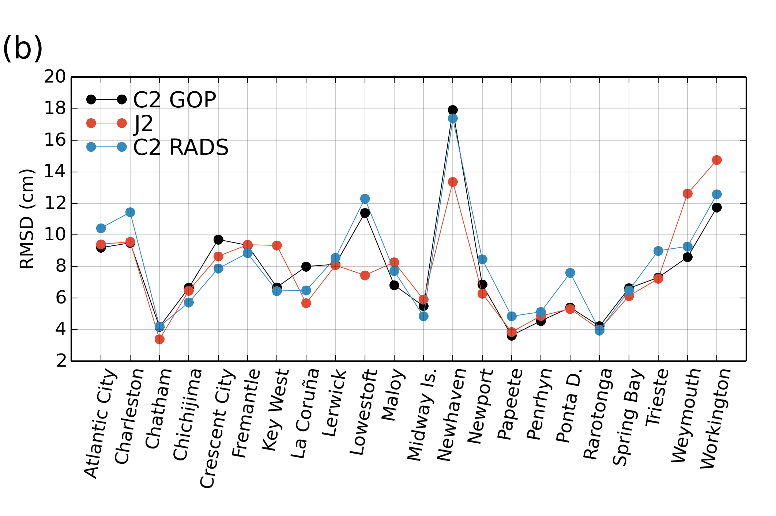
Figure 8. (a) Correlation, and (b) RMSD between tide gauge observations and SSHAs from C2 GOP, J2, and C2 RADS over the period April 2014 to April 2016.
To build the altimetry/tide gauge matching time series we imposed a maximum radius of 150 km (see Section 2.3). While testing for the effect of the radius choice we noted that for values of the maximum radius below 100 km J2 provides no valid data at Atlantic City, Spring Bay, and Trieste, which means that J2 has no valid measurements within at least 100 km from those stations. Since we apply the same editing criteria to the three altimetry datasets, the fact that data exist for C2 GOP and C2 RADS but not for Jason-2 at those stations suggests that CryoSat-2 may behave better near the coast than Jason-2. Note, however, that meaningful measurements of sea level in the coastal zone can be recovered by using dedicated coastal altimetry techniques, as shown in Passaro et al. (2014) for Jason-2 along pass 196 close to the Trieste tide gauge, a pass for which data are missing in our analysis. It is also important to recognize that Jason-2 provides better temporal sampling than CryoSat-2, with one measurement every 10 or, at some stations where two tracks fall within the search radius, 5 days as compared to over 20 days (depending on the latitude) for CryoSat-2.
As noted above, correlation and RMSD values show significant variability across sites (Figure 8). Discrepancies between SSHAs and tide gauge observations are mainly due to: 1) instrument noise; and 2) the altimeter and tide gauge measuring different sea level signals. The latter is difficult to avoid since tide gauge observations often reflect the effect of coastal processes, with cross-shelf length scales smaller than 30 km (an internal Rossby radius), which are not captured by the altimeter measurements unless they are taken within a few kilometres of the tide gauge (as discussed in Bouffard, 2007 and Bouffard et al., 2011). Naturally, differences between altimetry and tide gauge observations will be larger at stations where coastal processes are dominant and have relatively small length scales. This is largely the reason for the difference in correlation and RMSD across stations (Figure 8), and is also consistent with the fact that such differences across stations are very consistent among the altimetry datasets. In the case of CryoSat-2, differences across stations may, in principle, also be due to performance differences between LRM and PLRM. Nevertheless, the fact that differences for stations located in the same mode area (LRM or PLRM) or across mode areas are similar (see Figure 8) suggests that performance differences between LRM and PLRM, if they exist, are small relative to the other factors mentioned above.
3.2.2. Comparison with steric height
Figure 9 shows the correlation between the atmospherically-corrected SSHAs from C2 GOP, J2, and C2 RADS and the steric heights derived as described in Section 2.4. For the sake of visualization, the correlation values at each Argo float have been interpolated on a regular 1º x 1º grid to obtain the maps shown in Figure 9. The spatial distribution of correlations is very similar across the three altimetry datasets, with statistically significant correlations over most of the ocean, the exception being the Southern Ocean where the sea level variability is strongly influenced by the Antarctic Circumpolar Current (ACC), and the region of the Gulf Stream. The median correlation is 0.68 for C2 GOP, 0.74 for J2, and 0.67 for C2 RADS. We also note that correlations are higher in the tropical zone and they gradually decrease as latitude increases. This particular feature becomes very clear if we compute and plot the zonal-median correlation in different latitudinal bands (Figure 9d). The dependence of the correlation with latitude is obvious and almost identical for the three altimetry datasets, reflecting similar performances at all latitudes. The zonal-median correlation for latitudes below and above 40º is, respectively, 0.73, and 0.40 for both C2 GOP and C2 RADS, and 0.77 and 0.42 for J2, confirming the consistency among the three altimetry datasets. The meridional structure of the correlation is not, however, symmetric with respect to the equator since correlations decrease faster in the Southern Hemisphere, especially for latitudes south of 40ºS. As an illustration, the zonal-median correlation in the band 40º-60º north and south is, respectively, 0.57 and 0.35 for C2 GOP (similar differences are observed in C2 RADS and J2).
The relatively low correlation values in the Southern Ocean clearly reflect the non-significant correlations found in the region dominated by the ACC. The observed latitudinal dependence could be due to a number of reasons. First, as noted above, the length scales of the mesoscale variability decrease with latitude and thus the spatio-temporal separation between the altimeter measurements and the steric heights becomes more problematic as latitude increases. Second, the altimeter SSHAs include a contribution from barotropic motion in addition to steric changes. Consequently, the correlation between SSHAs and Argo steric heights will be lower in regions where the barotropic and steric components are comparable in magnitude. It turns out that the barotropic contribution is generally larger at mid and high latitudes than near the equator (e.g. Quinn and Ponte, 2012), which may partly explain the latitudinal dependence of the correlation. Finally, recall that by using a reference level of 1000 m in the computation of the steric height we are neglecting the contribution of deeper layers to the steric height. Hence, in regions where such contribution is important relative to that of the upper layers larger differences between the steric heights and SSHAs are to be expected.
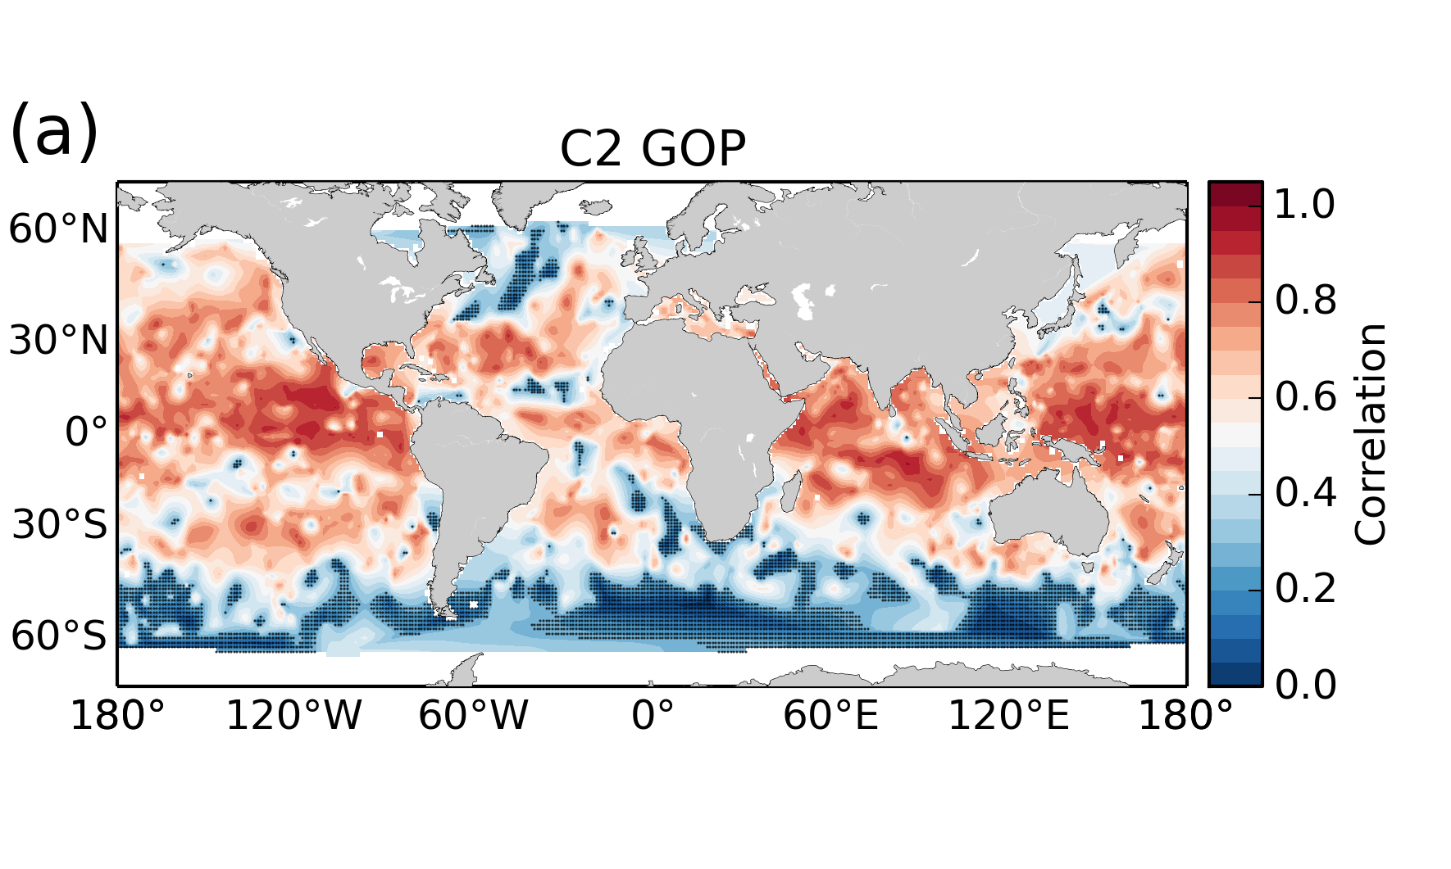
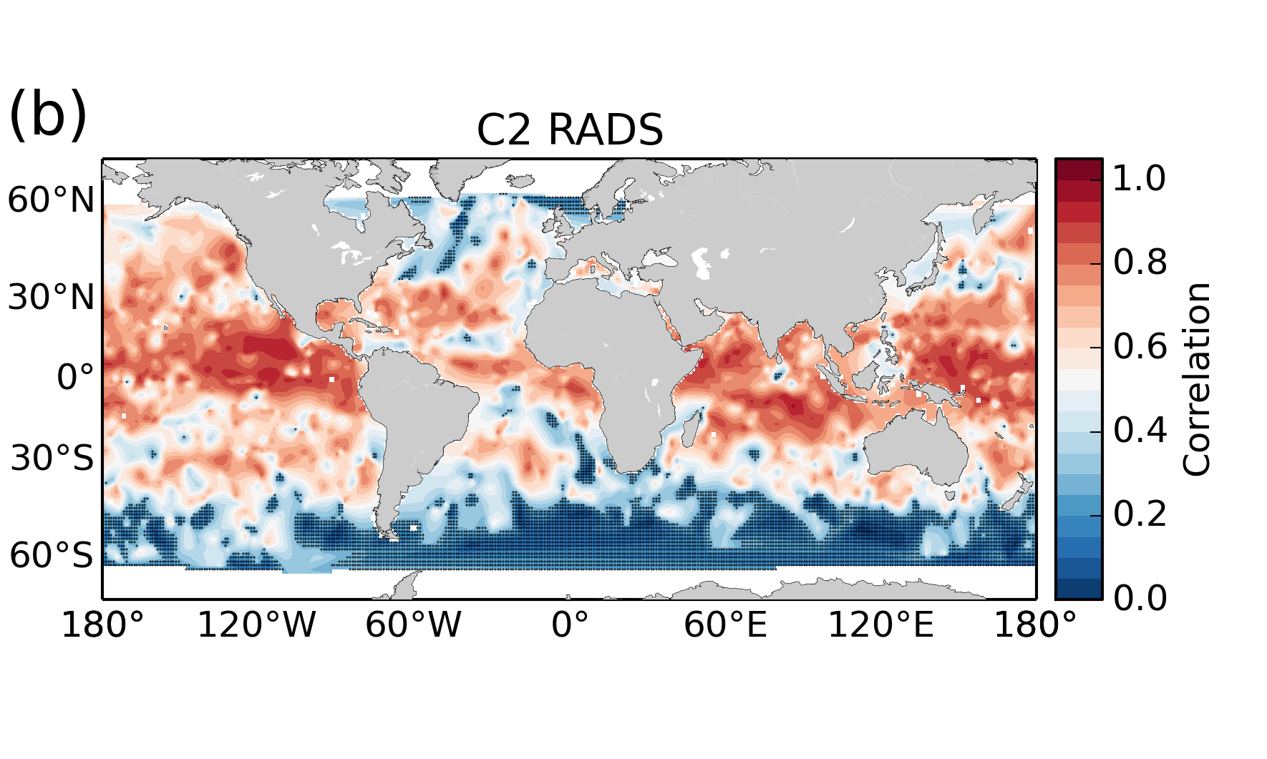
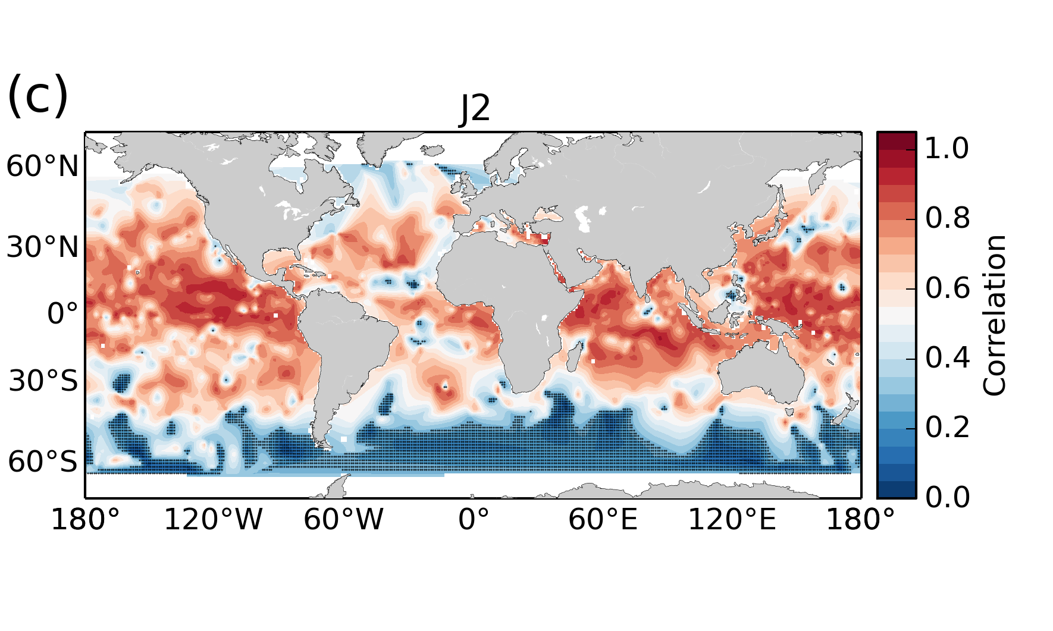
Figure 9. Maps showing the correlation between SSHAs and Argo-derived steric heights over the period April 2014 to April 2016 for: (a) C2 GOP; (b) C2 RADS; and (c) J2. Black dots denote non-significant correlation at the 95% confidence level. The median correlation as a function of latitude is also shown in (d).
The RMSDs between the SSHAs and the steric heights are shown in Figure 10. We show the RMSDs only for C2 GOP since the spatial patterns for C2 RADS and J2 are almost identical. The median RMSD over all Argo floats is 5.3 cm for C2 GOP, 5.1 cm for C2 RADS and 4.6 cm for J2. As expected from our analysis of the correlation patterns, the spatial distribution of RMSDs is highly non-uniform, with higher values (>15 cm) concentrated in regions dominated by major ocean currents such as the Gulf Stream along the western boundary of the North Atlantic, the Kuroshio in the western Pacific, the Agulhas current along the east coast of South Africa, and the ACC in the Southern Ocean. The relatively large RMSD values found over major ocean currents are likely due to a relatively large contribution of the barotropic component, sub-sampling of mesoscale features caused by barotropic and baroclinic instabilities associated with the current, and to a non-negligible contribution of the layers below 1000 m to the steric height. This is, for instance, the case in the region of the ACC, where currents can penetrate to depths greater than 2000 m and the barotropic contribution to sea level can be as large as 60% (Behnisch et al., 2013). Both the Gulf Stream and the Kuroshio can also penetrate to the bottom and have significant contributions from the barotropic component (Hall, 1989). In addition, temporal and spatial separation between the altimetry and Argo measurements may have a larger impact in western boundary currents due to the smaller decorrelation scales associated with mesoscale dynamics in those areas (see Pascual et al. 2006).

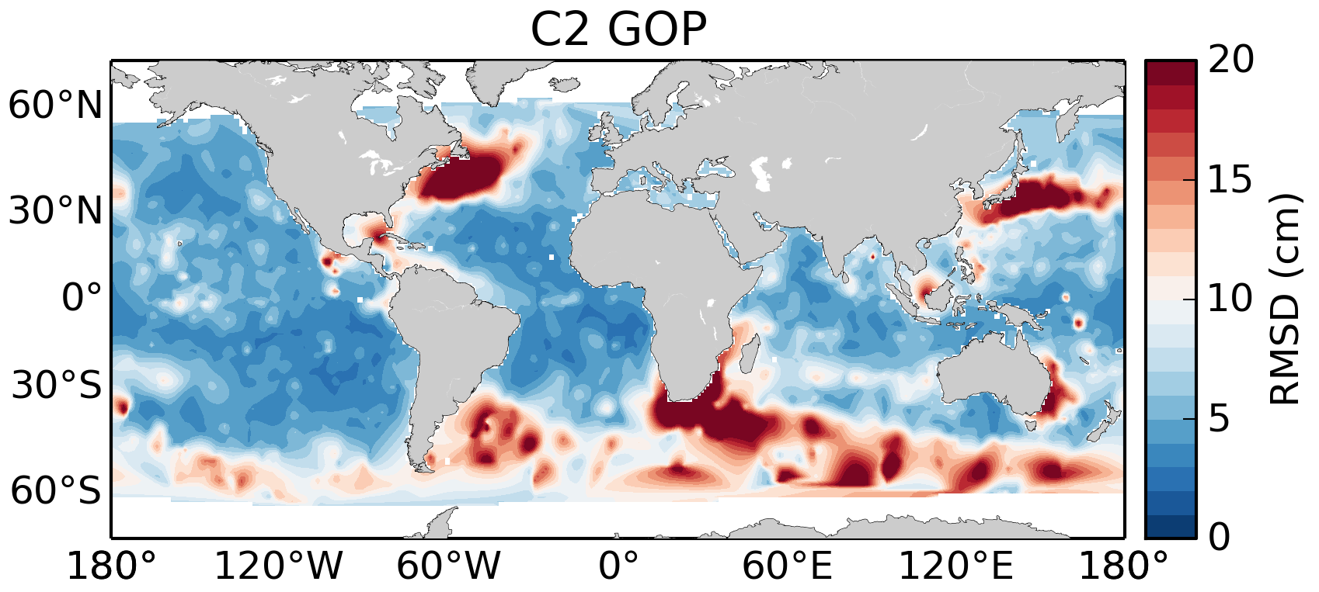
Figure 10. Map showing the RMSD between C2 GOP SSHAs and Argo-derived steric heights for the period April 2014 to April 2016.

3.3. Validation of the SWH and wind speed
3.3.1. Comparison against in situ observations
Altimetric measurements of SWH and wind speed are compared with buoy observations by means of scatter plots (Figure 11). We discuss first the results for the SWH and then move to the results for the wind speed. Focusing on the SWH (Figures 11a,b,c), the scatter plots for the three altimetry datasets show similar patterns, with most points falling along the line y=x, which indicates a good agreement between altimetric and buoy observations and no significant offset or bias. To further assess the agreement between the altimetric and buoy SWHs we have performed a linear regression of the data and the resulting fitted line (blue line) is drawn as reference in Figure 11. The slope of the regression line is 0.98 for C2 GOP, 1.05 for C2 RADS, and 0.97 for J2 whereas the RMS errors are 15 cm for C2 GOP, 17 cm for C2 RADS, and 16 cm for J2. These results indicate a very good agreement between altimetric and buoy measurements.
Minor differences among the altimetry datasets are noticeable. In particular, we note from Figure 11b that C2 RADS tends to slightly underestimate the SWH during low sea state (SWH<1.5 m) and overestimate it for moderate and high sea state, whereas this is not the case for C2 GOP and J2, which show almost no bias. This feature in C2 RADS is small but seems to be robust and it is confirmed by computing the histogram of SWHs over the global oceans for C2 GOP, C2 RADS, and J2 (Figure 12a). Visually the three histograms are almost indistinguishable but estimates of their mean confirm that C2 RADS (2.75 m) provides indeed slightly larger SWH values than C2 GOP (2.64 m) and J2 (2.65 m). More evidence supporting this result will be provided on the basis of a comparison with data from the wave model WWIII.
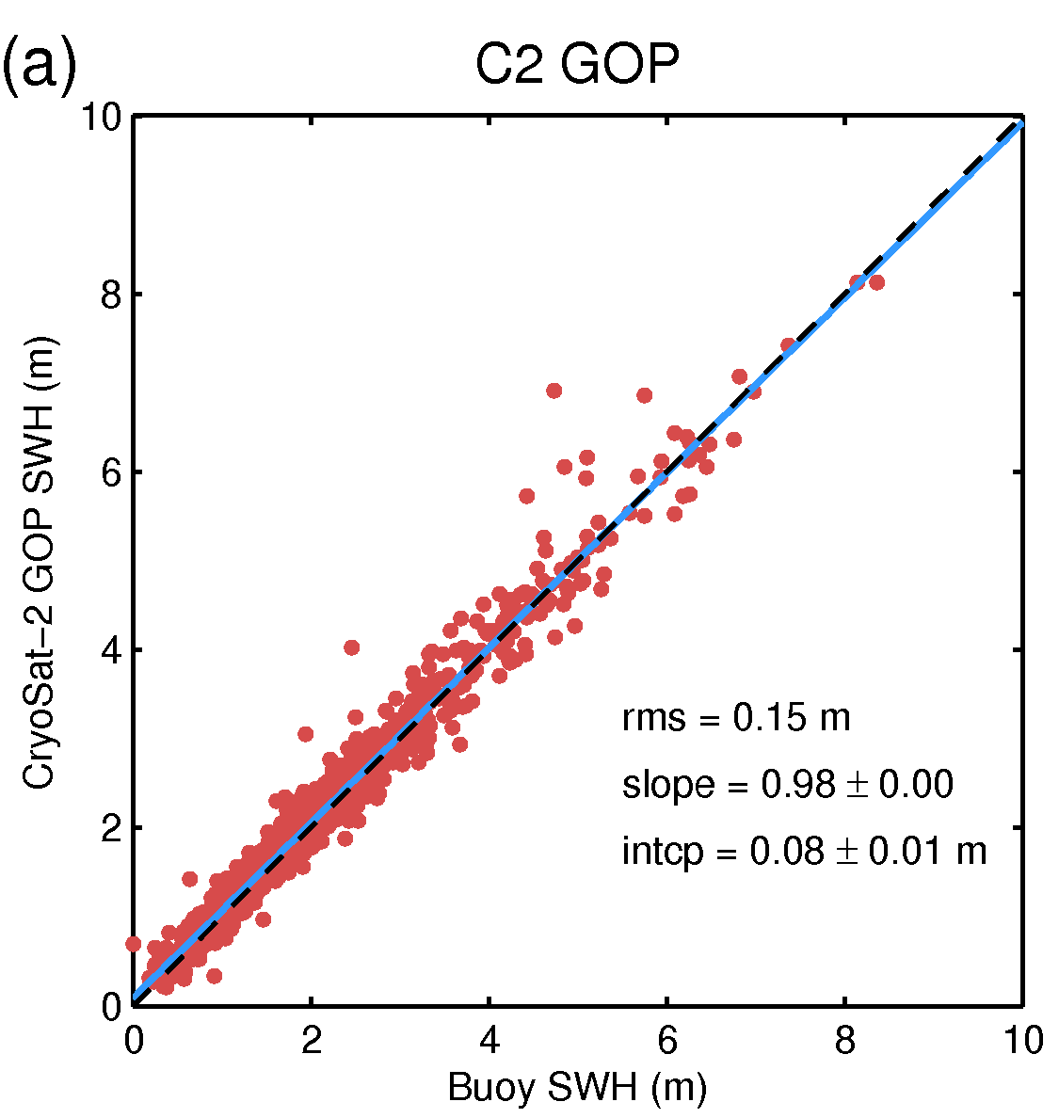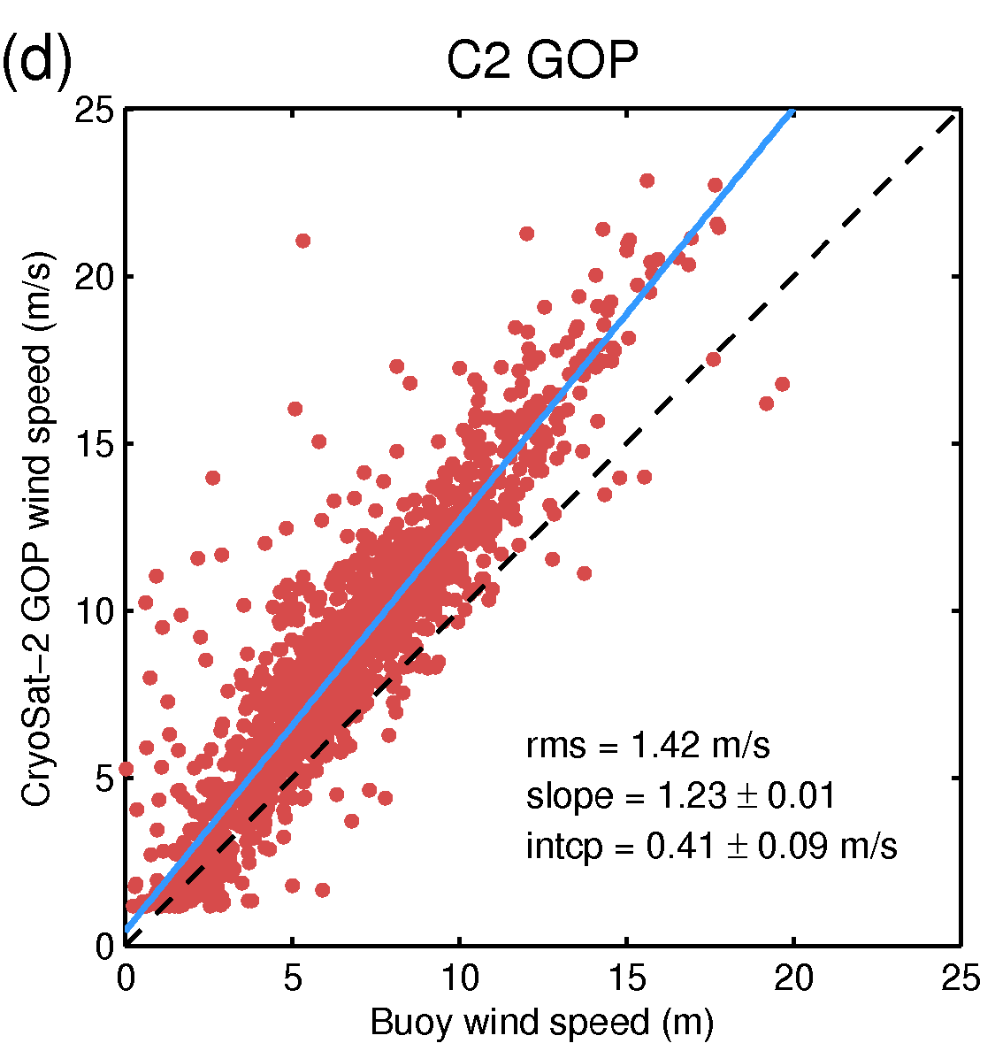
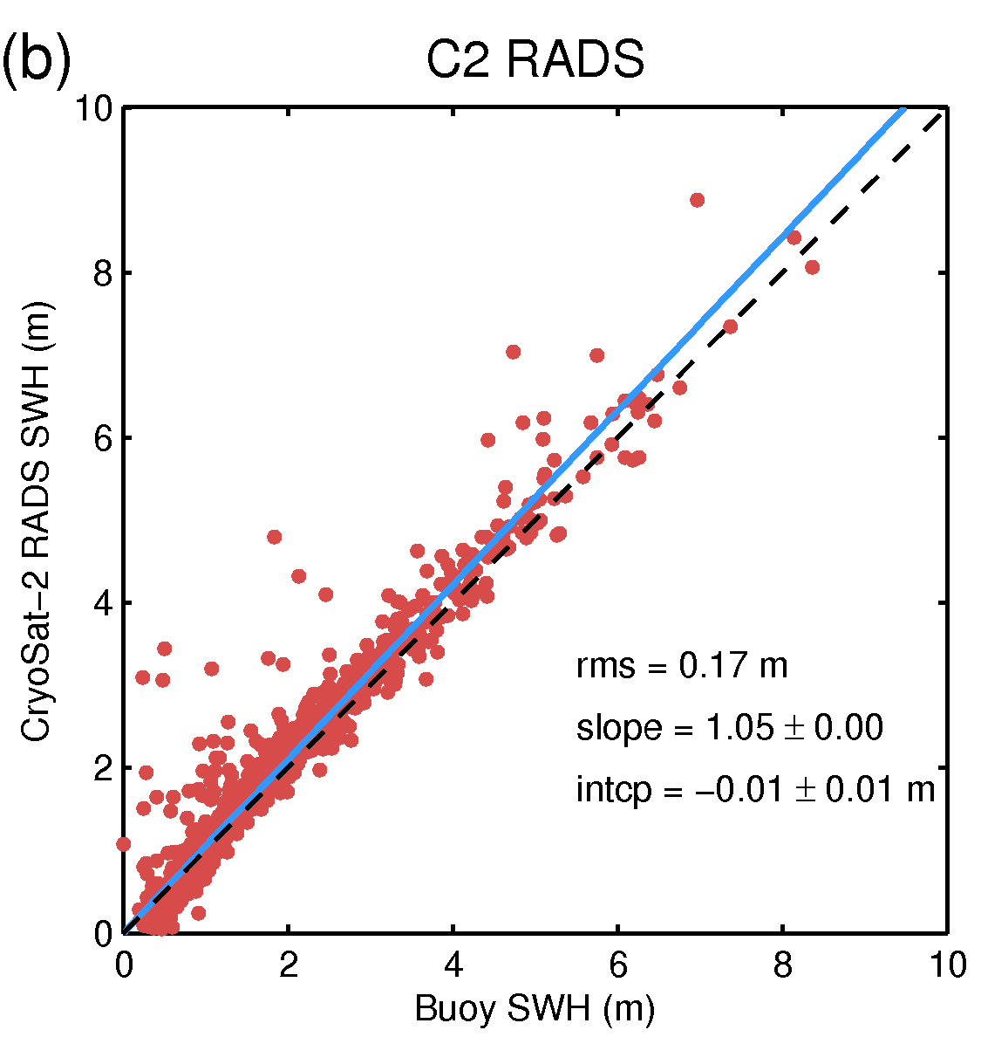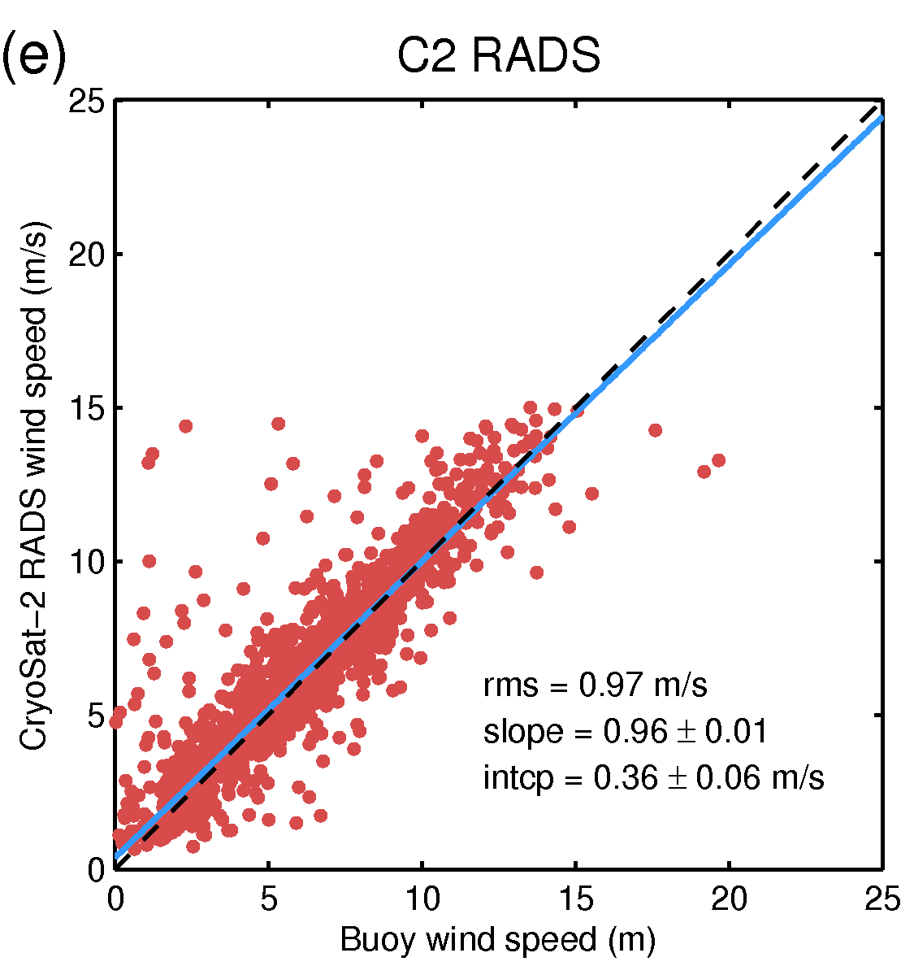
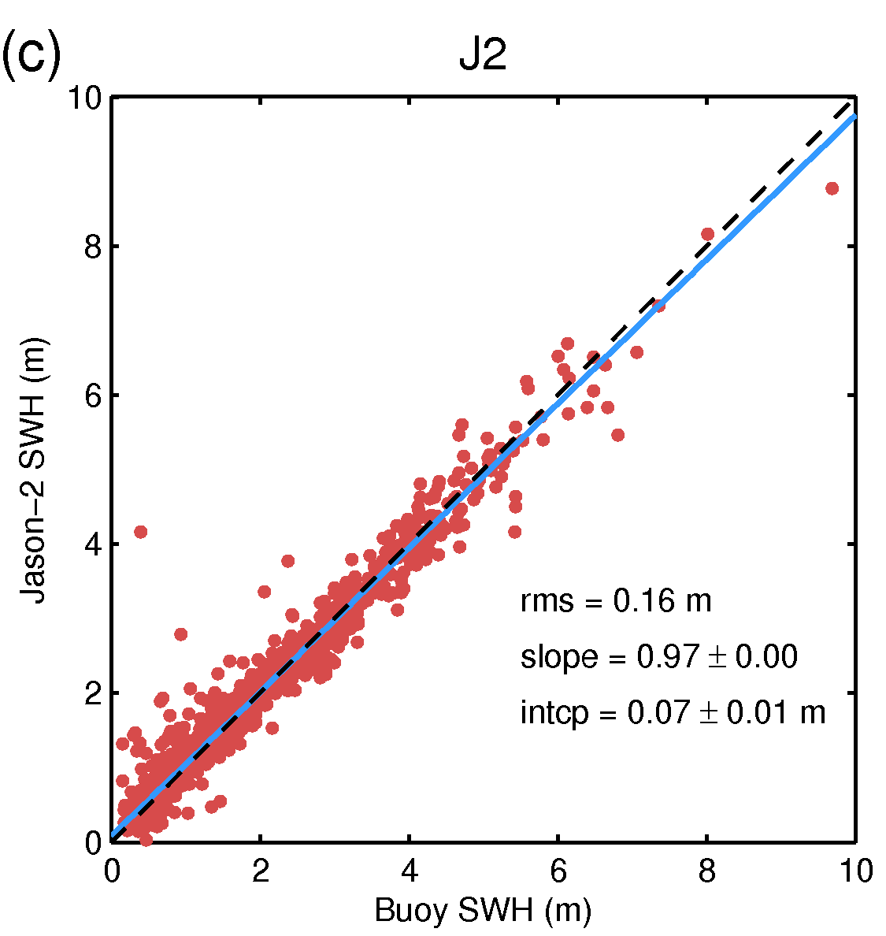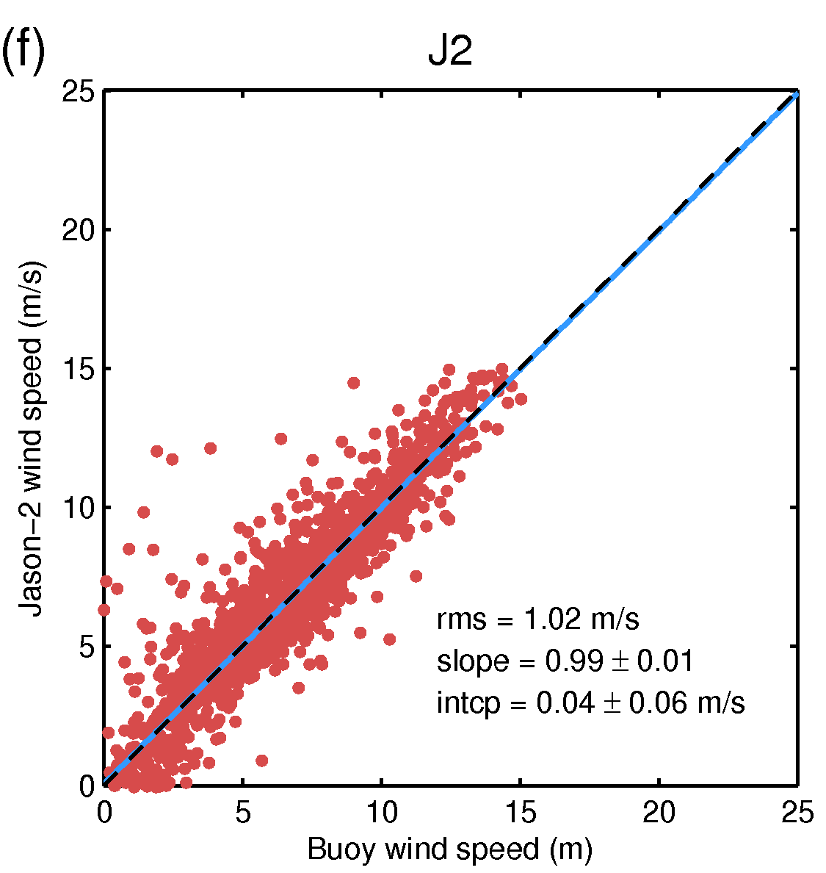
Figure 11. Scatter plot of the SWH and wind speed from (a, d) C2 GOP, (b, e) C2 RADS, and (c, f) J2 against buoy observations over the period April 2014 to April 2016. The blue line represents the result of a linear regression of the data (using robust regression) whereas the inset values denote the RMS error (rms), the slope, and the intercept (intcp) derived from the regression.
Focusing now on the wind speed, the scatter plots (Figures 11d,e,f) show that C2 RADS and J2 agree well with the buoy observations. In contrast, C2 GOP significantly overestimates the wind speed and shows a larger spread of points. As for the SWH, we have computed and overlaid a regression line on the scatter plot. The slope of the fitted line is 1.23 for C2 GOP, 0.96 for C2 RADS, and 0.99 for J2 whereas the RMS errors are 1.42 m/s for C2 GOP, 0.97 m/s for C2 RADS, and 1.02 m/s for J2. The relatively high slope of C2 GOP reflects its general tendency to overestimate the wind speed for moderate and high values (>5 m/s) and underestimate it for low values (<2 m/s). The positive bias affecting C2 GOP for high wind speed is even more apparent in the histogram of the wind speed over the global ocean (Figure 12b). While C2 RADS and J2 show similar distributions with similar means (7.67 m/s and 7.46 m/s, respectively), the mode of the distribution for C2 GOP is clearly shifted towards the right which results in a mean that is significantly larger (9.66 m/s).
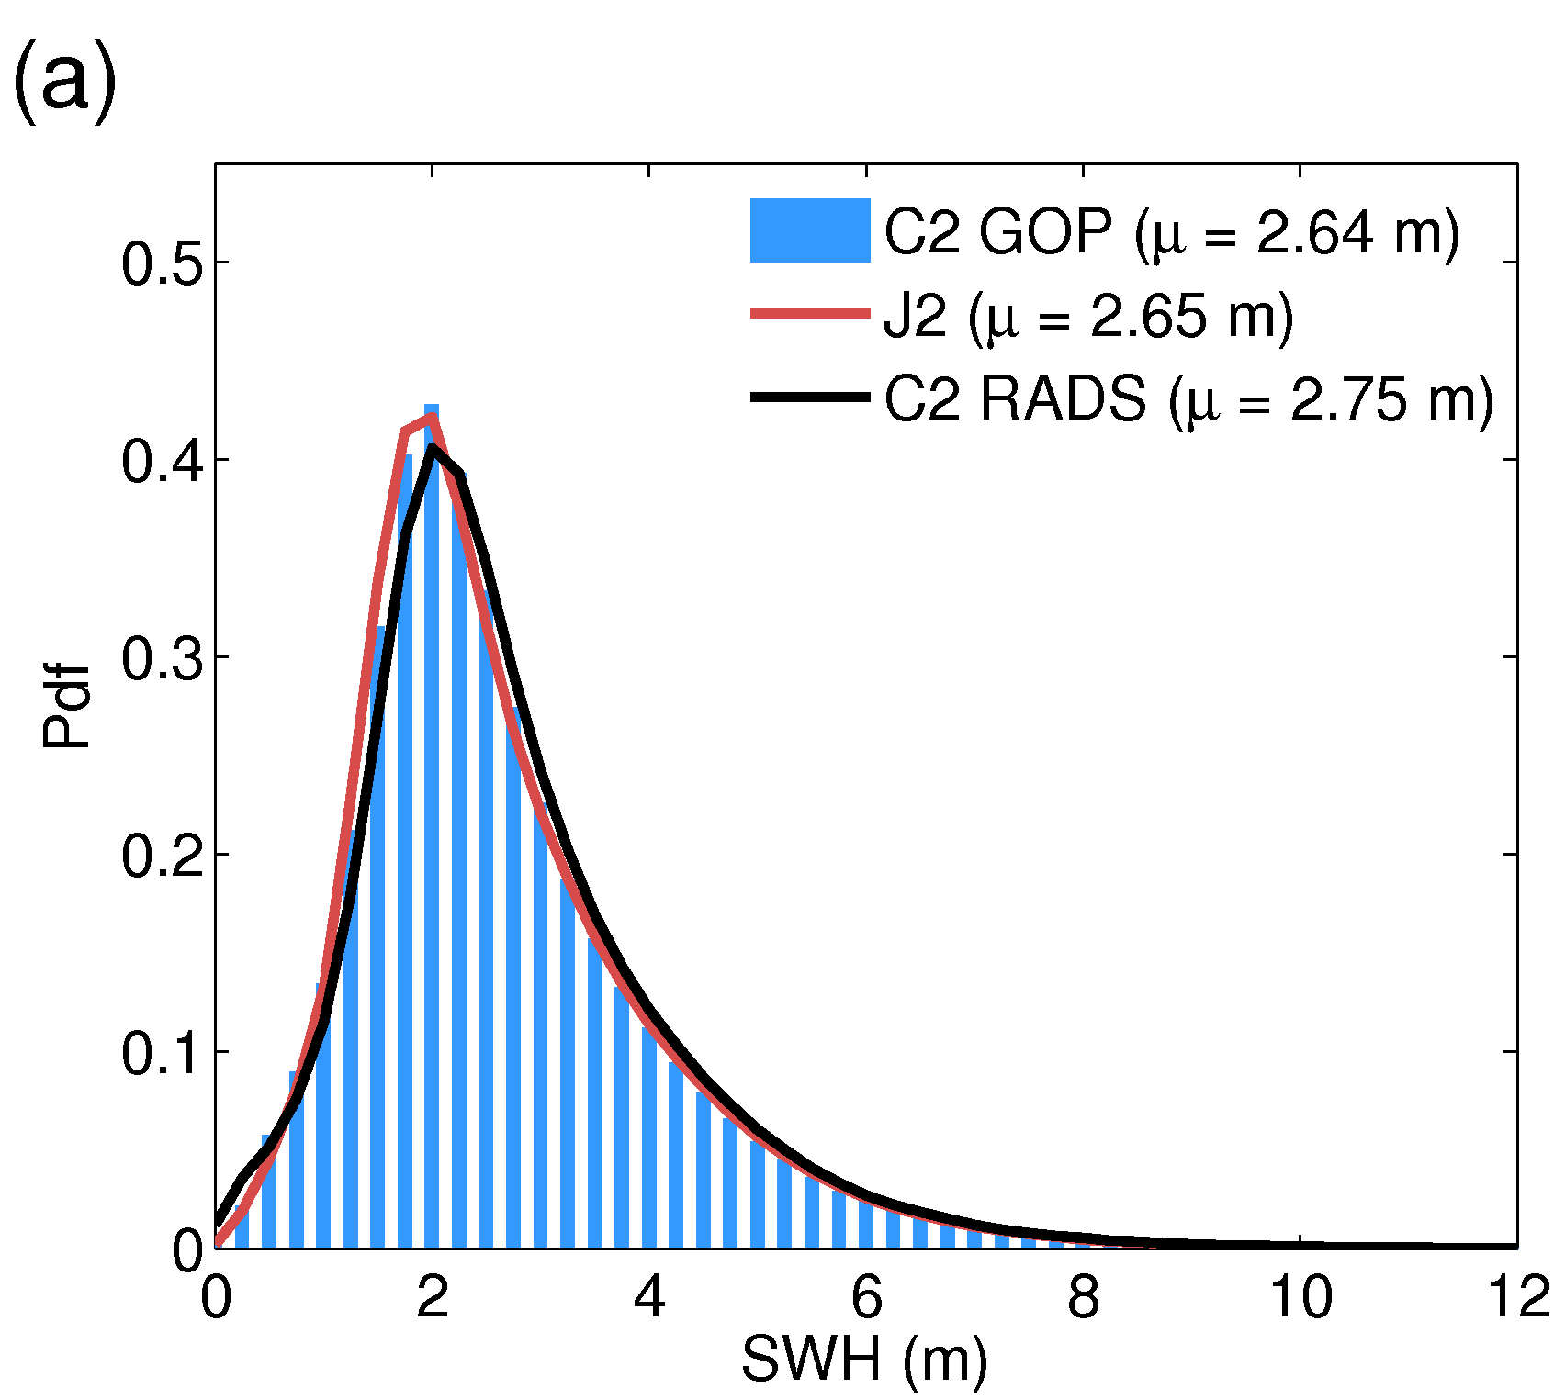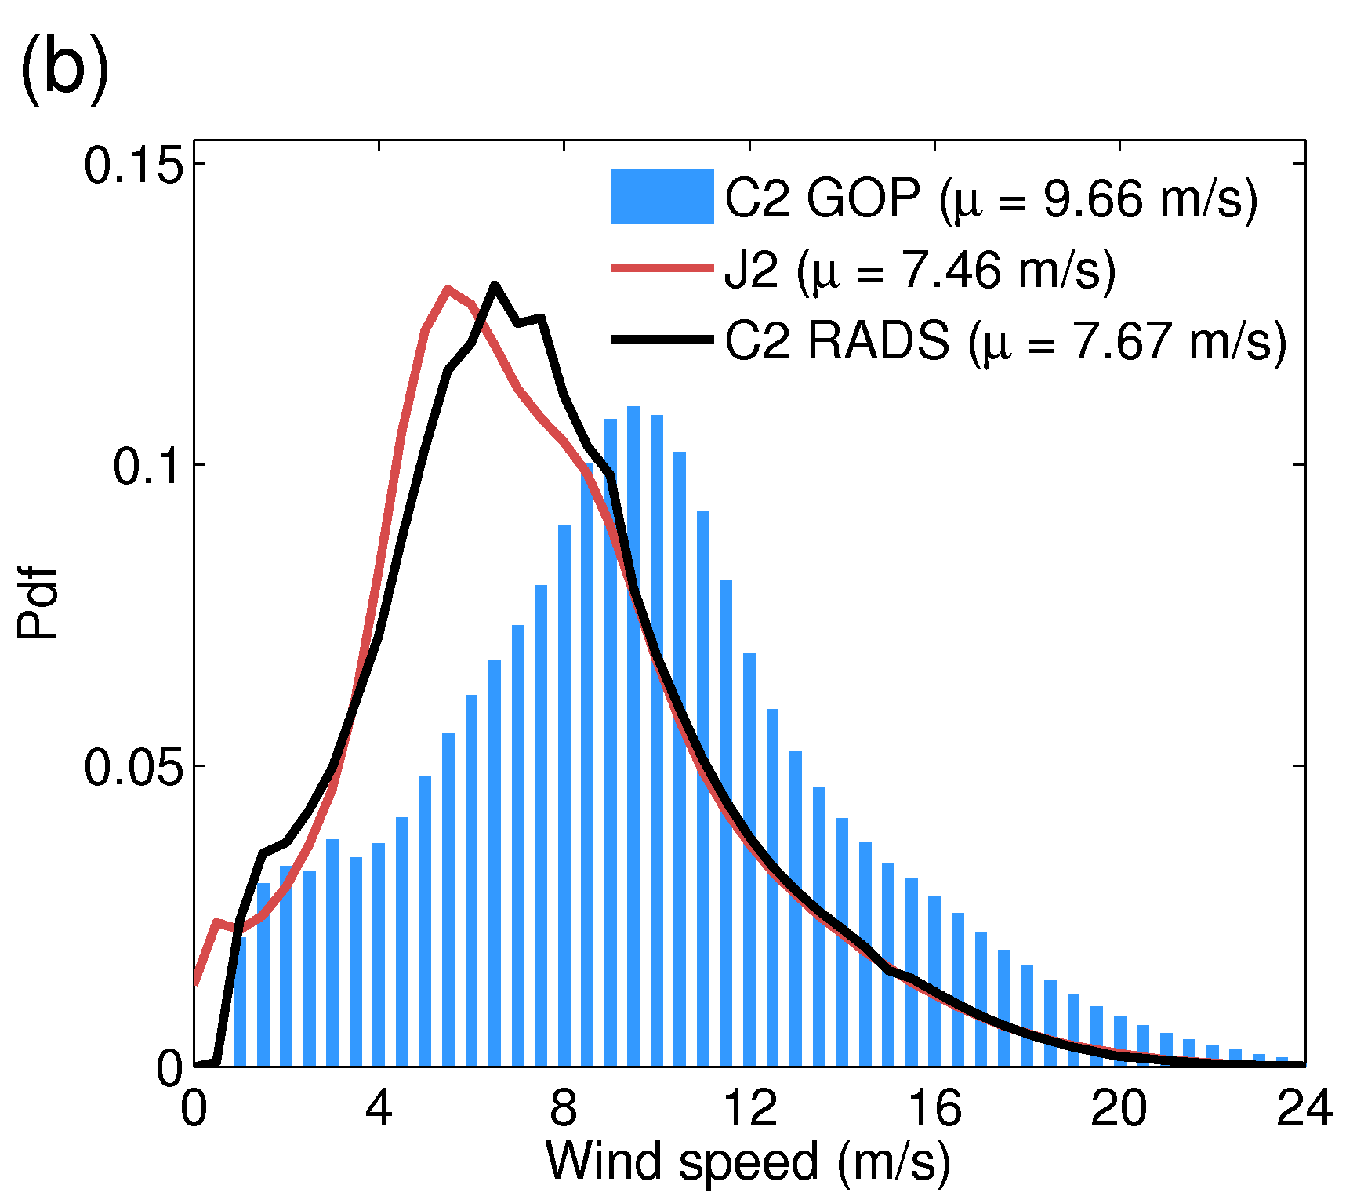
Figure 12. Histograms (normalized to have a total area of 1) of the (a) SWH and (b) wind speed from C2 GOP (blue bars), C2 RADS (black line), and J2 (red line).

3.3.2. Comparison against Wavewatch III model data.
As a last validation test we compare SWHs from C2 GOP and C2 RADS with WWIII model data. Although observations are usually preferred to modelled data for validation purposes, WWIII provides a useful tool to examine altimetric SWH over the global ocean, and in particular in regions where buoy data are not available. We have assessed the consistency between the two data sets over the entire ocean (excluding polar regions) by first creating scatter plots of altimeter observations against modelled data (Figure 13). Because of the large amount of data, it is not possible to show all data over the whole period (April 2014 to April 2016) in a single scatter plot, instead we have created monthly scatter plots, which in addition allows us to assess whether the performance of the altimetric SWH changes with season. Here we show the results for July 2014 and February 2015. Overall there is a good agreement between the altimetric and modelled SWH both for C2 GOP and C2 RADS, with the data clustering around the y=x line. The points show, however, greater scatter than in the comparison with in situ buoy data, especially in February. We also note that the spread of points is greater in C2 RADS than in C2 GOP, both in July and February. Another interesting feature, apparent in both C2 RADS and C2 GOP, is the tendency of WWIII to underestimate the altimetric SWHs during low to moderate sea state (SWH < 3 m) and to overestimate them during high sea state (SWH > 5 m). This tendency is more pronounced in February than in July.

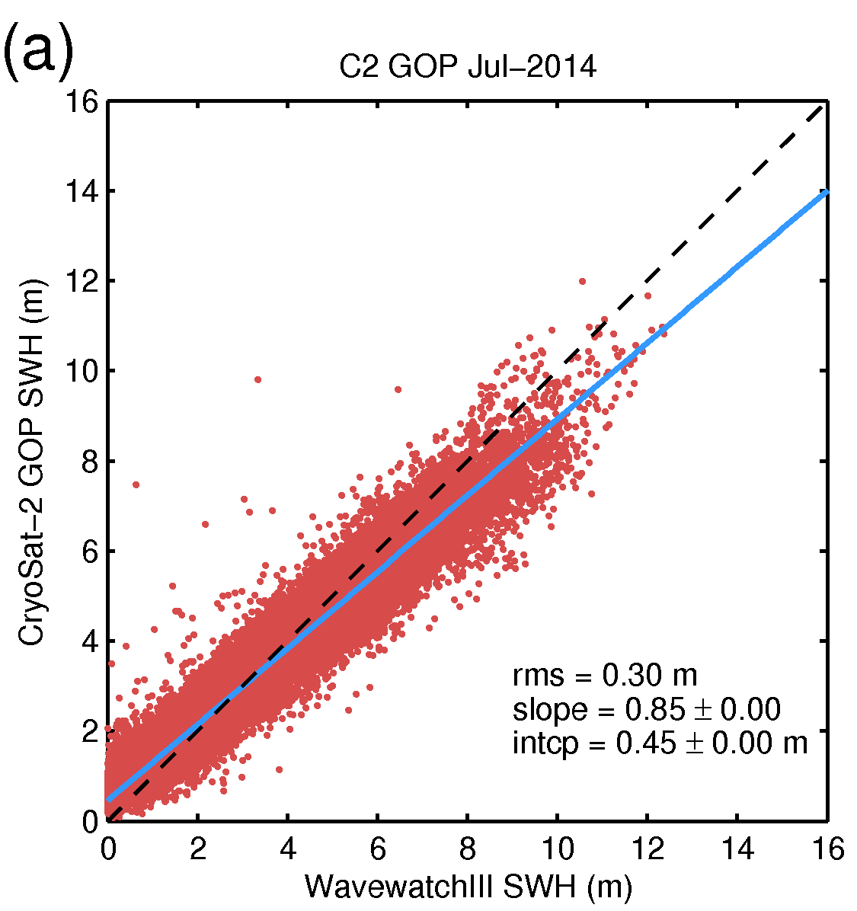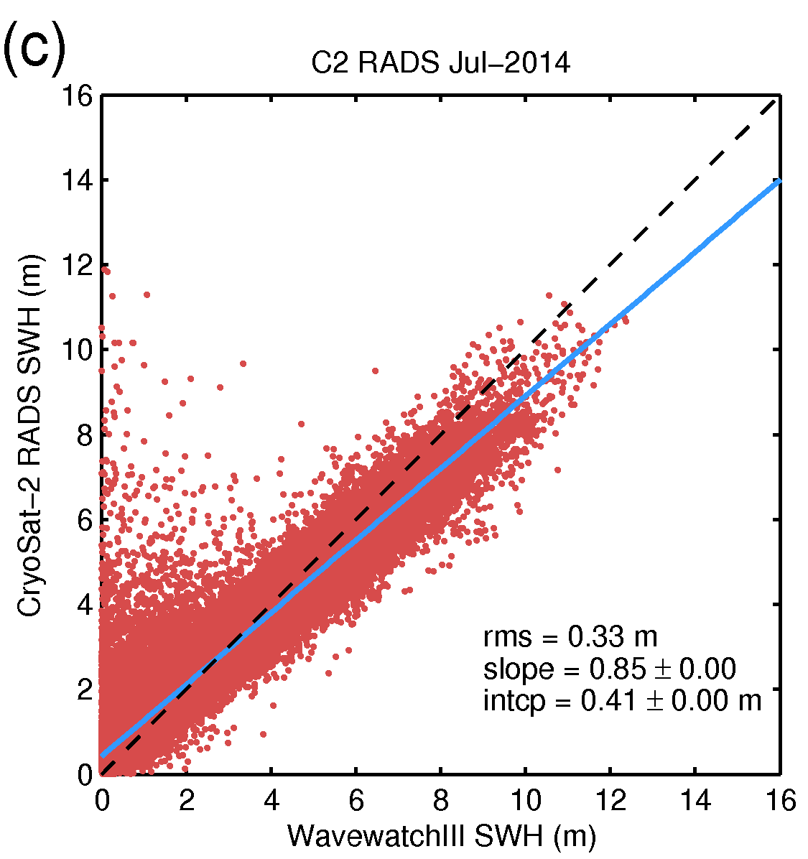
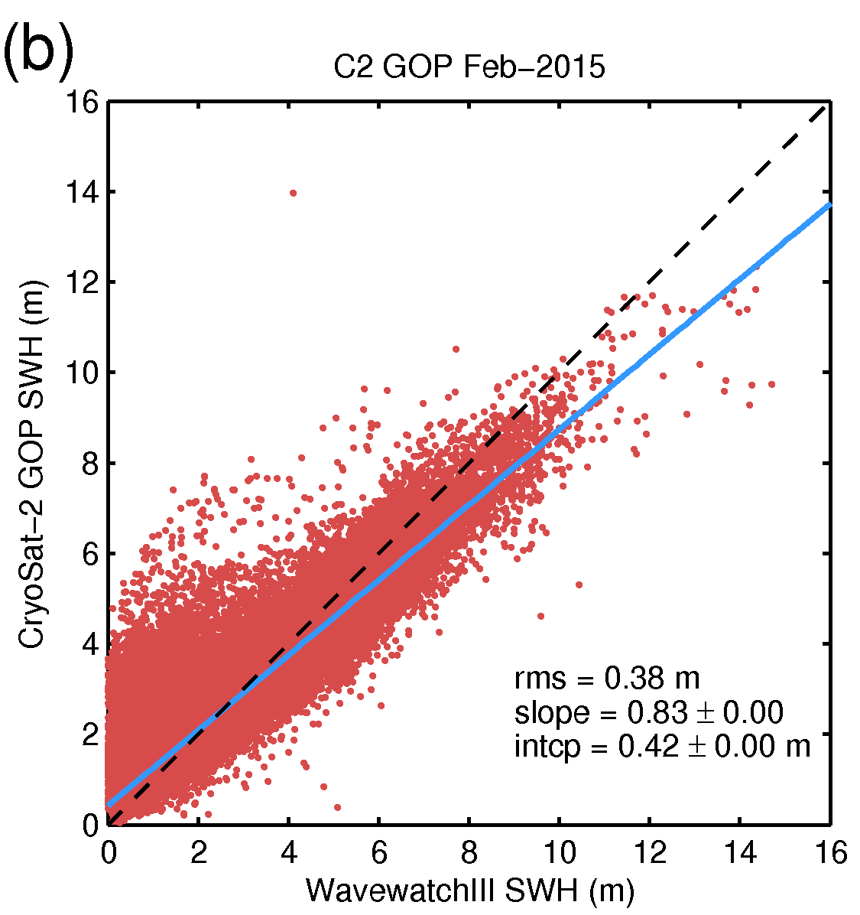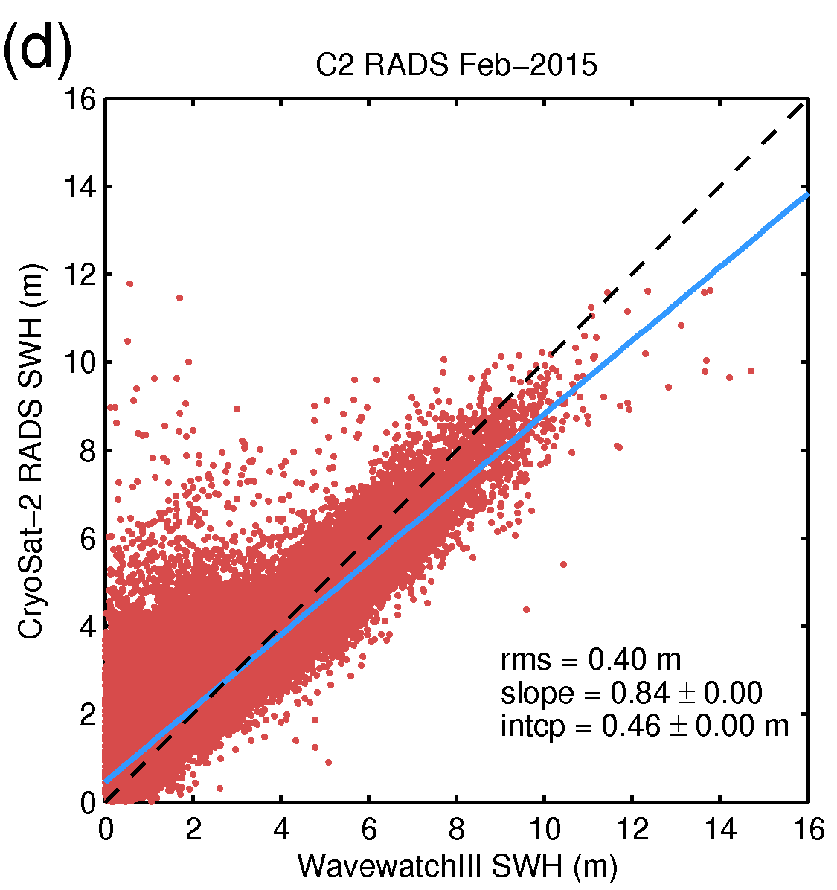
Figure 13. Scatter plots of the SWH from (a, b) C2 GOP and from (c, d) C2 RADS against the SWH from the WWIII model for July 2014 and February 2015. The blue line represents the result of a linear regression of the data (using robust regression) whereas the inset values denote the RMS error (rms), the slope, and the intercept (intcp) derived from the regression.

The fitting of a linear model to the scatter points provides quantitative confirmation of the features shown by the scatter plot. The slope of the fitted line is significantly smaller than 1, with values ranging from 0.83 to 0.85, which reflects the general tendency of WWIII to yield lower SWH values during low sea states and higher values during high sea states. The RMS error resulting from the fit ranges from 30 cm to 38 cm for C2 GOP and from 33 cm to 40 cm for C2 RADS, which is significantly larger than the value obtained for the comparison with the buoys and reflects the wider scatter of the points.
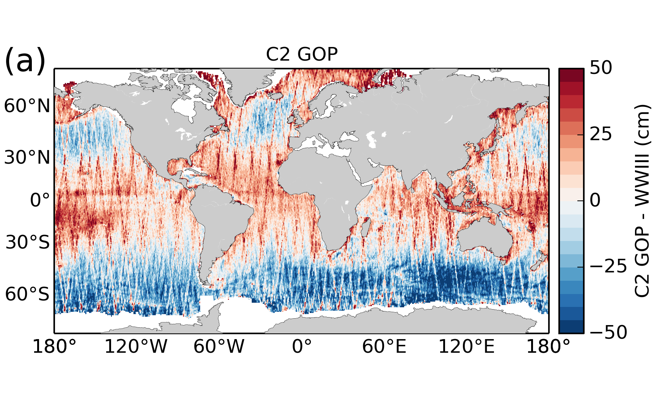
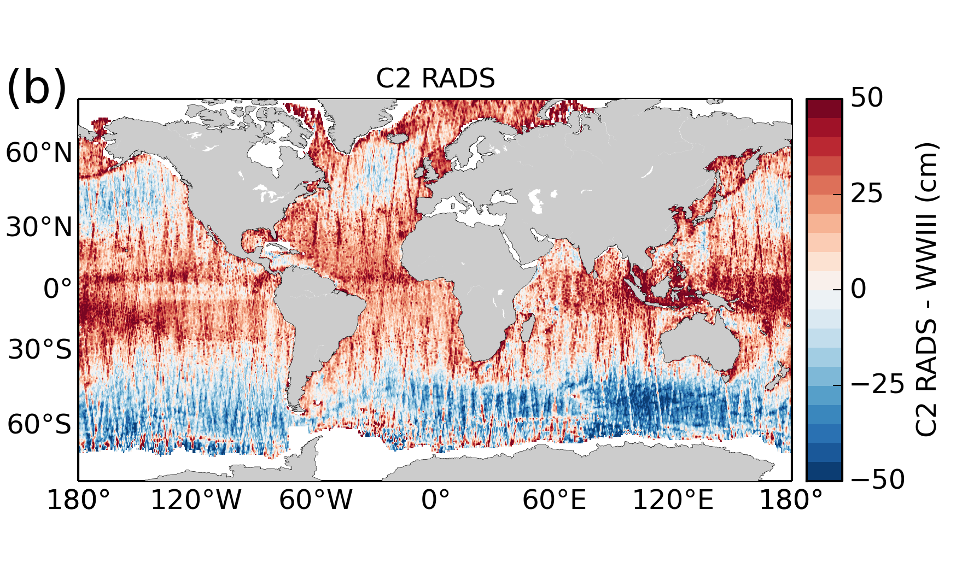
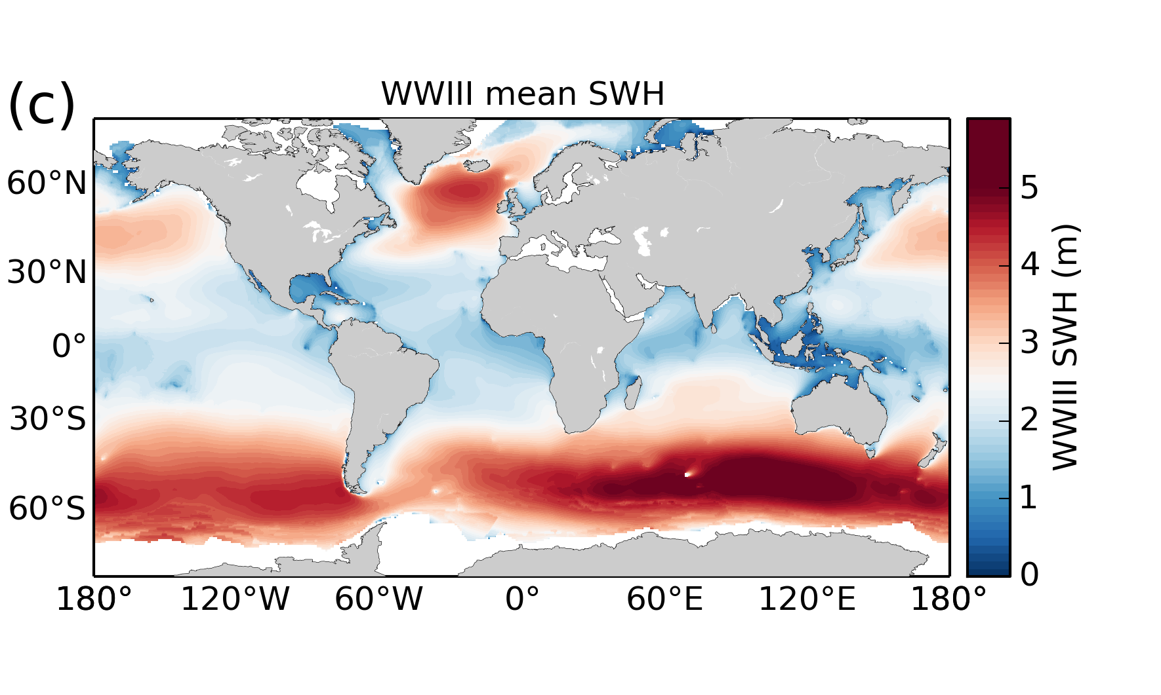
Figure 14. Maps showing the differences between the SWH from the WWIII model and that from (a) C2 GOP and (b) C2 RADS over the period July 2014 to June2015. The time-mean SWH from the WWIII model over the same period is also shown in (c).

In order to identify regions of stronger and weaker consistency between the altimetry datasets and the model, we have plotted a map showing the spatial distribution of the mean difference between the altimetric and modelled SWHs for both C2 GOP (Figure 14a) and C2 RADS (Figure 14b) over the period July 2014 to June 2015. We also show the time-mean SWH as provided by the WWIII model over that period (Figure 14c). As expected from the analysis of the scatter plots, we note that WWIII tends to yield lower SWH values in regions of relatively low sea state such as the tropical zone, and higher values in regions of predominantly high sea states such as the Southern Ocean between 40ºS and 65ºS and the North Atlantic and North Pacific north of 45ºN. The fact that altimeter SWHs agree very well with buoy observations and show almost no bias (see Figure 11) suggests that it is the WWIII model that gives slightly biased estimates and not the altimetry data. Nevertheless, the differences between the altimetry and WWIII data are small in most regions, with a median value of 15.2 cm for C2 GOP and 16.7 cm for C2 RADS. In fact, by comparing the map of differences (Figures 14a,b) with the time-mean SWH (Figure 14c) we note that differences are much smaller (<20%) than the value of the SWH over most of the ocean, indicating that the magnitude of the SWH is relatively consistent between the altimeter and WWIII. From Figures 14a,b is also apparent that C2 RADS gives higher values than C2 GOP over most of the ocean, as indicated by the more intense red in the tropical zone and the lighter blue in the Southern Ocean. This is consistent with the histogram of SWHs (Figure 12a), which shows a slight positive bias of C2 RADS relative to C2 GOP and J2.
4. Summary and conclusions
In this study we have presented a global assessment and validation of the new CryoSat-2 GOP for the SSHA, SWH, and wind speed. Given its relatively long repeat cycle (~369 days), CryoSat-2 is, in principle, more suitable for Cryosphere as well as for geodetic or bathymetric applications, which require high spatial resolution, than for studies of ocean dynamics. However, recent studies have shown that altimeters in non-repeating orbits are as useful for oceanography as dedicated ocean altimeters with much shorter repeat cycles. In particular, Smith and Scharroo (2009) found that the non-repeating phase of the ERS-1 mission captured about 85% of the mesoscale variability seen in the along-track TOPEX SSHA data. In a more recent study, Dibarboure et al. (2012) showed that CryoSat-2 could capture up to 66% of the mesoscale variability observed by ENVISAT and Jason-1. Our results confirm those previous findings and show that C2 GOP measurements, even without applying the full SAR processing algorithm (Raney 1998), are already of comparable quality to those from other altimetry missions routinely used in oceanography,
We have first presented an assessment of the C2 GOP SSHA, SWH and sigma0 in terms of measurement noise and crossover differences. The mean value of the C2 GOP 20-Hz SSHA noise corresponding to a SWH of 2 m is 6.3 cm for LRM data and 10.2 cm for PLRM data. Note that, assuming that the 20-Hz measurements are uncorrelated, a noise of 6.3 cm at 20 Hz corresponds to a value of about 1.4 cm when averaging to 1 Hz, which indicates very good performance. The value of 1.4 cm for C2 GOP is, for instance, better than the 1-Hz noise estimated for Jason-1 (1.7 cm) and Envisat (1.8 cm) at 2 m SWH (Garcia et al., 2014). It is also slightly lower than the value given by Garcia et al. (2014) for CryoSat-2 LRM data (1.5 cm) but higher than the value for CryoSat-2 SAR data (1.1 cm).
The results of the crossover analysis also indicate very good performance. The standard deviation of the crossover differences over the entire ocean after excluding differences larger than 20 cm and shallow waters (<1000 m) is 5.4 cm, which is slightly better than the value for Envisat (5.5 cm) and only slightly higher than the value for Jason-1 (5.1 cm) and Jason-2 (4.9 cm) (values for Envisat, Jason-1 and Jason-2 are from the validation annual reports available at http://www.aviso.altimetry.fr/fileadmin/documents/calval/validation_report/). The value of 5.4 cm that we find for the C2 GOP data is also significantly smaller than the value of 6.0 cm found by Labroue et al. (2012) for the CryoSat-2 data generated by the CryoSat-2 Processor Prototype developed by CNES, although the value found by Labroue et al. (2012) corresponds to December 2010 whereas the 5.4 cm reported here is for May 2015. Nevertheless, we find similar values for all months from April 2014 to April 2016.
The results of the validation against in situ observations and model data are also very promising and demonstrate that the SSHA and SWH measurements provided by C2 GOP are of comparable quality to those from other dedicated ocean altimetry missions. The SSHA has been validated against both a set of 22 tide gauges and steric heights derived from Argo T/S measurements globally. In order to place the results in the context of other existing altimetry datasets, we have performed the comparison against in situ data also for Jason-2 and CryoSat-2 data from RADS. The RADS data have been subject to the same editing criteria as those applied to C2 GOP. The correlation and RMSD over all stations is very consistent across the three altimetry datasets, with median values of 0.78 and 7.1 cm for C2 GOP, 0.76 and 7.3 cm for J2, and 0.79 and 7.8 cm for C2 RADS. These correlation values are significantly higher than the median correlation (0.58 and 0.46 for island and coastal tide gauges, respectively) found by Mitchum (1994) for TOPEX/POSEIDON based on 10 months of data. Mitchum (1994) also found a median RMSD of 5.8 cm for island tide gauges, which is also larger than the median RMSD (5.0 cm) that we find for island stations. And that in spite of the fact that our comparison is for instantaneous values of sea level whereas that of Mitchum (1994) is for daily average sea levels. Our RMSD value of 7.1 cm for C2 GOP over all tide gauges is better than the value found by Fenoglio-Marc et al. (2015) for CryoSat-2 SAR data at the Helgoland island tide gauge station in the German Bight (7.7 cm).
The comparison of SSHA with steric heights indicates also very good and similar performance for C2 GOP, J2 and C2 RADS. The median correlation over all Argo floats is 0.68 for C2 GOP, 0.67 for C2 RADS, and 0.74 for J2. One interesting feature is the latitudinal dependence of the correlation, with higher values in low latitudes. For instance, the median correlation in the region within 10ºS and 10ºN is larger than 0.8 for the three altimetry datasets. Regarding the RMSD between SSHA and steric height, we have found median values of 5.3 cm for C2 GOP, 5.1 cm for C2 RADS and 4.6 cm for J2, which reflect the good agreement between the altimetry SSHAs and the Argo steric heights. Both the correlations and the RMSDs that we have found here are very similar to those reported in other studies. Guinehut et al (2006) and Dhomps et al. (2011) report correlations larger than 0.7 in the tropical Pacific and in most parts of the Indian Ocean and smaller correlations (<0.5) at higher latitudes, in agreement with our findings.
The validation of the SWH has been carried out against buoys observations and data from the WWIII model. Results for SWH are as encouraging as for SSHA. The mean SWH over the global oceans has been estimated to be 2.64 m for C2 GOP, 2.75 for C2 RADS, and 2.65 for J2, indicating similar SWH distributions for C2 GOP and J2 and a slight positive bias for C2 RADS. The comparison with buoys indicates that C2 GOP slightly outperforms J2 and C2 RADS according to several key performance indicators. Such indicators include the RMS error and the slope as derived from regressing the altimetric SWH on the SWH from buoys and their values have been estimated to be 15 cm and 0.98 for C2 GOP, 17 cm and 1.05 for C2 RADS, and 16 cm and 0.97 for J2. The RMS value of 15 cm for C2 GOP is very similar to the best value obtained by Fenoglio-Marc et al. (2015) for CryoSat-2 SAR data in the German bight (14 cm) and much smaller than the value for CryoSat-2 PLRM data (29 cm). Regarding the wind speed, we find that C2 GOP measurements exhibit a bias of about 2 m/s relative to both Jason-2 and to buoy data. This issue affecting the C2 GOP wind speed is the expected result of using too small of a data sample (~2 months) in its computation and will be fixed in the next CryoSat Ocean Processor upgrade (planned for mid 2017), by using a multi-year GOP datasets and refined algorisms.
The comparison with the SWH from the WWIII model has confirmed the excellent skill of C2 GOP in capturing the SWH over most of the global oceans. Differences between C2 GOP and WWIII are very small relative to the magnitude of the SWH (less than 20% of the SWH) over most areas of the ocean. However, we have also found that WWIII tends to yield higher SWH values than both C2 GOP and C2 RADS in regions of high SWH, such as the Southern Ocean, and the North Atlantic and the North Pacific north of 45ºN, and lower values in regions where low SWH values are predominant, such as the tropical zone. This is very consistent with the results of Ardhuin et al. (2010), who found similar biases for WWIII when compared with data from Jason-1 and Envisat.
In conclusion, this study has provided a global quality assessment and validation of SSHA, SWH, and wind speed derived from the new CryoSat-2 GOP, showing excellent performance for the SSHA and the SWH, comparable to that of Jason-2, demonstrating the potential applicability of the measurements acquired by CryoSat-2 over the ocean to a wide range of oceanographic problems. ESA plans to make available the whole GOP datasets (i.e since the beginning of the mission) based on the current CryoSat Ocean Processor baseline towards the end of 2016. These will help bridge the gap between previous ocean-oriented altimetry missions and the new Sentinel-3 mission being developed for Europe’s Copernicus programme, which has been launched in February 2016. Based on the outcomes from 2 years of quality control and validation activities performed by the NOC and the first scientific exploitations of CryoSat data over the ocean, ESA intends to upgrade the CryoSat Ocean processing chain with a set of improvements including new corrections and algorithms such as a full SAR altimetry processing dedicated to the ocean. The resulting high resolution ocean products, reprocessed with a new processing baseline over the whole mission period, will help scientists to better address key operational and scientific issues, ranging from regional sub-mesoscale to climate and open-ocean large-scale processes.
Acknowledgements
This work has been funded by the European Space Agency within the framework of the CryOcean-QCV (CryoSat Ocean Data Scientific Quality Control and Validation) project (ESRIN/Contract No. 4000111795/14/I-LG). This research would have not been possible without the Jason-2 data from RADS, the tide gauge records from BODC and the UHSLC, the EN4 T and S profile data hosted at the Met Office Hadley Centre, the buoy data from NDBC, and the Wavewatch III wave data from PacIOOS. This work has been partially supported by the Natural Environment Research Council (NERC) National Capability funding.

References
Andersen, O. B., 2010. The DTU10 Gravity field and Mean sea surface. Second international symposium of the gravity field of the Earth (IGFS2), Fairbanks, Alaska.
Ardhuin, F. et al., 2010. Semi-empirical dissipation source functions for wind-wave models: Part I, definition, calibration and validation. J. Phys. Oceanogr., 40, 1917–1941.
Behnisch, M., Macrander, A., Boebel, O., Wolff, J.-O., Schröter, J., 2013, Barotropic and deep-referenced baroclinic SSH variability derived from Pressure Inverted Echo Sounders (PIES) south of Africa. J. Geophys. Res. Oceans, 118, 3046–3058, doi:10.1002/jgrc.20195.
Bouffard, J., 2007. Amélioration de l’altimétrie côtière appliquée à l’étude de la circulation dans la partie nord du bassin occidental méditerranéen (in French). PhD thesis under the supervision of Y. Ménard and P. De Mey
Bouffard J., Roblou, L., Birol, F., Pascual, A., Fenoglio-Marc, L., Cancet, M., Morrow, R., Ménard, Y., 2011. Introduction and assessment of improved coastal altimetry strategies: case study over the North Western Mediterranean Sea, in: Vignudelli, S., A. Kostianoy, P. Cipollini, J. Benveniste (Eds.), Coastal Altimetry. Springer.
Bouffard J., Femenias, P., Parrinello, T., Bojkov, B., 2016. CryoSat Mission: Data Quality Status and Next Product Evolutions, 6th CryoSat User Workshop, 9-13 May 2016, Prague, Czech Republic.
Calafat, F. M., Marcos, M., 2012. Comparison of satellite altimetry sea level anomalies and hydrographic observations in the Mediterranean Sea. Scientia Marina, 76(3), 429-439.
Carrere, L., Lyard, F., 2003. Modeling the barotropic response of the global ocean to atmospheric wind and pressure forcing - comparisons with observations. Geophys. Res. Lett., 30 (6), 1275, doi:10.1029/2002GL016473.
Cartwright, D.E., Edden, A.C., 1973. Corrected tables of tidal harmonics. Geophys. J. R. Astron. Soc. 33, 253–264.
Chelton, D.B., deSzoeke, R.A., Schlax, M.G., El Naggar, K., Siwertz, N., 1998: Geographical variability of the first-baroclinic Rossby radius of deformation. J. Phys. Oceanogr., 28, 433-460.
Dhomps, A. -L. , Guinehut, S., Le Traon, P.-Y., Larnicol, G., 2011. A global comparison of Argo and satellite altimetry observations. Ocean Sciences, 7, 175-183.
Dibarboure, G., Renaudie, C., Pujol, M.-I., Labroue, S., Picot, N. 2012. A demonstration of the potential of Cryosat-2 to contribute to mesoscale observation. Advances in Space Research 50, 1046-1061.
Dibarboure, G., Boy, F., Desjonqueres, J.D., Labroue, S., Lasne, Y., Picot, N., Poisson, J.C., Thibaut, P., 2014. Investigating Short-Wavelength Correlated Errors on Low-Resolution Mode Altimetry. J. Atmos. Oceanic Technol., 31, 1337–1362. doi: http://dx.doi.org/10.1175/JTECH-D-13-00081.1.
Drinkwater, M.R., Francis, R., Ratier, G., Wingham, D., 2004. The European Space Agency's Earth Explorer Mission CryoSat: Measuring Variability in the Cryosphere. Annals of Glaciology, 39, 313-320.
Faugère, Y., Dorandeu, J., Lefevre, F., Picot, N., Femenias, P., 2006. Envisat ocean altimetry performance assessment and cross-calibration. Sensors, 6, 100–130, doi:10.3390/s6030100.
Fenoglio-Marc, L., Dinardo, S., Scharroo, R., Roland, A., Dutour Sikiric, M., Lucas, B., Becker, M., Benveniste, J., Weiss, R., 2015. The German Bight: A validation of CryoSat-2 altimeter data in SAR mode. Advances in Space Research, 55, 1641-2656.
Garcia, E.S., Sandwell, D.T., Smith, W.H.F., 2014. Retracking CryoSat-2, Envisat, and Jason-1 radar altimetry waveforms for improved gravity field recovery. Geophysical Journal International, 196(3): 1402-1422.
Gaspar, P., Florens, J.P., 1998. Estimation of the sea state bias in radar altimeter measurements of sea level : Results from a new nonparametric method. Journal of Geophysical Research: Oceans, 103, NO. C8, 15803-15814.
Good, S. A., Martin, M.J., Rayner, N.A., 2013. EN4: quality controlled ocean temperature and salinity profiles and monthly objective analyses with uncertainty estimates. Journal of Geophysical Research: Oceans, 118, 6704-6716, doi:10.1002/2013JC009067
Guinehut S., Le Traon, P.-Y., Larnicol, G., 2006. What can we learn from Global Altimetry/Hydrography comparisons? Geophys. Res. Lett. 33: L10604.
Guinehut S., Coatanoan, C., Dhomps, A.L., Le Traon, P.-Y., Larnicol, G., 2009. On the use of satellite altimeter data in Argo quality control. J. Atmos. Oceanic Technol. 26: 395-402.
Hall, M. M., 1989. Velocity and transport structure of the Kuroshio Extension at 35°N, 152°E. J. Geophys. Res., 94(C10), 14445–14459, doi:10.1029/JC094iC10p14445.
Ivchenko, V.O., Danilov, S.D., Sidorenko, D.V., Schroter, J., Wenzel, M., Aleynik, D.L., 2007. Comparing the steric height in the northern Atlantic with satellite altimetry. Ocean Science, 3, (4), 485-490.
Kim, S. Y. et al.,, 2011. Mapping the U.S. West Coast surface circulation: A multiyear analysis of high-frequency radar observations. J. Geophys. Res., 116, C03011, doi:10.1029/2010JC006669.

Labroue, S., Boy, F., Picot, N., Urvoy, M., Ablain, M., 2012. First quality assessment of the Cryosat-2 altimetric system over ocean. Advances in Space Reseach, 50, 1030-1045.
Mitchum, G. T., 1994. Comparison of TOPEX sea surface heights and tide gauge sea levels. J. Geophys. Res., 99(C12), 24541–24553, doi:10.1029/94JC01640.
Monaldo, F. M., 1988. Expected differences between buoy and radar altimeter estimates of wind speed and significant wave height and their implications on buoy-altimeter comparisons. J. Geophys. Res., 93, 2285–2302.
Pascual, A., Faugère, Y., Larnicol, G., Le Traon, P.-Y., 2006. Improved description of the ocean mesoscale variability by combining four satellite altimeters. Geophys. Res. Lett., 33, L02611, doi:10.1029/2005GL024633.
Passaro, M., Cipollini, P., Vignudelli, S., Quartly, G., Snaith, H., 2014. ALES: A multi-mission subwaveform retracker for coastal and open ocean altimetry. Remote Sens. Environ., 145, 173–189, doi:10.1016/j.rse.2014.02.008.
Pawlowicz, R., Beardsley, B., Lentz, S., 2002. Classical tidal Harmonic Analysis Including Error Estimates in MATLAB using T_TIDE. Comput. Geosci., 28, 929–937.
Quinn, K.J., Ponte, R.M., 2012. High frequency barotropic ocean variability observed by GRACE and satellite altimetry. Geophys. Res. Lett., 39, L07603, doi:10.1029/2012GL051301.
Raney, R. K., 1998. The Delay Doppler radar altimeter. IEEE Trans. Geosci. Remote Sens., 36, 1578–1588.
Ray, R., 1999. A global ocean tide model from Topex/Poseidon altimetry: GOT99.2. NASA Tech Memo 209478: 58 pages.
Sandwell, D.T., Müller, R.D., Smith, W.H.F., Garcia, E., Francis, R., 2014. New global marine gravity model from CryoSat-2 and Jason-1 revels buried tectonic structure. Science, 346, 65-67.
Smith, W.H.F., Scharroo, R., 2009. Mesoscale ocean dynamics observed by satellite altimeters in non-repeat orbits. Geophys. Res. Lett., 36, L06601, doi:10.1029/2008GL036530.
Tolman, H. L., 2009. User manual and system documentation of WAVEWATCH III version 3.14. NOAA / NWS / NCEP / MMAB Technical Note 276, 194 pp.
Wahr, J. M., 1985. Deformation induced by polar motion. J. Geophys. Res. 90(B11):9363–9368. doi:10.1029/JB090iB11p09363.
Walsh, E. J., 1982. Pulse to pulse correlation in satellite radar altimeters. Radio Sci., vol. 17, no. 4, pp. 786–800, Jul./Aug.
Welch, P.D., 1967. The Use of Fast Fourier Transform for the Estimation of Power Spectra: A Method Based on Time Averaging Over Short, Modified Periodograms. IEEE Transactions on Audio Electroacoustics, AU-15, 70–73.
Wingham D. J., Francis C.R., Baker S., Bouzinac C., Cullen R., de Chateau-Thierry P., Laxon S.W., Mallow U., Mavrocordatos C., Phalippou L., Ratier G., Rey L., Rostan F., Viau P., and Wallis D., 2006. CryoSat: A Mission to Determine the Fluctuations in Earth's Land and Marine Ice Fields. Advances in Space Research, 37, 841-871.

Present address: National Oceanography Centre, Liverpool, UK.

