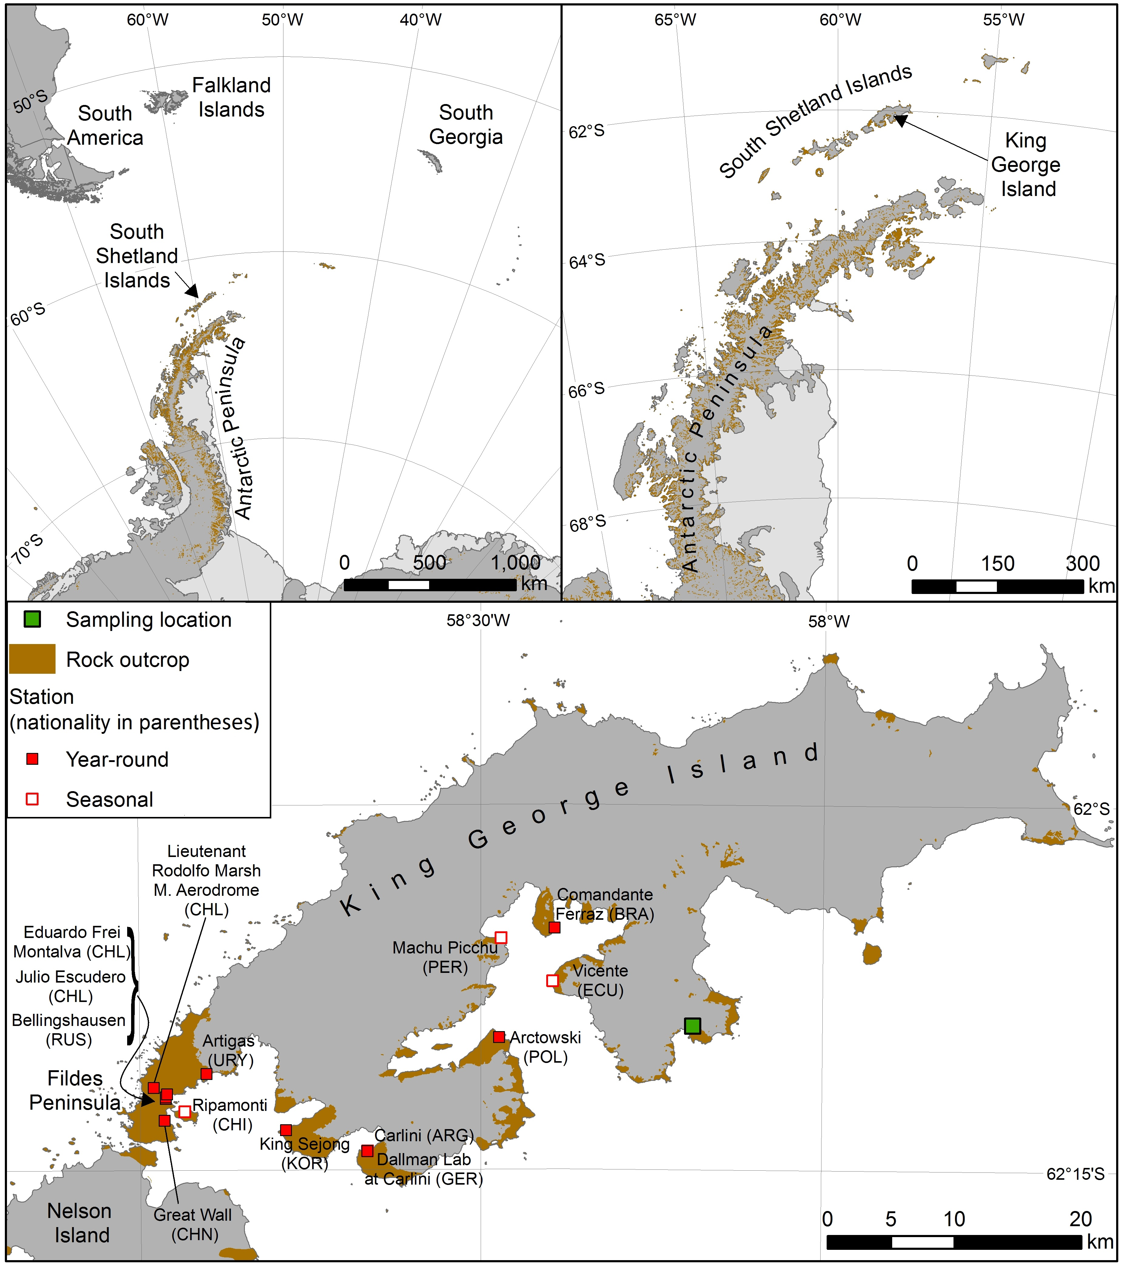
(c)
(b)
(a)
Fig 1 Map of study area. a and b Location of the South Shetland Islands in relation to the southern South America and Antarctic Peninsula, and c King George Island within the South Shetland Islands, including the study sampling location and the permanent research stations on the island

Fig. 2 Degradation of 0.5 g/L phenol by strains AQ5-05 (), AQ5-06 () and AQ5-07 ( ) at 10°C. The error bars represent the mean ± standard deviation for three replicates

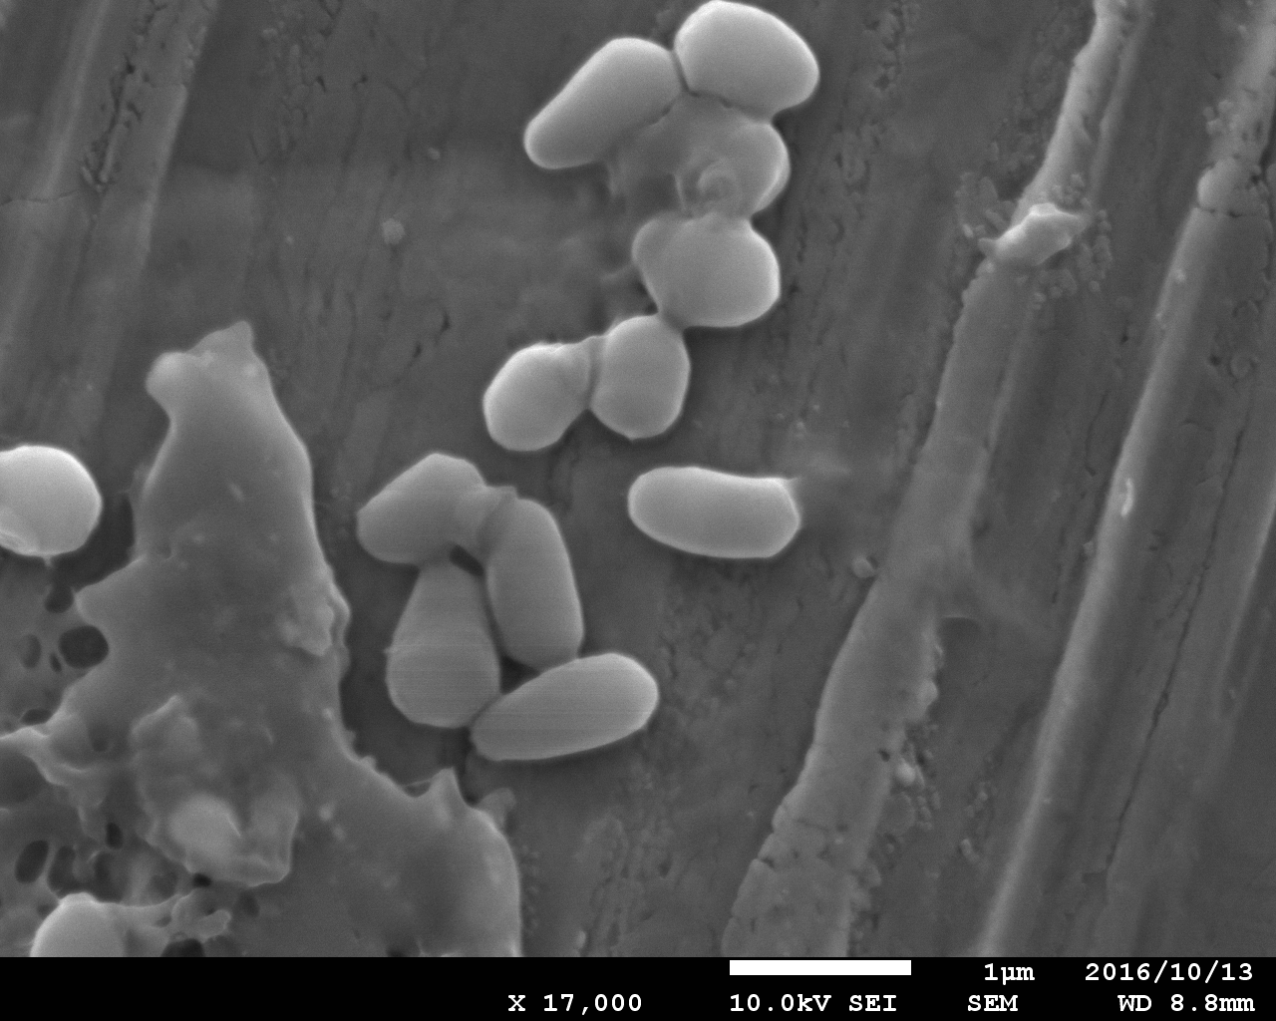
(a)

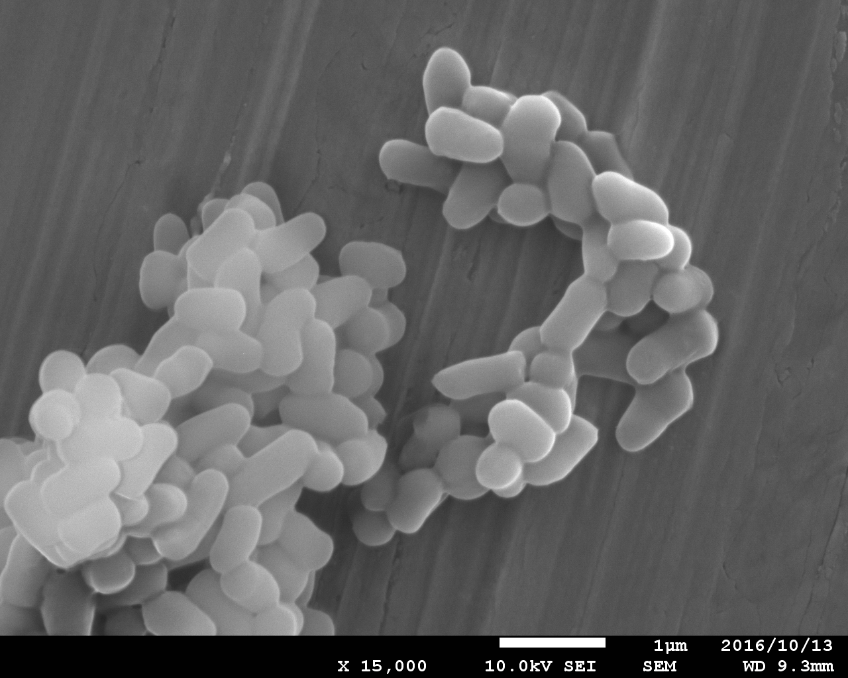
(b)

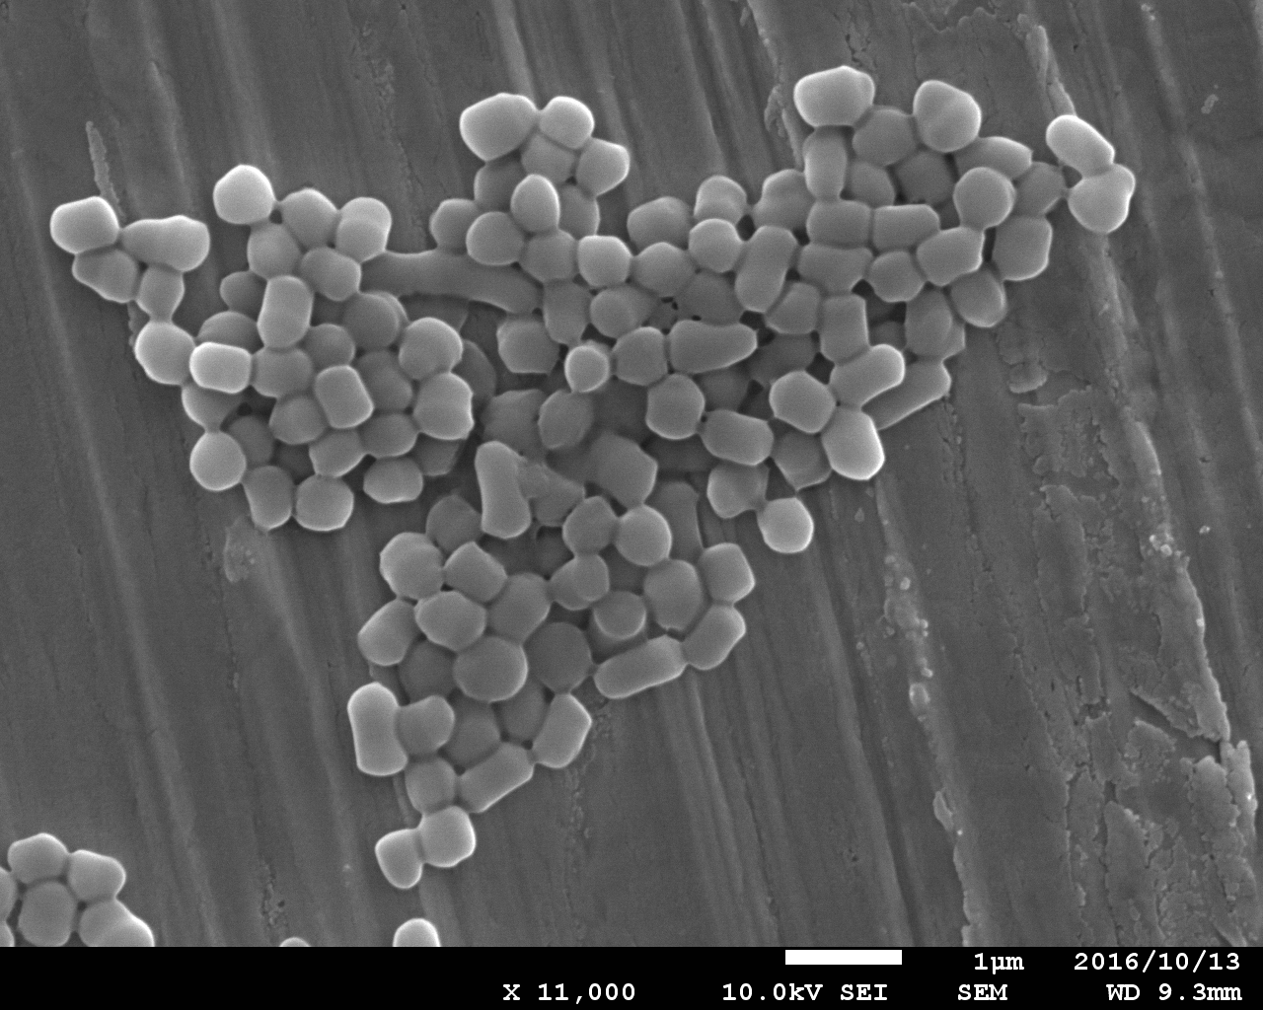
(c)

Fig. 3 Morphological study under SEM. a Arthrobacter sp. strain AQ5-05, b Arthrobacter sp. strain AQ5-06, c Rhodococcus sp. strain AQ5-07. Scale bars represent 1 μm

Fig. 4 Effects of temperature on the growth of strains AQ5-05 (), AQ5-06 () and AQ5-07 () in phenol medium and phenol degradation by strains AQ5-05 (), AQ5-06 () and AQ5-07 (). The error bars represent the mean ± standard deviation for three replicates

Fig. 5 Effects of salinity on the growth of strains AQ5-05 (), AQ5-06 () and AQ5-07 () in phenol medium and phenol degradation by strains AQ5-05 (), AQ5-06 () and AQ5-07 (). The error bars represent the mean ± standard deviation for three replicates

(a)

(b)

Fig. 6 Effects of pH on the a. growth and b. phenol degradation of strains AQ5-05 (), AQ5-06 () and AQ5-07 () using an overlapping buffer system consisting of acetate () phosphate () and Tris-HCl () system in phenol medium. The error bars represent the mean ± standard deviation for three replicates

(a)

(b)

Fig. 7 Effects of different nitrogen sources on the a. growth and b. phenol degradation of strains AQ5-05 (), AQ5-06 () and AQ5-07 (). The error bars represent the mean ± standard deviation for three replicates

Fig. 8 Effects of ammonium sulphate concentration on the growth of strains AQ5-05 (), AQ5-06 () and AQ5-07 () in phenol medium and phenol degradation by strains AQ5-05 (), AQ5-06 () and AQ5-07 (). The error bars represent the mean ± standard deviation for three replicates

