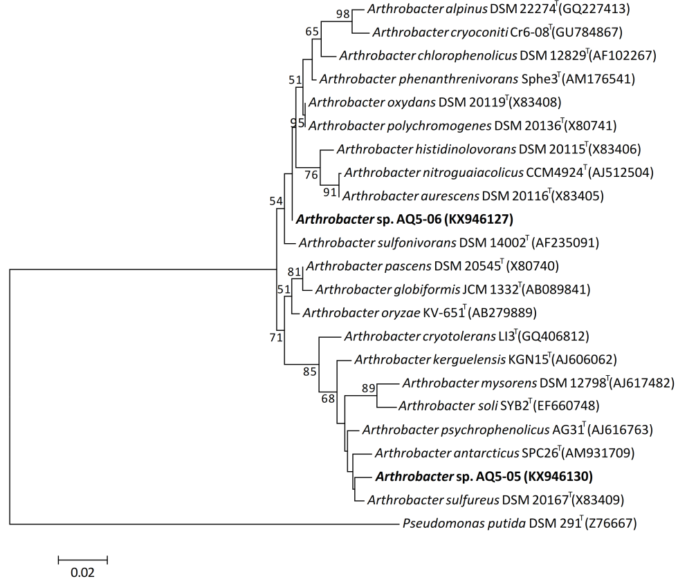
Online Resource 1 Maximum likelihood derived phylogenetic tree of strains AQ5-05 and AQ5-06 with type strains of Arthrobacter species. The percentage of trees (bootstrap scores > 50%) in which the associated taxa clustered together is shown next to the branches. Numbers in brackets are the accession numbers of the sequence with the superscript T indicates the type strains of each species. The tree is drawn to scale, with branch lengths measured in the number of substitutions per site

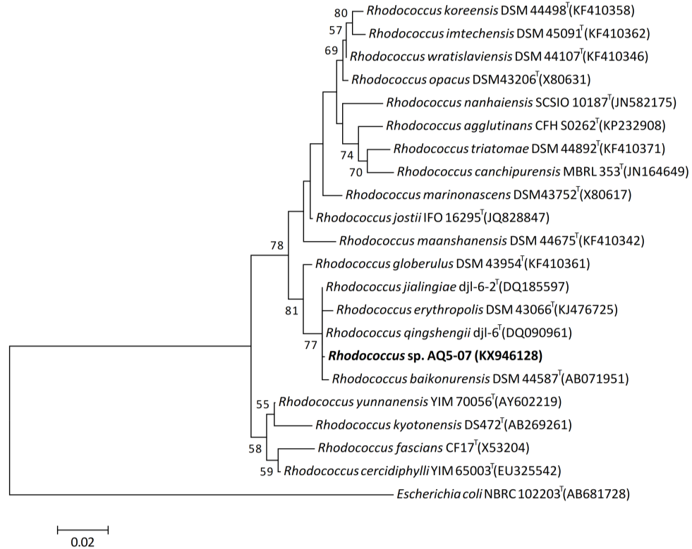
Online Resource 2 Maximum likelihood derived phylogenetic tree of Rhodococcus sp. AQ5-07 conducted with MEGA 6 based on Tamura-Nei model. The percentage of trees (bootstrap scores > 50%) in which the associated taxa clustered together is shown next to the branches. Numbers in brackets are the accession numbers of the sequence with the superscript T indicates the type strains of each species. The tree is drawn to scale, with branch lengths measured in the number of substitutions per site

