Conservation implications of the consistent foraging and trophic ecology of a rare petrel species

Ramírez, I. ^{1,6}, Paiva, V.H. ^{2,6}, Fagundes, I. ³, Menezes, D. ⁴, Silva, I. ⁴, Ceia, F.R. ², Phillips, R.A. ⁵, Ramos, J.A. ², Garthe, S. ⁶

¹ BirdLife International – Wellbrook Court, Girton Road, Cambridge, CB4 ONA, United Kingdom
² MARE – Marine and Environmental Sciences Centre, Department of Life Sciences, University of Coimbra, 3004-517 Coimbra, Portugal
³ SPEA-Portuguese Society for the Study of Birds, Avenida João Crisostomo N°18 4Dto, Lisboa 1000-179, Portugal
⁴ Parque Natural da Madeira, Quinta do Bom Sucesso, Caminho do Meio, Funchal 9050-251, Madeira, Portugal
⁵ British Antarctic Survey, Natural Environment Research Council, High Cross, Madingley Road, Cambridge CB3 0ET, United Kingdom
⁶ Research and Technology Centre (FTZ), University of Kiel, Hafentörn 1, 25761 Büsum, Germany

Running Head: Ecological consistency of a rare petrel species
Contact: ivan.ramirez@birdlife.org

Keywords: spatial ecology; behavioural consistency; isotopic niche; endangered seabird; conservation implications

ABSTRACT
Individuals within populations can use different resources, leading to ecological segregation and niche variation within species. This segregation could have direct impacts on the migratory strategy and/or breeding success of a species, thus affecting the overall population and community dynamics and ultimately a species survival. In this study we assessed the inter-annual and intra-individual foraging ecology of an endemic and highly threatened seabird species, the Desertas petrel Pterodroma deserta, during the breeding and non-breeding phases. We combined 54 annual tracks (26 individuals; 2009-2013) obtained with light-level loggers (Global Location Sensing or GLS loggers) with blood (plasma and cells) and feathers for stable isotope analyses (δ¹⁵N and δ¹³C). Wide-ranging tracking data shows that this species is a generalist predator, able to adapt to very different habitats. All birds remained loyal to their selected non-breeding areas over the years leading to very high spatial, temporal and trophic inter-annual consistency (i.e. usually with intra-correlation coefficient values, which is an index of repeatability, > 40%). During both the breeding and non-breeding seasons, individual birds showed narrow and segregated isotopic niches, indicating a high level of specialisation and limited choice of prey and habitats. The conservation of a seabird with such a dispersive (species-level) yet consistent (individual-level) non-breeding distribution pattern does represent a challenge in marine policy terms. On one hand, such a consistent temporal and spatial pattern will help defining core areas for conservation, which may well be addressed through specific management measures or by the establishment of Marine Protected Areas. Yet, their relatively large size (on average 4,000 km² ) and the fact that all areas cover both national and international waters, where different legislative frameworks apply, will certainly require the coordinated action by many nations, international organisations and Multilateral Environmental Agreements (MEAs).

INTRODUCTION
Populations of wild animals are often highly heterogeneous, composed of individuals with differing life-history, foraging or other behavioral or ecological characteristics. Such individual differences may be very important for understanding responses to ecological and evolutional processes, and may have implications for the conservation of species, particularly in the current era of rapid environmental change. Individual specialization refers to the use of a limited portion of the available resources by each individual, independent of other life-history class or cohort effects, which are consistent over time (Bolnick et al. 2003; Araújo, Bolnick & Layman 2011; Ceia et al. 2012) . Populations with individual specialization will present a wide variation in resource use among individuals (Bolnick et al. 2003). The factors driving intra-specific variation in non-breeding movements and foraging behaviour are varied and include, among others, energy saving strategies linked to wind conditions, foraging site fidelity and memory effects (Grémillet et al. 2004) and have been already pointed out at various studies (González-Solís et al. 2009; Shepard et al. 2013).
Information from breeding grounds is more readily available but, with the recent advent of tracking technology, information from the non-breeding season is attainable, even for those species that until recently were too small to track (Pinet et al. 2011; Rayner et al. 2012; Priddel et al. 2014). The development of miniaturised geolocators (Global Location Sensing or GLS loggers) has allowed researchers to determine the year-round movements of many oceanic seabird species, including gadfly petrels Pterodroma spp. (Rayner et al. 2010; Ramírez et al. 2013; Priddel et al. 2014). Individual migratory patterns and spatial distribution at sea during the non-breeding season may vary considerably within the same species (Roscales et al. 2011). Different individuals might exploit different niches over the same time period (Bolnick et al., 2003). Such intra-specific variation could be related to age, sex or breeding status (Svanback & Bolnick 2007; Ceia et al. 2012). This spatial or trophic niche divergence could reflect (and reduce) competition for the same resources by conspecifics and other species from the same foraging guild (Lewis et al. 2001; Gotelli & McCabe 2012). If a wide range of habitats are used, a particular species or population might be better prepared to cope with rapid climatic or habitat changes, or threats from fisheries (Phillips et al. 2009; Reed et al. 2010; Dias et al. 2011). Characterising these differences may have direct value for the conservation and management needs of a particular species (Tranquilla et al., 2013; 2014). Also, and as pointed out by (Svanback & Bolnick 2007), threatened species such as most Gadfly petrels, may suffer from anthropogenic processes and environmental deterioration at sea. All these factors need to be incorporated into conservation management measures that should be applied either at breeding colonies or at sea (e.g. by-catch mitigation strategies).
There are a number of studies targeting the degree of annual consistency within individuals, and between years, (Tranquilla et al. 2014; Yamamoto et al. 2014; Müller et al. 2014). Some studies show individual site fidelity and consistency in migratory movements of pelagic seabirds during the non-breeding season (Phillips et al. 2005; Guilford et al. 2011; Raine et al. 2013), but other studies show greater plasticity, with some individuals changing non-breeding areas between years (Dias et al. 2011). There is considerably less information about the consistency in trophic ecology and habitat use of seabirds during the non-breeding season (Phillips et al. 2007; Quillfeldt et al. 2013). Indeed, recent developments in stable isotope analysis have enabled assessments of diet and at-sea habitat use by numerous seabird species (Phillips et al. 2009; Gonzalez-Solis et al. 2011; Ceia et al. 2014). When used in combination with tracking devices, stable isotope analysis can be used not only to ascertain migratory patterns, habitat preferences and trophic niches at the species level, but also the degree of intra-specific variation (Newsome et al. 2007). The stable isotope ratios of nitrogen (¹⁵N/¹⁴N, expressed as δ¹⁵N) and carbon (¹³C/¹²C, expressed as δ¹³C) are used most frequently in the marine environment. The δ¹⁵N values increase at each successive trophic level by 2 to 5‰ (Kelly 2000), whereas δ¹³C values are higher in coastal or benthic than offshore or pelagic habitats, and increases around 1‰ per trophic level (Cherel, Hobson & Hassani 2005). Hence, δ¹⁵N values can be used to infer the trophic position of organisms, and δ¹³C values to determine foraging areas in relation to a neritic-pelagic gradient or with latitude (Phillips et al. 2009; Paiva et al. 2010b; Roscales et al. 2011).
In this study we combined the use of geolocators with analyses of stable isotope ratios (δ¹³C and δ¹⁵N) in blood and feathers sampled from breeding adults of Desertas petrel Pterodroma deserta, an endangered seabird species (BirdLifeInternational 2014) that is endemic to a very restricted area on the island of Bugio (Madeira archipelago, Portugal). We evaluate spatial, behavioural and trophic consistency within and between individuals over a 5-year study period (2009-2013). A previous tracking study revealed that there were 5 main areas used during the non-breeding season: 1) Gulf Stream Current (GSC) (2) North Equatorial Current (NEC) (3) North Brazilian current (NBC) (4) South Brazil Current (SBC), and (5) central South Atlantic (CSA) (Ramírez et al. 2013). Here, we extend that study by evaluating long-term foraging consistency in this species during the breeding and non-breeding seasons. Results from the repeated tracking of individual movements and at-sea activity patterns (based on light and saltwater immersion data) were combined with the trophic choices of the individuals (based on stable isotopic analyses of diverse tissues). We investigated variability in the (1) timing of the post- and pre-breeding migrations (2), fidelity to non-breeding areas, and (3) degree of flexibility in trophic ecology. The implications of the inter-annual consistency on the spatial, behavioural and trophic ecology for the conservation of this rare seabird species are discussed.

METHODS
Fieldwork protocol
Fieldwork was conducted at Bugio Islet, Desertas Islands (Madeira) each July from 2009 to 2013. Overall, 26 Desertas petrels were caught and ringed at the breeding burrows, and fitted with a combined GLS-immersion logger (MK14, weight 1.4 grams; British Antarctic Survey, UK and Biotrack, UK). A single cable-tie was used to secure each logger on a thin bed of silicone sealant to a metal ring on the tarsus of each bird. The logger plus attachment represented 0.3-0.6% of adult mass, which is less than the threshold beyond which deleterious effects on trip duration tend to be observed (Vandenabeele et al. 2011) . Each year we aimed to deploy the devices on previously tracked individuals, with the intention of testing for individual route and site fidelity, and behavioural consistency. On average, 78% of the devices were retrieved in the following year. Upon retrieval and replacement of the tracking devices (in July of subsequent years), blood samples of ~100-150 μl were taken from the tarsal vein with a 25G needle, and the tips of the first primary (P1) and eighth secondary (S8) feathers collected for stable isotope analyses. Egg laying began 1-2 weeks after blood sampling, thus blood provides information about the pre-laying period. There is no detailed information on the moulting patterns of this species, but information from other petrel species indicate absence of wing moult during the breeding season (Warham 1996). Therefore P1 should represent the end of the breeding season/beginning of the non-breeding season, and S8 fully represents the non-breeding season. Handling times were < 20 min. and birds were then returned to their burrows. In subsequent observations, there was no incidence of injuries or other negative impacts to the birds related to handling or carrying the device.

Habitat use
Light and immersion data recorded by the logger were downloaded, and processed using the BASTrack software suite, generating two locations per day from the time of sunset and sunrise transitions (British Antarctic Survey, Cambridge). Subsequently, locations derived from curves with apparent interruptions around sunset and sunrise (e.g. light sensor was shaded or even blocked by feathers) were removed using bespoke software routines written in the R environment (R Core Team 2014) (for further details, see (Ramírez et al. 2013). So were those derived from several weeks around the equinoxes when latitudes are unreliable or others that represented unrealistic flying speeds (> 10 ms⁻¹ sustained over a 48 h period).. Filtered locations were used to generate kernel utilization distributions (kernel UD) estimates with a smoothing parameter (h) of 2° and a cell size of 1° using the adehabitatHR R package (Calenge 2006). Both the h value and the cell size of the grid were chosen based on the mean accuracy of the devices; i.e. ~0.4º for longitude and ~1.7º for latitude (Phillips et al. 2004). Following previous authors (e.g. (Paiva et al. 2010a)), we considered the 50 % (core foraging area) and the 95 % (home range) kernel UD contours. The period spent at the non-breeding area was defined as the dates of arrival and departure from the 50% Kernel UD, i.e., excluding the periods spent in transit during the post- and pre-breeding migrations. We measured the percentage of overlap of the home range (95% kernel UD) and core foraging area (50% kernel UD) of each individual in successive non-breeding periods, to assess how consistent each bird was in the use of its main non-breeding region. Overlap calculations were performed in R with the kerneloverlap function of the adehabitat library.

Activity data
The at-sea activity patterns were derived from both immersion and light data recorded for each individual Desertas petrel. The loggers tested for salt-water immersion every 3 s using 2 electrodes and stored the number of positive tests from 0 (continuously dry) to 200 (continuously wet) at the end of each 10 min period. The loggers also measured light level every minute and stored the maximum (truncated at a value of 64) at the end of each 10 min period. The immersion data were categorized as day (including twilight) or night (based on the light data), and used to determine the proportion of time spent on the sea surface (as distinct from flying or on land) during daylight and darkness. Time budget calculations excluded periods spent in burrows (prolonged periods of darkness and no immersion). Bouts spent on the water surface were identified as any continuous sequence of 10 min blocks with at least 3 s sitting on the water, whereas a continuous sequence of dry (0) values was considered to be a flight bout (see (Mackley et al. 2011)). Light and activity (immersion) data were used simultaneously to distinguish time spent at sea from time in the colony (burrows) and hence to infer colony attendance. For instance, prolonged periods (more than 40 min.) of dry records or dark periods during the day were assigned as periods at the burrow. These data were analyzed using customized functions, and functions within the adehabitat package in R (Calenge 2006) to extract accurate information on at-sea activity patterns and the timing of events.

Trophic ecology
Stable isotope ratios (δ¹³C and δ¹⁵N) in tissues of consumers reflect the isotope ratios of their prey (Kelly 2000; Inger & Bearhop 2008). The SIBER package (Stable Isotope Bayesian Ellipses in R; metrics in siar package; (Parnell et al. 2010)) was used to determine isotopic niche width (Jackson et al. 2011), based on stable isotope ratios in P1 and S8 feathers, and whole blood. The Standard Ellipse Area after small sample size correction (SEAc) was used to compare estimated isotopic niches among individuals. SEAc, which is a estimated ellipse encompassing 40% of the data regardless of sample size, facilitated visualization and characterization of isotopic niches, allowing measuring the size (area) and the overlap of the isotopic niches among individuals over-wintering on the 5 different non-breeding regions (Jackson et al. 2011; Parnell et al. 2013).

Statistical procedures
The following parameters (response variables) were calculated for each individual during each tracking year: (1) 50 % kernel UD area, (2) 50 % kernel UD overlap (across years), (3) 95 % kernel UD overlap, (4) mean distance from the non-breeding areas to the colony, % time on the water surface during the (5) non-breeding and (6) breeding phases, δ¹³C values of (7) S8 and (8) P1 feathers, δ¹⁵N values of (9) S8 and (10) P1 feathers. Linear Mixed Effect Models (LMMs) were used to test the effect of the non-breeding ground (GSC, NEC, NBC, SBC, CSA) as an explanatory variable on the absolved mention 10 response variables. Bird ID was used as a random effect, because each individual was tracked during multiple years (i.e. to control for pseudo-replication issues). Pairwise multiple comparisons (post-hoc tests) were made using Bonferroni correction tests, to disentangle which of the five categories (main non-breeding regions) differ significantly among each other. Percentage values were arcsine transformed to meet normality. A Gaussian family of distributions was selected for all models (Zuur, Ieno & Smith 2007). All LMMs were performed using the R-library lmerTest (Kuznetsova, Brockhoff & Christensen 2014). LMMs were also used to test for consistency within individuals between years of the various parameters by inclusion of individual as a random effect in all models. The variance explained by the model (d), i.e., the between-individual variance, and the residual variance (σ) were used to calculate the intra-class correlation coefficient (ICC) as d² (d² + σ²), which is a measure of repeatability (Nakagawa & Schielzeth 2010). ICC ranges from 0 to 1, with higher values indicating that more of the variance is explained by between-individual differences.
Throughout the results, all values are presented as the mean ± SD unless otherwise stated. All statistical analyses were carried out in R (Version 3.01) (R Core Team 2014). Response variables were tested for normality (Q-Q plots) and homogeneity (Cleveland dotplots) before each statistical test and transformed when needed (Zuur, Ieno & Elphick 2010). All analyses were performed assuming a significance level of P< 0.05.

RESULTS
We tracked 54 trips from 26 individuals, each for 2-3 successive years (Table I, Fig. 1). Birds visited the same 5 main non-breeding areas identified in Ramírez et al. (2013): Gulf Stream Current (GSC, N = 8 tracks), North Equatorial Current (NEC, N = 12), North Brazil Current (NBC, N = 15), South Brazil Current (SBC, N = 11) and central South Atlantic (CSA, N = 8). No tracked individual switched its non-breeding area between years (Fig. 2)

Spatial consistency
During the non-breeding period, there was a wide range of sites used, but 50% Kernel UD’s overlapped 59-95% between consecutive years in the same individuals. The core foraging areas of birds that migrated to the GSC and NEC were significantly smaller than those of birds at the NBC and SBC, which, in turn, were smaller than that of birds in the CSA (LMM: F_{4,49} = 3.58, P = 0.02; Fig. 2 and 2A). The degree of overlap of the non-breeding range over consecutive years in the same individuals depended on the non-breeding area used, although was always >59 % for the core foraging area (50% kernel UD) and >72% for the home range (95% kernel UD) (Table I, Supplement A). The overlap in UDs was significantly lower for birds that travelled to the CSA than to the GSC, NEC, NBC and SBC in terms of both the core foraging area (LMM: F_{4,49} = 3.58, P = 0.02) and home range (LMM: F_{4,49} = 3.58, P = 0.02). Repeatability in the geographical extent of the core foraging area (ICC > 0.61) and distance to the breeding colony (ICC > 0.56) was also high (Fig. 3A, B).

Consistency in timing of movements and activity patterns
In general, there was a high repeatability in the percentage of time spent on the water during the non-breeding period for birds at all five main non-breeding grounds (ICC > 0.81), although repeatability was lower for birds at the NEC than elsewhere. Annual repeatability in the date of departure from, and arrival at the breeding colony was higher for birds that migrated to the GSC and NEC (ICC > 0.91 and ICC > 0.92, respectively) than for individuals that travelled to the NBC, SBC and CSA (ICC < 0.63, ICC < 0.68 and ICC < 0.56, respectively; Tables I and II). During the non-breeding period, individuals at the NEC spent a significantly lower percentage of time on the water surface than those at the NBC, which in turn was lower than that of birds at the GSC, SBC or CSA (LMM: F_{4,49} = 5.76, P = 0.001; Fig. 3C). Birds were less consistent in the percentage of time spent on the water surface during the breeding period (ICC < 0.65; Fig. 3D).

Trophic consistency
There was a high level of consistency in the stable isotope ratios of individuals tracked in consecutive non-breeding periods (Table II and Fig. 3E and F). Repeatability was always higher for δ¹³C (ICC > 0.60) than for δ¹⁵N (ICC < 0.40), both for the isotopic signatures of S8 (non-breeding period) and P1 (breeding period) feathers. ICC values were generally higher for δ¹³C in the non-breeding (ICC > 0.63) than breeding periods (ICC > 0.40). The δ¹⁵N values were significantly higher in S8 for birds that spent the non-breeding period in the CSA region than for those that migrated to the GSC, NEC, NBC or SBC (LMM: F_{4,49} = 2.97, P = 0.03; Fig. 4). There were no significant differences between individuals that migrated to these 5 main non-breeding areas for δ¹⁵N in P1 (LMM: F_{4,49} = 1.99, P = 0.11) nor in whole blood, (LMM: F_{4,49} = 1.63, P = 0.18). Birds that migrated to the CSA region showed significantly lower δ¹³C in their S8 feather than those that travelled to the SBC, which were also lower than in birds from the GSC, NEC or NBC (LMM: F_{4,49} = 5.52, P = 0.001). δ¹³C in whole blood was significantly lower in birds that used the CSA region than elsewhere (LMM: F_{4,49} = 6.02, P = 0.001; Fig. 4).
During the non-breeding season, birds from the 5 main non-breeding grounds exhibited a generally low overlap in their isotopic niches, with the highest value (27.5 %) between individuals at the NEC and NBC (Fig. 3). Significant differences in the size of standard ellipses were found between birds that spent the non-breeding season at the NBC (large isotopic niche) and those at the GSC (p = 0.02) and the CSA (p = 0.04) (small niches). During breeding, the niche overlap was generally high, especially between birds from the NEC and NBC (59.5 %). The niche size of individuals from the GSC was significantly smaller than that of birds from the NBC (p = 0.05). During the pre-laying phase, niche overlap was even higher, with the greatest overlap between birds from the GSC and NBC (69.0 %). The niche size of birds from the GSC was significantly smaller than those from the SBC (p = 0.04; Fig. 3).

DISCUSSION
This study demonstrated significant site fidelity during the non-breeding season, and individual consistency in timing of migration and trophic ecology in a highly pelagic seabird, the Desertas petrel. Overall, all birds returned to the same non-breeding areas in consecutive years, and thus the trophic consistency that we can infer from the high repeatability in stable isotope ratios could be a secondary outcome of site selection. To date, few studies have shown such strong spatial fidelity in a species with such a diverse range of alternative non-breeding destinations, in our case, 5 different areas located long distances apart in the Atlantic Ocean (Ramírez et al. 2013). Such strong individual specialization can be presumed to play an important role in the ecology and dynamics of the Desertas petrel population, and has implications for the conservation of this highly threatened species given its small breeding population. In addition, the high degree of individual specialization is intriguing from a theoretical perspective, as it presumably reflects some environmental or behavioural driver relating to the availability of different habitats or prey, and intraspecific competition (Araújo et al. 2011). Our results also suggest that this behaviour applies to species with a restricted breeding range (breeding in the same colony), as observed for other petrels breeding in two extant breeding colonies (Rayner et al. 2011).

Spatial consistency
Results from tracking studies of migratory seabirds suggest that high non-breeding site fidelity is apparently more common than switching sites between years but data for more species is needed (Phillips et al., 2005; Gonzalez-Solis et al., 2007; Catry et al., 2009). The exceptions include a number of seabird species from Macaronesia, including Cory’s shearwater Calonectris diomedea or the little shearwater Puffinus assimilis. Both species appear to adapt their migratory routes and to change non-breeding areas from one year to the next in response to variation in food availability and environmental conditions (Dias et al. 2011; Roscales et al. 2011). This is not the case for the Desertas petrel, since birds in this study were consistent in their use of the same non-breeding grounds. When compared to other gadfly petrels breeding in the Atlantic, the Desertas petrel showed a much wider non-breeding distribution than, for instance, Zino’s petrel Pterodroma madeira (Zino, Phillips & Biscoito 2011) and Cape Verde petrel Peterodroma feae (Raül Ramos, unpublished data), based on tracking data, or Atlantic Petrel Pterodroma incerta and black-capped petrels Pterodroma hasitata, based on vessel surveys (Enticott, 1991). The non-breeding distribution was also wider than gadfly petrels from other ocean basins, including Barau’s petrel Pterodroma baraui and Chatham petrel Pterodroma axillaris, which have one or two core areas, respectively, in the Indian or south Pacific oceans (Pinet et al. 2011; Rayner et al. 2012). Site fidelity was similar or greater than other, more distantly-related taxa, including black-legged kittiwakes Rissa tridactyla (Gonzalez-Solis et al. 2011) and Brunnich’s Uria lomvia and common guillemots U. aalge (Tranquilla et al. 2014).
As well as being highly faithful to the non-breeding areas, individual Desertas petrels showed little variation between years in the timing of migration (in terms of departure from, and return to the colony). The migration routes followed by this species (Ramírez et al. 2013) overlap with those used by other Procellaridae species in the Atlantic, including the Cory’s shearwater breeding at the Selvagens (Catry et al. 2011) and the Cape Verde shearwater Calonectris edwardsii (Gonzalez-Solis et al. 2007; Roscales et al. 2011). There was a high overlap between years in the non-breeding areas used by the Desertas petrels, and the size of those areas remained very consistent. Individuals visiting the same site over multiple years may benefit from increased familiarity with feeding conditions, resource availability, among other ecological reasons (Newton 2007)

Temporal and behavioural consistency
Regardless of the non-breeding areas from which birds were returning, consistency across years in the arrival dates of individual at the breeding colony remained high, even though all birds arrived in late May. Yet, repeatability was particularly high for birds that had spent the non-breeding period at the GSC and NEC. The return migration routes eastward that are used by the individuals from these two areas share an important characteristic: neither are trans-equatorial journeys and so birds do not need to cope with the predominantly calm winds of the tropics (Grodsky & Carton 2003). Low wind speed is a known problem for other trans-equatorial migrants, including Cory’s shearwater (Felicísimo, Munoz & Gonzalez-Solis 2008). Two reasons could explain the somewhat lower annual repeatability in the return date of birds that spent the non-breeding period south of the equator: 1) birds would follow the characteristic figure-of-eight migration pattern described for other Atlantic Procellaridae (Gonzalez-Solis et al. 2007; Dias, Granadeiro & Catry 2012), which can result in delays because of the need to wait for favourable winds (Felicísimo et al. 2008), and 2) moonlight may affect the return migration departure, as inferred from the departure dates of the Barau’s petrel Pterodroma baraui (Pinet et al. 2011) and the Desertas petrel (Ramírez et al. 2013) which depart only during bright moonlight nights.
The percentage of time spent on the water by each individual was consistent between years, regardless of the area in which they spent the non-breeding season. This indicates a high degree of behavioural plasticity, at the population level, when inhabiting regions with very diverse environmental characteristics. For instance, birds at the NEC or NBC are closer to the continental shelf where concentrations of prey are more predictable than those in areas of deep water such as CSA. During the breeding season, all birds showed low to moderate repeatability in the proportion of time spent on the water surface. Birds tended to spend less time on the water and more actively searching for prey than during the non-breeding period. This is an indication of the higher energetic and nutritional requirements of adults during reproduction, which need to return regularly to the colony to incubate the egg or feed the chick. Other species show similar seasonal changes in at-sea activity patterns that reflect the demands of reproduction and the degree of the central-place constraint (Paiva et al. 2010b; Mackley et al. 2011; Hedd et al. 2012).

Trophic consistency
The stable isotope ratios in the tissues of the Desertas petrels sampled at the colony reflect those of the prey in the areas where those tissues were formed. Higher δ¹³C values indicate a distribution in more coastal habitat, and higher δ¹⁵N values indicate feeding at higher trophic levels. Yet such conclusions need to take account of the substantial spatial heterogeneity in baselines for both δ¹³C and δ¹⁵N in the Atlantic Ocean (Graham et al. 2010). Variation in the types of prey consumed by this species can therefore only be assessed by comparing isotope signatures and diets of conspecifics or heterospecifics that spend the non-breeding season in the same regions.
Our stable isotope results from different tissues suggest that trophic consistency in the breeding and non-breeding periods is very high in consecutive years in the Desertas petrel, indicating that birds maintain a fairly constant diet throughout their annual cycle. This consistency could be the result of an inter-specific adaptation that would benefit them from other competitors both during breeding (Roscales et al. 2011) and non-breeding (Catry et al. 2011; Quillfeldt et al. 2013). Regardless of the non-breeding destination, all birds in this study showed very high repeatability in stable isotope ratios in tissues sampled in consecutive years: ICC values in secondary 8th (representing the non-breeding period) were very high for δ¹³C and δ¹⁵N. This may partly reflect the limited choice of prey and habitats because of the mainly oligotrophic areas visited. For example, (Forero et al. 2008) indicated that there might be few dietary choices at each trophic level of seabirds present in the Patagonian sea .
Non-breeding isotopic values for δ¹³C were low for birds visiting purely oceanic waters, such as CSA and SBC and increased on a pattern that followed NBC-GSC-NEC. This is a pattern linked to the oceanic characteristics of each region, where feeding events are mainly associated with upwelling fronts that occur at coarse scale and are therefore more dispersed than those linked to bathymetric features (Fauchald 2009). δ¹³C values in NEC were similar to those observed for other seabird species breeding in Madeira, Selvagens and the Canaries archipelagos, such as the Cory’s shearwater, the Fea’s petrel Pterodroma feae or the Cape Verde shearwater (Roscales et al. 2011). This reinforces the importance of the NEC-Canary Current area, where small pelagic fish are abundant and where many seabird species co-exist without apparent inter-specific foraging segregation (Camphuysen & van der Meer 2005).
Most Desertas petrels foraged during chick-rearing in an area relatively enriched in ¹³C, which is the Canary upwelling system off the northwest African coast, and around the Cape Verde archipelago, where there are probably a few types of prey that are very abundant (Roscales et al. 2011). This would result in a narrow isotopic feeding niche (Ceia et al. 2014), which is observed in other Procellaridae that use those waters, including the Cory’s shearwater (Ramos et al. 2013). A parallel situation may arise during the pre-laying exodus, as Desertas petrels usually travel > 2,000 km to a large area northwest of the Azores characterised by low Sea Surface Temperature (SST) and high Chlorophyll a (Chl a) concentrations, that is a known hotspot for other Procellaridae (Paiva et al. 2010a; Roscales et al. 2011). Although there is no diet information for the species while foraging at this region, Desertas petrels may feed on a very restricted number of species, given that Cory’s shearwaters that travel there from the Azores during the breeding season typically target a single pelagic fish species, Trachurus picturatus
(Xavier et al. 2011).

Implications for conservation
This study has greatly improved our understanding of the migration strategies, at-sea activity patterns and trophic niche of one of the rarest seabird species breeding in the north Atlantic, providing substantial new information on consistency within individuals. Given the small population size (160-180 breeding pairs; D. Menezes unpubl. data), and potential impact of loss of a meal on chick growth, no attempt was made to collect conventional diet samples at the breeding colony. Instead, this study highlights the potential of combining tissue isotope ratios with tracking data to understand seasonal and annual variation in trophic ecology of seabirds. Our results indicate that the Desertas petrel has a very extensive non-breeding distribution, and wider habitat affinities than any other gadfly petrel tracked to date (Pinet et al. 2011; Zino et al. 2011; Rayner et al. 2011; Priddel et al. 2014). Despite this wide distribution, individual Desertas petrel exhibited very high spatial, temporal and trophic consistency over the years, which indicates that birds have adapted to very different oceanic environments, potentially to avoid intra or inter-specific competition, and also that their prey preferences remain stable over the years. The species is classified as Vulnerable (VU) by IUCN (BirdLifeInternational 2014), with a tiny population that breeds on a very restricted area (a 300 m² plateau on Bugio islet). Its population trend is thought to be stable (D. Menezes unpubl. data) but negative stochastic events happening either at the colony level or in the waters used during the breeding season could potentially lead to the extinction of this species.
In accordance with (Ceia et al. 2014), our data suggest that narrow isotopic niches while breeding may be related to low prey diversity. In this study, we were able to show that variation between individuals, especially during the non-breeding season, is higher than that between years. Following the description given to other seabird species breeding in the Atlantic, the Desertas petrel would be defined as a ‘generalist’ in terms of its migration strategy, since the population is able to select a wide range of non-breeding habitats (Tranquilla et al. 2014), but rather ‘specialist’ at the individual level, considering the individual consistency in the use of the non-breeding grounds. In comparison, the preliminary data obtained for the other two Pterodroma species breeding in the Macaronesian and Cape Verde archipelagos suggests they are more specialised in their non-breeding habitats (Roscales et al. 2011; Zino et al. 2011).
Variability among and within individuals may suggest a greater ability to adapt to environmental change (Reed et al. 2010). The diverse (at the population level) yet individually highly consistent migration strategies and foraging behaviour of the Desertas petrel has implications for conservation. If total fidelity to an existing migration pattern (as apparent in this study) is maintained even if environmental conditions deteriorate in a particular non-breeding area, the birds that travel there will be selected against. This would reduce the effective population size and increase the vulnerability of the remaining birds to stochastic events, potentially leading to rapid decline given the tiny breeding population. Alternatively, the diversity of migration strategies may act as a buffer, because some birds may prosper while those elsewhere decline if the threat is spatially constrained. Both scenarios should be considered carefully when addressing the management of this species in the future.
Within a global decline of allocated funds for species protection (Global Biodiversity Outlook 2015; https://www.cbd.int) a prioritisation of the existing resources becomes essential when targeting threatened species such as the Desertas petrel. Thus, priority efforts should be dedicated to addressing threats at colony level. Following the successful removal of mice, rabbits and goats carried during the period 2006-2010 (LIFE06 NAT/P/000184) breeding habitat restoration and colony monitoring are needed. Additional efforts should also be dedicated to understand whether or not natural recolonization of other surrounding islands can happen or if translocation of this species could be viable. This study also reinforces the need to protect not only the waters surrounding Bugio, but also (for instance) the wider Canary Upwelling system which is also used extensively by many Macaronesian, west African and European seabird populations (Camphuysen & van der Meer 2010)
Throughout its non-breeding stages, sound management of the five different wintering marine areas used by this species would be necessary. Such a dispersive (at a species-level) yet consistent (at an individual-level) non-breeding distribution patterns requires complex conservation measures, involving coordinated action by many nations, international organizations and Multilateral Environmental Agreements (MEAs) (Lascelles et al. 2014). Though all five non-breeding areas are relevant for the conservation of this species, three out of the five areas (i.e. NEC, NBC and SBC) are ideal targets for prioritized conservation measures for the species, since they were used during the 5-years study, whereas GSC and CSA seemed to be less used. Effective protection on this site basis could involve the designation of Marine Protected Areas (MPAs) functioning under a dynamic time-area closure management technique (Lascelles et al. 2014). Though, further investigation is needed to assess the best methods to protect this and other endangered seabird species around the globe.

Acknowledgements
V.H.P. acknowledges the support provided by the Portuguese Foundation for Science and Technology (SFRH/BPD/63825/2009 and SFRH/BPD/85024/2012). The project received a small research grant from the British Ornitologists’ Union (BOU) in 2013, for which we are extremely grateful. We thank the Natural Park of Madeira (PNM) for the unconditional logistic support, permission to visit Bugio island and, the help and companionship of the PNM wardens. Cátia Gouveia provided valuable help during fieldwork.

REFERENCES

Araújo, M.S., Bolnick, D.I. & Layman, C.A. (2011) The ecological causes of individual specialisation. Ecology Letters, 14, 948–958.
BirdLifeInternational. (2014) Pterodroma deserta. The IUCN Red List of Threatened Species. URL www.iucnredlist.org [accessed 21 May 2015]
Bolnick, D.I., Svanback, R., Fordyce, J.A., Yang, L.H., Davis, J.M., Hulsey, C.D. & Forister, M.L. (2003) The ecology of individuals: Incidence and implications of individual specialization. American Naturalist, 161, 1–28.
Calenge, C. (2006) The package “adehabitat” for the R software: A tool for the analysis of space and habitat use by animals. Ecological Modelling, 197, 516–519.
Camphuysen, C.J. & van der Meer, J. (2005) Wintering seabirds in West Africa: foraging hotspots off Western Sahara and Mauritania driven by upwelling and fisheries. African Journal of Marine Science, 27, 427–437.
Camphuysen, C.J. & van der Meer, J. (2010) Wintering seabirds in West Africa: foraging hotspots off Western Sahara and Mauritania driven by upwelling and fisheries. dx.doi.org, 27, 427–437.
Catry, P., Dias, M.P., Phillips, R.A. & Granadeiro, J.P. (2011) Different Means to the Same End: Long-Distance Migrant Seabirds from Two Colonies Differ in Behaviour, Despite Common Wintering Grounds (ed RM Brigham). Plos One, 6, e26079.
Ceia, F.R., Paiva, V.H., Garthe, S., Marques, J.C. & Ramos, J.A. (2014) Can variations in the spatial distribution at sea and isotopic niche width be associated with consistency in the isotopic niche of a pelagic seabird species? Marine Biology, 161, 1861–1872.
Ceia, F.R., Phillips, R.A., Ramos, J.A., Cherel, Y., Vieira, R.P., Richard, P. & Xavier, J.C. (2012) Short- and long-term consistency in the foraging niche of wandering albatrosses. Marine Biology, 159, 1581–1591.
Cherel, Y., Hobson, K.A. & Hassani, S. (2005) Isotopic Discrimination between Food and Blood and Feathers of Captive Penguins: Implications for Dietary Studies in the Wild. Physiological and Biochemical Zoology, 78, 106–115.
Dias, M.P., Granadeiro, J.P. & Catry, P. (2012) Do seabirds differ from other migrants in their travel arrangements? On route strategies of Cory's shearwater during its trans-equatorial journey. Plos One, 7, e49376.
Dias, M.P., Granadeiro, J.P., Phillips, R.A., Alonso, H. & Catry, P. (2011) Breaking the routine: individual Cory's shearwaters shift winter destinations between hemispheres and across ocean basins. Proceedings of the Royal Society B-Biological Sciences, 278, 1786–1793.
Fauchald, P. (2009) Spatial interaction between seabirds and prey: review and synthesis. Marine Ecology Progress Series, 391, 139–151.
Felicísimo, A.M., Munoz, J. & Gonzalez-Solis, J. (2008) Ocean Surface Winds Drive Dynamics of Transoceanic Aerial Movements (ed J Figuerola). Plos One, 3.
Forero, M.G., Tella, J.L., Hobson, K.A., Bertellotti, M. & Blanco, G. (2008) Conspecific food competition explains variability in colony size: a test in Magellanic penguins. dx.doi.org, 83, 3466–3475.
Gonzalez-Solis, J., Croxall, J.P., Oro, D. & Ruiz, X. (2007) Trans-equatorial migration and mixing in the wintering areas of a pelagic seabird. Frontiers in Ecology and the Environment, 5, 297–301.
Gonzalez-Solis, J., Smyrli, M., Militao, T., Grémillet, D., Tveraa, T., Phillips, R.A. & Boulinier, T. (2011) Combining stable isotope analyses and geolocation to reveal kittiwake migration. Marine Ecology Progress Series, 435, 251–261.
González-Solís, J., Felicísimo, A., Fox, J.W., Afanasyev, V., Kolbeinsson, Y. & Muñoz, J. (2009) Influence of sea surface winds on shearwater migration detours. Marine Ecology Progress Series, 391, 221–230.
Gotelli, N.J. & McCabe, D.J. (2012) Species co-occurence: a meta-analysis of J. M. Diamond's assembly rules model. Ecology, 83, 2091–2096.
Graham, B.S., Koch, P.L., Newsome, S.D., McMahon, K.W. & Aurioles, D. (2010) Using Isoscapes to Trace the Movements and Foraging Behavior of Top Predators in Oceanic Ecosystems. Isoscapes (eds J.B. West, G.J. Bowen, T.E. Dawson & K.P. Tu pp. 299–318. Springer Netherlands, Dordrecht.
Grémillet, D., Dell'Omo, G., Ryan, P.G., Peters, G., Ropert-Coudert, Y. & Weeks, S.J. (2004) Offshore diplomacy, or how seabirds mitigate intra-specific competition: a case study based on GPS tracking of Cape gannets from neighbouring colonies. Marine Ecology Progress Series, 268, 265–279.
Grodsky, S.A. & Carton, J.A. (2003) The intertropical convergence zone in the South Atlantic and the equatorial cold tongue. Journal of Climate, 16, 723–733.
Guilford, T., Freeman, R., Boyle, D., Dean, B., Kirk, H., Phillips, R. & Perrins, C. (2011) A Dispersive Migration in the Atlantic Puffin and Its Implications for Migratory Navigation (ed Y Ropert-Coudert). Plos One, 6.
Hedd, A., Montevecchi, W.A., Otley, H., Phillips, R.A. & Fifield, D.A. (2012) Trans-equatorial migration and habitat use by sooty shearwaters Puffinus griseus from the South Atlantic during the nonbreeding season. Marine Ecology Progress Series, 449, 277–290.
Inger, R. & Bearhop, S. (2008) Applications of stable isotope analyses to avian ecology. Ibis, 150, 447–461.
Jackson, A.L., Inger, R., Parnell, A.C. & Bearhop, S. (2011) Comparing isotopic niche widths among and within communities: SIBER - Stable Isotope Bayesian Ellipses in R. Journal of Animal Ecology, 80, 595–602.
Kelly, J.F. (2000) Stable isotopes of carbon and nitrogen in the study of avian and mammalian trophic ecology. Canadian Journal of Zoology-Revue Canadienne De Zoologie, 78, 1–27.
Kuznetsova, A., Brockhoff, P.B. & Christensen, R.H.B. (2014) lmerTest: Tests for random and fixed effects for linear mixed effect models (lmer objects of lme4 package). URL http://CRAN.R- project.org/package=lmerTest [accessed 21 May 2015]
Lascelles, B., Notarbartolo Di Sciara, G., Agardy, T., Cuttelod, A., Eckert, S., Glowka, L., Hoyt, E., Llewellyn, F., Louzao, M., Ridoux, V. & Tetley, M.J. (2014) Migratory marine species: their status, threats and conservation management needs. Aquatic Conservation: Marine and Freshwater Ecosystems, 24, 111–127.
Lewis, S., Sherratt, T.N., Hamer, K.C. & Wanless, S. (2001) Evidence of intra-specific competition for food in a pelagic seabird. Nature, 412, 816–819.
Mackley, E.K., Phillips, R.A., Silk, J.R.D., Wakefield, E.D., Afanasyev, V. & Furness, R.W. (2011) At-sea activity patterns of breeding and nonbreeding white-chinned petrels Procellaria aequinoctialis from South Georgia. Marine Biology, 158, 429–438.
Müller, M.S., Massa, B., Massa, Phillips, R.A. & Dell'Omo, G. (2014) Individual consistency and sex differences in migration strategies of Scopoli’s shearwaters Calonectris diomedea despite year differences. Current Zoology, 60, 631–641.
Nakagawa, S. & Schielzeth, H. (2010) Repeatability for Gaussian and non-Gaussian data: a practical guide for biologists. Biological Reviews, 85, 935–956.
Newsome, S.D., del Rio, C.M., Bearhop, S. & Phillips, D.L. (2007) A niche for isotopic ecology. Frontiers in Ecology and the Environment, 5, 429–436.
Newton, I. (2007) The Migration Ecology of Birds. Academic Press, UK.
Paiva, V.H., Geraldes, P., Ramírez, I., Meirinho, A., Garthe, S. & Ramos, J.A. (2010a) Oceanographic characteristics of areas used by Cory's shearwaters during short and long foraging trips in the North Atlantic. Marine Biology, 157, 1385–1399.
Paiva, V.H., Xavier, J., Geraldes, P., Ramírez, I., Garthe, S. & Ramos, J.A. (2010b) Foraging ecology of Cory's shearwaters in different oceanic environments of the North Atlantic. Marine Ecology Progress Series, 410, 257–268.
Parnell, A.C., Inger, R., Bearhop, S. & Jackson, A.L. (2010) Source Partitioning Using Stable Isotopes: Coping with Too Much Variation (ed S Rands). Plos One, 5, e9672.
Parnell, A.C., Phillips, D.L., Bearhop, S., Semmens, B.X., Ward, E.J., Moore, J.W., Jackson, A.L., Grey, J., Kelly, D.J. & Inger, R. (2013) Bayesian stable isotope mixing models. Environmetrics, 24, 387–399.
Phillips, R.A., Bearhop, S., Mcgill, R.A.R. & Dawson, D.A. (2009) Stable isotopes reveal individual variation in migration strategies and habitat preferences in a suite of seabirds during the nonbreeding period. Oecologia, 160, 795–806.
Phillips, R.A., Catry, P., Silk, J.R.D., Bearhop, S., McGill, R., Afanasyev, V. & Strange, I.J. (2007) Movements, winter distribution and activity patterns of Falkland and brown skuas: insights from loggers and isotopes. Marine Ecology Progress Series, 345, 281–291.
Phillips, R.A., Silk, J., Croxall, J.P., Afanasyev, V. & Bennett, V.J. (2005) Summer distribution and migration of nonbreeding albatrosses: Individual consistencies and implications for conservation. Ecology, 86, 2386–2396.
Phillips, R.A., Silk, J., Croxall, J.P., Afanasyev, V. & Briggs, D.R. (2004) Accuracy of geolocation estimates for flying seabirds. Marine Ecology Progress Series, 266, 265–272.
Pinet, P., Jaquemet, S., Pinaud, D., Weimerskirch, H., Phillips, R.A. & Le Corre, M. (2011) Migration, wintering distribution and habitat use of an endangered tropical seabird, Barau's petrel Pterodroma baraui. Marine Ecology Progress Series, 423, 291–302.
Priddel, D., Carlile, N., Portelli, D., Kim, Y., O'Neill, L., Bretagnolle, V., Ballance, L.T., Phillips, R.A., Pitman, R.L. & Rayner, M.J. (2014) Pelagic distribution of Gould's Petrel (Pterodroma leucoptera): linking shipboard and onshore observations with remote-tracking data. Emu, 114, 360–370.
Quillfeldt, P., Masello, J.F., Navarro, J. & Phillips, R.A. (2013) Year-round distribution suggests spatial segregation of two small petrel species in the South Atlantic. Journal of Biogeography, 40, 430–441.
R Core Team. (2014) R: A language and environment for statistical computing.
Raine, A.F., Borg, J.J., Raine, H. & Phillips, R.A. (2013) Migration strategies of the Yelkouan Shearwater Puffinus yelkouan. Journal of Ornithology, 154, 411–422.
Ramírez, I., Paiva, V.H., Menezes, D., Silva, I., Phillips, R.A., Ramos, J.A. & Garthe, S. (2013) Year-round distribution and habitat preferences of the Bugio petrel. Marine Ecology Progress Series, 476, 269–284.
Ramos, R., Granadeiro, J.P., Rodriguez, B., Navarro, J., Paiva, V.H., Becares, J., Reyes-Gonzalez, J.M., Fagundes, I., Ruiz, A., Arcos, P., Gonzalez-Solis, J. & Catry, P. (2013) Meta-population feeding grounds of Cory's shearwater in the subtropical Atlantic Ocean: implications for the definition of Marine Protected Areas based on tracking studies (ed G Cumming). Diversity and Distributions, 19, 1284–1298.
Rayner, M.J., Hartill, B.W., Hauber, M.E. & Phillips, R.A. (2010) Central place foraging by breeding Cook’s petrel Pterodroma cookii: foraging duration reflects range, diet and chick meal mass. Marine Biology, 157, 2187–2194.
Rayner, M.J., Hauber, M.E., Steeves, T.E., Lawrence, H.A., Thompson, D.R., Sagar, P.M., Bury, S.J., Landers, T.J., Phillips, R.A., Ranjard, L. & Shaffer, S.A. (2011) Contemporary and historical separation of transequatorial migration between genetically distinct seabird populations. 2, 1–7.
Rayner, M.J., Taylor, G.A., Gummer, H.D. & Phillips, R.A. (2012) The breeding cycle, year-round distribution and activity patterns of the endangered Chatham Petrel (Pterodroma axillaris). Emu.
Reed, T.E., Waples, R.S., Schindler, D.E., Hard, J.J. & Kinnison, M.T. (2010) Phenotypic plasticity and population viability: the importance of environmental predictability. Proceedings of the Royal Society B-Biological Sciences, 277, 3391–3400.
Roscales, J.L., Gómez-Díaz, E., Neves, V. & González-Solís, J. (2011) Trophic versus geographic structure in stable isotope signatures of pelagic seabirds breeding in the northeast Atlantic. Marine Ecology Progress Series, 434, 1–13.
Shepard, E.L.C., Wilson, R.P., Rees, W.G., Grundy, E., Lambertucci, S.A. & Vosper, S.B. (2013) Energy Landscapes Shape Animal Movement Ecology. American Naturalist, 182, 298–312.
Svanback, R. & Bolnick, D.I. (2007) Intraspecific competition drives increased resource use diversity within a natural population. Proceedings of the Royal Society B-Biological Sciences, 274, 839–844.
Tranquilla, L.A.M., Montevecchi, W.A., Fifield, D.A., Hedd, A., Gaston, A.J., Robertson, G.J. & Phillips, R.A. (2014) Individual Winter Movement Strategies in Two Species of Murre ( Uria spp.) in the Northwest Atlantic (ed S Descamps). Plos One, 9.
Vandenabeele, S.P., Shepard, E.L., Grogan, A. & Wilson, R.P. (2011) When three per cent may not be three per cent; device-equipped seabirds experience variable flight constraints. Marine Biology, 159, 1–14.
Warham, J. (1996) The Behaviour, Population Biology and Physiology of the Petrels. Academic Press.
Xavier, J.C., Magalhães, M.C., Mendonça, A.S., Antunes, A.S., Carvalho, N., Machete, M., Santos, R.S., Paiva, V.H. & Hamer, K.C. (2011) Changes in diet of Cory's Shearwaters Calonectris diomedea breeding in the Azores. Marine Ornithology
, 39, 129–134.
Yamamoto, T., Takahashi, A., Sato, K., Oka, N., Yamamoto, M. & Trathan, P.N. (2014) Individual consistency in migratory behaviour of a pelagic seabird. Behaviour, 151, 683–701.
Zino, F., Phillips, R.A. & Biscoito, M. (2011) Zino’s petrel movements at sea-a preliminary analysis of datalogger results. Birding World, 24, 216–219.
Zuur, A.F., Ieno, E.N. & Elphick, C.S. (2010) A protocol for data exploration to avoid common statistical problems. Methods in Ecology and Evolution, 1, 3–14.
Zuur, A.F., Ieno, E.N. & Smith, G.M. (2007) Analysing Ecological Data. Springer Press, NY.

Table I. The timing of migration, extent of the non-breeding distribution and isotope ratios of Desertas petrels tracked from Bugio Islet, Madeira between 2009 and 2013 to different non-breeding regions. The Standard Ellipse Area after small sample size correction (SEAc), was used as a metric based in a Bayesian framework to compare isotopic niche width between periods and wintering regions (see main text for further details).
Variables | Gulf Stream  Current | North Equatorial  Current | North Brazil  Current | South Brazil  Current | Central South  Atlantic
Number of tracks [N individuals] | 8 [4] | 12 [7] | 15 [6] | 11 [5] | 8 [4]
Departure from the breeding colony | 10-Dec ± 5 d | 29-Nov ± 4 d | 12-Nov ± 6 d | 19-Nov ± 7 d | 22-Dec ± 5 d
Arrival at the breeding colony | 30-May ± 6 d | 27-May ± 3 d | 26-May ± 5 d | 28-May ± 6 d | 30-May ± 7 d
95 % Kernel UD overlap for the non-breeding phase | 94.3 ± 5.3 | 91.4 ± 6.8 | 86.2 ± 8.9 | 84.7 ± 7.7 | 72.2 ± 9.1
50 % Kernel UD overlap for the non-breeding phase | 75.6 ± 4.8 | 66.5 ± 6.8 | 71.8 ± 9.0 | 77.2 ± 8.8 | 59.2 ± 10.2
SEAc non-breeding phase (S8 feather) | 0.08 | 0.60 | 1.29 | 0.32 | 0.05
SEAc breeding phase (P1 feather) | 0.07 | 0.39 | 0.94 | 0.28 | 0.21
SEAc pre-breeding phase (whole blood) | 0.15 | 1.11 | 1.03 | 3.25 | 0.10

Table II. Variance explained by the model (d), residual variance (σ) and intra-class correlation coefficients (ICC; providing an index of repeatability) from linear mixed-effects models with individual included as a random effect, comparing the migration characteristics, activity patterns and stable isotope ratios of Desertas petrels tracked from Bugio Islet, Madeira to one of 5 non-breeding regions between 2007 and 2013. ICC = d² (d² + σ²)
 | Gulf Stream  Current |  |  |  | North Equatorial Current |  |  |  | North Brazil  Current |  |  |  | South Brazil  Current |  |  |  | Central South  Atlantic
Variables | d² | σ² | ICC |  | d² | σ² | ICC |  | d² | σ² | ICC |  | d² | σ² | ICC |  | d² | σ² | ICC
50 % kernel UD area | 0.48 | 0.15 | 0.76 |  | 0.56 | 0.11 | 0.84 |  | 0.67 | 0.12 | 0.85 |  | 0.51 | 0.09 | 0.85 |  | 0.39 | 0.25 | 0.61
Mean distance to breeding colony | 0.38 | 0.12 | 0.76 |  | 0.59 | 0.21 | 0.74 |  | 0.61 | 0.08 | 0.88 |  | 0.48 | 0.07 | 0.87 |  | 0.44 | 0.35 | 0.56
% of time on the water during the non-breeding phase | 0.49 | 0.06 | 0.89 |  | 0.47 | 0.09 | 0.84 |  | 0.61 | 0.11 | 0.85 |  | 0.47 | 0.12 | 0.80 |  | 0.58 | 0.14 | 0.81
% of time on the water during the breeding phase | 0.41 | 0.22 | 0.65 |  | 0.50 | 0.45 | 0.53 |  | 0.33 | 0.21 | 0.61 |  | 0.49 | 0.29 | 0.63 |  | 0.33 | 0.31 | 0.52
Departure from the breeding colony | 0.30 | 0.03 | 0.91 |  | 0.45 | 0.05 | 0.90 |  | 0.29 | 0.18 | 0.62 |  | 0.24 | 0.12 | 0.67 |  | 0.24 | 0.19 | 0.56
Arrival at the breeding colony | 0.35 | 0.02 | 0.95 |  | 0.58 | 0.05 | 0.92 |  | 0.37 | 0.22 | 0.63 |  | 0.38 | 0.18 | 0.68 |  | 0.27 | 0.28 | 0.49
Non-breeding carbon signature (S8 feather) | 0.49 | 0.09 | 0.84 |  | 0.37 | 0.08 | 0.82 |  | 0.45 | 0.06 | 0.88 |  | 0.41 | 0.03 | 0.93 |  | 0.22 | 0.13 | 0.63
Breeding carbon signature (P1 feather) | 0.56 | 0.15 | 0.79 |  | 0.49 | 0.14 | 0.78 |  | 0.55 | 0.19 | 0.74 |  | 0.55 | 0.31 | 0.64 |  | 0.37 | 0.25 | 0.60
Non-breeding nitrogen signature (S8 feather) | 0.63 | 0.19 | 0.77 |  | 0.55 | 0.15 | 0.79 |  | 0.50 | 0.16 | 0.76 |  | 0.61 | 0.19 | 0.76 |  | 0.48 | 0.58 | 0.45
Breeding nitrogen signature (P1 feather) | 0.30 | 0.09 | 0.77 |  | 0.38 | 0.18 | 0.68 |  | 0.41 | 0.17 | 0.71 |  | 0.28 | 0.18 | 0.61 |  | 0.40 | 0.61 | 0.40

List of Figures

Figure 1. Individual non-breeding areas (50% Kernel UD) of Bugio petrel by study year. Bathymetry represented on the background.
Figure 2. Individual non-breeding areas (50% kernel UD) of Desertas petrel tracked from Bugio Islet, Madeira between 2007 and 2013 to different non-breeding regions. GSC – Gulf Stream Current, NEC – North Equatorial Current, NBC – North Brazilian Current, SBC – South Brazilian Current, CSA – Central South Atlantic. Bathymetry represented on the background.
Figure 3. Correlations between migration characteristics and stable isotope ratios of Desertas petrels tracked from Bugio Islet, Madeira in consecutive years between 2007 and 2013 to different non-breeding regions. (A) % of time on water during the non-breeding period, (B) % on water during non-breeding vs breeding period, (C) 50 % Kernel UD area during the non-breeding period, (D) mean distance to the colony from the main non-breeding ground, (E) δ¹⁵N in secondary 8 feather (wintering period), and (F) δ¹³C in secondary 8 feather (wintering period). Dashed line represents the expected relationship (1:1) if values of each individual are the same in consecutive years and there is no shift in isotopic baselines. GSC – Gulf Stream Current, NEC – North Equatorial Current, NBC – North Brazilian Current, SBC – South Brazilian Current, CSA – Central South Atlantic.
Figure 4. Isotopic niches of Desertas petrels tracked between 2007 and 2013, based on Jackson et al. (2011) applied to SI ratios in S8 (non-breeding) and P1 feathers (breeding) and whole blood (pre-laying). The area of the standard ellipses (SEAc) is represented by the solid bold lines.

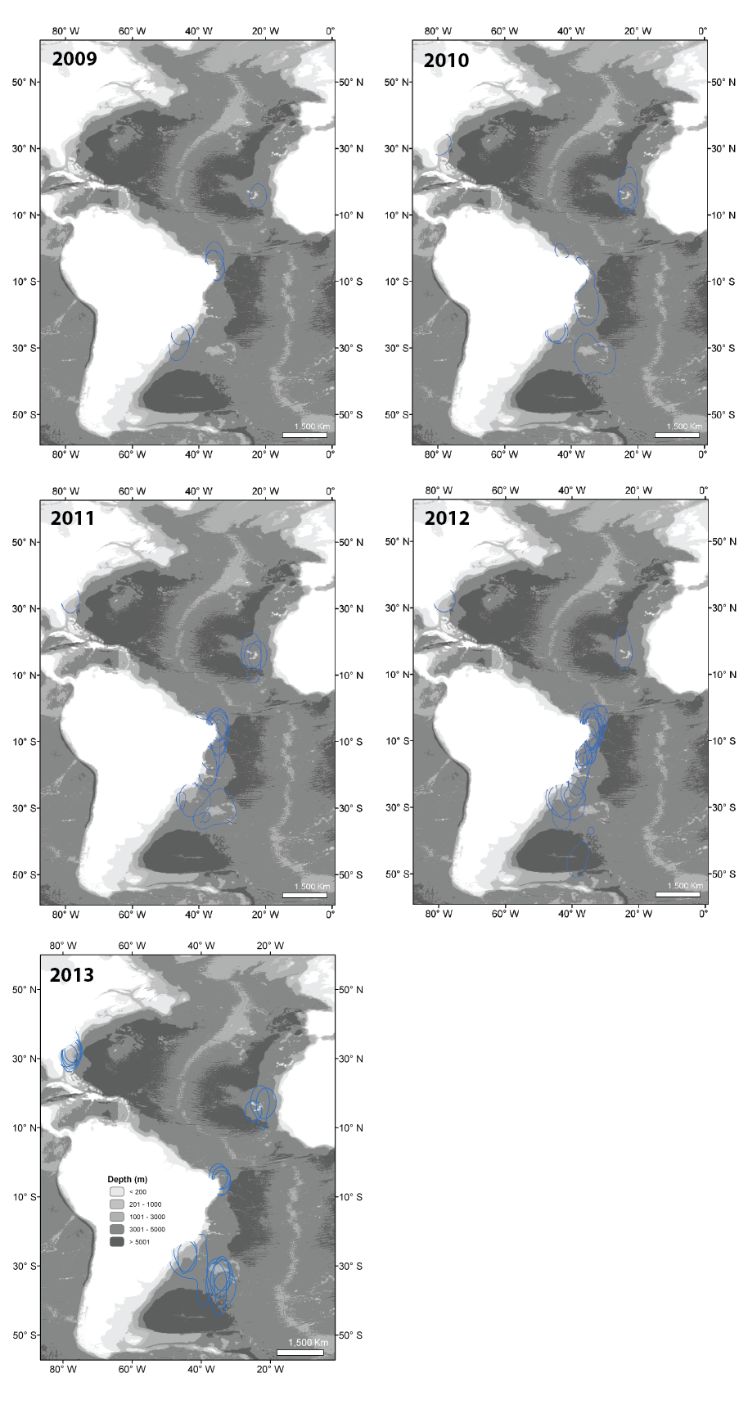

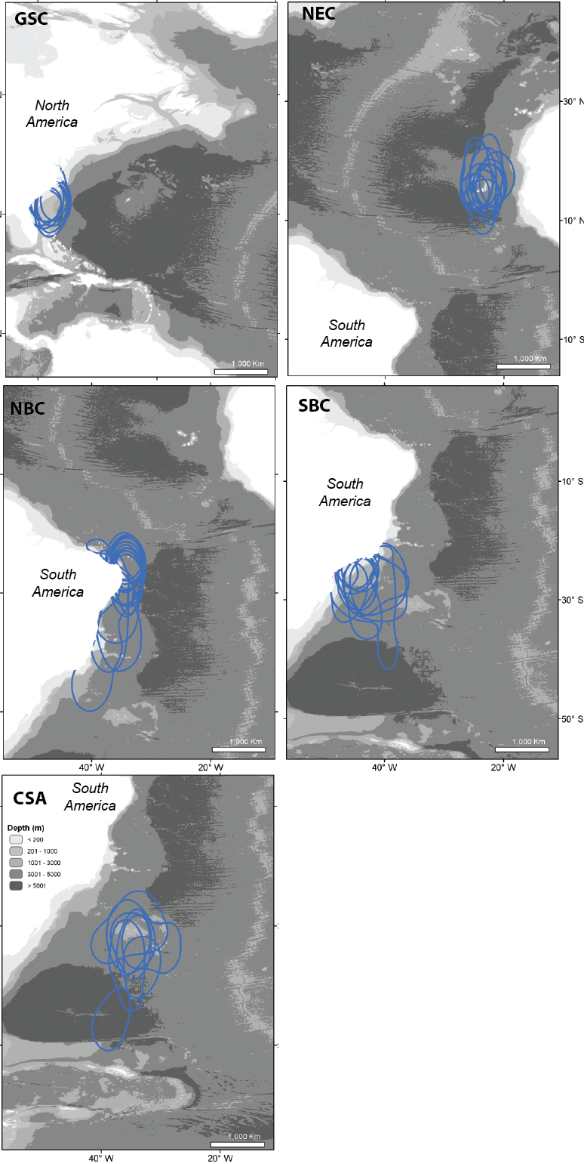

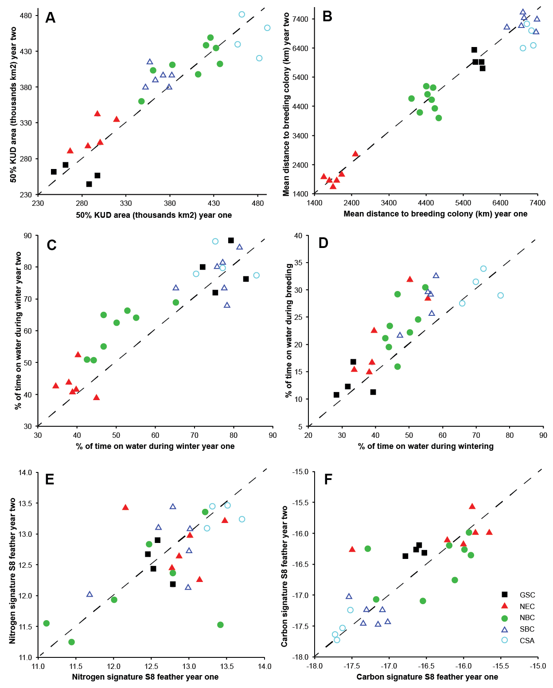

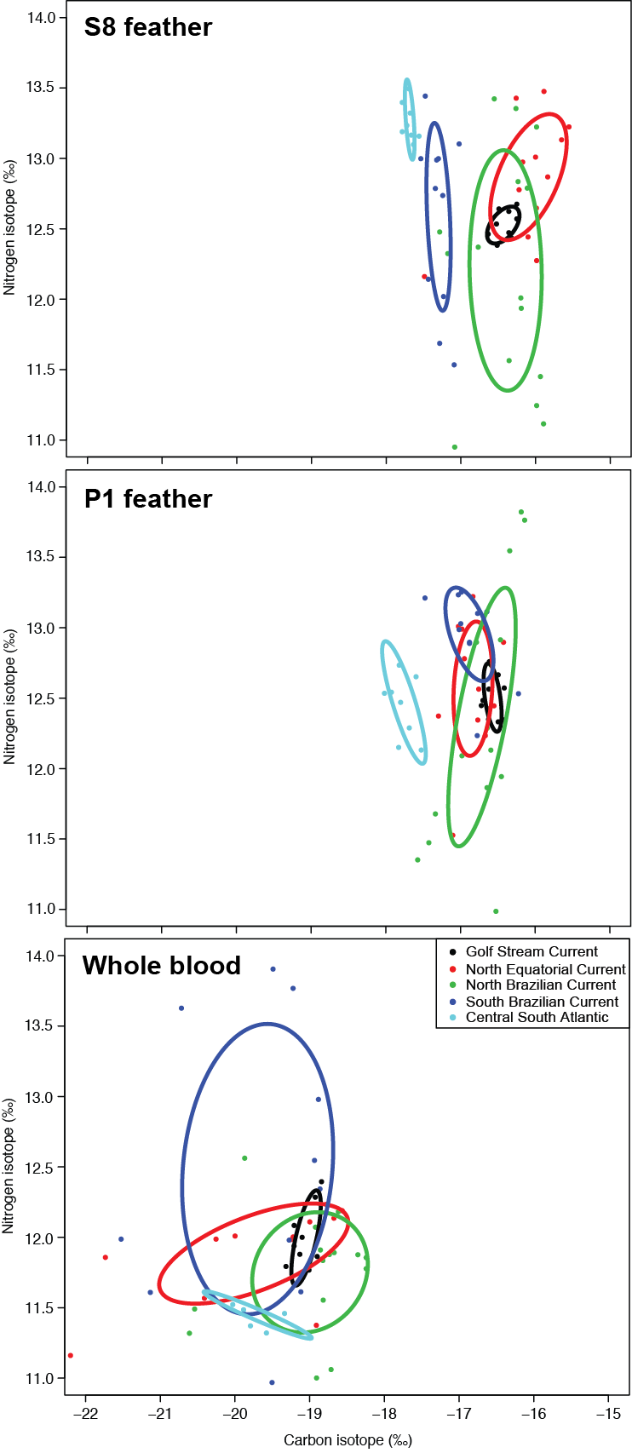

SUPPLEMENTARY MATERIAL

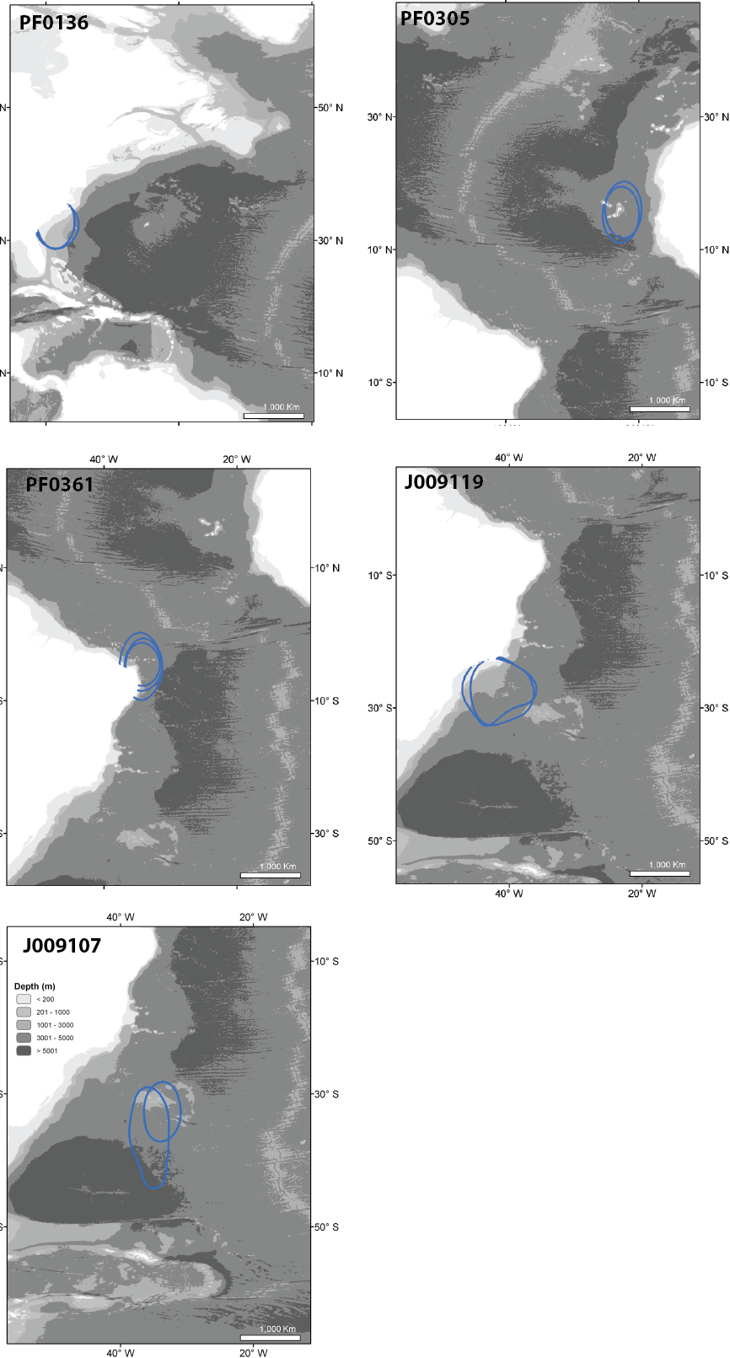
Supplement A. Examples of repeatability in the use of space by Bugio petrels during the non-breeding period on the five main non-breeding grounds: Gulf Stream Current (PF0136), North Equatorial Current (PF0305), North Brazilian Current (PF0361), South Brazilian Current (J009119) and Central South Atlantic area (J009107). Bathymetry represented on the background.

