Diving capabilities of diving petrels

Joan Navarro^{1,*}, Stephen C. Votier², Richard A. Phillips³,

¹ Institut de Ciències del Mar (ICM-CSIC), Passeig Maritim de la Barceloneta 37-49, 08003-Barcelona, Spain
² Environment and Sustainability Institute, University of Exeter, Penryn, Cornwall TR10 9EZ, UK
³ British Antarctic Survey, Natural Environment Research Council, High Cross, Madingley Road, Cambridge CB3 0ET, United Kingdom

*Author for correspondence (joan@icm.csic.es)

Short title: Diving capabilities of petrels

Abstract
In striking contrast to the general increase in diving ability with body mass in seabirds, amongst the Procellariiformes, the deepest dives appear to be by the smallest species. Here we use recently-developed, miniaturised Time Depth Recorders (TDRs) to provide the first accurate measurement of dive depth and duration in two small Procellariiformes: Common (Pelecanoides urinatrix) and South Georgian Diving Petrel (P. georgicus), and compare their diving performance in relation to body mass with that of 58 seabirds from four orders. The 20 common and 6 South Georgia diving petrels in our study dived to considerable depths and for long periods (respective means ± SD of 10.5±4.6 m and 18.1±3.6 m, and 36.4±9.1 s and 44.2±5.9 s). In relation to body mass, these dives are closely comparable to those of small alcids, which are considered to be diving specialists, and much greater than in closely-related petrels. Previous work has shown that diving petrels and small alcids share a number of convergent morphological traits; our data reveal these are manifested in terms of diving ability.
Keywords: Alcids, convergent evolution, diving capability, diving-seabirds, polar ecosystems, dive depth, dive duration

Introduction
Although many seabirds are capable of diving, the majority only conduct shallow and short dives (del Hoyo et al. 1992, 1996). The few species that are considered to be diving specialists are penguins, alcids, cormorants and diving petrels, which alternate long periods foraging underwater with time spent resting on the sea-surface to recover or handle captured prey (Schreer and Kovacs 1997; Watanuki and Burger 1999; Brischoux et al. 2008). In general, dive capability increases with body mass across taxonomic groups (Schreer and Kovacs 1997; Watanuki and Burger 1999; Halsey et al. 2006; Brischoux et al. 2008; Watanabe et al. 2011). This is largely because oxygen storage capacity scales linearly with body mass, whereas mass-specific metabolic rate scales with an exponent markedly less than one (Lasiewski and Calder 1971; Butler and Jones 1982).
There are some exceptions to the general trend for increasing dive capability with body mass, most obviously amongst Procellariiform seabirds (Halsey and Butler 2006). Based on data from capillary-tube depth gauges (CDGs), diving petrels (Family Pelecanoididae) appear to make unusually deep dives, despite their comparatively small size (Chastel 1994; Reid et al. 1997; Zavalaga and Jahncke 1997; Bocher et al. 2000a). However, CDGs only provide information on the maximum depth reached during the deployment period, which will be much greater than the mean diving depth, and are relatively inaccurate (Burger and Wilson 1988; Elliott and Gaston 2009). In addition, CDG do not measure dive duration, which is another useful indicator of diving ability since it is a measure of breath-holding capacity. Although time-depth recorders (TDRs) can overcome these problems and provide much more detailed diving statistics, until recently they were too large to deploy on small seabirds.
Here, by taking advantage of the availability of miniature TDRs, we provide the first accurate measurement of diving activity, including mean and maximum dive depth and dive duration of sympatric Common (Pelecanoides urinatrix) and South Georgian Diving Petrel (P. georgicus), and using published data, compare their mass specific performance with 58 other species of seabird from 4 orders.

Material and Methods
Fieldwork was carried out at Bird Island, South Georgia (54°00′S, 38°03′W) during the Antarctic summer of 2010/11. We equipped 20 Common and 6 South Georgian Diving Petrels with miniaturised TDRs (Cefas G5, 8 bit resolution, Cefas Technology Ltd, Lowestoft, UK) during the incubation period when birds were attending their single egg (November 2011 and January 2012 for common and South Georgian diving petrels, respectively). The TDRs were 3.1cm in length, 8 mm in diameter and weighed 2.5 g in air, <1g in water, representing <2% of adult body mass (Table 1). TDRs were programmed to record pressure (depth, ±0.2 m, relative accuracy ± 0.04 m) every 1 sec, covering the entire foraging trip. Incubating birds were caught by hand in their burrows, and a TDR attached to the tail feathers using waterproof tape. Birds were returned to their burrows which were then inspected daily using a burrowscope to check for partner change-overs, and the device recovered after a single foraging trip. Deployment and retrieval took <3 min.
We tested for potential effects of device deployment on two foraging parameters - trip duration and body mass at the end of the trip - which were recorded for all individuals fitted with TDRs, and 10 untracked Common and South Georgian Diving Petrels breeding in adjacent burrows during the same period whose attendance was also monitored using a burrowscope. All individuals (tracked and untracked) were individually marked with a standard British Trust for Ornithology metal ring.
Downloaded TDR data were processed using diveMove 1.2.6 software (Luque 2007), available through GNU R (R Development Core Team 2007). Data were corrected for surface drift (zero offset correction; Luque and Fried 2011) and a dive threshold was set at 1 m depth. Mean depth during the bottom phase and maximum dive depth and dive time were extracted for each dive.
Data on body mass, maximum dive duration and dive depth of 11 alcids, 12 penguins, 11 cormorants and 24 procellariiforms (13 Procellaridae, 4 Diomedeidae, 3 Hydrobatidae and 3 Pelecanoididae) were obtained from the literature (see Table S1-electronic supplement). We consulted three exhaustive reviews of air-breathing vertebrates (Schreer and Kovacs 1997; Halsey et al. 2006; Brischoux et al. 2008), supplemented by searches of ISI Web of Knowledge and a diving database (Ropert-Coudert and Kato 2012).
Maximum and mean dive depths and durations of tracked Common and South Georgian Diving Petrels were compared using Kruskal-Wallis tests. Relationships between body mass, maximum dive duration and depth among species in different taxonomic groups were determined using Pearson’s correlation coefficient. Diving data were log-transformed in order to normalize (log10 (1+body mass)) and to reduce the effect of outliers prior to statistical analyses. All statistical analyses were conducted in IBM Statistic SPPS 210 software (SPSS, Inc., Chicago, Illinois). The significance level was set at P=0.05.

Results
Based on TDR data, mean and maximum dive depth was significantly greater and mean and maximum dive duration marginally greater in South Georgian than Common Diving Petrels (Table 1; mean dive depth; χ²=10.01, df=24, p=0.003, maximum dive depth, χ²=8.53, df=24, p=0.003; mean dive duration; χ²=3.01, df=24, p=0.06, maximum dive duration; χ²=3.57, df=24, p=0.05). For both species, the maximum dive depths recorded using the TDRs were considerably lower than those obtained previously with CDGs (Fig. 1).
Trip duration and body mass at the end of the foraging trip were similar in birds equipped with TDRs, and controls, for both common (Table 1; body mass, χ²=2.58, p=0.11; trip duration, χ²=1.14, p=0.28) and South Georgian diving petrel (Table 1; body mass, χ²=0.05, p=0.82; trip duration, χ²=0.61, p=0.44).
The relationships between diving parameters (maximum dive depth and duration) and body mass were positive for alcids, cormorants and penguins (Fig. 1). In contrast, among the Procellariiformes, the relationship between maximum dive depth and body mass was negative for both the Procellaridae and Diomedeidae (Fig. 1a). Due to sample size constraints (n < 3 spp. in Diomedeidae, Pelecanoididae and Hydrobatidae), the relationship between dive duration and body mass was only estimated for the Procellariidae, and was positive (Fig. 1b). Despite being closer taxonomically to the Procellariidae, the maximum dive durations of diving petrels were much closer to the regression line calculated for alcids (see 95% CI). Indeed, the diving capabilities (maximum dive depth and duration) of diving petrels are comparable to those of similarly-sized alcids, and dive durations in particular were much greater than would be predicted for a procellariid of the same body mass (Fig. 1a, 1b and 2).

Discussion
This is the first study to provide reliable data from TDRs on the diving activity of the diving petrels, or indeed any of the numerous small (<250g) procellariiforms, including prions, storm petrels and gadfly petrels. Based on the comparison with untracked birds, the deployment of TDRs apparently did not affect the foraging behaviour and body mass of Common and South Georgian Diving Petrels. Although both Common and South Georgia Diving Petrels dived to considerable depths and for prolonged periods based on the TDR records, they did not dive as deep as suggested from previous studies using CDGs (Common Diving Petrels = 30-40 m; South Georgian Diving Petrels =25 m; Reid et al. 1997; Bocher et al. 2000b). Unsurprisingly, the values for mean dive depth and duration from the TDRs were lower still. The differences in maximum values are almost certainly attributable to the inaccuracy of CDGs, which tend to overestimate depth (Burger and Wilson 1988; Elliott and Gaston 2009). However, it should be borne in mind that the TDRs were deployed for a single trip, and the CDGs for several trips, and hence the longer observation period may also be a contributing factor. Alternatively, although we did not find an effect of TDR deployment on trip duration and body mass, these devices can change the buoyancy of seabirds and reduce the depths reached (Ropert-Coudert et al. 2007).
Our results indicate that South Georgian Diving Petrels on average dive deeper and reach greater maximum depths than Common Diving Petrels. In theory, this could simply reflect a seasonal shift in the vertical distribution of prey because the timing of incubation and therefore deployment periods for each species were several weeks apart. However, there are differences in diet between these two species that are maintained in the period when both are simultaneously rearing chicks, suggesting consistent differences in the way they exploit the water column (Reid et al. 1997). Although the diet of both species is dominated by crustaceans, in particular euphausiids (mainly Antarctic krill Euphausia superba and Thysanoessa spp), Common Diving Petrels consume a much higher proportion of copepods (Reid et al. 1997; Bocher et al. 2000a), which could be distributed differently in the water column. In any case, based on the clear correlation between dive depth and duration, a common pattern showed in diving seabirds, both diving petrel species apparently change the duration and depth of diving events, probably in response to diurnal variation in the vertical distribution of their prey.
Why do both diving petrels need to dive to such depths? One presumes that such energetically-expensive behavior must reflect the vertical distribution of their main food resources, which are euphausiids and copepods (Reid et al. 1997; Bocher et al. 2000a). However, it could also be a mechanism to reduce interspecific competition for food with other sympatric small petrels including Antarctic Prion (Pachyptila desolata) and Blue Petrels (Halobaena caerulea), which are very abundant (Prince 1980; Cherel et al. 2002a), but have much lower diving capability than diving petrels (Chastel and Bried 1996; Cherel et al. 2002b; Navarro et al. 2013).
As expected, when comparing the diving capabilities (dive depth and dive duration) with other families of seabird, the diving capabilities of diving petrels are similar to those of alcids of similar body mass. Based on the TDR data, the maximum depth and dive durations of diving petrels are similar to the data reported for Little Auk (Alle alle) (Harding et al. 2009), and proportionally lower than in larger alcids such as Rhinoceros Auklet (Cerorhinca monocerata) and Common Guillemot (Uria aalge) (Kato et al. 2003; Tremblay et al. 2003). Diving petrels dive to much greater depths and for longer periods than any species in the order Procellariiformes with the exception of some Puffinus shearwaters (Table S1), highlighting the high diversity of diving modes found in this order.
Diving petrels share a number of convergent traits with small alcids, including compact body shape, high wing loading and short wings (Warham 1977). These are all adaptations for effective underwater wing propulsion (Thaxter et al. 2010). Moreover, our data confirm that these are manifested in terms of very similar dive depth and dive duration. In addition, as both diving petrels and alcids breed in polar or cold temperate regions, they probably have adaptations to reduce loss of body heat during dives such as the presence of particular feather configurations (Ortega-Jiménez and Álvarez-Borrego 2010), or the use of vasoconstriction to reduce blood flow to peripheral tissues (Wilson et al. 1992).
In summary, this study provides the first reliable dive data for two species of diving petrel, revealing that both Common and South Georgian Diving Petrels are proficient divers in relation to their small size. This energetically-expensive behavior not only reflects the vertical distribution of their main prey, but reduces interspecific competition with other sympatric small petrels. Parallel diving capabilities of diving petrels and small alcids confirm their apparent convergence in a range of morphological and physiological traits.

Acknowledgements We extend special thanks to Ruth Brown, Stacy Adlard and Jaume Forcada for their fieldwork support and to Norman Ratcliffe and Akiko Kato for their help with dive analyses. The NERC Antarctic Funding Initiative provided financial and logistic support. JN was supported by a postdoctoral contract of the Juan de la Cierva program (Spanish-MINECO). This study is part of the British Antarctic Survey Polar Science for Planet Earth Programme, funded by The Natural Environment Research Council.

References
Bocher P, Cherel Y, Hobson KA (2000a) Complete trophic segregation between South Georgian and common diving petrels during breeding at Iles Kerguelen. Mar Ecol Prog Ser 208:249-264
Bocher P, Labidoire B, Cherel Y (2000b) Maximum dive depths of common diving petrels (Pelecanoides urinatrix) during the annual cycle at Mayes Island, Kerguelen. J Zool 251:517-524
Brischoux F, Bonnet X, Cook TR, Shine R (2008) Allometry of diving capacities: ectothermy vs. endothermy. J Evol Biol 21:324-9
Burger AE, Wilson RP (1988) Capillary-tube depth gauges for diving animals: an assessment of their accuracy and applicability. J Field Ornithol 59:345-354
Butler PJ, Jones DR (1982) The comparative physiology of diving. Adv Comp Physiol Biochem 8:179–364
Chastel O (1994) Maximum diving depths of common diving petrels Pelecanoides urinatrix at Kerguelen Islands. Polar Biol 14:211-213
Chastel O, Bried J (1996) Diving ability of Blue Petrels and Thin-billed Prions. Condor 98:627-629
Cherel Y, Bocher P, Trouvé C, Weimerskirch H (2002a) Diet and feeding ecology of blue petrels Halobaena caerulea at Iles Kerguelen, Southern Indian Ocean. Mar Ecol Prog Ser 228:283-299
Cherel Y, Bocher P, De Broyer C, Hobson K (2002b) Food and feeding ecology of the sympatric thin-billed Pachyptila belcheri and Antarctic P. desolata prions at Iles Kerguelen. Mar Ecol Prog Ser 228:263–281
Elliott KH, Gaston AJ (2009) Accuracy of depth recorders. Waterbirds 32: 183-191.
Halsey LG, Butler PJ (2006) Optimal diving behaviour and respiratory gas exchange in birds. Resp Physiol Neurob 154:268-83
Halsey LG, Butler PJ, Blackburn TM (2006) A phylogenetic analysis of the allometry of diving. Am Nat 167:276-87
Harding AMA, Egevang C, Walkusz W, Merkel F, Blanc S, Grémillet D (2009) Estimating prey capture rates of a planktivorous seabird, the little auk (Alle alle), using diet, diving behaviour, and energy consumption. Polar Biol 32:785-796
del Hoyo J, Elliott A, Sargatal J (1992) Handbook of the Birds of the World. Volume 1 Ostrich to Ducks. Lynx Editions, Barcelona, Spain
del Hoyo J, Elliott A, Sargatal J (1996) Handbook of the Birds of the World. Volume 3 Hoatzin to Auks. Lynx Editions, Barcelona, Spain
Kato A, Watanuki Y, Naito Y (2003) Foraging behaviour of chick-rearing rhinoceros auklets Cerorhinca monocerata at Teuri Island, Japan, determined by acceleration-depth recording micro data loggers. J Avian Biol 34:282-287
Lasiewski RC, Calder WA (1971) A preliminary allometric analysis of respiratory variables in resting birds. Resp Physiol 11:152–166
Luque S (2007) Behaviour Analysis in R. R News 7:8-14
Luque S, Fried R (2011) Recursive filtering for zero offset correction of diving depth time series with GNU R package diveMove. PloS ONE 6:e15850
Navarro J, Votier SC, Aguzzi J, Chiesa JJ, Forero MG, Phillips RA (2013) Ecological segregation in space, time and trophic niche of sympatric planktivorous petrels. PLoS ONE 8:e62897
Ortega-Jiménez VM, Álvarez-Borrego S (2010) Alcid feathers wet on one side impede air outflow without compromising resistance to water penetration. Condor 112:172-176
Prince P (1980) The food and feeding ecology of blue petrel (Halobaena caerulea) and dove prion (Pachyptila desolata). J Zool 190:59-76
Reid K, Croxall J, Edwards T, Hill H, Prince P (1997) Diet and feeding ecology of the diving petrels Pelecanoides georgicus and P.urinatrix at South Georgia. Polar Biol 17:17-24
Ropert-Coudert Y, Knott N, Chiaradia A, Kato A (2007) How do different data logger sizes and attachment positions affect the diving behaviour of little penguins? Deep-Sea Res Pt II 54:415-423
Ropert-Coudert Y, Kato A (2012) The Penguiness book. World Wide Web electronic publication (http:/penguinessbook.scarmarbin.be/), version 2.0, March 2012, http://penguinessbook.scarmarbin.be/
Schreer JF, Kovacs KM (1997) Allometry of diving capacity in air-breathing vertebrates. Can J Zool 75:339–358
Thaxter CB, Wanless S, Daunt F, Harris MP, Benvenuti S, Watanuki Y, Grémillet D, Hamer KC (2010) Influence of wing loading on the trade-off between pursuit-diving and flight in common guillemots and razorbills. J Exp Biol 213:1018-25
Tremblay Y, Cherel Y, Oremus M, Tveraa T, Chastel O (2003) Unconventional ventral attachment of time-depth recorders as a new method for investigating time budget and diving behaviour of seabirds. J Exp Biol 206:1929-194
Warham J (1977) Wing loadings, wing shapes, and flight capabilities of Procellariiformes. New Zeal J Zool 4:73-83
Watanabe YY, Sato K, Watanuki Y, Takahashi A, Mitani Y, Amano M, Aoki K, Narazaki T, Iwata T, Minamikawa S, Miyazaki N (2011) Scaling of swim speed in breath-hold divers. J Animal Ecol 80:57-68
Watanuki Y, Burger AE (1999) Body mass and dive duration in alcids and penguins. Can J Zool 77:1838-1842
Wilson RP, Hustler K, Ryan PG, Burger AE, Noldeke EC (1992) Diving birds in cold water: do Archimedes and Boyle determine energetic costs? Am Nat 140:179–200
Zavalaga C, Jahncke, J. (1997) Maximum dive depths of the Peruvian diving-petrel. Condor 99:1002-1004

Table 1 Mean and standard deviation of maximum and mean dive duration, maximum and mean dive depth, body mass at the end of foraging trip and trip duration for Common Diving Petrel (CDP) and South Georgian Diving Petrels tracked with TDRs at Bird Island, South Georgia. Body mass at the end of foraging trip and trip duration for untracked CDP and SGDP are also indicated. The number of individuals is indicated in parentheses.
 | CDP | SGDP
Instrumented birds
Mean dive duration (s) | 10.1±4.1 (20) | 14.3 ± 4.2 (6)
Maximum dive duration (s) | 36.4±9.1 (20) | 44.2±5.9 (6)
Mean dive depth | 2.1±0.3 (20) | 4.2±1.1 (6)
Maximum dive depth (m) | 10.4±4.6 (20) | 18.1±3.6 (6)
Body mass (g) | 149.1±6.8(20) | 128.5±12.6 (6)
Trip duration (days) | 1.11±0.47 (20) | 2 (6)
Untracked birds
Body mass (g) | 140.6±15.3 (10) | 129.5±9.7 (10)
Trip duration (days) | 1.20±0.42 (10) | 1.90±0.32 (10)

Figure captions

Fig 1 Relationships between body mass and; (a) log-maximum dive depth, and (b) log-maximum dive duration in alcids, cormorants, penguins, four procellariiform families (Procellariidae, Diomedeidae, Hydrobatidae and Pelecanoididae). Linear regressions are shown for each group. 95% CI for the Alcidae is also indicated. Crosses indicate dive data from Pelecanoides spp. fitted with TDRs (black fill) or capillary-tube gauges (white fill) for: (1) common diving petrel, (2) South Georgian diving petrel, and (3) Peruvian diving petrel.

Fig 2 (a) Relationship between dive depth and dive duration of Common and South Georgian Diving Petrels and, (b) example of the diving activity during an entire trip of one Common Diving Petrel tracked with TDRs at Bird Island, South Georgia.

Fig 3 Mean of maximum dive depth of seabirds of less than 250 g. Black and white bars indicate dive data obtained using capillary-tube gauges and TDRs, respectively.

Electronic Supplementary Material:
Table S1 Seabird species, diving information (maximum dive depth and maximum dive time), methodology used (TDR, time-depth recorders; CDG, capillary-depth gauges; VHF, VHF radio-transmitter; VO, visual observation) and references.

Figure 1
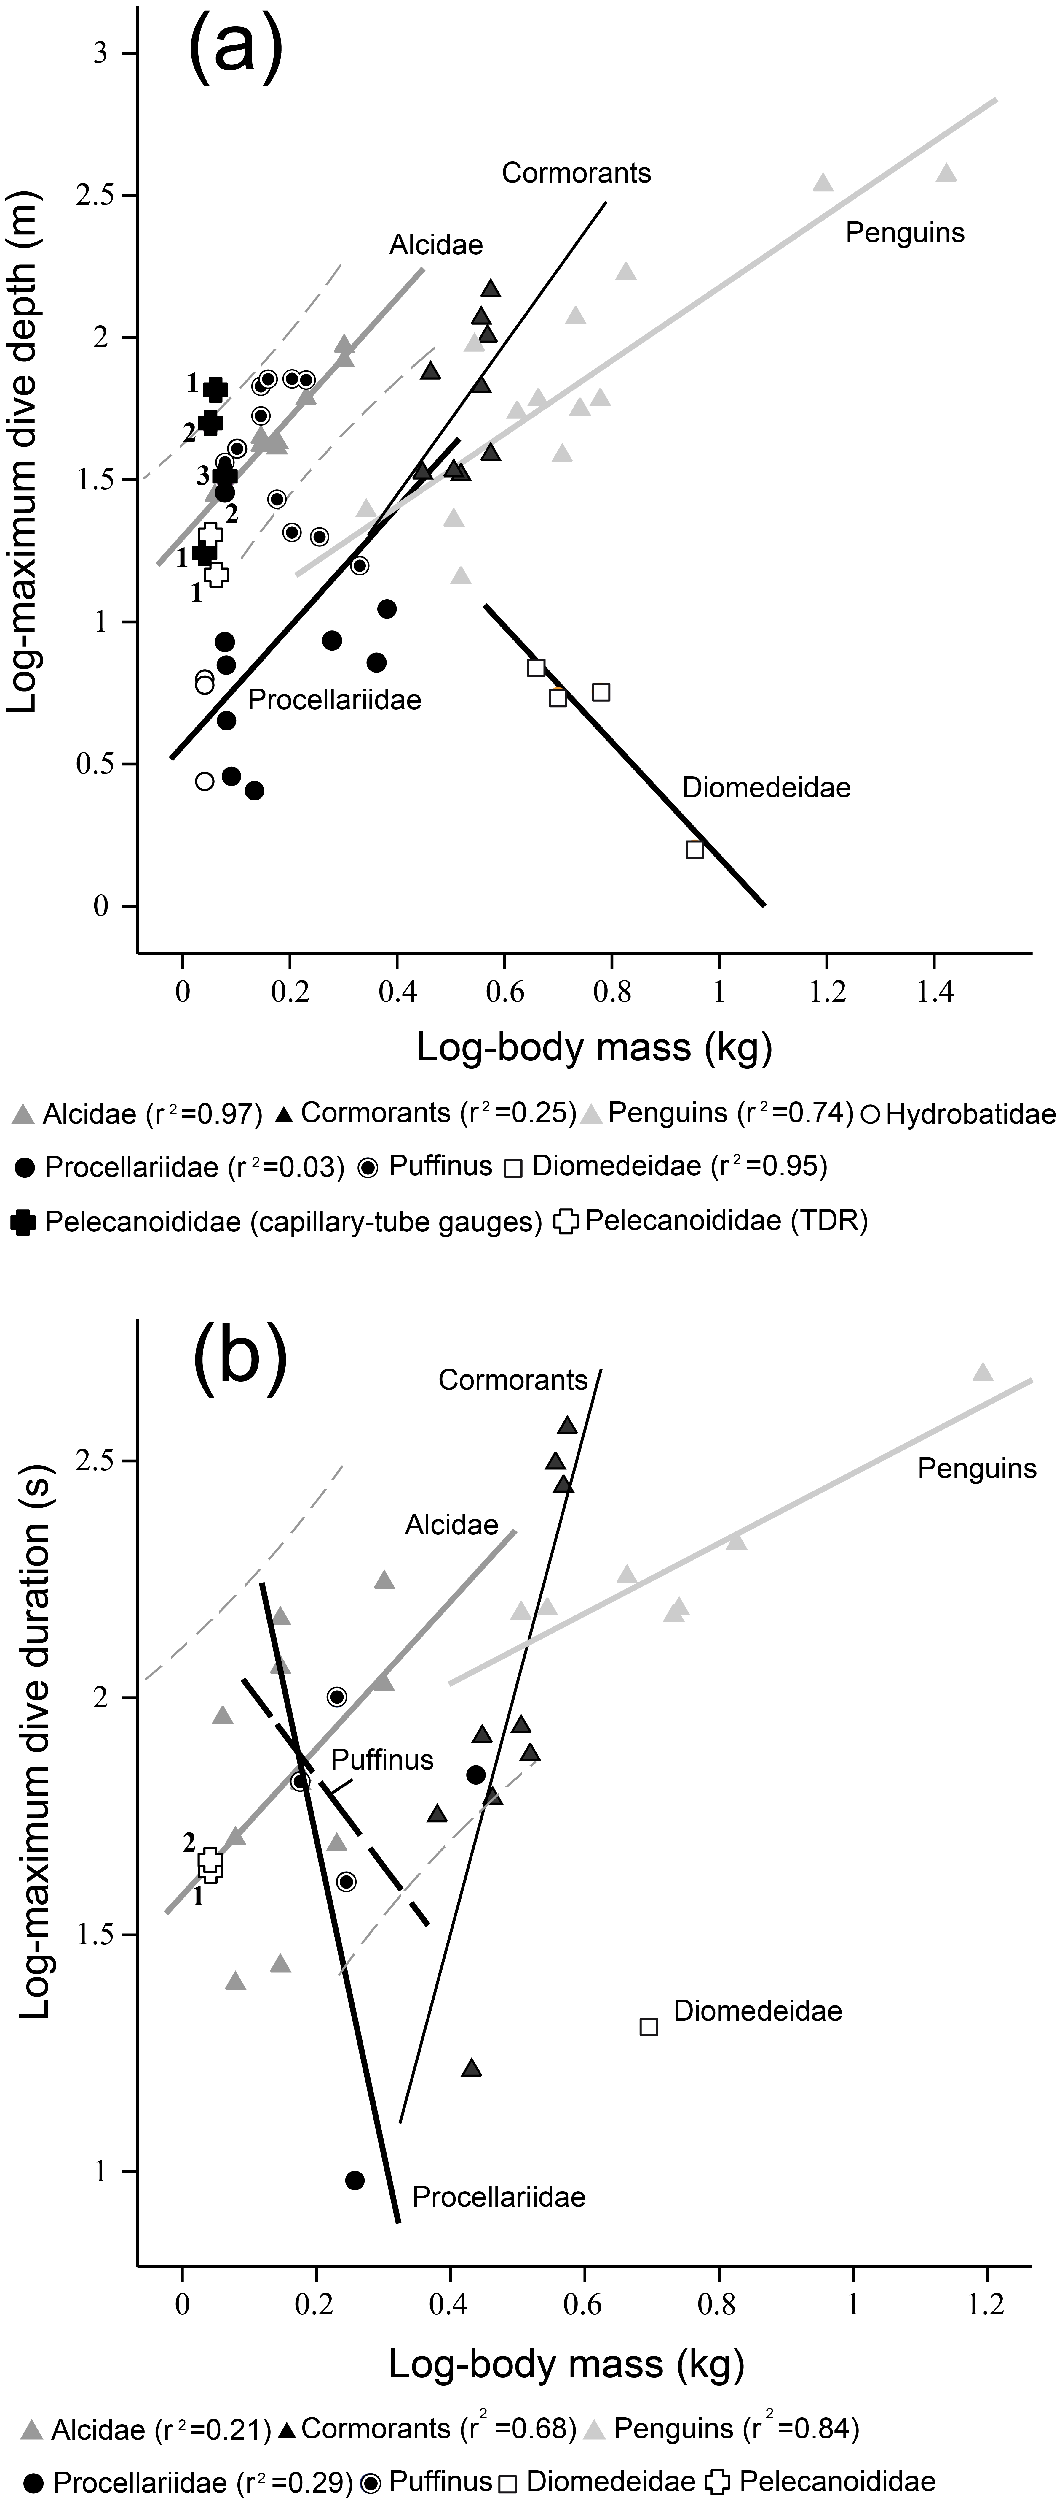

Figure 2
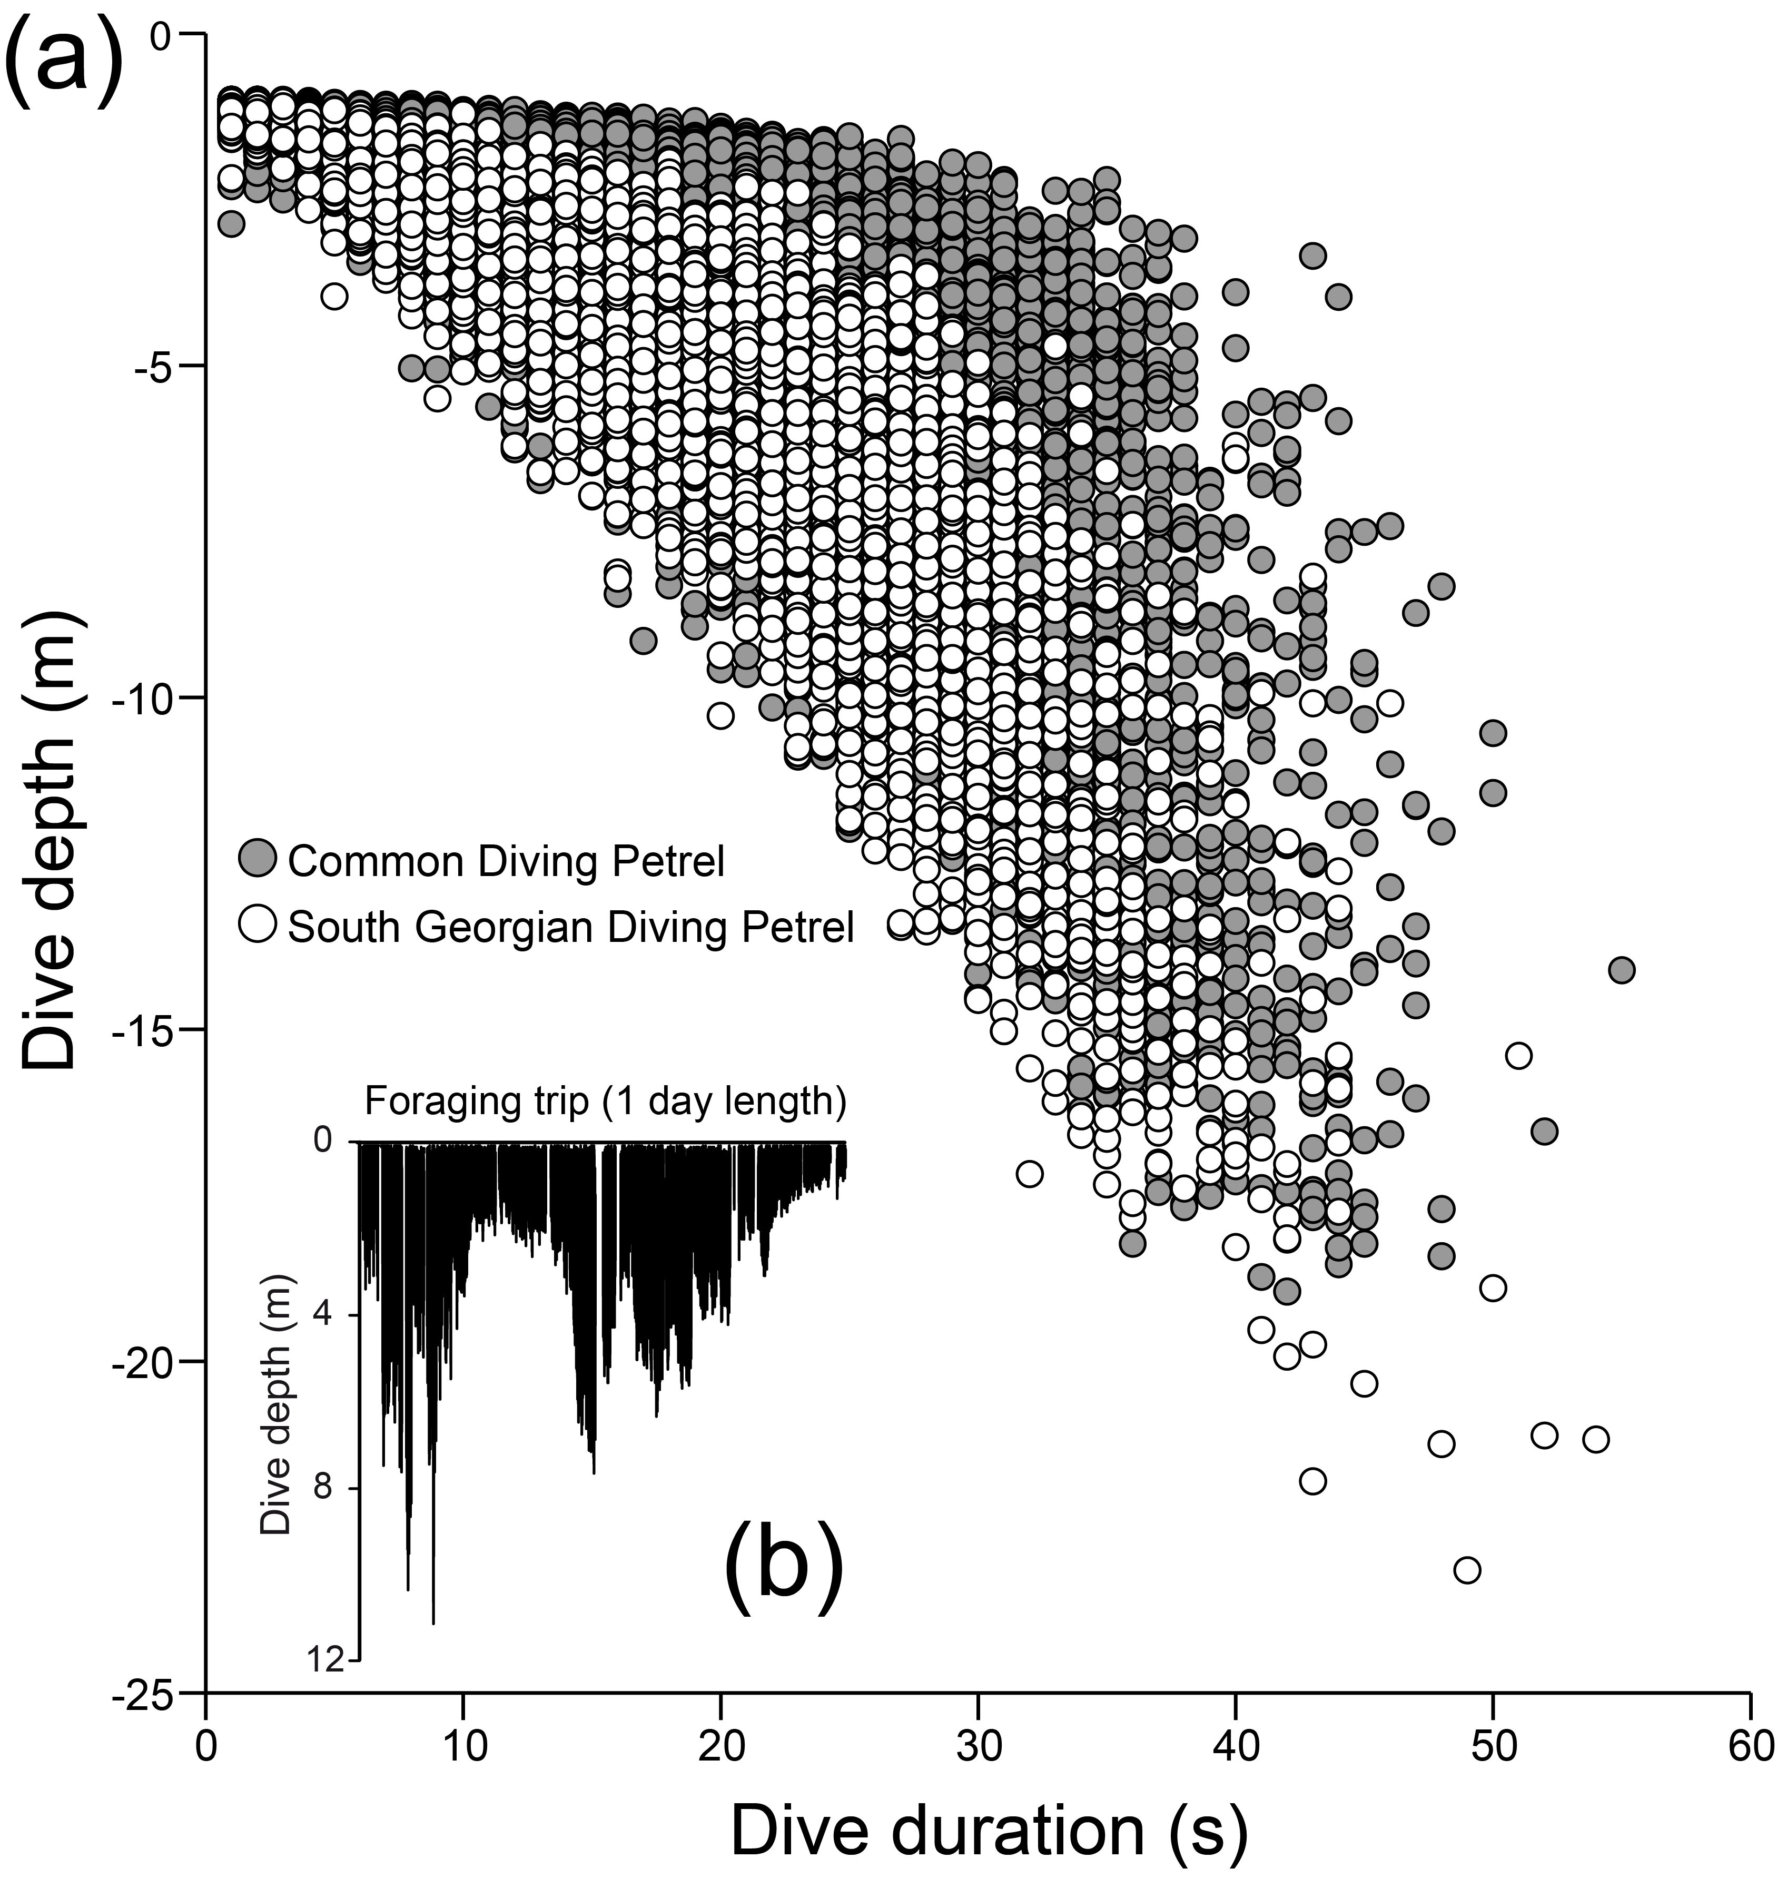

Figure 3


