Inter-year differences in survival of Atlantic puffins Fratercula arctica are not associated with winter distribution

Michael P. Harris • Francis Daunt •
Maria I. Bogdanova • José J. Lahoz-Monfort •
Mark A. Newell • Richard A. Phillips •
Sarah Wanless

Received xx xxxx 2013

Communicated by xxxxxxxx

M.P. Harris (x) • F.Daunt • M.I. Bogdanova • M.A. Newell
Centre for Ecology & Hydrology, Bush Estate, Penicuik, Midlothian EH26 0QB, UK
Email: mph@ceh.ac.uk
J.J. Lahoz-Monfort
School of Botany, University of Melbourne, Parkville 3010, Victoria, Australia
R. A. Phillips
British Antarctic Survey, Natural Environment Research Council, High Cross, Madingley Road, Cambridge CB3 0ET, UK

Abstract Miniature geolocator loggers (Global Location Sensing (GLS)) that provide daily locations of birds have revolutionized the study of winter ecology and migration patterns of seabirds. A long-term study of ringing recoveries and analyses of heavy metals and pollutants in tissues of Atlantic puffins Fratercula arctica from the Isle of May, southeast Scotland suggested that this population wintered mainly within the North Sea. However, deployment of GLS devices over the 2007/08 winter showed that many breeding birds made major excursions into the east Atlantic. This winter was the second of two when survival was extremely low (survival in 2006/07 and 2007/08 was 0.696 and 0.695, respectively, compared to the average of 0.922 over the period 1984/85–2005/06). These low rates of survival suggested that the unexpected use of the Atlantic might have been associated with unusually poor conditions in the North Sea as indicated by very low breeding success in 2007. Survival rate returned to previous levels in 2008/09 providing the opportunity to test whether higher survival was associated with birds remaining in the North Sea, or whether movements into the Atlantic are a feature of this population unrelated to survival. Accordingly geolocators were deployed over the 2009/10 winter when adult survival was subsequently established to be high (0.913). We found greater support for the hypothesis that winter distribution is not associated with survival. Thus 8 (40 %) of 20 individuals followed in 2009/10 went into the Atlantic, a rate not significantly different from 11 (58 %) of the 19 followed in the 2007/08 winter. Indeed, birds actually spent longer in the Atlantic and used a wider variety of areas in 2009/10, although the time spent away from the colony was significantly shorter than in 2007/08.
Since our data were from individuals that survived, remaining in or moving out of the North Sea can both be successful strategies during winters when the population as a whole shows either high or low survival rates. Unfortunately, we do not know where birds that died had gone and hence the relative survival of birds that did or did not move into the Atlantic. Determining the link between survival and wintering area for any seabird remains a formidable challenge and will have to await the development of technologies that can determine both where and when birds die.

Introduction

Although the breeding biology of many seabirds is well documented, until recently there was a major gap in our knowledge of seabird migration and wintering areas. What little information there was came mostly from recoveries of ringed birds killed by hunters or washed up on beaches, both of which undoubtedly give biased results (Wernham et al. 2002). Surveys of birds at sea can indicate important feeding areas but in most cases it is impossible to know from which colonies the birds originated, their age or breeding status. Numbers of breeding seabirds are declining at many colonies in the northeast Atlantic (Barrett et al. 2006; JNCC 2012), and since most mortality appears to occur outside the breeding season (Newton 1998), information on distribution during the nonbreeding period is an essential pre-requisite for identifying the key environmental drivers of these changes.
The development of miniature geolocator loggers (Global Location Sensing (GLS)) that provide locations of birds on a daily basis, has revolutionized the study of the winter ecology and migration patterns of seabirds (Wilson et al. 1992; Hill 1994; Guilford et al. 2009; Egevang et al. 2010; Frederiksen et al. 2012). In many cases, the findings have confirmed conclusions based on ringing recoveries and at-sea surveys, but in others there have been unexpected results. For instance, recent GLS data from northern gannets Morus bassanus breeding in Canada indicate that the Gulf of Mexico is a much more important wintering area than previously suspected, and moreover, that a few individuals regularly migrate across the Atlantic to winter off northwest Africa (Fifield 2011, Montevecchi et al. 2012). Similarly, GLS data from Westland petrels Procellaria westlandica from New Zealand colonies revealed that birds wintered on the Patagonian shelf, a region where the species had previously not been recorded, presumably because birds had been misidentified as white-chinned petrels P. aequinoctialis (Landers et al. 2011).
Geolocators provide new opportunities to explore links between winter movements and seabird population dynamics. Timing of movements and winter destinations may vary between years depending on environmental conditions or intrinsic mechanisms such as density dependence or carry-over effects (Newton 2008; Inger et al. 2010; Bogdanova et al. 2011; Catry et al. 2013). Such variation may have major consequences for survival probability. In this study, we used geolocators to explore the link between winter distribution and survival in the Atlantic puffin Fratercula arctica (hereafter puffin), an abundant and widespread species in the northern North Atlantic where numbers are currently declining at many colonies (Harris and Wanless 2011). Despite large numbers of puffins being ringed, there are few recoveries and hence the wintering grounds of most puffin populations remain poorly known (Harris and Wanless 2011). However, deployments of geolocators at three colonies in the British Isles (Skomer, southwest Wales, Skellig Michael, southwest Ireland and the Isle of May, southeast Scotland) have started to clarify the situation. The studies on Skomer and Skellig Michael confirmed the long held belief that puffins breeding in western Britain disperse widely to the west Atlantic and west Mediterranean outside the breeding season (Harris 1984b; Guilford et al. 2011; Jessopp et al. 2013). In contrast, work on the Isle of May challenged the view based on ring recoveries and heavy metal/pollutant levels that this population remains in the North Sea in winter (Harris 1984a; Harris 1984b). Rather, the geolocation work showed that almost half of the tracked birds left the North Sea for some of the time and made major excursions into the east Atlantic (Harris et al. 2010). However, the 2007/08 winter when these data were collected, coincided with the second of two years when long-term demographic monitoring indicated that adult survival rates were greatly reduced. Thus, after a 50 year period of population increase at c.10% per annum, the breeding population declined by 30% between 2003 and 2008 (Harris and Wanless 2011). The reason for the exceptionally low survival over the 2006/07 and 2007/08 winters was not unequivocally established but the geolocation results hinted at the possibility that poor survival could have been associated with changes in wintering area and longer distances migration. Return rates of marked adults over the 2008/09 winter indicated that the survival of Isle of May puffins had returned to the higher levels typical of the previous three decades (Harris and Wanless 2011). This recovery provided us with the opportunity to test whether migration into the Atlantic of Isle of May puffins was a short term response associated with temporarily adverse conditions in the North Sea or a regular feature of this population that occurs irrespective of the conditions experienced during the breeding and nonbreeding periods.

Materials and methods
Field methods
Deployments were carried out on the Isle of May, southeast Scotland (56º11’N, 2º34’W) during the late chick-rearing stage, 28 June–4 July 2007 and 24–25 June 2009. Geolocators (British Antarctic Survey, Mark 14) were attached, under licence from Scottish Natural Heritage to adult puffins with chicks caught in their burrows (N = 50 in 2007 and N = 26 in 2009). Each device measured 20 x 9 x 5.5 mm, had a mass of 1.5 g and was attached to a coloured plastic leg ring. A numbered metal ring and a coloured ring were placed on the other leg to allow individual recognition in the field. In total these attachments represented ~0.9 % of the mean mass of puffins rearing a chick on the Isle of May (390g).The attachment procedure took 3–5 min after which the bird was returned to its burrow. To minimise disturbance, burrows were not checked again so breeding success of the instrumented birds was unknown.
Puffins at some colonies, including the Isle of May, are intolerant of handling, particularly when extracted from the burrow. Effects are usually only apparent for a few days and the birds do not abandon the breeding colony (reviewed in Harris and Wanless 2011). We used light data and immersion data recorded by the geolocators (see below) to check burrow attendance of birds after the attachment of loggers. We also compared the return rates the next year of birds with devices with those of colour-ringed adults checked as part of a long-term population study in another part of the colony.
Twenty-two (44 %) and 21 (81 %) devices deployed in 2007 and 2009, respectively, were retrieved by catching birds at, or in front of, the original or an adjacent burrow in subsequent years. Four devices had failed but we obtained data on the movements of 19 birds during the 2007/08 winter (full information on 13 of these is given in Harris et al. 2010) and 20 birds during the 2009/10 winter. Thirty-six birds were sexed using DNA extracted from 2-3 breast feathers taken under UK Home Office licence when the loggers were retrieved (Griffiths et al. 1996). Although there were more males (25) than females (11) in our study sample, the ratio did not differ significantly from equality (χ ²₁ = 2.83, P = 0.09). Visual inspection of the data suggested no obvious differences between the sexes in their overwinter behaviour so data for males, females and unsexed birds were pooled.
The survival of adult puffins on the Isle of May was assessed between 1984 and 2011 in an area 300 m away from the area where the geolocators were deployed. Breeding puffins were caught in burrows in front of a permanent hide and marked with a numbered metal ring and a unique combination of three colour-rings which together had a total mass of 2.0 g which compared with 3.5 g for birds with loggers. Searches for these birds were made in each subsequent year. Following recruitment to a breeding population, a puffin rarely, if ever, breeds more than a few metres away from its original burrow (Harris and Wanless 2011). Hence, resighting effort was concentrated in the area were birds were marked, although checks were periodically made of nearby areas. Throughout the study, additional birds were marked to replace those disappearing from the marked population.
Adult survival in the Isle of May population from year _{t} to year _{t+1} is positively correlated with mean breeding success and chick mass at fledging in year _{t} (Harris & Wanless 2011). We therefore used these two variables as proxies to investigate the possible effect of conditions during the breeding season on subsequent overwinter survival. Annual values for breeding success and chick condition were obtained between 1984 and 2010. The former was estimated as the proportion of burrows with eggs from which a chick fledged (N = 150–200 burrows), and the latter was the mean mass at fledging of chicks weighed daily when near fledging ( N = 25–35 chicks; details in Harris and Wanless 2011). The first date that an egg was recorded (either directly or back-calculated from the date when puffins were first seen bringing fish into the colony, or from chicks aged from their bill or wing measurements assuming an incubation period of 41 days) was used as an index of the timing of breeding.

Analysis of logger data
Light data were processed following Phillips et al. (2004) in Multitrace-geolocation (Jensen Software Systems). Briefly, timing of dawn and dusk were estimated from light curves using a threshold of one and angles of sun elevation of -6º and -5º for the loggers deployed in 2007 and 2009, respectively, the different angle reflecting the lower light sensitivity of the loggers manufactured in 2009. Latitude was derived from day length, and longitude from the timing of local midday in relation to GMT and Julian day. This procedure produces two locations per day. Although use of low light thresholds partly overcomes problems of interference in the light curves at dawn or dusk, in the 2007/08 winter, 939 locations (13.2 % of those from outside the equinox periods) were later excluded either for this reason or because they required implausible rates of travel to achieve (apparently erroneous locations identified visually in ArcGIS). This resulted in a total of 6196 validated locations (146–421 per individual). In the 2009/10 winter, 2131 locations (24.6 % of those outside the equinox periods) were excluded for the same reasons, resulting in 6536 validated locations (223–431 per individual). Locations were unavailable for variable periods between 2 September–4 November 2007 and 12 February–4 April 2008, and 31 August–25 October 2009 and 15 February–17 April 2010, when latitude estimation was not possible because of proximity to the equinoxes (Wilson et al. 1992). However, longitudes were available for all birds during these periods and could be used to determine whether a bird was in the Atlantic or North Sea. All validated locations were smoothed twice, following Phillips et al. (2004). Kernel density maps in a Lambert equal-area azimuthal (North Pole) projection were generated in ArcGIS (Hawth Tools), with a cell size of 50 km and a search radius of 200 km (Croxall et al. 2005; Phillips et al. 2005). Three loggers failed part-way through the 2007/08 winter and there was light interference in three loggers at the start of the 2009/10 winter. Hence, sample sizes vary slightly between seasonal kernel densities. We defined the Atlantic as the area west of the Orkney and Shetland Islands, extending this boundary along the 1ºW meridian north of these islands; the area east of this boundary was defined as the North Sea. The inherent error in GLS positions of flying seabirds is ± ~185 km (Phillips et al. 2004). Therefore, when >95% of GLS locations occurred east of the longitude separating the 'North Sea' from 'Atlantic waters', birds were considered to have remained in the North Sea.
The loggers stored light readings taken every 10 min. These ranged from zero (no light during the night or when the bird was down a burrow) to 64 (full light), and allowed us to define the length of each day. Each logger had a saltwater sensor that registered every 3 s whether or not it was submerged and summed the number of such immersions in each 10 min period to give a value from 0 (dry over entire period) to 200 (immersed over entire period). Dry periods include when a bird is in flight, on land or, as has been noted for auks in aquaria, short periods asleep on the water when the leg and foot can be tucked into the plumage (C.J. McCarty, T. DiMarzio, Z. Eppley, D.A. Oehler, and S. Cruciger personal communications). Combining the light and immersion data allowed us to separate when a bird was likely to be above ground at the colony (periods, often prolonged at the end of the breeding season since puffins visit the colonies for many days after their chick has fledged, of constant light and no immersion during the day) from when it was down a burrow (periods during daylight hours when the light reading was zero, usually preceded and followed by periods on the colony surface). Constant light and no immersion could also indicate flight but such periods during the breeding season were usually of short duration with sporadic readings from the saltwater sensor, presumably due to residual moisture or salt even when the leg was retracted into the bird’s plumage. Data derived from the loggers agreed well with field observations of colony attendance and behaviour of large numbers of puffins ashore on the Isle of May. We therefore used data from the loggers to determine the dates of first and last visits to the colony and the burrow for individual birds.
Data from two loggers that failed on 20 and 21 November 2007, respectively, when the birds were in the Atlantic were excluded from the analysis of total time spent away from the colony. When testing for a difference in time spent in the Atlantic between the two winters, we took a conservative approach and assumed that these two birds had remained in the Atlantic until 26 March, the latest date recorded for the other 17 birds that travelled there in either winter. Another device failed on 31 December 2007, two months after the bird had returned from the Atlantic to the North Sea. We assumed that this bird remained in the North Sea thereafter, as no bird made two excursions into the Atlantic during the same winter. One logger failed to record saltwater immersion after 31 March 2010. At this point the bird had not returned to land so we took a conservative view and assumed that it did so on 4 April, the latest date for any of the other 19 birds tracked that spring. Repeating analyses tests excluding these assumed values did not alter any of our conclusions and had no effect on whether or not any differences were statistically significant.

Adult survival analysis
Resightings of puffins ringed as breeding adults were modelled with the Cormack-Jolly-Seber (‘CJS’) model (Williams et al. 2002), which has year-dependent survival and resighting probabilities, $ϕ\left(t\right)$ and $p\left(t\right),$ respectively, and no age structure (since the ages of the ringed puffins were not known). Permanent emigration is confounded with true mortality in the CJS model and survival is therefore often termed ‘apparent survival’. Nevertheless, puffins that are established breeders have high colony fidelity, such that apparent survival will be close to true survival. Previous analyses (Harris et al. 2005) have demonstrated some heterogeneity in resight probability in the form of ‘trap dependence’, i.e. birds have different probability of being resighted depending on whether or not they were seen the previous season (Pradel 1993). A structure with 1-year trap-dependence in resighting probability was therefore included in the model (details in Lahoz-Monfort et al. 2011).
The analysis was conducted within the Bayesian framework in program JAGS v2.2.0 (Plummer 2003), using uninformative priors for all variables. Convergence of the MCMC chains was assessed visually and with the Gelman–Rubin diagnostic $\hat{R}$ (Gelman and Rubin 1992) calculated in the R package CODA (Plummer et al. 2006), using three chains started at different values. The analysis suggested that a burn-in period of 50000 samples ensured convergence ($\hat{R}≤1.01$ for all parameters). Marginal posterior distributions were characterised using 50000 MCMC iterations per chain after a burn-in of 50000, and point estimates (medians) and 95% symmetric credible intervals ('95 % CI', defined as limited by quantiles 2.5% and 97.5 %; King et al. 2009) were obtained by pooling all samples from the 3 chains. Model fit was assessed with the Bayesian P-value (King et al. 2009), using the Pearson $χ^{2}$ test statistic as a measure of discrepancy between observed and simulated data. The Bayesian P-value obtained (0.84) did not show strong evidence of lack of fit.
The percentage of variation in survival explained by each covariate (breeding success and chick mass at fledging) was estimated in the framework of random effects models (Loison et al. 2002). Using a logit link-function for survival, a first model was fitted assuming a constant mean and a normally-distributed year random effect with variance $σ^{2}$ corresponding to the overall year-to-year variation on the logit scale. A second model was then fitted with a covariate and a random effect with residual variance $σ_{res}^{2}$. The percentage of variance explained by the covariate was estimated as $\left({\hat{σ}}^{2}-{\hat{σ}}_{R}^{2}\right)/{\hat{σ}}^{2}$.

Results
Device effects
Of the 39 birds fitted with devices that downloaded successfully, light and immersion data indicated that 16 (41 %) visited a burrow (presumably their own) within 2 days of logger deployment, 18 (46 %) did so 3–25 days after logger deployment, and 5 (13 %) never entered a burrow again that season despite continuing to visit the colony. Normally, a puffin visits its burrow several times a day to feed its chick; hence, it appeared that GLS deployments had disrupted the attendance behaviour of ~60 % of birds i.e. those which took >3 days to go down their burrow or deserted completely. Although four of the five birds that did not return to their burrow were the earliest to leave the colony, departure dates for the remainder accorded broadly with typical departure dates from the Isle of May i.e. the second half of July, although detailed observations for the two seasons were not available. There was no evidence that the level of device-related disruption (estimated as the number of days between logger deployment and return to a burrow or, for birds that never re-entered the burrow, the number of days between deployment and the mean date when birds with loggers left the colony) was related to whether the bird left the North Sea (t₃₂ = 0.63, P = 0.53).
Twenty-five (50 %) of the GLS birds from 2007 were seen back at the colony in 2008. This return rate did not differ significantly from that of the colour-ringed adults used in the survival analyses (see below) that were checked more intensively (58.8 %, N = 148, χ²₁ = 1.17, P = 0.28). Similarly, of the 26 GLS birds in 2009, 25 (96.2 %) were seen in 2010, a value which did not differ significantly from that of colour-ringed birds (90.9 % (140/154); Fisher exact test, P = 0.70). Return rates of GLS birds did not, therefore, differ from those of colour-ringed birds in either winter indicating that the devices had not adversely affected survival and, crucially, that survival of GLS birds mirrored that of birds in the demographic study.

Wintering areas
Puffins from the Isle of May showed considerable variation in their overwintering areas (Fig. 1). Over the two winters combined, 20 individuals (51 %) remained within the North Sea throughout the winter with 14 (36 %) staying within ~300 km of the colony and six (15 %) spending some time in the central North Sea towards southwest Norway. The other 19 individuals (49 % of those tracked) remained in the northwest North Sea for a few days to several months after leaving the colony, before travelling west around the north of Scotland into the Atlantic. Here they dispersed widely, with individuals heading west to Greenland (35ºW), north to Iceland (67ºN) and south to the Bay of Biscay (45ºN), in some cases spending time in more than one of these regions (Fig. 2). The six individuals that spent time off southwest Ireland and in the Bay of Biscay were there mainly between January and March and returned to the North Sea via the west and north of Scotland and not through the English Channel. Fewer puffins left the North Sea in 2009/10 compared to 2007/08 but the difference was not statistically significant (8 of 20 compared to 11 of 19; Fisher exact test, P = 0.34).

Wintering phenology
Field observations indicated that first return dates to the colony and first egg dates were 2 and 15 April in 2007, 1 and 19 April in 2008, 16 March and 1 April in 2009 and 8 March and 2 April in 2010. Prior to 2007, average values for the Isle of May were 20 March (N = 32 years) for first return, and 8 April (N = 34 years) for first egg, suggesting that 2007 and 2008 were relatively late breeding seasons while 2009 and 2010 were relatively early. No field observations were made of when birds left the colony in 2007 and 2009 but results for the GLS birds indicated that although the 2007 breeding season was late compared to that of 2009, puffins left the colony earlier (Table 1). However, in accord with the observational data, birds returned later in 2008 compared to 2010. Therefore, on average, puffins were away from the colony for 19 days more in the 2007/08 winter compared to the situation in 2009/10.
In 2007 the 11 birds that entered the Atlantic left the colony significantly earlier than the nine that remained in the North Sea (medians 21 July and 25 July; Mann-Whitney W = 108.5, P = 0.02). However, the first three GLS birds to leave (on 5, 17 and 17 July) were all birds that had deserted their burrows after deployment so the early departure could well have been associated with our disturbance. In 2009 the median departure dates of birds that went to the Atlantic and those that stayed in the North Sea were identical (both 27 July). In 2008, birds that had been to the Atlantic returned to the colony 4 days earlier than those that had not whereas in 2010 the situation was reversed with Atlantic birds returning 2 days later. However, neither of these differences was statistically significant (Mann-Whitney tests, both P > 0.53). Although puffins were away from the colony for longer in 2007/08 than 2009/10 (see above), in neither winter was there a significant difference between North Sea and Atlantic birds (medians both 257 days in 2007/08 and 238 and 240 days in 2009/10; Mann-Whitney tests, P > 0.90). However, the birds that migrated into the Atlantic in 2009/10 spent significantly longer there compared to those in 2007/08 (129.5 days compared to 79 days, Mann-Whitney test W = 76, P = 0.006) and appeared to range more widely (Fig. 2).

Overwinter survival
Overwinter survival rates of breeding puffins on the Isle of May averaged 0.922 over the period 1984/5-2005/06 (Table 2). Survival in the next two seasons was extremely low (0.696 in 2006/07, 0.695 in 2007/08), falling well outside the 95 % CI of the mean for the earlier years. However, values returned to normal levels in 2008/09 and 2009/10. Marked annual variation in breeding success and chick mass at fledging was also apparent over this period with values being low in 2007 and 2008 (Table 2). Breeding success and fledging mass were significantly correlated (r = 0.513, P = 0.007, N = 27) and in the survival model the regression coefficients for both covariates were significantly different from zero, with medians (and 95 % CI) of 0.36 (0.12, 0.61) and 0.40 (0.15, 0.66), respectively. Approximately 33 % and 31 % of the variation in annual adult survival was explained by these two factors, suggesting a considerable carry-over effect of the conditions during the summer on survival over the following winter.

Discussion
The attachment of a device, however small, to a bird has the potential to disrupt its behaviour and compromise its survival. Such effects are particularly likely in species like the puffin that have a high wing loading (Vandenabeele et al. 2012). Puffins fitted with ring-mounted geolocators were initially disturbed by the GLS deployments although whether this was due to handling stress, the additional mass of the device or a combination of these effects is unclear (Harris et al. 2012). Several studies have demonstrated that ring-mounted geolocators do not adversely affect breeding success (e.g. Quillfeldt et al. 2012) although few appear to have monitored the behaviour of birds immediately after deployment at the end of the breeding season (but see Carey et al. 2009). Thus there is currently little information with which to assess whether adverse short-term effects are common. In 2007 and 2009 we found that GLS puffins were less likely to visit burrows in the days following deployment, and a similar effect was apparent when puffins were fitted with larger and heavier back-mounted Global Positioning System loggers in 2010 (Harris et al. 2012). Breeding success differed between 2007 and 2009 (Table 2) and thus disruption associated with loggers appeared to have occurred irrespective of conditions. However, it seems likely that severe effects were relatively short-lived, and colony departure dates of most GLS birds accorded well with patterns at this colony (Harris and Wanless 2011). Thus, as far as we could tell departure dates of the majority of GLS puffins were unaffected, and we assumed that scheduling of other events during the autumn and winter was not disrupted.
Elliott et al. (2012) found that guillemots Uria spp. fitted with ring-attached geolocators had higher levels of corticosterone and lower body masses than controls when the devices were retrieved the following year. Although survival was not depressed, the authors concluded that even these very small devices caused chronic stress. Similarly, the attachment of geolocators to thin-billed prions Pachyptila belcheri appeared not to influence overwinter survival or foraging ecology but the birds’ hormonal response to stress differed from those of controls one year later (Quillfeldt et al. 2012). We did not record body mass or corticosterone levels so cannot rule out similar chronic effects of stress to these. However, return rates of GLS puffins did not differ from colour-ringed birds in either the low or high survival winter. From this we concluded that (1) even when conditions were severe, geolocators had not caused any substantial additional mortality and (2) behaviour and location data could be used to test whether differences in overwinter survival were associated with differences in the scheduling of overwinter events and/or the tendency to leave the North Sea.
Elevated adult mortality rates in 2006/07 and 2007/08, combined with a similar increase in the mortality of immature puffins were sufficient to explain the 30 % decline in the breeding population on the Isle of May between 2003 and 2008 (Harris and Wanless 2011). Based on our preliminary findings for the 2007/08 winter that 77 % of 13 GLS birds spent some time in the Atlantic, we speculated that the high mortality was associated with poor conditions in the North Sea forcing birds to leave their normal wintering grounds (Harris et al. 2010). Breeding success and chick mass at fledging were also unusually low in 2007 suggesting that conditions in the North Sea, at least in the waters around the Isle of May, had been unfavourable during the summer and thus it was plausible that bad conditions extended into the autumn and winter. Retrieval of six more loggers in subsequent seasons that are included in the current analysis supported our original view, and final figures indicated that 58 % of the puffins had visited the Atlantic during the 2007/08 winter. Survival over the 2009/10 winter was markedly higher than that in 2007/08 and thus, if migration into the Atlantic was a response to unfavourable conditions for overwinter survival in the North Sea, fewer birds should have moved into the Atlantic. Although the proportion of birds leaving was indeed lower in 2009/10, the difference was not statistically significant. Furthermore, although puffins were away from the colony for longer during the 2007/08 winter, those that went into the Atlantic were there for longer in 2009/10 i.e. they spent proportionally longer there when survival was high. Thus, we found no support for the hypothesis that more Isle of May puffins would remain in the North Sea when conditions as indicated by higher adult survival, were good.
Our results therefore support the alternative hypothesis that excursions into the Atlantic are currently a regular feature of the overwintering behaviour of puffins on the Isle of May and occur irrespective of conditions experienced during the breeding season as indicated by breeding success and chick condition, or during the winter as indicated by adult survival. This contrasts with the previously held view, based on the comparison of ringing recoveries and pollutant levels of birds from the Isle of May and St Kilda off the west coast of Scotland, that puffins from North Sea colonies remain in the area throughout the year (Harris 1984a, 1984b). No recent data on pollutant levels are available to check if these indicate any changes, but ringing recoveries of Isle of May puffins from around 2000 onwards indicate increased usage of the waters around the Faeroes, Orkney and Shetland. However, unequivocally resolving whether the wintering range of Isle of May puffins has actually expanded into the Atlantic since the turn of the century or whether birds have always used the area but the methods to demonstrate this have previously been lacking, may never be possible. Nevertheless, changes in puffin migration behaviour are certainly plausible because environmental conditions have changed markedly. The North Sea has undergone substantial oceanographic and environmental changes including several regime shifts in recent decades (Alvarez-Fernandez et al. 2012) and the winter distribution of puffins might have responded to conditions at these decadal time scales, as opposed to annual variation in conditions. The limited information available on the diet of puffins during the winter suggests that they eat a wide range of small fish and zooplankton (Falk et al. 1992; Hedd et al. 2010). Thus, establishing whether puffin winter distribution is driven by variation in conditions at annual or decadal scales would require better knowledge of puffin diet, annual scale data on the distribution of important prey species and a substantially longer run of overwinter distribution data than the two years we currently have available.
In neither winter did whether or not a bird had left the North Sea significantly influence the date it returned to the colony. In 2007/08 most puffins had returned from the Atlantic by January and so broadly overlapped with North Sea birds in the period prior to colony reoccupation. In contrast, in 2009/10 many birds remained in the Atlantic until mid-February and so had less opportunity to synchronise arrival at the colony with the North Sea wintering birds. In many bird species, including puffins, pairs that breed early are more successful (Drent et al. 2003). Although sample-sizes were low and we had no information on laying dates of the geolocator birds, there was no evidence to support the view that annual differences in overwintering phenology resulted in differences in breeding phenology.
The distance that puffins moved away from the Isle of May varied markedly. Some individuals remained within a few hundred kilometres of the colony over the entire winter while others travelled thousands of kilometres around the north of Scotland into the Atlantic (Fig.1). Similar individual variation in migration distances and wintering areas has also been recorded for puffins from Skomer and Skellig Michael, although none of these birds stayed close to the breeding colony (Guilford et al. 2011; Jessopp et al. 2013). In addition, Guilford et al. (2011) found that individual puffins were consistent in the areas where they wintered in successive winters. Repeatability in wintering areas has been recorded in several other seabirds (e.g. Yelkouan Shearwater Puffinus yelkouan; Raine et al. 2012) and may well be a common feature (although see Dias et al. 2011). Our study was not designed to investigate individual consistency but three geolocators deployed in 2007 which were not retrieved until 2009, recorded data for two winters. All three birds used the same areas in both winters, two remaining within the northwest North Sea while the third wintered towards southwest Norway. The statement to the contrary in Harris and Wanless (2011) was based on a few fixes just west of Shetland during the autumn equinoxes that are now considered unreliable. Assuming that results from the Isle of May, Skellig Michael and Skomer are representative of these breeding populations, indicates that there is considerable overlap of wintering areas of birds from all three colonies in the Atlantic but only Isle of May birds are present in the North Sea. Our results also indicate that Isle of May puffins enter and leave the Atlantic around the north of Scotland even when they are destined for areas off southwest Ireland. It was previously assumed that puffins ringed on the Isle of May and recovered in the Bay of Biscay and nearby areas, had taken the more direct route through the English Channel (Harris 1984a). Puffins are extremely uncommon in the southern North Sea (European Seabirds at Sea Specialists Group data in Harris and Wanless 2011) so it may well be that these previous records were also for birds that had taken the northern route.
Our results have implications for understanding synchrony in the survival of adult puffins at widely separated colonies. Between 1984 and 2002, patterns of inter-year variation in adult survival at the Isle of May, Fair Isle (Shetland), Skomer, Røst and Hornøya (Norway) were similar, despite the fact that ringing recoveries of birds from these colonies suggested that in some cases wintering areas did not overlap (Harris et al. 2005). The recent GLS data suggest substantially more overlap which would be consistent with similar patterns of survival for puffins from Skomer and the Isle of May. Ringing recoveries suggest that adult puffins from Fair Isle, which lies on the boundary between the North Sea and the Atlantic, winter mainly in the Atlantic (Wernham et al. 2002). The adult survival rates of puffins from Fair Isle over the 2006/07 and 2007/08 winters were 0.718 and 0.754 respectively, well below the mean of 0.866 (95 % CI 0.850, 0.921) for the previous 20 winters (Fair Isle Bird Observatory Trust unpublished data). The coincidence of low survival for adult puffins from Fair Isle and the Isle of May over these two winters suggests strongly that both populations were adversely affected by some unknown unfavourable environmental conditions in the Atlantic. However, breeding success of puffins on Fair Isle in 2006 and 2007, at 0.47 and 0.17 chicks fledged per egg laid, respectively were, as at the Isle of May, much lower than the long-term average of 0.68 (95 % CI 0.63, 0.75; N = 19 years). Thus, as on the Isle of May, poor survival might also be a carry-over effect of poor conditions during the summer.
Whereas some puffins from the Isle of May, Skomer and Skellig Michael winter over vast tracts of the northeast North Atlantic, migrate thousands of kilometres and in the case of Skomer have individual, and apparently repeatable, migration patterns many birds from the Isle of May, but not the other two colonies, remain within a few hundred km of the colony outside the breeding season (Guilford et al. 2011; Jessopp et al. 2013; this study). Migration is a trade-off between finding a wintering area with a good and predictable food supply, especially critical for a species such as the puffin that is flightless for part of the nonbreeding season when it replaces its main wing-feathers, and the time and energy needed to undertake the migration. A number of studies have demonstrated differential survival probabilities of migratory and resident individuals in partially migratory species (Adriaensen and Dhondt 1990; Gillis et al. 2008; Hebblewhite and Merrill 2011; Sanz-Aguilar et al. 2012). Repeated deployment of loggers on Isle of May puffins over several winters might allow individuals to be classified as ‘North Sea’ or ‘Atlantic’ migrants so enabling survival to be followed in individuals of known migration destination. However, GLS estimates of wintering areas are based on surviving individuals and, if a bird disappears from the population, it is unclear whether it died where it normally wintered or went to a different area. As stressed by Adriaensen and Dhondt (1990), it is not that the alternative strategies should be equally successful (see also Lundberg 1988), but that an individual should travel to the area where its survival is likely to be higher. Our data show that for Isle of May puffins remaining in, or moving out of, the North Sea can both be successful strategies during winters when the population as a whole shows either high or low survival rates. Unfortunately, we do not know the destinations of birds that died and hence the relative survival of birds that did or did not move into the Atlantic. Determining the link between survival and wintering area for any seabird remains a formidable challenge and will probably have to await the development of technologies that can determine both where and when death occurs.

Acknowledgements We thank J. Fox and V. Afanasyev for GLS device development, Scottish Natural Heritage for allowing us to work on the Isle of May National Nature Reserve and the Joint Nature Conservation Committee (on behalf of Natural England, Scottish Natural Heritage the Countryside Council for Wales and the Council for Nature Conservation and the Countryside in Northern Ireland) for financial support for the collection of survival data and three anonymous reviewers for their very positive and helpful comments on a previous version of the manuscript.

References

Adriaensen F, Dhondt AA (1990) Population dynamics and partial migration of the European robin (Erithacus rubecula) in different habitats J Anim Ecol 59: 1077-1090
Alvarez-Fernandez S, Lindeboom H, Meesters E (2012) Temporal changes in plankton of the North Sea: community shifts and environmental drivers. Mar Ecol Progr Ser 462: 21-38
Barrett RT, Lorentsen S-H, Anker-Nilssen T (2006) The status of breeding seabirds in mainland Norway. Atlantic Seabirds 8: 97-126
Bogdanova MI, Daunt F, Newell M, Phillips RA, Harris MP, Wanless S (2011) Seasonal interactions in the black-legged kittiwake, Rissa tridactyla: links between breeding performance and winter distribution. Proc R Soc Lond B 278: 2412-2418
Carey MJ, Meathrel CE, May NA (2009) A new method for the long-term attachment of data-loggers to shearwaters (Procellariidae). Emu 109: 310-315
Catry P, Dias MP, Phillips RA, Granadeiro JP (2013) Carry-over effects from breeding modulate the annual cycle of a long-distance migrant. An experimental demonstration Ecology http://dx.doi.org/10.1890/12-2177.1
Choquet R, Cole DJ (2012) A hybrid symbolic-numerical method for determining model structure. Math Biosci 236: 117-125
Croxall JP, Silk JRD, Phillips RA, Afanasyev V, Briggs DR (2005) Global circumnavigations: tracking year-round ranges of non-breeding albatrosses Science 307: 249-250
Dias MP, Granadeiro JP, Phillips RA, Alonso H, Catry P (2011) Breaking the routine: individual Cory's shearwaters shift winter destinations between hemispheres and across ocean basins. Proc R Soc Lond B 278: 1786-1793
Drent R, Both C, Green M, Madsen J, Piersma T (2003) Pay-offs and penalties of competing migratory schedules. Oikos 103: 274-292
Egevang C, Stenhouse IJ, Phillips RA, Petersen A, Fox JW, Silk JRD (2010) Tracking of Arctic terns Sterna paradisaea reveals longest animal migration. Proc Nat Acad Sci USA 107: 2078-2081
Elliott KH, McFarlane-Tranquilla L, Burke CM, Hedd A, Montevecchi WA, Anderson WG (2012) Year-long deployments of small geolocators increase cortisterone levels in murres. Mar Ecol Prog Ser 466: 1-7
Falk K, Jensen JK, Kampp K (1992) Winter diet of Atlantic Puffins (Fratercula arctica) in the Northeast Atlantic. Col Waterbird 15: 230-235
Fifield DA (2011) Winter areas and migratory tactics of northern gannets (Morus bassanus) breeding in North America. MSc thesis, St John's, Newfoundland
Frederiksen M, Moe B, Daunt F, Phillips RA, Barrett RT, Bogdanova MI, Boulinier T, Chardine JW, Chastel O, Chivers LS, Christensen-Dalsgaard S, Clement-Chastel C, Colhoun K, Freeman R, Gaston AJ, Gonzalez-Solis J, Goutte A, Gremillet D, Guilford T, Jensen GH, Krasnov Y, Lorentsen SH, Mallory ML, Newell M, Olsen B, Shaw D, Steen H, Strom H, Systad GH, Thorarinsson TL, Anker-Nilssen T (2012) Multicolony tracking reveals the winter distribution of a pelagic seabird on an ocean basin scale. Divers Distrib 18: 530-542
Gelman A, Rubin DB (1992) Inference from iterative simulation using multiple sequences. Stat Sci 7: 457-472
Gillis EA, Green DJ, Middleton HA, Morrissey CA (2008) Life history correlates of alternative migratory strategies in American Dippers. Ecology 89: 1687-1695
Griffiths R, Daan S, Dijkstra C (1996) Sex identification in birds using two CHD genes. Proc R Soc Lond B 263: 1251-1256
Guilford T, Freeman R, Boyle D, Dean B, Kirk H, Phillips R, Perrins C (2011) A dispersive migration in the Atlantic puffin and its implications for migratory navigation PLOS One, pp e21336. doi:21310.21371/journal.pone.0021336
Guilford T, Meade J, Willis J, Phillips RA, Boyle D, Roberts S, Collett M, Freeman R, Perrins CM (2009) Migration and stopover in a small pelagic seabird, the Manx shearwater Puffinus puffinus: insights from machine learning. Proc R Soc Lond B 276: 1215-1223
Harris MP (1984a) Movements and mortality patterns of north Atlantic puffins as shown by ringing. Bird Study 31: 131-140
Harris MP (1984b) The Puffin. T. and A.D. Poyser, Calton
Harris MP, Anker-Nilssen T, McCleery RH, Erikstad KE, Shaw DN, Grosbois V (2005) Effect of wintering area and climate on the survival of adult Atlantic puffins Fratercula arctica in the eastern Atlantic. Mar Ecol Prog Ser 297: 283-296
Harris MP, Bogdanova MI, Daunt F, Wanless S (2012) Using GPS technology to assess feeding areas of Atlantic Puffins Fratercula arctica. Ringing and Migration 27: 43–49
Harris MP, Daunt F, Newell M, Philips RA, Wanless S (2010) Wintering areas of adult Atlantic puffins Fratercula arctica from a North Sea colony as revealed by geolocation technology. Mar Biol 157: 827-836
Harris MP, Wanless S (2011) The Puffin. T. and A.D. Poyser, London
Hebblewhite M, Merrill EH (2011) Demographic balancing of migrant and resident elk in a partially migratory population through forage-predation tradeoffs. Oikos 120: 1860-1870
Hedd A, Fifield DA, Burke CM, Montevecchi WA, Tranquilla LM, Regular PM, Buren AD, Robertson GJ (2010) Seasonal shift in the foraging niche of Atlantic puffins Fratercula arctica revealed by stable isotope (delta N-15 and delta C-13) analyses. Aquat Biol 9: 13-22
Hill RD (1994) Theory of geolocation by light levels. In: LeBoef BJ, Laws RM (eds) Elephant seals: population ecology, behaviour and physiology University of California Press, Berkeley, California
Inger R, Harrison XA, Ruxton GD, Newton J, Colhoun K, Gudmundsson GA, McElwaine G, Pickford M, Hodgson D, Bearhop S (2010) Carry-over effects reveal reproductive costs in a long-distance migrant. J Anim Ecol 79: 974-982
Jessopp MJ, Cronin M, Doyle TK, Wilson M, McQuatters-Gollop A, Newton S, Phillips RA (2013) Trans-Atlantic migration by post-breeding puffins: a strategy to exploit a temporary abundant food source. Mar Biol in press
JNCC (2012) Seabird Population Trends and Causes of Change: 2012 Report (http://www.jncc.defra.gov.uk/page-3201). Joint Nature Conservation Committee. Updated July 2012. Accessed 1 December 2012.
King R, Morgan BJT, Gimenez O, Brooks SP (2009) Bayesian Analysis for Population Ecology. Chapman & Hall
Lahoz-Monfort JJ, Morgan BJT, Harris MP, Wanless S, Freeman SN (2011) A capture-recapture model for exploring multi-species synchrony in survival. Method Ecol Evol 2: 116–124
Landers TJ, Rayner MJ, Phillips RA, Hauber ME (2011) Dynamics of seasonal movements by a trans-Pacific migrant, the Westland petrel. Condor 113: 71-79
Loison A, Saether BE, Jerstad K, Rostad OW (2002) Disentangling the sources of variation in the survival of the European dipper. J Appl Stat 29: 289-304
Lundberg P (1988) The evolution of partial migration in birds. Trends Ecol Evol 3: 172-175
Montevecchi W, Fifield D, Burke C, Garthe S, Hedd A, Rail J-F, Robertson G. (2012) Tracking long-distance migration to assess marine pollution impact. Biol Letters 8:218-221
Newton I (1998) Population limitation in birds. Academic Press, London
Newton I (2008) The migration ecology of birds. Academic Press, London
Phillips RA, Silk JRD, Croxall JP (2005) Foraging and provisioning strategies of the light-mantled sooty albatross at South Georgia: competition and co-existence with sympatric pelagic predators. Mar Ecol Prog Ser 285: 259-270
Phillips RA, Silk JRD, Croxall JP, Afanasyev V, Briggs DR (2004) Accuracy of geolocation estimates for flying seabirds Mar Ecol Prog Ser 266: 265-272
Plummer M (2003) JAGS: a program for analysis of Bayesian graphical models using Gibbs sampling 3rd International Workshop on Distributed Statistical Computing. http://www.ci.tuwien.ac.at/Conferences/DSC-2003/, Vienna, Austria
Plummer M, Best N, Cowles K, Vines K (2006) CODA: convergence diagnosis and output analysis for MCMC. R News 6: 7-11
Pradel R (1993) Flexibility in survival analysis from recapture data: Handling trap-dependence. In: Lebreton JD, North PM (eds) Marked individuals in the study of bird population. Birkhaeuser Verlag, Basel, SwitzerlandQuillfeldt P, McGill RAR, Furness RW, Moestl E, Ludynia K, Masello JF (2012) Impact of miniature geolocation loggers on a small petrel, the thin-billed prion Pachyptila belcheri. Mar Biol 159: 1809-1816
Quillfeldt P, McGill RAR, Furness RW, Moestl E, Ludynia K, Masello JF (2012) Impact of miniature geolocation loggers on a small petrel, the thin-billed prion Pachyptila belcheri. Mar Biol 159: 1809-1816
Raine AF, Borg JJ, Raine H, Phillips RA (2012) Migration strategies of the Yelkouan Shearwater Puffinus yelkouan. J.Ornithol DOI 101007/s10336-012-0905-4
Sanz-Aguilar A, Bechet A, Germain C, Johnson AR, Pradel R (2012) To leave or not to leave: survival trade-offs between different migratory strategies in the greater flamingo. J Anim Ecol 81: 1171-1182
Vandenabeele SP, Shepard EL, Grogan A, Wilson RP (2012) When three per cent may not be three per cent; device-equipped seabirds experience variable flight constraints. Mar Biol 159: 1-14
Wernham CV, Toms M, Marchant JH, Clark J, Siriwardena G, Baillie SR (2002) The migration atlas; movements of birds of Britain and Ireland. T. & A.D.Poyser, London
Williams BK, Nichols JD, Conroy MJ (2002) Analysis and management of animal populations. Academic Press, San Diego
Wilson RP, Ducamp JJ, Rees G, Culik BM, Niekamp K (1992) Estimation of location: global coverage using light intensity In: Priede IM, Swift SM (eds) Wildlife telemetry: remote monitoring and tracking of animals. Ellis Horward, Chichester

Fig. 1 The distributions of two Atlantic puffins from the Isle of May during the 2009/10 winter. Place names mentioned in the text are shown in the top panel. The position of the Isle of May is indicated by a star. Bird 8801 (middle panel) was absent from the colony from 27 July until 23 March but never left the northwest North Sea. Bird 8803 (bottom panel) was last recorded ashore at the colony on 19 July, went west around the north of Scotland on 26 July towards Greenland to 35ºW, returned east to spend three months off southwest Ireland, re-entered the North Sea in late January and was back at the colony on 26 March

Fig. 2 Kernel density distribution of Atlantic puffins in August, September, October, November, December, January, February and July -April over the 2007/08 and 2009/10 winters. Sample sizes are shown in brackets after the month. Kernels are not shown over land and the apparent use of areas immediately to the west of southern Scotland and northwest England are probably artefacts due to the inherent errors in fixes

Table 1 Schedule of events from departure at the end of the breeding season to return the following spring for Atlantic puffins breeding on the Isle of May. All between-winter comparisons were significant (Mann-Whitney tests all P < 0.01)

 |  |  | 2007/08 winter |  | 2009/10 winter
 | N | Median | Range | N | Median | Range
Last date at colony | 19 | 23 Jul | 5–30 July | 20 | 27 Jul | 19 Jul–2 Aug
First date in Atlantic | 11 | 19 Sept | 1 Aug–10 Nov | 8 | 11 Oct | 26 Jul–13 Nov
Last date in Atlantic | 9 | 1 Dec | 28 Oct–15 Jan | 8 | 19 Feb | 8 Dec–26 Mar
First date at colony | 16 | 4 Apr | 27 Mar–21 Apr | 20 | 23 Mar | 16 Mar–4 Apr
Days spent in Atlantic | 9 | 77 | 28–120 | 8 | 129.5 | 56–240
Days spent away from colony | 16 | 257 | 246–270 | 20 | 238 | 228–251

Table 2 Mean values for Atlantic puffin adult survival, breeding success and mass of chicks at fledging on the Isle of May 1984-2005 and annual values for 2006-10
Survival | 1984/85-2005/06 (95 % CI) |  | 2006/07 | 2007/08 | 2008/09 | 2009/10 | 2010/11
Survival to the following summer |  | 0.922 (0.866, 0.963) | 0.696 | 0.695 | 0.888 | 0.913 | 0.923
Breeding performance | 1984-2005 (95 % CI) |  | 2006 | 2007 | 2008 | 2009 | 2010
Breeding success (chicks fledged burrow⁻¹) |  | 0.73 (0.68, 0.78) | 0.69 | 0.30 | 0.48 | 0.67 | 0.68
Mass at fledging (g) |  | 267 (262, 271) | 222 | 254 | 260 | 266 | 243
For survival, “95 % CI” refers to Bayesian credible interval, for success and mass it is 95 % confidence interval

Figure 1. The distributions of two Atlantic puffins from the Isle of May during the 2009/10 winter. Place names mentioned in the text are shown in the top panel. The position of the Isle of May is indicated by a star. Bird 8801 (middle panel) was absent from the colony from 27 July until 23 March but never left the northwest North Sea. Bird 8803 (bottom panel) was last recorded ashore at the colony on 19 July, went west around the north of Scotland on 26 July towards Greenland to 35ºW, returned east to spend three months off southwest Ireland, re-entered the North Sea in late January and was back at the colony on 26 March.

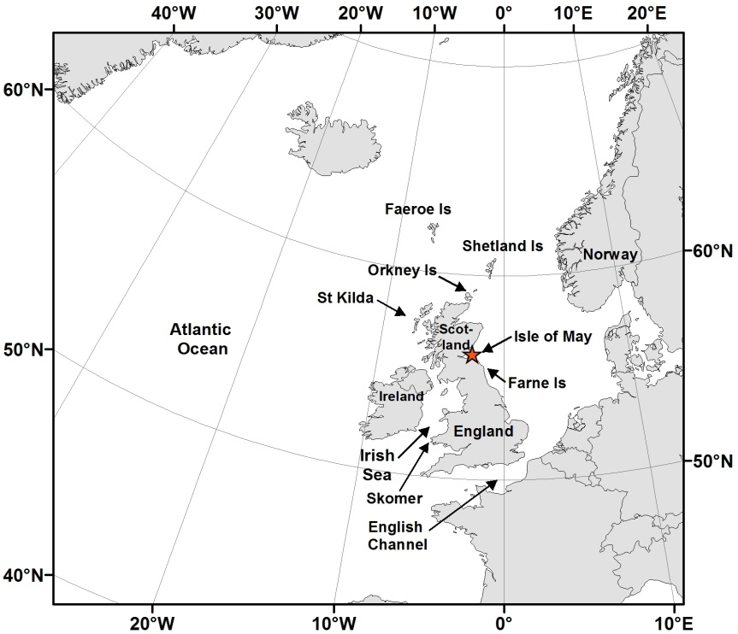
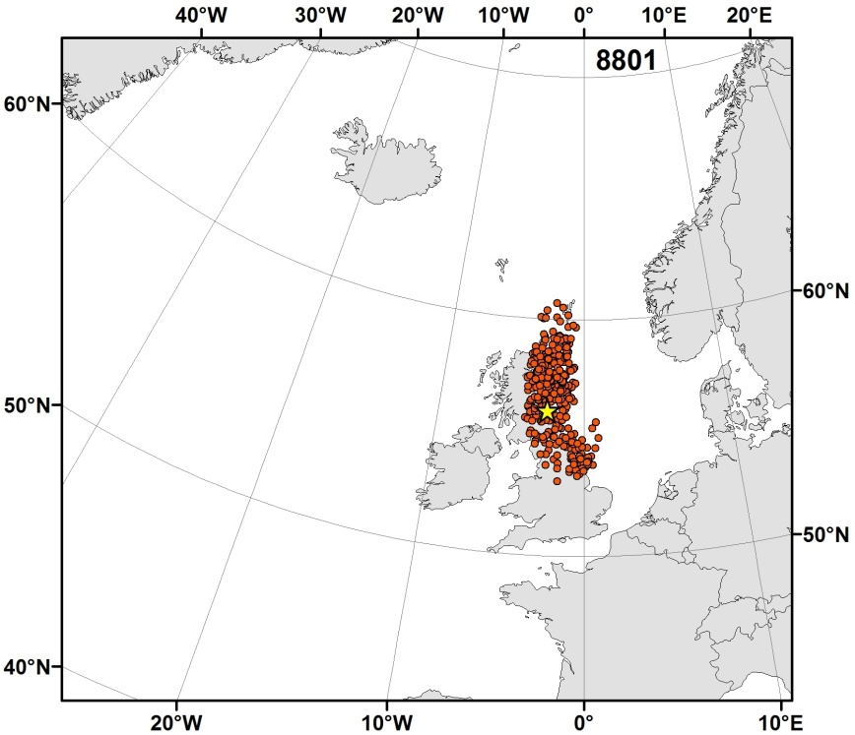
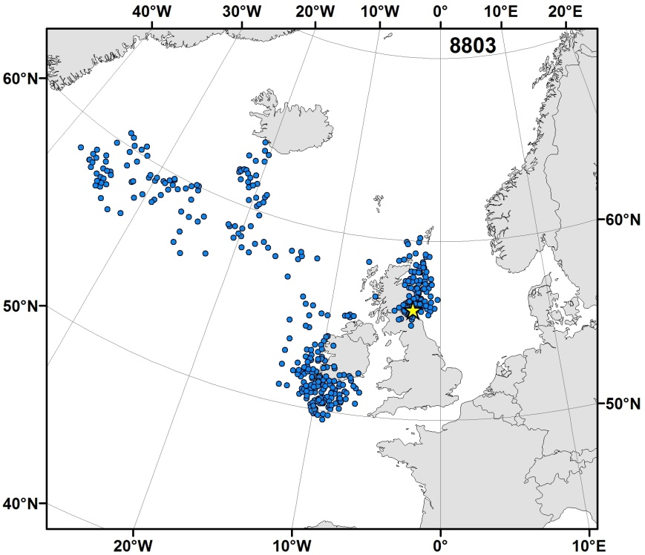

Figure 2. Kernel density distribution of Atlantic puffins in August, September, October, November, December, January, February and July -April over the 2007/2008 and 2009/2010 winters. Sample sizes are shown in brackets after the month. Kernels are not shown over land and the apparent use of areas immediately to the west of southern Scotland and northwest England are probably artefacts due to the inherent errors in fixes.

