Thicker shells compensate dissolution in brachiopods under future ocean acidification and warming

Emma L. Cross†, ‡, Elizabeth M. Harper†, Lloyd S. Peck‡

†Department of Earth Sciences, University of Cambridge, Downing Street, Cambridge, CB2 3EQ, UK.

‡British Antarctic Survey, Natural Environment Research Council, High Cross, Madingley Road, Cambridge, CB3 0ET, UK

KEYWORDS: global warming, climate change, shell dissolution, shell thickness, compensatory mechanisms, phenotypic plasticity, *Calloria inconspicua*, *Liothyrella uva*, Terebratulide

ABSTRACT

Organisms with long generation times require phenotypic plasticity to survive in changing environments until genetic adaptation can be achieved. Marine calcifiers are particularly vulnerable to ocean acidification due to a reduction in shell-building carbonate ions. Long-term experiments assess organisms’ abilities to acclimatise or even adapt to environmental change. Here we present an unexpected compensatory response to extensive shell dissolution in a highly calcium-carbonate-dependent organism after long-term culture in predicted end-century acidification and warming conditions. Substantial shell dissolution with decreasing pH posed a threat to both a polar (*Liothyrella uva*) and a temperate (*Calloria inconspicua*) brachiopod after 7 months and 3 months exposure, respectively, with more extensive dissolution present in *L. uva.* This impact was reflected in decreased outer primary layer thickness in *L. uva*. A compensatory response of increasing inner secondary layer thickness, and thereby producing a thicker shell was exhibited by *L. uva.* Less extensive dissolution in *C. inconspicua* with decreasing pH did not affect shell thickness. Increased temperature did not impact shell dissolution or thickness. Brachiopod ability to produce a thicker shell when extensive shell dissolution occurs suggests this marine calcifier has great plasticity in calcification providing insights into how similar species might cope under future environmental change.

INTRODUCTION

Changing environments pose serious risks to organisms that cannot shift their geographic range, physiologically acclimatise or genetically adapt1. Current understanding of the biological impacts of ocean acidification and warming is largely based on short- (days) to medium-term (weeks) laboratory and field experiments that have revealed mixed responses in many species2-5. More recently, however, there has been an increase in long-term (many months to years) studies that demonstrate surprising abilities of marine organisms to acclimate6-10, or even adapt in organisms with short generation times11-13 to decreased pH and increased temperature. Compensatory mechanisms could be paramount to maintain overall performance of organisms that have limited capacities to alter their geographic range under future changed conditions and subsequently sustain their key ecological functions in our oceans14.

Marine calcifiers are considered the most vulnerable organisms to ocean acidification due to the reduction in carbonate ions making shell production more difficult and energetically expensive2,15,16. The external skeleton is crucial for protecting animal tissue in shell-bearing organisms against predation, infection and loss of bodily fluids17,18. Any negative impacts to shell integrity, therefore, could compromise its protective function and potentially prove fatal. Shell integrity may be affected by erosion from natural scour or attack from shell-boring organisms as well as dissolution. The calcified shell of all shell-bearing organisms is protected by an outer organic layer, the periostracum19,20. Abrasion of this protective layer and subsequently inner shell layers naturally occurs through abrasion from suspended inorganic particulate material, the movement of individuals against each other, and with other calcified biota or substrata. Shell dissolution also poses a threat depending on the solubility of the biomineral, the chemical characteristics of the surrounding seawater and metabolic by-products released by the adhering biofilm21,22. Predicted environmental conditions for 2100 will shift surface seawater carbonate chemistry to favour CaCO3 dissolution, which could exacerbate the loss of shell integrity of marine calcifiers.

Compensatory mechanisms may counteract deleterious ocean acidification and warming effects on organisms. For these to succeed, the compensatory mechanism must occur at a faster rate than that of the deleterious effect to provide successful protection. Phenotypic plasticity of shell morphology has been reported in shelled organisms in response to the presence of predators23 and changing environmental conditions14,24-26. These include shell thickening, production of a more rotund shell and increased shell growth rates through plasticity in producing different calcium carbonate polymorphs14,23-29. Production of a thicker periostracum could also withstand more wear and deter dissolution30. Periostracum loss or shell dissolution at the external surface far away from the secretory tissue cannot be directly repaired by the organism. Compensatory mechanisms such as induced thickening, however, could counteract this potentially fatal effect of ocean acidification.

Brachiopods are one of the most calcium-carbonate-dependent groups of marine animals because their calcareous skeleton and other support structures make up > 90% of their dry mass31,32. Rhynchonelliform brachiopods possess a low-magnesium calcite shell consisting of the periostracum underlain by two biomineralised inner layers; the thin nanocrystalline primary layer and the generally much thicker fibrous secondary layer33,34. In previously published work we showed that shell growth rates of the polar brachiopod *L. uva* and temperate brachiopod *C. inconspicua* were not impacted by predicted end-century seawater pH’s6,7. Another study demonstrated increased dissolution in the Antarctic *L. uva* in pH 7.4 conditions after only 14 days35, however, only empty dried valves were used so the brachiopods ability to compensate shell dissolution remains unknown. This study, therefore, investigated dissolution effects and potential compensatory mechanisms of a polar and a temperate brachiopod living under acidified and warming conditions. Specifically, the extent of dissolution and thickness of whole valves and individual shell layers were assessed under predicted end-century pH levels in *L. uva* and *C. inconspicua* and also under increased temperature in *L. uva.*

MATERIALS AND METHODS

**Sampling collection.** *L. uva* (Broderip, 1833) were hand collected by SCUBA divers from Trolval Island, Ryder Bay, Antarctica (67° 35.44’ S, 68° 12.44’ W) at 15-25 m depth in May 2012. Environmental conditions in Ryder Bay at 15-25 m depth consist of seawater temperatures that range from -1.8 to +1.5°C, however, temperatures rarely exceed +1.0°C and salinity is 33.0-34.036 and the pH range is 8.04-8.1037. Brachiopods were kept in recirculating aquaria (0.0 ± 0.5°C) whilst being transported back to the British Antarctic Survey, Cambridge, UK where the polar experiment was conducted.

*C. inconspicua* (Sowerby, 1846) were hand collected at low tide from under rocks in Portobello Bay, Otago Harbour, New Zealand (45° 82.00’S, 170° 70.00’E) in January 2013. Environmental conditions in Otago Harbour are surface seawater temperatures of 6.4-16.0°C38,39, pH range of 8.10-8.21 (K. Currie, pers. comm.) and salinity is 32.5-34.839. Brachiopods were kept in seawater during the short transportation to Portobello Marine Laboratory, Otago Harbour, New Zealand where the temperate experiment was performed.

**Experimental Design.**

***Polar experiment.***The polar experiment was conducted in a temperature-controlled recirculating CO2 microcosm with four treatments6. Two were acidified treatments (“Moderate pH” – pH 7.75 ± 0.03 and “Low pH” – pH 7.54 ± 0.03) based on the IPCC ‘business-as-usual’ scenario of the predicted end-century reduction of 0.3-0.5 pH units from the present day average of pH 8.1 in surface oceanic seawater by 210040 (Table 1). The third was a pH control where the seawater remained at ambient pH (pH 8.05 ± 0.03). All these three treatments were maintained at 2°C throughout the experiment due to the concurrent 2°C increase in sea surface temperature (SST) expected to occur alongside these predicted decreased pH levels by the end of the century41. The fourth treatment was a temperature control which was held at the present-day average conditions for Ryder Bay42 (SST: 0°C, pH: 7.98 ± 0.02). The pH of the acidified treatments was controlled by intermittently bubbling CO2 gas into a header tank. Seawater was then gravity fed into the experimental tanks6. The pH control treatment had a similar set up but without the pH manipulation system. The temperature control treatment was situated separately in the main BAS aquarium. Seawater temperature of all treatments was manipulated by controlling the air temperature in temperature-controlled laboratories.

Seawater temperatures (°C, Digital Testo 106) and pHNIST (Aquamedic pH controlled computer and electrode system) were monitored and recorded daily. Salinity (Tropical Marine Centre V2 Handheld refractometer), TCO2 (mmol L-1; Ciba Corning TCO2 Analyzer 965, Olympic Analytical. UK) and nutrient content (silicate and phosphate) of each treatment were measured weekly. Other carbonate system parameters, including the partial pressure of CO2 (*p*CO2) and the saturation values for calcite (ΩC) and aragonite (ΩA), were modelled from applying TCO2 and pHNIST data to the program CO2SYS43 with refitted constants44,45. Brachiopods in each treatment were fed weekly with microalgal concentrate of approximately 331 x 104 cells L-1, which is within the natural range of phytoplankton cell abundance along the west Antarctic Peninsula (62–1150 x 104 cells L-1) 46,47.

***Temperate experiment.*** The temperate experiment was conducted in a flow-through CO2 perturbation system with three treatments7. Two were acidified treatments (“Moderate pH” – pH 7.79 ± 0.06 and “Low pH” – pH 7.62 ± 0.05) and the third was a pH control (8.16 ± 0.03). The pH of the acidified treatments was lowered in header tanks by intermittently bubbling CO2 gas before being gravity fed into the replicate experimental tanks7. The pH control system had an identical set up except that it lacked CO2 injection, and air was injected into the header tank. Seawater temperature was not manipulated and was ambient for Otago Harbour.

Seawater temperatures (°C, Digital Testo 106) and pHNIST were measured three times a day and salinity (YSI data logger) was measured once a week. Dissolved inorganic carbon (DIC) and total alkalinity (AT) were analysed at the beginning, middle and end of the experiment by a Single Operator Multi-parameter Metabolic Analyser (SOMMA) and closed-cell potentiometric titration, respectively48. Other carbonate system parameters, including the partial pressure of CO2 (*p*CO2) and the saturation values for calcite (ΩC) and aragonite (ΩA) were calculated using CO2SYS43 with CO2 equilibrium constants44,45,49. Brachiopods were fed three times a week with microalgal concentrate of approximately 397 x 104 cells mL-1 of *Tetraselmis* spp., which is within the natural range of phytoplankton cell abundance in Otago Harbour.

**Table 1.** Mean (±SD) seawater parameters during both the polar and temperate experiments.

|  |  |  |  |  |  |  |  |
| --- | --- | --- | --- | --- | --- | --- | --- |
| Experiment | Treatment | pHNIST | Temperature (°C) | Salinity | *p*CO2 (µatm) | Ω Calcite | Ω Aragonite |
| Polar | Temperature control | 7.98 ± 0.02 | -0.3 ± 0.1 | 35 ± 1 | 417 ± 15 | 1.2 ± 0.1 | 0.8 ± 0.1 |
| pH control | 8.05 ± 0.03 | 1.7 ± 0.3 | 35 ± 1 | 365 ± 67 | 1.5 ± 0.2 | 0.9 ± 0.1 |
| Moderate pH | 7.75 ± 0.03 | 1.9 ± 0.4 | 35 ± 1 | 725 ± 133 | 0.8 ± 0.1 | 0.5 ± 0.1 |
| Low pH | 7.54 ± 0.03 | 2.2 ± 0.4 | 35 ± 1 | 1221 ± 179 | 0.5 ± 0.1 | 0.3 ± 0.1 |
| Temperate | pH control | 8.16 ± 0.03 | 16.5 ± 1.7 | 34 ± 1 | 465 ± 83 | 3.5 ± 0.5 | 2.2 ± 0.3 |
| Moderate pH | 7.79 ± 0.06 | 16.9 ± 1.7 | 34 ± 1 | 1130 ± 12 | 1.6 ± 0.0 | 1.0 ± 0.0 |
| Low pH | 7.62 ± 0.05 | 16.6 ± 1.7 | 34 ± 1 | 1536 ± 235 | 1.3 ± 0.2 | 0.8 ± 0.1 |

Values for *p*CO2, Ω calcite and Ω aragonite were calculated from CO2SYS43 with refitted constants44,45.

***Shell condition index.*** Scanning Electron Microscopes (JEOL 820 for *L. uva* and FEI QEMSCAN 650F for *C. inconspicua*; both operated using an accelerating voltage of 20 kV) were used to image gold-coated outer surfaces of five ventral valves of adult specimens from each treatmentof both speciesto determine shell condition. Five types of shell condition were present: intact shell (IS; intact periostracum with pitted layer), minimal wear (W1; periostracum without pitted layer), extensive wear (W2; wear but no dissolution), partial shell dissolution (SD1; dissolution in the inner primary layer) and extensive shell dissolution (SD2; dissolution exposing the innermost secondary layer). Full descriptions and examples of each type of shell condition for both species are presented in Table S1. Micrographs (1 mm x 1 mm) were collected at five standardised areas in shell laid down in the natural environment (Fig. S1A; which we refer to as “thickening shell”) and five standardised areas from growth in the experiments (Fig. S1A; which we refer to as “growing shell”). Percentage areas of each type of shell condition from each SEM micrograph were calculated/measured in ImageJ (Fig. S1B). Each shell region was analysed separately to determine whether treatment and/or the location of shell analysed (which we refer to as “shell position”) affected shell that had already been potentially subjected to substantial wear (thickening shell) and newly produced shell with less time subjected to wear (growing shell).

***Shell thickness.*** Longitudinal cross sections of five dorsal valves of adult specimens from each treatment of both species were finely polished to 3 μm using Kemet met papers (P400, P800, P2500 and P4000) followed by MetPrep diamond solutions (6 µm and 3 µm). Acetate peels from polished cross sections of the brachial valves of both species were made according to a previous study50.Thickness measurements (± 0.1 mm) of the primary layer, secondary layer and total shell were then measured from three areas of thickening shell and three areas of growing shell (Fig. S2) on a Swift monocular petrological microscope with fitted micrometer.

***Statistical analyses.*** Shell condition index data were non-normally distributed due to the presence of zeros in the dataset. Non-parametric Kruskal-Wallis tests were, therefore, used to determine whether treatment and/or shell position affected the median percentage area of each type of shell condition. When significant differences occurred, post-hoc Dunn’s tests were conducted to identify which treatments and shell positions were statistically different from each other. As shell condition and shell thickness measurements were conducted at several points within an individual, Kruskal-Wallis tests were also used to determine if individual number affected each shell condition. Linear mixed effects models were computed to determine if treatment, shell position (fixed effects) and/or individual number (random effect) impacted primary layer, secondary layer and total shell thickness:

Thickness measurement = Treatment + Shell Position + (1|Individual Number)

+ error

Likelihood ratio tests were used to determine p values (p < 0.05) between the full model with the effect in question against the reduced model without the effect in question. When the ratio tests identified significant differences, post-hoc Tukey tests were performed to determine which treatments or shell positions were responsible. Shell thickness data were checked for variance homogeneity and normality using Levene’s and Shapiro-Wilk tests (p < 0.05), respectively. Each shell region was analysed separately for both shell condition index and shell thickness to determine whether treatment and/or shell position affected shell maintenance (thickening shell) and shell production (growing shell). Statistical analyses were computed using R51 with the *FSA* package52 used for the Kruskal-Wallis and post-hoc Dunn’s tests, the *lme4* package53 for the linear mixed effects models and the *emmeans* package54 for the post-hoc Tukey tests.

RESULTS

**Shell condition index.**

***Thickening shell.*** Intact shell (IS) was absent from both acidified treatments and only present in < 8.4 ± 4.5% (mean ± SE) of both controls in the thickening shell in *L. uva* (Figure 1a & Figure 2)*.* Instead, minimal wear (W1) dominated this region in both controls (Figure 2a; 71.0 ± 6.2% in pH control and 65.1 ± 4.1% in temperature control). Partial shell dissolution (SD1), however, was the most prominent shell condition in both acidified treatments (Figure 1a; 64.3 ± 4.6% in moderate pH and 71.7 ± 4.3% in low pH). With decreasing pH, the percentage area of partial shell dissolution increased (Figure 1a & Figure 2; Kruskal-Wallis: H = 70.93, p < 0.001). The extent of shell dissolution in *L. uva* alsoincreased with decreasing pH (Kruskal-Wallis: H = 42.38, p < 0.001), with 18.2 ± 4.5% of shell exhibiting exposed secondary layer in the low pH treatment (SD2) compared to 0.9 ± 0.4% in the moderate pH treatment and the secondary layer never being exposed in either control. Temperature had no effect on shell dissolution or wear (Figure 1a; Dunn’s Test: SD1 – T = 1.16, p = 0.244, SD2 – T = 0.26, p = 0.795, W1 – T = 0.25, p = 0.805, W2 – T = 1.60, p = 0.109). In contrast to *L. uva,* thickening shell of *C. inconspicua* was mainly characterised by intact shell (Figure 1c; IS; 56.6 - 82.3%) across all treatments. Amounts of minimal wear (W1) decreased with decreasing pH in this shell region in *C. inconspiuca* (Figure 1c; Kruskal-Wallis: H = 7.92, p = 0.020). Partial shell dissolution (SD1)*,* however, increased with decreasing pH (Figure 1c & Figure 3; Kruskal-Wallis: H = 53.72, p < 0.001) in growing shell in *C. inconspicua*. Shell dissolution in this temperate specieswas less extensive than for the polar species *L. uva* (Figure 2 & Figure 3)as the secondary layer was not exposed (SD2) in any individual in any treatment. Shell position or individual number did not affect any shell condition in the thickening shell of both species (Table S2).

***Growing shell.*** Growing shell in both species was mainly characterised by intact shell (IS) in all treatments (Figure 1b, d; *L. uva*:> 63.9 ± 4.7%; *C. inconspicua*: > 83.2 ± 1.8%). Less intact shell occurred in the most acidified conditions compared to all other treatments in both species (Figure 1b, d; Kruskal-Wallis: *L. uva -* H = 41.81, p < 0.001; *C. inconspicua* – H = 20.96, p < 0.001). Partial shell dissolution (SD1) increased with increasing acidity in the experimental growth of *L. uva* (Figure 1b & Figure 2; Kruskal-Wallis: *L. uva -* H = 63.08, p < 0.001). This shell dissolution, however, occurred at a much lower level (3.2 ± 1.0% in moderate pH and 35.9 ± 4.7% in low pH) in the growing shell than in the thickening shell in this species. Temperature had no effect on partial shell dissolution (Dunn’s Test: Temperature control vs pH control: T = -0.22, p = 0.829). Partial shell dissolution (SD1) only occurred in the most acidified treatment in *C. inconspicua* (Figure 1d; 11.1 ± 1.5%), also in lower levels than in the thickening shell (28.3 ± 3.2%) in this species. Extensive shell dissolution (SD2) was absent in the growing shell in both species across all treatments. Minimal wear (W1) was only present in two individuals across all treatments in *L. uva* and was absent from *C. inconspicua.* Extensive wear (W2) was present in higher levels in the control treatments of both species than in the acidified treatments (Figure 1c, d; Kruskal-Wallis; *L. uva* – H = 43.98, p < 0.001, *C. inconspicua -* H = 10.67, p < 0.001), however, only in low levels (< 11.1 ± 1.2%). Neither shell position nor individual number affected any shell condition in the growing shell of both species (Table S2).

Both shell condition graphs

**Figure 1.** Shell condition - Average percentage area of the different types of shell condition in thickening shell (a, c) and growing shell (b, d) in *L. uva* (top row) and in *C. inconspicua* (bottom row) in all treatments. Lighter grey tones indicate an increase in wear and/or shell dissolution (see legend).

**Thickening shell**

**Growing shell**

**pH control**

**Temperature control**

**Moderate pH**

**Low pH**

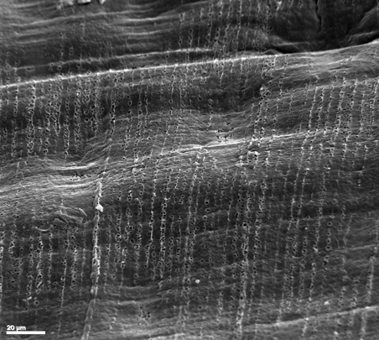

**D**

**IS**

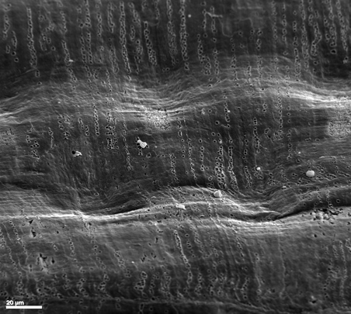

**B**

**IS**

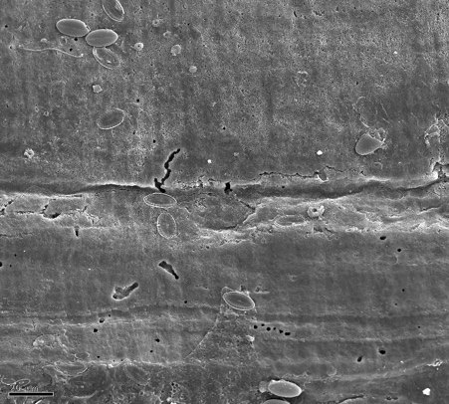

**A**

**W1**

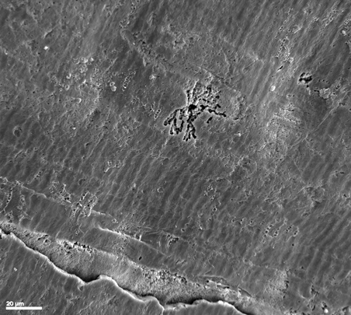

**C**

**W2**

**W1**

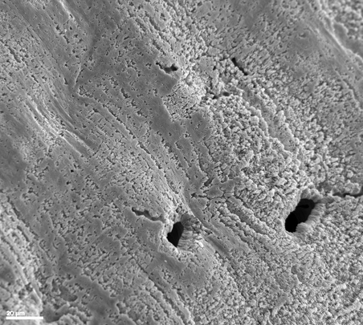

**F**

**IS**

**SD1**

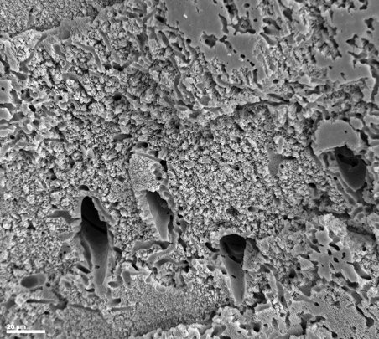

**E**

**SD1**

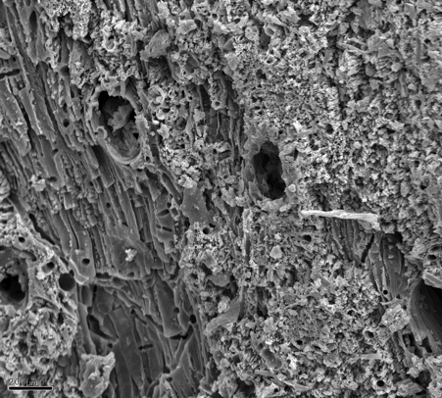

**G**

**SD2**

**SD1**

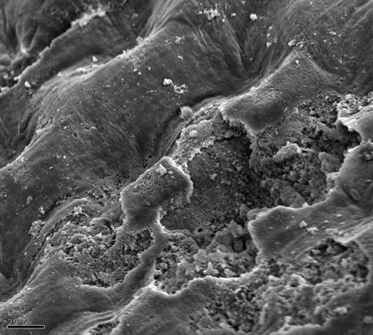

**H**

**IS**

**SD1**

**Figure 2.** Shell condition in *L. uva* – Examples of SEM micrographs of shell surfaces of thickening shell (A, C, E, G) and growing shell (B, D, F, H) in temperature control (A, B), pH control (C, D), moderate pH (E, F) and low pH treatment (G, H). IS = intact shell, W1 = minimal wear, W2 = extensive wear, SD1 = partial shell dissolution and SD2 = extensive shell dissolution. Scale bar = 20 µm.

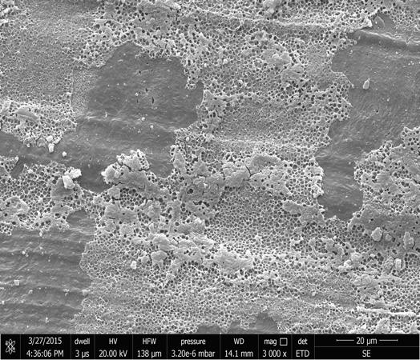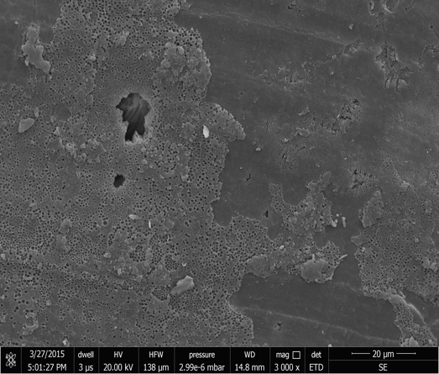

**A**

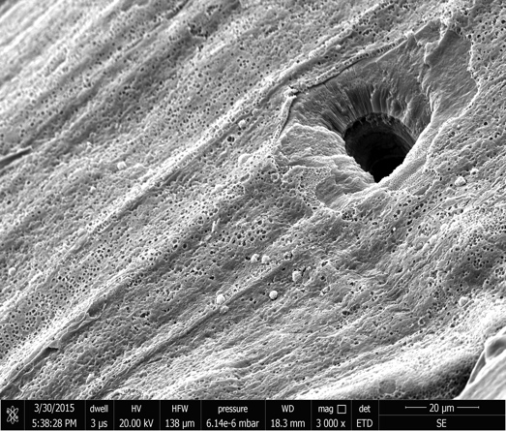

**B**

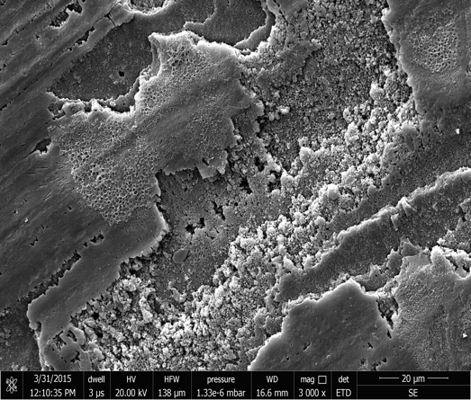

**E**

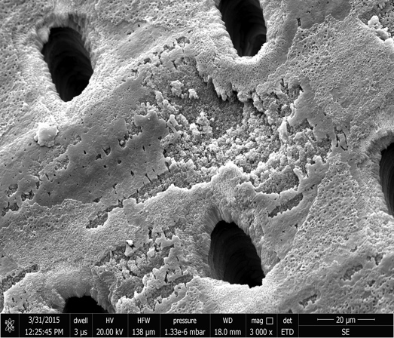

**F**

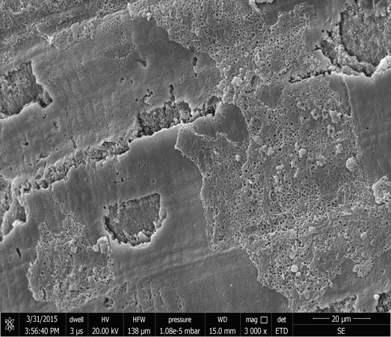

**D**

**C**

**SD1**

**IS**

**IS**

**SD1**

**IS**

**W1**

**W1**

**W1**

**SD1**

**IS**

**IS**

**IS**

**W1**

**Thickening shell**

**Growing shell**

**pH control**

**Moderate pH**

**Low pH**

**Figure 3**. Shell condition in *C. inconspicua* – Examples of SEM micrographs of shell surfaces of thickening shell (A, C, E) and growing shell (B, D, F) in pH control (A, B), moderate pH (C, D) and low pH treatment (E, F). IS = intact shell, W1 = minimal wear, W2 = extensive wear and SD1 = partial shell dissolution. SD2 (extensive shell dissolution) was absent in all treatment in this species. Scale bar = 20 µm.

**Shell thickness.**

***Thickening shell.*** The outer primary layer became progressively thinner in thickening shell as pH reduced in *L. uva* (Figure 4a; Linear Mixed Effects Model; χ2 = 79.72, df = 3, p < 0.001). Simultaneously in this species, the inner secondary layer, and the whole shell, were thicker in the most acidified treatment (Figure 4a; Linear Mixed Effects Model; Secondary Layer - χ2 = 39.63, df = 3, p < 0.001; Total Shell - χ2 = 18.19, df = 3, p < 0.001). Increased temperature had no effect on primary layer, secondary layer or total shell thickness (Tukey; Primary Layer – T = 1.73, p = 0.319; Secondary Layer – T = -1.20, p = 0.627; Total Shell – T = -0.80, p = 0.855). In contrast, neither individual shell layers nor total shell thickness were affected by lowered pH in the thickening shell in *C. inconspicua* (Figure 4c; Linear Mixed Effects Model; Primary Layer - χ2 = 4.17, df = 2, p = 0.124; Secondary Layer - χ2 = 4.80, df = 2, p = 0.091; Total Shell - χ2 = 4.27, df = 2, p = 0.118). Primary layer was thinnest in the oldest part of the shell, the umbo region, across all treatments in both species (Table S3). Secondary layer and total shell thickness did not differ in different places in the thickening shell in each treatment in both species (Table S3). Individual number also had no effect on individual shell layer and total shell thickness in both species (Table S3).

***Growing shell.*** Primary layer, secondary layer and total shell thickness were not impacted by lowered pH in either species (Figure 4b & 4d; Linear Mixed Effects Model; *L. uva*: Primary Layer - χ2 = 3.62, df = 3, p = 0.306; Secondary Layer - χ2 = 6.80, df = 3, p = 0.078; Total Shell - χ2 = 5.26, df = 3, p = 0.154; *C. inconspicua*: Primary Layer - χ2 = 2.63, df = 2, p = 0.268; Secondary Layer - χ2 = 0.82, df = 2, p = 0.663; Total Shell - χ2 = 1.12, df = 3, p = 0.572). Increased temperature also had no effect on either individual shell layers or total shell thickness in *L. uva* (Figure 4b). Primary layer thickness did not differ indifferent places throughout the growing shell in each treatment in either species (Table S3). Secondary layer and the total shell thickness, however, did get progressively thinner with the direction of growth in each treatment in both species (Table S3). Individual number also had no effect on individual shell layer and total shell thickness in growing shell in either species (Table S3).

Both species averages

**Figure 4**. Shell thickness *–* Average primary layer (black bar) and secondary layer (grey bar) thicknesses in thickening shell (a, b) and growing shell (c, d) in *L. uva* (top row) and *C. inconspicua* (bottom row) in all treatments. Whole bars represent total shell thickness.

DISCUSSION

Long-term culturing of polar and temperate brachiopod species’ under predicted end-century acidified conditions revealed that although shell dissolution was minimal in ambient conditions, both were more susceptible with increasing acidity. We have two principal findings: there was significant dissolution in the thickening shell and an unexpected compensation of induced thicker shells.

**Dissolution of shell.** Shell loss has been widely reported in several marine calcifiers, however, these have largely been those which use higher solubility polymorphs of calcium carbonate (i.e. aragonite), such as corals55-57 and molluscs21,58-61, high-magnesium calcite including coralline algae62,63 and echinoderms64,65. Fewer studies have investigated shell dissolution in taxa which are entirely constructed of the lower solubility polymorph, low-magnesium calcite, such as rhynchonelliform brachiopods. Previously, the only other ocean acidification study assessing dissolution in brachiopods was conducted on dead shells35*.* Working on *L. uva,* they showed deterioration of the primary layer after only 35 days exposure to pH 7.4, which after 56 days exposed the fibres of the secondary layer below. This is the same dissolution pattern reported here in experiments involving live individuals after 7 months exposure to pH 7.54. Exposure of the secondary layer calcite fibres may compromise shell integrity and probably strength due to the loss of the hard outer protective primary layer35,66.

Dissolution was more extensive in the polar *L. uva* than the temperate *C. inconspicua,* as indicated by increased deterioration in the primary layer of *L. uva* compared to *C. inconspicua* in the moderate pH treatment and it was only in *L. uva* that the secondary layer was exposedin the low pH treatment. Antarctic calcified invertebrates are probably the most vulnerable organisms to ocean acidification for a number of reasons: they tend to be weakly calcified16,67; dissolution rates of calcium carbonate are inversely related to temperature68; and the polar regions are predicted to become the first to be undersaturated in aragonite by 2050 and calcite by 210037,69-72. Differences in dissolution between the two investigated species may have also been influenced by the state of the shells. Wear was more prominent in the thickening shell of *L. uva* than in *C. inconspicua,* which was most likely due to the longer lifespan of the polar brachiopod (up to 55-60 years)73 compared to the temperate brachiopod (up to 14 years)74. Thus the shells of *L. uva* had been exposed to wear for a longer time in their natural environment before the experiment began. Such wear will have damaged or removed periostracum, which is key in protecting the animal from shell dissolution29,75-80. Since periostracum is only formed at the growing edge of the mantle, it cannot be repaired if damaged or lost from the surface of the shell. Thinning or loss of this organic layer through physical or biotic abrasion and epibiont erosion, therefore, restricts protection from corrosive acidified waters. The periostracum in brachiopods is < 1 µm thick81 and so is very vulnerable to loss.

Newly formed growing shell was mainly characterised by intact shell in both species. Partial shell dissolution did occur, however, in the most acidified treatment in both species albeit at a much lower level than in the thickening shell. Damage to the ultrathin periostracum from abrasion of other brachiopods in their conspecific cluster, natural decay of this outer layer or potentially the lowered pH conditions could have either softened the periostracum itself or disrupted the protective function of the periostracum. This latter possibility was suggested for external dissolution reported in newly formed shell in *M. edulis* after 2 months exposure to 1400 µatm and 4000 µatm77. Disintegration of organic matrix in the shell rather than corrosion of crystals could have caused this shell degradation, as seen in spirorbirds after 100-day exposure to pH 7.7 conditions82.

Temperature had no clear effect on shell dissolution or thickness in *L. uva* as indicated by the lack of or only minimal primary layer dissolution and no change in any thickness measurement in both thickening and growing shell in the temperature control (held at 0°C – current average Antarctic summer temperatures) and the pH control (kept at the 2°C temperature increase predicted for 2100). In contrast, temperature and not acidification reduced shell strength in *M. edulis* after 6 months exposure to forecasted end-century pH and warming conditions83. It was concluded that warming had an indirect effect on shell strength by shifting the energy budget from shell deposition to increased maintenance costs. Food availability was limited throughout the experiment, which would likely have enhanced the temperature effect as low food levels can reduce shell growth and significantly influence the amount of inner shell dissolution in *M. edulis* after 7 weeks exposure to varying *p*CO2 levels84. This highlights the necessity of using multistressors in ocean acidification research to better understand the abilities of marine calcifiers to maintain shell integrity under future predicted environmental conditions.

**Compensation.** Despite the widely reported significant effects of dissolution on marine calcifiers in ocean acidification research, very few studies investigate organisms’ abilities to compensate for shell loss. New shell deposited by *M. edulis* after 9 months exposure to 750 *µ*atm and 1000 *µ*atm *p*CO2 was rounder and flatter with a thinner aragonite layer than shell produced in ambient conditions of 380 µatm25. The authors attributed this new shell shape to a compensatory mechanism to enhance protection from predators and changing environments as these mussels were unable to grow thicker shells in high *p*CO2 conditions. Shell thickening has occurred in response to biotic shell loss by endoliths and other conspecifics grazing on their external shell in Patellid limpets, *Patella granatina* and *P. argenvillei*85, and to abiotic shell loss by physical impacts from ice in the Antarctic limpet *Nacella concinna*86. Decreased shell thickness has also been reported in molluscs in lowered pH conditions, due to internal dissolution of the highly soluble aragonite layer25,76,84. For compensatory mechanisms to succeed, they must occur at faster rates than the deleterious effect. Thicker basal shells were reported in the barnacle *Amphibalanus amphitrite* under lowered pH conditions (pH 7.4), however, this compensation calcification was insufficient as dissolution weakened shells faster than it was deposited87. A pteropod specimen collected from the Fram Strait in the Arctic Ocean also produced a shell four times thicker than the original shell in response to mechanical and dissolution damage from undersaturated waters29.

Extensive shell dissolution at low pH in thickening shell ofthe polar brachiopod led to a drastic decrease in primary layer thickness. *L. uva* counteracted this chemical attack by laying down more secondary layer on the internal surface of the shell, which resulted in increased overall shell thickness during the experimental period. The less extensive dissolution in *C. inconspicua* was reflected by no clear impact of acidified conditions on either total shell or individual shell layer thicknesses. Our findings appear to contrast with reports of primary layer thickening in the Chilean terebratulide *Magellania venosa* after being cultured in pH 7.35 conditions88, however, their observations appear to be based on only one measured specimen in both the acidified treatment and the control.

Compensatory mechanisms must also be sufficient in maintaining an organism’s overall performance. The secondary layer of terebratulide brachiopod shells is softer than the harder protective primary layer34,89 raising the question of whether a shell made solely out of secondary layer would provide adequate protection to ensure survival. No external dissolution of the exposed secondary layer of *L. uva* was observed perhaps due to protection from the organic matrix shrouding calcite crystals of this innermost fibrous shell layer90,91. Primary layer is often missing in older parts of brachiopod shells or in older individuals88, therefore, a thicker shell consisting of only secondary layer could provide sufficient protection in predicted pH conditions expected by 2100, although this warrants further investigation.

Total shell thickness or individual shell layer thickness of growing shell of *L. uva* and *C. inconspicua* were not affected by predicted end-century acidified conditions. In a previous study, shell thickness in *C. inconspicua* did not vary over the last 120 years despite a 0.1 pH unit decrease and 2°C increase in temperature since the Industrial Revolution92. The resilience of shell thickness in *L. uva* and *C. inconspicua* to past and predicted environmental change, in addition to their unaffected shell growth rates under end-century pH levels6,7, indicates the robust ability of rhynchonelliform brachiopods to construct shell under acidified conditions. The thickness of calcite and aragonite layers in newly formed shell of *M. edulis* were also not affected by elevated *p*CO277. This lack of variation in shell thickness to acidified conditions in newly produced shell further demonstrates the increase of shell thickness in the thickening shell is a compensatory response to extensive shell dissolution occurring at the external shell surface, although the mechanisms whereby the brachiopods identify the shell is thinning remain to be elucidated.

The extent of vulnerability of two highly calcium-carbonate-dependent species to dissolution in acidified seawater is concerning. Without any counteracting response, dissolution may compromise shell integrity leading to reduced protection and decreased suitability of brachiopod shells as a habitat for other marine organisms. Physiological acclimatisation is one approach organisms can utilise to cope with such threats in the challenging conditions predicted by 2100. We identified induced shell thickening forming thicker shells in polar *L. uva* as a compensatory mechanism to extensive shell dissolution under lowered pH levels. The less extensive dissolution in *C. inconspicua* was probably a function of higher temperatures in the temperate study and the corresponding lower CaCO3 solubility. This suggests that the level of dissolution in *C. inconspicua* after 3 months exposure to predicted end-century pH conditions did not induce similar compensation. This induced shell thickening could come at an overall cost to the organism as calcification is energetically expensive, involving the accumulation, transportation and precipitation of calcium carbonate as seen in the ophiuroid *Amphiura filiformis*93*.* Acidification also significantly increases the proportion of the animal’s energy budget that needs to be devoted to shell production94, therefore, there may be long-term impacts on life histories and maintenance of populations. Long-term experiments investigating the capacity of organisms to acclimatise and possibly adapt to future change is crucial to further our understanding of how marine organisms will cope with future environmental change.

ASSOCIATED CONTENT

**Supporting Information**

Descriptions and examples of each shell condition (Table S1)

Schematic and example of shell condition index measurements (Figure S1)

Schematic and example of shell thickness measurements (Figure S2)

Shell dissolution additional statistical results (Table S2)

Shell thickness additional statistical results (Table S3)

AUTHOR INFORMATION

**Corresponding Author**

* Emma L. Cross. Email: E.L.Cross@cantab.net. Telephone: +18604059051.

ACKNOWLEDGEMENTS

The authors would like to thank the scientific dive team at the British Antarctic Survey Rothera Research Station for collecting the *L. uva* specimens and to Dr. Coleen Suckling, Dr. Simon Morley and Rebecca Smith for their help in the set-up and maintenance of the polar experimental system. We are very grateful to Dr. Miles Lamare for his assistance in the organisation and collection of the *C. inconspicua* specimens. Thanks also to the science support staff at the Portobello Marine Laboratory, University of Otago for their help in the construction and maintenance of the temperate experimental system. Thanks to Dr. Kim Currie at the National Institute of Water and Atmospheric Research for the DIC and total alkalinity measurements. This research was funded by the NERC PhD Studentship (NE/T/A/2011) awarded to ELC.

REFERENCES

(1) Peck, L. S., Organisms and responses to environmental change. *Mar. Genom.* **2011,** *4*, 237-243.

(2) Doney, S. C.; Fabry, V. J.; Feely, R. A.; Kleypas, J. A., Ocean acidification: the other CO2 problem. *Ann. Rev. Mar. Sci.* **2009,** *1*, 169-192.

(3) Hofmann, G. E.; Barry, J. P.; Edmunds, P. J.; Gates, R. D.; Hutchins, D. A.; Klinger, T.; Sewell, M. A., The effect of ocean acidification on calcifying organisms in marine ecosystems: An organism-to-ecosystem perspective. *Annu Rev Ecol Evol Syst* **2010,** *41*, 127-147.

(4) Byrne, M., Impact of ocean warming and ocean acidification on marine invertebrate life history stages: vulnerabilities and potential for persistence in a changing ocean. *Oceanogr Mar Biol Annu Rev* **2011,** *49*, 1-42.

(5) Parker, L. M.; Ross, P. M.; O'Connor, W. A.; Pörtner, H. O.; Scanes, E.; Wright, J. M., Predicting the response of molluscs to the impact of ocean acidification. *Biology* **2013,** *2*, 651-92.

(6) Cross, E. L.; Peck, L. S.; Harper, E. M., Ocean acidification does not impact shell growth or repair of the Antarctic brachiopod *Liothyrella uva* (Broderip, 1833). *J. Exp. Mar. Biol. Ecol.* **2015,** *462*, 29-35.

(7) Cross, E. L.; Peck, L. S.; Lamare, M. D.; Harper, E. M., No ocean acidification effects on shell growth and repair in the New Zealand brachiopod *Calloria inconspicua* (Sowerby, 1846). *ICES J. Mar. Sci.* **2016,** *73*, 920-926.

(8) Queirós, A. M.; Fernandes, J. A.; Faulwetter, S.; Nunes, J.; Rastrick, S. P.; Mieszkowska, N.; Artioli, Y.; Yool, A.; Calosi, P.; Arvanitidis, C.; Findlay, H. S.; Barange, M.; Cheung, W. W.; Widdicombe, S., Scaling up experimental ocean acidification and warming research: from individuals to the ecosystem. *Global Change Biol.* **2015,** *21*, 130-143.

(9) Suckling, C. C.; Clark, M. S.; Richard, J.; Morley, S. A.; Thorne, M. A.; Harper, E. M.; Peck, L. S., Adult acclimation to combined temperature and pH stressors significantly enhances reproductive outcomes compared to short-term exposures. *J. Anim. Ecol.* **2014,** *84*, 773-784.

(10) Hazan, Y.; Wangensteen, O. S.; Fine, M., Tough as a rock-boring urchin: adult *Echinometra* sp. EE from the Red Sea show high resistance to ocean acidification over long-term exposures. *Mar. Biol.* **2014,** *161*, 2531-2545.

(11) Collins, S.; Rost, B.; Rynearson, T. A., Evolutionary potential of marine phytoplankton under ocean acidification. *Evolutionary Applications* **2014,** *7*, 140-155.

(12) Kelly, M. W.; Hofmann, G. E., Adaptation and the physiology of ocean acidification. *Funct. Ecol.* **2013,** *27*, 980-990.

(13) Sunday, J. M.; Calosi, P.; Dupont, S.; Munday, P. L.; Stillman, J. H.; Reusch, T. B., Evolution in an acidifying ocean. *Trends Ecol. Evol.* **2014,** *29*, 117-125.

(14) Leung, J. Y. S.; Russell, B. D.; Connell, S. D., Mineralogical plasticity acts as a compensatory mechanism to the impacts of ocean acidification. *Environ. Sci. Technol.* **2017,** *51*, 2652-2659.

(15) Byrne, M.; Przeslawski, R., Multistressor impacts of warming and acidification of the ocean on marine invertebrates' life histories. *Integ. Comp. Biol.* **2013,** *53*, 582-596.

(16) Watson, S.-A.; Peck, L. S.; Tyler, P. A.; Southgate, P. C.; Tan, K. S.; Day, R. W.; Morley, S. A., Marine invertebrate skeleton size varies with latitude, temperature and carbonate saturation: implications for global change and ocean acidification. *Global Change Biol.* **2012,** *18*, 3026-3038.

(17) Vermeij, G. J., The Mesozoic marine revolution: evidence from snails, predators and grazers. *Paleobiology* **1977,** *3*, 245-258.

(18) Harper, E. M.; Clark, M. S.; Hoffman, J. I.; Philipp, E. E.; Peck, L. S.; Morley, S. A., Iceberg scour and shell damage in the Antarctic bivalve *Laternula elliptica*. *PLoS ONE* **2012,** *7*, e46341.

(19) Harper, E. M., The molluscan periostracum: an important constraint in bivalve evolution. *Palaeonotology* **1997,** *40*, 71-97.

(20) Williams, A.; Mackay, S., Secretion and ultrastructure of the periostracum of some terebratulide brachiopods. *Proc. R. Soc. B.* **1978,** *202*, 191-209.

(21) Nienhuis, S.; Palmer, A. R.; Harley, C. D., Elevated CO2 affects shell dissolution rate but not calcification rate in a marine snail. *Proc. R. Soc. B.* **2010,** *277*, 2553-2558.

(22) Bausch, A. R.; Gallego, M. A.; Harianto, J.; Thibodeau, P.; Bednaršek, N.; Havenhand, J. N.; Klinger, T., Influence of bacteria on shell dissolution in dead gastropod larvae and adult *Limacina helicina* pteropods under ocean acidification conditions. *Mar. Biol.* **2018,** *165*, 40.

(23) Freeman, A. S.; Byers, J. E., Divergent induced responses to an invasive predator in marine mussel populations. *Science* **2006,** *313*, 831-834.

(24) Peyer, S. M.; Hermanson, J. C.; Lee, C. E., Developmental plasticity of shell morphology of quagga mussels from shallow and deep-water habitats of the Great Lakes. *J. Exp. Biol.* **2010,** *213*, 2602-2609.

(25) Fitzer, S. C.; Vittert, L.; Bowman, A.; Kamenos, N. A.; Phoenix, V. R.; Cusack, M., Ocean acidification and temperature increase impact mussel shell shape and thickness: problematic for protection? *Ecology & Evolution* **2015,** *5*, 4875-4884.

(26) Telesca, L.; Michalek, K.; Sanders, T.; Peck, L. S.; Thyrring, J.; Harper, E. M., Blue mussel shell shape plasticity and natural environments: a quantitative approach. *Scientific Reports* **2018,** *8*, 2865.

(27) Vermeij, G. J., Phenotypic evolution in a poorly dispersing snail after arrival of a predator. *Nature* **1982,** *299*, 349-350.

(28) Fisher, J. A.; Rhile, E. C.; Liu, H.; Petraitis, P. S., An intertidal snail shows a dramatic size increase over the past century. *PNAS* **2009,** *106*, 5209-12.

(29) Peck, V. L.; Oakes, R. L.; Harper, E. M.; Manno, C.; Tarling, G. A., Pteropods counter mechanical damage and dissolution through extensive shell repair. *Nature communications* **2018,** *9*, 264.

(30) Telesca, L.; Peck, L. S.; Sanders, T.; Thyrring, J.; Sejr, M. K.; Harper, E. M., Plasticity and environmental heterogeneity predict geographic resilience patterns of foundation species to future change. *bioRxiv* **2018**.

(31) Peck, L. S., The tissues of articulate brachiopods and their value to predators. *Phil. Trans. R. Soc. B.* **1993,** *339*, 17-32.

(32) Peck, L. S., Brachiopods and climate change. *Earth Env. Sci. T. R. So.* **2008,** *98*, 451-456.

(33) Williams, A.; Brunton, C. H. C.; MacKinnon, D. I., Morphology. In *Treatise on Invertebrate Paleontology, Part H, Brachiopods (Revised)*, Kaesler, R. L., Ed. The Geological Society of America and The University of Kansas Press: Boulder, Colorado, and Lawrence, Kansas, 1997; Vol. 1, pp 321-422.

(34) Goetz, A. J.; Griesshaber, E.; Neuser, R. D.; Lüter, C.; Hühner, M.; Harper, E. M.; Schmahl, W. W., Calcite morphology, texture and hardness in the distinct layers of rhynchonelliform brachiopod shells. *European Journal of Mineralogy* **2009,** *21*, 303-315.

(35) McClintock, J. B.; Angus, R. A.; McDonald, M. R.; Amsler, C. D.; Catledge, S. A.; Vohra, Y. K., Rapid dissolution of shells of weakly calcified Antarctic benthic macroorganisms indicates high vulnerability to ocean acidification. *Antarct. Sci.* **2009,** *21*, 449-456.

(36) Venables, H. J.; Clarke, A.; Meredith, M. P., Wintertime controls on summer stratification and productivity at the western Antarctic Peninsula. *Limnol. Oceanogr.* **2013,** *58*, 1035-1047.

(37) McNeil, B. I.; Matear, R. J., Southern Ocean acidification: a tipping point at 450-ppm atmospheric CO2. *PNAS* **2008,** *105*, 18860-18864.

(38) Greig, M. J.; Ridgway, N. M.; Shakespeare, B. S., Sea surface temperature variations at coastal sites around New Zealand. *N. Z. J. Mar. Freshwat. Res.* **1988,** *22*, 391-400.

(39) Roper, D. S.; Jillett, J. B., Seasonal occurrence and distribution of flatfish (Pisces: Pleuronectiformes) in inlets and shallow water along the Otago coast. *N. Z. J. Mar. Freshwat. Res.* **1981,** *15*, 1-13.

(40) IPCC, Climate Change 2013: The Physical Science Basis. In *Working Group I Contribution to the Fifth Assessment Report of the Intergovernmental Panel on Climate Change*, Stocker, T. F.; Qin, D.; Plattner, G.-K.; Tignor, M.; Allen, S. K.; Boschung, J.; Nauels, A.; Xia, Y.; Bex, V.; Midgley, P. M., Eds. Cambridge, United Kingdom and New York, NY, USA, 2013; p 1552.

(41) Mitchell, J. F. B.; Senior, C. A.; Johns, T. C., *Transient response to increasing greenhouse gases using models with and without flux adjustment*. Metrological Office: 1998.

(42) Clarke, A.; Meredith, M. P.; Wallace, M. I.; Brandon, M. A.; Thomas, D. N., Seasonal and interannual variability in temperature, chlorophyll and macronutrients in northern Marguerite Bay, Antarctica. *Deep Sea Research Part II: Topical Studies in Oceanography* **2008,** *55*, 1988-2006.

(43) Lewis, E.; Wallace, D. W. R.; Allison, L. J., *Program developed for CO2 system calculations*. Carbon Dioxide Information Analysis Center, Oak Ridge National Laboratory, US Department of Energy, Oak Ridge, Tennessee, US, 1998.

(44) Mehrbach, C.; Culberson, C. H.; Hawley, J. E.; Pytkowicxz, R. M., Measurement of apparent dissociation constants of carbonic acid in seawater at atmospheric pressure. *Limnol. Oceanogr.* **1973,** *18*, 897-907.

(45) Dickson, A. G.; Millero, F. J., A comparison of the equilibrium-constants for the dissociation of carbonic-acid in seawater media. *Deep-Sea Res Pt I* **1987,** *34*, 1733-1743.

(46) Garibotti, I. A.; Vernet, M.; Ferrario, M. E., Annually recurrent phytoplanktonic assemblages during summer in the seasonal ice zone west of the Antarctic Peninsula (Southern Ocean). *Deep-Sea Res Pt I* **2005,** *52*, 1823-1841.

(47) Garibotti, I. A.; Vernet, M.; Ferrario, M. E.; Smith, R. C.; Ross, R. M.; Quentin, L. B., Phytoplankton spatial distribution patterns along the western Antarctic Peninsula (Southern Ocean). *Mar. Ecol. Prog. Ser.* **2003,** *261*, 21-39.

(48) Dickson, A. G.; Sabine, C. L.; Christian, J. R. *Guide to best practices for Ocean CO2 Measurements*; 2007.

(49) Wanninkhof, R.; Lewis, E.; Feely, R. A.; Millero, F. J., The optimal carbonate dissociation constants for determining surface water *p*CO2 from alkalinity and total inorganic carbon. *Marine Chemist* **1999,** *65*, 291-301.

(50) Richardson, C. A.; Crisp, D. J.; Runham, N. W., Tidally deposited growth bands in the shell of the common cockle, *Cerastoderma edula* (L.). *Malacologia* **1979,** *18*, 277-290.

(51) Team, R. C., R: A language and environment for statistical computing. R Foundation for Statistical Computing, Vienna, Austria. URL <https://www.R-project.org/>. **2017**.

(52) Ogle, D. H., Fisheries Stock Analysis. **2018**, R Package version 0.8.20.

(53) Bates, D.; Maechler, M.; Bolker, B.; Walker, S., Fitting linear mixed-effects models using lme4. *Journal of Statistical Software* **2015,** *67*, 1-48.

(54) Lenth, R., emmeans: Estimated Marginal Means, aka Least-Squares Means. **2018**, R package version 1.2.3.

(55) Andersson, A. J.; Kuffner, I. B.; MacKenzie, F. T.; Jokiel, P. L.; Rodgers, K. S.; Tan, A., Net loss of CaCO3 from a subtropical calcifying community due to seawater acidification: mesocosm-scale experimental evidence. *Biogeosciences* **2009,** *6*, 1811-1823.

(56) Comeau, S.; Carpenter, R. C.; Lantz, C. A.; Edmunds, P. J., Ocean acidification accelerates dissolution of experimental coral reef communities. *Biogeosci. Disc.* **2014,** *11*, 12323-12339.

(57) Silbiger, N. J.; Donahue, M. J., Secondary calcification and dissolution respond differently to future ocean conditions. *Biogeosci. Disc.* **2014,** *11*, 12799-12831.

(58) Hall-Spencer, J. M.; Rodolfo-Metalpa, R.; Martin, S.; Ransome, E.; Fine, M.; Turner, S. M.; Rowley, S. J.; Tedesco, D.; Buia, M. C., Volcanic carbon dioxide vents show ecosystem effects of ocean acidification. *Nature* **2008,** *454*, 96-9.

(59) Milano, S.; Schöne, B. R.; Wang, S.; Müller, W. E., Impact of high *p*CO2 on shell structure of the bivalve *Cerastoderma edule*. *Mar. Environ. Res.* **2016,** *119*, 144-155.

(60) Bednaršek, N.; Tarling, G. A.; Bakker, D. C. E.; Fielding, S.; Feely, R. A., Dissolution dominating calcification process in polar pteropods close to the point of aragonite undersaturation. *PLoS ONE* **2014,** *9*, e109183.

(61) Harvey, B. P.; Agostini, S.; Wada, S.; Inaba, K.; Hall-Spencer, J. M., Dissolution: The achilles’ heel of the triton shell in an acidifying ocean. *Frontiers in Marine Science* **2018,** *5*, 371.

(62) Kamenos, N. A.; Burdett, H. L.; Aloisio, E.; Findlay, H. S.; Martin, S.; Longbone, C.; Dunn, J.; Widdicombe, S.; Calosi, P., Coralline algal structure is more sensitive to rate, rather than the magnitude, of ocean acidification. *Global Change Biol.* **2013,** *19*, 3621-3628.

(63) Cornwall, C. E.; Boyd, P. W.; McGraw, C. M.; Hepburn, C. D.; Pilditch, C. A.; Morris, J. N.; Smith, A. M.; Hurd, C. L., Diffusion boundary layers ameliorate the negative effects of ocean acidification on the temperate coralline macroalga *Arthrocardia corymbosa*. *PLoS ONE* **2014,** *9*, e97235.

(64) Miles, H.; Widdicombe, S.; Spicer, J. I.; Hall-Spencer, J., Effects of anthropogenic seawater acidification on acid-base balance in the sea urchin *Psammechinus miliaris*. *Mar. Pollut. Bull.* **2007,** *54*, 89-96.

(65) Dubois, P., The skeleton of postmetamorphic echinoderms in a changing world. *Biol. Bull.* **2014,** *226*, 223-236.

(66) Scurr, D. J.; Eichhorn, S. J., Structure/property relationships in seashells. In *Mechanical Properties of Bioinspired Materials* Viney, C.; Katti, K.; Ulm, F.-J.; Hellmich, C., Eds. Materials Research Society Symposium Proceedings: Warrendale, PA, 2005; pp 87–92.

(67) Nicol, D., Some characteristics of cold-water marine pelecypods. *J. Paleontol.* **1967,** *41*, 1330-1340.

(68) Revelle, R. R.; Fairbridge, R. W., Carbonates and carbon dioxide. In *Geological Society of America Memoirs*, 1957; Vol. 67, pp 239-296.

(69) Caldeira, K.; Wickett, M. E., Ocean model predictions of chemistry changes from carbon dioxide emissions to the atmosphere and ocean. *J. Geophys. Res.* **2005,** *110*, C09S04.

(70) Orr, J. C.; Fabry, V. J.; Aumont, O.; Bopp, L.; Doney, S. C.; Feely, R. A.; Gnanadesikan, A.; Gruber, N.; Ishida, A.; Joos, F.; Key, R. M.; Lindsay, K.; Maier-Reimer, E.; Matear, R.; Monfray, P.; Mouchet, A.; Najjar, R. G.; Plattner, G. K.; Rodgers, K. B.; Sabine, C. L.; Sarmiento, J. L.; Schlitzer, R.; Slater, R. D.; Totterdell, I. J.; Weirig, M. F.; Yamanaka, Y.; Yool, A., Anthropogenic ocean acidification over the twenty-first century and its impact on calcifying organisms. *Nature* **2005,** *437*, 681-6.

(71) Fabry, V. J.; Seibel, B. A.; Feely, R. A.; Orr, J. C., Impacts of ocean acidification on marine fauna and ecosystem processes. *ICES J. Mar. Sci.* **2008,** *65*, 414-432.

(72) Guinotte, J. M.; Fabry, V. J., Ocean acidification and its potential effects on marine ecosystems. *Ann. N. Y. Acad. Sci.* **2008,** *1134*, 320-42.

(73) Peck, L. S.; Brey, T., Bomb signals in old Antarctic brachiopods. *Nature* **1996,** *380*, 207-208.

(74) Doherty, P. J., A demographic study of a subtidal population of the New Zealand articulate brachiopod *Terebratella inconspicua*. *Mar. Biol.* **1979,** *52*, 331-342.

(75) Ries, J. B.; Cohen, A. L.; McCorkle, D. C., Marine calcifiers exhibit mixed responses to CO2-induced ocean acidification. *Geology* **2009,** *37*, 1131-1134.

(76) Tunnicliffe, V.; Davies, K. T. A.; Butterfield, D. A.; Embley, R. W.; Rose, J. M.; Chadwick Jr, W. W., Survival of mussels in extremely acidic waters on a submarine volcano. *Nature Geoscience* **2009,** *2*, 344-348.

(77) Thomsen, J.; Gutowska, M. A.; Saphörster, J.; Heinemann, A.; Trübenbach, K.; Fietzke, J.; Hiebenthal, C.; Eisenhauer, A.; Körtzinger, A.; Wahl, M.; Melzner, F., Calcifying invertebrates succeed in a naturally CO2-rich coastal habitat but are threatened by high levels of future acidification. *Biogeosciences* **2010,** *7*, 3879-3891.

(78) Rodolfo-Metalpa, R.; Houlbreque, F.; Tambutte, E.; Boisson, F.; Baggini, C.; Patti, F. P.; Jeffree, R.; Fine, M.; Foggo, A.; Gattuso, J.-P.; Hall-Spencer, J. M., Coral and mollusc resistance to ocean acidification adversely affected by warming. *Nature Clim. Change* **2011,** *1*, 308-312.

(79) Coleman, D. W.; Byrne, M.; Davis, A. R., Molluscs on acid: gastropod shell repair and strength in acidifying oceans. *Mar. Ecol. Prog. Ser.* **2014,** *509*, 203-211.

(80) Peck, V. L.; Tarling, G. A.; Manno, C.; Harper, E. M.; Tynan, E., Outer organic layer and internal repair mechanism protects pteropod *Limacina helicina* from ocean acidification. *Deep Sea Res. (II Top. Stud. Oceanogr.)* **2016,** *127*, 41-52.

(81) Williams, A.; MacKay, S., Differentiation of the brachiopod periostracum. *Palaeontology* **1979,** *22*, 721-736.

(82) Peck, L. S.; Clark, M. S.; Power, D.; Reis, J.; Batista, F. M.; Harper, E. M., Acidification effects on biofouling communities: winners and losers. *Global Change Biol.* **2015,** *21*, 1907-1913.

(83) Mackenzie, C. L.; Ormondroyd, G. A.; Curling, S. F.; Ball, R. J.; Whiteley, N. M.; Malham, S. K., Ocean warming, more than acidification, reduces shell strength in a commercial shellfish species during food limitation. *PLoS ONE* **2014,** *9*, e86764.

(84) Melzner, F.; Stange, P.; Trubenbach, K.; Thomsen, J.; Casties, I.; Panknin, U.; Gorb, S. N.; Gutowska, M. A., Food supply and seawater *p*CO2 impact calcification and internal shell dissolution in the blue mussel *Mytilus edulis*. *PLoS ONE* **2011,** *6*, e24223.

(85) Day, E. G.; Branch, G. M.; Viljoen, C., How costly is molluscan shell erosion? A comparison of two patellid limpets with contrasting shell structures. *J. Exp. Mar. Biol. Ecol.* **2000,** *243*, 185-208.

(86) Hoffman, J. I.; Peck, L. S.; Hillyard, G.; Zieritz, A.; Clark, M. S., No evidence for genetic differentiation between Antarctic limpet *Nacella concinna* morphotypes. *Mar. Biol.* **2009,** *157*, 765-778.

(87) McDonald, M. R.; McClintock, J. B.; Amsler, C. D.; Rittschof, D.; Angus, R. A.; Orihuela, B.; Lutostanski, K., Effects of ocean acidification over the life history of the barnacle *Amphibalanus amphitrite*. *Mar. Ecol. Prog. Ser.* **2009,** *385*, 179-187.

(88) Ye, F.; Jurikova, H.; Angiolini, L.; Brand, U.; Crippa, G.; Henkel, D.; Laudien, J.; Hiebenthal, C.; Šmajgl, D., Variation in brachiopod microstructure and isotope geochemistry under low pH-ocean acidification-conditions. *Biogeosci. Disc.* **2018**, 1-64.

(89) Griesshaber, E.; Schmahl, W. W.; Neuser, R.; Pettke, T.; Blum, M.; Mutterlose, J.; Brand, U., Crystallographic texture and microstructure of terebratulide brachiopod shell calcite: An optimized materials design with hierarchical architecture. *American Mineralogist* **2007,** *92*, 722-734.

(90) Pérez-Huerta, A.; Dauphin, Y.; Cusack, M., Biogenic calcite granules--are brachiopods different? *Micron* **2013,** *44*, 395-403.

(91) Harper, E. M., Are calcitic layers an effective adaptation against shell dissolution in the Bivalvia? *J. Zool. Lond.* **2000,** *251*, 179-186.

(92) Cross, E. L.; Harper, E. M.; Peck, L. S., A 120-year record of resilience to environmental change in brachiopods. *Global Change Biol.* **2018,** *24*, 2262-2271.

(93) Wood, H. L.; Spicer, J. I.; Widdicombe, S., Ocean acidification may increase calcification rates, but at a cost. *Proc. R. Soc. B.* **2008,** *275*, 1767-73.

(94) Watson, S.-A.; Morley, S. A.; Peck, L. S., Latitudinal trends in shell production cost from the tropics to the poles. *Science Advances* **2017,** *3*, e1701362.

DISCLOSURES

The authors declare no competing financial interest.