Appendix S1. Full set of state process equations describing development of number of individuals in different states as a function of demographic rates.
To enable demographic stochasticity to be modelled, we used Poisson and binomial distributions to describe the dynamics of the true population size over time with a pre-breeding projection model (Schaub et al. 2012). Thus, the number of fledglings in year t depended on the number of breeding (age 3+) females in year t and productivity in year t. The number of age 3, age 4 and age 5+ females at each colony in each year depended on the numbers of each age group in the preceding year, age- and colony-specific survival rate and age and colony-colony-specific dispersal rate. The definitions of the states and demographic parameters used in the model are in Table S1.

State process equations for Rockabill (ROC)
The equations describing the pre-breeding projection model for ROC can be written mathematically as:
${Ff}_{ROC,t} \sim Binomial\left(F_{ROC,t}, 0.5\right)$, where $F_{ROC,t} \sim Poisson\left(ρ_{ROC,t}×N_{ROC,t}\right)$,
${N3}_{ROC,t} \sim Binomial\left({Ff}_{ROC,t-3},S_{juv,ROC,t-3}\left(1-\left(ψ_{juv,ROC-LIL,t-3}+ ψ_{juv,ROC-COQ,t-3}\right)\right)\right)$,
${N3}_{LIL-ROC,t} \sim Binomial\left({Ff}_{LIL,t-3},S_{juv,LIL,t-3}, ψ_{juv,LIL-ROC,t-3}\right)$,
${N3}_{COQ-ROC,t} \sim Binomial\left({Ff}_{COQ,t-3},S_{juv,COQ,t-3}, ψ_{juv,COQ-ROC,t-3}\right)$,
${N4}_{ROC,t} \sim Binomial\left(\left({N3}_{ROC,t-1}+{N3}_{LIL-ROC,t-1}+{N3}_{COQ-ROC,t-1}\right),S_{age3,ROC,t-1}\left(1-\left(ψ_{age3,ROC-LIL,t-1}+ ψ_{age3,ROC-COQ,t-1}\right)\right)\right)$,
${N4}_{LIL-ROC,t} \sim Binomial\left(({N3}_{LIL,t-1}+ {N3}_{ROC-LIL,t-1}+ {N3}_{COQ-LIL,t-1}),S_{age3,LIL,t-1}ψ_{age3,LIL-ROC,t-1}\right)$,
${N4}_{COQ-ROC,t} \sim Binomial\left({(N3}_{COQ,t-1}+ {N3}_{ROC-COQ,t-1}+ {N3}_{LIL-COQ,t-1}),S_{age3,COQ,t-1}ψ_{age3,COQ-ROC,t-1}\right)$,
${N5}_{ROC,t} \sim Binomial\left(\left({N4}_{ROC,t-1}+{N4}_{LIL-ROC,t-1}+{N4}_{COQ-ROC,t-1}+{N5}_{ROC,t-1}+ {N5}_{LIL-ROC,t-1}+{N5}_{COQ-ROC,t-1}\right),S_{age4+,ROC,t-1}\left(1-\left(ψ_{age4+,ROC-LIL,t-1}+ ψ_{age4+,ROC-COQ,t-1}\right)\right)\right)$,
${N5}_{LIL-ROC,t} \sim Binomial\left(({N4}_{LIL,t-1}+ {N4}_{ROC-LIL,t-1}+ {N4}_{COQ-LIL,t-1}+{N5}_{LIL,t-1}+ {N5}_{ROC-LIL,t-1}+ {N5}_{COQ-LIL,t-1}),S_{age4+,LIL,t-1}ψ_{age4+,LIL-ROC,t-1}\right)$ and
${N5}_{COQ-ROC,t} \sim Binomial\left(({N4}_{COQ,t-1}+ {N4}_{ROC-COQ,t-1}+ {N4}_{LIL-COQ,t-1}+{N5}_{COQ,t-1}+ {N5}_{ROC-COQ,t-1}+ {N5}_{LIL-COQ,t-1}),S_{age4+,COQ,t-1}ψ_{age4+,COQ-ROC,t-1}\right)$.
The total population size in year t is then given by:
$$N_{ROC,t}={N3}_{ROC,t}+{N3}_{LIL-ROC,t}+{N3}_{COQ-ROC,t}+{N4}_{ROC,t}+{N4}_{LIL-ROC,t}+{N4}_{COQ-ROC,t}+{N5}_{ROC,t}+ {N5}_{LIL-ROC,t}+{N5}_{COQ-ROC,t}$$

State process equations for Lady’s Island Lake (LIL)
The equations describing the pre-breeding projection model for LIL can be written mathematically as:
${Ff}_{LIL,t} \sim Binomial\left(F_{LIL,t}, 0.5\right)$, where $F_{LIL,t} \sim Poisson\left(ρ_{LIL,t}×N_{LIL,t}\right)$,
${N3}_{LIL,t} \sim Binomial\left({Ff}_{LIL,t-3},S_{juv,LIL,t-3}\left(1-\left(ψ_{juv,LIL-ROC,t-3}+ ψ_{juv,LIL-COQ,t-3}\right)\right)\right)$,
${N3}_{ROC-LIL,t} \sim Binomial\left({Ff}_{ROC,t-3},S_{juv,ROC,t-3}, ψ_{juv,ROC-LIL,t-3}\right)$,
${N3}_{COQ-LIL,t} \sim Binomial\left({Ff}_{COQ,t-3},S_{juv,COQ,t-3}, ψ_{juv,COQ-LIL,t-3}\right)$,
${N4}_{LIL,t} \sim Binomial\left(\left({N3}_{LIL,t-1}+{N3}_{ROC-LIL,t-1}+{N3}_{COQ-LIL,t-1}\right),S_{age3,LIL,t-1}\left(1-\left(ψ_{age3,LIL-ROC,t-1}+ ψ_{age3,LIL-COQ,t-1}\right)\right)\right)$,
${N4}_{ROC-LIL,t} \sim Binomial\left(({N3}_{ROC,t-1}+ {N3}_{LIL-ROC,t-1}+ {N3}_{COQ-ROC,t-1}),S_{age3,ROC,t-1}ψ_{age3,ROC-LIL,t-1}\right)$,
${N4}_{COQ-LIL,t} \sim Binomial\left(({N3}_{COQ,t-1}+ {N3}_{LIL-COQ,t-1}+ {N3}_{ROC-COQ,t-1}),S_{age3,COQ,t-1}ψ_{age3,COQ-LIL,t-1}\right)$,
${N5}_{LIL,t} \sim Binomial\left(\left({N4}_{LIL,t-1}+{N4}_{ROC-LIL,t-1}+{N4}_{COQ-LIL,t-1}+{N5}_{LIL,t-1}+{N5}_{ROC-LIL,t-1}+{N5}_{COQ-LIL,t-1}\right),S_{age4+,LIL,t-1}\left(1-\left(ψ_{age4+,LIL-ROC,t-1}+ ψ_{age4+,LIL-COQ,t-1}\right)\right)\right)$,
${N5}_{ROC-LIL,t} \sim Binomial\left(({N4}_{ROC,t-1}+ {N4}_{LIL-ROC,t-1}+ {N4}_{COQ-ROC,t-1}+{N5}_{ROC,t-1}+ {N5}_{LIL-ROC,t-1}+ {N5}_{COQ-ROC,t-1}),S_{age4+,ROC,t-1}ψ_{age4+,ROC-LIL,t-1}\right)$ and
${N5}_{COQ-LIL,t} \sim Binomial\left(({N4}_{COQ,t-1}+ {N4}_{ROC-COQ,t-1}+ {N4}_{LIL-COQ,t-1}+{N5}_{COQ,t-1}+ {N5}_{ROC-COQ,t-1}+ {N5}_{LIL-COQ,t-1}),S_{age4+,COQ,t-1}ψ_{age4+,COQ-LIL,t-1}\right)$.
The total population size in year t is then given by:
$$N_{LIL,t}={N3}_{LIL,t}+{N3}_{ROC-LIL,t}+{N3}_{COQ-LIL,t}+{N4}_{LIL,t}+{N4}_{ROC-LIL,t}+{N4}_{COQ-LIL,t}+{N5}_{LIL,t}+{N5}_{ROC-LIL,t}+{N5}_{COQ-LIL,t}$$

State process equations for Coquet Island (COQ)
The equations describing the pre-breeding projection model for COQ can be written mathematically as:
${Ff}_{COQ,t} \sim Binomial\left(F_{COQ,t}, 0.5\right)$, where $F_{COQ,t} \sim Poisson\left(ρ_{COQ,t}×N_{COQ,t}\right)$,
${N3}_{COQ,t} \sim Binomial\left({Ff}_{COQ,t-3},S_{juv,COQ,t-3}\left(1-\left(ψ_{juv,COQ-ROC,t-3}+ ψ_{juv,COQ-LIL,t-3}\right)\right)\right)$,
${N3}_{ROC-COQ,t} \sim Binomial\left({Ff}_{ROC,t-3},S_{juv,ROC,t-3}, ψ_{juv,ROC-COQ,t-3}\right)$,
${N3}_{LIL-COQ,t} \sim Binomial\left({Ff}_{LIL,t-3},S_{juv,LIL,t-3}, ψ_{juv,LIL-COQ,t-3}\right)$,
${N4}_{COQ,t} \sim Binomial\left(\left({N3}_{COQ,t-1}+{N3}_{ROC-COQ,t-1}+{N3}_{LIL-COQ,t-1}\right),S_{age3,COQ,t-1}\left(1-\left(ψ_{age3,COQ-ROC,t-1}+ ψ_{age3,COQ-LIL,t-1}\right)\right)\right)$,
${N4}_{ROC-COQ,t} \sim Binomial\left(({N3}_{ROC,t-1}+ {N3}_{LIL-ROC,t-1}+ {N3}_{COQ-ROC,t-1}),S_{age4+,ROC,t-1}ψ_{age4+,ROC-COQ,t-1}\right)$,
${N4}_{LIL-COQ,t} \sim Binomial\left(({N3}_{LIL,t-1}+ {N3}_{ROC-LIL,t-1}+ {N3}_{COQ-LIL,t-1}),S_{age4+,LIL,t-1}ψ_{age4+,LIL-COQ,t-1}\right)$,
${N5}_{COQ,t} \sim Binomial\left(\left({N4}_{COQ,t-1}+{N4}_{ROC-COQ,t-1}+{N4}_{LIL-COQ,t-1}+{N5}_{COQ,t-1}++{N5}_{ROC-COQ,t-1}+{N5}_{LIL-COQ,t-1}\right),S_{age4+,COQ,t-1}\left(1-\left(ψ_{age4+,COQ-ROC,t-1}+ ψ_{age4+,COQ-LIL,t-1}\right)\right)\right)$,
${N5}_{ROC-COQ,t} \sim Binomial\left(({N4}_{ROC,t-1}+ {N4}_{LIL-ROC,t-1}+ {N4}_{COQ-ROC,t-1}+{N5}_{ROC,t-1}+ {N5}_{LIL-ROC,t-1}+ {N5}_{COQ-ROC,t-1}),S_{age4+,ROC,t-1}ψ_{age4+,ROC-COQ,t-1}\right)$ and
${N5}_{LIL-COQ,t} \sim Binomial\left(({N4}_{LIL,t-1}+ {N4}_{ROC-LIL,t-1}+ {N4}_{COQ-LIL,t-1}+{N5}_{LIL,t-1}+ {N5}_{ROC-LIL,t-1}+ {N5}_{COQ-LIL,t-1}),S_{age4+,LIL,t-1}ψ_{age4+,LIL-COQ,t-1}\right)$..
The total population size in year t is then given by:
$$N_{COQ,t}={N3}_{COQ,t}+{N3}_{ROC-COQ,t}+{N3}_{LIL-COQ,t}+{N4}_{COQ,t}+{N4}_{ROC-COQ,t}+{N4}_{LIL-COQ,t}+{N5}_{COQ,t}+{N5}_{ROC-COQ,t}+{N5}_{LIL-COQ,t}$$
Table S1. Definitions of the states and demographic parameters used in the integrated population model.
Parameter | Description
N3_{ROC,t} | Females at ROC in year t that fledged at ROC in year t-3
N3_{LIL,t} | Females at LIL in year t that fledged at ROC in year t-3
N3_{COQ,t} | Females at COQ in year t that fledged at ROC in year t-3
N3_{ROC-LIL,t} | Females at LIL in year t that fledged at ROC in year t-3
N3_{ROC-COQ,t} | Females at COQ in year t that fledged at ROC in year t-3
N3_{LIL-ROC,t} | Females at ROC in year t that fledged at LIL in year t-3
N3_{LIL-COQ,t} | Females at COQ in year t that fledged at LIL in year t-3
N3_{COQ-ROC,t} | Females at ROC in year t that fledged at COQ in year t-3
N3_{COQ-LIL,t} | Females at LIL in year t that fledged at COQ in year t-3
N4_{ROC,t} | Age 4 females at ROC in year t that were at ROC at age 3 in year t-1
N4_{LIL,t} | Age 4 females at LIL in year t that were at LIL at age 3 in year t-1
N4_{COQ,t} | Age 4 females at COQ in year t that were at COQ at age 3 in year t-1
N4_{ROC-LIL,t} | Age 4 females at LIL in year t that were age 3 at ROC in year t-1
N4_{ROC-COQ,t} | Age 4 females at COQ in year t that were age 3 at ROC in year t-1
N4_{LIL-ROC,t} | Age 4 females at ROC in year t that were age 3 at LIL in year t-1
N4_{LIL-COQ,t} | Age 4 females at COQ in year t that were age 3 at LIL in year t-1
N4_{COQ-ROC,t} | Age 4 females at ROC in year t that were age 3 at COQ in year t-1
N4_{COQ-LIL,t} | Age 4 females at LIL in year t that were age 3 at COQ in year t-1
N5_{ROC,t} | Age 5+ females at ROC in year t that were age 4+ at ROC in year t-1
N5_{LIL,t} | Age 5+ females at LIL in year t that were age 4+ at LIL in year t-1
N5_{COQ,t} | Age 5+ females at COQ in year t that were age 4+ at COQ in year t-1
N5_{ROC-LIL,t} | Age 5+ females at LIL in year t that were age 4+ at ROC in year t-1
N5_{ROC-COQ,t} | Age 5+ females at COQ in year t that were age 4+ at ROC in year t-1
N5_{LIL-ROC,t} | Age 5+ females at ROC in year t that were age 4+ at LIL in year t-1
N5_{LIL-COQ,t} | Age 5+ females at COQ in year t that were age 4+ at LIL in year t-1
N5_{COQ-ROC,t} | Age 5+ females at ROC in year t that were age 4+ at COQ in year t-1
N5_{COQ-LIL,t} | Age 5+ females at LIL in year t that were age 4+ at COQ in year t-1
N_{ROC,t} | Total number of breeding females at ROC in year t
N_{LIL,t} | Total number of breeding females at LIL in year t
N_{COQ,t} | Total number of breeding females at COQ in year t
Ff_{ROC,t} | Number of female fledglings at ROC in year t
Ff_{LIL,t} | Number of female fledglings at LIL in year t
Ff_{COQ,t} | Number of female fledglings at COQ in year t
F_{ROC,t} | Number of fledglings at ROC in year t
F_{LIL,t} | Number of fledglings at LIL in year t
F_{COQ,t} | Number of fledglings at COQ in year t
S_{juv,ROC,t} | Survival rate between year t and year t+3 of birds fledged at ROC
S_{juv,LIL,t} | Survival rate between year t and year t+3 of birds fledged at LIL
S_{juv,COQ,t} | Survival rate between year t and year t+3 of birds fledged at COQ
S_{age3,ROC,t} | Survival rate from year t to year t+1 of age 3 females at ROC
S_{age3,LIL,t} | Survival rate from year t to year t+1 of age 3 females at LIL
S_{age3,COQ,t} | Survival rate from year t to year t+1 of age 3 females at COQ
S_{age4+,ROC,t} | Survival rate from year t to year t+1 of age 4+ females at ROC
S_{age4+,LIL,t} | Survival rate from year t to year t+1 of age 4+ females at LIL
S_{age4+,COQ,t} | Survival rate from year t to year t+1 of age 4+ females at COQ
ψ_{juv,ROC-LIL,t} | Dispersal rate of females fledged at ROC in year t to LIL in year t+3
ψ_{juv,ROC-COQ,t} | Dispersal rate of females fledged at ROC in year t to COQ in year t+3
ψ_{juv,LIL-ROC,t} | Dispersal rate of females fledged at LIL in year t to ROC in year t+3
ψ_{juv,LIL-COQ,t} | Dispersal rate of females fledged at LIL in year t to COQ in year t+3
ψ_{juv,COQ-ROC,t} | Dispersal rate of females fledged at COQ in year t to ROC in year t+3
ψ_{juv,COQ-LIL,t} | Dispersal rate of females fledged at COQ in year t to LIL in year t+3
ψ_{age3,ROC-LIL,t} | Dispersal rate of age 3 females at ROC in year t to LIL in year t+1
ψ_{age3,ROC-COQ,t} | Dispersal rate of age 3 females at ROC in year t to COQ in year t+1
ψ_{age3,LIL-ROC,t} | Dispersal rate of age 3 females at LIL in year t to ROC in year t+1
ψ_{age3,LIL-COQ,t} | Dispersal rate of age 3 females at LIL in year t to COQ in year t+1
ψ_{age3,COQ-ROC,t} | Dispersal rate of age 3 females at COQ in year t to ROC in year t+1
ψ_{age3,COQ-LIL,t} | Dispersal rate of age 3 females at COQ in year t to LIL in year t+1
ψ_{age4+,ROC-LIL,t} | Dispersal rate of age 4+ females at ROC in year t to LIL in year t+1
ψ_{age4+,ROC-COQ,t} | Dispersal rate of age 4+ females at ROC in year t to COQ in year t+1
ψ_{age4+,LIL-ROC,t} | Dispersal rate of age 4+ females at LIL in year t to ROC in year t+1
ψ_{age4+,LIL-COQ,t} | Dispersal rate of age 4+ females at LIL in year t to COQ in year t+1
ψ_{age4+,COQ-ROC,t} | Dispersal rate of age 4+ females at COQ in year t to ROC in year t+1
ψ_{age4+,COQ-LIL,t} | Dispersal rate of age 4+ females at COQ in year t to LIL in year t+1
ρ_{ROC,t} | Productivity at ROC in year t (fledglings produced per breeding female)
ρ_{LIL,t} | Productivity at LIL in year t (fledglings produced per breeding female)
ρ_{COQ,t} | Productivity at COQ in year t (fledglings produced per breeding female)

Appendix S2. JAGS code for running a multistate integrated population model.
# 7.10. Fitting the Multistate model to data in the m-array format: the multinomial likelihood
# No resightings of 1-2 yo individuals. P by age class 1-2yo (not seen), 3yo, 4+yo and recap occ since release (last sighting)
# Phi{col,age,yr}, Psi{age,col}, p{col,age,yr}
# Phij is for period fledgling to 3yo
# 3 age classes for Phi and Psi

# Select a working directory
setwd("C:\\...")

#-------------------------------------------------
# Load required package
#-------------------------------------------------
library(rjags)
library(jagsUI)

#-------------------------------------------------
# Load data
#-------------------------------------------------

# Import data
raw_import <- read.table("CH_RLC_Ringed_as_J.txt", sep="", header = T) # 1 and 2yo will be removed shortly

# Replace state letters with numbers
raw_import$ch<-gsub("C","1",raw_import$ch) # 1 = Coquet
raw_import$ch<-gsub("R","2",raw_import$ch) # 2 = Rockabill
raw_import$ch<-gsub("L","3",raw_import$ch) # 3 = Lady's Island Lake

# Split the character string into vector
char.vec <- unlist(strsplit(raw_import$ch,""))
# Turn the vector into a matrix
nyears <- nchar(raw_import$ch)[1] # give number occasions to numoccs
CH.1 <- matrix(as.numeric(char.vec),ncol=nyears,byrow=TRUE) # ncol = number of occasions

# Remove individuals that were caught first time in final year, second-to-last and third-to-last year (as cannot be recaptured at age 3+)
CH.2 <- CH.1[-which(rowSums(CH.1[,1:(dim(CH.1)[2]-3)])==0),]

# Compute vector with occasion of first capture
get.first <- function(x) min(which(x!=0))
f <- apply(CH.2, 1, get.first)
# ###########################################
# Remove sightings at 1 and 2 yr old
CH <- CH.2
for (i in 1:dim(CH)[1]){
CH[i,f[i]+1] <- 0
CH[i,f[i]+2] <- 0
}
# ###########################################

# Remove individuals that have had all sightings removed by previous step (with logical step to prevent deletion of all if none were removed)
if(dim(CH.2)[1]>dim(CH)[1])
CH <- CH[-which(rowSums(CH[,1:dim(CH)[2]])==0),]

# Define number of sampling occasions
nyears <- dim(CH)[2]

#-----------------------------------------------------------------------------------------
# M-ARRAY CREATION FUNCTIONS
#----------------------------------------------------------------------------------------

# Individuals recaptured at least once
marraymulti <- function(CH){
nind <- dim(CH)[1]
n.occ <- dim(CH)[2]
states <- max(CH)
m.array <- array(data = 0, dim = c(states,states,n.occ-1,n.occ+1))

# Sums of individuals never re-encountered up to last but one release time
for (t in 1:(n.occ-2)){
if(sum(CH[,t]>0)) # if at least 1 individual released in ith year then proceed
for (i in 1:states){
if (i %in% CH[,t]) # if TRUE then do rest
ch <- CH[CH[,t]==i,]
ifelse (is.vector(ch), ch1 <- ch[which(sum(ch[(t+1):n.occ])==0)], # if 1 case only
ifelse (is.matrix(ch), ch1 <- ch[which(rowSums(ch[,(t+1):n.occ])==0),],next))
ifelse(exists("ch1"),
ifelse(is.vector(ch1), sum(ch1[t]==i) -> m.array[i,1,t,n.occ], # if 1 case only
ifelse(is.matrix(ch1), sum(ch1[,t]==i) -> m.array[i,1,t,n.occ], next)))
}
}

# Sum of individuals released final time and never re-encountered
for (i in 1:states){
if (i %in% CH[,n.occ-1]) # if TRUE then do rest
ch <- CH[CH[,n.occ-1]==i & CH[,n.occ]==0,]
ifelse (is.vector(ch), sum(ch[n.occ-1]==i) -> m.array[i,1,n.occ-1,n.occ], # if 1 case only
sum(ch[,n.occ-1]==i) -> m.array[i,1,n.occ-1,n.occ])
}

# Loops to get sums of first re-encounter occs must be split up to avoid errors when
# using rowSums and only a single column of matrix in subset
# Sum of individuals seen first time at first re-encounter occasion
for (t in 1:(n.occ-1)){
for (i in 1:states){
ifelse (i %in% CH[,t],
ch <- CH[CH[,t]==i,], next)
for (m in 1:states){
ifelse (is.vector(ch), sum(ch[t+1]==m) -> m.array[i,m,t,t], # if 1 case only
sum(ch[,t+1]==m) -> m.array[i,m,t,t])
}
}
}

# Sums of individuals seen first time at second re-encounter occasion
for (t in 1:(n.occ-2)){
for (i in 1:states){
ifelse (i %in% CH[,t],
ch <- CH[CH[,t]==i,], next)
ifelse (dim(ch)[1] >=1,
ch1 <- ch[ch[,t+1]==0,], next)
for (m in 1:states){
ifelse (is.vector(ch1), sum(ch1[t+2]==m) -> m.array[i,m,t,t+1],
sum(ch1[,t+2]==m) -> m.array[i,m,t,t+1])
}
}
}

# Sums of individuals seen first time at third to last re-encounter occasions
for (t in 1:(n.occ-3)){
for (i in 1:states){
ifelse (i %in% CH[,t],
ch <- CH[CH[,t]==i,], next)
for (u in (t+3):(n.occ)){
ifelse (dim(ch)[1] >=1,
ch1 <- ch[which(rowSums(ch[,(t+1):(u-1)])==0),], next)
for (m in 1:states){
ifelse (is.vector(ch1), sum(ch1[u]==m) -> m.array[i,m,t,u-1],
sum(ch1[,u]==m) -> m.array[i,m,t,u-1])
}
}
}
}

out <- m.array[,,1:(n.occ-1),1:n.occ]
return(out)
} # End of function

#--------------------------------------------------------------------------------------
# Separate m-array function for individuals never re-encountered
marraymulti.N <- function(CH){
nind <- dim(CH)[1]
n.occ <- dim(CH)[2]
states <- max(CH)
m.array <- array(data = 0, dim = c(states,states,n.occ-1,n.occ))
# Get total released for each state for each year & put in final column
for (i in 1:states){
for (t in 1:(n.occ-1)){
m.array[i,1,t,n.occ] <- sum(CH[,t]==i)
}
}

out <- m.array[,,1:(n.occ-1),1:n.occ]
return(out)
} # End of function

#-------------------------------------------------------------------------------
# CREATE SEPARATE M-ARRAYS BY AGE CLASS
#-------------------------------------------------------------------------------
# Define number of sampling occasions
nyears <- dim(CH)[2]

CH.R_or_N <- CH
CH.R_or_N[CH.R_or_N==2] <- 1
CH.R_or_N[CH.R_or_N==3] <- 1
CH.R_or_N[CH.R_or_N==4] <- 1 # This is ignored unless using 4th colony
cap <- apply(CH.R_or_N, 1, sum) # vector of each individual with number of total captures incl release
ind <- which(cap >= 2) # vector of IDs of indivs recaptured at least once
CH.J.R <- CH[ind,] # Juvenile CH recaptured at least once
CH.J.N <- CH[-ind,] # Juvenile CH never recaptured
# Remove first capture
first <- numeric()
for (i in 1:dim(CH.J.R)[1]){
first[i] <- min(which(CH.J.R[i,]>=1))
}
CH.J.R1 <- CH.J.R
for (i in 1:dim(CH.J.R)[1]){
CH.J.R1[i,first[i]] <- 0
}
# Create CH matrix for juveniles, ignoring subsequent recaptures
second <- numeric()
for (i in 1:dim(CH.J.R1)[1]){
second[i] <- min(which(CH.J.R1[i,]>=1))
}
CH.J.R2 <- CH.J.R
for (i in 1:dim(CH.J.R)[1]){
if(second[i]+1 <= dim(CH.J.R)[2]){
CH.J.R2[i,(second[i]+1):dim(CH.J.R)[2]] <- 0
}
}
# Separate juvs released as subadults from those released as adults
dif <- second-first
# Juvs released as subads will have dif = 3 !! ENSURE CORRECT FOR AGE STRUCTURE
indsubs <- which(dif==3)
CH.J.R1subs <- CH.J.R1[indsubs,] # Juv CH recaptured & released as subadults
CH.J.R1ads <- CH.J.R1[-indsubs,] # Juv CH recaptured & released as adults

# Create m-array for juveniles
CH.J.R.marray <- marraymulti(CH.J.R2)
# Final column should be zero since all were recaptured (otherwise those released again count in not seen column)
CH.J.R.marray[,,,nyears] <- 0
# Create the m-array for juveniles never recaptured and add it to the previous m-array
CH.J.N.marray <- marraymulti.N(CH.J.N)
CH.J.marray.temp <- CH.J.R.marray + CH.J.N.marray

# Age 3
CH.S.R_or_N <- CH.J.R1subs
CH.S.R_or_N[CH.S.R_or_N==2] <- 1
CH.S.R_or_N[CH.S.R_or_N==3] <- 1
CH.S.R_or_N[CH.S.R_or_N==4] <- 1 # This is ignored unless using 4th colony
cap <- apply(CH.S.R_or_N, 1, sum) # vector of each individual with number of total captures incl release
ind <- which(cap >= 2) # vector of IDs of indivs recaptured at least once
CH.S.R <- CH.J.R1subs[ind,] # Age 3 CH recaptured at least once
CH.S.N <- CH.J.R1subs[-ind,] # Age 3 CH never recaptured
# Remove individuals that were caught first time in final year
CH.S.N <- CH.S.N[-which(rowSums(CH.S.N[,1:(dim(CH.S.N)[2]-1)])==0),]

# Remove first capture
firstS <- numeric()
for (i in 1:dim(CH.S.R)[1]){
firstS[i] <- min(which(CH.S.R[i,]>=1))
}
CH.S.R1 <- CH.S.R
for (i in 1:dim(CH.S.R)[1]){
CH.S.R1[i,firstS[i]] <- 0
}
# Create CH matrix for age 3s, ignoring subsequent recaptures
secondS <- numeric()
for (i in 1:dim(CH.S.R1)[1]){
secondS[i] <- min(which(CH.S.R1[i,]>=1))
}
CH.S.R2 <- CH.S.R
for (i in 1:dim(CH.S.R)[1]){
if(secondS[i]+1 <= dim(CH.S.R)[2]){
CH.S.R2[i,(secondS[i]+1):dim(CH.S.R)[2]] <- 0
}
}

# Create m-array for age 3 recaptured
CH.S.R.marray <- marraymulti(CH.S.R2)
# Final column should be zero since all were recaptured (otherwise those released again count in not seen column)
CH.S.R.marray[,,,nyears] <- 0

# Create the m-array for Age 3 never recaptured and add it to the previous m-array
CH.S.N.marray <- marraymulti.N(CH.S.N)
CH.S.marray.temp <- CH.S.R.marray + CH.S.N.marray

# Age 4+
# Create age 4+ m-array from grown-up juveniles CH and grown-up age 3 CH
CH.A.all <- rbind(CH.S.R1, CH.J.R1ads)
CH.A.R_or_N <- CH.A.all
CH.A.R_or_N[CH.A.R_or_N==2] <- 1
CH.A.R_or_N[CH.A.R_or_N==3] <- 1
CH.A.R_or_N[CH.A.R_or_N==4] <- 1 # This is ignored unless using 4th colony
cap <- apply(CH.A.R_or_N, 1, sum) # vector of each individual with number of total captures incl release
ind <- which(cap >= 2) # vector of IDs of indivs recaptured at least once
CH.A.R <- CH.A.all[ind,] # Age 4+ CH recaptured at least once
CH.A.N <- CH.A.all[-ind,] # Age 4+ CH never recaptured
# Remove individuals that were caught first time in final year
CH.A.N <- CH.A.N[-which(rowSums(CH.A.N[,1:(dim(CH.A.N)[2]-1)])==0),]
CH.A.R.marray <- marraymulti(CH.A.R)
CH.A.N.marray <- marraymulti.N(CH.A.N)
# Add age 4+ never recaptured m-array to age 4+ recaptured m-array
CH.A.marray.temp <- CH.A.R.marray + CH.A.N.marray

# So that dmulti can be used as the distribution, the m-arrays must be stacked side by side.
# Doing this means that there is a single column for individuals never seen again for each release state.
states <- max(CH)
CH.J.marray <- array((0),dim=c(states,nyears-1,((nyears-1)*states)+1))
CH.J.marray[1,,] <- c(CH.J.marray.temp[1,1,,1:(nyears-1)],CH.J.marray.temp[1,2,,1:(nyears-1)],CH.J.marray.temp[1,3,,1:(nyears-1)],CH.J.marray.temp[1,1,,nyears])
CH.J.marray[2,,] <- c(CH.J.marray.temp[2,1,,1:(nyears-1)],CH.J.marray.temp[2,2,,1:(nyears-1)],CH.J.marray.temp[2,3,,1:(nyears-1)],CH.J.marray.temp[2,1,,nyears])
CH.J.marray[3,,] <- c(CH.J.marray.temp[3,1,,1:(nyears-1)],CH.J.marray.temp[3,2,,1:(nyears-1)],CH.J.marray.temp[3,3,,1:(nyears-1)],CH.J.marray.temp[3,1,,nyears])
CH.S.marray <- array((0),dim=c(states,nyears-1,((nyears-1)*states)+1))
CH.S.marray[1,,] <- c(CH.S.marray.temp[1,1,,1:(nyears-1)],CH.S.marray.temp[1,2,,1:(nyears-1)],CH.S.marray.temp[1,3,,1:(nyears-1)],CH.S.marray.temp[1,1,,nyears])
CH.S.marray[2,,] <- c(CH.S.marray.temp[2,1,,1:(nyears-1)],CH.S.marray.temp[2,2,,1:(nyears-1)],CH.S.marray.temp[2,3,,1:(nyears-1)],CH.S.marray.temp[2,1,,nyears])
CH.S.marray[3,,] <- c(CH.S.marray.temp[3,1,,1:(nyears-1)],CH.S.marray.temp[3,2,,1:(nyears-1)],CH.S.marray.temp[3,3,,1:(nyears-1)],CH.S.marray.temp[3,1,,nyears])
CH.A.marray <- array((0),dim=c(states,nyears-1,((nyears-1)*states)+1))
CH.A.marray[1,,] <- c(CH.A.marray.temp[1,1,,1:(nyears-1)],CH.A.marray.temp[1,2,,1:(nyears-1)],CH.A.marray.temp[1,3,,1:(nyears-1)],CH.A.marray.temp[1,1,,nyears])
CH.A.marray[2,,] <- c(CH.A.marray.temp[2,1,,1:(nyears-1)],CH.A.marray.temp[2,2,,1:(nyears-1)],CH.A.marray.temp[2,3,,1:(nyears-1)],CH.A.marray.temp[2,1,,nyears])
CH.A.marray[3,,] <- c(CH.A.marray.temp[3,1,,1:(nyears-1)],CH.A.marray.temp[3,2,,1:(nyears-1)],CH.A.marray.temp[3,3,,1:(nyears-1)],CH.A.marray.temp[3,1,,nyears])

#-------------------------------------------------------------------------------
# LOAD CENSUS AND PRODUCTIVITY DATA
#-------------------------------------------------------------------------------
popraw <- read.table("popcounts.txt", sep="", header = T)

# A* = Population count data (pairs), B* = Surveyed broods, J* = Fledglings from surveyed broods

# Rockabill
AR <- popraw$AR
BR <- popraw$BR
JR <- popraw$JR

# Lady's Island Lake
AL <- popraw$AL
BL <- popraw$BL
JL <- popraw$JL

# Coquet
AC <- popraw$AC
BC <- popraw$BC
JC <- popraw$JC

#----------------------------------------------------------------------------------
# RUN THE MODEL
#----------------------------------------------------------------------------------

# Specify model in JAGS language
sink("ipm_ms_marray_3age.txt")
cat("
# Define structure of the arrays for the transition matrices
var pr.temp.j1[states,states,nyears-1,nyears], pr.temp.j2[states,states,nyears-1,nyears], pr.j[states,nyears-1,((nyears-1)*3)+1],
pr.temp.s1[states,states,nyears-1,nyears], pr.temp.s2[states,states,nyears-1,nyears], pr.s[states,nyears-1,((nyears-1)*3)+1],
pr.temp.a1[states,states,nyears-1,nyears], pr.temp.a2[states,states,nyears-1,nyears], pr.a[states,nyears-1,((nyears-1)*3)+1];
model {
#------------------------------------------------------------
# Integrated metapopulation model
# Age at first breeding = 3 year
# Prebreeding census, female-based
# All vital rates are assumed to be time-dependent (random)
# Immigration and emigration rates calculated post hoc using rates of state transition (assumes all migration within metapopulation)
# Population growth rate calculated post hoc to allow model to run to completion
# PARAMETERS:
# phij: juvenile survival probability (for interval fledging to age 3) (with index for site)
# annual.phij: juvenile annual survival probability with index for site, derived from phij
# phia: adult (age 3+) annual survival probability (with index for site)
# psij1: movement probability between index-determined sites for for ages 0 and 1 (fixed at zero)
# psij2: movement probability between index-determined sites for age 2 (interval age 2-3)
# psia: movement probability between index-determined sites for age 3+
# p1: resighting probability at index-determined site at age 1 and 2 (fixed at zero)
# p2: resighting probability at index-determined site at age 3 (released as juv)
# p3: resighting probability at index-determined site at age 4+ (released as juv)
# p4: resighting probability at index-determined site at age 4 (released age 3)
# p5: resighting probability at index-determined site at age 5+ (released age 3)
# p6: resighting probability at index-determined site at age 5+ (released age 4+ t-1)
# p7: resighting probability at index-determined site at age 6+ (released age 4+, not seen t-1)
# fecR: fecundity (productivity) at Rockabill
# fecL: fecundity (productivity) at Lady's Island Lake
# fecC: fecundity (productivity) at Coquet

#----------------------------------------
# 1. Define the priors for the parameters
#----------------------------------------
# Initial population sizes
# 1.1 Rockabill
for (t in 1:3){
n3_R[t] ~ dnorm(100, 0.0001)I(0,) # 3-year (1- and 2-year not estimated)
n4_R[t] ~ dnorm(100, 0.0001)I(0,) # 4-year
n5_R[t] ~ dnorm(100, 0.0001)I(0,) # 5-year
n3imm_CR[t] ~ dnorm(50, 0.0001)I(0,500)
n3imm_LR[t] ~ dnorm(50, 0.0001)I(0,500)
n4imm_CR[t] ~ dnorm(50, 0.0001)I(0,500)
n4imm_LR[t] ~ dnorm(50, 0.0001)I(0,500)
n5imm_CR[t] ~ dnorm(50, 0.0001)I(0,500)
n5imm_LR[t] ~ dnorm(50, 0.0001)I(0,500)
}
for (t in 1:3){
N3R[t] <- round(n3_R[t])
N4R[t] <- round(n4_R[t])
N5R[t] <- round(n5_R[t])
N3immCR[t] <- round(n3imm_CR[t])
N3immLR[t] <- round(n3imm_LR[t])
N4immCR[t] <- round(n4imm_CR[t])
N4immLR[t] <- round(n4imm_LR[t])
N5immCR[t] <- round(n5imm_CR[t])
N5immLR[t] <- round(n5imm_LR[t])
}

# 1.2 LIL
for (t in 1:3){
n3_L[t] ~ dnorm(100, 0.0001)I(0,) # 3-year (1- and 2-year not estimated)
n4_L[t] ~ dnorm(100, 0.0001)I(0,) # 4-year
n5_L[t] ~ dnorm(100, 0.0001)I(0,) # 5-year
n3imm_CL[t] ~ dnorm(50, 0.0001)I(0,500)
n3imm_RL[t] ~ dnorm(50, 0.0001)I(0,500)
n4imm_CL[t] ~ dnorm(50, 0.0001)I(0,500)
n4imm_RL[t] ~ dnorm(50, 0.0001)I(0,500)
n5imm_CL[t] ~ dnorm(50, 0.0001)I(0,500)
n5imm_RL[t] ~ dnorm(50, 0.0001)I(0,500)
}
for (t in 1:3){
N3L[t] <- round(n3_L[t])
N4L[t] <- round(n4_L[t])
N5L[t] <- round(n5_L[t])
N3immCL[t] <- round(n3imm_CL[t])
N3immRL[t] <- round(n3imm_RL[t])
N4immCL[t] <- round(n4imm_CL[t])
N4immRL[t] <- round(n4imm_RL[t])
N5immCL[t] <- round(n5imm_CL[t])
N5immRL[t] <- round(n5imm_RL[t])
}

# 1.3 Coquet
for (t in 1:3){
n3_C[t] ~ dnorm(100, 0.0001)I(0,) # 3-year (1- and 2-year not estimated)
n4_C[t] ~ dnorm(100, 0.0001)I(0,) # 4-year
n5_C[t] ~ dnorm(100, 0.0001)I(0,) # 5-year
n3imm_RC[t] ~ dnorm(50, 0.0001)I(0,500)
n3imm_LC[t] ~ dnorm(50, 0.0001)I(0,500)
n4imm_RC[t] ~ dnorm(50, 0.0001)I(0,500)
n4imm_LC[t] ~ dnorm(50, 0.0001)I(0,500)
n5imm_RC[t] ~ dnorm(50, 0.0001)I(0,500)
n5imm_LC[t] ~ dnorm(50, 0.0001)I(0,500)
}
for (t in 1:3){
N3C[t] <- round(n3_C[t])
N4C[t] <- round(n4_C[t])
N5C[t] <- round(n5_C[t])
N3immRC[t] <- round(n3imm_RC[t])
N3immLC[t] <- round(n3imm_LC[t])
N4immRC[t] <- round(n4imm_RC[t])
N4immLC[t] <- round(n4imm_LC[t])
N5immRC[t] <- round(n5imm_RC[t])
N5immLC[t] <- round(n5imm_LC[t])
}

#-------------------------
# 2. Parameters time-dependent
#-------------------------
for (i in 1:3){ # states
for (t in 1:(nyears-1)){
logit(phij[i,t]) <- logit.b0.phij[i]+epsilon.phij[i,t]
epsilon.phij[i,t] ~ dmnorm(0,tau.phij[i])
logit(phis[i,t]) <- logit.b0.phis[i]+epsilon.phis[i,t]
epsilon.phis[i,t] ~ dmnorm(0,tau.phis[i])
logit(phia[i,t]) <- logit.b0.phia[i]+epsilon.phia[i,t]
epsilon.phia[i,t] ~ dmnorm(0,tau.phia[i])
} # time
# Priors for variance parameters
tau.phij[i] <- pow(sigma.phij[i],-2)
sigma.phij[i] ~ dunif(0.1,10)
sigma2.phij[i] <- pow(sigma.phij[i],2)
tau.phis[i] <- pow(sigma.phis[i],-2)
sigma.phis[i] ~ dunif(0.1,10)
sigma2.phis[i] <- pow(sigma.phis[i],2)
tau.phia[i] <- pow(sigma.phia[i],-2)
sigma.phia[i] ~ dunif(0.1,10)
sigma2.phia[i] <- pow(sigma.phia[i],2)

b0.phij[i] ~ dunif(0,1)
b0.phis[i] ~ dunif(0,1)
b0.phia[i] ~ dunif(0,1)
} # state
b0.fecR ~ dunif(0,2) # Capped at 2 because lay max 2 eggs
b0.fecC ~ dunif(0,2) # Capped at 2 because lay max 2 eggs
b0.fecL ~ dunif(0,2) # Capped at 2 because lay max 2 eggs

for (t in 1:nyears){
log(fecR[t]) <- log.b0.fecR+epsilon.fecR[t]
epsilon.fecR[t] ~ dmnorm(0,tau.fecR)
log(fecC[t]) <- log.b0.fecC+epsilon.fecC[t]
epsilon.fecC[t] ~ dmnorm(0,tau.fecC)
log(fecL[t]) <- log.b0.fecL+epsilon.fecL[t]
epsilon.fecL[t] ~ dmnorm(0,tau.fecL)
} # t
tau.fecR <- pow(sigma.fecR,-2)
sigma.fecR ~ dunif(0.1,10)
sigma2.fecR <- pow(sigma.fecR,2)
tau.fecC <- pow(sigma.fecC,-2)
sigma.fecC ~ dunif(0.1,10)
sigma2.fecC <- pow(sigma.fecC,2)
tau.fecL <- pow(sigma.fecL,-2)
sigma.fecL ~ dunif(0.1,10)
sigma2.fecL <- pow(sigma.fecL,2)

# Back transformations
for(i in 1:3){ # states
logit.b0.phij[i] <- log(b0.phij[i] / (1 - b0.phij[i]))
logit.b0.phis[i] <- log(b0.phis[i] / (1 - b0.phis[i]))
logit.b0.phia[i] <- log(b0.phia[i] / (1 - b0.phia[i]))

} # i
log.b0.fecR <- log(b0.fecR)
log.b0.fecC <- log(b0.fecC)
log.b0.fecL <- log(b0.fecL)

# Resighting first resighting years (by age)
for(i in 1:3){ # site
for (t in 1:(nyears-1)){
p1[i,t] <- 0 # no resightings at 1yo
} # t
p2[i,1] <- 0
p2[i,2] <- 0
p3[i,1] <- 0
p3[i,2] <- 0
p3[i,3] <- 0
p4[i,1] <- 0
p4[i,2] <- 0
p4[i,3] <- 0
p5[i,1] <- 0
p5[i,2] <- 0
p5[i,3] <- 0
p5[i,4] <- 0
p6[i,1] <- 0
p6[i,2] <- 0
p6[i,3] <- 0
p6[i,4] <- 0
p7[i,1] <- 0
p7[i,2] <- 0
p7[i,3] <- 0
p7[i,4] <- 0
p7[i,5] <- 0
} # i

# Priors for resighting excluding LIL
for(i in 1:2){ # state
for (t in 3:(nyears-1)){
p2[i,t] ~ dunif(0, 1)
} # t
for (t in 4:(nyears-1)){
p3[i,t] ~ dunif(0, 1)
p4[i,t] ~ dunif(0, 1)
} # time
for (t in 5:(nyears-1)){
p5[i,t] ~ dunif(0, 1)
p6[i,t] ~ dunif(0, 1)
} # time
for (t in 6:(nyears-1)){
p7[i,t] ~ dunif(0, 1)
} # time
} # state

# Priors for resighting for LIL
for (t in 4:7){
p2[3,t] ~ dunif(0, 1)
p3[3,t] ~ dunif(0, 1)
p4[3,t] ~ dunif(0, 1)
} # time
for (t in 5:7){
p5[3,t] ~ dunif(0, 1)
p6[3,t] ~ dunif(0, 1)
} # time
for (t in 6:7){
p7[3,t] ~ dunif(0, 1)
} # time
for (t in 10:(nyears-1)){
p2[3,t] ~ dunif(0, 1)
p3[3,t] ~ dunif(0, 1)
p4[3,t] ~ dunif(0, 1)
p5[3,t] ~ dunif(0, 1)
p6[3,t] ~ dunif(0, 1)
p7[3,t] ~ dunif(0, 1)
} # time

# Set years where no resighting took place at LIL:
p2[3,3] <- 0
p2[3,8] <- 0
p2[3,9] <- 0
p3[3,8] <- 0
p3[3,9] <- 0
p4[3,8] <- 0
p4[3,9] <- 0
p5[3,8] <- 0
p5[3,9] <- 0
p6[3,8] <- 0
p6[3,9] <- 0
p7[3,8] <- 0
p7[3,9] <- 0

# Transitions: multinomial logit
# Normal priors on logit of all but one transition probas
for (i in 1:3){
for (j in 1:2){
for (t in 1:(nyears-1)){
lpsij1[i,j,t] ~ dnorm(0, 0.001)
lpsis[i,j,t] ~ dnorm(0, 0.001)
lpsia[i,j,t] ~ dnorm(0, 0.001)
} #t
} #j
} #i
# Constrain the transitions such that their sum is < 1
for (i in 1:3){ # departure state
for (j in 1:2){ # arrival state
for (t in 1:(nyears-1)){
psij1[i,j,t] <- exp(lpsij1[i,j,t]) / (1 + exp(lpsij1[i,1,t]) + exp(lpsij1[i,2,t]))
psis[i,j,t] <- exp(lpsis[i,j,t]) / (1 + exp(lpsis[i,1,t]) + exp(lpsis[i,2,t]))
psia[i,j,t] <- exp(lpsia[i,j,t]) / (1 + exp(lpsia[i,1,t]) + exp(lpsia[i,2,t]))
} # t
} # j
} # i

# Calculate the last transition probability
for (i in 1:3){
for (t in 1:(nyears-1)){
psij1[i,3,t] <- 1-psij1[i,1,t]-psij1[i,2,t]
psis[i,3,t] <- 1-psis[i,1,t]-psis[i,2,t]
psia[i,3,t] <- 1-psia[i,1,t]-psia[i,2,t]
} # t
} # i

# No transition over second & third year (transition for juvs is 0-3)
for (t in 1:(nyears-1)){
psij2[1,1,t] <- 1
psij2[1,2,t] <- 0
psij2[1,3,t] <- 0
psij2[2,1,t] <- 0
psij2[2,2,t] <- 1
psij2[2,3,t] <- 0
psij2[3,1,t] <- 0
psij2[3,2,t] <- 0
psij2[3,3,t] <- 1
} #t

#-----------------------------------------------------------------------
# TRANSITION MATRICES
#----------------------------------------------------------------------

# T_j1 # Transition matrix for juveniles (psij1) in first year
# T_j2 # Transition matrix for juveniles yr1 to yr3 (psij2; no transition, phi not estimated)
# T_s # Transition matrix for age 3 (phis*psis)
# T_a # Transition matrix for age 4+ (phia*psia)

for (j in 1:3){
for (i in 1:3){
for (t in 1:(nyears-1)){
p1diag[j,i,t] <- p1[i,t]
p2diag[j,i,t] <- p2[i,t]
p3diag[j,i,t] <- p3[i,t]
p4diag[j,i,t] <- p4[i,t]
p5diag[j,i,t] <- p5[i,t]
p6diag[j,i,t] <- p6[i,t]
p7diag[j,i,t] <- p7[i,t]
}
}
}

for (i in 1:3){
for (j in 1:3){
for (t in 1:(nyears-1)){
q1diag[i,j,t] <- 1-p1diag[i,j,t]
q2diag[i,j,t] <- 1-p2diag[i,j,t]
q3diag[i,j,t] <- 1-p3diag[i,j,t]
q4diag[i,j,t] <- 1-p4diag[i,j,t]
q5diag[i,j,t] <- 1-p5diag[i,j,t]
q6diag[i,j,t] <- 1-p6diag[i,j,t]
q7diag[i,j,t] <- 1-p7diag[i,j,t]
}
}
}

for (i in 1:3){
for (j in 1:3){
for (t in 1:(nyears-1)){
phijdiag[i,j,t] <- phij[i,t]
phisdiag[i,j,t] <- phis[i,t]
phiadiag[i,j,t] <- phia[i,t]
}
}
}
for (i in 1:3){
for (j in 1:3){
for (t in 1:(nyears-1)){
T_j1[i,j,t] <- phijdiag[i,j,t]*psij1[i,j,t]
T_j2[i,j,t] <- psij2[i,j,t]
T_s[i,j,t] <- phisdiag[i,j,t]*psis[i,j,t]
T_a[i,j,t] <- phiadiag[i,j,t]*psia[i,j,t]
}
}
}

#-----------------------
# 3. Derived parameters
#-----------------------

# Convert 0-3 survival for juvs to annual survival
for (i in 1:3){
for (t in 1:(nyears-1)){
annual.phij[i,t] <- phij[i,t]^(1/3)
}
}

#-------------------------------------------------
# Specify population-level parameters
#-------------------------------------------------
# Rockabill
for(t in 1:(nyears-1)){
psi.juv.R[t] <- 1-psij1[2,2,t] # for 0-3yo
psi.sub.R[t] <- 1-psis[2,2,t]
psi.ad.R[t] <- 1-psia[2,2,t]
surv.stay.juv.R[t] <-phij[2,t]*psij1[2,2,t] # for 0-3yo
surv.stay.sub.R[t] <-phis[2,t]*psis[2,2,t]
surv.stay.ad.R[t] <-phia[2,t]*psia[2,2,t]
surv.to.C.juv.R[t] <-phij[2,t]*psij1[2,1,t] # for 0-3yo
surv.to.L.juv.R[t] <-phij[2,t]*psij1[2,3,t] # for 0-3yo
surv.to.C.sub.R[t] <-phis[2,t]*psis[2,1,t]
surv.to.L.sub.R[t] <-phis[2,t]*psis[2,3,t]
surv.to.C.ad.R[t] <-phia[2,t]*psia[2,1,t]
surv.to.L.ad.R[t] <-phia[2,t]*psia[2,3,t]
} # time

# LIL
for(t in 1:(nyears-1)){
psi.juv.L[t] <- 1-psij1[3,3,t] # for 0-3yo
psi.sub.L[t] <- 1-psis[3,3,t]
psi.ad.L[t] <- 1-psia[3,3,t]
surv.stay.juv.L[t] <-phij[3,t]*psij1[3,3,t] # for 0-3yo
surv.stay.sub.L[t] <-phis[3,t]*psis[3,3,t]
surv.stay.ad.L[t] <-phia[3,t]*psia[3,3,t]
surv.to.C.juv.L[t] <-phij[3,t]*psij1[3,1,t] # for 0-3yo
surv.to.R.juv.L[t] <-phij[3,t]*psij1[3,2,t] # for 0-3yo
surv.to.C.sub.L[t] <-phis[3,t]*psis[3,1,t]
surv.to.R.sub.L[t] <-phis[3,t]*psis[3,2,t]
surv.to.C.ad.L[t] <-phia[3,t]*psia[3,1,t]
surv.to.R.ad.L[t] <-phia[3,t]*psia[3,2,t]
} # time

# Coquet
for(t in 1:(nyears-1)){
psi.juv.C[t] <- 1-psij1[1,1,t] # for 0-3yo
psi.sub.C[t] <- 1-psis[1,1,t]
psi.ad.C[t] <- 1-psia[1,1,t]
surv.stay.juv.C[t] <-phij[1,t]*psij1[1,1,t] # for 0-3yo
surv.stay.sub.C[t] <-phis[1,t]*psis[1,1,t]
surv.stay.ad.C[t] <-phia[1,t]*psia[1,1,t]
surv.to.R.juv.C[t] <-phij[1,t]*psij1[1,2,t] # for 0-3yo
surv.to.L.juv.C[t] <-phij[1,t]*psij1[1,3,t] # for 0-3yo
surv.to.R.sub.C[t] <-phis[1,t]*psis[1,2,t]
surv.to.L.sub.C[t] <-phis[1,t]*psis[1,3,t]
surv.to.R.ad.C[t] <-phia[1,t]*psia[1,2,t]
surv.to.L.ad.C[t] <-phia[1,t]*psia[1,3,t]
} # time

#--------------------------------------------
# 4. The likelihoods of the single data sets
#--------------------------------------------
# Rockabill
# 4.1. Likelihood for population population count data (state-space model)
# 4.1.1 System process
for (t in 4:nyears){
meanflR[t-3] <- fecR[t-3] * NtotR[t-3]
FlR[t-3] ~ dpois(meanflR[t-3]) # Total number of fledglings
FfR[t-3] ~ dbin(0.5, FlR[t-3]) # Number of female fledglings
N3R[t] ~ dbin(surv.stay.juv.R[t-3], FfR[t-3]) # Number of 3 yo females that fledged at R
N3immLR[t] ~ dbin(surv.to.R.juv.L[t-3],FfL[t-3]) # Number of 3 yo females from L
N3immCR[t] ~ dbin(surv.to.R.juv.C[t-3],FfC[t-3]) # Number of 3 yo females from C
mean3R[t] <- N3R[t] + N3immLR[t] + N3immCR[t]
N4R[t] ~ dbin(surv.stay.sub.R[t-1], mean3R[t-1]) # Number of age 4 females that were at same site t-1
N4immLR[t] ~ dbin(surv.to.R.sub.L[t-1],mean3L[t-1]) # Number of 4 yo females from L
N4immCR[t] ~ dbin(surv.to.R.sub.C[t-1],mean3C[t-1]) # Number of 4 yo females from C
mean4R[t] <- N4R[t] + N4immLR[t] + N4immCR[t]
+ N5R[t] + N5immLR[t] + N5immCR[t]
N5immLR[t] ~ dbin(surv.to.R.ad.L[t-1],mean4L[t-1]) # Number of 5+ yo females from L
N5immCR[t] ~ dbin(surv.to.R.ad.C[t-1],mean4C[t-1]) # Number of 5+ yo females from C
N5R[t] ~ dbin(surv.stay.ad.R[t-1], mean4R[t-1])# Number of age 5+ females that were at same site t-1
} # t

# Number of fledglings in last study years
for (t in (nyears-2):nyears){
meanflR[t] <- fecR[t] * NtotR[t]
FlR[t] ~ dpois(meanflR[t])
FfR[t] ~ dbin(0.5, FlR[t])
} # t

mean3R[3] <- N3R[3] + N3immLR[3] + N3immCR[3]
mean4R[3] <- N4R[3] + N4immLR[3] + N4immCR[3] + N5R[3] + N5immLR[3] + N5immCR[3]

# 4.1.2 Observation process
for (t in 1:nyears){
NtotR[t] <- N3R[t] + N3immLR[t] + N3immCR[t]
+ N4R[t] + N4immLR[t] + N4immCR[t] + N5R[t] + N5immLR[t] + N5immCR[t] # Total number of breeding females
yR[t] ~ dpois(NtotR[t])
} # t

# 4.2. Likelihood for productivity data: Poisson regression
for (t in 1:(nyears)){
JR[t] ~ dpois(rhoR[t])
rhoR[t] <- BR[t] * fecR[t]
}

# Lady's Island Lake
# 4.1. Likelihood for population population count data (state-space model)
# 4.1.1 System process
for (t in 4:nyears){
meanflL[t-3] <- fecL[t-3] * NtotL[t-3]
FlL[t-3] ~ dpois(meanflL[t-3]) # Total number of fledglings
FfL[t-3] ~ dbin(0.5, FlL[t-3]) # Number of female fledglings
N3L[t] ~ dbin(surv.stay.juv.L[t-3], FfL[t-3]) # Number of 3 yo females that fledged at L
N3immRL[t] ~ dbin(surv.to.L.juv.R[t-3],FfR[t-3]) # Number of 3 yo females from R
N3immCL[t] ~ dbin(surv.to.L.juv.C[t-3],FfC[t-3]) # Number of 3 yo females from C
mean3L[t] <- N3L[t] + N3immRL[t] + N3immCL[t]
N4L[t] ~ dbin(surv.stay.sub.L[t-1], mean3L[t-1]) # Number of age 4 females that were at same site t-1
N4immRL[t] ~ dbin(surv.to.L.sub.R[t-1],mean3R[t-1]) # Number of 4 yo females from R
N4immCL[t] ~ dbin(surv.to.L.sub.C[t-1],mean3C[t-1]) # Number of 4 yo females from C
mean4L[t] <- N4L[t] + N4immRL[t] + N4immCL[t]
+ N5L[t] + N5immRL[t] + N5immCL[t]
N5immRL[t] ~ dbin(surv.to.L.ad.R[t-1], mean4R[t-1]) # Number of 5+ yo females from R
N5immCL[t] ~ dbin(surv.to.L.ad.C[t-1], mean4C[t-1]) # Number of 5+ yo females from C
N5L[t] ~ dbin(surv.stay.ad.L[t-1], mean4L[t-1]) # Number of age 5+ females that were at same site t-1
} # t

# Number of fledglings in last study years
for (t in (nyears-2):nyears){
meanflL[t] <- fecL[t] * NtotL[t]
FlL[t] ~ dpois(meanflL[t])
FfL[t] ~ dbin(0.5, FlL[t])
} # t

mean3L[3] <- N3L[3] + N3immRL[3] + N3immCL[3]
mean4L[3] <- N4L[3] + N4immRL[3] + N4immCL[3] + N5L[3] + N5immRL[3] + N5immCL[3]

# 4.1.2 Observation process
for (t in 1:nyears){
NtotL[t] <- N3L[t] + N3immRL[t] + N3immCL[t]
+ N4L[t] + N4immRL[t] + N4immCL[t] + N5L[t] + N5immRL[t] + N5immCL[t]# Total number of breeding females
yL[t] ~ dpois(NtotL[t])
} # t

# 4.2. Likelihood for productivity data: Poisson regression
for (t in 1:nyears){
JL[t] ~ dpois(rhoL[t])
rhoL[t] <- BL[t] * fecL[t]
}
# years where number monitored breeding pairs unknown
BL[1] ~ dnorm(100, 0.0001)I(0,)
BL[3] ~ dnorm(100, 0.0001)I(0,)
BL[9] ~ dnorm(100, 0.0001)I(0,)
BL[11] ~ dnorm(100, 0.0001)I(0,)
BL[12] ~ dnorm(100, 0.0001)I(0,)

#---------------------------------------------------------------------

# Coquet
# 4.1. Likelihood for population population count data (state-space model)
# 4.1.1 System process
for (t in 4:nyears){
meanflC[t-3] <- fecC[t-3] * NtotC[t-3]
FlC[t-3] ~ dpois(meanflC[t-3]) # Total number of fledglings
FfC[t-3] ~ dbin(0.5, FlC[t-3]) # Number of female fledglings
N3C[t] ~ dbin(surv.stay.juv.C[t-3], FfC[t-3]) # Number of 3 yo females that fledged at C
N3immRC[t] ~ dbin(surv.to.C.juv.R[t-3],FfR[t-3]) # Number of 3 yo females from R
N3immLC[t] ~ dbin(surv.to.C.juv.L[t-3],FfL[t-3]) # Number of 3 yo females from L
mean3C[t] <- N3C[t] + N3immRC[t] + N3immLC[t]
N4C[t] ~ dbin(surv.stay.sub.C[t-1], mean3C[t-1]) # Number of age 4 females that were at same site t-1
N4immRC[t] ~ dbin(surv.to.C.sub.R[t-1],mean3R[t-1]) # Number of 4 yo females from R
N4immLC[t] ~ dbin(surv.to.C.sub.L[t-1],mean3L[t-1]) # Number of 4 yo females from L
mean4C[t] <- N4C[t] + N4immRC[t] + N4immLC[t]
+ N5C[t] + N5immRC[t] + N5immLC[t]
N5immRC[t] ~ dbin(surv.to.C.ad.R[t-1], mean4R[t-1]) # Number of 5+ yo females from R
N5immLC[t] ~ dbin(surv.to.C.ad.L[t-1], mean4L[t-1]) # Number of 5+ yo females from L
N5C[t] ~ dbin(surv.stay.ad.C[t-1], mean4C[t-1]) # Number of age 5+ females that were at same site t-1
} # t

# Number of fledglings in last study years
for (t in (nyears-2):nyears){
meanflC[t] <- fecC[t] * NtotC[t]
FlC[t] ~ dpois(meanflC[t])
FfC[t] ~ dbin(0.5, FlC[t])
} # t

mean3C[3] <- N3C[3] + N3immRC[3] + N3immLC[3]
mean4C[3] <- N4C[3] + N4immRC[3] + N4immLC[3] + N5C[3] + N5immRC[3] + N5immLC[3]

# 4.1.2 Observation process
for (t in 1:nyears){
NtotC[t] <- N3C[t] + N3immRC[t] + N3immLC[t]
+ N4C[t] + N4immRC[t] + N4immLC[t] + N5C[t] + N5immRC[t] + N5immLC[t] # Total number of breeding females
yC[t] ~ dpois(NtotC[t])
} # t

# 4.2. Likelihood for productivity data: Poisson regression
for (t in 1:(nyears)){
JC[t] ~ dpois(rhoC[t])
rhoC[t] <- BC[t] * fecC[t]
}

#----------------------------------------------------------------------------------------
# 5. Likelihood for capture-recapture data: Multistate model (3 states and 3 age classes)
#----------------------------------------------------------------------------------------

# Multinomial likelihood
for (i in 1:3){
for (t in 1:(nyears-1)){
marray.j[i,t,1:(((nyears-1)*states)+1)] ~ dmulti(pr.j[i,t,], r.j[i,t]) # r.j/s/a[t] = total number released each year from rowSums of each marray
marray.s[i,t,1:(((nyears-1)*states)+1)] ~ dmulti(pr.s[i,t,], r.s[i,t])
marray.a[i,t,1:(((nyears-1)*states)+1)] ~ dmulti(pr.a[i,t,], r.a[i,t])
} # t
} # i

#@@@@@@@@@@@@@@@@@@@@@@@@@@@@@@@@@@@@@@@@@@@@@@@@@@@@@@@@@@@@@@@@@@@@@@@@@@@@@@@@@@@@@@@@@# The release year for pr.temp.j2, pr.temp.s and pr.temp.a is the 3rd dimension, i.e. [,,X,]. [,,1,] is the first year in the capture history.
# The recapture year for pr.temp.j2, pr.temp.s and pr.temp.a is the 4th dimension, i.e. [,,,X]. [,,,1] is the second year in the capture history.
# [X,,,] is the release state (colony) and [,X,,] is the recapture state (colony).
# The code must be edited manually for changes to age structure.
#@@@@@@@@@@@@@@@@@@@@@@@@@@@@@@@@@@@@@@@@@@@@@@@@@@@@@@@@@@@@@@@@@@@@@@@@@@@@@@@@@@@@@@@@@

#-----------------------------------------------------------------------------------------

# Juveniles
# Temporary arrays for the transition matrices defined in vr statements at start of model

# Cells for first recap occ after release
for (i in 1:(nyears-3)){
pr.temp.j1[,,i,i] <- T_j1[,,i]*p1diag[,,i]
} # i
# Set out not seen probabilities for 2nd recap occ after release
for (i in 1:(nyears-3)){
pr.temp.j1[,,i,i+1] <- T_j1[,,i]*q1diag[,,i]
} # i
# Set out not seen probabilities for 3rd recap occ after release
for (i in 1:(nyears-3)){
pr.temp.j1[,,i,i+2] <- pr.temp.j1[,,i,i+1] %*% (T_j2[,,i+1] * q1diag[,,i+1])
} # i
# Set out not seen probabilities for 4th recap occ after release
for (i in 1:(nyears-4)){
pr.temp.j1[,,i,i+3] <- pr.temp.j1[,,i,i+2] %*% (T_j2[,,i+2] * q2diag[,,i+2])
} # i
# Set out not seen probabilities for 5th recap occ after release
for (i in 1:(nyears-5)){
pr.temp.j1[,,i,i+4] <- pr.temp.j1[,,i,i+3] %*% (T_s[,,i+3] * q3diag[,,i+3])
} # i
# Calculate remaining not seen probabilities
for (i in 1:(nyears-6)){
for (j in (i+5):(nyears-1)){
pr.temp.j1[,,i,j] <- pr.temp.j1[,,i,j-1] %*% (T_a[,,j-1] * q3diag[,,j-1])
} # j
} # i
# Matrix multiply all cells except diagonal (because no previous unseen to account for with diagonal)
# by probability of being seen, into the second temp array
# Firstly j2*p1 (still not back)
for (i in 1:(nyears-3)){ # Juvs ringed nyears-2 not back until nyears+1
pr.temp.j2[,,i,i+1] <- (pr.temp.j1[,,i,i+1] %*% T_j2[,,i+1]) * p1diag[,,i+1]
} # i
# Secondly j2*p2 (back as subadult)
for (i in 1:(nyears-3)){
pr.temp.j2[,,i,i+2] <- (pr.temp.j1[,,i,i+2] %*% T_j2[,,i+2]) * p2diag[,,i+2]
} # i
# Thirdly s*p3 (back as adult)
for (i in 1:(nyears-4)){
pr.temp.j2[,,i,i+3] <- (pr.temp.j1[,,i,i+3] %*% T_s[,,i+3]) * p3diag[,,i+3]
} # i
# Lastly remainder all as adult
for (i in 1:(nyears-5)){
for (j in (i+4):(nyears-1)){
pr.temp.j2[,,i,j] <- (pr.temp.j1[,,i,j] %*% T_a[,,j]) * p3diag[,,j]
} # j
} # i
# Copy diagonal to the second temp array
for (i in 1:(nyears-3)){
pr.temp.j2[,,i,i] <- pr.temp.j1[,,i,i]
} # i

for (i in 1:3){
for (j in 1:3){
for (r in (nyears-2):(nyears-1)){
for (t in r:nyears){
pr.temp.j2[i,j,r,t] <- 0 # No juveniles released nyears-2 and nyears-1
}
}
}
}

# Below main diagonal
for (i in 1:3){
for (j in 1:3){
for (r in 2:(nyears-1)){
for (t in 1:(r-1)){
pr.temp.j2[i,j,r,t] <- 0
}
}
}
}
# Last column
for (t in 1:(nyears-3)){
pr.temp.j2[1,1,t,nyears] <- 1-sum(pr.temp.j2[1,,t,1:(nyears-1)])
pr.temp.j2[2,1,t,nyears] <- 1-sum(pr.temp.j2[2,,t,1:(nyears-1)])
pr.temp.j2[3,1,t,nyears] <- 1-sum(pr.temp.j2[3,,t,1:(nyears-1)])
for (i in 1:3){
for (j in 2:3){
pr.temp.j2[i,j,t,nyears] <- 0
}
}
} #t

# Transform the temporary array into an array where recapture states are stacked side by side
# This allows for a single column for individuals never recaptured
# pr.j dimensions defined in vr statements at beginning of model
pr.j[1,,1:(nyears-1)] <- pr.temp.j2[1,1,,1:(nyears-1)]
pr.j[1,,nyears:((nyears-1)*2)] <- pr.temp.j2[1,2,,1:(nyears-1)]
pr.j[1,,(((nyears-1)*2)+1):((nyears-1)*3)] <- pr.temp.j2[1,3,,1:(nyears-1)]
pr.j[1,,(((nyears-1)*3)+1)] <- pr.temp.j2[1,1,,nyears]
pr.j[2,,1:(nyears-1)] <- pr.temp.j2[2,1,,1:(nyears-1)]
pr.j[2,,nyears:((nyears-1)*2)] <- pr.temp.j2[2,2,,1:(nyears-1)]
pr.j[2,,(((nyears-1)*2)+1):((nyears-1)*3)] <- pr.temp.j2[2,3,,1:(nyears-1)]
pr.j[2,,(((nyears-1)*3)+1)] <- pr.temp.j2[2,1,,nyears]
pr.j[3,,1:(nyears-1)] <- pr.temp.j2[3,1,,1:(nyears-1)]
pr.j[3,,nyears:((nyears-1)*2)] <- pr.temp.j2[3,2,,1:(nyears-1)]
pr.j[3,,(((nyears-1)*2)+1):((nyears-1)*3)] <- pr.temp.j2[3,3,,1:(nyears-1)]
pr.j[3,,(((nyears-1)*3)+1)] <- pr.temp.j2[3,1,,nyears]

#-----------------------------------------------------------------------------------------

# Age 3
# Temporary arrays for the transition matrices defined in vr statements at start of model

for (i in 1:3){
for (j in 1:3){
for (r in 1:3){
for (t in r:nyears){
pr.temp.s2[i,j,r,t] <- 0 # No subadults released until t = 4
}
}
}
}

# Cells for birds seen first recap occ after release
for (i in 4:(nyears-1)){
pr.temp.s1[,,i,i] <- T_s[,,i] * p4diag[,,i]
} # i
# Set out not seen probabilities for 2nd recap occ after release
for (i in 4:(nyears-2)){
pr.temp.s1[,,i,i+1] <- T_s[,,i] * q4diag[,,i]
} # i
# Calculate remaining not seen probabilities
for (i in 4:(nyears-3)){
for (j in (i+2):(nyears-1)){
pr.temp.s1[,,i,j] <- pr.temp.s1[,,i,j-1] %*% (T_a[,,j-1] * q5diag[,,j-1])
} # j
} # i
# Matrix multiply all cells except diagonal (because no previous unseen to account for with diagonal)
# by probability of being seen, into the second temp array
# First 3 years no releases of subadults
for (i in 4:(nyears-2)){ # Final recap year already completed above
for (j in (i+1):(nyears-1)){
pr.temp.s2[,,i,j] <- (pr.temp.s1[,,i,j] %*% T_a[,,j]) * p5diag[,,j]
} # j
} # i
# Copy diagonal to the second temp array
for (i in 4:(nyears-1)){
pr.temp.s2[,,i,i] <- pr.temp.s1[,,i,i]
} # i

# Below main diagonal
for (i in 1:3){
for (j in 1:3){
for (r in 2:(nyears-1)){
for (t in 1:(r-1)){
pr.temp.s2[i,j,r,t] <- 0
}
}
}
}
for (t in 4:(nyears-1)){
# Last column
pr.temp.s2[1,1,t,nyears] <- 1-sum(pr.temp.s2[1,,t,1:(nyears-1)])
pr.temp.s2[2,1,t,nyears] <- 1-sum(pr.temp.s2[2,,t,1:(nyears-1)])
pr.temp.s2[3,1,t,nyears] <- 1-sum(pr.temp.s2[3,,t,1:(nyears-1)])
for (i in 1:3){
for (j in 2:3){
pr.temp.s2[i,j,t,nyears] <- 0
}
}
} #t

# Transform the temporary array into an array where recapture states are stacked side by side
# This allows for a single column for individuals never recaptured
# pr.s dimensions defined in vr statements at beginning of model
pr.s[1,,1:(nyears-1)] <- pr.temp.s2[1,1,,1:(nyears-1)]
pr.s[1,,nyears:((nyears-1)*2)] <- pr.temp.s2[1,2,,1:(nyears-1)]
pr.s[1,,(((nyears-1)*2)+1):((nyears-1)*3)] <- pr.temp.s2[1,3,,1:(nyears-1)]
pr.s[1,,(((nyears-1)*3)+1)] <- pr.temp.s2[1,1,,nyears]
pr.s[2,,1:(nyears-1)] <- pr.temp.s2[2,1,,1:(nyears-1)]
pr.s[2,,nyears:((nyears-1)*2)] <- pr.temp.s2[2,2,,1:(nyears-1)]
pr.s[2,,(((nyears-1)*2)+1):((nyears-1)*3)] <- pr.temp.s2[2,3,,1:(nyears-1)]
pr.s[2,,(((nyears-1)*3)+1)] <- pr.temp.s2[2,1,,nyears]
pr.s[3,,1:(nyears-1)] <- pr.temp.s2[3,1,,1:(nyears-1)]
pr.s[3,,nyears:((nyears-1)*2)] <- pr.temp.s2[3,2,,1:(nyears-1)]
pr.s[3,,(((nyears-1)*2)+1):((nyears-1)*3)] <- pr.temp.s2[3,3,,1:(nyears-1)]
pr.s[3,,(((nyears-1)*3)+1)] <- pr.temp.s2[3,1,,nyears]

#-----------------------------------------------------------------------------------------

# Age 4+
# Temporary arrays for the transition matrices defined in vr statements at start of model

# Age 4+
for (i in 1:3){
for (j in 1:3){
for (r in 1:4){
for (t in r:nyears){
pr.temp.a2[i,j,r,t] <- 0 # No age 4+ released until t = 5
}
}
}
}

# Cells for birds seen first recap occ after release
for (i in 5:(nyears-1)){
pr.temp.a1[,,i,i] <- T_a[,,i] * p6diag[,,i]
} # i
# Set out not seen probabilities for 2nd recap occ after release
for (i in 5:(nyears-2)){
pr.temp.a1[,,i,i+1] <- T_a[,,i] * q6diag[,,i]
} # i
# Calculate remaining not seen probabilities
for (i in 5:(nyears-3)){
for (j in (i+2):(nyears-1)){
pr.temp.a1[,,i,j] <- pr.temp.a1[,,i,j-1] %*% (T_a[,,j-1] * q7diag[,,j-1])
} # j
} # i
# Matrix multiply all cells except diagonal (because no previous unseen to account for with diagonal)
# by probability of being seen, into the second temp array
for (i in 5:(nyears-2)){ # Final recap year already completed above
for (j in (i+1):(nyears-1)){
pr.temp.a2[,,i,j] <- (pr.temp.a1[,,i,j] %*% T_a[,,j]) * p7diag[,,j]
} # j
} # i
# Copy diagonal to the second temp array
for (i in 5:(nyears-1)){
pr.temp.a2[,,i,i] <- pr.temp.a1[,,i,i]
} # i

# Below main diagonal
for (i in 1:3){
for (j in 1:3){
for (r in 2:(nyears-1)){
for (t in 1:(r-1)){
pr.temp.a2[i,j,r,t] <- 0
}
}
}
}
for (t in 5:(nyears-1)){
# Last column
pr.temp.a2[1,1,t,nyears] <- 1-sum(pr.temp.a2[1,,t,1:(nyears-1)])
pr.temp.a2[2,1,t,nyears] <- 1-sum(pr.temp.a2[2,,t,1:(nyears-1)])
pr.temp.a2[3,1,t,nyears] <- 1-sum(pr.temp.a2[3,,t,1:(nyears-1)])
for (i in 1:3){
for (j in 2:3){
pr.temp.a2[i,j,t,nyears] <- 0
}
}
} #t

# Transform the temporary array into an array where recapture states are stacked side by side
# This allows for a single column for individuals never recaptured
# pr.a dimensions defined in vr statements at beginning of model
pr.a[1,,1:(nyears-1)] <- pr.temp.a2[1,1,,1:(nyears-1)]
pr.a[1,,nyears:((nyears-1)*2)] <- pr.temp.a2[1,2,,1:(nyears-1)]
pr.a[1,,(((nyears-1)*2)+1):((nyears-1)*3)] <- pr.temp.a2[1,3,,1:(nyears-1)]
pr.a[1,,(((nyears-1)*3)+1)] <- pr.temp.a2[1,1,,nyears]
pr.a[2,,1:(nyears-1)] <- pr.temp.a2[2,1,,1:(nyears-1)]
pr.a[2,,nyears:((nyears-1)*2)] <- pr.temp.a2[2,2,,1:(nyears-1)]
pr.a[2,,(((nyears-1)*2)+1):((nyears-1)*3)] <- pr.temp.a2[2,3,,1:(nyears-1)]
pr.a[2,,(((nyears-1)*3)+1)] <- pr.temp.a2[2,1,,nyears]
pr.a[3,,1:(nyears-1)] <- pr.temp.a2[3,1,,1:(nyears-1)]
pr.a[3,,nyears:((nyears-1)*2)] <- pr.temp.a2[3,2,,1:(nyears-1)]
pr.a[3,,(((nyears-1)*2)+1):((nyears-1)*3)] <- pr.temp.a2[3,3,,1:(nyears-1)]
pr.a[3,,(((nyears-1)*3)+1)] <- pr.temp.a2[3,1,,nyears]

}
",fill = TRUE)
sink()

# Bundle data

# Row sums to get number of each age class released from each state per year
r.j <- r.s <- r.a <- matrix((0),nrow=3,ncol=nyears-1)
for (i in 1:3){
for (t in 1:(nyears-1)){
r.j[i,t] <- sum(CH.J.marray[i,t,])
r.s[i,t] <- sum(CH.S.marray[i,t,])
r.a[i,t] <- sum(CH.A.marray[i,t,])
}
}

jags.data <- list(nyears = nyears, marray.j = CH.J.marray, marray.s = CH.S.marray,
marray.a = CH.A.marray, yR = AR, JR = JR, BR = BR,
yC = AC, JC = JC, BC = BC, yL = AL, JL = JL, BL = BL,
r.j = r.j, r.s = r.s, r.a = r.a, states=3
)

# FUNCTIONS

# Function to create initial values for psi age/col
init.psi <- function(cols){
psi.array <- array(NA,dim=c(cols,cols-1,nyears-1))
for (i in 1:cols){
for (j in 1:(cols-1)){
for (t in 1:(nyears-1)){
psi.array[i,j,t] <- rnorm(1)
} #t
} #j
} #i

return(psi.array)
}

# Function to create initial values for p with missing years
init.p <- function(miss_yr, lower, upper){ # miss_yr = year that age group not seen
p.array <- matrix(data=NA,nrow=3,ncol=nyears-1)
for (i in 1:3){
for (t in 1:(nyears-1)){
p.array[i,t] <- runif(1,lower,upper)
}}
for (i in 1:3){
p.array[i,miss_yr] <- NA # recap years in which age not seen (1 for sub, 1:2 for ad)
}
p.array[3,3] <- NA # nothing seen LIL 1995
p.array[3,8:9] <- NA # nothing seen LIL 2000 and 2001

return(p.array)
}

# Initial values
inits <- function(){list(b0.phij = runif(3, 0.4, 0.8), b0.phis = runif(3, 0.5, 0.9),
b0.phia = runif(3, 0.5, 0.9),
b0.fecC = runif(1, 0, 2), b0.fecR = runif(1, 0, 2),
b0.fecL = runif(1, 0, 2),
p2 = init.p(1:2, 0.2, 0.5), p3 = init.p(1:3, 0.3, 0.5), p4 = init.p(1:3, 0.3, 0.5),
p5 = init.p(1:4, 0.2, 0.4), p6 = init.p(1:4, 0.3, 0.5), p7 = init.p(1:5, 0.2, 0.4),
sigma.phij = runif(3, 0.1, 1), sigma.phia = runif(3, 0.1, 1),
sigma.fecC = runif(1, 0.1, 1),
sigma.fecR = runif(1, 0.1, 1),
sigma.fecL = runif(1, 0.1, 1),
lpsij1 = init.psi(3), lpsia = init.psi(3),
n3_R = round(runif(3, 1, 50), 0),
n4_R = round(runif(3, 1, 50), 0),
n5_R = round(runif(3, 1, 50), 0),
n3imm_CR = round(runif(3, 1, 50), 0),
n3imm_LR = round(runif(3, 1, 50), 0),
n4imm_CR = round(runif(3, 1, 50), 0),
n4imm_LR = round(runif(3, 1, 50), 0),
n5imm_CR = round(runif(3, 1, 50), 0),
n5imm_LR = round(runif(3, 1, 50), 0),
n3_C = round(runif(3, 1, 50), 0),
n4_C = round(runif(3, 1, 50), 0),
n5_C = round(runif(3, 1, 50), 0),
n3imm_RC = round(runif(3, 1, 50), 0),
n3imm_LC = round(runif(3, 1, 50), 0),
n4imm_RC = round(runif(3, 1, 50), 0),
n4imm_LC = round(runif(3, 1, 50), 0),
n5imm_RC = round(runif(3, 1, 50), 0),
n5imm_LC = round(runif(3, 1, 50), 0),
n3_L = round(runif(3, 1, 50), 0),
n4_L = round(runif(3, 1, 50), 0),
n5_L = round(runif(3, 1, 50), 0),
n3imm_CL = round(runif(3, 1, 50), 0),
n3imm_RL = round(runif(3, 1, 50), 0),
n4imm_CL = round(runif(3, 1, 50), 0),
n4imm_RL = round(runif(3, 1, 50), 0),
n5imm_CL = round(runif(3, 1, 50), 0),
n5imm_RL = round(runif(3, 1, 50), 0)
)}

# Parameters monitored
params <- c("phij", "phis", "phia", "psij1", "psis", "psia", "annual.phij",
"psi.juv.R", "psi.sub.R", "psi.ad.R",
"surv.stay.juv.R", "surv.stay.sub.R", "surv.stay.ad.R",
"psi.juv.C", "psi.sub.C", "psi.ad.C",
"surv.stay.juv.C", "surv.stay.sub.C", "surv.stay.ad.C",
"psi.juv.L", "psi.sub.L", "psi.ad.L",
"surv.stay.juv.L", "surv.stay.sub.L", "surv.stay.ad.L",
"p2", "p3", "p4", "p5", "p6", "p7",
"fecC", "fecR", "fecL",
"N3C", "N4C", "N5C", "N3immRC", "N3immLC", "N4immRC", "N4immLC", "N5immRC", "N5immLC",
"NtotC", "FlC", "FfC",
"N3R", "N4R", "N5R", "N3immCR", "N3immLR", "N4immCR", "N4immLR", "N5immCR", "N5immLR",
"NtotR", "FlR", "FfR",
"N3L", "N4L", "N5L", "N3immCL", "N3immRL", "N4immCL", "N4immRL", "N5immCL", "N5immRL",
"NtotL", "FlL", "FfL",
"b0.phij", "b0.phis", "b0.phia",
"b0.fecC", "b0.fecR", "b0.fecL"
)

# Specify MCMC settings: number of iterations, thinning, burn-in and chains
# Approximately 8 days to run 800,000 iterations on machine with Intel i7 processor and 16 GB RAM.
ni <- 800000
nt <- 50
nb <- 600000
na <- 10000
nc <- 4
ncores <- 3

# Call JAGS from R
out.all <- jags(jags.data,
out.all <- jags(jags.data,
inits=inits,
parameters.to.save=params,
model.file="ipm_ms_marray_3age.txt",
n.chains = nc,
n.thin = nt,
n.iter = ni,
n.burnin = nb,
n.adapt = na,
parallel = FALSE,
n.cores = ncores,
DIC=FALSE)

# save the output to the file .RData in the cwd for post hoc analysis and figure production
save(out.all, file = "C:/…/ipm.ms.marray_3ages.RData")

Figure S1. Annual estimates of resighting probability by age when last resighted and time since last resighting (resighted preceding year or not) obtained from the integrated population model for Rockabill (ROC), LIL and Coquet (COQ), with 95% credible intervals.
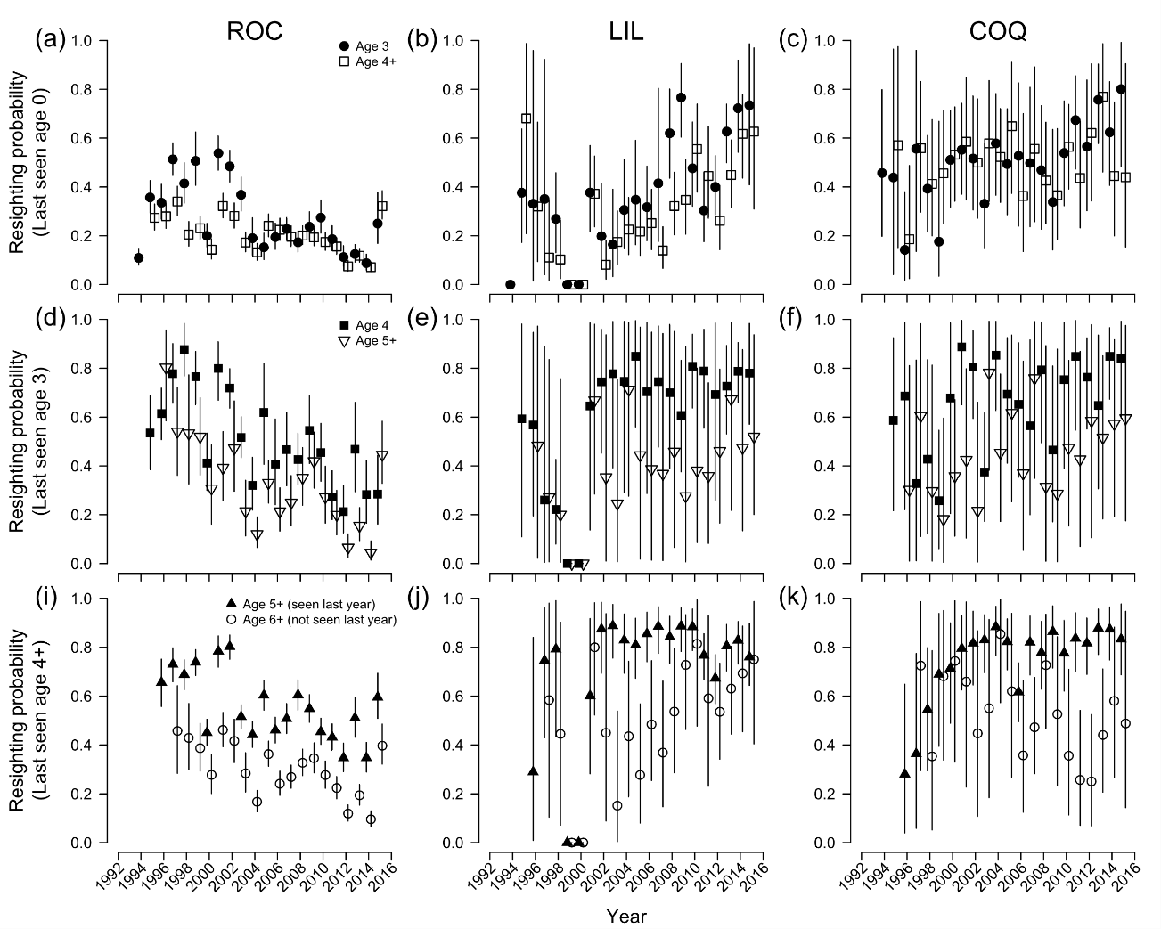
Figure S2. Estimates of juvenile, age 3 and age 4+ number of emigrants and immigrants obtained from the integrated population model for Rockabill (ROC), LIL and Coquet (COQ), with 95% credible intervals.
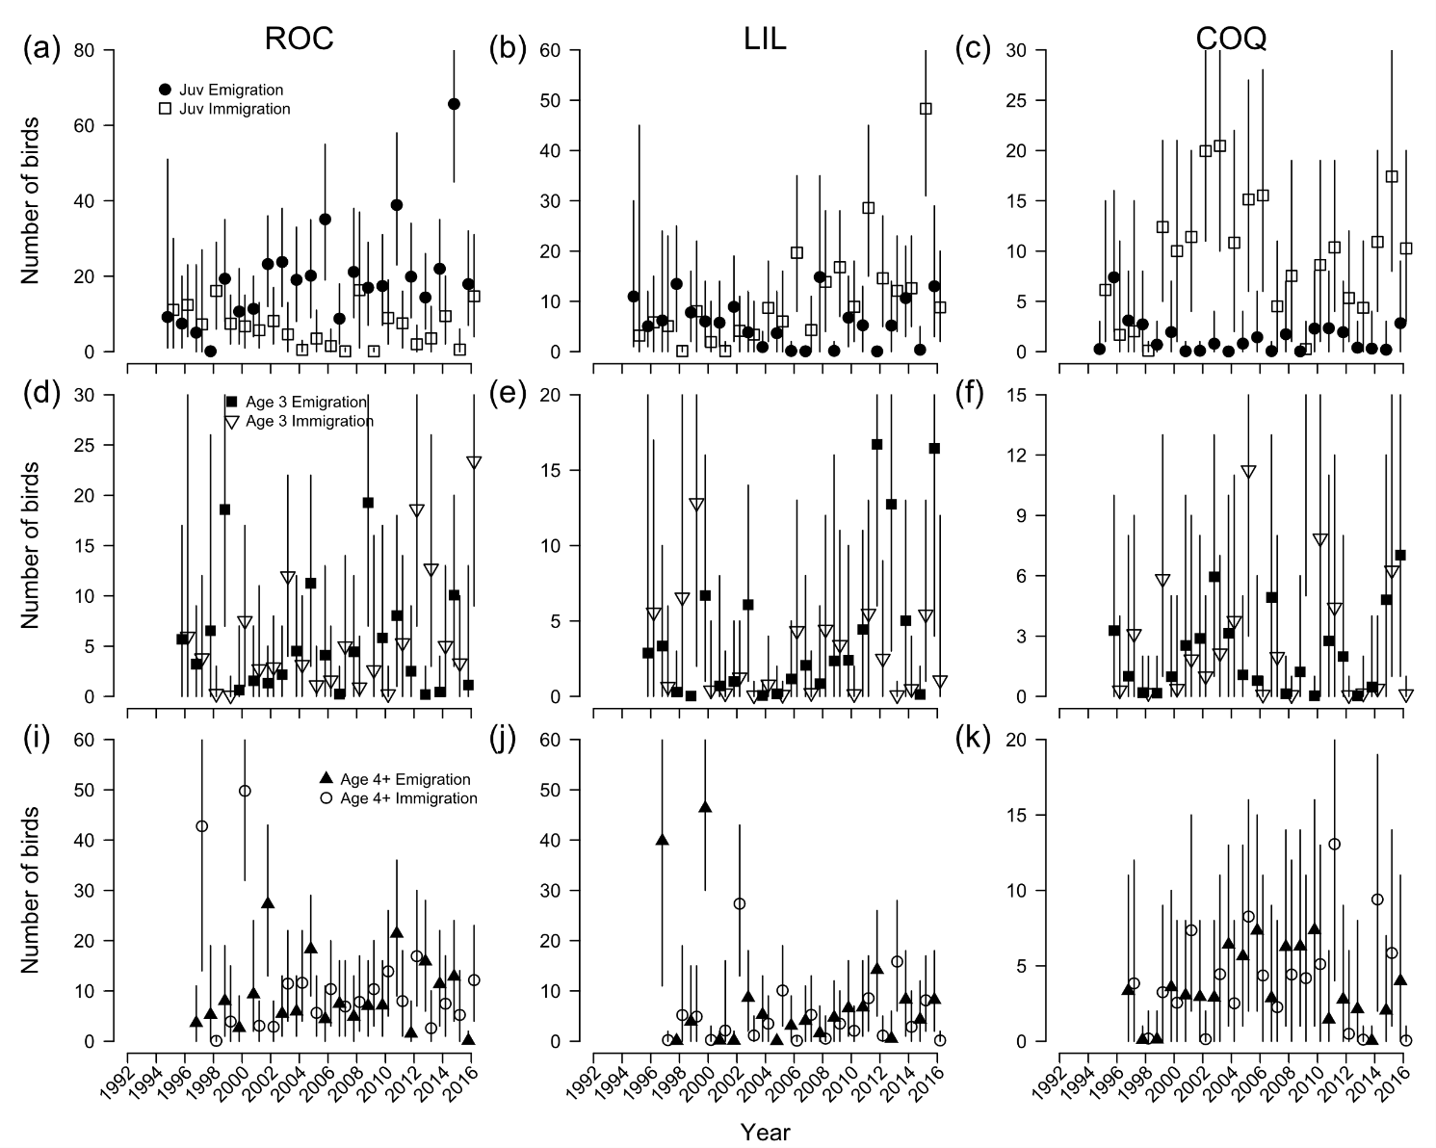

Figure S3. Estimates of juvenile survival from fledging to age 3 (a), annual age 3 survival (b), annual age 4+ survival (c), juvenile (d), age 3 (e) and age 4+ (f) emigration, juvenile (g), age 3 (h) and age 4+ (i) immigration, and productivity (j), plotted against the annual estimates of population growth rate at Rockabill. The black dots show posterior means and the grey lines 95% credible intervals.
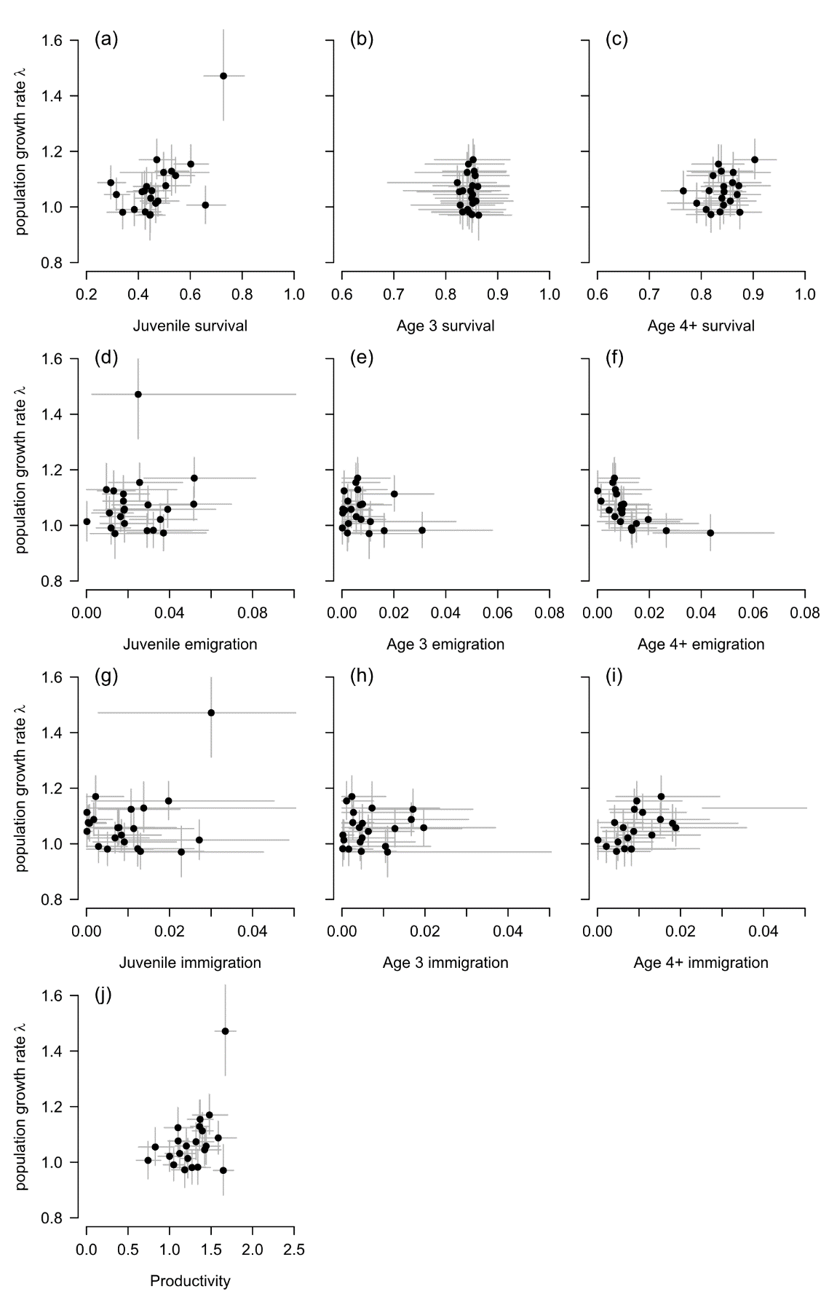
Figure S4. Estimates of juvenile survival from fledging to age 3 (a), annual age 3 survival (b), annual age 4+ survival (c), juvenile (d), age 3 (e) and age 4+ (f) emigration, juvenile (g), age 3 (h) and age 4+ (i) immigration, and productivity (j), plotted against the annual estimates of population growth rate at LIL. The black dots show posterior means and the grey lines 95% credible intervals.
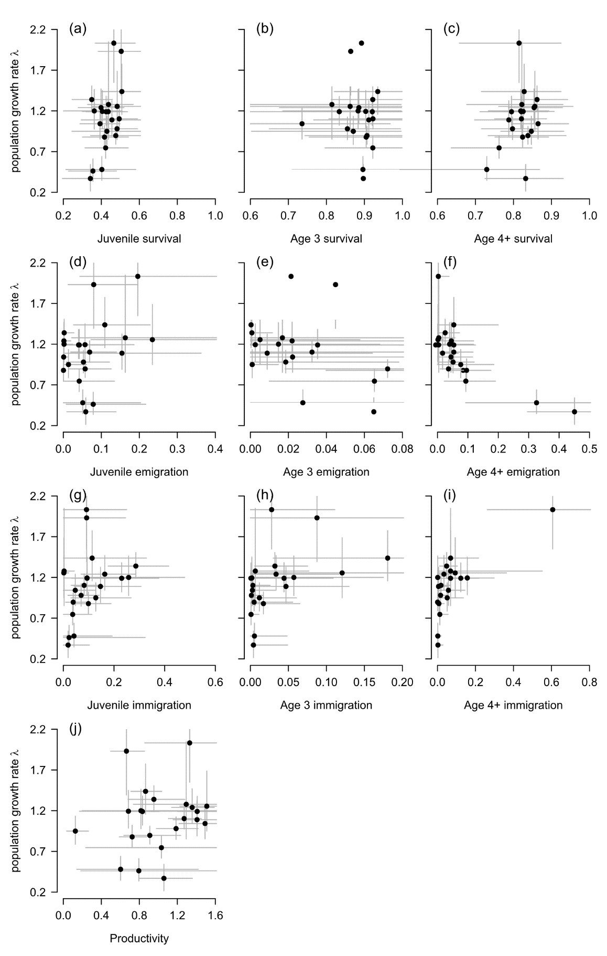

Figure S5. Estimates of juvenile survival from fledging to age 3 (a), annual age 3 survival (b), annual age 4+ survival (c), juvenile (d), age 3 (e) and age 4+ (f) emigration, juvenile (g), age 3 (h) and age 4+ (i) immigration, and productivity (j), plotted against the annual estimates of population growth rate at Coquet. The black dots show posterior means and the grey lines 95% credible intervals.
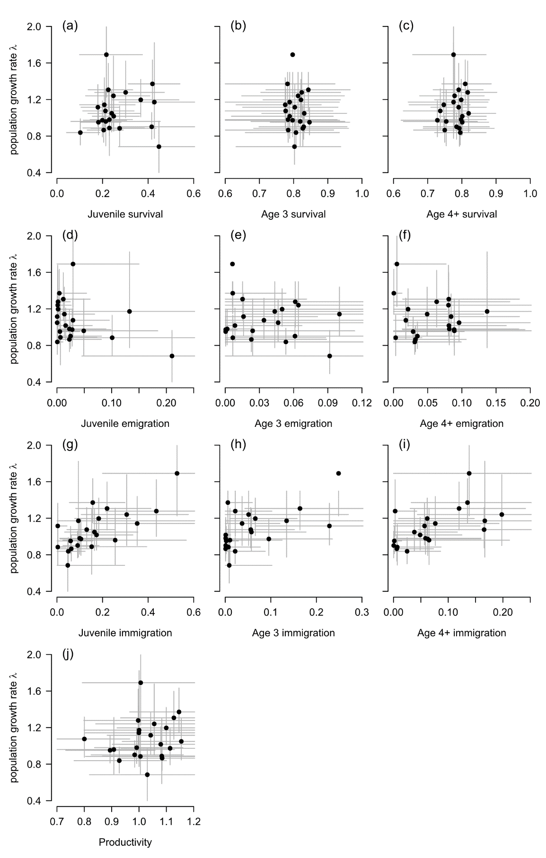
Figure S6. Estimates of juvenile survival from fledging to age 3 at Rockabill (a), LIL (b) and Coquet (c), annual age 3 survival at Rockabill (d), LIL (e) and Coquet (f), annual age 4+ survival at Rockabill (g), LIL (h) and Coquet (i), and annual productivity at Rockabill (j), LIL (k) and Coquet (l) plotted against the annual estimates of total population growth rate (the three colonies combined). The black dots show posterior means and the grey lines 95% credible intervals.
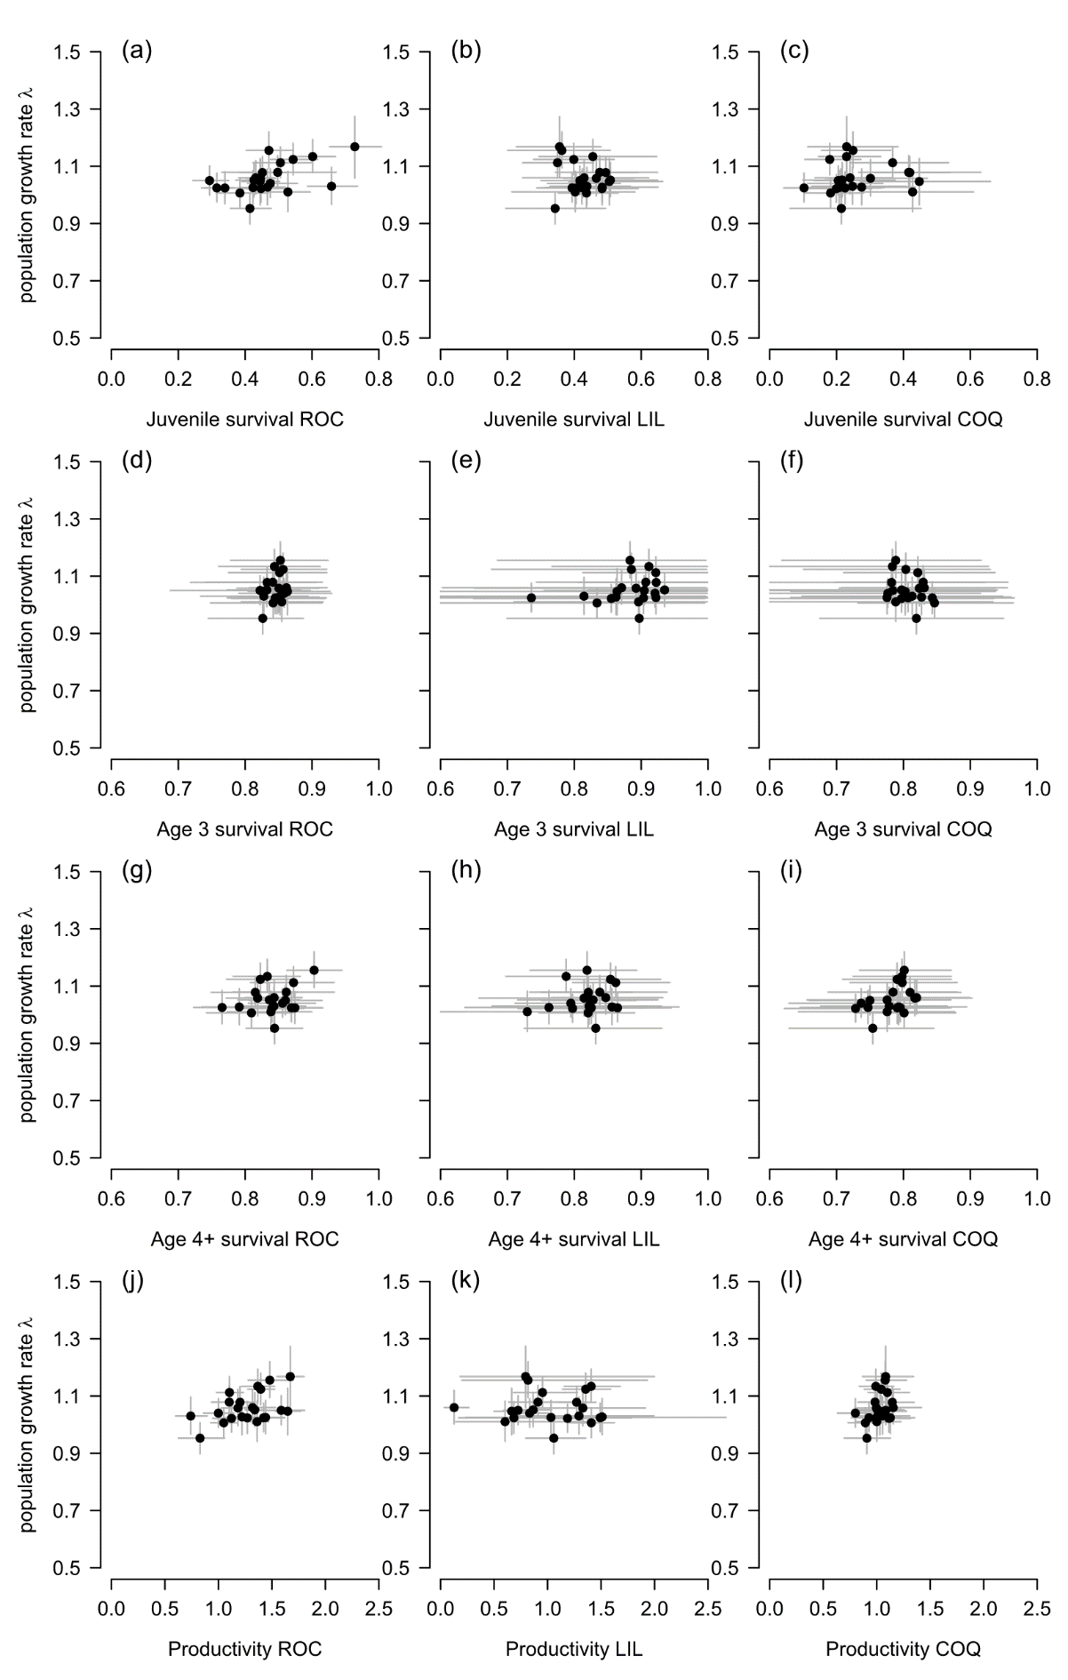
Figure S7. Estimates of juvenile survival from fledging to age 3 (a), annual age 3 survival (b), annual age 4+ survival (c), juvenile (d), age 3 (e) and age 4+ (f) emigration, juvenile (g), age 3 (h) and age 4+ (i) immigration, and productivity (j), plotted against the annual estimates of population size at Rockabill. The black dots show posterior means and the grey lines 95% credible intervals.
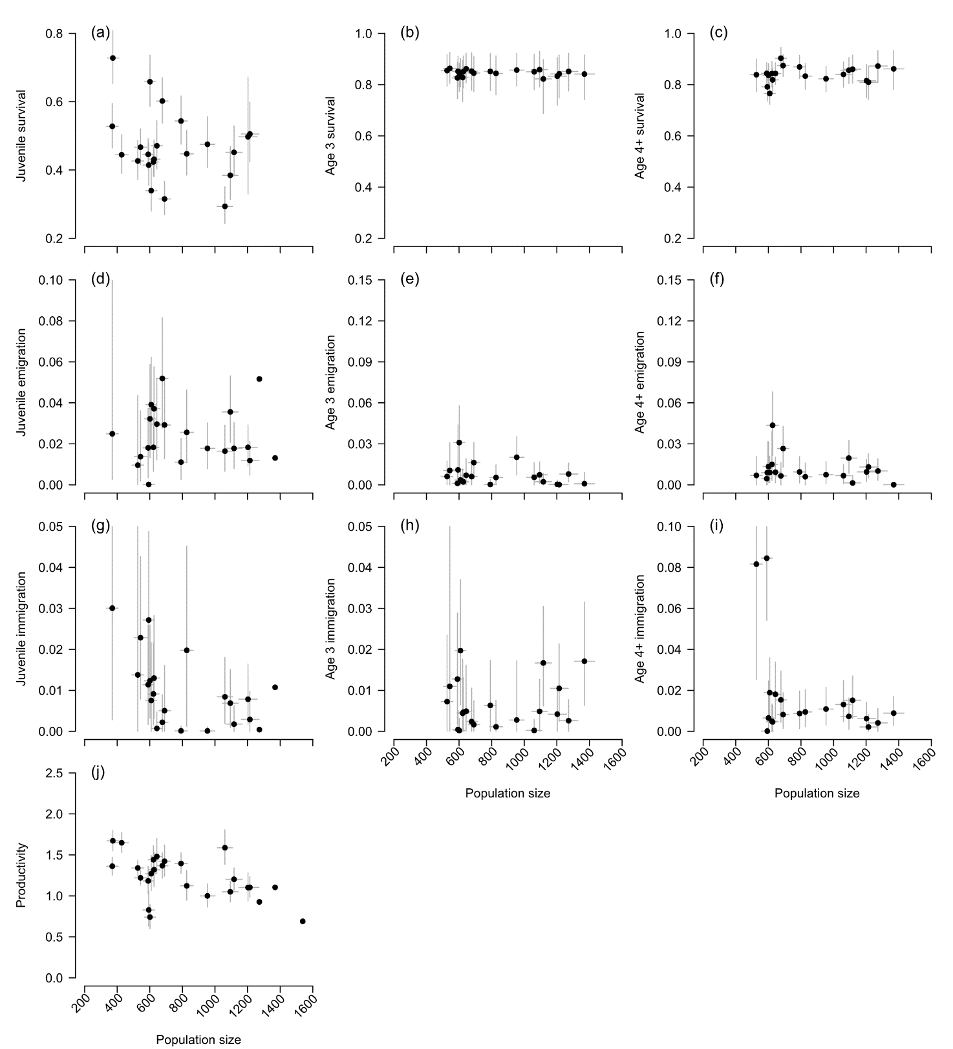

Figure S8. Estimates of juvenile survival from fledging to age 3 (a), annual age 3 survival (b), annual age 4+ survival (c), juvenile (d), age 3 (e) and age 4+ (f) emigration, juvenile (g), age 3 (h) and age 4+ (i) immigration, and productivity (j), plotted against the annual estimates of population size at LIL. The black dots show posterior means and the grey lines 95% credible intervals.
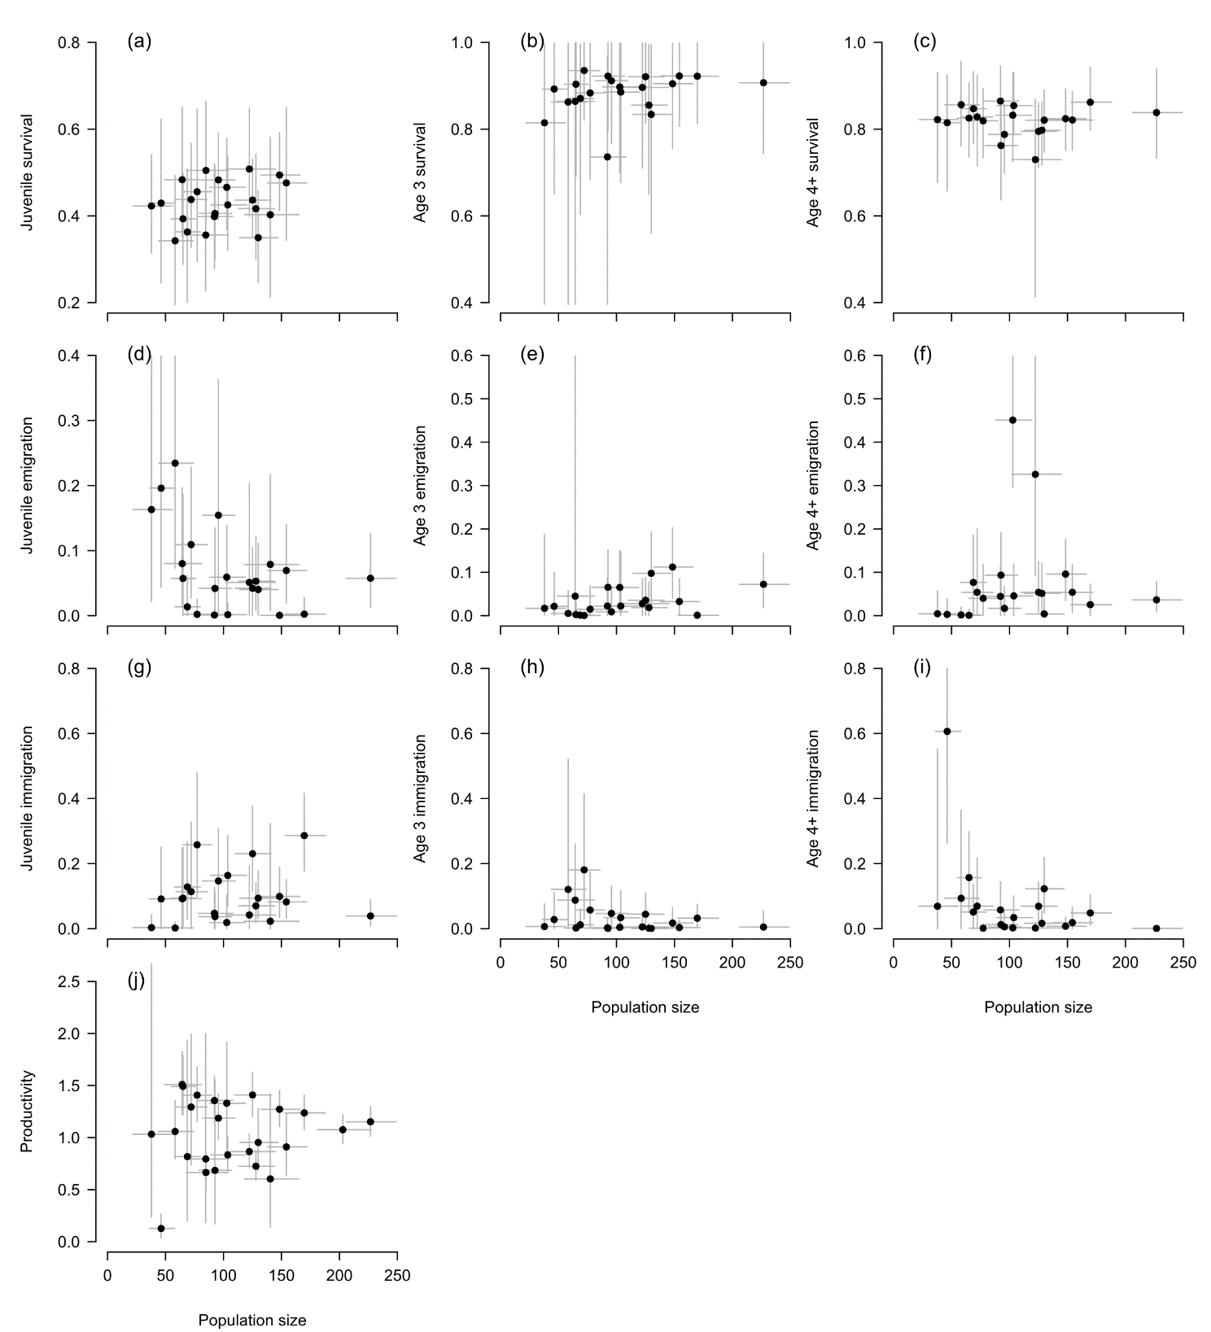

Figure S9. Estimates of juvenile survival from fledging to age 3 (a), annual age 3 survival (b), annual age 4+ survival (c), juvenile (d), age 3 (e) and age 4+ (f) emigration, juvenile (g), age 3 (h) and age 4+ (i) immigration, and productivity (j), plotted against the annual estimates of population size at Coquet. The black dots show posterior means and the grey lines 95% credible intervals.
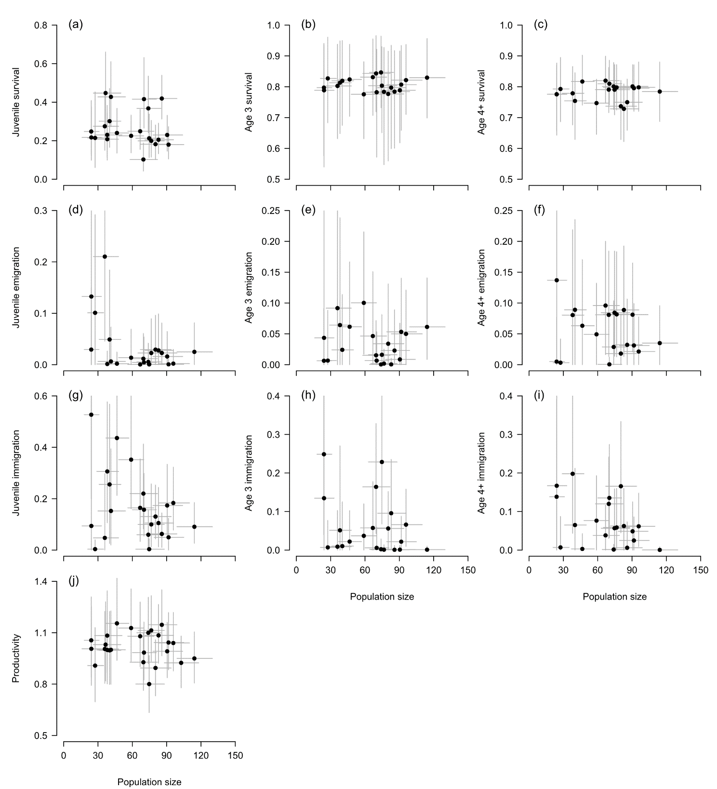

Table S2. Posterior modes and 95% credible intervals (in parentheses) of correlation coefficients between actual numbers of emigrants and immigrants and population size at the three colonies. Correlations with a probability >0.95 of being positive or negative are marked with *.
 | Correlation with population size
Parameter | Rockabill | LIL | Coquet
Juvenile emigrants | 0.46 (0.28, 0.58)* | -0.03 (-0.26, 0.24) | -0.33 (-0.52, 0.03)
Age 3 emigrants | -0.08 (-0.26, 0.17) | 0.34 (0.08, 0.47)* | 0.24 (-0.11, 0.44)
Age 4+ emigrants | -0.04 (-0.22, 0.14) | -0.31 (-0.39, -0.14)* | 0.20 (-0.09, 0.42)
Juvenile immigrants | -0.03 (-0.32, 0.21) | 0.68 (0.51, 0.77)* | 0.40 (0.18, 0.56)*
Age 3 immigrants | 0.50 (0.16, 0.61)* | 0.13 (-0.07, 0.43) | 0.25 (0.06, 0.41)*
Age 4+ immigrants | -0.19 (-0.28, -0.02)* | 0.11 (-0.03, 0.29) | 0.29 (0.04, 0.48)*

Table S3. Results of goodness of fit tests of a general JMV model to the data using programme U-CARE. These results show that resighting probability varies between ‘new’ and ‘old’ birds (transience) and that there is a difference in resighting probability between birds encountered in the previous year to those not encountered in the previous year (‘trap’ dependence). We therefore incorporated a 3-age class structure in the model, while allowing resighting probability to vary between individuals encountered or not encountered the previous year.
Test | Statistic | df | p | Testing for
3G.SR | 8731.0 | 413 | 0.000 | Transience
M.ITEC | 1242.8 | 72 | 0.000 | Trap dependence

