A new method for the determination of primary and secondary terrestrial and marine biomarkers in ice cores using liquid chromatography high-resolution mass spectrometry

Amy.C.F.King^{a,b}*, Chiara Giorio^{b,}*, Eric Wolff^{c}, Elizabeth Thomasª, Ornela Karroca^{b,d}, Marco Roverso^{e}, Margit Schwikowski^{f}, Andrea Tapparo^{e}, Andrea Gambaro^{d}, Markus Kalberer^{b}

ªBritish Antarctic Survey, High Cross, Madingley Road, Cambridge, CB3 0ET, United Kingdom
^{b}Department of Chemistry, University of Cambridge, Lensfield Road, Cambridge, CB2 1EW, United Kingdom
^{c}Department of Earth Sciences, University of Cambridge, Downing Street, Cambridge CB2 3EQ, United Kingdom
^{d}Ca’ Foscari University of Venice, Venice, Italy
^{e}Dipartimento di Scienze Chimiche, Università degli Studi di Padova, Via Marzolo 1, 35131 Padova, Italy
^{f}Paul Scherrer Institut, Forschungsstrasse 111, 5232 Villigen PSI, Switzerland

Email addresses in order of authorship;

acfk2@cam.ac.uk*; chiara.giorio@unipd.it; ew428@cam.ac.uk; lith@bas.ac.uk; ornela86@live.it; marco.roverso@unipd.it; margit.schwikowski@psi.ch; andrea.tapparo@unipd.it; gambaro@unive.it; mk594@cam.ac.uk

*Corresponding authors (Amy C.F.King, acfk2@cam.ac.uk and Chiara Giorio, chiara.giorio@unipd.it)

Declarations of interest: none

Abstract
The majority of atmospheric compounds measured in ice cores are inorganic, while analysis of their organic counterparts is a less well developed field. In recent years, understanding of formation, transport pathways and preservation of these compounds in ice and snow has improved, showing great potential for their use as biomarkers in ice cores. This study presents an optimised analytical technique for quantification of terrestrial and marine biosphere emissions of secondary organic aerosol (SOA) components and fatty acids in ice using HPLC-MS analysis. Concentrations of organic compounds in snow and ice are extremely low (typically ppb or ppt levels) and thus pre-concentration is required prior to analysis. Stir bar sorptive extraction (SBSE) showed potential for fatty acid compounds, but failed to recover SOA compounds. Solid phase extraction (SPE) recovered compounds across both organic groups but methods improving some recoveries came at the expense of others, and background contamination of fatty acids was high. Rotary evaporation was by far the best performing method across both SOA and fatty acid compounds, with average recoveries of 80%. The optimised preconcentration – HPLC-MS method achieved repeatability of 9% averaged for all compounds. In environmental samples, both concentrations and seasonal trends were observed to be reproducible when analysed in two different laboratories using the same method.

Keywords

Ice Core, Organic Aerosol, Biomarker, Mass Spectrometry, Rotary Evaporation, Paleoclimate

Introduction
Analysis of organic compounds in ice cores is a growing area of investigation in paleoclimate reconstruction [1]. A small number of organic compounds have already been investigated and shown to give robust environmental records, including biomass burning markers [2,3], anthropogenic pollutants such as persistent organic pollutants (POPs) and polycyclic aromatic hydrocarbons (PAHs) [4,5], and the sea-ice proxy methanesulfonic acid (MSA) [6]. However, non-anthropogenic organic compounds sourced from both the terrestrial and marine biosphere are in general not as well developed in either analytical quantification, or our understanding of any available records.
Fatty acids are sourced from terrestrial leaf epicuticular waxes, soil dust, microbial processes or marine phytoplankton [7] and entrained in the atmosphere as so-called primary aerosols [8]. Their concentrations may be expected to demonstrate a record of biogeochemical emissions [9]. Relatively resistant to degradation [10], they persist in the atmosphere at time scales at least allowing long-range transportation over several days. Fatty acids from terrestrial sources may be identified as high molecular weight fatty acids (HFA) (>C24), as opposed to low molecular weight fatty acids (LFA) (<C24) which are indicative of marine and microbial sources [7,8].
Isoprenes and terpenes are emitted from all plants and form a significant contribution to the hydrocarbon budget of the atmosphere [11]. They are also emitted from algal sources in ocean regions [12,13], a minor source in comparison to terrestrial emissions [14]. Significant terrestrial emissions have been observed over a wide range of ecosystems; for example, isoprene and monoterpenes are shown to dominate the flux of organic compounds above Amazonian forest canopies [15,16]. Sesquiterpenes also contribute, though emissions, flux and oxidation pathways are difficult to study because of their very high reactivity [17]. Shown to change in correspondence to ambient atmospheric conditions, isoprene and terpene emissions have been proposed to result from a ‘thermotolerance mechanism’ of plants [11]. The production of isoprene is also shown to both increase (where NOx levels are high) and decrease (where NOx levels are low) the local production of ozone through a series of oxidation reactions, which in the latter case may be beneficial in a plant’s protection of leaves from ozone damage [11,18].

Isoprene and terpenes have short chemical lifespans of minutes up to a few hours [15]. However, some oxidation products of these compounds in both gas and condensed )i.e. aerosol) phase demonstrate a greater potential for longevity in the atmosphere, and possible subsequent deposition on snow and ice further from the source region.
Some compounds from these groups have been detected in snow throughout polar and low-latitude mountainous regions and with records dating back over many centuries. The most successful examples include the detection of lipid compounds in ice layers dating back 450 years at Site J, Greenland [19], oxidation products of isoprene and monoterpenes in ice up to 350 years old in Alaska [20], and an annually resolved record of carboxylic acids and inorganic ions between 1942-1993 from Grenzgletscher (Monte Rosa Massif) in the southern Swiss Alps [21]. One thing these studies have in common is compound concentrations at parts per billion (ppb) levels or well below, more commonly parts per trillion (ppt), leading us to the requirement to preconcentrate samples to allow reliable detection and quantification.
Rotary evaporation preconcentration has been previously applied to both the SOA and fatty acid compound groups including compounds which we consider in this study. Pokhrel et al. [22] quantified fatty acids in rotary evaporated Alaskan ice samples using gas chromatography mass spectrometry (GC-MS), with average concentrations of individual compounds ranging between 0.09 and 20.3 ppb (Limit of Detection (LOD) 0.001ppb, percentage recovery not reported). Kawamura (1993) achieved LODs of 0.05 ppb for oxocarboxylic acids, and measured dicarbonyls at concentrations of 0.25-1.72 ppb in snow and aerosol samples. In examples of SOA compounds, Pokhrel et al. [20] and Fu et al. [24] rotary evaporated ice from Alaska and Kamchatka respectively, with GC-MS analysis detecting isoprene and monoterpene SOA compounds at 6.99±17 to 692±702 ppb in the Alaskan and 0.05−18.4 ppb in the Kamchatkan (percentage recovery was not reported) ice.
Stir bar sorptive extraction (SBSE) has also been used to preconcentrate snow and ice samples. Muller-Tautges et al. [25] used a polydimethylsiloxane (PDMS) coated bar for extraction of α-dicarbonyls (glyoxal and methylglyoxal). Using high-performance liquid chromatography coupled to electrospray ionization tandem mass spectrometry (HPLC-ESI-MS/MS), they report LODs of 0.242 and 0.213 ppb for glyoxal and methylglyoxal respectively, and recoveries of 78.9±5.6 % for glyoxal and 82.7±7.5 % for methylglyoxal.
This study aims to provide an optimised method of pre-concentration, detection and quantification for a wide list of the most promising terrestrial and marine organic biomarkers in ice (Table 1) for paleo environmental reconstruction. The commonly used biomass burning marker levoglucosan [2,26] is also included in the list to enable comparisons between our results and detection of an organic compound by existing studies. The criteria for the compounds on our list is that they should have either been detected in snow and ice previously or shown potential to be detected in such locations via their long-range transport in atmospheric aerosol, sufficiently long atmospheric lifetime over long distances, and preservation in snow and ice. Furthermore, emission changes of the compound should be related to climatological or environmental changes at the source. A final consideration is the availability of laboratory standards of the compounds to allow calibration, quantification and multi-laboratory comparison.

Table 1: Target compound list for this study, by compound group and in order of increasing number of carbon atoms.
Source | Compound name | Neutral Formula
Isoprene-derived SOA | Meso-erythritol* | C₄H₁₀O₄
Isoprene-derived SOA | Methyl-tetrols | C₅H₁₂O₄
Monoterpene-derived SOA | Pimelic acid* | C₇H₁₂O₄
Monoterpene-derived SOA | 1,2,4-butanetricarboxylic acid (BTCA)* | C₇H₁₀O₆
Monoterpene-derived SOA | 3-methyl-1,2,3-butanetricarboxylic acid (MBTCA) | C₈H₁₂O₆
Monoterpene-derived SOA | Terebic acid | C₇H₁₀O₄
Monoterpene-derived SOA | Pinolic acid | C₁₀H₁₈O₃
Monoterpene-derived SOA | Cis-pinonic acid | C₁₀H₁₆O₃
Monoterpene-derived SOA | Keto-pinic acid | C₁₀H₁₄O₃
Sesquiterpene-derived SOA | β-caryophyllinic acid | C₁₄H₂₂O₄
Sesquiterpene-derived SOA | β-caryophyllonic acid | C₁₅H₂₄O₃
Sesquiterpene-derived SOA | β-nocaryophyllonic acid | C₁₄H₂₂O₄
Biomass burning | Levoglucosan | C₆H₁₀O₅
Biogenic SOA | D-malic acid | C₄H₆O₅
Primary biogenic | Salicylic acid | C₇H₆O₃
Low molecular weight fatty acids (LFA) (<C24); marine / microbial sources | Lauric acid | C₁₂H₂₄O₂
 | Myristic acid | C₁₄H₂₈O₂
 | Heptadecanoic acid | C₁₇H₃₄O₂
 | Oleic acid | C₁₈H₃₄O₂
 | Nonadecanoic acid | C₁₉H₃₈O₂
 | Arachidonic acid | C₂₀H₃₂O₂
 | Behenic acid | C₂₂H₄₄O₂
 | Tricosanoic acid | C₂₃H₄₆O₂
High molecular weight fatty acids (HFA) (>C24); terrestrial biomass | Heptacosanoic acid | C₂₇H₅₄O₂
 | Octacosanoic acid | C₂₈H₅₆O₂
 | Melissic acid | C₃₀H₆₀O₂
*surrogate standards (analytes chemically similar to those being extracted where actual standard not available)

Materials and methods
Sample analysis, after preconcentration in a rotary evaporator, was carried out using high performance liquid chromatography (HPLC) electrospray ionisation (ESI) high-resolution mass spectrometry (HRMS) with a post-column injection of ammonium hydroxide in methanol. The method has been optimised for analytes in Table 1 and the optimisations steps leading to this final methodology are described in section 3.

Chemicals and reagents
Dichloromethane (>99.9%, OptimaTM, HPLC/MS, Fisher Chemical), and acetonitrile (>99.9%, Optima™ HPLC/MS, Fisher Chemical) were used for preparation of the bulk standard solutions. Standard solutions of each analyte were prepared at a concentration of 100 ppm in acetonitrile for methyltetrols (synthesised standard), meso-erythritol (≥99%, Sigma-Aldrich®), levoglucosan (99%, Sigma-Aldrich®), ketopinic acid (99%, Sigma-Aldrich®), pinolic acid (Sigma-Aldrich®, analytical grade), terebic acid (Sigma-Aldrich®, analytical grade), MBTCA (synthesised standard), BTCA (99%, Sigma-Aldrich®), cis-pinonic acid (98%, Sigma-Aldrich®), D-malic acid (HPLC/GC suitable, Supelco), salicylic acid (≥99%, Sigma-Aldrich®,), pimelic acid (98%, Sigma-Aldrich®), β-caryophyllinic acid (synthesised standard), β-caryophyllonic acid (synthesised standard), β-nocaryophyllonic acid (synthesised standard), oleic acid (>99%, Sigma-Aldrich®), arachidonic acid (95%, Sigma-Aldrich®), palmitic acid (≥99%, FlukaTM), heptadecanoic acid (≥98%, Sigma-Aldrich®), lauric acid (97.9%, European Directorate for the Quality of Medicines & HealthCare), myristic acid (≥99.5%, FlukaTM), d10-pimelic acid (99%, Sigma-Aldrich®) and d3-malic acid (98%, Sigma-Aldrich®), and in dichloromethane for behenic acid (≥99%, FlukaTM), melissic acid (≥98%, Sigma-Aldrich®), tricosanoic acid (>99%, Sigma-Aldrich®), heptacosanoic acid (≥97%, Sigma-Aldrich®), octacosanoic acid (≥98%, Sigma-Aldrich®), nonadecanoic acid (≥99.5%, FlukaTM) and d31-palmitic acid (99%, Sigma-Aldrich®). Five of the compounds on our list are not commercially available standards and were therefore specifically synthesised and provided by other labs; MBTCA from the lab of Magda Claeys (University of Antwerp, Belgium), methyl-tetrols from the lab of Jean-Louis Clement (Aix-Marseille Universite, France), and β-caryophyllonic, β-caryophyllinic, and β-nocaryophyllonic acids from the lab of Thorsten Hoffman (University of Mainz, Germany). Standard solutions were then combined into a diluted standard mixture of all analytes at a concentration of 1 ppm in acetonitrile. All standards were stored at -18°C.
Methanol (>99.9%, Optima™ UHPLC/MS, Fisher Chemical), water (>99.9%, Optima™ UHPLC/MS, Fisher Chemical), and acetonitrile (>99.9%, Optima™ HPLC/MS, Fisher Chemical) were used as eluents. Ammonium hydroxide (25% in water, LC-MS grade, Honeywell Fluka™), ammonium formate (≥99%, Sigma-Aldrich®), ammonium acetate (≥98%, Sigma-Aldrich®), sodium acetate (≥99%, Sigma-Aldrich®), ammonium fluoride (≥99.99%, Sigma-Aldrich®), and formic acid (98%, LC-MS grade, Honeywell Fluka™) were tested as eluent additives.

Cleaning procedures and solvent purification
All glassware was baked in a furnace at 450ºC for 8hrs following the method of Müller-Tautges et al. (2014). Solvents, used as eluents and for preparation of the diluted standard solutions, were additionally cleaned by ozonation. The set up used a stream of air (Zero grade, BOC) at 0.2 L/min run through a glass tube containing a UV lamp (185/254 nm, Appleton Woods), which created air at high concentrations of ozone (ca. 290 ppm). This air was bubbled directly through the solvents using a pre-cleaned glass pipette, for 1 hr per 1 L of solvent. Solvents were then sonicated for 15 minutes to remove residual ozone from the solvent.

Sample preparation
Ice samples from the Belukha glacier (Russian Altai Mountains) ice core were provided by the Paul Scherrer Institut, Switzerland, for which details on drilling, transportation and cutting can be found in [27,28]. Additionally for organics samples, cut using the band-saw to remove any outer ice surfaces, the sample surfaces were scraped using a clean metal blade and placed directly inside amber glass vials with PTFE lined caps. Cut samples were transported onward to Cambridge frozen, and stored at -25ºC until melting (in sealed glass vials inside a clean room at approx. 16ºC), preconcentration and analysis. A total of 19 samples were measured at sub-annual resolution, representing the time period 1866-1869.
Samples were preconcentrated in a rotary evaporator [22, and thereafter]; this followed testing of a range of methods using stir-bar preconcentration, SPE or rotary evaporation. Optimisation and the choice of final parameters are discussed in section 3.4.
10 mL of each sample was evaporated to dryness after addition of d3-malic acid, d10-pimelic acid, and d31-palmitic acid at a concentration of 10 ppb in a 50 mL round-bottom flask. Evaporation was done with a water bath temperature of 30°C, a rotator speed of 60 rpm, and a vacuum pressure of 100 mbar. 3 mL of methanol was added to the flask and sonicated for 5 mins. The methanolic extract was transferred into a 4 mL vial and evaporated down to 0.5 mL under a gentle flow of N₂ at room temperature of approximately 18ºC. 0.1 mL of methanolic extract was then transferred into a glass HPLC vial for analysis while the remaining 0.4 mL were kept at -18°C for eventual future analysis.

Instrumental analysis
All analyses used a HPLC-ESI-HRMS with an Accela system HPLC (Thermo Scientific, Bremen, Germany) coupled to an LTQ Velos Orbitrap (Thermo Scientific, Bremen, Germany). A Waters XBridge™ C18 (3.5 µm, 3.0x150 mm) column was used for chromatographic separation of the analytes. Mobile phases were (A) water with 0.5 mM NH₃ and (B) methanol with 0.5 mM NH₃. Separation was done at room temperature (~20°C), with a flow rate of 250 μL/min. Elution gradient was: 0–3 min 0% B, 3–4 min linear gradient from 0% to 30% B, 4–9 min 30% B, 9–10 min linear gradient from 30% to 100% B, 10–25 min 100% B, 25–26 min linear gradient from 100% to 0% B, 26–35 min 0% B. In addition, a post-column injection of methanol with 5 mM NH₃ was added at 100 µL/min. Injection volume was 20 μL. All analytes were quantified in negative ionisation using the following ESI source parameters: 400°C source temperature, 40 arbitrary units (a.u.) sheath gas flow rate, 20 a.u. auxiliary gas flow rate, 3.5 kV needle voltage, 350°C transfer capillary temperature, S-Lens RF Level 50%. MS spectra were collected in full scan, with a resolution of 100 000 at m/z 400, in the mass range m/z 80–600 and in MS/MS for all target compounds with a collision-induced dissociation (CID) energy of 30 (normalized collision energy). The mass spectrometer was calibrated routinely to within an accuracy of ± 2 ppm, using Pierce LTQ Velos ESI Positive Ion Calibration Solution and a Pierce ESI Negative Ion Calibration Solution (Thermo Scientific, Bremen, Germany).
The instrument was calibrated daily using standard solutions in the range 1-100 ppb in methanol prepared by diluting the 1 ppm stock standard mixture. d3-m alic acid, d10-pimelic acid and d31-palmitic acid at a concentration of 10 ppb were used as internal standards. Quality check standards at a concentration of 10 ppb have also been analysed every 10 samples.

Results and Discussion
The aim of the study was to develop a single analytical method for the quantification of both primary, e.g. long chain fatty acids, and secondary, e.g. oxidation products of isoprene, monoterpenes and sesquiterpenes, sourced biomarkers in ice cores using HPLC-MS.

Optimisation of the chromatographic separation
The optimisation of the chromatographic separation aimed at finding a good compromise in terms of retention and sensitivity between low molecular weight and high molecular weight compounds. Different chromatographic columns have been tested: two long C18 columns (Waters Atlantis® T3 and Waters Xbridge™, 3.5 µm, 3.0x150 mm), a short C18 column (Phenomenex Synergi™ Hydro-RP, 4.0 µm, 4.6x50 mm), a C3 column (Agilent ZORBAX SB-C3, 3.5 µm, 3.0x100 mm), and a pentafluorophenyl (PFP) column (Phenomenex Kinetex® PFP, 2.6 µm, 2.1x100 mm). The HPLC columns have been tested with different eluent compositions using a gradient elution with water as eluent A and an organic phase constituting of either acetonitrile, methanol or a mixture of methanol and isopropyl alcohol (90:10) as eluent B. In addition, different combinations of additives have been tested on both the water and the organic phase to improve separation and instrumental response: formic acid (0.01% and 0.1%), ammonium formate (5 mM), ammonium acetate (5 mM), sodium acetate (5 µM), ammonium fluoride (1 mM) and ammonium hydroxide (0.1, 0.5, 1 and 5 mM). A list of the different conditions tested, including different combinations of chromatographic columns, eluents and additives, is reported in Table S1 in the supporting information. The effects of different eluents tested on the separation, peak shape and sensitivity towards the target analytes are schematically shown in Figure 1.

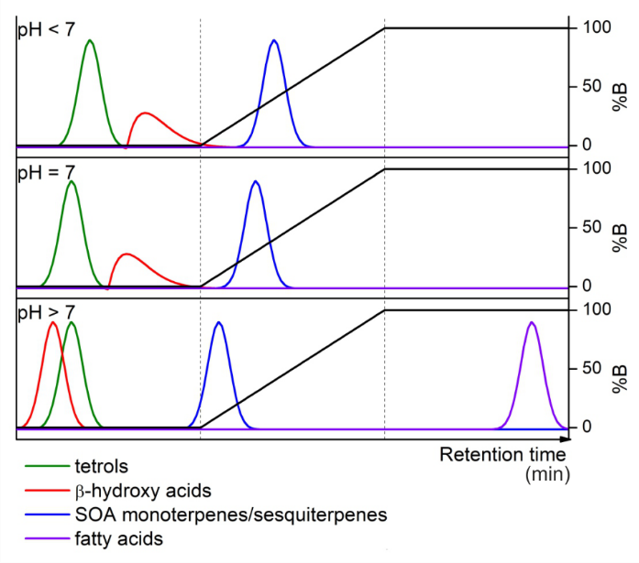
Figure 1: Example chromatograms showing the effect of the pH of the eluents on the elution time, peak shape and sensitivity of the HPLC-ESI-HRMS method for the determination of terrestrial and marine biomarkers both primarily and secondarily sourced. "%B" indicates the percentage concentration of organic phase in the eluent.

Elution of long-chain fatty acids proved to be challenging due to their high affinity for all the stationary phases. For example, retention time of melissic acid (C₃₀H₆₀O₂) was >60 mins for both long C18 columns with neutral eluents (flow rate 250 µL/min). There was not any significant improvement in this regard by using a short C18 column while the C3 and PFP columns provided shorter retention times (<60 mins at 250 µL/min). Methanol provided slightly shorter retention times, more symmetric and sharper peaks for long chain fatty acids compared with acetonitrile. The use of a mixture of methanol and isopropyl alcohol significantly, but not sufficiently, reduced retention times of long chain fatty acids. The best results in terms of instrumental response and sufficiently short retention times have been obtained using ammonium hydroxide as an additive in the organic phase. Ammonium hydroxide can successfully deprotonate the fatty acids decreasing their affinity for the stationary phase.
Concerning low molecular weight compounds, the two long C18 columns provided the best chromatographic separation with all eluent compositions tested. However, the use of ammonium hydroxide as an additive shortens their retention times so that the smallest compounds are eluted close to the dead time. A combination of acidic eluent A (with 0.01% and 0.1% formic acid) and basic eluent B (with 0.1-5 mM ammonium hydroxide) was tested to overcome this issue while maintaining short retention times and a good instrumental response for fatty acids. While chromatographic separation improved for most of the low molecular weight compounds, the most acidic compounds, like the β-hydroxy acid (malic acid) and the tricarboxylic acids (BTCA and MBTCA), presented extensive peak broadening due to the establishment of an equilibrium between the protonated and neutral forms, or the neutral and deprotonated forms, which significantly decreased sensitivity for those compounds. The same applies with the other eluent additives tested which provided a neutral pH eluent. Using ammonium hydroxide at a concentration of 0.5 mM in both eluent A and B provides a good compromise between retention of low molecular weight compounds and sensitivity (sharp peaks) for β-hydroxy acids and tricarboxylic acids.
Finally, gradient elution has been optimised for chromatographic separation of low molecular weight compounds in conjuction with analysis time (dependent on the elution of fatty acids). Retention times of all analytes with the optimised gradient elution (see section “2.4” for details) are demonstrated in the example chromatogram for a 100 ppb standard in Figure 2.

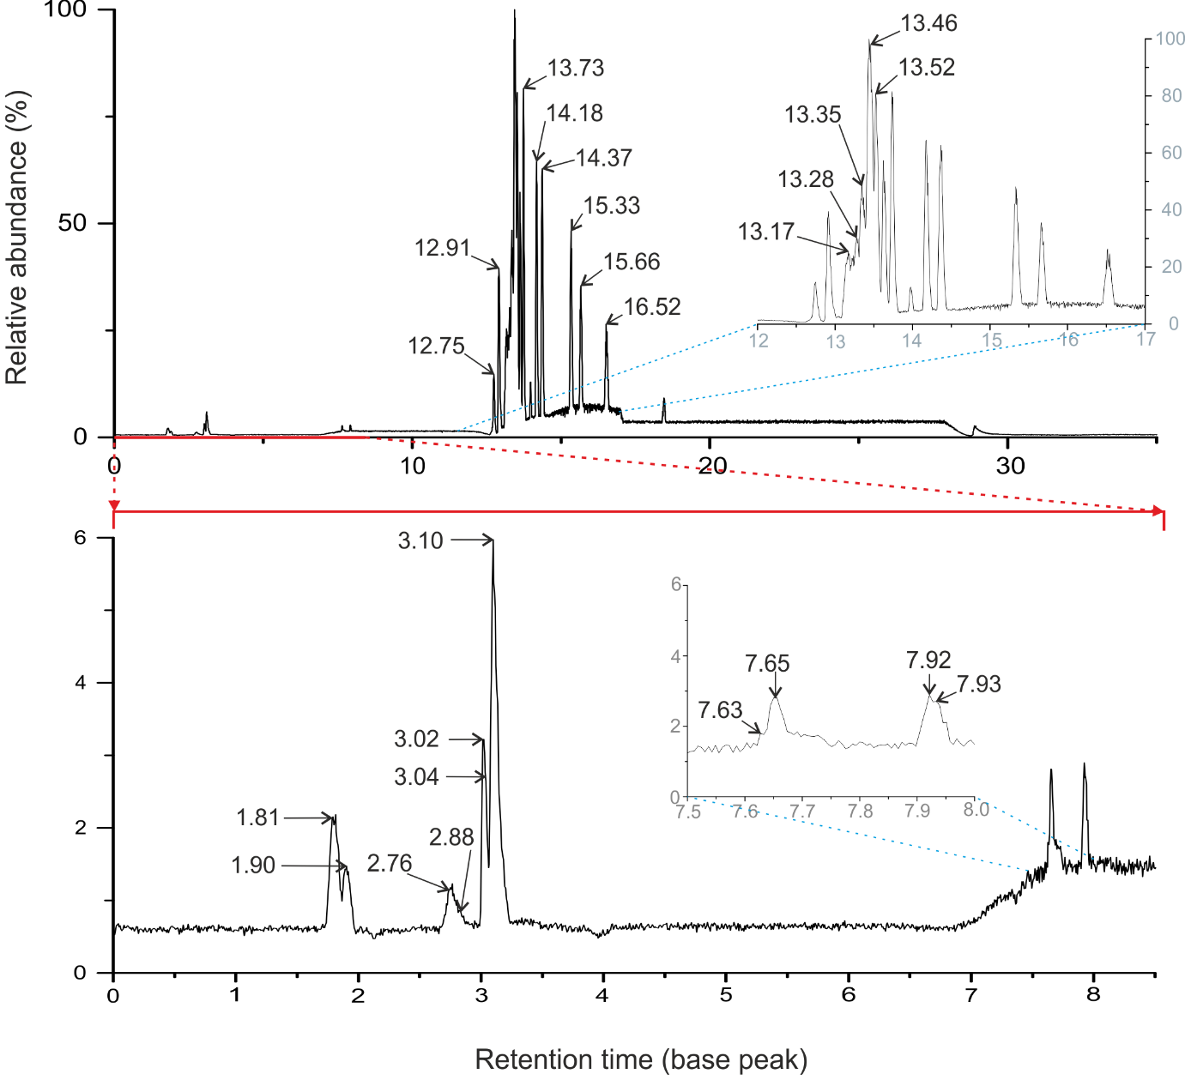
Figure 2: Example chromatogram in base peak for a 100 ppb standard solution with the fully optimised method of chromatographic separation and instrumental response. Compounds are as follows by increasing retention time: 1.81 (BTCA), 1.81 (MBTCA), 1.90 (D-malic acid), 1.90 (Pimelic acid), 2.76 (Levoglucosan), 2.88 (Meso-erythritol), 3.02 (Terebic acid), 3.04 (Methyl-tetrols), 3.10 (Pinolic acid), 7.63 (cis-pinonic acid), 7.65 (Salicylic acid), 7.92 (Keto-pinic acid), 7.93 (β-caryophyllinic acid), 12.75 (β-nocaryophyllonic acid), 12.91 (β-caryophyllonic acid), 13.17 (Lauric acid), 13.28 (Myristic acid), 13.35 (Arachidonic acid), 13.46 (Oleic acid), 13.52 (Heptadecanoic acid), 13.73 (Nonadecanoic acid), 14.18 (Behenic acid), 14.37 (Tricosanoic acid), 15.33 (Heptacosanoic acid), 15.66 (Octacosanoic acid), 16.52 (Melissic acid).

Optimisation of the instrumental response
Most of the target analytes are organic acids, and so are better ionised in negative mode. In one particular case, the isoprene-derived methyl-tetrols and the surrogate standard meso-erythritol, the analyte could be ionised in both positive and negative polarity. Positive ionisation as protonated (with formic acid additive), adduct with ammonium (with ammonium formate and acetate additives) and adduct with sodium (with sodium acetate additive) molecular ions was compared with negative ionisation as deprotonated molecular ions (with ammonium hydroxide or ammonium fluoride additives). The best performances were obtained using ammonium hydroxide as an additive in negative ionisation. High concentrations of ammonium hydroxide are necessary to ensure good sensitivity for those compounds; however, it also reduces chromatographic separation. In order to increase the instrumental response for meso-erythritol and methyl-tetrols in particular, while maintaining a good chromatographic separation, post-column injections of ammonium hydroxide solutions were tested. Solutions of 5 mM, 50 mM, 100 mM and 200 mM ammonium hydroxide in either water or methanol at a flow rate of 10-100 µL/min were tested. The best results, with a sensitivity increase by a factor of five for the two compounds, have been obtained using a 5 mM ammonium hydroxide solution in methanol at a flow rate of 100 µL/min and this is therefore the conditions chosen as most optimised. Increasing the ammonium hydroxide concentration further did not make any improvement. The post-column injection also provided a higher sensitivity for the other analytes, especially those being eluted at the beginning of the chromatographic run at 100% A eluent composition.
Optimisation of source parameters with the final chromatographic method was done by changing source temperature between 50 to 400°C, capillary temperature between 300-350°C, sheath gas flow rate between 40-60 a.u., RF Lens between 10-100% and needle voltage between 3-4 kV. The best instrumental response for all analytes were obtained using 400°C source temperature, 350°C capillary temperature, 40 a.u. sheath gas flow rate, RF lens of 50% and 3.5 kV needle voltage. Auxiliary gas flow rate was kept at 20 a.u. while the sweep gas was not used.
Sample injection volume was also tested between 1-100 µL. A final injection volume of 20 µL was used as it provided a good compromise between maximising injected quantity for better sensitivity at low concentrations, and providing sharp enough chromatographic peaks in the concentration range tested.

Optimisation of the decontamination procedures
Ozonation of both UHPLC water and UHPLC methanol significantly reduced, but did not totally eliminate, background contamination of unsaturated fatty acids to the extent that calibration curves could be generated for all fatty acids on our list down to 1 ppb concentrations. We compared background contaminations in ozonated and non-ozonated solvents for all target analytes and observed that ozonated solvent did not introduce or increase contaminations for any compound.
The remaining contamination in the water blanks may come from sample preparation, the solvent used to make the stock-standard solution, or the instrument during sample analysis. It is worth noticing that the use of ozonated solvents causes a shift in the elution of most of the analytes, especially fatty acids, to higher retention times.
In an attempt to decrease background contamination of some fatty acids (e.g. lauric and myristic acids), we tested (i) adding a C18 SPE cartridge mounted on the water line (before the pump) in order to trap in the cartridge the fatty acids eventually present in water, and (ii) using an on-line trap (chromatographic) column [29] mounted between the mixer and the injector in order to separate chromatographically the background contamination of fatty acids in the eluents from the analyte and contamination present in the samples. The SPE cartridge did not make any improvement since it is probably quickly overloaded with the contamination and does not retain further contaminants. The use of a trap column caused a significant background reduction of lauric, myristic and palmitic acid however this was accompanied by a loss of sensitivity for other target analytes. While we cannot explain the loss of sensitivity, we decided to sacrifice those three analytes in order to maintain a good sensitivity overall.

Optimisation of the pre-concentration method

Stir-bar (SBSE) pre-concentration

The polydimethylsiloxane (PDMS) stir bar used in previous studies [25,30] (GERSTEL Twister®) enables extraction of organic compounds from a liquid matrix. The bars are also available with a second solid phase type: the EG/Silicon stir bar is a combination of PDMS / Ethylene glycol (EG). Both PDMS and EG stir bars were tested here.
The variables in the process which were optimised are as follows: stir bar solid phase (EG or PDMS), stir time (10 or 22 hrs), solvent for desorption of compounds from the bar (methanol or acetonitrile with additions of ammonium hydroxide), sonication time for desorption (15 minutes or 1 hr). There were further tests adjusting the pH of the sample (pH 3.5 or 5) to protonate the most acidic analytes and increase their affinity for the stationary phase for initial capture, and adding salts to the sample (sodium chloride, sodium sulphate) to decrease the solubility of non-electrolytes and increase their transfer to the stationary (organic) phase (salting-out effect). All tests were performed on a 10 mL sample of 10 ppb bulk standard solution of all compounds, concentrating down to 1 mL of sample for injection in to the HPLC-MS at a final theoretic maximum concentration of 100 ppb if recovery was 100%. Factors which were kept constant throughout the tests were the stir rate of the magnetic plate (700 rpm) and the temperature of solvents, which were at the lab temperature of 18ºC.
The final, most optimised (i.e. highest average recoveries of all compounds), stir bar method stirred the PDMS bar in the liquid sample at 700rpm for 20hours, and then desorbed the compounds in to 1mL of methanol+0.5mM ammonium hydroxide by sonication for 15 minutes. This is illustrated graphically in Figure S1.

SPE pre-concentration

In this study we tested a C18 cartridge (Perkin Elmer), and two new cartridges not previously used for organic analysis in snow or ice: HyperSep™ SAX (Thermo Fisher Scientific), a strong anion exchange sorbent for extraction of weak acids) and Strata-X® X-A (Phenomenex®), a strong anion-exchange functionalized polymeric sorbent.
A number of factors can be adjusted throughout the SPE method. This includes changing the counter ion (in this case, from chloride to formate), adjusting the acidity of the samples themselves (either acidified or basified from original pH) to change affinity of the compounds to the cartridge, changing solvents or solutions used to wash the cartridge to reduce loss of target compounds at this stage (either 25 mM ammonium acetate in water or 0.25% ammonium hydroxide in water for the first wash, and methanol for the second wash), and changing the number of washing stages (via elimination of the second wash stage). Further tested were the solvents or solutions used to elute the compounds, to improve recovery rate of total compounds from the cartridge (either 5% formic acid in methanol, ammonium hydroxide in water at solutions of 0.25%, 2%, and 5%, 1.2% hydrogen chloride in methanol, 20 mM potassium hydroxide (KOH) in water).
Factors that were constant throughout the tests were as follows; all cartridges were 1 mL in size with 100 mg sorbent mass. Manufacturer guidelines stipulate using 1 mL of solvents and solutions at stages 1, 2, 4 and 5 for this size and mass of cartridge. All samples were 10 mL of 50 ppb bulk standard, concentrated to 1 mL corresponding to a final concentration of 500 ppb if recovery is fully successful. Conditioning stages were always 1 mL of UHPLC water followed by 1 mL of UHPLC methanol. Because cartridge tops are open, all tests were performed under a fume hood and the cartridges covered over with foil between additions of liquid to the cartridges, to limit contamination.
The final method, considered most fully optimised due to best overall compounds recoveries, conditioned the HyperSep™ SAX cartridge with 1 mL of water and 1 mL of methanol, changed the counter ion to formate using 1 mL of 2% formic acid followed by 1 mL water and 1 mL water at pH 7, loaded 1 mL of liquid sample, washed the cartridge with 1 mL of 25 mM ammonium acetate solution at pH 8, and eluted the compounds with 1 mL of a 50/50 water/methanol solution with 5% ammonium hydroxide. This is illustrated graphically in Figure S2.

Rotary evaporation pre-concentration

Figure 3 illustrates the processing steps associated with rotary evaporation pre-concentration, described for the most fully optimised method (i.e. the method with the highest recoveries of compounds).
Variables tested in method optimisation were the addition of KOH to the samples to adjust pH, the volume of solvent used to redissolved compounds in step 2 (1-4 mL), whether to stir or sonicate this solvent to extract the dried analytes from the glass wall, and how many samples to run on the rotary evaporator at the same time (one or four flasks). This last point arises because it is possible to fit an attachment to the rotator to allow up to four individual evaporator flasks to be run at the same time.
Factors that were kept constant were as follows; water bath temperature was 30ºC, rotator speed 60 rpm, and vacuum pressure of 100 mbar. Compounds were eluted from the flask with high purity methanol. All samples were 10 mL of 10 ppb bulk standard solution. The resulting 0.5 mL sample corresponds to a final concentration for analysis of 200 ppb if recovery was fully successful. The above combination of factors gave a sample evaporation time (i.e. step 1) of ~45 minutes. The final method, considered fully optimised, is as presented in Figure 3.

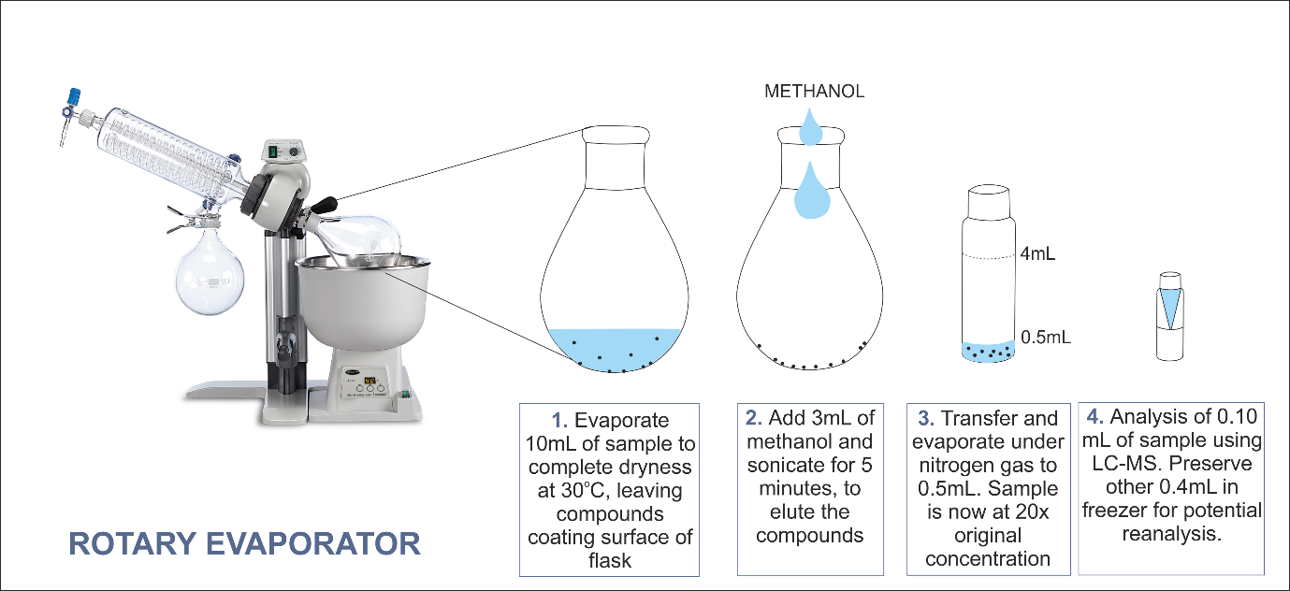

Figure 3: Sample preparation stages of the fully optimised rotary evaporator process resulting in concentation of analytes by a factor of 20.

Comparison of the pre-concentration

The results presented here refer to the fully optimised version (based on the entire compound list) of each of the methods: SBSE, SPE and rotary evaporation. Results are presented in Figures 4 and 5.
Stir bar pre-concentration was not successful for SOA compounds, with 0% recovery. The technique performed better for fatty acids, with recovery of 60% on average. It was the most successful of all techniques for the longer chain fatty acids on our list, heptacosanoic acid, octacosanoic acid, and melissic acid, with recoveries of 68%, 91%, and 104% respectively. This is considerably higher than those obtained with the SPE and rotary evaporation techniques.
SPE achieved highly variable results test-to-test, with methods improving some compound recoveries often being at the expense of other compounds. For example, a test in which elution used 50/50 water/methanol with 2% NH₄OH (herein referred to as Test A), instead of 5% in the chosen ‘most fully optimised’ test (referred to herein as Test B), while keeping all other variables the same, gave higher recoveries of terebic acid, pinolic acid, keto-pinic acid, oleic acid, heptadecanoic acid, nonadecanoic acid, and behenic acid and tricosanoic acid. However, Test A performed very poorly for the smallest SOA compounds BTCA, MBTCA and pimelic acid, as well as all β-sesquiterpene SOA compounds (Figure 4). Because the aim is to achieve a method which targets all the compounds groups on the list, the Test A method was not therefore chosen as more optimised.
Considering the SPE optimisations steps, we can conclude that exchanging the counter ion from chloride to formate and using ammonium acetate 5 mM solution at the wash stage strongly improved retention of our target compounds on the cartridge, with the chosen elution method exerting the most control on the overall success. Using NH₄OH in solution with either methanol or water, at concentrations 0.25-5%, gave the best results compared to alternative elutions, such as formic acid in methanol, as basic solutions are good eluents for anion-exchange cartridges. An elution solution of 2-5% NH₄OH in water was the most successful for SOA compounds. The highest recovery elution solution for fatty acids was 2-5% NH₄OH in methanol, which gave higher fatty acid recoveries in tests leading up to the most optimised final test, but as previously shown in Figure 4, this gave lower recoveries for SOA compounds. The 5% NH₄OH in 50/50 methanol/water solution was the optimal balance between the two, recovering fatty acids at acceptable levels while not compromising SOA recovery in comparison to elution in water.

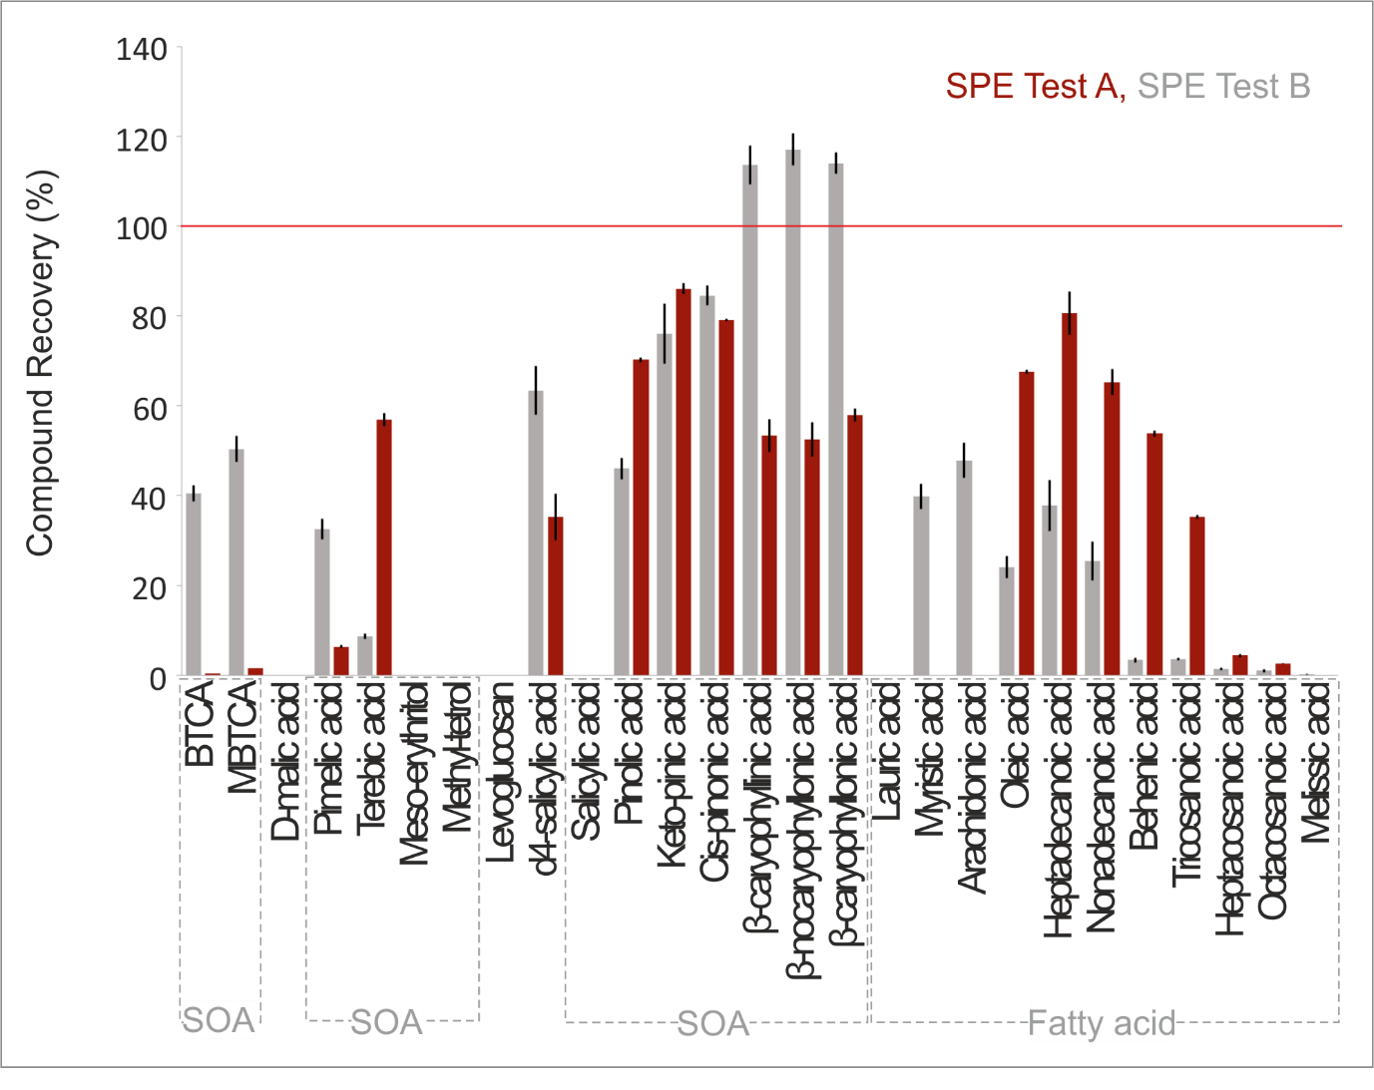
Figure 4: Compound recovery comparison of the fully optimised SPE method. The processing steps of the SPE is the same for both tests changing only in the final elution, which used 5% NH4OH in 50/50 methanol/water solution in Test B and 2% NH4OH 50/50 solution in Test A. The tests demonstrate improved recoveries of some compounds, in this case fatty acids, comes always at the expense of reduced recoveries of others and thus full optimisation was difficult for all compounds. It should be noted that we could not compare lauric acid, myristic acid and arachidonic acid in this case because of contamination affecting the calibration curve in Test A.

The fully optimised method, Test B, was the highest of any method for recoveries of our smallest SOA compounds and was particularly successful for sesquiterpene oxidation products (recovering ≥100%) and moderately successful for some SOA compounds and shorter-chain fatty acids, with recoveries between ~30—50%. However SPE did not perform well for the alcohols in our target list, meso-erythritol, methyl-tetrols and levoglucosan, with the latter showing very low recovery levels (only measurable in 2 of the total 18 iterations of the SPE method which were tested), and the others in none (including the most optimised choice). Collection of the ‘waste’ at each stage of the SPE method (see Figure S2) revealed that the loss of these compounds was entirely at the load stage, meaning none of the compound concentration was retained by the cartridge. This was not improved from test-to-test by changing of the counter ion, and suggests that the SAX cartridge is too polar and thus not appropriate for these compounds.
When considering the initial SPE tests between the different types of sorbent mass in the cartridge, the results overall promoted the use of the SAX cartridge since the load phase showed loss of the least number of compounds. The C18 cartridge, although showing some loss of methyl-tetrols, meso-erythritol and levoglucosan at the load stage, also showed loss at the wash stage, suggesting these compounds were retained to some extent by this cartridge and with further optimisation may show successful recoveries for these specific compounds. This is for future consideration if these are specific target compounds.
Considering this ‘balancing act’ between methods and compound recoveries, it was decided that although recovery was well below 100% for many compounds, the method had probably reached its optimum output if the goal was to target such a diverse list of compounds of varying molecular sizes, structures and chemical-physical properties such as polarity. Such a list makes it difficult to find an all-inclusive technique at each stage of the SPE method, using one type of cartridge, and the ‘success’ of the method must therefore be adjusted in expectation.
Rotary evaporation was the most successful method of pre-concentration, being the only method to display recovery to some extent of all compounds. In Figure 5, the exception to this is lauric acid, myristic acid and oleic acid because of very high background contamination which prevented generation of a calibration curve at ppb concentration levels. This was improved with ozonation of the solvents (see also the “Optimisation of the decontamination procedures” section, 3.3).
In more general terms, it was observed that only one sample could be run at a time, as the multiple-vial attachment of the rotary evaporator caused cross-contamination between samples. The greater the solvent volume used to elute the compounds from the dried rotary evaporator vial, the greater the compound recovery; this is because it increased the coverage of the solvent over the vial surface during sonication to include the entire surface which the liquid sample was in contact with during evaporation. The maximum increase in solvent volume required was 3 mL, since this covered the whole inner-vial surface upon rotation of the vial within the sonicator.
The least lowest recoveried overall (<10%) were for the smallest compounds (lowest C-numbers) on the compound list: BTCA, MBTCA, and D-malic acid. This is perhaps due to their higher vapour pressures, meaning they are more easily lost at the evaporation stage than the majority of the other compounds we test which have lower vapour pressures. The exception to this is meso-erythritol, which has higher vapour pressure and yet shows higher recovery. Recoveries of other compounds were 33-100%, with average recovery of 80% overall; 86% for SOA compounds (not including BTCA, MBTCA and D-malic acid) and 69% for fatty acids. Considering this overall recovery, it is the best method of pre-concentration for the compound list as a whole. It is therefore the method we carry forward for sample preparation before further optimisation work. The best preconcentration method for each individual compound can be found summarised in Table S2.

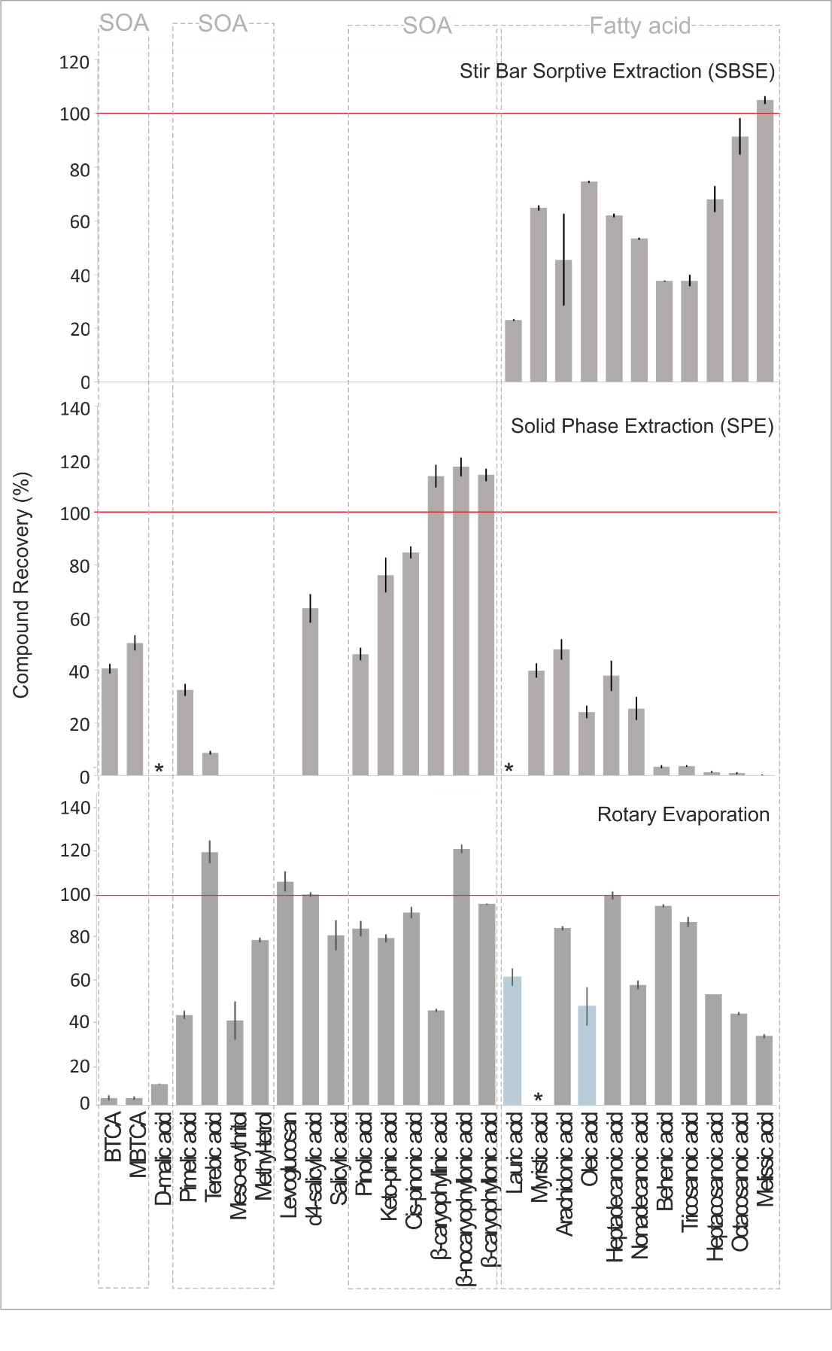
Figure 5: Comparative compound recoveries for each of the most fully optimised pre-concentration techniques. Dashed red lines represent 100% recovery, while blue bars differentiate compounds recovered only after ozonation of solvents to reduce background contamination (tested for rotary evaporation only). Asterisks represent compounds that were recovered, but contamination was too high to obtain a reliable calibration curve.

Validation of the method
Instrumental LODs were evaluated on standard solutions using the Hubaux-Vos method, following IUPAC recommendations [31,32]. Limits of quantifications (LOQs) were evaluated as 10/3*LODs. Sensitivity (slope of the calibration line) and linearity range were tested on standard solutions. Linearity was tested up to a concentration of 100 ppb using both the r-Pearson correlation test and the F-test to compare linear and quadratic fits. Results showed a good linearity in the tested range. Method/instrumental repeatability has been evaluated in real ice core samples. Validation parameters are reported and described in Table 2.
Matrix effects were tested by comparing the slopes of two calibration lines; one for standard solutions in water and one for standard additions (of the same concentrations) to an ice core sample. Results of the t-test showed that there are no statistically significant differences between the two slopes at 95% confidence level.

Interlaboratory comparison

Ice samples from the Belukha glacier ice core were prepared for analysis using the fully optimised preconcentration method. The final sample was split for replicate analysis on two HPLC-MS instruments; the first was the same HPLC-LTQ Velos Orbitrap used for methodological development at the Department of Chemistry, University of Cambridge, UK, and the second a UHPLC UltiMate3000 coupled with a Thermo Scientific™ Q Exactive™ Hybrid Quadrupole-Orbitrap MS at the Department of Chemical Sciences, University of Padua, Italy. Both instruments used the same optimised settings developed previously, and were tested for limits of detection using replicate calibration standards. Overall, the Q Exactive showed detection limits down to ppt levels for SOA compounds, while the LTQ Velos Orbitrap did not achieve detection below ppb. The Q exactive also gave lower detection limits for most fatty acids, mostly in the ppb, rather than ppt, range.
The same compounds were detected in both sample analyses of the Belukha ice core; D-malic acid, Terebic acid, Methyl-tetrols, Keto-pinic acid, Pimelic acid, cis-pinonic acid, Heptacosanoic acid, Octacosanoic acid, and Melissic acid, with the addition of MBTCA on the Q Exactive which was below detection limits on the LTQ Velos Orbitrap. Results are shown as reproducibility-between-instruments values in Table 2, which are R² values from linear regression lines of scatterplots comparing the data series for each compound from the two different instruments. Some example scatterplots are shown in Figure 6 for a representative selection of compounds, and in Figure S3 for all other compounds. For particular compounds the concentrations in individual samples varied by typically a factor 10 between seasons, indicating that the reproducibility achieved here is sufficient to clearly observe the seasonal trends on different instruments. One compound, heptacosanoic acid, showed very poor reproducibility with an R² value of 0.32. This was due to high background contamination levels, combined with low compound concentrations in samples.

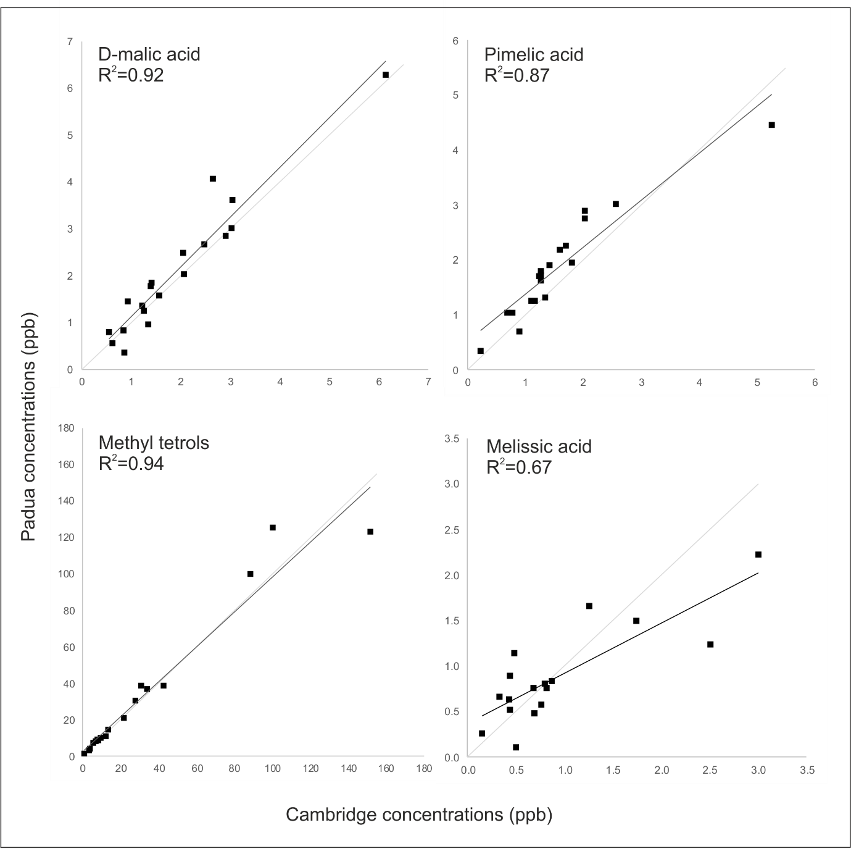

Figure 6: Scatterplots of comparison compound concentrations from replicate sample analysis on two different Orbitrap HPLC-MS instruments. Compounds shown are chosen to represent the different compound groups of interest. The plots demonstrate good reproducibility of both concentrations and trends based on R² values of linear regression lines (black). 1:1 lines are presented in light grey for comparison.

Table 2: Compound specific limit of detection achieved using a linear calibration method, of standard values 1, 10 and 100ppb, listed in order of lowest to highest detection limit for the Cambridge instrument. Also presented are retention time, limit of quantification, limit of detection for the comparative instrument in Padua, instrument repeatability (i.e. variability between repeat injections of the same sample in to the same instrument), method repeatability (variability between different samples prepared using the same method and analysed on one instrument), reproducibility (difference in results between the same samples analysed on two different instruments, given as R² of a linear regression line between the two sets of sample concentrations) and recovery (the percentage of the compound recovered from analysis compared to that which was present in the original sample before processing, as determined using standards of known input values). As is expected, RSD values of the method and instrumental repeatability increased greatly as concentrations lowered towards detection limits for all compounds, and the presented values therefore exclude values at 1ppb concentration so as not to be disproportionately weighted to these high errors. N/D = not detected.

Compound | Retention time (min)  [Cambridge] | LOD  (ppb)  [Cambridge] | LOQ  (ppb)  [Cambridge] | LOD  (ppb)  [Padua] | Instrumental Repeatability (%RSD) [Cambridge] | Method Repeatability  (%RSD) [Cambridge] | Reproducibility  (R²)  [Cambridge] | Recovery  (%)  [Cambridge]
Nonadecanoic acid | 13.73 | 2.00 | 6.67 | 0.29 | 0.94 | 9.50 | N/D | 57
Pimelic acid | 1.90 | 2.32 | 7.73 | 0.04 | 1.47 | 2.02 | 0.87 | 43
β-nocaryophyllonic acid | 12.75 | 2.52 | 8.40 | 0.25 | 3.18 | 2.67 | N/D | 122
D-malic acid | 1.90 | 2.61 | 8.70 | 0.09 | 2.68 | 2.31 | 0.92 | 10
Keto-pinic acid | 7.92 | 2.62 | 8.73 | 0.03 | 3.46 | 13.14 | 0.90 | 80
MBTCA | 1.81 | 2.68 | 8.93 | 0.04 | 1.37 | 3.92 | N/D | 3
β-caryophyllonic acid | 12.91 | 2.73 | 9.10 | 0.11 | 2.39 | 11.69 | N/D | 95
β-caryophyllinic acid | 7.93 | 2.91 | 9.70 | 0.07 | 3.05 | 11.27 | N/D | 45
BTCA | 1.81 | 3.09 | 10.30 | 0.08 | 2.31 | 5.77 | N/D | 3
Lauric acid | 13.17 | 4.47 | 14.90 | 13.72 | 2.43 | 6.23 | N/D | 62
Methyl-tetrols | 3.04 | 4.57 | 15.23 | 0.55 | 3.26 | 10.62 | 0.94 | 79
Arachidonic acid | 13.25 | 4.69 | 15.63 | 0.05 | 3.51 | 10.96 | N/D | 84
Tricosanoic acid | 14.37 | 4.73 | 15.77 | 0.25 | 2.53 | 6.21 | N/D | 87
Terebic acid | 3.02 | 5.65 | 18.83 | 0.09 | 4.99 | 7.27 | 0.85 | 120
Behenic acid | 14.18 | 5.93 | 19.77 | 0.33 | 4.46 | 5.28 | N/D | 95
Meso-erythritol | 2.88 | 5.94 | 19.80 | 3.16 | 17.74 | 15.49 | N/D | 40
Heptadecanoic acid | 13.52 | 6.27 | 20.90 | 2.33 | 1.00 | 7.06 | N/D | 100
Pinolic acid | 3.10 | 8.38 | 27.93 | 0.06 | 7.15 | 10.20 | N/D | 84
Cis-pinonic acid | 7.63 | 8.94 | 29.80 | 1.00 | 7.80 | 10.96 | 0.83 | 92
Salicylic acid | 7.65 | 10.23 | 34.10 | 0.35 | 9.09 | 11.27 | N/D | 81
Octacosanoic acid | 15.66 | 11.73 | 39.10 | 0.32 | 1.35 | 12.10 | 0.74 | 44
Heptacosanoic acid | 15.33 | 12.21 | 40.70 | 0.49 | 1.99 | 9.09 | 0.32 | 53
Melissic acid | 16.52 | 17.03 | 56.77 | 6.04 | 0.28 | 17.03 | 0.67 | 33
Levoglucosan | 2.76 | 17.53 | 58.43 | 100 | 27.72 | 10.29 | N/D | 106
Myristic acid | 13.28 | 19.14 | 63.80 | 11.88 | 6.59 | 8.70 | N/D | N/A
Oleic acid | 13.46 | 20.13 | 67.10 | 2.11 | 2.91 | 12.22 | N/D | 54

Conclusions
This study presents a fully optimised HPLC-MS analytical method, including preconcentration steps, for the detection and quantification of fatty acids and secondary organic aerosol components in ice cores as markers of terrestrial and marine activity. The method is shown to provide reproducible results for concentrations of organic markers in ice core samples in the range of ppt-ppb concentrations.
The study tested and compared three pre-concentration techniques with the aim of choosing the best method for the compound list as a whole, representing a wide range of organic compounds detectable in snow and ice. The chosen method was rotary evaporation, with average recoveries of 80%. However, optimising one technique for all compounds was challenging and different techniques were more successful for individual compounds. For future analysis, the recommendation would be to reduce the target list following an initial broad investigation in to the sample content, to allow specific preconcentration techniques to be applied to those markers. Alternatively if a more extensive list of compounds is maintained and where enough sample volume is available, to divide each sample between multiple preconcentration methods. As an example, for very long chain fatty acids, specifically those considered to be indicators of terrestrial source location (heptacosanoic acid, octacosanoic acid, and melissic acid), stir bars would give the best recoveries. For the very smallest SOA compounds (BTCA, MBTCA, and D-malic acid) solid phase extraction is recommended, which would also give reasonable results for other SOA compounds such as sesquiterpene SOAs, but not in combination with fatty acids. If the intention was specifically to target isoprene SOAs (methyl-tetrols and meso-erythritol) or levoglucosan, rotary evaporation is the only successful pre-concentration method out of those applied here, and could be combined with good recoveries of fatty acids in the same analysis.
At this early stage of the development of these novel organic markers in ice, we hope to investigate the presence of as many organic compounds as possible in a single sample preparation step in ice samples across multiple locations. The rotary evaporation method combined with the optimised HPLC-MS methodology allows the maximum potential for compound recovery, with low error for methodological repeatability and good reproducibility when applied to analysis in different mass spectrometers. The final method therefore provides maximum potential for the identification of new records of organic compounds in ice, and is carried forward to future sample analysis.

Acknowledgements
We acknowledge Magda Claeys (University of Antwerp) for providing the sysnthesised chemical standard of MBTCA; Thorsten Hoffman (University of Mainz) for providing the sysnthesised chemical standards of sesquiterpene SOAs, and Jean-Louis Clément (Aix-Marseille Université) for providing the sysnthesised chemical standard of methyl tetrols. We acknowledge the expertise of Sarah Steimer (University of Cambridge) for help in running of the LC-MS instrument, and Alexander Vogel, Paul Scherrer Institut, for preparing the Belukha ice samples.

Funding Sources
Work by Amy King was jointly supported by Selwyn College, Cambridge, and the NERC Doctoral Training Programme [grant number NE/L002507/1]. Work by Chiara Giorio was supported by the ‘BAS-UCAM Innovation Centre Feasibility Studies’ programme 2013-2015 [project ‘Organics in Ice’] and by the ERC Consolidator Grant 279405 “COrANE”. Eric Wolff was supported by a Royal Society Professorship.

References
[1] C. Giorio, N. Kehrwald, C. Barbante, M. Kalberer, A.C.F. King, E.R. Thomas, E.W. Wolff, P. Zennaro, Prospects for reconstructing paleoenvironmental conditions from organic compounds in polar snow and ice, Quat. Sci. Rev. 183 (2018) 1–22. doi:10.1016/j.quascirev.2018.01.007.
[2] N. Kehrwald, R. Zangrando, P. Gabrielli, J.-L. Jaffrezo, C. Boutron, C. Barbante, A. Gambaro, Levoglucosan as a specific marker of fire events in Greenland snow, Tellus B. 64 (2012) 18196. doi:10.3402/tellusb.v64i0.18196.
[3] K. Kawamura, Y. Izawa, M. Mochida, T. Shiraiwa, Ice core records of biomass burning tracers (levoglucosan and dehydroabietic, vanillic and p-hydroxybenzoic acids) and total organic carbon for past 300years in the Kamchatka Peninsula, Northeast Asia, Geochim. Cosmochim. Acta. 99 (2012) 317–329. doi:10.1016/j.gca.2012.08.006.
[4] J.-L. Jaffrezo, M.P. Clain, P. Masclet, Polycyclic aromatic hydrocarbons in the polar ice of greenland. Geochemical use of these atmospheric tracers, Atmos. Environ. 28 (1994) 1139–1145. doi:10.1016/1352-2310(94)90291-7.
[5] P. Gabrielli, P. Vallelonga, Environmental Contaminants, 2015. doi:10.1007/978-94-017-9541-8.
[6] N.J. Abram, E.W. Wolff, M.A.J. Curran, A review of sea ice proxy information from polar ice cores, Quat. Sci. Rev. 79 (2013) 168–183. doi:10.1016/j.quascirev.2013.01.011.
[7] A. Pokhrel, Studies on ice core records of dicarboxylic acids, ω− ω− ω− ω−oxocarboxylic acids, pyruvic acid, α α α α-dicarbonyls and fatty acids from southern Alaska since 1665AD: A link to climate change in the Northern Hemispehre, (2015).
[8] S. Yamamoto, K. Kawamura, O. Seki, Long-range atmospheric transport of terrestrial biomarkers by the Asian winter monsoon: Evidence from fresh snow from Sapporo, northern Japan, Atmos. Environ. 45 (2011) 3553–3560. doi:10.1016/j.atmosenv.2011.03.071.
[9] K. Kawamura, H. Kasukabe, L.A. Barrie, Source and reaction pathways of dicarboxylic acids, ketoacids and dicarbonyls in arctic aerosols: One year of observations, in: Atmos. Environ., 1996. doi:10.1016/1352-2310(95)00395-9.
[10] R.D. Pancost, C.S. Boot, The palaeoclimatic utility of terrestrial biomarkers in marine sediments, in: Mar. Chem., 2004. doi:10.1016/j.marchem.2004.06.029.
[11] T.D. Sharkey, A.E. Wiberley, A.R. Donohue, Isoprene emission from plants: Why and how, Ann. Bot. (2008). doi:10.1093/aob/mcm240.
[12] B. Bonsang, C. Polle, G. Lambert, Evidence for marine production of isoprene, Geophys. Res. Lett. 19 (1992) 1129–1132. doi:10.1029/92GL00083.
[13] N. Yassaa, I. Peeken, E. Zllner, K. Bluhm, S. Arnold, D. Spracklen, J. Williams, Evidence for marine production of monoterpenes, Environ. Chem. 5 (2008) 391–401. doi:10.1071/EN08047.
[14] M. Hallquist, J.C. Wenger, U. Baltensperger, Y. Rudich, D. Simpson, M. Claeys, J. Dommen, N.M. Donahue, C. George, a. H. Goldstein, J.F. Hamilton, H. Herrmann, T. Hoffmann, Y. Iinuma, M. Jang, M.E. Jenkin, J.L. Jimenez, a. Kiendler-Scharr, W. Maenhaut, G. McFiggans, T.F. Mentel, a. Monod, a. S.H. Prévôt, J.H. Seinfeld, J.D. Surratt, R. Szmigielski, J. Wildt, The formation, properties and impact of secondary organic aerosol: current and emerging issues, Atmos. Chem. Phys. 9 (2009) 5155–5236. doi:10.5194/acp-9-5155-2009.
[15] J. Kesselmeier, U. Kuhn, A. Wolf, M.O. Andreae, P. Ciccioli, E. Brancaleoni, M. Frattoni, A. Guenther, J. Greenberg, P. De Castro Vasconcellos, T. de Oliva, T. Tavares, P. Artaxo, Atmospheric volatile organic compounds (VOC) at a remote tropical forest site in central Amazonia, Atmos. Environ. 34 (2000) 4063–4072. doi:10.1016/S1352-2310(00)00186-2.
[16] H.J.I. Rinne, A.B. Guenther, J.P. Greenberg, P.C. Harley, Isoprene and monoterpene fluxes measured above Amazonian rainforest and their dependence on light and temperature, Atmos. Environ. 36 (2002) 2421–2426. doi:10.1016/S1352-2310(01)00523-4.
[17] P.Q. Fu, K. Kawamura, J. Chen, B. Charrière, R. Sempéré, Organic molecular composition of marine aerosols over the Arctic Ocean in summer: Contributions of primary emission and secondary aerosol formation, Biogeosciences. 10 (2013) 653–667. doi:10.5194/bg-10-653-2013.
[18] M. Trainer, E.J. Williams, D.D. Parrish, M.P. Buhr, E.J. Allwine, H.H. Westberg, F.C. Fehsenfeld, S.C. Liu, Models and observations of the impact of natural hydrocarbons on rural ozone, Nature. 329 (1987) 705–707. doi:10.1038/329705a0.
[19] K. Kawamura, I. Suzuki, Y. Fujii, O. Watanabe, Ice core record of fatty acids over the past 450 years in Greenland, Geophys. Res. Lett. 23 (1996) 2665–2668. doi:10.1029/96gl02428.
[20] A. Pokhrel, K. Kawamura, K. Ono, O. Seki, P. Fu, S. Matoba, T. Shiraiwa, Ice core records of monoterpene- and isoprene-SOA tracers from Aurora Peak in Alaska since 1660s: Implication for climate change variability in the North Pacific Rim, Atmos. Environ. 130 (2015) 105–112. doi:10.1016/j.atmosenv.2015.09.063.
[21] C. Müller-Tautges, A. Eichler, M. Schwikowski, G.B. Pezzatti, M. Conedera, T. Hoffmann, Historic records of organic compounds from a high Alpine glacier: Influences of biomass burning, anthropogenic emissions, and dust transport, Atmos. Chem. Phys. 16 (2016) 1029–1043. doi:10.5194/acp-16-1029-2016.
[22] A. Pokhrel, K. Kawamura, O. Seki, S. Matoba, T. Shiraiwa, Ice core profiles of saturated fatty acids (C12:0–C30:0) and oleic acid (C18:1) from southern Alaska since 1734 AD: A link to climate change in the Northern Hemisphere, Atmos. Environ. 100 (2015) 202–209. doi:10.1016/j.atmosenv.2014.11.007.
[23] K. Kawamura, Identification of C2-C10 -Oxocarboxylic Acids , Pyruvic Acid , and C2-C3 -Dicarbonyls in Wet Precipitation and Aerosol Samples by Capillary GC and GC / MS, (1993) 3505–3511. doi:10.1021/ac00071a030.
[24] P. Fu, K. Kawamura, O. Seki, Y. Izawa, T. Shiraiwa, K. Ashworth, Historical Trends of Biogenic SOA Tracers in an Ice Core from Kamchatka Peninsula, Environ. Sci. Technol. Lett. 3 (2016) 351–358. doi:10.1021/acs.estlett.6b00275.
[25] C. Müller-Tautges, A. Eichler, M. Schwikowski, T. Hoffmann, A new sensitive method for the quantification of glyoxal and methylglyoxal in snow and ice by stir bar sorptive extraction and liquid desorption-HPLC-ESI-MS., Anal. Bioanal. Chem. 406 (2014) 2525–32. doi:10.1007/s00216-014-7640-z.
[26] Q.-H. Hu, Z.-Q. Xie, X.-M. Wang, H. Kang, Q.-F. He, P. Zhang, Secondary organic aerosols over oceans via oxidation of isoprene and monoterpenes from Arctic to Antarctic., Sci. Rep. 3 (2013) 2280. doi:10.1038/srep02280.
[27] S. Olivier, M. Schwikowski, S. Brütsch, S. Eyrikh, H.W. Gäggeler, M. Lüthi, T. Papina, M. Saurer, U. Schotterer, L. Tobler, E. Vogel, Glaciochemical investigation of an ice core from Belukha glacier, Siberian Altai, Geophys. Res. Lett. 30 (2003) 3–6. doi:10.1029/2003GL018290.
[28] A. Eichler, S. Olivier, K. Henderson, A. Laube, Temperature response in the Altai region lags solar forcing, 36 (2009) 1–5. doi:10.1029/2008GL035930.
[29] S. Salihovic, A. Kärrman, G. Lindström, P.M. Lind, L. Lind, B. van Bavel, A rapid method for the determination of perfluoroalkyl substances including structural isomers of perfluorooctane sulfonic acid in human serum using 96-well plates and column-switching ultra-high performance liquid chromatography tandem mass spectrometry, J. Chromatogr. A. 1305 (2013) 164–170. doi:10.1016/j.chroma.2013.07.026.
[30] S. Lacorte, J. Quintana, R. Tauler, F. Ventura, A. Tovar-Sánchez, C.M. Duarte, Ultra-trace determination of Persistent Organic Pollutants in Arctic ice using stir bar sorptive extraction and gas chromatography coupled to mass spectrometry, J. Chromatogr. A. 1216 (2009) 8581–8589. doi:10.1016/j.chroma.2009.10.029.
[31] A. Hubaux, G. Vos, Decision and Detection Limits for Linear Calibration Curves, Anal. Chem. 42 (1970) 849–855. doi:10.1021/ac60290a013.
[32] L.A. Currie, Nomenclature in Evaluation of Analytical Methods Including Detection and Quantification Capabilities, Int. Union Pure Appl. Chem. 67 (1995) 1699–1723. doi:10.1016/S0003-2670(99)00104-X.

Now at: Dipartimento di Scienze Chimiche, Università degli Studi di Padova, Via Marzolo 1, 35131 Padova, Italy

