Original research
Polar zoobenthos blue carbon storage increases with sea ice losses, because across-shelf growth gains from longer algal blooms outweigh ice scour mortality in the shallows.

David K. A. Barnes
British Antarctic Survey, Natural Environment Research Council, High Cross, Madingley Road, Cambridge, CB3 OET, U.K. Tel 01223 221613, Email: dkab@bas.ac.uk

Running head: Phytoplankton giveth and iceberg taketh away
Abstract.
One of the major climate-forced global changes has been white to blue to green; losses of sea ice extent in time and space around Arctic and West Antarctic seas has increased open water and the duration (though not magnitude) of phytoplankton blooms. Blueing of the poles has increases potential for heat absorption for positive feedback but conversely the longer phytoplankton blooms have increased carbon export to storage and sequestration by shelf benthos. However ice shelf collapses and glacier retreat can calve more icebergs, and the increased open water allows icebergs more opportunities to scour the seabed, reducing zoobenthic blue carbon capture and storage. Here the size and variability of benthic blue carbon in mega and macrobenthos was assessed in time and space at Ryder and Marguerite bays of the West Antarctic Peninsula (WAP). In particular the influence of the duration of primary productivity and ice scour are investigated from the shallows to typical shelf depths of 500 m. Ice scour frequency dominated influence on benthic blue carbon at 5 m, to comparable with phytoplankton duration by 25 m depth. At 500 m only phytoplankton duration was significant and influential. WAP zoobenthos was calculated to generate ~10⁷, 4.5x10⁶ and 1.6x10⁶ tonnes per year (between 2002-2015) in terms of production, immobilization and sequestration of carbon respectively. Thus about 1% of annual primary productivity has sequestration potential at the end of the trophic cascade. Polar zoobenthic blue carbon capture and storage responses to sea ice losses, the largest negative feedback on climate change, has been underestimated despite some offsetting of gain by increased ice scouring with more open water. Equivalent survey of Arctic and subAntarctic shelves, for which new projects have started, should reveal the true extent of this feedback and how much its variability contributes to uncertainty in climate models.

Key words; blue carbon capture and storage, Southern Ocean, response to climate change, benthos, phytoplankton.

Introduction
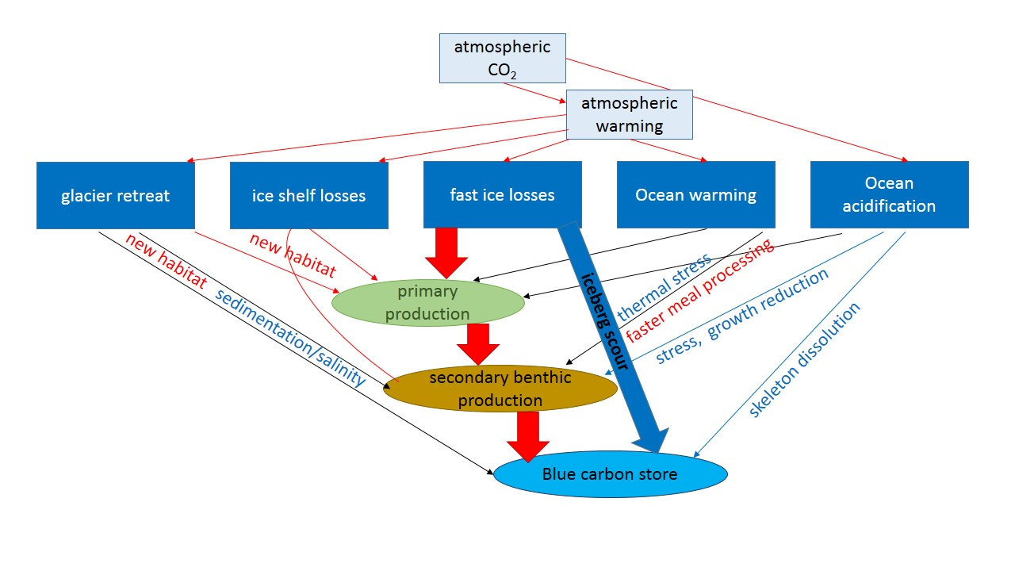
Arguably the most visible and fundamental climate-forced change across our planet is the ‘white to blue’ of Arctic and West Antarctic sea ice losses (Stammerjohn et al., 2008). This response to warming is a positive feedback (amplifying climate change) as it increases heat absorption and reduces gas retention of water. Sea ice losses have increased iceberg opportunity to scour the seabed, thereby recycling benthic carbon that would otherwise be stored, because they spend less time locked into winter fast ice (Barnes, 2017). Furthermore ice-shelf collapses and glacier retreat produce more icebergs and can smother benthos with sedimentation (Sahade et al., 2015). It is likely that increased surface area for gas exchange could also increase sensitivity to acidification. However these same processes have also lead to some simultaneous negative feedbacks (mitigating) against climate change. Ice shelf collapses generate new phytoplankton blooms (Peck et al. 2010), trigger rapid benthic growth (Fillinger et al., 2013) and calve giant icebergs, which iron fertilize new blooms (Duprat et al., 2016). The picture is complex because although seasonal sea ice losses have made phytoplankton blooms longer (Arrigo et al., 2008), smaller blooms follow low sea ice years (Venables et al., 2013). For benthos it seems it is not how big is the feast, but how long is food on the table; increases in algal bloom duration (beyond a critical threshold) rather than bloom size generate longer meal times for benthos, increasing their production and carbon immobilization (Barnes, 2015). Thus for most coastal waters the colour shift has actually been ‘white to blue to green’, increasing carbon flow from air to seabed (Fig. 1).

Figure 1. Schematic of influences on sizes and mechanisms of benthic blue carbon capture and storage. Negative feedback elements, increasing benthic carbon are shown in red, whereas positive feedback elements reducing carbon storage are shown in blue. Squares represent physical processes and ovals represent biological levels. The links suggested to be most important for most shelf area are shown as thick arrows.
Most Antarctic species live on the seabed and whilst they are under multiple stresses and threats (Gutt et al., 2015) they also provide vital ecosystem services, besides societal benefits of food, medical compounds and tourist aesthetics. Living on wide and deep continental shelves, marine life around Antarctica has an important role in carbon capture and storage. The 2.3% of the West Antarctic Peninsula (WAP) which constitute the shallows (<50 m) alone may hold 11 million tonnes of immobilized carbon and generate 270,000 tonnes a year (Barnes, 2017). This appears surprising given their low metabolic rates and slow growth (Arntz et al., 1994) but benthos can be dense, their habitat (polar continental shelf) areas very extensive and unlike elsewhere in the world are effected little by trawling. However iceberg scouring may prevent long term deposition of much of this carbon by grinding up benthos in massive collisions that reshape the seabed. Given that polar shelf benthos may represent one of, if not, the largest negative feedbacks on climate change it would seem important to quantify carbon gains and losses on such seabeds, and how they alter with ice dynamics. Unfortunately this is not a minor undertaking as even establish an underwater grid of markers to measure icescour in the shallows, resurvey and replace markers across multiple depths effectively requires a station-based team of scientific divers a month every year. Annual variability of ice scour can be high and thus requires multiple years to be representative, making initial scientific yield on high effort low. Thus only two Antarctic research stations undertake such iceberg scour monitoring to date, Carlini in the north and Rothera in the south of the WAP (Deregibus et al., 2017). Ultimately most of the value of such marine disturbance monitoring can only be realized when other oceanographic (Venables et al., 2013) and biological variables (Barnes et al., 2014) can be simultaneously monitored, and combined (see Sahade et al., 2015).
The current study asks the question is there a net gain in polar continental shelf zoobenthos carbon capture and storage despite increased ice scour? The answer is important because it is effectively also asking how strong is the largest negative feedback on climate change and is biology a significant part of the error (variability) in climate models? To answer such questions requires combination of station and ship based work, which were undertaken at Rothera Research Station and RRS James Clark Ross in Ryder and Marguerite bays. Here variability in carbon capture and storage by benthos was investigated, and how this is shaped by one of nature’s most intense algal blooms (Ducklow et al., 2006) and one of its largest natural disturbance forces, ice scour (Gutt & Starmans, 2001). Phytoplankton standing stock (Venables et al., 2013), shallow ice scour (Smale, et al., 2007; Barnes, 2017), deep and shallow shelf annual production of sessile benthos (WAP data reported in Barnes, 2015 and Barnes, 2017 respectively). These were supplemented by additional deep water iceberg grounding observations and seabed imagery. Our hypotheses were that 1) scour limits blue carbon in the shallows whereas phytoplankton abundance limits blue carbon across the deep shelf; 2) overall phytoplankton has a dominant impact on how much shelf carbon is immobilized to become truly sequestered because so little shelf area is shallow.

Materials and methods

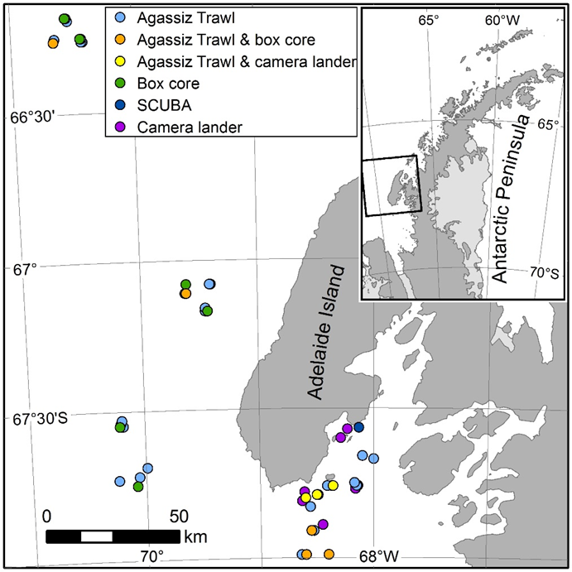
Phytoplankton, ice scour and encrusting benthos production and carbon immobilization were measured across depths around Adelaide Island, West Antarctic Peninsula (Fig. 2). Size fractionated phytoplankton standing stock have been measured weekly since 1997 (Venables et al., 2013), from which monthly means were compiled for 5, 10, 25, 200 and 500 m depth for 1997 to 2015. The duration of phytoplankton abundance (food availability for benthos) was considered as the number of days per year in which nanophytoplankton exceeded 200 µg.l⁻¹ (~6 µg l⁻¹ of Carbon, see Barnes et al., 2016a). Peak phytoplankton values, temperature and other oceanographic variables were not considered further having been shown to be of little explanatory significance to benthos in the same region in previous analyses (Barnes, 2017). Mean annual phytoplankton mass per area per year for West Antarctic Peninsula, and export value to benthos was taken from Ducklow et al. (2006, 2007). The annual frequency of ice scour at 5, 10 and 25 m from annual SCUBA surveys of 75 ice scour seabed markers at this site has been calculated, with additional occasional surveys at 0 and 40 m and extrapolated for deeper depths by curve (Barnes, 2017).
Figure 2. Study region and sample types on the West Antarctic Peninsula. Differing sample apparatus are shown by coloured symbols (see legend on map).

Annual SCUBA collections of benthic suspension feeders within 1m² areas were made at each of the 5-25 m depths, with additional one-off collections made in three of the years at 40 m. Deeper faunal collections were trawled with densities calculated using a box core and seabed imaging by camera lander (a bespoke Shelf Underwater Camera System - SUCS).

Annual growth production of benthos (from annual measurement of cohorts in selected fauna with growth check lines) was used from Barnes (2017), which reported values for combined 5-25 m. Here this was separated into 5, 10 and 25 m depth data and supplemented with deeper shelf data from 200 and 500 m from Marguerite Bay calculated the same way. Benthic production was defined as annual drymass increment and immobilized Carbon as that proportion held by fauna with hard skeletons. Carbon ‘immobilization’ was computed by multiplying ash free dry (organic) mass by 0.5 (Salonen et al., 1976) and adding to the carbon proportion of skeletal mass ~13.3% (±2.5%). Conservative values of multiplication up were used, considering sessile suspension feeders to constitute ~10% of shallow (<50 m depth) benthos and15% in deeper samples see Barnes et al., 2016a). Sequestration potential was estimated based on observations of zoobenthic burial frequency from SCUBA, box core values and SUCS images and soft sediment presence to preserve zoobenthos burial. Sequestration potential was estimated to be ~0.21 to ~0.33 of immobilized carbon in deep and shallow shelf waters respectively.

Impact of ice scour and phytoplankton with depth and year were assessed using GLM ANOVA. Following this the impact of ice scour on incremental immobilized benthic carbon was investigated by regression how scour vs carbon per bloom day altered with depth. Annual values of benthic carbon immobilization were divided by the numbers of days of phytoplankton abundance for each year, with values separated by depth. These immobilized carbon per phytoplankton abundance day data were then plotted against ice scour frequencies for the same years of data collection. Potential across West Antarctic Peninsula benthic carbon losses (recycling) due to ice scour were then estimated; Values of benthic production, carbon immobilization and sequestration estimate were multiplied up by to entire West Antarctic Peninsula shelf areas. To do this each of production, carbon immobilization and sequestration were averaged across the shallows (5, 10, 25 & 40 m data) and their area of shelf was calculated to be ~3% (of 800,000 km² total). Scaled up WAP shelf values of annual a) theoretical zero scour [using mean data of unscoured patches], b) actual data from the least scoured year, c) actual data from the most scoured year, d) theoretical 100% scour [using mean data of scoured patches] and e) estimate for grounded ice mostly covering shelf as thought during the Last Glacial Maximum were calculated. The mean measured values since 2002 were subtracted from the calculated values a) to e) such that the difference in benthic carbon deposition could be shown.
Results
Primary production, ice scour and benthic carbon with time and depth
There was considerable variability in the duration of primary production across years but this followed a similar pattern from shallows to deep water (fig. 3). The longest duration of phytoplankton abundance (food availability for benthos) was more than twice that of the shortest years. Variability was much higher with time than depth. Iceberg scour in the highest years was also more than twice that of the lower years but in contrast to primary production, varied more with depth than time. High scour years were typically, but not always associated with low primary productivity. In the shallows scouring explained most variability in benthic carbon storage, though duration of primary production was still significant (Table 1). Duration of primary production increased importance to benthic carbon storage with depth such that at 500 m depth it explained nearly 80% of variability and ice scour was not a significant factor. Figure 4 shows the influence of scouring on mean carbon immobilized per day of phytoplankton bloom in Ryder (0-200 m) and Marguerite (200-500 m) bays. The lower level of carbon storage at 5 m was not explained by total scour % area. Evidence suggests this is from proportionally more indirect, marginal effects at 5 m. Scours at 5 m were more frequent but less than half the size of those at 10 m or deeper and thus many more benthos around adjacent markers were disturbed per scour. About 40% of total carbon storage losses from the monitored 5-25 m marker grids were found to be indirect effects. These were from areas (markers) immediately adjacent to markers hit by icebergs (the other 60% from areas where markers were directly hit).
Figure 3 Annual variability with depth in the nearshore marine shallows at Ryder Bay and offshore Marguerite Bay, West Antarctic Peninsula from 2002. The data are duration of phytoplankton abundance (months) and ice scour frequency from the Rothera Time Series (RaTS). Carbon immobilization by benthos are shown from values in Barnes (2016). Green bands highlight high primary and secondary production, whilst red bands highlight low secondary production. Raw data available on request from the Polar Data Centre, National Environment Research Council.
Table 1 ANOVA F, p and r² values of ice scour and primary production influences on annual immobilization of carbon by benthos on West Antarctic Peninsula seabed since 2002. Note the increasing importance (variation explained by) primary production with depth.
Source of variation | F | p | r²
5 m ice scour | 24.3 | <0.001 | 63
Primary production | 9.9 | <0.001 | 26
10 m ice scour | 4.2 | 0.004 | 48
Primary production | 2.8 | 0.048 | 29
25 m ice scour | 13.9 | <0.001 | 55
Primary production | 18.5 | <0.001 | 36
500 m ice scour | 0.04 | 0.844 | -
Primary production | 21.1 | <0.001 | 77
Figure 4. Variability of benthic carbon stored per day of phytoplankton bloom duration with ice scour at Ryder and Marguerite bays, West Antarctic Peninsula. The production data are; benthic carbon is given as grams of immobilized carbon [by mega and macrobenthos] per day of phytoplankton abundance measured to exceed 200µg/L⁻¹. The scour data are; proportion of the seabed observed to be scoured per year from 5 – 25 m and estimated to be scoured in deeper water from video and direct observations of where icebergs grounded relative to known mapped bathymetry.
Benthic carbon pathway
The trophic carbon cascade calculated for the WAP shelf from literature data, our samples and estimate from zoobenthos burial rates is shown in figure 5. Values of annual phytoplankton mass and export to benthos were taken from Ducklow et al. (2006, 2007). Mean benthic productivity was calculated to be 12.9 tonnes.km².year, which is ~37% of the mass of primary production Ducklow et al. (2006, 2007) reported to be exported. The calculation for this was ((top 50 m mean =23.2 x 2.3% of WAP shelf area) + (deep shelf mean = 12.7 x 97.7% of WAP shelf area))/100. Zoobenthic carbon immobilization was 5.6 tonnes.km².year (16% of phytoplankton carbon reaching benthos). Sequestration potential was estimated to be 1.9 tonnes.km².year (5% of phytoplankton carbon reaching benthos but just 1% of phytoplankton annual productivity per km² of shelf at the West Antarctic Peninsula). These scale up to ~ 10⁷, 4.5x10⁶ and 1.6x10⁶ tonnes.year for production, immobilization and sequestration respectively (Table 2 right). Calculations for the shelves of South Georgia and the South Orkney Islands (from data in Barnes 2015) revealed comparable values per km² (Table 2 left) but totals were two orders of magnitude smaller in accordance with much smaller shelves.

Figure 5. Blue carbon pathway from primary production to sequestration potential on the West Antarctic Peninsula shelf. Data are reported as tonnes of carbon per km² per year, and are shown for organic carbon (filled circles) and inorganic carbon (unfilled circles). Phytoplankton production (olive green) and consumption by benthos (bright green) data are from Ducklow et al. (2006, 2007). Benthic production and carbon immobilization scaled up from measures in shallows (Barnes, 2017) and deeper samples (current study). Carbon sequestration potential calculated on basis of zoobenthos burial observation frequency and observations in cores (following Barnes et al., 2016b).

Table 2 Carbon in benthos on three West Antarctic continental shelves from 2002. Data are across year means and their sources are calculated from data in Barnes (2015) for South Georgia, South Orkney Islands and West Antarctic Peninsula (Ryder & Marguerite bays). Parentheses enclose the difference between the highest and lowest annual values.
Tonnes seabed C .year | South Georgia | South Orkney I. | WAP
per km²
Carbon immobilization | 3.94 (1.56) | 7.89 (3.64) | 5.6 (2.14)
Carbon sequestration potential | 0.82 (0.31) | 2.27 (0.72) | 1.94 (0.29)
scaled to shelf area
Carbon immobilization | 16.55k | 34.72k | 4480k
Carbon sequestration potential | 3.44k | 9.99k | 1552k

How much difference does ice scouring make to blue carbon storage?
On average across the 2002-2015 study period the impact of ice scouring was 0.72 tonnes.km².year, but the difference between the highest and lowest measured scour level was 2.03 tonnes.km².year. This scaled to WAP shelf area represented nearly 1.6x10⁶ tonnes of immobilized zoobenthic carbon. The study period was short (14 years), so unlikely to yield a real maximum or minimum scouring level. If all experimental markers were scoured compared with all markers intact (no scouring) more than twice observed differences would be expected; 4.5 tonnes.km².year (scaling up to 3.6 x10⁶ tonnes across WAP). The scale of impact changes with the level in the trophic cascade of carbon considered because of the change in annual mass increments at each level (see fig. 6). However ultimate extremes are grounded ice across shelf at glaciations (recent past, such as the Last Glacial Maximum) versus near zero iceberg densities, such as after iceshelves have gone and when glaciers have retreated past grounding lines (future and distant past).
Fig. 6 Blue carbon benthic mass with differing factors influencing blue carbon storage, scaled up to the area of the West Antarctic Peninsula shelf. The data are; mean and maximum values measured. The category ‘Other factors’ was just the remaining variability unexplained in analyses, though literature shows competition, predation and substratum are likely to constitute much of this.
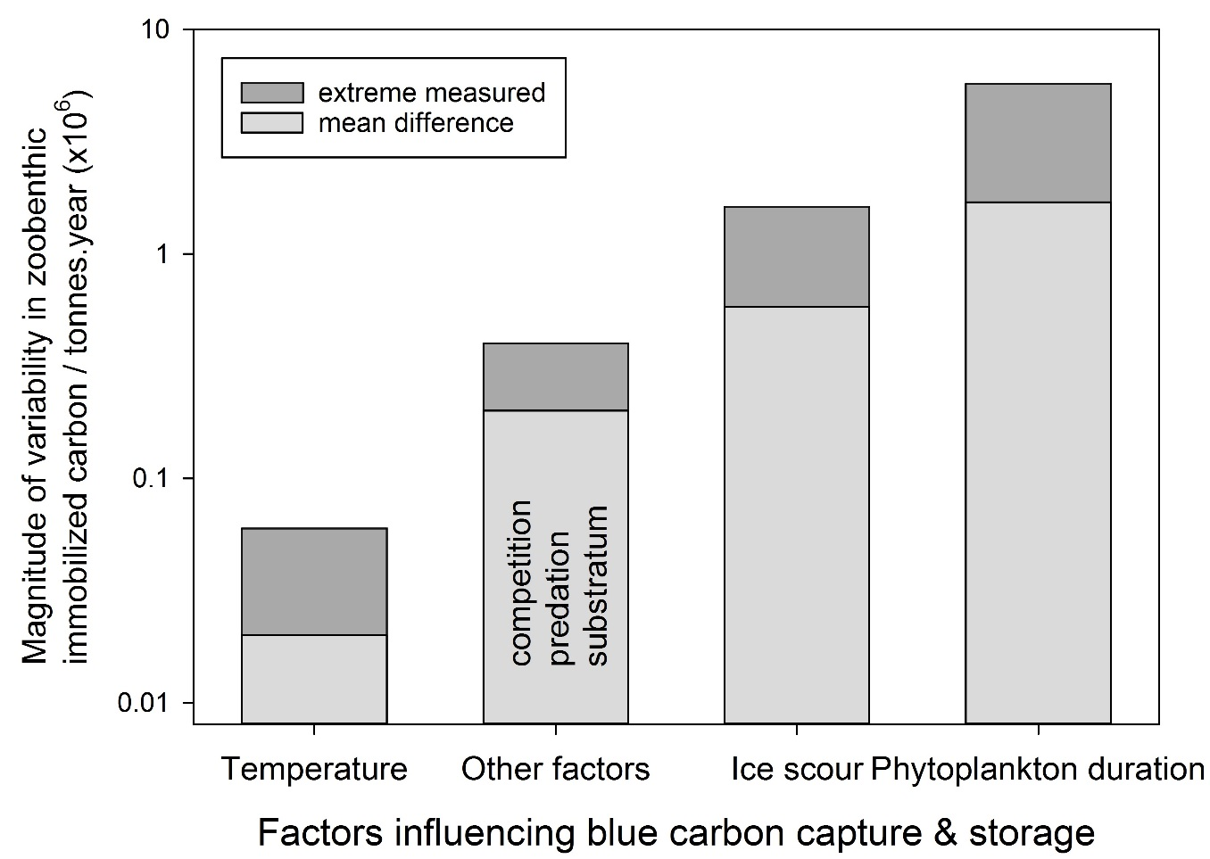

The context of how much difference variability in ice scour makes to zoobenthic blue carbon storage is the difference variability in the other major factor, phytoplankton duration, makes to that same deposition. Mean annual difference in zoobenthic immobilised carbon between 2002 and 2015 driven by phytoplankton duration (ie standardised for ice scour) was 2.1 tonnes.km².year. This was nearly times the magnitude of mean ice scour influence. The between the highest and lowest measured phytoplankton durations was 7.1 tonnes.km².year, which scales to 5.7x10⁶ tonnes for the area of the WAP shelf. Similarly this was nearly three times the largest difference measured due to ice scour.

Discussion
Polar feedbacks on climate change
Ice shelf losses (Peck et al., 2010), Arctic forest (UNEP GEO 3, 2002) and seasonal sea ice losses (Barnes, 2015) are, in ascending order the largest negative feedbacks known against ongoing climate change. These are each estimated at approximately 10⁶ to 10⁷ tonnes C.year, or ~1% of anthropogenic emissions. Considering the very considerable implications of climate forcing on both biodiversity and human society it is perhaps surprising that none of these feedbacks are particularly well categorised or understood. Benthic responses to Larsen iceshelf fragmentation showed that newly established zoobenthic growth, and thus capture and storage of carbon, was much more prolific than previously thought possible (Fillinger et al., 2013). In contrast Housset et al. (2014) found that warming-associated Arctic forest growth may be less than envisaged. Other negative feedbacks may also have been misjudged, such as the considerable fertilization of primary production by giant icebergs (Duprat et al., 2016). Perhaps the least known, and most complex, negative feedback is that of sea ice losses, the magnitude and variability of which is assessed here. The vast area and depth of continental shelf across the two polar regions combined with the immobilization of much carbon captured into heavily skeletonized benthos, make this carbon storage important because of its high potential for zoobenthos burial and genuine sequestration.
West Antarctic seas are a hotspot of sea ice losses, in time and space, increasing open water area driving heat uptake (Parkinson, 2014) and ice scouring (Barnes, 2017). The feedback on climate is complex; typically algal blooms that follow low sea ice years are longer (Arrigo et al., 2008) they may be smaller (Venables et al., 2013). So bloom changes mean less sea ice may reduce carbon drawdown and cycling (due to less phytoplankton biomass) but increase benthic carbon storage and immobilization (longer blooms mean more zoobenthic growth). Complexity is further increased by climate-mediated iceberg and ice scouring increases; more ice scour reduces zoobenthic carbon storage in the shallows (Barnes, 2017) but can bulldoze deeper shelf benthic zoobenthos into sediment burial and increased sequestration (Gutt et al., 2013). Furthermore those authors and Fillinger et al. (2013) showed that (ice mediated) newly available shelf space can lead to rapid zoobenthic growth and carbon immobilization. Uncertainty over medium to long term sea temperature trends also add another level of complexity through their effect on zoobenthos meal processing times. With considerable annual variability in each of these factors (see Fig. 3), estimation of the net carbon capture and storage performance of this feedback would seem to be both difficult and important to measure, even at a single locality. The areas involved are considerable, e.g. 806,000 km² of West Antarctic Peninsula shelf and temporal variability could multiply up to globally important values – e.g. as high as 10⁵ tonnes annually in the shallows alone (Barnes, 2017). The trophic cascade of carbon from primary production to benthic immobilization and sequestration potential (Fig. 5) is steep but requires some interpretation. For example much of what Ducklow et al. (2006, 2007) report as exported to the benthos are likely to be large, armoured diatoms which may be too big for some benthos too eat or too tough for others to physically rupture (the silicon tests). Thus efficiencies may be higher than they appear, when processing what is actually their food (e.g. ciliates, flagellates and other cells which are easier for primary consumers to break down). Secondly export probably arrives at the seabed considerably downstream of any given point measured, so benthic secondary productivity in Marguerite Bay could be driven by primary production off Alexander Island (South Antarctic Peninsula). Nevertheless if the study values are representative of the wider area the mean value of the feedback, at 10⁷ tonnes of production and 4.5x10⁶ of immobilized tonnes.C. year, for the WAP alone is bigger than thought (Barnes, 2015). Although the WAP is where most of Antarctica’s sea ice losses have been recorded to date (Stammerjohn et al., 2008), it represents less than 25% of the shelf area and a similar proportion of the carbon sink around continental Antarctica. Thus the biodiversity (as opposed to the oceanic, see Legg et al., 2015) component of Southern Ocean’s carbon sink could be worth 4x10⁷ tonnes C each year and increasing, of which at least 10⁷ would be long term immobilized. Even this does not include the 6+ million square kilometres of cool temperate and subAntarctic shelves at 45-55ºS, for which the considerable biological potential for carbon sequestration has only recently started to be considered (see www.asccc.co.uk).
Variability in carbon immobilization and thus feedback performance
A striking feature of climate change forecast models is how considerable the differences are between maximum and minimum impacts – reduction of uncertainty (variability) should be a high societal priority. Most focus on this has been oceanic with targeted funding at oceanography in new programmes such as ORCHeSTra and RoSES, but biology may have a strong though little recognized component as well – and is arguably the only mechanism of true sequestration. Antarctic zoobenthic mass can vary in many and complex ways in time (e.g. Dayton 1989) and space (Arntz et al., 1994, Gutt, 2001). Zoobenthic carbon storage per unit area varied between major regions (Table 2); the South Orkney Islands are particularly productive (Barnes et al., 2016a) but massive inequality of shelf sizes dominated such differences. However comparison of WAP values with those from literature shows there were also strong differences in time, depth and habitat (Table 3). Some differences can be explained by youth of habitat still in the process of recolonization (Barnes et al., 2016b). Others, such as depressed fjordic values at South Georgia contrast strongly with benthic performance in similar situations elsewhere (Grange & Smith, 2013). Much emphasis has been placed on understanding of variability in carbon sinks as sources of error in models and predictions. Thus as the biggest identified negative feedback to date, it seems that identification of magnitudes of variability of the carbon sink associated with sea ice losses are as important as gaging its size (Fig. 5). Several factors are important (Fig. 6) but the key two to zoobenthos carbon storage, ice scour and phytoplankton duration, showed converse patterns with depth (Table 1).
Table 3 Variability in carbon immobilization by benthos in space and time on three West Antarctic continental shelves from 2002. Data are means (each n>10) and their sources are calculated from data in Barnes et al (2016a) South Georgia, Barnes et al (2016b) South Orkney Islands and Barnes (2016) West Antarctic Peninsula (Ryder & Marguerite bays). Fjords* includes Cumberland Bay East, West, Stromness and Drygalski but Moraine fjord may be an order of magnitude higher than this mean.
Source of variation | Mean carbon immobilization by benthos (grams. m² .year)
 | 1986-90 | 1991-95 | 1996-2000 | 2001-05 | 2006-10 | 2011-15
Time (year) – South Orkney I. | 5.85 | 6.3 | 5.88 | 6.23 | 6.92 | 7.52
 | canyon floor | Fjords* | old sediment | young sediment | moraines | coastal shallow
Space (habitat) – South Georgia | 0.20 | 0.40 | 0.78 | 0.72 | 3.71 | 30
 | 5 m | 10 m | 25 m | 40 m | 200 m | 500 m
Space (depth) – West Ant Penin | 4.2 | 16.3 | 22.9 | 17.4 | 5.4 | 4.3
The scale of zoobenthic carbon immobilization annual variability, scaled to the WAP area, is here estimated as 10⁶ but at extreme can approach 10⁷ (1% anthropogenic emissions)(Fig. 6). This variability is mainly driven by ice scour in the coastal shallows and primary production beyond these depths. Ice scour shaping of shallow biodiversity structure and its blue carbon ecosystem (Smale et al., 2007; Barnes, 2017), is however overtaken by sedimentation in fjords and adjacent to glacier retreat (Sahade et al., 2015). Fjords form a considerable proportion of high latitude coastline and, like newly available space from ice shelf collapses, can have significantly above average zoobenthic carbon storage outputs (Grange & Smith, 2013), or not (Table 3). Thus investigation of these by new research programmes such as FjordEco and ICEBERGS will hopefully reduce coastal aspects of uncertainty. In deeper water Over long time scales ice scour is important on the deep shelf too (Conlan et al., 1998, Gutt, 2001, Teixido et al., 2004) but in terms of annual variability in carbon storage it seems that phytoplankton duration dominates (Fig. 6). As the vast majority of continental shelf around Antarctica is deep (>100 m), it means that how the duration of phytoplankton responds to climate becomes very important to understanding and predicting blue carbon variability.
Whilst this study indicates that the overall negative feedback (mitigation) against climate change by polar benthos is likely to be large, there are some important qulaifiers and caveats. Work on growth polar zoobenthic blue carbon sinks have mainly focussed on West Antarctic seas, and often small areas within these, so scaling up in area depends on these locations being representative. Arctic shelves in particular differ in many ways to those along the WAP so investigations of benthic blue carbon dynamics, with respect to sea ice losses, should greatly inform and constrain global estimates of overall polar benthic carbon budgets and feedbacks. The Changing Arctic Ocean Seabed (ChAOS) programme will investigate this from 2017 onwards. Work has also been focussed on a small range of functional groups and taxa, so scaling up across benthos depends on these groups being representative. The conversion of immobilised zoobenthic blue carbon to sequestered (through burial) is poorly defined and quantified so this is suggested as a key area needing progress. Finally the time period which this and other studies (but see Gutt et al., 2013) have considered is small and estimates of climate change magnitude and complexity have been continually revised. Further changes in ocean acidification, temperature or other variables could quickly alter the validity of assumptions made her altering the balance of positive (amplification) vs negative (mitigation) on climate change by polar zoobenthic blue carbon pathways.
It may be true that around much of Antarctic continental shallows ‘benthic carbon gains [from longer phytoplankton blooms associated with sea ice losses] will continue to be recycled by likely increased ice scouring for at least the coming decades’ (Barnes, 2017). Whether this is also the case around much of the Arctic shelf, particularly around Russia which is shallow, is unknown. Given that sea ice losses have been particularly severe there (Parkinson, 2014), work there will be important to determine to both the total size of polar blue carbon responses to sea ice loss but also to total scales of variability. However the dwarfing of ice scour effects by phytoplankton duration effects (fig. 6) show that the negative feedback on climate change remains important and could be considerable on the vast subAntarctic continental shelves which are largely unaffected by offsetting ice scour.
Data underpinning all figures and tables are available on request from the Polar Data Centre, NERC.
Acknowledgements. The diving and boating officers of Rothera Research Station are thanked along with generations of Rothera marine assistants who run the Rothera Time Series (RaTS) oceanographic measurements. The crew, officers and scientists of RRS James Clarke Ross are also thanked for their help with shipboard deployments for specimen collection. Laura Gerrish for construction of Fig. 2. This work was carried out as part of the Antarctic Seabed Carbon Capture Project (www.asccc.co.uk).
References
Arntz WE, Brey T, Gallardo VA (1994) Antarctic zoobenthos. Oceanography and Marine Biology an Annual Review, 32, 241-304.
Arrigo KR, van Dijken GL, Bushinsky, S (2008) Primary production in the Southern Ocean, 1997-2006. Journal of Geophysical Research, 113, C08004. doi:10.1029/2007JC004551.
Barnes DKA (2015) Antarctic sea ice losses drive gains in benthic carbon immobilization. Current Biology, 25, R789-790.
Barnes DKA (2017) Iceberg killing fields limit huge potential for benthic blue carbon in Antarctic shallows. Global Change Biology. doi:10.1111/gcb.13523
Barnes DKA, Fenton M, Cordingley A (2014) Climate-linked iceberg activity massively reduces spatial competition in Antarctic shallow waters. Current Biology, 24, 553-554
Barnes DKA, Ireland L, Hogg OT, Morley S, Enderlein P, Sands CJ (2016) Why is the South Orkney Island shelf (the world's first high seas marine protected area) a carbon immobilization hotspot? Global Change Biology, 22, 1110–1120.
Barnes DKA, Sands CJ, Hogg OT et al. (2016b) Biodiversity signature of the Last Glacial Maximum at South Georgia, Southern Ocean. Journal of Biogeography, 43, 2391–2399.
Conlan KE, et al. 1998. Ice scour disturbance to benthic communities in the Canadian High Arctic. Marine Ecology Progress Series, 166, 1-16.
Dayton PK (1989) Interdecadal variation in an Antarctic sponge and its predators from oceanographic climate shifts. Science 245, 1484–1486.
Deregibus D, Quartino L, Zacher K, Campana GL, Barnes DKA (2017) Understanding the link between sea ice, ice scour and Antarctic benthic biodiversity – the need for cross-station and international collaboration. Polar Record. 10.1017/S0032247416000875
Ducklow HW, Baker K, Martinson DG et al. (2007) Marine pelagic ecosystems: the West Antarctic Peninsula. Philosophical Transactions of the Royal Society of London B, 362, 67–94.
Ducklow HW, Fraser W, Karl DM et al. (2006) Water-column processes in the West Antarctic peninsula and the Ross sea: interannual variationsand foodweb structure. Deep Sea Research II – Topical Studies in Oceanography, 53, 8–10.
Duprat LPAM, Bigg GR, Wilton DJ (2016) Enhanced Southern Ocean marine productivity due to fertilization by giant icebergs. Nature Geoscience, 9, 219-221.
Fillinger L, Janussen D, Lundälv T, Richter C (2013) Rapid glass sponge expansion after climate-induced Antarctic ice shelf collapse. Current Biology, 23, 1330–1334.
Grange LJ, Smith CR (2013). Megafaunal Communities in Rapidly Warming Fjords along the West Antarctic Peninsula: Hotspots of Abundance and Beta Diversity. PLoS One, http://dx.doi.org/10.1371/journal.pone.0077917
Gutt J (2001) On the direct impact of ice on marine benthic communities, a review. Polar Biology, 24, 553–564.
Gutt J, Starmans A (2001) Quantification of iceberg impact and benthic recolonisation patterns in the Weddell Sea (Antarctica). Polar Biology, 24, 615–619
Gutt J, Böhmer A, Dimmler W (2013) Antarctic sponge spicule mats shape macrobenthic diversity and act as a silicon trap. Marine Ecology Progress Series, 480, 57-71
Gutt J et al. (2015) The Southern Ocean ecosystem under multiple climate change stresses - an integrated circumpolar assessment. Global Change Biology, 21, 1434–1453
Housset J, Girardin M, Carcaillet C, Bergeron Y (2014) Unexpected recent Warming induced growth decline in Thuja occidentalis at its northern limit in North America. Tree Rings in Archaeology, Climatology and Ecology (TRACE 2014), Aviemore, Scotland.
Legge, O. J., et al. (2015), The seasonal cycle of ocean-atmosphere CO₂ flux in Ryder Bay, west Antarctic Peninsula, Geophysical Research Letters, 42, 2934–2942,
Meredith MP, King JC (2005) Rapid climate change in the ocean west of the Antarctic Peninsula during the second half of the 20th century. Geophysical Research Letters, 32, L19604. (DOI:10.1029/2005GL024042)
Parkinson CL (2014) Global Sea Ice Coverage from Satellite Data: Annual Cycle and 35-Yr Trends. Journal of Climate, 27, 9377–9382.
Peck LS, Barnes DKA, Cook AJ et al. 2010. Negative feedback in the cold: ice retreat produces new carbon sinks in Antarctica. Global Change Biology, 16, 2614-2623.
Sahade R et al. (2015) Climate change and glacier retreat drive shifts in an Antarctic benthic ecosystem. Science Advances, 1, e1500050 (2015).
Salonen K, Sarvala J, Hakala I, Viljanen ML (1976) Relation of energy and organic-carbon in aquatic invertebrates. Limnology and Oceanography, 21, 724–730.
Smale D, Barnes DKA, Fraser KPP (2007) The influence of depth, site exposure and season on the intensity of iceberg scouring in nearshore Antarctic waters. Polar Biology, 30, 769-779
Stammerjohn SE, Martinson DG, Smith RC, Iannuzzi RA (2008) Sea ice in the western Antarctic Peninsula region: Spatio-temporal variability from ecological and climate change perspectives. Deep-Sea Research Part Ii-Topical Studies in Oceanography, 55(18-19), 2041-2058
Teixido N, Garrabou J, Gutt J, Arntz WE (2004) Recovery in Antarctic benthos after iceberg disturbance: trends in benthic composition, abundance, and growth forms. Marine Ecology Progress Series, 278, 1–16.
UNEP (2002) UNEP Geo-3. Earth Scan Publications Ltd. London, UK, 1-397.
Venables HJ, Clarke A, Meredith MP (2013), Wintertime controls on summer stratification and productivity at the western Antarctic Peninsula, Limnology and Oceanography, 58, 1035–1047.

