Southern Ocean mesopelagic fish communities in the Scotia Sea are sustained by mass immigration

^{1*}Ryan A. Saunders, ^{2, 3} Martin A. Collins, ¹Gabriele Stowasser and ¹Geraint A. Tarling

¹British Antarctic Survey, Natural Environment Research Council, High Cross, Madingley Road, Cambridge, CB3 0ET, UK
²Institute of Biological and Environmental Sciences, University of Aberdeen, Tillydrone Avenue, Aberdeen, AB24 2TZ, UK
³Centre for Environment Fisheries and Aquaculture Sciences, Pakefield Road, Lowestoft, NR33 0HT, UK

*Corresponding author: Email: ryaund@bas.ac.uk, Tel: +44(0)1223 221275, Fax: +44 (0)1223 362616

Manuscript in preparation for Marine Ecology Progress Series

ABSTRACT
The biomass of mesopelagic fish in the Southern Ocean is one of the largest of any ocean region and is dominated (both in terms of diversity and biomass) by myctophids (lantern-fish). Despite their high ecological importance in this region, and globally, our understanding of the life-cycles and distribution of myctophids remains limited. We examined length-frequency data from trawl-nets collected across a major sector of the Southern Ocean (the Scotia-Weddell sector) in different seasons to determine patterns of recruitment and growth. There was an absence of larval myctophids, of any species, in net-catches, while larger, older individuals became increasingly dominant with increasing latitude. Very few specimens were found to contain mature gonads, indicating that individuals do not reach reproductive condition in this region. Most myctophid species that occurred within the survey regions neither recruited locally nor were self-supporting. Myctophids are prey for a large number of higher predators (penguins, seals and cetaceans) in the Scotia Sea and are a major predator of zooplankton and krill. We show that this vital part of the Southern Ocean food-web is dependent on mass immigration from lower latitudes in the region. By implication, the sensitivities of this system depend not only on local conditions but also on levels of connectivity to other oceanic regions.

KEY WORDS
Myctophidae, expatriate, food-webs, population dynamics, recruitment
INTRODUCTION
Myctophid fish are one of the most abundant and diverse groups of mesopelagic fishes on Earth, yet remain one of the least studied, with major gaps in our knowledge of their biology and ecology (Gjøsaeter & Kawaguchi 1980, Irigoien et al. 2014). They play a pivotal role in open-ocean food webs as an important conduit in the transfer of energy from primary consumers and omnivorous zooplankton (e.g. copepods and euphausiids) to a range of higher predators. They also comprise a pathway for substantial export of carbon between the sea surface and the deep ocean through their extensive vertical migrations (Pakhomov et al. 1996). Determining the ecology of myctophid fish is therefore essential for a better understanding of the operation of oceanic ecosystems and biogeochemical cycles at a regional and global scale.

Worldwide, myctophids comprise 32 genera that include around 240 species (Bekker 1983). The global biomass of myctophids has been estimated to be between 550 and 660 million tonnes (Mt) from net hauls (Hulley 1995), although there are major uncertainties about their regional and global biomass and actual estimates could be at least an order of magnitude greater than previously thought (Irigoien et al. 2014). Myctophids are generally considered to be most abundant and speciose around the tropics, with most species having broadly tropical, or sub-tropical distribution patterns (Gjøsaeter & Kawaguchi 1980, Hulley 1995). However, the Southern Ocean sustains one of the largest myctophid fish biomasses of any ocean region (Lubimova et al. 1987). Myctophids are the most successful fish group of the open Southern Ocean, with around 35 species in 12 genera (Hulley 1981) and an estimated biomass of between 70 and 200 Mt (Lubimova et al. 1987). The majority of the biomass-dominant species that occur in this region are generally considered to have Southern Temperate, or broadly Antarctic distribution patterns (Hulley 1981), although the dynamic oceanographic processes of the Southern Ocean often break the latitudinal zonality of many species’ distributional boundaries, resulting in mixed community assemblages and species occurring at latitudes beyond their core range (Bekker 1985, Konstantinova et al. 1994, Frolkina et al. 1998). Large aggregations of myctophids are also often associated with dynamic ocean currents and frontal features, further confounding our understanding of their distribution patterns and population processes (Gjøsaeter & Kawaguchi 1980, Koubii 1993).

Myctophids are an integral part of the Southern Ocean food-web. They predate copepods, amphipods and euphausiids (Pakhomov et al. 1996) and are in turn consumed by several species of penguins, seals, petrels, squid and large predatory fish (Olsson & North 1997, Dickson et al. 2004, Reid et al. 2006, Collins et al. 2007, Connan et al. 2007). Despite their high abundance and ecological significance, there remain major uncertainties in their population ecology. For example, it is still unclear if species can complete their life cycles in regions south of the Antarctic Polar Front (APF), and are therefore true residents of Antarctic waters. Recent population studies (Saunders et al. 2015a, b), together with previous studies conducted at more limited spatial and temporal scales (Linkowski 1985, Pusch et al. 2004, Collins et al. 2008), indicate that at least some species may not recruit locally. They found that only large adult size classes appear to inhabit these waters, with smaller, juveniles situated predominantly in waters much further north (Hulley 1981, McGinnis 1982). Based on larval surveys in the southwest Atlantic, Efremenko (1980, 1986, 1991) hypothesised that spawning and recruitment of most myctophid species is largely confined to waters around the APF and not further south.

We examine spatial and temporal variations in the population structure of the myctophid fish community between the APF to the north and the sea ice zone (SIZ) to the south to test the hypothesis that the majority of myctophid species found in this region of the Southern Ocean do not recruit locally. We focus in particular on the Scotia Sea (Atlantic sector), which is one of the most productive regions in the Southern Ocean (Holm-Hansen et al. 2004) with a substantial, depth-stratified myctophid fauna that includes 21 species in 7 genera, comprising an estimated biomass of 4.5 Mt (Collins et al. 2012). Net haul samples were collected across a wide latitudinal range encompassing productivity gradients and a number of water masses. Spatial and temporal analyses of length-frequency data were conducted for 10 of the most abundant myctophid species in the region, together with analyses of their gonad maturity status. Overall, this study comprises the most detailed examination of the spatial variations in the population dynamics of the Southern Ocean myctophid community to date.

MATERIALS AND METHODS
Study location
Three research cruises were undertaken onboard R.R.S James Clark Ross in the open-ocean region of the Scotia Sea, covering the region from the APF to the SIZ (Fig. 1). Cruise JR161 was in austral spring (Oct-Nov 2006), JR177 in austral summer (Jan-Feb 2008) and JR200 in austral autumn (Mar-Apr 2009). Oceanographic, acoustic and biological data were collected repeatedly at six stations that encompassed the predominant water masses and frontal zones: Southern Scotia Sea (SSS), Mid Scotia Sea (MSS), Western Scotia Sea (WSS), Northern Scotia Sea (NSS), Georgia Basin (GB) and the Polar Front (PF).

Sample collection
Mesopelagic fish were collected using a rectangular mid-water trawl net (RMT25; 5 mm mesh) (Piatkowski et al. 1994). Depth-stratified hauls were undertaken at 0-200 m, 200-400 m, 400-700 m and 700-1000 m by day and night during the spring and summer, but sampling was conducted only during hours of darkness in the autumn. An array of plankton samplers, including a Multiple Opening and Closing Net with Environmental Sensing System (MOCNESS; 300 µm mesh), Longhurst-Hardy Plankton Recorder (LHPR; 200 µm mesh) and RMT8 (3 mm mesh) were also used concurrently at each station to collect larval stages that might have been missed by the RMT25 (Table 1). Both the MOCNESS and LHPR were deployed to a depth of 1000 m, whilst RMT8 nets were deployed to depths of 600 m. Samples collected by these devices during previous mesopelagic fish surveys in the Scotia Sea between 1991 and 2004 were also examined for larval specimens (Table 1). Details of the samplers and sample processing protocols are described elsewhere (Ward et al. 2012).

Sample processing
Net haul samples were sorted onboard to the lowest taxonomic level possible. Total catch weights per fish species were recorded using a motion-compensated balance. All fish were measured to the nearest mm using standard length (SL) before freezing at -20 °C. Where possible, sex and maturity status were recorded from a random subsample following dissection and microscopy back at the laboratory. Maturity was recorded as (1) Juvenile (gonad absent), (2) Immature (gonad visible, but immature and small), (3) Developing (gonad visible and maturing), (4) Mature (gonad fully developed), (5) Gravid female (ovaries full of oocytes and ready to spawn), and (6) Spawned female (ovaries large with a wrinkled membrane, and few/no oocytes visible). Juveniles were excluded from the gonad analyses, since these specimens had no reproductive organs.

Population analyses
A series of Kolmogorov-Smirnov tests were conducted on the length-frequency data (5 mm bins) to investigate possible differences in population structure between regions across the Scotia Sea. Our data were pooled by season to determine if the same trends were evident in each survey. The tests were performed for each species where there were >50 individuals per region and survey. Component-fitting software (CMIX) was used to fit normal distributions to the composite length-frequency data and identify modes (de la Mare 1994) following protocols described previously (Saunders et al. 2014).

For our cohort analyses, we considered individuals as belonging to a 0-group from the time of hatching (t) to t₁ (t+1 yr), to a I-group from t₁ to t₂ (t+2 yr), to II-group from t₂ to t₃ (t+3 yr), and so on. We assumed that spawning in Southern Ocean Gymnoscopelus, Protomyctophum, Electrona carlsbergi and Nannobrachium achirus was timed so that hatching coincided with the main spring phytoplankton bloom in Sep/Oct (Hulley 1981, Zasel'sliy et al. 1985). Published data indicate that Electrona antarctica and Krefftichthys anderssoni spawn in autumn/early winter (Apr to Jun) and hatching occurs between Jun and Aug (Lubimova et al. 1987, Belchier & Lawson 2013). Identification of cohorts based on modal size relative to the time of hatching was aided by published growth rates of high latitude and temperate myctophids (Smoker & Pearcy 1970, Gjøsaeter 1978, Linkowski 1985, Greely et al. 1999).

RESULTS
Distribution
Temperature and salinity profiles showed the presence of three major water masses in each region: Antarctic Surface Water (ASW) above ~50 m, Winter Water (WW) around 80 to 200 m and Circumpolar Deep Water (CDW) below ~200 m (Fig. 2; see Venables et al., 2012 for further details). A total of 21 myctophid species were caught during the surveys across these regions, with Electrona antarctica, Gymnoscopelus braueri, Krefftichthys anderssoni and Protomyctophum bolini being the most abundant. Other relatively abundant species included E. carlsbergi, G. fraseri, P. tenisoni, G. nicholsi, P. choriodon and Nannobrachium achirus. P. choriodon was the only one of these 10 species not to be caught on every survey, as it was absent in spring. All species had overlapping distribution patterns in the northern Scotia Sea, but only E. antarctica, G. braueri, P. bolini and G. nicholsi occurred in the SIZ (Fig 1). All species occupied ASW, WW and CDW, with most species distributed predominantly in the upper 400 m of the water column. Both E. antarctica and G. braueri were spread between 0 and 1000 m, whilst K. anderssoni and N. achirus were distributed predominantly below 400 m and occupied mostly CDW. More comprehensive descriptions of the distribution patterns are given elsewhere (Collins et al. 2012, Saunders et al. 2014, Saunders et al. 2015a, b, Lourenço et al. 2016).

Patterns in population structure
Larval 0-group specimens <35 mm in size were notably absent in catches of all net types across numerous years and seasons (Table 1). The exception was K. anderssoni, of which 0-group specimens were found during autumn 2009 (Fig. 3), autumn 2004 and summer 1998/99 (Table 1). There was evidence of seasonal growth and recruitment for cohorts greater than I-group in all species, except E. carlsbergi that had a population comprised exclusively of ~III-group specimens (mode: ~80 mm) in each season and region.

With the exception of E. carlsbergi, there were clear differences in population structure between waters around the APF and waters further south in the Scotia Sea for all species where n> 50 (Fig. 4). Cohorts from the juvenile I-group (mode >30 mm) onwards were present in the populations of E. antarctica, G. braueri, G. fraseri, P. bolini, P. choriodon and P. tenisoni, in waters around the APF, but the I-group and specimens less than ~40 mm in size were markedly absent from their counterpart populations in the colder waters of the Scotia Sea. A similar trend was apparent for P. choriodon for older cohorts (III- and +IV- group). K. anderssoni was the only species that had I-group specimens present in the northern Scotia Sea population, although this cohort was absent from the population around 56 °S.

Gonad maturity
For each species, the majority of adult specimens sampled during the surveys had either immature or developing gonads (Fig. 5). Substantial proportions (> 20%) of mature gonads were found only in E. antarctica and K. anderssoni specimens, with the largest proportions (~45-50%) occurring in autumn. No gravid or post-spawning females were found for any species in the Scotia Sea. There was also little evidence of seasonal or regional patterns in gonad development for any species from the available data.

DISCUSSION
Evidence for expatriate myctophids
Our results show that the waters south of the APF comprise a relatively diverse and abundant myctophid community, with many species having overlapping distribution patterns in the region, which is consistent with previous studies (Hulley 1981, McGinnis 1982, Collins et al. 2008). We further demonstrate that the majority of these species exist only as expatriates in the Antarctic waters of the Scotia Sea, which may be considered as a sterile expatriation area where individuals cannot pass their entire life cycle (Ekman 1953).

Firstly, our results showed that myctophid larvae were markedly absent in waters south of the APF with the exception of two species, Electrona antarctica and Krefftichthys anderssoni. This lack of larvae was consistent across several years and different seasons and was apparent in both oceanic and shelf-break areas, indicating that our results are unlikely to be attributable to a poor recruitment event, a seasonal mismatch in sampling, or an under-sampling of potentially key shelf-break regions (Table 1). This is consistent with previous myctophid studies in Antarctic waters (Piatkowski et al. 1994, Pusch et al. 2004, Collins et al. 2008, Donnelly & Torres 2008). Size selectivity in the principal sampling device, the RMT25, can also be ruled out as a potential source of sampling error since it effectively captured macrozooplankton of equivalent size to larval myctophid species. For instance, amphipods (Vibilia antarctica, maximum size ~15 mm) large copepods (Rhincalanus gigas, maximum size ~10 mm), euphausiids (Thysanoessa vicina, maximum size ~16 mm) and molluscs (Spongiobranchaea australis, maximum size ~20 mm; see www.species-identification.org) were regularly captured by the RMT25. Furthermore, the device was successful in capturing small specimens of the myctophid K. anderssoni (15 mm SL) as well as the early life stages of other mesopelagic fishes, such as Cyclothone spp. (22 mm SL) and Bathylagus spp. (25 mm SL).

Secondly, both gravid and post spawning females were notably absent in myctophid populations and specimens with mature gonads were rare for all species other than E. antarctica and K. anderssoni. This suggests that spawning and recruitment is most likely confined to waters north of the APF for the majority of Southern Ocean myctophid species in the Scotia Sea, and possibly throughout the Southern Ocean. Data from myctophid larval surveys in the southwest Atlantic, Pacific and Indian Ocean sectors support this notion, as the larvae of most of the biomass-dominant species appeared to be distributed predominantly in waters around, or north of, the APF, with only the larvae of E. antarctica and K. anderssoni extending further south (Efremenko 1980, 1986, 1987, 1991).

Thirdly, there were clear latitudinal differences in population structure for most of the studied species in the region, with I-group specimens of P. tenisoni, P. bolini, G. braueri, G. fraseri and E. antarctica largely confined to waters associated with the APF and only larger and older specimens of these species occurring in populations at higher latitudes. A similar trend was apparent for K. anderssoni between waters of the northern Scotia Sea and those at higher latitudes towards the South Antarctic Circumpolar Current Front, which constituted the southernmost limit of its range. Since only specimens greater than III-group were found for both E. carlsbergi and P. choriodon, we hypothesise that the core distributional range of these species’ populations is centred much further north than for the other species and that a similar latitudinal zonation of the I-group and II-group cohorts occurs at lower latitudes. This overall latitudinal trend in population dynamics is consistent with findings from previous myctophid surveys in the southwest Atlantic that show latitudinal trends in mean body size (and age) for many Southern Ocean species, with the exception of E. antarctica (Hulley 1981, McGinnis 1982). In these studies, small juveniles (<40 mm) are reported to dominate the populations of several myctophid species in waters around the sub-tropical front, whilst there is a progressive increase in mean body size with increasing latitude towards the APF and northern Scotia Sea. This, together with the results of our study, suggests that the majority of the myctophid species that occur in the Southern Ocean have either temperate, or sub-tropical origins, with the full reproductive populations recruiting in waters north of the APF and only expatriate populations of increased body size (and age) occurring at latitudes further south.

Non-expatriate species
The available data suggest that E. antarctica and K. anderssoni are the only two species of the Southern Ocean myctophid community that are not expatiates south of the APF and can therefore be considered to be true Antarctic ichthyofauna. Despite being a species that is closely associated with the APF (Hulley 1981), K. anderssoni appears to form self-sustaining populations in the northern Scotia Sea around the South Georgia shelf-break (Collins et al. 2008). Studies in other sectors of the Southern Ocean also found larvae of this species in oceanic waters mostly in close proximity to the southern APF (Efremenko 1987). However, we found no K. anderssoni larvae in open-ocean waters south of the APF, suggesting that the species is only able to recruit in this region due to its association with the South Georgia shelf waters.

All ontogenetic stages of E. antarctica are largely absent from waters north of the APF and its abundance tends to be highest in the SIZ (Hulley 1981, Efremenko 1986, Saunders et al. 2014). Its larval stages have been found across the Scotia Sea (Efremenko 1986, 1991), and at high latitudes in the Lazarev Sea (Eastern Antarctica) (Flores et al. 2008, Van de Putte et al. 2010), Indian Ocean sector, and in the Pacific Ocean sector (Efremenko 1987). However, they were noticeably absent in populations at high latitudes in other studies in the Scotia Sea (Rowedder 1979, Lubimova et al. 1983, Greely et al. 1999, Pusch et al. 2004, Collins et al. 2008, Donnelly & Torres 2008), suggesting limited recruitment of larval stages into the populations that occupy these regions. Our data suggest that, similar to other species in the region, the northern waters around the APF may be important for successful reproduction in this species in the Scotia Sea, since only specimens greater than II-group appear to occur in the cold waters south of this front. The biological adaptations of these two species are poorly resolved, so the mechanisms that enable them to complete their life cycles in high latitude waters remain unclear. One possible explanation could be that, unlike the other species in the study, both K. anderssoni and E. antarctica appear to spawn in winter, a time when water temperatures are predominantly low (Lubimova et al. 1987, Belchier & Lawson 2013). Therefore, their eggs and larvae may be pre-adapted for increased survival in the colder waters at higher latitudes (Gjøsaeter & Kawaguchi 1980).

It has been estimated that the mean biomass of myctophids in the upper 1000 m of the Scotia Sea is around 2.23 g m⁻², which equates to a total biomass of 4.5 Mt when scaled up to the total area of the Scotia Sea (2 million km²) (Collins et al. 2012). We used the same approach to estimate the biomass of expatriate myctophids in the region (i.e. all species other than E. antarctica and K. anderssoni). From our data, we calculated that the mean integrated biomass of expatriate myctophids between 0 and 1000 m was 1.23 g m⁻² (SD 0.71), giving an estimated biomass of 2.5 Mt of expatriate myctophids occurring above 1000 m in the Scotia Sea. Thus a substantial proportion of the overall biomass of the Scotia Sea myctophid community depends on the immigration of populations that spawn further north.

Possible expatriation mechanisms
Expatriate populations have been observed widely for a range of marine organisms, with ocean transportation, spatial/temporal variations in ambient temperature and food availability, and behavioural processes all being possible drivers of this effect (Huntley & Niiler 1995). It has been hypothesised that, in the Southern Ocean, most myctophid species are seasonal migrants at high latitudes and undertake behavioural, ontogenetic-specific migrations to waters north of the APF to spawn and then subsequently move back to the Scotia Sea to feed (Hulley 1981, McGinnis 1982, Linkowski 1985, Zasel'sliy et al. 1985, Efremenko 1986, Collins et al. 2008). Southward migrations have been suggested previously for some myctophids in the southwest Atlantic, particularly E. carlsbergi (Kozlov 1991, Zemsky & Zozuljia 1991), and such behaviour is consistent with that of pelagic squid in the southwest Atlantic and other high latitude fish species, such as north Atlantic herring Clupea harengus (Hanlon & Messenger 1996, Corten 2002). However, in the case of myctophids in the Scotia Sea area, the adaptive advantage of such behaviour between regions with similar levels of food availability is unclear (Ward et al. 2012), and seasonal migrations back and forth across the APF have yet to be verified. Our data indicate that most of the biomass-dominant myctophids are resident in the Scotia Sea during all seasons and are therefore unlikely to undertake seasonal migrations. The one possible exception is P. choriodon, which was not found in the region in spring and seems to undertake a southward migration away from the northern Scotia Sea between summer and autumn (Reid et al. 2006). This species may be absent in the study region in spring as a function of aggregative behaviour in waters north of the APF for the main reproductive season at this time (Oven et al. 1990).

In other fish groups, it is commonly found that larger species and later ontogenetic stages tend to orientate towards progressively lower temperature regimes as a potential means of optimising growth efficiency (McCauley & Huggins 1979, Jobling 1997). Reproductive development is often delayed at the expense of somatic growth at low temperatures so such a strategy would decrease the probability that individuals survive to produce any offspring over the course of their life span (Angilletta et al. 2004). Eggs and larvae are also more susceptible to mortality and predation at low temperatures due to slower growth and development (Houde 1989), which may further inhibit recruitment in myctophid populations at high latitudes. Oceanic processes, such as high intensity eddies associated with the APF, are also likely to play an important role in facilitating expatriation and have already been implicated in explaining the occurrence in the Scotia Sea of certain sub-Antarctic myctophid species, such as E. carlsbergi (Kozlov 1991, Kozlov et al. 1991, Zemsky & Zozuljia 1991). New advances in otolith microchemistry (Trueman et al. 2012, Longmore et al. 2014), population genetics (Van de Putte et al. 2012), and compound-specific biochemical dietary markers (Brown et al. 2014, Goutte et al. 2014) may offer complementary ways of verifying the existence of expatriate populations of myctophids at high latitudes in the Southern Ocean and enable hypotheses of long distance behavioural migrations across the APF to be tested. For example, specimens spawned and reared under different temperature and biogeochemical regimes in APF and high latitude waters would be unlikely to have the same otolith microchemistry, whilst the presence of a dietary signature specific to the sea ice environment in specimens residing north of the APF may be evidence of behavioural migrations.

Are myctophid community dynamics unique in the Southern Ocean?
The relatively high biomass and species diversity of the myctophid community in the Southern Ocean appears to be in stark contrast to that found in the Arctic Ocean. Although the distributional range of the myctophids Myctophum punctatum and Benthosema glaciale appears to extend into Arctic waters (see fishbase.org), it has been suggested that there is a distinct lack of myctophid fish in the Arctic Ocean and that this is possibly due to the extreme photoperiod that prevents visual feeding during periods of prolonged light attenuation (Kaartvedt 2008, Catul et al. 2011). The continental mass of Antarctica means that the latitudinal range of the Southern Ocean is more equivalent to that of the sub-Arctic rather than the Arctic. Data obtained at sub-Arctic latitudes indicate that temperature related expatriations, similar to those found in the present study, are evident in that region also (Zurbrigg & Scott 1972, Gjøsaeter 1978, Kawaguchi & Mauchline 1982, Sassa & Kawaguchi 2005). For example, larval stages of species such as B. glaciale, Protomyctophum thompsoni, M. punctatum, and Diaphus theta occur only in warmer transitional waters in the sub-Arctic, whilst older stages become expatriated by ocean currents into waters at higher latitudes where they are lost from the reproductive population (Zurbrigg & Scott 1972, Moku et al. 2003, Sassa & Kawaguchi 2005).

Ecosystem perspective
Myctophid biomass in the Southern Ocean is similar to that found in other highly productive oceans, and this group of fish are integral to sustaining large higher predator populations in the region, particularly in the Scotia Sea. Myctophids are the most successful pelagic fish in the high latitude Southern Ocean in terms of abundance and diversity, but most species appear to be unable to reproduce successfully in regions south of the APF. Ocean transportation mechanisms, such as eddies associated with the APF, are likely to play an important role in the influx of myctophids into Antarctic waters. By implication, this means that the marine ecosystem in the Southern Ocean not only depends on proximal environmental conditions, but also on processes occurring more remotely, particularly in sub-Antarctic regions where the majority of myctophid recruitment is taking place. Mechanistic studies examining the impact of environmental change on the Southern Ocean ecosystem must therefore also consider transport pathways and the role of immigration on ecosystem structure and resilience.

Acknowledgements
This work was funded by the UK’s Natural Environment Research Council in its support of the Ecosystems programme at the British Antarctic Survey. The officers, crew and scientists of the RRS James Clark Ross made a substantial contribution to the fieldwork and Emma Foster assisted with lab work. We also thank V Laptikhovsky for locating and translating several Soviet research publications and P Ward and C Liszka for the analysis of zooplankton net samples.
LITERATURE CITED
Angilletta MJ, Steury TD, Sears MW (2004) Temperature, growth rate, and body size in ectotherms: Fitting pieces of a life-history puzzle. Integr Comp Biol 44:498-509
Bekker VE (1983) Myctophids of the World Ocean. Nauka, Moscow (in Russian)
Bekker VE (1985) Distribution of myctophid fishes and the position of the biogeographical border between the islands of Saint Paul and Kerguelen. J Ichthyol 25:159-162
Belchier M, Lawson J (2013) Analysis of temporal variability in abundance, diversity and growth rates within the coastal ichthyoplankton assembalge of South Georgia (sub-Antarctic). Pol Biol 36:969-983
Brown TA, Yurkowski DJ, Ferguson SH, Alexander C, Belt ST (2014) H-Print: a new chemical fingerprinting approach for distinguishing primary production sources in Arctic ecosystems. Environ Chem Lett 12:387-392
Catul V, Gauns M, Karuppasamy PK (2011) A review on mesopelagic fishes belonging to family Myctophidae. Rev Fish Biol Fish 21:339-354
Collins MA, Ross KA, Belchier M, Reid K (2007) Distribution and diet of juvenile Patagonian toothfish on the South Georgia and Shag Rocks Shelves (Southern Ocean). Mar Biol 152:135-147
Collins MA, Stowasser G, Fielding S, Shreeve R, Xavier JC, Venables HJ, Enderlein P, Cherel Y, Van de Putte A (2012) Latitudinal and bathymetric patterns in the distribution and abundance of mesopelagic fish in the Scotia Sea. Deep-Sea Res Part II 59:189-198
Collins MA, Xavier JC, Johnston NM, North AW, Enderlein P, Tarling GA, Waluda CM, Hawker EJ, Cunningham NJ (2008) Patterns in the distribution of myctophid fish in the northern Scotia Sea ecosystem. Polar Biol 31:837-851
Connan M, Cherel Y, Mayzaud P (2007) Lipids from stomach oil of procellariiform seabirds document the importance of myctophid fish in the Southern Ocean. Limnol Oceanogr 52:2445-2455
Corten A (2002) The role of "conservatism" in herring migrations. Rev Fish Biol Fish 11:339-361
de la Mare W (1994) Estimating krill recruitment and its variability. CCAMLR Sci 1:55-69
Dickson J, Morley SA, Mulvey T (2004) New data on Martialia hyadesi feeding in the Scotia Sea during winter; with emphasis on seasonal and annual variability. J Mar Biol Assoc UK 84:785-788
Donnelly J, Torres JJ (2008) Pelagic fishes in the Marguerite Bay region of the West Antarctic Peninsula continental shelf. Deep-Sea Res Part II 55:523-539
Efremenko VN (1980) On results of ichthyoplankton studies in the Scotia Sea. In: Ecological and biological features of the abundant commercial Antarctic and notalian fishes. VNIRO Moscow (In Russian)
Efremenko VN (1986) Distribution of eggs and larvae of Myctophidae in the southern Atlantic. J Ichthyol 26:141-147
Efremenko VN (1987) Species composition and distribution of eggs and larvae of mesopelagic fish in the Ross Sea. In: Biological and oceanographic surveys of the Pacific Ocean sector of the Antarctic. Collection of scientific papers. Moscow: USSR Ministry of Fisheries (In Russian)
Efremenko VN (1991) Ichthyoplankton researches in the autumn-winter season of 1989 in the Southwest Atlantic. In: Maslennikov VV (ed) Elektrona karlsberga in the Southern Polar frontal zone Vol 2: Biological aspects of existence and distribution Collection of Scientific papers. VNIRO, Moscow (In Russian)
Ekman S (1953) Zoogeography of the Seas. Sidgwick and Jackson, London
Flores H, de Putte APV, Siegel V, Pakhomov EA, Van Franeker JA, Meesters HWG, Volckaert FAM (2008) Distribution, abundance and ecological relevance of pelagic fishes in the Lazarev Sea, Southern Ocean. Mar Ecol Prog Ser 367:271-282
Frolkina GA, Konstantinova MP, Trunov IA (1998) Composition and characteristics of ichthyofauna in pelagic waters of South Georgia (subarea 48.3). CCAMLR Sci 5:125-164
Gjøsaeter J (1978) Age, growth and mortality of the myctophid fish, Benthosema glaciale (Reinhardt), from western Norway. Sarsia 52:53-58
Gjøsaeter J, Kawaguchi K (1980) A review of the world resources of mesopelagic fish. FAO Fish Tech Pap 193:1-151
Goutte A, Cherel Y, Ozouf-Costaz C, Robineau C, Lanshere J, Masse G (2014) Contribution of sea ice organic matter in the diet of Antarctic fishes: a diatom-specific highly branched isoprenoid approach. Pol Biol 37:903-910
Greely TM, Gartner JV, Torres JJ (1999) Age and growth of Electrona antarctica (Pisces : Myctophidae), the dominant mesopelagic fish of the Southern Ocean. Mar Biol 133:145-158
Hanlon RT, Messenger JB (1996) Cephalopod Behaviour. Cambridge University Press, Cambridge
Holm-Hansen O, Kahru M, Hewes CD, Kawaguchi S, Kameda T, Sushin VA, Krasovski I, Priddle J, Korb R, Hewitt RP, Mitchell BG (2004) Temporal and spatial distribution of chlorophyll-a in surface waters of the Scotia Sea as determined by both shipboard measurements and satellite data. Deep-Sea Res Part II 51:1323-1331
Houde ED (1989) Comparative growth, mortality and energetics of marine fish larvae- temperature and implied latitudinal effects. Fish Bull 87:471-495
Hulley PA (1981) Results of the research cruises of FRV "Walther Herwig" to South America. 58. Family Myctophidae (Osteichthyes, Myctophiformes). Arch Fischereiwiss 31:1-300
Hulley PA (1995) Lanternfishes. In: Paxton JR, Eschmeyer WN (eds) Encyclopedia of Fishes. Academic Press, San Diego
Huntley ME, Niiler PP (1995) Physical controls of population dynamics in the Southern Ocean. ICES J Mar Sci 52:457-468
Irigoien X, Klevjer TA, Rostad A, Martinez U, Boyra G, Acuna JL, Bode A, Echevarria F, Gonzalez-Gordillo JI, Hernandez-Leon S, Agusti S, Aksnes DL, Duarte CM, Kaartvedt S (2014) Large mesopelagic fishes biomass and trophic efficiency in the open ocean. Nat Commun 5:3271
Jobling M (ed) (1997) Temperature and growth: modulation of growth rate via temperature change. Cambridge University Press, Cambridge, UK
Kaartvedt S (2008) Photoperiod may constrain the effect of global warming in arctic marine systems. J Plank Res 30:1203-1206
Kawaguchi K, Mauchline J (1982) Biology of myctophid fishes (Family Myctophidae) in the Rockall Trough, Northeastern Atlantic Ocean. Biol Ocean 1:337-374
Konstantinova MP, V. RA, Fedulov PP (1994) The distribution of myctophids in the southwest Atlantic in relation to water structure and dynamics. J Ichthyol 37:151-160
Koubii P (1993) Influence of the frontal zones on ichthyoplankton and mesopelagic fish assemblages in the Crozet Basin (Indian sector of the Southern Ocean). Pol Biol 13:557-564
Kozlov AN (1991) Biological characteristics of elektrona carlsberga in the area of the PFZ north-east of the South Georgia island in spring – summer 1987-1988. In: Maslennikov VV (ed) Elektrona karlsberga in the Souther Polar frontal zone Vol2 Biological aspects of existence and distribution Collection of Scientific papers. VNIRO, Moscow (In Russian)
Kozlov AN, Shust K, Zemsky AV (1991) Seasonal and inter-annual variability in the distribution of Electrona carlsbergi in the Southern Polar Front area (the area to the north of South Georgia is used an example). CCAMLR Sel Sci Pap 7:337-368
Linkowski TB (1985) Population biology of the myctophid fish Gymnoscopelus nicholsi (Gillber, 1911) from the western South Atlantic. J Fish Biol 27:683-698
Longmore C, Trueman CN, Neat F, Jorde PE, Knutsen H, Stefanni S, Catarino D, Milton JA, Mariani S (2014) Ocean-scale connectivity and life cycle reconstruction in a deep-sea fish. Can J Fish Aquat Sci 71:1312-1323
Lourenço S, Saunders RA, Collins MA, Shreeve RS, Assis CA, Belchier M, Watkins JL, Xavier JC (2016) Life cycle, distribution and trophodynamics of the lanternfish Krefftichthys anderssoni (Lönnberg, 1905) in the Scotia Sea. Pol Biol DOI: 10.1007/s00300-016-2046-3
Lubimova T, Shust K, Popkov V (1987) Specific features in the ecology of Southern Ocean mesopelagic fish of the family Myctophidae. Nauka Press, Moscow
Lubimova TG, Shust KV, Trojanovsky FM, Semenov AB (1983) On the ecology of mass species of Myctophidae in the Atlantic sector of the Antarctic. Soviet Committee of Antarctic Research. The Antarctic. The Committee Report 22:99-106 (In Russian)
McCauley RW, Huggins NW (1979) Ontogentic and nonthermal seasonal effects on the thermal preferenda of fish. Am Zool 19:267-271
McGinnis RF (1982) Biogeography of lanternfishes (Myctophidae) south of 30 ºS. Amercian Geophysical Union, Washington DC
Moku M, Tsuda A, Kawaguchi K (2003) Spawning season and migration of the myctophid fish Diaphus theta in the western North Pacific. Ichthyol Res 50:52-58
Olsson O, North AW (1997) Diet of the King Penguin Aptenodytes patagonicus during three summers at South Georgia. Ibis 139:504-512
Oven LS, Konstantinova MP, Shevchenko NF (1990) Aspects of of reproduction and feeding of myctophids (Myctophidae) in the southwest Atlantic. J Ichthyol 30:115-127
Pakhomov EA, Perissinotto R, McQuaid CD (1996) Prey composition and daily rations of myctophid fishes in the Southern Ocean. Mar Ecol Prog Ser 134:1-14
Piatkowski U, Rodhouse PG, White MG, Bone DG, Symon C (1994) Nekton community of the Scotia Sea as sampled by the RMT 25 during austral summer. Mar Ecol Prog Ser 112:13-28
Pusch C, Hulley PA, Kock KH (2004) Community structure and feeding ecology of mesopelagic fishes in the slope waters of King George Island (South Shetland Islands, Antarctica). Deep-Sea Res Part I 51:1685-1708
Reid K, Davis D, Staniland IJ (2006) Spatial and temporal variability in the fish diet of Antarctic fur seal (Arctocephalus gazella) in the Atlantic sector of the Southern Ocean. Can J Zool 84:1025-1037
Rowedder U (1979) Some aspects of the biology of Electrona antarctica (Gunther, 1878) (Family Myctophidae). Meeresforschung 27:244-251
Sassa C, Kawaguchi K (2005) Larval feeding habits of Diaphus theta, Protomyctophum thompsoni, and Tarletonbeania taylori (Pisces : Myctophidae) in the transition region of the western North Pacific. Mar Ecol Prog Ser 298:261-276
Saunders RA, Collins MA, Foster E, Shreeve RS, Stowasser G, Ward P, Tarling GA (2014) The trophodynamics of Southern Ocean Electrona (Myctophidae) in the Scotia Sea. Pol Biol 37:789-807
Saunders RA, Collins MA, Ward P, Stowasser G, Shreeve RS, Tarling GA (2015a) Distribution, population structure and trophodynamics of Southern Ocean Gymnoscopelus (Myctophidae) in the Scotia Sea. Pol Biol 38:287-308
Saunders RA, Collins MA, Ward P, Stowasser G, Shreeve RS, Tarling GA (2015b) Trophodynamics of Protomyctophum (Myctophidae) in the Scotia Sea (Southern Ocean). J Fish Biol 87:1031-1058
Smoker W, Pearcy WG (1970) Growth and reproduction of the lanternfish Stenobrachius leucopsarus. J Fish Res Board Can 27:1265-1275
Trueman CN, MacKenzie KM, Palmer MR (2012) Identifying migrations in marine fishes through stable-isotope analysis. J Fish Biol 81:826-847
Van de Putte AP, Jackson GD, Pakhomov E, Flores H, Volckaert FAM (2010) Distribution of squid and fish in the pelagic zone of the Cosmonaut Sea and Prydz Bay region during the BROKE-West campaign. Deep Sea Res Part II 57:956-967
Van de Putte AP, Van Houdt JKJ, Maes GE, Hellemans B, Collins MA, Volckaert FAM (2012) High genetic diversity and connectivity in a common mesopelagic fish of the Southern Ocean: The myctophid Electrona antarctica. Deep-Sea Res Part II 59:199-207
Venables H, Meredith MP, Atkinson A, Ward P (2012) Fronts and habitat zones in the Scotia Sea. Deep-Sea Res Part II 59:14-24
Ward P, Atkinson A, Tarling G (2012) Mesozooplankton community structure and variability in the Scotia Sea: A seasonal comparison. Deep-Sea Res Part II 59:78-92
Zasel'sliy VS, Kudrin BD, Poletayev VA, Chechenin SC (1985) Some features of the biology of Electrona carlsbergi (Taning) (Myctophidae) in the Atlantic sector of the Antarctic. J Ichthyol 25:163-166
Zemsky AV, Zozuljia SA (1991) Functional division of the species range in E. carlsbergi (Taning, 1932), family Myctophidae, in respect to the seasonal zonation of the ocean. In: Maslennikov VV (ed) Elektrona karlsberga in the Souther Polar frontal zone Vol2 Biological aspects of existence and distribution Collection of Scientific papers. VNIRO, Moscow (In Russian)
Zurbrigg RE, Scott WB (1972) Evidence for expatriate populations of the lanternfish Myctophum punctatum in the Northwest Atlantic. J Fish Res Board Can 29:1679-1683

 |  |  |  |  |  | ELC |  | ELN |  | GYF |  | GYN |  | GYR |  | KRA |  | LAC |  | PRE |  | PRM |  | PRY |  | Total
Cruise | Date | Region | Net | Depth (m) | No. hauls | n | n <35 mm | n | n <35 mm | n | n <35 mm | n | n <35 mm | n | n <35 mm | n | n <35 mm | n | n <35 mm | n | n <35 mm | n | n <35 mm | n | n <35 mm | n | n <35 mm
JB11 | Jan-Feb 1991 | SG-APF | RMT25 | 0-800 | 29 | 157 | 0 | 708 | 15 | 26 | 0 | 23 | 0 | 677 | 0 | 657 | 2 | 36 | 0 | 0 | 0 | 419 | 12 | 51 | 0 | 2754 | 29
JR26 | Nov-Dec 1997 | SIZ-APF | RMT8 | 0-600 | 94 | 18 | 0 | 24 | 3 | 0 | 0 | 4 | 0 | 17 | 0 | 13 | 8 | 0 | 0 | 0 | 0 | 47 | 0 | 1 | 0 | 124 | 11
JR38 | Dec 1998-Jan 1999 | SG | RMT8 | 0-500 | 30 | 4 | 0 | 46 | 30 | 0 | 0 | 5 | 0 | 6 | 0 | 104 | 96 | 3 | 0 | 0 | 0 | 51 | 0 | 0 | 0 | 219 | 126
JR82 | Jan-Feb 2003 | SIZ-APF | RMT8 | 0-500 | 124 | 1 | 0 | 9 | 3 | 2 | 0 | 7 | 0 | 15 | 0 | 1 | 1 | 0 | 0 | 0 | 0 | 19 | 2 | 12 | 0 | 66 | 6
JR82 | Jan-Feb 2003 | SIZ-APF | LHPR | 0-1000 | 7 | 0 | 0 | 0 | 0 | 0 | 0 | 0 | 0 | 0 | 0 | 0 | 0 | 0 | 0 | 0 | 0 | 0 | 0 | 0 | 0 | 0 | 0
JR100 | Mar 2004 | SG | RMT25 | 0-1000 | 54 | 504 | 0 | 249 | 0 | 258 | 0 | 329 | 0 | 386 | 0 | 181 | 77 | 92 | 0 | 3 | 0 | 416 | 4 | 325 | 0 | 2743 | 81
JR100 | Mar 2004 | SG | LHPR | 0-1000 | 8 | 0 | 0 | 0 | 0 | 0 | 0 | 0 | 0 | 0 | 0 | 0 | 0 | 0 | 0 | 0 | 0 | 0 | 0 | 0 | 0 | 0 | 0
JR161 | Oct-Nov 2006 | SIZ-APF | LHPR | 0-1000 | 4 | 0 | 0 | 0 | 0 | 0 | 0 | 0 | 0 | 0 | 0 | 0 | 0 | 0 | 0 | 0 | 0 | 0 | 0 | 0 | 0 | 0 | 0
JR161 | Oct-Nov 2006 | SIZ-APF | RMT8 | 0-600 | 22 | 0 | 0 | 0 | 0 | 0 | 0 | 0 | 0 | 0 | 0 | 0 | 0 | 0 | 0 | 0 | 0 | 0 | 0 | 0 | 0 | 0 | 0
JR177 | Jan-Feb 2008 | SIZ-APF | LHPR | 0-1000 | 12 | 0 | 0 | 0 | 0 | 0 | 0 | 0 | 0 | 0 | 0 | 0 | 0 | 0 | 0 | 0 | 0 | 0 | 0 | 0 | 0 | 0 | 0
JR177 | Jan-Feb 2008 | SIZ-APF | MOCNESS | 0-1000 | 32 | 0 | 0 | 2 | 0 | 0 | 0 | 0 | 0 | 0 | 0 | 1 | 1 | 0 | 0 | 0 | 0 | 0 | 0 | 0 | 0 | 0 | 0
JR177 | Jan-Feb 2008 | SIZ-APF | RMT8 | 0-600 | 80 | 0 | 0 | 0 | 0 | 0 | 0 | 0 | 0 | 0 | 0 | 0 | 0 | 0 | 0 | 0 | 0 | 0 | 0 | 0 | 0 | 0 | 0
JR200 | Mar-Apr 2009 | SIZ-APF | LHPR | 0-1000 | 9 | 0 | 0 | 0 | 0 | 0 | 0 | 0 | 0 | 0 | 0 | 0 | 0 | 0 | 0 | 0 | 0 | 0 | 0 | 0 | 0 | 0 | 0
JR200 | Mar-Apr 2009 | SIZ-APF | MOCNESS | 0-1000 | 32 | 0 | 0 | 0 | 0 | 0 | 0 | 0 | 0 | 0 | 0 | 0 | 0 | 0 | 0 | 0 | 0 | 0 | 0 | 0 | 0 | 0 | 0
JR200 | Mar-Apr 2009 | SIZ-APF | RMT8 | 0-600 | 80 | 0 | 0 | 0 | 0 | 0 | 0 | 0 | 0 | 0 | 0 | 0 | 0 | 0 | 0 | 0 | 0 | 0 | 0 | 0 | 0 | 0 | 0
Total |  |  |  |  | 617 | 684 | 0 | 1038 | 51 | 286 | 0 | 368 | 0 | 1101 | 0 | 957 | 185 | 131 | 0 | 3 | 0 | 952 | 18 | 389 | 0 | 5906 | 253
TABLES

Table 1. Summary of myctophid larvae caught by various net trawls deployed in the Scotia Sea during British Antarctic Survey fish surveys between 1991 and 2009. N is the total number of individuals and n<35 mm is the number of larval specimens (0-group). Species codes are: Electrona carlsbergi (ELC), Electrona antarctica (ELN), Gymnoscopelus fraseri (GYF), Gymnoscopelus nicholsi (GYN), Gymnoscopelus braueri (GYR), Krefftichthys anderssoni (KRA), Nannobrachium achirus (LAC), Protomyctophum tenisoni (PRE), Protomyctophum bolini (PRM), and Protomyctophum choriodon (PRY). Regions are denoted South Georgia (SG), sea ice zone (SIZ) and Southern boundary of Antarctic Polar Front (APF).
FIGURES
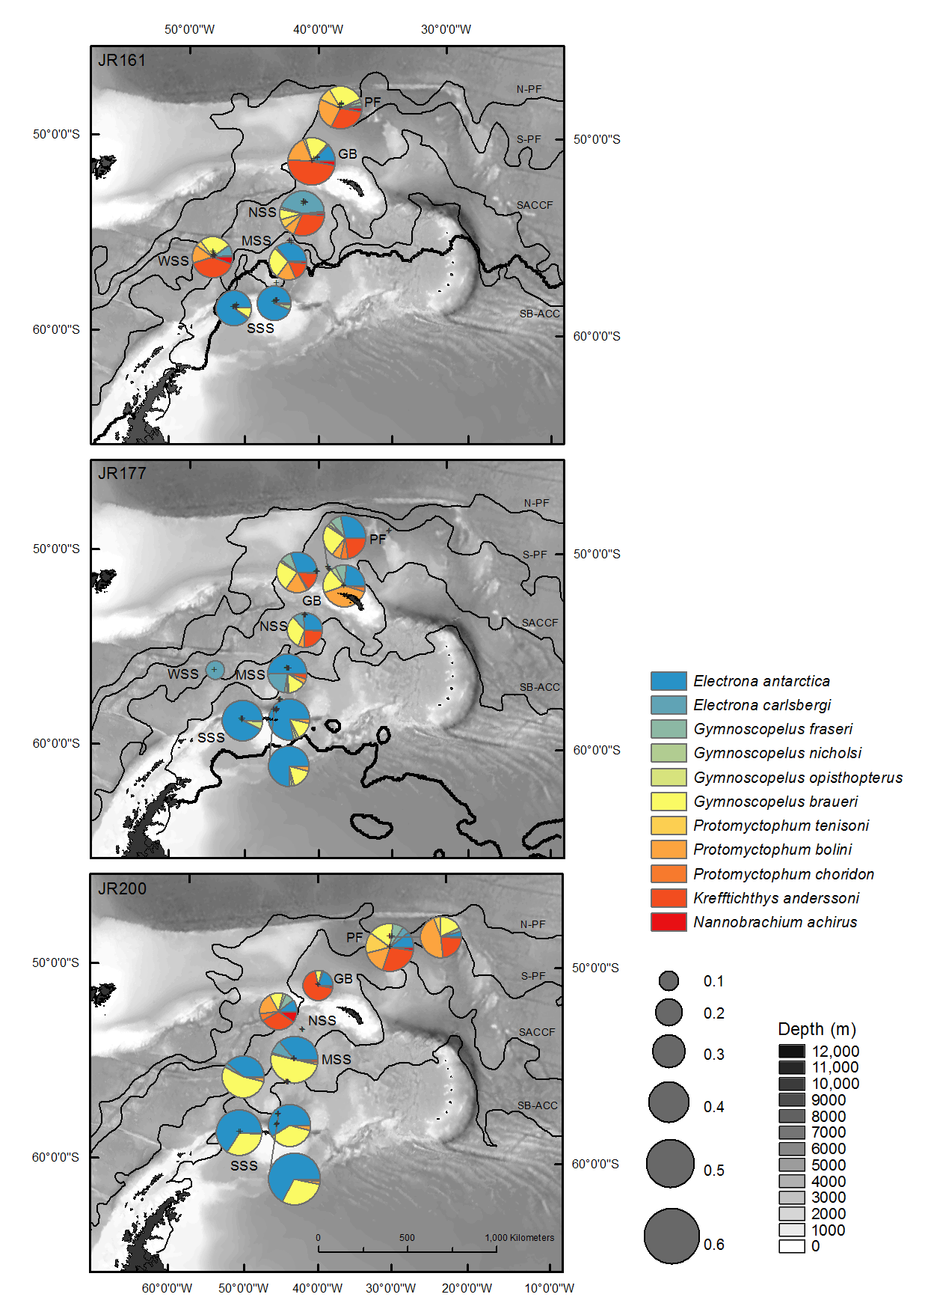
Fig. 1. Map of the Scotia Sea and the distribution of the most abundant myctophids during the surveys. The size of the pies is proportional to the log total of fish densities per net. Crosses denote net haul positions. Sampling stations are: Southern Scotia Sea (SSS), Western Scotia Sea (WSS), Mid-Scotia Sea (MSS), North Scotia Sea (NSS), Georgia Basin (GB) and Polar Front (PF). Mean frontal positions determined during the cruises from dynamic height data (Venables et al. 2012) are: northern Antarctic Polar Front (N-PF), southern Antarctic Polar Front (S-PF), South Antarctic Circumpolar Current Front (SACCF) and Southern Boundary of the Antarctic Circumpolar Current (SB-ACC). The heavy black line shows the position of the 15% ice-edge cover for 24/10/2006 and for 15/01/2008. The ice-edge occurred well south of the transect during autumn 2009 (JR200). Bathymetry data are from the GEBCO_08 grid (version 20091120, www.gebco.net).

Fig. 2. Typical vertical temperature (a) and salinity (b) profiles from each station across the Scotia Sea during Summer (JR177), with temperature-salinity plots of the same data (c). Stations are: Polar Front (PF), Georgia Basin (GB), North Scotia Sea (NSS), Mid Scotia Sea (MSS) and Southern Scotia Sea (SSS). Water masses are: Antarctic Surface Water (ASW), Winter Water (WW) and Circumpolar Deep Water (CDW).
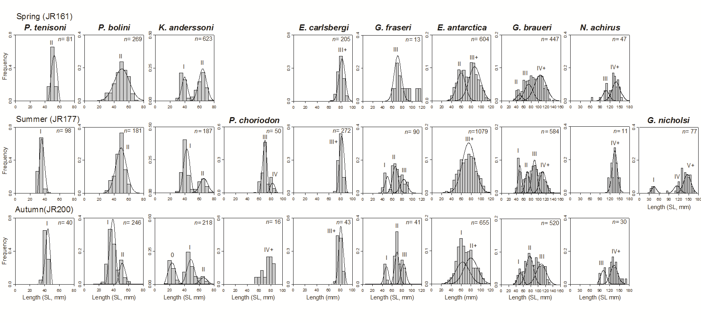
Fig. 3. Seasonal length-frequency distributions (5 mm length classes) of the 10 most abundant species of myctophid fish caught in the Scotia Sea between 2006 and 2009.
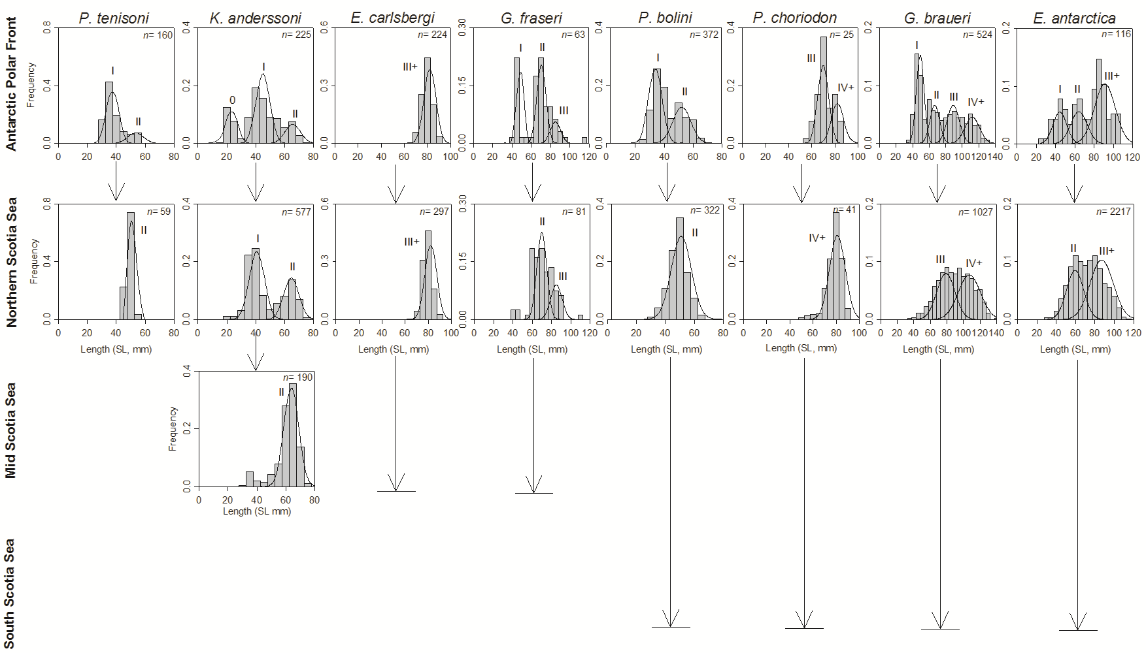
Fig. 4. Variation in length-frequency distributions (5 mm length classes) between the Antarctic Polar Front (APF) and Scotia Sea for 8 abundant species of myctophid fish caught between 2006 and 2009. Terminal arrows show the southernmost extent of their observed distributional range.
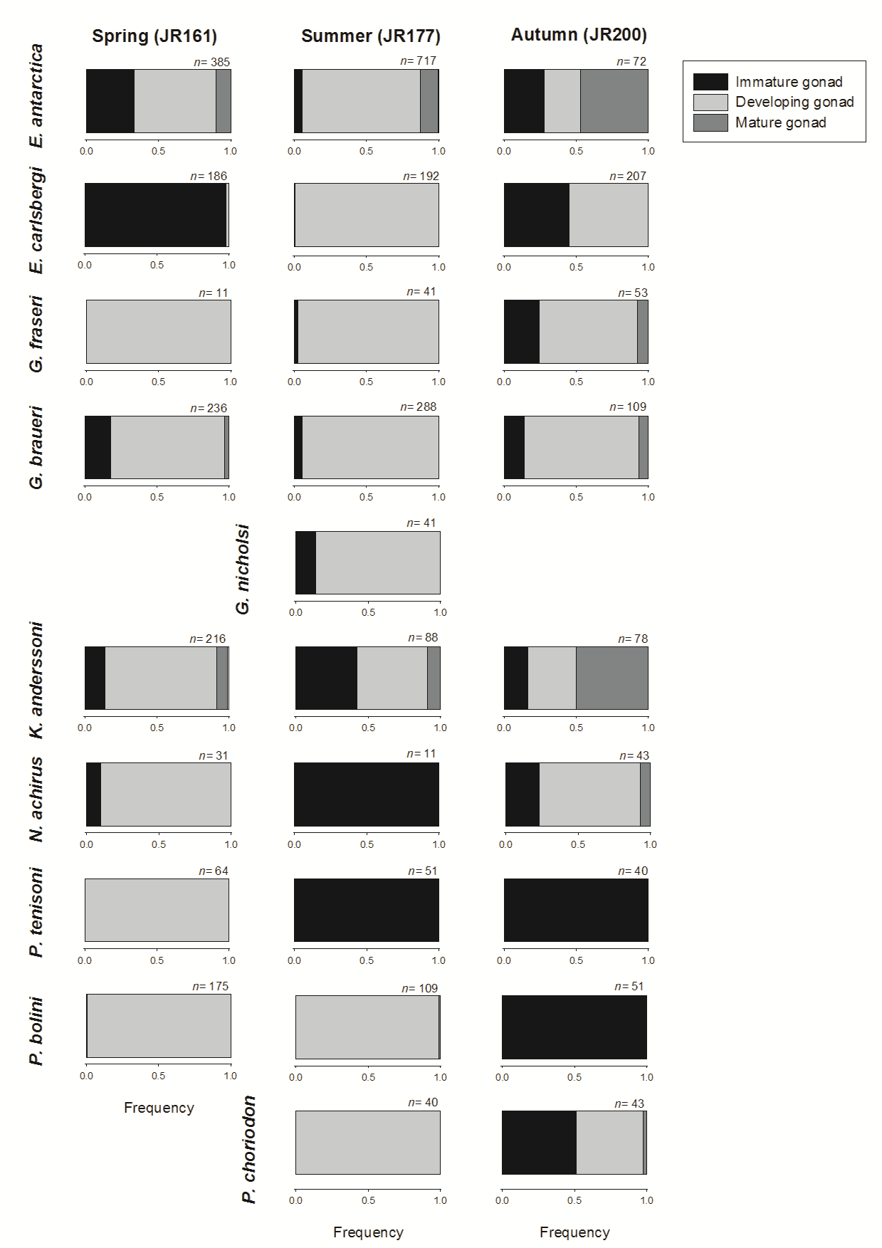
Fig. 5. Seasonal gonad maturity composition of the 10 most abundant species of myctophid fish caught in the Scotia Sea between 2006 and 2009.

