Environmental correlates of Antarctic krill distribution in the Scotia Sea and southern Drake Passage
Janet R.D. Silk*, Sally E. Thorpe, Sophie Fielding, Eugene J. Murphy, Philip N. Trathan, Jonathan L. Watkins, and Simeon L. Hill
British Antarctic Survey, High Cross, Madingley Road, Cambridge CB3 0ET, UK
*Corresponding author: e-mail: jrds@bas.ac.uk; tel: +44 1223 221400

ABSTRACT
Antarctic krill is a key prey species for many vertebrate and invertebrate predators in the Southern Ocean; it is also an abundant fishery resource in the Scotia Sea and southern Drake Passage. Here, we identify environmental correlates of krill distribution utilizing acoustic data collected during an extensive international survey in January 2000. Separate models (at scales of 10 to 80 nautical miles) were derived for the full study area and for each of four subregions; northern and southern shelf waters, the seasonally ice-covered open ocean, and the generally ice-free open ocean. Krill distribution was strongly correlated with bathymetry; densities were higher over island shelves and shelf breaks and decreased with increasing distance offshore. Low krill densities occurred in areas of low chlorophyll concentration and high geostrophic velocity. Krill distribution was also related to sea level anomaly but relationships were not consistent between subregions. The models explained a maximum of 44% of the observed deviance in krill density, but did not reliably identify areas of high krill density in the open ocean, and explained a small proportion of the deviance (16%) in offshore areas covered seasonally by sea ice, probably because of the strong, residual influence of retreated ice. The commercial krill fishery is currently concentrated in shelf areas, where high densities of krill are most predictable. As krill are not predictable in the open ocean, the fishery is likely to remain principally a near-shore operation, and should be managed accordingly.
Keywords: Antarctic krill, fisheries management, species distribution model, CCAMLR 2000 synoptic survey, environmental drivers, Scotia Sea
INTRODUCTION
The processes that influence the spatial distribution of marine organisms include biological interactions and environmental drivers operating across a range of spatial and temporal scales (Murphy et al., 1988; Legendre and Fortin, 1989; Fauchald et al., 2000). A diverse group of marine organisms, sometimes termed “forage species”, are particularly important in the functioning of marine ecosystems. Typically, these are locally abundant mid-trophic level fish or crustaceans that support a diverse range of predators as well as fisheries (Cury et al., 2011; Pikitch et al., 2012). Forage species typically have extensive ranges (on the scale of 100s to 10000s km²) and their distribution and abundance is sensitive to variability in the physical environment (Lehodey et al., 2006). Managing fisheries for these species in the context of environmental variability and climate change, and in a manner that is also sensitive to the needs of dependent species is complex, particularly where the fundamental drivers of distribution are poorly understood.
Antarctic krill Euphausia superba (hereafter krill) is the main forage species in the Southern Ocean and might support a greater biomass of predators than any of the world’s other forage species (Pikitch et al., 2012). It is the principal prey for numerous higher trophic level predators, and is a key component of Antarctic food webs (Croxall et al., 1999; Atkinson et al., 2012; Murphy et al., 2012). It is a circumpolar species found in waters south of the Antarctic Polar Front (Marr, 1962), with a total estimated biomass of 117-379 million tonnes (Atkinson et al., 2008). Around a quarter of this biomass is concentrated in the Scotia Sea and southern Drake Passage (Figure 1, Atkinson et al., 2008). This region supports a high biomass of predators which are estimated to consume 48 million tonnes of krill annually (Hill et al., 2007), and a krill fishery that accounted for 90% by mass of all species targeted by fisheries in the Southern Ocean in 2005-2014 (CCAMLR, 2015).
The krill fishery is managed by the Commission for the Conservation of Antarctic Marine Living Resources (CCAMLR). CCAMLR is responsible for developing a spatially structured management approach to limit impacts upon the krill stock and krill-dependent predators (Article II CCAMLR, 1982; Hewitt et al., 2004a). Regional catch limits have been established across the CCAMLR area with lower interim limits in the four subareas in the Scotia Sea where harvesting currently occurs (CCAMLR, 2010a; Nicol et al., 2012; Grant et al., 2013). Currently, the fishery operates over island shelves and shelf slopes (Murphy et al., 1997; Grant et al., 2013). This spatial concentration of fishing effort has the potential to increase impacts on the numerous krill-dependent predators which concentrate their foraging over island shelves and slopes during the summer when many are constrained to return to land to raise their offspring (Croxall and Prince, 1987; Trathan et al., 1998b; Murphy et al., 2007).
Although Antarctic krill is a circumpolar species, it has a highly heterogeneous distribution and occurs in habitats from on-shelf and open ocean environments to the marginal sea ice zone (Marr, 1962). Environmental correlates of krill distribution have long been sought. However, most relationships are not predictable and vary subject to the location and scale of the analyses (reviewed by Siegel, 2005; and Nicol, 2006). There is frequently an association with bathymetry, and in the Scotia Sea, increased krill abundance is associated with the shelf regions of the Antarctic Peninsula and around the islands of South Georgia in the north-east Scotia Sea, and with the open ocean (Marr, 1962; Siegel, 2005; Atkinson et al., 2008). Krill distribution has also been linked to temperature, phytoplankton biomass, and chlorophyll a concentration, which is considered to be a proxy for food availability (Whitehouse et al., 2009; Fielding et al., 2014). At the circumpolar scale, high krill abundance occurs in regions of moderate chlorophyll a concentrations (Atkinson et al., 2008). However, relationships at local scales are variable (Santora et al., 2012; Siegel et al., 2013). Advection is thought to play a major role in the distribution of krill at the meso and basin scale (Everson and Murphy, 1987; Hofmann and Murphy, 2004; Thorpe et al., 2007). Modelling studies have also shown that the movement of krill within the marginal sea ice zone is likely to affect the distribution of krill in the following summer (Thorpe et al., 2007).
Synoptic data on krill abundance are available from three large-scale, acoustic surveys in the Scotia Sea and southern Drake Passage. The first two were the FIBEX and SIBEX surveys (El-Sayed, 1994). The third and most comprehensive was the CCAMLR synoptic survey, which was conducted in January-February 2000 to estimate krill biomass in the waters open to the krill fishery in this region (Hewitt et al., 2004b). In this study we use data from this recent survey to examine relationships between the observed krill distribution and a range of environmental variables, at both the survey scale and within smaller subregions. The objectives were to understand the meso-scale drivers of distribution and to determine whether areas of high krill density can be predicted from environmental data. For this reason, we use satellite remote-sensing data that are collected continuously rather than in situ oceanographic measurements which require dedicated scientific cruises and are constrained both in time and space. The results are discussed in terms of refining the spatial management of the krill fishery in the region.
METHODS
Survey design
Data on the density and distribution of krill in the Scotia Sea and southern Drake Passage region were collected by four vessels during an international cruise programme during January and February 2000 (hereafter the CCAMLR synoptic survey; Trathan et al., 2001; Watkins et al., 2004). The survey comprised a series of parallel acoustic transects (total length 17,424 km). By using multiple ships to complete the survey in a relatively short period of time, it was possible to obtain a high resolution quasi-synoptic estimate of krill distribution and density. To ensure compatibility of acoustic data, all transects were carried out in daylight using a Simrad EK500 echosounder. Sampling, calibration and validation protocols, and derivation of the initial krill biomass estimates, including the method to cross-calibrate the acoustic data between the vessels, are provided in Watkins et al. (2004) and Hewitt et al. (2004b).
Study area
Currently, krill fishing only takes place in three CCAMLR subareas to the west of 30⁰W (Grant et al., 2013). We restricted our analysis to data collected by the three vessels that sampled in this region during the synoptic survey (81% of the whole survey area, hereafter the study area (Figure 1); Hewitt et al., 2004b) and excluded data collected by R. V. Atlantida, the only vessel to sample exclusively to the east of 30⁰W in an area of apparently very low krill densities.
Krill density data
Since the original analyses of the CCAMLR survey data (Hewitt et al., 2004b), there has been considerable development in algorithms that estimate krill biomass from acoustic back-scatter data and we used methods that generated a revised estimate of krill biomass of 60.3 million tonnes (CCAMLR, 2010b; Fielding et al., 2011) compared with 44.3 million tonnes (Hewitt et al., 2004b). Briefly, acoustic data at 120 kHz were apportioned to krill or non-krill using a three frequency (38, 120 and 200 kHz) variable window identification technique, and converted to wet-weight density using the validated physics-based Stochastic Distorted Wave Born Approximation (SDWBA) target strength model (McGehee et al., 1998; Demer and Conti, 2004). Estimates of krill density (g m⁻²) were available at 1 nautical mile (1 nm; 1.85 km) intervals along each transect.
Environmental variables
Two static and five dynamic environmental variables were selected to describe key physical and biological characteristics (Table 1, Figure 2): water depth (Depth), the distance to the nearest shelf break (Break distance), chlorophyll a concentration (Chl), sea surface temperature (SST), sea level anomaly (SLA), surface geostrophic velocity (Velocity) and water mass zone (Zone). Distance to the maximum winter sea ice extent was initially considered as a potential proxy of seasonal ice coverage; however, this static variable was very highly correlated with latitude and was excluded because it did not provide any additional environmental information.
The position of the shelf break was defined as the 1000 m isobath following Atkinson et al. (2008) and distances were calculated in a Lambert Azimuthal equal-area projection. Negative distances were assigned to locations on the shelf i.e. at depths < 1000 m. The dynamic variables were obtained from satellite-derived data. Cloud cover affected the quality of the daily and weekly datasets for chlorophyll a and SST, so monthly composites were used for these variables. Water mass zone was defined according to frontal positions derived from daily fields of absolute dynamic topography data, following Venables et al. (2012). There were four distinct zones: sub polar waters, the southern zone of the Antarctic Circumpolar Current, the Antarctic Zone and the Polar Frontal Zone. Concurrent environmental data were extracted at the location of each 1 nm krill density estimate. Prior to modelling, velocity and chlorophyll a data were log-transformed to reduce the influence of extreme values.
Other variables
The nominal variable Ship (three levels) was included in all regional analyses to test whether differences among survey vessels affected the heterogeneity of the data following the post-stratification of the original survey area into subregions.
Analysis scale
We analysed the relationship between krill density and environmental variables at a spatial resolution of 10 nautical miles (10 nm; 18.5 km), consistent with the resolution of the available environmental data (Table 1), and previous studies of krill distribution in the Scotia Sea (Whitehouse et al., 2009). Along each transect, the 1 nm data were binned into 10 nm intervals and the mean krill density and mean value of each environmental variable was calculated from the values extracted at the 1 nm locations. Bins with less than 10 contributing 1 nm values or incomplete environmental data (in total 91 of 781) were excluded from subsequent analyses.
Regionalisation
The study area was extensive (1.7 x 10⁶ km² of ocean) and included a diverse range of environmental regimes; hence, analyses were carried out both at the level of the whole area and within four clearly defined subregions: 1) Southern Shelves; 2) South Georgia Shelf; 3) Sea Ice Zone, and; 4) Open Ocean (Table 2, Figure 3a). This classification of subregions was based on the circumpolar regionalisation of the Southern Ocean developed by Raymond (2011) which used cluster analysis of data on sea surface temperature, depth and sea ice cover to distinguish regions in waters south of 40⁰S. Eleven of the 20 cluster types identified by Raymond (2011) occur in the study area (Figure 3b). As there was little or no survey effort in many of the corresponding fine-scale regions, we combined Raymond’s regions to produce a spatial subdivision of the study area appropriate to the scale of our analyses. Specifically, we merged cluster types in ice-covered areas according to depth to produce two aggregate types: shallow (< ~1000 m; cluster types 1 to 7) and deep water (> ~2000 m; cluster types 8 to 11). We then merged isolated regions of intermediate depth (original cluster types 12 and 14) with the neighbouring region of shallow or deep water. This process resulted in a subdivision of the survey area into 5 subregions; however, the extensive band of deep oceanic waters bounded by the Polar Front and the Subantarctic Front (cluster type 16, Figure 3) was under-sampled, and so no attempt was made to analyse relationships for the corresponding subregion of the survey area (4.9% of the survey data).
Data analysis
Generalised additive models (GAMs; Hastie and Tibshirani, 1990; Wood, 2006) were used to explore the relationships between krill density (ρ) and the candidate explanatory variables. The krill density data were highly right-skewed, which suggests that a family of Tweedie distributions and the negative binomial distribution may be appropriate. We considered Tweedie distributions for which 1 < γ (the index parameter) < 2, also called Poisson-gamma distributions, which are suited to a response variable with positive, continuous values and observations of zero. Diagnostic plots of residuals were used to assess which of the competing response distributions provided the best fits to the data. The GAMs were restricted to smooth functions (‘smoothers’) of single covariates and used a log link function.
The GAMs were fitted in R (R Development Core Team, 2010) using the mgcv library (Wood, 2006). Isotropic thin plate regression splines (s) were selected and the optimal degree of smoothing for each term was chosen automatically using the generalised cross-validation (GCV) method, with the gamma multiplier set to 1.4 to avoid over-fitting (Kim and Gu, 2004). Where the resulting smoothers appeared to over-fit the data, particularly in areas with few data, the degree of smoothing was modified manually (Zuur et al., 2009).
A forward model selection procedure was adopted to identify the optimal model for each subregion and the whole study area. Automatic model selection procedures were discounted for a number of reasons, including the high degree of collinearity in some pairs of explanatory variables (Zuur et al., 2009) and the small sample size for the South Georgia Shelf subregion. In the first round of model selection, each GAM included a single explanatory variable. The models with the explanatory variables significant at P < 0.05 were compared and the one with the lowest Akaike Information Criteria (AIC) was selected as the best model. Next, GAMs with two explanatory variables, comprising the variable selected in the first round and each of the remaining uncorrelated variables (|r| < 0.5; Booth et al., 1994) were fitted. Competing models, i.e. those with both explanatory variables significant at P < 0.05, lower AIC than the best model from the previous round and that produced a reasonable (> 3%) increase in explained deviance, were retained and the one with the lowest AIC was considered to be the best. An F-test (Wood, 2006) was used to determine whether the inclusion of an interaction term between selected nominal and continuous explanatory variables further improved the model fit. This process was repeated in subsequent rounds, each with one additional explanatory variable, until no new competing models were generated.
Potential heterogeneity and other problems with the resulting model specifications were assessed using the standard GAM diagnostic plots. The auto correlation functions (ACF) of the model residuals were also plotted to investigate whether any spatial autocorrelation remained beyond that accounted for by the explanatory variables. The ACF plots for the models fitted to the 10 nm data for the whole study area and the Open Ocean subregion showed clear residual correlation and the corresponding GAM diagnostic plots suggested that the distributional assumptions of the model were inappropriate. These issues are typical of statistical analyses of marine at-sea survey data that, as a consequence of the highly patchy spatial distribution of marine organisms, are characteristically spatially correlated and have an excess of zero or low values (Ciannelli et al., 2008). To minimise the effects of spatial heterogeneity in the krill data, we repeated analyses for the whole study area and Open Ocean subregion with 1 nm data aggregated at increasingly coarse resolutions (each a multiple of 10 nm) until no remaining autocorrelation was apparent in the ACF plot of the model residuals (Dungan et al., 2002; Ciannelli et al., 2008). An offset, defined as natural log(number of 1 nm density values / bin size), was included in the model definition to account for differences in the number of 1 nm density values used to calculate the mean krill density for each bin. Maps of fitted krill density were compared to the observed densities at each location and used to assess model performance. Very high densities were recorded along two transects at the shelf break to the north of the South Orkney Islands; however, repeating these analyses with the resulting bins capped at the next highest estimate of krill density had no effect on the results.
RESULTS
Overall krill density distribution
The density distribution of krill across the study area was highly heterogeneous (Figure 4). Areas of high density occurred around the South Shetland Islands, particularly in shelf and shelf-slope waters to the north; on the shelf region south of the South Orkney Islands and in the deep canyons to the north; from about 30 to 40⁰W in the central Scotia Sea, and; north-west of South Georgia as far as Shag Rocks. Densities were relatively low in the west of the Scotia Sea and in the Drake Passage north-west of the Antarctic Peninsula area.
The distribution of the krill density estimates at the 10 nm bin size was strongly skewed, with 75% of values < 25 g m⁻², and 10 high (> 500 g m⁻²) and two very high values (> 2500 g m⁻²). There were clear differences in the distribution of krill across subregions; mean density was highest in the Southern Shelves and lowest in the South Georgia Shelf and Open Ocean (Table 3).
Model fitting and validation
GAMs fitted to data binned at 10 nm intervals, using a Tweedie error distribution with γ =1.8, provided a good fit for three of the four subregions (Southern Shelves, South Georgia Shelf and Sea Ice Zone). At the 10 nm scale, the GAM diagnostics and ACF plots indicated a poor fit and correlation in residuals for the models for the large Open Ocean subregion and the whole study area. For these areas, valid models were obtained for data binned at 40 nm and 80 nm, respectively, using the same Tweedie error distribution. Aggregating the data reduced both the skew and kurtosis (Table 3). In both cases, the coarse-scale models (> 10 nm) included the same set of variables as the best (but ultimately rejected) fine-scale model (10 nm). The highest values for krill density fitted by each model ranged from 89 to 564 g m⁻². However, a small proportion (2-9%) of observed values were higher than the model-predicted maxima. Not only did the models underestimate these rare, very high krill densities, they also tended to overestimate lower densities.
Model for whole study area
ρ = s(Break distance, 1.0) + s(Velocity, 3.1) + s(Chl, 2.2)
The final model for the whole study area included a linear term for break distance and smoothers for velocity and chl (Table 4, Figure 5a). The distance term alone accounted for over half (26.5%) of the explained deviance of the final model (42%). Krill density declined with increasing distance from the shelf break; densities were highest on the shelf and low ~100 km beyond the shelf break. Krill density was higher within the velocity range 0.05 to 0.15 m s⁻¹, with a peak at ~0.09 m s⁻¹, and decreased with increasing velocity at values greater than 0.15 m s⁻¹. Finally, krill density was lower in areas with very low chlorophyll a values (< 0.32 mg m⁻³).
The model for the whole study area predicted relatively high densities more or less throughout the shelf and shelf slopes of the southern Scotia Ridge, from the western Antarctic Peninsula to 30⁰W, and around South Georgia, in particular to the north and west (Figure 6). Although high krill densities were observed over parts of this area, the model did not capture the wider heterogeneity. This included the observed lower densities in shelf waters to the west of 63⁰W at the Antarctic Peninsula, and along the southern Scotia Ridge east of the South Orkney Islands. Fitted krill densities were generally higher east than west of 40⁰W in the central Scotia Sea, but the observed high densities that were patchily distributed between 30 and 40⁰W were not well captured; here the model did not estimate any krill densities > 50 g m⁻² although such densities occurred in 5% of the 80 nm bins.
Regional models
The explanatory variables most commonly retained in the regional models were break distance, chl, velocity and SLA (Table 4, Figure 5b-e). Depth, SST, zone and ship were not retained in any of the selected models (Table 5). The deviance explained ranged from 15.6 to 43.9%, and was highest in the two shelf subregions (Southern Shelves and the South Georgia Shelf).
Southern Shelves
ρ = s(Chl, 5.0) + s(SLA, 4.0) + s(Break distance, 1.4)
The final model for this subregion included the variables chl, SLA and break distance (Table 4, Figure 5b). SST was also a close contender during the first and second model selection rounds. The smoother for chl indicates that krill density is very low in areas with relatively low chlorophyll a concentration (< 0.30 mg m⁻³), and higher where chlorophyll a concentration is > 0.30 mg m⁻³. In addition, krill density declined at chlorophyll a concentrations above ~1.40 mg m⁻³ (0.34 on the log-transformed scale in Figure 5b), although the confidence bands are wide reflecting the sparseness of data in this range. SLA, which was closely correlated with longitude (r = 0.66), explains the broad differences in krill density in the eastern part of the subregion; high krill densities were observed around the South Orkneys Islands and very low krill density further east. Finally, the smoother for break distance increased the overall explained deviance by 4.5% and indicates that krill density increases from the shore to the shelf break in this subregion. This model also failed to predict the relatively low densities observed on the south-west Antarctic Peninsula to the west of 63⁰W.
South Georgia Shelf
ρ = s(Break distance, 1.0) + s(SLA, 1.0)
Break distance accounted for over 75% of the explained deviance in the model for the South Georgia Shelf subregion (Table 4, Figure 5c). This variable, which has a restricted range in this subregion, was fitted as a negative linear term and indicates that krill density increases towards the coastline of South Georgia. A negative linear term for SLA was retained in the second (final) round of model selection. It is important to note that, with the exception of velocity, all continuous explanatory variables are correlated with longitude in this relatively small subregion (|r| > 0.7 for SLA and SST, and |r| > 0.5 for depth, break distance and chl); hence the derived relationships with break distance and SLA may simply reflect the higher krill densities observed to the east of 38⁰W during the survey (Figure 4).
Sea Ice Zone
ρ = s(Velocity, 1.0) + s(Break distance, 1.0) + s(SLA, 1.0)
The final model for the Sea Ice Zone included linear terms for velocity, break distance and SLA (Table 4, Figure 5d), each of which produced a similar increase in explained deviance. However, the overall explained deviance for this model is very low (15.6%), suggesting that some key variables are missing or that krill density is less predictable.
Open Ocean
ρ = s(Break distance, 2.5) + s(Chl, 4.0) + s(Velocity, 1.0)
In the Open Ocean subregion, krill density decreased with increasing distance from the shelf to ~100 km, was relatively constant from ~100 to ~270 km, and declined thereafter (Table 4, Figure 5e). Chl was retained in the second round of model selection and the shape of the smoother for this variable was similar to that for the Southern Shelves model (Figure 5b), with very low krill density at chlorophyll a concentrations < 0.13 mg m⁻³. Finally, krill density decreases with increasing surface geostrophic velocity in this region. As was the case for the whole study area, the model did not estimate a krill density > 50 g m⁻² at any 40 nm location in the Central Scotia Sea between 30 and 40⁰W despite the high values observed during the survey.
DISCUSSION
This study used GAMs to identify relationships between the distribution of Antarctic krill in the Scotia Sea and southern Drake Passage and a suite of environmental variables. The model results provide insights into physical and biological influences on the distribution of krill in an area that is important for both dependent predators and the commercial fishery. The combinations of variables that best explained krill distribution were scale-dependent, depending upon whether the analysis was of the entire study area, or different subregions defined a priori on the basis of oceanographic characteristics.
The models developed for the South Georgia Shelf, Southern Shelves, and Sea Ice Zone subregions were based on data resolved to a spatial scale of 10 nm whereas those for the Open Ocean subregion and the whole study area required data aggregated at 40 nm and 80 nm, respectively. These scales of analysis improved model fit and minimised autocorrelation in the residuals. Autocorrelation can indicate that an important covariate is missing, but in our analyses it more likely indicates over-dispersion in the 10 nm data due to the patchy spatial distribution of krill (Murphy et al., 1988; Zuur et al., 2009). To account for multi-colinearity during model selection, we excluded environmental variables that were highly correlated with an already-selected variable. This explains why SST, for example, was not selected for inclusion in any model as it was correlated with either surface geostrophic velocity or SLA. With the exception of the Sea Ice Zone subregion, the models explained a substantial proportion of the observed deviance in krill density at both the subregion and whole study area scales (32.7-43.9% deviance explained). Krill distribution within each model was related to at least two environmental variables
Relationship to shelf break
Krill density was related to bathymetry (distance to the shelf break) in every model. At the scale of the whole study area, higher krill densities were found on the shelf. This is consistent with previous studies in this region indicating that krill occur in predictable high densities over shelves and shelf breaks (Murphy et al., 1997; Trathan et al., 1998a; Atkinson et al., 2008). Recent studies indicate that submarine canyons are important for the advection of krill and other zooplankton into shelf waters, including at the Antarctic Peninsula where they are consequently more accessible to land-based predators (Dinniman and Klinck, 2004; Ward et al., 2004; Pinones et al., 2011). Continental shelves and slopes are considered key habitats for post-larval krill, and are associated with greater food abundance and predictability, and extensive sea ice coverage at higher latitudes (Nicol, 2006; Atkinson et al., 2008). This is reflected in the distribution of krill fishing effort, which is concentrated in shelf areas (Kawaguchi and Nicol, 2007; Grant et al., 2013).
The two shelf subregion models showed opposing relationships between krill density and position on the shelf. At South Georgia, krill density was greatest near the coast and decreased towards the shelf edge, possibly due to local circulation patterns. Results from a high resolution ocean model of the South Georgia shelf suggest that in addition to flux across the northern shelf of the island, originating from both the southern shelf and offshore, there are several areas of retention on the northern shelf (Young et al., 2014), which may increase krill density closer to shore. In contrast, on the shelves of the Antarctic Peninsula and South Orkney Islands, krill density increased from the inner to outer shelf. Here, bathymetry explained less than 5% of the observed deviance in krill density distribution. However, the relationship described by the model is consistent with observations of the population structure of krill over the Antarctic Peninsula shelf in summer; high numbers of small krill are found inshore, and low numbers of larger krill offshore (Siegel et al., 2013).
Ocean circulation
Surface geostrophic velocity, SLA and water mass zone were included as candidate environmental variables in order to capture aspects of ocean dynamics that may be related to krill distribution. At the scale of our study area, water mass zone and surface velocity were closely related, with faster currents in the north, associated with the more intense activity of the Antarctic Circumpolar Current (ACC), and slower currents to the south of the ACC over the South Scotia Ridge and into the Weddell Sea. Most areas of high krill density in the open ocean were south of the southern ACC front in the southern and subpolar zones (cf. Figures 2 and 4). In the model for the whole study area, krill density showed a broadly quadratic relationship with surface geostrophic velocity. The highest densities were found in locations with weak to mid-range geostrophic velocity values (< 0.15 m s⁻¹). This is broadly in agreement, given our larger spatial scale, with results from a recent study in the Scotia Sea, in which over 75% of krill swarms were located in current velocities < 0.3 m s⁻¹, with peak distribution in velocities of 0.1-0.2 m s⁻¹ (Tarling and Thorpe, 2014).
At the subregion scale, SLA was selected in the second round of model selection for the Southern Shelves subregion, and included as the final term in models for the South Georgia Shelf and the Sea Ice Zone subregions. In the Southern Shelves subregion, SLA accounted for 17.9% of the observed deviation in krill density with a broadly quadratic relationship. However, SLA was closely correlated with both longitude and SST in this region and may not be the underlying factor. In the South Georgia subregion, there was a negative linear relationship between krill density and SLA but, again, SLA was correlated with longitude and SST. Moreover, although there have been improvements in the processing of altimetry data over continental shelves, the data quality in shallow waters is still dependent on the ability of, for example, tidal models to predict local tides (Volkov et al., 2007). As such, it is likely that the on-shelf processes that were important in determining the krill density distribution in these subregions during the Synoptic Survey were insufficiently resolved in the altimetric datasets.
Chlorophyll a distribution
The models showed curvilinear relationships between krill density and chlorophyll a concentration. At the scale of the whole study area, this reflects the large spatial variation in primary production (Figures 2 and 5a); there were very low krill densities associated with very low chlorophyll a offshore at the western Antarctic Peninsula and generally higher values in the main belt of enhanced chlorophyll a in offshore areas in the Scotia Sea, east of the Shackleton Fracture Zone. Chlorophyll a concentration was selected as an explanatory variable in models for two subregions: the Southern Shelves and the Open Ocean. These results suggest that krill density increases with food availability but rapidly reaches a plateau well below peak chlorophyll a concentrations. Krill densities tended to be higher at chlorophyll a concentrations of 0.3-1.4 mg m⁻³ in the Southern Shelves region and > 0.13 mg m⁻³ in the Open Ocean. Atkinson et al. (2008) reported a similar relationship, with krill occupying regions of moderate chlorophyll a concentrations (0.5-1.0 mg m⁻³), which they suggested was a trade-off between food availability and growth potential, and predation risk. Other studies find that krill distribution is difficult to predict from chlorophyll a levels (Santora et al., 2012; Siegel et al., 2013). Although chlorophyll a can be a useful general proxy for food availability, the type of phytoplankton is also important as krill feed preferentially on diatoms (Haberman et al., 2003). Furthermore, krill are omnivores and can feed on a variety of other food items (Price et al., 1988; Schmidt et al., 2014). Subsurface chlorophyll maxima (Holm-Hansen et al., 2005) are not detected using satellites yet are likely to be important feeding locations for krill. Studies suggest that feeding by aggregations of krill can lead to localised chlorophyll depletion (Graneli et al., 1993; Pakhomov et al., 1997; Whitehouse et al., 2009), which would obscure the relationship between the two variables. Seasonality of phytoplankton blooms, particularly the earlier onset in the northern compared with the southern Scotia Sea, means the degree of progression of blooms differ across the area of the synoptic survey (Park et al., 2010). It is likely that the differences between the models for each subregion reflect these processes to varying degrees.
Methodological considerations
The CCAMLR synoptic survey sampled some areas of open ocean in the eastern Scotia Sea where krill densities were high (> 50 g m⁻² at 80 nm resolution; Figure 6). However, the models underestimated krill density, indicating that these aggregations are not predictable based on the combination of environmental variables available. Nevertheless, our results are in agreement with other studies that suggest that krill aggregations in the open ocean are frequently associated with particular conditions, including moderate food availability and moderate current velocity (Atkinson et al., 2008; Tarling et al., 2009).
In our regionalisation, the Sea Ice Zone encompassed the off-shelf areas north of, and over the South Scotia Ridge, that are strongly affected by seasonal sea ice dynamics. This was the only subregion for which the model was able to explain only a small part of the observed deviance in krill density. We hypothesise that this reflects the strong influence of seasonal sea ice, which is an important over-wintering habitat for krill. At the time of the CCAMLR synoptic survey, the sea ice edge was south of the South Scotia Ridge, and the Scotia Sea was ice-free (Figure 1). Krill that over-wintered under the sea ice will have potentially remained in areas of open-ocean as the ice retreated, but to be able to predict their distribution would require a dynamic representation of the sea ice field and of spring phytoplankton blooms that establish following its retreat, which are an important food source for krill and will affect their distribution in subsequent months (Thorpe et al., 2007; Ross et al., 2014; Schmidt et al., 2014).
Although the CCAMLR synoptic survey was unusual in its large spatial extent, it was carried out in a single year, when krill density around South Georgia was relatively low (mid-season 2000 had the lowest mean krill density recorded between 1997 and 2013 (3 g m-2); Fielding et al., 2014). Repeated large scale surveys in future years would provide a greater understanding of underlying environmental drivers of krill distribution.
Implications for the krill fishery
The effectiveness of management measures for forage species depend upon detailed knowledge of their density and distribution, and how this changes over time. Species distributions are influenced by a complex range of environmental factors, both physical (e.g. oceanography, climate) and biological (e.g. predation). Here, we focused principally upon remotely-sensed environmental correlates, which together explained a substantial amount of spatial variability in the distribution of krill; however, considerable uncertainty remains. Current management of the krill fishery is based upon estimates of overall biomass and, at smaller scales, overlap and competition with dependent predators including whales, seals, penguins and other seabirds (Nicol et al., 2012). The current operational catch limit for Antarctic krill in the Scotia Sea and southern Drake Passage (620 kt, known within CCAMLR as the “trigger level”) is a fraction (11%) of the larger potential catch limit (5.61 mt, known as the “precautionary catch limit”). This precautionary limit will only be permitted if a spatially structured management approach is developed that successfully limits any resource competition or other impacts on krill-dependent predators; with present fishing patterns, impacts would be highly likely should the full precautionary catch limit be reached, as harvesting would be focused on shelf and shelf-break areas which are important for numerous predators (Murphy et al., 1997; Trathan et al., 1998a).
Increases in catches up to the precautionary catch limit would require a greater proportion of the fishing effort to occur in open ocean areas (Plaganyi and Butterworth, 2012; Watters et al., 2013). In other oceans, many open ocean fisheries targeting pelagic species rely on spotter planes or fish aggregation devices, or vessels target fish aggregations at ocean fronts (Waluda et al., 2001), or at bathymetric features such as seamounts (Morato et al., 2010). However, in the Antarctic, knowledge about krill distribution in the open ocean is insufficient to facilitate profitable harvesting. Our results confirm that it is challenging to predict the locations of harvestable stocks in such areas.
A key reason why the fishery operates on, and particularly to the north of, the island shelves and shelf breaks is because exploitable concentrations of Antarctic krill occur predictably in these regions (Kawaguchi and Nicol, 2007; Hill et al., 2009). In addition, island-wake effects may make these areas inherently more productive; they are also more sheltered from prevailing winds and therefore safer areas of operation for vessels, and often free from drift ice that may accumulate on the southern coasts. Consequently, these are areas where competition between the fishery and natural predators is likely to be high.
If krill aggregations are not predictable in the open ocean, then management methods need to consider the wider krill stock in a different way. Inevitably krill move from shelf areas to the open ocean, and vice versa, either through behavioural or advective processes (Hofmann and Murphy, 2004; Siegel, 2005). However, the rate of movement is key to estimating the stock available to natural predators and to the fishery. If movement is rapid, then the component of the stock in the open ocean can justifiably be considered as part of the stock available to predators and the fishery. Conversely, if movement is slow, and the component over the shelf is essentially isolated, krill in the open ocean should effectively be ignored in any assessment of the harvestable stock. Consequently it might be appropriate to replace the precautionary catch limit with a lower limit that recognises that the fishery will continue to operate predominantly in shelf areas.
Our models formalise hypotheses about the statistical relationships between a number of environmental variables and krill biomass distribution. Although bathymetry plays a dominant role, other variables are dynamic and will almost certainly vary as a consequence of climate change (Whitehouse et al., 1996; Meredith and King, 2005; Turner et al., 2009). The implications for krill stocks, predators and the fishery are hard to predict, and identifying appropriate process models that describe how krill will respond to combinations of fixed and variable environmental characteristics is a major challenge. However, this would facilitate assessments of how krill, predators and fisheries might respond under future change scenarios.
ACKNOWLEDGEMENTS
We thank the officers, crews and scientists involved in the CCAMLR 2000 Synoptic Survey including David Demer, Valerie Loeb and Roger Hewitt. We would also like to thank Jaume Forcada, Richard Phillips and Norman Ratcliffe for helpful discussions, and the anonymous referees and editor for helping to improve the manuscript. We obtained GEBCO 1 minute grid depth data from http://www.gebco.net/data_and_products/gridded_bathymetry_data/. The Chlorophyll a data product are Sea-viewing Wide Field-of-view Sensor (SeaWiFS) Ocean Color Data, Level 3 2009 Reprocessing. NASA OB.DAAC, Greenbelt, MD, USA. http://oceancolor.gsfc.nasa.gov/REPROCESSING/R2009/. We used AVHRR Pathfinder Version 5.0 sea surface temperature data, described in Casey et al. (2010), and available from the US National Oceanographic Data Center and GHRSST (http://pathfinder.nodc.noaa.gov). The altimeter products were produced by Ssalto/Duacs and distributed by Aviso, with support from Cnes (http://www.aviso.oceanobs.com/duacs/). This study was funded by core funding from the Natural Environment Research Council to the British Antarctic Survey’s Ecosystems Program.
REFERENCES
Atkinson, A., Siegel, V., Pakhomov, E. A., Rothery, P., Loeb, V., Ross, R. M., Quetin, L. B., et al. 2008. Oceanic circumpolar habitats of Antarctic krill. Marine Ecology Progress Series, 362: 1-23.
Atkinson, A., Nicol, S., Kawaguchi, S., Pakhomov, E., Quetin, L., Ross, R., Hill, S., et al. 2012. Fitting Euphausia superba into Southern Ocean food-web models: a review of data sources and their limitations. CCAMLR Science, 19: 219-245.
Booth, G. D., Niccolucci, M. J., and Schuster, E. G. 1994. Identifying proxy sets in multiple linear-regression: an aid to better coefficient interpretation. Research paper INT-470, United States Department of Agriculture, Forest Service, Ogden, USA. 1-13 pp.
Casey, K. S., Brandon, T. B., Cornillon, P., and Evans, R. 2010. The Past, Present and Future of the AVHRR Pathfinder SST Program. In Oceanography from Space: Revisited. Ed. by V. Barale, J. F. R. Gower, and L. Alberotanza. Springer.
Cavalieri, D. J., Parkinson, C. L., Gloersen, P., and Zwally, H. J. 1996, updated yearly. Sea Ice Concentrations from Nimbus-7 SMMR and DMSP SSM/I-SSMIS Passive Microwave Data, Version 1. Boulder, Colorado USA. NSIDC: National Snow and Ice Data Center, http://dx.doi.org/10.5067/8GQ8LZQVL0VL.
CCAMLR 1982. Conservation of Antarctic Marine Living Resources (CAMLR) Convention text. CCAMLR, https://www.ccamlr.org/en/organisation/camlr-convention-text (last accessed October 2015).
CCAMLR 2010a. Conservation Measure 51-01. Precautionary catch limitations on Euphausia superba in Statistical Subareas 48.1, 48.2, 48.3 and 48.4. CCAMLR, https://www.ccamlr.org/en/conservation-and-management/browse-conservation-measures (last accessed October 2015).
CCAMLR 2010b. Report of the Fifth Meeting of the Subgroup on Acoustic Survey and Analysis Methods (Cambridge, UK 1 to 4 June 2010). SC-CAMLR-XXIX/06. CCAMLR, Hobart, Tasmania.
CCAMLR 2015. CCAMLR Statistical Bulletin, Vol. 27 (2005-2014). CCAMLR, https://www.ccamlr.org/en/document/data/ccamlr-statistical-bulletin-vol-27 (last accessed October 2015).
Ciannelli, L., Fauchald, P., Chan, K. S., Agostini, V. N., and Dingsor, G. E. 2008. Spatial fisheries ecology: Recent progress and future prospects. Journal of Marine Systems, 71: 223-236.
Croxall, J. P., and Prince, P. A. 1987. Seabirds as predators on marine resources, especially krill, at South Georgia. In Seabirds: feeding biology and role in marine ecosystems, pp. 347-368. Ed. by J. P. Croxall. Cambridge University Press, New York.
Croxall, J. P., Reid, K., and Prince, P. A. 1999. Diet, provisioning and productivity responses of marine predators to differences in availability of Antarctic krill. Marine Ecology Progress Series, 177: 115-131.
Cury, P. M., Boyd, I. L., Bonhommeau, S., Anker-Nilssen, T., Crawford, R. J. M., Furness, R. W., Mills, J. A., et al. 2011. Global seabird response to forage fish depletion - one-third for the birds. Science, 334: 1703-1706.
Demer, D. A., and Conti, S. G. 2004. Validation of the stochastic distorted-wave Born approximation model with broad bandwidth total target strength measurements of Antarctic krill (vol 60, pg 625, 2003). Ices Journal of Marine Science, 61: 155-156.
Dinniman, M. S., and Klinck, J. M. 2004. A model study of circulation and cross-shelf exchange on the west Antarctic Peninsula continental shelf. Deep Sea Research Part II: Topical Studies in Oceanography, 51: 2003-2022.
Dungan, J. L., Perry, J. N., Dale, M. R. T., Legendre, P., Citron-Pousty, S., Fortin, M. J., Jakomulska, A., et al. 2002. A balanced view of scale in spatial statistical analysis. Ecography, 25: 626-640.
El-Sayed, S. Z. 1994. Southern Ocean Ecology: The BIOMASS Perspective. Cambridge University Press, Cambridge.
Everson, I., and Murphy, E. 1987. Mesoscale variability in the distribution of krill Euphausia superba. Marine Ecology Progress Series, 40: 53-60.
Fauchald, P., Erikstad, K. E., and Skarsfjord, H. 2000. Scale-dependent predator-prey interactions: The hierarchical spatial distribution of seabirds and prey. Ecology, 81: 773-783.
Fielding, S., Watkins, J., Cossio, A. M., Reiss, C., Watters, G., Calise, L., Skaret, G., et al. 2011. The ASAM 2010 assessment of krill biomass for area 48 from the Scotia Sea CCAMLR 2000 synoptic survey. WG-EMM-11/20. CCAMLR, Hobart, Tasmania.
Fielding, S., Watkins, J. L., Trathan, P. N., Enderlein, P., Waluda, C. M., Stowasser, G., Tarling, G. A., et al. 2014. Interannual variability in Antarctic krill (Euphausia superba) density at South Georgia, Southern Ocean: 1997-2013. ICES Journal of Marine Science, 71: 2578-2588.
Graneli, E., Graneli, W., Rabbani, M. M., Daugbjerg, N., Fransz, G., Cuzinroudy, J., and Alder, V. A. 1993. The influence of copepod and krill grazing on the species composition of phytoplankton communities from the Scotia-Weddell sea: an experimental approach. Polar Biology, 13: 201-213.
Grant, S. M., Hill, S. L., and Fretwell, P. T. 2013. Spatial distribution of management measures, Antarctic krill catch and Southern Ocean bioregions: implications for conservation planning. CCAMLR Science, 20: 1-19.
Haberman, K. L., Ross, R. M., and Quetin, L. B. 2003. Diet of the Antarctic krill (Euphausia superba Dana): II. Selective grazing in mixed phytoplankton assemblages. Journal of Experimental Marine Biology and Ecology, 283: 97-113.
Hastie, T., and Tibshirani, R. 1990. Generalized Additive Models, Chapman and Hall/CRC, Boca Raton, USA.
Hewitt, R. P., Watters, G., Trathan, P. N., Croxall, J. P., Goebel, M. E., Ramm, D., Reid, K., et al. 2004a. Options for allocating the precautionary catch limit of krill among small-scale management units in the Scotia Sea. CCAMLR Science, 11: 81-97.
Hewitt, R. P., Watkins, J., Naganobu, M., Sushin, V., Brierley, A. S., Demer, D., Kasatkina, S., et al. 2004b. Biomass of Antarctic krill in the Scotia Sea in January/February 2000 and its use in revising an estimate of precautionary yield. Deep Sea Research Part II: Topical Studies in Oceanography, 51: 1215-1236.
Hill, S. L., Reid, K., Thorpe, S. E., Hinke, J., and Watters, G. M. 2007. A compilation of parameters for ecosystem dynamics models of the Scotia Sea-Antarctic Peninsula region. CCAMLR Science, 14: 1-25.
Hill, S. L., Trathan, P. N., and Agnew, D. J. 2009. The risk to fishery performance associated with spatially resolved management of Antarctic krill (Euphausia superba) harvesting. ICES Journal of Marine Science, 66: 2148-2154.
Hofmann, E. E., and Murphy, E. J. 2004. Advection, krill, and Antarctic marine ecosystems. Antarctic Science, 16: 487-499.
Holm-Hansen, O., Kahru, M., and Hewes, C. D. 2005. Deep chlorophyll a maxima (DCMs) in pelagic Antarctic waters. II. Relation to bathymetric features and dissolved iron concentrations. Marine Ecology Progress Series, 297: 71-81.
Kawaguchi, S., and Nicol, S. 2007. Learning about Antarctic krill from the fishery. Antarctic Science, 19: 219-230.
Kim, Y. J., and Gu, C. 2004. Smoothing spline Gaussian regression: more scalable computation via efficient approximation. Journal of the Royal Statistical Society Series B-Statistical Methodology, 66: 337-356.
Legendre, P., and Fortin, M. J. 1989. Spatial pattern and ecological analysis. Vegetatio, 80: 107-138.
Lehodey, P., Alheit, J., Barange, M., Baumgartner, T., Beaugrand, G., Drinkwater, K., Fromentin, J. M., et al. 2006. Climate variability, fish, and fisheries. Journal of Climate, 19: 5009-5030.
Marr, J. W. S. 1962. The natural history and geography of the Antarctic krill (Euphausia superba Dana). Discovery Reports. 32, 33-464 pp.
McGehee, D. E., O'Driscoll, R. L., and Traykovski, L. V. M. 1998. Effects of orientation on acoustic scattering from Antarctic krill at 120 kHz. Deep-Sea Research Part Ii-Topical Studies in Oceanography, 45: 1273-1294.
Meredith, M. P., and King, J. C. 2005. Rapid climate change in the ocean west of the Antarctic Peninsula during the second half of the 20th century. Geophysical Research Letters, 32.
Morato, T., Hoyle, S. D., Allain, V., and Nicol, S. J. 2010. Seamounts are hotspots of pelagic biodiversity in the open ocean. Proceedings of the National Academy of Sciences of the United States of America, 107: 9707-9711.
Murphy, E. J., Morris, D. J., Watkins, J. L., and Priddle, J. 1988. Scales of Interaction Between Antarctic Krill and the Environment. In Antarctic Ocean and Resources Variability, pp. 120-130. Ed. by D. Sahrhage. Springer-Verlag, Berlin Heidelberg.
Murphy, E. J., Trathan, P. N., and Everson, I. 1997. Krill fishing in the Scotia Sea in relation to bathymetry, including the detailed distribution around South Georgia. CCAMLR Science, 4: 1-17.
Murphy, E. J., Watkins, J. L., Trathan, P. N., Reid, K., Meredith, M. P., Thorpe, S. E., Johnston, N. M., et al. 2007. Spatial and temporal operation of the Scotia Sea ecosystem: a review of large-scale links in a krill centred food web. Philosophical Transactions of the Royal Society B-Biological Sciences, 362: 113-148.
Murphy, E. J., Cavanagh, R. D., Hofmann, E. E., Hill, S. L., Constable, A. J., Costa, D. P., Pinkerton, M. H., et al. 2012. Developing integrated models of Southern Ocean food webs: Including ecological complexity, accounting for uncertainty and the importance of scale. Progress in Oceanography, 102: 74-92.
Nicol, S. 2006. Krill, currents, and sea ice: Euphausia superba and its changing environment. Bioscience, 56: 111-120.
Nicol, S., Foster, J., and Kawaguchi, S. 2012. The fishery for Antarctic krill - recent developments. Fish and Fisheries, 13: 30-40.
Orsi, A. H., Whitworth, T., and Nowlin, W. D. 1995. On the meridional extent and fronts of the Antarctic Circumpolar Current. Deep Sea Research Part I: Oceanographic Research Papers, 42: 641-673.
Pakhomov, E. A., Verheye, H. M., Atkinson, A., Laubscher, R. K., and TauntonClark, J. 1997. Structure and grazing impact of the mesozooplankton community during late summer 1994 near South Georgia, Antarctica. Polar Biology, 18: 180-192.
Park, J., Oh, I.-S., Kim, H.-C., and Yoo, S. 2010. Variability of SeaWiFs chlorophyll-a in the southwest Atlantic sector of the Southern Ocean: strong topographic effects and weak seasonality. Deep Sea Research Part I: Oceanographic Research Papers, 57: 604-620.
Pikitch, E. K., Rountos, K. J., Essington, T. E., Santora, C., Pauly, D., Watson, R., Sumaila, U. R., et al. 2012. The global contribution of forage fish to marine fisheries and ecosystems. Fish and Fisheries, DOI: 10.1111/faf.12004.
Pinones, A., Hofmann, E. E., Dinniman, M. S., and Klinck, J. M. 2011. Lagrangian simulation of transport pathways and residence times along the western Antarctic Peninsula. Deep Sea Research Part II: Topical Studies in Oceanography, 58: 1524-1539.
Plaganyi, E. E., and Butterworth, D. S. 2012. The Scotia Sea krill fishery and its possible impacts on dependent predators: modeling localized depletion of prey. Ecological Applications, 22: 748-761.
Price, H. J., Boyd, K. R., and Boyd, C. M. 1988. Omnivorous feeding behavior of the Antarctic krill Euphausia superba. Marine Biology, 97: 67-77.
R Development Core Team 2010. R: A Language and Environment for Statistical Computing. R Foundation for Statistical Computing, Vienna, Austria.
Raymond, B. 2011. A circumpolar regionalisation of the Southern Ocean. WS-MPA-11/06. CCAMLR, Hobart, Tasmania.
Ross, R. M., Quetin, L. B., Newberger, T., Shaw, C. T., Jones, J. L., Oakes, S. A., and Moore, K. J. 2014. Trends, cycles, interannual variability for three pelagic species west of the Antarctic Peninsula 1993-2008. Marine Ecology Progress Series, 515: 11-32.
Santora, J. A., Sydeman, W. J., Schroeder, I. D., Reiss, C. S., Wells, B. K., Field, J. C., Cossio, A. M., et al. 2012. Krill space: a comparative assessment of mesoscale structuring in polar and temperate marine ecosystems. ICES Journal of Marine Science, 69: 1317-1327.
Schmidt, K., Atkinson, A., Pond, D. W., and Ireland, L. C. 2014. Feeding and overwintering of Antarctic krill across its major habitats: The role of sea ice cover, water depth, and phytoplankton abundance. Limnology and Oceanography, 59: 17-36.
Siegel, V. 2005. Distribution and population dynamics of Euphausia superba: summary of recent findings. Polar Biology, 29: 1-22.
Siegel, V., Reiss, C. S., Dietrich, K. S., Haraldsson, M., and Rohardt, G. 2013. Distribution and abundance of Antarctic krill (Euphausia superba) along the Antarctic Peninsula. Deep Sea Research Part I: Oceanographic Research Papers, 77: 63-74.
Tarling, G. A., Klevjer, T., Fielding, S., Watkins, J., Atkinson, A., Murphy, E., Korb, R., et al. 2009. Variability and predictability of Antarctic krill swarm structure. Deep Sea Research Part I: Oceanographic Research Papers, 56: 1994-2012.
Tarling, G. A., and Thorpe, S. E. 2014. Instantaneous movement of krill swarms in the Antarctic Circumpolar Current. Limnology and Oceanography, 59: 872-886.
Thorpe, S. E., Heywood, K. J., Brandon, M. A., and Stevens, D. P. 2002. Variability of the southern Antarctic Circumpolar Current front north of South Georgia. Journal of Marine Systems, 37: 87-105.
Thorpe, S. E., Murphy, E. J., and Watkins, J. L. 2007. Circumpolar connections between Antarctic krill (Euphausia superba Dana) populations: Investigating the roles of ocean and sea ice transport. Deep Sea Research Part I: Oceanographic Research Papers, 54: 792-810.
Trathan, P. N., Everson, I., Murphy, E. J., and Parkes, G. B. 1998a. Analysis of haul data from the South Georgia krill fishery. CCAMLR Science, 5: 9-30.
Trathan, P. N., Murphy, E. J., Croxall, J. P., and Everson, I. 1998b. Use of at-sea distribution data to derive potential foraging ranges of macaroni penguins during the breeding season. Marine Ecology Progress Series, 169: 263-275.
Trathan, P. N., Watkins, J. L., Murray, A. W. A., Brierley, A. S., Everson, I., Goss, C., Priddle, J., et al. 2001. The CCAMLR-2000 Krill Synoptic Survey: A description of the rationale and design. CCAMLR Science, 8: 1-23.
Turner, J., Bindschadler, R. A., Convey, P., Di Prisco, G., Fahrbach, E., Gutt, J., Hodgson, D. A., et al. 2009. Antarctic Climate Change and the Environment, Scientific Committee on Antarctic Research, Cambridge, UK.
Venables, H., Meredith, M. P., Atkinson, A., and Ward, P. 2012. Fronts and habitat zones in the Scotia Sea. Deep Sea Research Part II: Topical Studies in Oceanography, 59: 14-24.
Volkov, D. L., Larnicol, G., and Dorandeu, J. 2007. Improving the quality of satellite altimetry data over continental shelves. Journal of Geophysical Research-Oceans, 112: C6.
Waluda, C. M., Rodhouse, P. G., Trathan, P. N., and Pierce, G. J. 2001. Remotely sensed mesoscale oceanography and the distribution of Illex argentinus in the South Atlantic. Fisheries Oceanography, 10: 207-216.
Ward, P., Grant, S., Brandon, M., Siegel, V., Sushin, V., Loeb, V., and Griffiths, H. 2004. Mesozooplankton community structure in the Scotia Sea during the CCAMLR 2000 survey: January–February 2000. Deep Sea Research Part II: Topical Studies in Oceanography, 51: 1351-1367.
Watkins, J. L., Hewitt, R., Naganobu, M., and Sushin, V. 2004. The CCAMLR 2000 Survey: a multinational, multi-ship biological oceanography survey of the Atlantic sector of the Southern Ocean. Deep Sea Research Part II: Topical Studies in Oceanography, 51: 1205-1213.
Watters, G. M., Hill, S. L., Hinke, J. T., Matthews, J., and Reid, K. 2013. Decision-making for ecosystem-based management: evaluating options for a krill fishery with an ecosystem dynamics model. Ecological Applications, 23: 710-725.
Whitehouse, M. J., Priddle, J., and Symon, C. 1996. Seasonal and annual change in seawater temperature, salinity, nutrient and chlorophyll a distributions around South Georgia, South Atlantic. Deep Sea Research Part I: Oceanographic Research Papers, 43: 425-443.
Whitehouse, M. J., Atkinson, A., Ward, P., Korb, R. E., Rothery, P., and Fielding, S. 2009. Role of krill versus bottom-up factors in controlling phytoplankton biomass in the northern Antarctic waters of South Georgia. Marine Ecology Progress Series, 393: 69-82.
Wood, S. N. 2006. Generalized Additive Models: An Introduction with R, Chapman and Hall/CRC, Boca Raton, USA.
Young, E. F., Thorpe, S. E., Banglawala, N., and Murphy, E. J. 2014. Variability in transport pathways on and around the South Georgia shelf, Southern Ocean: Implications for recruitment and retention. Journal of Geophysical Research-Oceans, 119: 241-252.
Zuur, A. F., Ieno, E. N., Walker, N. J., Saveliev, A. A., and Smith, G. M. 2009. Mixed Effects Models and Extensions in Ecology with R, Springer, New York.

TABLES
Table 1. Details of the environmental variables included in the models.
 | Variable name | Units | Spatial resolution | Temporal resolution | Source ^{2.}
Static
Depth | Depth | m | 1 arc minute | - | GEBCO 1 minute grid
Distance to the shelf break | Break distance | km | 1 arc minute | - | See Methods
Dynamic
Chlorophyll a ^{1.} | Chl | mg m⁻³ | 9 km | Monthly | SeaWiFS Level 3
Sea surface temperature | SST | °C | 4 km | Monthly | AVHRR Pathfinder SST V5
Sea level anomaly | SLA | cm | 1/3° Mercator grid | Daily | Aviso Ssalto/Duacs
Absolute surface geostrophic velocity ^{1.} | Velocity | m s⁻¹ | 1/3° Mercator grid | Daily | Aviso Ssalto/Duacs
Water mass zone | Zone | - | 1/3° Mercator grid | Daily | See Methods
^{1.} Log transformed before inclusion in analyses
^{2.} See Acknowledgements for further details

Table 2. Subregions within the study area.
Subregion | Area (x1000 km²) | Raymond (2011) clusters | Description
Southern Shelves | 251 | 1,2,3,7,12,14 | Seasonally ice covered shallow and moderate depth waters (~2000 m) of the south Scotia Ridge.
South Georgia Shelf | 72 | 13,14 | South Georgia continental shelf.
Sea Ice Zone | 276 | 9,10,11,12 | Areas of deep water along the south Scotia Ridge, mainly south of the mean maximum sea ice extent.
Open Ocean | 999 | 14,15 | Deep oceanic waters, encompassing approximately the southern Antarctic Circumpolar Current front and the Polar Front.

Table 3. Krill density distribution at the 10 nm bin size, and final analysis scale if different, within the study area and subregions.
 |  |  |  | Krill density (g m⁻²)
Geographic area |  | Scale (nm) | N | Maximum | Mean | Median | Skewness | Kurtosis
Study area |  | 10 | 687 | 3083.9 | 43.7 | 5.0 | 0.62 | 2.72
 |  | 80 | 111 | 653.8 | 47.1 | 16.5 | 0.53 | 1.49
Southern Shelves |  | 10 | 97 | 2693.0 | 106.2 | 26.7 | 0.59 | 1.34
South Georgia Shelf |  | 10 | 34 | 128.8 | 16.8 | 2.4 | 0.79 | 1.30
Sea Ice Zone |  | 10 | 107 | 829.2 | 43.0 | 10.3 | 0.35 | 2.77
Open Ocean |  | 10 | 416 | 3083.9 | 26.6 | 2.5 | 0.72 | 2.20
 |  | 40 | 115 | 783.2 | 26.7 | 5.7 | 0.65 | 1.43

Table 4. Summary of GAMs fitted to krill density data (in g m⁻²) for the study area and subregions. The increase in the deviance explained (DE) by the model with the addition of each term is shown in parentheses. Chl is chlorophyll a concentration and SLA is sea level anomaly.
 |  |  |  |  | Degrees of freedom of smoother
Model | Scale (nm) | N | DE (%) |  | Break distance | Chl | Velocity | SLA
Study area | 80 | 111 | 42.0 |  | 1.0 (26.5) | 2.2 (5.9) | 3.1 (9.6)
Southern Shelves | 10 | 97 | 43.9 |  | 1.4 (4.5) | 5.0 (21.5) |  | 4.0 (17.9)
South Georgia Shelf | 10 | 34 | 43.9 |  | 1.0 (34) |  |  | 1.0 (9.9)
Sea Ice Zone | 10 | 107 | 15.6 |  | 1.0 (4.5) |  | 1.0 (5.3) | 1.0 (5.8)
Open Ocean | 40 | 115 | 32.7 |  | 2.5 (23.7) | 4.0 (6.0) | 1.0 (3)

Table 5. Summary of the forwards selection procedure for each model. The selection order (1, 2 or 3) and significance level (‘***’ p < 0.001, ‘**’ p < 0.01 and ‘*’p < 0.05) for the explanatory variables included in the final model are shown in bold font. A blank cell indicates that the variable was available during model selection but not retained in the final model. Other cell values indicate the following: (c1, c2 or c3) - the variable is correlated with an explanatory variable selected in a previous round (1, 2 or 3 respectively) and was subsequently excluded from model selection, and (na) - the nominal variable was excluded from model selection due to insufficient sample size per level. Chl is chlorophyll a concentration, SLA is sea level anomaly, and SST is sea surface temperature.
 | Continuous variables |  |  |  |  |  |  |  |  | Nominal variables
Model | Depth | Break distance | Chl | Velocity | SLA | SST |  |  | Zone |  | Ship
Study area | (c1) | 1 *** | 3 * | 2 ** |  | (c2) |  |  |  |  | (na)
Southern Shelves | (c3) | 3 * | 1 *** |  | 2 *** | (c2)
South Georgia Shelf | (c1) | 1 ** |  |  | 2 * | (c2) |  |  | (na)
Sea Ice Zone |  | 2 *** |  | 1 ** | 3 ** |  |  |  | (na)
Open Ocean |  | 1 *** | 2 * | 3 *

FIGURE HEADINGS
Figure 1. Map of the study area. Climatological mean positions of the fronts of the Antarctic Circumpolar Current (ACC) are plotted (Orsi et al., 1995; Thorpe et al., 2002). SAF - Subantarctic Front, PF - Polar Front, SACCF - Southern ACC front, SBACC - Southern boundary of the ACC. The mean sea ice extent, corresponding to 15% ice concentration, is shown for September 1999 and January 2000 (Cavalieri et al., 1996, updated yearly).
Figure 2. Examples of the remotely sensed environmental data used in the analysis: (a) water mass zone (SP - sub polar waters, SZACC - southern zone of the Antarctic Circumpolar Current, AZ - Antarctic Zone, and PFZ - Polar Frontal Zone), (b) sea surface temperature (SST), (c) surface geostrophic current speed, (d) sea level anomaly (SLA), and (e) chlorophyll a concentration (Chl; log-transformed). Mean daily values for the time period of the survey are shown in panels (a), (c) and (d). Monthly composites for January 2000 are shown in panels (b) and (e). For further details, including sources, see Table 1.
Figure 3. Division of the study area into subregions: (a) the four subregions used in the regional analysis and the small subregion excluded because of undersampling, and (b) spatial distribution of cluster types from the Raymond (2011) pelagic regionalisation. See Table 2 for the mapping of cluster types to subregions. The thick black line delineates the study area.
Figure 4. Distribution of Antarctic krill (g m⁻²) at 10 nm resolution in January-February 2000 during the CCAMLR 2000 synoptic survey, based on re-estimated values (CCAMLR, 2010b; Fielding et al., 2011).
Figure 5. Estimated smoothing curves for the GAMs fitted to krill density data (in g m⁻²): (a) the whole study area, (b) Southern Shelves subregion, (c) South Georgia Shelf, (d) Sea Ice Zone, and (e) Open Ocean. The dotted lines indicate the 95% confidence intervals. Note that the axes limits vary between models. Chl is chlorophyll a concentration and SLA is sea level anomaly.
Figure 6. Krill density distribution (g m⁻²) at 80 nm resolution: (a) observed values, and (b) values fitted by the GAM for the whole study area.

Figure 1.

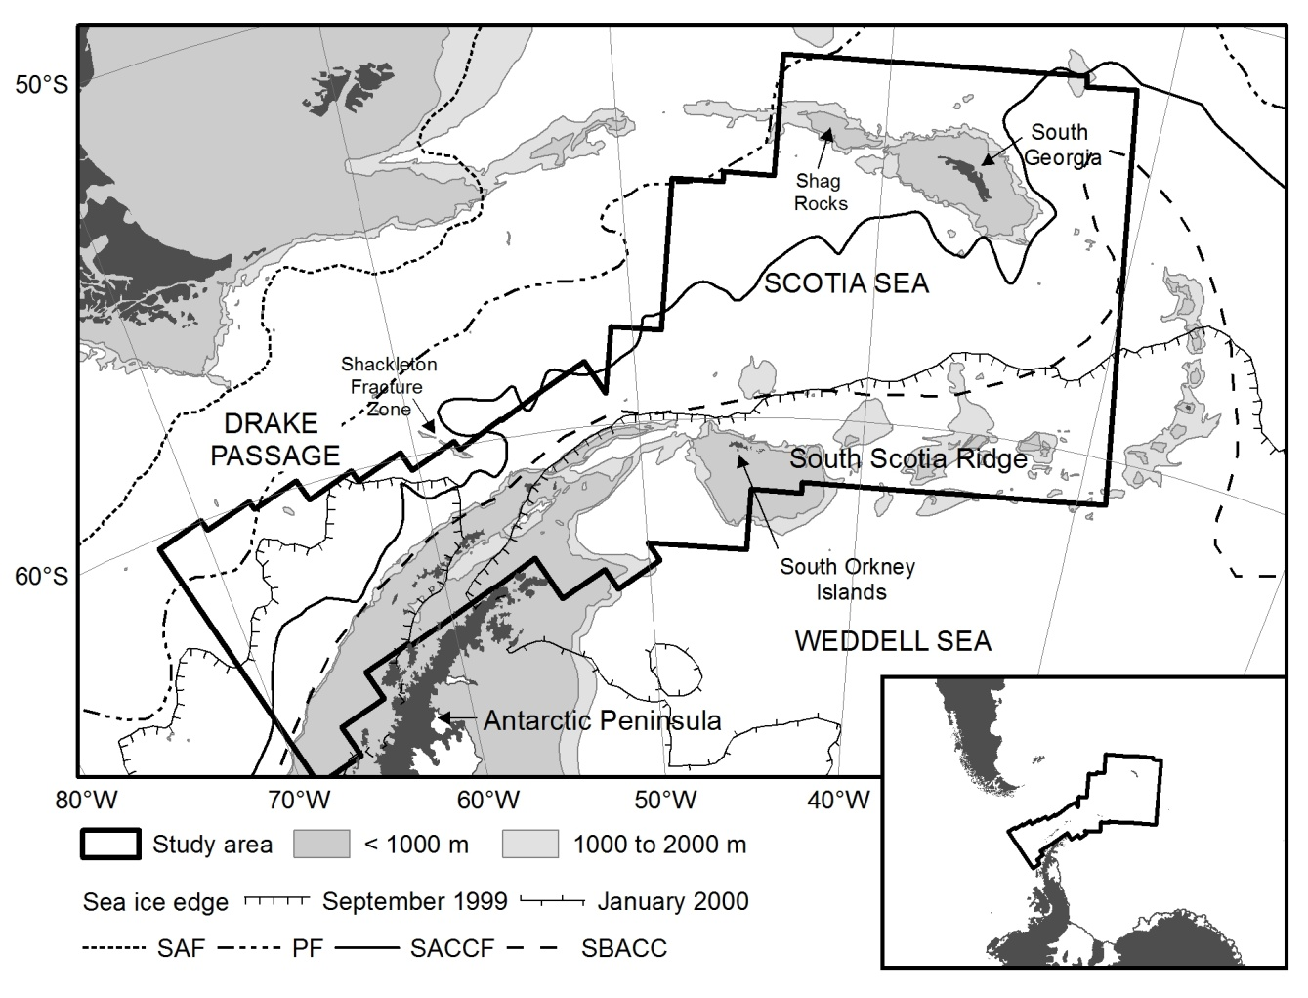

Figure 2.

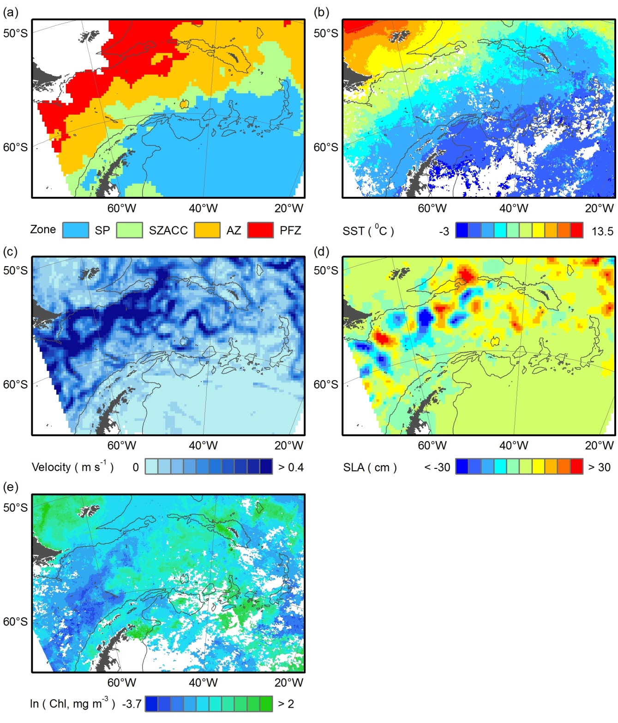

Figure 3.

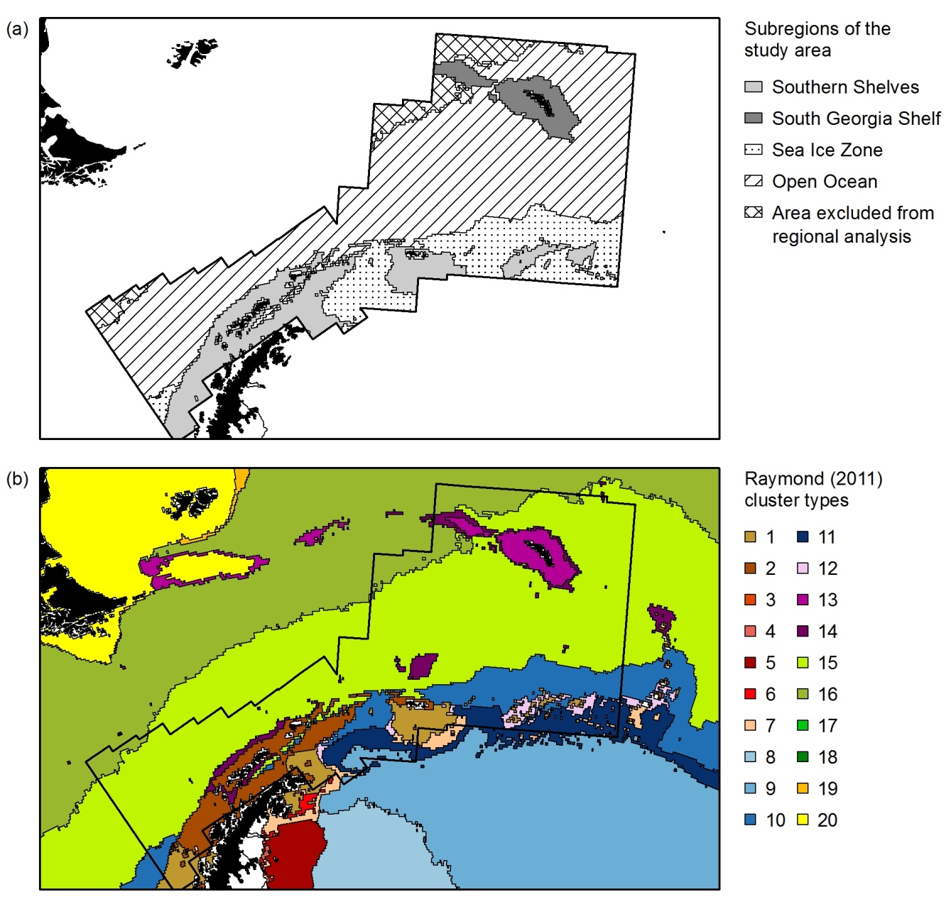

Figure 4.

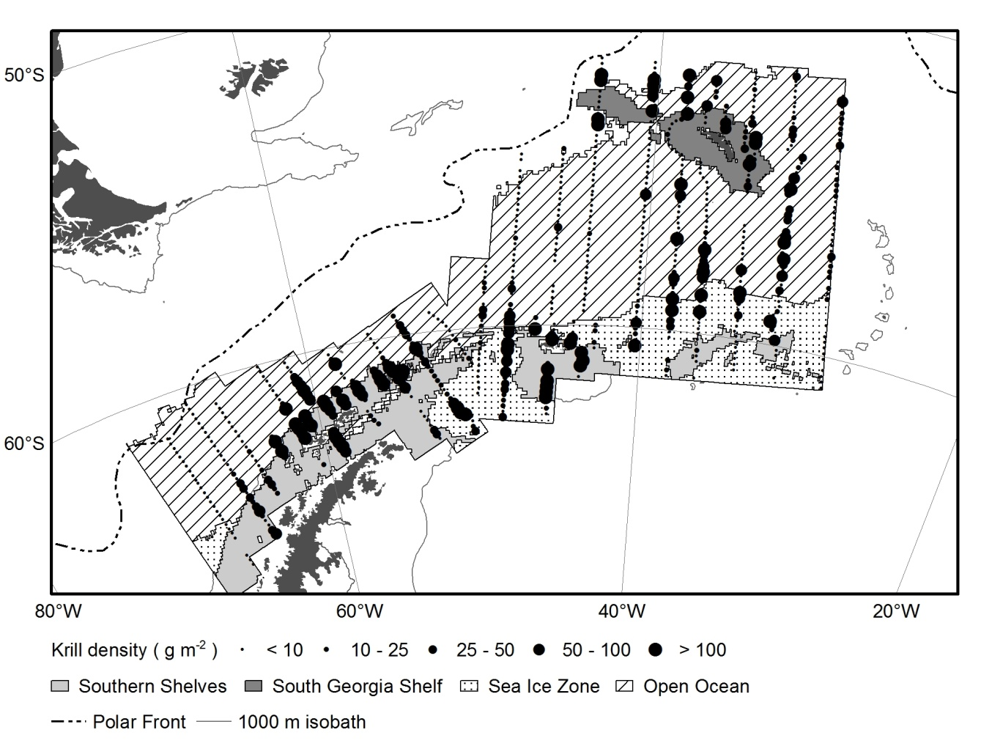

Figure 5.

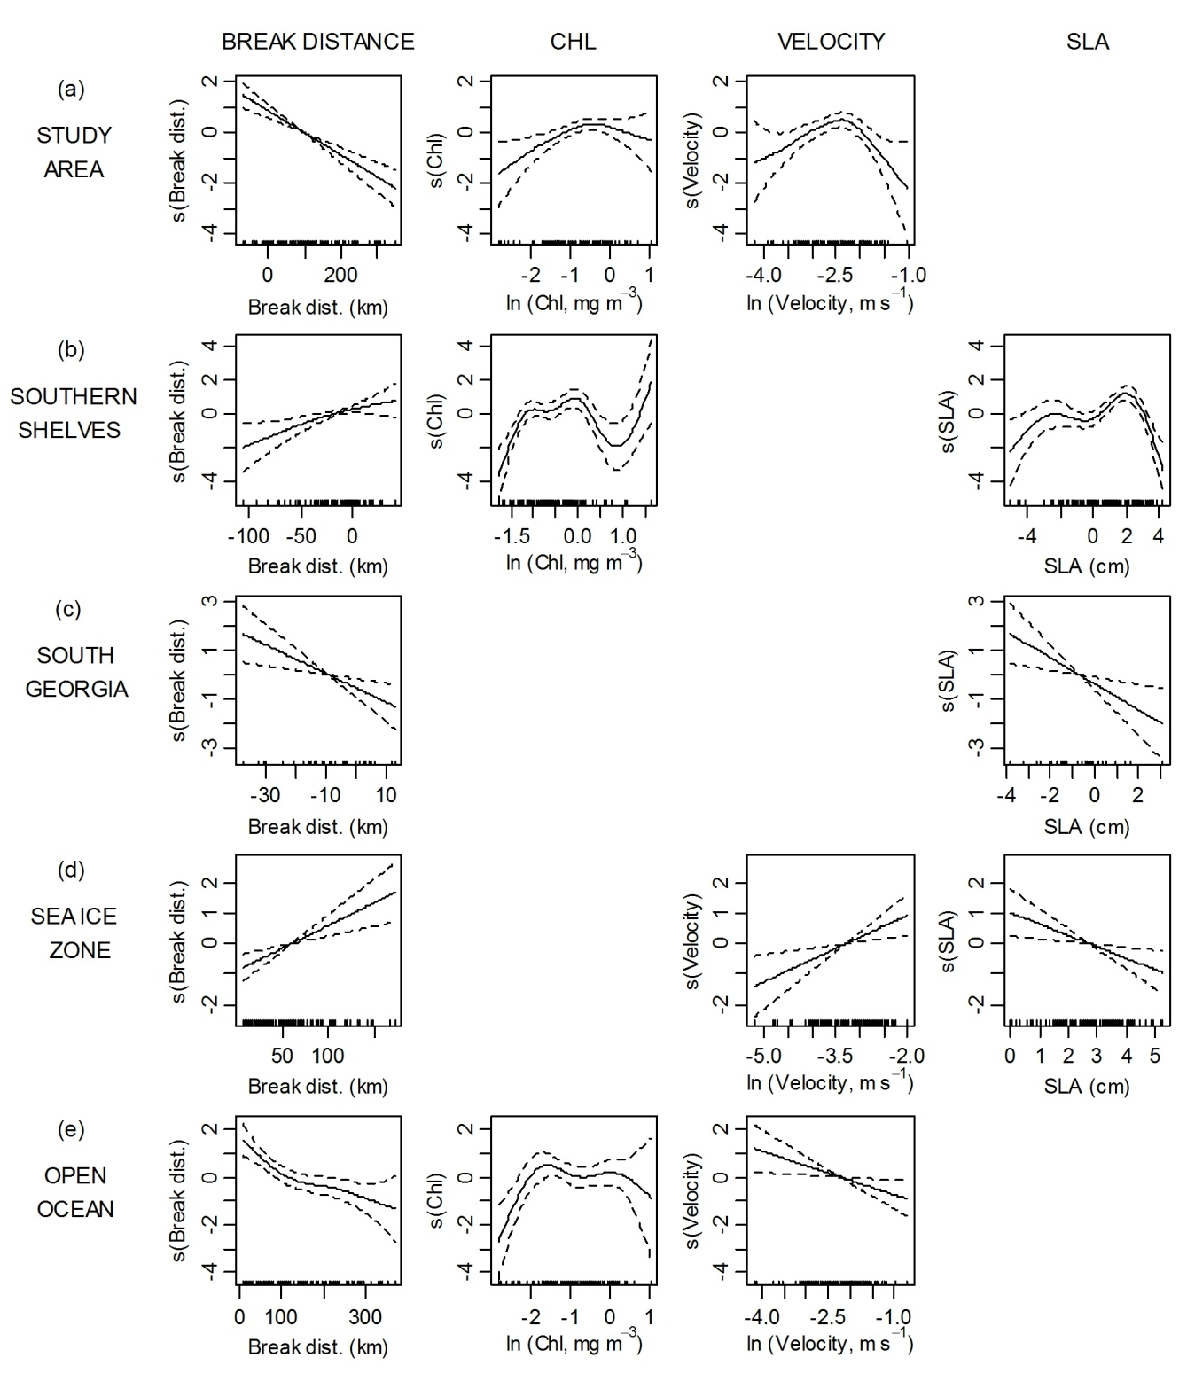

Figure 6.

