**Thermocline bulk shear analysis in the northern North Sea**

Shengli Chen 1, 2, 3, Jeff A. Polton 2, Jianyu Hu 3\*, Jiuxing Xing 1

1 Shenzhen Key Laboratory for Coastal Ocean Dynamic and Environment, Graduate School at Shenzhen, Tsinghua University, Shenzhen 518055, China

2National Oceanography Centre, Liverpool L3 5DA, UK

3State Key Laboratory of Marine Environmental Science, College of Ocean & Earth Sciences, Xiamen University, Xiamen 361102, China

\* Corresponding author: Dr. Jianyu Hu

State Key Laboratory of Marine Environmental Science, College of Ocean & Earth Sciences, Xiamen University, Xiamen 361102, China

Telephone: +86-592-2186981; Fax: +86-592-2186981

E-mail: hujy@xmu.edu.cn

**Abstract**

Thermocline bulk shear is investigated in the northern North Sea using historical observations. The conventional bulk shear is modified to define a thermocline bulk shear (TBS), in order to better represent the shear across the thermocline. The TBS computed by observed currents is decomposed into components at different frequency bands. The near-inertial TBS is the largest component. Its dominance is significant during the period of high wind. It is formed by the wind-driven near-inertial current which has a distinct phase shift (~180º) across the thermocline. A linear model is presented, which well simulates the observed near-inertial TBS, especially during the period of relatively strong wind. The semidiurnal TBS makes a secondary contribution to the total TBS. It is only slightly smaller than the near-inertial TBS when the wind is relatively weak. The large values of semidiurnal TBS are associated with semidiurnal currents which have a phase shift (~30-40º) or a magnitude difference (~5 cm/s) across the thermocline. The low-frequency (<0.7 cpd) TBS also makes an episodic contribution to the total. Its variation coincides with the Ekman transport during the period of relatively strong wind. The low-frequency TBS is mainly formed by an Ekman-like clockwise spiraling of velocity with depth or a distinct magnitude difference in velocities between upper and lower layers.

**Keywords**: thermocline bulk shear; near-inertial; semidiurnal; North Sea

**1. Introduction**

In shelf seas, strong current shear is frequently observed across the thermocline. The instability of this shear can induce diapycnal mixing (Large et al. 1994; Rippeth et al. 2005), which is crucial for vertical substance exchange across the thermocline. When the thermocline is thin (~10 m), a bulk shear can be defined as the shear between mean flows of upper and lower layers separated by the thermocline (Burchard and Rippeth 2009). This bulk shear is found to be significantly correlated with high levels of dissipation (Burchard and Rippeth 2009; Rippeth et al. 2009). Measurement of dissipation has been a widely used way to examine the rate of mixing. The traditional way to measure dissipation uses microstructure freefall probes, which are labour intensive and typically result in relatively short time series. Using bulk shear as a proxy for mixing, however, is anticipated to be valuable since longer time series are readily available.

Burchard and Rippeth (2009) demonstrated that the bulk shear in the northern North Sea rotates anti-cyclonically at near-inertial frequencies. By constructing a simple model, they showed that the bulk shear is affected by the surface wind stress, the bottom stress and the thermocline interfacial stress. The wind stress plays a dominant role, which can generate a ‘shear spiking’ when the wind direction is in alignment with the bulk shear. In the same region, Knight et al. (2002) also reported large current shears across the thermocline that are associated with near-inertial currents and contribute to mixing. A phase shift of 180 degrees between mixed layer and lower layer near-inertial currents are often observed in other shelf seas (e.g., Millot and Crépon 1981; Mirko 1987; Chen et al. 1996; MacKinnon and Gregg 2005). This is in part due to no-flux boundary condition at the coast, which sets up a barotropic pressure gradient that opposites the flow in the lower layer (e.g., Craig 1989; Shearman 2005). Brannigan et al. (2013) constructed a similar model as Burchard and Rippeth (2009), and showed that the bulk shear is effectively predicted when the near-inertial current is relatively strong. These observations and model results indicate a high correlation between the bulk shear and near-inertial currents, which, however, have not yet been quantitatively analyzed.

Rippeth et al. (2009) also indicated that the bulk shear behaves as an anti-cyclonical rotating vector, but with a frequency that is sometimes close to the inertial frequency and sometimes close to the tidal frequency. In the Arctic’s Laptev Sea, Lenn et al. (2011) reported that the alignment of the under-ice stress with the bulk shear can generate a similar shear spike, which gives a plausible mechanism for the episodic high shear. The bulk shear is close to the semidiurnal frequency, however, at these latitudes (~80ºN) it is hard to separate near-inertial motions from semidiurnal tidal currents by filtering. The semidiurnal tidal currents probably make a significant contribution to the bulk shear in the Laptev Sea since Janout and Lenn (2014) reported that semidiurnal tidal currents provide a major source of energy that drives diapycnal mixing in this area. These studies suggest that the tidal component of the total bulk shear may be important.

The thermocline mixing is found to be highly correlated to the occurence of internal tides (e.g., Holloway et al. 2001; Rippeth and Inall 2002) and near-inertial waves (e.g., Price 1981; van Haren et al. 1999). Several turbulence schemes (Gregg 1989; Kunze et al. 1990; MacKinnon and Gregg 2003) were established to parametrize the thermocline mixing. By comparison of these schemes, Palmer et al. (2013) found the success of these schemes relies on local tuning of parameters, which are based on differing forcing mechanisms. Therefore, a detailed knowledge of physical processes in the thermocline will be important for the parameterization of mixing there. Considering the strong relationship between the bulk shear and mixing, a study on the mechanism for the bulk shear will be helpful to understand these processes.

In this paper, the conventional bulk shear is modified to define a thermocline bulk shear (TBS) which aims to better represent the shear across the thermocline. The TBS computed by historical observations is decomposed into components at different frequency bands to examine their relative contributions. The TBS at semidiurnal frequency, inertial frequency and low-frequency (<0.7 cpd) bands are further analyzed to study how their TBS are formed and to discuss what physical processes are involved.

**2. Measurements**

The observational data used in this paper come from the North Sea Processes of Vertical Stratification in Shelf Seas (PROVESS) project (1998-2001). It includes a current mooring, wind data, a temperature chain and CTD temperature profiles (Fig. 1). Previous works using this data include Knight et al. (2002) on near-inertial motions and Burchard and Rippeth (2009) on the bulk shear.

The mooring is a bottom-mounted Acoustic Doppler Current Profiler (ADCP) deployed at 59º19.7′ N, 1º0.2′ E in a water depth of 110 m (Fig. 1), which is chosen to be away from coasts and the Norwegian Trench in order to minimize the influence by advection, horizontal gradients and topography (Howarth et al. 2002). The tide in this site is predominantly semidiurnal (M2), with a maximum depth-averaged amplitude of 0.15 m/s (Howarth et al. 2002). The water column is stratified most of the year, except in winter. The currents were recorded every ten minutes from September to November 1998, with a bin size of 4 m between depths 14.5-98.5 m. The studied period is from year day 255.00 to 300.00 (that is from 00 o’clock on 13 September to 24 o’clock on 27 October).

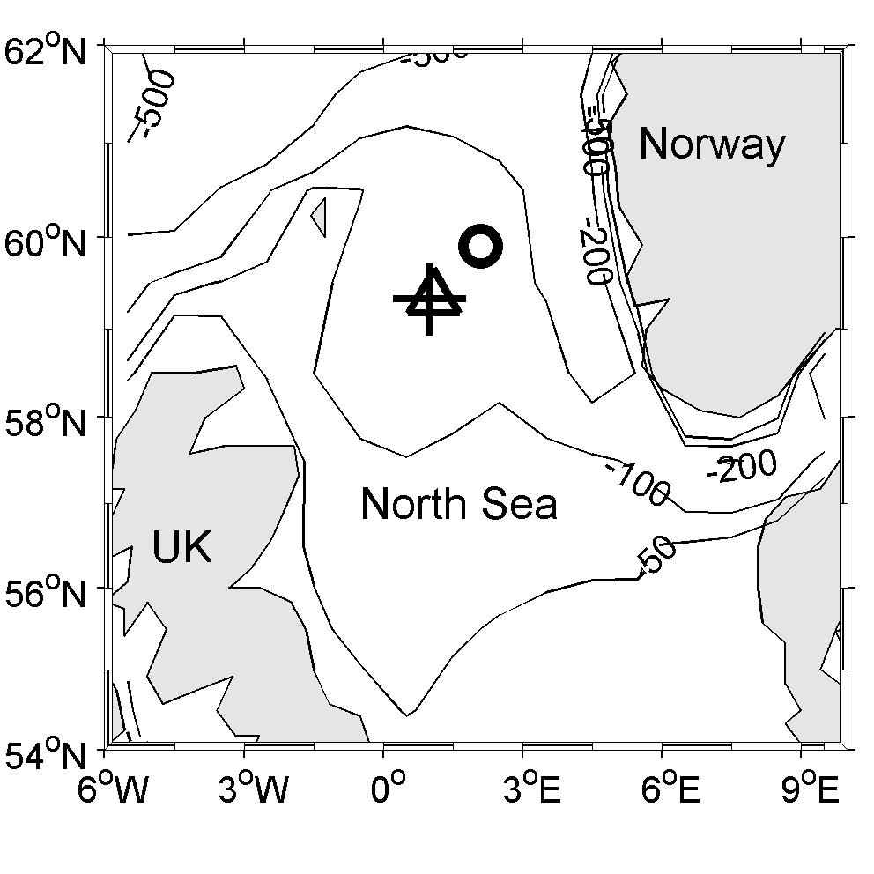

**Fig. 1** Map of the northern North Sea, with contoured bathymetry (meters) showing observation locations: ADCP mooring (cross), temperature chain mooring (triangle) and the Frigg oil platform from which wind measurements were taken (circle).

The wind speed and direction were obtained on the Frigg oil platform (59º54.0′ N, 2º6.0′ E, 90 km away from the ADCP mooring) with an interval of 20 minutes. A meteorological buoy was deployed at the ADCP site, but unfortunately the wind direction data are invalid. However, the comparison of wind speeds between the buoy and the platform shows good agreement.

Between year days 255-300, about 40 CTD profiles were taken within 2 km of the current mooring. These profiles are averaged by day number (Fig. 2). During this period the depth of the surface mixed layer deepens monotonically from 30 m to 50 m. At the same time the thermocline thickness decreases to just 10 m on day 298.

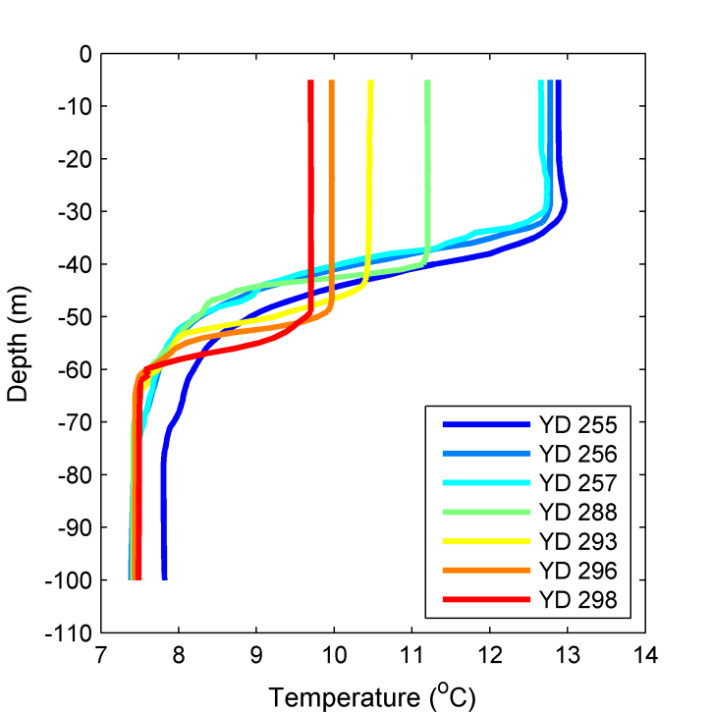

**Fig. 2** CTD temperature profiles recorded in close proximity to the ADCP mooring. The profiles are averaged into daily bins, denoted by colour, for each available year day (YD).

A temperature chain was also deployed at 59º20.0′ N, 1º2.0′ E, about 2 km away from the current mooring (Fig. 1). It recorded every 5 minutes with an interval of 5 m between depths of 37.3~ 87.3 m. The vertical gradient of temperature is computed and shown in Fig. 3a. This also indicates a similar deepening of thermocline with time.

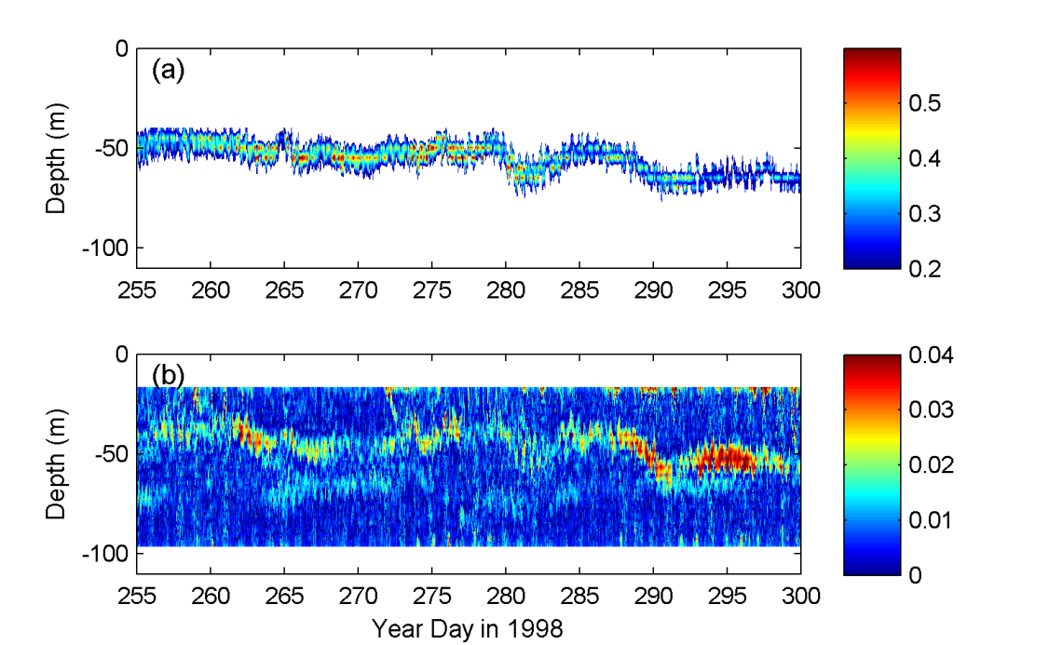

**Fig. 3** (a) The vertical temperature gradient (, ºC/m) observed by the temperature chain. Only values greater than 0.2 ºC/m are displayed. (b) The magnitude of vertical velocity shear (, 1/s) calculated from the mooring ADCP data.

**3. Definition of the thermocline bulk shear**

Figure 3b shows the vertical current shear directly computed from the ADCP data. High values of shear occur near the surface, across the thermocline and near the bottom. In close proximity above or below the thermocline the current is relatively uniform. Thus we define a bulk shear across the thermocline, i.e. the TBS, as the difference between mean currents above and below the thermocline being divided by the thermocline thickness. If we assume the thermocline has a thickness of 2*δ* with the center at the depth of *Zs*, and that the velocity **u** (in a complex form) exhibits no significant shear in a band of height *h* above and below the thermocline, then the TBS is defined as:

 (1)

The averaging band *h* is set as 20 m, in order to exclude the influence of bottom and surface shears. The centered depth of thermocline (*Zs*) can be adequately determined from ADCP data by locating the depth of maximum current shear near the thermocline region, since the position of high shear coincides well with that of thermocline (Fig. 3).

The CTD profiles, which have much higher vertical resolution than the temperature chain, are used to estimate the thermocline thickness 2*δ*. As seen from Fig. 2, 2*δ* is approximately 20 m on day 255, reduces to 10 m on day 288, and remains approximately 10 m afterwards. Thus the value of 2*δ* on the year day (*yd*) is fitted linearly as:

 (2)

**4. Analysis of the thermocline bulk shear (TBS)**

The TBS is calculated by Eqs. (1) and (2). The ADCP currents are interpolated vertically from a vertical interval of 4 m to 2 m when computing the bulk velocities above and below the thermocline. The magnitude of TBS is firstly analyzed in terms of its power spectrum (Fig. 4). There is a significant peak near the inertial frequency (1.72 cpd). A smaller peak also appears near the semidiurnal frequency (2 cpd).

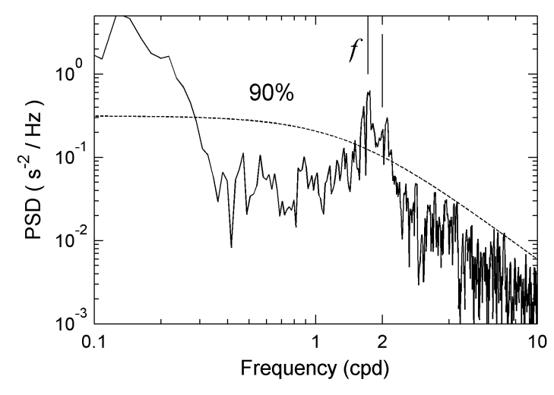

**Fig. 4** Power Spectral Density (PSD) of the thermocline bulk shear (TBS) magnitude. The dotted line denotes 90% confident level. The inertial frequency (1.72 cpd) is denoted by *f*. A solid bar also denotes the semi-diurnal frequency.

The current is filtered into three frequency bands and then used to compute the corresponding TBSs. The low-frequency band is (0, 0.7) cpd. The mid-frequency band is (0.7, 2.3) cpd, which includes diurnal, inertial and semidiurnal frequencies. The high-frequency band is (2.3, 30) cpd. The ADCP measurement resolves the semidiurnal and inertial frequencies well with a spectral resolution of 0.018 cpd. An FFT (Fast Fourier Transform) is applied and followed by an inverse FFT over the desired frequency band. The filtered results agree well with those obtained by a Lanczos filter. From Fig. 5a, it is evident that the mid-frequency TBS (red) dominates the tendency of the total TBS (black). The low-frequency TBS (green) has a significant contribution during a few portions of the record. The high frequency TBS (blue) contributes the least and thus will not be discussed further in this study.

E:\NorthSea\Manuscripts\Revised_3\fig5.tif

**Fig. 5** The magnitude of the thermocline bulk shear (TBS) decomposed into different frequency bands: (a) total (black); low-frequency band (<0.7 cpd, green); mid-frequency band (0.7-2.3 cpd, red); and high-frequency band (2.3-30 cpd, blue). (b) The TBS in the mid-frequency band is further decomposed into those at diurnal frequency (blue), near-inertial frequency (black) and semidiurnal frequency (green). (c) The complex superposition (red) and the magnitude sum (blue) of near-inertial and semidiurnal TBS.

As the mid-frequency TBS is the largest component, it is further decomposed. The currents are filtered for diurnal tidal currents, semidiurnal tidal currents and near-inertial currents, which are then used to compute the corresponding TBS (Fig. 5b). The near-inertial TBS dominates, especially after day 283 when it increases rapidly. Before day 283, the near-inertial TBS is only slightly greater than the semidiurnal TBS. The semidiurnal TBS is generally greater than the diurnal TBS, because the tides in this region are predominantly semidiurnal (Knight et al. 2002).

Since shear is a complex variable, the phase of its components may be important in their complex superposition. If the magnitudes of near-inertial TBS and semidiurnal TBS are added without considering their phases, then the value clearly exceeds the amplitude of their complex superposition at many time periods (Fig. 5c), such as on days 265, 270 280 and 291-295. It is interesting that the amplitudes are overlapped at most peaks with a period of ~5 days, which is approximately the beat frequency between the M2 and inertial frequencies. This implies that when the near-inertial and the semidiurnal TBS are aligned, the maximal TBS is attained and possibly leads to an occurrence of instability and a localized thermocline mixing event.

**4.1 Semidiurnal thermocline bulk shear**

The semidiurnal TBS is enhanced after day 286. This is mainly attributed to the decrease of thermocline thickness from 20 m to 10 m (see Eq. 1). The semidiurnal tidal current displays a clear spring-neap cycle (Fig. 6), which is, however, not apparent in the variability of the semidiurnal TBS. This indicates the contribution to TBS from topographically generated internal tides (which would exhibit a spring-neap modulation) is minor at this site. It is noted that the peaks of semidiurnal TBS on days 262, 270, 289 and 295 coincide with those of near-inertial TBS (Fig. 5b).

The vertical structure of semidiurnal currents is shown at four time periods associated with strong semidiurnal TBS (Fig. 7). On day 262 (row a of Fig. 7), the current below the thermocline is slightly greater than that above the thermocline. The semidiurnal TBS is primarily the result of the phase difference in the currents (~30 degree) across the thermocline. On day 270 (row b), the currents at different depths exhibit little variation in magnitude. Again the TBS is mainly induced by the phase difference (~40 degree) across the thermocline. On day 290 (row c), the phase difference is reduced. The magnitudes of current above the thermocline are clearly larger than those below the thermocline. Thus the semidiurnal TBS is mainly induced by the magnitude difference (~5 cm/s) during this day. On day 295, the phase difference is almost absent. But the current magnitudes below the thermocline are much greater (~5 cm/s) than those above the thermocline, leading to significant semidiurnal TBS. These four different vertical structure patterns all result in elevated semidiurnal TBS.

In shelf and coastal seas, the thickness of boundary layer generated by the bottom friction for the clockwise and anti-clockwise components of tides is different, leading to variation of tidal ellipses at different depths (Prandle 1982; Visser et al. 1994; Verspecht et al. 2010). In the shelf seas, the influence of bottom boundary layer could not cover the whole depth. The presence of stratification which reduces the viscosity across the thermocline could induce a slight phase shift (~30 degree) of tidal currents (Maas and van Haren 1987; Howarth 1998; van Haren 2000). This is probably the case in these data.

E:\NorthSea\Manuscripts\Revised_3\fig6.tif

**Fig. 6** The depth averaged magnitudes of semidiurnal tidal currents (blue) and the magnitude of the semidiurnal thermocline bulk shear (TBS, green).

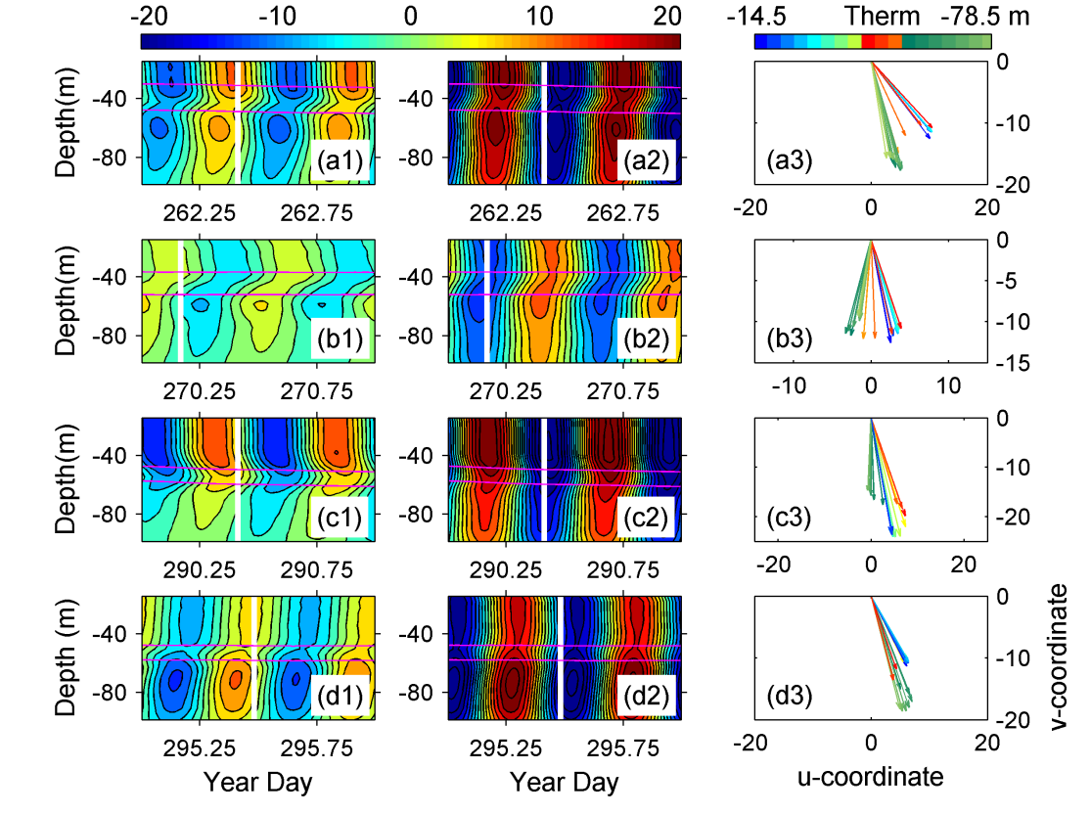

**Fig. 7** Four typical vertical structures of semidiurnal currents. The first and second columns are northward (*u*) and eastward (*v*) currents (cm/s), respectively, with a contour interval of 3 cm/s, in which pink lines represent boundaries of thermocline (>0.2 ºC/m). The third column shows velocity vectors (cm/s) at the time displayed by white lines in the first two columns. These velocities spanning a depth range of 14.5-78.5 m are plotted every 4 m in different colors, of which near-red colors denote the thermocline.

**4.2 Near-inertial thermocline bulk shear**

The near-inertial TBS also has a clear increase after day 286. The decreasing thermocline thickness (from 20 m to 10 m) can at most double the TBS, which is insufficient to account for the total increase. By contrast with the semidiurnal TBS, the near-inertial TBS varies synchronously with the intensity of near-inertial currents (Fig. 8). This is because the near-inertial current has a low mode vertical structure. It has been reported frequently that in shelf seas the near-inertial current in the mixed layer is in opposite phase with that below the mixed layer (e.g., Millot and Crépon 1981; Mirko 1987; Chen et al. 1996; MacKinnon and Gregg 2005), thus generating a strong vertical shear across the thermocline.

E:\NorthSea\Manuscripts\sm2OD\fig8_revised.tif

**Fig. 8** The depth average of near-inertial current magnitudes (blue) and the magnitude of the near-inertial thermocline bulk shear (TBS, green).

To investigate vertical structure of the near-inertial TBS in more detail, two typical periods are selected (Fig. 9). On day 290 (upper panels in Fig. 9), the near-inertial current is uniform in the upper layer. When it encounters the thermocline, the velocity turns clockwise with depth. The clockwise spiral continues below the thermocline, making the velocity below the thermocline exhibit a phase difference of slightly in excess of 180 degree relative to that in the upper layer. On day 295 (lower panels), the near-inertial current is also uniform in the upper layer. The clockwise rotation with depth mainly happens within the thermocline. Below the thermocline, the currents are almost 180 degree out of phase with those in the upper layer.

E:\NorthSea\Manuscripts\sm2OD\fig9_revised.tif

**Fig. 9** Two typical vertical structures of near-inertial currents. The first and second columns are northward (*u*) and eastward (*v*) currents (cm/s), respectively. The third column shows velocity vectors (cm/s) at the time displayed by white lines in the first two columns. All line settings are the same as those in Fig. 7.

As the variability of near-inertial TBS and near-inertial currents are highly correlated, a classical wind-driven model for near-inertial current can be slightly modified to predict near-inertial TBS and examine the relation with wind. The near-inertial current is mainly wind-driven and can be well predicted by a linear model (e.g., Pollard and Millard 1970; Kundu 1976; D’Asaro 1985; Knight et al. 2002),

 (3)

where the wind stress is assumed uniform in the mixed layer. *Hmix* is the thickness of mixed layer, **u** the velocity vector in the mixed layer, **τ** the wind stress. *f* denotes the inertial frequency and *ρ* is the seawater density. The damping constant *r* parameterizes dissipative processes and momentum flux out of the mixed layer as a linear friction term.

Assuming the near-inertial current has opposite values above and below the thermocline, the near-inertial TBS can be simply obtained as

 (4)

where 2*δ* is the thickness of thermocline, the same as in Eq. (2). Substituting Eq. (4) into Eq. (3) yields

 (5)

This model is applied to our data set to see how well it works. The wind speed is observed from the Frigg oil platform and then converted to wind stress following Large and Pond (1981). The damping constant *r* is set with a typical value of 2.510-6 1/s, which approximately corresponds to the value for linearized tidal friction and represents a decay time period of 4.6 days (Knight et al., 2002). The mixed layer thickness, *Hmix* *=Zs - δ*,is time dependent and estimated from the observations. The simulated **TBS**in is filtered to exclude the low-frequency component and plotted alongside the observed value (Fig. 10).

The model performs generally well, especially on days 280-300 when the wind intensity is much increased. The simulation is not good enough on days 260-275 when the wind is, however, weak and generates a weak near-inertial TBS response. As the model is wind-driven and based on the shear structure of near-inertial current, its generally good performance demonstrates that the near-inertial TBS is mainly formed by the wind-driven near-inertial current.

E:\NorthSea\Manuscripts\Submitted2AOS\fig10.tif

**Fig. 10** (a) The time series of wind stress. (b) Magnitudes of observed (black) and simulated (red) near-inertial TBS.

**4.3 Low-frequency thermocline bulk shear**

The low-frequency TBS is greatest on days 272-283 (Fig. 5a). The amplifying effect induced by a decreasing of the thermocline thickness after day 286 (as seen in the semidiurnal and near-inertial TBS) is not evident. On days 286-300 when the wind is most intense, most peaks of low-frequency TBS coincide with peaks of the wind-driven Ekman transport (Fig. 11). This relation does not hold on days 265-270 and 273-280 when the wind is relatively weak, and the low-frequency TBS is thus attributed to other forms of non-wind-driven low-frequency currents.

E:\NorthSea\Manuscripts\sm2OD\fig11_revised.tif

**Fig. 11** Magnitudes of the Ekman transport (blue) and the low-frequency TBS (red). The Ekman transport is low-pass (0~0.7 cpd) filtered current from the linear wind-driven model (Eq. 3).

Figure 12 shows four typical vertical profiles of low-frequency currents. At day 257.25 (panel a), the velocity vectors rotate clockwise with depth, and also decay gradually with depth. Below the thermocline velocities change little in either phase or magnitude. This pattern of vertical spiral also happens on days 259, 267 and 275 (not shown). At day 272.25 (panel c), the clockwise spiral with depth is apparent in the mixed layer, and extends across the thermocline. The velocities below the thermocline are in excess of 180 degrees out of phase with the surface velocities. This structure occurs slightly more often than the structure of day 257.25. At day 264.87 (panel b), little rotation with depth is evident. The velocities below the thermocline are much smaller than those in the upper layer. This structure is commonly observed before day 288 when the thermocline is relatively thicker. At day 297.75 (panel d), both the clockwise phase rotation and the magnitude decay are small with increasing depth within the upper and lower layers. However, the transition in phase and magnitude across the thermocline is stark, with the velocity below the thermocline being as much as half of that above. This structure is usually present after day 288 when the thermocline becomes quite thin (10 m).

E:\NorthSea\Manuscripts\Revised_3\fig_low_vertical.tif

**Fig. 12** Four typical profiles of low-frequency currents (cm/s). These velocities spanning a depth range of 14.5-78.5 m are plotted every 4 m in different colors, of which near-red colors denote the thermocline.

The clockwise spiraling with depth is due to the Ekman-like nature of the momentum balance between viscous stresses and acceleration. An idealized Ekman spiral would only appear in a steady state, when the wind stress is not varying, or is varying sufficiently slowly. Indeed in our observations irregular velocity spiral is more often observed than the regular clockwise spiral. This is likely to be due to the unsteady nature of the wind forcing.

**4.4 The relation with the Richardson number**

The inverse gradient Richardson number, Ri-1 (the square of the velocity shear being divided by the square of the Brunt–Väisälä frequency) can be estimated using CTD profile and ADCP current data if we assume the density profile keeps unchanged within one day (Fig. 13). In shelf seas, the thermocline is in a state of marginal stability (Ri≈1) (e.g., van Haren et al. 1999; MacKinnon and Gregg 2005; Rippeth et al. 2005; Burchard and Rippeth 2009), which means the shear instability could be induced by the addition of extra shear (Thorpe and Liu 2009). On day 288, the Ri-1 is mostly below the general critical value of instability, i.e. Ric-1=4. Near the time of 288.5 and 289.0, it exceeds 4, which coincides with TBS peaks and is probably indicative of an instability and mixing. On day 293, Ri-1 in the thermocline is generally larger than 4. On this day, the TBS is large as well, with most value greater than 0.02 s-1. Peaks of the TBS agree well with the presence of probable diapycnal mixing. A similar consistency between TBS and Ri-1 occurs on day 296 (not shown). At some days (298, 255, 256, not shown) when the TBS is small, and the inverse Richardson number rarely exceeds the critical threshold.

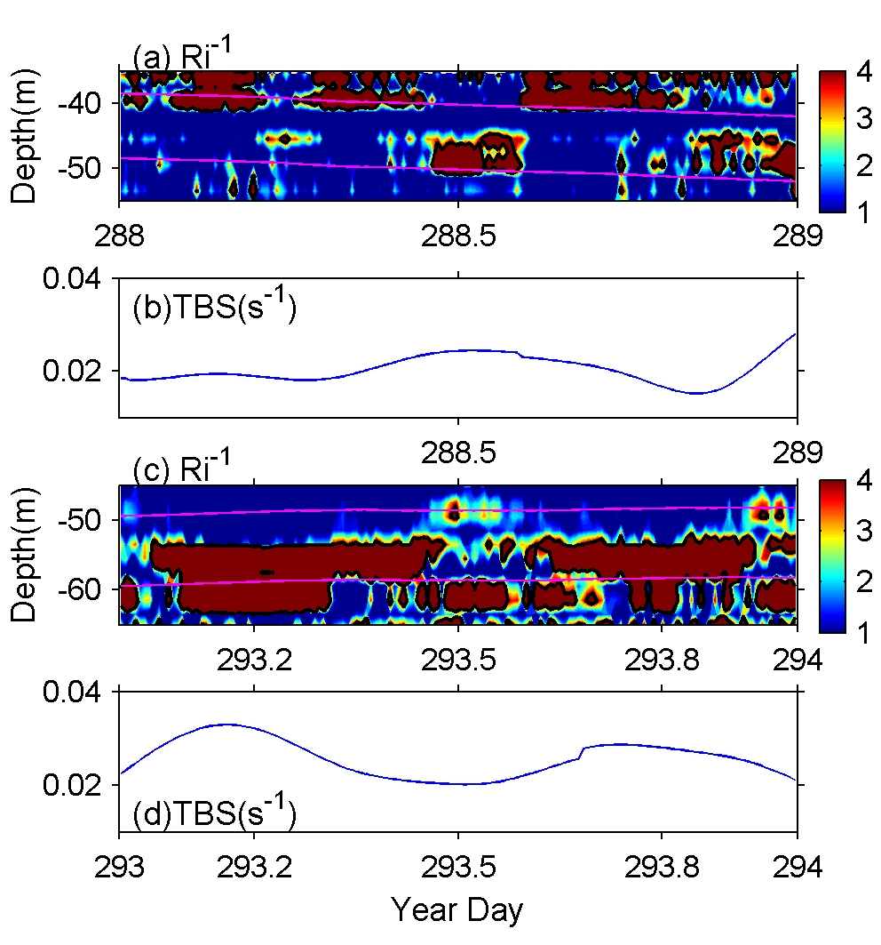

**Fig. 13** The inverse gradient Richardson number (a,c) and the thermocline bulk shear (TBS) (b,d) on two days. Pink lines represent estimated position of the thermocline; thick black contour lines denote the value of 4. The TBS is the value at a frequency band of (0, 2.3) cpd.

**5. Discussion on the definition**

The bulk shear (BS) is conventionally defined as the difference between mean flows in the upper and lower layers being divided by the distance (~50 m in our case) between centers of these two layers (Burchard and Rippeth 2009). By contrast, the TBS focuses on the currents in close proximity to the thermocline thereby excluding the influence of surface and bottom boundaries, where the shear contributes little to instability across the thermocline. Furthermore, the TBS is divided by thickness of the thermocline (~10-20 m in our case), therefore, the BS is much smaller than the TBS (around 1:5 on average), as seen in Fig.14. Compared with the maximum shear (MS) across thermocline (which is directly computed from the ADCP measurements, and is highly correlated with the shear instability across the thermocline), the TBS varies quite consistently with the MS, although the TBS is always smaller due to the averaging effect.

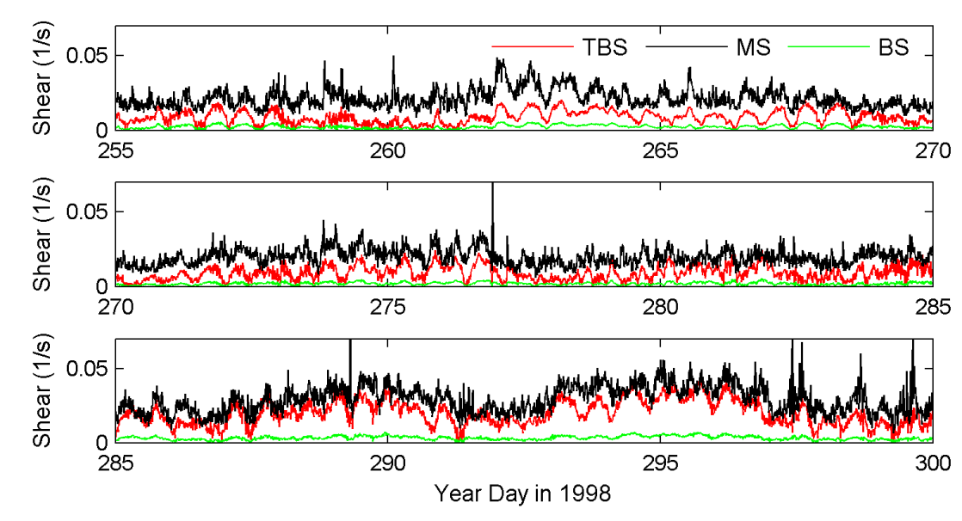

**Fig. 14** The comparison between the thermocline bulk shear (TBS, red), the maximum shear across the thermocline (MS, black) and the conventional bulk shear (BS, green). MS is the maximum value among the shears across the thermocline directly computed from the ADCP measurements.

**6. Conclusion**

In this paper, a modified definition of the thermocline bulk shear (TBS) is presented in order to better reflect the shear across the thermocline. Compared to the conventional bulk shear, this definition excludes the shear near surface and bottom boundaries. And it has a much more comparable value with the maximum shear (MS) across the thermocline than the conventional bulk shear (~0.2 of TBS as in Fig. 14). With limited CTD profiles, a simple algorithm is developed to compute the TBS, which could accommodate varying thermocline. Historic observations in the northern North Sea are used to calculate the TBS, which is then decomposed into components at several frequency bands.

The near-inertial TBS is the greatest component. Its dominance is significant during the period with relatively high winds. The near-inertial TBS varies consistently with the intensity of near-inertial current. The typical structures of near-inertial current during two periods are examined. They both show a large phase shift of ~180 degrees across the thermocline as previously reported (e.g., Millot and Crépon 1981; Mirko 1987; MacKinnon and Gregg 2005). It is this phase shift that results in a great value of near-inertial TBS. A linear wind-driven model is presented and simulates the variability of near-inertial TBS generally well, especially during the period of relatively strong wind.

The semidiurnal TBS makes a secondary contribution, whereas the diurnal TBS is much smaller. The semidiurnal TBS is only slightly smaller than the near-inertial TBS when the wind is relatively weak, during which the phase coherence between the semidiurnal and near-inertial TBS is not negligible. The variation of semidiurnal TBS shows little connection with the spring-neap cycle of semidiurnal tidal currents, suggesting a minor contribution to the TBS from the topography-generated internal tides. Four typical vertical structures of semidiurnal tidal currents are investigated. A strong semidiurnal TBS is formed by a relatively small phase shift (~30-40 degree) or by a modest magnitude difference (~5 cm/s) across the thermocline, which are probably due to the reduction of viscosity across the thermocline.

The low-frequency TBS (<0.7 cpd) occasionally makes a significant contribution. During the periods of high wind, it coincides well with the wind-driven Ekman transport. However, several peaks occurs at times with low wind. The clockwise Ekman spiral, with increasing depth, is often observed in the low-frequency current, which could induce a great low-frequency TBS. A significant magnitude difference of currents between upper and lower layers that is frequently observed also plays an important role in forming the low-frequency TBS.

The vertical shear structure of Ekman spirals is sensitive to the value of vertical viscosity, of which the reduction across the thermocline is also important in forming the shear of barotropic tides. If the parameterization of mixing is not correct, the error will lead to failure of simulating these shears. Then the derived parameters of mixing from these shears will be poor, thus resulting in a negative feedback.

**Acknowledgement**

We are appreciate the comments from two anonymous reviewers and are grateful for the help from the British Oceanographic Data Centre with regard to obtaining the historical PROVESS data. This study is supported by the National Basic Research Program of China projects 2014CB745002 and 2015CB954004, the Natural Science Foundation of China projects of 41276006, U1405233 and 40976013, the Environmental Protection Special Funds for Public Welfare project 201309006, and the Shenzhen Special Funds for Future Industry Development project 201411201645511650. Jeff Polton is funded under the NERC programme FASTNEt (NE/I030259/1). Shengli Chen is funded by the China Scholarship Council for his two-year visiting study in the National Oceanography Centre (Liverpool).

**References**

Brannigan L, Lenn Y-D, Rippeth TP, McDonagh E, Chereskin TK, and Sprintall J (2013) Shear at the base of the oceanic mixed layer generated by wind shear alignment. J Phys Oceanogr 43: 1798–1810

Burchard H, and Rippeth TP (2009) Generation of bulk shear spikes in shallow stratified tidal seas. J Phys Oceanogr 39: 969–985

Chen C, Reid RO, and Nowlin WD (1996) Near-inertial oscillations over the Texas–Louisiana shelf. J Geophys Res 101: 3509–3524

Craig PD (989) A model for diurnally forced vertical current structure near 30º latitude. Cont Shelf Res 9, 965–980

D’Asaro EA (1985) The energy flux from the wind to near-inertial motions in the surface layer. J Phys Oceanogr 15: 1043–1059

Gregg MC (1989) Scaling turbulent dissipation in the thermocline. J Geophys Res 94: 9686–9698

Holloway PE, Chatwin PG, and Craig P (2001) Internal tide observations from the Australian North West shelf in summer 1995. J Phys Oceanogr 31: 1182–1199

Howarth MJ (1998) The effect of stratification on tidal current profiles. Cont Shelf Res 18:1235-1254

Howarth MJ, Simpson JH, Sündermann J, and van Haren H (2002) Processes of Vertical Exchange in Shelf Seas (PROVESS). J Sea Res 47: 199-208

Janout MA and Lenn Y-D (2014) Semidiurnal tides on the Laptev Sea shelf with implications for shear and vertical mixing. J Phys Oceanogr 44: 202–219

Knight PJ, Howarth MJ, and Rippeth TP (2002) Inertial currents in the northern North Sea. J Sea Res 47: 269–284

Kundu PK (1976) An analysis of inertial oscillations observed near Oregon coast. J Phys Oceanogr 6: 879–893

Kunze E, Williams III AJ, and Briscoe MG (1990) Observations of shear and vertical stability from a neutrally buoyant float. J Geophys Res 95.C10: 18127–18142

Large WG and Pond S (1981) Open ocean momentum flux measurements in moderate to strong winds. J Phys Oceanogr 11: 324–336

Large WG, McWilliams JC, and Doney SC (1994) Oceanic vertical mixing: A review and a model with a nonlocal boundary layer parameterization. Reviews of Geophysics 32: 363–403

Lenn Y-D, Rippeth TP, Old CP, Bacon S, Polyakov I, Ivanov V, and Hoelemann J (2011) Intermittent intense turbulent mixing under ice in the Laptev Sea continental shelf. J Phys Oceanogr 41: 531–547

Maas LRM, and van Haren J (1987) Observations on the vertical structure of tidal and inertial currents in the central North Sea. J Mar Res 45: 293-318

MacKinnon JA and Gregg MC (2003) Mixing on the late-summer New England Shelf—solibores, shear and stratification. J Phys Oceanogr 33(7): 1476–1492

MacKinnon JA and Gregg MC (2005) Near-inertial waves on the New England shelf: the role of evolving stratification, turbulent dissipation, and bottom drag. J Phys Oceanogr 35: 2408–2424

Millot C, and Crépon M (1981) Inertial oscillations on the continental shelf of the Gulf of Lions-observations and theory. J Phys Oceanogr 11: 639–657

Mirko O (1987) Oscillations of the inertia period on the Adriatic Sea shelf. Cont Shelf Res 7: 577–598

Palmer MR, Polton JA, Inall ME, Rippeth TP, Green JAM, Sharples J, and Simpson JH (2013) Variable behavior in pycnocline mixing over shelf seas. Geophys Res Lett 40, doi: 10.1029/2012GL054638

Pollard RT, and Millard RC (1970) Comparison between observed and simulated wind-generated inertial oscillations. Deep Sea Res 17: 813–821

Prandle D (1982) The vertical structure of tidal currents and other oscillatory flows. Cont Shelf Res 1: 191-207

Price JF (1981) Upper ocean response to a hurricane. J Phys Oceanogr 11: 153-175

Rippeth TP, and Inall ME (2002) Observations of the internal tide and associated mixing across the Malin Shelf. J Geophys Res 107(C4): 3028, doi:10.1029/2000JC000761

Rippeth TP, Palmer MR, Simpson JH, Fisher NR, and Sharples J (2005) Thermocline mixing in summer stratified continental shelf seas. Geophys Res Lett 32: L05602, doi:10.1029/2004GL022104

Rippeth TP, Wiles P, Palmer MR, Sharples J, and Tweddle J (2009) The diapycnal nutrient flux and shear-induced diapycnal mixing in the seasonally stratified western Irish Sea. Cont Shelf Res 29: 1580–1587

Shearman R K (2005) Observations of near-inertial current variability on the New England shelf. J Geophys Res 110: C02012, doi:10.1029/2004JC002341

Thorpe SA, and Z Liu (2009) Marginal Instability?. J Phys Oceanogr 39: 2373-2381

van Haren (2000) Properties of vertical current shear across stratification in the North Sea. J Marine Res 58: 465-491

van Haren H, Mass L, Zimmerman JEF, Ridderinkhof H, and Malschaert H (1999) Strong inertial currents and marginal internal wave stability in the central North Sea. Geophys Res Lett 26: 2993–2996

Verspecht F, Simpson JH, and Rippeth TP (2010) Semi-diurnal tidal ellipse variability in a region of freshwater influence. Geophys Res Lett 37: L18602, doi:10.1029/2010GL044470

Visser AW, Souza AJ, Hessner K, and Simpson JH (1994) The effect of stratification on tidal current profiles in a region of freshwater influence. Oceanol Acta 17: 369-381