The 10th Antarctic Meteorological Observation, Modeling, and Forecasting Workshop

Steve R. Colwell¹, Arthur M. Cayette^{2,} , Matthew A. Lazzara³, Jordan G. Powers⁴,
David H. Bromwich⁵, John J. Cassano⁶, and Scott Carpentier⁷

¹British Antarctic Survey, Cambridge, United Kingdom

²Space and Naval Warfare System Center (SPAWAR) Office of Polar Programs (SOPP), North Charleston SC, USA

³ Antarctic Meteorological Research Center, Space Science and Engineering Center

University of Wisconsin-Madison, and Department of Physical Sciences, School of Arts and Sciences, Madison Area Technical College, Madison WI, USA
⁴National Center for Atmospheric Research, Boulder CO, USA

⁵Polar Meteorology Group, Byrd Polar & Climate Research Center, The Ohio State University, Columbus OH, USA

⁶ Cooperative Institute for Research in Environmental Sciences and Department of Atmospheric and Oceanic Sciences, University of Colorado – Boulder, Boulder CO, USA

⁷Bureau of Meteorology, Hobart, Tasmania, Australia

Submitted to: Advances in Atmospheric Sciences

Overview
The 10th Antarctic Meteorological Observation, Modeling, and Forecasting Workshop (hereinafter AMOMFW) took place June 17-19, 2015 in the historic city of Cambridge, United Kingdom. The meeting followed its purpose of connecting Antarctic atmospheric science to weather-related operational issues and advances in observing, modeling, forecasting, and understanding the Antarctic environment. The workshop offers a cooperative spirit which aims in part to assist the National Science Foundation (NSF) Division of Polar Programs (PLR) and the United States Antarctic Program (USAP) in its supporting of Antarctic research and operations, but also it brings together and serves the international Antarctic community. Attendees included a variety of research scientists, undergraduate/graduate students, and professionals from 10 different countries. The workshop was hosted by the British Antarctic Survey (BAS) and the Scientific Committee on Antarctic Research (SCAR) and held at the Scott Polar Research Institute (SPRI).

Oral presentations, a poster session, and brainstorming sessions covered a range of topics and facilitated diverse input reflecting varied perspectives on the Antarctic-based scientific and logistical issues. Topics were as diverse as the workshop's title, ranging from dynamic meteorology to new tools for weather forecasting. One session addressed the possible contributions that the groups and interests represented by the Antarctic community at the workshop could make to the upcoming World Meteorological Organization’s (WMO) Year of Polar Prediction (YOPP), 2017-2019. A subgroup has been established to coordinate YOPP research in the Southern Ocean and Antarctica (http://polarmet.osu.edu/YOPP-SH/).

Antarctic Observational Studies
Reviewing the status and developments in Antarctic observing systems, particularly of surface weather station networks, is a cornerstone of the AMOMF Workshop. The efforts to maintain Automatic Weather Station (AWS) networks during the 2014-2015 field season were presented by BAS (for the Antarctic Peninsula region) and, in two presentations, by the University of Wisconsin. The first of these looked at the 2014-2015 season, while the second considered future plans for the following seasons. Similarly, a presentation was given by the University of Utrecht (UU) on its AWS network in Antarctica. The unique power package and AWS design of the iWS designed by UU sparked the attention of other attendees. Additional details about UU Antarctic AWSs can be found at http://www.projects.science.uu.nl/iceclimate/aws/.

Several presentations were given on the Antarctic boundary layer and surface meteorology and using in-situ measurements. Various sensors were identified throughout the workshop, which provided a range of good, poor, and mixed results. BAS presented a review of precipitation measurements being made at its Rothera Station. Relationships of atmospheric measurements and model output were analyzed, identifying areas of where model improvements and better observations from this vast region were needed.

Antarctic Numerical Modeling
Numerical modeling over Antarctica, for both real-time weather forecasting and research, is a regular topic at the AMOMFW. The Antarctic Mesoscale Prediction System (AMPS; Powers et al. 2012; http://www2.mmm.ucar.edu/rt/amps) is a widely-used real-time numerical weather prediction capability for Antarctica and motivated a number of talks. The annual update to the community on the AMPS was provided. Developments such as improved forecast displays, an updated depiction of Ross Ice Shelf in the numerical model, and AMPS ensemble forecasts were briefed. The testing of and assimilation of Atmospheric Infrared Sounder (AIRS) Version 6 data for the Weather Research and Forecasting (WRF) Model used in AMPS was reported. Improving the cloud base and PBL forecasts for Antarctica have been priorities, and talks covered Polar WRF boundary layer forecasts (which compared well with automatic weather station observations at the Alexander Tall Tower site on the Ross Ice Shelf), validation of near-surface variables over West Antarctica, and a self-organizing map assessment of AMPS surface layer forecasts. The performance of the UK Met Office's Unified Model over the Antarctic Peninsula was also analyzed. Numerical model output is used extensively for Antarctic meteorological research and an update was provided on the database maintained by the Byrd Polar & Climate Research Center of The Ohio State University, which holds the most popular model fields from AMPS and offers the community easy access to the forecast output (http://polarmet.osu.edu/AMPS/).

Antarctic Forecasting
Presentations addressed the infrastructure, or the lack of it, associated with Antarctic weather forecasting and how to promote best practices and sustainable operations. This is a common area of concern for all agencies in an expanding scientific and operational setting that has limited facilities. With a popular movement to shift much of the forecasting operations out of Antarctica, the lack of infrastructure provides notable restrictions.

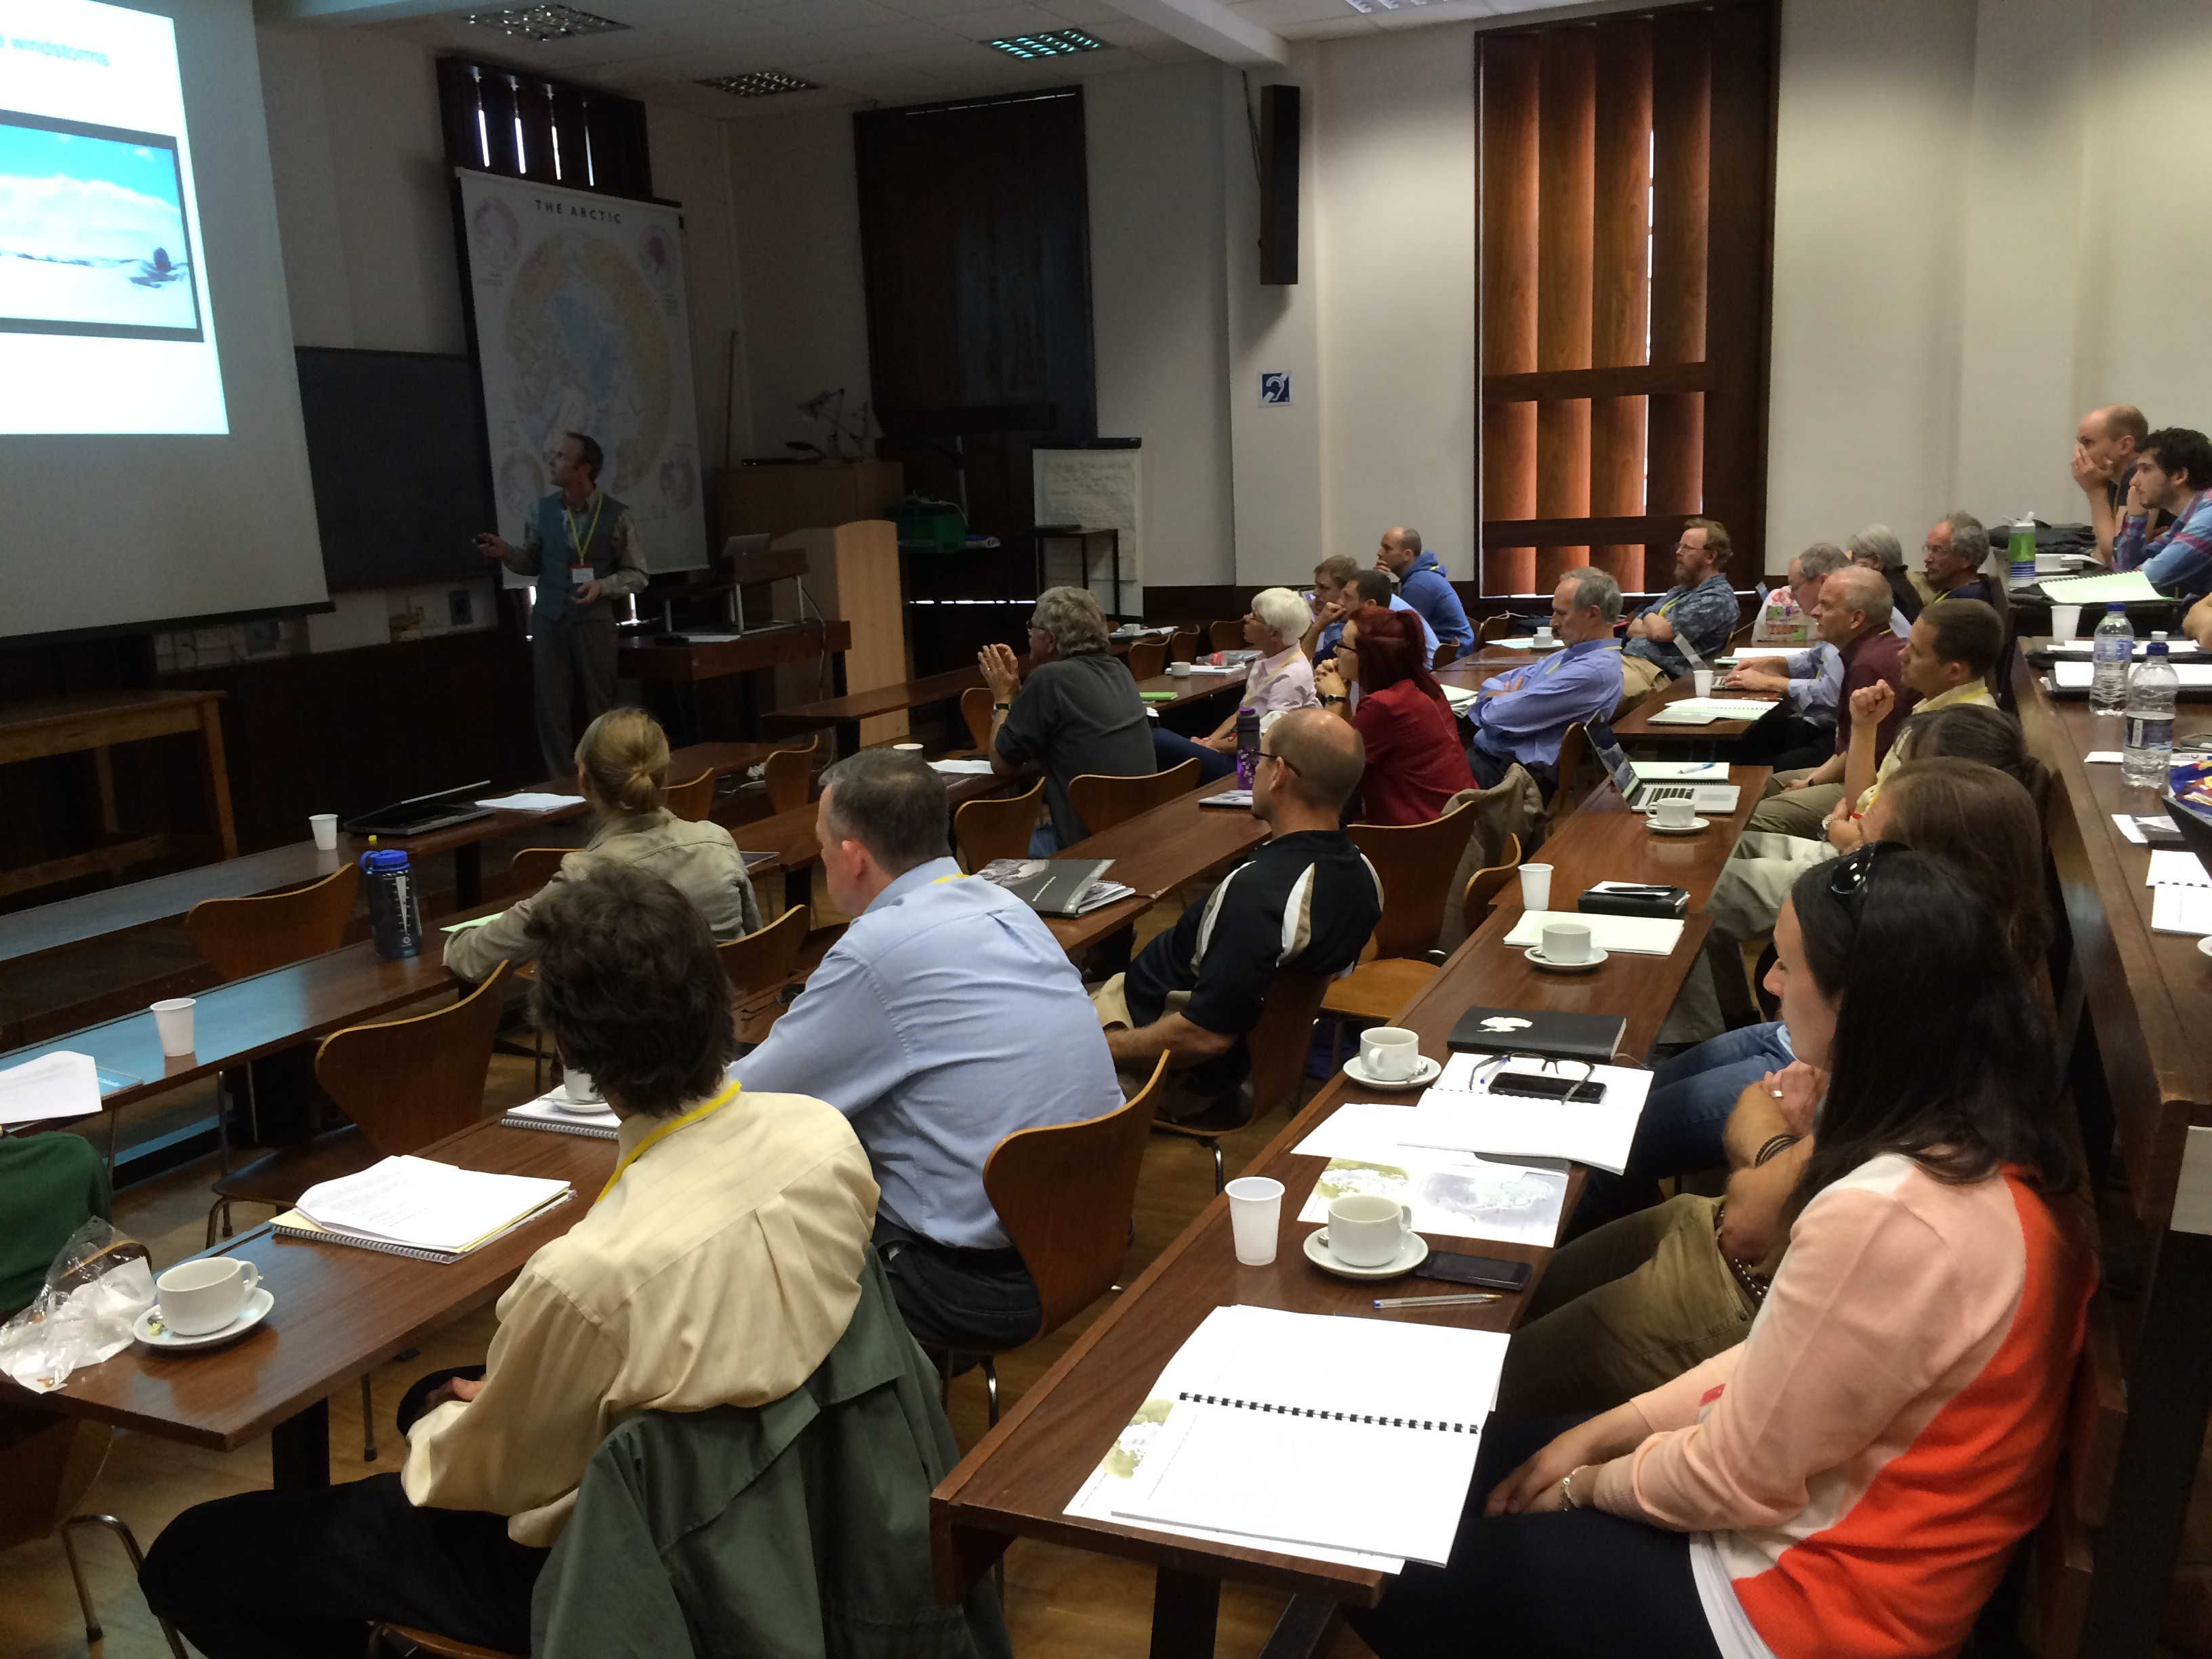
Figure 1. A presentation being given during the Antarctic Meteorological Observation, Modeling and Forecasting Workshop (AMOMFW) at the Scott Polar Research Institute (SRI) June 17-19, 2015.

An examination of operational flight safety was presented through an analysis of a notable emergency ("whiteout") landing from the previous field season in bad weather at Williams Field, near McMurdo Station on Ross Island. Forecasting for locations on the Ice without landing alternatives is challenging, given limited options and the need for long advance warnings of severe conditions. This is an example of the type of issue covered in the AMOMFW that brings together those involved in forecasting, observing, modeling, and logistics. It is a primary motivation for the workshop and the discussions foster broader understanding of Antarctic meteorological issues and improved abilities to deal with them.

In an effort to reduce reliance on forecasting proficiency, the Italian Antarctic Program reported on its project to construct a gravel runway near Mario Zucchelli Station in Terra Nova Bay. When completed, the facility will provide another landing option in the region to support the increased operational tempo seen there.

There were discussions on applying Antarctic meteorological research to practical weather forecasting and how research leads to critical tools used by forecasters. As part of these, the need for science-to-operations cooperation for Antarctic weather forecasting was noted. One highlighted example was the relationship between the activities of Antarctic Meteorological Research Center (AMRC) and of the USAP forecasters. Likewise, the development of decision aids based on radiosonde observations for critical Antarctic weather forecasting situations for the USAP in the McMurdo Station region were discussed, as was an overview of meteorological support for the Australian Antarctic Program.

Poster Session
The AMOMFW regularly includes a poster session, and the presentations provide a good forum for extended discussions on research and operational topics. For example, this year the posters addressed automatic weather station efforts, modeling of atmospheric rivers in East Antarctica, and the linkage of West Antarctic warming and change in stratospheric ozone. Posters are always welcome at the AMOMFW, and offer a means for those already giving oral presentations to show additional work.

Recommendations
While the AMOMFW is not convened to issue recommendations to any specific body or group, the community participants typically arrive at consensus ideas on certain issues. Regarding support of YOPP, the workshop participants felt that a goal for all YOPP nations and programs should be an archive of high-resolution meteorological data for the period. This could serve as a reference dataset for all manner of subsequent research and development. Regarding AWSs, it was felt that improved information on Antarctic observing practices and enhanced metadata for instrumentation used at manned stations and on AWS sites is needed. Another suggestion regarding AWSs was the idea that additional units should be deployed on selected Antarctic islands, such as Scott Island and Peter I Island. Lastly, the advantage for WMO numbers to be allocated for all year-round operational AWSs was noted.

Conclusion
The 10th AMOMFW ended with an open community discussion on various groups' plans for the upcoming 2015-2016 Antarctic field season. The dialogue revealed areas where efforts can be coordinated and mutually supportive, and there was strong interest in opening channels of cooperative data- and idea-sharing. The participants continue to be motivated by the workshop goal of communication on developments, results, and issues in Antarctic meteorology to benefit operational needs and efforts and to improve the observation, modeling, and understanding of Antarctic weather and climate.

All presentations from the workshop can be viewed at AMOMFW site, http://amrc.ssec.wisc.edu/meetings/meeting2015/program.shtml. Materials from prior AMOMFW can also be found on the AMRC meeting web site, http://amrc.ssec.wisc.edu/meetings.html. The 2016 AMOMFW is scheduled for June 6–8 in Columbus, Ohio and will be hosted by the Byrd Polar & Climate Research Center, at The Ohio State University (http://polarmet.osu.edu/AMOMFW_2016/). Immediately preceding AMOMFW will be a workshop on coupled modelling in the polar-regions (based on Polar WRF and COAWST), and immediately after will be a one-day workshop on the stable boundary layer.

Acknowledgements
The University of Wisconsin-Madison Automatic Weather Station Program is supported by the Division of Polar Programs, Geoscience Directorate, National Science Foundation grant number ANT-1245663. AMPS is supported by Division of Polar Programs, Geoscience Directorate, National Science Foundation. The authors thank the British Antarctic Survey for its hosting of the workshop and SCAR for its support of new attendees.

