Supporting information on

Autonomous Reagent-Based microfluidic pH Sensor Platform
Isabel M. Perez de Vargas Sansalvador ^{a,1}, Cormac D. Fay ^{a,1}, John Cleary¹, Adrian Nightingale², Matthew Mowlem², and Dermot Diamond^{*,1}
¹NCSR: National Centre for Sensor Research, Dublin City University, Dublin, Ireland.
¹Insight: Centre for Data Analytics, Dublin City University, Dublin, Ireland
²NOC: National Oceanography Centre, University of Southampton, Southampton , United Kingdom.
ªBoth authors contributed equally to this work

Selection and optimisation of pH reagent

Mixture #1 – Thionin Acetate and Neutral Red
The solution was prepared as follows: 0.014 g of each dye was dissolved in 10mL of water. 0.1 mL of each dye was mixed together and water was added up to 10 mL.
The calibration curve was obtained as explained in section 2.3 of the paper. There was found a pH dependant response at 525 nm obtaining a sigmoidal response if absorbance is plotted versus pH. In this case, pH dependent response was found at only one wavelength, and the range of response was linear in the range 6-8. The spectra is shown in Figure 1.

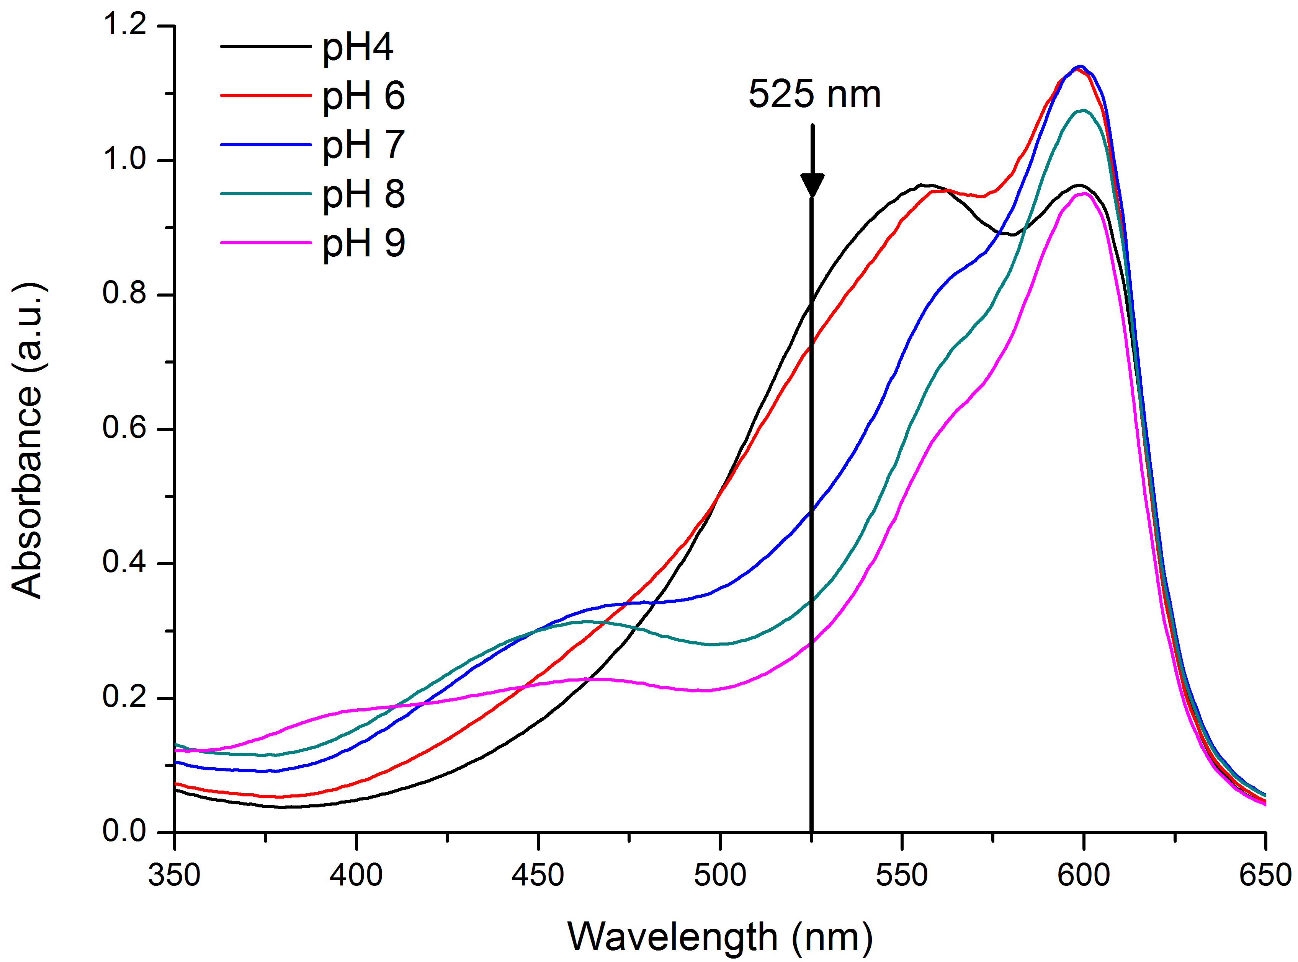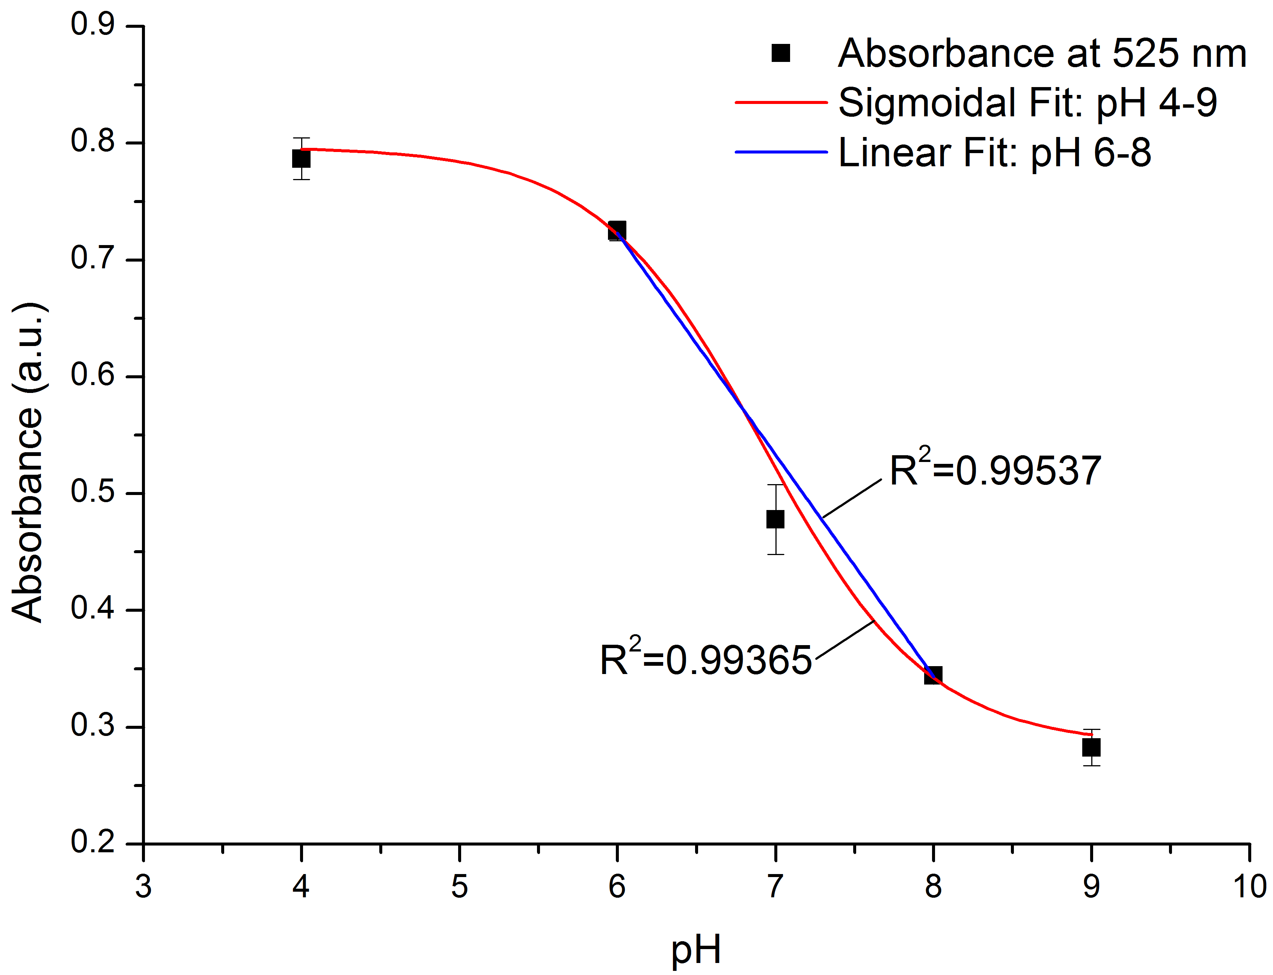
Figure 1. (Left) Absorbance spectra of pH mixture #1 (thionin acetate and neutral red), with pH concentrations ranging from 4 to 9. Black vertical line represents the wavelength of maximum sensitivity, i.e. 525 nm. (Right) Calibration plot of absorbance at 525 nm. Points represent the average of multiple measurements with error bars as the standard deviation (n=3). Red line is a sigmoidal fit to the data (pH4-9, R²=0.99365), and the blue line represents the linear range via a fit (pH6-8, R²=0.99537).

Mixture #2 – Phenol Red and Bromocresol Green
This mixture was prepared by dissolving the dyes in water (0.014 g in 10mL). Different concentrations have been used for these two dyes to achieve an extended pH range. Table 1 shows the ratios investigated

Table 1. Ratios of dyes studied
Solution | PR content /  BCG content
1 | 50/1
2 | 2/1
3 | 20/1
4 | 30/1
5 | 10/1
6 | 5/1

The solution showing the best results in terms of pH sensitivity was solution 6. The spectrophotometric studies showed the best response at 435 and 565 nm. The peak at 565 nm exhibits an increase in absorbance as pH increases, in the case of the peak at 435 nm, the opposite behaviour is observed. Both peaks can be used to detect pH.. Figure 11 shows the spectra obtained at different pH values.

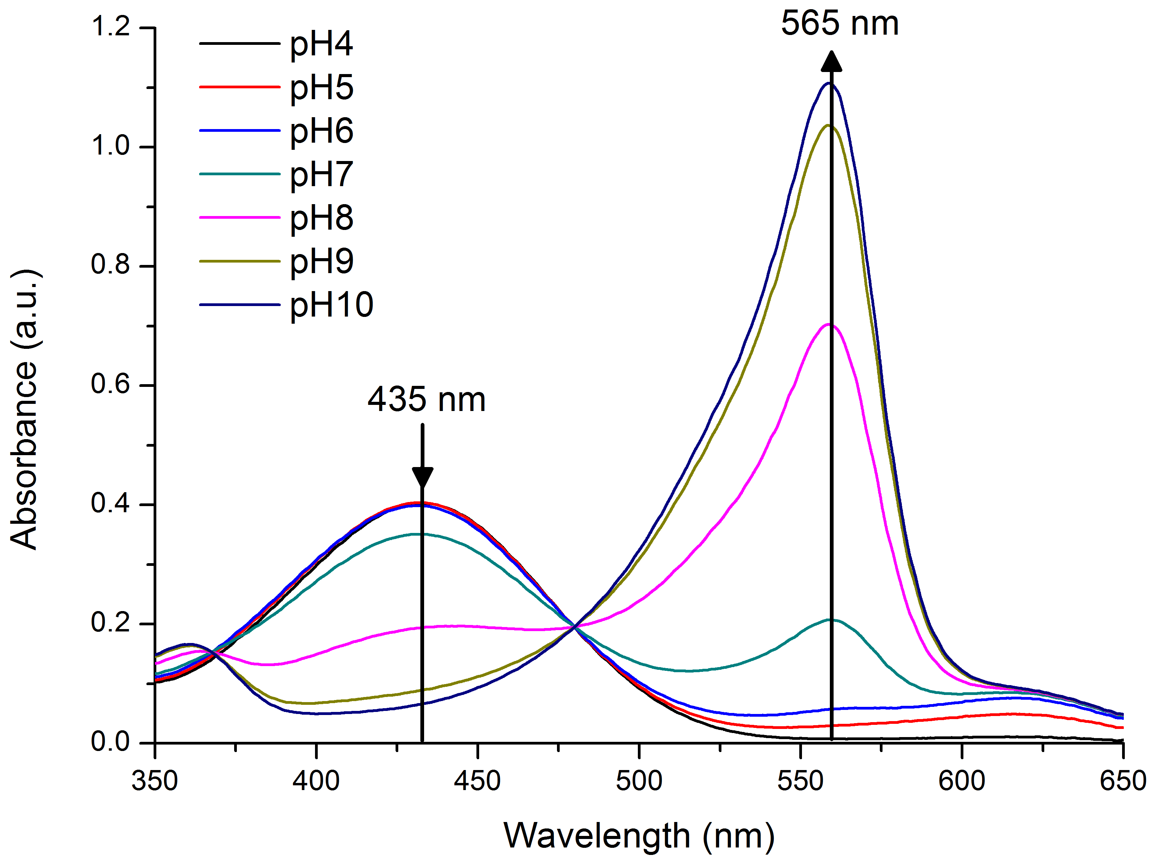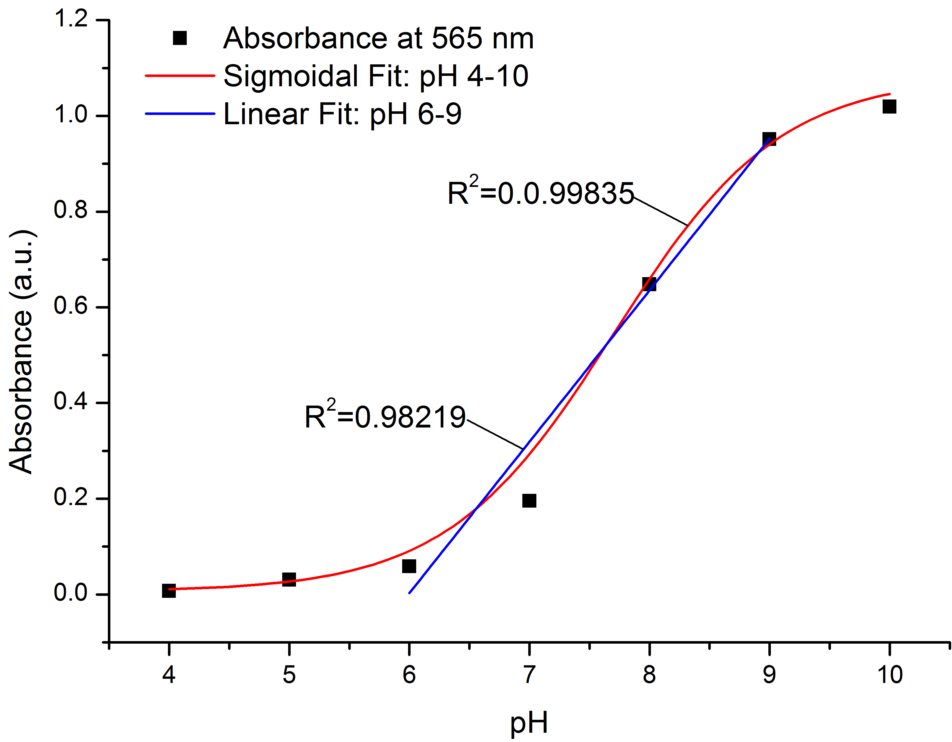
Figure 2. (Left) Absorbance spectra of pH mixture #2 (PR/BCG) within the range of pH 4-10. Black vertical lines represent two sensitive peaks at 435 nm and 656 nm. (Right) Points represent the average absorbance at 565 nm with error bars as the standard deviation (n=3); red line is a sigmoid fit to the data (pH4-10, R²=0.99835); blue line represents a linear fit (pH6-9, R²=0.98219).

Mixture #3 – Phenol red, Chlorophenol Red and Bromocresol Blue

The mole fraction used for this mixture was 0.46% PR, 0.25% CPR, and 0.29% BCB. The spectra obtained at different pH concentrations are shown in Figure 3.

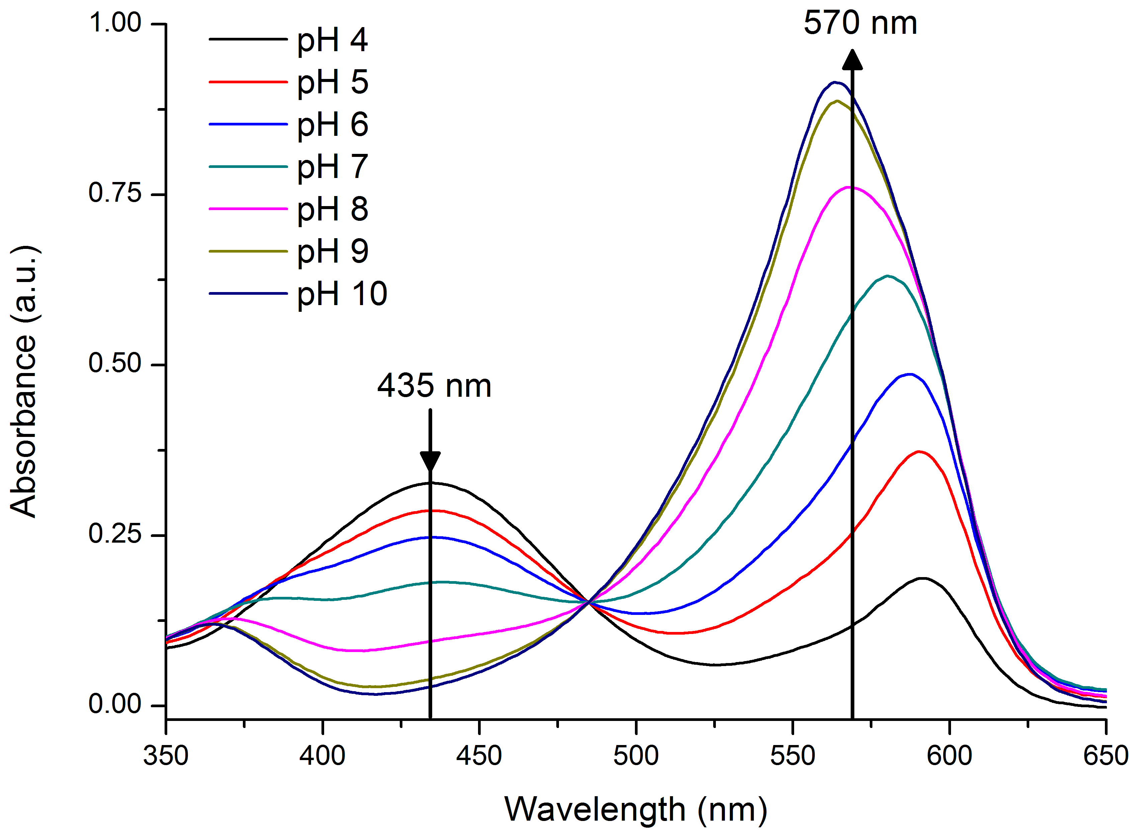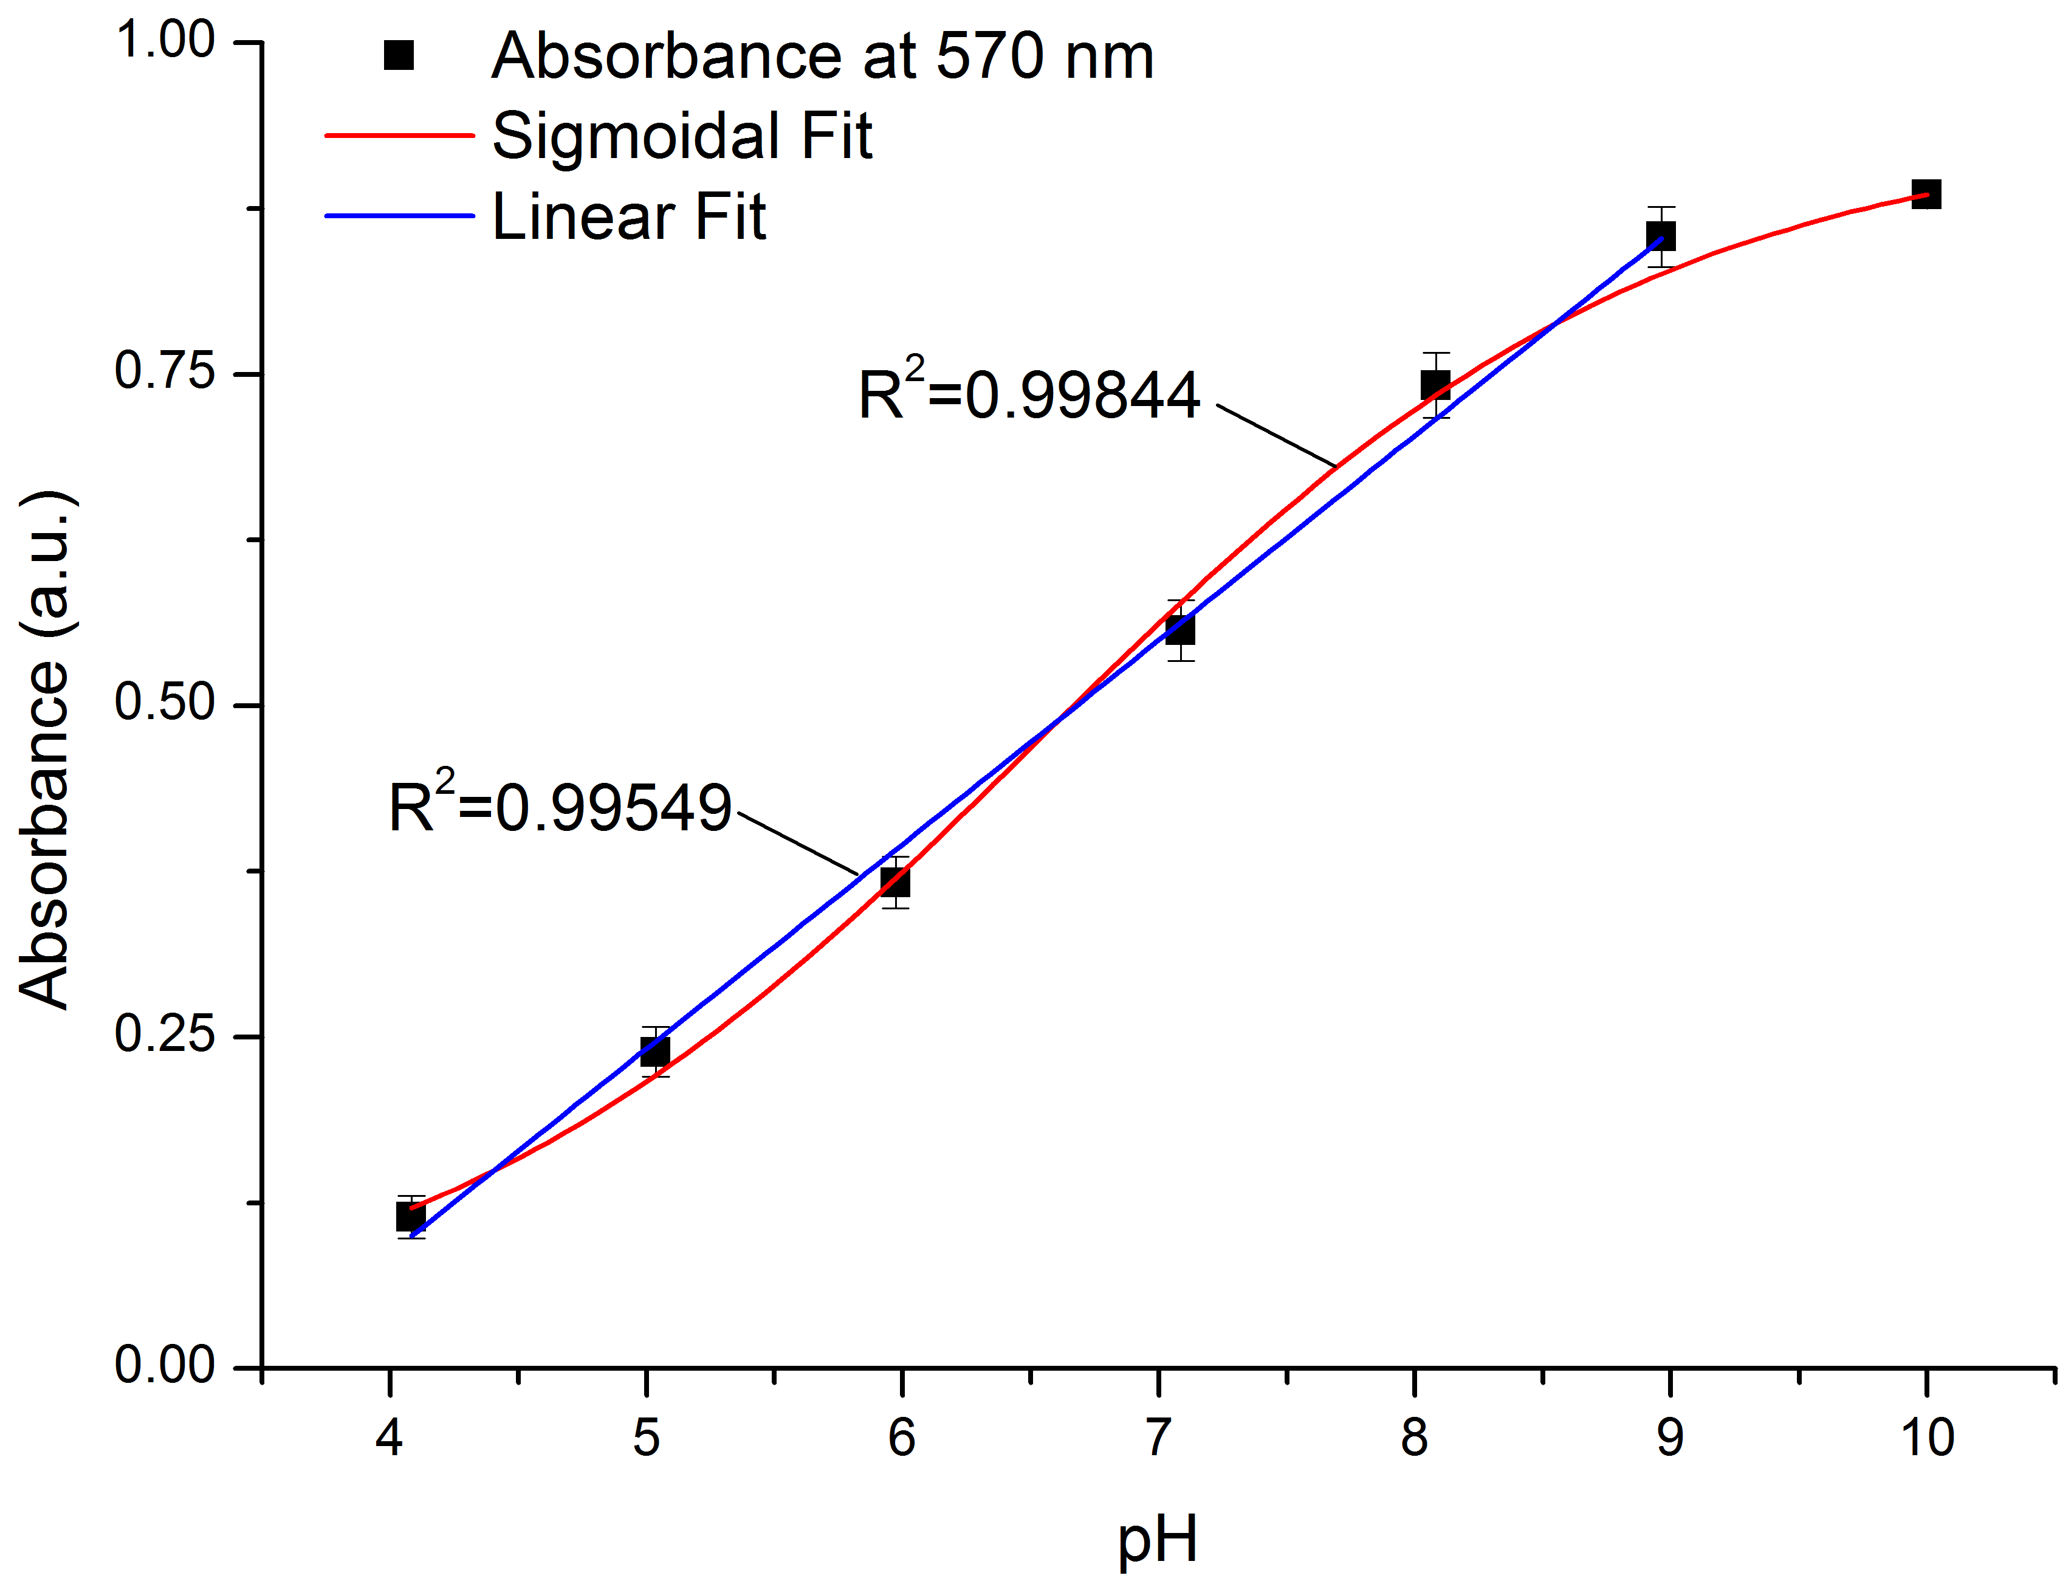
Figure 3. (Left) Absorbance spectra of pH mixture #3 (PR/CPR/BCB). Vertical lines represent two sensitive wavelengths, 435 and 570 nm. (Right) Absorbance at 570 nm as a function of pH. Points are the average across multiple measurements, error bars the standard deviation (n=3). Red line represents a sigmoidal fit (pH4-10, R²=0.99844), blue line shows linear fit at the linear range (pH4-9, R²=0.99549).

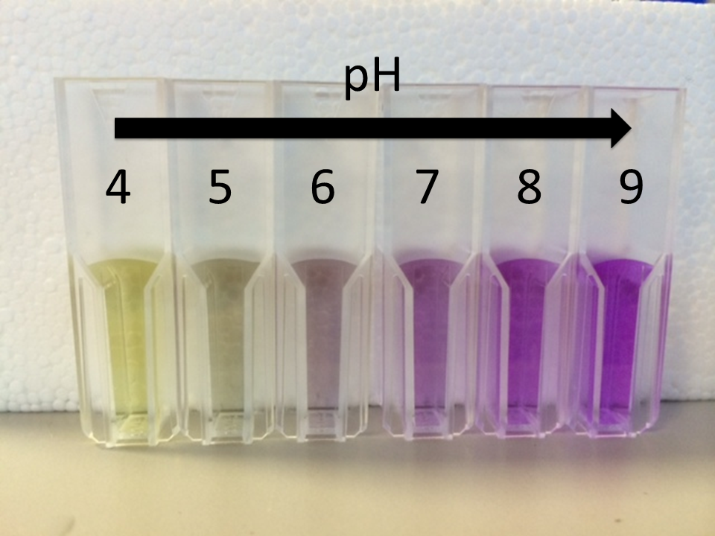
Figure 4 Captured image of prepared pH solutions (dye:buffer – 1:1) at pH 4, 5, 6, 7, 8 and 9 (from left to right) using dye mixture #3.

Two maximum peaks of absorbance are observed as in mixture #2, with the same behaviour but a wider linear response is observed, from 4 to 9 units of pH.

Once the response of the three combination of dyes was checked using bench-top instrumentation, Mixture #3 was selected as the optimum combination for pH sensing as presented a linear relationship Absorbance-pH for the whole pH range studied (4-9).

