Autonomous Reagent-Based microfluidic pH Sensor Platform

Isabel M. Perez de Vargas Sansalvador ^{a,1}, Cormac D. Fay ^{a,1}, John Cleary¹, Adrian Nightingale², Matthew Mowlem² and Dermot Diamond^{*,1}

¹Insight: Centre for Data Analytics, National Centre for Sensor Research, Dublin City University, Dublin 9, Ireland
²NOC: National Oceanography Centre, University of Southampton, Southampton, United Kingdom.
ªBoth authors contributed equally to this work
*Corresponding author: dermot.diamond@dcu.ie

Abstract

A portable sensor has been developed for in situ measurement of pH in aqueous samples.
The sensor design incorporates microfluidic technology, allowing for the use of low volume of samples and reagents, and an integrated low cost detection system that uses a light emitting diode as light source and a photodiode as a detector. Different combination of dyes has been studied in order to allow a broader pH detection range, than can be obtained using a single dye. The optimum pH range for this particular dye combination was found to be 4 to 9.
The reagents developed for pH measurement were first tested using bench-top instrumentation and once optimised, the selected formulation was then implemented in the microfluidic system.
The prototype system has been characterised in terms of pH response, linear range, reproducibility and stability. Results obtained using the prototype system are in good agreement with those obtained using glass electrode/pH meter and spectrophotometer based assays.
The reagent is shown to be stable for over 8 months, which is important for long term deployments. A high reproducibility is reported with a global RSD of ≤1.8% across measurmements of 90 samples, i.e. with respect to concentrations reported by a calibrated pH meter.
A series of real water samples from different sources were also analysed using the portable sensor system developed showing its feasibility for real applications.

Keywords. Microfluidic system, pH sensor, water analysis, autonomous monitoring

Introduction
As human activity continues to have a negative impact on the environment, governing authorities have established bodies of legislation specifying limits on the release of key chemical and biological pollutants into our waterways (portable, drinking, ground, etc.) [1, 2] Enforcing such policies requires continuous monitoring by means of analytical measurements. However, this almost always takes place through manual collection of samples, transportation to centralised facilities, and analysis by trained personnel using sophisticated instrumentation. Due to the cost involved, this model is inherently not scalable [3] As a result, only high priority areas of the environment can be effectively monitored, leaving a vast number of areas prone to unquantifiable pollutant effects. In recent years, experts have recognised that the ability to harvest information related to the bio/chemical state of the environment “more extensively and frequently than is now possible” to the extent that this has been identified as a ‘Grand Challenge’ facing modern society [4]. The need for technology to fulfil this requirement has never before been in such demand. This is reflected in the establishment of national competitions for affordable chemical sensing technology such as the Ocean Health X-Prize ($2,000,000 USD) for ocean pH sensing, and the recently launched Nutrient Sensor Challenge (http://www.nutrientchallenge.org/).
A key parameter of central importance for aquatic life is pH. One significant contributor to pH imbalances in water systems is the generation of carbonic acid through the absorbance of excess atmospheric CO₂ (from the burning of fossil fuels), which lowers the surrounding pH and adversely impacts aquatic ecosystems. Aquatic life exists in a delicate pH balance with respect to its surrounding environment, i.e. from ca. pH 6.5 – pH 8.0 [5]. Outside of this range the quality of water-based life typically diminishes, because of the physiological systems of most organisms are affected. For instance, at lower pH, heavy metals (e.g. Cd, Pb, Cu, etc.) become more soluble, thereby increasing toxicity levels for surrounding life [6]. Furthermore, this toxicity is not localised to water-based life, as connecting ecosystems can be affected [2]. As a result, awareness of the importance of pH monitoring has increased and a number of application areas have been identified such as marine [7], natural waters [8] and fish tanks [9], ,
The challenge is to transform the current monitoring practice into a much more scalable approach. Some studies have appeared investigating alternatives, e.g. by using portable devices [10-14] or the use of smart phones as detectors [15-17] i.e. to avoid sample transportation and laboratory costs. Further trends towards a fully autonomous model have been explored through the use of microfluidic devices in combination with a low-power detection system. Microfluidics enables sample measurements to be performed with minute amounts of reagent, allowing for an increase in the operational lifetime of the device per unit volume of reagent [18-20]. Moreover, the integration of light emitting diodes (LEDs) and photodiodes as light sources and detectors, respectively, coupled with syringe pumps, facilitates the development of low-cost, portable, autonomous devices [21-23].
Microfluidic (MF) devices for colorimetric pH measurements are still relatively under developed and just a few examples are found in literature. Florea et al. [24] developed a MF device for pH based on polyaniline with a detectable range from pH 2-12. The capability of a digital colour camera as detector was also simultaneously investigated; however the system required some user input, i.e. photographs were taken by the system’s operator and also the samples were manually handled. A more fully developed autonomous system for pH measurements in sea water has been reported by Rérolle et al. [25]. It incorporated microfluidic technology, an LED as the light source, and a USB spectrophotometer as the detector. The pH sensitive material employed in this case was thymol blue.
In this paper we explore the combination of different dye formulations as pH reagent within a microfluidic chip and a LED-photodetector detection system.

Experimental

Reagents and Materials
Phenol red (PR), thionin acetate, bromocresol green (BCG), neutral red, bromophenol blue (BPB) were all sourced from Sigma-Aldrich S.A. (Ireland). Chlorophenol red (CPR) was purchased from TCI Europe (Belgium). All buffers and samples were obtained from TelLab (Ireland). The analytical characterisation measurements were performed using a spectrophotometer (Cary® 50 UV-Vis, Varian.). All solutions were prepared by weighing the chemicals with a sensitive laboratory balance (Ohaus), which had a precision of ±0.01 g.

pH Reagent Preparation
The main limitation of the use of colorimetric dyes for pH determination is that they are typically sensitive over a limited range of ca. two units of pH. This can be overcome using a mixture of dyes; the concentration of these selected dyes have to be carefully formulated to achieve a broader linear range [26]
The different combinations of dyes were first tested using UV-Vis instrumentation and once selected, they were integrated in the microfluidic chip.

Three different mixtures of dyes were tested:

Mixture #1. : thionin acetate and neutral red The mole fraction used was 0.5% of each dye
Mixture #2.: PR and BCG the optimised mole fraction used was 0.09 % BCG and 0.91% PR
Mixture #3. : PR, CPR and BPB The mole fraction used was 0.46% PR, 0.25% CPR, and 0.25% BCB

Reference Measurements (Spectrophotometer)
For spectroscopic measurements, pH buffer solutions were mixed with the dyes mixture solutions in a 1:1 ratio (V/V) in 1.5 mL cuvettes, which had a path length of 1 cm. The absorbance spectra were recorded from 350-650 nm on a laboratory spectrophotometer
A correlation study took place for each dye mixture under consideration to determine the optimum wavelength at which to analyse samples. The rationale behind this was to identify the spectral region that gave the optimum response characteristics for analysis, as in some cases, the wavelength with highest Absorbance, is not the one that shows the best correlation. Two variables were considered for this, i.e. the coefficient of correlation and the sensitivity. This was calculated for all wavelengths from spectral scans and weighed for each dye mixture.
Data for a calibration plot were gathered from three successive spectral scans. The average at the optimum wavelength (from the correlation study) was calculated to represent the absorbance with the standard deviation representative of the reproducibility. Results of the optimised mixture can be seen in figure 5.
The above analysis model was repeated over a period of eight months to investigate the stability of the reagent, and therefore give a good indication of the dye mixture lifetime during deployment, showing that the dye mixture could be used for the whole time studied.

Microfluidic Chip

Design & Fabrication
The most suitable wavelength for colorimetric measurements (570 nm) was determined through analysis of the reagent’s absorbance spectrum, as explained earlier. An LED with a matching peak wavelength at 570 nm was sourced (Roithner LaserTechnik, LED570-03) and incorporated into the microfluidic chip design. In addition, a photodiode sensitive to this wavelength was also found (Taos, TSL257). The microfluidic chip was fabricated in tinted PMMA (Plexiglas GS 7F60, Röhm), milled on an LPKF mill, and composed of two layers as shown in Figure 1. Component inserts such as the LED, PD, and tubing connectors (BDMR220, West Group Ltd.) were facilitated via appropriate openings in the top layer. The channels were milled on the bottom layer at 200 µm thickness, with the detection channel being slightly broader at 300 µm. Both layers were bonded using a solvent vapour bonding method [27], aligned using via alignment pins, and the components were fixed in place using a UV-curable optical adhesive (Norland NOA-68).

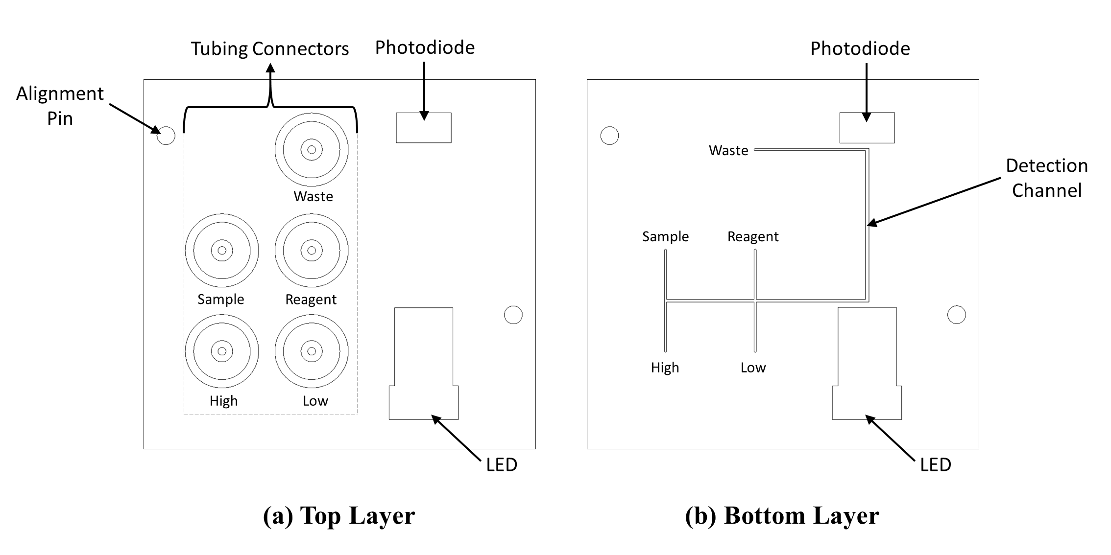
Figure 1. Microfluidic chip design.

Bench Top Measurements
Two approaches were adopted for analysis of the solutions via the microfluidic chips. Firstly, the channels were filled with premixed solutions (the same as used during analysis via the spectrophotometer) in order to optimise the response of the LED/PD detector. This was achieved through a bench-top fluidic control system depicted in Figure 2. The premixed solutions were introduced to the chip by taking all four channels from the same source. The four channels of the bench-top pump (Ismatic, Reglo ICC, ISM4408) were set at a flow rate of 1 ml/min and solutions pumped for a duration of 2.5 min for all measurements. A number of check valves (placed directly at the chip connectors) enabled the flow direction to be controlled, which reduced carryover from previous solutions within the channels/tubing, and minimised dead volume. It must be noted that prior to the introduction of all solutions, the channels and chip were flushed with deionised water (DW). For each measurement the detection system recorded 60 data points at a frequency of 1 Hz (i.e., for1 minute). The average of this dataset was calculated and considered representative of the sample absorbance and from this the sample pH could be inferred. This was repeated in triplicate to investigate reproducibility.
The second approach investigated mixing of the reagent/sample mixture on-chip. This followed the same procedure as for the premixed approach except that the reagent was drawn from solution sources 1 and 2 (figure 2), while the ‘unknown sample’ was drawn from sources 3 and 4. This ensured a 1:1 (v/v) ratio for mixing of the solutions prior to measurement. The same pumping time was employed. Following this, analysis took place for an additional minute and a representative value was calculated in the same manner as described above. Again, this was repeated in triplicate to investigate reproducibility.

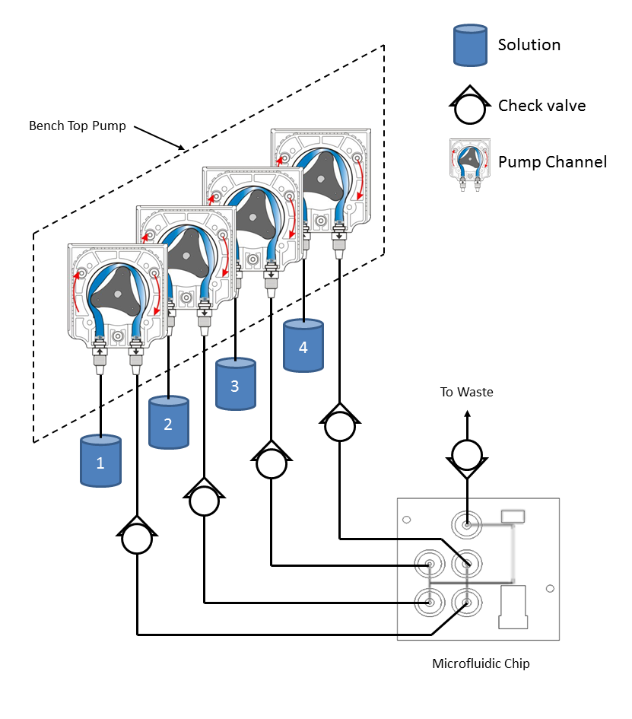
Figure 2. Schematic of the bench-top fluidic control system for investigating the response of the microfluidic chip detector to different concentrations of pH.

Sensing Platform
Figure 3 presents a number of views of the sensing platform used in this study. The assembled view (a) shows the arrangement of the internal components within the housing (Pelican Case 1300, Pelican Products, Inc.). The internal view (b) shows the placement of storage containers (high standard, low standard, and reagent) in addition to the battery, electronics (housed within an IP65 rated housing; Spelsberg, Abox 040-L), and a waste bag (Haemopharm Healthcare). Located behind this internal view (b) is the syringe pump plate (c). This is composed of four syringe pumps – the operation of which is shown in Figure 4. To fill the syringe(s), the motor rotates causing the gears (and threaded rods) to rotate in opposite directions. This results in translation of the carriage towards the motor end, drawing the solutions from the storage containers into the syringes. Reversing the applied polarity to the motor causes the movement to occur, pushing solution from the syringes. The light switch acts as a fail-safe sensor, detecting when the syringe is fully emptied, and turning off the drive movement. The T-check valve controls the direction of flow of the solution, i.e. towards the microfluidic chip (empty) or from the storage containers (fill). Additional single check valves were placed directly at the microfluidic chip in a similar way as shown in Figure 2 to minimise dead volume.

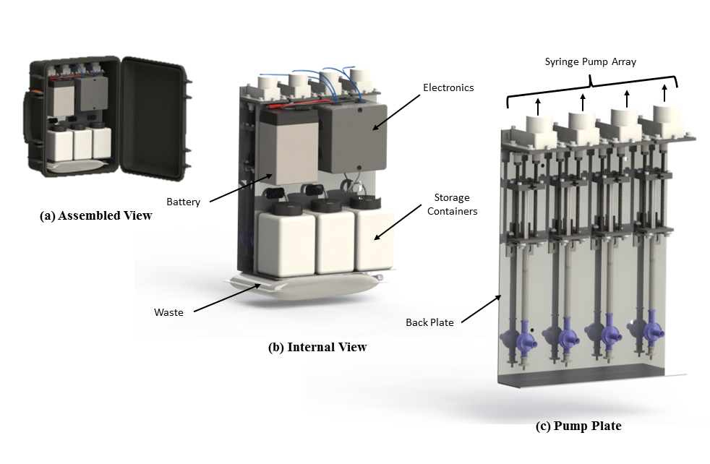
Figure 3. Assorted views of the sensing platform.
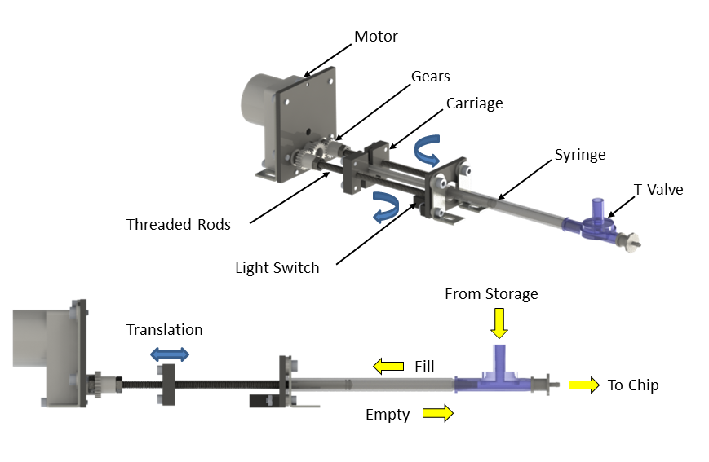
Figure 4. Syringe pump operation.

Results and Discussion

Spectral Analysis – Spectrophotometer
The optimum pH reagent formulation used was found to be mixture #3, a mixture of three dyes, i.e. PR, CPR, and BCB. PR is a weak acid that changes colour over the pH range 6.8-8.2, pK_{a} = 8.00, CPR in the range 4.8-6.4, pK_{a} = 6, and BPB 3-4.6 pK_{a} = 4.0 [28]. These were used in combination in order to extend the linear range of pH detection. The optimum formulation was arrived at through comparative analysis of the three pH dye mixtures, see supplementary information (SI). From these results, mixture #3 was the most suitable candidate for the requirements of this study due to its sensitivity and linear range.
Figure 5 (left) presents the spectra of the dye with the insert showing a captured image from pH 4-9. Visually, there appears to be two sensitive peaks to choose from for analysis; at ca. 435 nm and 570 nm, which are shown as vertical lines in the figure. However, the correlation study concluded that the most suitable wavelength for analysis was at 570 nm (see SI).

Figure 5 (right) presents the spectral absorbance of the dye at 570 nm and plotted as a function of pH (measured via a calibrated pH meter). An excellent sigmoid fit to the data is shown as the red line from pH 4-10 (R²=0.99844, n=3). However, it appears that the sensitivity decreases slightly at pH 10. As a result a linear fit was overlaid on the figure for data between pH4-9; appearing as the blue line (R²=0.99549, n=3).

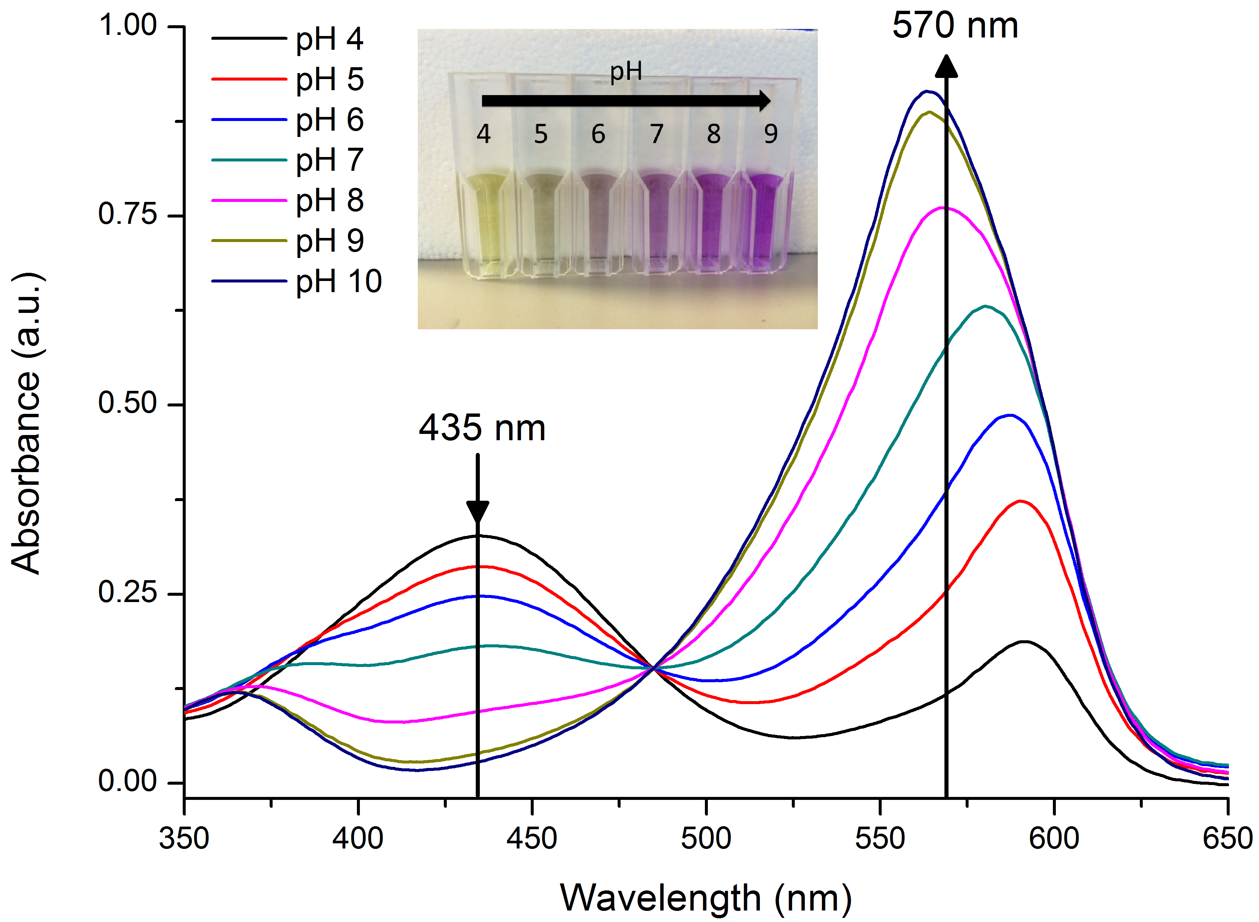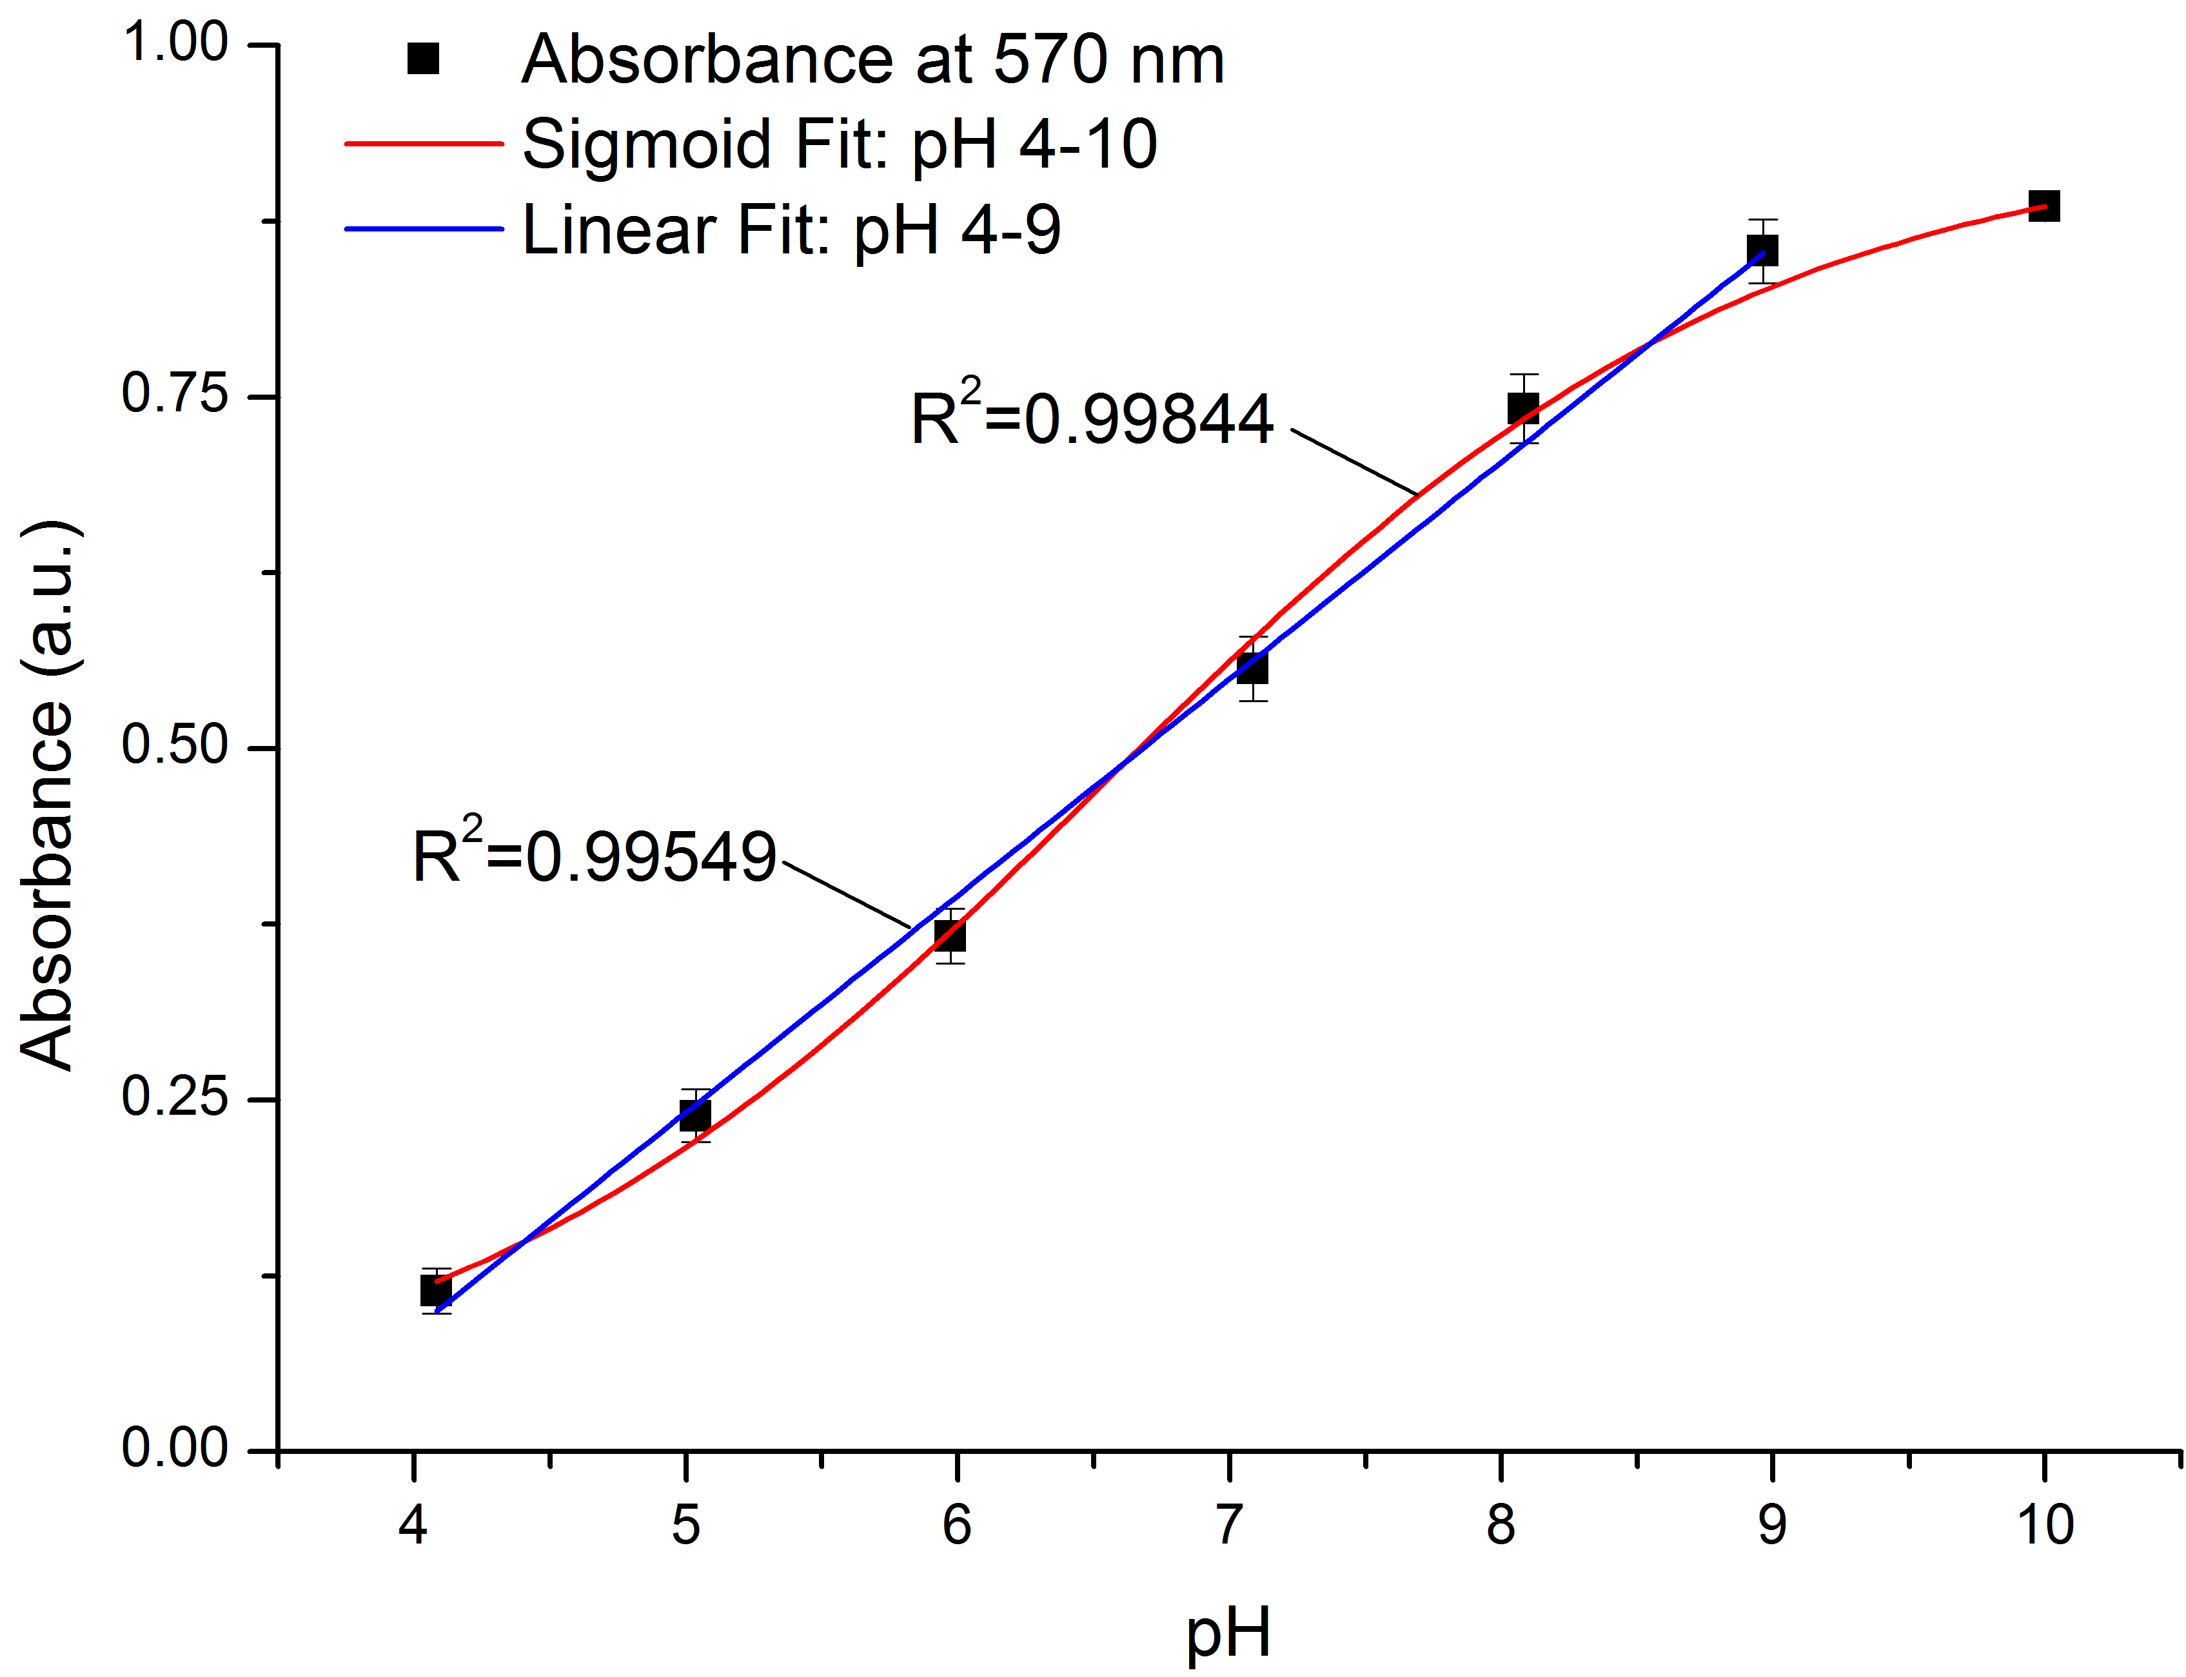
Figure 5. (Left) Absorbance spectra of pH mixture #3 (PR/CPR/BCB). Vertical lines represent two selected wavelengths, 435 and 570 nm. Inset – captured image of prepared pH solutions at pH 4, 5, 6, 7, 8 and 9. (Right) Absorbance at 570 nm as a function of pH. Points are the average of 3 measurements, error bars the standard deviation . Red line represents a sigmoid fit (pH4-10, R²=0.99844), blue line shows linear fit at the linear range (pH4-9, R²=0.99549).

The correlation study was also carried out for mixture #1 and six different ratios of mixture #2 The best correlations found were 0.95 and 0.92, respectively, which, while reasonably good, was less than that of mixture #3. In addition, the linear range for #3 was better than the other dye combinations studied, and for therefore we focused on #3 for further studies (Table1).

Table 1. Comparison between the three different combination of dyes for pH sensing

Mixture | Linear Range | Slope | Correlation
#1 | 6-8 | 0.11 | ≤0.95
#2 | 6-9 | 0.19 | ≤ 0.92
#3 | 4-9 | 0.15 | ≥ 0.99

Bench-top Microfluidic Chip Analysis

Premixed Solutions
Introducing premixed solutions into the chip and analysis of the response allowed for adjustment of the LED intensity for optimising the response of the photodiode. This initially took place by filling the detection channel with solutions of max and min pH concentrations, pH 9 and pH 4, respectively, and measuring the response of the detector between these solutions. The LED intensity was adjusted so that a response close to the upper limit of the ADC (3.3V) resulted when a solution of pH 4 filled the detector channel. Given that pH 4 has the least absorbance at 570 nm (
Figure 5), it yields the maximum transmittance and therefore tuning of the response to the upper limit resulted in maximum resolution/sensitivity of the detector.
Figure 6 presents a calibration plot showing the response of the detection system within the microfluidic chip when different concentrations of premixed pH solutions were pumped within the chip. The trend appears to be non-linear from pH 4-9, which is indicated by an excellent sigmoid fit as the red line in the figure (R²=0.99975, n=3). The linear range appears from ca. pH 4-8, and investigated though a good linear fit (R²=0.99212, n=3) appearing as the blue line. This linear range differs from that obtained from analysis via the spectrophotometer, see
Figure 5 (right). There can be a number of reasons for this. The first is that the emission spectra of the LED is not localised on one wavelength, but rather over a distribution composed of many wavelengths. This in conjunction with the non-aligned peak surrounding 570 nm in the spectra (Figure 5, right) can lead to loss in sensitivity at the extreme(s).

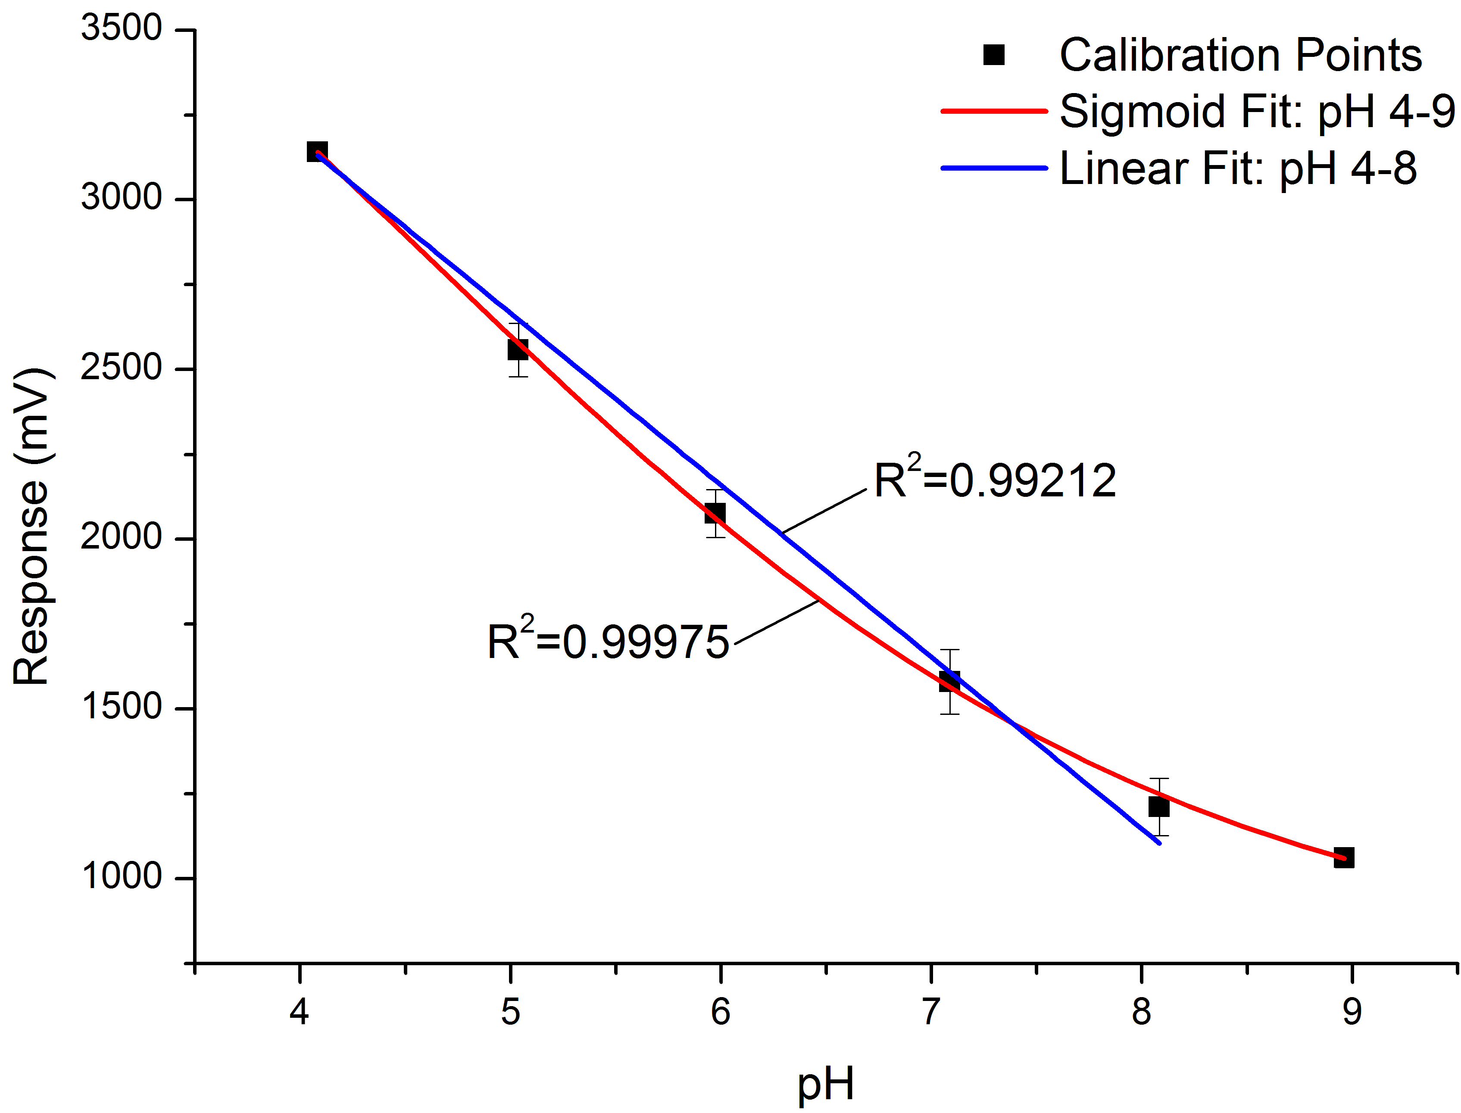
Figure 6. Calibration on-chip using pre-mixed solutions. Points are the response of the detector; error bars are the standard deviation over three successive measurements. Red line represents a sigmoid fit to the data (pH 4-9; R2=0.9997), blue line represents a linear fit (pH 4-8; R2=0.99210).

Mixing of Solutions on Chip
Figure 7 presents a calibration plot when the sample solutions and reagent was allowed to mix on-chip. The same observations made for the premixed data can be extended to the mixing data shown in the figure. However, it appears that the linear and non-linear fits overlap more closely from pH 4-7 than for the premixed approach. One reason for this can be related to same experimental conditions under which the reaction occurs for all pH solutions. Overall, the linearity from pH 4-8 is excellent (R²=0.99987, n=3), which suits the requirements for many water quality monitoring scenarios [5]

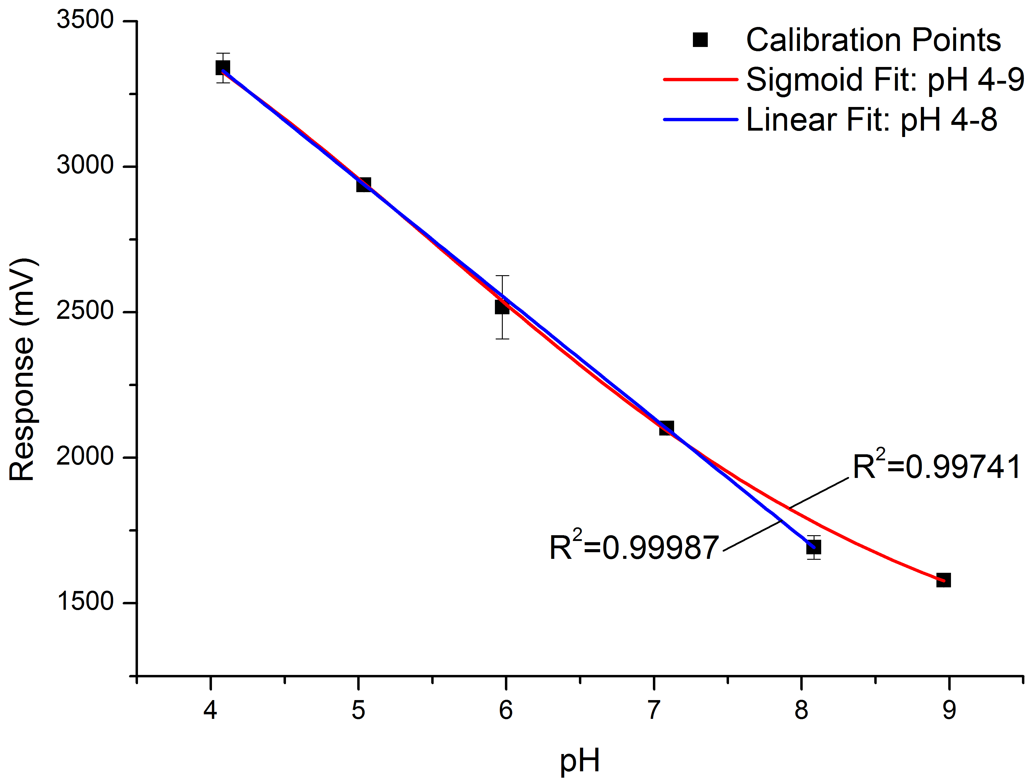
Figure 7. Mixing on-chip. Points are the response of the detector; error bars are the standard deviation for n=3 successive measurements. Red line represents a sigmoid fit to the data (pH 4-9; R2=0.9974), blue line represents a linear fit (pH 4-8; R²=0.9998).

System Validation

Platform Calibration
The platform (Figure 3) was equipped with the microfluidic chip, relevant chemical standards, and reagent. A calibration took place in which the sample inlet was sourced from pH buffers (4-9). Figure 8 presents the response of the system with respect to changing pH concentrations. It can be seen that a similar trend results with respect to previous calibrations. A sigmoid regression model (represented as the red line in the figure) was applied to the data with an excellent fit (pH 4-9; R²=0.99847, n=3). As before, the linear range extends from pH 4 to pH 8 with a good linear fit (R²=0.99058, n=3). There is a choice between using either model; however the sensitivity reduces past pH 8. As a result the linear fit may offer a simpler model for pH estimations, which can be performed on the microcontroller for smart analysis and/or for eventual delta reporting. This will depend upon the desired conditions and operation of the platform once deployed.
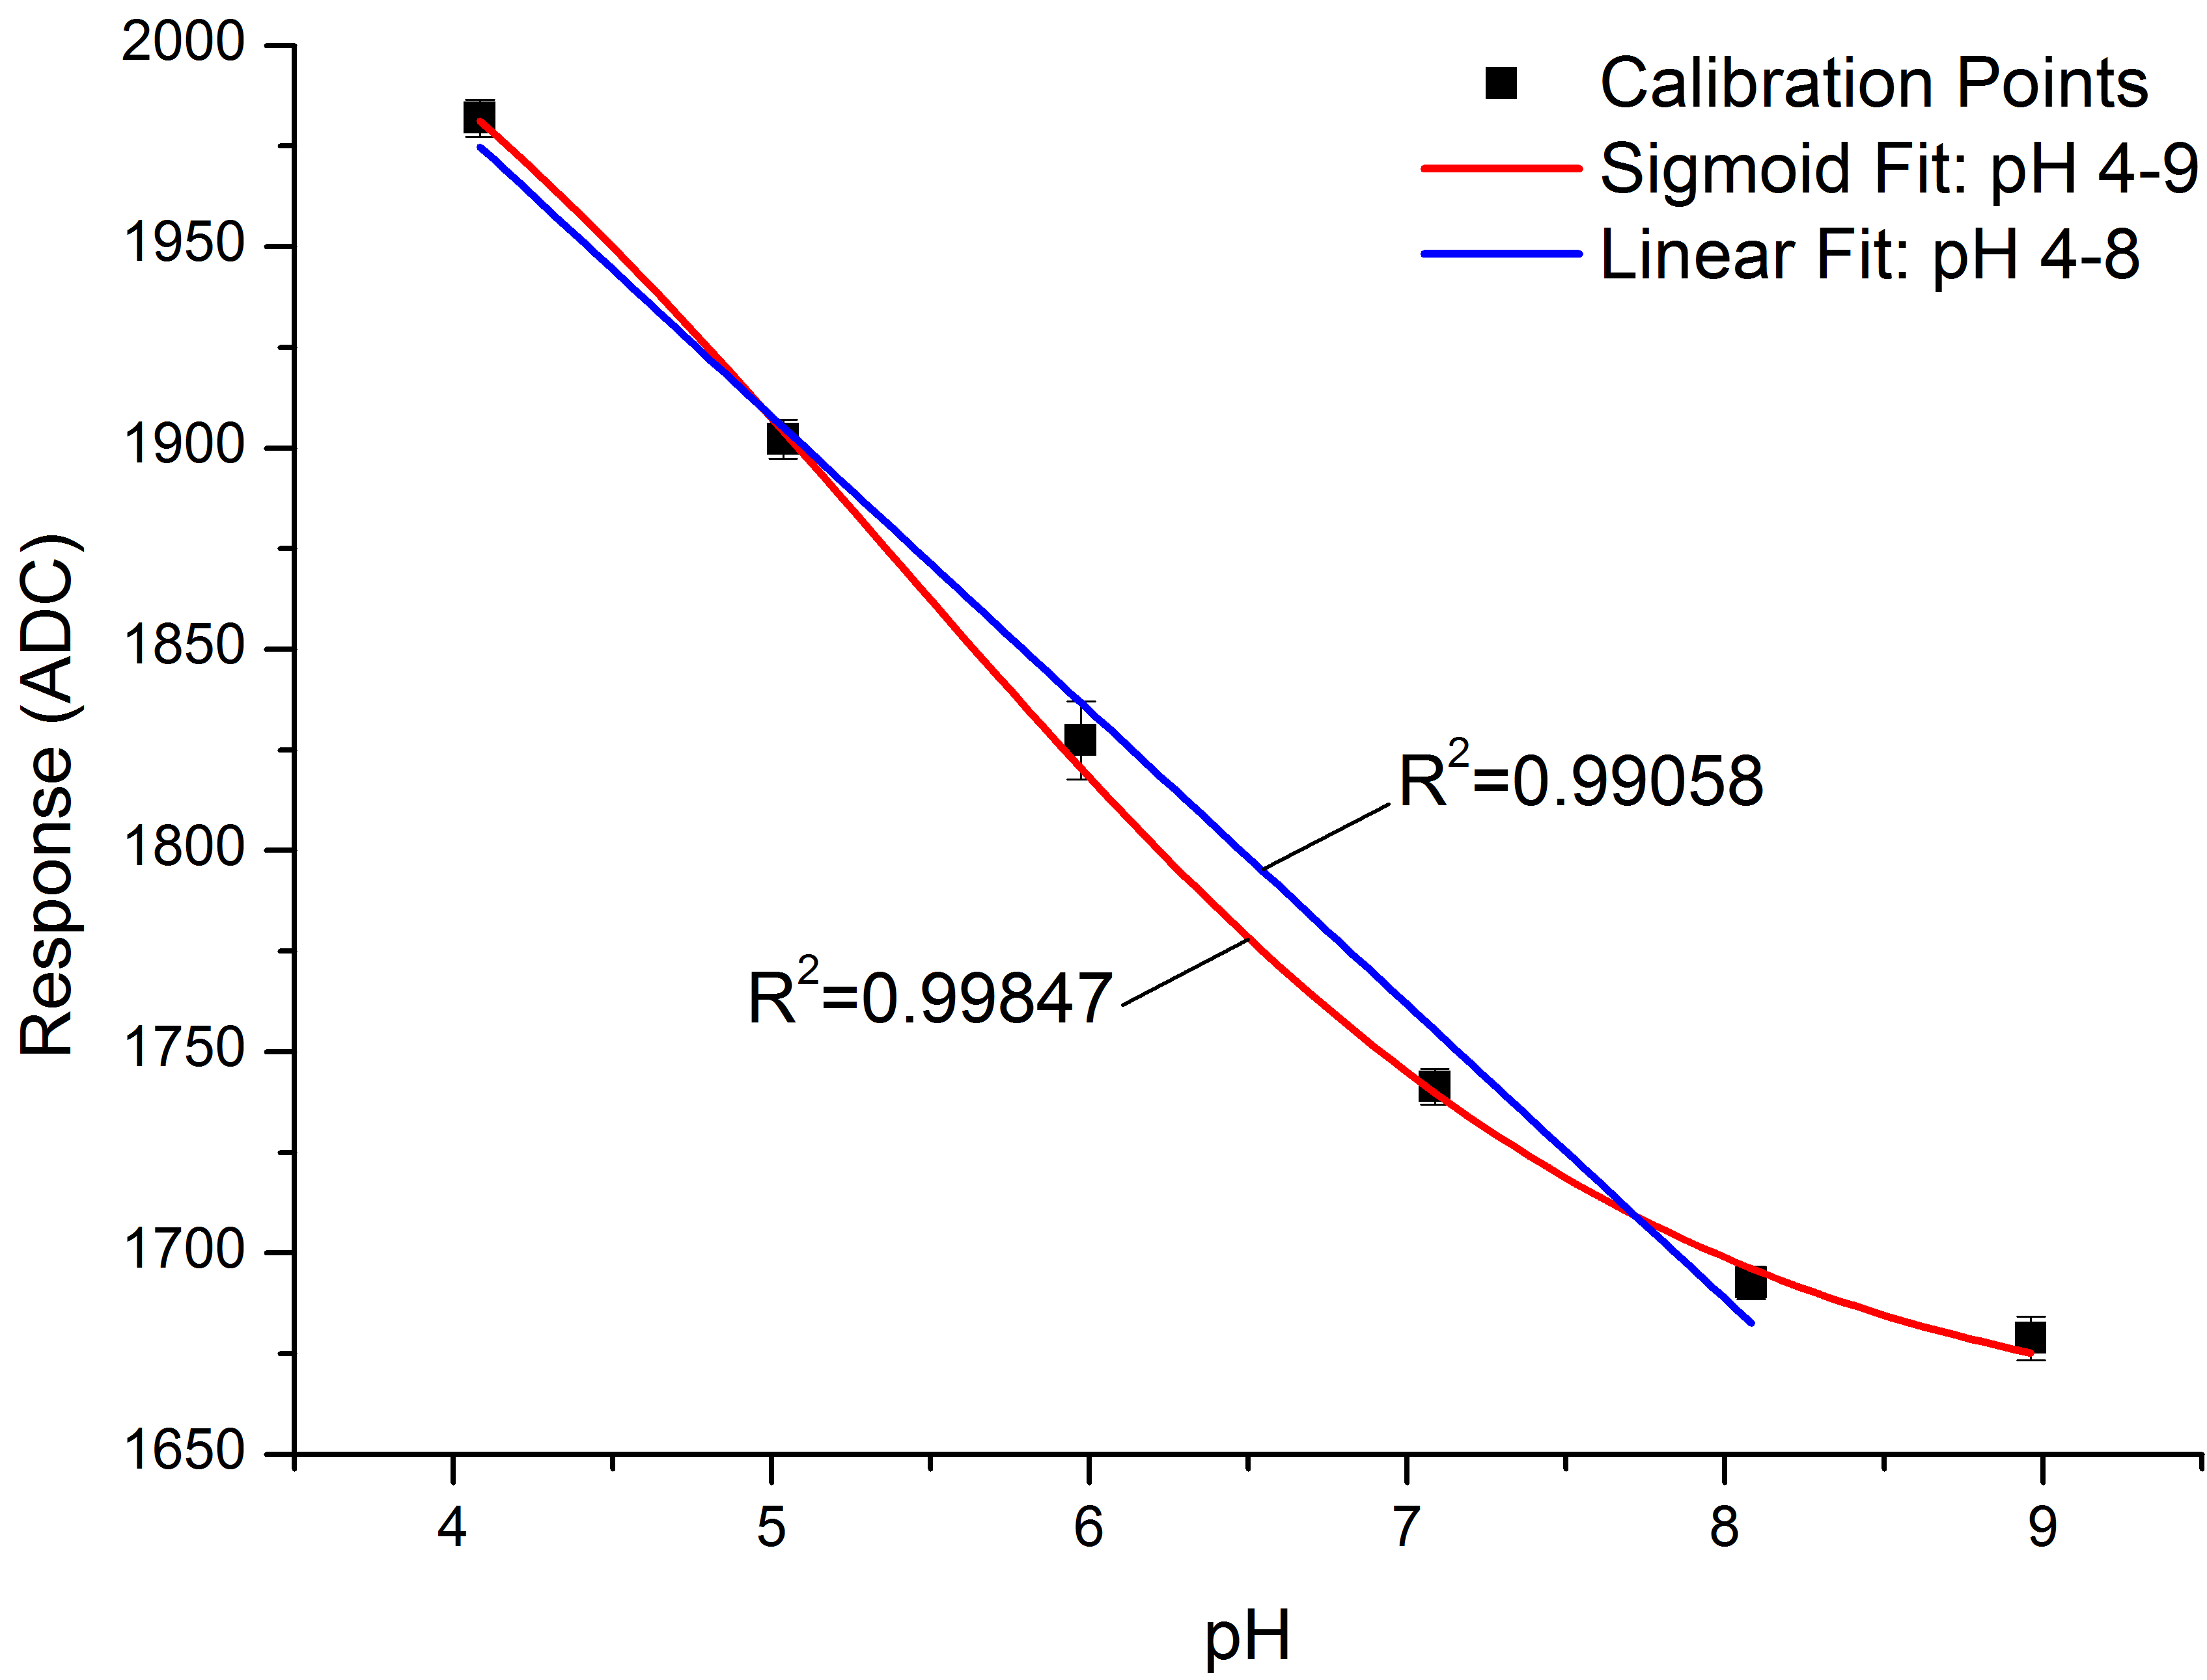
Figure 8. Platform calibration. Points represent the average response of the system to repeated measurements (3), error bars are the standard deviation. Red line represents an excellent sigmoid fit from pH 4-9 (R²=0.99847, n=3), blue line is a linear fit from pH 4-8 (R²=0.99847, n=3).

Repeatability Tests
The system was examined extensively to evaluate its response when examining a large number of pH samples. In this case the platform measured 15 samples of each pH buffer (6), i.e. 15x6 (90) samples in total. These data are summarised in Table 2. Here the relative standard deviation was calculated to determine the repeatability of the system. It can be seen that the RSD is low with a global RSD 1.77%,. This gives high assurances that the system is consistently capable of analysing given samples in controlled conditions, i.e. with buffers in an accurate manner.

Table 2. Results of the repeatability test. The response represents the average of 15 separate samples of relative pH.
pH | Avg. Response (ADC) | RSD (%)
4 | 1979.7 | 0.9
5 | 1899.1 | 1.9
6 | 1812.2 | 1.4
7 | 1737.7 | 2.3
8 | 1688.0 | 2.8
9 | 1669.4 | 1.3

pH Estimation

Buffer Solutions
The ability of the prototype platform to estimate the pH of buffered solutions (when mixed on chip) was investigated. This was achieved by analysis of prepared solutions of each pH buffer as before (pH 4-9) analysing them on both systems (spectrophotometer and system), and calculating the percentage relative error to measured values via a standard, i.e. a calibrated pH meter. The non-linear mathematical model achieved through the calibration plots (discussed earlier) was used to estimate the pH of the prepared solutions. Table 3 presents the estimations via both instruments. It can be seen that the spectrophotometer achieved a global error ≤ 1.65 %,. While the global relative error associated with the prototype ≤ 1.18 %,. These are comparable and the accuracy is acceptable for the purposes of this project, i.e. to act as an early warning system.

Table 3. Estimated pH via the spectrophotometer and the prototype platform. Percentage relative errors are calculated for both (%RE).
pH Meter (true) | UV-Vis  (pH) | Platform  (pH) | UV-Vis Error  (%RE) | Prototype Platform Error  (%RE)
4.08 | 4.14 | 4.03 | -1.47 | 1.23
5.04 | 4.94 | 4.98 | 1.98 | 1.19
5.97 | 5.77 | 5.90 | 3.35 | 1.17
7.09 | 7.01 | 7.05 | 1.13 | 0.56
8.08 | 8.21 | 8.20 | -1.61 | -1.49
8.96 | 8.93 | 8.83 | 0.33 | 1.45

Blind Samples
A number of real samples were sourced from a reputable contract analysis company (TelLabs, Ireland) for evaluation. Before shipping of the samples, the samples were analysed using certified methods used by the company [29]. Upon delivery, each sample was first filtered through a 0.45 Nylon filter to eliminate any suspended particles. The samples were then evaluated using the detector and its pH was predicted via the aforementioned non-linear calibration model. Later, the reference measurements by TelLabs were obtained and examined against the prototype platform results. Table 4 compares the reference measurements (pH TELabs) and the results predicted pH using the prototype platform (pH Predicted). It can be seen that the error was acceptable being the global error found 3.40% , which suggests that the prototype platform has an overall acceptable performance.
Sample  Reference | Sample Characteristics | pH TELabs  21.11.14 (true) | pH (Prototype Platform)  21.11.14 | Relative Error (%)
A | Effluent | 7.25 | 7.12 | 1.79
B | Drinking Water (Well) | 5.70 | 6.04 | -5.96
C | Buffer 6 | 6.01 | 5.91 | 1.66
D | Surface Water | 7.62 | 7.3 | 4.20

Table 4. Results obtained with blind water samples. Comparison between independent laboratory results and the prototype platform.

Reagent Stability
The stability of the reagent is a crucial variable for maximising the duration of service intervals during deployments, which can significantly reduce the cost of ownership of sensors. To check this, spectrophotometer calibrations were carried out at the commencement of this study, and on a weekly basis for the first month, and on a monthly basis thereafter using the same reagent solutions for another 7 months. The reagent was stored within a glass bottle and kept in darkness (with the exception of aliquots for analysis) at room temperature for eight months. The calibration curve shown in Figure 9 is representative of the entire eight months. The points represent the average for measurements across respective pH concentrations, error bars are the standard deviation, and an excellent linear fit appears as the red line (A=0.1539pH – 0.5216, R²=0.9984). Overall, it can be observed from the figure that there is no significant difference between the calibrations performed over the eight months. This gives high assurances that the reagent will be stable for the target deployment duration of three months.

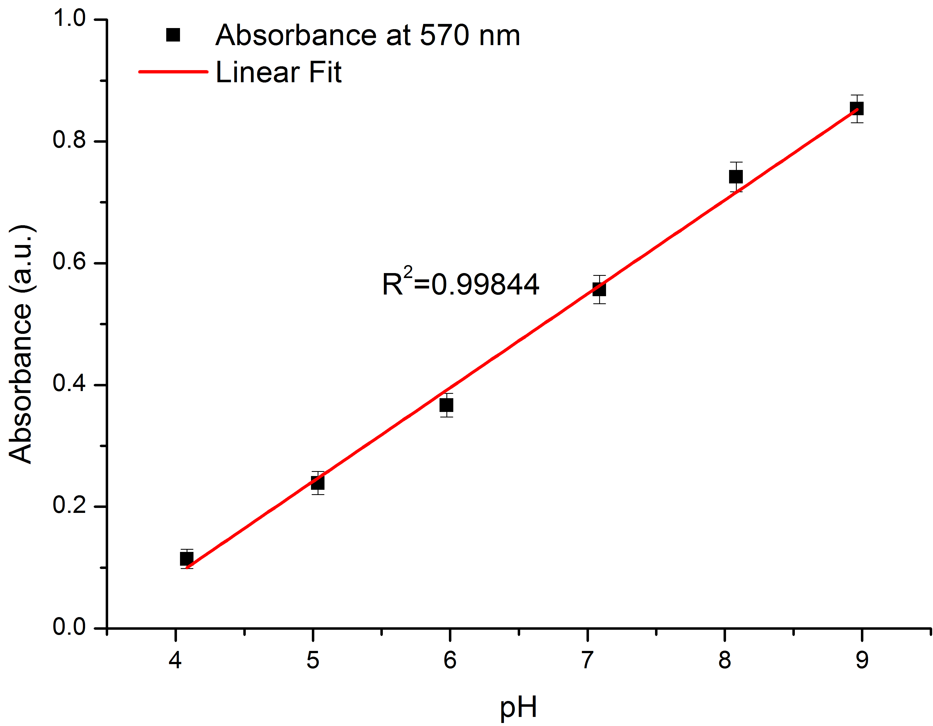
Figure 9. Stability of pH reagent over a period of eight months as described in the test. Points represent an average of the dye spectra at 570 nm, error bars the standard deviation, and red line is a linear fit (R²=0.9984, n=11).

Conclusions

The work documented in this paper has detailed the design, development, and testing of a fully autonomous microfluidic chemical sensing platform. A study related to extending the pH detection range to between pH 4 – 9 took place by combining a number of pH sensitive dyes and ratios therein. Design of a microfluidic chip coupled with a selected LED (λ_{max} of pH dye) and photodiode successfully formed the detection system. This was tested using bench top instrumentation and validated the working of this system element. Integration of this within a platform capable of delivering and therefore mixing reagent and samples in an autonomous manner was explored. The prototype was tested during laboratory trials in three ways. Firstly, the repeatability trials showed an accuracy of RSD ≤ 2.82%. Secondly, blind samples were estimated and compared to measurements achieved by an accreted laboratory (%RE ≤ 5.96%). Finally, the stability of the pH reagent was examined, as this is a key parameter in order to determine the potential deployment time of the system. This mixture has been studied for 8 moths so far and is still stable.

Acknowledgements
The authors gratefully acknowledge financial support from EU FP7 project AQUAWARN (FP7-SME-2013-605937). Dermot Diamond would like to thank financial support of Science Foundation Ireland (SFI) under grant number SFI/12/RC/2289. The authors would like to thank Tellabs for providing pH buffers and samples.

References

1. Parliament, E., EU Water Framework Directive, D. 2000/60/EC, Editor 2000, Official Journal p. 1 - 73.
2. Kallis, G. and D. Butler, The EU water framework directive: measures and implications. Water Policy, 2001. 3(2): p. 125-142.
3. Diamond, D., Peer Reviewed: Internet-Scale Sensing. Analytical Chemistry, 2004. 76(15): p. 278 A-286 A.
4. Murray, R., Challenges in Environmental Analytical Chemistry. Analytical Chemistry, 2010. 82(5): p. 1569-1569.
5. EPA. pH in water moitoring and assessment. 2012; Available from: http://water.epa.gov/type/rsl/monitoring/vms54.cfm.
6. Ariza-Avidad, M., et al., Feasibility of the use of disposable optical tongue based on neural networks for heavy metal identification and determination. Analytica Chimica Acta, 2013. 783(0): p. 56-64.
7. Rérolle, V.M.C., et al., Seawater-pH measurements for ocean-acidification observations. TrAC Trends in Analytical Chemistry, 2012. 40(0): p. 146-157.
8. Martz, T.R., et al., A Submersible Autonomous Sensor for Spectrophotometric pH Measurements of Natural Waters. Analytical Chemistry, 2003. 75(8): p. 1844-1850.
9. Spotte, S., Marine Aquarium Keeping. 1993: Wiley & sons, Inc.
10. Martinez-Olmos, A., et al., Multisensor probe for soil monitoring. Sensors and Actuators B: Chemical, 2011. 160(1): p. 52-58.
11. Pérez de Vargas-Sansalvador, I.M., et al., A new light emitting diode–light emitting diode portable carbon dioxide gas sensor based on an interchangeable membrane system for industrial applications. Analytica Chimica Acta, 2011. 699(2): p. 216-222.
12. Carvajal, M.A., et al., Hand-held optical instrument for CO2 in gas phase based on sensing film coating optoelectronic elements. Sensors and Actuators B: Chemical, 2010. 144(1): p. 232-238.
13. Perez de Vargas-Sansalvador, I., et al., LED–LED portable oxygen gas sensor. Analytical and bioanalytical chemistry, 2012. 404(10): p. 2851-2858.
14. Perez de Vargas-Sansalvador, I.M., et al., Compact optical instrument for simultaneous determination of oxygen and carbon dioxide. Microchimica Acta, 2011. 172(3-4): p. 455-464.
15. Sicard, C., et al., Tools for water quality monitoring and mapping using paper-based sensors and cell phones. Water Research, 2015. 70(0): p. 360-369.
16. López-Ruiz, N., et al., Determination of O2 using colour sensing from image processing with mobile devices. Sensors and Actuators B: Chemical, 2012. 171–172(0): p. 938-945.
17. Curto, V.F., et al., Real-time sweat pH monitoring based on a wearable chemical barcode micro-fluidic platform incorporating ionic liquids. Sensors and Actuators B: Chemical, 2012. 171–172(0): p. 1327-1334.
18. Bowden, M. and D. Diamond, The determination of phosphorus in a microfluidic manifold demonstrating long-term reagent lifetime and chemical stability utilising a colorimetric method. Sensors and Actuators B: Chemical, 2003. 90(1–3): p. 170-174.
19. Beaton, A.D., et al., Lab-on-chip measurement of nitrate and nitrite for in situ analysis of natural waters. Environ Sci Technol, 2012. 46(17): p. 9548-56.
20. Bhakta, S.A., et al., Determination of nitrite in saliva using microfluidic paper-based analytical devices. Analytica Chimica Acta, 2014. 809(0): p. 117-122.
21. John Cleary, C.S., and Dermot Diamond, Analysis of Phosphate in Wastewater Using an Autonomous Microfluidics-Based Analyser. World Academy of Science, Engineering and Technology, 2009. 52: p. 4.
22. Czugala, M., et al., Portable integrated microfluidic analytical platform for the monitoring and detection of nitrite. Talanta, 2013. 116(0): p. 997-1004.
23. Cogan, D., et al., The development of an autonomous sensing platform for the monitoring of ammonia in water using a simplified Berthelot method. Analytical Methods, 2014. 6(19): p. 7606-7614.
24. Florea, L., et al., Dynamic pH mapping in microfluidic devices by integrating adaptive coatings based on polyaniline with colorimetric imaging techniques. Lab on a Chip, 2013. 13(6): p. 1079-1085.
25. Rérolle, V.M.C., et al., Development of a colorimetric microfluidic pH sensor for autonomous seawater measurements. Analytica Chimica Acta, 2013. 786(0): p. 124-131.
26. B. Raghuraman, G.G., R.E.G. Van Hal, E. Dressaire and O. Zhdaneev, Extended-range spectroscopic pH measurement using optimized mixtures of dyes. Applied Spectrocopy, 2006. 60(12): p. 8.
27. R G Ogilvie, V.J.S., C F A Floquet, R Zmijan, M C Mowlem and H Morgan, Reduction of surface roughness for optical quality microfluidic devices in PMMA and COC. Journal of Micromechanics and Microengineering, 2010. 20(6): p. 8.
28. Green, F.J., The Sigma-Aldrich handbook of stains, dyes and indicators. 1991: Aldrich Chemical Company.
29. Methods, S., Standard Methods for the examination of water and wastewater, in Section 4500-H+ B2012.

