Probe technologies for clean sampling and measurement of subglacial lakes
Matt Mowlem^{1*}, Kevin Saw¹, Robin Brown¹, Edward Waugh², Christopher L. Cardwell¹, James Wyatt¹, Iordanis Magiopoulos¹, Peter Keen³, Jon Campbell^{1†}, Nicholas Rundle¹, Athanasios Gkritzalis- Papadopoulos⁴
- National Oceanography Centre, European Way, Southampton, SO14 3ZH
- Dyson Ltd., Tetbury Hill, Malmesbury, Wiltshire, SN16 0RP
- Keen Marine Limited, 15 Minerva Road, East Cowes, Isle of Wight, PO32 6HD
- Flanders Marine Inst VLIZ, B-8400 Oostende, Belgium
* Corresponding author, matm@noc.ac.uk
† retired
Keywords: instrumentation, probe, sensors, water, particle, samplers, clean, subglacial

*Author for correspondence (matm@noc.ac.uk).
†Present address: National Oceanography Centre, European Way, Southampton, SO14 3ZH

Summary

It is four years since the subglacial lake community published its plans for accessing, sampling, measuring and studying the pristine, and hitherto enigmatic and very different Antarctic Subglacial Lakes Vostok, Whillans, and Ellsworth.. This paper summarises the contrasting probe technologies designed for each of these subglacial environments, and briefly updates how these designs changed or were used differently when compared to previously published plans. A detailed update on the final engineering design and technical aspects of the probe for Subglacial Lake Ellsworth is presented. This probe is designed for clean access, is negatively buoyant (350 kg), 5.2 m long, 200 mm in diameter, approximately cylindrical and consists of five major units: i) an upper power and communications unit attached to an optical and electrical conducting tether, ii-iv) three water and particle samplers and v) a sensors, imaging and instrumentation pack tipped with a miniature sediment corer. To date, only in Subglacial Lake Whillans have instruments been successfully deployed. Probe technologies for subglacial Lake Vostok (2014/15) and Ellsworth (2012/13) were not deployed for technical reasons, in the case of Lake Ellsworth because hot water drilling was unable to access the lake during the field season window. Lessons learned and opportunities for probe technologies in future subglacial access missions are discussed.

Introduction
Accessing, measuring and sampling subglacial lakes has been attempted to address a number of scientific aims including: i) to determine whether, and in what form, microbial life exists in Antarctic subglacial lakes (1-5);
ii) to reveal the post-Pliocene history of the West Antarctic Ice Sheet (1-4);
iii) to obtain paleoenvironmental and paleoclimatic records (5), to determine ice sheet dynamics (5);
iv) to further understanding of biodiversity and the evolutionary processes of living organisms under unknown habitat conditions (6);
v) to assist preparation of technologies and equipment to search for living organisms on other planets of the solar system (6)
Together with the scientific necessity, and internationally agreed requirement to ensure minimal contamination of these pristine environments (2, 7), these scientific aims translate to demanding requirements for probe technologies that can access, measure and sample subglacial lakes (3).
The principal requirements are to:
1) ensure minimal forward contamination of the environment;
2) prevent confounding with exogenous populations of samples that will be analysed for endogenous microbiology and hydrochemistry;
3) maintain function at extremes of physical and environmental conditions experienced during transport, on site and during deployment;
4) maximise the quantity and quality of data returned by in situ measurement systems and;
5) sample water, particles and sediment to enable hydrochemistry, microbiology and sedimentology study.

Whilst these scientific aims and requirements unite the different subglacial lake access projects, the engineering solutions to these requirements, and the extent to which each is addressed, differ. This is because of a number of reasons including the differing depth and temperature of the overlying glacial ice which affects the drilling methodology, the drill fluid used, the dimensions of the access hole, and how long it can be kept open. Differences also reflect the particular scientific priorities in each location and for each team and the history of the development of these projects.
This paper reviews the probe technologies used in recent attempts (1, 6) and successful subglacial lake measurement and sampling campaigns (5), provides an update beyond the plans (2, 3, 6, 8) already present in the literature and discusses lessons learned and future directions. The primary focus is on the probe developed to access, measure and sample Subglacial Lake Ellsworth (SLE).

Plans for subglacial probe technologies
The plans for Antarctic subglacial lake probe technologies have previously been published (2-4, 7-9) and are summarised here.

The probe proposed for the direct measurement and sampling of Subglacial Lake Vostok (SLV) (8) was modular with modules for: i) hydrophysical measurements; ii) hydrobiochemical fluorimeter-spectrometers; iii) a water sampler; iv) video cameras; v) thermal imager. They would be sealed within a heated cylindrical transportation unit, between 3 and 13 m in length, depending on the configuration and number of modules, and 127 mm in diameter. The modules and transportation unit were to be sterilised using gamma radiation in preparation in Russia, and with ozone at Vostok. The transportation unit was to be used for traverse of the mechanically drilled borehole to prevent modules contacting exogenous microbial communities present in the drill fluid (kerosene-Freon in borehole, silicone oil above the lake water body contact). The transportation unit was to be connected to the main electrically conducting drill wire and contains a winch system (750 m veer, 120 kg working load) to lower modules into the lake. The modules would emerge from the transportation unit once contact with lake water was made. This would be in the lower part of the borehole. The water sample module has a mass of 6.2 kg, a sampling volume of 550 mL and was to be controlled by on-board microprocessor. The probe is extremely integrated as the access time before the water in the lower part of the borehole freezes is limited (hours).

The probes and instrumentation proposed for the direct measurement and sampling of Subglacial Lake Whillans (SLW) (9, 10) include multiple packages designed to be deployed in succession down a shorter (800.4 ± 0.8m (5) versus 3750 m (8) for SLV and 3155 ± 10 m for SLE (2)) hot water drilled borehole which would remain open, with reaming, for ~ 8 days (9). The instruments planned to be deployed (9, 11, 12) include:
- the camera enabled micro submersible Micro-Subglacial Lake Exploration Device (MSLED (10));
- a Conductivity Temperature and Depth (CTD) probe with integrated oxygen sensor (Seabird electronics, USA) LISST Deep particle analyser (Sequoia Scientific, USA), transmissometer (CStar, Wetlabs, USA) and Doppler current meter (Aquadopp, Nortek, Norway);
- CO₂ and CH₄ analysers (Contros GmbH, Germany);
- Wet chemical analysers for (NH₄, NO₃, Si, PO₄, Envirotech, USA);
- an integrated probe bottom section including an altimeter, down and side looking cameras and lights, fluorometer (FLNTU, Wetlabs, USA), e/m current meter (Contros GmbH, Germany) and Altimeter (Tritech, UK);
- water sampler (Envirotech, USA)
- a water sample pump (distributing to other elements);
- a lifting and telemetry stage;
- surface sediment corer (UWITEC Austria);
- a percussion corer (Northern Illinois University, USA / DOER-Marine, USA);
- a piston corer (University of California Santa Cruz, USA);
- thermal gradient probe (based on (13));
- torvane (sediment shear strength similar to that discussed in (14))
- a borehole string (temperature and GPS strain sensors (9)) to be left in the borehole following re-freeze.
The extended access time for SLW made integration of instrumentation into a single probe less essential, though this was planned for some of the instruments. It was planned (11) to integrate ii and v-viii to form an approximately 10 m long Physical Oceanography Package (POP). Subsequently iii-viii would be integrated to form an approximately 13.1 m long Water chemistry Instrument Package for Sub-Ice Exploration (WIPSIE). These packages, and their modules, were to be deployed using an umbilical containing a single optical fibre and five 18 AWG copper conductors (smart cable) with steel armour and outer polyurethane jacket with pay-out controlled by a hydraulic winch. The smart cable was also required for x). The integrated systems are modular and hence packages could be configured in response to conditions during lake access.
The strategy for microbiologically clean access to SLW with this instrumentation (7) is to treat with 3% H₂O₂, which produced a 2 to 3-log reduction of endospore and non-endospore test organisms in method validation experiments. Cleaned equipment would be handled over an open borehole by personnel in microbiological clean dress. In addition all hoses and tethers would pass through a UV exposure collar at >40 mJ/cm² for speeds <1 m/s producing a 6-log reduction in test organisms (pers. comm. Brendt C. Christner, 2015) on exposed surfaces.
For the sampling of SLE ((3 ) updated in (2 )) an identical pair of probes were proposed (for redundancy and availability during a very short deployment window). The proposed probes were heavily negatively buoyant, ~3.5 m in length with 25 mm diameter push corer mounted on the tip, 200 mm in diameter and integrated water (gas tight, 24 ×100 ml) and particle (0.2 μm filtering >100 L in 30 min) samplers and sensors into a single vehicle specifically designed for high reliability and microbial contamination control. The specifications were driven by the pristine nature of the continental SLE and because the deployment window would be short. The ~3200 m borehole would be available prior to refreeze for approximately 24 hrs for the deployment of all instrumentation. It was planned that at least one of the probes and either a percussion or gravity corer (Hodgson et al., this volume) would be deployed in this window, with an additional probe and / or corer deployed time permitting.
The planned probe consisted of two pressure cases separated by three carousels of water sampler bottles. Each carousel contained two particle samplers. The planned sensor suite included sensors for pressure (P), temperature (T), conductivity (EC), oxygen concentration (electrode), redox potential (Eh), and pH (Idronaut, Italy). Redundant T, C (Seabird Scientific), and oxygen (optode, Aanderaa, Norway) sensors were included to increase the probability of a successful measurement. The probe was to be operated with a composite tether which was to be sheathed for cleaning and consisted of four copper conductors for power (2.5 mm²), two copper conductors for backup communication channels, and six optical fibres for primary communication and video transmission. The probe would be equipped with two ranging sonar and video / light packages, one looking up, the other down.
Functionality planned for the probe included resilience to tether failure using batteries and on-board microprocessors and limited autonomy in the case of either power or communications failure or both.
The strategy for microbiologically clean access to SLE, for both the probes and corers (2) was to use a design that minimises traps and areas difficult to clean, to clean and sterilise with chemical wash, Hydrogen Peroxide Vapour (typically 10⁶ reduction (2)) and where possible Autoclaving. A combination of HPV and UV exposure was planned if these treatments were not sufficient. This cleaning would be completed in a cleanroom environment working to ISO 14644 Class 100,000 (ISO 8). Equipment would be re-sterilized post construction, and assessed prior to being placed in a protective environment for transport to SLE.
Once at site, it was envisaged that post-drilling the borehole would be sealed from the atmosphere using an airlock through which instrumentation could be docked, the interface cleaned, and then passed without contact with contamination or the atmosphere into the borehole. Prior to deployment of the first probe the air filled section of the borehole would be treated with a UV source (15) . This source, or reactor, was designed to pass through the airlock after installation. The source or “reactor” comprised tubular UV lamps arranged in a circular pattern around a central column and behind a protective quartz sleeve. Calculations of UV fluence gave a conservative estimate of output between 13.23 and 14.06 mW cm⁻¹. At an anticipated descent rate of 1 metre every 6 seconds this would be capable of delivering a dose 76 mJ cm⁻² to the wall of the borehole. For the microbial communities anticipated in this area this would achieve better than log 3 reduction of an already low density population at the borehole wall and within the surrounding snow and ice. CPESESSE recommendations (16) are to maintain viable cell density below 102 cells mL⁻¹ and based on best estimates of microbial density this UV dosage should achieve this. A UV collar, and borehole liner was planned to be included in the wellhead. The materials, methods and protocols that were used for the SLE probe were dictated by the project’s Comprehensive Environmental Evaluation (CEE).

Deployment of subglacial probes
In all of the subglacial lake programmes there have been numerous changes to the operational plans, probe designs, and equipment used in both successful and unsuccessful subglacial lake access. This reflects the technical challenge in this new field, but also other factors such as the timescales chosen, quality control procedures, and the relative compactness of the engineering teams (e.g. in comparison to satellite and aerospace engineering). The lessons learnt from these experiences provide valuable input to future similar programmes and therefore they are discussed here.

The ability to repeatedly deploy the hot water drill to correct and maintain clean access to SLW, and the modularity and hence flexibility of the instrumentation used were critical elements in the success of the SLW field season 2012/13 (5). The drilling team maintained access with a functional borehole for approximately 5 days during which time 17 deployments of 8 different instrument packages were completed. In addition to challenges with the drilling itself, the team overcame a number of instrument challenges. Despite extensive pre-deployment testing in both lake Tahoe in August 2012 (11) and McMurdo Ice Shelf in December 2012 (12) a number of instruments were not deployable at SLW. This included the water sampler (vi, above) which leaked water into its motor housing during testing at McMurdo, and the smart winch (required for ii-viii above) which showed some scrolling and sensor errors at McMurdo and failed at SLW. In addition the multicorer (ix, above) failed to transit the borehole on 7 attempts requiring an addition 24 hours of borehole reaming before success. The wet chemical analysers (iv, above) were withdrawn from the deployed packages at McMurdo where the decision was made to use them as lab autoanalysers because of fears of leaking reagents. The in situ torvane (xiii, above) was not deployed and measurements were performed on a split percussion core post retrieval instead.
Despite these challenges nearly all of the data expected was returned using a succession of modules from the instruments listed above, and with additional equipment. The actual deployment sequence was as follows: i) Video capture with a borehole camera (subsystem of MSLED) with its own dedicated fibre optic enabled tether; ii) Conductivity Temperature and Depth recorded with an oceanographic CTD (SBE 19 plus V2, Seabird Electronics, USA; iii) water sampling with an oceanographic 10 L Niskin Bottle (with bottom weight mechanical trigger); iv) particle sampling with an oceanographic in situ filter sampler (McLane Research Laboratories, Inc., USA) v) 24 hours of hole reaming and then three successful deployments of the NIU / UWITEC multicorer; vi) a repeat CTD followed by alternating Niskin and Filter sampler deployments; vii) deployment of the (logging) geothermal probe; viii) 0.8 m of sediment was sampled with the Piston corer; ix) following a repeat geothermal probe deployment in the absence of the smart winch the Percussion Corer was deployed as a gravity corer and collected 0.4 m samples; x) a geophysical sensor string consisting of one three-axes borehole seismometer, three vertical-axes geophones plus an 800 m-long fibre-optic distributed temperature sensor.

In the field season 2014/15 the water sample and camera system developed by the Petersburg Nuclear Physics Institution (Russia) was prepared for deployment whilst water remained unfrozen in the bottom part of the borehole following the second successful access of SLV with mechanical drilling on Jan 25 2015(Sergey Bulat, 2015 ). The heated 700 mL water sampler, includes a small protruding orifice, <1 mm internal diameter, at its lowest point and can be flushed many times, both to minimise contamination of the sample with drill fluid. The sampler was successfully tested in the borehole to a depth of 350 m prior to breakthrough. The camera was tested in the borehole prior to breakthrough to a depth only 4 m above the lake.
Following lake access, lake water rose 72-77 m into the bottom part of the borehole, and because of the very small temperature difference (0.1 K) did not completely refreeze for 48 hours. The plan was to sample liquid lake water in the bottom part of the borehole as close as possible to the lake proper, but this was not possible for technical reasons. Nor was it possible to deploy the camera or a Japanese oxygen sensor that was also prepared for deployment.
Table 1 Principal changes between preliminary design and final design for the SLE probe
Property | Concept design (3) | Updated design (2) | Final probe for 2012/13
Length | 4 m inc. corer | 4.5 m | 5.2 m
Backup systems | Battery and limited autonomy after tether fail |  | No backup battery, limited self-logging on comms. fail
Wellhead |  | mechanical liner with UV sterilising collar | Liner heated and HPV sterilisation
particle samplers | 3 parallel 0.45 µm filters, or integrated with bottle per carousel | Two 0.2 µm filter samplers per carousel | Two units in total, 0.2 µm, self-priming, fill with air on retrieve
Sediment sampler | UWITECH, Austria  Positioning with sonar | 25 mm push corer | 22.3 mm ball valve tipped piston corer, visual positioning
Water sampler | 24 × 100 ml unheated gas tight bottles with cone and cup valves. 2 pumps per carousel (8 bottles) | 21 unheated and 3 heated 100 ml gas tight bottles with sliding seal valves. 1 pump per carousel,
Particle sampler |  | 0.2 µm filters
Motility | Rotation through pump exhaust |  | Vertical only via tether veer/haul
Sterilisation in construction | HPV, Autoclaving, UV, ethanol, hypochlorite | Autoclaving, HPV and UV | No UV. Detergent, biocide and ethanol as standard. Additional autoclaving for hard materials, isopropanol only for electronics. HPV final step for all materials.
Instrumentation | Secondary CTD is Midas SVX2 (Valeport, UK)  Laser spot altimeter |  | Secondary CTD is SBE 49 (Seabird electronics, USA)  Acoustic altimeter
Vision systems | Cameras are Iconix High Definition Colour Video, CA, USA  Tungsten and LED lights |  | Cameras are IK-HR1S, Toshiba, Japan  LED light

The attempt to access, measure and sample SLE in 2012/13 (1) was unsuccessful (see also Mackinson, this volume) because of the failure to join the main borehole with a cavity at approximately 300 m beneath the ice surface. The cavity and the link was required to setup water recirculation and conserve both water and energy, enabling the hot water drill system used to penetrate ~3.1 km of ice overlying the lake.
There were numerous differences between the planned probe (above and detailed in Table 1), the method of operation and the ancillary equipment used for the experiment (see details below). Principally these were an increase in length (but not diameter), a reduction to only two particle samplers, removal of the battery systems and autonomy under microprocessor control in favour of power and communications redundancy and improved reliability in the tether link. In addition a heated well head was constructed to warm the probe prior to deployment to avoid contact freezing of moving parts on transition from the cold (-14 ºC) air filled section of the borehole to the water filled section.
The microbial control strategy (see Pearce this volume and Magiopolous in prep.) was bolstered significantly to include pre-treatment of most materials with detergent and mechanical brushing, biocide (17), and 70 % ethanol prior to repeated HPV in each stage of construction, and once the probe was fully assembled. Electronics and mechatronic components were cleaned with isopropanol (not detergent, biocide or 70 % ethanol) and then HPV treated. Where possible, heat resistive components (e.g. Titanium parts) were pre-treated with detergent and mechanical brushing, biocide, 70 % ethanol and also autoclaved prior to HPV treatment. All externally accessible ‘O-ring’ grooves, threaded holes and recesses were filled with polyurethane potting compound (EL171C, Robnor Resins, UK) post at least one HPV treatment and prior to the final HPV treatment. The UV source used to clean the air filled section of the borehole, and to the corers were prepared with a similar method but with less attention to the components internal to the percussion corer pressure cases.
Prior to transport to Antarctica, the probes, tether, communications and winch systems were tested at the component level in cold and hyperbaric facilities, and also, when fully assembled, to ~10 m depth in Empress Dock adjacent to the National Oceanography Centre, Southampton. One of the probes was also retested in Empress Dock (after microbial population assessment) on return from Antarctica and obtained all samples and data that would have been critical in a SLE deployment. Details of these designs and testing are given below.

The Lake Ellsworth Probe and support systems

A schematic of the probe developed for the SLE 2012/13 field campaign is shown in Figure 1. The major focus of the design process was to ensure reliability and reduce risk (18) whilst ensuring the scientific requirements were met. The two identical probes are 5.2 m in length, 200 mm in diameter, and weigh approximately 350 kg in air. They are heavily negatively buoyant (~275 kg) with positional control via a mechanical tether which also provides power and communications link. The tether is controlled by a hydraulic winch with onward connection to power and communication units via a slip-ring. The specification of the tether (Cortland Fibron BX, UK) is as planned (see above) it has a working load of 40 kN, and a breaking load of 60 kN in order to accommodate pull out loads when used to operate the corers (Hodgson et al. this volume) . There is no rotational control via thrust from pump exhausts as proposed in early versions of the design. All exposed metal parts are Titanium Grade V and the probe is pressure rated to 40 MPa though many systems have a higher rating. The overall mechanical design consists of five main pressure cases held in position by four titanium rectangular section bars that are attached to the cases via blind ended threaded holes in the endcaps of the pressure cases. The main pressure cases (from bottom to top (left to right Figure 1 A) then B))) are i) for sensors electronics and control; ii) two water sampler and particle sampler control units; iii) one water sampler controller; iv) communications and power unit for up and downlink from the tether. These pressure cases are linked together, and to sensors via cables which are predominantly connected through pressure cases with potted penetrators rather than connectors. The exceptions are the heated water sampler bottles (3 off, one in each sampler carousel (see Sensors and sediment corer)). There are additional mechanical links internal-external of pressure cases using magnetic couplings (see Sensors and sediment corer) in the sampler systems. The probe is connected to the tether via a deep-sea rated connector (OPT-20-CCP-Ti, Seacon (Europe), UK) containing electrical power and communications as well as fibre optic links. This connects to the communications and power unit. To ease handling and loading into and out of the borehole, the probe is self-supporting and stiff: if held horizontal and simply supported at its ends, it would deflect by only 12.5 mm at the centre. Sterility is obtained for the probe, winch and tether, by an extensive cleaning protocol (above) and maintained by enclosure in a transit system (see Transit system). For deployment the probe and winch are docked onto a cleaned and heated wellhead insert using airlocks and interface sterilisation to maintain sterility (2). The principal operational units of the system are described the subsections below.

Sensors and sediment corer
The sensors module (shown schematically in Figure 2) is at the front (lowest) part of the probe. At its tip is a short (200 mm travel, 22.3 mm diameter) piston corer (Keen Marine, UK / NOC) with active core catcher (ball valve). During actuation, the tip is brought within approximately 90 mm of the sediment surface using a visual altimeter gauge viewed with the forward looking HD video (see below). When actuated an unlined core barrel is powered past a static piston by a thrust plate driven by a threaded nut on a lead screw (M10 × 1.5 mm). The same lead screw also drives the ball valve closed when the barrel thrust plate comes to rest at the end of the lead screw. Guide rods, and bearings resist the loads and prevent lock-up in the off axis lead screw. The lead screw is driven by a 2:1 gear itself driven by a magnetic coupling that passes torque through the endplate of the pressure case of the sensors module without the need for moving seals (see samplers for further details). The coupling is driven internally by a geared motor (motor RE25, gearhead 144043, Maxon Motor, UK). The enclosed sample is expected to freeze in the air filled section of the borehole (the barrel has low thermal mass compared with water samplers) / during handing in the wellhead and can be extruded frozen for analysis. Testing in marine settings and simulated subglacial sediment demonstrated that the key scientific target of the microbe-rich sediment-water interface was sampled with no visible disturbance.
A forward looking HD video camera (IK-HR1S, Toshiba, Japan) is enclosed in a bespoke pressure housing with its forward face aligned with the endplate of the probe. A light (bespoke but includes a 40 W cool white light LED LZC_C0CWC0, LEDENGIN, USA) is mounted as far as possible from the camera on the same end plate (to reduce backscatter in images). Also mounted on the endplate are an acoustic altimeter (PA200, Tritech, UK) and an integrated CTD, Eh and O₂ sensor (320 Plus, Idronaut, Italy). Behind the endplate, and approximately behind the light is placed a duplicate CTD (SBE 49, Seabird, USA). As this is a pumped CTD unit there is little impact of it not being placed at the tip of the probe. An additional O₂ sensor (4330 Optode, Aanderaa, Norway) is placed on the least cluttered side of the forward endcap of the sensors module electronics pressure housing. This aids flushing with fresh rather than entrained water / wake from other sensors. An additional Eh sensor (19) is also provided.
The sensors module pressure case contains a bespoke controller for the camera, corer, and light. It also includes a HD video recorder (nanoFlash, Convergent designs, USA) which together with logging within the Idronaut CTD gives some resilience to communications (but not power) failure. The sensors module is connected to the communications and power unit via 2 × 0.5 mm² twisted pair (power), 4 x 0.22 mm² twisted pair (sensors data, all RS232) and 1 × 75 Ohm coaxial for HD Video (HD-SDI / SMPTE-292M).
An additional altimeter, camera, light and internal HD video recorder (all as above) are provided in a “flying” sensor pack facing upward on the top of the probe (Figure 1 B) right). This arrangement was used as the diameter of the bulkhead for the main tether connector was too large for the camera, light and altimeter to also be included on the endcap of the communications and power pressure case.
Sensors were tested in calibration facilities at NOC before and after a test sterilisation treatment. Cameras and lights were tested in a cold dark room. The full probe and support systems apart from the sterile handling were tested in Empress Dock, Southampton. These tests demonstrated that all science critical data and samples would be returned but also generated an errata list which was attended to prior to final construction, cleaning and transport to Antarctica.

Water and particle samplers
A 3D CAD rendering of an integrated water and particle sampler unit (known as carousel) is shown in Figure 3. Each of the three carousels is subtly different because of the position of the particle sampler pumps (see below). The one pictured is the middle carousel and has a particle sampler filter stack at the centre of an octagonal array of sample bottles. This arrangement is also found in the upper carousel. The particle sampler is operated with a bidirectional gear pump (GJN27, Micropumps Inc., USA) which was modified by the manufacturer to use trace metal compliant materials throughout. This mounted in the centre of the upper end plate of the pressure housing below the sampler and is operated through a rotary magnetic coupling itself driven by an ungeared motor (RE40, Maxon Motors, UK).The filter stack is connected by a network of passive (check) valves to both a filtered and unfiltered input. This enables it to be air filled on deployment, primed with in situ filtered borehole fluid once submerged, and to sample >100 L of lake water and its particulates in 30 minutes onto 8 parallel 0.2 μm, 33.5 mm diameter filter (trimmed MicropreSure™, Merck Millipore, USA) discs. In order to avoid damage to filters and hence samples due to icing on ascent in the borehole, the pump is operated continuously via the priming filter. This replaces the lake water (approximately -2 ºC), which is close to its pressure freezing point, with warmer filtered borehole water above its pressure freezing point. On transition to the air (approximately -18 ºC) the pump continues to operate reducing the volume of water in the filter stack protecting it and the samples from cracking on ice formation.
The water sample bottles are connected in parallel on their exhaust side to a microgearpump (GJN23, Micropumps Inc., USA) which is driven by a magnetic coupling in the centre of the lower endcap of the carousel electronics pressure case above the bottles. The coupling is driven by a motor inside the housing (RE25, Maxon Motor, UK). The gas tight bottles have high pressure sliding seal valves at both ends operated by a central push rod and are designed to withstand >270 MPa internal pressure which would be experienced when pressurised water samples freeze in the borehole. They are individually driven by magnetic couplings and motors (RE25, Maxon Motor, UK) which drive a nut on a thread on the end of the valve push rod. The valves cannot be opened when air filled and when the internal pressure is lower than the external. Therefore seven of the bottles on each carousel were deployed open and would be filled at low pressure with borehole fluid. One of the bottles in each carousel was heated with a thin film heater (Holroyd, UK) and insulated (Polyurethane, PDM Neptech, UK) and was filled with sterile water prior to deployment to provide a control for borehole water contamination in lake samples.
The materials used in both the water and particle samplers (and indeed the whole probe) are compatible with uncontaminated trace metal analysis of samples. The samplers were controlled with electronics in the carousel pressure housings which includes a microprocessor (PIC18F87K22, Microchip Technology Inc., USA) enabling distributed control. The control uses multiple sensor inputs to improve reliability of function, for example the heated bottles have thermistors attached, the motors have encoders (Maxon Motor, UK) giving angular data as they rotate, as do the magnetic couplings (bespoke, NOC) enabling bottle valve position control even in the presence of magnetic coupling slip.
These samplers were extensively tested at component, subsystem and system level in the lab and both temperature and pressure controlled hyperbaric facilities. They were also validated in full probe testing in Empress Dock (as above).

Power and communications systems
The power system makes 1 kW available at the probe (or corer) using a pair of Glassman Europe power supplies (LP1pt2kWdc) in parallel at 400 V_{DC}. The four tether power conductors each have a resistance of 31 Ohms and are wired in parallel for redundancy in the tether. At full load 352 W is lost in the tether resulting in 296 V_{DC} at the probe. Inside the power and communications pressure case power is down converted by multiple DC-DC converters (3 off Vicor, V375B24M300BG2 and 2 off V375B48M200BG2 per probe) with a maximum operating voltage of 425 V_{DC} producing separate 24 V_{DC} or 48 V_{DC} outputs to each of the other pressure cases. This design achieves the 1 kW target and means that a failure in any pressure case does not affect the rest of the probe.
It would be possible to operate the tether at a higher voltage which is above the DC-DC converters’ maximum operating voltage and rely on the voltage drop in the tether to protect them. However, this would require careful power scheduling at the probe to ensure sufficient power draw otherwise over voltage would occur. Suitable over voltage protection circuits were not commercially available and a bespoke solution was both risky and a single point of failure for the entire system and therefore these were not used. Converters with a higher operating voltage were considerably larger and were not practical. Instead resilience to failure of up to two conductors was enabled by power scheduling (i.e. reducing peak power at the probe or corer) or by increasing the supply voltage and careful power scheduling (as above). Cost benefit analysis of adding batteries to the system (3) determined that this decreased rather than increased the reliability of the probe, principally because of the constrained design and testing time available, limited available space in the probe, and risk of added complexity.
The communication system has multiple redundancy. It uses the six single mode fibres as the primary redundant data link. In addition a modem (ME800A-E, Black Box) operates on the twisted pair copper conductors and provides a link to the sampler carousels and SBE 49 CTD in the event of complete optical communications loss. Each camera is connected in parallel to two optical multiplexers (Rattler, Telecast Fibre Systems Inc., USA and Prizm HD-SDI Camera Interface, Moog Components Group, USA) each connected to a separate optical fibre. All sensor and sampler control is via a single multiplexer (Prizm Mini4 201780, Moog Components Group, USA) but with a fibre optic splitter used to transmit on the two remaining optical fibres which can be selected between at the surface. At the winch end (see below), the tether was linked via a slip ring (Prizm CK7206 Moog Components Group, USA) to the same arrangement of multiplexers and modems to provide the link to the control system.
The power and communication systems were tested extensively at component level, subsystem level (including using the full tether) in the lab and in the fully integrated system during testing in Empress Dock. These systems were also tested in Punta Arenas and at site above SLE during transport and field season 2012/13.

Winch and control
A 3D CAD rendering of the winch and control container (Lawson Engineering ltd., UK) and its contents are shown in Figure 4. This is mounted on wheels that run on rails enabling the whole container to be retracted from the wellhead during drilling, brought next to it to supply HPV (Clarus L2, Bioquell UK, UK) to enable sterile mounting of the probe onto the wellhead (see transit system below) and finally moved with the sheave directly over the wellhead, and sterile sealed to it to enable operation of instruments via the tether. The winch (Lebus international, UK) is housed in a hermetically sealed tent structure and was cleaned prior to the cleaned tether being rolled on under load and HPV atmosphere. The slip-ring (see above) is internal to the tent with sealed penetrators communicating optical fibres and electrical connections to the power supplies (above) and control system which are outside the sterile tent in racks in the winch and control container. The control system includes a hydraulic control lever (PVG 100, Sauer-Danfos, Denmark) mounted in front of a viewing panel (Acrylic) in the tent enclosing the winch. This enabled full control from 10 mm/min to 2 m/s in both directions, though maximum normal descent and ascent rate was set to be 1 m/s. Hydraulic power was supplied by a hydraulic power pack (55 kW variable displacement, The Hydraulic Company, UK) and was set for a maximum pull of 60 kN and 1.6 m/s with a reserve of an additional 30 kN to make 90 kN to be used only when breaking out a stuck instrument. The hydraulic power pack was placed in a protective tent and connected to the container with flexible hose. The outputs from the topside video multiplexers are connected to two HD recorders (HDR50, Datavideo, USA) and displayed on screen (Prolite XB2374HDS, Iiyama, Japan) a repeater screen was provided in the science tent. The data multiplexer and modem interface with two identical robust PC units (AEC-6940, Aaeon, Taiwan) that provide redundancy but in normal operation share tasks. These include running the probe control software; communicating with the probe systems via RS232 connections; providing a user interface; recording data to a solid state drive (X200 industrial 64 GB, Swissbit, Switzerland) and industrial compact flash. Data and the user interface was visualised on robust low-temperature tolerant monitors (LCM-260T-RMC - LCD monitor with heater, Nagasaki, Japan). Electrical supply for all control systems was via an Uninterruptable Power Supply (Sentinel Dual 3 kVA single phase online UPS, Riello, Italy).
The winch and control system was tested at the NOC in component, subsystem and system level in the laboratory, and as a fully integrated system using a power reeler (40 kN, Lawson, UK), and during full system test in Empress Dock (above).

Wellhead
The well head consisted of a plywood load plate which supported a stainless steel tube with two webbed and welded flange plates of wider diameter at the upper end. This structure was heated with heat trace (5 m, 75 W, STOPGEL/5, Flexelec, Germany) and insulated (Climaflex, NMC, UK) and was able to achieve >70 ºC in situ at site and could be controlled to a lower working temperature (see Figure 5). This structure was required to ensure that the magnetic couplings, pumps, valves and corer on the probe were above freezing when they reached the water in the borehole. Contact freezing would prevent opening of the bottles and priming of both the bottles and filter stack rendering them unable to withstand external pressure. They would therefore fail if lowered to the lake in this state. To prevent this they needed to be heated to >10 ºC prior to descent through the air filled section (approx. -18 ºC). The wellhead heating arrangement was constructed on site prior to drilling and was tested in a dummy borehole on site.

Transit system
The transit system was used to maintain the sterility of systems during transport from NOC to Antarctica, maintain this sterility during the procedure of loading the probes / corers into and out of the wellhead and during their deployment (2). This procedure enables cleaning of interfaces between elements of the transit system and the wellhead such that they can be joined together and sterilised prior to passing instruments through them and into the borehole. The system consists of a number of flexible bags and tubes formed in clear polyurethane (Beakbane Ltd., UK) made to our design. These are supported by a framework of Aluminium alloy flanges and posts. At strategic locations these flanges are sealed with a valve consisting of a polyurethane (Bonaprene, UK) gasket and disk of aluminium (6082, Safire Associates, UK) which is hinged onto one of the flanges and held shut with over-centre clamps (Pull action, DeStaco, USA). The same gasket material was used to seal the tubes and bags to each other and to the flanges. All components of the transit system were cleaned as above prior to assembly inside the cleaning system (below). To prevent sticking a film of sterile (autoclaved) grease (High Vacuum Grease, Dow Corning, USA) was applied to the gasket. Without this the ultra-clean (post cleaning) polyurethane seal bonded to the aluminium. Thus we constructed discrete gas tight and sterile containers for each of the probes / corers with a valve at each end. The instrument cases were constructed, cleaned and pulled over the instruments in the cleaning system, treated again with HPV before having their valves shut. In addition we constructed: i) a system mounted below the sheave in the winch container which included a valve, sterile integral gloves (10750 PUR, Piercan, SA) to enable sterile connection to transit system of the instruments; ii) a glove box that mounted on the wellhead enabling sterile connection between the wellhead and the instruments’ transit systems; iii) a separate long polyurethane tube with a pair of valves / gloved areas to enable sterile connection to transit cases with a tether for testing, and manipulation of instruments whilst sterile (e.g. for repairs, or sterile disassembly). The instrument cases included long (4.1 m for probe, 4.53 m for gravity corer) poles between aluminium flanges and external to the sterile environment that were removed once the load from the instrument and transit case was taken by a crane (Sno-Cat, British Antarctic Survey) allowing the tube to concertina as the instrument was lowered into the wellhead prior to the winch container being wheeled over the wellhead and the sterile connection with the probe transit case being made. The instrument transit cases included a load bearing clamp and gloved section that enabled the connection with the tether to be made and the instrument released ready for deployment.
The transit system and the procedures for their use were tested in the laboratory at NOC including rehearsal of a full deployment of a mock-up probe into a deep storm drain in the Empress Dock quayside. This was essential in optimising the process. The process was further rehearsed on site in Antarctica and the loading procedure reduced to approximately 30 minutes.

Cleaning system
The cleaning system (see Figure 6) was used to provide final HPV cleaning of large numbers of components, to assemble the large (e.g. the probe is 5.2 m) instruments in a sterile environment and to place them in sterile transit systems. This was designed and constructed at NOC and includes a load bearing framework (Kee Klamp, Kee Safety Ltd., UK) and internal I-beam on which custom load bearing cars with rollers run (J&J Engineering, UK). These cars contain wide hooks on which webbing can be hung to enable handling and movement of large and heavy components inside the system. These cars were also useful as trays for transfer of small components. An internal sealed environment is created by a custom designed tent (manufactured by Custom Covers, UK and is 9.6 m × 0.9 m × 1.054 m) with side walls tilted to 23 º from vertical to ease viewing and manipulation. The tent is manufactured from low temperature PVC and includes numerous glove ports (Newman Stallard, UK), ports for HPV (Hampshire Hose, UK), ULPA filtered (A12-003S ASM 2X2 ULPA, Envirco, USA) air supply, and gases. Valves and fans control rapid filling via ULPA filtered intake, facilitate HPV sterilisation (Clarus L2, Bioquell UK, UK), and enable rapid HPV venting through activated carbon filters (external, not shown in Figure 6). It has many large visualisation windows (PVC) and a gas tight zip (Waterproof medium weight, YKK, Japan) at both ends and also one running along the length of the tent below the gloves and visualisation windows. These enable loading of the system with pre-cleaned components before closing to become gas tight and filling with filtered air prior to further HPV treatments. At one end of the system (RHS Figure 6) a glove box similar to that used at the wellhead is attached. This enables transit cases to be mounted for sterile transfer of vehicles into or out of the cleaning system. Alternatively the glovebox can be removed making a wider opening so that instruments in their transit cases can pass into or out of the cleaning system. To ease loading / unloading an external I-beam of the same dimension as the internal beam is brought close to the internal beam. This enables the instrument to remain supported as it is rolled on the cars outside the tent. At the other end a section of tent (1075 mm, yellow in Figure 6) is isolated with a further flexible PVC bulkhead and zip and has HPV ports and gloves fitted enabling it to be used as a pass-through airlock, or isolator for loading clean material in or out of the main tent without compromising its sterility. Further load handling and manipulation is provided by hydraulically actuated lifting (<200 kg) platforms on rollers (FB200, Hu-Lift Equipment Co. Ltd., China) that are placed under the bottom of the tent. The tent is configured such that its floor can be lifted or lowered with these platforms and in conjunction with webbing and the cars enables large items to be manipulated without the need for excessive manual force.
The cleaning system was tested using sampling and model organisms at high population density immobilised on surfaces (Magiopoulus et al. in prep) as well as HPV monitoring with test cards (HPV-CI, bioquell, UK) and sensor (Hand-held HPV detector, bioquell, UK)). The efficacy of the system has also been tested by analysing the instruments on return from Antarctica where they were not removed from their transit systems (Magiopoulus et al. in prep).

Discussion and Conclusions
The exploration of subglacial lakes and their sampling and measurement with probes and instrumentation remains technically challenging but now benefits from two attempted and one successful field campaign. Future campaigns will benefit from the methods, engineering and testing of subglacial lake probes and instrumentation in these past programmes. Indeed the technology developed provides a portfolio of complete systems, technologies and components that can be reused in future campaigns and probe designs.
Future missions will need to evaluate which of the approaches used are appropriate to their expected field, borehole and logistics conditions, and where additional engineering development is needed. For example the ability to have access via an open borehole over a number of days and the use of modular and reconfigurable instrumentation may have contributed greatly to the successful SLW 2012/13 field season. If such extended access is possible in future campaigns similar use of proven off the shelf instrumentation (such as oceanographic sensors, Niskin water samplers, and traditional corer technology) should provide an economic and low-risk strategy for lake measurement and sample return. However, in deeper and / or more remote settings prolonged lake access is unlikely to be feasible and mission designers must either restrict the sampling (e.g. to water only, such as in SLV) or combine sensors and samplers into an integrated package (as done for SLE). The complexity of the latter exercise attempted for SLE has been detailed above, and together with sterility management in probe systems equated to approximately twenty person years of effort and to approximately 30 % of the cost of the entire programme. Even with this effort, the probe lacks some functionality offered by the deployment of multiple probes / instruments, e.g. the ability to gather long sediment cores, or the inclusion of nutrient or biology sensors. Whilst these and other desirable systems could be added, this would need to be balanced against the effect on system cost and reliability. The same is true for adaptations of instruments and probes for SLV and SLW.
The existing (18) and continued formal risk modelling and testing of the SLE technology provides some statistics on the reliability (or predicted availability) of the technology and allows comparison with alternative approaches. For example the provision of multiple pressure tolerant sample bottles improves the probability of representative sample collection versus a single traditional Niskin bottle. This challenges the axiom that simple systems are more reliable. However, complexity is certainly no guarantee of reliability as was demonstrated by the increased estimated risk associated with backup battery systems on the SLE power system (see above). This suggests that it is useful to embed formal reliability engineering in future programmes from the earliest stages of mission and instrumentation design. However, even after employing this approach, there is a list of known faults in the SLE probe and its support technologies. None of these are mission critical and therefore can be considered minor. They include a non-functional altimeter in the top of probe 1, minor camera focus offsets, and the aforementioned requirement to heat the probe in the wellhead to prevent contact freezing of moving parts when they contact water in the borehole. These should be engineered out prior to future deployments.
Further lessons learned include the need for reliability engineering in all systems, not just for probes. Testing has been used widely in all campaigns but may have produced improved results if extended to further systems and if it had occurred further in advance of field campaigns so that faults and risks could be fully addressed prior to final deployment. There is also considerable likely benefit if expertise in probe design was pooled to create wider international teams for future subglacial missions, not least because of the considerable financial and intellectual investment to date by all of the teams.
In summary the legacy of the three subglacial lake access programmes includes an array of instrumentation and sampling technologies and recommendations for best practice that are an invaluable resource for future missions. The probe and support systems developed for the Subglacial Lake Ellsworth programme are for example, proven and well placed to provide high quality sterile sampling and direct measurement of subglacial lakes in projects in the future.

Additional Information

Acknowledgments
The authors would like to express their sincere thanks to the Ellsworth Consortium and all supporting staff at the partner institutions and in particular: the probe project board led by Gwyn Griffiths (NOC) and Martyn Tranter (Uni Bristol); Chris Hill (BAS) for programme management; and Martin Siegert (Imperial College) for leading the programme. We also thank: Ko-ichi Nakamura for the supply of bespoke high performance Eh (redox) sensors; Martin Siegert (Imperial College), Mike Bentley (Uni Durham), Martyn Tranter (Uni Bristol), Andy Tate (BAS), Andy Webb (BAS), Christopher Hill (BAS), Riet Van de Velde (BAS), Dom Hodgson (BAS), David Pearce (BAS), Julian Klepacki (BAS), Neil Ross (Uni Edinburgh) from the Ellsworth Consortium and Jeff Pugh, Peter Foden, Steve Mack (all NOC) who all participated in the cleaning an sterilisation of probes and corers in summer 2012. Special thanks go to volunteers who also undertook this long and arduous work including: Freay Gill, Anne Wilkins (Uni Aberdeen), Colin Taylor (Uni Aberdeen), Luke Fairweather (Uni Aberdeen), Stephen Bowden (Uni Aberdeen), Chris Darvill (Uni Durham), John Telling (Uni Bristol), Bonnie Pickard (Uni Southampton), Paul Thomas (BAS), Simon Reeves (BAS), Tom Welsh (BAS), and Karen Fowler (BAS)
Thanks also to NOC staff: Mario Brito for leading the reliability engineering process; Steve Shorter for machining and assembly and mechanical engineering development, Andy Staszkiewicz for pressure testing, Dave Jones, Geoff Shannon and Ray Udin for precision machining of Titanium water sampler parts; Andrew Harris for design of the power distribution electronics in the Power and Communications pressure case; Catherine Burd for assisting with the creation and operation of the sterilisation procedure; (Maria) Nefeli Tsaloglou for initial design of the sterilisation and verification process; Lee Fowler for assisting with concept design for the probe and systems; Gerry Scott for project management; Ian Murdoch and Terry Sloan for engineering support; Mike McCarthy, Peter Diaper, Richard Harfield, and Alan Wilkinson for support and logistics.
We would like to thank the anonymous reviewers for their help in improving the manuscript.
Funding Statement
All current and previous NOC staff (including Gkritzalis-Papadopoulos, Waugh and Campbell) were funded by NERC through the responsive mode grant “Direct measurement and sampling of Subglacial Lake Ellsworth” NE/G004242/1 and through Oceans 2025 Theme 8.1. Peter Keen (Keen Marine) was funded under subcontract from NE/G004242/1. The SLE consortium was funded under grants NE/G005028/1, NE/G00336X/1, NE/G004242/1, NE/G006067/1, NE/G00465X/1 and NE/G00322X/1

Data Accessibility
Designs and supporting information are stored in a secure server at the NOC and the University of Southampton. Please contact the corresponding Author with any enquiries.

Competing Interests
We have no competing interests.
Authors' Contributions
Mowlem: was the PI at NOC for the NERC funded grant “Direct measurement and sampling of Subglacial Lake Ellsworth”; wrote the technology sections of this grant; was the senior engineer on the project; lead the development of clean technologies, the probe and all support systems; participated in the cleaning and assembly of the probe and systems; and wrote the first draft of this paper.
Kevin Saw: was the senior mechanical engineer, designed and drafted the majority of the mechanical systems for the probe; participated in the cleaning and assembly of the probe and systems; and contributed to the paper.
Robin Brown: invented and manufactured a number of key systems including the sterilisation system; he led the production of the winch and control container and HPU; assisted Saw in all aspects of mechanical design and testing; participated in the cleaning and assembly of the probe and systems; participated in the 2012/13 field campaign, and contributed to the writing of this paper.
Edward Waugh: was the lead electronic engineer on the project; developed a number of the electronic, electrical and software systems, led the electronics development, testing and documentation of the project; participated in the cleaning and assembly of the probe and systems; participated in the 2012/13 field campaign; and contributed to the writing of this paper.
Christopher Cardwell: designed and tested the electronics in the power and communications pressure case and a number of other systems; participated in the testing, cleaning and assembly of the probe and systems; and contributed to the writing of this paper.
James Wyatt: assisted with the design of mechanical systems; assisted with documentation of the project; participated in the testing, cleaning and assembly of the probe and systems; and contributed to the writing of this paper.
Iordanis Magiopoulos: led the operation of the sterilisation and cleaning process; participated in the cleaning and assembly of the probe and systems; and contributed to the writing of this paper.
Peter Keen: developed the probe mounted corer under subcontract; and contributed to the writing of this paper.
Jon Campbell: prepared and integrated the sensor suite and its supporting electronics and cabling; participated in the testing cleaning and assembly of the probe and systems; and contributed to the writing of this paper.
Nicholas Rundle: led the development of the particle sampler; participated in the testing cleaning and assembly of the probe and systems; and contributed to the writing of this paper.
Athanasios Gkritzalis-Papadopoulos; provided project management support and troubleshooting for the project; advised on biogeochemistry, instrumentation and operations; participated in testing; and contributed to the writing of this paper.

References

1. Siegert MJ, Makinson K, Blake D, Mowlem M, Ross N. An assessment of deep hot-water drilling as a means to undertake direct measurement and sampling of Antarctic subglacial lakes: experience and lessons learned from the Lake Ellsworth field season 2012/13. Annals of Glaciology. 2014;55(65):59-73.
2. Siegert MJ, Clarke RJ, Mowlem M, Ross N, Hill CS, Tait A, et al. Clean Access, Measurement, and Sampling of Ellsworth Subglacial Lake: A Method for Exploring Deep Antarctic Subglacial Lake Environments. Rev Geophys. 2012;50.
3. Mowlem MC, Tsaloglou M-N, Waugh EM, Floquet CFA, Saw K, Fowler L, et al. Probe Technology for the Direct Measurement and Sampling of Ellsworth Subglacial Lake. In: Siegert MJ, editor. Antartic Subglacial Aquatic Environments. Geophysical Monograph Series. 1922011. p. 159-86.
4. Siegert MJ, Behar A, Bentley M, Blake D, Bowden S, Christoffersen P, et al. Exploration of Ellsworth Subglacial Lake: a concept paper on the development, organisation and execution of an experiment to explore, measure and sample the environment of a West Antarctic subglacial lake. Also published in Life in Extreme Environments, Amils, R, Ellis-Evans, C and Hinghofer-Szalkay, HG (eds), Springer, Dordrecht, the Netherlands, 25-44 (2007). 2006;6:161–79.
5. Tulaczyk S, Mikucki JA, Siegfried MR, Priscu JC, Barcheck CG, Beem LH, et al. WISSARD at Subglacial Lake Whillans, West Antarctica: scientific operations and initial observations. Annals of Glaciology. 2014;55(65):51-8.
6. Lukin VV, Vasiliev NI. Technological aspects of the final phase of drilling borehole 5G and unsealing Vostok Subglacial Lake, East Antarctica. Annals of Glaciology. 2014;55(65):83-9.
7. Priscu JC, Achberger AM, Cahoon JE, Christner BC, Edwards RL, Jones WL, et al. A microbiologically clean strategy for access to the Whillans Ice Stream subglacial environment. Antarctic Science. 2013;25(5):637-47.
8. Lukin V, Bulat S. Vostok Subglacial Lake: Details of Russian Plans/Activities for Drilling and Sampling. In: Kennicutt MC, Bindschadler RA, Siegert MJ, editors. Antartic Subglacial Aquatic Environments. Geophysical Monograph Series. 192. Washington: Amer Geophysical Union; 2011. p. 187-97.
9. Fricker HA, Powell R, Priscu J, Tulaczyk S, Anandakrishnan S, Christner B, et al. Siple Coast Subglacial Aquatic Environments: The Whillans Ice Stream Subglacial Access Research Drilling Project. In: Kennicutt MC, Bindschadler RA, Siegert MJ, editors. Antartic Subglacial Aquatic Environments. Geophysical Monograph Series. 192. Washington: Amer Geophysical Union; 2011. p. 199-219.
10. Behar A. Micro-SubglacialLake Exploration Device (MSLED) [PDF presentation]. 2011 [cited 2015 May 15]. Available from: http://sese.asu.edu/sites/default/files/file/MSLED%20slides_SESEColloquium_v5.pdf.
11. Powell RD, Scherer RP. Testing of Instrumentation for WISSARD Lake Tahoe, August 20-30, 2012. 2012.
12. Powell R, Hodson T, Winans J. Report on NIU Instrumentation at McMurdo Ice Shelf Test Site. 2012.
13. Heesemann M, Villinger H, Fisher AT, Tréhu AM, White S. Data report: testing and deployment of the new APCT-3 tool to determine in situ temperatures while piston coring. Proc IODP. 2006;311.
14. Kamb B. Basal Zone of the West Antarctic Ice Streams and Its Role in Lubrication of Their Rapid Motion. The West Antarctic Ice Sheet: Behaviour and Environment. Antarctic Research Series. 772001. p. 157-99.
15. Keen PW, Brito MP. Design considerations and solutions in rapid-prototyping an ultraviolet reactor for ice borehole disinfection. Annals of Glaciology. 2014;55(65):74-82.
16. Commitee on Principles of Environmental Stewardship for the Exploration and Study of Subglacial Environments. Exploration of Antarctic Subglacial Aquatic Environments: Environmental and Scientific Stewardship. Washington, DC: The National Academies Press; 2007. 162 p.
17. Product data sheet: Biocleanse, TK210. Available from: http://www.biocleanse.co.uk/alt/datasheets/Teknon-Biocleanse-TK210.pdf.
18. Brito MP, Griffiths G, Mowlem M. Exploring Antarctic subglacial lakes with scientific probes: a formal probabilistic approach for operational risk management. J Glaciol. 2012;58(212):1085-97.
19. Nakamura K, Veirs S, Sarason C, McDuff R, Stahr F, Yoerger D, et al. Electrochemical signals in rising buoyant plumes and tidally oscillating plumes at the Main Endeavour vent field, Juan de Fuca Ridge. Eos Trans AGU. 2000;81:48.

Figures

A)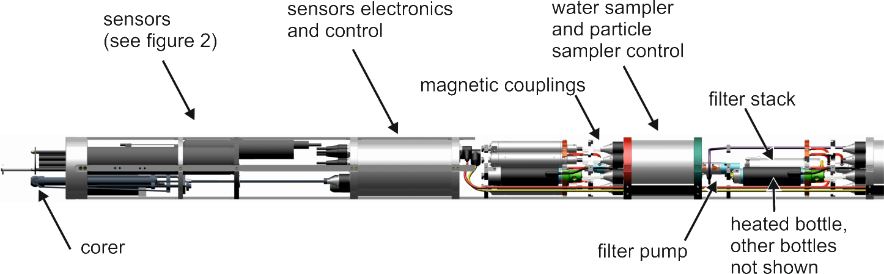

B)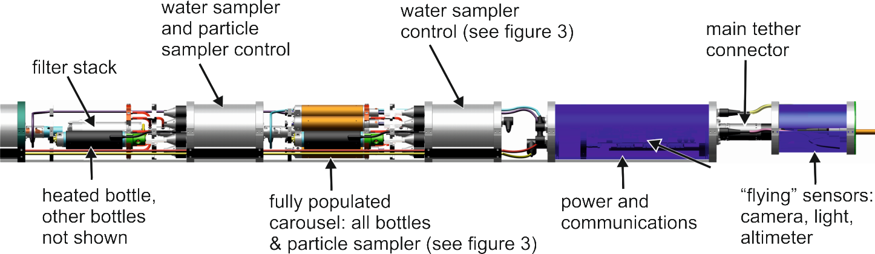

Figure 1 3D CAD rendering of the probe developed for the SLE 2012/13 field campaign depicted in two sections A) lower portion, and B) upper portion. The heated bottle and filter stack for the middle carousel is shown in both A) and B). The probe which includes (left to right): Visual altimeter gauge; the short piston corer with active core catcher; sensors module (see figure 2); three water sampling carousels (see figure 3) of which the bottles in the upper two (B) right) enclose particle samplers (see figure 3); power, communications and control unit; upper “flying” sensors pack

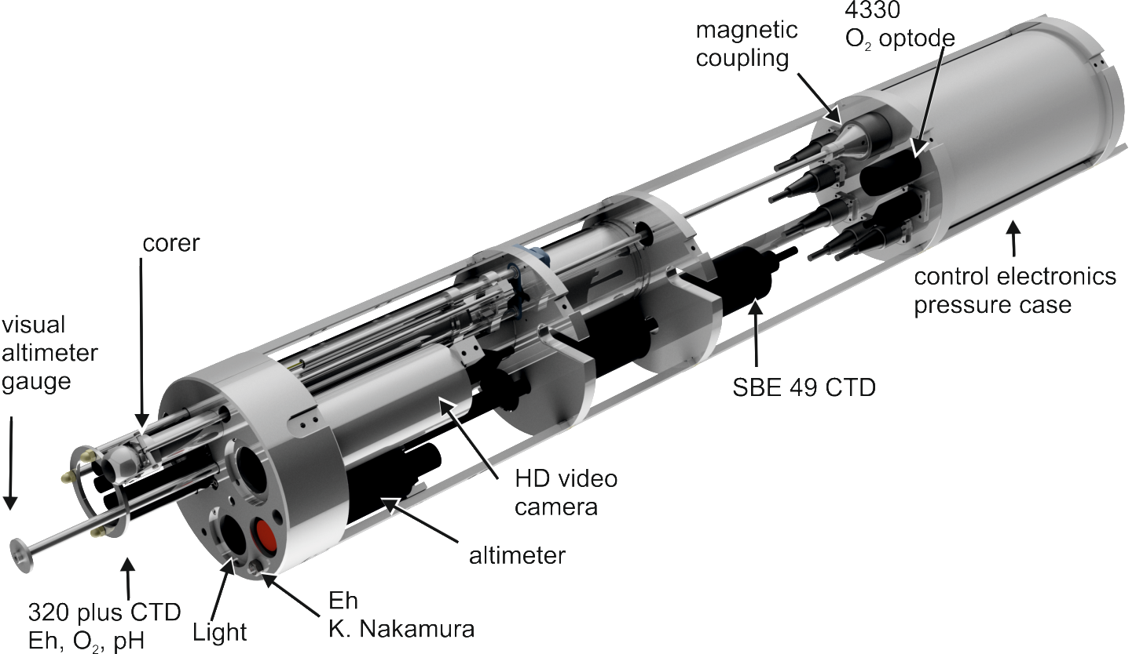
Figure 2 3D CAD rendering of the sensors module at the tip of the probe (cables and two stiffening bars not shown for clarity) which includes: a short (200 mm travel) piston corer (Keen Marine, UK / NOC) with active core catcher (ball valve); HD Video (IK-HR₁P, Toshiba, Japan in custom housing); light (bespoke but includes a 40 W cool white light LED LEDENGIN LZC_C₀CWC₀); Altimeter (PA200, Tritech, UK); Integrated CTD, Eh and O₂ sensor (320 Plus, Idronaut, Italy); duplicate CTD ( SBE 49, Seabird, USA); and duplicate O₂ sensor (4330, Aanderaa, Norway)
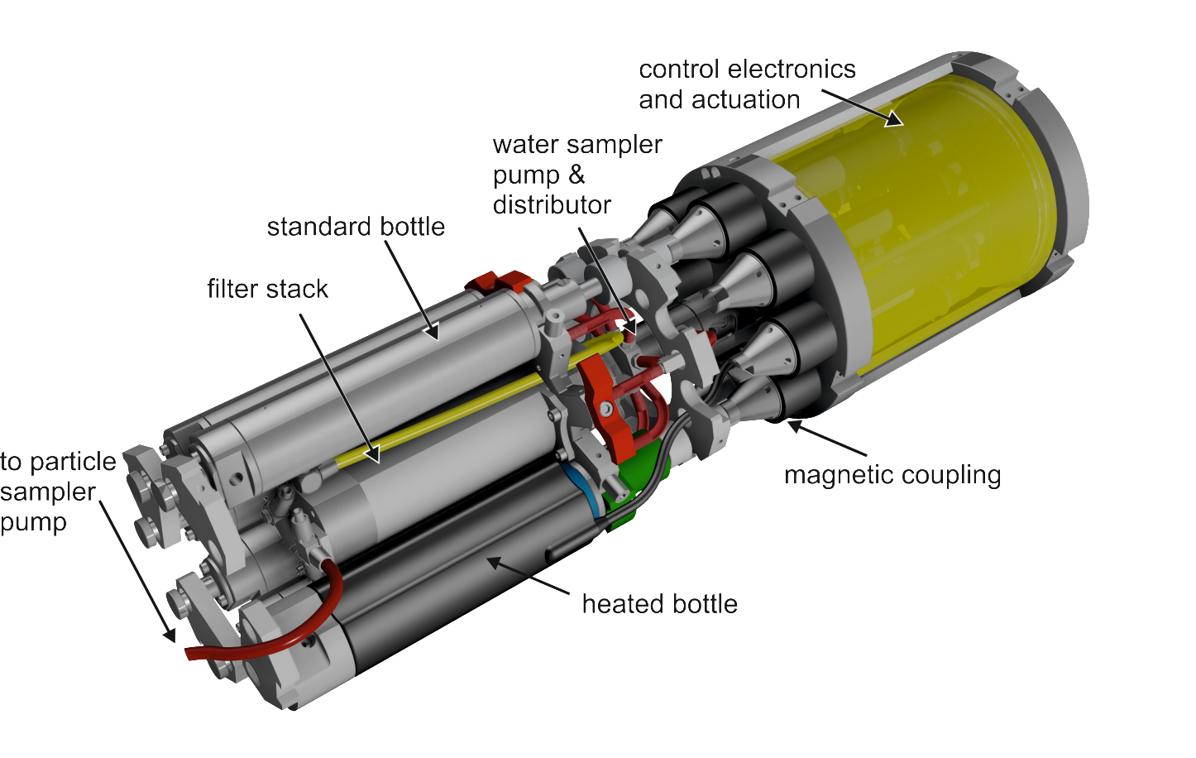
Figure 3 3D CAD rendering of the water and particle samplers or “carousel”.
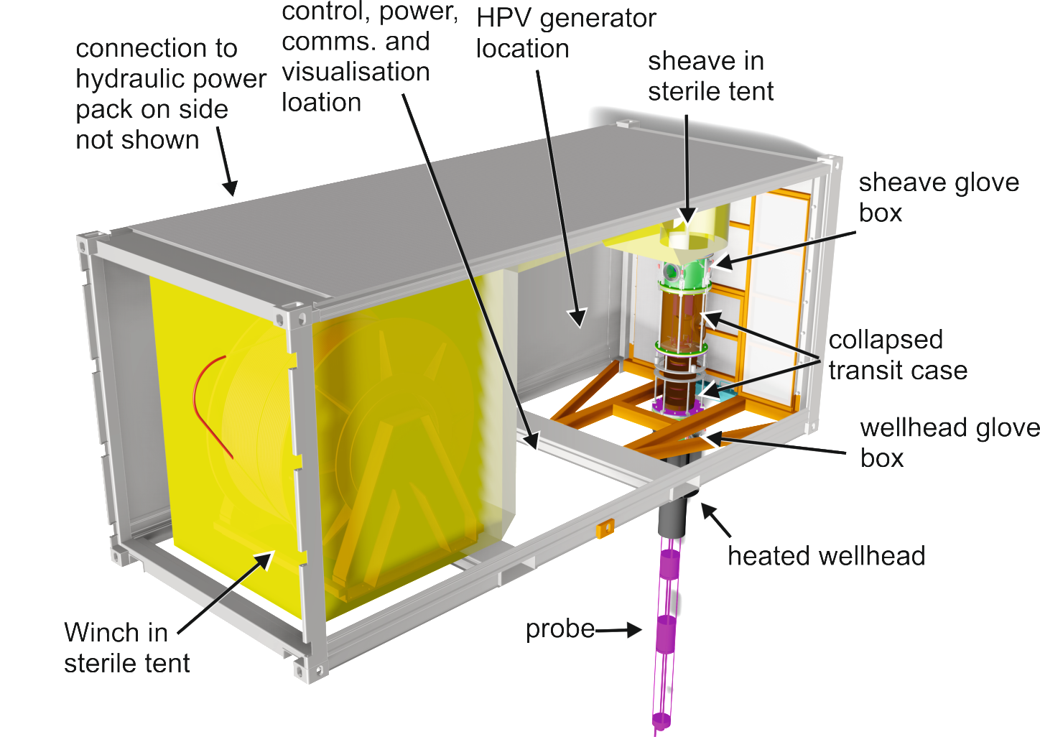
Figure 4 3D CAD rendering of the container that houses the winch, winch control, sheave, tether, HPV unit, power supplies, electronic control and visualisation tools. Power for the winch is supplied by an external hydraulic power pack (The Hydraulic Company, UK) which is not shown.
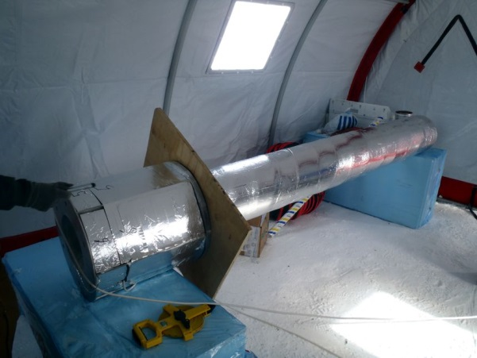
Figure 5 Photograph of the stainless steel wellhead section with heat trace and insulation applied.
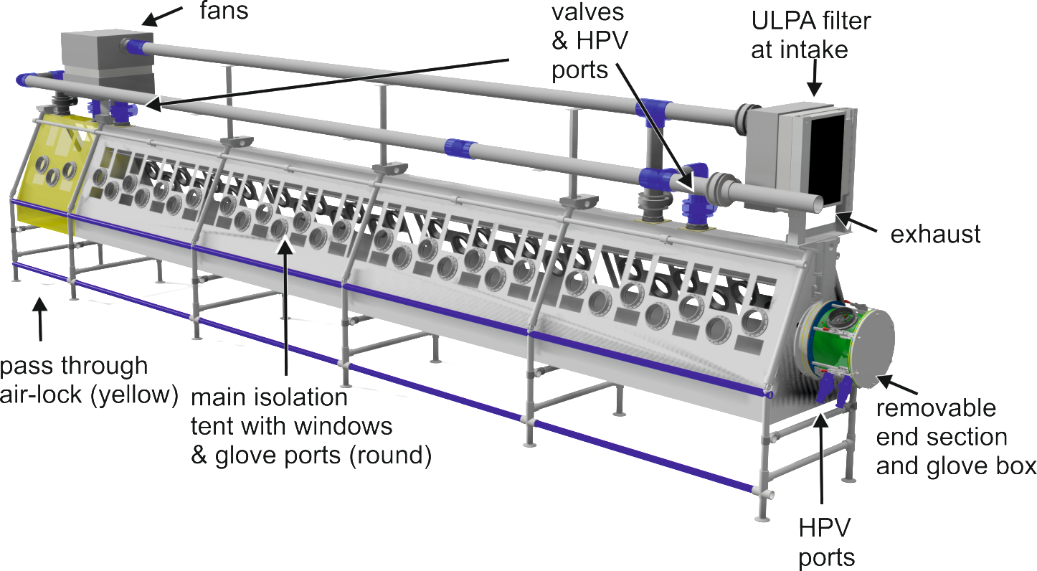
Figure 6 3D CAD rendering of the cleaning system which consists of an isolation tent with windows and glove ports (arrowed), an additional tent section acting as a pass through air-lock, mechanical supports for the tent and instruments, an air and HPV system including ULPA filters, glove box (arrowed) and zips (not shown) to enable access and sealing.

http://www.antarctica.ac.uk//about_antarctica/environment/bas/subglacial_lake_ellsworth_final_cee.pdf
http://downloads.royalsociety.org/events/2015/03/subglacial-antarctic-lakes/bulat.mp3

