Connectivity in the cold: the comparative population genetics of vent-endemic fauna in the Scotia Sea, Southern Ocean.

C.N. Roterman^{a*}, J.T. Copley^{b}, K.T. Linse^{c}, P.A. Tyler^{b}, A.D. Rogersª

a Department of Zoology, University of Oxford, South Parks Road, Oxford, OX1 3PS, UK
b Ocean and Earth Science, University of Southampton, Waterfront Campus, Southampton, SO14 3ZH, UK
c British Antarctic Survey, High Cross, Madingley Road, Cambridge, CB3 0ET, UK

* Corresponding author: christopher.roterman@zoo.ox.ac.uk

Keywords: Hydrothermal Vents, Southern Ocean, Kiwa, Gigantopelta, Lepetodrilus, Connectivity

Running Title: Connectivity of vent-endemic fauna in the Scotia Sea

Abstract

We report the first comparative population genetics study for vent fauna in the Southern Ocean using cytochrome C oxidase I and microsatellite markers. Three species are examined: the kiwaid squat lobster, Kiwa tyleri, the peltospirid gastropod Gigantopelta chessoia and a lepetodrilid limpet, Lepetodrilus sp. collected from the E2 and E9 vent fields 440 km apart on the East Scotia Ridge (ESR) and from the Kemp Caldera on the South Sandwich Island Arc, 95 km east of E9. We report no differentiation for all species across the ESR, consistent with panmixia or recent range expansions. The absence of population structure is particularly noteworthy for Kiwa tyleri, which exhibits extremely abbreviated lecithotrophic larval development, suggestive of a very limited dispersal range. Larval lifespans and dispersal range, may, however, be enhanced by low temperature-induced metabolic rate reduction in the Southern Ocean, muting the impact of dispersal strategy on connectivity. Patterns of COI diversity suggest all species experienced demographic bottlenecks on the ESR at different times; perhaps reflecting different intrinsic sensitivities to past geological and hydrographical changes. The divergence of the ESR and Kemp limpets, possibly indicative of insipient speciation, along with the absence of the other two species may be the consequence of depth disparity, differing dispersal capabilities and/or different selective regimes between the two areas. Estimates of historic and recent limpet gene flow between the ESR and Kemp are consistent with an easterly current flow in the region and potentially therefore, cross-axis currents on the ESR, with biogeographic implications for the region.
Introduction

Hydrothermal vents, found on mid-ocean ridges (MORs), back-arc spreading basins and volcanically active seamounts, host high densities of megafauna sustained by chemosynthetic bacteria; unlike most of the deep-sea, which is food limited (Gage & Tyler 1992). Vent fields can be conceived of as habitat patches, separated by tens to hundreds of kilometres of deep-sea floor. Such patches are considered ephemeral, lasting decades to millennia, as geothermal heat sources are disrupted by plate tectonic movements and eruptions can suddenly resurface fields with fresh basalt (Van Dover 2000).

This habitat patchiness and ephemerality necessitates the maintenance of vent metapopulations by larval dispersal between fields, making vent fauna ideal candidates for examining the way realised larval dispersal affects genetic connectivity and diversity in benthic marine metapopulations in general (Jollivet et al. 1999; Vrijenhoek 1997; 2010). Despite this common requirement, there is a surprising diversity of dispersal strategies, which appears phylogenetically constrained (Tyler & Young 2003). The historical paradigm has held that lecithotrophic larvae have a more limited dispersal range compared to planktotrophic larvae as their planktonic larval duration (PLD) is limited by the size of their nutritional reserves (Jablonski & Lutz 1983). The evidence for a correlation between dispersal strategy, PLD, species range and population structure in the marine environment (both at vents and in general), however, is equivocal (Creasey & Rogers 1999; Weersing & Toonen 2009; Vrijenhoek 2010; Selkoe & Toonen 2011; Faurby & Barber 2012; Mercier et al. 2013). Dispersal strategy may therefore be unreliable as a predictor of species range and patterns of population structure, with other factors (e.g. temperature, hydrography, habitat patchiness and sea floor topography) having an equal or greater impact. For example, vent fauna producing planktotrophic larvae have yet to be reported from polar regions (Pedersen et al. 2010; Rogers et al. 2012; Hahm et al. 2015) and it has been suggested this is the consequence of the extreme seasonality of food supply in high latitude surface waters (Pearse et al. 1991; Rogers et al. 2012).

The same factors affecting population structure will also affect the genetic diversity of vent metapopulations. Greater site occupancy and lower vent field ephemerality along a ridge should result in greater genetic diversity, owing to a reduced likelihood of demographic bottlenecks; a pattern observed on the East Pacific Rise (EPR) (Vrijenhoek 2010). The near ubiquitous presence of star-like mtDNA haplotype networks (and negative Tajima’s D, Fu’s Fs) amongst vent-endemic fauna, consistent with recent demographic expansions following bottlenecks, likely reflects the general state of demographic instability in vent metapopulations subject to stochastic changes in site occupancy along MORs (e.g. Plouviez et al. 2009; 2013; Teixeira et al. 2010).

Since the discovery of vents in 1977 (Corliss et al. 1979), the East Pacific has been the focus of population genetics studies (summarised by Vrijenhoek 2010) but more recently, research has extended to other areas in the Pacific, Atlantic, Indian and Southern oceans (Thaler et al. 2011; Teixeira et al. 2012; Chen et al. 2015a; b). Few studies, however, involve multiple species comparisons (Plouviez et al. 2009; Thaler et al. 2014), which can provide insights into the ways life history traits affect vent-endemic populations in the face of present and past geophysical conditions. In this study we report the first multi-species population genetics data for vent fauna in the Southern Ocean, featuring the entire known distribution range of three recently discovered species in the Scotia Sea: the kiwaid squat lobster, Kiwa tyleri (Thatje et al. 2015a), the peltospirid gastropod, Gigantopelta chessoia (Chen et al. 2015b) and a lepetodrilid limpet, Lepetodrilus sp.

Setting

The East Scotia Ridge (ESR) is an isolated back-arc spreading ridge, which is divided into nine segments (E1–E9) and spans ~500 km in the Scotia Sea (Fig. 1A). Black smoker hydrothermal venting, hosting dense assemblages of macrofaunal species, has been observed on the E2 and E9 segments, which are ~440 km apart (Rogers et al. 2012). These two segments are character-ized by shallow (~2500 m depth), axial highs (Fig. 1B) indicating the presence of underlying buoyant magma plumes related to their proximity to the subducting South American plate (Baker et al. 2005; Livermore 2006). In contrast, segments E3–E9 have deep (~3500–4500 m depth) axial valleys indicating an absence of such magmatic plumes. The presence of conﬁrmed venting only at the topographical highs of the E2 and E9 segments may indicate that venting is largely restricted to such shallow sites and is rare on other ridge segments, although the signature of a hydrother-mal plume has been detected over the shallowest por-tion of the E5 segment (Baker et al. 2005; Livermore 2006). Consequently, dispersal stepping stones between E2 and E9 may be few and far between for vent-endemic fauna.
Only 95 km to the east of E9 are shallower vents (~1400 m depth) recently discovered within the Kemp Caldera (herein referred to as Kemp), part of the South Sandwich Island (SSI) volcanic back-arc system (Rogers 2010) (Fig. 1A). These vents are situated on a volcanic subcone within a 7-km-wide caldera, the rim of which rises to ~800 m depth, potentially isolating their inhabi-tants from ocean currents (Fig. 1C). Observations of ash and sulphur deposits (Rogers 2010) and extremely high [H2S] in the vent ﬂuid (~200 mM) indicate a very recent volcanic ‘blow-out’ event occurred (Cole et al. 2014). Sulphur-coated white smoker chimneys were largely devoid of fauna, and of the three study species, only Lepetodrilus sp. was found on hard substrata adjacent to the venting, with the other two study species absent.
The easterly ﬂowing Antarctic Circumpolar Current (ACC) dominates the current regime of the Southern Ocean. Within the Scotia Sea, cold bottom waters (<0 °C) around the ESR and SSI are a mix of Weddell Sea Deep Water and variants of Circumpolar Deep Water, gener-ally ﬂowing east or northeasterly (Fig. 1) (Orsi et al. 1999; Naveira-Garabato et al. 2002; Meredith et al. 2008). Strong, cross-axis currents have been measured on the E9 segment, consistent with this picture (Larter 2009).

The possible combination of few dispersal stepping stones with cross-axis currents along portions of the ESR could limit connectivity along the ESR to a greater extent than equivalent distances along other ridges.

Study species
The study species were chosen on the grounds of being the most visually and numerically dominant immediately adjacent to venting chimneys. On the ESR, kiwaid ‘crabs’ were observed closest to venting ﬂuid on the sides and bases of chimneys (Rogers et al. 2012) at densities exceeding 700 m􀀀2 (Marsh et al. 2012). These anomuran crustaceans belong to a recently discovered family of chirostyloid squat lobsters found only in deep-sea chemosynthetic ecosys-tems (Macpherson et al. 2005; Schnabel & Ahyong 2011; Roterman et al. 2013b). The dorsal surface of Kiwa tyleri features a dense covering of hair-like setae supporting chemosynthetic microbial episymbionts, which appears to be their principle source of nutrition (Reid et al. 2013; Thatje et al. 2015a). Kiwa tyleri females produce few (~200), but very large (~1800 lm diameter) eggs, which are likely brooded for an extended period (>18 months) (Marsh et al. 2015). Freshly hatched zoea larvae resemble functional, non-buoyant, nonswimming megalopa, with large yolk reserves sufﬁcient for extended food-independent development (>1 year) (Thatje et al. 2015b). Kiwa tyleri appears therefore to exhibit the most abbreviated development known among crab-like decapods, (Thatje et al. 2015b), suggesting a reproductive strategy geared towards high maternal investment in offspring and larval retention close to the natal site (Marsh et al. 2015; Thatje et al. 2015b). Owing to the inability of reptant decapods to downregulate [Mg2⁺] in temperatures approaching 0 °C leading to narcotization (Frederich et al. 2001), individuals may be restricted to a narrow thermal envelope around the vent efﬂuent, preventing the dispersal of adults (Thatje et al. 2015a).
Next to the kiwaid assemblage at densities exceeding 1500 m⁻², were large peltospirid gastropods Gigantopelta chessoia, which along with G. aegis and the scaly-foot gastropod Chrysomallon squamiferum are the only known gastropods to house endosymbiotic bacteria in an enlarged oesophageal gland (Chen et al. 2015b,c). Lit-tle is presently known of their life history, but their pro-toconch morphology is consistent with lecithotrophic dispersal (Chen et al. 2015c), as are examinations of East Paciﬁc peltospirid oocytes (Tyler et al. 2008; Matabos & Thiebaut 2010).
Lepetodrilus sp. limpets were the most numerous of the study species (>50 000 m􀀀2 at E9; Leigh Marsh, per-sonal communication) and found at all three sites apparently grazing on the microbial ﬁlms growing adja-cent to vent efﬂuent. Lepetodrilid limpets are com-monly found at hydrothermal vents and sometimes also at other chemosynthetic habitats such as hydrocarbon seeps and whale carcasses (Johnson et al. 2008; Amon et al. 2013), making them potentially the most habitat ﬂexible of the study species. Unlike those on the ESR, the Kemp limpets exhibited evidence of shell corrosion (Katrin Linse, personal communication). Lepetodrilus spp. females produce numerous (up to ~1800) small (<90 lm diameter), actively swimming lecithotrophic larvae (Lutz et al. 1986; Tyler et al. 2008). Both lepetodrilid and peltospirid larvae have been found in the buoyant hydrothermal plume and close to the seaﬂoor around vents in the Paciﬁc, indicating a capacity for long-range dispersal along currents entrained by ridge axes (Mullineaux et al. 1995, 2005).

Aims and Expectations

This study, characterises the population genetics of the three study species at hydrothermal vents in the Scotia Sea using mitochondrial sequences and custom-designed microsatellite markers. It provides an opportunity to examine the patterns of population structure, gene flow and genetic diversity of fauna inhabiting hot vents surrounded by frigid water. Based on what is known about the dispersal strategies of the three species, it was expected that Kiwa tyleri would exhibit population structure along the ESR, owing to its extremely abbreviated larval development, whereas the two gastropod species would be less likely to exhibit structure. The limpets at Kemp were expected to be divergent from those on the ESR (and with a smaller effective population size), owing to the presumed topographical isolation of the caldera, with the historical direction of gene ﬂow reﬂecting the predominantly west-to-east current regime. As is the case for nearly all vent-endemic fauna, the three species were expected to exhibit evidence of demographic change associated with the inherent demographic instability of vent metapopulations.

Materials and Methods

Sampling and DNA Extraction

Aggregations of macrofauna were sampled with a ‘slurp gun’ from the sides and bases of chimneys using the remotely operated vehicle ISIS, which was deployed from the Royal Research Ship James Cook during the JC042 expedition (Rogers 2010) (Table 1, Fig. 1). The chimneys sampled at E2 were ~30 m apart and those at E9, ~450 m apart. All individuals within a sample were collected from the same location within a few metres of each other. Fresh tissue (gastropod foot and kiwaid pereopod muscle) was excised, placed in Corning 5 mL cryotubes in 96% ethanol and stored at 􀀀20 °C. Total genomic DNA was extracted from the tissue using the Qiagen DNeasy Blood and Tissue Kit (Cat. 69506).

COI Sequencing and Analyses

PCR Reactions were performed in 9 µl volumes on a Bio-Rad C1000 Thermal Cycler containing 0.6 µl of each primer (forward and reverse) at a concentration of 4 pmol/µl, 6 µl of Qiagen HotStarTaq Master Mix, 1.5 µl of DNA template (~50-100 ng/µl) and 0.3 µl of double-distilled water. Universal invertebrate primers, LCO1490 and HCO2198 (Folmer et al. 1994) were used to amplify COI from K. tyleri and G. chessoia, yielding fragments ~500 bp in length. For G. chessoia, this dataset is an augmentation of a smaller dataset of sequences in Chen et al. (2015). For Lepetodrilus sp., new specific primers, LepESR-F (5’-TAACGATATGCGTTGACCATT-3’) and LepESR-R (5’-ACCCGGGAAGAATCAGAATA-3’) were designed using a COI fragment template generated by Leese et al. 2012). This primer may be effective with other members of the genus. All PCR reactions were performed as follows: initial HotStarTaq denaturation at 95 ˚C for 15 minutes, followed by 40 cycles of 94 ˚C for 45 seconds, 50 ˚C for 1 minute, 72 ˚C for 1 minute and a final extension of 5 minute at 72 ˚C. Sequences were deposited in GenBank (Acc# KU312406–KU312689).

Descriptive diversity statistics as well as pairwise F_{ST} values indicating the degree of genetic differentiation between sample sites (10⁵ permutations) were calculated in Arlequin 3.5.1.3 (Excoffier & Lischer 2010). To test for demographic history, Fu’s Fs test (Fu 1996) and mismatch distributions assessed with Harpending’s raggedness index (Hri) (Rogers & Harpending 1992), both with 10⁴ bootstrap replicates, were implemented in Arlequin. Median-Joining networks, representing the most parsimonious relationships between haplotypes were calculated using Network 4.6.1.1 (Bandelt et al. 1999).

To date possible genetic bottlenecks, Bayesian Skyline Plots (BSPs) reconstructing demographic histories based on inferred genealogies to the coalescent (Ho & Shapiro 2011), were generated in Beast 1.8.2 (Drummond & Rambaut 2007) for populations as defined by F_{ST}. All analyses ran for 10⁷ Markov Chain Monte Carlo (MCMC) generations with 10% discarded as ‘burn-in’. Genealogies and model parameters were sampled every thousand generations and analyses were replicated twice to ensure consistent results. Both runs were then combined using LogCombiner 1.8.2 (Drummond & Rambaut 2007) to estimate parameters. The model of evolution for each population was chosen with PartitionFinder (Lanfear et al. 2012), which uses a maximum likelihood approach to determine the best-fitting model of evolution to a sequence alignment, using both the Akaike information criterion (AIC) and the more conservative Bayesian information criterion (BIC) (Minin et al. 2003). Both criteria favoured the Tamura-Nei model with invariant sites for all three species as well as gamma-distributed rate variation among sites for the kiwaids.

Bayesian Skyline Plots runs were calibrated with taxon-centric COI substitution rates generated from the divergence of vent-associated geminate species either side of the Easter Microplate on the Southern East Paciﬁc Rise (SEPR) under a strict molecular clock model. The microplate formed ~5.25–2.47 Ma (Naar & Hey 1991; Rusby & Searle 1995), with a mean age of 3.86 Ma. For K. tyleri, the 7.3% divergence of Bythograea spp. brachyuran crabs (Guinot & Hurtado 2003) gave a rate of 9.45596 9 10􀀀9 substitutions/locus/year. For G. chessoia, a neomphaline gastropod-speciﬁc substitu-tion rate of 1.45078 9 10􀀀8 was estimated based on the 11.2% divergence of Pachydermia spp. (Matabos et al. 2011), and for the limpet, a Lepetodrilus-speciﬁc rate of 1.0583 9 10􀀀8 was used based on the 8.17% divergence of the L. pustulosus species complex (Johnson et al. 2008). BSP reconstructions were visualized in TRACER 1.5 (Rambaut & Drummond 2007).

Microsatellite Genotyping and Analyses

Microsatellite markers developed by Roterman et al. (2013) were used in this study: nine loci for K. tyleri, 12 loci for G. chessoia and 14 loci for Lepetodrilus sp.. All loci were amplified in singleplex reactions with 6-Fam tagged forward primers as per PCR protocols in Roterman et al. (2013). Size-fragment analyses of the PCR products were conducted on an ABI 3730xl DNA analyser. Chromatograms were scored using Peak Scanner 1.0. Genotyping error rates were calculated by comparing 24 individuals with those same individuals genotyped in Roterman et al. (2013). Diversity statistics as well as tests for deviation from Hardy-Weinberg Equilibrium (HWE) and linkage disequilibrium (LD) were generated with Arlequin and corrected for multiple comparisons using the sequential Bonferroni approach (Rice 1989). Allelic richness was calculated with Fstat 2.9.3.2 (Goudet 1995). LD was examined with a likelihood ratio test (10⁴ permutations) and an exact test of HWE was performed (10⁶ Markov chain steps and 10⁶ dememorisation steps). Presence of null alleles, excessive stutter and large allele dropout were assessed using MicroChecker (10³ randomisations) (van Oosterhout et al. 2004). Loci were screened using LOSITAN (Antao et al. 2008) to test for the potential influence of selection by an F_{ST} outlier method (Beaumont & Nichols 1996). 10⁶ simulations were performed, with the Infinite Alleles mutational Model (IAM) as well as the Stepwise Mutational Model (SMM). Significance was set at the 95% confidence level with a false discovery rate of 0.1. Microsatellite markers showing deviations from HWE expectations were discarded from subsequent analyses with the exception of BayesAss, which does not require loci to be in HWE (Wilson & Rannala 2003). Loci deemed under selection were excluded from F_{ST}, Ima2 and demographic analyses, but not STRUCTURE and BayesAss as the assumptions of these assignment methods are not violated (Pritchard et al. 2000; Wilson & Rannala 2003).

Pairwise F_{ST} and R_{ST} analyses (the microsatellite equivalent of F_{ST} incorporating the SMM) were performed in Arlequin (10⁵ permutations). Compound loci were excluded from the R_{ST} analyses, as motif repeat numbers are unknown. To test the number of distinct populations represented in this study for all three species, STRUCTURE 2.3.4 (Pritchard et al. 2000) was used with an admixture ancestry model and correlated allele frequencies both with and without sample locations as priors. STRUCTURE allows loci under selection to be used, but not loci that are not in HWE. Location priors can help tease apart fine structure with weak data, but can distort individual assignments if populations are more divergent (Hubisz et al. 2009). Analyses were based on a 2 x 10⁵ step ‘burn-in’ with 2 x 10⁶ MCMC steps. Five replicates were run for each K (number of populations) from K = 1 to 5. The best K was determined by using the median ln(Pr(X|K) values to calculate Pr(K=k) as suggested by the software developers (Pritchard et al. 2000) in combination with the ∆K method of Evanno et al. (2005). Best K was calculated using the CLUMPAK server (Kopelman et al. 2015).

Contemporary gene flow (within the last couple generations) between differentiated populations (as determined by F_{ST}, R_{ST} and STRUCTURE) was estimated with BayesAss 3.03 (Wilson & Rannala 2003), which uses an assignment method within a Bayesian MCMC framework to estimate an immigration rate as the fraction of individuals in population ‘A’ from population ‘B’ etc. Additionally, the software designates likely migrants as either first or second generation with accompanying probabilities. Three runs, each with 2 x 10⁷ iterations and a ‘burn-in’ of 2 x 10⁶ were performed with different random number seeds, with the average was taken. DeltaA, DeltaF and DeltaM (mixing parameters for allele frequencies, inbreeding coefficients and migration rates respectively) were set to 0.2, 0.35 and 0.15 respectively. Long-term gene flow between differentiated populations in the form of M, the mutation rate-scaled per generation immigration rate going back to the coalescent, was estimated within an isolation-with-migration model with IMa2 on a combined COI and microsatellite dataset (Hey 2010), whereby bi-directional gene flow is modeled between divergent populations subsequent to their splitting from an ancestral population. In addition to M, IMa2 estimates the mutation-rate scaled effective population size (θ) of the sampled and ancestral populations as well as the splitting time, τ. Initial short IMa2 runs were performed to optimize model parameters and find reasonable priors for MCMC search efficiency. The following uniform prior limits were used in final runs: θ = 150, M= 5, and τ = 10. Eighteen independent analyses (using random number seeds), each with 100 geometrically heated chains, were run for 2 x 10⁶ steps (genealogy sampling every 100 steps, yielding 2 x 10⁴ trees) with the length of ‘burn-in’ determined by the scrutiny of trend plots printed every six hours. Final burn-in lengths for the runs were ~1.5 x 10⁶ steps per independent run. Final run trend plots assessed to ensure that results were consistent between runs. The maximum of 3 x 10⁵ sampled genealogies were then combined in L-mode and the significance of inferred immigration rates tested using likelihood-ratio tests (LLR) (Nielsen & Wakeley 2001).

BOTTLENECK 1.2.2 (Cornuet & Luikart 1996) was used to test for recent bottlenecks or phases of expansion, by assessing the mismatch between expected heterozygosi-ties estimated from the allele frequencies (He) and heterozygosities estimated from the number and spread of alleles (Heq) based on the assumption of mutation–drift equilibrium and a speciﬁc mutational model. Two models were used (104 permutations): the SMM and the two-phase model (TPM) incorporating 5% IAM, which has been shown to be closer to real world observations of microsatellite evolution (Di Rienzo et al. 1994). Com-pound loci were discarded for these analyses as the SMM requires the motif repeat number to be known.

Results

Population Diversity and Structure

A total of 79 COI haplotypes from a 642-bp alignment were recovered from 90 Kiwa tyleri individuals across the ESR. Consequently, haplotype diversity (h) was very high: 0.998 both at E2 and at E9. h values from a 437-bp alignment of 84 Gigantopelta chessoia individuals (24 haplotypes) were lower with 0.865 and 0.855 at E2 and E9, respectively. For a 618-bp alignment of Lepetodrilus sp., 36 haplotypes accounted for the diversity of 140 individuals across E2, E9 and Kemp with h values of 0.614, 0.743 and 0.85 for E2, E9 and Kemp, respectively (Table 2). There was no evidence for population differ-entiation with the COI dataset between E2 and E9 for all three species in this study, although there was strong evidence for a divergence between the ESR and Kemp limpet populations, with FST > 0.45 (Table 3) and few haplotypes shared between the ESR and Kemp (Fig. 2). All substitutions between the ESR and Kemp limpets were third codon synonymous substitutions. All but four individuals at Kemp (F622_3, F622_19, F622_26, F622_28) shared an A-G substitution at COI alignment position 87 that was exclusive to Kemp.
Microsatellite regenotyping of 24 individuals from Roterman et al. (2013) revealed mean error rates across loci per species of 2.3%, 3.1% and 2.9% for Kiwa tyleri, Gigantopelta chessoia and Lepetodrilus sp. respectively. In total, 35 microsatellite loci were amplified: nine for Kiwa tyleri (one compound locus), 12 for Gigantopelta chessoia (two compound loci) and 14 for Lepetodrilus sp.. Observed heterozygosity was slightly lower than expected heterozygosity for all species and sites and allelic richness values were similar at the two ESR locations. Kemp limpet allelic richness was lower than on the ESR sites (Table 2). No loci were linked according to LD pairwise tests and only one locus, LepESR_06, significantly deviated from HWE with heterozygote deficiency (Table S3, Supplementary Materials) after correction for multiple tests, where null alleles were also detected with MicroChecker. No selection was detected with Kiwa tyleri and Gigantopelta chessoia, however, four Lepetodrilus sp. loci were found to be under balancing selection (LepESR_02, LepESR_05, LepESR_07 and LepESR_14) and one under directional selection (LepESR_10). Additionally, under the SMM, another locus was found to be under directional selection (LepESR_11) (Table S4, Supplementary Materials).

Pairwise R_{ST} analyses revealed no pattern of microsatellite differentiation on the ESR for all three species (Table 3). However, significant differentiation was detected between Kemp and ESR lepetodrilids with R_{ST} values in excess of 0.29 respectively (with similar F_{ST} values; Table S5, Supplementary Materials). Structure analyses (Table S6, Supplementary Materials) supported this finding for the limpets: both the ∆K method of Evanno et al. (2005) and the method using the median ln(Pr(X|K) values to calculate Pr(K=k) (Pritchard et al. 2000) determined K = 2 to be the best number of populations, with ESR individuals belonging to one population (Fig. 3). For the kiwaids and peltospirids, the Pritchard et al. (2000) method supported K = 1, echoing the pairwise R_{ST} results. However, the ∆K method, which cannot detect the best K if K = 1 (Evanno et al. 2005), supported K = 2 along the ESR. Examination of STRUCTURE bar plots showing the estimated membership coefficients for each individual under the K = 2 model revealed no pattern between E2 and E9 with all individuals assigned equally to both populations (Fig. S2, Supplementary Materials). Consequently the K = 2 estimate according to the ∆K method was rejected in favour of K = 1 for Kiwa tyleri and Gigantopelta chessoia.

Gene flow estimates

Estimates of gene flow were only conducted between ESR and Kemp limpets owing to a lack of differentiation for all three species on the ESR. BayesAss analyses revealed the contemporary per generation ESR-Kemp mean immigration rate was 0.028, whereas the Kemp-ESR immigration rate was 0.004 (Table S7, Supplementary Materials). The individual assignments indicated that individuals F622_3, F622_19 and F622_28 may be first generation migrants from the ESR (mean posterior probabilities of 0.81, 0.96 and 0.88 respectively) (Table S8, Supplementary Materials). In IMa2 analyses (seven microsatellite loci plus COI), the Lepetodrilus sp. COI substitution rate used for calibrating the analyses was based on the divergence (8.17 %) of L. pustulosus across the Easter Microplate, which formed 3.86 Ma (2.47-5.25 Ma) (Naar & Hey 1991; Rusby & Searle 1995) giving a mean rate of 6.40415 x 10⁻⁶ (4.70857 x 10⁻⁶–1.00081 x 10⁻⁵) substitutions per gene per year. Trace outputs did not reveal any trends and estimated parameters were unimodal (Fig. 4). θ for the ancestral population as well as splitting time did not reach zero at the upper prior boundary and therefore the mean and the highest posterior density interval may be unrepresentative (Fig. 4). Under the isolation with migration model, the ESR limpet population is inferred to be roughly five times larger than the Kemp population, though both populations are far smaller than the ancestral population (Table 4) since splitting from each other 1.68 Ma (0.36-7.26 Ma, 95% HPD). According to LLR tests, Kemp-ESR immigration rates (going forward in time) were non-significant, but ESR-Kemp rates were highly significant (P < 0.001) (Table 4) indicating long-term easterly gene flow since the splitting event.

Demography

With the COI dataset, Fu’s Fs were significantly negative for all species at all locations consistent with either a recent demographic expansion following a bottleneck, or a selective sweep. Mismatch distributions were largely unimodal for all three species at all locations (Fig. S1, Supplementary Materials). Hri scores for all species were non-significant; signifying the null hypothesis of exponential population expansion cannot be rejected. For the limpet and the peltospirid, median-joining networks revealed a distinctive star-like pattern (Fig. 2). A similar pattern was also noticeable with the kiwaid, however the number of equally parsimonious connections was too great for visualisation and one of several equally parsimonious trees was presented instead (Fig. 2). BSP plots for all three species (Fig. 2) modelled a pattern of demographic expansion within the last million years. Kiwa tyleri underwent demographic expansion ~500 Ka, with the peltospirid population expanded more recently at ~90 Ka. The Kemp limpets expanded ~130 Ka and the ESR population, ~50 Ka. Microsatellite BOTTLENECK analyses revealed a significant (P < 0.05) pattern of heterozygote deficiency relative to the heterozygosity estimated from the number and spread of alleles (H_{eq}) under SMM, for all three species (Table S9, Supplementary Materials), consistent with recent demographic expansion (Cornuet & Luikart 1996), although H_{eq} > H_{e} was not significant for the peltospirid under the TPM.

Discussion

ESR Connectivity

Both COI and microsatellite datasets reveal no differen-tiation for all three species across ~440 km of the ESR. These results are comparable to levels of differentiation found at similar scales on the EPR (Plouviez et al. 2009; Coykendall et al. 2011), although the ESR may have a lower density of vent ﬁelds in comparison (Livermore 2006). The absence of differentiation is consistent with either panmixia, or range expansions so recent as to have left no signature in the diversity of mtDNA haplo-types. This study, then, ﬁnds no correlation between dispersal strategy and patterns of population structure on the ESR. Although all the study species appear to produce lecithotrophic larvae, the kiwaid mode of lar-val development is so abbreviated as to be nearly direct, with large, passive larvae expected to have a very limited dispersal capability (Thatje et al. 2015b), making an absence of kiwaid population structure still surprising. These results therefore augment a body of evidence that so far has failed to show a particularly strong correlation between dispersal strategy and pat-terns of population structure in the marine environ-ment, and particularly in the deep sea (Creasey & Rogers 1999; Weersing & Toonen 2009; Vrijenhoek 2010; Selkoe & Toonen 2011; Faurby & Barber 2012; Mercier et al. 2013).

One factor that may help explain the unexpected absence of population structure in K. tyleri is the tem-perature regime of the Southern Ocean. Bottom temperatures encountered at the ESR were 􀀀1.3 to 0 °C (Rogers et al. 2012) and such low temperatures may boost lecithotrophic larval longevity by substantially slowing metabolic rate and arresting development, as demonstrated for the larvae of the vent polychaete Alvinella pompejana at 2 °C (Pradillon et al. 2001). Antarctic conditions could conceivably allow kiwaid larvae to survive for several years, as has been shown with echinoderm lecithotrophic larvae in laboratory conditions (Shilling & Manahan 1994). At such low temperatures, dispersal strategy may have little or no effect on PLD, in keeping with the ﬁndings of Mercier et al. (2013) on echinoderms from high latitudes. K. tyleri may have a dispersal strategy optimized for retention, justifying high maternal investment in individual off-spring, but where the low temperature of the Scotia Sea substantially extends the ‘tail’ on the dispersal kernel distribution, therefore enhancing interpatch connectivity through the long-range dispersal of a small subset of larvae.

Additionally, the density of vent ﬁelds and hence potential dispersal stepping stones along the ESR may be higher than is presently thought, facilitating dispersal. The detection of a hydrothermal plume on the dee-per E5 segment (Fig. 1B) (Baker et al. 2005; Livermore 2006) raises the possibility that other vent ﬁelds may yet be discovered on the E3–E8 segments in future surveys. Nevertheless, a higher density of vent ﬁelds along the ESR would still present a dispersal challenge for K. tyleri as nonswimming, demersal larvae would need to overcome the huge depth disparity between the E2 and E9 segments and the deep axial valleys of E3–E8. Higher vent density alone may therefore be insufﬁcient in accounting for apparent kiwaid panmixia on the ESR, without considering the effect of temperature-enhanced dispersal.

Kemp Caldera

Despite no evidence of differentiation along the ESR, limpet COI and microsatellite datasets revealed high levels of differentiation between the ESR and Kemp, which are only ~95 km apart. This level of differentiation could reﬂect the ~1000 m depth disparity between the sites (~1600 m if the caldera rim is included). Differentiation across isobaths has been observed in both vent and nonvent deep-sea fauna owing to either limited vertical migration of larvae, or adaptive divergence across depth gradients, such as pressure, temperature, salinity or food availability (e.g. France & Kocher 1996; Etter et al. 1999; Cho & Shank 2010; Vrijenhoek 2010; Quattrini et al. 2015). The absence of Kiwa tyleri and Gigantopelta chessoia from Kemp may be a consequence of this depth disparity, if their larvae cannot migrate as far vertically as the limpets, or the conditions at Kemp are beyond their physiological tolerances. Additionally, the greater range of habitats that host Lepetodrilus individuals (Johnson et al. 2008) may reﬂect their tolerance of a wider set of conditions (and therefore additional dispersal stepping stones) compared to the other study species.
The observations of corroded limpet shells and smaller mean size at Kemp suggests that these limpets may be experiencing physiological stress in the highly acidic and suboxic conditions. ESR-Kemp differentiation between the sites could therefore be the result of hydrothermal ﬂuid chemistries imposing different selective regimes at the sites, although the depth disparity itself may be enough.
Notably, STRUCTURE and BAYESASS analyses assigned three Kemp limpets (6.5% of those sampled) to the same pop-ulation as those on the ESR (Fig. 3 and Table S8, Sup-porting information). Such a level of immigration in the long term would be expected to prevent divergence between populations (Wright 1943) in the absence of selection. The two populations may therefore be under-going incipient speciation, with each population being adapted to different hydrothermal ﬂuid chemistries or other environmental conditions (e.g. temperature or pressure); hybrid offspring may be unviable, or ESR limpet adults are unable to produce eggs in the local conditions, for example. The fact that nearly half of the microsatellite loci of Lepetodrilus sp. were deemed under some form of selection by the FST outlier method (LOSI-TAN) supports this. Other (not mutually exclusive) pos-sibilities include the caldera being a reproductive sink for limpet larvae coming from the ESR and another nearby population, or that recent recolonization from these populations has occurred following defaunation after an eruption, with insufﬁcient time for admixture. Future sampling of Kemp limpets, as well as the dis-covery and exploration of vents nearby, may provide a clearer picture. Additionally, the use of high-through-put sequencing methods to generate genomewide single nucleotide polymorphism datasets, such as restriction site-associated DNA sequencing (RAD seq) (e.g. Reitzel et al. 2013) offers the prospect of identifying speciﬁc genes that are experiencing selection, which may pro-vide insights into the ways that different environmental conditions impact hydrothermal vent organisms surviv-ing at physiological extremes. Furthermore, it has been suggested that comparing populations that are geo-graphically close, but experiencing different environ-mental conditions (e.g. ESR and Kemp lepetodrilids) is the ideal way to use the FST outlier method to detect the effects of selection on population differentiation (Lotterhos & Whitlock 2015).

Limpet Gene Flow Estimates

The results of the IMA2 analysis revealed a pattern of unidirectional gene ﬂow from the ESR to Kemp (going forwards in time) since the splitting of a hypothesized ancestral population during the Plio-Pleistocene, simi-lar to the BAYESASS estimates indicating predominantly easterly contemporary gene ﬂow. These geneﬂow esti-mates are consistent with inferences of broadly east-erly current ﬂow in the deep waters of the eastern Scotia Sea, (Orsi et al. 1999; Naveira-Garabato et al. 2002; Meredith et al. 2008) indicating that cross-axis currents may be common on portions of the ESR, as was observed on the expedition JCR224 (Larter 2009). It should be noted, however, that the association
between past and present current regimes and long-and short-term gene ﬂow is often unclear (Hellberg 2009). Additionally, the inferred splitting age pro-duced in IMA2 should be treated with caution, as the substitution rate used is probably highly conservative; rapidly evolving genes like COI are likely to be satu-rated when vicariance events are used in calibrating processes occurring on population genetics timescales. Thetruerate may thereforebeas muchas anorder of magnitude faster (Ho et al. 2011) and the same goes for the BSP estimates of bottleneck ages discussed below.

Diversity and Demography

Signiﬁcantly negative Fu’s Fs, unimodal mismatch dis-tributions and star-like haplotype networks in the COI dataset, along with the results of microsatellite BOTTLE-NECK analyses, are consistent with all three species hav-ing experienced recent demographic bottlenecks followed by population expansions. This pattern is nearly universal in vent-endemic fauna and may reﬂect the inherent demographic instability of metapopulations spanning ephemeral vent ﬁelds (Vrijenhoek 2010). Selec-tive sweeps at the COI locus can also result in similar patterns, but studies combining mitochondrial and nuclear sequence datasets of vent-endemic species reveal similar patterns of diversity across all loci (Plouviez et al. 2010; Coykendall et al. 2011).
A notable feature of Lepetodrilus sp. is that the ESR sites have lower COI diversity, but higher microsatellite allelic richness than at Kemp, which could be indicative of a selective sweep at the COI locus on the ESR. Such a selec-tive sweep on the mitochondrial locus could also account, through genetic hitching, for the absence of any ESR individuals with the A-G substitution at COI third codon position 87. Alternatively, the discrepancy between the limpet COI and microsatellite dataset may reﬂect the different mutation rates of mitochondrial and microsatellite DNA after a recent demographic bottle-neck and subsequent expansion on the ESR. Regardless of the precise mechanism responsible for this discrep-ancy, the combined limpet COI and microsatellite data set in the IMA2 analyses infers a smaller effective popula-tion at Kemp compared with the ESR, which chimes with expectations. However, the high COI diversity of the Kemp limpets (h = 0.85) is not compatible with a popula-tion solely restricted to a single, volcanically active cal-dera. It appears more likely that the Kemp limpets comprise part of a population that extends beyond the boundary of the caldera, with the steep walls of the cal-dera not acting as a dispersal ﬁlter for the limpet larvae, which is consistent with there being a high percentage (6.5%) of possible immigrants from the ESR (see earlier).

If the COI locus does reﬂect demographic processes, however, then the remarkably high COI diversity of the kiwaids and the lower diversity of the ESR limpets (peltospirids intermediate) does not reﬂect observations of numerical dominance at the ESR (Marsh et al. 2012). Bayesian Skyline Plots (BSPs, Fig. 2) indicate these species experienced bottlenecks at different times, unlike Plouviez et al. (2009), where COI bottlenecks across multiple co-occurring taxa on the East Paciﬁc Rise (EPR) were attributed to a single past eruptive episode. Whilst the inferred bottleneck ages presented are likely highly conservative (Ho et al. 2011), in relative terms, if a single event was responsible for the ESR bottlenecks, limpet COI substitution rates would have to be approximately ten times slower than that of the kiwaids. Such a difference is far higher than the spec-trum of substitution rates across invertebrate taxa sepa-rated by the ﬁnal appearance of the Panama Isthmus (varying by a factor of ~3.3) (Lessios 2008), or across vent taxa separated by the subduction of the Paciﬁc–Farallon ridge (~2.1)(Vrijenhoek 2013). Different bottleneck ages among these species, therefore, may reﬂect varying intrinsic demographic sensitivities to the stochastic birth and death of vent ﬁelds and changing hydrographic conditions along the ESR during the Plio-Pleistocene. High kiwaid genetic diversity could then signify a greater metapopulation resilience to such changes on the ESR.
These data, however, are a momentary snapshot of processes occurring over millennia, making it difﬁcult to directly link a particular life history trait to patterns of COI diversity within the scope of this study, and as already mentioned, substitution rates generated from vicariance events should be treated with caution. Additionally, given that vent-endemic fauna may regularly experience physiological stress in the extreme hydrothermal conditions, selective sweeps at the mitochondrial locus may be far more common in compari-son to residents of other marine environments. Nevertheless, the very high COI haplotype diversity of Kiwa tyleri on the ESR is consistent with the maintenance of a large, relatively (by vent standards) stable population and is similar to the level of haplotype diversity (>0.95) exhibited by the polychaete worm Alvi-nella pompejana that has high site occupancy along the East Paciﬁc Rise (Vrijenhoek 2010). It seems likely therefore that there may be more vent ﬁelds hosting Kiwa tyleri on the ESR than presently anticipated, which war-rants further investigation.

Biogeographic implications

As already discussed, the thermal regime of the deep Scotia Sea may be key in facilitating dispersal along the ESR. This could especially be the case for kiwaids, where in warmer waters, higher metabolic rates may substantially reduce their potential dispersal range (i.e. a diminished dispersal kernel tail); populations would be more fragmented and potentially vulnerable to extinction on stretches of mid-ocean ridge where vents are short-lived and large eruptive events are common. This may account for why kiwaids have been found on the Pacific-Antarctic Ridge (Macpherson et al. 2005) and at the junction between the EPR and the Galapagos Rift (Wang et al. 2013), but not on the fast spreading Southern EPR, where such conditions are thought to be common (Van Dover 2000).
The results of the Lepetodrilus sp. geneﬂow analyses, consistent with long-term easterly current ﬂow, may have implications for the diversity of vent fauna in the region. Populations of species producing small, buoyant larvae, such as those that produce planktotrophic larvae, may be particularly vulnerable to demographic bottlenecks and extinction, if cross-axis currents dominate on isolated ridges such as the ESR. The absence of planktotrophic species on the ESR as reported by Rogers et al. (2012), therefore, may have as much to do with the location and orientation of the ESR in relation to the ACC, as with the extreme seasonality of high lati-tudes favouring lecithotrophy (Pearse et al. 1991). If this is the case, then vent fauna producing planktotrophic larvae may yet be found in polar regions elsewhere. Given the risks of inferring currents from geneﬂow esti-mates mentioned earlier, however, only direct long-term current measurements on the ESR would reveal if cross-axis currents predominate.

A limitation of this study is its geographical extent, as well as the number of sites; constraining the number of inferences that can be made. The data presented here, however, represents the entire known range of the study species and should be seen as a primer for future population genetics studies of vent fauna in the Southern Ocean. Presently only two small vent regions have been explored in the Southern Ocean: the Scotia Sea and a segment of the Australian–Antarctic Ridge in the SW Paciﬁc sector (Rogers et al. 2012; Hahm et al. 2015), despite the Southern Ocean being a biogeographical gateway to the other oceans of the world. This paucity of exploration and study reﬂects the challenges of operating research vessels and submersible craft in extreme polar conditions. The future sampling of vents on the American–Antarctic Ridge, in close proximity of the ESR and the southern part of the Southwest Indian and Mid-Atlantic Ridges, may yet provide greater insights into how the population structure and genetic diversity of the study species (or congeners) and other taxa are affected by intrinsic (e.g. life history, dispersal strategy) and extrinsic (e.g. temperature, the ACC, transform faults, current boundaries) factors in the Southern Ocean. The results will inform the ongoing debate regarding the impact of such intrinsic factors on population structure in the marine realm, with implications for the future management of marine resources.
Acknowledgements

Thanks goes to the JC042 expedition crews of RRS James Cook and ROV ISIS for collecting specimens from vents in the most challenging conditions and to Dr Michelle Taylor and Dr Tom Hart for their invaluable advice. Fieldwork and analyses were funded by NERC Consortium Grant (NE/DO1249X/1), NERC Grant NE/F005504/1 and NERC PhD studentship NE/D01429X/1(CNR, JTC, KL, PAT, ADR).
Figures
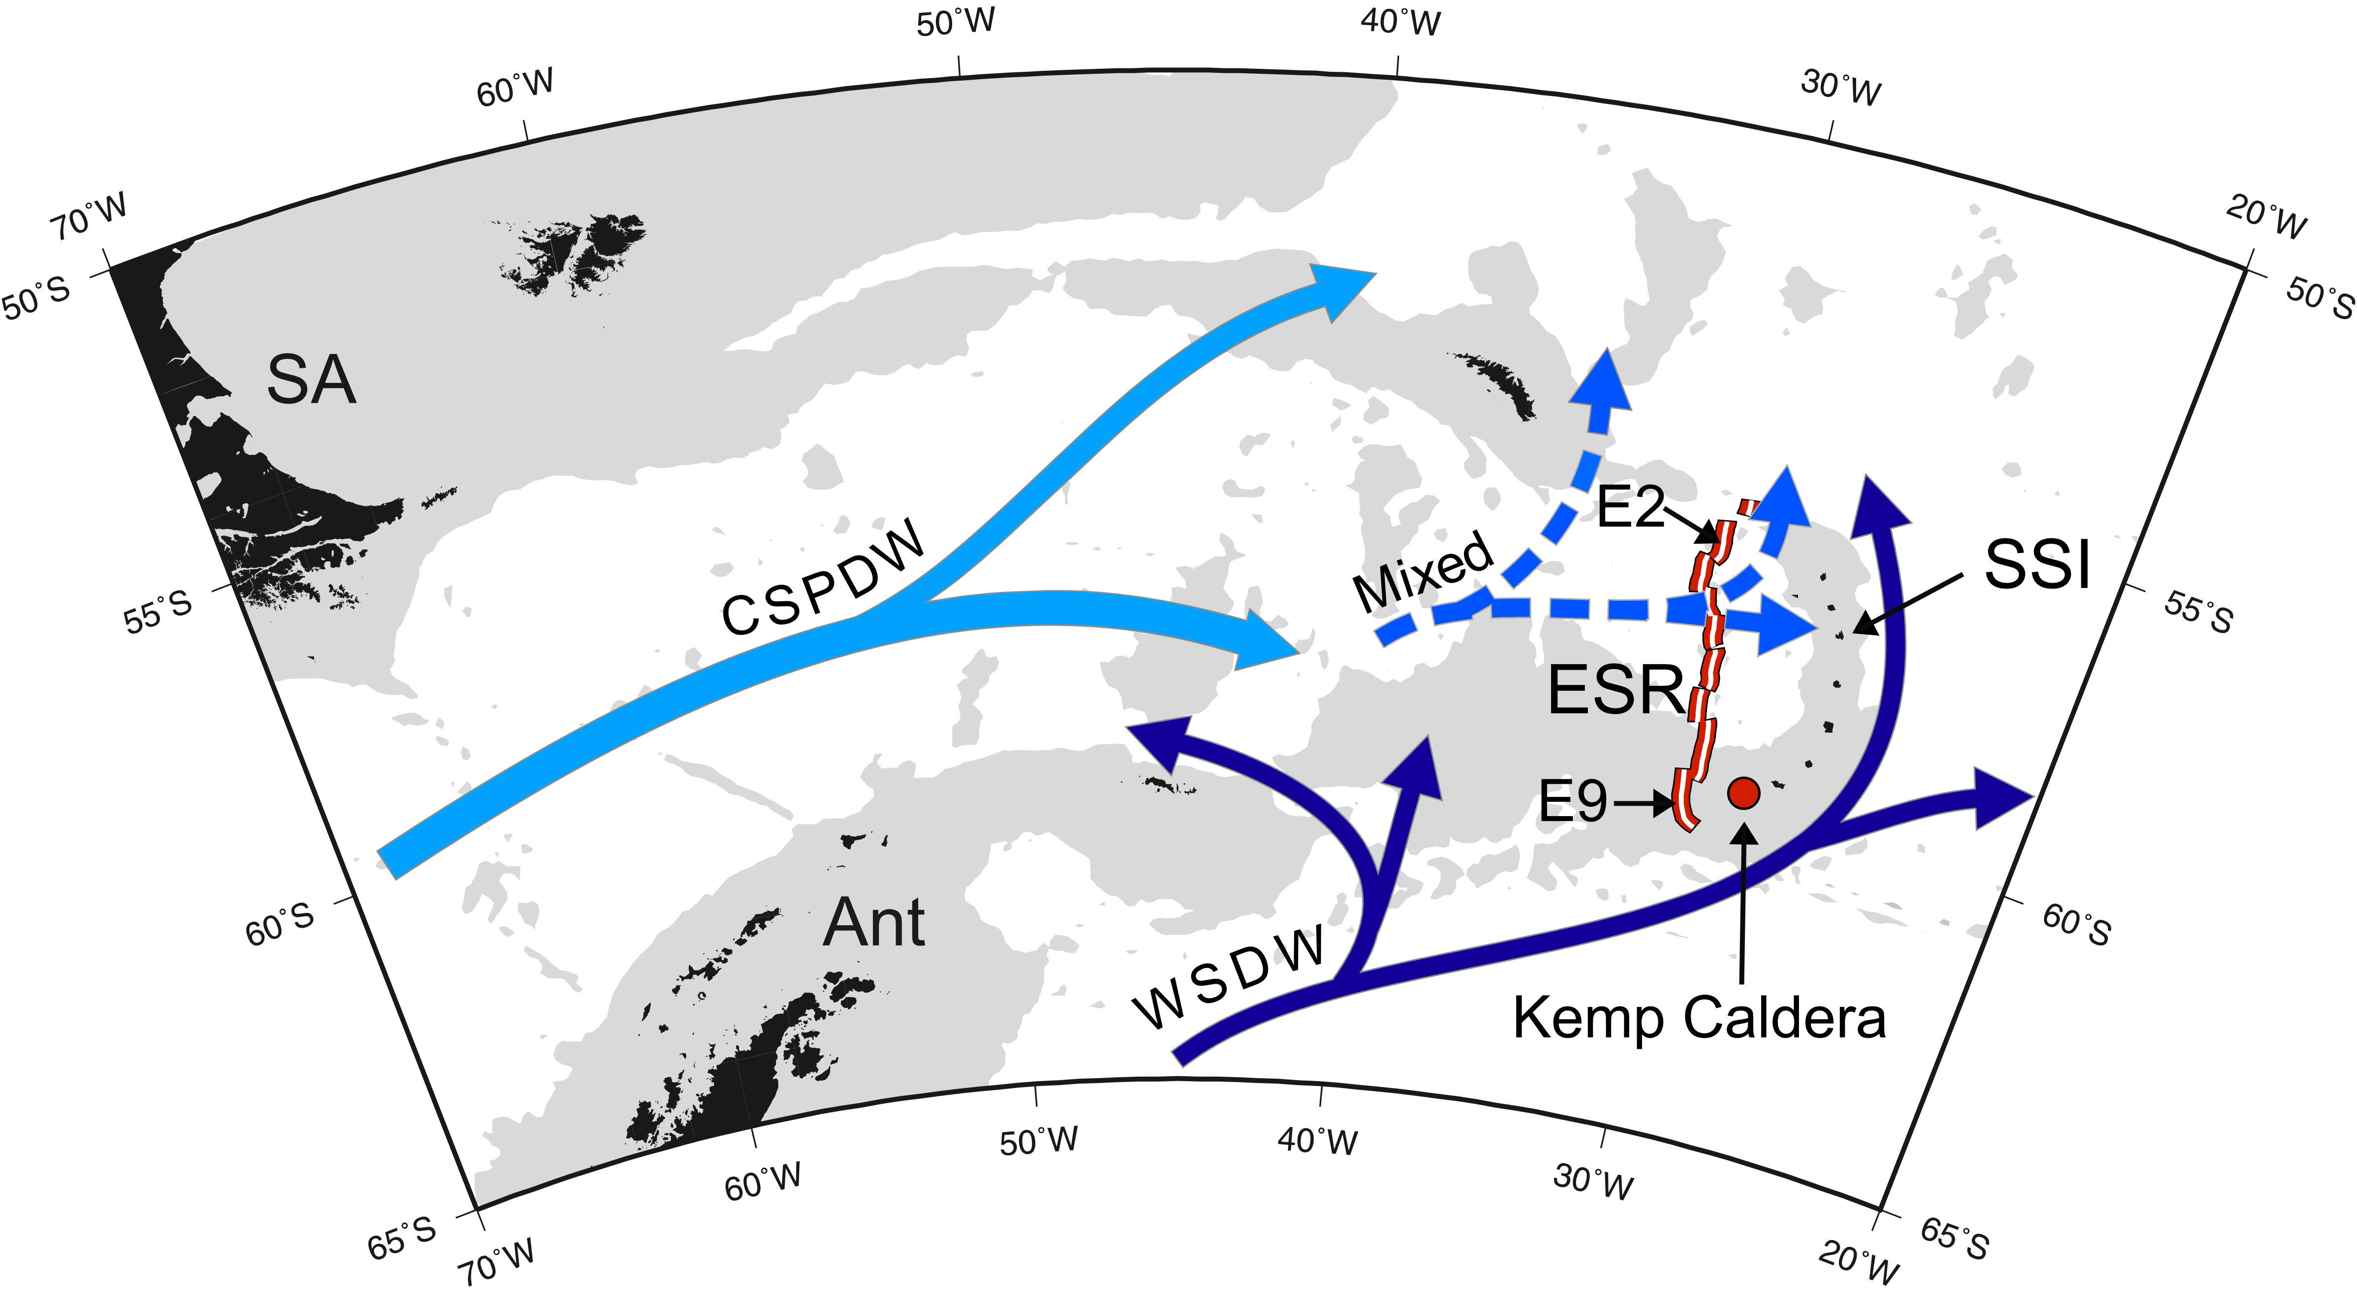
Figure 1. Deep-water currents in the Scotia Sea, modified from other sources (Livermore 2006; Orsi et al. 1999; Naveira-Garabato et al. 2002; Meredith et al. 2008). WSDW = Weddell Sea Deep Water, CSPDW = Circumpolar and South Pacific Deep Water flow. SA = South America, Ant = Antarctica, ESR = East Scotia Ridge, SSI = South Sandwich Islands. Areas shaded in light grey are ≤ 3,000 m depth.

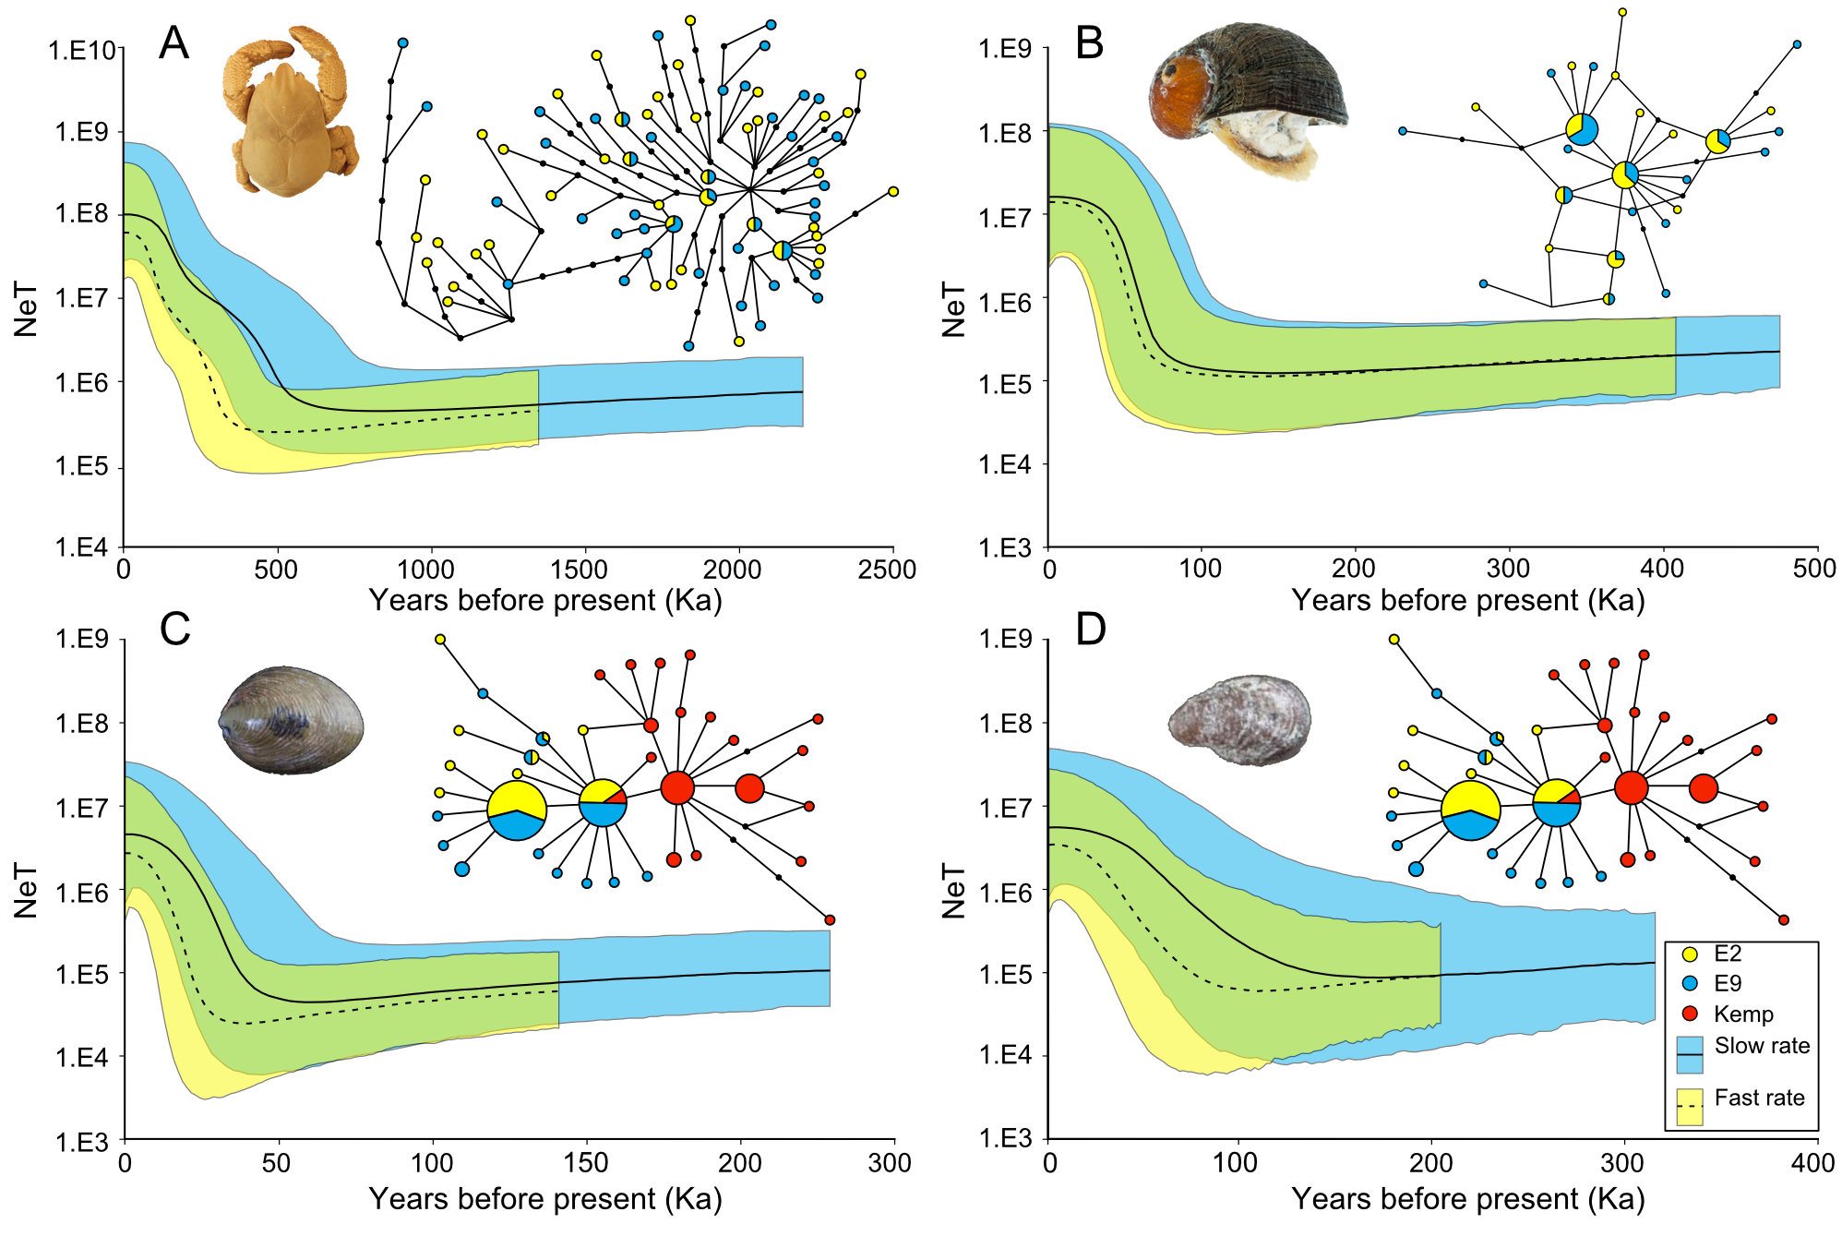
Figure 2. COI Bayesian skyline plots (BSPs) of (A) Kiwa tyleri, (B) Gigantopelta chessoia, (C) Lepetodrilus sp. collected from the E2 and E9 vent fields on the East Scotia Ridge and (D) Lepetodrilus sp. collected from the Kemp Caldera, with accompanying median joining haplotype networks (median spanning tree for K. tyleri) for each species. For the haplotype networks, circles represent haplotypes. Black circles denote hypothesised haplotypes. Lines represent base pair changes. Shaded circles are scaled to the number of individuals. For the BSPs, black lines (solid and dashed) denote median estimates with shaded areas representing 95% HPD intervals. A slower and a faster rate was used for each species. For Kiwa tyleri, a slower rate based on Bythograea spp. divergence (7.3%) across the Easter Microplate (Guinot & Hurtado 2003), which formed ~5.25-2.47 Ma (mean age of 3.86 Ma) (Naar & Hey 1991; Rusby & Searle 1995) and a faster rate based on Synalpheus spp. divergence (8.7%) across the Panama Isthmus, which formed ~2.8 Ma (Lessios 2008) were used. For the two gastropods, a faster based on Conus spp. divergence (9.2%) across the Panama Isthmus (Lessios 2008) and slower rates based on neomphaline gastropod and Lepetodrilus pustulosus divergence (11.2% and 8.17% respectively) across the Easter Microplate (Johnson et al. 2008; Matabos et al. 2011). NeT on the y-axis represents the generation time-scaled effective population size.

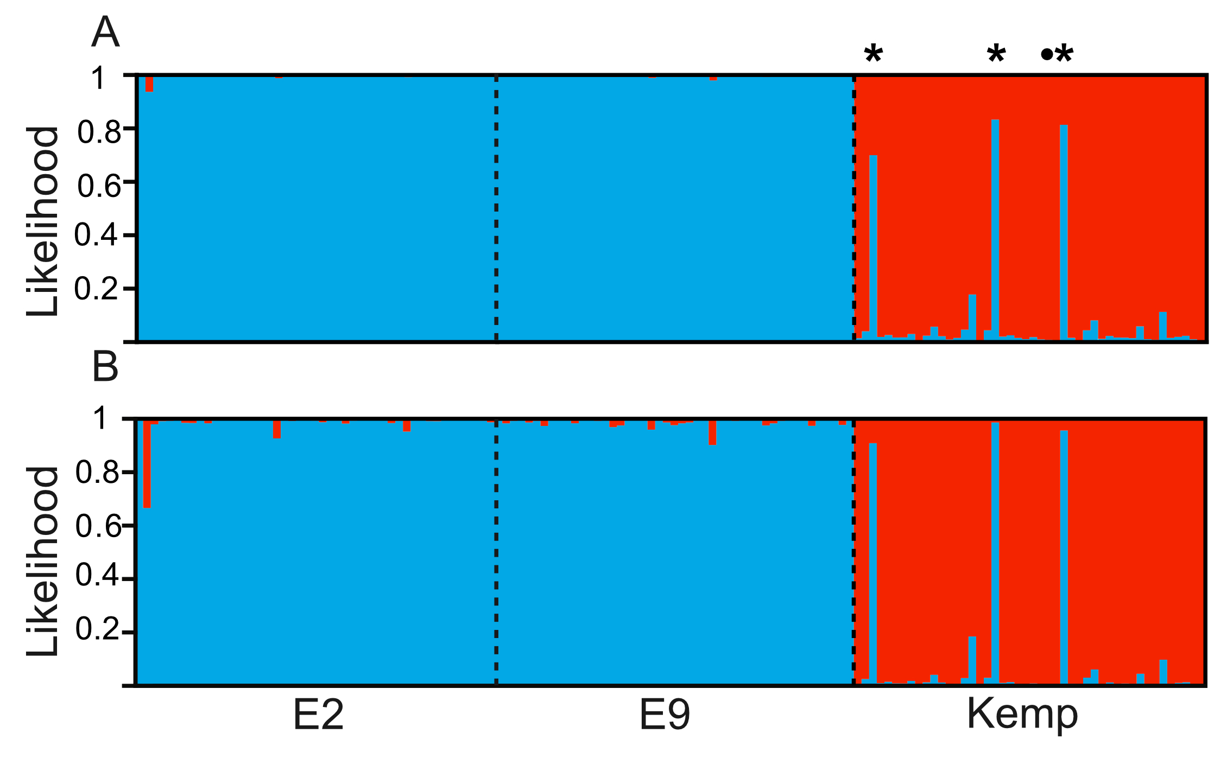
Figure 3. STRUCTURE individual assignment bar plots of Lepetodrilus sp. collected at hydrothermal vents on the East Scotia Ridge (ESR) at E2 and E9 and the Kemp Caldera, based on the two population model using 13 microsatellite loci, with (A) and without (B) the location prior. Three individuals, F622_3, F622_19 and F622_28 are marked (asterisk) as possible first generation migrants and exhibit ESR-like COI haplotypes. Individual F622_26 is marked (dot) as exhibiting a microsatellite genotype typical of Kemp, but with a common ESR COI haplotype.

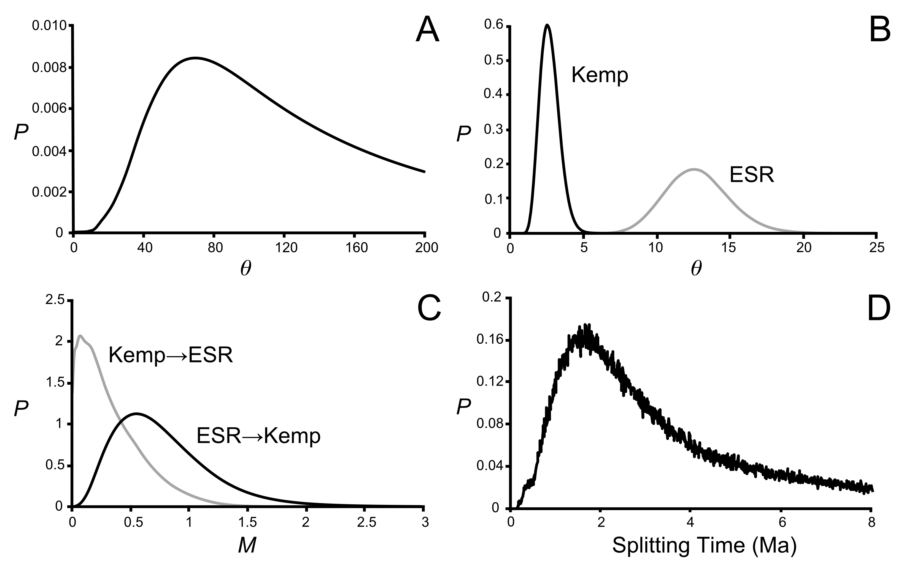
Figure 4. IMa2 gene flow output for Lepetodrilus sp. between hydrothermal vents on the East Scotia Ridge (ESR) and the Kemp Caldera using seven microsatellite loci and a 618 bp fragment of COI. Marginal posterior densities, P, of model parameters generated in L-mode (300,000 genealogies) showing (A) estimates of θ (mutation rate-scaled effective population size) for the ancestral population (B) estimates of θ of ESR and Kemp populations (C) immigration rates, M and (D) the estimate of the splitting time (in millions of years) of the ancestral population into the two populations. The analysis was calibrated by incorporating a COI substitution rate of 6.40415 x 10⁻⁶ (4.70857 x 10⁻⁶–1.00081 x 10⁻⁵) substitutions per gene per year, based on the divergence (8.17%) of Lepetodrilus pustulosus across the Easter Microplate (Johnson et al. 2008), which formed a mean age of 3.86 Ma (2.47-5.25 Ma) (Naar & Hey 1991; Rusby & Searle 1995).
Tables

Table 1. Sampling locations for the collection of Kiwa tyleri, Gigantopelta chessoia, Lepetodrilus sp. from hydrothermal vents on the East Scotia Ridge (ESR) and in the Kemp Caldera, South Sandwich Islands arc (SSI).
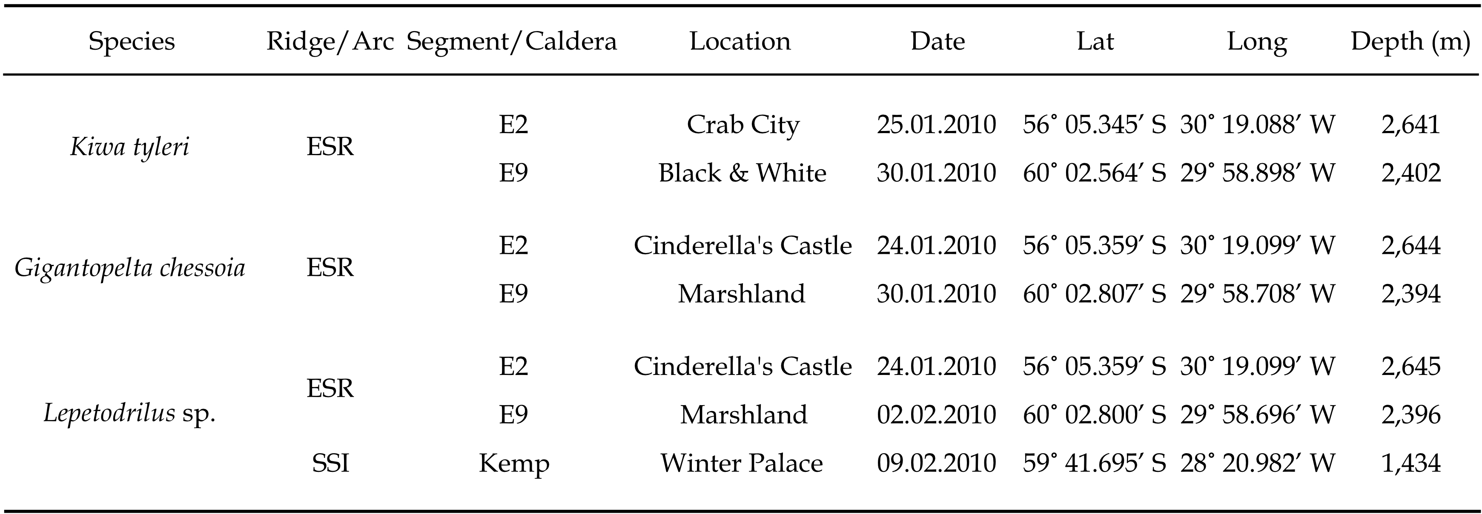

Table 2. COI and Microsatellite diversity indices for Kiwa tyleri, Gigantopelta chessoia and Lepetodrilus sp. sampled from hydrothermal vents on the East Scotia Ridge and the Kemp Caldera. For COI, sample size (n), number of haplotypes (Nh), haplotype diversity (h), nucleotide diversity (π), Fu’s Fs are reported (P < 0.05, in bold). For the microsatellites (shaded), sample size (n), number of loci (nLoci), mean number of alleles (A), mean allelic richness (A_{R}), observed heterozygosity (H_{obs}) and expected heterozygosity (H_{exp}) are reported.
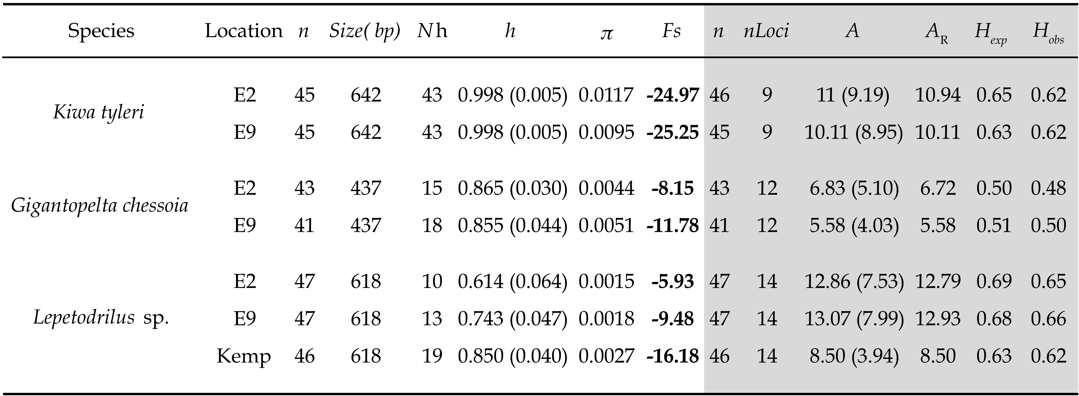

Table 3.COI F_{ST} and microsatellite R_{ST} pairwise comparison matrix of Kiwa tyleri, Gigantopelta chessoia and Lepetodrilus sp., at hydrothermal vents on the East Scotia Ridge and the Kemp Caldera. R_{ST} values are shaded (P < 0.05 in bold).
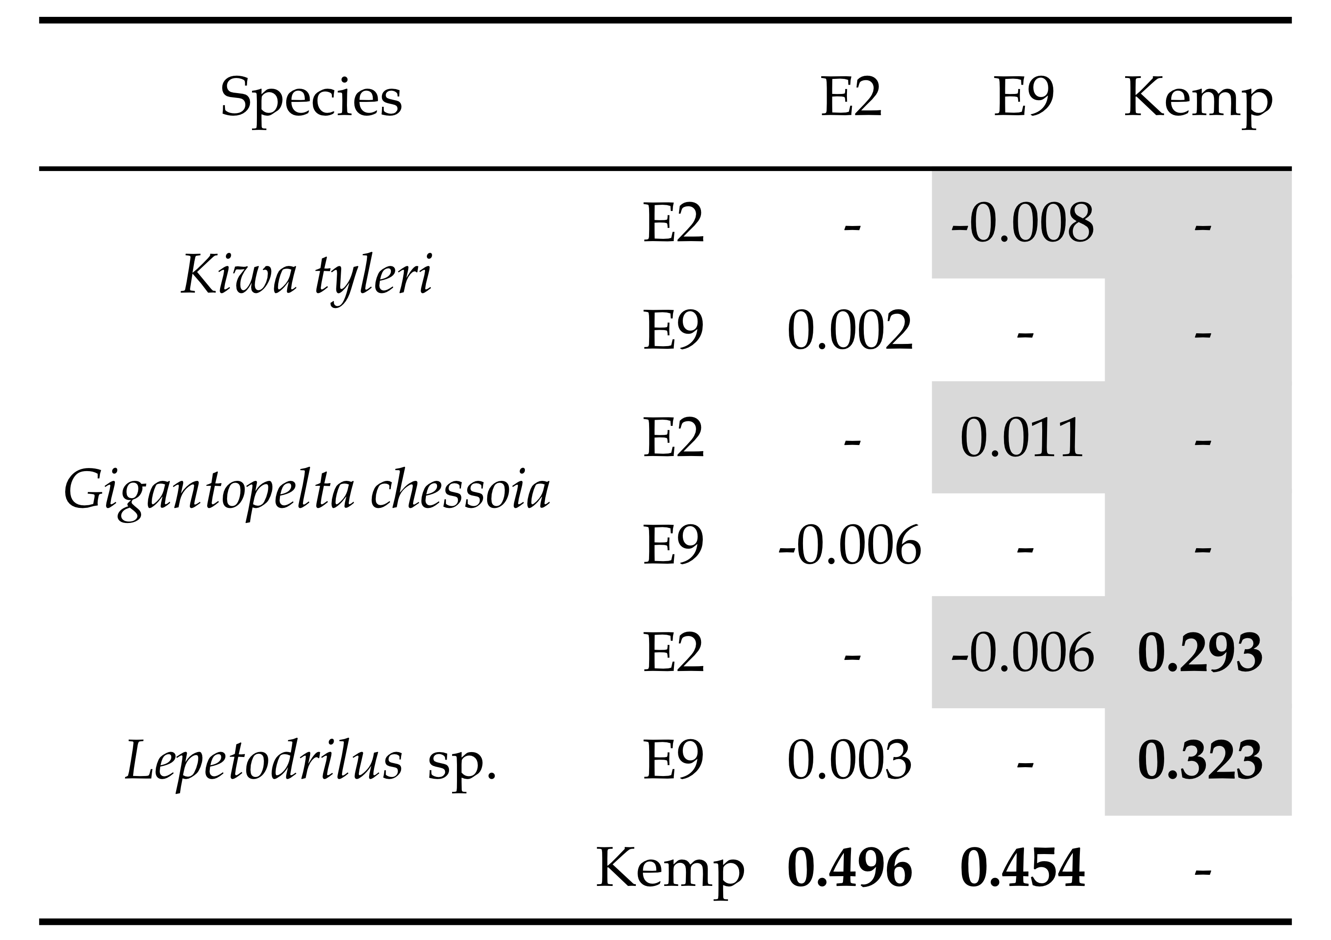

Table 4. Summary results of IMa2 analyses (in L mode, 300,000 genealogies) on Lepetodrilus sp. from the East Scotia Ridge (ESR) and the Kemp Caldera in the Scotia Sea under a model of an ancestral population splitting with subsequent bidirectional gene flow. Parameter values are taken from estimated marginal posteriors. High Point values denoting peak values. HDP 95% values taken from the estimated 95% highest posterior density interval. Displayed estimated parameters are the mutation rate–scaled effective size of the populations (θ), the mutation rate-scaled per generation immigration rate, displayed going forwards from the coalescent (M), the mutation rate-scaled splitting time (τ) and the splitting time in years based on rate of a 6.40415 x 10⁻⁶ substitutions per gene per year substitution rate. Likelihood-ratio tests (LLR) of immigration rates were either highly significant (***, P < 0.001) or not significant (^{ns}). † = upper marginal posterior bounds that did not reach zero at the upper prior boundary.
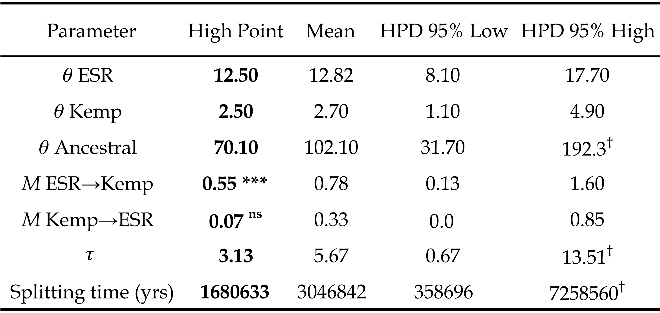
References

Amon DJ, Glover AG, Wiklund H et al. (2013) The discovery of a natural whale fall in the Antarctic deep sea. Deep Sea Research Part II: Topical Studies in Oceanography, 92, 87–96.
Antao T, Lopes A, Lopes R, Beja-Pereira A, Luikart G (2008) LOSITAN: a workbench to detect molecular adaptation based on a Fst-outlier method. BMC bioinformatics, 9, 323.
Baker ET, Massoth GJ, Nakamura K-I et al. (2005) Hydrothermal activity on near-arc sections of back-arc ridges: results from the Mariana Trough and Lau Basin. Geochem. Geophys. Geosyst., 6.
Bandelt H-J, Forster P, Röhl A (1999) Median-joining networks for inferring intraspecific phylogenies. Molecular Biology and Evolution, 16, 37–48.
Beaumont MA, Nichols RA (1996) Evaluating loci for use in the genetic analysis of population structure. Proceedings of the Royal Society of London. Series B: Biological Sciences, 263, 1619–1626.
Chen C, Copley JT, Linse K, Rogers AD (2015a) Low connectivity between “scaly-foot gastropod” (Mollusca: Peltospiridae) populations at hydrothermal vents on the Southwest Indian Ridge and the Central Indian Ridge. Organisms Diversity & Evolution, 1–8.
Chen C, Linse K, Roterman CN, Copley JT, Rogers A A new genus of large hydrothermal vent-endemic gastropod (Neomphalina: Peltospiridae) with two new species showing evidence of recent demographic expansion. Zoological Journal of the Linnean Society, Submitted.
Chen C, Linse K, Roterman CN, Copley JT, Rogers AD (2015b) A new genus of large hydrothermal vent‐endemic gastropod (Neomphalina: Peltospiridae). Zoological Journal of the Linnean Society, 175, 319–335.
Cho W, Shank TM (2010) Incongruent patterns of genetic connectivity among four ophiuroid species with differing coral host specificity on North Atlantic seamounts. Marine Ecology, 31, 121–143.
Cole CS, James RH, Connelly DP, Hathorne EC (2014) Rare earth elements as indicators of hydrothermal processes within the East Scotia subduction zone system. Geochimica et Cosmochimica Acta, 140, 20–38.
Corliss JB, Dymond J, Gordon LI et al. (1979) Submarine thermal springs on the Galapagos Rift. Science, 203, 1073–1083.
Cornuet JM, Luikart G (1996) Description and power analysis of two tests for detecting recent population bottlenecks from allele frequency data. Genetics, 144, 2001–2014.
Coykendall DK, Johnson SB, Karl SA, Lutz RA, Vrijenhoek RC (2011) Genetic diversity and demographic instability in Riftia pachyptila tubeworms from eastern Pacific hydrothermal vents. Bmc Evolutionary Biology, 11, 96.
Creasey SS, Rogers AD (1999) Population genetics of bathyal and abyssal organisms. Advances in Marine Biology, 35, 1–151.
Di Rienzo A, Peterson AC, Garza JC et al. (1994) Mutational processes of simple-sequence repeat loci in human populations. Proceedings of the National Academy of Sciences, 91, 3166–3170.
Diekmann B (2007) Sedimentary patterns in the late Quaternary Southern Ocean. Deep Sea Research Part II: Topical Studies in Oceanography, 54, 2350–2366.
Drummond A, Rambaut A (2007) BEAST: Bayesian evolutionary analysis by sampling trees. Bmc Evolutionary Biology, 7, 214.
Etter RJ, Rex MA, Chase MC, Quattro JM (1999) A genetic dimension to deep-sea biodiversity. Deep Sea Research Part I: Oceanographic Research Papers, 46, 1095–1099.
Evanno G, Regnaut S, Goudet J (2005) Detecting the number of clusters of individuals using the software structure: a simulation study. Molecular Ecology, 14, 2611–2620.
Excoffier L, Lischer HEL (2010) Arlequin suite ver 3.5: a new series of programs to perform population genetics analyses under Linux and Windows. Molecular Ecology Resources, 10, 564–567.
Faurby S, Barber PH (2012) Theoretical limits to the correlation between pelagic larval duration and population genetic structure. Molecular Ecology, 21, 3419–3432.
Folmer O, Black M, Hoeh W, Lutz R, Vrijenhoek R (1994) DNA primers for amplification of mitochondrial cytochrome c oxidase subunit 1 from diverse metazoan invertebrates. Molecular Marine Biology and Biotechnology, 3, 294–299.
France SC, Kocher TD (1996) Geographic and bathymetric patterns of mitochondrial 16S rRNA sequence divergence among deep-sea amphipods, Eurythenes gryllus. Marine Biology, 126, 633–643.
Frederich M, Sartoris FJ, Portner HO (2001) Distribution patterns of decapod crustaceans in polar areas: a result of magnesium regulation? Polar Biology, 24, 719–723.
Fu YX (1996) New statistical tests of neutrality for DNA samples from a population. Genetics, 143, 557.
Gage JD, Tyler PA (1992) Deep-sea biology: a natural history of organisms at the deep-sea floor. Cambridge University Press.
Goudet J (1995) FSTAT (version 1.2): a computer program to calculate F-statistics. Journal of Heredity, 86, 485–486.
Guinot D, Hurtado LA (2003) Two new species of hydrothermal vent crabs of the genus Bythograea from the southern East Pacific Rise and from the Galapagos Rift (Crustacea Decapoda Brachyura Bythograeidae). Comptes Rendus Biologies, 326, 423–439.
Hahm D, Baker ET, Rhee TS et al. (2015) First hydrothermal discoveries on the Australian-Antarctic Ridge: Discharge sites, plume chemistry, and vent organisms. Geochem. Geophys. Geosyst, n/a–n/a.
Hellberg ME (2009) Gene flow and isolation among populations of marine animals. Annual Review of Ecology, Evolution, and Systematics, 40, 291–310.
Hey J (2010) Isolation with migration models for more than two populations. Molecular Biology and Evolution, 27, 905–920.
Ho SYW, Shapiro B (2011) Skyline-plot methods for estimating demographic history from nucleotide sequences. Molecular Ecology Resources, 11, 423–434.
Ho SYW, Lanfear R, Bromham L et al. (2011) Time-dependent rates of molecular evolution. Molecular Ecology, 20, 3087–3101.
Hubisz MJ, Falush D, Stephens M, Pritchard JK (2009) Inferring weak population structure with the assistance of sample group information. Molecular Ecology Resources, 9, 1322–1332.
Jablonski D, Lutz RA (1983) Larval ecology of marine benthic invertebrates: paleobiological implications. Biol. Rev., 58, 21–89.
Johnson SB, Waren A, Vrijenhoek RC (2008) DNA barcoding of Lepetodrilus limpets reveals cryptic species. Journal of Shellfish Research, 27, 43–51.
Jollivet D, Chevaldonne P, Planque B (1999) Hydrothermal-vent alvinellid polychaete dispersal in the eastern Pacific. 2. A metapopulation model based on habitat shifts. Evolution, 53, 1128–1142.
Kopelman NM, Mayzel J, Jakobsson M, Rosenberg NA, Mayrose I (2015) CLUMPAK: a program for identifying clustering modes and packaging population structure inferences across K. Molecular Ecology Resources.
Lanfear R, Calcott B, Ho SYW, Guindon S (2012) PartitionFinder: combined selection of partitioning schemes and substitution models for phylogenetic analyses. Molecular Biology and Evolution, 29, 1695–1701.
Larter R (2009) Cruise Report JR224. Chemosynthetically-driven ecosystems south of the polar front consortium programme. RRS James Clark Ross.
Leese F, Brand P, Rozenberg A et al. (2012) Exploring pandora's box: potential and pitfalls of low coverage genome surveys for evolutionary biology. Plos One, 7, e49202.
Lessios HA (2008) The Great American Schism: Divergence of Marine Organisms after the Rise of the Central American Isthmus. Annual Review of Ecology, Evolution, and Systematics, 39 IS -, 63–91.
Levin LA (2006) Recent progress in understanding larval dispersal: new directions and digressions. American Zoologist, 46, 282–297.
Livermore R (2006) The East Scotia Sea: mantle to microbe. Geophysical monograph, 166, 243–261.
Lutz RA, Bouchet P, Jablonski D, Turner RD, Waren A (1986) Larval ecology of mollusks at deep-sea hydrothermal vents. American Malacological Bulletin, 4, 49–54.
Macpherson E, Jones W, Segonzac M (2005) A new squat lobster family of Galatheoidea (Crustacea, Decapoda, Anomura) from the hydrothermal vents of the Pacific-Antarctic Ridge. Zoosystema, 27, 709–723.
Marko PB, Hart MW (2012) Retrospective coalescent methods and the reconstruction of metapopulation histories in the sea. Evolutionary Ecology, 26, 291–315.
Marsh L, Copley JT, Huvenne VAI et al. (2012) Microdistribution of faunal assemblages at deep-sea hydrothermal vents in the Southern Ocean. Plos One, 7, e48348.
Marsh L, Copley JT, Tyler P, Thatje S (2015) In hot and cold water: differential life-history traits are key to success in contrasting thermal deep-sea environments. Journal of Animal Ecology.
Matabos M, Thiebaut E (2010) Reproductive biology of three hydrothermal vent peltospirid gastropods (Nodopelta heminoda, N. subnoda and Peltospira operculata) associated with Pompeii worms on the East Pacific Rise. Journal of Molluscan Studies, 76, 257–266.
Matabos M, Plouviez S, Hourdez S et al. (2011) Faunal changes and geographic crypticism indicate the occurrence of a biogeographic transition zone along the southern East Pacific Rise. Journal of Biogeography, 38, 575–594.
Mercier A, Sewell MA, Hamel JF (2013) Pelagic propagule duration and developmental mode: reassessment of a fading link. Global Ecology and Biogeography, 22, 517–530.
Meredith MP, Garabato ACN, Gordon AL, Johnson GC (2008) Evolution of the deep and bottom waters of the Scotia Sea, Southern Ocean, during 1995-2005*. Journal of Climate, 21, 3327–3343.
Minin V, Abdo Z, Joyce P, Sullivan J (2003) Performance-based selection of likelihood models for phylogeny estimation. Systematic Biology, 52, 674–683.
Mullineaux LS, Mills SW, Sweetman AK et al. (2005) Vertical, lateral and temporal structure in larval distributions at hydrothermal vents. Marine Ecology-Progress Series, 293, 1–16.
Mullineaux LS, Wiebe PH, Baker ET (1995) Larvae of benthic invertebrates in hydrothermal vent plumes over Juan de Fuca Ridge. Marine Biology, 122, 585–596.
Naar DF, Hey RN (1991) Tectonic evolution of the Easter Microplate. J. Geophys. Res., 96, 7961–7993.
Naveira-Garabato AC, Heywood KJ, Stevens DP (2002) Modification and pathways of Southern Ocean deep waters in the Scotia Sea. Deep Sea Research Part I: Oceanographic Research Papers, 49, 681–705.
Nielsen R, Wakeley J (2001) Distinguishing migration from isolation: a Markov chain Monte Carlo approach. Genetics, 158, 885.
Orsi AH, Johnson GC, Bullister JL (1999) Circulation, mixing, and production of Antarctic Bottom Water. Progress In Oceanography, 43, 55–109.
Pearse JS, McClintock JB, Bosch I (1991) Reproduction of Antarctic benthic marine invertebrates: tempos, modes, and timing. American Zoologist, 31, 65–80.
Pedersen RB, Rapp HT, Thorseth IH et al. (2010) Discovery of a black smoker vent field and vent fauna at the Arctic mid-ocean ridge. Nature Communications, 1, 126.
Piry S, Luikart G, Cornuet JM (1999) Computer note. BOTTLENECK: a computer program for detecting recent reductions in the effective size using allele frequency data. Journal of Heredity, 90, 502–503.
Plouviez S, Le Guen D, Lecompte O, Lallier FH, Jollivet D (2010) Determining gene flow and the influence of selection across the equatorial barrier of the East Pacific Rise in the tube-dwelling polychaete Alvinella pompejana. Bmc Evolutionary Biology, 10, 220.
Plouviez S, Schultz TF, McGinnis G et al. (2013) Genetic diversity of hydrothermal-vent barnacles in Manus Basin. Deep Sea Research Part I: Oceanographic Research Papers, 82, 73–79.
Plouviez S, Shank TM, Faure B et al. (2009) Comparative phylogeography among hydrothermal vent species along the East Pacific Rise reveals vicariant processes and population expansion in the South. Molecular Ecology, 18, 3903–3917.
Pradillon F, Shillito B, Young CM, Gaill F (2001) Deep-sea ecology: developmental arrest in vent worm embryos. Nature, 413, 698–699.
Pritchard JK, Stephens M, Donnelly P (2000) Inference of population structure using multilocus genotype data. Genetics, 155, 945.
Quattrini AM, Baums IB, Shank TM, Morrison CL, Cordes EE (2015) Testing the depth-differentiation hypothesis in a deepwater octocoral. Proceedings of the Royal Society of London B: Biological Sciences, 282.
Rambaut A, Drummond AJ (2007) Tracer v1. 4 [computer program]. Available at website http://beast.bio.ed.ac.uk.
Rice WR (1989) Analyzing tables of statistical tests. Evolution, 43, 223–225.
Rogers AD (2010) Chemosynthetic Ecosystems of the Southern Ocean (CHESSO). RRS James Cook Cruise 42.
Rogers AD, Tyler PA, Connelly DP et al. (2012) The discovery of new deep-sea hydrothermal vent communities in the Southern Ocean and implications for biogeography. Plos Biology, 10, e1001234.
Rogers AR, Harpending H (1992) Population growth makes waves in the distribution of pairwise genetic differences. Molecular Biology and Evolution, 9, 552.
Roterman CN, Copley JT, Linse KT et al. (2013) Development of polymorphic microsatellite loci for three species of vent-endemic megafauna from deep-sea hydrothermal vents in the Scotia Sea, Southern Ocean. Conservation Genetics Resources, 5, 835–839.
Rusby RI, Searle RC (1995) A history of the Easter microplate, 5.25 Ma to present. J. Geophys. Res., 100, 12617–12640.
Selkoe KA, Toonen RJ (2011) Marine connectivity: a new look at pelagic larval duration and genetic metrics of dispersal. Marine Ecology-Progress Series, 436, 291–305.
Shilling FM, Manahan DT (1994) Energy metabolism and amino acid transport during early development of Antarctic and temperate echinoderms. The Biological Bulletin, 187, 398–407.
Teixeira S, Cambon Bonavita MA, Serrão EA, Desbruyeres D, Arnaud Haond S (2010) Recent population expansion and connectivity in the hydrothermal shrimp Rimicaris exoculata along the Mid-Atlantic Ridge. Journal of Biogeography, 38, 564–574.
Teixeira S, Serrão EA, Arnaud-Haond S (2012) Panmixia in a fragmented and unstable environment: the hydrothermal shrimp Rimicaris exoculata disperses extensively along the Mid-Atlantic Ridge. Plos One, 7, e38521.
Thaler AD, Plouviez S, Saleu W et al. (2014) Comparative Population Structure of Two Deep-Sea Hydrothermal-Vent-Associated Decapods (Chorocaris sp. 2 and Munidopsis lauensis) from Southwestern Pacific Back-Arc Basins. Plos One, 9, e101345.
Thaler AD, Zelnio K, Saleu W et al. (2011) The spatial scale of genetic subdivision in populations of Ifremeria nautilei, a hydrothermal-vent gastropod from the southwest Pacific. Bmc Evolutionary Biology, 11, 372.
Thatje S, Marsh L, Roterman CN, Mavrogordato MN, Linse K (2015a) Adaptations to Hydrothermal Vent Life in Kiwa tyleri, a New Species of Yeti Crab from the East Scotia Ridge, Antarctica (S Kiel, Ed,). Plos One, 10, e0127621.
Thatje S, Smith KE, Marsh L, Tyler PA (2015b) Evidence for abbreviated and lecithotrophic larval development in the yeti crab Kiwa tyleri from hydrothermal vents of the East Scotia Ridge, Southern Ocean. Sexuality and Early Development in Aquatic Organisms, In Press.
Tyler PA, Young CM (2003) Dispersal at hydrothermal vents: a summary of recent progress. Hydrobiologia, 503, 9–19.
Tyler PA, Pendlebury S, Mills SW et al. (2008) Reproduction of gastropods from vents on the East Pacific Rise and the Mid-Atlantic Ridge. Journal of Shellfish Research, 27, 107–118.
Van Dover CL (2000) The ecology of deep-sea hydrothermal vents. Princeton University Press.
van Oosterhout C, Hutchinson WF, Wills DP, Shipley P (2004) microchecker: software for identifying and correcting genotyping errors in microsatellite data. Molecular Ecology Notes, 4, 535–538.
Vrijenhoek RC (2013) On the instability and evolutionary age of deep-sea chemosynthetic communities. Deep Sea Research Part II: Topical Studies in Oceanography, 92, 189–200.
Vrijenhoek RC (1997) Gene flow and genetic diversity in naturally fragmented metapopulations of deep-sea hydrothermal vent animals. Journal of Heredity, 88, 285–293.
Vrijenhoek RC (2010) Genetic diversity and connectivity of deep-sea hydrothermal vent metapopulations. Molecular Ecology, 19, 4391–4411.
Wang J, Lin R, Bamber RN, Huang D (2013) Two new species of Sericosura Fry & Hedgpeth, 1969 (Arthropoda: Pycnogonida: Ammotheidae) from a hydrothermal vent on the East Pacific Rise. Zootaxa, 3669, 165–171.
Weersing K, Toonen RJ (2009) Population genetics, larval dispersal, and connectivity in marine systems. Marine Ecology Progress Series, 393, 1–12.
Wilson GA, Rannala B (2003) Bayesian inference of recent migration rates using multilocus genotypes. Genetics, 163, 1177–1191.
Wright S (1943) Isolation by distance. Genetics, 28, 114.

Data Accessibility

COI sequences deposited in Genbank (Acc# XXXXXXXX-XXXXXXXX).

Following data incorporated into a zip file called “Data_accessibility” - included in supplementary section:

COI fasta files

Beast 1.7.4 Bayesian Skyline Plot input xml files
Microsatellite genotype excel spreadsheets
STRUCTURE 2.3.4 input files and parameter files
BOTTLENECK 1.2.2 input files.
IMa2 input files.

