**Föhn winds on South Georgia and their impact on regional climate**

Daniel Bannister*a and John Kinga

aThe British Antarctic Survey, Cambridge, UK

For submission to *Weather*

* Corresponding Author

Daniel Bannister (danban70@bas.ac.uk)

The British Antarctic Survey

Madingley Road, High Cross

Cambridge, Cambridgeshire, CB3 0ET

TEL: 01223 221389

**Abstract**

Average summer temperatures over South Georgia have risen by around 1oC since the 1920s. Coupled with this has been an increase in the rate of glacial retreat, with glaciers on the northeast of the island retreating faster than those on the southwest side. These asymmetrical changes are thought to be linked with the föhn warming process. To explore the link between föhn and the regional climate of South Georgia, we show results from a climatological analysis based on 10 years of Automatic Weather Station observations, and high-resolution simulations of föhn events using the Weather Research and Forecasting model. We find that föhn events significantly contribute to the asymmetry of South Georgia’s regional climate.

Keywords: föhn, glacial melt, WRF, climate change, Southern Ocean, orography

**Introduction**

South Georgia (35o50'-38oW, 54o-54o55'S) is a remote subantarctic island located in the Southern Ocean, situated 1500km east-southeast of the Falkland Islands (Figure 1). The dominant physiographic feature of South Georgia is its axial mountain chain, which is orientated in a crescent north-west to south-east direction, and extends over two-thirds of the total length of the island. With 19 peaks over 2000m, South Georgia is a very mountainous island. The tallest of these peaks is Mount Paget, which rises 2934m above sea level. Approximately 56% of the total land surface is covered by permanent snow and ice, 9% of the land area is vegetated, and the other 35% is too steep to permit permanent snow and ice.

### Though a small, remote and isolated island, South Georgia has high biogeographical importance in the high-latitude Southern Hemisphere. The ocean surrounding South Georgia is characterised by high levels of biological productivity, and plays a vital role in supporting vast colonies of both marine- and terrestrial-based animals. The waters of South Georgia are the most speciose region of the Southern Ocean, with greater species richness than comparable northern latitudes. South Georgia is the perfect island for many terrestrial and marine animals to shelter, feed and reproduce away from the Antarctic frozen wilderness. The most dominant species found on the island include Southern elephant seals, Antarctic fur seals, 65 million nesting birds, many of which are endangered (i.e. black-browed albatross), vulnerable (i.e. white-chinned petrel) or near-threatened (i.e. South Georgia pipit), four species of penguin (king, gentoo, macaroni and chinstrap), and four species of albatross (wandering, black-browed, grey-headed and light-mantled sooty). Therefore, it is of high importance to understand the processes that control the regional climate of the island in order to identify potential impacts climate change will have on the rich, yet delicate, ecosystems of South Georgia.

**The Climate of South Georgia**

Manual observations of the weather at Grytviken whaling station began in 1905, shortly after the station began operations. These observations ended in 1982 with the outbreak of the Falklands conflict. Observations using an Automatic Weather Station (AWS) recommenced in March 2001 at King Edward Point (approximately 700m east of Grytviken) by the British Antarctic Survey, which also coincided with the withdrawal of the small British garrison that had remained on the island. An AWS was also installed on Bird Island in 2000. The west coast of the island, by contrast, is less accessible and hence there are no instrumental or long-term observational data available for comparison.

The climate of South Georgia is maritime in nature – cool, moist and windy. Prevailing westerly winds mean that the western side of the island is particularly exposed to low cloud and severe weather conditions. In contrast, the eastern side of the island is more sheltered and often experiences clearer and quieter weather. Despite this, strong winds (approaching 40ms-1) have been recorded at King Edward Point. The climate of South Georgia is also inherently governed by its position south of the Antarctic Convergence. This accounts for the island’s cool (mean temperature of 2.5oC, Figure 2) and wet climate (annual average precipitation total of 2033mm recorded at King Edward Point), and explains why more than half of South Georgia is locked up in snow and ice, despite being located on the same latitude as the city of York.

Average summer temperatures at King Edward Point have risen by almost 1oC between the 1920s and the present. There have also been signs of rapid ice-mass change across the island. 97% of glaciers have retreated since the 1950s (Gordon & Timmis, 1992; Gordon *et al*., 2008; Cook *et al*., 2010). However, rates of glacial retreat across the island have been asymmetrical. The largest retreats have all taken place along the northeast coast (i.e. north-facing glaciers), where retreat rates have accelerated to an average of 60 metres per year, but those on the southwest coast (i.e. south-facing glaciers) have been retreating more slowly since the 1950s. Although this pattern of change is broadly comparable with atmospheric warming, the rapidity and asymmetry of the retreat suggests that local factors may be important. Since 56% of South Georgia is permanently frozen the consequences of warming on these glaciers could be extensive in a warming world.

Over the last 50 years the speed of the surface westerly winds over the Southern Ocean has also increased by approximately 3ms-1. This is thought to have been driven through stratospheric ozone depletion and increases in greenhouse gas emissions (Hegerl *et al*., 2007). Since South Georgia is one of very few landmasses in the Southern Hemisphere at latitude of 54oS, the island acts as a formidable barrier to the mean westerly flow of the lower troposphere. As a consequence of this, an increase in the strength of the westerlies encourages enhanced air flow over South Georgia. This suggests that the observed asymmetric pattern of regional warming and glacier retreat may be caused by the interaction of strengthening westerlies with the steep orography of the mountainous island.

**The Föhn Effect**

A föhn is generally defined as a warm, dry, downslope wind, descending on the lee side of a mountain range as a result of synoptic-scale, cross-barrier flow (Figure 3). A parcel of moist air will be forced to rise when it approaches a mountain barrier. As the ascending parcel rises on the windward side, adiabatic cooling occurs resulting in condensation once the dew-point temperature is reached (Figure 3a). Latent heat is subsequently released (condensational heating), allowing the air parcel to continue to cool at the saturated adiabatic lapse rate (~6oC/km altitude). Precipitation may then occur on the windward side of the barrier, further lowering the humidity of the advected air parcel. As the parcel descends the leeward slope, the now unsaturated air is warmed due to adiabatic compression (~10oC/km altitude). In reality, föhn winds often do not follow this classical thermodynamic theory. The most prevalent variation on the classic theory does not require precipitation on the windward side of the mountain. Blocked flow (caused by a low level, stable layer) can also generate warming on the lee side by way of the descent of potentially warmer air sources above and beyond the mountain barrier (Figure 3b). This potentially warmer air from above is usually drier too, and will then descend on the lee slopes, thus warming through adiabatic compression (~10oC/km altitude). While the air aloft descends the lee slopes, the upstream blocked and stable flow may be diverted around rather than over the mountain. Regardless of the mechanism, large surface temperature rises on the lee slopes of South Georgia may occur due to the warming associated with föhn winds. Despite this, there has been no thorough investigation into the föhn winds of South Georgia. Consequently, it is necessary to explore the link between the föhn warming process and the recent rapid asymmetrical glacial retreat of South Georgia, and to infer how this relationship may change in the future.

**A Föhn Case Study**

The onset and cessation of föhn wind events happens suddenly at King Edward Point, and are characterised by sudden shifts to southwesterly-northwesterly wind directions, increases in wind speed and air temperature, and a corresponding decrease in relative humidity.

On 5 February 2013, a föhn event was recorded in the AWS observations at King Edward Point (Figure 4). The morning of 5 February was calm and relatively mild. Temperatures remained around 6oC with a gentle breeze of 5ms-1 up until 0900 UTC. The presence of a low pressure system (998hPa) situated to the southwest of the island during the morning of 5 February generated north-west wind flow over the island. By 1200 UTC the system had tracked to the southeast of South Georgia, inducing south-westerly flow. The start of the föhn event was detected at 1210 UTC, and lasted 9 hours and 24 minutes in total. The maximum temperature and wind speed recorded was 13.7oC and 24.7ms-1 respectively (the highest measurements of the day), while relative humidity reached a minimum of 32%. The average wind direction during the event was 297o, though it was somewhat variable during the start and end of the event. This is likely a result of small-scale local topographic modification of the air flow within King Edward Cove. Satellite imagery (not shown) reveals a cloud-free region downstream of South Georgia and a train of mountain waves propagating north-eastwards from the island as a result of the cross-barrier flow and subsequent leeside föhn warming. The end of the event was marked by a drop in temperature of ~5oC within an hour, and a concurrent increase in relative humidity. The event ceased as the low pressure system had continued to track eastwards throughout the day, restoring a variable northerly air flow by the evening. This case study is a typical example of föhn events at King Edward Point, with the characteristic surface warming, windiness and drying response, as a consequence of a descending föhn flow from the direction of the mountains.

**Climatology of Föhn Events**

Since föhn events can be identified by an abrupt rise in temperature, the onset of high winds, and a constant wind from the direction of the mountain barrier, a föhn classification method was developed to identify föhn events from 10 years of AWS near-surface observations. Using an objective classification, a total number of 874 föhn events that produced rapid temperature rises (in excess of 2oC) and changes in wind speed and humidity at King Edward Point were found to have occurred between January 2003 and December 2012. This translates into a frequency of 7.2 events per month, or one event approximately every four days. As a consequence of this, King Edward Point is under föhn warming (and drying) for approximately 30% of the total time. We find that 85% of days at King Edward Point with a mean temperature greater than 10oC coincide with föhn events. Föhn winds are also the predominant source of strong winds at King Edward Point. Föhn events also account for 65% of days with mean wind speed ≥5ms-1, and 65% of days with mean wind speed ≥10ms-1. Therefore, föhn wind events play a significant role in the overall wind and temperature regime of King Edward Point.

The highest maximum temperature reached during a single föhn event at King Edward Point was 23.5oC (9 – 10 February 2004). During this event a total temperature rise of 19.3oC occurred within 5 hours of föhn onset. The driest föhn wind event was recorded on 16 December 2011, when the relative humidity dropped to 7% (a total drop of 85%). The relative humidity stayed below 20% for 9 consecutive hours. The windiest föhn occurred on 30 August 2006, when winds at King Edward Point reached a remarkable 42.3ms-1.

The total number of föhn wind events in each month at King Edward Point for the period 2003 – 2012 is given in Figure 5a. This figure shows that föhn winds occur throughout the year, and exhibit negligible seasonality. Although föhn events do not tend to be more common in austral summer months, we find that föhn events in summer tend to be more intense; they are typically longer, with larger temperature and wind speed increases, and relative humidity drops, compared to winter föhn events. For instance, austral summer föhn events are on average 9 hours longer than austral winter föhn events (Figure 5c). This seasonality in the intensity of events may be driven by the seasonal variation in prevailing wind direction and speeds, and the larger scale atmospheric variations between winter and summer.

The ECMWF (European Centre for Medium-Range Weather Forecasts) ERA-Interim reanalysis data has been used to determine the large-scale synoptic conditions responsible for generating intense föhn events at King Edward Point. Mean sea level pressure composite maps for the 100 most intense föhn days (by total temperature rise) and the long-term climatological (1976 – 2014) average field reveal the synoptic situation favourable for strong föhn events (Figure 6). Immediately apparent is the well-defined ridge of high pressure, roughly centred at ~40oS 40oW, during strong föhn conditions (Figure 6b). This feature is absent in the climatological mean (Figure 6a). Sea level pressure in the strong föhn composite is also generally lower than the climatological mean over the Drake Passage, the Bellingshausen Sea, and the Weddell Sea, resulting in an enhanced meridional pressure gradient over the Scotia Sea. Consequently, a stronger surface pressure gradient leads to enhanced westerly to south-westerly airflow over the island, and therefore, potentially more intense föhn winds on the eastern side of South Georgia.

Whether föhn events are becoming more frequent or intense is difficult to quantify since variability between years is so great and because the King Edward Point AWS record is so short (Figure 5b). Owing to the lack of meteorological data in this region, it is clear that future work is required to understand how the drivers of variability could impact on föhn wind frequency and intensity. While it has been shown that föhn winds are frequent at King Edward Point, it is important to know whether they are experienced elsewhere along the length of the lee coast. To investigate this, we have carried out simulations of atmospheric flow over South Georgia using a high-resolution model.

**High-resolution Atmospheric Modelling**

Very high-resolution simulations (0.9km horizontal resolution, 70 vertical levels) over South Georgia using the Weather Research and Forecasting (WRF) model were conducted to explore the regional scale of leeside föhn warming. WRF is an advanced mesoscale atmospheric model and is capable of simulating atmospheric processes with very high spatial and temporal resolution (<http://www.wrf-model.org>). The initial and lateral boundary conditions were derived from the ERA-Interim pressure-level re-analysis. The WRF run started at 0000 UTC 1 June 2011 and ended at 0000 UTC 1 March 2013. This period was chosen as a representative full melt year, covering one ablation and two accumulation seasons. AWS observations at King Edward Point recorded 159 föhn events of varying intensities during this period.

A comparison of the annual and seasonal 2-m air temperature at the AWS and equivalent WRF location is shown in Table 1. In the observations, the temperature ranges from -10.6oC to 18.5oC, with a mean of 2.4oC (standard deviation (σ) = 4.5). In comparison, the temperature ranges in the WRF model from -8.3oC to 12.4oC, with a mean of 1.5oC (σ = 3.0). It appears that air temperature in the AWS observations has a larger range, compared to the WRF simulation. Therefore, WRF exhibits a clear muted temperature bias throughout the year. Biases in the near-surface meteorology may be a result of the smoothed topography and any unresolved topographic features, and may also be due to poor physical parameterisations and model resolution. King Edward Cove is topographically very complex, and it is only just resolved in the model and so will not capture the precise conditions within the Cove.

To identify single föhn events within the model, a model-appropriate objective föhn identification method was developed to select föhn events. This method is based on the assumption that the strongest föhn events occur when the wind maintains a strong west-east trend perpendicular to South Georgia. Therefore, we assume that when the change in height of a given isentrope across the island exceeds 2000m (approximately the average elevation around Mount Paget), then dynamically a föhn should be occurring on the lee slopes of South Georgia. Using this methodology for föhn identification, it is found that WRF reproduces 120 of the 159 observed events between 2011 and 2013, but also generates 89 false positives. Generally, WRF overestimates the total number of föhn events at King Edward Point throughout all seasons, and also produces too many events which are too cool. In the instance of the 5 February 2013 case study (Figure 4), WRF captures the beginning and end of the event, as well as the intensity of the temperature and wind speed increases, but overall the modelled temperature, wind speed and relative humidity are much more variable. Generally, the modelled föhn event is cooler (AWS average temperature = 11.5oC, WRF average temperature = 10.6oC), windier (AWS average wind speed = 12.5ms-1, WRF average wind speed = 14.2ms-1) and drier (AWS average relative humidity = 53.3%, WRF average relative humidity = 41.0%). Despite the clear muted surface response to föhn in WRF, which is likely also related to the model’s systematic near-surface cold bias, the model föhn climatology is in good agreement with the observed AWS föhn climatology. Given these results, we can be moderately optimistic that WRF is able to reproduce observed föhn events, and therefore, the model can be used as a proxy for observations to explore the impacts of föhn on the regional climate of South Georgia.

**The Impact of Föhn**

Since föhn events at King Edward Point can raise the surface and air temperature above freezing throughout the year, then the frequency (and intensity) of föhn winds may have contributed to the recent observed period of asymmetrical glacial retreat. As snow and ice respond rapidly to slight variations in precipitation and temperature, föhn winds have large and pronounced consequences on the island’s mountain hydrology (and thus also upon the island’s terrestrial and marine ecosystems). Figure 7 shows the near-surface temperature and relative humidity anomalies (from the climatological mean) for all positive föhn hits from the WRF model to uncover the impact of föhn across South Georgia.

Immediately apparent is the asymmetry of the modelled anomalous patterns, with clear cross-barrier gradients, showing that föhn episodes act to warm and dry the eastern slopes, above that of the climatological mean. We find that föhn events occur across much of the length of the eastern coastline of South Georgia, with the highest frequency of föhn events over the Hamberg Lakes (4.5km south of King Edward Point). The warming and drying effects of the föhn also extend downstream of the island. The greatest modelled temperature (up to +3oC) and relative humidity (exceeding -20%) anomalies are over Nordenskjöld glacier, roughly 13km southeast of King Edward Point. During these föhn episodes, on average, the modelled 0oC isotherm height increases by +49m for north-facing glaciers during föhn episodes, whereas it decreases by -31m for south-facing glaciers. Föhn also impacts the surface skin temperature, and this is evident by an increase in the number of 0oC days experienced over north-facing glaciers on South Georgia. This is an indication that föhn can lead to enhanced leeside melt. Since föhn events are so frequent they have an important role to play in shaping the asymmetrical pattern of the regional climate of South Georgia, resulting in the east side of the island being significantly warmer and drier compared to the west side of the island. Further work is being undertaken to quantify the surface mass balance and melt rates during föhn events in order to understand the exact extent to which föhn events are responsible for the asymmetrical leeside warming and glacial retreat of South Georgia.

**Conclusion**

Our study has shown that föhn winds play a significant and important role in the overall wind and temperature regime of South Georgia. Föhn events at King Edward Point are very frequent, with one event occurring approximately every four days. Föhn frequency does not change seasonally, but more intense events are found to occur during austral summer months compared to austral winter föhn events. It also appears that the occurrence and characteristics of föhn are strongly correlated to the large scale atmospheric circulation. We have also shown that the high-resolution WRF simulations are capable of reproducing the main characteristics of föhn events observed at King Edward Point. An extended run of this model has demonstrated that föhn events contribute to the asymmetry of South Georgia’s regional climate. Our results support the view that föhn is at least partly responsible for the asymmetrical retreat of glaciers, via enhanced leeside surface warming and drying. These results support the hypothesis that an enhancement of the föhn warming process could have implications on future asymmetrical warming and glacial melt. Further work is required to establish connections between changes in regional climate and those in broad-scale circulation. South Georgia is a useful case study to illustrate the potential impact of regional climate change on both local and global scales, as well as the importance of mesoscale processes in shaping regional climate.

**References**

**Cook AJ, Poncet S, Cooper APR, Herbert D, Christie D.** 2010. Glacier retreat on South Georgia and implications for the spread of rats. *Antarctic Science,* **22(03)**: 255-263.

**Gordon JE, Haynes VM, Hubbard A.** 2008. Recent glacier changes and climate trends on South Georgia. *Global and Planetary Change,* **60(1-2)**: 72-84.

**Gordon JE, Timmis RJ.** 1992. Glacier fluctuations on South Georgia during the 1970s and early 1980s. *Antarctic Science,* **4(2)**: 215-226.

**Hegerl GC, Zweirs FW, Braconnot P, Gillett NP, Luo Y, Marengo Orsini JA, Nicholls N, Penner JE, Stott PA.** 2007. Understanding and Attributing Climate Change. In: Solomon, S., Qin, D., Manning, M., Chen, Z., Marquis, M., Averyt, K., Tignor, M. and Miller, H. (Eds.). *Climate Change 2007: The Physical Science Basis*. Cambridge University Press: Cambridge.

C:\Users\danban70\Desktop\Weather Article\NEWFigure 1 - Map of South Georgia.tif

**Figure 1.** (a) Climatological (1979 – 2014) sea-level pressure contours (hPa) and 10-m wind speed vectors (ms-1) over South America and Antarctica. South Georgia is marked with a black box. (b) The Island of South Georgia. The meteorological stations at Bird Island and King Edward Point are indicated by red filled circles.



**Figure 2.** Box plot of mean monthly 2-m air temperature as recorded by the AWS observations at King Edward Point, 2001 - 2013. Thick horizontal line is the median, box indicates first and third quartiles, bars extend to 1.5 interquartile ranges outside of the quartiles. Outliers (🞯) are defined as being >3 interquartile ranges outside of the quartiles.

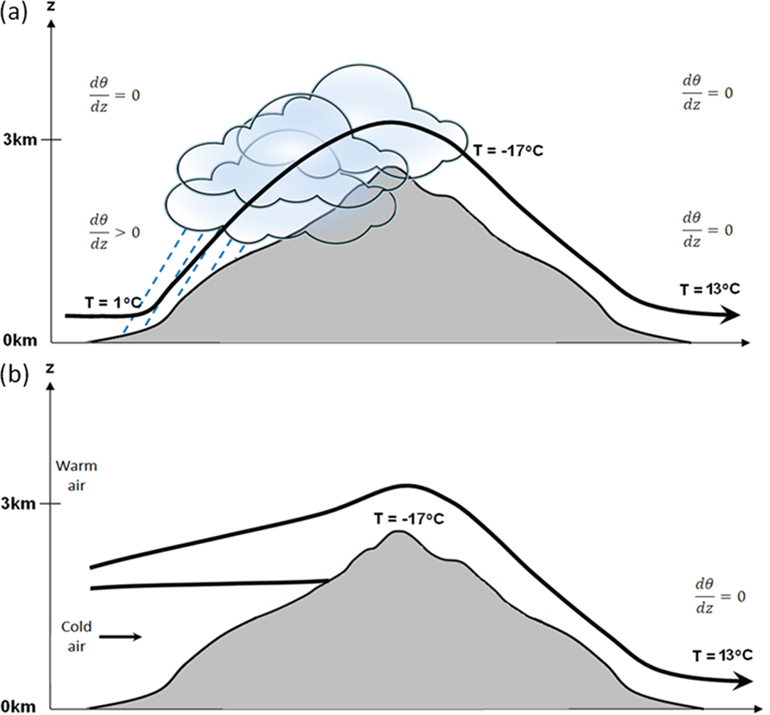

**Figure 3.** Schematic representation of (a) the classical, and (b) the dynamical föhn mechanism.

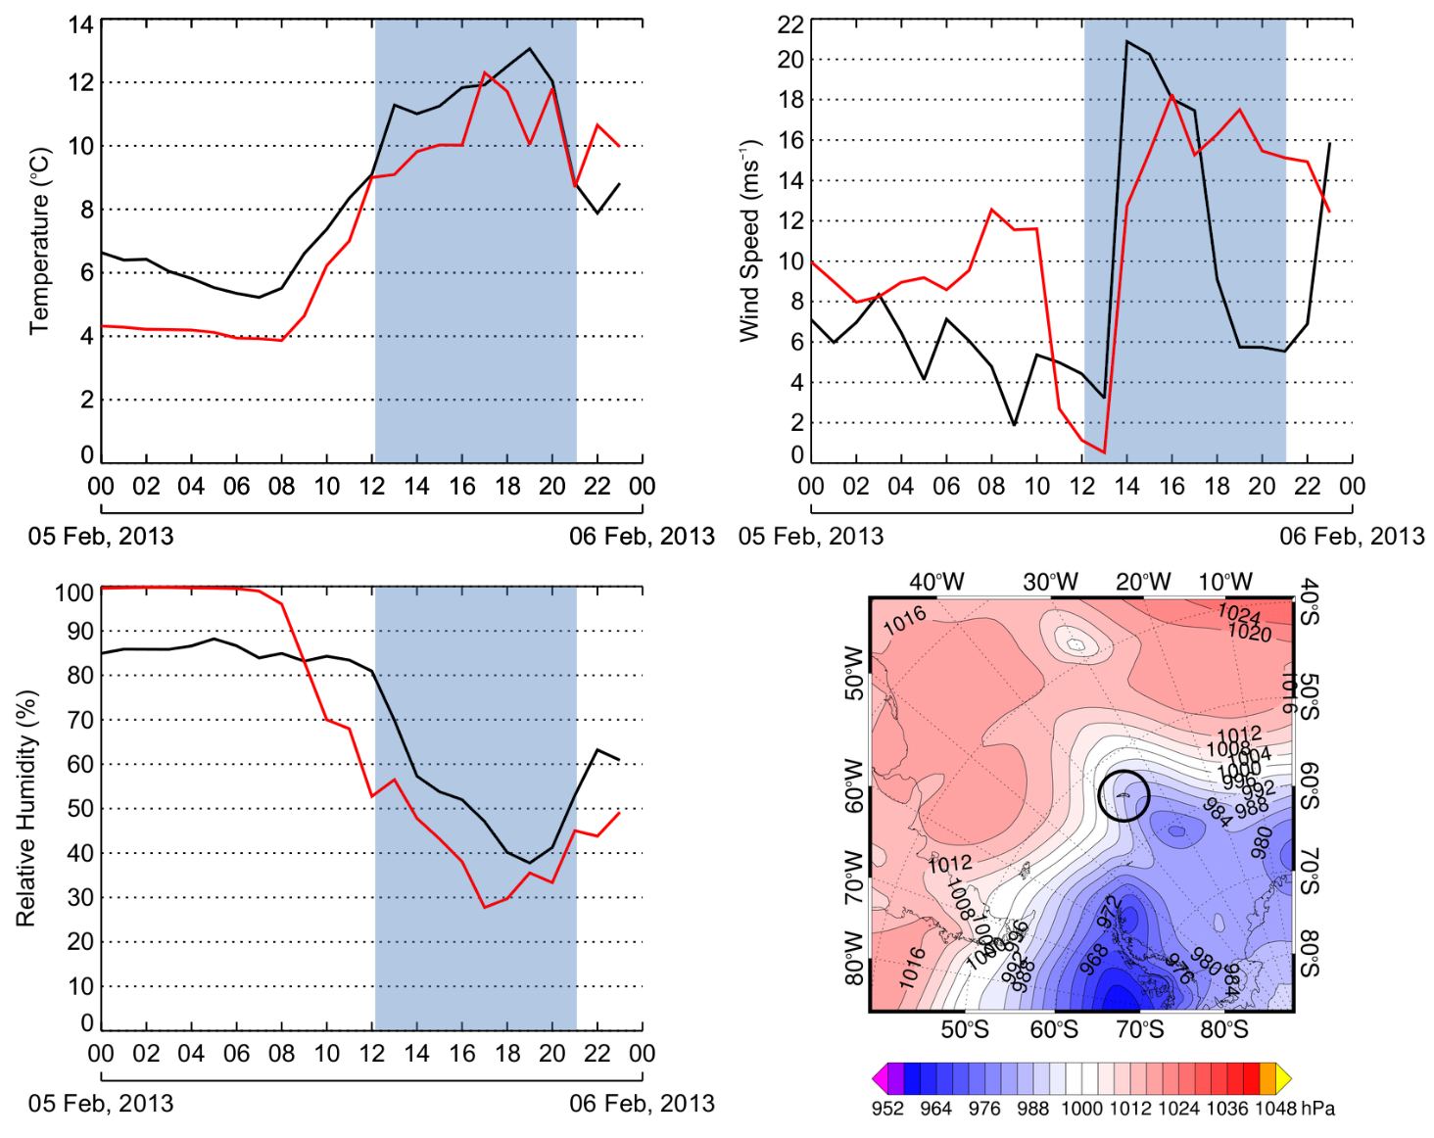

**Figure 4.** Meteorological conditions (2-m air temperature, 10-m wind speed and 2-m relative humidity) during 5 February 2013, (black solid line) AWS observations, (red solid line) Weather Research and Forecasting (WRF) model simulation. Blue shading highlights föhn event as defined by the AWS föhn classification method. ERA-Interim Reanalysis surface pressure (hPa) at 1200 UTC also plotted. South Georgia is circled in black.

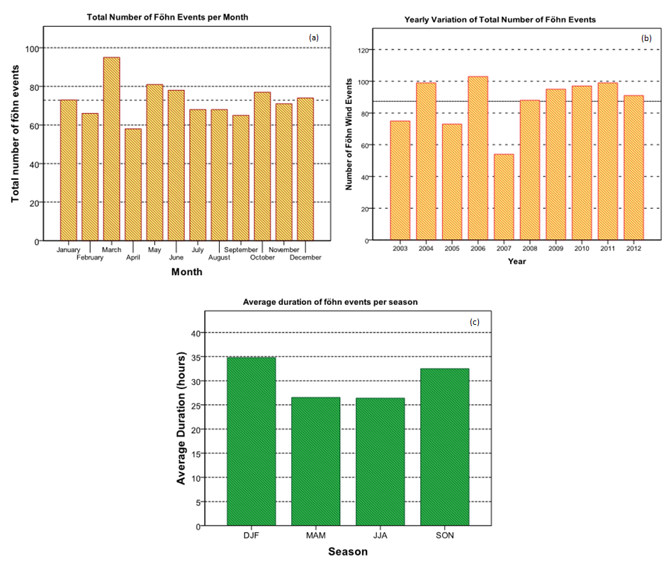

**Figure 5.** Climatology of föhn events recorded at King Edward Point, 2003 – 2012. (a) Monthly variation of föhn event frequency. (b) Yearly variation of föhn event frequency. (c) Seasonal variation of average föhn duration.

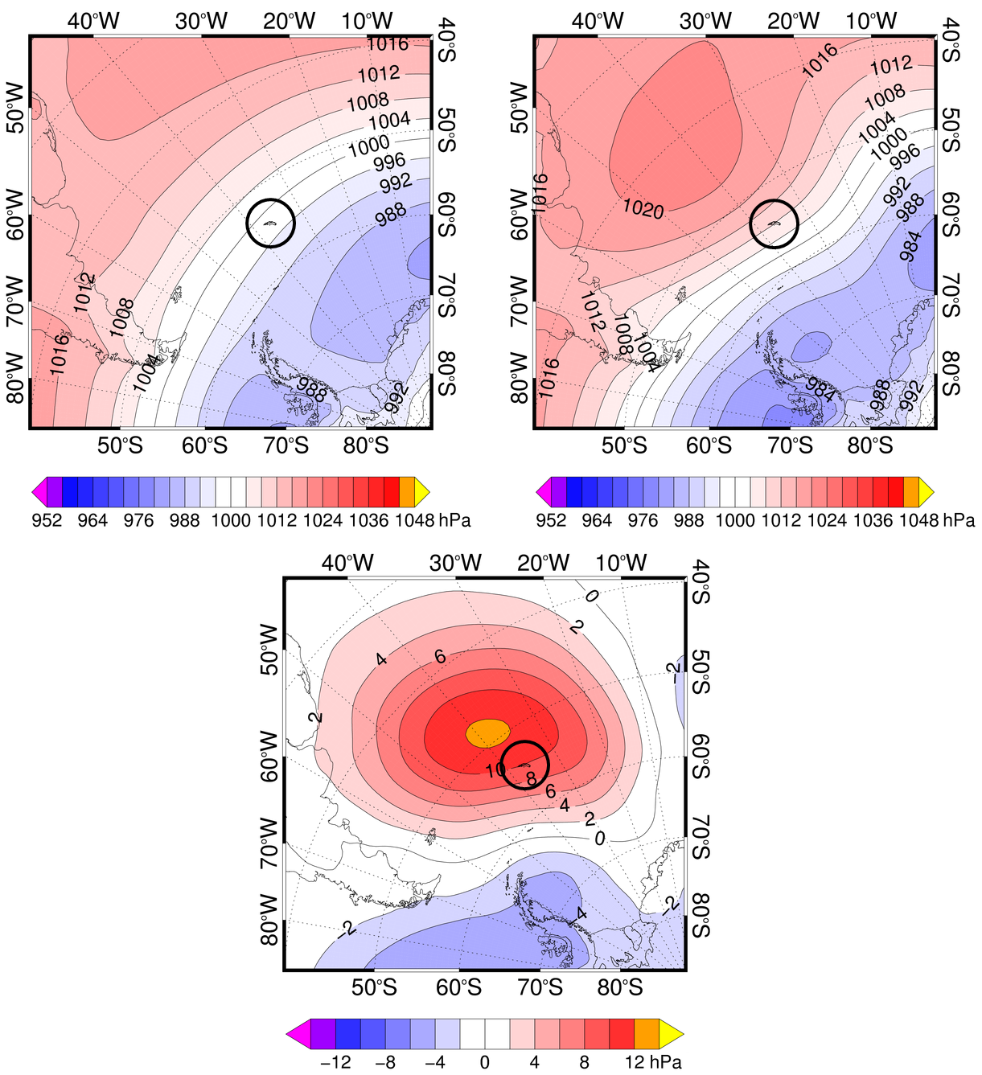

**Figure 6.** (a) ERA-Interim composite mean sea level pressure chart for the long-term climatological average (1979 – 2014). (b) ERA-Interim composite mean sea level pressure chart for 100 of the strongest föhn days (by total temperature increase). (c) The difference between long-term average conditions and the strongest föhn days. South Georgia is circled in black.

|  |  |  |  |  |  |
| --- | --- | --- | --- | --- | --- |
|  | Annual | DJF | MAM | JJA | SON |
| AWS  mean temperature (oC) | 2.4 oC | 5.6 oC | 2.2 oC | -0.8 oC | 2.7 oC |
|
| WRF | 1.5 oC | 4.1 oC | 2.2 oC | -0.4 oC | 1.0 oC |
| mean temperature (oC) |
| r2 value, statistical significance | 0.71, <0.05 | 0.66, <0.05 | 0.60, <0.05 | 0.68, <0.05 | 0.64, <0.05 |

**Table 1.** A comparison of annual and seasonal 2-m air temperature at the AWS and equivalent WRF location of King Edward Point. Determination coefficients (r2 values) and statistical significance is also given.

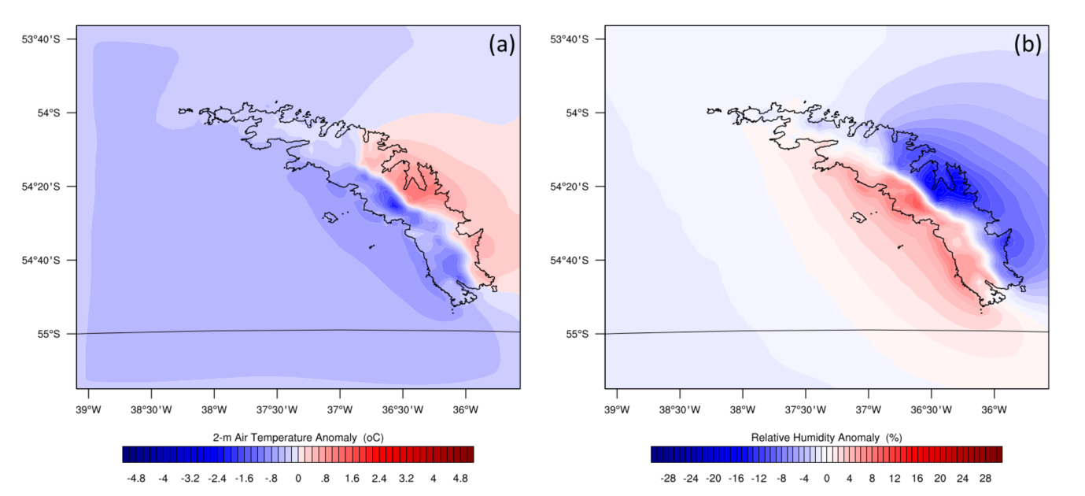

**Figure 7.** (a) 2-m air temperature föhn anomaly and (b) 2-m relative humidity föhn anomaly from the climatological mean.