Original Article
LRH R. A. Orben et al.
RRH Winter niche separation of kittiwakes
North or south? Niche separation of endemic red-legged kittiwakes and sympatric black-legged kittiwakes during their non-breeding migrations
Rachael A. Orben¹*, David B. Irons², Rosana Paredes³, Daniel D. Roby³, Richard A. Phillips⁴ and Scott A. Shaffer^{5,6}
¹Department of Ocean Sciences, Long Marine Lab, University of California Santa Cruz, Santa Cruz, CA 95060, USA, ²US Fish and Wildlife Service, MS 341, Anchorage, AK 99503, USA, ³Department of Fisheries and Wildlife, Oregon State University, Corvallis, OR 97331–3803, USA, ⁴British Antarctic Survey, Natural Environment Research Council, High Cross, Cambridge CB3 0ET, UK, ⁵Department of Biological Sciences, San Jose State University, San Jose, CA 95192–0100, USA, ⁶Institute of Marine Sciences, Long Marine Lab, University of California Santa Cruz, Santa Cruz, CA 95060, USA
*Correspondence: Rachael A. Orben, Department of Ocean Sciences, Long Marine Lab, University of California Santa Cruz, Santa Cruz, CA 95060, USA.
E-mail: raorben@gmail.com

Abstract
Aim Species that breed sympatrically often occupy different foraging niches to mitigate competition for prey. When resource availability declines at the end of the breeding season, most animals migrate to regions with more favourable environmental conditions. When these life-history traits combine, foraging habitat preferences may continue to influence migration patterns and habitat utilization. The Bering Sea is home to the red-legged kittiwake (RLKI), Rissa brevirostris, which is endemic, and the black-legged kittiwake (BLKI), Rissa tridactyla, which has a circumpolar breeding distribution. Since the 1970s, numbers of RLKIs at the largest colony have declined and then recovered, whilst the BLKI population has remained stable. Knowledge of the migration ecology of kittiwakes is key to understanding differences in population trajectories, and predicting possible future responses of these species to climate change.
Location Pribilof Islands, Bering Sea, subarctic North Pacific.
Methods Using geolocation loggers, we tracked adult RLKIs and BLKIs during their non-breeding migrations. We used iterative methods to assess suitable sample sizes for determining space use. Kittiwakes are surface foragers; therefore we used wet–dry data to distinguish active foraging behaviour and to test the species’ responses to environmental conditions. Stable isotope ratios of feathers grown during the non-breeding period were used to assess dietary niche.
Results RLKIs remained largely in the Bering Sea, where they experienced colder conditions and shorter days; individual birds used multiple habitats, including the continental shelves, the sea-ice edge and pelagic waters. In contrast, BLKIs migrated to the subarctic North Pacific, where they dispersed laterally across the basin; the majority of birds travelled to the western subarctic. RLKIs spent less time actively foraging than BLKIs, and consumed higher trophic-level prey.
Main conclusions The disparate wintering ranges and foraging behaviour of BLKIs and RLKIs suggest distinct environmental factors drive variation in overwinter survival. A strong association with sea-ice, and specialization both in diet and foraging behaviour, may make RLKIs particularly vulnerable to climatic change.
Keywords
Bering Sea, ecological segregation, geolocation, non-breeding habitat, North Pacific, resource partitioning, Rissa brevirostris, Rissa tridactyla, seabird, sibling species.

Introduction
Species that breed sympatrically often occupy different foraging niches to mitigate competition for prey (Ashmole, 1968; Kappes et al., 2010; Jeglinski et al., 2013). However, few studies have addressed whether niche specialization during breeding has an influence, in turn, on the migration ecology of marine species (e.g. Thiebot et al., 2013). During migration, individuals must adjust to changes in niche space, not only in terms of the physical environment, but also in food-web structure, including the composition of prey and predator communities and the presence of competitors. Because specialist predators need to track particular prey resources year-round, they are likely to be especially vulnerable to changes in prey distributions and community composition (Hückstädt et al., 2012). In the marine environment, anthropogenic climate change continues to affect temperature and wind regimes, the strength and routes of ocean currents, and to increase the pH of the oceans, altering prey fields and therefore influencing the distribution of upper trophic-level organisms (Hazen et al., 2012; Weimerskirch et al., 2012; Pinsky et al., 2013). Understanding the importance of migration strategies for life histories is essential for assessing how highly mobile species may cope with environmental change.
The physical environment of the Bering Sea is annually variable, as sea-ice influences the timing of the spring bloom, water column temperature and stratification. This results in a dichotomy between warm and cold years, in which different primary producers and secondary consumers are favoured (Hunt et al., 2011). Open-water spring blooms are higher in net primary productivity, occur in warmer water than ice-associated blooms, and over the long term will probably increase the carrying capacity of this ecosystem (Brown & Arrigo, 2013); however, warmer regimes disfavour Neocalanus copepods and their predators (Mueter et al., 2011; Dorresteijn et al., 2012). As the global climate changes, conditions in the Bering Sea are predicated to transition to current subarctic conditions, with greater stratification during the summer months likely to affect primary producers and have knock-on effects at upper trophic levels (Hunt et al., 2011; Brown et al., 2011).
Red-legged kittiwakes (RLKIs), Rissa brevirostris (Bruch, 1853), and black-legged kittiwakes (BLKIs) Rissa tridactyla (Linnaeus, 1758), breed sympatrically on a few islands in the Bering Sea. St George Island, of the Pribilof Island group, on the south-eastern Bering Sea shelf, is home to approximately 70% of all RLKIs and a large population of BLKIs (in 1977, 220,000 pairs of RLKIs and 72,000 pairs of BLKIs; Byrd et al., 2008a). RLKIs are currently listed as ‘Vulnerable’ by the World Conservation Union (BirdLife International, 2013). On St George, the population trends of these two species have diverged. RLKIs decreased by roughly 44% between 1976 and 1986, but subsequently increased such that recent counts suggest populations have recovered to levels recorded in the mid-1970s (Klosterman et al., 2011). In contrast, the BLKI population has remained relatively stable (Byrd et al., 2008a; Klosterman et al., 2011). The differing population trends of the two species, despite strongly correlated breeding productivity (Byrd et al., 2008b), suggest that some degree of non-breeding niche separation may play a role in population regulation; however, basic life-history differences, such as longevity, may also contribute. At the smaller colony on St Paul Island, populations of both kittiwake species are declining, although here the causes are likely to be a combination of low local food availability (Paredes et al., 2012) and targeting of RLKIs for subsistence hunting (Byrd et al., 2008a).
During the breeding period the two kittiwakes species appear to occupy different foraging niches. On St George: diet and trip duration indicate that RLKIs forage predominantly over the basin and tend to specialize on lipid-rich myctophid fishes (Lance & Roby, 1998), while BLKIs feed on a broader suite of prey from both the basin and shelf (Paredes et al., 2012; Renner et al., 2012). There is evidence that RLKIs have the capacity to forage on neritic prey (Hunt et al., 1981); however, since the 1990s, myctophids have increased in occurrence in the diet of both species, probably increasing interspecific competition (Sinclair et al., 2008; Renner et al., 2012). It is unknown how the release of the central-place breeding constraint affects RLKI foraging, particularly whether they continue to act as specialized foragers. Compared with BLKIs, RLKIs have physiological adaptations for their particular foraging style, including shorter bills and larger eyes, that suggest specialization for foraging at low light levels is an important life-history strategy (Storer, 1987). Outside the breeding period, the habitat use and diet of RLKIs is largely unknown, but they are thought to be highly pelagic; limited at-sea survey data indicate that they could range from the pack-ice edge to south-east Alaska, California and the Kuril Islands (Byrd & Williams, 1993). In contrast, BLKIs from coastal Alaska migrate south along the coast of North America (McKnight et al., 2011).
In the present study, we characterized and compared the non-breeding foraging ecology of these two sympatric kittiwake species to determine whether niche partitioning occurs in space, time or dietary trophic level. For both species on the Pribilof Islands, we determined the distribution, habitat utilization, activity patterns and trophic partitioning based on stable isotope analysis. We used remotely sensed environmental data to examine how these species respond to habitat conditions. In light of these results, we speculate on the potential mechanisms that could drive population regulation in these congeners.

Materials and Methods
Global location sensor (GLS) loggers (2.5 g, Mk9/Mk19; British Antarctic Survey, Cambridge, UK) were attached to leg bands on kittiwakes in July 2010, on St Paul Island (57°11’ N 170°15’ W; BLKI = 31, RLKI = 5) and St George Island (56°34’ N 169°37’ W; BLKI = 28, RLKI = 22) of the Pribilof Islands, Alaska, USA. The birds were captured when attending nests, which typically contained one chick, using a telescoping noose pole or foot snare. Birds were recaptured using a foot snare or hand-held CO₂-powered net gun (Super Talon Animal Catcher; Advanced Weapons Technology, La Quinta, CA, USA). Body measurements were taken from all birds. Wing loading was calculated as body mass divided by the wing area. The latter was twice the area of the right wing (plus the rootbox, the area of the body between the wings), which was traced in the field then a cut-out weighed (accuracy 0.001g) and a standard curve used to calculate area (Pennycuick, 2008). Sex was determined from DNA extracted from blood samples (Fridolfsson & Ellegren, 1999).
All data processing and spatial analyses were conducted using Matlab 2009a (The Mathworks, Natick, MA, USA). Statistical tests were run in R 3.0.0 (R Core Team, 2013). The results are shown as means ± SD. Significance was set to P < 0.05.

Movement and area utilization
Loggers were used to record light levels, and TransEdit and Locator (British Antarctic Survey) were used to identify dawn and dusk transitions using a threshold of 10, and to calculate locations based on a Sun angle of –3.5 for the Mk9 loggers and –3.0 for the Mk19 loggers (values selected on the basis of stationary calibration data). Locations were calculated following Phillips et al. (2004), by smoothing locations twice and then applying an iterative forward/backward averaging speed filter based on a maximum travel speed of 48 km h^{–1} sustained over 12 h (Coulson, 2011). Geolocation has an error of approximately 180–200 km that increases around the equinoxes (Phillips et al., 2004; Shaffer et al., 2005), therefore analysis was restricted to the period 15 October–27 February. Smoothed tracks were used to identify the furthest location (maximum range) from the colony, as well as the date and bearing of that location. To calculate departure and return dates, sea-surface temperatures (SST) were used to estimate latitudes for those loggers that recorded temperature (BLKI = 27, RLKI = 8) and then the tracks were speed filtered (Shaffer et al., 2005).
Utilization distributions (UDs) were calculated using smoothed locations for the pooled samples by year and month to show general movement patterns, and for each bird using the IKNOS toolbox (Y. Tremblay, University of California Santa Cruz, Santa Cruz, unpublished data). The grid cell size was set at 80 km. To enable comparisons between species and iterations, the smoothing parameter was selected using the entre dataset (latitude 0.0171, longitude 0.0068; Sheather & Jones, 1991). Portions of UDs overlapping land were subtracted from area calculations. The 50% and 95% UDs were considered to represent the core area and overall range, respectively.
Bootstrapping was used to calculate standard deviations for area estimates, to determine whether enough individuals were tracked to make reasonable inferences of area use (Hindell et al., 2003; Soanes et al., 2013) and to assess overlap between groups (Breed et al., 2006). To assess whether sample sizes were sufficient, the areas of the 50% and 95% UDs were calculated with the addition of a new bird selected at random until all individuals were included. This was repeated for 1000 iterations. To determine spatial partitioning between species, colonies (BLKIs only, due to small sample size of RLKI from St Paul) and sexes, the amount of overlap between observed distributions was compared with the overlap from 1000 bootstrapped selections from the pooled dataset. The area of overlap divided by the area of the 95% UD of the overall dataset was used as the test statistic, and the P-value was determined as the proportion of iterations that resulted in a smaller overlap than observed (Breed et al., 2006).

Habitat
Habitat use was characterized in terms of oceanographic, topographical, astronomical and atmospheric variables extracted at a grid scale of 2° latitude by 1° longitude. SSTs were extracted as an 8-day blended product from National Oceanic and Atmospheric Administration (NOAA)’s Environmental Research Division (Pacific Grove, CA) (http://oceanwatch.pfeg.noaa.gov/thredds/catalog.html). Sea-surface height (SSH) and surface currents used to calculate eddy kinetic energy (EKE) were extracted from the Navy Layered Ocean Model (http://www7320.nrlssc.navy.mil/global_nlom/) using the nctoolbox (https://github.com/nctoolbox/). The distance to the coast was calculated using mean high water (National Geophysical Data Center, NOAA, Boulder, CO). The distance to the sea-ice edge (5% contour) was calculated from daily Advanced Microwave Scanning Radiometer - EOS (AMSR-E, National Space Development Agency of Japan) georeferenced images captured aboard the Aqua satellite (National Aeronautics and Space Administration, USA) projected using ArcGIS 9.0 (ESRI, Redlands, CA, USA). Bathymetry was extracted from 2-minute gridded global relief data (Smith, 1997). Day and twilight length (nautical) were calculated for each estimated location (Reda & Andreas, 2003). The fraction of the Moon illuminated was extracted from the US Naval Observatory (Washington, DC). Surface values of air temperature, wind speed, relative humidity, precipitation and barometric pressure were extracted from the NCEP/NCAR reanalysis I and NCEP/DOE reanalysis II datasets (Kanamitsu et al., 2002; Kemp et al., 2011).

Activity patterns
Kittiwakes are surface foragers, and immersion (wet–dry) sensors are particularly suited to monitoring their activities, as frequent switches between wet and dry indicate periods of more intensive foraging behaviour. Following Paredes et al. (2012), activity data, recorded in 10-min blocks, was classified into three categories: (1) active foraging, with periods of frequent switches between wet and dry; (2) on water, delineated when a bird spent 100% of a 10 min period on the water as well as sequential periods of ≥ 90% of 10 min on the water; and (3) dry, when the logger spent > 99% of a 10 min interval dry, indicative of flight or roosting behaviour. Light levels recorded by the logger were used to classify behaviours into daylight or darkness activities.
Linear mixed models were used to relate active foraging (as a percentage of 24 h) to environmental characteristics. The following variables were excluded because inclusion resulted in variance inflation factors > 3 (Zuur et al., 2009): distance to coast and colonies, precipitation, and day and twilight length. SSH and EKE were excluded because they were unavailable on the Bering Sea shelf. Bathymetry was included as a categorical variable (shelf, < 200 m; shelf break, 200–1000 m; continental slope, 1000–2000 m; oceanic, > 2000 m) and day and twilight length were combined into one variable. Therefore, the full models contained 10 variables. To meet conditions of normality, Moon illumination and cloud cover were logit transformed, and distance to sea-ice and the response variable, the percentage time spent actively foraging, were square-root transformed. Best-fit models, constructed using a reductive approach, were identified from Akaike information criterion (AIC) scores based on restricted maximum likelihood estimates (Zuur et al., 2009), and marginal and conditional R²-values were used to assess the variance explained by the fixed effects and the combined fixed and random effects, respectively (Nakagawa & Schielzeth, 2012).

Stable isotope analysis
We sampled head feathers, which are grown in late winter as birds moult into their breeding plumage (Gabrielson & Lincoln, 1959), and body feathers, which were probably replaced over a broader time frame during the non-breeding period. Feathers were washed with 2:1 chloroform : methanol for 24 h, rinsed twice, allowed to dry for > 48 h, and cut finely. The feathers were analysed for δ¹³C and δ¹⁵N using a Carbo-Elba elemental analyser interfaced with a Finnigan Delta Plus XP mass spectrometer (Light Stable Isotope Lab, University of California Santa Cruz, Santa Cruz, CA, USA). Data were corrected for sample mass and instrument drift. Measurement precision (standard deviation), based on within-run replicate measures of the laboratory standard (pugel), was 0.08 for δ¹³C and 0.08 for δ¹⁵N (n = 24).

Results
Overall, 86% of tagged birds were resighted in the following breeding season (St Paul, BLKI 87%, RLKI 60%; St George, BLKI 92%, RLKI 82%). These may be underestimates of survival as there was almost complete breeding failure of BLKIs during incubation and poor overall hatching success of RLKIs (Klostermann et al., 2011; Thomson & Drummond, 2012). Overall, 71% of loggers were recovered; nine loggers failed. Complete datasets were available for analysis from 34 BLKIs (St Paul, 15; St George, 19) and 17 RLKIs (St Paul, 2; St George, 15). Mean mass at recapture was not significantly different from that at deployment (paired t-test, P > 0.05).

Morphometrics
BLKIs were larger than RLKIs in all measurements; however, there was no significant difference in aspect ratio or wing loading (see Appendix S1 in Supporting Information). Male BLKIs were larger than female BLKIs in all measurements except wing area, whereas male RLKIs were larger than female RLKIs in only head plus bill length (F_{1,30} = 4.70, P = 0.038). There were no significant differences between the sexes in either species regarding aspect ratio and wing loading (see Appendix S1).

Movements and area utilization
During the non-breeding period, both species migrated away from their colonies. Their distributions were spatially segregated, with almost no overlap of 50% UDs (Fig. 1). The core areas for BLKIs were between 40° N and 50° N, while those of RLKIs were largely in the Bering Sea (Fig. 1). There were overlaps between the 95% UDs of the two species in the south-east Bering Sea, the Western Subarctic Gyre (WSG) and along the northern edge of the BLKI distribution (Fig. 1). Both species remained in the Pribilof region until late September. Although there were no significant differences in the maximum range, departure or arrival date between species, the ranges of individual RLKIs were further west and significantly smaller than those of BLKIs (see Appendix S2). The furthest locations of males were further to the west than those of females, but no other significant effects of sex were observed.
High densities of BLKIs were consistently present in the central subarctic North Pacific (Fig. 2). In February, BLKIs were highly dispersed, with a distribution that spanned the North Pacific from the Kuril Islands to the California coast. A total of 23 BLKIs (68%) travelled to the WSG. Overall BLKIs spent minimal time in the Gulf of Alaska, with three birds (8%) travelling to the California Current system in February (6 February ± 6 days), where they remained for 30 ± 8 days until departure in March (9 March ± 5 days). In contrast, 82% of RLKIs remained in the eastern Bering Sea through December, largely foraging over the shallow shelf, north to the Chukchi Peninsula. In November, two RLKIs (12%) flew to the northern Kuril Islands. By January, the remaining birds left the eastern Bering Sea as the sea-ice extended south, and rapidly crossed the basin or moved south along the coast of Kamchatka, where high densities occurred into February (Fig. 2). By this time, all RLKIs had briefly visited the western subarctic and, when the birds began returning north, four birds made brief forays into the Sea of Okhotsk.
The total area occupied during the non-breeding period appeared to approach saturation (i.e. an asymptote) with the number of birds tracked; for RLKIs, an asymptote was reached at a lower sample size, indicating little variation between individuals (Fig. 3). The species differed significantly in spatial extent, with BLKIs using a larger area (Fig. 3). The species’ distributions showed significantly less overlap than occurred randomly at both the core and range scales (50% UD, 10% overlap; 95% UD, 68.5% overlap; P < 0.001). BLKIs originating from the two study colonies showed significantly less overlap than occurred at random, indicating spatial differences (50% UD, 17% overlap, P < 0.001; 95% UD, 67% overlap, P = 0.022). There was less overlap between sexes than occurred at random in BLKIs for the 50% UDs (14% overlap, P = 0.002) but not the 95% UDs (59% overlap, P = 0.065); for RLKIs, there was less overlap for both the 50% UDs (10% overlap, P < 0.001) and 95% UDs (69% overlap, P < 0.001; see Fig. S1 in Appendix S3). Females appeared to be more widely dispersed; however, sample sizes were small. Because it was not possible to account for inter-colony variation for RLKIs, the colonies were combined in the following analysis.

Habitat
The physical characteristics of the habitats used by RLKIs and BLKIs in their core areas differed significantly for all environmental variables except mean sea level pressure and SSH (Table 1). RLKIs encountered, on average, significantly colder water and air temperatures and lower humidity, whereas BLKIs encountered higher winds and more cloud and precipitation. BLKIs experienced more hours of daylight but fewer hours of twilight. RLKIs were closer to the sea-ice edge; however, not all core areas were associated with sea-ice. Core areas of RLKIs had higher EKE; this difference reflected the pelagic portion of the respective distributions, as satellite remote-sensing limits the measurement of EKE to off-shelf regions. RLKIs remained closer to the Pribilof Islands and the coast, and hence in shallower water.

Daily activity patterns
BLKIs actively foraged more than RLKIs throughout the non-breeding period; RLKIs spent more time in flight or roosting in October–December and more time on the water in December–January than BLKIs (Fig. 4; percentage of 24 h). Both species engaged in their most active foraging in October (RLKIs 15%, BLKI 25.3%) and the least in January (RLKIs 11.5%, BLKI 19.1%). The majority of the night was spent sitting on the water (BLKI 84.8 ± 8.5%, RLKI 91.1 ± 1.4%, F_{1,46} = 4.66, P = 0.036), with < 5% of darkness spent in flight; however, BLKIs spent a higher percentage of the night engaged in active foraging behaviour than RLKIs (BLKI 10.3 ± 4.1%, RLKI 6.1 ± 2.1%, F_{1,46} = 21.54, P < 0.001).
For the linear models relating active foraging (percentage of 24 h) to environmental characteristics, the inclusion of a temporal autocorrelation term improved the AIC scores. For RLKIs, the best-fit model included six significant factors (Table 2); air temperature and combined daylight and twilight length were all positively related to active foraging, while SST, distance to the sea-ice, cloud cover and wind speed were negatively related. For BLKIs, the best-fit model included seven significant factors (Table 2); active foraging was related positively to SST, mean sea level pressure, air temperature, moonlight, humidity and cloud cover, and negatively to distance to sea-ice.

Stable isotope analysis

Compared with BLKIs, the head feathers of RLKIs had higher δ¹⁵N (F_{1,62} = 27.29, P < 0.001), lower δ¹³C (F_{1,62} = 10.38, P = 0.002) and less variance for both δ¹⁵N (F_{42,18} = 11.91, P < 0.001) and δ¹³C (F_{42,18} = 3.14, P = 0.011; Fig. 5). δ¹⁵N of body feathers was higher for RLKIs (F_{1,62} = 9.41, P = 0.003); neither δ¹³C nor variances of body feathers were significantly different, but variance was higher between body feathers than head feathers for both species (Fig. 5). δ¹⁵N of body feathers was higher head feathers of BLKIs (t = –2.56, P = 0.032) but not RLKIs (t = –1.774, P = 0.093). There was a significant difference in δ¹³C of head feathers of individual RLKIs sampled in two consecutive years (2010, –18.56 ± 0.32‰; 2011, –18.34 ± 0.21‰; t = –2.2, n = 17, P = 0.043) but not in those of individual BLKIs (2010, 14.94 ± 0.96‰; 2011, 14.32 ± 1.50‰; t = 2.73, n = 37, P = 0.01); within individuals, there were no significant differences between years in δ¹⁵N of head feathers and δ¹³C and δ¹⁵N of body feathers.

Discussion
We found that both kittiwake species made long-distance migrations and showed a substantial degree of spatial and dietary niche partitioning during the non-breeding period. Contrary to expectations, RLKIs were more coastal whereas BLKIs migrated to more pelagic areas and therefore experienced very different physical environmental conditions. Overall, BLKIs foraged more actively, were more active at night and foraged more in moonlight. The lower variance in stable isotope ratios suggested that RLKIs tended to be dietary specialists during the late winter, whereas BLKIs were generalists. Our data suggest that RLKIs are particularly adapted to exploitation of the Bering Sea ecosystem, and that changes in the oceanographic regime here will more strongly influence population trends of this species.

Spatial niche
The two kittiwake species showed marked segregation in spatial distribution and associated environmental conditions during the non-breeding period, which was independent of the colony of origin (BLKIs from the two study colonies showed extensive overlap in distribution). By utilizing both the eastern and western Bering Sea, RLKIs exploited a diversity of habitats, including the shallow continental shelf, sea-ice edge and pelagic regions of high EKE. The use of the Bering Sea shelf in the autumn is supported by at-sea data (March–October), as the relative abundance of RLKIs increases over the shelf break, and to some extent over the shelf, during both the early autumn and spring, following the general trend for surface foragers in the region to move nearer to the shore during these periods (Hunt et al., 2013). The sea-ice edge is likely to be a key habitat for RLKIs, although from our large-scale geolocation data it is impossible to resolve the exact association. As well as the extensive coastal sea-ice present for much of the winter, the Kamchatka Current is characterized by areas of relatively high EKE. Eddy activity may make prey more available for surface-foraging seabirds and provide predictable spatial structure for locating prey (Bost et al., 2009). Although the diversity in non-breeding habitats used by RLKIs might be expected to result in dietary shifts, our data on activity budgets, and the low variance in stable isotope ratios in feathers grown during the non-breeding season, suggest they maintain similar levels of foraging specialization throughout this period.
BLKIs showed a preference for westerly and central areas in the subarctic North Pacific and RLKIs also utilized waters of the WSG. This preference is similar to large-scale patterns observed for other marine predators, including migratory shearwaters and some cetacean species (Springer et al., 1999). It is likely that resources are more abundant or predictable here, as high primary productivity supports higher winter zooplankton biomass and a greater diversity of myctophid fishes than in the eastern North Pacific (Beamish et al., 1999; Nagasawa, 2000). None of the tracked kittiwakes utilized the Gulf of Alaska, one of the stormiest regions of the North Pacific (Wilson & Overland, 1986). Nevertheless, this is likely to be an important wintering area for a proportion of Alaskan BLKIs; birds from Prince William Sound have ranged there during some years (McKnight et al., 2011). Many kittiwakes breeding in the north-east Atlantic also cross the basin to winter in cold waters off Newfoundland and Labrador, suggesting a commonality in winter resource availability where cold waters, the Kamchatka Current (North Pacific) and Labrador Current (North Atlantic) move south (Frederiksen et al., 2012).

Behavioural niche
Both species were largely diurnal in their use of active foraging, which is similar to BLKIs tracked in the eastern North Pacific (McKnight et al., 2011). Environmental conditions were only able to explain a small portion of the variance in the percentage of time the two species spent actively foraging, reflecting the large amount of individual variation in both species. In general, BLKIs were more active, even during darkness, and, unlike RLKIs, BLKIs increased their active foraging when the Moon was fuller. Specialist predators are sometimes more efficient at catching and handling prey (Heinrich, 1976). However, it is surprising RLKIs were not more active during darkness, as suggested previously on the basis of their relatively large eyes (Storer, 1987). This does not refute the hypothesis that larger eyes are an adaptation for foraging at night, as this species could be employing a less energetically costly sit-and-wait strategy for night foraging (Jodice et al., 2003). RLKIs experienced more hours of twilight than BLKIs, but the activity patterns of both species suggest that they do not use all the daylight hours to meet their energetic needs.

Dietary niche
Our data suggest that RLKIs are foraging predominantly on higher trophic-level prey than BLKIs. Elevated δ¹⁵N values do occur for other reasons, including as a result of fasting or spatial differences in baseline values. The latter are particularly important when considering large geographical ranges; however, for head feathers grown in the late winter the geolocation data suggest both species were using off-shore resources, supporting the idea of higher trophic foraging by RLKIs. Nevertheless, higher δ¹⁵N of body feathers from some RLKIs is probably the result of movement to the northern Bering Sea, as the baseline δ¹⁵N values increase 2–6‰ from south to north, whereas δ¹³C values are more spatially heterogeneous (Schell et al., 1998). Myctophids are not found in the shallow waters on the Bering Sea shelf (Beamish et al., 1999), which in itself suggests that RLKIs are able to shift their diets from the types of prey exploited during the summer. Excluding the individuals with elevated δ¹⁵N, the remaining RLKIs showed a low degree of variance in stable isotope ratios in their body feathers (δ¹⁵N variance = 0.257‰), indicating a diet specialization that is maintained for long periods.
Dietary specialization during the non-breeding period appears to be rare, and instead an expansion in trophic niche is more common (Cherel et al., 2007; González-Solís et al., 2011; but see Bodey et al., 2013). RLKIs appear to be specialists during the pre-nuptial moult, as the variance in isotope ratios among individuals was less than 1‰ (Jaeger et al., 2009). This specialization may make them vulnerable to changes in prey populations, and indeed fluctuations in breeding success are evident at St George that relate to a negative competitive interaction with pink salmon, Oncorhynchus gorbusch (Springer & van Vliet, 2014). How these interactions influence distributions is unknown, as we only tracked individuals during one year. However, individual RLKIs showed a slight, but significant, shift of 0.22‰ in δ¹³C in head feathers grown in consecutive years, which could relate to annual differences in spatial habitat use.

Population regulation
The striking non-breeding niche separation between these kittiwake species may help to explain the divergent population trends observed on St George, although other differences in life-history factors may also be important. Regardless, as RLKIs spent a large portion of the non-breeding period in the Bering Sea, it seems reasonable to expect that changes in year-round prey resources in this region will influence overwinter survival. Declines in RLKIs followed the 1976–77 regime shift in the Bering Sea (Hare & Mantua, 2000); however, how winter prey availability changed during this time period is unclear. Winter conditions in the Bering Sea show a high degree of annual variability, because of changes in sea-ice extent and the timing of ice retreat (Overland & Stabeno, 2004), whereas the subarctic North Pacific may provide a more stable wintering habitat (Bograd, 2004). Our data relate to a single year of tracking and hence the degree of annual variation in migration patterns and distributions is unknown; however, for RLKIs the lack of any significant change within individuals in the isotopic ratios of body feathers grown during consecutive winters of extensive sea-ice suggests a high degree of fidelity in both habitat use and diets under these conditions.
The restricted range of the RLKI and its greater dietary specialization may make this species vulnerable to future declines in sea-ice extent, as the eastern Bering Sea is predicted to be ice-free year-round by 2050 (Wang et al., 2012). Our study highlights a close association between RLKIs and sea-ice; however, it is unknown to what extent RLKIs rely on pagophilic prey. Kittiwake reproductive success is linked to sea-ice extent and timing of retreat at lagged time-scales (Zador et al., 2013); hatch dates have become progressively earlier, which is also thought to be related to prey availability and changes in sea-ice dynamics (Byrd et al., 2008b). In this study, both species returned to the Pribilof Islands around the spring equinox, when there was still sea-ice in the south-eastern Bering Sea. Independent time series data for observed return dates are not available, but on 8 April 1914, G D. Hanna observed the first RLKIs returning to St George (Gabrielson & Lincoln, 1959), which hints that the reliance on springtime resources in the Bering Sea has existed for at least the last 100 years.

CONCLUSIONS
Our study provides new insights into the non-breeding distribution and ecology of two important avian predators in the Bering Sea ecosystem. Specifically, the division of range and habitat use of these two congeneric kittiwake species during this time implies that different environmental factors will influence foraging success and survival. The lower levels of activity shown by the RLKIs, as well as the high degree of similarity in stable isotope values, suggest that this species employs a specialized foraging strategy, which may increase their susceptibility to environmental change. Warming temperatures may allow BLKIs to use more of the Bering Sea during the winter, while the RLKIs’ preferred habitat may shift further north. The degree of individual flexibility in migratory patterns may be an important factor in how well these two species will adapt to future climate change.

Acknowledgements
This research was approved by the animal care and use committee of the University of California Santa Cruz (UCSC) and by permit from the US Fish and Wildlife Service (USFWS). We are highly indebted to a team of field biologists including S.D. Kildaw, B. Drummond, J. Harley, C. Kroeger, D. Lyons, K. McKay, V. Patel, R. Steenweg, and J. Warzybok. We also thank the Alaska Marine National Wildlife for their continued and long-term efforts to monitor seabird populations in Alaska. R. Young and A. Kitaysky provided laboratory assistance in sexing study birds. We are grateful to two anonymous reviewers for their valuable comments. This research was predominantly funded by the North Pacific Research Board (NPRB) project 911 to D.B.I., D.A.R. and S.A.S., and project B63 to D.B.I. and D.D.R. R.A.O. was supported by a UCSC Regents fellowship, a NPRB graduate fellowship and a UCSC Chancellor’s dissertation year fellowship. Grants from Friends of Long Marine Lab and Earl and Ethyl Meyers Oceanographic Trust to R.A.O. supported the RLKI work. This is NPRB Contribution No. 507.

REFERENCES
Ashmole, N.P. (1968) Body size, prey size, and ecological segregation in five sympatric tropical terns (Aves: Laridae). Systematic Biology, 17, 292–304.
Beamish, R.J., Leask, K.D., Ivanov, O.A., Balanov, A.A., Orlov, A.M. & Sinclair, B. (1999) The ecology, distribution, and abundance of midwater fishes of the Subarctic Pacific gyres. Progress in Oceanography, 43, 399–442.
BirdLife International (2013) Rissa brevirostris. The IUCN Red List of threatened species. Version 2014.1. Available at: http://www.iucnredlist.org/ (accessed 10 July 2014).
Bodey, T.W., Ward, E.J., Phillips, R.A., McGill, R.A.R. & Bearhop, S. (2013) Species versus guild level differentiation revealed across the annual cycle by isotopic niche examination. Journal of Animal Ecology, 83, 470–478.
Bograd, S.J., Foley, D.G., Schwing, F.B., Wilson C., Laurs, R.M., Polovina, J.J., Howell, E.A. & Brainard, R.E. (2004) On the seasonal and interannual migrations of the transition zone chlorophyll front. Geophysical Research Letters, 31, L17204.
Bost, C.-A., Cotté, C., Bailleul, F., Cherel, Y., Charrassin, J.-B., Guinet, C., Ainley, D.G. & Weimerskirch, H. (2009) The importance of oceanographic fronts to marine birds and mammals of the southern oceans. Journal of Marine Systems, 78, 363–376.
Breed, G.A., Bowen, W.D., McMillan, J.I. & Leonard, M.L. (2006) Sexual segregation of seasonal foraging habitats in a non-migratory marine mammal. Proceedings of the Royal Society B: Biological Sciences, 273, 2319–2326.
Brown, Z.W. & Arrigo, K.R. (2013) Sea ice impacts on spring bloom dynamics and net primary production in the Eastern Bering Sea. Journal of Geophysical Research: Oceans, 118, 43–62.
Brown, Z.W., van Dijken, G.L. & Arrigo, K.R. (2011) A reassessment of primary production and environmental change in the Bering Sea. Journal of Geophysical Research: Oceans (1978–2012), 116, C08014.
Byrd, G. V. & Williams, J.C. (1993) Red-legged kittiwake (Rissa brevirostris). The birds of North America online (ed. by A. Poole). Cornell Lab of Ornithology, Ithaca, NY.
Byrd, G.V., Schmutz, J.A. & Renner, H.M. (2008a) Contrasting population trends of piscivorous seabirds in the Pribilof Islands: a 30-year perspective. Deep-Sea Research Part II: Topical Studies in Oceanography, 55, 1846–1855.
Byrd, G.V., Sydeman, W.J., Renner, H.M. & Minobe, S. (2008b) Responses of piscivorous seabirds at the Pribilof Islands to ocean climate. Deep-Sea Research Part II: Topical Studies in Oceanography, 55, 1856–1867.
Cherel, Y., Hobson, K.A., Guinet, C. & Vanpe, C. (2007) Stable isotopes document seasonal changes in trophic niches and winter foraging individual specialization in diving predators from the Southern Ocean. Journal of Animal Ecology, 76, 826–836.
Coulson, J.C. (2011) The kittiwake. T. & A.D. Poyser, London.
Dorresteijn, I., Kitaysky, A.S., Barger, C.P., Benowitz-Fredericks, Z.M., Byrd, G.V., Shultz, M.T. & Young, R. (2012) Climate affects food availability to planktivorous least auklets Aethia pusilla through physical processes in the southeastern Bering Sea. Marine Ecology Progress Series, 454, 207–220.
Frederiksen, M., Moe, B., Daunt, F. et al. (2012) Multicolony tracking reveals the winter distribution of a pelagic seabird on an ocean basin scale. Diversity and Distributions, 18, 530–542.
Fridolfsson, A.K. & Ellegren, H. (1999) A simple and universal method for molecular sexing of non-ratite birds. Journal of Avian Biology, 30, 116–121.
Gabrielson, I.N. & Lincoln, F.C. (1959) The birds of Alaska. Stackpole Co., Harrisburg, PA.
González-Solís, J., Smyrli, M., Militão, T., Grémillet, D., Tveraa, T., Phillips, R.A. & Boulinier, T. (2011) Combining stable isotope analyses and geolocation to reveal kittiwake migration. Marine Ecology Progress Series, 435, 251–261.
Hare, S.R. & Mantua, N.J. (2000) Empirical evidence for North Pacific regime shifts in 1977 and 1989. Progress in Oceanography, 47,103–145
Hazen, E.L., Jorgensen, S., Rykaczewski, R.R., Bograd, S.J., Foley, D.G., Jonsen, I.D., Shaffer, S.A., Dunne, J.P., Costa, D.P., Crowder, L.B. & Block, B.A. (2012) Predicted habitat shifts of Pacific top predators in a changing climate. Nature Climate Change, 3, 234–238.
Heinrich, B. (1976) The foraging specializations of individual bumblebees. Ecological Monographs, 46, 105–128.
Hindell, M.A., Bradshaw, C.J.A., Sumner, M.D., Michael, K.J. & Burton, H.R. (2003) Dispersal of female southern elephant seals and their prey consumption during the austral summer: relevance to management and oceanographic zones. Journal of Applied Ecology, 40, 703–715.
Hückstädt, L.A., Burns, J.M., Koch, P.L., McDonald, B.I., Crocker, D.E. & Costa, D.P. (2012) Diet of a specialist in a changing environment: the crabeater seal along the western Antarctic Peninsula. Marine Ecology Progress Series, 455, 287–301.
Hunt, G.L., Jr, Eppley, Z.A., Burgeson, B. & Squibb, R.C. (1981) Reproductive ecology, foods and foraging areas of seabirds nesting on the Pribilof Islands, 1975–1979. Environmental assessment of the Alaskan continental shelf. NOAA Environmental Research Laboratories, Boulder, CO, 1-258.
Hunt, G.L., Jr, Coyle, K.O., Eisner, L.B., Farley, E.V., Heintz, R.A., Mueter, F.J., Napp, J.M., Overland, J.E., Ressler, P.H., Salo, S. & Stabeno, P.J. (2011) Climate impacts on eastern Bering Sea foodwebs: a synthesis of new data and an assessment of the Oscillating Control Hypothesis. ICES Journal of Marine Science, 68, 1230–1243.
Hunt, G.L., Jr, Renner, M. & Kuletz, K. (2013) Seasonal variation in the cross-shelf distribution of seabirds in the southeastern Bering Sea. Deep-Sea Research Part II: Topical Studies in Oceanography, doi:10.1016/j.dsr2.2013.08.011.
Jaeger, A., Blanchard, P., Richard, P. & Cherel, Y. (2009) Using carbon and nitrogen isotopic values of body feathers to infer inter- and intra-individual variations of seabird feeding ecology during moult. Marine Biology, 156, 1233–1240.
Jeglinski, J.W.E., Goetz, K.T., Werner, C., Costa, D.P. & Trillmich, F. (2013) Same size – same niche? Foraging niche separation between sympatric juvenile Galapagos sea lions and adult Galapagos fur seals. Journal of Animal Ecology, 82, 694–706.
Jodice, P.G.R., Roby, D.D., Suryan, R.M., Irons, D.B., Kaufman, A.M., Turco, K.R., Visser, G.H. (2003) Variation in energy expenditure among black‐legged kittiwakes: Effects of activity‐specific metabolic rates and activity budgets. Physiological and Biochemical Zoology, 76, 375–388
Kanamitsu, M., Ebisuzaki, W., Woollen, J., Yang, S.K., Hnilo, J.J., Fiorino, M. & Potter, G.L. (2002) NCEP-DOE AMIP-II reanalysis (R-2). Bulletin of the American Meteorological Society, 83, 1631–1643.
Kappes, M.A., Shaffer, S.A., Tremblay, Y., Foley, D.G., Palacios, D.M., Robinson, P.W., Bograd, S.J. & Costa, D.P. (2010) Hawaiian albatrosses track interannual variability of marine habitats in the North Pacific. Progress in Oceanography, 86, 246–260.
Kemp, M.U., Emiel van Loon, E., Shamoun-Baranes, J. & Bouten, W. (2011) RNCEP: global weather and climate data at your fingertips. Methods in Ecology and Evolution, 3, 65–70.
Klostermann, M.R., Scopel, L.C. & Drummond, B.A. (2011) Biological monitoring at St George Island, Alaska in 2011. U.S. Fish and Wildlife Service. Homer, AK.
Lance, B.K. & Roby, D.D. (1998) Diet and postnatal growth in red-legged and black-legged kittiwakes: an interspecies comparison. Colonial Waterbirds, 21, 375–387.
McKnight, A., Irons, D.B., Allyn, A.J., Sullivan, K.M. & Suryan, R.M. (2011) Winter dispersal and activity patterns of post-breeding black-legged kittiwakes Rissa tridactyla from Prince William Sound, Alaska. Marine Ecology Progress Series, 442, 241–253.
Mueter, F.J., Bond, N.A., Ianelli, J.N. & Hollowed, A.B. (2011) Expected declines in recruitment of walleye pollock (Theragra chalcogramma) in the eastern Bering Sea under future climate change. ICES Journal of Marine Science, 68, 1284–1296.
Nagasawa, K. (2000) Winter zooplankton biomass in the subarctic North Pacific, with a discussion on the overwintering survival strategy of Pacific salmon (Oncorhynchus spp.). North Pacific Anadromous Fish Commission, 2, 21–32.
Nakagawa, S. & Schielzeth, H. (2012) A general and simple method for obtaining R² from generalized linear mixed-effects models. Methods in Ecology and Evolution, 4, 133–142.
Overland, J.E. & Stabeno, P.J. (2004) Is the climate of the Bering Sea warming and affecting the ecosystem? Eos, 85, 309–316.
Paredes, R., Harding, A.M.A., Irons, D.B., Roby, D.D., Suryan, R.M., Orben, R.A., Renner, H.M., Young, R. & Kitaysky, A.S. (2012) Proximity to multiple foraging habitats enhances seabirds’ resilience to local food shortages. Marine Ecology Progress Series, 471, 253–269.
Pennycuick, C.J. (2008) Modelling the flying bird. Elsevier Inc., London.
R Core Team (2013) R: A language and environment for statistical computing. R Foundation for Statistical Computing, Vienna, Austria. URL http://www.R-project.org/.
Phillips, R.A., Silk, J.R.D., Croxall, J.P., Afanasyev, V. & Briggs, D.R. (2004) Accuracy of geolocation estimates for flying seabirds. Marine Ecology Progress Series, 266, 265–272.
Pinsky, M.L., Worm, B., Fogarty, M.J., Sarmiento, J.L. & Levin, S.A. (2013) Marine taxa track local climate velocities. Science, 341, 1239–1242.
Reda, I. &, Andreas, A. (2003) Solar position algorithm for solar radiation application. Technical Report NREL/TP-560–34302, National Renewable Energy Laboratory (NREL), Golden, CO.
Renner, H.M., Mueter, F.J., Drummond, B.A., Warzybok, J.A. & Sinclair, E.H. (2012) Patterns of change in diets of two piscivorous seabird species during 35 years in the Pribilof Islands. Deep-Sea Research Part II: Topical Studies in Oceanography, 65–70, 273–291.
Schell, D.M., Barnett, B.A. & Vinette, K.A. (1998) Carbon and nitrogen isotope ratios in zooplankton of the Bering, Chukchi and Beaufort seas. Marine Ecology Progress Series, 162, 11–23.
Shaffer, S.A., Tremblay, Y., Awkerman, J.A., Henry, R.W., Teo, S.L.H., Anderson, D.J., Croll, D.A., Block, B.A. & Costa, D.P. (2005) Comparison of light- and SST-based geolocation with satellite telemetry in free-ranging albatrosses. Marine Biology, 147, 833–843.
Sheather, S.J. & Jones, M.C. (1991) A reliable data-based bandwidth selection method for kernel density estimation. Journal of the Royal Statistical Society B: Methodological, 53, 683–690.
Sinclair, E.H., Vlietstra, L.S., Johnson, D.S., Zeppelin, T.K., Byrd, G.V., Springer, A.M., Ream, R.R. & Hunt, G.L., Jr (2008) Patterns in prey use among fur seals and seabirds in the Pribilof Islands. Deep-Sea Research Part II: Topical Studies in Oceanography, 55, 1897–1918.
Soanes, L.M., Arnould, J.P.Y., Dodd, S.G., Sumner, M.D. & Green, J.A. (2013) How many seabirds do we need to track to define home-range area? Journal of Applied Ecology, 50, 671–679.
Smith, W.H. (1997) Global sea floor topography from satellite altimetry and ship depth soundings. Science, 277, 1956–1962.
Springer, A.M. & van Vliet, G.B. (2014) Climate change, pink salmon, and the nexus between bottom-up and top-down forcing in the subarctic Pacific Ocean and Bering Sea. Proceedings of the National Academy of Sciences USA, 111, E1880–E1888
Springer, A.M., Piatt, J.F., Shuntov, V.P., van Vliet, G.B., Vladimirov, V.L., Kuzin, A.E. & Perlov, A.S. (1999) Marine birds and mammals of the Pacific subarctic gyres. Progress in Oceanography, 43, 443–487.
Storer, R.W. (1987) The possible significance of large eyes in the red-legged kittiwake. The Condor, 89, 192–194.
Thiebot, J.-B.B., Cherel, Y., Crawford, R.J.M., Makhado, A.B., Trathan, P.N., Pinaud, D. & Bost, C.-A. (2013) A space oddity: geographic and specific modulation of migration in Eudyptes penguins. PLoS ONE, 8, e71429.
Thomson, G. & Drummond, B.A. (2012) Biological monitoring at St Paul Island, Alaska in 2012. U.S. Fish and Wildlife Service. Homer, AK.
Wang, M., Overland, J.E. & Stabeno, P.J. (2012) Future climate of the Bering and Chukchi seas projected by global climate models. Deep-Sea Research Part II: Topical Studies in Oceanography, 65–70, 46–57.
Weimerskirch, H., Louzao, M., de Grissac, S. & Delord, K. (2012) Changes in wind pattern alter albatross distribution and life-history traits. Science, 335, 211–214.
Wilson, G.J. & Overland, J.E. (1986) Meteorology of the northern Gulf of Alaska. The Gulf of Alaska: physical environment and biological resources (ed. by D.W. Hood and S.T. Zimmerman), pp. 31–54, U.S. Department of Commerce, National Oceanic and Atmospheric Administration, National Ocean Service, Office of Oceanography and Marine Assessment, Ocean Assessments Division, Anchorage, AK and U.S. Department of the Interior, Minerals Management Service, Alaska OCS Region; Springfield, VA.

Zador, S., Hunt, G.L., Jr, TenBrink, T. & Aydin, K. (2013) Combined seabird indices show lagged relationships between environmental conditions and breeding activity. Marine Ecology Progress Series, 485, 245–258.
Zuur, A.F., Ieno, E.N., Walker, N.J., Saveliev, A.A. & Smith, G.M. (2009) Mixed effects models and extensions in ecology with R. Springer, Heidelberg, Germany.

SUPPORTING INFORMATION
Additional Supporting Information may be found in the online version of this article:
Appendix S1 Morphometrics of red-legged and black-legged kittiwakes.
Appendix S2 Migration characteristics of red-legged and black-legged kittiwakes.
Appendix S3 Overlap of utilization distributions between colonies and sexes of kittiwakes.

BIOSKETCH
Rachael Orben is a PhD candidate at the University of California of Santa Cruz. Her dissertation research focuses on the winter foraging ecology of Bering Sea seabirds.
Author contributions: all the authors conceived the ideas; R.A.O. and R.A.P. collected the data; R.A.O. analysed the data; and R.A.O. wrote the paper with contributions from the other authors.
Editor: Lisa Manne

TableS
Table 1 Habitat characteristics (mean ± SD) of red-legged kittiwakes (RLKIs), Rissa brevirostris, and black-legged kittiwakes (BLKIs), Rissa tridactyla, in the subarctic North Pacific in the 50% utilization distributions (UDs) for the period 15 October–27 February; P-values are the result of ANOVAs with sex and species as factors, and indicate species differences. No significant differences between sexes were found.
RLKI (n = 17) BLKI (n = 34) F P
SST (°C) 1.96 ± 0.91 6.85 ± 0.68 468.64 < 0.001
Depth (m) –862 ± –805 –5516 ± –92 1195 < 0.001
EKE (cm² s^{–2}) 239 ± 156 79 ± 19 34 < 0.001
SSH (cm) –11.00 ± 3.06 –11.75 ± 3.45 0.58 0.451
Distance to coast (km) 93 ± 26 670 ± 104 485 < 0.001
Distance to sea-ice (km) 122 ± 41 1052 ± 207 323 < 0.001
Distance to Pribilofs (km) 855 ± 318 1559 ± 337 51 < 0.001
Air temperature (° C) –1.8 ± 2.2 5.9 ± 1.0 290.3 < 0.001
Cloud cover (%) 64.5 ±7.3 74.5 ± 2.3 56.6 < 0.001
Humidity (%) 84.3 ± 2.6 85.6 ± 1.8 4.4 0.042
Precipitation (kg m^{–2}) 7.8 ± 1.1 13.6 ± 1.5 192.3 < 0.001
Sea level pressure (mb) 1008.5 ± 3.2 1010.5 ± 3.8 3.4 0.071
Wind speed (m s^{–1}) 6.29 ± 0.77 9.47 ± 1.23 90.45 < 0.001
Day length (h) 7.67 ± 0.71 9.55 ± 0.30 182.35 < 0.001

SST, sea surface temperature; EKE, eddy kinetic energy; SSH, sea surface height.

Table 2 Summary statistics for linear mixed models of environmental influences on time spent actively foraging for red-legged kittiwakes (RLKIs), Rissa brevirostris (n = 17, observations = 1927), and black-legged kittiwakes (BLKIs), Rissa tridactyla (n = 32, observations = 4202), in the subarctic North Pacific. All models include a temporal correlation term [corCAR1(form = ~date|id)]. Akaike information criterion (AIC), change in AIC relative to the best-fit model (ΔAIC) and marginal R² [R²(m)] and conditional R² [R²(c)] values are presented. For both species, AIC indicated that model 4 (in bold) was the best-fit model.

Model d.f. AIC ΔAIC R²(m) R²(c)
RLKI
Full SST+d2ice+cloud+wind+BP+air+light+moon+humid+bathy 14 –5184.1 7.0 0.054 0.130
1 SST+d2ice+cloud+wind+BP+air+light+moon+bathy 13 –5186.1 5.0 0.054 0.131
2 SST+d2ice+cloud+wind+BP+air+light+moon 12 –5187.9 3.2 0.054 0.131
3 SST+d2ice+cloud+wind+air+light+moon 11 –5189.6 1.5 0.054 0.131
4 SST+d2ice+cloud+wind+air+light 10 –5191.1 0 0.053 0.131
5 d2ice+cloud+wind+air+light 9 –5190.3 0.8 0.053 0.131
6 d2ice+cloud+air+light 8 –5188.8 2.3 0.051 0.130
7 d2ice+cloud+air 7 –5187.6 3.5 0.047 0.126
BLKI
Full SST+d2ice+cloud+wind+BP+air+light+moon+humid+bathy 14 –9997.0 3.6 0.070 0.201
1 SST+d2ice+cloud+wind+BP+air+light+moon+humid 13 –9998.8 1.8 0.070 0.200
2 SST+d2ice+wind+BP+air+light+moon+humid 12 –9999.5 1.1 0.070 0.200
3 SST+d2ice+wind+BP+air+moon+humid 11 –10000.2 0.5 0.069 0.200
4 SST+d2ice+BP+air+light+moon+humid 10 –10000.6 0 0.068 0.200
5 SST+d2ice+BP+light+moon+humid 9 –9999.2 1.4 0.065 0.199
SST, sea surface temperature; d2ice, distance to sea-ice edge; cloud, cloud cover; wind, wind speed; BP, mean sea level pressure; air, air temperature; moon, moonlight; humid, humidity; bathy, bathymetry.

Figures
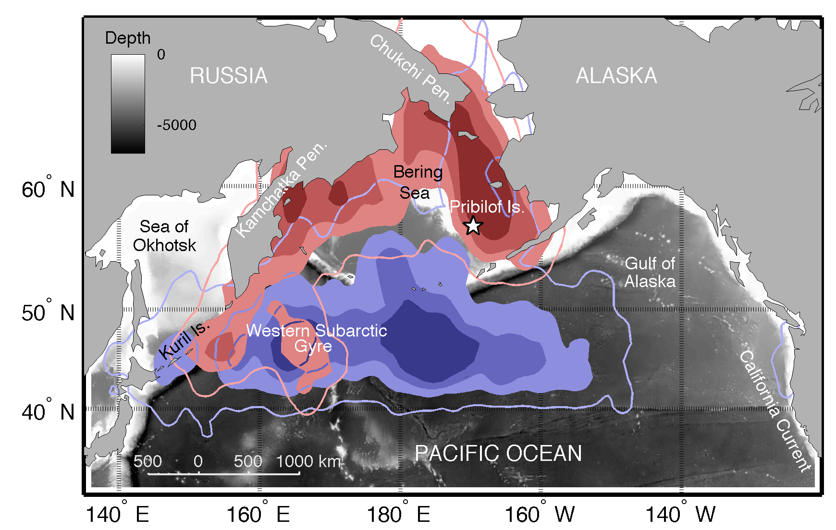
Figure 1 At-sea utilization distributions (UDs) for red-legged kittiwakes (RLKIs), Rissa brevirostris (shades of red, n = 17), and black-legged kittiwakes (BLKIs), Rissa tridactyla (shades of blue, n = 34), in the subarctic North Pacific, from 15 October 2010 to 27 February 2011. The 25%, 50% and 75% UDs are represented by continuously lighter shades, and the lightest solid line represents the 95% UD.
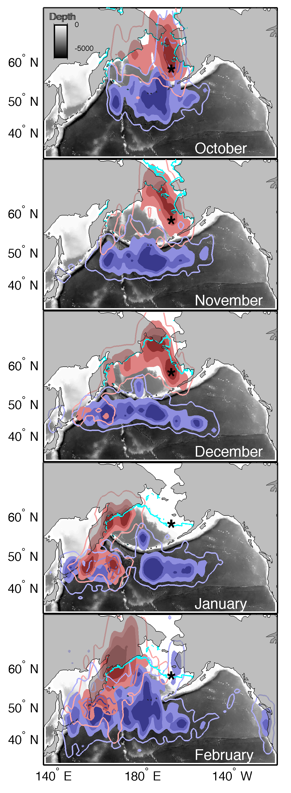
Figure 2 Monthly utilization distributions (UDs) derived from smoothed locations for red-legged kittiwakes (RLKIs), Rissa brevirostris (shades of red, n = 17), and black-legged kittiwakes (BLKIs), Rissa tridactyla (shades of blue, n = 34), in the subarctic North Pacific. The 25%, 50% and 75% UDs are represented by continuously lighter shades, and the lightest solid line represents the 95% UD. The Bering Sea ice edge (5% contour) at the end of each month is shown in light blue.
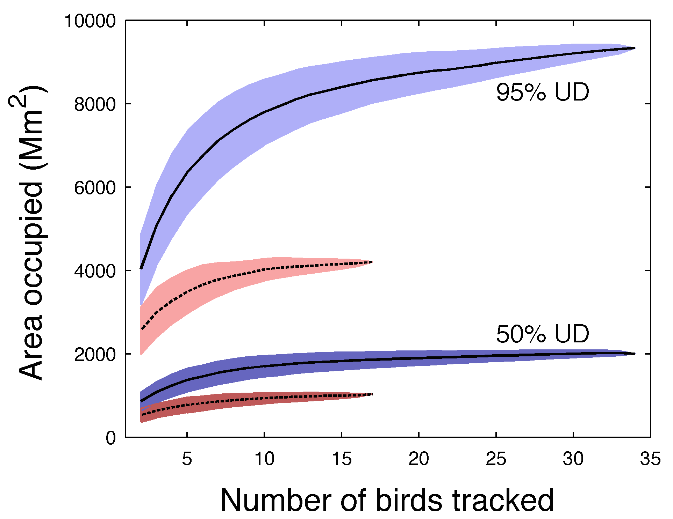
Figure 3 Area of the 95% utilization distributions (UDs) and 50% UDs relative to sample size from 1000 iterations of sequential area estimates for red-legged kittiwakes (RLKIs), Rissa brevirostris (dashed line, red), and black-legged kittiwakes (BLKIs), Rissa tridactyla (solid line, blue), based on their presence in the subarctic North Pacific.

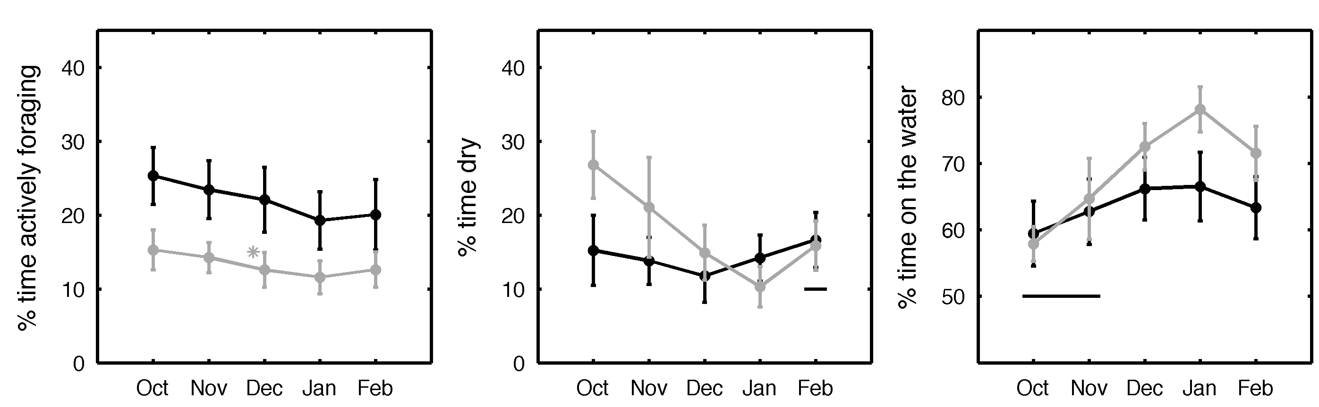
Figure 4 Activity budgets of red-legged kittiwakes (RLKIs), Rissa brevirostris (grey), and black-legged kittiwakes (BLKIs), Rissa tridactyla (black), for the non-breeding period, October–February, in the subarctic North Pacific. Percentages are of 24-h periods. Months when species are not significantly different, as determined by monthly linear mixed effects models with individual as a random effect, are indicated by a horizontal line. An asterisk indicates differences between sexes within a species. Means ± SD.

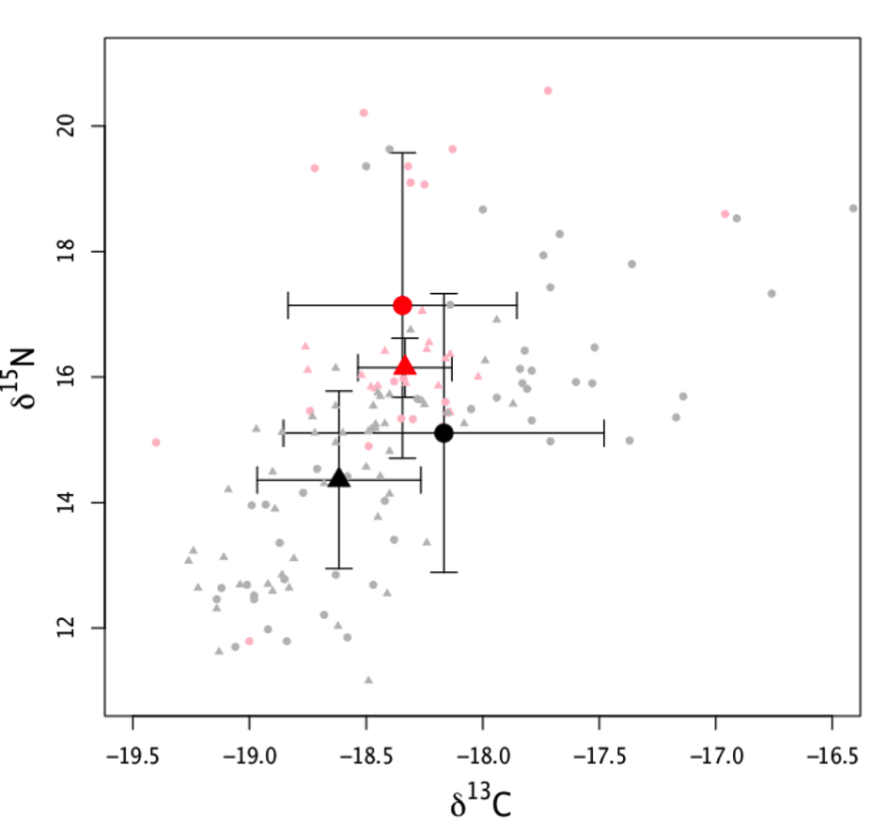
Figure 5 Stable carbon and nitrogen isotope values from subarctic North Pacific red-legged kittiwakes (RLKIs), Rissa brevirostris (red, n = 19), and black-legged kittiwakes (BLKIs), Rissa tridactyla (black, n = 49), from head feathers (triangles) and body feathers (circles). Error bars are ± SD and lighter shaded markers indicate values of individual birds.

Journal of Biogeography
SUPPORTING INFORMATION
North or south? Niche separation of endemic red-legged kittiwakes and sympatric black-legged kittiwakes during their non-breeding migrations

Rachael A. Orben, David B. Irons, Rosana Paredes, Daniel D. Roby, Richard A. Phillips and Scott A. Shaffer

Appendix S1 Morphometrics of red-legged and black-legged kittiwakes.

Morphometrics of red-legged kittiwakes (RLKIs), Rissa brevirostris, and black-legged kittiwakes (BLKIs), Rissa tridactyla, from colonies on St George and St Paul islands of the Pribilof Islands, Alaska, USA, were tested for species, sex and colony differences. The degree of sexual dimorphism in each morphometric was assessed using an index of sexual size dimorphism (SSD), where positive values indicate males are larger than females, defined as SSD = (male – female)/female× 100 (Table S1). Comparisons between the sexes are the result of one-way ANOVAs within each species. Species’ P-values are the result of a two-way ANOVA with species and sex as factors (Table S2). Colony differences were tested for BLKIs only, as just two RLKIs were tracked from St Paul, with a two-way ANOVA including sex as a factor (Table S1). Mass was measured at first capture, prior to instrument attachment, during the chick brooding phase of breeding. Natural wing chord was measured in the field as the measurement from the carpel joint to the tip of the primary feathers, while wing chord (or width) was calculated from measurements at five equally spaced points along each tracing following Pennycuick (2008). Culmen indicates the straight-line measurement from the tip of the beak to the point where feathering starts at the base of the bill. Head+bill indicates the straight-line measurement from the tip of the beak to the back of the head. Tarsus was measured as the diagonal distance between the notch at the tarsal joint to the end of the tarsus.

REFERENCE

Pennycuick, C.J. (2008) Modelling the flying bird. Elsevier Inc., London.
Table S1 Morphometric characteristics (mean ± SD) of male and female red-legged kittiwakes (RLKIs), Rissa brevirostris, and black-legged kittiwakes (BLKIs), Rissa tridactyla, from colonies on St George and St Paul islands of the Pribilof Islands, Alaska, USA. Significant differences are highlighted in bold. Sample sizes are shown in parentheses.

Size metric Female Male SSD F P
RLKI
Mass (g) 365.6 ± 45.9 (14) 379.1 ± 24.2 (18) 3.69 77.63 0.800
Culmen (mm) 29.0 ± 1.8 (14) 29.8 ± 1.4 (18) 2.76 1.89 0.180
Head + bill (mm) 81.8 ± 3.9 (14) 84.3 ± 2.7 (18) 3.06 4.70 0.038
Tarsus (mm) 31.8 ± 1.9 (14) 31.5 ± 1.5 (18) –0.94 0.21 0.650
Natural wing chord (mm) 308.5 ± 6.8 (14) 310.8 ± 6.6 (18) 0.75 0.96 0.336
Wing span (B, cm) 95.15 ± 3.24 (4) 96.13 ± 6.70 (3) 1.03 0.068 0.804
Wing area (S_{wing}, cm²) 898 ± 106 (4) 939 ± 81 (3) 4.57 0.308 0.603
Wing chord [c_{m}, (S_{wing}/B), cm] 9.44 ± 0.81 (4) 9.78 ± 0.27 (3) 3.60 0.477 0.521
Wing loading (N/m²) 40.41 ± 5.4 (4) 39.67 ± 3.04 (3) –1.83 0.044 0.842
Aspect ratio (B/c_{m}) 10.12 ± 0.58 (4) 9.83 ± 0.61 (3) –2.87 0.415 0.548
BLKI
Mass (g)* 380.6 ± 30.8 (24) 435.3 ± 36.3 (26) 14.37 26.66 <0.001
Culmen (mm) 38.5 ± 1.4 (24) 40.8 ± 1.6 (26) 5.97 23.35 <0.001
Head + bill (mm) 93.5 ± 2.2 (24) 98.5 ± 2.2 (26) 5.35 45.87 <0.001
Tarsus (mm) 34.5 ± 1.6 (24) 36.7 ± 1.7 (26) 6.38 18.26 <0.001
Natural wing chord (mm)* 311.4 ± 7.4 (24) 320.9 ± 6.1 (26) 3.08 17.45 <0.001
Wing span (B, cm) 101.4 ± 2.5 (17) 105.0 ± 2.4 (10) 3.55 7.72 <0.001
Wing area (S_{wing}, cm²) 1063 ± 77 (17) 1125 ± 77 (10) 5.83 4.046 0.055
Wing chord [c_{m}, (S_{wing}/B), cm] 10.50 ± 0.59 (17) 10.72 ± 0.60 (10) 2.10 0.90 0.351
Wing loading (N/m²)* 35.71 ± 4.85 (17) 38.64 ± 4.07 (10) 8.20 2.578 0.121
Aspect ratio (B/c_{m}) 9.67 ± 0.44 (17) 9.82 ± 0.49 (10) 1.55 0.601 0.444
*Colony significantly different: mass, St Paul 419 ± 40.7 (19), St George 387.9 ± 38.2 (22), F = 13.66, P < 0.001; natural wing chord, St Paul 317.9 ± 7.7 (19), St George 312.9 ± 8.1 (22), F = 7.10, P = 0.011; wing loading, St Paul 38.3 ± 4 (18), St George 33.7 ± 4.7 (9), F = 6.91, P = 0.015).

Table S2 Comparison of species morphometric characteristics between red-legged kittiwakes (RLKIs), Rissa brevirostris, and black-legged kittiwakes (BLKIs), Rissa tridactyla, from the Pribilof Islands, Alaska, USA. Results are from two-way ANOVAs with species and sex as factors. Significant differences are highlighted in bold.

Size metric F P
Mass (g) 13.25 <0.001
Culmen (mm) 768.07 <0.001
Head + bill (mm) 88.02 <0.001
Tarsus (mm) 356.69 <0.001
Natural wing chord (mm) 11.42 0.001
Wing span (B, cm) 31.87 <0.001
Wing area (S_{wing}, cm²) 24.85 <0.001
Wing chord [c_{m}, (S_{wing}/B), cm] 15.35 <0.001
Wing loading (N/m²) 2.87 0.101
Aspect ratio (B/c_{m}) 1.72 0.200

Appendix S2 Migration characteristics of red-legged and black-legged kittiwakes.

Migration characteristics of red-legged kittiwakes (RLKIs), Rissa brevirostris, and black-legged kittiwakes (BLKIs), Rissa tridactyla, from the subarctic North Pacific, tracked with geolocation loggers from September 2010 to May 2011 (Table S3). Utilization distributions (UDs) were calculated using smoothed locations for the pooled samples and for each individual. The grid cell size was set at 80 km. The smoothing parameter was selected using the entre dataset (latitude 0.0171, longitude 0.0068l; Sheather & Jones, 1991). Portions of UDs overlapping land were subtracted from area calculations. To calculate departure and return dates, sea-surface temperatures were used to estimate latitudes for those loggers that recorded temperature (BLKI = 27, RLKI = 8) and then the tracks were speed filtered (Shaffer et al., 2005).

REFERENCES
Shaffer, S.A., Tremblay, Y., Awkerman, J.A., Henry, R.W., Teo, S.L.H., Anderson, D.J., Croll, D.A., Block, B.A. & Costa, D.P. (2005) Comparison of light- and SST-based geolocation with satellite telemetry in free-ranging albatrosses. Marine Biology, 147, 833–843.

Sheather, S.J. & Jones, M.C. (1991) A reliable data-based bandwidth selection method for kernel density estimation. Journal of the Royal Statistical Society B: Methodological, 53, 683–690.

Table S3 Migration characteristics (mean ± SD) of red-legged kittiwakes (RLKIs), Rissa brevirostris, and black-legged kittiwakes (BLKIs), Rissa tridactyla, from the subarctic North Pacific; P-values indicate species differences and are the result of two-way ANOVAs with species and sex as factors. ANOVAs did not assume that variances were equal. Sample sizes are given in parentheses. Significant differences are highlighted in bold.

RLKI BLKI F P
Departure date 28 September ± 21 (8) 24 September ± 17 (26) 0.36 0.058
Return date 22 March ± 3 (8) 26 March ± 23 (25) 0.24 0.626
Trip duration (days) 175 ± 22 (8) 183 ± 30 (25) 0.51 0.480
Maximum range (km) 2,600 ± 400 (17) 2,800 ± 800 (34) 0.85 0.361
Date at maximum range 16 January ± 15 (17) 25 January ± 27 (34) 1.51 0.224
Bearing to maximum range (°) 259 ± 11 (17) 220 ± 43 (34) 14.62 < 0.001*
Individual area of 50% UD (km²)† 468,000 ± 202,000 (17) 674,000 ± 249,000 (34) 8.59 0.005
Individual area of 95% UD (km²)† 2,212,000 ± 672,000 (17) 3,197,000 ± 1,062,000 (34) 11.80 0.001
Area of 50% UD (km²) 1,281,000 (17) 2,219,000 (34) – –
Area of 95% UD (km²) 5,534,000 (17) 9,874,000 (34) – –
*Bearing to maximum range (location at the maximum distance from the colony), female 224.5 ± 45.7, male 248.5 ± 22.1, F = 6.81, P = 0.012.
†Average area of utilization distribution (UD) for individual birds.

Appendix S3 Overlap of utilization distributions between colonies and sexes of kittiwakes.

To determine spatial partitioning between species [red-legged kittiwakes (RLKIs), Rissa brevirostris, and black-legged kittiwakes (BLKIs), Rissa tridactyla], colonies (BLKIs only, due to the small sample size of RLKIs from St Paul Island) and sexes, the amount of overlap between observed distributions in the subarctic North Pacific was compared with the overlap from 1000 bootstrapped selections from the pooled dataset (Fig. S1). The area of overlap divided by the area of the 95% utilization distributions (UDs) of the overall dataset was used as the test statistic, and the P-value was determined as the proportion of iterations that resulted in a smaller overlap than observed (Breed et al., 2006).

REFERENCE

Breed, G.A., Bowen, W.D., McMillan, J.I. & Leonard, M.L. (2006) Sexual segregation of seasonal foraging habitats in a non-migratory marine mammal. Proceedings of the Royal Society B: Biological Sciences, 273, 2319–2326.
Figure S1 Bootstrap area of overlap for 1000 iterations at 50% and 95% utilization distributions (UDs) and kernel density plots of observed distributions in the subarctic North Pacific between (a) colonies of black-legged kittiwakes (BLKIs), Rissa tridactyla (St Paul Island, green, n = 15; St George Island, grey, n = 19), (b) sexes of BLKI (male, blue, n = 10; female, grey, n = 24) and (c) sexes of red-legged kittiwakes (RLKIs), Rissa brevirostris (male, blue, n = 10; female, grey, n = 7). Coloured circles on box plots correspond to the percentage of area overlapped by the observed groups.
(a)
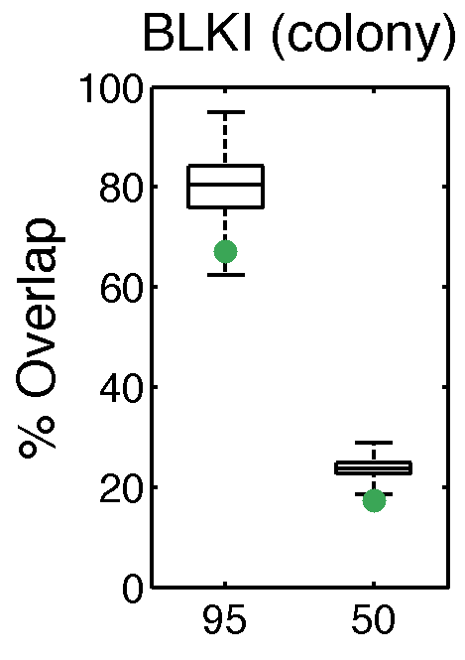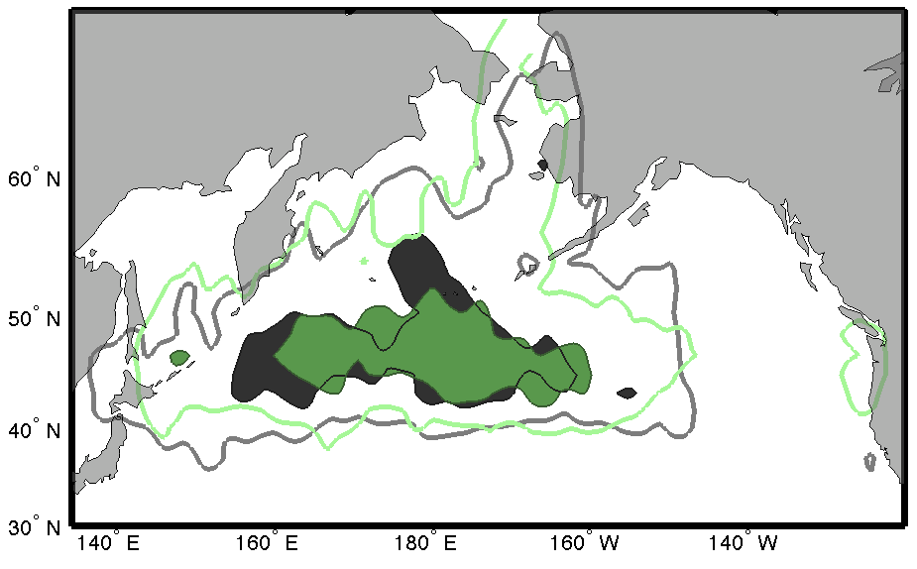
(b)
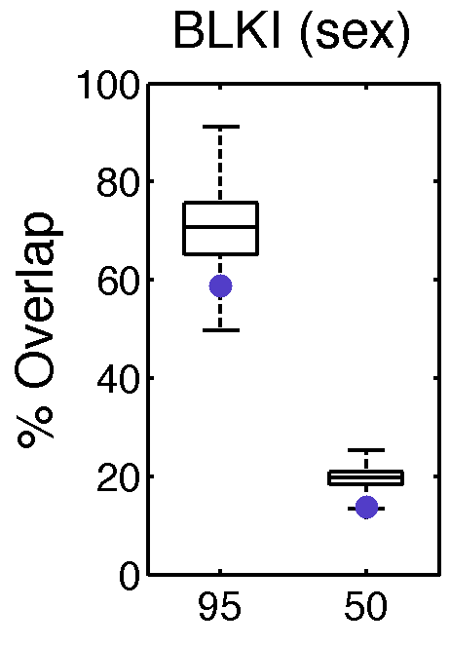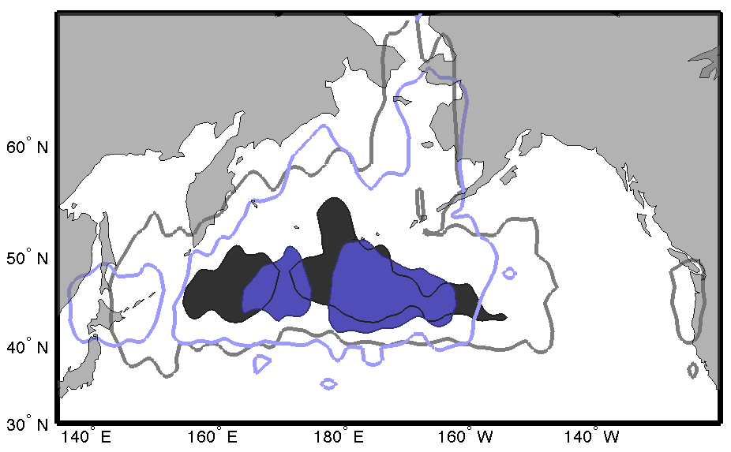
(c)
