Assessing penguin colony size and distribution using digital mapping and satellite remote sensing

Claire M. Waluda^{1,}*, Michael J. Dunn¹, Michael L. Curtis^{1,2} and Peter T. Fretwell¹

1. British Antarctic Survey, Natural Environment Research Council, High Cross, Madingley Road, Cambridge CB3 0ET, UK

2. Current address: CASP, 181A Huntingdon Road, Cambridge, CB3 0DH, UK

*corresponding author
Email: clwa@bas.ac.uk
Tel: +44(0)1223 221334
Fax: +44 (0)1223 221 259

Abstract
Changes in penguin abundance and distribution can be used to understand the response of species to climate change and fisheries pressures, and as a gauge of ecosystem health. Traditionally, population estimates have involved direct counts, but remote sensing and digital mapping methodologies can provide us with alternative techniques for assessing the size and distribution of penguin populations. Here, we demonstrate the use of a field-based digital mapping system (DMS); combining a handheld Geographic Information System (GIS) with integrated Geographical Positioning System (GPS) as a method for: (a) assessing penguin colony area and, (b) ground-truthing colony area as derived from satellite imagery. Work took place at Signy Island, South Orkneys where colonies of the three congeneric pygoscelid penguins: Adélie Pygoscelis adeliae, chinstrap P. antarctica and gentoo P. papua were surveyed. Colony areas were derived by mapping colony boundaries using the DMS with visual counts of the number of nesting birds made concurrently. Area was found to be a good predictor for number of nests for all three species of penguin. Using a maximum likelihood multivariate classification of remotely sensed satellite imagery (QuickBird2, 18 January 2010; Digital Globe ID: 01001000B90AD00) we were able to identify penguin colonies from the spectral signature of guano and differentiate between colonies of Adélie and chinstrap penguins. The area classified (all species combined) from satellite imagery versus area from DMS data was closely related (R² = 0.88). Combining these techniques gives a simple and transferrable methodology for examining penguin distribution and abundance at local and regional scales.

Keywords: pygoscelid penguins, satellite remote sensing, digital mapping, population estimate
Introduction
Penguins are key predators within Antarctic and sub-Antarctic ecosystems, with an estimated global consumption of approximately 24 million tonnes of prey per year (Brooke 2004). Many penguin species have shown susceptibility to climate change (Forcada et al., 2006; Forcada and Trathan 2009; Trivelpiece et al. 2011), often being cited as ‘sentinels’ or ‘ecological indicators’ of marine ecosystems (Ainley 2002; Weimerskirch et al. 2003; Reid et al. 2005; Boersma 2008; Le Bohec et al. 2013). In order to examine the response of penguins to climate change and other drivers, it is important to obtain accurate estimates of population size at regular intervals.

Estimates of the breeding population size of penguin colonies are collected at many localities in the Antarctic and sub-Antarctic. Counts of penguin colonies are usually made by one or two observers simply counting the number of nesting birds during the early incubation period (Croxall et al. 1981; CCAMLR 2004). This is done either by counting all individuals or by extrapolation from subsamples of the colony (Reid 1962; Jehl and Todd 1985). In addition, digital photographs are often used as an alternative to, or to confirm counts of birds (Greenfield and Wilson 1991; Ciaputa and Sierakowski 1999; CCAMLR 2004; Sander et al. 2007).

The use of satellite imagery to assess penguin distribution has been demonstrated for a number of species in the Antarctic and sub-Antarctic (Schwaller et al. 1989; Fretwell et al. 2012; Lynch et al. 2012; Schwaller et al. 2013). Satellite data have been used to examine population changes (Guinet et al. 1995), for censuses of penguin populations inhabiting inaccessible regions (Barber-Meyer et al. 2007), and in the identification of previously undiscovered colonies (Fretwell and Trathan 2009; Fretwell et al. 2012).

Signy Island in the South Orkneys archipelago supports colonies of all three pygoscelid penguin species (gentoos Pygoscelis papua, chinstraps, P. antarctica, and Adélies, P. adeliae) breeding sympatrically (White and Conroy 1975). The three species occupy areas with differing topography, with Adélie penguin colonies usually found on relatively flat or gently sloping ground, gentoo penguin colonies on ridge areas and chinstrap penguin colonies on slopes or cliffs (White and Conroy 1975; Volkman and Trivelpiece 1981). The populations of all three species are routinely monitored at Signy Island, with counts made of selected colonies on an annual basis (Croxall et al. 1988; Forcada et al. 2006), and whole-island censuses taking place approximately once per decade (Croxall et al. 1981; BAS unpublished data). All three species are defined as ‘indicator species’ by the Commission for the Conservation of Antarctic Marine Resources (CCAMLR), so it is vital to obtain accurate population data at local and regional scales for these species. These population data are used to detect and record significant changes in critical components of the marine ecosystem within the Convention Area, to serve as a basis for the conservation of Antarctic marine living resources and to distinguish between changes due to harvesting of commercial species and changes due to environmental variability, both physical and biological (Agnew 1997).

In this paper we: (1) present a method for recording penguin distribution and colony counts using a handheld digital system developed initially for field-based geological mapping in the Antarctic (for a full description see Curtis et al. 2011), (2) examine the relationship between area occupied and visual colony counts of the three pygoscelid penguin species, (3) derive colony distribution and area data from satellite imagery using an automated classification technique, and (4) use the DMS data to ground-truth satellite data indicating the size and distribution of penguin rookeries at Signy Island, South Orkney Islands.

Materials and Methods
1. Colony boundaries
Data on colony boundaries were obtained from Signy Island in the South Orkneys archipelago (60°43' S; 45°36' W; Figure 1) during the period 24 November to 12 December 2006. Penguin colonies were defined as discrete assemblages of contiguous nests (Forcada et al. 2006). Gentoo penguins are resident only at North Point (Figure 1), whereas Adélie and chinstrap rookeries are located around the coastal margins of Signy Island, with the largest colonies occupying the Gourlay Peninsula to the southeast of the island (Croxall and Kirkwood 1979; Lynnes et al. 2002). At the Gourlay Peninsula the topography consists of a number of raised flat areas with sloping sides, resulting in almost all Adélie colonies being closely surrounded by neighbouring chinstrap colonies. However, at North Point the rookeries are more widely distributed, with much less overlap between colonies of the three different species.

A digital mapping system (DMS), comprising a handheld computer, GPS and mobile GIS software (for details see Curtis et al. 2011), was used to map the extent of each colony as an individual feature within a polygon shapefile. The perimeter of each colony was surveyed on foot, the DMS logging the route via the continuous capture of polygon vertices using streamed GPS positions. We used a buffer of one metre from the colony edge, removed post-survey, to calculate colony area. Bespoke data capture forms created in ESRI (Environmental Systems Research Institute) ArcPad Application Builder for use in ArcPad 6 were used to ascribe colony observations (e.g. species and colony code) to each feature in real time, as well as to calculate the area of the mapped colony.

2. Population counts
Nests were counted by at least one observer using a hand-tally counter (Croxall et al. 1981) with nests counts collected concurrently with surveys of colony area. Counts were repeated until the results were within ± 5 % of each other. Due to time constraints and the inaccessible nature of some colonies (particularly chinstrap colonies nesting on cliffs) it was not possible to collect data for all colonies of penguins at Signy Island.

3. Satellite imagery
A QuickBird2 satellite image was obtained from Digital Globe for 18 January 2010. This image has an on-the-ground resolution of 0.6 m in the panchromatic bands and 2.4 m in the four multispectral bands (Digital Globe ID 01001000B90AD00; image details at http://www.digitalglobe.com/downloads/QuickBird-DS-QB-Web.pdf). All image processing was done using ESRI ArcGIS 10.0. Precise maps of Signy Island are available with a positional error of approximately +/- 2 m accuracy, along with a high resolution photogrammetric digital elevation model held locally at the BAS Mapping and Geographic Information Centre. These were used to adjust georectification (the positional quality of the image was approximately 40 metres from the more accurate map data) and orthorectify the satellite image to compensate for area distortion caused by sloping terrain. Once corrected, the panchromatic and multispectral bands were pan-sharpened to create a four-band colour image with a resolution of 0.6 m. This image was classified using a maximum likelihood multivariate classification using the Spatial Analyst Toolbox in ArcGIS. This is a semi-automated classification routine where pixels of typical classes which make up the image are manually assigned by the operator; these are then converted into signature points. We used 448 training samples from 11 typical classes taken from across the whole image. Classes used were: sea, ice, light rock, iceberg, vegetation, dark rock, Adélie guano, chinstrap guano, cloud, scree and lake. The program then classified the remaining pixels into each class using a maximum likelihood classification algorithm. This technique has been successfully used to estimate population size from discrete huddles or groups of emperor penguins, Aptenodytes forsteri (Barber-Meyer et al. 2008; Fretwell et al. 2012).

4. Species differentiation in satellite imagery
As Adélie penguins breed earlier than chinstrap penguins at Signy Island (Lishman 1985; Lynnes et al. 2002), we aimed to classify guano data based on the breeding stage of the two penguin species resident at the Gourlay Peninsula (gentoo penguin colonies were not included in this part of the analysis as they do not form rookeries at the Gourlay Peninsula). In mid-January (when the satellite image was obtained), Adélie chicks were in crèche and chinstrap penguins still on eggs or young chicks (Lishman 1985; Lynnes et al. 2002). It was clear in the satellite image that Adélie penguin colonies had darker and redder substrata of guano than that of chinstrap penguins. This is consistent with field observations that guano from chicks is a darker colour to that of adult birds. We therefore classified two categories of guano staining: that produced by Adélie penguin colonies (dark red pixels) and by chinstrap penguin colonies (lighter red/pink pixels). Once classified the pixels classed as penguin colonies were converted into polygons to assess their areas and compare the results with those obtained using the DMS.

Results
- Colony nest counts and area derived using DMS
Using the DMS, count and area data were obtained from 27 gentoo penguin colonies, 40 Adélie penguin colonies and 25 chinstrap penguin colonies. Data for gentoo penguins were obtained from North Point whereas data for Adélie and chinstrap penguins were obtained from the Gourlay Peninsula (Figure 1).

Regression analyses comparing area occupied by colony and the number of nesting pairs in that colony showed area to be a good predictor of number of pairs for all three species. The strongest relationship between area and number of pairs was for Adélie penguin colonies (n = 40, F_{1,39} = 308.87, R² = 0.89, P < 0.001; Figure 2a), followed by gentoo penguins (n = 27, F_{1,26} = 170.96, R² = 0.87, P < 0.001; Figure 2b) and chinstrap penguins (n = 25, F_{1,24} = 72.49, R² = 0.75, P < 0.001; Figure 2c). Average nesting densities (nests per m²) were 1.48 ± 1.08 for Adélie penguins, 0.53 ± 0.33 for chinstrap penguins and 0.31 ± 0.19 for gentoo penguins.

- Ground-truthing satellite classification using DMS data
There was a good fit between colony location and area estimates collected using the DMS and those produced by the satellite classification (Figure 3). At the Gourlay Peninsula the total area of colonies measured by the DMS was 30657 m², compared to 30233 m² classified from satellite. In some cases, larger colonies/areas of guano had broken into a number of smaller subgroups between one dataset and the other, but in most cases the position and the area of the colonies were similar. Individually, the area derived using image classification compared to the equivalent area derived using the DMS had an R² value of 0.88 (n = 45; P < 0.001; Figure 4).

When we differentiated between species type at the Gourlay Peninsula (occupied by colonies of both chinstrap and Adélie penguins), the fit between satellite classification and the DMS output was reasonable, but less good than the overall area of colony comparison (Figure 5), with the area occupied by chinstraps estimated at 20099 m² using the DMS and 33504 m² using satellite classification and the area occupied by Adélie penguins estimated at 9014 m² using the DMS and 8282 m² using the satellite classification data. The general pattern was similar, with all the large colonies of each species in the DMS analysis also being represented in the satellite classification; although the area of chinstraps was overestimated in the satellite data.

Discussion
Using a simple digital mapping system (DMS), we were able to quickly and accurately assess the distribution of penguin populations on Signy Island, South Orkneys, and ground-truth colony distribution and area estimates obtained using an automated classification of satellite imagery. Pygoscelid nests are usually uniformly spaced (Croxall et al. 1981); accordingly, we found that the area occupied by the colony was a good predictor of population size (number of nesting pairs) in all three species. Adélie colonies were the most closely represented by area, probably due to their habit of nesting close together on flat ground with a uniform distance between nests (Trivelpiece and Volkman 1979). Gentoo and chinstrap penguins nesting at Signy Island prefer ridge areas and slopes/cliffs respectively (White and Conroy 1975), such that nests are less evenly spaced, but both still showed a strong relationship between area and colony size. Our estimate of 1.48 pairs/m² for Adélie penguins is reasonably consistent with studies elsewhere, for example nest site occupation was approximately 1.13 pairs/m² at King George Island, South Shetlands (Trivelpiece and Volkman 1979) and 1.33 pairs/m² at Wilkes station, Eastern Antarctica (Penney 1968), whereas colonies of chinstrap penguins at Signy Island (0.5 pairs/m²) were less densely occupied than at Deception Island (1.5 pairs/ m²; Naveen and Lynch et al. 2012). Chinstrap penguins nesting at King George Island had a significantly higher distance between nests (516 ± 15 mm) than Adélie penguins (370 ± 8mm) (Trivelpiece and Volkman 1979), which is consistent with the results obtained here.

The equipment used in this study is relatively inexpensive (< £1K) and easy to master, with the techniques used transferable to other areas and species of ground-nesting birds. Using a DMS (rather than a GPS alone) to map colonies has the advantage that it is possible to add attributes (such as species information) whilst in the field, thus reducing the need for any post-processing of the data. Whilst the technique may require a small amount of training and equipment calibration, this is a useful tool for population estimation, which is much quicker than tally counting individual nests in large colonies. It is also cheaper and less complex than aerial photography or plane-table surveying, is rugged enough for use in extreme environments (Curtis et al. 2011) and is potentially a useful tool for the long-term monitoring of large colonies of nesting birds such as chinstrap, macaroni and king penguins which can occur in significantly larger colonies than the penguin populations resident at Signy Island.

Our results obtained using the DMS were comparable to those obtained from the classification of satellite imagery, with a high level of correlation between area estimates using both techniques. There was a small but consistent mismatch in the location of colonies derived using the two techniques (Figure 3). The datasets were temporally separated both in terms of years (2006 and 2010) and season (November/December and January), and this may have accounted for some of the differences encountered in area location and estimation. Estimates of overall area occupied were higher for 2006 (DMS) than 2010 (satellite imagery) which is consistent with population counts in the two seasons (BAS unpublished data). It was possible to differentiate colonies due to the different breeding schedules of chinstrap and Adélie penguins nesting at the Gourlay Peninsula. Guano staining from chicks is much darker than from adult birds, and, as Adélie chicks hatch in December and chinstrap chicks approximately a month later (Lishman 1985; Lynnes et al. 2002), at the time of acquisition of our satellite image (mid January) the colouration of colonies of Adélie penguins was appreciably darker than that of corresponding chinstrap colonies. Area estimates using DMS and satellite data were similar for Adélie penguin colonies but not for chinstrap penguins, suggesting that the image classification detailed here was more successful in identifying the boundaries of guano staining from Adélie penguins than from chinstrap penguins. This is probably because the signature from Adélie penguin guano was more spectrally distinct than that of chinstrap penguin guano. By co-ordinating the timing of the two methods more closely, future studies will be able to address these issues.

Future work will reanalyse colony boundaries using DMS and satellite remote sensing techniques at approximately decadal intervals in order to monitor shifts in colony size and distribution and species occupancy and allow us to make more accurate comparisons of long-term variability in colony size and structure (cf. Guinet et al. 1995; Woehler and Riddle 1998; Chamaille-Jammes et al. 2000). In addition, these data will be used to examine changes in species distribution and rates of colony fragmentation (cf. Jackson et al. 2005). Overall, population mapping using DMS and satellite remote sensing techniques are useful for examining long term changes in colony distribution and penguin species abundance, and may be of particular interest for habitat mapping projects especially in light of current warming scenarios (Forcada and Trathan 2009). The populations of Adélie, chinstrap and gentoo penguins breeding at Signy Island are important CCAMLR indicator species, and are changing in response to climate driven variability (Croxall et al. 2002; Forcada et al. 2006; Forcada and Trathan 2009). Understanding the large-scale processes that produce these changes is clearly an important issue in the development of predictive models of penguin population status.

Acknowledgements
We would like to thank staff at Signy Island, particularly Dirk Briggs, Matt Jobson and Dave Routledge for help with logistics and in the field. Thanks to Ella Walsh for the satellite image classification. This work is a contribution to the ECOSYSTEMS Programme at the British Antarctic Survey.

References
Ainley DG (2002) The Adélie penguin - bellwether of climate change. Columbia University Press, New York
Agnew DJ (1997) The CCAMLR Ecosystem Monitoring Programme. Antarct Sci 9:235-242
Barber-Meyer S, Kooyman GL, Ponganis PJ (2007) Estimating the relative abundance of emperor penguins at inaccessible colonies using satellite imagery. Polar Biol 30: 1565-1570
Boersma PD (2008) Penguins as marine sentinels. BioScience 58: 597-607
Brooke MdL (2004) The food consumption of the world's seabirds. Proc R Soc Lond B 271:S246-S248
CCAMLR (2004) CCAMLR Ecosystem Monitoring Program (CEMP) Standard Methods. CCAMLR, Hobart
Chamaille-Jammes S, Guinet C, Nicoleau F, Argentier M (2000) A method to assess population changes in king penguins: the use of a Geographical Information System to estimate area-population relationships. Polar Biol 23: 545-549
Ciaputa P, Sierakowski K (1999) Long-term population changes of Adélie, chinstrap and gentoo penguins in the regions of SSSI No. 8 and SSSI No. 34, King George Island, Antarctica. Polish Polar Res 20: 355-365
Croxall JP, Kirkwood ED (1979) The distribution of penguins on the Antarctic peninsula and islands of the Scotia Sea. British Antarctic Survey, Natural Environment Research Council, Cambridge
Croxall JP, McCann TS, Prince PA, Rothery P (1988) Reproductive performance of seabirds and seals at South Georgia and Signy Island, South Orkney Islands, 1976-1987: implications for Southern Ocean monitoring studies. In: Sahrhage D (ed) Antarctic Ocean and resources variability. Springer-Verlag, Berlin, pp 261-285
Croxall JP, Rootes DM, Price RA (1981) Increases in penguin populations at Signy Island, South Orkney Islands. Br Antarct Surv Bull 54: 47-56
Croxall JP, Trathan PN, Murphy EJ (2002) Environmental change and Antarctic seabird populations. Science 297:1510-1514
Curtis ML, Riley TR, Flowerdew MJ, Tate AJ (2011) Short Note: The application and benefits of digital geological mapping in Antarctica. Antarct Sci 23: 387-388
Forcada J, Trathan PN (2009) Penguin responses to climate change in the Southern Ocean. Glob Change Biol 15: 1618-1630
Forcada J, Trathan PN, Reid K, Murphy EJ, Croxall JP (2006) Contrasting population changes in sympatric penguin species in association with climate warming. Glob Change Biol 12: 411-423
Fretwell PT, LaRue MA, Morin P, Kooyman GL, Wienecke B, Ratcliffe N, Fox AJ, Fleming AH, Porter C, Trathan PN (2012) An emperor penguin population estimate: the first global, synoptic survey of a species from space PLoS ONE 7 (4): e33751.
Fretwell PT, Trathan PN (2009) Penguins from space: faecal stains reveal the location of emperor penguin colonies. Glob Ecol Biogeog 18: 543-552
Greenfield LG, Wilson KJ (1991) Adélie penguin colony estimations from aerial photography and ground counts. Polar Rec 27: 129-130
Guinet C, Jouventin P, Malacamp J (1995) Satellite remote sensing in monitoring change of seabirds: use of Spot Image in king penguin population increase at Ile aux Cochons, Crozet Archipelago Polar Biol 15: 511-515
Jackson AL, Bearhop S, Thompson DR (2005) Shape can influence the rate of colony fragmentation in ground nesting seabirds. Oikos 111: 473-478
Jehl JR, Todd FS (1985) A census of the Adélie penguin colony on Paulet Island, Weddell Sea. Antarct J US 20: 171-172
Le Bohec C, Whittington J, Le Maho Y (2013) Polar monitoring: seabirds as sentinels of marine ecosystems. In: Verde C, di Prisco G. (eds) Adaptation and evolution in marine environments, vol. 2. Springer, Berlin, pp. 205-230
Lishman GS (1985) The comparative breeding biology of Adélie and chinstrap penguins Pygoscelis adeliae and P. antarctica at Signy Island, South Orkney Islands. Ibis 127:84-99
Lynch HJ, White RW, Black AD, Naveen R (2012) Detection, differentiation, and abundance estimation of penguin species by high-resolution satellite imagery. Polar Biol 35: 963-968
Lynnes AS, Reid K, Croxall JP, Trathan PN (2002) Conflict or co-existence? Foraging distribution and competition for prey between Adélie and chinstrap penguins. Mar Biol 141:1165-1174
Naveen R, Lynch HJ, Forrest S, Mueller T, Polito M (2012) First direct, site-wide penguin survey at Deception Island, Antarctica, suggests signiﬁcant declines in breeding chinstrap penguins. Polar Biol 35:1879-1888Penney RL (1968) Territorial and social behavior in the Adélie penguin. Antarctic Res Ser 12: 83-131
Reid B (1962) An assessment of the size of the Cape Adare Adélie penguin rookery and skuary - with notes on petrels. Notornis 10: 98-111
Reid K, Croxall JP, Briggs DR, Murphy EJ (2005) Antarctic ecosystem monitoring: quantifying the response of ecosystem indicators to variability in Antarctic krill. ICES J Mar Sci 62: 366-373
Sander M, Balbão CT, Polito MJ, Costa ES, Bertoldi AP, Carneiro B (2007) Recent decrease in chinstrap penguin (Pygoscelis antarctica) populations at two of Admiralty Bay’s islets on King George Island, South Shetland Islands, Antarctica. Polar Biol 30: 659-661
Schwaller MR, Olson CE, Ma Z, Zhu Z, Dahmer P (1989) A remote sensing analysis of Adélie penguin rookeries. Remote Sens Environ 28: 199-206
Schwaller MR, Southwell CJ, Emmerson LM (2013) Continental-scale mapping of Adélie penguin colonies from Landsat imagery. Remote Sens Environ 139: 353-364
Trivelpiece WZ, Hinke JT, Miller AK, Reiss CS, Trivelpiece SG, Watters GM (2011) Variability in krill biomass links harvesting and climate warming to penguin population changes in Antarctica. PNAS 108: 7625-7628. doi: 10.1073/pnas.1016560108
Trivelpiece WZ, Volkman NJ (1979) Nest-site competition between Adélie and chinstrap penguins: an ecological interpretation. The Auk 96: 675-681
Volkman J, Trivelpiece WZ (1981) Nest-site selection among Adélie, chinstrap and gentoo penguins in mixed species rookeries. Wilson Bull 93: 243-248
Weimerskirch H, Inchausti P, Guinet C, Barbraud C (2003) Trends in bird and seal populations as indicators of a system shift in the Southern Ocean. Antarct Sci 15: 249-256
White MG, Conroy JWH (1975) Aspects of competition between pygoscelid penguins at Signy Island, South Orkney Islands. Ibis 117: 371-373
Woehler EJ, Riddle MJ (1998) Spatial relationships of Adélie penguin colonies: implications for assessing population changes from remote imagery. Antarct Sci 10: 449-454

Figure Legends

- Map of study area: (a) South Orkneys archipelago (b) Signy Island showing locations of main penguin colonies at North Point (NP), and the Gourlay Peninsula (GP).

- Colony area derived using a digital mapping system (DMS) versus visual nest counts for (a) Adélie penguins Pygoscelis adeliae [number of pairs = 75.8 + 0.864 * area; R² = 0.89] (b) gentoo penguins P. papua [number of pairs = 3.49 + 3.92 * area; R² = 0.87] (c) chinstrap penguins P. antarctica [number of pairs = 63.4 + 0.303 * area; R² = 0.75] at Signy Island. Dashed lines indicate 95% confidence intervals.

- Gourlay Peninsula showing the locations of penguin colonies (Adélie Pygoscelis adeliae and chinstrap P. antarctica penguins; species not differentiated in this analysis). Black lines denote outlines from handheld DMS (December 2006), white lines are derived from image classification analysis of QuickBird2 VHR satellite imagery (January 2010). Solid white areas are snow cover. The underlying scene is part of the panchromatic QuickBird2 satellite image.

- Comparison of the area occupied by penguin colonies at Signy Island as derived by satellite classification and handheld DMS (N = 45; R² = 0.88; P < 0.001). Dashed lines indicate 95% confidence intervals.

- Boundaries of Adélie penguin Pygoscelis adeliae colonies (white lines) and chinstrap penguin P. antarctica colonies (black lines) derived by (a) supervised image-classification based on guano colour from QuickBird2 satellite imagery and (b) handheld DMS. Solid white areas are snow cover.

Figure 2
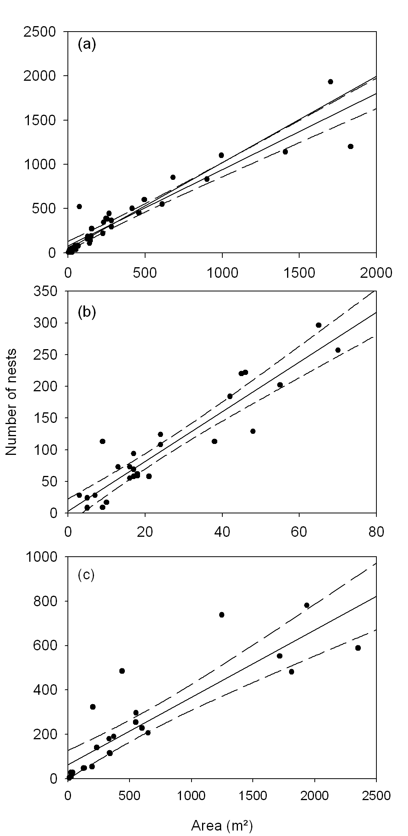
Figure 3
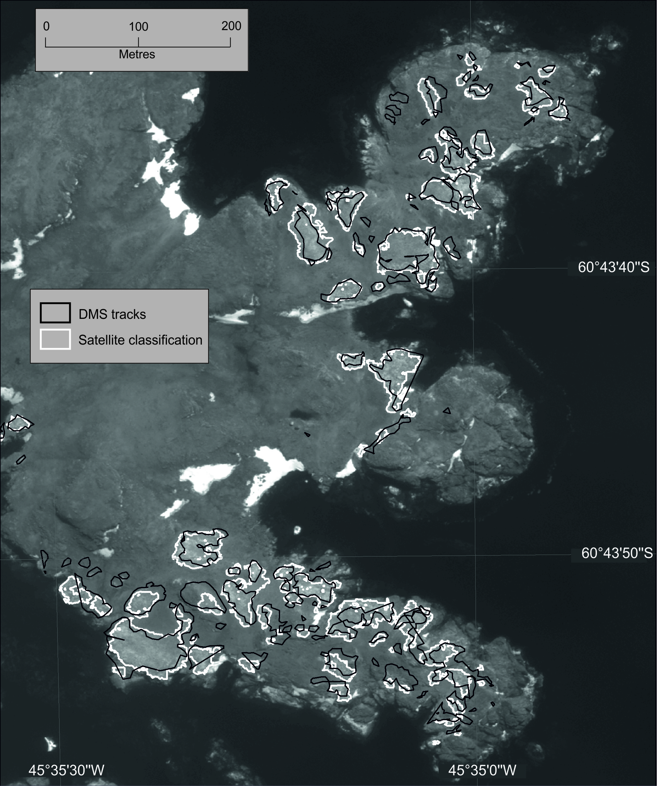

Figure 4

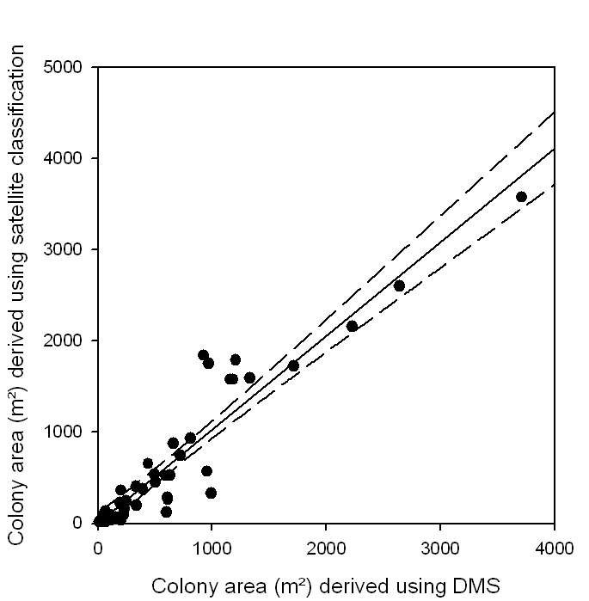

Figure 5
(a) (b)
