Ardea #1637

Fijn et al.: ARCTIC TERN MIGRATION

Arctic Terns Sterna paradisaea from The Netherlands migrate record distances across three oceans to Wilkes Land, East Antarctica

Ruben C. Fijn^{1,*}, Derick Hiemstra², Richard A. Phillips³ & Jan van der Winden¹

Fijn R.C., Hiemstra D., Phillips R.A. & van der Winden J. 2013. Arctic Terns Sterna paradisaea from The Netherlands migrate record distances across three oceans to Wilkes Land, East Antarctica. Ardea 101: 3-12.

Arctic Terns Sterna paradisaea have an exceptionally long distance migration, annually travelling back and forth between the Arctic and the Antarctic. Birds from Greenland, Iceland and the USA were recently found to spend most of the non-breeding period in the Weddell Sea, a small part of the large Antarctic range of Arctic Terns. Based on ring recoveries and sightings of West European Arctic Terns in the Indian Ocean and Australian waters, we expected that terns from The Netherlands (the southern limit of the breeding range) inhabit different Antarctic regions during the non-breeding season to their conspecifics from Greenland. To find out, geolocators were deployed on seven Arctic Terns captured on the nest in 2011 in The Netherlands. All birds were recaptured in 2012 and five devices yielded information on migration routes. The tracked terns spent on average 273 ± 7 days away from The Netherlands, and visited known staging areas in the North Atlantic and the Benguela Current, on both the outward and return journey. Similar tracks were observed in the terns from Greenland. However, hereafter the terns from The Netherlands moved to a previously unknown staging area in the central Indian Ocean, between 20–40°N and 65–100°E, and spent most of the non-breeding season in the Southern Ocean between 35–150°E. One bird migrated as far as New Zealand. Eventually, all five birds spent the Austral summer in Wilkes Land, Antarctica, before flying back to the breeding colonies with a small detour to the same North Atlantic staging area they visited on their southward migration. The total travel distance in the course of the non-breeding period was ~90,000 ± 2000 km, which substantially exceeds previous estimates for this species. Our study revealed new offshore staging areas and a yet unknown route through three different oceans, the longest bird migration described thus far.

Key words: Antarctica, Indian Ocean, Australian Antarctic Sector, longest bird migration distance, distance, migration strategies, geolocation, at-sea hotspots, stopover sites

¹Bureau Waardenburg, Consultants for Ecology and Environment, P.O. Box 365, 4100 AJ Culemborg, The Netherlands; ²Koartwald 13, 9283 TW Surhuizum, The Netherlands; ³British Antarctic Survey, Natural Environment Research Council, Madingley Road, High Cross, Cambridge, Cambridgeshire, CB3 0ET, United Kingdom;
*corresponding author (r.c.fijn@buwa.nl)

Arctic Terns have a mirrored distribution with a circumpolar Arctic range during the breeding season and a circumpolar Antarctic range during the non-breeding season (Salomonsen 1967, Cramp 1985). Over the years a variety of theories have been formulated about Arctic Tern migration routes and their non-breeding range (Austin 1928, Salomonsen 1967, Alerstam 1985, Gudmundsson et al. 1992, Bourne & Casement 1996). The first comprehensive review was based on sightings and ring recoveries by Salomonsen (1967). He suggested that birds from different breeding areas within the Atlantic flyway merge during their southerly journeys. Nevertheless, it remained unknown whether terns from different breeding origins also remain mixed upon arrival in Antarctic waters, or segregate into different parts of the Antarctic.
Ring recoveries have previously shown that Arctic Terns perform the longest avian migration (e.g. Morgan 2004, Bønløkke et al. 2006). Only recently, Egevang et al. (2010) revealed the full extent of Arctic Tern migration with the use of tracking devices. Terns deployed with geolocators migrated from the high Arctic breeding grounds in East Greenland and Iceland via various routes and staging sites to the non-breeding areas in the Antarctic Weddell Sea. The Weddell Sea is an area with high densities of Arctic Terns (Bierman & Voous 1950, Cline et al. 1969). Other recent tracking studies on Arctic Terns breeding in West Greenland (High Arctic Institute 2013) and in Maine (U.S. Fish & Wildlife Service 2013) resulted in similar migration routes and a similar non-breeding range. So far no Arctic Terns deployed with geolocators have been recorded in East Antarctica during the non-breeding season, although Salomonsen (1967), indicated that the region between c. 55°E and c. 150°E in East Antarctica hosts many Arctic Terns. This is congruent with at-sea surveys in this region (van Oordt & Kruijt 1954, Veit & Hunt Jr. 1991) and a ring recovery from a Danish bird in Wilkes Land, East Antarctica (Bønløkke et al. 2006). Moreover, most of the ring recoveries in Australasian waters (Gwynn 1968) involved birds from West European countries such as the United Kingdom (Monaghan 2002), Denmark (Bønløkke et al. 2006) and Sweden (Morgan 2004). Also, some Arctic Terns ringed in The Netherlands were recovered on the Indian Ocean coast of South Africa (Vogeltrekstation 2013). This presumed contrast in non-breeding distribution of Arctic Terns breeding in the western and eastern North Atlantic would indicate parallel longitudinal migration patterns characteristic for many other bird species (Newton 2010).
Using miniature light loggers, we addressed the question of how Arctic Terns breeding in the eastern North Atlantic (the North Sea) fit in the distribution patterns of Arctic Terns along the Antarctic coasts. The tagged birds originated from a small, declining population in The Netherlands at the southern edge of the North European breeding range. Our specific study colony was located respectively 3000 km and 5000 km southeast and east of the colonies in Greenland and Maine where the previously studied terns were breeding (Egevang et al. 2010, U.S. Fish & Wildlife Service 2013). Consequently, we expected the terns from this colony in The Netherlands to differ in timing of migration and the use of staging areas. We indeed discovered new migration routes in Arctic Terns. We identified new staging areas along the routes and located the Antarctic non-breeding range of terns from two North Sea breeding colonies.

METHODS

Seven Arctic Terns were caught on the nest on 3 June 2011 in two different mixed colonies of Arctic and Common Terns Sterna hirundo situated on industrial estates in The Netherlands. Both colonies are monitored intensively and many colour-ringed individuals in the population are annually re-sighted (DH, unpubl. data). This enabled us to select birds with a high recapture probability. Three birds were captured in Delfzijl (53.45°N 6.82°E) and four birds in Eemshaven (53.33°N 6.94°E), using walk-in traps. After standard biometric measurements were taken, we fitted a colour ring to the leg with an archival light logger (MK20 geolocators; British Antarctic Survey, Cambridge, UK) attached to the ring using Kevlar string and glue (mass of both rings, logger, string and glue: 1.5 g, ~1.3% of body mass). Light data was downloaded from retrieved loggers and processed using BASTrak software (British Antarctic Survey, Cambridge, UK). Transitions in light curves around dawn and dusk were assessed in TransEdit2 using a light threshold of 10. Two locations per day were calculated in Locator using an angle of elevation of –3.3° (based on three weeks of calibration data in LocatorAid for a known location) and applying the compensation for rapid movement, a tool within Locator. In this tool, the longitudinal speed is first calculated since the last position. Assuming the bird moved at this speed during the day/night length between the two transitions used for the current position, the time gained/lost (West/East) due to this movement is subtracted/added to the day or night length and the latitude recalculated (BAS 2010). Locations were unavailable during periods of the year when birds experienced daylight 24 hours a day. This occurred for approximately three weeks around mid-late December depending on the position of the bird in that period. Calculated latitudes around equinoxes are unreliable and locations were excluded, as appropriate, based on visual examination. Noticeable disruptions in light curves were noted during processing and those associated with unlikely locations were also excluded. The accuracy of the retained locations was assumed to be ~180 km (Phillips et al. 2004). Missing locations or missing latitudes were interpolated assuming a straight-line path between the preceding and succeeding valid fixes, for a total of 220 out of 1640 days (mean ± SD of 13 ± 2.2%, range: 9.9–15.8 of locations, n = 5 birds).
All geographical coordinates derived in this way were stored in WGS84 datum and projected in an Aitoff projection (azimuthal equidistant). All subsequent spatial analysis and mapping were based on these projected data. We distinguished two categories of locations by inspecting subsequent positions: “movements” and “stationary periods” (breeding range, staging area, non-breeding range). If birds did not continue their flight in a chosen direction, that is: were present at for least two and a half days or five positions (cf. Guilford et al. 2009) within a region, we decided to classify this location as “stationary period”. Kernel analysis was used to get a general picture of utilisation distributions during these stationary periods. Based on locations for all birds, a kernel density map of stationary periods was generated in R (R Core Team 2012) using ‘adehabitatHR’ (Calenge 2006), and a cell size of 100 km. To determine the smoothing parameter, the default setting of the program (the ad hoc method ('href' setting)) was chosen, which is a proven method for kernels of staging, relatively immobile animals (Worton 1995, Walter et al. 2011). Since the movement periods were not included in the kernel analysis, the terns can be regarded as relatively immobile within the staging periods. This resulted in a map of kernel densities with variable smoothing factors to illustrate the general locations of the staging areas and non-breeding range. The kernels have not been used to estimate ranges. An additional analysis of kernels based on a fixed smoothing factor did not change the general positions of these areas and therefore the first standardized method was used. Distance calculations during periods of movement and stationary periods were based on great-circle distances between the mean of two daily positions, to allow direct comparison with tracks and distances published by Egevang et al. (2010).
Migration speed (km/day) is defined as the total distance covered during northbound or southbound migration, divided by the time elapsed, including stops at staging areas (conform Alerstam 2003 et al.). Migration speed is calculated starting from the departure from The Netherlands until arrival in the Antarctic, and vice versa. Travel speed between staging sites (km/day) is defined as average daily travel distance (km) divided by the time elapsed while travelling between locations, which is in line with the methodology of Mellone et al. (2012). Daily travel distance is calculated as the shortest path between subsequent locations, the great-circle distance. Daily movements within a staging area (km/day) is defined as the total distance travelled during a staging period or in the non-breeding area, divided by time spent in those areas. Throughout the paper, the parameters distance (km) and time (day) are given in means ± SD.

RESULTS

In 2012, all seven birds fitted with a geolocator in 2011 were recaptured in the colonies. Five loggers were retrieved. In two birds the logger had become detached from the colour ring by wear and tear. All birds were recaptured during the incubation stage, were in good physical condition, and had no apparent injuries to the legs. There was no significant difference between weight at capture and recapture (2011 = 112 ± 6 g; 2012 = 117 ± 9 g, paired sample t-test; t₄ = –1.614, P = 0.182, n = 5). All retrieved loggers were collecting data on retrieval. Timing, routes and length of migration were remarkably similar in the five terns (Figure 1, Table 1). Several distinct staging areas were used on both north- and southbound trips (see below); all birds used the same non-breeding region off Wilkes Land in the Antarctic.
On average, the tracked birds spent 273 ± 7 days away from The Netherlands (Table 1). During this period they travelled a total mean distance of 90,000 ± 2000 km (n = 5, range 86,100–91,000 km), including distances travelled within staging areas and the Antarctic non-breeding region. The average total migration distance, excluding distances travelled within the staging areas and Antarctic non-breeding range, was 48,700 ± 2000 km (n = 5, range 45,200–50,000 km).

Southbound migration and staging sites
Exact date of departure from the colony was unknown due to access limitations to the breeding colonies, but observations on the few intermittent visits suggested that all birds with loggers left the colony in the first week of July. The tracks showed that birds spent the immediate post-nuptial period in the North Sea region, in relative close proximity to the colony. Given the absence of any report during this period of colour-ringed birds from this colony in the surrounding area, despite the large number of keen birdwatchers searching for rings (DH, unpubl. data), it seems that adults and juveniles stage at sea directly after the breeding season.
At the end of July, the Arctic Terns started their migration west via the English Channel (three birds) or the Irish Sea (two birds) towards a staging area east of the Grand Banks off Newfoundland. This area in the North Atlantic is approximately 1000 km north-northwest of the Azores; here they spent 6 ± 2 days (Figure 1, Table 1).
Most birds departed from this North Atlantic staging area in an easterly direction towards Portugal before bearing south. Two birds passed close to the Canary Islands, and the two others close to the Cape Verde Islands. All birds then travelled south to the African mainland, with one bird off Sierra Leone, three off Liberia, and one off Ghana. The second staging area was located in the Benguela Current (Boebel et al. 1998) off Namibian and South African coast and up to 1000 km offshore (Figure 1, Table 1). Here, most birds appeared to stage in an offshore area over a chain of seamounts called the Walvis Ridge. The terns staged here for 32 ± 16 days, from late August to late September.
All terns continued their migration towards a third staging area in subtropical waters in the Indian Ocean between 20–40°S and 65–100°E. Here, they spent 14 ± 10 days, with two terns staging near Amsterdam Island (Figure 1, Table 1). Four of the Arctic Terns then continued east to Australian waters before heading south to Wilkes Land, Antarctica. Two birds spent some time in the Great Australian Bight, one of which continued to the Tasman Sea and south of the New Zealand mainland before passing near the Auckland Islands towards the Antarctic.
After 110 ± 9 days since leaving the colony and having migrated 29,700 ± 2700 km and flown 16,100 ± 2100 km within the various staging areas (migration speed of 420 ± 24 km/day, Figure 2), the terns reached Antarctic waters between 100–170°E (median arrival date of 12 November). Here they spent the remainder of the austral summer. The maximum travel speed between staging sites on their southbound migration was 690 ± 94 km/day (Figure 2), recorded for the segment between the North Atlantic staging area and the offshore staging area off Namibia.

Antarctic non-breeding region
All five birds spent an average of 128 ± 9 days in the marginal ice zone off Wilkes Land (Figure 1, Table 1), during which they flew 23,600 ± 3160 km (daily movement of 180 ± 16 km/day, Figure 2). Although individual non-breeding ranges were very large (40–90°E, 60–100°E, 105–120°E, 25–115°E, or 120–150°E), all birds spent a large proportion of time in a more restricted region. Three birds spent most time to the east of Prydz Bay in the Amery Basin, where one of the largest glaciers flows into the sea. Another bird spent the majority of time in the Dumont D’Urville Sea off Terre Adélie. The fifth bird was mostly found near the Shackleton Ice Shelf. The tracked terns slowly moved westwards between mid November and mid March.

Northward migration and staging sites
In mid-late March, most birds left Antarctica off the coast of Dronning Maud Land (0–35°E) using an oceanic route to fly directly to the Northern Hemisphere. One bird departed directly from the Prydz Bay region and flew back to the Atlantic via the Kerguelen Islands. All returned via the North Atlantic staging area that was used during southward migration (Figure 1), but now stopped either for a shorter period (3 ± 2 days, n = 4) in mid-late April (cf. 6 ± 2 days on southward migration), or not at all (n = 1). This latter bird turned east at the latitude of the Azores and flew directly on towards Europe. The return migration took only 34 ± 8 days, and covered an average distance of 19,000 ± 2600 km and 1200 ± 960 km within the North Atlantic staging area (migration speed of 610 ± 120 km/day, Figure 2). The maximum travel speed between staging sites on their northbound migration was 670 ± 280 km/day (Figure 2) recorded for the segment between the North Atlantic staging area and the colony in The Netherlands. All Arctic Terns with geolocators arrived in the colony at the end of April.

DISCUSSION

The longest recorded migration route
The Arctic Terns tracked in our study performed the longest avian migration recorded thus far. The total average trip length exceeded previous calculations for birds from Greenland and Iceland (Egevang et al. 2010) by almost 20,000 km. It is worth noting that both studies used similar devices and an identical approach to calculate travel distances (inclusion of distances travelled within staging areas and the non-breeding region). Migration routes and timing of migration were different between birds from Greenland and The Netherlands, as the latter made shorter, direct journeys (both in km and days) within the Atlantic Ocean (Figure 3). Also, the location of the main Antarctic non-breeding region was strikingly different, Weddell Sea versus Indian Ocean sector of Antarctica, respectively.
A new finding is that the terns of Dutch origin used the Indian Ocean much more than the birds from Greenland, both at temperate and Antarctic latitudes. Moreover, unlike some birds from Greenland, none of the five tracked terns in this study migrated along the coasts of South America (Egevang et al. 2010). The migration routes of terns from Greenland were characterised by sinusoidal patterns (closer to the coasts of Africa and South America on southern and northern migration, respectively). Similar sinusoidal patterns are reported for other trans-equatorial migrant birds in both the Atlantic (González-Solís et al. 2007, Guilford et al. 2009, Egevang et al. 2010, Kopp et al. 2011) and the Pacific (Shaffer et al. 2006, Kopp et al. 2011). In contrast, terns from The Netherlands took rather direct routes across the Atlantic. This previously unknown migratory flyway for terns could be referred to as the North-Atlantic/Indian-Ocean flyway. Although terns from Greenland flew longer distances between the different staging sites across the Atlantic (Figure 3), total distance travelled outside the breeding season by terns from The Netherlands was much larger. Their breeding location in the Netherland and their farthest observed non-breeding location were almost exactly at opposite sides of the globe.

Well-defined staging areas during migration
Timing and migratory routes were similar in the five terns in this study. Previous studies on Arctic Terns (Egevang et al. 2010) and other long-distance trans-equatorial migratory seabirds from the North Atlantic (González-Solís et al. 2007, Guilford et al. 2009, Dias et al. 2012) showed larger between individual variation in north- and southward migration routes. After the breeding season all five birds from The Netherlands staged in the North Sea area, a suggested staging area for failed breeders (Camphuysen & Winter 1996). Similar to Arctic Terns from Greenland and many other migratory seabirds, the next two staging regions used on southward migration were recently identified hot-spots in the North Atlantic (Egevang et al. 2010, Sittler et al. 2011, Frederiksen et al. 2012, Mosbech et al. 2012) and the Benguela Current offshore Namibia (Boebel et al. 1998, Dias et al. 2012, Stenhouse et al. 2012). Close to both regions, the junction of cold and warm water masses results in high eddy variability (Richardson et al. 2003, Egevang et al. 2010) and high primary productivity (NASA, 2013). The food abundance in such areas is likely the most important factor determining the concentration of migrants (Egevang et al. 2010, Frederiksen et al. 2012), but social aspects might also drive terns to congregate (Camphuysen & Winter 1996).
In contrast to the terns from Greenland, our birds spent a shorter period in the North Atlantic staging area (~1 week versus ~1 month). However, our birds staged ~ 1 month offshore Namibia, a region passed on migration by only four of eleven terns from Greenland. Although a few of the terns from Greenland entered the Indian Ocean (Egevang et al. 2010), they eventually returned west to join the others in the main non-breeding region in the Weddell Sea. In contrast, the Arctic Terns from The Netherlands flew directly east after rounding Southern Africa and transited towards a third staging area, formerly unknown in this species, in subtropical waters between 20–40°S and 60–100°E, north and east of Amsterdam Island. The large breeding populations of many seabirds on Amsterdam Island indicate that this is clearly a productive region, but its importance for migrant Arctic Terns was thus far unknown. There are records of Arctic Terns at temperate latitudes in the Indian Ocean, both at sea (Mörzer Bruyns & Voous, 1964), and on land (Amsterdam Island, Paulian 1953). Ring recoveries and sightings in Australian waters indicate a regular presence in this region (collated in BWPi 2006) but our study provided the first direct evidence for previous suggestions (Salomonsen 1967, Monaghan 2002) that a regular migration route through the Indian Ocean towards Australia exists. We were able to identify a relatively well-defined offshore staging area for these five individuals from two Dutch breeding colonies. These colonies are part of a declining population of Arctic Terns (DH, unpubl. data), highlighting that this tracking study provides useful knowledge for conservation, by recognizing previously unknown important areas for this specific population.

An East Antarctic non-breeding range
Arctic Terns from The Netherlands spent the Austral summer in the marginal ice-zone along the coast of the Antarctic continent between 35–100°E (Enderby Land and Wilkes Land). This region supports high concentrations of (breeding) seabirds (Montague 1988, Woehler & Croxall 1997, Woehler et al. 2003), and Arctic Terns are one of the most abundant bird species present here during the Austral summer (e.g. van Oordt & Kruijt 1954, Veit & Hunt Jr. 1991). Egevang et al. (2010), the U.S. Fish & Wildlife Service (2013) and the High Arctic Institute (2013) showed that Arctic Terns from colonies in East and West Greenland as well as Maine (USA), spent the Austral summer solely in the Weddell Sea region. Egevang et al. (2010) even suggested that this is the main non-breeding area for all North Atlantic Arctic Terns. However, none of the birds from The Netherlands staged in or near the Weddell Sea region. Given that many seabirds show high fidelity to non-breeding ranges (e.g. Phillips et al. 2005, Magnusdottir et al. 2012), this absence in the Weddell Sea region suggests that the typical Antarctic non-breeding range of the terns from the North Sea breeding range lies much further east. Also a recovery of a ringed individual from Denmark supports our findings that terns from breeding colonies in the North Sea region occur in Antarctica between 35–100°E (Bønløkke et al. 2006). An East Antarctic non-breeding area might seem less suitable for terns because primary production is relatively low compared to the Weddell Sea (Arrigo et al. 2007). However, this area might have beneficial habitat quality, weather, food availability, or reduced inter- and intra-specific competition. Comparative studies in both East- and West Antarctica are needed to shed light on the mechanisms behind this apparent contradiction.

Differences in north and southbound migration
Timing and duration of the return migration were similar between Arctic Terns from Greenland (40 days, range: 36–46) and The Netherlands (34 days, range: 25–45), although the routes differed markedly (Figure 3). Northward migration was much faster than southbound (34 (range: 25–45) versus 110 (range: 100–125) days). Rapid northward migration towards the colony and a slower southward migration have been found in many bird species (Tøttrup et al. 2012, Vardanis et al. 2011). The more coastal route during southward migration and the pelagic route during northward migration are congruent with the relatively small number of ring recoveries on the African coasts at different times of the year (Monaghan 2002, Lyngs 2003, Bønløkke et al. 2006). Also, in this study, the terns did not take the route along the coasts of South America, which has been recorded for birds from Greenland (Egevang et al. 2010). Neither was evidence found for the theory of Gudmundsson et al. (1992), who suggested a possible clockwise circumpolar movement of some Arctic Terns in order to reduce the overall travel distance.
Timing and duration of the southward migration was quite different: the Arctic Terns from The Netherlands took longer (110 days, range: 100–125) to arrive in the Antarctic non-breeding region than those from Greenland (93 days, range: 69–103). In addition, terns in this study arrived three to four weeks earlier in the staging areas in the Atlantic (in line with the earlier ending of the breeding season), but did not arrive earlier in their non-breeding region in the Antarctic (mid November).
The clear spatial segregation in wintering areas of Arctic Terns from the east and west Atlantic is congruent with previous studies of migration patterns in seabirds of a variety of taxonomic groups (e.g. Phillips et al. 2007, Grémillet et al. 2000, Rayner et al. 2011, Shaffer et al. 2006, Magnusdottir et al. 2012). Birds can breed in separate areas and spend the non-breeding season in the same region (e.g. Black-legged Kittiwakes, Frederiksen et al. 2012). They can also breed in the same areas but segregate in the non-breeding area (e.g. Sooty Shearwater, Shaffer et al. 2006). Or they can be segregated in both breeding and non-breeding areas (e.g. Great Skua, Magnusdottir et al. 2012). The first system, i.e. mixing in the non-breeding grounds, was assumed for Arctic Terns by Egevang et al. (2010) and Monaghan (2002). A high degree of population mixing in the staging areas and non-breeding range was suggested, based on the lack of evidence for distinct races of Arctic Terns (Monaghan 2002). However, our data do not support their statements. Although sample sizes and study durations in both tracking studies were relatively small, our data clearly indicate a segregation in Antarctic non-breeding ranges used by Arctic Terns from Greenland and from The Netherlands. This would imply that Arctic Terns show a stronger migratory connectivity (cf. Webster et al. 2002) than assumed previously, which has considerable implications for their ecology, evolution, and conservation.

Prospects
This study showed that tracked terns from The Netherlands use a different Antarctic region than the tracked terns from Greenland, Iceland and Maine, and that they travel the largest distances outside the breeding season. Do Arctic Terns from The Netherlands indeed make the longest migratory avian flights? Hypothetically, Arctic Terns from colonies on the coasts of Norway, Svalbard and Arctic Russia could make even longer migrations when they use East Antarctic non-breeding ranges. Tracking of these birds will be one of the future challenges if we are to understand the potential scale and extent of the longest avian migrations. The other key question that remains is why Arctic Terns from The Netherlands spend the non-breeding season in the Antarctic Indian Ocean when suitable habitat is present much closer in the Weddell Sea.

ACKNOWLEDGEMENTS

This project was started by a group of Dutch volunteers studying several species of terns throughout The Netherlands. We like to thank all volunteers who contributed during fieldwork. We thank Vogelbescherming Netherlands for financial support to analyse data, and Bureau Waardenburg for use of their IT infrastructure and GIS department. Peter van Horssen is thanked for providing GIS support, maps and distance calculations. Carsten Egevang and Martin Poot are thanked for participation in methodological discussions. Theunis Piersma, Eldar Rakhimberdiev, Mark Collier, Yvonne Verkuil, Kees Camphuysen, and one anonymous referee commented on earlier drafts of this paper.

REFERENCES

Alerstam T. 1985. Strategies of migratory flight, illustrated by Arctic and Common Terns, Sterna paradisaea and Sterna hirundo. Contrib. Mar. Sci. Suppl. 27: 580–603.
Alerstam T., Hedenström A. & Åkesson S. 2003. Long-distance migration: evolution and determinants. Oikos 103: 247–260.
Arrigo K.R., van Dijken G.L., Bushinsky S. 2007. Primary production in the Southern Ocean, 1997–2006. J. Geophys. Res. 113: C08004. (doi:10.1029/2007JC004551)
Austin O.L. 1928. Migration routes of the Arctic Tern (Sterna paradisaea Brünnich). Bull. N.E. Bird-Banding Assoc. 4: 121–125.
BAS. 2010. Geolocator Manual V8 (March 2010). British Antarctic Survey, Cambridge, UK. Available at ftp://ftp.nerc-bas.ac.uk/pub/addg/Geolocator_manual_v8.pdf.
Bierman W.H. & Voous K.H. 1950. Birds observed and collected during the Whaling expeditions of the ‘Willem Barendsz’ in the Antarctic, 1946–1947 and 1947–1948. Ardea 37: 1–123.
Boebel O., Duncombe Rae C., Garzoli S., Lutjeharms J., Richardson P., Rossby T., Schmid C. & Zenk W. 1998. Float experiment studies interocean exchanges at the tip of Africa, Eos Trans. AGU 79: 1–8.
Bourne W.R.P. & Casement M.B. 1996. The migrations of the Arctic tern. Bull. Br. Ornithol. Club 116: 117–123.
Bønløkke J., Madsen J.J., Thorup K., Pedersen K.T., Bjerrum M. & Rahbek C. 2006. Dansk Traekfugleatlas. Rhodos, Humlebaek, Denmark. (in Danish)
BWPi 2006. Birds of the Western Palearctic interactive DVD ROM 2.0. Oxford University Press, UK.
Calenge C. 2006. The package adehabitat for the R software: a tool for the analysis of space and habitat use by animals. Ecol. Model. 197: 516–519.
Camphuysen C.J. & Winter C.J.N. 1996. Arctic Terns Sterna paradisaea in the central northern North Sea in July: offshore staging area for failed breeders? Seabird 18: 20–25.
Cline D.R., Siniff D.B., & Erickson A.W. 1969. Summer birds of the pack ice in the Weddell Sea, Antarctica. Auk 86: 701–716.
Cramp S. 1985. Birds of the Western Palearctic 4, terns to woodpeckers. Oxford University Press, UK.
Dias M.P., Granadeiro, J.P. & Catry, P. 2012. Do seabirds differ from other migrants in their travel arrangements? On route strategies of Cory’s Shearwater during its trans-equatorial journey. PLoS ONE 7: e49376.
Egevang C., Stenhouse I.J., Phillips R.A., Petersen A., Fox J.W. & Silk J.R.D. 2010. Tracking of Arctic terns Sterna paradisaea reveals longest animal migration. PNAS 107: 2078–2081.
Frederiksen M. et al. 2012. Multicolony tracking reveals the winter distribution of a pelagic seabird on an ocean basin scale. Diversity Distrib. 18: 530–543.
González-Solís J., Croxall J.P., Oro D. & Ruiz X. 2007. Trans-equatorial migration and mixing in the wintering areas of a pelagic seabird. Front. Ecol. Environ. 5: 297–301.
Grémillet D., Wilson R.P., Wanless S. & Chater T. 2000. Black-browed albatrosses, international fisheries and the Patagonian Shelf. Mar. Ecol. Prog. Ser. 195: 269–280.
Gudmundsson G.A., Alerstam T. & Larsson B. 1992. Radar observations of northbound migration of the Arctic tern, Sterna paradisaea, at the Antarctic Peninsula. Antarctic Science 4: 163–170.
Guilford T., Meade J., Willis J., Phillips R.A., Boyle D., Roberts S., Collet M., Freeman R. & Perrins C.M. 2009. Migration and stopover in a small pelagic seabird, the Manx Shearwater Puffinus puffinus: insights from machine learning. Proc. R. Soc. B 276: 1215–1223.
Gwynn A.M. 1968. The Migration of the Arctic Tern. The Australian Bird Bander 6: 71–74.
High Arctic Institute. 2013. Online published results of ‘Arctic Tern Geolocator Project’. Accessed on 30 April 2013, http://www.higharctic.org/?page_id=33.
Kopp M., Peter H-U., Mustafa O., Losovski S., Ritz M.S., Phillips R.A. & Hahn S. 2011. South polar skuas from a single breeding population overwinter in different oceans though show similar migration patterns. Mar. Ecol. Prog. Ser. 435: 263–267.
Lyngs P. 2003. Migration and winter ranges of birds in Greenland. An analysis of ringing recoveries. Download via http://www.dof.dk/sider/images/stories/doft/dokumenter/doft_2003_1_1.pdf
Magnusdottir E., Leat E.H.K., Bourgeon S., Strøm H., Petersen A., Phillips R.A., Hanssen S.A., Bustnes J.O., Hersteinsson P. & Furness R.W. 2012. Wintering areas of Great Skuas Stercorarius skua breeding in Scotland, Iceland and Norway. Bird Study 59: 1–9.
Mellone U., Klaassen R.H.G., García-Ripollés C., Limiñana R., López-López P., Pavón D., Strandberg R., Urios V., Vardakis M. & Alerstam T. 2012. Interspecific Comparison of the Performance of Soaring Migrants in Relation to Morphology, Meteorological Conditions and Migration Strategies. PLoS ONE 7(7): e39833.
Monaghan P. 2002. Arctic Tern. In Wernham, C.V., Toms, M.P., Marchant, J.H., Clark, J.A., Siriwadena, G.M. & Baillie, S.R. (eds). 2002. The Migration Atlas: movements of the birds of Britain and Ireland. T. & A.D. Poyser, London.
Montague T.L. 1988. Birds of Prydz Bay, Antarctica: Distribution and abundance. Hydrobiologica 165: 227–237.
Morgan G. 2004. Banding Notes - A record tern up. Southern Bird 18: 9.
Mörzer Bruyns W.F.J. & Voous K.H. 1964. Arctic Tern (Sterna paradisaea) in Southern Indian Ocean. Ardea 52: 117–118.
Mosbech A., Johansen K.L., Bech N.I., Lyngs P., Harding A.M.A., Egevang C., Phillips R.A., Fort J. 2012. Inter-breeding movements of little auks Alle alle reveal a key post-breeding staging area in the Greenland Sea. Polar Biol. 35: 305–311.
National Aeronautics and Space Administration. 2013. MODIS satellite data, NASA SeaWiFS Project. Accessed in February 2013, http://oceancolor.gsfc.nasa.gov.
Newton I. 2010. Bird migration. Collins, London, UK.
Paulian P. 1953. Pinnipèdes, cétacés, oiseaux des iles Kerguelen et Amsterdam. Mission Kerguelen 1951. Mém. Inst. Sc. Madagascar. Sér. A. 8: 217–218.
Phillips R.A., Silk J.R.D., Croxall J.P., Afanasyev V. & Briggs D.R. 2004. Accuracy of geolocation estimates for flying seabirds. Mar. Ecol. Prog. Ser. 266: 265–284.
Phillips R.A., Silk J.R.D., Croxall J.P., Afanasyev V. & Bennett V.J. 2005. Summer distribution and migration of nonbreeding albatrosses: individual consistencies and implications for conservation. Ecology 86: 2386–2396.
Phillips R.A., Croxall J.P., Silk J.R.D. & Briggs D.R. 2007. Foraging ecology of albatrosses and petrels from South Georgia: two decades of insights from tracking technologies. Aquatic Conserv. Mar. Freshw. Ecosyst. 17: S6–S21.
R Core Team. 2012. R: A language and environment for statistical computing. R Foundation for Statistical Computing, Vienna, Austria. http://www.R-project.org/.
Rayner M.J., Hauber M.E., Steeves T.E., Lawrence H.A., Thompson D.R., Sagar P.M., Bury S.J., Landers T.J., Phillips R.A., Ranjard L. & Shaffer S.A. 2011. Contemporary and historical separation of transequatorial migration between genetically distinct seabird populations. Nat. Commun. 2: 332.
Richardson P.L., Pacheco M.A. & Wooding C.M. 2003. KAPEX RAFOS Float Data Report 1997–1999 Part B: Float Trajectories at 750m in the Benguela Current. Technical Report WHOI-2003-02, Massachusetts, USA. Online access: http://wfdac.whoi.edu/kpxwhdr.htm.
Salomonsen F.1967. Migratory movements of the arctic tern (Sterna paradisaea Pontoppidan) in the Southern Ocean. Biol Medd Dan Vid Selsk 24: 1–42.
Shaffer S.A., Tremblay Y., Weimerskirch H., Scott D., Thompson D.R., Sagar P.M., Moller H., Taylor G.A., Foley D.G., Block B.A. & Costa D.P. 2006. Migratory shearwaters integrate oceanic resources across the Pacific Ocean in an endless summer. PNAS 103: 12799–12802.
Sittler B., Aebischer A. & Gilg O. 2011. Post-breeding migration of four Long-tailed Skuas Stercorarius longicaudus from North and East Greenland to West Africa. J. Ornithol. 152: 375–381.
Stenhouse I.J., Egevang C., Phillips R.A. 2012. Trans-equatorial migration, staging sites and wintering area of Sabine’s Gulls Larus sabini in the Atlantic Ocean. Ibis 154: 42–51.
Tøttrup A.P., Klaassen R.H.G., Strandberg R., Thorup K., Kristensen M.W., Jørgensen P.S., Fox J., Afanasyev V., Rahbek C. & Alerstam T. 2012. The annual cycle of a trans-equatorial Eurasian –African passerine migrant: different spatio-temporal strategies for autumn and spring migration. Proc. R. Soc. B 279: 1008–1016.
U.S. Fish & Wildlife Service. 2013. Field Notes Entry - Geolocators Reveal Migratory Pathway of Arctic Terns. Online published results. Accessed on 30 April 2013, http://www.fws.gov/FieldNotes/regmap.cfm?arskey=32639.
van Oordt G.J. & Kruijt J.P. 1954. Birds observed on a voyage in the South Atlantic and Southern Oceans in 1951/1952. Ardea 42: 245–280.
Vardanis Y., Klaassen R.H.G., Strandberg R. & Alerstam T. 2011. Individuality in bird migration: routes and timing. Biol. Lett. 7: 502–505.
Veit R.R. & Hunt Jr. G.L. 1991. Broadscale density and aggregation of pelagic birds from a circumnavigational survey of the Antarctic ocean. Auk 108: 790–800.
Vogeltrekstation. 2013. Arctic Tern ring recovery map from GRIEL database. Accessed on 30 April 2013, http://www.griel.nl/pages/staticmaps.aspx.
Walter W.D., Fisher J.W., Baruch-Murdo S. & VerCauteren K.C. 2011. What is the proper method to delineate home range of an animal using today’s advanced GPS telemetry systems: the initial step. In: Krejcar O. Modern Telemetry, InTech, Rijeka, Croatia. www.intechopen.com.
Webster M.S., Marra P.P., Haig S.M., Bensch S. & Holmes R.T. 2002. Links between worlds: unraveling migratory connectivity. Trends Ecol. Evol. 17: 76–83.
Woehler E.J. & Croxall J.P. 1997. The status and trends of Antarctic and sub-Antarctic seabirds. Mar. Ornithol. 25: 43–66.
Woehler E.J., Raymond B. & Watts D.J. 2003. Decadal-scale seabird assemblages in Prydz Bay, East Antarctica. Mar. Ecol. Prog. Ser. 251: 299–310.
Worton B.J. 1995. Using Monte Carlo simulation to evaluate kernel-based home range estimators. J. Wildl. Manage. 59: 794–800.

SAMENVATTING

De Noordse Stern Sterna paradisaea spreekt tot onze verbeelding vanwege zijn uitzonderlijk lange trekweg tussen de arctische broedgebieden en de overwinteringsgebieden in het Zuidpoolgebied. Met behulp van geolocators is vastgesteld dat Noordse Sterns die op Groenland, IJsland en in Maine (USA) broeden, buiten de broedtijd de meeste tijd in de Weddell Zee (Antarctica) verblijven. Ze vliegen hierheen via een tussenstop in de noordelijke Atlantische Oceaan en een route die via de westkust van Afrika of langs Zuid-Amerika loopt. Van scheepstellingen is bekend dat Noordse Sterns niet alleen in de Weddell Zee voorkomen, maar ook in gebieden meer naar het oosten. Ook enkele terugmeldingen van geringde sterns en waarnemingen van de oostkust van Zuid-Afrika en de kust van Australië en Nieuw-Zeeland doen vermoeden dat er ook andere routes in gebruik zijn, bijvoorbeeld via de Indische Oceaan. Nederlandse Noordse Sterns broeden 3000 km oostelijker dan de sterns van Groenland, aan de zuidrand van het broedareaal. De aantallen zijn klein en nemen af. Om meer inzicht te krijgen in de trekroutes, pleisterplaatsen en overwinteringsgebieden zijn in 2011 zeven Noordse Sterns in Noord-Groningen met een geolocator uitgerust. Alle vogels keerden in 2012 terug en konden worden gevangen. Vijf loggers waren nog beschikbaar en openbaarden een opzienbarende trekroute. De sterns waren gemiddeld 273 ± 7 dagen onderweg. Ze vlogen alle naar dezelfde pleisterplaats in de noordelijke Atlantische Oceaan waar de sterns van Groenland twee weken later verblijven. Evenals deze sterns vlogen de Nederlandse sterns (zij het eerder) vervolgens naar een gebied ten westen van Namibië. Hierna volgden de vogels van Nederlandse kolonies een andere route. Ze vlogen eerst over de Indische Oceaan naar een tevoren onbekende pleisterplaats tussen 20–40° N and 65–100° O (omgeving van Amsterdam Eiland). Vanaf deze pleisterplaats trokken ze vervolgens door naar zeegebieden ten zuiden van Australië. Een deel vloog vanaf hier zuidwaarts naar het Zuidpoolgebied, maar één vogel vloog door naar Nieuw-Zeeland om daarna naar Antarctica af te buigen. Tijdens de zuidelijk zomer vlogen ze langs de kust van Antarctica westwaarts, waarbij ze in het zeegebied tussen 35–150°O verbleven. In maart keerden ze naar het noorden terug met een tussenstop in de noordelijke Atlantische Oceaan. Het is ons met de geolocators gelukt in detail een trekroute te beschrijven die uniek is in de vogelwereld. De afgelegde afstand van de sterns bedroeg gemiddeld zo’n 90.000 km, een recordafstand. Als de afstanden die op de pleisterplaatsen onderweg en in het overwinteringsgebied niet worden meegerekend, was de trekweg gemiddeld 48.700 km.

Corresponding editor: Yvonne I. Verkuil
Received 24 April 2013; accepted 9 May 2013

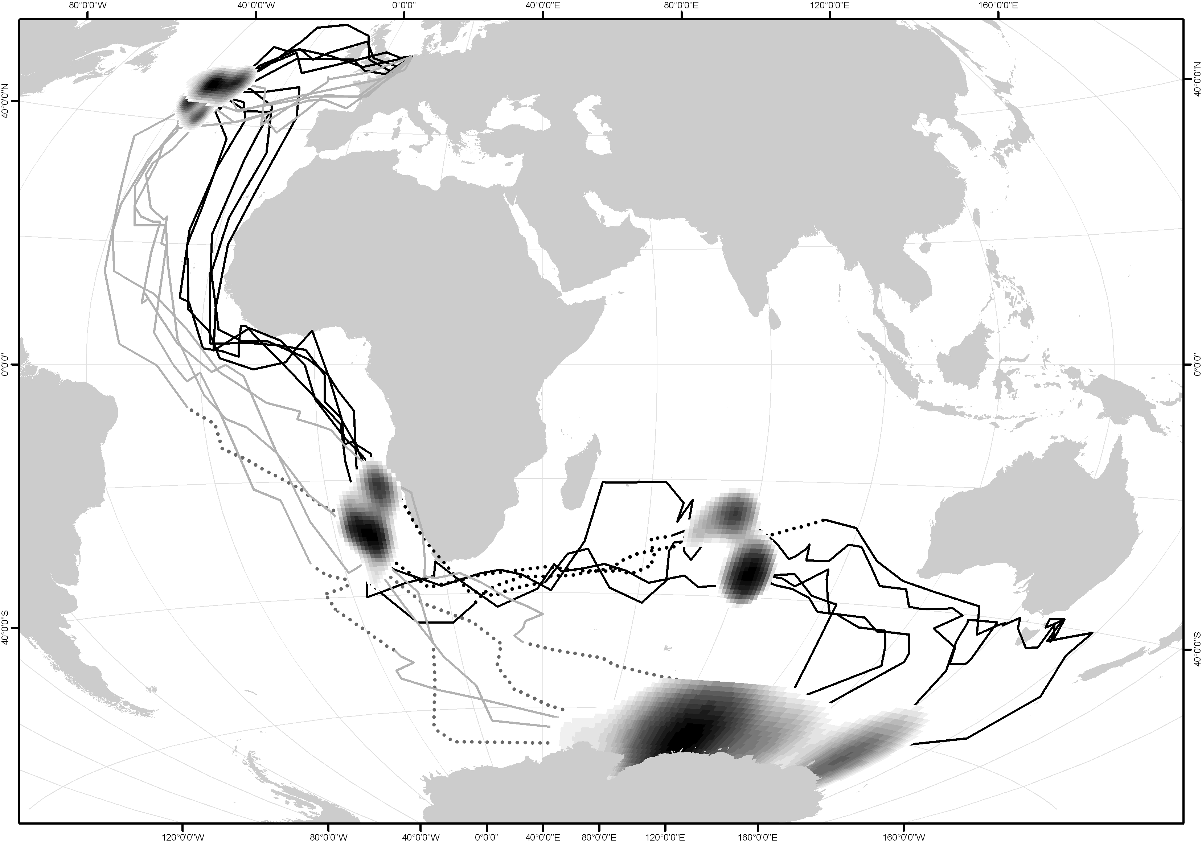Figure 1. Migration routes of five Arctic Terns tracked from The Netherlands. Shown are interpolated migratory routes, staging areas during migration, and non-breeding region during the Austral summer. Black lines represent southbound, and grey lines represent northbound routes. Dashed lines depict linearly interpolated latitudes during equinox periods. Density kernels represent isopleths of 0–70% of the distribution at 10% intervals within the staging areas and non-breeding region. The map is in Aitoff projection with central meridian at 40°E.

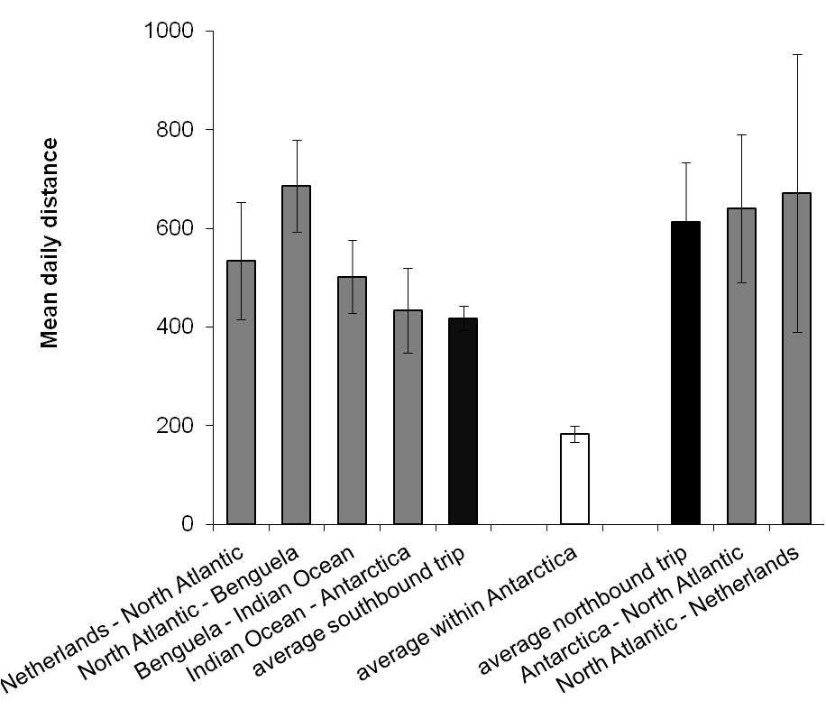
Figure 2. Migration speed ± SD (black bars) during north and southbound routes (including staging time), travel speeds between staging sites ± SD (grey bars) separated for distinctive segments of the north and southbound journeys, and average daily movement ± SD within the Antarctic non-breeding region (white bar) in km/day of Arctic Terns (n = 5) tagged in The Netherlands.

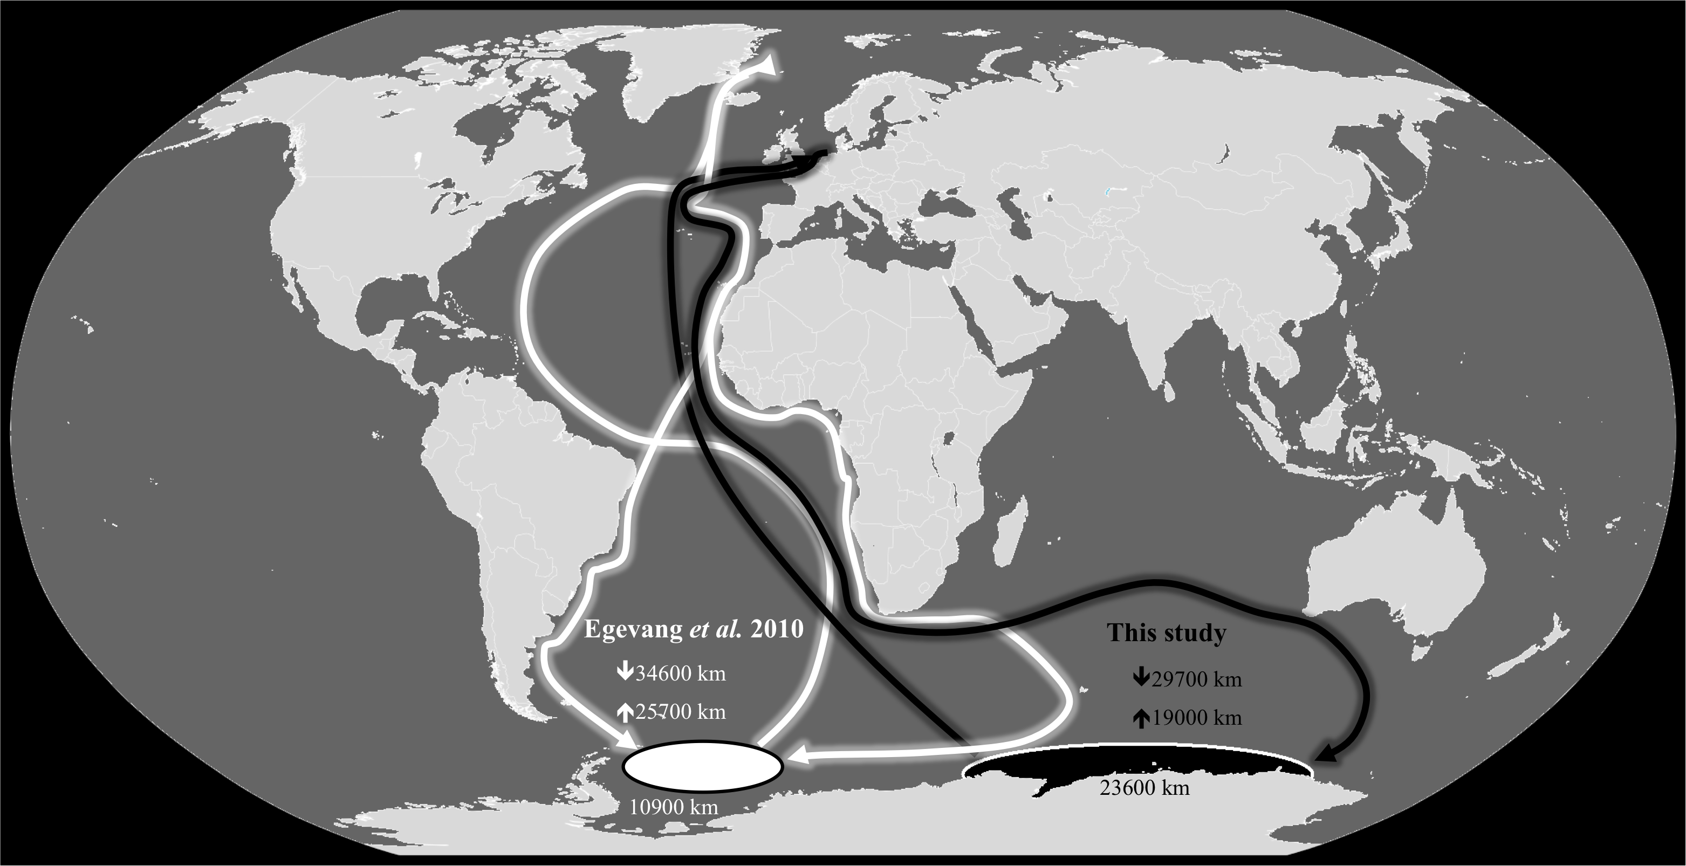Figure 3. Schematic comparison between the movements of Arctic Terns breeding in The Netherlands (black lines) and Greenland (white lines) during the non-breeding period, including average migration distance. Antarctic non-breeding ranges are depicted in black (terns from The Netherlands) and white (terns from Greenland) with average total movement within these areas.

Table 1. Timing of migration in Arctic Terns tracked from The Netherlands (n = 5), including distances travelled during different legs of migration and duration of staging in days.

Migration stage or  Migration distance (km) | Median date or  Mean distance ± SD | Mean number  of days ± SD
Leaving colony | ~1–7 Jul | ~ 14 to 28 days
Departure North Sea post breeding staging area | 27 Jul 2011 | ~ 14 to 28 days
Distance to North Atlantic southbound staging area (km) | 3200 ± 530
Arrival to North Atlantic southbound staging area | 2 Aug | 6 ± 2
Departure to Benguela staging area | 9 Aug | 6 ± 2
Distance to Benguela staging area (km) | 10,100 ± 1000
Arrival to Benguela staging area | 23 Aug | 32 ± 16
Departure into ‘Indian Ocean traverse’ | 25 Sep | 32 ± 16
Distance of total ‘Indian Ocean traverse’ (km) | 16,500 ± 2800
Arrival to Amsterdam Island staging area | 14 Oct | 14 ± 10
Departure to Antarctic non-breeding range | 29 Oct | 14 ± 10
Arrival to Antarctic non-breeding range | 12 Nov | 128 ± 10
Departure from Antarctic non-breeding range | 21 Mar 2012 | 128 ± 10
Distance to North Atlantic staging area (km) | 15,800 ± 2600
Arrival to North Atlantic northbound staging area | 17 Apr | 3 ± 2
Departure from North Atlantic northbound staging area | 18 Apr | 3 ± 2
Distance to colonies (km) | 3200 ± 290
Arrival in colonies | 25 Apr
Total distance travelled between staging areas | 48,700 ± 2000 | 89 ± 11
Total distance travelled during the non-breeding season including distance within staging areas and Antarctic | 90,000 ± 2000 | 273 ± 7

