The megafauna community from an abyssal area of interest for mining of polymetallic nodules.
Bart De Smet ^{a, b *}, Erik Simon-Lledó ^{c}, Lisa Mevenkamp ª, Ellen Pape ª, Francesca Pasotti ª, Daniel O. B. Jones ^{c}, Ann Vanreusel ª

ª Department of Biology, Marine Biology Research Group, Ghent University, Krijgslaan 281/S8, 9000 Ghent, Belgium (mevenkamp@bioconsult.de; ellen.pape@ugent.be; francesca.pasotti@ugent.be; ann.vanreusel@ugent.be)
^{b} Flanders Marine Institute, Wandelaarkaai 7, 8400 Oostende, Belgium (bart.de.smet@vliz.be)
^{b} National Oceanography Centre, European Way, Southampton, SO14 3ZH. United Kingdom (erimon@noc.ac.uk; dj1@noc.ac.uk)

* Corresponding author: Bart De Smet
E-mail: bart.de.smet@vliz.be
Telephone: +32 (0)478 56 96 78
Abstract
Polymetallic nodules increase habitat heterogeneity in some abyssal benthic ecosystems by providing hard substrate. Besides their important role in structuring ecosystems, polymetallic nodules have high grades of valuable minerals and are a target of likely future exploitation, particularly in the Pacific Clarion-Clipperton Zone (CCZ). Mining activities will remove hard substrate and sediment and cause sediment plumes potentially affecting faunal communities over large areas. Long-lived megafaunal assemblages may be particularly vulnerable but data are lacking on the density, biodiversity and community structure in many areas of the CCZ. This study aims to provide megabenthic community baseline data from two physically similar areas (B6S02 and B4S03) located in the contract area of Global Sea Mineral Resources N.V. (GSR). Seafloor images, obtained by an autonomous underwater vehicle are used to characterise the large areas required for robust evaluation of sparse megafauna. Higher altitude images cover a larger area for the same effort but have reduced resolution compared to images obtained closer to the seafloor, leading to difficulties in detecting and identifying individuals. Our comparison of images obtained at different altitudes shows that images taken above 8m altitude underestimate the megafauna density by almost 50%, so images <8m were used for further analysis. We also used multiobserver agreement analysis to improve the megafaunal annotation consistency, and the quality and robustness of the data in this study. The two GSR areas were significantly different in nodule coverage and megafauna composition and a general positive relationship between nodule coverage and megafauna abundance was observed. Differences in the megafaunal composition were primarily caused by differences in echinoderms (asteroids, echinoids, ophiuroids and holothuroids), representing almost 70% of the megafauna.
Keywords: Megafauna; deep-sea mining; polymetallic nodules; CCZ; biodiversity; community structure; deep sea; AUV
- Introduction
The Clarion-Clipperton Zone (CCZ) in the equatorial North-East Pacific encompasses approx. 6 million km² and harbours the greatest concentration of polymetallic nodules known to date with an average nodule density of nearly 15 kg m⁻² (Petersen et al., 2016). The economic interest in this abyssal resource is high, mainly resulting from their high ore grade of valuable minerals including cobalt, copper, nickel but also rare earth elements (REE) compared to land-based resources (Hein et al., 2013). As a hard substrate in the predominantly fine sediment environment of the abyssal plains, polymetallic nodules are an important component structuring the benthic ecosystem and increasing habitat heterogeneity (Vanreusel et al., 2010, 2016; Simon‐Lledó et al., 2019). Sessile species attach themselves to nodules, which in turn support diverse species assemblages with other sessile and mobile organisms (Amon et al., 2016; Simon‐Lledó et al., 2019). Consequently, the presence and density of nodules is important in driving the abundance and diversity of both mobile and sessile megafauna (Vanreusel et al., 2016; Simon‐Lledó et al., 2019).
Direct impacts of polymetallic nodule mining on benthic communities are expected to emerge from the removal of hard substrate and sediment, while indirect impacts are expected to be driven by sediment plume re-depositions potentially affecting large areas (Oebius et al., 2001; Peukert et al., 2018). Considering that nodule re-growth is unlikely within the next millennia and the growth of many deep-sea taxa is slow, recovery of disturbed nodule fields is expected to take a long time and lead to altered community structure (Gollner et al., 2017; Jones et al., 2017). Our knowledge of recovery is rudimentary and most past studies on the recovery of fauna from polymetallic nodule fields are based on relatively small-scale experiments that focused only on some aspects of the benthos (Jones et al., 2017).
With limited existing information, thorough environmental baseline data for potential exploitation areas and the wider CCZ are urgently needed (Durden et al., 2017). These data will help assess any impact of a realistic mining scenario and to develop a good environmental management and monitoring plan, as required by the International Seabed Authority (ISA). As of today, the ISA has issued eighteen fifteen-year long contracts for the exploration of polymetallic nodules in the CCZ (www.isa.org.jm; accessed 30.06.2020), each for an area of approximately 75,000 km². One of the contractors is the Belgian company Global Sea Mineral Resources (GSR), which holds a contract area in the eastern part of the CCZ. In accordance with the ISA recommendations for exploration (International Seabed Authority, 2019), GSR has sampled its contract area to establish the environmental baseline.
Megafaunal organisms play a major role in the functioning of abyssal ecosystems through bioturbation and phytodetritus processing (Smith et al., 2008). In some cases, large megafauna, make greater contributions to benthic carbon flows than smaller organisms, for example by incorporating more phytodetritus per unit biomass than macrofauna (Stratmann et al., 2018a). For the abyssal CCZ, as with many other deep-water areas, many of the most conspicuous large-sized invertebrate megafauna are echinoderms, principally holothurians but also including large asteroids and echinoids (Simon-Lledó et al., 2019b).
The use of seafloor image analysis is considered an important tool for the assessment of habitat heterogeneity, megabenthos diversity and abundance and it can aid in the detection of impacts following mining across relatively large areas (Amon et al., 2016; Vanreusel et al., 2016; Simon-Lledó et al., 2019a). Imagery also underpins mining resource exploration/evaluation (e.g. Nautilus Minerals, 2016), so while expensive to acquire, imagery can have multiple uses. There are some limitations of image-based assessment too. Generally, the ecological analysis of seafloor images is time-consuming and although recommendations for image annotation exist (Schoening et al., 2016) the performance by different observers may produce divergent results (Schoening et al., 2012; Durden et al., 2016a). Furthermore, the accuracy with which animals can be identified from seafloor images largely depends on the resolution of the image, the focus, and the object distance from the camera (Durden et al., 2016). The resolution of objects on the seafloor decreases with increasing distance from the seafloor (camera altitude) while the area that can be captured within one image increases (Schoening et al., 2020). The camera altitude should be optimised according to the aim of the study and the required accuracy and detail. More recent developments in autonomous underwater vehicle (AUV) technology is enabling rapid seafloor image acquisition over wide areas (Morris et al., 2014; Simon-Lledó et al., 2019b). Higher altitude AUV surveys can image impressive amounts of seafloor area, while still enabling detection of larger-sized megafauna (Simon-Lledó et al., 2019a).
During cruise GSRNOD15A (September-October 2015), nodule coverage and epifaunal densities were assessed using AUV seafloor imagery in two zones of the GSR contract area. In this study, we characterized the megabenthic community in the GSR contract area within the CCZ, by means of a rapid AUV-based imaging assessment, focussing on images taken at a height of <8m above the seafloor. This enabled the characterisation of large-sized megafauna over a wide area, at a scale relevant to potential mining impact. Additionally, we assessed how polymetallic nodule coverage structures the megabenthic community in the GSR exploration area.
- Material & Methods

  - Study area
The GSR licence area is located between the Clarion and Clipperton Fracture zones (CCZ; centred around 12─17° N, 122─129° W; ± 4500 m water depth). The CCZ is located within the mesotrophic Pacific abyss, positioned between the eutrophic abyssal sediments around the equator and the oligotrophic sediments underlying the North Pacific central gyre. The region is characterized by a longitudinal and latitudinal gradient in productivity (Wedding et al., 2013). Within the GSR contract area, three 10 x 20 km sampling sites (B6S02, B4S03 and B4N01) located between ~ 60 and 270 km apart from each other (Fig. 1) were selected based on the presence of polymetallic nodules and suitability for future deep-sea mining from (1) available ecological literature, (2) low resolution bathymetry (i.e. 70 m horizontally, 50 m vertically) and slope maps (a slope < 15%), and (3) backscatter intensity data (giving an indication of the potential presence of polymetallic nodules) collected during a previous expedition to the contract area (August-September 2014).
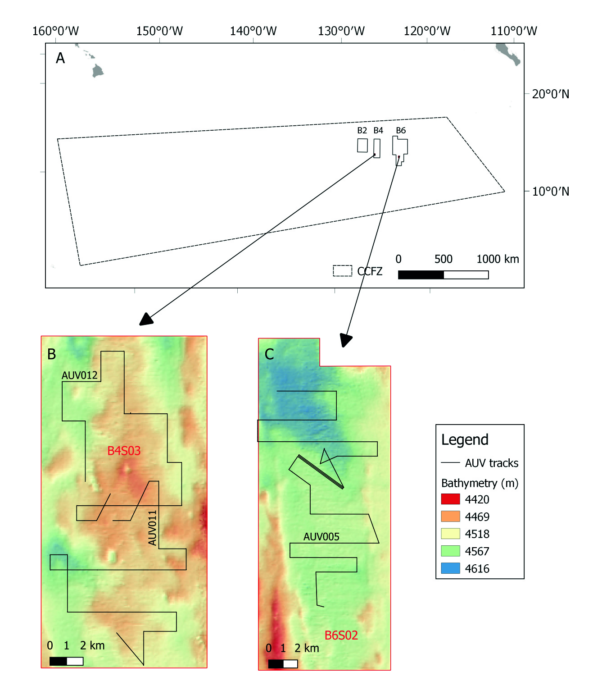
Figure 1. (A) The location of the Clarion-Clipperton Fracture Zone (CCZ) within the central Equatorial Pacific, with an indication of the Global Sea Mineral Resources (GSR) exploration area. (B) Detailed view on site B4S03 within the GSR exploration area, showing the tracks of the AUV camera dives AUV011 and AUV012. (C) Detailed view on site B6S02 within the GSR exploration area, showing the track of the AUV camera dive AUV005. The coordinates of the CCZ polygon was based on the working definition of the CCZ used by Glover et al. (2015).

Although we lacked a comprehensive evaluation of the habitat heterogeneity covered by the selected sites, based on low resolution bathymetric data, the sites are similar with respect to bathymetry and slope. The GSR contract area, positioned in the eastern CCZ, is characterized by a latitudinal and longitudinal gradient in the annual average seafloor particulate organic carbon (POC) flux. POC values slightly increase from B4N01 (1.51 g C_{org} m⁻² year⁻¹) to B4S03 (1.56 g C_{org} m⁻² year⁻¹) to B6S02 (1.61 g C_{org} m⁻² year⁻¹) (Lutz et al., 2007). Despite this POC flux gradient, a rather similar macro- and meiofauna community, in terms of densities and the composition of higher taxa, was observed at a scale of 10 to 100s of km in the GSR contract area (De Smet et al., 2017; Pape et al., 2017).
  - Study design and data collection
From September 10th to October 19th 2015, three camera dives were conducted using an AUV REMUS 6000 (Woods Hole Oceanographic Institute, WHOI) on board the RV ‘Mt. Mitchell’. In order to survey megafauna in the study area, the AUV was fitted with a 9.1 MP (3384 x 2704) digital still colour camera (Proscillica GT4200), which took pictures every 3 sec. The camera used a 14 bit, high dynamic range, Sony ICX814 Type I acquisition chip and was paired with a 15mm lens. The camera pressure dome had a matched index curvature to minimize distortion at the outer edges of the images. Lighting was provided by a 200 W-s strobe triggered to fire with camera exposure. One dive was conducted in B6S02 (AUV005) and two dives were conducted in B4S03 (AUV011 and AUV012) (Table 1).
Site | AUV dive | Date | Min latitude | Max latitude | Min longitude | Max longitude | Average depth (m) | Average altitude (m) | Average altitude <8m (m) | Total number of pictures | Pictures <8 m altitude | Surface area covered by annotated pictures (m²) | % of total pictures annotated
B6S02 | AUV005 | 25/09/2015 | 13.802 | 13.937 | -123.328 | -123.250 | 4,541 | 8.22 | 5.13 | 13,948 | 5,299 | 10,144 | 3.58
B4S03 | AUV011 | 2/10/2015 | 14.004 | 14.105 | -125.932 | -125.856 | 4,498 | 7.77 | 6.71 | 7,634 | 5,137 | 5,652
 | AUV012 | 3/10/2015 | 14.083 | 14.175 | -125.927 | -125.859 | 4,490 | 8.64 | 7.14 | 7,052 | 3,524 | 6,409 | 3.40
Table 1. Details of the AUV picture dives conducted during GSRNOD15A. AUV011 and AUV012 each cover half of site B4S03 (Fig. 1), therefore pictures of these dives were pooled and analysed as being one dive. DD = decimal degrees. The surface area covered by annotated pictures (m²) displays the summed seafloor area covered by the pictures selected and annotated per dive.
Over the three selected dives 28,634 images (covering 0.65 km²) were collected at altitudes ranging from 2.7 to 19.9 m, and at a speed of about 2.75 kts. An overview of the AUV dives and the metadata is provided in Table 1. Aboard, the raw pictures were corrected for colour and processed to 53.6 Mb RGB24 images. Additional light normalization and seabed projection steps were not performed for further biological analyses.
  - Megafauna annotations
For sites B6S02 and B4S03, a selection of AUV images taken during the dive(s) was annotated for the presence of megafauna on the seabed. Since AUV011 and AUV012 each cover half of site B4S03, pictures of these dives were pooled and analysed as being one dive. Pictures taken at an altitude < 8m above the seabed were processed separately from the pictures taken at an altitude > 8m above the seabed to enable comparison of megafaunal abundances between different altitudes for each site (Supplementary Material 1). Below 8m altitude, pictures were collected on average 6m above the seabed (Table 1; Supplementary Material 2). Because of the relatively high altitude at which the pictures were taken, the resolution of the images was not sufficient to make reliable biodiversity calculations. Nevertheless, we were able to compare the relative abundances of the major groups of larger-sized megafauna (approximately > 5 cm). Five replicate sets of 50 images were randomly selected per combination of site and altitude and stored on a server hosted by Geomar (Helmholtz Centre for Ocean Research, Kiel, Germany). The pictures were visually reviewed and annotated for megafauna, using the online software tool BIIGLE 2.0 (Langenkämper et al., 2017). The annotated megafauna was identified to the lowest possible taxon level (i.e. morphotypes) and counted. Fauna that could not be identified was labelled as ‘Unknown’.
  - Annotation data quality control
An inter-observer agreement analysis was performed to assess the quality of megafauna annotations (Durden et al., 2016a; Schoening et al., 2016). To perform this assessment, a total of 200 randomly selected images (i.e. 20% of each replicate set), were re-annotated for megafauna by an independent observer. To avoid the inclusion of a fauna detectability bias, observer 1 (Obs1) annotations were hidden from observer 2 (Obs2) during the annotation process. Obs2 followed exactly the same methodological approach and taxonomical resolution as Obs1, adding new taxonomical categories where deemed pertinent.
Relative x and y pixel positions were recorded for all annotations and used to interpolate the fauna identified by both observers for each analysed image using a custom algorithm developed using R software (R Development Core Team, 2015). The algorithm calculated a buffer area (±30 pixels) around the x and y positioning of each Obs1 annotation, to then align each Obs1 annotation with any Obs2 annotation(s) falling within the same buffer area range, at the same given image. A buffer size of approximately 30 pixels (~7.3 cm) was selected to ensure a sufficiently large range for the alignment between annotations from both observers, provided that the average maximum length of Obs1 annotations was 34 px (calculated from all annotations where a line was used), and animal lengths of the largest taxa (Holothuroidea) averaged 81 px. Position-aligned annotations with matching taxonomical labels given by both observers were given a “1” score (full agreement), those aligned in position but with a different taxonomical label were given a “0.5” score, and annotations from both observers that could not be aligned in position with any annotation from the other observer where given a “0”. When multiple annotations fell within the same buffer area, the algorithm prioritized the alignment between annotations with the same taxonomical label given, under the assumption that these referred to the same individual in the image. In situations where multiple annotations falling within the same buffer had no possible taxonomical label match, alignment between Obs1 and Obs2 annotations was randomly assigned between any combination of these, and given a “0.5” score. The algorithm also flagged all cases of multiple alignment were the total number of annotations from each observer aligned were impaired (29 cases), so that these could be manually inspected and resolved. The specimen detection success was computed as the number of specimens detected by an observer as a fraction of the total number of specimens detected by both observers. The classification success was calculated as the number of specimens that were identically classified by both observers as a fraction of the number of specimens detected by both observers.
  - Polymetallic nodule coverage
From each of the AUV images, nodule presence and size was measured by means of a custom script in Python programming language developed with a combination of tools from the opensource libraries OpenCV (https://opencv.org/) and Scikit-Image (https://scikit-image.org/). The surface area covered by nodules (nodule coverage, %) was determined analysing the pictures by means of two approaches: a qualitative and a quantitative approach. The qualitative approach distinguishes images with many nodules (dense/intermediate class) from images with no or few nodules (bare class). The quantitative approach identified for each nodule in the image a set of parameters: major axis, minor axis, orientation surface, roundness, and for each parameter the mean, standard deviation, minimum, maximum and 5% and 95% percentiles were calculated. The script followed a different workflow for bare, intermediate and dense class images, based on the outcome of the qualitative approach.
  - Data processing and statistical analyses

    - Polymetallic nodule coverage
Differences in the polymetallic nodule coverage (%) below 8m altitude between sites were tested with a non-parametric two sample Wilcoxon test, because the assumptions of normality (Shapiro-Wilk tests) and homogeneity of variance were not fulfilled. Prior to the analysis, the zero nodule coverage images were removed from the dataset.
    - Megafauna density and community composition
Only the annotations from Obs 1 were used for further ecological analysis as these covered the full dataset, whereas Obs 2 annotations encompassed only a 20% of the images already annotated by Obs1. The megafauna community was investigated both at higher taxon level (i.e. phylum, class or order level) and at the lowest identifiable taxon level (morphotypes: mtp), excluding unknown annotations and Xenophyophora (megafauna-sized unicellular eukaryotes, which are generally not taken into account in deep-sea megafauna community studies because it is not possible to determine whether they are alive in images; Hughes and Gooday, 2004). Megafaunal abundances were standardized to number of individuals per hectare (ha). Differences in megafaunal density (ind. ha⁻¹) were tested with a two-way Analysis of Variance (ANOVA), with Site and Altitude as two fixed factors. Prior to ANOVA, the assumptions of normality (Shapiro-Wilk tests), homogeneity of variances (Levene tests), and the independence of the residuals were tested on untransformed data. Besides, to put focus on the data retrieved below 8m altitude, differences in megafaunal density (ind. ha⁻¹) were tested with a t-test. The correlation between total megafauna densities below 8m altitude and nodule coverage was evaluated using a Spearman Rank correlation test.
Differences in megafaunal community composition between sites and altitudes were tested with a multivariate 2-factor permutational ANOVA (PERMANOVA), based on Bray-Curtis resemblance matrices of untransformed density data (lowest available taxon level). If a significant interaction effect was found, pair-wise tests for Site × Altitude were carried out. A SIMPER analysis (Bray-Curtis resemblance, untransformed density data) was conducted to calculate the contribution of each taxon (%) to the dissimilarity in the megafauna community between altitudes and sites. Differences in megafaunal community composition between sites at an altitude < 8m only were tested with a multivariate 1-factor PERMANOVA, based on Bray-Curtis resemblance matrices of untransformed density data (lowest available taxon level). Although PERMANOVA makes no explicit assumptions regarding the distribution of the data, a test for the homogeneity of multivariate dispersions was done, using the PERMDISP routine. In addition, data was visualized by a Principal Coordinates Analysis (PCO; Anderson et al., 2008).
A significance level of α = 0.05 was used in all tests. All statistical analyses were conducted in the open source software R (version 3.3.1; R Development Core Team, 2015) and in PRIMER v6 with the PERMANOVA+ add-on software (Clarke and Gorley, 2006; Anderson et al., 2008).
- Results

  - Polymetallic nodule coverage
The polymetallic nodule coverage (±SD) was significantly higher in site B4S03 (31.9 ± 5.4 %) compared to site B6S02 (29.6 ± 2.3 %) (Wilcoxon t-test: p = 1.135 × 10⁻⁹).
  - Megafauna density and community composition
In total, 2,426 individuals, belonging to 41 megafaunal taxa, were counted and annotated in the GSR contract area (area analysed = 22,205 m²) (Fig. 2), resulting in an average megafaunal density (±SD) of 1,277 ± 464 ind.ha⁻¹ (Supplementary Material 3). A total of 98.2% of the megafauna individuals belonged to one of the following five higher taxa: Echinodermata (67.3%), Cnidaria (14.9%), Polychaeta (8%), Porifera (5.4%) and Arthropoda (2.6%) (Fig. 3).
Megafauna density was significantly different among the two altitudes (2-way ANOVA, F-value_{1,16} = 64.963, p = 5.03 × 10⁻⁷), but not significantly different among the two sites (2-way ANOVA, F-value_{1,16} = 0.7440, p = 0.4011). The average density (±SD) of megafauna was almost twice as high at an altitude <8m (1,676 ± 217 ind.ha⁻¹) compared to an altitude >8m (878 ± 230 ind.ha⁻¹). Multivariate analysis also revealed a significant interaction effect of Site × Altitude on the megafauna community (2-factor PERMANOVA, pseudo-F_{1,16} = 6.6807, pPERM = 0.0005) (Supplementary Material 4). Pair-wise tests showed that the megafauna community was significantly different when observed from different altitudes and between the two sites (all four pair-wise tests: p < 0.005). A SIMPER analysis revealed that 66.8% of the differences in the megafauna community between altitudes were caused by differences in the density of Ophiuroidea (20.2%), Aspidodiadematidae (16.7%), Actiniaria (15%) and Polychaeta (14.9%). Owing to the significant differences in the megafauna community as a result of the altitude at which the AUV images were taken, further statistical analyses were conducted only on the data retrieved below 8m altitude.
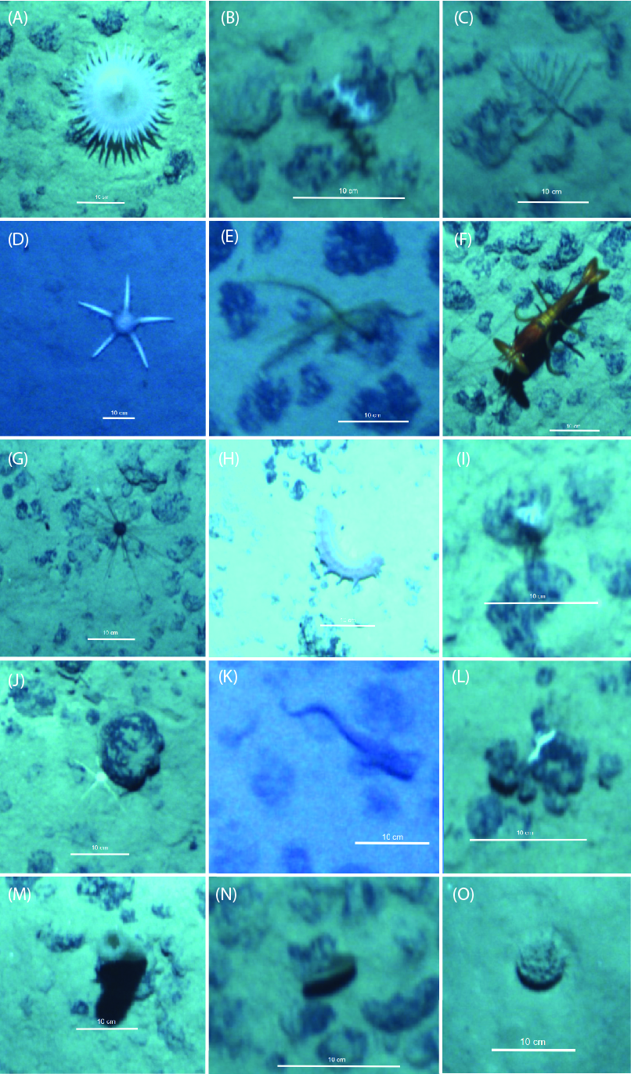
Figure 2. Examples of identified higher megafauna taxa (and the altitude at which the images were taken) from the GSR exploration area in the CCZ. (A) Actiniaria mtp (4.92m altitude), (B) Alcyonacea mtp (5.1m), (C) Antipatharia mtp (5.1m), (D) Asteroidea (Paxillosida mtp) (9.5m), (E) Crinoidea mtp (7.1m), (F) Decapoda (Aristeidae) (5.1m), (G) Echinoidea (Aspidodiadematidae mtp) (5.6m), (H) Holothuroidea mtp (5.1m), (I) Hydrozoa mtp (5.0m), (J) Ophiuroidea mtp (5.0m), (K) Osteichthyes mtp (10.3m), (L) Polychaeta mtp (5.1m), (M) Porifera mtp (5.3m), (N) Xenophyophora (plate-like morphotype) (5.1m), (O) Xenophyophora (reticulate morphotype) (5.5m). All scale bars = 10 cm.

Figure 3. Megafauna taxon composition as observed from AUV images taken at an altitude < 8m and > 8m at sites B6S02 and B4S03 in the GSR contract area. Per combination of site and altitude, 5 replicate sets of 50 images (1,000 images in total) were annotated. Only higher taxa comprising ≥1% of the total megafauna density over the different sites and altitudes were included. Xenophyophora were not included since these megafauna-sized unicellular eukaryotes are generally not taken into account in deep-sea megafauna community studies. Unknown annotations were removed. Other taxa include Alcyonacea, Antipatharia, Asteroidea, Ceriantharia, Corallimorpharia, Crinoidea, Ctenophora, Decapoda, Hydrozoa, Mollusca, Osteichthyes, Other_Anthozoa, Other_Cnidaria, Pennatulacea, Scyphozoa.

Below 8m altitude, 987 individuals, belonging to 29 megafaunal taxa, were counted and annotated on 500 images. The average density (±SD) in site B6S02 (1,626 ± 268 ind. ha⁻¹) and site B4S03 (1,726 ± 166 ind. ha⁻¹) was not significantly different (t-test: t₈ = -0.71, p = 0.4992). Total megafauna densities showed a strongly significant, positive correlation with nodule coverage (Spearman-Rank, R = 0.21, p < 0.001). The megafaunal community below 8m over the two sites was dominated by Ophiuroidea (31.8%), Echinoidea (25.1%), Actiniaria (14.5%), Polychaeta (10.1%), Porifera (4.9%) and Decapoda (3.5%). The remaining taxa comprised 10.1% of the total megafaunal density.
Multivariate analysis on the lowest identifiable taxon level revealed that the megafaunal community composition was significantly different between sites B6S02 and B4S03 (1-factor PERMANOVA, pseudo-F_{1,9} = 8.3554, p_{PERM} = 0.0066). A SIMPER analysis showed that the five taxa that contributed most to this dissimilarity between sites were the Aspidodiadematidae mtps (more abundant at B4S03; contribution to dissimilarity of 34.8%), Ophiuroidea mtps (more abundant at B6S02; 16.6%), Polychaeta mtps (more abundant at B6S02; 8.8%), Actiniaria mtps (more abundant at B4S03; 8.1%) and Porifera mtps (more abundant at B6S02; 3.9%). The PCO analyses showed a clear separation with PCO1 explaining 58% of the total variation in the resemblance matrix and separating B6S02 and B4S03 sample sets.
  - Annotation data quality control
In the 200 randomly selected images, the two observers made 3,993 annotations. 48.8% of the individuals (1,947 individuals) was detected by both observers, whereas 51.2% (2,046 individuals) was detected by only one of the two observers, with 25% (1,000 individuals) and 26.2% (1,046 individuals) only annotated by observer 1 and 2, respectively. The detection success was consistent between the two observers (75.0% vs. 73.8%), with a mean detection success of 74.4%. The megafauna detected by only one of the two observers comprised mainly ‘unknowns’ (42.3%, 865 individuals) and Xenophyophora (47.9%, 982 individuals). If an organism was detected by both observers, the observers labelled it identically in 89.7% of the cases (1,747 out of 1,947 detected individuals). The 10.2% differently labelled organisms (200 out of 1947 detected individuals) consisted mainly of Xenophyophora (32%), ‘unknowns’ (13.5%), and sponges (11%). If Xenophyophora and unknowns were removed, the two observers labelled 21% (109 out of 517 individuals) of the mutually detected organisms differently, yielding a classification success of 79%.

- Discussion

  - Data quality control
The majority of observations in this study reflect morphotypes because the identification of deep-sea species from imagery is typically constrained by the image resolution, and is uncertain as key morphological features required for positive identification can often only be resolved based on collected material (e.g. ventral morphology of the oral disc in ophiuroids; shape of spicules in holothuroidea and sponge taxa, etc.). For comparative ecological studies morphotype-level classification usually proves sufficient (Durden et al., 2016b). However, inconsistencies in the detection and the taxonomic classification of specimens among observers might impact the derived ecological metrics, such as density, diversity and composition (Durden et al., 2016a). The inter-observer agreement analysis showed a consistent specimen detection success among observers (74.4%), whereas the classification success was as high as 79%. Quantification of the inter-investigator bias by directly comparing observers in a randomly selected subset of the imagery, as suggested by Durden et al. (2016a) and Howell et al. (2014), improved the annotation consistency, and the quality and robustness of the data in our study.
Besides the inter-observer bias, the detected megafauna density and community composition are greatly influenced by the height of the camera above the seafloor (the altitude) at which the AUV images were taken. Based on our analysis, it appeared that the AUV images taken above 8m altitude underestimated the megafauna density by almost 50% compared to images taken below 8m altitude. Moreover, the image altitude affects the composition of the megafauna community that can be detected. Although the generally accepted altitude for image collection through underwater vehicles is between ±1 and 4m (Durden et al., 2016b), not many studies have compared images taken at different altitudes in the same study area (but see Schoening et al. (2020) for AUV analysis and Jones et al. (2009) for towed camera platform analysis). In line with the current study, Jones et al. (2009) observed the altitude to affect measures of the benthic community density and diversity, resulting from a decreased biological resolution with increasing altitude. They concluded that the optimal altitude depends on the minimum size of fauna needing to be resolved and the minimum operational altitude of the vehicle. With increasing altitude, faunal numbers reduced as a result of the limitations of the camera system: a fast dissipation of light in water, a reduced light intensity by the absorption of seawater and scattering by suspended particulate matter, and decreased film grains per area of seabed (equivalent to pixels in digital images) and hence lower biological resolution of the images (Jones et al., 2009). According to Schoening et al. (2020), the lowest altitude above seabed that can be reached using a given platform will always provide more data and higher taxonomical resolution in the faunal identification. Since the data collected from images above 8m altitude is not as well suited to infer patterns in the megafauna community compared to images below 8m altitude, focus was put on the data retrieved below 8m altitude only.
  - Megafaunal density
Megafaunal densities surveyed in this study (<8m data) were similar to the densities found in the eastern CCFZ (license areas of BGR and GSR, and APEI3) (Cuvelier et al., 2020) and in the exclusive economic zone of Kiribati (Simon-Lledó et al., 2019c) However, megafaunal densities were less than half of those found at the APEI6 seabed (Simon-Lledó et al., 2019b) and about a fifth of what was found at the UK-1 area, in the eastern CCZ (Amon et al., 2016) (Table 2). A recent study conducted at the TOML D area, next to the GSR site, also reported megafaunal density values that were double those encountered in this study (Simon-Lledó et al., 2020). All these studies were conducted upon imagery collected at lower altitudes above the seabed (e.g., 2 to 3.5m) compared to the 6m average altitude at which the <8m images were collected here.

 |  |  |  |  |  |  |  | Altitude (m) |  |  |  | Megafauna density (ind.ha-1) |  |  |  | Total megafauna morphotype richness
Reference | Imagery platform used | incl. Xeno | Nodules | Depth (m) | Area | Area surveyed (m²) | #pictures | Avg. | Min | Max |  | Avg. | Min | Max
Current study | AUV REMUS 6000 | yes | yes | 4,524 | GSR, CCFZ | 22,205 | 1,000 | 8.09 | 4.52 | 17.7 |  | 7,235 | 1,074 | 24,704 |  | 43
 |  | no | yes |  |  |  |  |  |  |  |  | 1,277 | 610 | 2,063 |  | 41
Current study (< 8 m) | AUV REMUS 6000 | yes | yes | 4,524 | GSR, CCFZ | 5,829 | 500 | 5.99 | 4.52 | 7.98 |  | 12,905 | 4,589 | 24,704 |  | 32
 |  | no | yes |  |  |  |  |  |  |  |  | 1,676 | 1,374 | 2,063 |  | 30
Tkatchenko & Radziejewska (1998) | Towed video camera system | ? | no | 4,430 | IOM, CCFZ | NA | NA | 3.3 | NA | NA |  | 261 | NA | NA |  | NA
Morgan et al. (1993) | Towed camera system | yes? | yes | 4,500-5,200 | CCFZ (regional study) | 66,709 | 9,546 | NA | NA | 5 |  | NA | 270 | 1,140 |  | NA
Tilot (2006) | Towed camera systems & remotely controlled devices | yes | yes | 4,950 | NIXO45_IFREMER, CCFZ | NA | NA | 5 | NA | NA |  | 553 | NA | NA |  | 122
Radziejewska & Stoyanova (2000) | Towed camera systems & remotely controlled devices | no | yes | 4,500 | IOM, CCFZ | +/- 37,073 | +/-7,739 | 3 | NA | NA |  | 305 | 125 | 485 |  | NA
 |  | no | no |  |  | +/- 34,116 | +/-7,143 |  |  |  |  | 176 | NA | NA |  | NA
Amon et al. (2016) | Remotely Operated Vehicle | no | yes | 4,400 | UK1, CCFZ | 4,202 | 2,458 | 2 | 1.2 | 3.2 |  | 8,000 | NA | NA |  | 126
Simon-Lledó et al. (2019b) | AUV Autosub6000 | no | yes | 3,950-4,250 | APEI6, CCFZ | 18,580 | 10,052 | 3 | 2.1 | 3.9 |  | 3,900 | 3,200 | 4,400 |  | 133
Simon-Lledó et al. (2019c) | Towed camera system | no | yes | 4,630-5,460 | Kiribati, Central Pacific | 14,666 | 4,074 | 3.5 | NA | NA |  | 1,700 | 700 | 3,000 |  | 118
Simon-Lledó et al. (2020) | Towed camera system | no | yes | 4,418-5,175 | TOML area B | 24,955 | 6,932 | 3.5 | NA | NA |  | 1,400 | NA | NA |  | 125
 |  |  |  | 4,817-5,065 | TOML area C | 29,246 | 8,124 | 3.5 | NA | NA |  | 1,100 | NA | NA |  | 105
 |  |  |  | 4,345-4,750 | TOML area D | 20,200 | 5,611 | 3.5 | NA | NA |  | 4,400 | NA | NA |  | 152
Cuvelier et al. (2020) | ROV Kiel 6000 | no | yes | 4,080-4,930 | BGR, GSR, APEI CCFZ | 15,155 | NA | NA | <1 | 5 |  | 1,744 | 380 | 3,030 |  | NA
Table 2. Comparison of this study with other megafauna studies in nodule bearing Pacific areas in terms of megafauna density and morphotype richness. NA = (data) not available, Xeno = Xenophyophores. Megafauna taxon richness determined at the lowest taxonomical level possible.
Seen that the TOML and the GSR area are expected to receive similarly low POC fluxes (Vanreusel et al., 2016; Volz et al., 2018), the differences in megafauna densities may be indicative of an effect of the difference in altitude of the image collection on the results of seabed surveys at the CCZ. More specifically, the megafaunal densities reported in the present study are most probably an underestimation. On the other hand, the older studies conducted by Morgan et al. (1993) (regional CCZ study), Tilot (2006) (IFREMER contract area), and Tkatchenko & Radziejewska (1998) and Radziejewska & Stoyanova (2000) (both IOM contract area) showed in comparison relatively low densities, which may be related to the less advanced camera technology (incl. lower resolution) and difficulties in estimating the seabed coverage at the time of these surveys.
Within the GSR contract area, we observed similar megafaunal abundance for sites B6S02 and B4S03. In abyssal nodule-bearing areas, bottom topography, local currents, sediment deposition rates, and nodule abundance are intrinsically linked on a local scale (Mewes et al., 2014; Peukert et al., 2018) and these abiotic parameters are known to affect megafauna abundance and community composition (Radziejewska and Stoyanova, 2000; Amon et al., 2016; Vanreusel et al., 2016; Simon-Lledó et al., 2019b). Upon pooling megafauna and nodule data from both sites, we found a statistically significant positive relationship between nodule coverage and megafauna abundance below 8m altitude. Also other studies (Radziejewska and Stoyanova, 2000; Vanreusel et al., 2016; Simon-Lledó et al., 2019c; Simon‐Lledó et al., 2019) found higher megafauna abundances in nodule-bearing compared to nodule-free areas. Although statistically significant differences were found, the absolute values of nodule coverage and bottom topography assessed between the two GSR sites were not sufficient to expect major differences in megafaunal density.
  - Megafauna community composition
The total number of megafaunal morphotypes (taxa) detected for the two GSR sites, i.e. 41, was considerably lower than the numbers reported by other studies in the nodule-bearing Pacific (Table 2). This difference in morphotype richness is probably related to differences in the seabed area encompassed, and the relatively high camera altitude (and thus certain, smaller taxa may have not been captured) in the current study (Table 2). Moreover, only two sites, which were highly comparable in terms of depth, nodule coverage and topography, were investigated here.
In the current study, representatives of 8 metazoan phyla were recorded in decreasing order of importance Echinodermata, Cnidaria, Polychaeta, Porifera, Arthropoda, Chordata, Mollusca and Ctenophora. They include both sessile and mobile taxa representing a mixture of traits and functional groups such as detritivores, suspension- and filter feeders and carnivores. The echinoderms, including asteroids, echinoids, ophiuroids and holothuroids, are particularly well represented in terms of densities and structural and functional biodiversity compared to the other groups. Together they represent almost 70% of the communities and their morphotype richness lies higher than any other group observed in the study area.
The two areas that were compared in this study (B6S02 and B4S03) are significantly different in nodule coverage and megafauna composition. However, both areas were overall nodule-rich and differences in both nodules and communities are not prominent. The higher nodule abundance in B4S03 coincided with slightly higher abundances in Actinaria mtps but also of Aspidodiadematidae mtps, a dominant echinoid family, whereas B6S02 is differentiated by slightly higher abundances of Ophiuroidea mtps, polychaetes but also of sponges. The local habitat patchiness in each area was not mapped, but is expected to contribute significantly to the distribution of those taxa, which is not investigated here.
Echinoderms were abundant at the GSR area, as is typical in other Pacific studies where they dominate the larger megafauna (Morgan et al., 1993; Ruhl, 2007; Smith et al., 2008; Simon-Lledó et al., 2019a). In the UK-1 exploration contract area just east of the GSR area, (Amon et al., 2016) echinoderms were well-represented (0.30 ind/m²; 20.3% of the total abundance), although cnidarians were overall slightly more abundant as a taxon (0.33 ind/m²; 22.3% of the total abundance). Similarly Tilot et al. (2018) recorded high abundances of cnidarians and echinoderms in different areas of the central CCZ compared to other taxa. The shifts in dominance from the suspension feeding cnidarians to the more deposit feeding echinoderms when comparing different areas was mainly explained by a combination of nodule abundance, currents and POC flux, with the echinoderms being more abundant at the higher range of the productivity gradient, whereas cnidarians preferred stronger currents, supplying material in suspension, and the presence of nodules which they use to attach to (Vanreusel et al., 2016; Tilot et al., 2018). Simon-Lledo et al. (2019b) mainly found cnidarians as the dominant group (0.18 ind/m²; 41% of the total abundance) in the most north eastern APEI#6, followed by sponges as the second most abundant group (0.08 ind/m²; 17% of the total abundance), and echinoderms and bryozoans equally ranked as the third most abundant groups, each representing 10% of the total abundance only (0.04 ind/m²).
The approach used here, rapid assessment of large-sized megafauna (approximately > 5 cm) during resource assessment, influences some of the results. For example, while flying the imagery platform higher, the smaller cnidarians with often indistinct colours can be easily underestimated, as appears to be the case in this study from comparison with other nearby areas. The more robust larger organisms, such as many echinoderms, are easier to observe and can be detected more consistently. Low flying altitudes are important for full estimation of epibenthic diversity (usually regarded as a sensitive indicator of change; Clarke, 1993), but require greater time for data acquisition. Higher observation distance more efficiently covers larger areas, which have larger numbers of individual organisms. The desired balance between survey efficiency and detection depends on the monitoring requirement. Taxon-specific responses to disturbance will also influence this: with less clear responses more taxonomic resolution may be needed for effective monitoring. Cnidarians, for example, are mostly associated with nodules and may be particularly impacted by sediment disturbance (Erftemeijer et al., 2012) and so may be an effective disturbance indicator. However, they are more difficult to detect and appear underestimated in higher-altitude studies such as in the current study. Echinoderms may seem less sensitive to sediment resuspension since they are detritivores, more opportunistic in their population dynamics and less exclusive for nodule rich areas. They are also amongst the most mobile invertebrate megafauna and are able to recover their densities relatively quickly (tens of years) in disturbed areas (Stratmann et al., 2018b; Simon-Lledó et al., 2019a). An approach analysing a number of different taxa that display different functional traits and/or life history strategies might be the way to go to assess the extent of the response to recent major disturbance events.
- Conclusion
This study presents the first rapid quantitative assessment of the megabenthic community in the nodule-rich GSR contract area within the CCZ. Based on seafloor image analysis below 8 m, the megabenthic community was observed to be moderately different between sites in the study area, while a positive relationship between nodule coverage and megafauna abundance was observed. This finding shows the role of nodule coverage in structuring the megabenthic community. Almost 70% of the megabenthic community in nodule-rich areas was dominated by Echinoderms. A taxon that may respond quickly to the changing environments in the abyss. A crucial factor in the monitoring of the seafloor by AUV image analysis is the altitude at which the images were taken. We showed that the altitude largely affected the megafauna density and community composition. In order to estimate the epibenthic diversity to the fullest (which may be required for more sensitive impact assessment), the optimal altitude has to be set at the minimum possible distance from the bottom to allow the highest detail of identification for the larger organisms and the possibility to record also smaller and less obvious groups. However, higher observation distance may save time by covering larger areas. Therefore, the final methodology selected should take all these aspects in consideration, and for long-term monitoring, we advise to be consistent with the chosen methodology.
- Acknowledgements
The authors would like to thank the Remus 6000 AUV technical team of Woodshole Oceanographic Institution (Greg Packard, Mark Dennet, Eric Hayden, Fred Jaffre) and OFG (Alison Proctor) for operating the AUV and colour-correcting the pictures. Moreover, the captain and the crew of the RV ‘Mt. Mitchell’, François Charlet (GSR), Tom De Wachter (GSR), Alison Proctor (OFG), Phil and Tony Wass (OFG), and Nick Eloot (G-TEC) are acknowledged for their help during the GSRNOD15A expedition. We thank Karen Soenen (G-TEC) for providing bathymetry data and Timm Schoening (GEOMAR) for assisting with the BIIGLE 2.0 software tool and arranging storage space on the Geomar server. The environmental baseline survey in the GSR contract area is supported by a service agreement between Global Sea Mineral Resources N.V. and Ghent University.
- References
Amon, D. J., Ziegler, A. F., Dahlgren, T. G., Glover, A. G., Goineau, A., Gooday, A. J., et al. (2016). Insights into the abundance and diversity of abyssal megafauna in a polymetallic-nodule region in the eastern Clarion-Clipperton Zone. Sci. Rep. 6, 30492. doi:10.1038/srep30492.
Anderson, M. J., Gorley, R. N., and Clarke, K. R. (2008). PERMANOVA+ for PRIMER: guide for software and statistical methods. Plymouth: Primer-E Ltd Available at: file:///D:/Elpape/My Documents/Ellen.Data/PDF/permanova+_for_primer_2008-3210213892/permanova+_for_primer_2008.pdf.
Billett, D. S. M., Bett, B. J., Reid, W. D. K., Boorman, B., and Priede, I. G. (2010). Long-term change in the abyssal NE Atlantic: The ‘Amperima Event’ revisited. Deep Sea Res. Part II Top. Stud. Oceanogr. 57, 1406–1417. doi:10.1016/j.dsr2.2009.02.001.
Clarke, K., and Gorley, R. (2006). PRIMER v6: User Manual/tutorial. Plymouth: Primer-E Ltd Available at: file:///D:/Elpape/My Documents/Ellen.Data/PDF/Primer_v6_manual_2-0211588865/Primer_v6_manual_2.pdf.
Clarke, K. R. (1993). Non-parametric multivariate analyses of changes in community structure. Aust. J. Ecol. 18, 117–143. doi:10.1111/j.1442-9993.1993.tb00438.x.
Cuvelier, D., Ribeiro, P. A., Ramalho, S. P., Kersken, D., Martinez Arbizu, P., and Colaço, A. (2020). Are seamounts refuge areas for fauna from polymetallic nodule fields? Biogeosciences 17, 2657–2680. doi:https://doi.org/10.5194/bg-17-2657-2020.
De Smet, B., Pape, E., Riehl, T., Bonifácio, P., Colson, L., and Vanreusel, A. (2017). The Community Structure of Deep-Sea Macrofauna Associated with Polymetallic Nodules in the Eastern Part of the Clarion-Clipperton Fracture Zone. Front. Mar. Sci. 4. doi:10.3389/fmars.2017.00103.
Durden, J., Bett, B., Schoening, T., Morris, K., Nattkemper, T., and Ruhl, H. (2016a). Comparison of image annotation data generated by multiple investigators for benthic ecology. Mar. Ecol. Prog. Ser. 552, 61–70. doi:10.3354/meps11775.
Durden, J. M., Murphy, K., Jaeckel, A., Van Dover, C. L., Christiansen, S., Gjerde, K., et al. (2017). A procedural framework for robust environmental management of deep-sea mining projects using a conceptual model. Mar. Policy 84, 193–201. doi:10.1016/j.marpol.2017.07.002.
Durden, J. M., Schoening, T., Althaus, F., Friedman, A., Garcia, R., Glover, A. G., et al. (2016b). Perspectives in Visual Imaging for Marine Biology and Ecology: From Acquisition to Understanding. Oceanogr. Mar. Biol. 54, 1–72. doi:10.1201/9781315368597-6.
Erftemeijer, P. L. A., Riegl, B., Hoeksema, B. W., and Todd, P. A. (2012). Environmental impacts of dredging and other sediment disturbances on corals: A review. Mar. Pollut. Bull. 64, 1737–1765. doi:https://doi.org/10.1016/j.marpolbul.2012.05.008.
Fukushima, T., Shirayama, Y., and Kuboki, E. (2000). The characteristics of deep-sea epifaunal megabenthos community two years after an artificial rapid deposition event. Publ. Seto Mar. Biol. Lab. 39, 17–27.
Glover, A., Dahlgren, T. G., Wiklund, H., and Smith, C. R. (2015). An end-to-end DNA taxonomy methodology for biodiversity survey in the central Pacific abyssal plain. J. Mar. Sci. Eng. 4, 1–34. doi:10.3390/jmse4010002.
Gollner, S., Kaiser, S., Menzel, L., Jones, D. O. B., Brown, A., Mestre, N. C., et al. (2017). Resilience of benthic deep-sea fauna to mining activities. Mar. Environ. Res. doi:10.1016/j.marenvres.2017.04.010.
Hein, J. R., Mizell, K., Koschinsky, A., and Conrad, T. A. (2013). Deep-ocean mineral deposits as a source of critical metals for high- and green-technology applications: Comparison with land-based resources. Ore Geol. Rev. 51, 1–14. doi:10.1016/j.oregeorev.2012.12.001.
Howell, K. L., Bullimore, R. D., and Foster, N. L. (2014). Quality assurance in the identification of deep-sea taxa from video and image analysis: response to Henry and Roberts. ICES J. Mar. Sci. 71, 899–906. doi:10.1093/icesjms/fsu052.
Hughes, J. A., and Gooday, A. J. (2004). The influence of dead Syringammina fragilissima (Xenophyophorea) tests on the distribution of benthic foraminifera in the Darwin Mounds region (NE Atlantic). Deep-Sea Res. I 51, 1741–1758.
International Seabed Authority (2019). ISBA/25/LTC/8 Recommendations for the guidance of contractors for the assessment of the possible environmental impacts arising from exploration for marine minerals in the Area.
Jones, D. O. B., Bett, B. J., Wynn, R. B., and Masson, D. G. (2009). The use of towed camera platforms in deep-water science. doi:info:doi/10.3723/ut.28.041.
Jones, D. O. B., Kaiser, S., Sweetman, A. K., Smith, C. R., Menot, L., Vink, A., et al. (2017). Biological responses to disturbance from simulated deep-sea polymetallic nodule mining. PLOS ONE 12, e0171750. doi:10.1371/journal.pone.0171750.
Langenkämper, D., Zurowietz, M., Schoening, T., and Nattkemper, T. W. (2017). BIIGLE 2.0 - Browsing and Annotating Large Marine Image Collections. Front. Mar. Sci. 4. doi:10.3389/fmars.2017.00083.
Lutz, M. J., Caldeira, K., Dunbar, R. B., and Behrenfeld, M. J. (2007). Seasonal rhythms of net primary production and particulate organic carbon flux to depth describe the efficiency of biological pump in the global ocean. J. Geophys. Res. Oceans 112, C10011. doi:10.1029/2006JC003706.
Mewes, K., Mogollón, J. M., Picard, A., Rühlemann, C., Kuhn, T., Nöthen, K., et al. (2014). Impact of depositional and biogeochemical processes on small scale variations in nodule abundance in the Clarion‐Clipperton Fracture Zone. Deep Sea Res. Part Oceanogr. Res. Pap. 91, 125–141. doi:10.1016/j.dsr.2014.06.001.
Morgan, C. L., Nichols, J. A., Selk, B. W., Toth, J. R., and Wallin, C. (1993). Preliminary analysis of exploration data from Pacific deposits of manganese nodules. Mar. Georesources Geotechnol. 11, 1–25. doi:10.1080/10641199309379903.
Morris, K. J., Bett, B. J., Durden, J. M., Huvenne, V. A. I., Milligan, R., Jones, D. O. B., et al. (2014). A new method for ecological surveying of the abyss using autonomous underwater vehicle photography. Limnol. Oceanogr. Methods 12, 795–809. doi:10.4319/lom.2014.12.795.
Nautilus Minerals (2016). NI 43-101 Technical Report TOML Clarion Clipperton Zone Project, Pacific Ocean.
Oebius, H. U., Becker, H. J., Rolinski, S., and Jankowski, J. A. (2001). Parametrization and evaluation of marine environmental impacts produced by deep-sea manganese nodule mining. Deep Sea Res. Part II Top. Stud. Oceanogr. 48, 3453–3467. doi:10.1016/S0967-0645(01)00052-2.
Pape, E., Bezerra, T. N., Hauquier, F., and Vanreusel, A. (2017). Limited Spatial and Temporal Variability in Meiofauna and Nematode Communities at Distant but Environmentally Similar Sites in an Area of Interest for Deep-Sea Mining. Front. Mar. Sci. 4. doi:10.3389/fmars.2017.00205.
Petersen, S., Krätschell, A., Augustin, N., Jamieson, J., Hein, J. R., and Hannington, M. D. (2016). News from the seabed – Geological characteristics and resource potential of deep-sea mineral resources. Mar. Policy 70, 175–187. doi:10.1016/j.marpol.2016.03.012.
Peukert, A., Schoening, T., Alevizos, E., Köser, K., Kwasnitschka, T., and Greinert, J. (2018). Understanding Mn-nodule distribution and evaluation of related deep-sea mining impacts using AUV-based hydroacoustic and optical data. Biogeosciences 15, 2525–2549. doi:10.5194/bg-15-2525-2018.
R Development Core Team (2015). R: A language and environment for statistical computing. R Foundation for Statistical Computing, Vienna, Austria. URL http://www.R-project.org/.
Radziejewska, T., and Stoyanova, V. (2000). Abyssal epibenthic megafauna of the Clarion-Clipperton area (NE Pacific): changes in time and space versus anthropogenic environmental disturbance. Oceanol. Stud. 29, 83–101.
Ruhl, H. A. (2007). Abundance and Size Distribution Dynamics of Abyssal Epibenthic Megafauna in the Northeast Pacific. Ecology 88, 1250–1262. doi:10.1890/06-0890.
Ruhl, H. A., and Smith, K. L. (2004). Shifts in Deep-Sea Community Structure Linked to Climate and Food Supply. Science 305, 513–515. doi:10.1126/science.1099759.
Schoening, T., Bergmann, M., Ontrup, J., Taylor, J., Dannheim, J., Gutt, J., et al. (2012). Semi-Automated Image Analysis for the Assessment of Megafaunal Densities at the Arctic Deep-Sea Observatory HAUSGARTEN. PLoS ONE 7. doi:10.1371/journal.pone.0038179.
Schoening, T., Osterloff, J., and Nattkemper, T. W. (2016). RecoMIA—Recommendations for Marine Image Annotation: Lessons Learned and Future Directions. Front. Mar. Sci. 3. doi:10.3389/fmars.2016.00059.
Schoening, T., Purser, A., Langenkämper, D., Suck, I., Taylor, J., Cuvelier, D., et al. (2020). Megafauna community assessment of polymetallic-nodule fields with cameras: platform and methodology comparison. Biogeosciences 17, 3115–3133. doi:https://doi.org/10.5194/bg-17-3115-2020.
Simon-Lledó, E., Bett, B. J., Huvenne, V. A. I., Köser, K., Schoening, T., Greinert, J., et al. (2019a). Biological effects 26 years after simulated deep-sea mining. Sci. Rep. 9, 1–13. doi:10.1038/s41598-019-44492-w.
Simon-Lledó, E., Bett, B. J., Huvenne, V. A. I., Schoening, T., Benoist, N. M. A., Jeffreys, R. M., et al. (2019b). Megafaunal variation in the abyssal landscape of the Clarion Clipperton Zone. Prog. Oceanogr. 170, 119–133. doi:10.1016/j.pocean.2018.11.003.
Simon‐Lledó, E., Bett, B. J., Huvenne, V. A. I., Schoening, T., Benoist, N. M. A., and Jones, D. O. B. (2019). Ecology of a polymetallic nodule occurrence gradient: Implications for deep-sea mining. Limnol. Oceanogr. 64. doi:10.1002/lno.11157.
Simon-Lledó, E., Pomee, C., Ahokava, A., Drazen, J. C., Leitner, A. B., Flynn, A., et al. (2020). Multi-scale variations in invertebrate and fish megafauna in the mid-eastern Clarion Clipperton Zone. Prog. Oceanogr. 187, 102405. doi:10.1016/j.pocean.2020.102405.
Simon-Lledó, E., Thompson, S., Yool, A., Flynn, A., Pomee, C., Parianos, J., et al. (2019c). Preliminary Observations of the Abyssal Megafauna of Kiribati. Front. Mar. Sci. 6. doi:10.3389/fmars.2019.00605.
Smith, C. R., De Leo, F. C., Bernardino, A. F., Sweetman, A. K., and Arbizu, P. M. (2008). Abyssal food limitation, ecosystem structure and climate change. Trends Ecol. Evol. 23, 518–528. doi:10.1016/j.tree.2008.05.002.
Stratmann, T., Mevenkamp, L., Sweetman, A. K., Vanreusel, A., and van Oevelen, D. (2018a). Has Phytodetritus Processing by an Abyssal Soft-Sediment Community Recovered 26 Years after an Experimental Disturbance? Front. Mar. Sci. 5. doi:10.3389/fmars.2018.00059.
Stratmann, T., Voorsmit, I., Gebruk, A., Brown, A., Purser, A., Marcon, Y., et al. (2018b). Recovery of Holothuroidea population density, community composition, and respiration activity after a deep-sea disturbance experiment. Limnol. Oceanogr. 63, 2140–2153. doi:10.1002/lno.10929.
Tilot, V. (2006). Biodiversity and distribution of the megafauna. Vol. 1: the polymetallic nodule ecosystem of the Eastern Equatorial Pacific Ocean. Paris: UNESCO.
Tilot, V., Ormond, R., Moreno Navas, J., and Catalá, T. S. (2018). The Benthic Megafaunal Assemblages of the CCZ (Eastern Pacific) and an Approach to their Management in the Face of Threatened Anthropogenic Impacts. Front. Mar. Sci. 5. doi:10.3389/fmars.2018.00007.
Tkatchenko, and Radziejewska, T. (1998). Recovery and recolonization process in the area disturbed by a polymetallic nodule collector simulator. in Proceedings of the eight international offshore and polar engineering conference (Montreal, Canada).
Vanreusel, A., Fonseca, G., Danovaro, R., da Silva, M. C., Esteves, A. M., Ferrero, T., et al. (2010). The contribution of deep-sea macrohabitat heterogeneity to global nematode diversity. Mar. Ecol.- Evol. Perspect. 31, 6–20. doi:10.1111/j.1439-0485.2009.00352.x.
Vanreusel, A., Hilario, A., Ribeiro, P. A., Menot, L., and Arbizu, P. M. (2016). Threatened by mining, polymetallic nodules are required to preserve abyssal epifauna. Sci. Rep. 6, 26808. doi:10.1038/srep26808.
Volz, J. B., Mogollón, J. M., Geibert, W., Arbizu, P. M., Koschinsky, A., and Kasten, S. (2018). Natural spatial variability of depositional conditions, biogeochemical processes and element fluxes in sediments of the eastern Clarion-Clipperton Zone, Pacific Ocean. Deep Sea Res. Part Oceanogr. Res. Pap. 140, 159–172. doi:10.1016/j.dsr.2018.08.006.
Wedding, L. M., Friedlander, A. M., Kittinger, J. N., Watling, L., Gaines, S. D., Bennett, M., et al. (2013). From principles to practice: a spatial approach to systematic conservation planning in the deep sea. Proc. R. Soc. B Biol. Sci. 280, 20131684. doi:10.1098/rspb.2013.1684.

- Supplementary Material
Supplementary material 1. An example of (left) an AUV picture taken below 8m altitude (AUV005; B6S02; 4.99m) and (right) an AUV picture taken above 8m altitude (AUV005; B6S02; 9.98m). Blue marks are annotations made by observer 1; yellow marks are annotations made by observer 2. Scale bar = 0.5m.
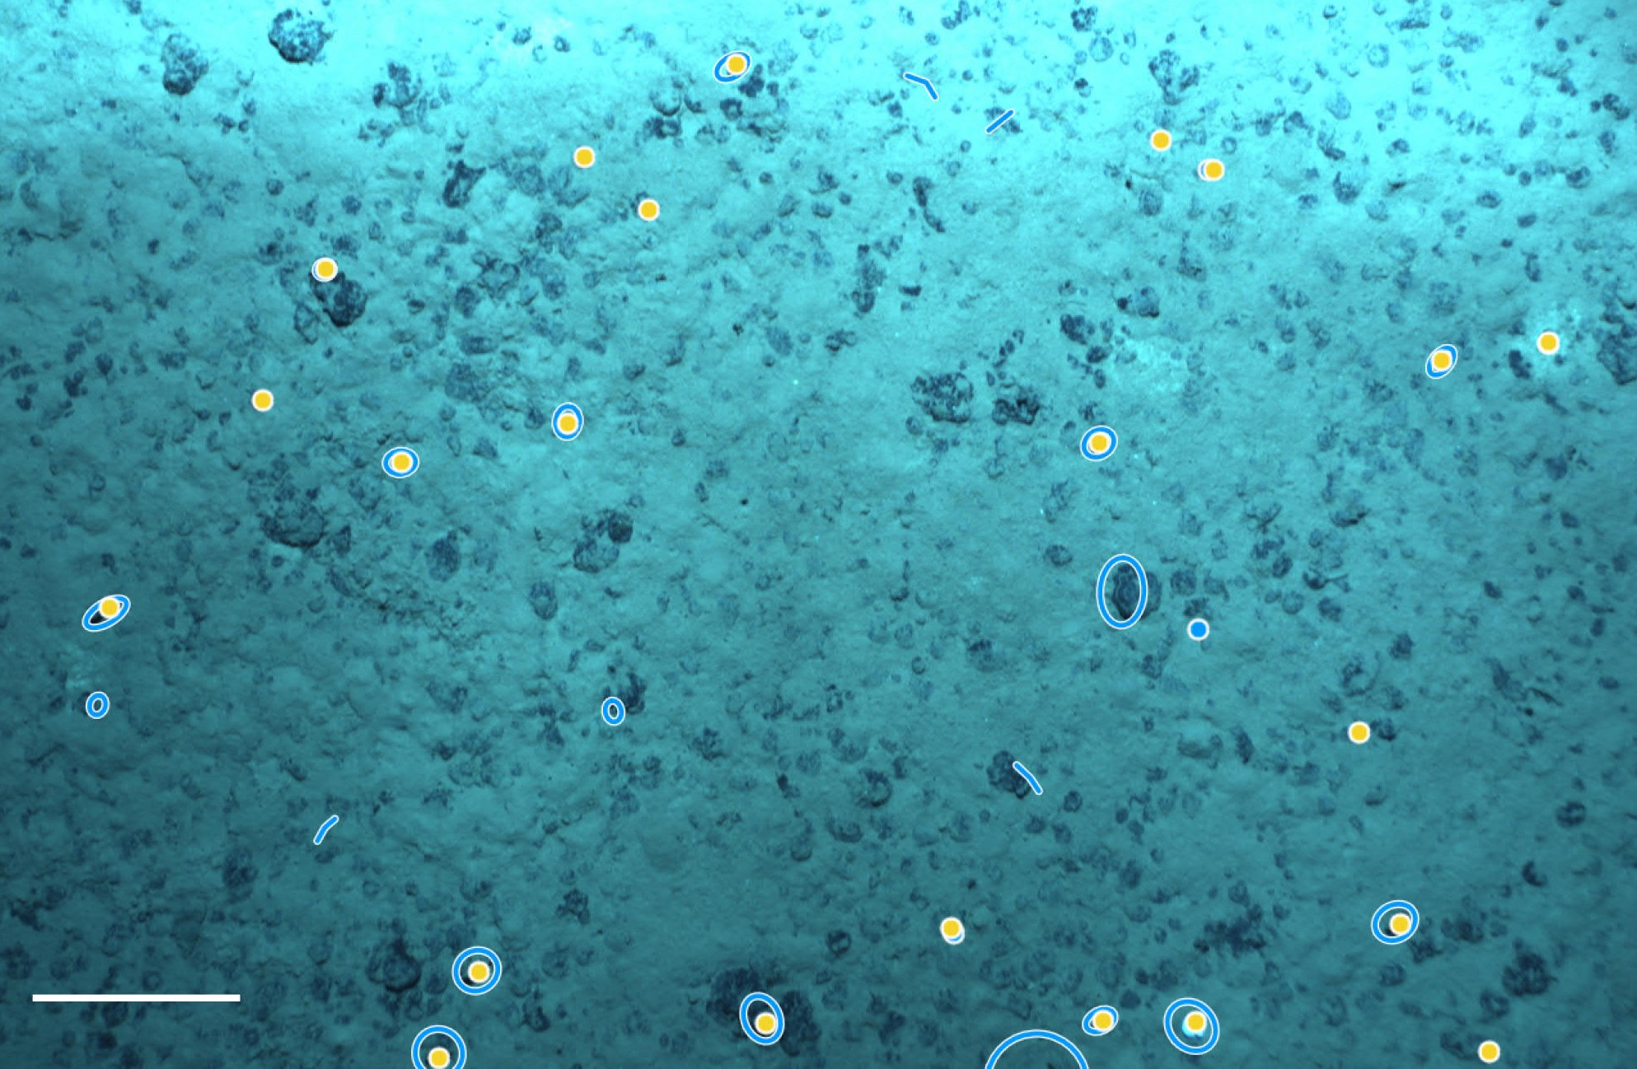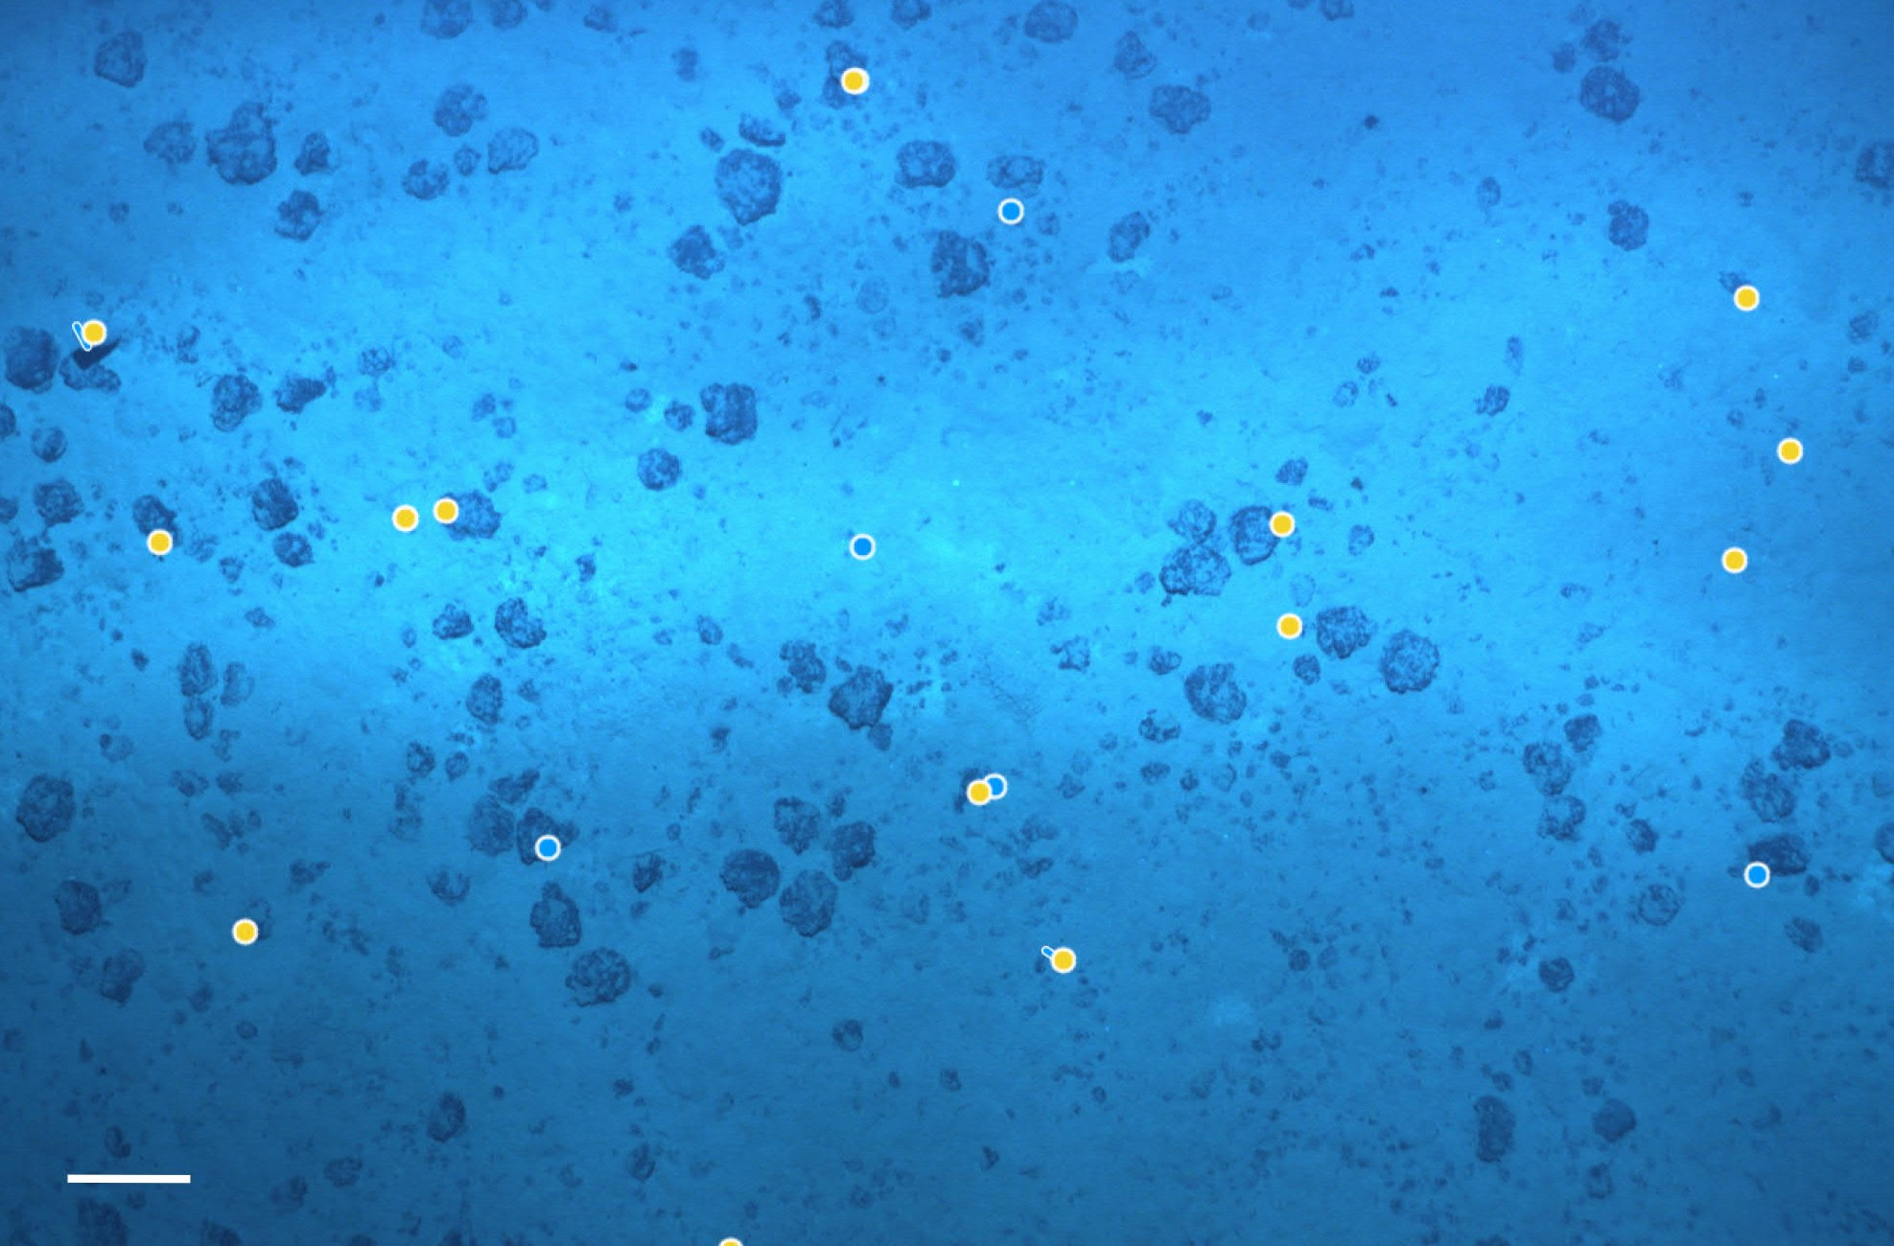
Supplementary material 2. The surface area (in m²) covered by each of the 20 sets of 50 randomly selected images, for the different combinations of site and altitude.
Site | AUV Dive | Altitude | Image set | Total surface area covered (m²)
B6S02 | AUV005 | <8m | 1 | 416.93
B6S02 | AUV005 | <8m | 2 | 408.83
B6S02 | AUV005 | <8m | 3 | 416.58
B6S02 | AUV005 | <8m | 4 | 414.94
B6S02 | AUV005 | <8m | 5 | 419.55
B6S02 | AUV005 | >8m | 1 | 1638.68
B6S02 | AUV005 | >8m | 2 | 1597.65
B6S02 | AUV005 | >8m | 3 | 1619.35
B6S02 | AUV005 | >8m | 4 | 1623.78
B6S02 | AUV005 | >8m | 5 | 1587.83
B4S03 | AUV011_AUV012 | <8m | 1 | 740.83
B4S03 | AUV011_AUV012 | <8m | 2 | 732.78
B4S03 | AUV011_AUV012 | <8m | 3 | 740.45
B4S03 | AUV011_AUV012 | <8m | 4 | 756.45
B4S03 | AUV011_AUV012 | <8m | 5 | 781.77
B4S03 | AUV011_AUV012 | >8m | 1 | 1644.87
B4S03 | AUV011_AUV012 | >8m | 2 | 1604.96
B4S03 | AUV011_AUV012 | >8m | 3 | 1652.50
B4S03 | AUV011_AUV012 | >8m | 4 | 1718.11
B4S03 | AUV011_AUV012 | >8m | 5 | 1688.23

Supplementary material 3. Megafauna taxon density (ind.ha⁻¹) per replicate set of 50 AUV images for the four combinations of sampling site (B6S02 and B4S03) and altitude (below 8m and above 8m) in the GSR contract area within the Clarion-Clipperton Fracture Zone (CCZ). mtp = morphotype.

Megafauna taxon |  | B6S02 |  |  |  |  |  |  |  |  |  |  |  | B4S03
 |  | < 8 m |  |  |  |  |  | > 8 m |  |  |  |  |  | < 8 m |  |  |  |  |  | > 8 m
 |  | Rep1 | Rep2 | Rep3 | Rep4 | Rep5 |  | Rep1 | Rep2 | Rep3 | Rep4 | Rep5 |  | Rep1 | Rep2 | Rep3 | Rep4 | Rep5 |  | Rep1 | Rep2 | Rep3 | Rep4 | Rep5
Actiniaria mtps |  | 336 | 196 | 264 | 193 | 381 |  | 61 | 50 | 49 | 49 | 63 |  | 243 | 232 | 230 | 172 | 179 |  | 85 | 112 | 85 | 134 | 118
Alcyonacea mtps |  | 48 | 24 | 24 | 0 | 0 |  | 0 | 0 | 0 | 0 | 0 |  | 0 | 14 | 0 | 0 | 0 |  | 0 | 0 | 0 | 0 | 0
Antipatharia mtps |  | 24 | 24 | 24 | 48 | 0 |  | 12 | 0 | 0 | 6 | 13 |  | 13 | 27 | 27 | 0 | 13 |  | 0 | 6 | 6 | 0 | 12
Asteroidea |  | 72 | 49 | 72 | 48 | 24 |  | 6 | 19 | 0 | 12 | 6 |  | 0 | 27 | 14 | 0 | 51 |  | 36 | 19 | 42 | 0 | 0
 | Brisingida mtp | 0 | 24 | 24 | 24 | 0 |  | 0 | 19 | 0 | 12 | 0 |  | 0 | 0 | 0 | 0 | 0 |  | 24 | 0 | 18 | 0 | 0
 | Paxillosida mtp | 0 | 0 | 0 | 0 | 0 |  | 0 | 0 | 0 | 0 | 0 |  | 0 | 0 | 0 | 0 | 0 |  | 6 | 0 | 6 | 0 | 0
 | Velatida | 0 | 0 | 0 | 0 | 0 |  | 6 | 0 | 0 | 0 | 0 |  | 0 | 0 | 0 | 0 | 0 |  | 0 | 0 | 6 | 0 | 0
 | Asteroidea mtps | 72 | 24 | 48 | 24 | 24 |  | 0 | 0 | 0 | 0 | 6 |  | 0 | 27 | 14 | 0 | 51 |  | 6 | 19 | 12 | 0 | 0
Ceriantharia mtps |  | 0 | 24 | 0 | 0 | 0 |  | 0 | 0 | 0 | 0 | 0 |  | 0 | 0 | 0 | 0 | 0 |  | 0 | 0 | 6 | 0 | 0
Corallimorpharia mtps |  | 0 | 0 | 0 | 0 | 0 |  | 0 | 0 | 0 | 6 | 6 |  | 0 | 0 | 0 | 0 | 0 |  | 0 | 0 | 0 | 0 | 18
Crinoidea mtps |  | 24 | 24 | 0 | 0 | 0 |  | 0 | 0 | 0 | 0 | 0 |  | 0 | 27 | 27 | 0 | 13 |  | 0 | 0 | 0 | 0 | 6
Ctenophora mtps |  | 0 | 0 | 0 | 0 | 0 |  | 0 | 0 | 0 | 0 | 0 |  | 0 | 0 | 0 | 13 | 0 |  | 0 | 0 | 0 | 0 | 0
Decapoda |  | 72 | 73 | 24 | 48 | 48 |  | 6 | 0 | 12 | 6 | 19 |  | 175 | 41 | 41 | 53 | 13 |  | 6 | 0 | 18 | 0 | 12
 | Aristeidae | 0 | 0 | 0 | 0 | 24 |  | 0 | 0 | 6 | 0 | 6 |  | 121 | 0 | 14 | 13 | 0 |  | 6 | 0 | 6 | 0 | 0
 | Galatheidae mtps | 24 | 24 | 0 | 0 | 0 |  | 6 | 0 | 6 | 6 | 0 |  | 13 | 0 | 14 | 26 | 13 |  | 0 | 0 | 12 | 0 | 0
 | Decapoda mtps | 48 | 49 | 24 | 48 | 24 |  | 0 | 0 | 0 | 0 | 13 |  | 40 | 41 | 14 | 13 | 0 |  | 0 | 0 | 0 | 0 | 12
Echinoidea |  | 240 | 122 | 312 | 193 | 191 |  | 49 | 94 | 56 | 74 | 63 |  | 648 | 505 | 648 | 687 | 652 |  | 419 | 430 | 551 | 431 | 444
 | Aspidodiadematidae mtps | 240 | 122 | 312 | 193 | 191 |  | 49 | 94 | 56 | 74 | 63 |  | 648 | 505 | 648 | 687 | 652 |  | 419 | 430 | 551 | 431 | 444
Holothuroidea |  | 0 | 24 | 0 | 72 | 95 |  | 43 | 38 | 43 | 74 | 44 |  | 40 | 55 | 0 | 66 | 51 |  | 18 | 37 | 91 | 23 | 71
 | Benthodytes | 0 | 0 | 0 | 0 | 0 |  | 0 | 0 | 0 | 0 | 0 |  | 0 | 0 | 0 | 0 | 0 |  | 0 | 0 | 0 | 0 | 6
 | Double velum mtps | 0 | 0 | 0 | 0 | 48 |  | 0 | 6 | 0 | 0 | 0 |  | 0 | 0 | 0 | 0 | 0 |  | 0 | 0 | 0 | 0 | 0
 | Elpidiidae | 0 | 0 | 0 | 0 | 24 |  | 6 | 0 | 12 | 0 | 0 |  | 0 | 0 | 0 | 0 | 0 |  | 0 | 0 | 0 | 0 | 0
 | Holothuroidea mtps | 0 | 24 | 0 | 72 | 24 |  | 31 | 31 | 31 | 68 | 38 |  | 40 | 55 | 0 | 66 | 51 |  | 12 | 37 | 67 | 17 | 59
 | Paelopatides sp | 0 | 0 | 0 | 0 | 0 |  | 0 | 0 | 0 | 0 | 0 |  | 0 | 0 | 0 | 0 | 0 |  | 0 | 0 | 0 | 6 | 0
 | Peniagone leander | 0 | 0 | 0 | 0 | 0 |  | 0 | 0 | 0 | 0 | 0 |  | 0 | 0 | 0 | 0 | 0 |  | 6 | 0 | 24 | 0 | 6
 | Psychropotes cf semperiana | 0 | 0 | 0 | 0 | 0 |  | 6 | 0 | 0 | 6 | 6 |  | 0 | 0 | 0 | 0 | 0 |  | 0 | 0 | 0 | 0 | 0
Hydrozoa mtps |  | 24 | 0 | 0 | 0 | 0 |  | 0 | 0 | 0 | 0 | 0 |  | 0 | 0 | 0 | 0 | 0 |  | 0 | 0 | 0 | 0 | 0
Mollusca |  | 0 | 0 | 0 | 0 | 0 |  | 0 | 0 | 0 | 0 | 0 |  | 0 | 14 | 14 | 13 | 0 |  | 0 | 0 | 0 | 0 | 0
 | Bivalvia | 0 | 0 | 0 | 0 | 0 |  | 0 | 0 | 0 | 0 | 0 |  | 0 | 14 | 14 | 0 | 0 |  | 0 | 0 | 0 | 0 | 0
 | Mollusca mtps | 0 | 0 | 0 | 0 | 0 |  | 0 | 0 | 0 | 0 | 0 |  | 0 | 0 | 0 | 13 | 0 |  | 0 | 0 | 0 | 0 | 0
Ophiuroidea mtps |  | 648 | 611 | 600 | 627 | 667 |  | 360 | 451 | 401 | 425 | 498 |  | 499 | 450 | 392 | 608 | 230 |  | 304 | 305 | 375 | 215 | 213
Osteichthyes |  | 24 | 24 | 48 | 0 | 0 |  | 6 | 0 | 31 | 0 | 13 |  | 13 | 41 | 27 | 26 | 90 |  | 12 | 6 | 6 | 17 | 12
 | Bathysaurus mollis | 0 | 0 | 0 | 0 | 0 |  | 0 | 0 | 0 | 0 | 0 |  | 0 | 0 | 0 | 0 | 0 |  | 0 | 0 | 0 | 6 | 0
 | Coryphaenoides | 0 | 24 | 0 | 0 | 0 |  | 0 | 0 | 12 | 0 | 6 |  | 0 | 0 | 0 | 0 | 26 |  | 6 | 6 | 6 | 12 | 0
 | Ipnops mtp | 24 | 0 | 24 | 0 | 0 |  | 6 | 0 | 6 | 0 | 6 |  | 13 | 41 | 27 | 26 | 38 |  | 0 | 0 | 0 | 0 | 0
 | Ophidiidae | 0 | 0 | 0 | 0 | 0 |  | 0 | 0 | 0 | 0 | 0 |  | 0 | 0 | 0 | 0 | 0 |  | 6 | 0 | 0 | 0 | 0
 | Osteichthyes mtps | 0 | 0 | 24 | 0 | 0 |  | 0 | 0 | 12 | 0 | 0 |  | 0 | 0 | 0 | 0 | 26 |  | 0 | 0 | 0 | 0 | 12
Other_Anthozoa |  | 24 | 24 | 0 | 24 | 0 |  | 0 | 0 | 0 | 0 | 0 |  | 13 | 14 | 0 | 0 | 0 |  | 0 | 0 | 0 | 0 | 0
Other_Cnidaria |  | 0 | 0 | 0 | 0 | 0 |  | 0 | 0 | 0 | 0 | 0 |  | 0 | 0 | 0 | 13 | 0 |  | 0 | 0 | 0 | 0 | 0
Pennatulacea mtps |  | 0 | 0 | 0 | 0 | 0 |  | 0 | 0 | 0 | 0 | 0 |  | 0 | 0 | 0 | 0 | 0 |  | 0 | 0 | 6 | 0 | 0
Scyphozoa |  | 0 | 0 | 0 | 0 | 0 |  | 0 | 0 | 0 | 0 | 0 |  | 0 | 0 | 0 | 0 | 0 |  | 0 | 0 | 6 | 0 | 0
 | Periphylla periphylla | 0 | 0 | 0 | 0 | 0 |  | 0 | 0 | 0 | 0 | 0 |  | 0 | 0 | 0 | 0 | 0 |  | 0 | 0 | 6 | 0 | 0
Polychaeta mtps |  | 360 | 147 | 144 | 120 | 167 |  | 0 | 0 | 0 | 0 | 6 |  | 121 | 41 | 365 | 132 | 102 |  | 49 | 93 | 85 | 76 | 47
Porifera |  | 168 | 73 | 120 | 0 | 48 |  | 67 | 31 | 49 | 37 | 113 |  | 54 | 136 | 81 | 53 | 90 |  | 55 | 50 | 61 | 17 | 65
 | Chonelasma | 24 | 0 | 0 | 0 | 0 |  | 0 | 0 | 0 | 0 | 0 |  | 0 | 0 | 0 | 13 | 0 |  | 0 | 0 | 0 | 0 | 0
 | Docosaccus | 0 | 73 | 48 | 0 | 0 |  | 6 | 6 | 19 | 12 | 31 |  | 40 | 14 | 14 | 0 | 13 |  | 18 | 6 | 24 | 0 | 36
 | Euplectella | 24 | 0 | 0 | 0 | 0 |  | 6 | 0 | 0 | 0 | 25 |  | 0 | 14 | 41 | 0 | 51 |  | 6 | 0 | 0 | 6 | 6
 | Porifera mtps | 120 | 0 | 72 | 0 | 48 |  | 55 | 25 | 31 | 25 | 57 |  | 13 | 109 | 27 | 40 | 26 |  | 30 | 44 | 36 | 12 | 18
 | Staurocalyptus mtp | 0 | 0 | 0 | 0 | 0 |  | 0 | 0 | 0 | 0 | 0 |  | 0 | 0 | 0 | 0 | 0 |  | 0 | 0 | 0 | 0 | 6
Unknown |  | 4413 | 4598 | 4129 | 2771 | 3337 |  | 1544 | 2303 | 2242 | 2402 | 1449 |  | 3334 | 3016 | 3957 | 4587 | 6345 |  | 1848 | 2262 | 2644 | 1676 | 1943
Xenophyophora |  | 17989 | 23261 | 19444 | 14629 | 19712 |  | 464 | 839 | 1000 | 1028 | 907 |  | 2767 | 3193 | 3120 | 4944 | 3223 |  | 590 | 536 | 629 | 396 | 486
 | Plate-like mtps | 7627 | 11031 | 9338 | 6507 | 8199 |  | 439 | 820 | 994 | 998 | 875 |  | 2430 | 2893 | 2850 | 4058 | 2993 |  | 584 | 536 | 575 | 373 | 438
 | Reticulate mtps | 10361 | 12230 | 10106 | 8122 | 11512 |  | 24 | 19 | 6 | 31 | 31 |  | 337 | 300 | 270 | 886 | 230 |  | 6 | 0 | 54 | 23 | 47

Supplementary material 4. Significant differences (2-factor PERMANOVA, pseudo-F_{1,16} = 6.6807, pPERM = 0.0005) in the megafauna community observed from different altitudes (<8m and >8m) and between the sites B4S03 and B6S02 (MDS analysis based on a Bray-Curtis resemblance matrix of untransformed density data (lowest available taxon level), excluding unknown annotations and Xenophyophora).

