Processes and patterns of glacier-influenced sedimentation and recent tidewater glacier dynamics in Darbel Bay, western Antarctic Peninsula

Batchelor, C.L.¹, Dowdeswell, J.A.¹, Hogan, K.A.², Larter, R.D.², Parsons, E.³, West, O.³

¹ Scott Polar Research Institute, University of Cambridge, Cambridge CB2 1ER, UK;
² British Antarctic Survey, Natural Environment Research Council, High Cross, Madingley Road, Cambridge CB3 0ET, UK;
³British Royal Navy

Abstract
Bathymetric data of unprecedented resolution are used to provide insights into former ice dynamics and glacial processes in a western Antarctic Peninsula embayment. An assemblage of submarine glacial landforms, which includes subglacially produced streamlined features and ice-marginal ridges, reveals the former pattern of ice flow and retreat. A group of more than 250 small (<1 to 3 m high, 10 to 20 m wide) and relatively evenly spaced recessional moraines was identified beyond the margin of Philippa Glacier. The small recessional moraines are interpreted to have been produced during short-lived, possibly annual, re-advances of a grounded ice margin during overall retreat. This is the first time that these features have been shown to be part of the assemblage of landforms produced by tidewater glaciers on the Antarctic Peninsula. Glacier-terminus changes during the last four decades, mapped from LANDSAT satellite images, were analysed to determine if the moraines were produced during recent still-stands or re-advances of Philippa Glacier, and to further investigate the short-term (annual to decadal) variability in ice-marginal position in tidewater glacier systems. The asynchronous response of individual tidewater glaciers in Darbel Bay is interpreted to be controlled mainly by local topography rather than by glacier catchment-area size.

Keywords: bathymetry; submarine glacial landforms; moraines

1. Introduction
Tidewater glaciers on the western Antarctic Peninsula have undergone substantial termini retreat and flow acceleration in response to increased air and ocean temperatures over the last half-century or so (Vaughan et al., 2003; Cook et al., 2005, 2016). In addition, the retreat and loss of floating ice shelves on the western Antarctic Peninsula, including the Wordie, Müller and Wilkins ice shelves, has been attributed to the southerly migration of the -9°C isotherm in response to regional warming (Morris and Vaughan, 2003).
Studies of the former configuration and dynamics of glaciers and ice sheets are motivated by the need to constrain numerical models and provide a context for satellite-era observations of outlet-glacier retreat. Whereas aerial and satellite imagery reveal the changing extent of glaciers over the past few decades (e.g. Cook et al., 2016), bathymetric data of the formerly glacierised seafloor can provide information about glacier behaviour prior to the widespread application of remote-sensing techniques (e.g. Anderson, 1999; Shipp et al., 2002; Dowdeswell et al., 2016). An important application of bathymetric data is that the identification and interpretation of submarine glacial landforms can reveal the style and relative rate of past ice retreat (Dowdeswell et al., 2008), which is important for predicting the likely future ice-sheet response to climatic change.
In contrast to Arctic and sub-Arctic fjords, where numerous geomorphic and stratigraphic investigations have revealed the complexity of glacimarine systems and enabled the development of detailed landsystem models (e.g. Ottesen and Dowdeswell, 2006; Hjelstuen et al., 2013), high-resolution studies of the seafloor beyond tidewater glaciers on the Antarctic Peninsula are relatively sparse (Anderson, 1999; García et al., 2016; Munoz and Wellner, 2018). The lack of high-resolution bathymetry from Antarctic Peninsula fjords and embayments hinders our understanding of glacimarine processes and past ice dynamics in these locations. The observed retreat of glacier termini on the western Antarctic Peninsula has been interpreted to be caused, at least in part, by the increasing incursion of warm subsurface Circum-polar Deep Water (CDW) across the continental shelf to the ice margin (Holland et al., 2010; Cook et al., 2016; Gunn et al., 2018). Access of warm subsurface waters to tidewater-glacier margins is controlled strongly by the water depth of the fjord or bay in which the glacier terminates (Walker et al., 2007; Jacobs et al., 2012); this provides further motivation to map the depth of the seafloor beyond tidewater glaciers on the Antarctic Peninsula.
In this paper, we present very high resolution bathymetric data from close to the margin of a tidewater glacier in Darbel Bay, western Antarctic Peninsula (Fig. 1), in order to map and interpret the glacial landforms that are preserved on the seafloor. This area typically experiences significant sea-ice cover through the Antarctic summer, which has historically prevented the collection of bathymetric data. These data are discussed in relation to the pattern of past ice flow in Darbel Bay and processes of glacier-influenced sedimentation on the Antarctic Peninsula more generally. Furthermore, we use satellite imagery to investigate the age of the seafloor glacial landforms, document the recent termini retreat of the tidewater glaciers that drain into Darbel Bay and examine the controls on their short-term (annual to decadal) variable behaviour.

2. Geological and glaciological framework
Darbel Bay is a wide (up to 50 km) embayment on the western side of the northern Antarctic Peninsula (Fig. 1). Ten tidewater glaciers, with termini widths of between 1 and 9 km, drain into Darbel Bay from the Antarctic Peninsula Ice Sheet (APIS) in Graham Land. During the Last Glacial Maximum (LGM) about 25,000 years ago, the APIS expanded through Darbel Bay and across the c. 200 km-wide continental shelf (Fig.1a) (Pudsey et al., 1994; Larter and Vanneste, 1995; Anderson et al., 2002; Ó Cofaigh et al., 2014; Lavoie et al., 2015). A well-preserved assemblage of glacial landforms, including mega-scale glacial lineations (MSGLs) and drumlins that are produced subglacially, provides evidence that a fast-flowing ice stream extended through Biscoe Trough to the shelf break during the LGM (Lavoie et al., 2015).
The APIS retreated from the shelf break beyond Biscoe Trough between around 17.5 ka and 14 ka (Heroy and Anderson, 2007; Ó Cofaigh et al., 2014). Although the deglacial and Holocene histories of the glaciers that drain into Darbel Bay are uncertain, the neighbouring Lallemand Fjord (Fig. 1a) is known to have deglaciated by 8 ka and experienced open-marine conditions between around 8 ka and 2.7 ka (Domack et al., 1995; Shevenell et al., 1996). An advance of the Müller Ice Shelf in Lallemand Fjord occurred around 400 years ago, which broadly corresponds with the timing of Little Ice Age cooling in the Northern Hemisphere (Domack et al., 1995).
At present, warm (c. 3°C above the seawater freezing temperature) and saline CDW is prevalent across the Bellingshausen Sea continental shelf below a water depth of around 200 m to 250 m, and is overlain by colder and fresher Winter Water and a Surface Mixed Layer (Holland et al., 2010; Cook et al., 2016; Gunn et al., 2018). There are concerns that the thickness of the CDW layer is increasing in response to increased ocean heat content in the Bellingshausen Sea (Martinson et al., 2008; Schmidtko et al., 2014).

3. Methods
The bathymetric data used in this study were collected by the British Royal Navy ice patrol vessel HMS Protector in January 2018. A small survey motor boat (SMB), the James Caird IV, was used to acquire data covering an area of around 1.5 km² from close to the terminus of Philippa Glacier (Fig. 2). The SMB James Caird IV is fitted with a hull-mounted, Kongsberg EM2040 multibeam echo-sounding system (MBES) that operates with frequencies in the 200-400 kHz range. Vertical and horizontal resolution are around 1 m and 0.5 m, respectively. The MBES performed well in water depths shallower than around 290 m. Data processing to remove erroneous soundings and production of maps were performed with Caris and Fledermaus software.
Glacier-terminus change information and glacier-catchment areas were mapped from LANDSAT satellite images for the period 1974-2016 (Fig. 1b). The satellite images were acquired during the Antarctic summer, between January and March, and were downloaded from Earth Explorer (https://earthexplorer.usgs.gov/).

4. Results

4.1 Bathymetry
Our bathymetric data show that the seafloor 0.5 to 1 km beyond the terminus of Philippa Glacier is between 140 and 170 m deep (Fig. 2a and b). The seafloor shallows rapidly, to around 30 m, at the eastern lateral margin of the glacier, where data were collected to within 100 m of a prominent headland (Fig. 2a). The seafloor depth increases seaward of this bathymetric high, reaching around 290 m at the northern limit of the dataset. Some areas of the seafloor have a rough and irregular character, which is interpreted as exposed or shallowly buried bedrock (Fig. 2d).
Two types of landforms are present on the seafloor beyond Philippa Glacier: elongate ridges; and small transverse ridges.
Sets of parallel to sub-parallel elongate ridges made up of exposed or near-surface bedrock features are common in the study area (Fig. 2d and e). The seafloor immediately beyond Philippa Glacier has a southwest-northeast structural component, whereas linear seafloor elements to the north appear to be arranged in a southeast-northwest direction (Fig. 2d). The elongate bedrock ridges are a few metres high and can be traced for up to 200 m.
More than 250 small subparallel ridges are identified in water depths of between 70 and 200 m (Fig. 2). The ridges are <1 to 3 m tall, 10 to 20 m wide and spaced between 5 and 30 m apart (Fig. 3a and b). They have linear to arcuate geometries in plan-form and occur as discontinuous segments that are less than 50 m in length. The transverse ridges are identified overprinting regions of the seafloor that are interpreted as exposed or near-surface bedrock (Fig. 2d). They have a generally southeast-northwest orientation, which is perpendicular to the ice-flow direction of Philippa Glacier (Fig. 2d).
The seafloor immediately beyond the terminus of Philippa Glacier is interpreted to have been affected by glacial erosion during periods in which the glacier was more extensive than at present. Long profiles of the seafloor away from the ice front (Fig. 2b and c) suggest that a sill, or possibly even a large moraine, may be present around 2 km seaward of the present-day terminus, beyond our data coverage (Fig. 2d).
The elongate bedrock ridges (Fig. 2d and e) are interpreted as ice-sculpted bedrock that indicates the direction of past ice-flow. Bedrock is moulded and shaped as it is overridden by glacial ice producing sculpted or streamlined bedrock forms, and is a common feature of rocky areas of glaciated fjords and inner-shelf environments (Larter et al., 2009; Graham et al., 2009; Dowdeswell et al., 2016; Munoz and Wellner, 2018).
The small subparallel ridges on the seafloor beyond Philippa Glacier (Figs. 2d, e, 3a, b) are interpreted as recessional moraines (sometimes referred to as De Geer moraines (Lindén
and Möller 2005)), and are orientated transverse to the past ice-flow direction inferred from ice-sculpted bedrock. These landforms are formed by the delivery and ice pushing of sediment during still-stands or re-advances of a grounded ice margin during overall retreat (Boulton, 1986). Groups of similar-sized and evenly spaced moraines are commonly found beyond the termini of tidewater glaciers in Arctic fjords and marine embayments (e.g. Fig. 3c and d) (Ottesen and Dowdeswell, 2006; Burton et al., 2016). The large number (more than 250) and small size (<1 to 3 m high) of the recessional moraines beyond Philippa Glacier indicate a relatively slow style of grounded ice retreat, in which multiple, short-lived re-advances of the ice margin were superimposed upon a general trend of retreat (Dowdeswell et al., 2008).

4.2 Satellite imagery
Satellite images provide evidence on the response of ten neighbouring tidewater glaciers to contemporary climatic changes along a c.100 km-long section of coastline in Darbel Bay (Fig.1). Since 1974, all of the glaciers in the study area have either maintained a stable terminus position or have undergone overall retreat (Figs. 1 and 4). Three different styles of outlet-glacier behaviour are recognised for the last c. 40 years: a) near-stationary terminus position; b) relatively small-scale fluctuations in terminus position with gradual overall retreat; c) significant (> 1 km), stepped terminus retreat.
Three of the tidewater glaciers in Darbel Bay (Peter, Philippa and Cardell glaciers) have experienced very little variation in their termini positions over the past four decades (Figs. 1 and 4).
Four of the glaciers (McCance, Drummond, Lampe and Erskine glaciers) have undergone an overall retreat of 0.5 to 2.4 km that includes relatively small-scale changes in termini positions (Figs. 1 and 4). Small-scale changes in the plan-form shape of the ice margin are probably the result of iceberg calving and may be related to water-depth variations at the grounding line. Erskine Glacier experienced the greatest variation in plan-form terminus shape, with the disappearance, re-growth and subsequent breakup of a 2 km-long ice promontory occurring between 1986 and 2011 (Fig. 1b), which probably regrows to a shallower submarine pinning point.
Three of the tidewater glaciers in Darbel Bay (Widdowson, Hopkins and Keith glaciers) have undergone significant, stepped retreat since 1974 (Figs. 1 and 4). The greatest retreat was experienced by Widdowson Glacier, which retreated around 4.4 km between 1991 and 1999 (average retreat rate of 550 m/year), leading to the formation of Widdowson Cove (Fig. 1b). Hopkins Glacier has retreated around 3.1 km since 1974, including significant terminus retreat, of around 1 km, between 1991 and 1999 (average retreat rate of around 120 m/year). After remaining relatively stable since 1974, the terminus position of Keith Glacier retreated around 1 km between 1999 and 2001 (average retreat rate of 500 m/year).

5. Discussion

5.1 The former pattern of ice flow beyond Philippa Glacier
Historical satellite images show that the assemblage of submarine glacial landforms beyond Philippa Glacier (Fig. 2d) was produced or last modified prior to 1974, when such imagery first became available. The distribution and orientation of ice-sculpted bedrock records the former pattern of ice-flow when Philippa Glacier was more extensive than at present. Relatively fast-moving ice is interpreted to have extended in a northeasterly direction beyond Philippa Glacier and to have become confluent with northwesterly-flowing ice in the deeper, central axis of Darbel Bay, which was fed by the other glaciers in the bay (Fig. 2d). The broad-scale bathymetry of the western Antarctic Peninsula suggests that ice in Darbel Bay may have nourished one or more of the ice streams that extended to the shelf break through Biscoe and Adelaide troughs during the LGM (Fig. 1a) (Ó Cofaigh et al., 2014).
The small recessional moraines beyond Philippa Glacier (Figs. 2, 3a and b) indicate the slow retreat of a grounded ice margin (Dowdeswell et al., 2008). The recessional moraines were probably produced during either regional deglaciation following the LGM or subsequent to a Holocene advance of the glacier terminus. Although it is uncertain if the outlet glaciers of the APIS underwent a regional response to Little Ice Age cooling between around 1300 and 1850, evidence for ice-sheet advance during this time has been recorded from Lallemand Fjord and Bourgeois Fjord, which are around 60 km and 100 km south of Darbel Bay, respectively (Fig. 1a) (Domack et al., 1995; Shevenell et al., 1996; García et al., 2016). On the Danco Coast to the north, moraines up to 30 m high and between 1 and 4 km beyond the present-day ice margin are interpreted to have been formed during the Little Ice Age (Munoz and Wellner, 2018). The tentative interpretation of a sill or large moraine around 2 km beyond the present-day ice margin (Fig. 2c and d) suggests that it is possible that Philippa Glacier also experienced a re-advance during this time.

5.2 Processes and patterns of glacier-influenced sedimentation in Darbel Bay
Although similar glacial landforms have been reported previously from the continental shelf of Antarctica (e.g. Shipp et al., 2002; Klages et al., 2016), the moraines identified beyond Philippa Glacier are the first suite of relatively evenly spaced small recessional moraines reported from an Antarctic Peninsula fjord or embayment. This is probably a consequence of the generally coarse data resolution and incomplete data coverage from ice-marginal settings on the Antarctic Peninsula, rather than atypical behaviour of Philippa Glacier. The identification of subdued transverse features, including recessional moraines, on bathymetric images is important for understanding the rate and style of former ice retreat (Dowdeswell et al., 2008). The assumed absence of small transverse features from the seafloor, for example due to coarse data resolution, could be misinterpreted as a signal of rapid grounding-line retreat.
The small size of the recessional moraines beyond Philippa Glacier, which have heights of <1 to 3 m and widths of 10 to 20 m, show that tidewater glaciers on the Antarctic Peninsula can undergo short-lived adjustments in their grounding-line positions. It is possible that the moraines were formed annually, with minor ice-margin re-advances taking place, for example, in response to the suppression of iceberg calving by sea-ice buttressing during winter months (Boulton, 1986; Dowdeswell et al., 2008).
The small recessional moraines beyond Philippa Glacier have comparable dimensions and geometry to transverse-to-flow moraines that have been identified beyond the margins of several tidewater glaciers in Svalbard (Fig. 3) (e.g. Ottesen and Dowdeswell, 2006; Burton et al., 2016). The environmental setting of a glaciated region provides a first-order control on the patterns and processes of sedimentation that occur at the ice margin (Dowdeswell et al., 1998, 2016). The similar size of the recessional moraines on the Antarctic Peninsula and Svalbard is therefore probably a consequence of the broadly similar climatic and oceanographic regimes of these regions, in which mass can be lost through surface-meltwater production, especially in summer months, as well as through iceberg calving and the melting of frontal ice cliffs. In contrast, glaciers in West and East Antarctica are restricted to minimal surface-meltwater production, whilst glaciers that terminate in the mild fjords of Chile and southeast Alaska lose the majority of their mass through surface-meltwater production and runoff (Dowdeswell et al., 2016).
An interesting contrast between the recessional moraines in Darbel Bay and in the fjords of Svalbard is that the former occur as a series of discontinuous segments, whereas the latter tend to be continuous across the width of the fjord (Fig. 3). The discontinuous nature of the recessional moraines in Darbel Bay may be a consequence of limited and/or irregular sediment cover over bedrock beyond Philippa Glacier. In contrast, the moraines in the fjords of Svalbard appear to overlie a sedimentary substrate, which may have provided a more laterally extensive and/or thicker source of sediment for the formation of moraine ridges through ice-pushing of sediment during short-lived re-advances of the grounding line.
The preservation of subdued glacial landforms on the seafloor beyond Philippa Glacier shows that this area experiences relatively low rates of glacier-derived sedimentation. In agreement with other studies (e.g. García et al., 2016; Munoz and Wellner, 2018), iceberg ploughmarks appear to be absent from the seafloor beyond Philippa Glacier, despite the proximity of the multibeam data to the ice margin (Fig. 2). The icebergs that are calved today from Philippa Glacier probably have insufficient keel depths to ground on the seafloor given that, in contrast to floating ice shelves, grounded tidewater glaciers tend to produce relatively small icebergs of irregular shape (e.g. Dowdeswell and Bamber, 2007). The absence of iceberg ploughmarks could also be explained by the prevalence of exposed or near-surface bedrock, which is more difficult than a sedimentary substrate for iceberg keels to incise, or the limited aerial extent of our dataset.

5.3 Controls on tidewater glacier retreat on the western Antarctic Peninsula
The tidewater glaciers that drain into Darbel Bay have undergone an overall trend of retreat since the first satellite observations in 1974 (Figs. 1b and 4). The behaviour of these glaciers is in agreement with the general pattern of terminus retreat that has been observed for glaciers on the western Antarctic Peninsula since the 1960s (Cook et al., 2005, 2016). These changes have been interpreted as a response to an increase in mid-ocean water column (100 to 300 m water depth) temperature (Cook et al., 2016), as well as atmospheric warming and increased summer melt (Morris and Vaughan, 2003).
The most significant termini retreat of the tidewater glaciers in Darbel Bay on a decadal scale took place between 1991 and 2001, with an average rate of terminus retreat of > 80 m/year (Figs. 1b and 4a). This pattern is in agreement with the work of Cook et al. (2014, 2016), who identified widespread acceleration of glacier retreat on the western Antarctic Peninsula between 64°S and 70°S during this time. The acceleration of glacier retreat is interpreted to be a consequence of regional warming and the increased temperature and upwelling onto the shelf of CDW since the 1990s (Cook et al., 2016).
Whereas the general trend of glacier-termini retreat in Darbel Bay is interpreted to be a response to regional atmospheric and oceanographic forcing, the asynchronous response of individual glaciers (Figs. 1b and 4) is probably a consequence of local glaciological and/or topographic factors. It has been suggested previously that recent ice retreat has affected most markedly the extent of smaller ice bodies on the Antarctic Peninsula (Fox and Cooper, 1998; García et al., 2016). In contrast, we find a weak positive correlation between both drainage basin area and terminus width and the range of terminus variation since 1974 (R = 0.23 and R = 0.24, respectively) (Fig. 4b and c). The three glaciers that have experienced very little variation in their termini positions over the past four decades (Peter Glacier, Philippa Glacier and Cardell Glacier) have some of the smallest drainage basin areas in Darbel Bay (Fig. 4b and c). Larger glaciers may experience greater variation in terminus position as a result of their higher ice flux; for example, Erskine Glacier has the largest drainage area in Darbel Bay and has undergone periods of both significant advance and retreat during the past few decades (Fig. 1b).
It is likely that local topographic factors also play a significant role in controlling the rate and style of tidewater glacier retreat in Darbel Bay. Land promontories or islands can act as lateral pinning points for ice stabilisation during retreat by increasing the lateral drag that is exerted on the glacier (Echelmeyer et al., 1991). For example, Widdowson Glacier remained relatively stable at a narrow lateral pinning point between 1974 and 1991, before it retreated rapidly through the wider Widdowson Cove (Fig. 1b).
Stability of an ice terminus can also be encouraged by shallow vertical pinning points in the underlying bathymetry. At around 140 to 170 m, our bathymetric data show that the seafloor beyond Philippa Glacier (Fig. 2a) is relatively shallow compared with other over-deepened regions of the seafloor beyond the termini of tidewater glaciers on the Antarctic Peninsula, which commonly reach depths of more than 500 m (Domack et al., 1995; García et al., 2016). In addition to encouraging ice-margin stabilisation through reducing the mass flow across the grounding line and slowing the rate of iceberg calving (Echelmeyer et al., 1991; Schoof, 2007), the relatively shallow seafloor beyond Philippa Glacier (Fig. 2a) may prevent the incursion of warm subsurface CDW, which is present below around 200 to 250 m on the western Antarctic Peninsula shelf (Cook et al., 2016), from reaching the ice front. Although the water depth beyond the other glaciers in Darbel Bay is unknown, it is possible that the relatively shallow seafloor beyond Philippa Glacier has led to reduced melting of the glacier terminus compared with glaciers that terminate in deeper areas of the embayment. Philippa Glacier may also have been less sensitive than neighbouring tidewater glaciers to the climatic and oceanographic changes that occurred prior to the availability of satellite imagery. The relatively slow style of ice-margin retreat that is interpreted to have occurred prior to 1974, as suggested by the small recessional moraines, may also be a consequence of the relatively shallow seafloor beyond this glacier.

6. Conclusions
- We present the first bathymetric data from Darbel Bay on the western Antarctic Peninsula. An assemblage of glacial landforms, which includes streamlined bedrock and small recessional moraines, is mapped on the seafloor beyond Philippa Glacier (Fig. 2c). Elongate landforms show the direction of former ice flow through Darbel Bay during the LGM and/or deglaciation, whilst small recessional moraines indicate the slow retreat of a grounded ice mass.
- Our very high resolution bathymetric data show, for the first time, that small (<1 to 3 m high) recessional moraines are a part of the landform assemblage produced by tidewater glaciers on the western Antarctic Peninsula despite the fact that these features have not been identified in marine embayments or fjords before. We suggest that small recessional moraines may be present in other Antarctic Peninsula fjords and embayments, yet have not hitherto been readily identified because of either coarse bathymetric data resolution and/or limited data coverage.
- The small recessional moraines in Darbel Bay, which were produced sometime prior to 1974, support inferences from the satellite record that tidewater glaciers on the Antarctic Peninsula can undergo short-lived re-advances in their grounding-line position. The moraines have similar dimensions to recessional moraines that have been identified beyond the margins of tidewater glaciers in Svalbard that may record annual responses to seasonal climatic variations.
- Satellite images show that, since 1974, the tidewater glaciers in Darbel Bay have retreated in line with the general trend of termini retreat that has been observed for glaciers on the Antarctic Peninsula and has been linked to the increased temperature and thickness of CDW. The greatest average rate of termini retreat in Darbel Bay occurred during the 1990s (Fig. 4a).
- However, the ten tidewater glaciers that drain into Darbel Bay have experienced contrasting styles of terminus retreat (Fig. 1b, 4b and c). Accepting that the glaciers are likely to have experienced almost identical regional oceanic warming forcing, we attribute the contrasting glacier behaviour to depend mainly on the physiography of the local area, including seafloor depth and fjord width, rather than on the glacier catchment-area size. The importance of local topographic factors on tidewater-glacier dynamics provides strong motivation to collect further bathymetric data using high-resolution multibeam systems from close to the margins of marine-terminating glaciers.

Acknowledgements
We thank Captain Matthew Syrett, the officers and the crew of the British Royal Navy patrol ship HMS Protector for their help with data acquisition. C.L. Batchelor was in receipt of a Junior Research Fellowship from Newnham College, Cambridge during this work. K.A Hogan and R.D Larter are supported by the Polar Science for Planet Earth programme funded by the Natural Environment Research Council, U.K. We thank two anonymous reviewers for their helpful reviews of this manuscript.

Author contribution statement
JAD, KAH and RDL devised the project. CLB, EP and OW collected and processed the data. CLB produced the figures and wrote the manuscript, with input from JAD, KAH and RDL.

Details of data deposit
The data will be located in the University of Cambridge’s open-access repository.

References
ANDERSON, J.B., SHIPP, S.S., LOWE, A.L., WELLNER, J.S. & MOSOLA, A.B. 2002. The Antarctic ice sheet during the last glacial maximum and its subsequent retreat history: a review. Quaternary Science Reviews, 21, 49-70.
ANDERSON, J.B. 1999. Antarctic Marine Geology. Cambridge University Press, Cambridge.
ARNDT, J.E., et al. 2013. The International Bathymetric Chart of the Southern Ocean (IBCSO) version 1.0—A new bathymetric compilation covering circum‐Antarctic waters, Geophysical Research Letters, 40, 3111–3117.
BOULTON, G.S. 1986. Push-moraines and glacier-contact fans in marine and terrestrial environments. Sedimentology, 33, 677–698.
BURTON, D.J., DOWDESWELL, J.A., HOGAN, K.A. & NOORMETS, R. 2016. Little Ice Age terminal and retreat moraines in Kollerfjorden, NW Spitsbergen. In: DOWDESWELL, J.A., CANALS, M., JAKOBSSON, M., TODD, B.J., DOWDESWELL, E.K. & HOGAN, K.A. (eds.) Atlas of Submarine Glacial Landforms: Modern, Quaternary and Ancient. Geological Society, London, Memoirs, 46, 71-72.
COOK, A.J., FOX, A.J., VAUGHAN, D.G. & FERRINGO, J.G. 2005. Retreating glacier fronts on the Antarctic Peninsula over the past half-century. Science, 308, 541-544.
COOK, A.J., VAUGHAN, D.G., LUCKMAN, A.J. & MURRAY, T. 2014. A new Antarctic Peninsula glacier basin inventory and observed area changes since the 1940s. Antarctic Science, 26, 614-624.
COOK, A.J., HOLLAND, P.R., MEREDITH, M.P., MURRAY, T., LUCKMAN, A. & VAUGHAN, D.G. 2016. Ocean forcing of glacier retreat in the western Antarctic Peninsula. Science, 15, 283-286.
DOMACK, E.W., ISHMAN, S.C., STEIN, A.B., MCCLENNEN, C.E. & JULL, A.J.T. 1995. Late Holocene advance of the muller ice shelf, Antarctic Peninsula: sedimentological, geochemical and palaeontological evidence. Antarctic Science, 7, 159-170.
DOWDESWELL, J.A. & BAMBER, J.L. 2007. Keel depths of modern Antarctic icebergs and implications for sea-floor scouring in the geological record. Marine Geology, 243, 120-131.
DOWDESWELL, J.A., ELVERHØI, A. & SPIELHAGEN, R. 1998. Glacimarine sedimentary processes and facies on the Polar North Atlantic margins. Quaternary Science Reviews, 17, 243–272.
DOWDESWELL, J.A., OTTESEN, D., EVANS, J., Ó COFAIGH, C. & ANDERSON, J.B., 2008. Submarine glacial landforms and rates of ice-stream collapse. Geology, 36, 819–822.
DOWDESWELL, J.A., CANALS, M., JAKOBSSON, M., TODD, B.J., DOWDESWELL, E.K. & HOGAN, K.A. 2016. The variety and distribution of submarine glacial landforms and implications for ice-sheet reconstruction. In: DOWDESWELL, J.A., CANALS, M., JAKOBSSON, M., TODD, B.J., DOWDESWELL, E.K. & HOGAN, K.A. (Eds.), Atlas of Submarine Glacial Landforms: Modern, Quaternary and Ancient. Geological Society, London, Memoirs, 46, 519–552.
ECHELMEYER, K., CLARKE, T.S. & HARRISON, W.D. 1991. Surficial glaciology of Jakobshavn Isbræ, West Greenland: part 1. Surface morphology. Journal of Glaciology, 37, 368–382.
FOX, A.J. & COOPER, A.P.R. 1998. Climate-change indicators from archival aerial photography of the Antarctic Peninsula. Annals of Glaciology, 27, 636-642.
GARCÍA, M., DOWDESWELL, J.A., NOORMETS, R., HOGAN, K.A., EVANS, J., Ó COFAIGH, C. & LARTER, R.D. 2016. Geomorphic and shallow-acoustic investigation of an Antarctic Peninsula fjord system using high-resolution ROV and shipboard geophysical observations: Ice dynamics and behaviour since the Last Glacial Maximum. Quaternary Science Reviews, 153, 122-138.
GRAHAM, A.G.C., LARTER, R.D., GOHL, K., HILLENBRAND, C-D., SMITH, J.A. & KUHN, G. 2009. Bedform signature of a West Antarctic palaeo-ice stream reveals a multi-temporal record of flow and substrate control. Quaternary Science Reviews, 28, 2774-2793.
GUNN, K.L., WHITE, N.J., LARTER, R.D. & CAULFIELD, C.P. 2018. Calibrated seismic imaging of eddy-dominated warm-water transport across the Bellingshausen Sea, Southern Ocean. Journal of Geophysical Research: Oceans, 123, 3072–3099.
HEROY, D.C. & ANDERSON, J.B. 2007. Radiocarbon constraints on Antarctic Peninsula Ice Sheet retreat following the Last Glacial Maximum (LGM). Quaternary Science Reviews, 26, 3286-3297.
HJELSTUEN, B.O., KJENNBAKKEN, H., BLEIKLI, V., ERSLAND, R.A., KVILHAUG, S., EULER, C. & ALVHEIM, S. 2013. Fjord stratigraphy and processes – evidence from the NE Atlantic Fensfjorden system. Journal of Quaternary Science, 28, 421–432.
HOLLAND, P.R., JENKINS, A. & HOLLAND, D.M. 2010. Ice and ocean processes in the Bellingshausen Sea, Antarctica. Journal of Geophysical Research, Oceans, 115, C5.
JACOBS, S., JENKINS, A., HELLMER, H., GIULIVI, C., NITSCHE, F., HUBER, B., GUERRERO, R. 2012. The Amundsen Sea and the Antarctic Ice Sheet. Oceanography, 25, 154-163.
KLAGES, J.P., KUHN, G., HILLENBRAND, C.-D., GRAHAM, A.G.C., SMITH, J.A., LARTER, R.D. & GOHL, K. 2016. A glacial landform assemblage from an inter-ice stream setting in the eastern Amundsen Sea Embayment, West Antarctica. In: DOWDESWELL, J.A., CANALS, M., JAKOBSSON, M., TODD, B.J., DOWDESWELL, E.K. & HOGAN, K.A. (Eds.), Atlas of Submarine Glacial Landforms: Modern, Quaternary and Ancient. Geological Society, London, Memoirs, 46, 349–352.
LARTER, R.D. & VANNESTE, L.E. 1995. Relict subglacial deltas on the Antarctic Peninsula outer shelf. Geology, 23, 33-36.
LARTER, R.D., GRAHAM, A.G.C., GOHL, K., KUHN, G., HILLENBRAND, C-D., SMITH, J.A., DEEN, T.J., LIVERMORE, R.A. & SCHENKE, H-W. 2009. Subglacial bedforms reveal complex basal regime in a zone of paleo–ice stream convergence, Amundsen Sea embayment, West Antarctica. Geology, 37, 411-414.
LAVOIE, C., DOMACK, E.W., PETTIT, E.C., SCAMBOS, T.A., LARTER, R.D., SCHENKE, H.-W., YOO, K.C., GUTT, J., WELLNER, J., CANALS, M., ANDERSON, J.B. & AMBLAS, D. 2015. Configuration of the northern Antarctic Peninsula Ice Sheet at LGM based on a new synthesis of seabed imagery. The Cryosphere, 9, 613-629.
LINDÉN, M., MÖLLER, P. 2005. Marginal formation of De Geer moraines and their implications to the dynamics of grounding-line recession. Journal of Quaternary Science, 20, 113–133.
MARTINSON, D.G., STAMMERJOHN, S.E., IANNUZZI, R.A., SMITH, R.C., VERNET, M. 2008. Western Antarctic Peninsula physical oceanography and spatio-temporal variability. Deep Sea Research Part II: Topical Studies in Oceanography, 55, 1964-1987.
MORRIS, E.M. & VAUGHAN, D.G. 2003. Spatial and temporal variation of surface temperature on the Antarctic Peninsula and the limit of variability of ice shelves. Antarctic Research Series, 79, 61-68.
MUNOZ, Y.P., WELLNER, J.S. 2018. Seafloor geomorphology of western Antarctic Peninsula bays: a signature of ice flow behaviour. The Cryosphere, 12, 205-225.
Ó COFAIGH, C., PUDSEY, C.J., DOWDESWELL, J.A. & MORRIS, P. 2002. Evolution of subglacial bedforms along a paleo-ice stream, Antarctic Peninsula continental shelf. Geophysical Research Letters, 29, 1199.
Ó COFAIGH, C. et al. 2014. Reconstruction of ice-sheet changes in the Antarctic Peninsula since the last glacial maximum. Quaternary Science Reviews, 100, 87-110.
OTTESEN, D. & DOWDESWELL, J.A. 2006. Assemblages of submarine landforms produced by tidewater glaciers in Svalbard. Journal of Geophysical Research, Earth Surface, 111, 1-16.
PUDSEY, C.J., BARKER, P.F. & LARTER, R.D. 1994. Ice sheet retreat from the Antarctic Peninsula shelf. Continental Shelf Research, 14, 1647-1675.
SCHMIDTKO, S., HEYWOOD, K.J., THOMPSON, A.F. & AOKI, S. 2014. Multidecadal warming of Antarctic waters. Science, 346, 1227-1231.
SCHOOF, C. 2007. Ice sheet grounding line dynamics: steady states, stability, and hysteresis. Journal of Geophysical Research, 112, F03S28.
SHEVENELL, A., DOMACK, E.W. & KERNAN, G. 1996. Record of Holocene paleoclimate change along the Antarctic Peninsula: evidence from glacial marine sediments, Lallemand Fjord. Papers and proceedings of the Royal Society of Tasmania, 130, 55-64.
SHIPP, S.S., WELLNER, J.A. & ANDERSON, J.B. 2002. Retreat signature of a polar ice stream: subglacial geomorphic features and sediments from the Ross Sea, Antarctica. In: DOWDESWELL, J.A. & Ó COFAIGH, C.S. (Eds.), Glacier-influenced Sedimentation on High Latitude Continental Margins. Geological Society of London, London, UK, 277–304.
VAUGHAN, D., MARSHALL, G., CONNOLLEY, W.M., PARKINSON, C., MULVANEY, R., HODGSON, D.A., KING, J.C., PUDSEY, C.J., TURNER, J. 2003. Recent Rapid Regional Climate Warming on the Antarctic Peninsula. Climatic Change, 60, 243-274.
WALKER, D.P., BRANDON, M.A, JENKINS, A., ALLEN, J.T, DOWDESWELL, J.A., EVANS, J. 2007. Oceanic heat transport onto the Amundsen Sea shelf through a submarine glacial trough. Geophysical Research Letters, 34, L02602.

Figure captions

Figure 1. a, Map of part of the western Antarctic Peninsula, showing the location of Darbel Bay (red box). Background is IBCSO bathymetry with 200 m contours (Arndt et al., 2013). B = Bourgeois Fjord; DC = Danco Coast; L = Lallemand Fjord. b, Satellite image of Darbel Bay, showing the locations of ten tidewater glaciers. Coloured lines show glacier-termini positions since 1974. Background is LANDSAT 8 satellite image acquired in January 2016. Inset shows location of Fig. 1a in Antarctica.

Figure 2. a, Bathymetric data from the seafloor beyond the margin of Philippa Glacier. Grid-cell size 2 m. Location is shown in Fig. 1b. H = headland in the ice margin. b and c, Long-profiles showing the changing seafloor depth away from the ice margin. d, The mapped distribution of submarine landforms in the area shown in a. e, Detail showing ice-sculpted bedrock and small recessional moraines. Grid-cell size 2 m.

Figure 3. a, Detail showing recessional moraines beyond the margin of Philippa Glacier. Location is shown in Fig. 2a. Grid-cell size 5 m. b, Long-profile showing the dimensions of the recessional moraines (black arrows) shown in a. c, Bathymetric image showing recessional moraines beyond the margin of a tidewater glacier in Kollerfjorden, North-West Spitsbergen. Grid-cell size 1 m. Modified from Burton et al. (2016). d, Long-profile showing the dimensions of the recessional moraines (black arrows) shown in c. Modified from Burton et al. (2016). e, Comparison of morphological parameters of the recessional moraines shown in a and c.

Figure 4. a, Bar chart showing the average change in glacier-terminus position for the ten tidewater glaciers in Darbel Bay since 1974. b, Morphological and physiographic parameters of the tidewater glaciers draining into Darbel Bay. c, Graph showing the weak positive relationship between the range of glacier-terminus fluctuation since 1974 and glacier drainage basin size. HG = Hopkins Glacier; KG = Keith Glacier; WG = Widdowson Glacier.

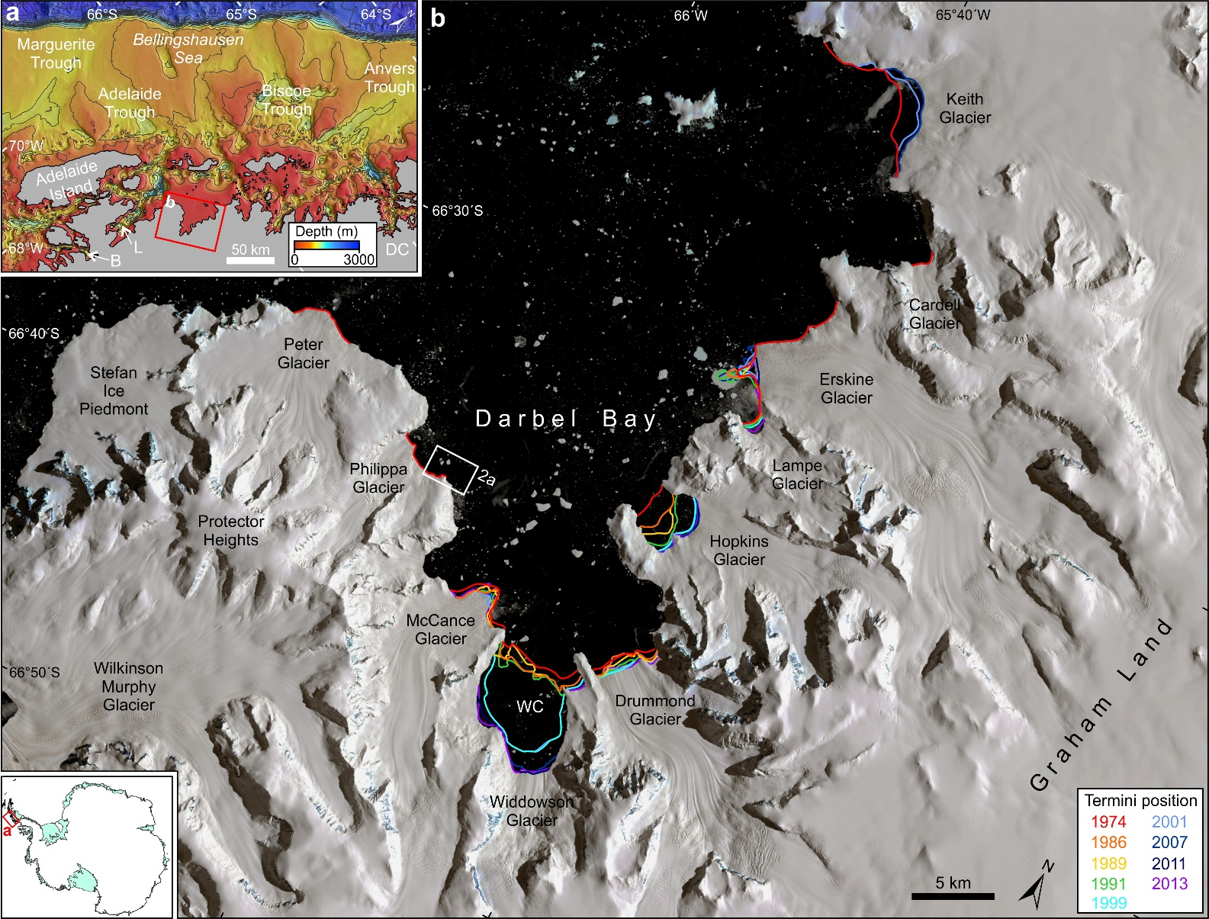

Figure 1

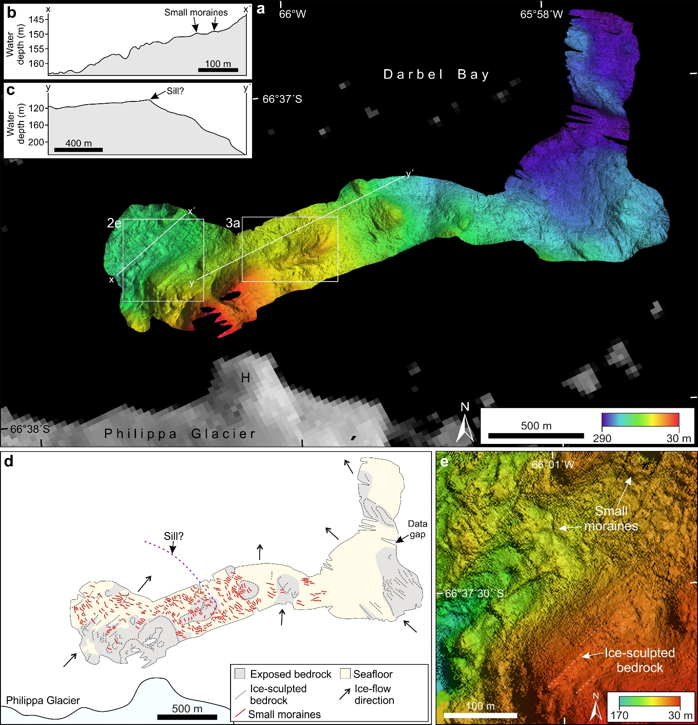

Figure 2

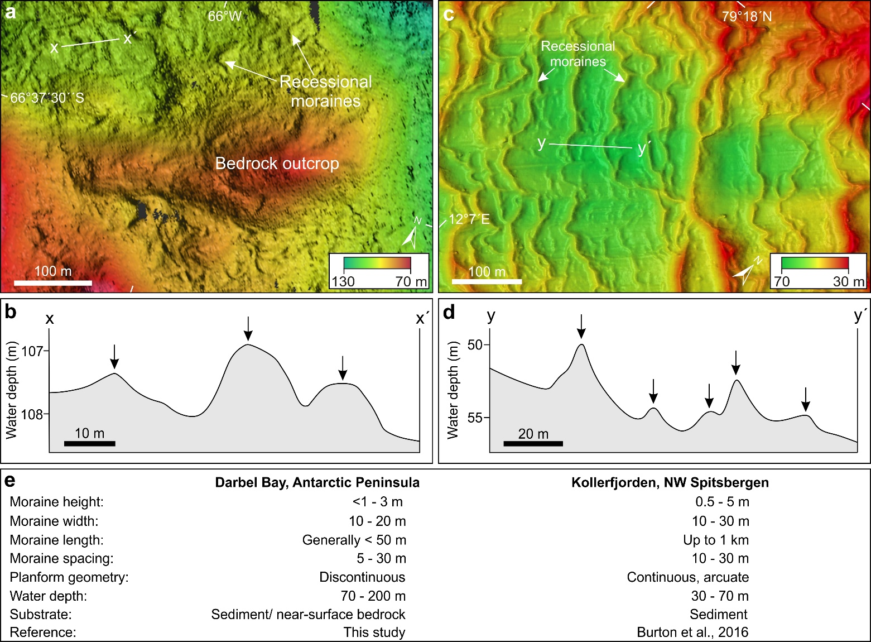

Figure 3

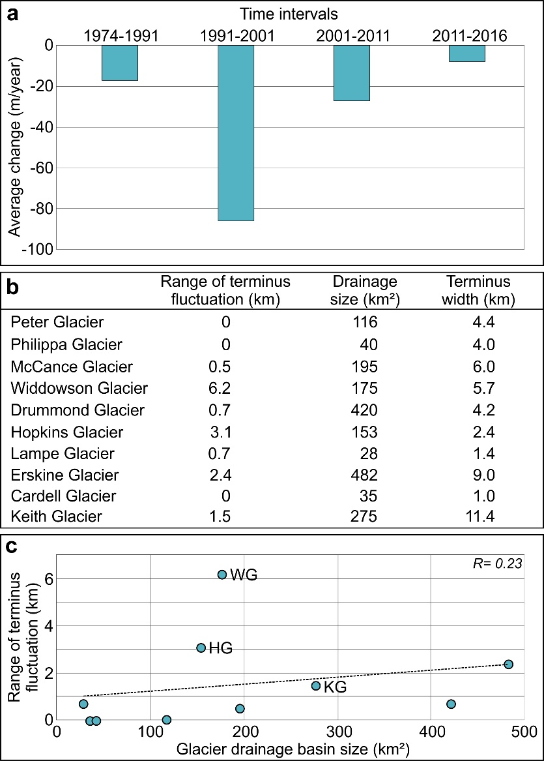

Figure 4

