Supporting Information

Figures
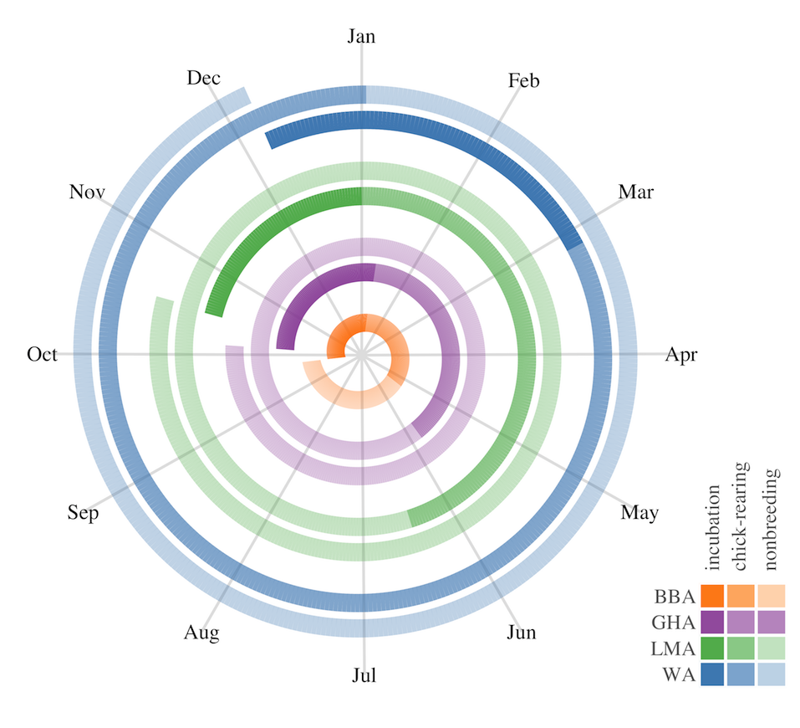
Fig. S1 Multi-year breeding cycles of black-browed (BBA), grey-headed (GHA), light-mantled (LMA) and wandering albatrosses (WA) at Macquarie Island (adapted from Terauds 2002).

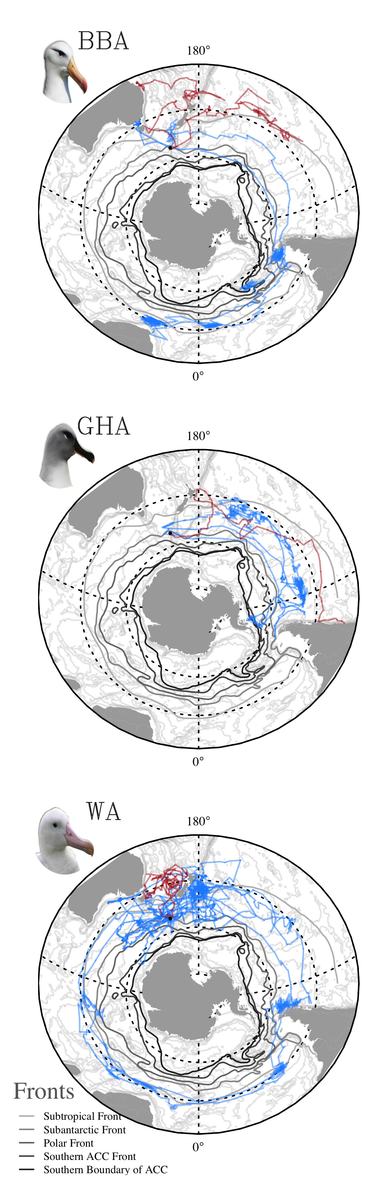
Fig. S2 Individual tracks from juvenile (red) and nonbreeding adult (blue) black-browed (BBA, n = 2, 2), grey-headed (GHA, n = 2, 2), and wandering (WA, n = 2, 5) albatrosses tracked from Macquarie Island in relation to major oceanic fronts from Orsi et al. 1995.

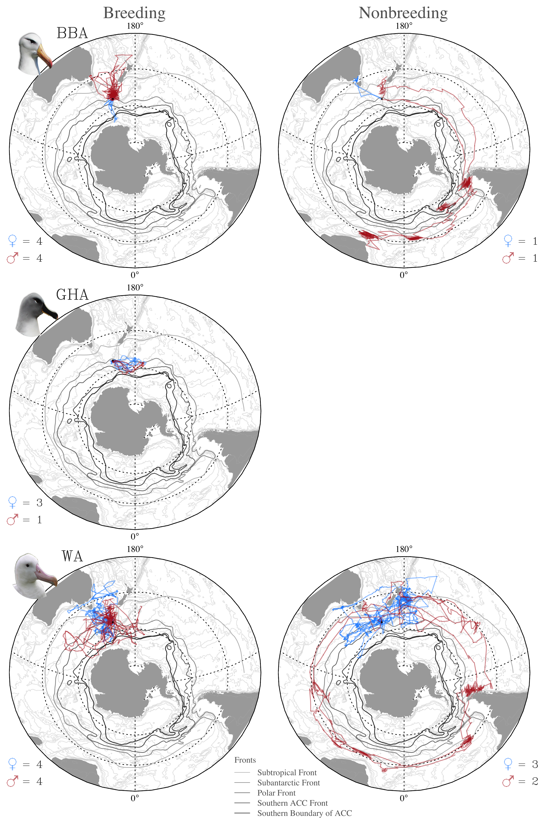
Fig. S3 Individual tracks from breeding and nonbreeding black-browed (BBA), grey-headed (GHA) and wandering albatrosses (WA) of known sex tracked from Macquarie Island in relation to major oceanic fronts from Orsi et al. 1995.

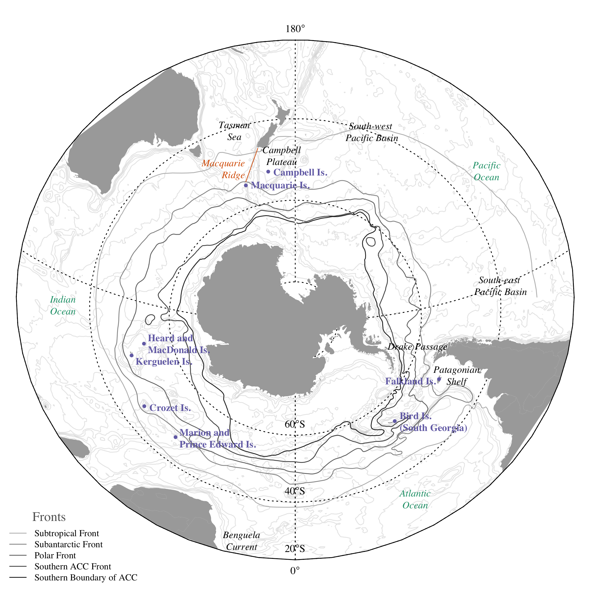
Fig. S4 Subantarctic islands and important Southern Ocean features for Macquarie Island albatrosses including major oceanic fronts from Orsi et al. 1995.

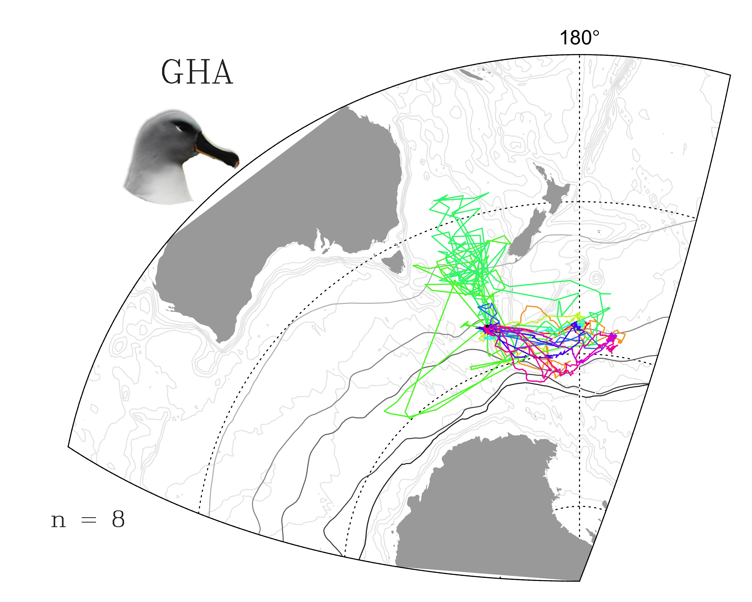
Fig. S5 Individual tracks from breeding grey-headed (GHA) tracked from Macquarie Island in relation to major oceanic fronts from Orsi et al. 1995.

Tables
Table S1. Summary of GLS and PTT deployments on albatrosses from Macquarie Island between 1992 and 2009. Mean daily fixes are reported with standard error.
Species | Sex | Status | Band number | Device type | Device ID | Deployment date | Days tracked | Total fixes | Mean daily fixes
Black-browed albatross | F | adult | 12143525 | GLS | 1203 | 30/11/05 | 349 | 352 | 1.01 ± 0.00
 | M | adult | 12139115 | GLS | 1187 | 21/12/05 | 351 | 703 | 2.00 ± 0.01
 | F | adult | 12139117 | PTT | 20876 | 20/12/99 | 32 | 458 | 14.31 ± 0.54
 | M | adult | 12139116 | PTT | 20877 | 28/11/00 | 28 | 291 | 10.39 ± 0.52
 | F | adult | 12112802 | PTT | 20875 | 28/11/00 | 30 | 256 | 8.53 ± 0.46
 | M | adult | 12139337 | PTT | 14418 | 2/12/01 | 26 | 684 | 26.31 ± 1.62
 | F | adult | 12139019 | PTT | 20877 | 2/12/01 | 28 | 678 | 24.21 ± 1.33
 | M | adult | 12119005 | PTT | 14257 | 6/12/01 | 22 | 445 | 20.23 ± 1.13
 |  | juvenile | 12149404 | PTT | 37467 | 1/4/06 | 96 | 735 | 7.66 ± 0.25
 |  | juvenile | 12149617 | PTT | 20877 | 1/4/06 | 96 | 760 | 7.92 ± 0.46
Grey-headed albatross |  | adult | 12139225 | GLS | 1191 | 30/11/05 | 252 | 253 | 1.00 ± 0.00
 |  | adult | 12138972 | GLS | 1192 | 8/12/05 | 365 | 733 | 2.01 ± 0.01
 | F | adult | 12112695 | PTT | 20875 | 20/12/99 | 26 | 322 | 12.38 ± 0.46
 | F | adult | 12118905 | PTT | 20874 | 20/12/99 | 27 | 203 | 7.52 ± 0.65
 | M | adult | A0409* | PTT | 20877 | 20/12/99 | 31 | 455 | 14.68 ± 0.63
 |  | adult | 12139051 | PTT | 20876 | 28/11/00 | 18 | 219 | 12.17 ± 0.53
 | F | adult | A0404 | PTT | 20874 | 28/11/00 | 28 | 225 | 8.04 ± 0.47
 | M | adult | A0409* | PTT | 14403 | 2/12/01 | 17 | 479 | 28.18 ± 0.8
 |  | adult | unbanded | PTT | 20875 | 4/12/01 | 19 | 440 | 23.16 ± 1.71
 |  | juvenile | 12149681 | PTT | 14257 | 1/4/06 | 22 | 146 | 6.64 ± 0.62
 |  | juvenile | 12149682 | PTT | 14418 | 1/4/06 | 87 | 660 | 7.59 ± 0.32
Light-mantled albatross |  | adult | 12063972 | GLS | 1198 | 1/12/05 | 760 | 763 | 1.00 ± 0.00
 |  | adult | 12146141 | GLS | 1195 | 14/12/05 | 109 | 217 | 1.99 ± 0.01
 |  | adult | 12025901 | GLS | 1186 | 14/12/05 | 449 | 899 | 2.00 ± 0.00
 |  | adult | unbanded | PTT | 12606 | 13/11/92 | 26 | 182 | 10.11 ± 1.05
 |  | adult | unbanded | PTT | 12609 | 13/11/92 | 18 | 170 | 7.73 ± 0.85
 |  | adult | unbanded | PTT | 12604 | 13/11/92 | 22 | 281 | 10.81 ± 0.63
 |  | adult | unbanded | PTT | 12606 | 2/12/92 | 9 | 68 | 7.56 ± 1.88
 |  | adult | 12143641 | PTT | 37468 | 9/12/02 | 5 | 108 | 21.6 ± 2.94
 |  | adult | 12139296 | PTT | 37467 | 9/12/02 | 16 | 712 | 44.5 ± 2.92
 |  | adult | 12138851 | PTT | 14257 | 12/12/02 | 17 | 731 | 43.00 ± 3.61
 |  | adult | 12139525 | PTT | 14418 | 15/12/02 | 28 | 1076 | 38.43 ± 3.33
 |  | adult | A1084 | PTT | 20877 | 15/12/02 | 33 | 1255 | 38.03 ± 2.72
 |  | adult | 12110945 | PTT | 37468 | 16/12/02 | 25 | 742 | 29.68 ± 3.09
 |  | adult | 12145258 | PTT | 37467 | 24/12/02 | 24 | 791 | 32.96 ± 3.72
 |  | adult | 12143650 | PTT | 14257 | 31/12/02 | 12 | 341 | 28.42 ± 3.67
Wandering albatross | M | adult | 14030938 | GLS | 2123 | 16/12/98 | 52 | 54 | 1.04 ± 0.03
 | F | adult | 14052756 | GLS | 1200 | 30/11/05 | 1473 | 1490 | 1.01 ± 0.00
 | F | adult | 14030500 | GLS | 1190 | 3/1/06 | 1083 | 1093 | 1.01 ± 0.00
 | M | adult | 14049634 | GLS | 1194 | 4/1/06 | 361 | 727 | 2.01 ± 0.01
 | F | adult | 14030935 | PTT | 43921 | 29/12/03 | 41 | 1079 | 26.32 ± 0.88
 | F | adult | 14030908 | PTT | 43922 | 1/1/04 | 56 | 1697 | 30.3 ± 0.73
 | M | adult | 14052748 | PTT | 37388 | 3/1/06 | 71 | 1192 | 16.79 ± 0.48
 | M | adult | 14030942 | PTT | 37389 | 5/1/06 | 67 | 1006 | 15.01 ± 0.7
 | M | adult | 14052375 | PTT | 37629 | 15/2/06 | 104 | 1001 | 9.62 ± 0.38
 | F | adult | 14049642 | PTT | 37631 | 21/2/06 | 131 | 1275 | 9.73 ± 0.29
 |  | juvenile | 14052638 | PTT | 55167 | 14/12/04 | 61 | 145 | 2.38 ± 0.14
 |  | juvenile | 14052370 | PTT | 55166 | 14/12/04 | 96 | 225 | 2.34 ± 0.09
* One grey-headed albatross (A0409) was tracked twice.

Table S2. Source of environmental and atmospheric data used to predict foraging effort of tracked Macquarie Island albatrosses, averaged over 100 km grid cells and temporally matched to GPS and GLS derived locations.
Acronym | Data | Justification for proxy | Temporal resolution | Dataset | Source
chl | Chlorophyll a concentration | Regions of high productivity | monthly | Ocean data MODIS Aqua Level-3 binned daily remote sensing reflectance | http://oceancolor.gsfc.nasa.gov/
eke | Eddy kinetic energy | Eddy features that may concentrate productivity | daily | SSALTO/DUACS gridded absolute geostrophic velocities | http://www.aviso.altimetry.fr/en/data/products/sea-surface-height-products/global/msla.html
bathy | Bathymetry gradient | Bathymetric features e.g. shelf, sea mounts; that may cause upwelling and elevate surface productivity | NA | ETOPO2 | http://www.ngdc.noaa.gov/mgg/global/etopo2.html
gsst | Sea surface temperature gradient | Frontal zones that may concentrate productivity | daily | NOAA Optimum Interpolation Sea Surface Temperature V2 | http://www.esrl.noaa.gov/psd/data/gridded/data.noaa.oisst.v2.html
ssha | Sea surface height anomaly | Eddy features that may concentrate productivity | monthly | SSALTO/DUACS gridded mean and climatological sea level anomalies | http://www.aviso.altimetry.fr/en/data/products/sea-surface-height-products/global/msla-mean-climatology.html
wind | Surface wind speeds | Areas with high wind driven mixing and productivity; and an influence on albatross flight costs | twice daily | NCEP-DOE Reanalysis 2 daily averages | http://www.esrl.noaa.gov/psd/data/gridded/data.ncep.reanalysis2.html

Literature cited
Orsi AH, Whitworth IT, Nowlin WD (1995) On the meridional extent and fronts of the Antarctic Circumpolar Current. Deep-Sea Research Part I 42:641-673
Terauds A (2002) Population biology and ecology of albatrosses on Macquarie Island: implications for conservation status. PhD Thesis, University of Tasmania, Hobart

