Electronic Supplementary Material

Table 1 – Changes in size in Wandering Albatrosses (number of breeding pairs) colonies counted irregularly and comparison with reference colonies (in bold) counted annually during the same time period

Crozet | 1972-1974 (Derenne et al. 1976; Despin et al. 1972) | February 1982  (Jouventin et al. 1984; Voisin 1984) | January 2008 | January 2017  (helicopter) | 2017 - 2018  (satellite)
Ile des Pingouins |  | 120 | 180 (+50.0%) |  | 171 (-5.0%)
Ile aux Cochons | 1002 | 879 (-12.3%) |  | 1280 (+45.6%)
Ile de l’Est | 427 | 329 (-23%) |  |  | 284 (-13.7%)
Reference colony  (Ile de la Possession) |  | 256 (-17.6%) | 362 (+30.7%) | 389 (+43.4%) | 389  (+9.7%)
Kerguelen | 1971  (Derenne et al. 1974) | January 1985  (Weimerskirch et al. 1989) | January 2013 | March 2017  (helicopter) | March 2017  (satellite)
Anse de l’Ours |  | 7 |  | 17 (+142.9%)
Grande Coulée |  | 600 |  | 700 (+16.7%) | 579
Feu de Joie |  | 80 |  | 87 (+8.7%) | 44
Téluromètre |  | 70 | 155 (+115.7%) | 151 (-2.6%)
Gallieni | 30 | 9 (-70.0%) |  | 10 (+11.1%)
Reference colony (Courbet Peninsula) |  | 295 (-40.3%) | 334 (+11.7%) | 322  +9.2%

Table 2 – Counts (number of breeding pairs) of 3 major populations of Grey-headed Albatrosses at Crozet and Kerguelen archipelagos in 1982-1985 and 2014-2016.

Colony | Year ancient count | Numbers | Year Recent count | Numbers (rate of change)
Ile de Croy, Iles Nuageuses, Kerguelen (1) | 1985  (Weimerskirch et al. 1989) | 7540 | 2014 | 6360 (-15.6%)  -0.54% / year
Ile des Apôtres,  Crozet | 1982 (Jouventin et al. 1984) | 180 | 2016 | 259 (+43.9%)  + 1.3% / year
Ile des Pingouins  Crozet | 1982 (Jouventin (Jouventin et al. 1984) et al. 1984) | 2000 | 2016 | 2300 (+15.0%)  +0.44% / year
(1) partial count

Table 3 – Counts (number of breeding pairs) of Indian Yellow-nosed Albatrosses in 1982-1985 and in 2014-2016 at the Kerguelen and Crozet archipelagos.
Colony | Year ancient count | Numbers | Year Recent count | Numbers (rate of change)
Ile de Croy, Iles Nuageuses, Kerguelen | 1985 | 50 | 2014 | 23 (-54%)  -2.3% / year
Ile des Apôtres,  Crozet | 1982 | 1230 | 2016 | 1114 (-9.4%)  -0.3% / year
Ile des Pingouins  Crozet | 1982 | 5800 | 2016 | 3098 (-46.6%)  -1.4% / year
Reference colony (Amsterdam) | 1982 | 10368 | 2016 | 5878  -1.1% per year

Table 4 – Numbers of breeding pairs of Black-browed Albatrosses at Ile de Croy (Kerguelen) and on Ile des Pingouins and Ile des Apôtres (Crozet) in 1982-1985 and in 2014-2016.

Colony | Year ancient count | Numbers | Year Recent count | Numbers (rate of change)
Ile de Croy, Iles Nuageuses, Kerguelen (1) | 1985 | 1253 | 2014 | 1290 (+2.9%)  +0.1%/year
Ile des Apotres,  Crozet | 1982 | 330 | 2016 | 252 (-23.6%)  -0.7% / year
Ile des Pingouins  Crozet | 1982 | 300 | 2016 | 108 (-64%)  -1.9% / year
Reference (Jeanne D’Arc, Kerguelen | 1976 | 1200 | 2014 | 945  -0.21% / year
(1) partial count

Image 1 - Satellite image of the Grande Coulée at Kerguelen taken on 17 March 2017. Yellow dots are individual wandering albatrosses

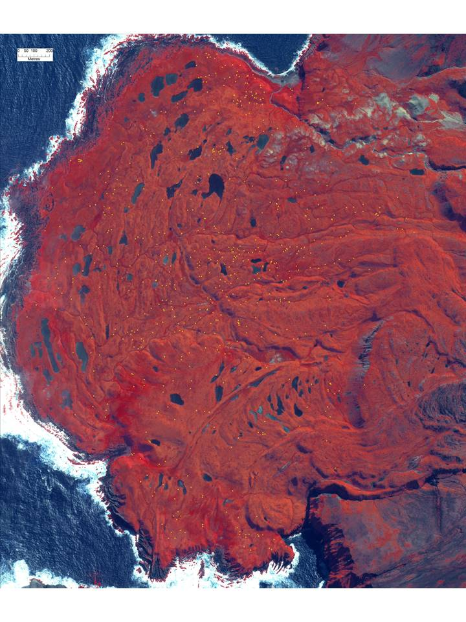
Image 2 – Upper photograph: Photograph taken from helicopter on 17 November 2016 of a cliff at Ile des Apôtres, Crozet, showing part of a Yellow-nosed Albatross colony. Lower Photograph: enlargement showing breeding and non-breeding Salvin’s and Black-browed Albatrosses, all other birds are Yellow-nosed Albatrosses
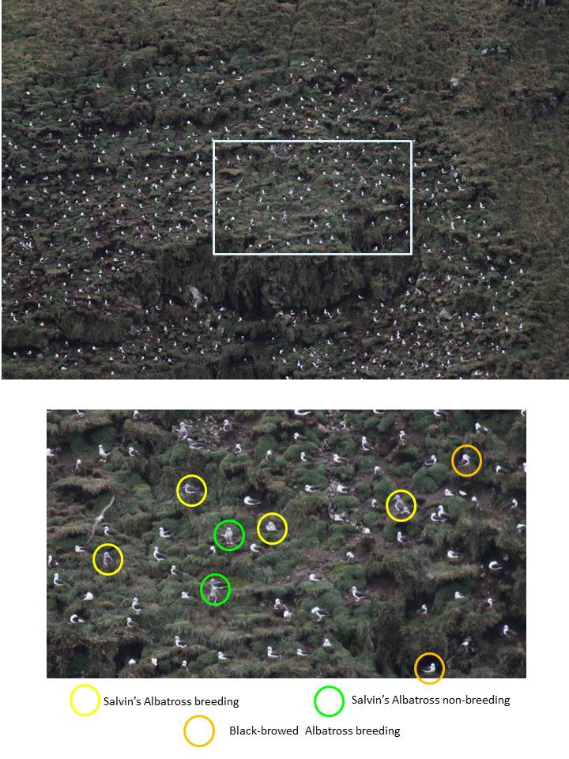

References

Derenne P, Lufbery JX, Tollu B (1974) L'avifaune de l'archipel Kerguelen CNFRA 33:57-87
Derenne P, Mougin JL, Steinberg C, Voisin JF (1976) Les oiseaux de l'ile aux Cochons, archipel Crozet CNFRA:107-148
Despin B, Mougin JL, Segonzac M (1972) Oiseaux et mammifères de l'ile de l'Est CNFRA 31:1-106
Jouventin P, Stahl JC, Weimerskirch H, Mougin JL (1984) The seabirds of the French Subantarctic Islands & Adélie Land, their status and conservation. ICBP Technical Publication 2:609-625.
Voisin JF (1984) Observations on the birds and mammals of île aux Cochons, Crozet Islands, in February 1982. S Afr J Nav Antarct Res 14:11-17.
Weimerskirch H, Zotier R, Jouventin P (1989) The avifauna of the Kerguelen Islands. Emu 89:15-29.

