Trallero L, Farré M, Phillips RA, Navarro J (2019) Geometric morphometrics reveal interspecific and sexual differences in bill morphology in four sympatric planktivorous petrels. Journal of Zoology, 307, 167–177

Geometric morphometrics reveal interspecific and sexual differences in bill morphology in four sympatric planktivorous petrels

Lucía Trallero¹, Marc Farré^{1,*}, Richard A. Phillips² & Joan Navarro¹

¹Institut de Ciències del Mar - CSIC, Passeig Marítim de la Barceloneta 37-49, 08003, Barcelona, Spain
²British Antarctic Survey, Natural Environment Research Council, Cambridge CB3 0ET, UK

*Corresponding author
Marc Farré, ¹Institut de Ciències del Mar - CSIC, Passeig Marítim de la Barceloneta 37-49, 08003, Barcelona, Spain. Tel: +34 932309555
Email: farre@icm.csic.es

Abstract
Variation in morphological structures may indicate the existence of ecological differences between species or sexes. In birds, the bill is one of the structures most affected by selection pressures because it is directly involved with several biological functions, particularly the acquisition of food. In the present study, we combined geometric morphometrics and comparisons of linear measurements to assess the presence of sexual dimorphism and differences in bill shape and size of four species of abundant zooplanktivorous seabirds that coexist during their breeding season in Southern Ocean ecosystems [blue petrel (Halobaena caerulea), Antarctic prion (Pachyptila desolata), common diving petrel (Pelecanoides urinatrix) and South Georgia diving petrel (P. georgicus)]. The results showed that bills of Antarctic prion and blue petrel differed noticeably in size and shape from those of the two diving petrels, whereas those of common diving and South Georgian diving petrels overlapped in bill shape. These differences may be due to diet segregation or factors such as diving strategy, vocalisations or olfaction development. In addition, there was sexual dimorphism in bill shape or size in all four species. However, we could not directly attribute these differences to selection pressures because of the lack of studies comparing feeding ecology between sexes in these seabirds. These results reveal relationships between the bill shape with key factors of the ecology of these species, and demonstrate the usefulness of geometric morphometrics for detecting interspecific and sexual differences in species of otherwise sexually monomorphic petrels.

Keywords: bill shape; bill size; geometric morphometrics; interspecific variability; sexual dimorphism; ecological segregation; seabirds

Introduction
Investigation on the morphological characteristics of organisms has been an essential element for understanding their evolution, adaptation to the environment, and behaviour, as well as for taxonomic classification, which is frequently based on descriptions of anatomical traits (Bookstein, 1998; Adams, Rohlf & Slice, 2004). In the field of ecology, it was only from the 1950s that researchers began to use and compare morphological characters of organisms, since many anatomical traits are directly related to basic ecological needs such as food acquisition, locomotion, reproductive strategies and defence (Bock & von Walhert, 1965; Bock, 1990). Therefore, studies examining linkages between the morphological characters of species and their ecological performances improve our understanding of the coexistence and competition between species, and the differentiation of ecological niches within communities (Karr & James, 1975; Ricklefs & Miles, 1994).
Given the limited availability of suitable breeding places without land-based predators, many species of seabirds breed in sympatry. Thus, inter- and intraspecific competition for food resources in the waters surrounding these sites can be very high. To reduce this high trophic competition and allow coexistence, these predators present different degrees of ecological segregation (e.g. Phillips et al., 2004; Navarro et al., 2013). This could be enabled by a variety of factors such as timing of breeding, partitioning of resources (targeting alternative prey) or other differences in foraging strategies, or divergence in certain morphological characters between coexisting species or between individuals within populations (Nebel, 2005; González-Solís, Croxall & Afanasyev, 2007; Navarro, Kaliontzopoulou & Gonzalez-Solís, 2009). One of the structures most affected by selective processes in birds is the bill, which is directly involved with essential functions such as the acquisition of food, territory or nest defence, vocalisation and mate (sexual) selection (Warham, 1996; van Oordt, Torres-Mura & Hertel, 2018). In terms of ecological functions, the bill has been linked mainly with foraging preferences and feeding efficiency (Gould, 1861; Darwin, 1871). Therefore, the morphology, and particularly the shape of the bill, can affect niche differentiation both among species and between sexes (Feinsinger & Colwell, 1978; Berns & Adams, 2010). For many years, studies on sexual dimorphism in birds focused on differences in social mating systems (Hedrick & Temeles, 1989; Owens & Hartley, 1998). However, sexual dimorphism may also reflect ecological drivers demonstrating that males and females become adapted to different ecological niches - a hypothesis proposed by Darwin in 1874 – potentially including dietary differences (Shine, 1989). Thus, differences in bill morphology between species or sexes seem likely to have an ecological driver, arising from the effect of competition and segregation between organisms, i.e., in feeding strategies and ecological habits (Selander, 1966; Navarro et al., 2009).
Geometric morphometrics is a powerful approach that is used widely for measuring shape variation in biological structures (Adams et al., 2004; Zelditch et al., 2004). Its use allows the easy and fast definition of biological forms and a robust statistical analysis of shape with great detail, since the effects of non-shape variation are held constant mathematically during all the analytical process (Berns & Adams, 2010). Thus, it permits differentiation between morphological structures that are otherwise very similar, which can then be interpreted in the context of likely ecological drivers (Zelditch et al., 2004; Farré et al., 2015).
Here, the main objective was to investigate sexual dimorphism and to compare bill shape and size using geometric morphometric and linear measurements among four small zooplanktivorous petrels [(blue petrel (Halobaena caerulea), Antarctic prion (Pachyptila desolata), common diving petrel (Pelecanoides urinatrix) and South Georgia diving petrel (Pelecanoides georgicus)] which breed in sympatry on islands in the Southern Ocean. Although all feed to some extent on planktonic crustaceans such as Antarctic krill (Euphausia superba) and other euphausiids, preferences for year-round interspecific differences in distribution and activity patterns observed in this feeding guild.
(Navarro et al., 2013, 2015). Thus, this ecological segregation may also explain the differences in bill shape and size among these small petrel taxa, and potentially between sexes. However, no published study has examined evidence for sexual dimorphism or sexual segregation in these four species, which are traditionally considered to be monomorphic (Warham, 1990).

Materials and methods

Study species
Antarctic prion, blue petrel, common diving petrel and South Georgia diving petrel show the typical procellariiform pattern of a single-egg clutch and slow chick development, with both parents sharing reproductive duties (Brooke, 2004). The four species consume mainly crustaceans (about one million tonnes per year), especially Antarctic krill (Guinet et al., 1996). Both diving petrels also includes a large quantity of copepods in the diet, and Antarctic prion and blue petrel also feed on small fish and squid (Cherel et al., 2002a, 2002b). However, there is a clear ecological segregation among species in terms of spatial distribution (diving capability and depth) related to feeding strategy (Navarro et al., 2013).

Fieldwork procedures
Fieldwork was carried out in Bird Island (54°00'S, 38°03'W), a small subantarctic island located in the west of the South Georgia archipelago in the Southern Ocean. During the incubation period of the four species (November 2010 to February 2011), a total of 58 Antarctic prions (34 males, 21 females and 3 undetermined), 29 blue petrels (12 males, 15 females and 2 undetermined), 50 common diving petrels (17 males, 18 females and 15 undetermined) and 47 South Georgia diving petrels (26 males, 19 females and 2 undetermined) were captured in their burrows. The sex of the major part of individuals was determined using molecular procedures from body feathers (Harvey et al., 2006).

Bill morphology
For each individual, we recorded three biometric measures of the bill to the nearest 0.1 mm using digital calipers (±0.1 mm): the culmen length, the maximum bill depth and the bill depth at the nares (Fig. 1a). For geometric morphometrics, we took digital pictures from standardized positions of the right profile and the dorsal view of the bill using a compact digital camera, ensuring that the objective was always parallel to the bill surface. In order to keep the bill in a standardized position, it was supported using a wooden board, with a ruler underneath to show the scale. We discarded some digital pictures that were taken incorrectly. All bill measurements and pictures were always taken by the same person (JN).
The analysis of bill shape variation was carried out using landmark-based geometric morphometrics. In order to describe the general shape of the bill and nares (Fig. 1a), a total of 11 landmarks (fixed homologous points) and 3 semilandmarks (sliding or mobile non-homologous points) of ecological and biological importance were selected in the profile pictures (Fig. 1b and Table 1; Navarro et al., 2009; Militão et al., 2014). A total of 10 landmarks were used in the dorsal-view pictures (Fig. 1c and Table 1; Tokita et al., 2016). The digitization of landmarks and semilandmarks was performed using tpsDig software v.2.29 (Rohlf, 2017a), which captures the spatial coordinates of landmarks and transforms them into geometric data. A Generalized Procrustes Analysis (GPA) was applied to eliminate the distortions not related to shape, translating all individuals to a common centroid position, scaling to a unit centroid size and rotating to minimize the distances between corresponding landmarks (Adams et al., 2004, Zelditch et al., 2004). Additionally, the GPA was also used to obtain the uniform components of the shape variation for each analysed object (relative warps, RWs) by applying the thin-plate spline procedure, which creates a consensus configuration by averaging the coordinates of all the landmarks. The GPA procedure was carried out using tpsRelw software v.1.67 (Rohlf, 2017b).
RWs can be interpreted as shape deformation variables, so their analysis allows the visualization of variation in shape between objects (Rohlf & Marcus, 1993). According to this, these RWs were used to spatially represent the distribution of individuals based on their morphological characteristics and axis orientation (morphospace). In the present study, the morphospaces were created using two–dimensional representations from the first two relative warps (RW1 and RW2), since they explained a high percentage (77.63% for the profile and 85.53% for the dorsal view of the bill) of the total morphological variability observed (Farré et al., 2016b).

Statistical analysis
Differences in bill size (culmen length, maximum bill depth and bill depth at nares) and bill shape (RW1 and RW2 of the profile and dorsal view) were compared between species and sexes using ANOVA (including post-hoc Tukey tests) and Student’s t-tests, respectively (Berns & Adams, 2010) using SPSS software. Because the bill size variables were not normally distributed, we log-transformed them prior to statistical analysis.

Results

Interspecific differences in bill morphology
According to the morphometric analysis, significant differences were found in size and shape of the bill (both profile and dorsal view) among the four species (Tables 2&S1; Fig. 2-3). ANOVA tests indicated significant differences among species (p< 0.05) in all measures of bill size and bill shape (Table 2), except for dorsal-RW1 between Antarctic prion and blue petrel, the only pairwise comparison which was not significant (Tukey HSD tests, p> 0.05; Table 2).
In terms of bill shape, there were significant differences in profile between Antarctic prion, blue petrel and the two diving petrels; both diving petrels showed a higher degree of overlap within the morphospace (Fig. 2a). The horizontal axis (RW1, which represented 67.77% of the total morphological variability) separated the species according to the overall length and maximum depth of the bill, as well as the general shape of the nares (Fig. 2b). Species with shorter ramicorns, more elongated and less deep bills, and with nares of similar heights at the proximal and distal ends, with forms that were approximately rectangular (Antarctic prion and blue petrel, Fig. 2a-b), clearly contrasted with the species with longer ramicorns, shorter and deeper bills (more robust aspect), with nares wider at the proximal end and narrower at the distal end, and with an overall more triangular form (common and South Georgia diving petrels, Fig. 2a-b). Moreover, the vertical axis (RW2, explaining 9.86% of the total morphological variability) differentiated the species based on the height of the nares and the shape and size of the maxillary unguis (Fig. 2b). Positive values represented bills with longer nares and more developed and rounded maxillary unguis, as well as shorter latericorns; negative values corresponded to less developed and thinner maxillary unguis, as well as shorter nares and longer latericorns (Fig. 2a-b).
Regarding the shape of the dorsal view of the bill, those of Antarctic prion and blue petrel were again distinct from the two diving petrels within the morphospace; these last two presented more similarity in bill shape, but to a lesser degree than for the shape of the profiles (Fig. 3a). The horizontal axis (RW1, representing 74.84% of the total morphological variability) grouped the species according to the width and length of the bill and the shape of the nares (Fig. 3b). The two diving petrels had shorter and wider bills, as well as wider and longer nares (Fig. 3a-b), whereas Antarctic prion and blue petrel possessed narrower and longer bills, and narrower and shorter nares (Figure 3a-b). The vertical axis (RW2, which explained 10.69% of the total morphological variability), distinguished the species according to the size of nares, culminicorns, maxillary unguis and bill width at the basis (Fig. 3b). Species with wider and longer nares, narrower bills at the basis, shorter culminicorns and longer and wider maxillary unguis showed more positive values, compared with the species with shorter and narrower nares, wider bills at their base, longer culminicorns and shorter and narrower maxillary unguis (Fig. 3b).

Sexual differences in bill morphology
Sex differences were detected in some characters related to the size and shape of the bill in the four species (Tables 3&S1). Males and females showed significant differences only in the shape of profile-RW1 (T₅₃= 3.33, p= 0.002; Table 3) in Antarctic prion. In blue petrel, sexual dimorphism was found in the size of the culmen (T₂₅= 2.2, p= 0.04), bill depth at nares (T₂₅= 2.99, p= 0.006) and shape of the bill profile-RW1 (T₂₆= 2.31, p=0.03; Table 3). Male and female common diving petrel presented significant differences in three characters: maximum bill depth (T₃₃= 2.44, p= 0.02), bill depth at nares (marginally significant, T₃₃= 2.03, p= 0.05) and shape of profile-RW1 (T₃₃= 4.12, p= 0.001, Table 3). Finally, in South Georgia diving petrel, there were significant differences between sexes only in bill depth at the nares (T₄₃= 3.21, p= 0.003, Table 3). No differences between sexes were detected from the dorsal view of the bill in any species.
Regarding the distribution of individuals within the morphospaces based on the shape of the profile and dorsal view of the bill, only comparisons indicating significant sexual dimorphism are described and showed below (Fig. 4a-c). In Antarctic prion, females were located slightly towards the negative extreme along the RW1 axis (67.7% of the total morphological variability) within the morphospace of the profile view of bill because they presented longer and less deep bills, and longer nares that were slightly narrower at the proximal end (Fig. 4a). In contrast, males had shorter and deeper (more robust) bills, and shorter and higher nares at the proximal end, as well as less protruding maxillary unguis compared to the mandibular unguis (Fig. 4a). In blue petrel, males possessed longer bills and higher nares than females (Table 3). In terms of the profile of the bill, females were located more to the left along the RW1 axis (67.77% of total morphological variance) within the morphospace, with longer and less deep bills, as well as smaller nares (Fig. 4b). Moreover, males, which showed more robust bills (shorter and taller) and higher nares, were situated towards the other extreme in the RW1 axis of the morphospace (Fig. 4b). Common diving petrel exhibited sexual differences in bill size (males had deeper bills than females, Table 3) and in the shape of the profile. Along the horizontal axis (RW1) of the morphospace, females tended to have longer and less deep bills, as well as slightly lower and shorter nares (Fig. 4c), whereas males were characterized by more robust (shorter and deeper) bills and also slightly narrower and taller nares (Fig. 4c). Males and females of South Georgia diving petrel showed significant differences only in the size of the bill; bill depth at nares was less in females than in males (Table 3).

Discussion
Although geometric morphometrics has been widely applied to quantify shape variation in many biological taxa and for many purposes (Zelditch et al., 2004), few studies have used it to evaluate sexual dimorphism in shape of anatomical structures. By applying this approach, we found clear interspecific differences in bill shape and size between four small, sympatric petrels and, for some of these species, also sexual dimorphism. In particular, Antarctic prions have bills with shorter nares, less developed and rounded maxillary unguis and longer latericorns compared to blue petrel. In contrast, the two diving species (common and South Georgia diving petrels) possess similar bill shapes: shorter and deeper bills with larger nares than Antarctic prion and blue petrel. We also found differences between sexes in all four species. In general, males have more robust bills than females, and shorter but higher nares. Both interspecific and sexual differences in bill morphology are probably related to different foraging strategies and natural selection processes that reduce competition during the breeding season.
Although the bill is directly involved in varied biological functions such as vocalisation, territorial defense or courtship, its key role is related to feeding process (Selander, 1966; Smith, 1990; Herrel et al., 2005). In the present study, we observed that Antarctic prion and blue petrel have longer and sharper bills and smaller nares. Although the four study species mainly exploit Antarctic krill (Guinet et al., 1996), Antarctic prion and blue petrel also include small fish and squid in their diet (Reid et al. 1997; Cherel et al., 2002a, 2002b). Therefore, the elongated and sharper shape of bills of Antarctic prion and blue petrel could be an adaptation to capture and tear these other secondary prey types, particularly as squid remains in the stomachs of blue petrel indicate consumption of individual squid that are too large to be ingested whole (Cherel et al., 2002b). In addition, feeding areas of these two species are noticeably different, demonstrating a degree of habitat segregation at sea (Navarro et al., 2013). Both species have a similar bill size and feed on similar resources, although blue petrel consumes more fish than Antarctic prion, which feeds on a higher proportion of copepods (Prince, 1980; Cherel et al., 2002b). Besides, Antarctic prion habitually feeds using hydroplaning and surface filtration (Harper, 1987; Warham, 1990), which is also a characteristic of larger prion species which have wider bills and palatal lamellae lining the interior of the upper jaw. These traits facilitate filtering of small, epipelagic organisms suspended in the sea surface and probably explain the greater incidence of copepods in their diet (Prince, 1980; Cherel et al., 2002a).
The two diving species presented more robust (shorter and deeper) bills and larger nares. However, the general shape and size of their bills were very similar, showing a high degree of overlap in both morphospaces (although bill size was slightly deeper in the common diving petrel; Payne & Prince, 1979). Both species dive to much deeper depths than Antarctic prion and blue petrel, since although they also feed mainly on Antarctic krill, common diving petrel supplements its diet with large amount of copepods and amphipods, and South Georgia diving petrel with euphausiids (Reid et al., 1997), all of them more abundant deeper in the water column. Therefore, their bill shape might be more suited to diving and filtering large amounts of water (more robust, as indicated our results) rather than catching larger prey such as fish or squid.
Besides the horizontal and vertical spatial segregation, the four petrel species also differ in their diurnal activity patterns, presumably in order to reduce interspecific competition. Antarctic prion and blue petrel search actively for food during daylight and darkness (Navarro et al., 2013). This behavior explains why they have well-developed vision and olfactory systems, both of vital importance for locating food at low light levels in the open ocean (Bang, 1966; Bonadonna et al., 2004; Nevitt, 2008). This could influence the size or shape of the nares and explain the morphometric differences between Antarctic prion and blue petrel with respect to the two diving petrels, which feed at sea mainly in daylight (Navarro et al., 2013).
However, some of the more unexpected results of the present study were the degrees of sexual dimorphism in certain parameters of the shape and size of the bill in the study species, which are considered to be sexually monomorphic, making it therefore difficult to sexually distinguish in the field (Warham, 1996). In general, males had more robust (deeper) bills, and the nares were shorter than in females for the four study species. As with the interspecific comparison, this could be related to sexual differences in foraging strategies (Selander, 1966; Navarro et al., 2009), sexual selection or territory defense (Coulter, 1986; Navarro et al., 2009). As far as we are aware, the only studies that have assessed the existence of sexual differences in foraging strategies in these species used trophic markers (stable isotopes). These found no sex differences at Kerguelen Islands in Antarctic prion and blue petrel (Cherel et al., 2014), nor at South Georgia in Antarctic prion or either diving petrel species in the breeding or nonbreeding seasons (Phillips et al., 2011). However, conventional diet sampling might reveal more subtle differences in diet between males and females in terms of prey species or size, which could be linked to the variability in bill size and shape.
Alternative hypotheses to understand sex differences in size and shape of the bills of these otherwise monomorphic species could be related to sexual selection, and involve aspects as burrow defense or courtship (Warham, 1996; Navarro et al., 2009). For example, the more robust bills of males could be an advantage in conflicts over burrow ownership (Herrel et al., 2005). Indeed, Antarctic prion and blue petrel actively defend burrows by sparring with the bill or making specific vocalisations (Warham, 1996). Variation in bill shape and size may also be related to partner selection (Temeles et al., 2000). Females may use bill traits (particularly size) as cues to select specific males of higher genetic quality, which would then be transmitted to their offspring (Warham, 1996). Otherwise, it is also well-known that the emission of calls is of primary importance during pair formation in petrels in general (Brooke, 1990; Bretagnolle & Genevois, 1997). Therefore, variability in vocal characteristics or types of songs used to select a partner could be another factor driving morphological differences in bill size and shape between species and sexes (Naguib & Haven-Wiley, 2001; Bragina & Beme, 2013).
In conclusion, the present study underlines the usefulness of landmark-based geometric morphometrics for detecting interspecific and sexual differences in bill size and shape in seabirds. Our results for the four small petrels are particularly interesting given that these species are considered to be sexually monomorphic, and previous studies did not find any clear differences in feeding strategies between males and females based on stable isotope ratios in blood or feathers (Naguib & Haven-Wiley, 2001; Bragina & Beme, 2013). Further research is therefore required to better identify the main ecological or behavioural drivers leading to natural or sexual selection on bill size and shape in males and females in these species, which are amongst the most abundant seabirds and therefore major consumers of marine resources in the Southern Ocean.

Acknowledgements
The authors want to thank Ruth Brown for her help during the fieldwork. JN was funded with the Collaborative Gearing Scheme of the NERC Antarctic Funding Initiative. All work was approved by the Ethics Committee of the British Antarctic Survey and was carried out under permit from the Government of South Georgia and the Sandwich Islands.

References
Adams, D.C., Rohlf, F.J. & Slice, D.E. (2004). Geometric morphometrics: ten years of progress following the “revolution.” Ital. J. Zool. 71, 5–16.
Bang, B.G. (1966). The olfactory apparatus of tubenosed birds (Procellariiformes). Cells Tissues Organs 65, 391–415.
Berns, C.M. & Adams, D.C. (2010). Bill Shape and Sexual Shape Dimorphism between Two Species of Temperate Hummingbirds : Black- Chinned Hummingbird (Archilochus alexandri) and Ruby-Throated Hummingbird (A . colubris). Auk 127, 626–635.
Bock, W.J. (1990). From Biologische Anatomie to Ecomorphology. Neth. J. Zool. 40, 254–277.
Bock, W.J., von Wahlert, G., 1965. Adaptation and the form-function complex. Evolution 19, 269–299.
Bonadonna, F., Villafane, M., Bajzak, C. & Jouventin, P. (2004). Recognition of burrow’s olfactory signature in blue petrels, Halobaena caerulea: An efficient discrimination mechanism in the dark. Anim. Behav. 67, 893–898.
Bookstein, F.L. (1998). A hundred years of morphometrics. Acta Zool. Acad. Sci. Hung. 44, 7–59.
Bragina, E. & Beme, I. (2013). Sexual and Individual Features in the Long-Range and Short-Range Calls of the White-naped Crane. Condor 115, 501–507.
Bretagnolle, V. & Genevois, F. (1997). Geographic variation in the call of the Blue Petrel: Effects of sex and geographical scale. Condor 99, 985–989.
Brooke, M. (1990). The Manx Shearwater. London: T. & A. D. Poyser.
Brooke, M.D.L. (2004). Albatrosses and petrels across the world. Oxford, UK: Oxford University Press.
Cherel, Y., Bocher, P., De Broyer, C. & Hobson, K. (2002a). Food and feeding ecology of the sympatric thin-billed Pachyptila belcheri and Antarctic P. desolata prions at Iles Kerguelen. Mar. Ecol. Prog. Ser. 228, 263–281.
Cherel, Y., Bocher, P., Trouvé, C. & Weimerskirch, H. (2002b). Diet and feeding ecology of blue petrels Halobaena caerulea at Iles Kerguelen, Southern Indian Ocean. Mar. Ecol. Prog. Ser. 228, 283–299.
Cherel, Y., Connan, M., Jaeger, A. & Richard, P. (2014). Seabird year-round and historical feeding ecology: blood and feather δ¹³C and δ¹⁵N values document foraging plasticity of small sympatric petrels. Mar. Ecol. Prog. Ser. 505, 267–280.
Coulter, M.C. (1986). Assortative Mating and Sexual Dimorphism in the Common Tern. Wilson Bull. 98, 93–100.
Darwin, C. (1871). The descent of man and selection in relation to sex. London. Murray, London.
Farré, M., Lombarte, A., Recasens, L., Maynou, F. & Tuset, V.M. (2015). Habitat influence in the morphological diversity of coastal fish assemblages. J. Sea Res. 99, 107–117.
Farré M., Tuset V.M, Cartes J.E., Massutí E. & Lombarte A. (2016a). Depth-related trends in morphological and functional diversity of demersal fish assemblages in the western Mediterranean Sea. Prog. Oceanogr. 147, 22–37.
Farré, M., Tuset, V.M., Maynou, F., Recasens, L. & Lombarte, A. (2016b). Selection of landmarks and semilandmarks in fishes for geometric morphometric analyses: a comparative study based on analytical methods. Sci. Mar. 80, 175–186.
Feinsinger, P. & Colwell, R.K. (1978). Community organization among neotropical nectar-feeding birds. Am. Zool. 18, 779–795
González-Solís, J., Croxall, J.P. & Afanasyev, V. (2007). Offshore spatial segregation in giant petrels Macronectes spp.: differences between species, sexes and seasons. Aquat. Conserv. Mar. Freshw. Ecosyst. 17, S22–S36.
Gould, S.L. (1861). A Monograph of the Trochilidae: Or Family of Humming-birds. London.
Guinet, C., Cherel, Y., Ridoux, V. & Jouventin, P. (1996). Consumption of marine resources by seabirds and seals in Crozet and Kerguelen waters - changes in relation to consumer biomass 1962–65. Antarct. Sci. 8, 23–30.
Harper, P.C. (1987). Feeding behaviour and other notes on 20 species of Procellariiformes at sea. Notornis 34: 169–192.
Harvey, M.G., Bonter, D.N., Stenzler, L.M. & Lovette, I.J. (2006). A comparison of plucked feathers versus blood samples as DNA sources for molecular sexing. J. Field Ornithol. 77, 136–140.
Hedrick, A. V. & Temeles, E.J. (1989). The evolution of sexual dimorphism in animals: Hypothesis and tests. Trends Ecol. Evol. 4, 136–138.
Herrel, A., Podos, J., Huber, S.K. & Hendry, A.P. (2005). Bite performance and morphology in a population of Darwin’s finches : implications for the evolution of beak shape. Funct. Ecol. 19, 43–48.
Karr, J.R. & James, F. (1975). Ecomorphological configurations and convergent evolution of species and communities. Cambridge. Pp. 258–291. In: Cody, M. L. & Diamond J. M. (eds). Ecology and evolution of communities. Belknap, Cambridge, MA.
Militão, T., Gómez-Díaz, E., Kaliontzopoulou, A., & González-Solís, J. (2014). Comparing multiple criteria for species identification in two recently diverged seabirds. PLoS ONE 9, e115650.
Naguib, M. & Haven-Wiley, R. (2001). Estimating the distance to a source of sound: mechanisms and adaptations for long-range communication. Anim. Behav. 62, 825–837.
Navarro, J., Cardador, L., Brown, R. & Phillips, R.A. (2015). Spatial distribution and ecological niches of non-breeding planktivorous petrels. Sci. Rep. 5, 12164.
Navarro, J., Kaliontzopoulou, A., González-Solís, J. (2009). Sexual dimorphism in bill morphology and feeding ecology in Cory’s shearwater (Calonectris diomedea). Zoology 112, 128–38.
Navarro, J., Votier, S.C., Aguzzi, J., Chiesa, J.J., Forero, M.G. & Phillips, R.A. (2013). Ecological segregation in space, time and trophic niche of sympatric planktivorous petrels. PLoS ONE 8, e62897.
Nebel, S. (2005). Latitudinal clines in bill length and sex ratio in a migratory shorebird: A case of resource partitioning? Acta Oecol. 28, 33–38.
Nevitt, G. A. (2008). Sensory ecology on the high seas: the odor world of the procellariiform seabirds. J. Exp. Biol. 211, 1706–1713.
van Oordt, F., Torres-Mura, J.C. & Hertel, F. (2018). Ecomorphology and foraging behaviour of Pacific boobies. Ibis 160, 313–326.
Owens, I.P.F. & Hartley, I.R. (1998). Sexual dimorphism in birds: why are there so many different forms of dimorphism? Proc. R. Soc. B Biol. Sci. 265, 397–407.
Payne, M. R. & Prince, P. A. (1979). Identification and breeding biology of the diving petrels Pelecanoides georgicus and P. urinatrix exsul at South Georgia, New Zealand. J. Zool. 6, 299–318.
Phillips, R.A., McGill, R.A.R., Dawson, D.A., Bearhop, S. (2011). Sexual segregation in distribution, diet and trophic level of seabirds: insights from stable isotope analysis. Mar. Biol. 158, 2199–2208.
Phillips, R.A., Silk, J.R.D., Phalan, B., Catry, P. & Croxall, J.P. (2004). Seasonal sexual segregation in two Thalassarche albatross species: competitive exclusion, reproductive role specialization or foraging niche divergence? Proc. Biol. Sci. 271, 1283–91.
Prince, P.A. (1980). The food and feeding ecology of blue petrel (Halobaena caerulea) and dove prion (Pachyptila desolata). J. Zool. 190, 59–76.
Reid, K., Croxall, J.P., Edwards, T.M., Hill, H.J. & Prince, P.A. (1997). Diet and feeding ecology of the diving petrels Pelecanoides georgicus and P.urinatrix at South Georgia. Polar Biol. 17, 17–24.
Ricklefs, R.E. & Miles, D.B. (1994). Ecological and evolutionary inferences from morphology: an ecological perspective. In: Wainwright, P.C. & Reilly, S.M. (Eds). Ecological morphology: integrative organismal biology. University of Chicago Press.
Rohlf, J. (2017a). tpsDig 2.29 Relative Warps Software. Ecology & Evolution and Anthropology, Stony Brook.
Rohlf, J. (2017b). tpsRelw 1.67 Relative Warps. Ecology & Evolution and Anthropology, Stony Brook.
Rohlf, F.J. & Marcus, L.F. (1993). A revolution morphometrics. Trends Ecol. Evol. 8, 129–132.
Selander, R.K. (1966). Sexual dimorphism and differential in birds. Condor 68, 113–151.
Shine, R. (1989). Ecological Causes for the Evolution of Sexual Dimorphism : A Review of the Evidence. Quaterly Rev. Biol. 64, 419–461.
Smith, T.B. (1990). Natural selection on bill characters in the two bill morphs of the African finch Pyrenestes ostrinus. Evolution 44, 832–842.
Temeles, E.J., Pan, I.L., Brennan, J.L. & Horwitt, J.N. (2000). Evidence for ecological causation of sexual dimorphism in a hummingbird. Science 289, 441–443.
Tokita, M., Yano, W., James, H.F. & Abzhanov, A., (2016). Cranial shape evolution in adaptive radiations of birds : comparative morphometrics of Darwin’s finches and Hawaiian honeycreepers. Phil. Trans. R. Soc. B, 372(1713), 20150481.
Warham, J. (1990). The Petrels: their ecology and breeding systems. A & C Black, London.
Warham, J. (1996). The behaviour, population biology and physiology of the Petrels. Academic Press, London.
Zelditch, M.L., Swidersky, D.L., Sheeds, H.D., Fink, W.L. (2004). Geometric morphometrics for biologists: a primer. Elsevier Academic Press, London.

Table 1 Description of the landmarks and semilandmarks used to define the shape of the profile and dorsal views of the bills of the four study species.
PROFILE |  | DORSAL
Landmark | Description | Landmark | Description
1 | Upper jaw, most distal tip of premaxilla (maxillary unguis) | 1 | Upper jaw, most distal tip of premaxilla (maxillary unguis)
2 | Lower jaw, most distal tip of the mandibular zone (mandibular unguis) | 2 | Articulation between the upper and lower ramicorn (right side)
3 | Anterior tip of the inferior ramicorn at the conjuncture with the inferior unguicorn | 3 | The most distal tip of the latericorn (right side)
4 | Interior tip of the lateriocorn | 4 | Lower and posterior border of the nare, at the junction with the posterior point of the latericorn joint (right side)
5 | Posterior tip of the latericorn | 5 | Upper and posterior border of the nare
6 | Lower and posterior border of the nare, at the junction with the posterior point of the latericorn joint | 6 | Point of maximum curvature at the rostral end of the right nare
7 | Upper and posterior border of the nare | 7 | Point of maximum curvature at the rostral end of the left nare
8 | Point of maximum curvature of the superior and anterior border of the nare | 8 | Lower and posterior border of the nare, at the junction with the posterior point of the latericorn joint (left side)
9 | Lower and anterior border, in the joint with the latericorn | 9 | The most distal tip of the latericorn (left side)
10 | Articulation between the upper anterior border of the culminicorn and the posterior superior border of the premaxillary zone | 10 | Articulation between the upper and lower ramicorn (left side)
14 | Articulation between the upper and lower ramicorn
Semilandmark
11, 12, 13 | Curvature of the premaxillary nail, between landmarks 1 and 10

Table 2 Comparison of bill size and shape measurements between the four petrel species. Values are the mean ± standard deviation, with the sample size in parentheses, and results of the ANOVA tests. Values with the same subscript indicate no significant difference between species based on Tukey HSD tests.
 | Antarctic prion | Blue petrel | Common diving petrel | South Georgia diving petrel | ANOVA tests
BILL SIZE
Culmen length | 28.19±1.16(53)_{A} | 26.32±1.11(28)_{B} | 16.72±0.72(49)_{C} | 15.33± 0.74(46)_{D} | F_{3, 172}= 2221.63, p< 0.001
Maximum bill depth | 9.13±0.9(53)_{A} | 7.51±0.47(28)_{B} | 7.02_{C} ± 0.55 (49)_{C} | 5.83± 0.41(46)_{D} | F_{3, 172}= 228.26, p< 0.001
Bill depth at nares | 12.42±1.04(53)_{A} | 10.12±0.64(27)_{B} | 9.17_{C} ± 0.53 (49)_{C} | 7.52±0.61(46)_{D} | F_{3, 171}= 369.91, p< 0.001
BILL SHAPE
Profile-RW1 | -0.12±0.02(57)_{A} | -0.07±0.02(29)_{B} | 0.11±0.03(49)_{C} | 0.09±0.02(45)_{D} | F_{3, 176}= 1280.56, p< 0.001
Profile-RW2 | -0.03±0.02(57)_{A} | 0.07±0.02(29)_{B} | -0.01±0.03(49)_{C} | 0.01±0.03(45)_{D} | F_{3, 176}= 103.6, p< 0.001
Dorsal-RW1 | 0.11±0.03(55)_{A} | 0.11±0.04(29)_{A} | -0.07±0.04(49)_{B} | -0.12±0.05(46)_{C} | F_{3, 175}= 380.97, p< 0.001
Dorsal-RW2 | -0.04±0.02(55)_{A} | 0.07±0.02(29)_{B} | 0.01±0.02(49)_{C} | -0.01±0.03(46)_{D} | F_{3, 175}= 141.14, p< 0.001

Table 3 Comparison of bill size and shape measurements between sexes in the four petrel species. Values are the mean ± standard deviation, with the sample size in parentheses. Values in bold indicate a significant difference (p<0.05) between the sexes in the Student’s t-test.
 | Antarctic prion |  | Blue petrel |  | Common diving petrel |  | South Georgia diving petrel
 | Males | Females | Males | Females | Males | Females | Males | Females
BILL SIZE
Culmen length | 28.03±1.26(31) | 28.4±0.87(19) | 26.88±1.03(12) | 26.04±0.9(14) | 16.91±0.51(17) | 16.51 ± 0.83 (17) | 15.4±0.75(26) | 15.18±0.75(18)
Maximum bill depth | 9.27±0.93(31) | 8.88±0.79(19) | 7.69±0.41(12) | 7.42±0.48(14) | 7.24±0.65(17) | 6.77 ± 0.45 (17) | 5.89±0.42(26) | 5.71±0.37(18)
Bill depth at nares | 12.54±1.09(31) | 12.1±0.90(19) | 10.46±0.54(12) | 9.8±0.56(13) | 9.31±0.45 (17) | 8.93 ± 0.62 (17) | 7.74±0.53(26) | 7.19±0.61(18)
BILL SHAPE
Profile-RW1 | -0.11±0.01(33) | -0.13±0.02(21) | -0.06±0.01(12) | -0.07±0.02(15) | 0.12±0.02(17) | 0.09±0.02(17) | 0.08±0.02(24) | 0.09±0.02(19)
Profile-RW2 | -0.03±0.02(33) | -0.03±0.02(21) | 0.06±0.02(12) | 0.07±0.02(15) | -0.02±0.03(17) | -0.01±0.03(17) | 0.01±0.02(24) | 0.01±0.03(19)
Dorsal-RW1 | 0.11±0.02(33) | 0.11±0.03(19) | 0.11±0.03(12) | 0.12±0.04(15) | -0.07±0.04(17) | -0.06±0.05(17) | -0.13±0.05(25) | -0.11±0.05(19)
Dorsal-RW2 | -0.04±0.02(33) | -0.04±0.02(19) | 0.06±0.02(12) | 0.07±0.02(15) | 0.01±0.02(17) | 0.01±0.02(17) | -0.01±0.03(25) | 0.001±0.03(19)

Figures

Figure 1. (a) Bill morphology and measurements: 1=superior unguicorn-maxillary unguis, 2=inferior unguicorn-mandibular unguis, 3=ramicorn, 4=latericorn, 5=nares, 6=culminicorn and 7=tomia-cutting edges. Landmarks (red dots) and semilandmarks (green dots) used to describe the shape of (b) the profile, and (c) the dorsal view of the bill. All pictures are of a blue petrel Halobaena caerulea.
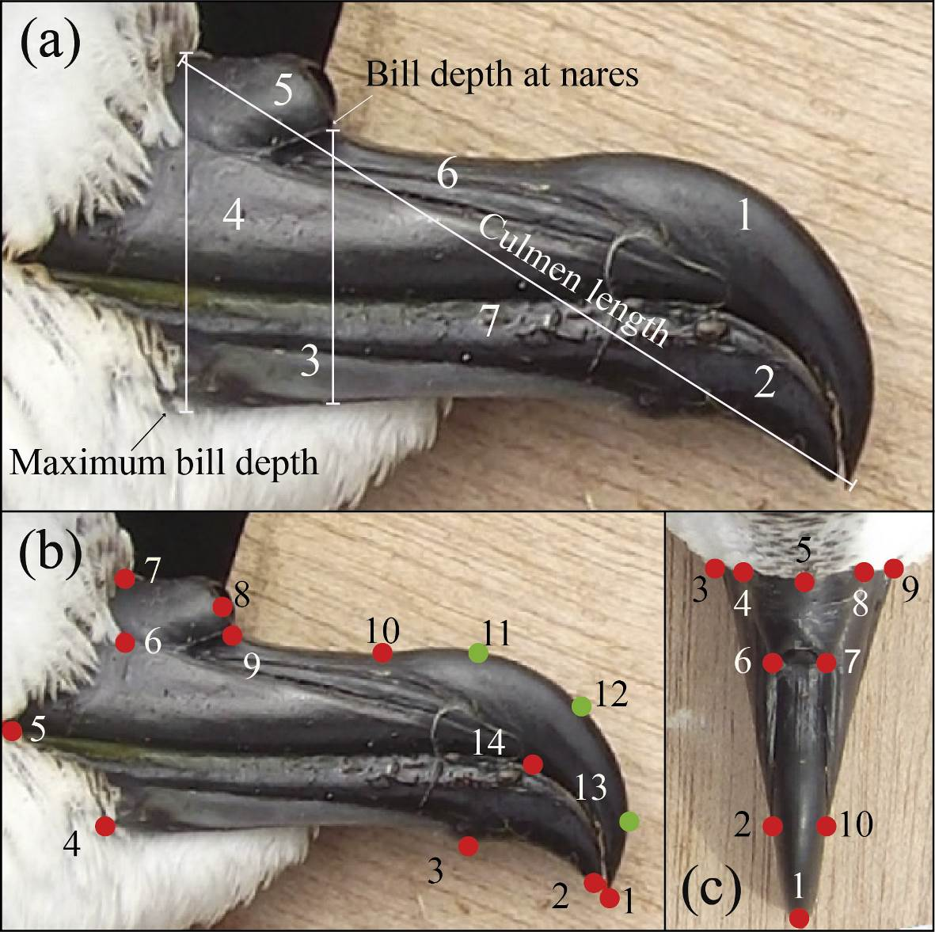

Figure 2. (a) Graphical representation of the morphospace of the shape of the right profile of the bills of Antarctic prion, blue petrel, common diving petrel and South Georgia diving petrel. The consensus configuration for each species and the percentage of morphological variability represented by each axis are provided. Relative warp 1 (RW1) and relative wrap 2 (RW2) from generalized procrustes analysis (GPA). (b) Descriptions of the meaning of the relative warps RW1 and RW2, which describe the horizontal and vertical axes of the morphospace, respectively. The most extreme forms (deformation grid) of each axis, both positive and negative, are included.
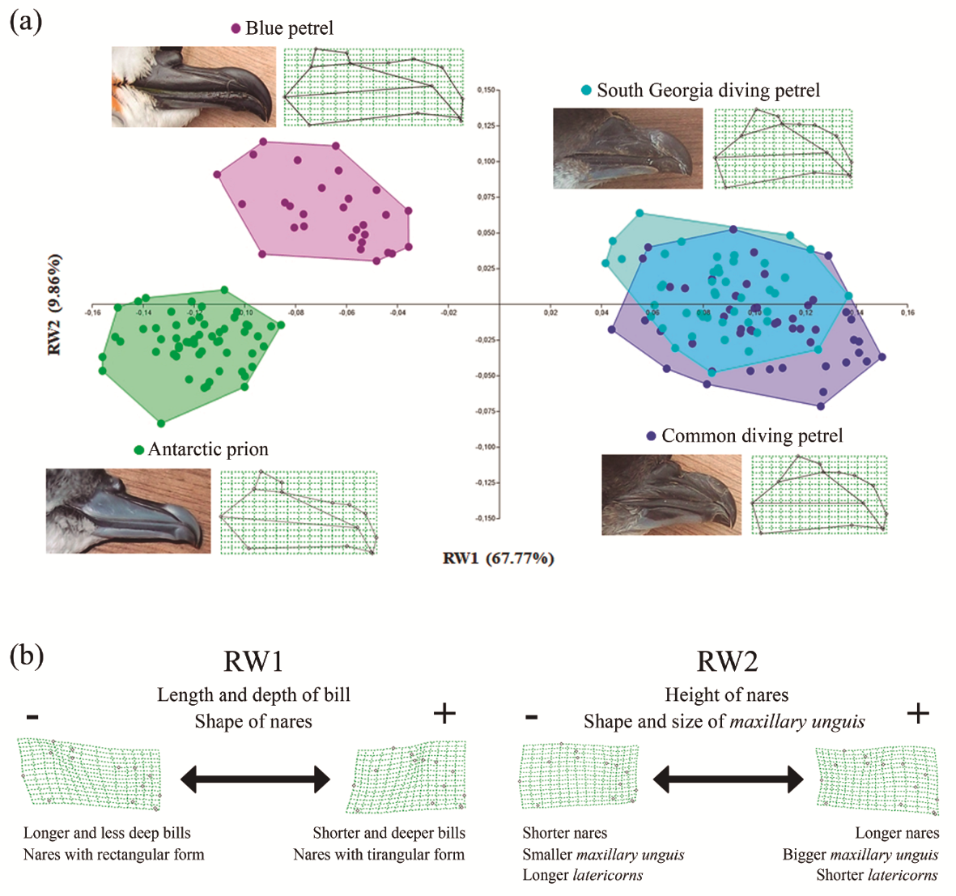

Figure 3. (a) Graphical representation of the morphospace of the shape of the dorsal view of the bills of Antarctic prion, blue petrel, common diving petrel and South Georgia diving petrel. The consensus configuration for each species and the percentage of morphological variability represented by each axis are provided. Relative warp 1 (RW1) and relative wrap 2 (RW2) from generalized procrustes analysis (GPA). (b) Descriptions of the meaning of the relative warps RW1 and RW2, which describe the horizontal and vertical axes of the morphospace, respectively. The most extreme forms (deformation grid) of each axis, both positive and negative, are included.
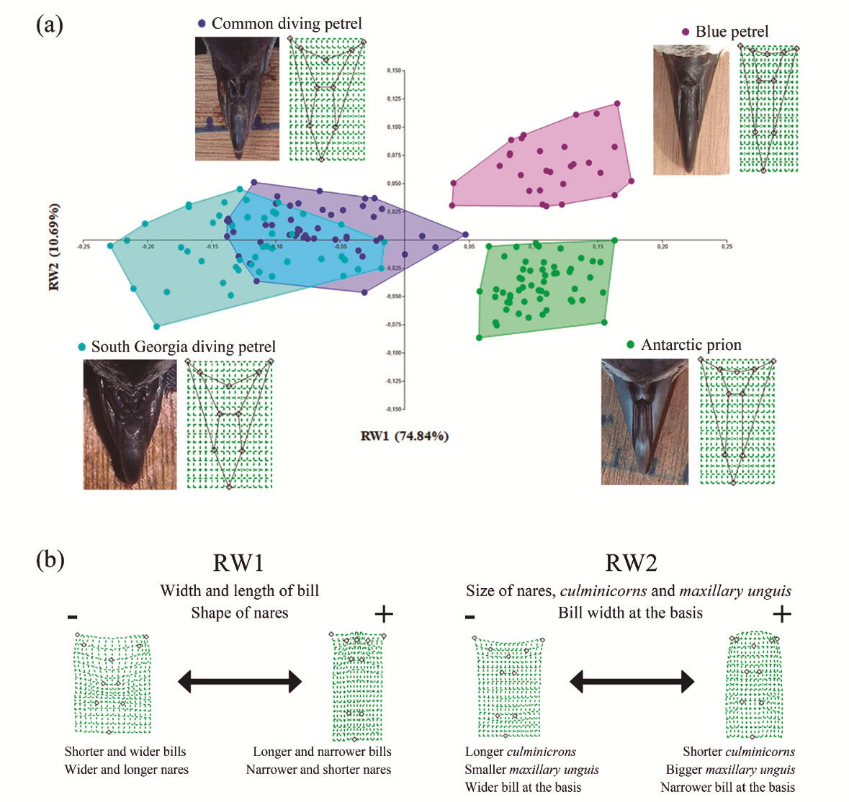

Figure 4. Graphical representation of the morphospaces that differed significantly (according to Student’s t-tests; Table 3) between males (dark blue) and females (light blue): (a) profile shape of the bill of Antarctic prion; (b) profile shape of the bill of blue petrel and (c) profile shape of the bill of common diving petrel. The consensus configuration of both sex within each morphospace and the percentage of the total morphological variability represented by each axis are included. Relative warp 1 (RW1) and relative wrap 2 (RW2) from generalized procrustes analysis (GPA).


