Accumulate or eliminate? Seasonal mercury dynamics in albatrosses, the most contaminated family of birds

Yves Cherel^{1,*}, Christophe Barbraud¹, Maxime Lahournat^{1,2},

Audrey Jaeger^{1,3}, Sébastien Jaquemet³, Ross M Wanless⁴,

Richard A Phillips⁵, David R Thompson⁶, Paco Bustamante²

¹Centre d'Etudes Biologiques de Chizé, UMR 7372 du CNRS-Université de La Rochelle, 79360 Villiers-en-Bois, France
²Littoral, Environnement et Sociétés, UMR 7266 du CNRS-Université de la Rochelle, 2 rue Olympe de Gouges, 17000 La Rochelle, France
³Laboratoire ENTROPIE, UMR 9220 du CNRS- IRD-Université de La Réunion, 15 Avenue René Cassin, BP 92003, 97744 Saint-Denis, La Réunion, France
⁴DST/NRF Centre of Excellence, Percy FitzPatrick Institute of African Ornithology, University of Cape Town, Rondebosch 7701, South Africa
⁵British Antarctic Survey, Natural Environment Research Council, High Cross, Madingley Road, Cambridge CB3 0ET, UK
⁶National Institute of Water and Atmospheric Research Ltd, 301 Evans Bay Parade, Hataitai, Wellington 6021, New Zealand

* Corresponding author
E-mail: cherel@cebc.cnrs.fr
Phone: + 33 5 49 09 78 35

ABSTRACT: Albatrosses (Diomedeidae) are iconic pelagic seabirds whose life-history traits (longevity, high trophic position) put them at risk of high levels of exposure to methylmercury (MeHg), a powerful neurotoxin that threatens humans and wildlife. Here, we report total Hg (THg) concentrations in body feathers from 516 individual albatrosses from 35 populations, including all 20 taxa breeding in the Southern Ocean. Our key finding is that albatrosses constitute the family of birds with the highest levels of contamination by Hg, with mean feather THg concentrations in different populations ranging from moderate (3.8 µg/g) to exceptionally high (34.6 µg/g). Phylogeny had a significant effect on feather THg concentrations, with the mean decreasing in the order Diomedea > Phoebetria > Thalassarche. Unexpectedly, moulting habitats (reflected in feather δ¹³C values) was the main driver of feather THg concentrations, indicating increasing MeHg exposure with decreasing latitude, from Antarctic to subtropical waters. The role of moulting habitat suggests that the majority of MeHg eliminated into feathers by albatrosses is from recent food intake (income strategy). They thus differ from species that depurate MeHg into feathers that has been accumulated in internal tissues between two successive moults (capital strategy). Since albatrosses are amongst the most threatened families of birds, it is noteworthy that two albatrosses listed as Critical by the World Conservation Union (IUCN) that moult and breed in temperate waters are the most Hg-contaminated species (the Amsterdam and Tristan albatrosses). These data emphasize the urgent need for robust assessment of the impact of Hg contamination on the biology of albatrosses and they document the high MeHg level exposure of wildlife living in the most remote marine areas on Earth.
Keywords: Antarctica · Feathers · Foraging · Methylmercury · Moult · Seabirds · Southern Ocean · Stable isotopes
Capsule: Albatrosses is the most mercury contaminated avian family and their feather Hg concentration reflects the birds’ moulting habitat (income strategy)

INTRODUCTION

Mercury (Hg) is a persistent and non-essential trace element that ranks third on the priority list of hazardous substances, based on toxicity and prevalence at contaminated sites (ATSDR; https://www.atsdr.cdc.gov/spl/). Hg is mobilized from geological deposits through both natural and anthropogenic processes and travels long distances within the atmosphere to reach even the most remote regions on Earth located far from emission sources. After atmospheric deposition, microorganisms methylate inorganic Hg (iHg) into methylmercury (MeHg), a powerful neurotoxin that bio-accumulates in organisms and biomagnifies in food webs to levels that pose major health risks to humans and wildlife (Driscoll et al., 2013). Among consumers, birds exhibit varying levels of trophic, spatial and temporal integration of contaminants and so are effective sentinels of MeHg bioavailability (Furness, 1993; Evers et al., 2005). Since MeHg contamination increases from terrestrial to aquatic ecosystems, consumption of freshwater and marine foods constitutes the major sources of MeHg exposure in humans and animals (Evers et al., 2005; Driscoll et al. 2013). Hence, seabirds have been frequently used as indicators of MeHg contamination in the marine environment (Monteiro and Furness, 1995; Burger and Gochfeld, 2004).
Albatrosses are iconic pelagic seabirds with life-history traits that make them potentially at high risk of MeHg exposure. They are extremely long-lived animals with some individuals living > 50 years (Wasser and Sherman, 2010), and they are at the top of the food web, typically preying on, or scavenging large carnivorous nekton (Cherel and Klages, 1998; Cherel et al., 2017). The liver is the principal tissue for long-term Hg storage (Thompson, 1990), and pioneering studies have shown that some albatross livers contained amongst the highest total Hg (THg) levels documented for apparently healthy free-living vertebrates, albeit lower than those recorded in some marine mammals (Muirhead and Furness, 1988; Honda et al.; 1989; Stewart et al., 1999). Subsequent measurements generally confirmed substantial Hg contamination of albatrosses, but with large variation depending on tissue type, individual, population and species (Thompson et al., 1993; Kim et al., 1996; Hindell et al., 1999; Stewart et al., 1999). Comparison between contemporary and historical specimens showed slight or no increase in albatross THg levels over time, thus suggesting that contamination results primarily from natural - not anthropogenic - processes (Thompson et al., 1993, but see Vo et al., 2011). The inference is that albatrosses are amongst the organisms most contaminated by Hg (Thompson et al., 1993), but the available data set remained largely incomplete and suffered from several limitations: (i) many taxa and populations have not been sampled, (ii) sample sizes were often low (n < 5), and (iii) relating published data to a species under the current taxonomy can be difficult because of splitting of species in the last decade (Phillips et al., 2016). This, together with the remoteness of most colonies, has resulted in a critical lack of comprehensive knowledge on Hg contamination in albatrosses.
Here, we report THg concentrations in 516 individual albatrosses from 35 populations, including all 20 species and subspecies that breed in the Southern Ocean, thus providing new information on THg levels in 11 taxa and 22 populations (Table 1). THg concentration was measured in body feathers for practical, ethical and scientific reasons: (i) body feathers can be collected easily and non-invasively from live birds and they allow comparisons of metal exposure over time using museum specimens (Thompson et al., 1993; Vo et al., 2011; Carravieri et al., 2016), (ii) body feathers present less THg variation than do wing and tail feathers, and their collection does not impair flying ability (Furness et al., 1986; Thompson et al., 1993), (iii) most THg in feathers is organic, thus providing a mean of measuring MeHg exposure of birds (Thompson and Furness, 1989b; Renedo et al., 2017), and (iv) plumage is a major pathway for MeHg elimination in avian species (Burger, 1993; Monteiro and Furness, 1995). We tested for the importance of several potential factors that might drive Hg exposure, including breeding frequency, geographical location of the breeding colonies and isotopic proxies of the foraging habitats and trophic levels during moult (feather δ¹³C and δ¹⁵N, respectively). In addition, we examined a potential latitudinal effect on Hg exposure in the Southern Ocean, because recent investigations indicate that birds foraging in colder, southerly waters present lower tissue Hg concentrations than those feeding further north in temperate waters (Carravieri et al., 2014a, 2016, 2017).

MATERIALS AND METHODS

Study sites, birds and sampling

Body feathers were collected at each breeding site from 7 to 33 randomly chosen adult albatrosses over the period 2004-2013. Fieldwork was carried out on 14 islands and archipelagos that are scattered within the Southern Ocean (south of the Subtropical Front, STF) or in warmer fringing waters (Table S1). Two, five and seven islands were located in the Atlantic, Indian and Pacific oceans, respectively. The Subtropical (STZ), Subantarctic (SAZ) and Antarctic (AZ) Zones are here defined as the zones north of the STF, between the STF and the Polar Front (PF), and south of the Polar Front (PF), respectively (Fig. 1). The 14 sampling sites are located within the STZ (Amsterdam, Tasmanian and Chatham islands), the SAZ (Gough, Prince Edward, Crozet, Kerguelen, Auckland, Snares, Campbell, Antipodes and Bounty islands), and the AZ (South Georgia and Heard Island) (Table S1). Based on feather δ¹³C isoscapes (Jaeger et al., 2010), values of > -18.3 ‰, -21.2 to -18.3 ‰, and < -21.2 ‰ were considered to correspond to STZ, SAZ and AZ, respectively.

Moult in albatrosses and feather sampling

To test for the potential effects of foraging habitat and trophic position on feather THg concentrations, THg and isotopic values were measured on the same body feather taken from each individual albatross. In the Southern Ocean, δ¹³C values of seabirds can be used to infer their foraging habitats (Cherel and Hobson, 2007; Phillips et al., 2009; Quillfeldt et al., 2010) and δ¹⁵N values increase with trophic level (Cherel et al., 2010). Because keratin is a metabolically inactive molecule that is inert following synthesis, isotope values reflect the diet at the time of feather growth (Hobson and Clark, 1992; Bearhop et al., 2002). Hence, stable isotope analysis of feathers documents the feeding ecology of albatrosses during moult (Cherel et al., 2000; Phillips et al., 2009). Three potential limitations of the method are notable. (i) The exact timing of growth of body feathers in albatrosses is unknown as they are replaced gradually over the long inter-breeding period, with only ~7% of body feathers being moulted and regrown at any one time (Battam et al., 2010). The temporal window represented in the composition of body feathers depends on albatross breeding frequency and duration of the breeding cycle. Consequently, the inter-breeding (moulting) period spans a full year plus a winter (~16 months) in small biennial breeders (the grey-headed, sooty and light-mantled albatrosses), a full year (~12 months) in large biennial breeders of the genus Diomedea (seven taxa), and one winter (~4 months) in annual breeders (10 taxa) (Table S1). (ii) Moult of body feathers in albatrosses rarely occurs during the breeding period (Catry et al., 2013). In the present study, most feather δ¹³C and δ¹⁵N values were different from the values that characterize feeding near the breeding sites (Cherel et al., 2013), thus verifying that feather moult took place during the inter-breeding period. (iii) More importantly, there is a temporal mismatch between isotopic values and THg concentrations in feathers of adult birds. The latter is considered to represent Hg accumulated between two consecutive moulting cycles, i.e. a much longer integration period than that corresponding to feather growth (Bond, 2010). However, a preliminary analysis of our data indicated a more complex picture; feather THg concentrations were correlated with δ¹³C in feathers, which represents the carbon source in moulting habitat (see Results). The very low THg concentrations in feathers that were grown in Antarctic waters (but not further north) prompted further investigations using three albatross populations that partly moult in Antarctic waters; grey-headed, sooty and light-mantled albatrosses from the Prince Edward, Gough, and Kerguelen Islands, respectively (Jaeger et al., 2013; Cherel et al., 2013). In those birds, THg concentrations and δ¹³C and δ¹⁵N values were measured on three additional body feathers from each individual (for a total of four feathers per bird) to better investigate potential relationships between Hg exposure and the foraging ecology of albatrosses during the inter-breeding period.

Mercury and stable isotope analyses

THg concentrations, δ¹³C and δ¹⁵N values were measured on the same individual body feathers. Feathers were first cleaned to remove surface contaminants using a 2:1 chloroform:methanol solution followed by two methanol rinses. They were then oven dried for 48 h at 50°C. Feather samples (1 to 5 mg dry weight, dw) were analyzed for THg with an Advanced Mercury Analyzer spectrophotometer (Altec AMA 254) (Bustamante et al., 2006). The analyses were repeated in duplicate or triplicate until the relative standard deviation was < 10% for multiple aliquots. Tort-2 Lobster Hepatopancreas, NRC, Canada (THg concentration: 0.27 ± 0.06 μg/g dw) was used as Certified Reference Material (CRM) to check the accuracy of the method. After adjusting the CRM mass to represent the same amount of THg in reference samples as in those from feathers, our measured values for CRM averaged 0.273 ± 0.008 μg/g dw (n = 53), thus corresponding to a recovery rate of 101 ± 3%. Blanks were analysed at the beginning of each set of samples, and the detection limit of the method was 0.005 μg/g dw. Feather THg concentrations are presented relative to the dry weight.
For isotopic analyses, ~0.4 mg subsamples of the feather homogenates were weighed in tin cups. A continuous flow mass spectrometer (Thermo Scientific Delta V Advantage) was coupled to an elemental analyser (Thermo Scientific Flash EA 1112) to measure feather δ¹³C and δ¹⁵N values, and feather carbon and nitrogen contents, respectively. Stable isotope ratios are expressed using standard d notation relative to carbonate Vienna PeeDee Belemnite and atmospheric nitrogen. The internal laboratory standards were acetanilide. Observed analytical errors were < 0.10 ‰ for both δ¹³C and δ¹⁵N values. The data on feather THg concentrations of albatrosses from the Kerguelen Islands, and most of the data presented here on feather δ¹³C and δ¹⁵N values are already published, but in distinct scientific contexts (Cherel et al., 2013; Carravieri et al., 2014b). Values are means ± SD.

Statistical analyses

The effects of species, phylogeny (Diomedea, large Thalassarche, small Thalassarche, Phoebetria), breeding frequency, breeding location, oceanographic zone (Table S1), ocean basin (Indian, Pacific, Atlantic), and foraging habitat and trophic level during moult (δ¹³C and δ¹⁵N, respectively) on feather THg concentrations (516 feathers from 516 individuals from 35 populations) were investigated using non-parametric smoothing regression techniques. While body condition is a main driving factor of avian THg concentrations (Fort et al. 2015), its effect was not tested because moult occurs at sea, thus precluding handling albatrosses at that time.
We used Generalised Additive Mixed Models (GAMM) in order to model potential non-linear relationships between THg concentrations and covariates, and to account for pseudo-replication. Indeed, our sampling unit was the population (n = 35, Table S1), represented by several individuals (mean of 15 ± 6, range 7-33). Population was thus modelled as a random effect in the GAMM. Data exploration was first carried out following Zuur et al. (2009). We then used variance inflation factors to assess which explanatory variables were collinear and should be dropped, based on a cut-off value of 4 (Zuur et al., 2009). The following was then considered as a starting model:
THg ~ s(δ¹³C) + s(δ¹⁵N) + species + phylogeny + breeding frequency + breeding location + oceanographic zone + ocean basin + two-way interactions between all categorical variables + random(population).
We then searched for the optimal model in terms of the explanatory variables and their interactions using a top-down strategy removing terms with non-significant p-values (significance level of α < 0.01). The GAMM models (‘gamm4’ library, version 0.2-4) were specified with a Gaussian family and a penalized thin plate regression spline, the optimal span for smoothing was determined by AIC, and the smoothing parameters estimated using restricted maximum likelihood (Wood, 2003; Zuur et al., 2009). The adjusted R-squared for the model was defined as the proportion of variance explained, where original variance and residual variance were both estimated using unbiased estimators. Model validation was performed by inspecting the relationship between residuals and fitted values (Zuur et al., 2009). GAMM analyses were performed using R 3.3.2 (R Development Core Team, 2016) and other statistical analyses using SYSTAT 13 for WINDOWS (Systat Software, Chicago).

RESULTS

THg concentrations varied 49-fold within the whole data set (618 body feathers), with the lowest value in a light-mantled albatross from the Kerguelen Islands and the highest in an Amsterdam albatross from Amsterdam Island (1.4 and 70.6 µg/g dw, respectively). All measurements of feather THg were > 1 µg/g, of which 74.1% and 1.1% were > 5 µg/g and > 40 µg/g, respectively, which are the two most widely used toxicity thresholds for feather THg (Burger and Gochfeld, 1997; Evers et al., 2008). Notably, all of the seven most THg-contaminated feathers (> 40 µg/g) were from Diomedea albatrosses, including four Amsterdam albatrosses. At the population level (n = 35), THg concentrations varied nine-fold, with mean values ranging from 3.8 µg/g in Atlantic yellow-nosed albatross to 34.6 µg/g in Amsterdam albatross (Fig. 2, Table S1). Accordingly, feather THg concentrations differed significantly between populations (Kruskal-Wallis, H = 353.3, p < 0.0001).
Results from the optimal GAMM model are presented in Table 2. Of the fixed factors, species, breeding frequency, breeding location, oceanographic zone and ocean basin were not retained, but phylogeny and feather δ¹³C and δ¹⁵N values had significant effects on feather THg concentrations. THg concentrations differed between albatross taxa, from 6.4 ± 4.4 µg/g in small Thalassarche species to 21.9 ± 11.0 µg/g in Diomedea spp. (Fig. 3). Feather THg concentrations were positively related to feather δ¹³C values (Fig. 4) and the estimated degree of freedom of the smooth term (2.74) indicated a near-linear effect. In contrast, the relationship between feather δ¹⁵N and THg concentrations was clearly non-linear (Fig. 4). The overall deviance explained by the optimal model was 49.5%. The population random effect explained 48.9% of the total variance of the residuals. There was no pattern between the residuals and the fitted values.
As expected, feather δ¹³C values ranged widely in the three populations for which isotopic values and THg concentrations were determined on four body feathers per bird. Grey-headed, sooty and light-mantled albatrosses moulted over a large latitudinal gradient from Antarctica to the subtropics, with considerable variation both within and between individuals (Table 3, Fig. 5). Two features are notable: (i) all feathers that were grown in the AZ contained less THg than those moulted and regrown further north, and (ii) THg concentrations of feathers grown in the AZ remained low over a wide range of δ¹⁵N values. For example, feathers of light-mantled albatrosses contained 8.8 times more THg if they were grown in the STZ than in the AZ, with no overlap in feather THg concentrations between the two groups. There was no change in THg concentration in feathers grown in the AZ, while their δ¹⁵N values ranged from 7.3 to 11.7 ‰ (a 4.4 ‰ difference). When feathers grew in warmer waters, THg concentrations were high, ranged widely and were associated with higher δ¹⁵N values (Fig. 5). Conversely, feathers of grey-headed albatrosses that were grown south and north of the PF showed no significant difference in mean δ¹⁵N values (n = 8 and 36, 11.0 ± 1.1 and 11.8 ± 1.5 ‰, respectively, Mann-Whitney test, U = 86.0, p = 0.078), but those grown in the AZ contained 2.4 times less THg than those grown further north (4.5 ± 1.2 and 10.9 ± 6.4 µg/g; U = 22.0, p < 0.0001).

DISCUSSION

Our key finding is that albatrosses are the most contaminated by Hg of all families of birds. The present work provides extensive new data on MeHg exposure in albatrosses from the Southern Ocean, where most species breed, thus allowing a comprehensive synthesis of the available information on albatrosses worldwide (Table 1). Two features are notable: (i) THg measurements are urgently needed from two Pacific Phoebastria species, waved albatross and short-tailed albatross (but see Shinsuke et al., 2003), and (ii) seven (32%) of the albatross species and subspecies present mean body feather THg concentrations ≥ 20 µg/g, including all five taxa of the wandering albatross species complex (wandering, Antipodean, Gibson’s, Amsterdam and Tristan albatrosses), sooty albatross, and black-footed albatross. A review of THg body feathers emphasizes the exceptionally high contamination levels of albatrosses when compared to adult seabirds from the more investigated Northern Atlantic and Northern Pacific (>35°N; from 0.6 to 22.6 µg/g, and from 0.9 to 10.3 µg/g, respectively) (Kim et al. 1996, Monteiro et al. 1999, Bond and Diamond 2008, Eagles-Smith et al. 2009). Only four populations of Procellariidae (closely-related to Diomedeidae) showed THg levels ≥ 20 µg/g, northern giant petrel Macronectes halli and great-winged petrel Pterodroma macroptera from Prince Edward Islands, Atlantic petrel P. incerta from Gough, and Bulwer’s petrel Bulweria bulwerii from the Azores, Madeira and Salvages (Monteiro et al., 1999; Becker et al., 2016). In contrast, average THg body feather levels ≥ 20 µg/g are very rare in other avian species, occurring only in a few diurnal and nocturnal raptors from the more contaminated Northern Hemisphere (Burger, 1993; Bowerman et al., 1994), and in tern chicks in two highly polluted areas (Furness et al., 1995; Herring et al., 2012).
Phylogeny explained much of the variation in feather THg concentrations in albatrosses; Diomedea species ranked first, and their body feathers contained on average 3.4 more THg than smaller Thalassarche species (Fig. 3). The wandering albatross species complex were the most Hg contaminated taxa, whereas northern and southern royal albatrosses showed moderate THg levels. These two groups of Diomedea albatrosses have essentially the same life-history traits, differing ecologically only in their main feeding grounds. Royal albatrosses forage primarily in neritic waters, whereas the wandering albatross and related taxa are essentially oceanic (Nicholls et al., 2002; Waugh and Weimerskirch, 2003), which fits well with a pattern of increasing feather THg values from coastal to oceanic seabirds (Ochoa-acuña et al., 2002). Phoebetria albatrosses ranked second, with the differences between the two species in feather THg concentrations likely explained by contrasting distributions; light-mantled albatrosses partly moult in the AZ, whereas sooty albatrosses do so further north (see below). Finally, the lowest feather THg concentrations were found in Thalassarche albatrosses; these are small to medium-sized albatrosses that are mostly annual breeders and, because they tend to eat more crustaceans, do not feed at as high trophic levels as the Diomedea albatrosses (Prince et al., 1993; Cherel and Klages, 1998; Jaeger et al., 2013). They thus differ from Diomedea and Phoebetria albatrosses in several life-history traits, which likely explain the lower THg concentrations in their feathers (this study), and also in internal tissues (Stewart et al., 1999).
Feather δ¹⁵N was also related to THg concentrations, which was to some extent expected given δ¹⁵N values is a proxy of trophic level and hence linked to biomagnification processes within ecosystems (the higher the trophic position, the higher the MeHg exposure). However, the relationship was nonlinear (Fig. 4), indicating a more complex relationship involving other confounding factors, including varying δ¹⁵N baselines at moulting grounds. The large range of feather δ¹³C values showed that plumage replacement took place in habitats that varied from Antarctic oceanic waters to northern coastal upwelling zones, depending on species, population and individual (Cherel et al., 2013). The different moulting habitats are likely marked by contrasting δ¹⁵N baselines that propagate up the food webs and thus raw δ¹⁵N values do not directly indicate relative trophic level. For example, the δ¹⁵N baseline varies little within the Southern Ocean but increases sharply at the STF, remaining elevated further north (Altabet and François, 1994), and the δ¹⁵N baseline varies significantly within the Humboldt Current where many albatrosses moult (Mollier-Vogel et al., 2012; Cherel et al., 2013).
Another key finding of the present study was the major influence of feather δ¹³C values, which reflect moulting habitat, on feather THg concentration in albatrosses. Conversely, breeding locality, oceanographic zone and ocean basin during breeding did not show significant relationships with feather THg concentration. This is presumably related largely to the timing of body feather moult, which takes place during the inter-breeding period. Importantly, our results indicate that in albatrosses, body feather THg concentration integrates predominantly very short-term MeHg intake at the temporal scale of a single growing body feather (Fig. 5). Consequently, there is no temporal mismatch between feather stable isotopic values and THg concentrations, all three parameters reflecting the feeding habits of albatrosses during feather growth. Hence, unlike feathers from most birds (Furness et al., 1986; Braune and Gaskin 1987; Bond, 2010), body feathers of albatrosses carry information about MeHg availability on the moulting grounds, with differences in the carbon source reflected in δ¹³C values.
Furthermore, it follows that because albatross body feather THg concentrations reflect MeHg intake over the time of feather growth, feather THg concentrations do not fully reflect MeHg accumulation over the long-term. Thus, plumage renewal in albatrosses does not appear to be a mechanism by which much of MeHg accumulated during the inter-moult period can be eliminated, unlike many other bird species that excrete most ingested and stored MeHg into newly grown feathers (Burger, 1993; Monteiro & Furness, 1995). Consequently, a critical issue for albatrosses is the fate of ingested MeHg, specifically in order to cope with potentially toxic effects. Since albatrosses are known to efficiently demethylate MeHg, we propose that they use two complementary detoxification mechanisms: (i) during moult, dietary MeHg is primarily eliminated directly into the keratin of growing feathers, and (ii) outside the moulting period, MeHg is continuously converted to iHg in the liver where it accumulates. These two mechanisms explain: (i) why feather THg does not increase with age in albatrosses (Thompson et al., 1993; Tavarez et al., 2013; Bustamante et al., 2016), (ii) the records of exceptionally high liver THg concentrations, with a large predominance of iHg over MeHg, in some (presumably old) individual albatrosses (Honda et al., 1989; Thompson and Furness, 1989a; Kim et al., 1996; Stewart et al., 1999), and (iii) the much lower THg burden in feathers (< 10%) than in the whole body, indicating that THg excretion during the moult is negligible in albatrosses (Honda et al., 1989; Kim et al., 1996).
We conclude that two strategies to deal with ingested MeHg operate in birds and we propose to call them the income and capital strategies in reference to the previous definition of those terms in the management of energy for breeding (Jonsson, 1997). Birds adopting the income strategy (e.g. albatrosses) convert ingested MeHg to iHg in the liver outside the moulting period and only eliminate MeHg ingested during feather growth into newly growing feathers. In species using the capital strategy (e.g. gulls; Braune and Gaskin, 1987), most feather MeHg comes from the accumulation of dietary MeHg into the body reservoir during the period between successive moults. A consequence of the capital strategy is that, unlike in albatrosses, feathers grown by these other species contain a major part (56-94%) of the THg burden of the whole body, indicating that they are the endpoint in a primary pathway for THg elimination (Burger, 1993; Monteiro and Furness, 1995). The concept of income and capital strategies requires further investigation, especially because some birds probably fall somewhere along an income-capital continuum. Albatrosses stands at the income end of the spectrum, and the income strategy is likely to be the prominent strategy in seabirds for which the moulting habitat affects feather THg concentrations (Fort et al., 2014; Watanuki et al., 2016).
Overall, feather δ¹³C values were near-linearly and positively related to feather THg concentrations (Fig. 4). Hence, Hg exposure is higher for albatrosses moulting in warmer, more northerly, than colder, more southerly waters, because both baseline and consumer δ¹³C values vary with latitude; the higher the latitude, the lower the δ¹³C values (Cherel and Hobson, 2007; Phillips et al., 2009; Jaeger et al., 2010; Quillfeldt et al., 2010). This relationship held both between and within individual birds. While all body feathers of grey-headed, sooty and light-mantled albatrosses grown in the STZ and the SAZ had elevated THg levels, feathers grown in the AZ showed consistently low THg concentrations (Fig. 5). Surprisingly, feather THg concentrations remained low whatever their corresponding δ¹⁵N values, indicating that habitat is much more important than trophic level when moulting in the AZ. The large feather δ¹⁵N range suggests that albatrosses fed on prey from low trophic levels (probably including Antarctic krill Euphausia superba) in southern Antarctic waters to high trophic levels (fish and squid) south of the PF, but with no concomitant feather THg increase. The primary importance of feeding latitude on Hg levels is highlighted by intra- and inter-individual variation in moulting grounds. Some individuals (e.g. light-mantled albatrosses shown in green and pink on Fig. 5) replaced their plumage in various oceanic zones, resulting in contrasting THg concentrations. Other individuals moulted over a more restricted latitudinal range, and consequently, levels of Hg contamination of birds moulting in the AZ were approximately ten times lower than in those moulting further north (e.g. the cyan vs. red individuals, 2.1 vs. 19.9 µg/g; Fig. 5).
Our data confirm that exposure to MeHg of top predators decreased with increasing latitude in the Southern Ocean (Carravieri et al., 2014a, 2016, 2017). Moreover, they show a stepwise drop in MeHg availability at the PF, thus suggesting that the PF acts as an oceanographic barrier (Guynn and Peterson, 2008). Lower Hg contamination in predators feeding in the AZ in our study contrasts with earlier work on Hg in the Southern Ocean, which showed higher MeHg concentrations available at shallower depths in waters to the south, compared to the north, of the PF (Cossa et al., 2011). Two non-exclusive explanations for this apparent mismatch between the base and the top of the trophic web merit further investigations: (i) a more complex oceanic food web involving more trophic levels and thus higher MeHg biomagnification processes in warmer (northern) than colder (southern) waters, and (ii) a higher MeHg enrichment within the trophic web due to higher production of MeHg by pelagic organisms (Pucko et al., 2014) to the north of the PF.

CONCLUSIONS
Overall, albatrosses clearly illustrate how elevated THg levels in avian species are governed by a combination of several factors, specifically (i) foraging grounds marked by high MeHg bioavailability (temperate waters) and (ii) feeding at the top of trophic webs (maximal biomagnification). The Diomedeidae is among the world’s most threatened families of birds, will all the 22 species classified from Near Threatened to Critically Endangered in the IUCN Red List (Annex, Table 1). They face a number of direct and indirect threats that are causes of population declines, including climate change, fishery-related mortality, infectious diseases, introduced predators, and pollutants (Phillips et al., 2016). In this context, it is noteworthy that two of the three Critically Endangered species were also the most contaminated by Hg (Amsterdam and Tristan albatrosses), and that information is lacking on the third species (waved albatross). It is especially relevant that most individuals with THg levels above the upper feather toxicity threshold (40 µg/g; Burger and Gochfeld, 1997; Evers et al., 2008) were breeding Amsterdam albatrosses, the rarest albatross on Earth with a single population of approximately 165 adults (C. Barbraud et al., unpublished data). The whole population of Amsterdam albatrosses is at risk, because chicks are also heavily contaminated, with body feather concentrations averaging 7.8 µg/g (Y. Cherel et al., unpublished data).
One of the main problems in environmental toxicology is to interpret the impact of observed contaminant concentrations on wildlife. Most adult albatrosses have THg levels above the lower feather toxicity threshold (5 µg/g; Fig. 2), but seabirds are expected to have higher toxicity resistance than other avian taxa since they cope with relatively high MeHg ingestion through efficient hepatic demethylation processes (Thompson and Furness, 1989a; Ikemoto et al., 2004). However, pioneering investigations on the biological consequences of Hg contamination pointed out (i) negative effects of blood THg on the immune function of black-footed albatrosses (Finkelstein et al., 2007), and (ii) negative effects of blood THg on demographic parameters of wandering albatrosses (Goutte et al., 2014; Bustamante et al., 2016). These data emphasize the urgent need for robust assessment of the impact of Hg exposure on the physiology and demography of albatrosses at a species, population and individual level, because Hg loading to the World Ocean is likely to continue rising (Lamborg et al., 2014), thus driving an increase accumulation of Hg in the biota, including albatrosses (Vo et al., 2011; Becker et al., 2016).

Acknowledgements. The authors thank all those colleagues who helped with collecting albatross feathers at the different breeding sites, and G. Guillou for running stable isotope samples. The present work was partly supported financially and logistically by the Institut Polaire Français Paul Emile Victor (programme no. 109, H. Weimerskirch), the Terres Australes et Antarctiques Françaises, and the British Antarctic Survey. This paper represents a contribution to the Ecosystems component of the British Antarctic Survey Polar Science for Planet Earth Programme, funded by The Natural Environment Research Council. S Jaquemet benefited from the National Research Fundation financial support and from the South African National Antarctic Program logistical support.

LITERATURE CITED

Altabet, M.A., François, R., 1994. Sedimentary nitrogen isotopic ratio as a recorder for surface ocean nitrate utilization. Global Biogeochem Cycles 8, 103-116.
Anderson, O.R.J., Phillips, R.A., McDonald, R.A., Shore, R.F., McGill, R.A.R., Bearhop, S., 2009. Influence of trophic position and foraging range on mercury levels within a seabird community. Mar. Ecol. Prog. Ser. 375, 277-288.
Battam, H., Richardson, M., Watson, A.W.T., Buttemer, W.A., 2010. Chemical composition and tissue energy density of the cuttlefish (Sepia apama) and its assimilation efficiency by Diomedea albatrosses. J. Comp. Physiol. B 180, 1247-1255.
Bearhop, S., Waldron, S., Votier, S.C., Furness, R.W., 2002. Factors that influence assimilation rates and fractionation of nitrogen and carbon stable isotopes in avian blood and feathers. Physiol. Biochem. Zool. 75, 451-458.
Becker, P.H., Gonzalez-Solis, J., Behrends, B., Croxall, J., 2002. Feather mercury levels in seabirds at South Georgia: influence of trophic position, sex and age. Mar. Ecol. Prog. Ser. 243, 261-269.
Becker, P.H., Goutner, V., Ryan, P.G., Gonzalez-Solis, J., 2016. Feather mercury concentrations in Southern Ocean seabirds: variation by species, site and time. Environ. Pollut. 216, 253-263.
Bond, A.L., 2010. Relationships between stable isotopes and metal contaminants in feathers are spurious and biologically uninformative. Environ. Pollut. 158, 1182-1184.
Bond, A.L., Diamond, A.W., 2008. High within-individual variation in total mercury concentration in seabird feathers. Environ. Toxicol. Chem. 27, 2375-2377.
Bowerman, W.W., Evans, E.D., Giesy, J.P., Postupalsky, S., 1994. Using feathers to assess risk of mercury and selenium to bald eagle reproduction in the Great Lakes Region. Arch. Environ. Toxicol. 27, 294-298.
Braune, B.M., Gaskin, D.E., 1987. Mercury levels in Bonaparte’s gulls (Larus philadelphia) during autumn molt in the Quoddy Region, New Brunswick, Canada. Arch. Environ. Contam. Toxicol. 16, 539-549.
Burger, J., 1993. Metals in avian feathers: bioindicators of environmental pollution. Rev. Environ. Toxicol. 5, 203-311.
Burger, J., Gochfeld, M., 1997. Risk, mercury levels, and birds: relating adverse laboratory effects to field biomonitoring. Environ. Res. 75, 160-172.
Burger, J., Gochfeld, M., 2000a. Metals in albatross feathers from Midway Atoll: influence of species, age, and nest location. Environ. Res. Section A 82, 207-221.
Burger, J., Gochfeld, M., 2000b. Metal levels in feathers of 12 species of seabirds from Midway Atoll in the northern Pacific Ocean. Sci. Total Environ. 257, 37-52.
Burger, J., Gochfeld, M., 2000c. Metals in Laysan albatrosses from Midway Atoll. Arch. Environ. Contam. Toxicol. 38, 254-259.
Burger, J., Gochfeld, M., 2004. Marine birds as sentinels of environmental pollution. EcoHealth 1, 263-274.
Bustamante, P., Carravieri, A., Goutte, A., Barbraud, C., Delord, K., Chastel, O., Weimerskirch, H., Cherel, Y., 2016. High feather mercury concentrations in the wandering albatross are related to sex, breeding status and trophic ecology with no demographic consequences. Environ. Res. 144, 1-10.
Bustamante, P., Lahaye, V., Durnez, C., Churlaud, C., Caurant, F., 2006. Total and organic Hg concentrations in cephalopods from the North East Atlantic waters: influence of geographical origin and feeding ecology. Sci. Total Environ. 368, 585–596.
Carravieri, A., Bustamante, P., Tartu, S., Meillère, A., Labadie, P., Budzinski, H., Peluhet, L., Barbraud, C., Weimerskirch, H., Chastel, O., Cherel, Y., 2014a. Wandering albatrosses document latitudinal variations in the transfer of persistent organic pollutants and mercury to Southern Ocean predators. Environ. Sci. Technol. 48, 14746-14755.
Carravieri, A., Cherel, Y., Blévin, P., Chastel, O., Brault-Favrou, M., Chastel, O., Bustamante, P., 2014b. Mercury exposure in a large subantarctic avian community. Environ. Pollut. 190, 51-57.
Carravieri, A., Cherel, Y., Brault-Favrou, M., Churlaud, C., Peluhet, L., Labadie, P., Budzinski, H., Chastel, O., Bustamante, P., 2017. From Antarctica to the subtropics: contrasted geographical concentrations of selenium, mercury, and persistent organic pollutants in skua chicks (Catharacta spp.). Environ. Pollut. 228, 464-473.
Carravieri, A., Cherel, Y., Jaeger, A., Churlaud, C., Bustamante, P., 2016. Penguins as bioindicators of mercury contamination in the southern Indian Ocean: geographical and temporal trends. Environ. Pollut. 213, 195-205.
Catry, P., Poisbleau, M., Lecoq, M., Phillips, R.A., 2013 Differences in the timing and extent of annual moult of black-browed albatrosses Thalassarche melanophris living in contrasting environments. Polar Biol. 36, 837–842.
Cherel, Y., Fontaine, C., Richard, P., Labat, J.P., 2010. Isotopic niches and trophic levels of myctophid fishes and their predators in the Southern Ocean. Limnol. Oceanogr. 55, 324-332.
Cherel, Y., Hobson, K.A., 2007. Geographical variation in carbon stable isotope signatures of marine predators: a tool to investigate their foraging areas in the Southern Ocean. Mar. Ecol. Prog. Ser. 329, 281-287.
Cherel, Y., Hobson, K.A., Weimerskirch, H., 2000. Using stable-isotope analysis of feathers to distinguish moulting and breeding origins of seabirds. Oecologia 122, 155-162.
Cherel, Y., Jaeger, A., Alderman, R., Jaquemet, S., Richard, P., Wanless, R.M., Phillips, R.A., Thompson, D.R., 2013. A comprehensive isotopic investigation of habitat preferences in nonbreeding albatrosses from the Southern Ocean. Ecography 36, 277-286.
Cherel, Y., Klages, N., 1998. A review of the food of albatrosses. In: Robertson G, Gales R (eds) Albatross Biology and Conservation. Surrey Beatty and Sons, Chipping Norton, Australia, p. 113-136.
Cherel, Y., Xavier, J.C., de Grissac, S., Trouvé, C., Weimerskirch, H., 2017. Feeding ecology, isotopic niche, and ingestion of fishery-related items of the wandering albatross Diomedea exulans at Kerguelen and Crozet Islands. Mar. Ecol. Prog. Ser. 565, 197-215.
Cossa, D., Heimbürger, L.E., Lannuzel, D., Rintoul, S.R., Butler, E.C.V., Bowie, A.R., Averty, B., Watson, R.J., Remenyi, T., 2011. Mercury in the Southern Ocean. Geochim. Cosmochim. Acta 75, 4037–4052.
Driscoll, C.T., Mason, R.P., Man Chan, H., Jacob, D.J., Pirrone, N., 2013. Mercury as a global pollutant: sources, pathways, and effects. Environ. Sci. Technol. 47, 4967-4983.
Eagles-Smith, C.A., Ackerman, J.T., de La Cruz, S.E.W., Takekawa, J.Y., 2009. Mercury bioaccumulation and risk to three waterbird foraging guilds is influenced by foraging ecology and breeding stage. Environ. Pollut. 157, 1993-2002.
Evers, D.C., Burgess, N.M., Champoux, L., Hoskins, B., Major, A., Goodale, W.M., Taylor, R.J., Poppenga, R., Daigle, T., 2005 Patterns and interpretation of mercury exposure in freshwater avian communities in northeastern North America. Ecotoxicol. 14, 193-221.
Evers, D.C., Savoy, L.J., DeSorbo, C.R., Yates, D.E., Hanson, W., Taylor, K.M., Siegel, L.S., Cooley, Jr. J.H., Bank, M.S., Major, A., Munney, K., Mower, B.F., Vogel, H.S., Schoch, N., Pokras, M., Goodale, M.W., Fair, J., 2008. Adverse effects from environmental mercury loads on breeding common loons. Ecotoxicology 17, 69-81.
Finkelstein, M.E., Grasman, K.A., Croll, D.A., Tershy, B.R., Keitt, B.S., Jarman, W.M., Smith, D.R., 2007. Contaminant-associated alteration of immune function in black-footed albatross (Phoebastria nigripes), a North Pacific predator. Environ. Toxicol. Chem. 26, 1896-1903.
Fort, J., Lacoue-Labarthe, T., Nguyen, H.L., Boué, A., Spitz, J., Bustamante, P., 2015. Mercury in wintering seabirds, an aggravating factor to winter wrecks? Sci. Total Environ. 527-528, 448-454.
Fort, J., Robertson, G.J., Grémillet, D., Traisnel, G., Bustamante, P., 2014 Spatial ecotoxicology: migratory Arctic seabirds are exposed to mercury contamination while overwintering in the northwest Atlantic. Environ Sci. Toxicol. 48, 11560-11567.
Furness, R.W., Muirhead, S.J., Woodburn, M., 1986. Using bird feathers to measure mercury in the environment: relationships between mercury content and moult. Mar. Pollut. Bull. 17, 27-30.
Furness, R.W., 1993. Birds as monitors of pollutants. In: Furness RW, Greenwood JJD (eds) Birds as Monitors of Environmental Change, Chapman & Hall, London, p. 86-143.
Furness, R.W., Thompson, D.R., Becker, P.H., 1995. Spatial and temporal variation in mercury contamination of seabirds in the North Sea. Helgölander Meeresunters 49, 605-615.
Goutte, A., Barbraud, C., Meillère, A., Carravieri, A., Bustamante, P., Labadie, P., Budzinski, H., Delord, K., Cherel, Y., Weimerskirch, H., Chastel, O., 2014. Demographic consequences of heavy metals and persistent organic pollutants in a vulnerable long-lived bird, the wandering albatross. Proc. R. Soc. Lond. B 281, 20133313.
Guynn, K.D., Peterson, M.S., 2008. Mercury concentrations in the Patagonian toothfish, Dissostichus eleginoides Smitt 1898, among three distinct stocks. Polar Biol. 31, 269-274.
Herring, G., Ackerman, J.T., Herzog, M.P., 2012. Mercury exposure may suppress baseline corticosterone levels in juvenile birds. Environ. Sci. Technol. 46, 6339-6346.
Hindell, M.A., Brothers, N., Gales, R., 1999. Mercury and cadmium concentrations in the tissues of three species of southern albatrosses. Polar Biol. 22, 102-108.
Hobson, K.A., Clark, R.G., 1992. Assessing avian diets using stable isotopes I: turnover of ¹³C in tissues. Condor 94, 181-188.
Honda, K., Kan, S., Tatsukawa, R., 1989. High residue levels and detoxification processes of mercury in pelagic seabirds from the North Pacific Ocean. In: Vernet JP (ed) Heavy Metals in the Environment, Vol 1. CEP Consultants Ltd, Edinburgh, p. 546-549.
Ikemoto, T., Kunito, T., Tanaka, H., Baba, N., Miyazaki, N., Tanabe, S., 2004. Detoxification mechanism of heavy metals in marine mammals and seabirds: interaction of selenium with mercury, silver, copper, zinc, and cadmium in liver. Arch Environ Contam. Toxicol. 47, 402-413.
Jaeger, A., Jaquemet, S., Phillips, R.A., Wanless, R.M., Richard, P., Cherel, Y., 2013. Stable isotopes document inter- and intra-specific variation in feeding ecology of nine large southern Procellariiformes. Mar. Ecol. Prog. Ser. 490, 255-266.
Jaeger, A., Lecomte, V.J., Weimerskirch, H., Richard, P., Cherel, Y., 2010. Seabird satellite tracking validates the use of latitudinal isoscapes to depict predators’ foraging areas in the Southern Ocean. Rapid Commun. Mass Spectrom. 24, 3456-3460.
Jonsson, K.I., 1997. Capital and income breeding as alternative tactics of resource use in reproduction. Oikos 78, 57-66.
Kim, E.Y., Murakami, T., Saeki, R., Tatsukawa, R., 1996. Mercury levels and its chemical form in tissues and organs of seabirds. Arch. Environ. Contam. Toxicol. 30, 259-266.
Lamborg, C., Bowman, K., Hammerschmidt, C., Gilmour, C., Munson, K., Selin, N., Tseng, C.M., 2014. Mercury in the anthropocene ocean. Oceanography 27, 76-87.
Mollier-Vogel, E., Ryabenko, E., Martinez, P., Wallace, D., Altabet, M.A., Schneider, R., 2012. Nitrogen isotope gradients off Peru and Ecuador related to upwelling, productivity, nutrient uptake and oxygen deficiency. Deep-Sea Res. I 70, 14-25.
Monteiro, L.R., Furness, R.W., 1995. Seabirds as monitors of mercury in the marine environment. Water, Air, Soil Pollut. 80, 851-870.
Monteiro, L.R., Granadeiro, J.P., Furness, R.W., Oliveira, P., 1999 Contemporary patterns of mercury contamination in the Portuguese Atlantic inferred from mercury concentrations in seabird tissues. Mar. Environ. Res. 47, 137-156.
Muirhead, S.J., Furness, R.W., 1988. Heavy metal concentrations in the tissues of seabirds from Gough Island, South Atlantic Ocean. Mar. Pollut. Bull. 19, 278-283.
Nicholls, D.G., Robertson, C.J.R., Prince, P.A., Murray, M.D., Walker, K.J., Elliott, G.P., 2002. Foraging niches of three Diomedea albatrosses. Mar. Ecol. Prog. Ser. 231, 269-277.
Ochoa-acuña, H., Sepulveda, M.S., Gross, T.S., 2002. Mercury in feathers from Chilean birds: influence of location, feeding strategy, and taxonomic affiliation. Mar. Pollut. Bull. 44, 340-349.
Phillips, R.A., Bearhop, S., McGill, R.A.R., Dawson, D.A., 2009. Stable isotopes reveal individual variation in migration strategies and habitat preferences in a suite of seabirds during the nonbreeding period. Oecologia 160, 795-806.
Phillips, R.A., Gales, R., Baker, G.B., Double, M.C., Favero, M., Quintana, F., Tasker, M.L., Weimerskirch, H., Uhart, M., Wolfaardt, A., 2016. The conservation status and priorities for albatrosses and large petrels. Biol. Conserv. 201, 169-183.
Prince, P.A., Rodwell, S., Jones, M., Rothery, P., 1993. Moult in black-browed and grey-headed albatrosses Diomedea melanophris and D. chrysostoma. Ibis 135, 121-131.
Pucko, M., Burt, A., Walkusz, W., Wang, F., Macdonald, R.W., Rysgaard, S., Barber, D.G., Tremblay, J.E., Stern, G.A., 2014. Transformation of mercury at the bottom of the Arctic food web: an overlooked puzzle in the mercury exposure narrative. Environ. Sci. Technol. 48, 7280–7288.
Quillfeldt, P., Masello, J.F., McGill, R.A.R., Adams, M., Furness, R.W., 2010. Moving polewards in winter: a recent change in the migratory strategy of a pelagic seabird? Frontiers Zool. 7, 15.
R Development Core Team, 2016. R: a Language and Environment for Statistical Computing. R Foundation for Statistical Computing, Vienna.
Renedo, M., Bustamante, P., Tessier, E., Pedrero, Z., Cherel, Y., Amouroux, D., 2017. Assessment of mercury speciation in feathers using species-specific isotope dilution analysis. Talanta 174, 100-110.
Shinsuke, T., Tokutaka, K., Takashi, T., Miyako, T., Fumio, S., Nariko, O., 2003. Trace element accumulation in short-tailed albatrosses (Diomedea albatrus) and black-footed albatrosses (Diomedea nigripes) from Torishima Island, Japan. J. Phys. IV France 107, 1231-1234.
Stewart, F.M., Phillips, R.A., Bartle, J.A., Craig, J., Shooter, D., 1999. Influence of phylogeny, diet, moult schedule and sex on heavy metal concentrations in New Zealand Procellariiformes. Mar. Ecol. Prog. Ser. 178, 295-305.
Tavarez, S., Xavier, J.C., Phillips, R.A., Pereira, M.E., Pardal, M.A., 2013. Influence of age, sex, and breeding status on mercury accumulation patterns in the wandering albatross Diomedea exulans. Environ. Pollut. 181, 315-320.
Thompson, D.R., 1990. Metal levels in marine vertebrates. In: Furness RW, Rainbow PS (eds) Heavy Metals in the Marine Environment. CRC Press, Boca Raton, p. 143-182.
Thompson, D.R., Furness, R.W., 1989a. The chemical form of mercury stored in South Atlantic seabirds. Environ. Pollut. 60, 305-317.
Thompson, D.R., Furness, R.W., 1989b. Comparison of the levels of total and organic mercury in seabird feathers. Mar. Pollut. Bull. 20, 577-579.
Thompson, D.R., Furness, R.W., Lewis, S.A., 1993. Temporal and spatial variation in mercury concentrations in some albatrosses and petrels from the sub-Antarctic. Polar Biol. 13, 239-244.
Thompson, D.R., Stewart, F.M., Furness, R.W., 1990. Using seabirds to monitor mercury in marine environments. The validity of conversion ratios for tissue comparisons. Mar. Pollut. Bull. 21, 339-342.
Vo, A.T.E., Bank, M.S., Shine, J.P., Edwards, S.V., 2011. Temporal increase in organic mercury in an endangered pelagic seabird assessed by century-old museum specimens. Proc. Nat. Acad. Sci. 108, 7466-7471.
Wasser, D.E., Sherman, P.W., 2010. Avian longevities and their interpretation under evolutionary theories of senescence. J. Zool. Lond. 280, 103-155.
Watanuki, Y., Yamashita, A., Ishizuka, M., Ikenaka, Y., Nakayama, S.M.M., Ishii, C., Yamamoto, T., Ito, M., Kuwae, T., Trathan, P.N., 2016. Feather mercury concentration in streaked shearwaters wintering in separate areas of southeast Asia. Mar. Ecol. Prog. Ser. 546, 263-269.
Waugh, S.M., Weimerskirch, H., 2003. Environmental heterogeneity and the evolution of foraging behaviour in long ranging greater albatrosses. Oikos 103, 374-384.
Wood, S.N., 2003. Thin plate regression splines. J. R. Stat. Soc. B 65, 95-114.
Zuur, A.F., Ieno, E.N., Walker, N.J., Saveliev, A.A., Smith, G.M., 2009. Mixed Effects Models and Extensions in Ecology with R. Springer, New York.
Fig. 1. Location of sampled albatross breeding populations and of the main oceanic fronts and zones of the Southern Ocean and fringing waters. Abbreviations: AZ, Antarctic Zone; PF, Polar Front; SAZ, Subantarctic Zone; STF, Subtropical Front; STZ, Subtropical Zone

Fig. 2. Concentrations of total mercury (THg) in body feathers of albatrosses from the Southern Ocean and fringing subtropical waters. Albatross taxa are placed in a sequence of increasing feather THg concentrations. Limited data for THg concentrations in feathers indicate a range of 5 to 40 µg/g (dotted lines) as being associated with adverse effects in birds (Burger and Gochfeld, 1997; Evers et al., 2008). Colour and symbols: red circles (Diomedea albatrosses), grey triangles up (large Thalassarche spp.), blue triangles down (small Thalassarche spp.), green diamonds (Phoebetria spp.). Abbreviations are detailed in Table S1. Values are means ± SD

Fig. 3. Histograms of feather THg concentrations in relation to albatross phylogeny. Large and small Thalassarche species are indicated in Table 1. Kruskal-Wallis, H = 219.89, p < 0.001; superscript letters indicate results from Conover-Inman tests for pairwise comparisons, all p < 0.0001; see also text and Table 2 for GAMM statistics. Values are means ± SD

Fig. 4. Fitted GAMM results showing the relationship between feather THg concentration and feather δ¹³C and δ¹⁵N values for the 516 sampled albatrosses. The y-axis gives the smooth transformed value, and the little vertical lines along the x-axis indicate the feather THg values of the observations. Dashed lines indicate the 95% confidence intervals

Fig. 5. Total mercury (THg) versus δ¹³C (a proxy of moulting habitat) and δ¹⁵N (a proxy of trophic position) in feathers of light-mantled albatrosses from Kerguelen Islands. THg concentrations and δ¹³C and δ¹⁵N values were measured in four different body feathers per individual (one different colour per bird). Following Jaeger et al. (2010), dashed lines correspond to the isotopic estimation of the Polar Front (PF) and of the Subtropical Front (STF), which delimit the Antarctic (AZ), Subantarctic (SAZ) and Subtropical (STZ) Zones; LMSA, light-mantled albatross. Diamonds and circles indicate feathers that grew in the Antarctic Zone and further north, respectively.

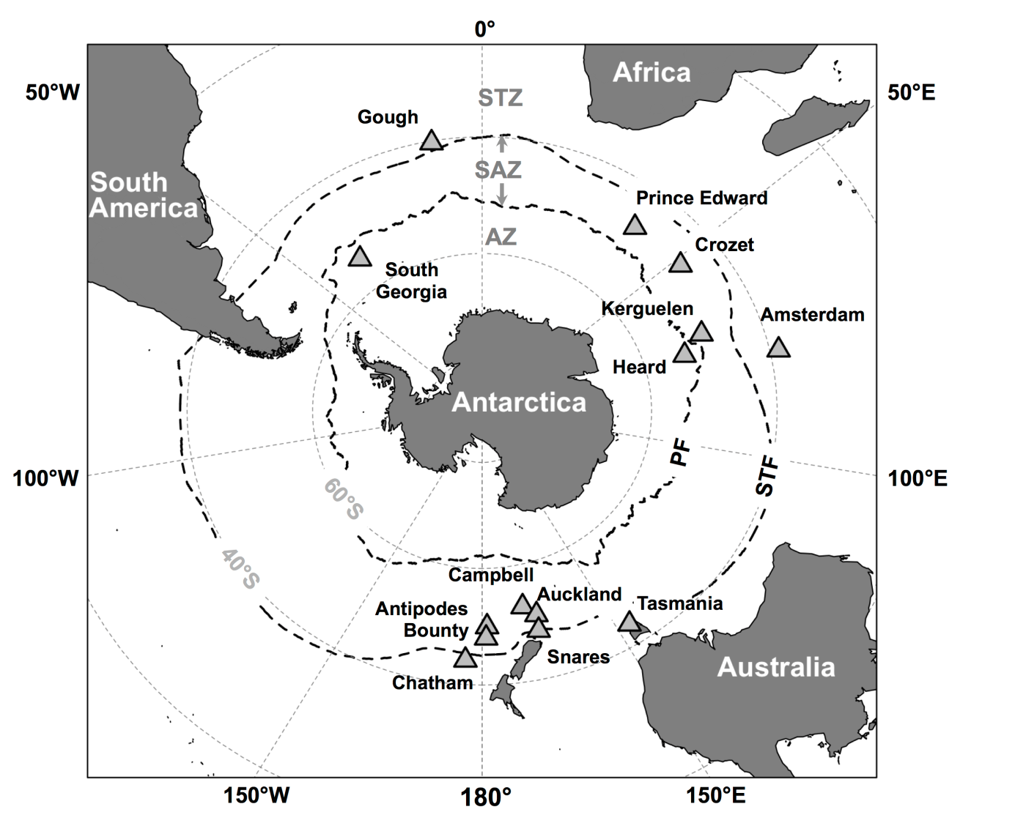

Figure 1

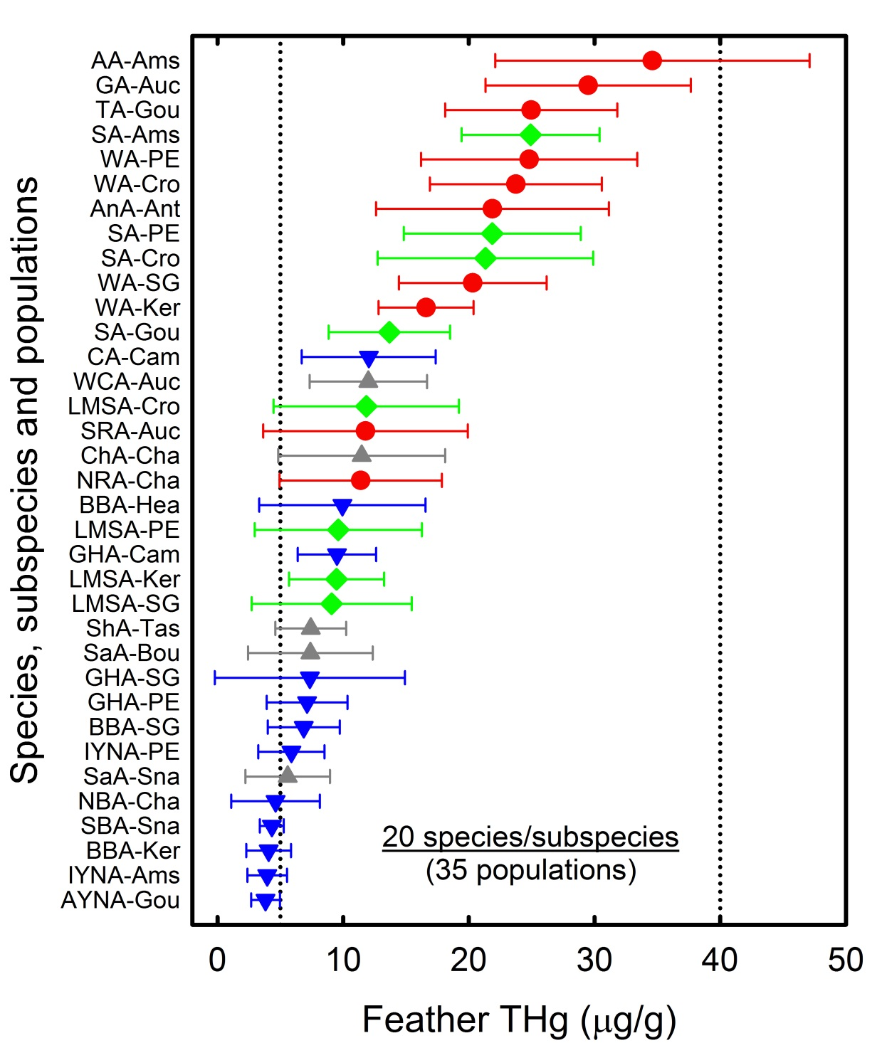

Figure 2

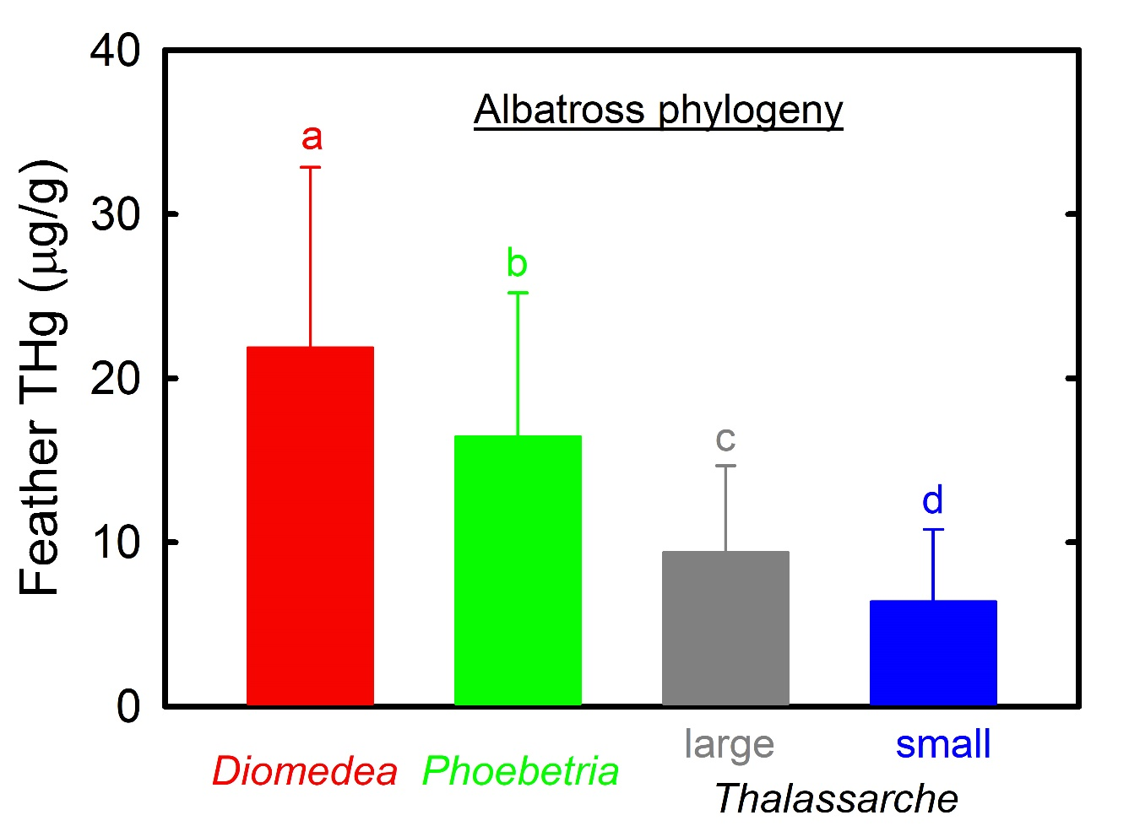

Figure 3

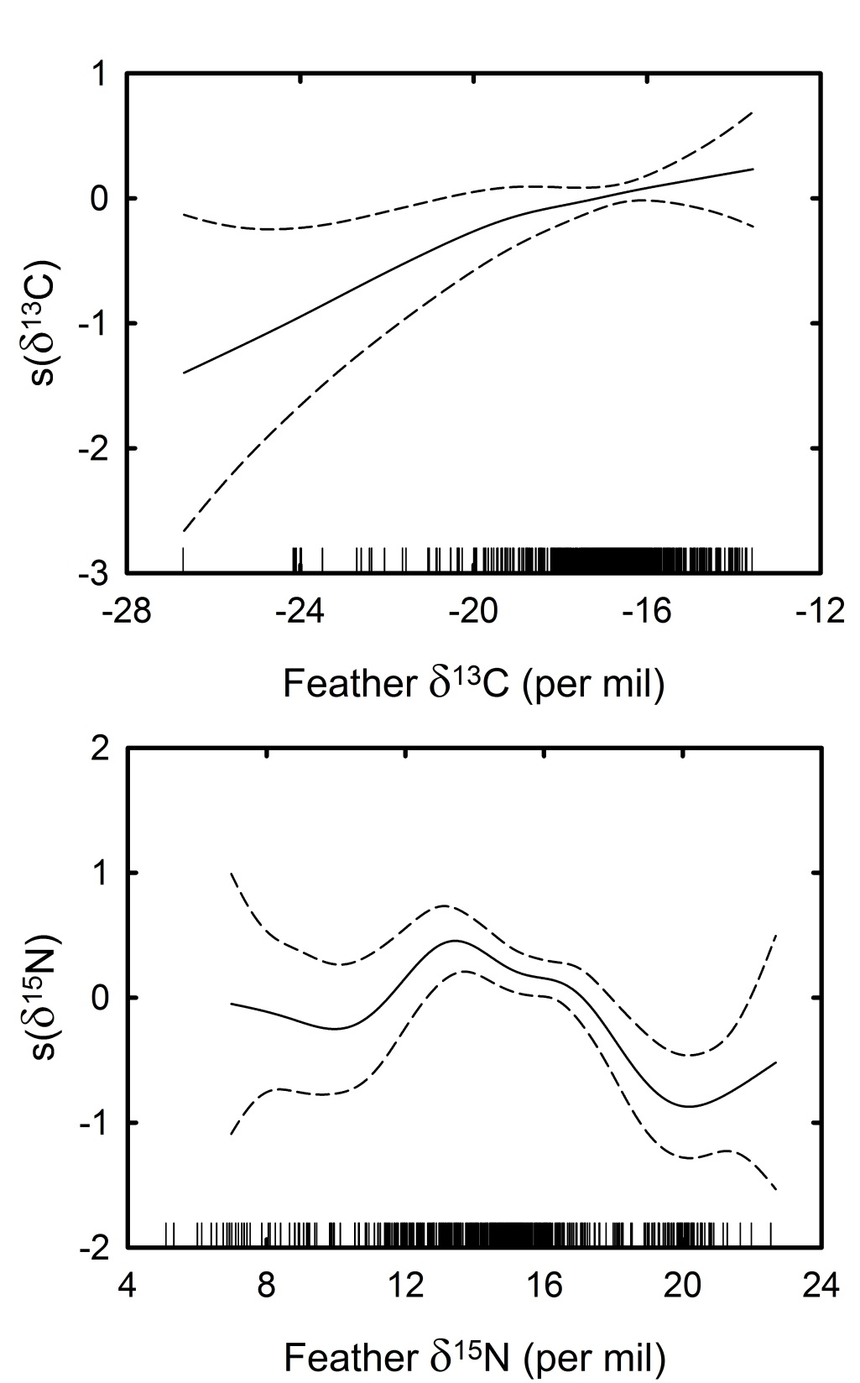

Figure 4

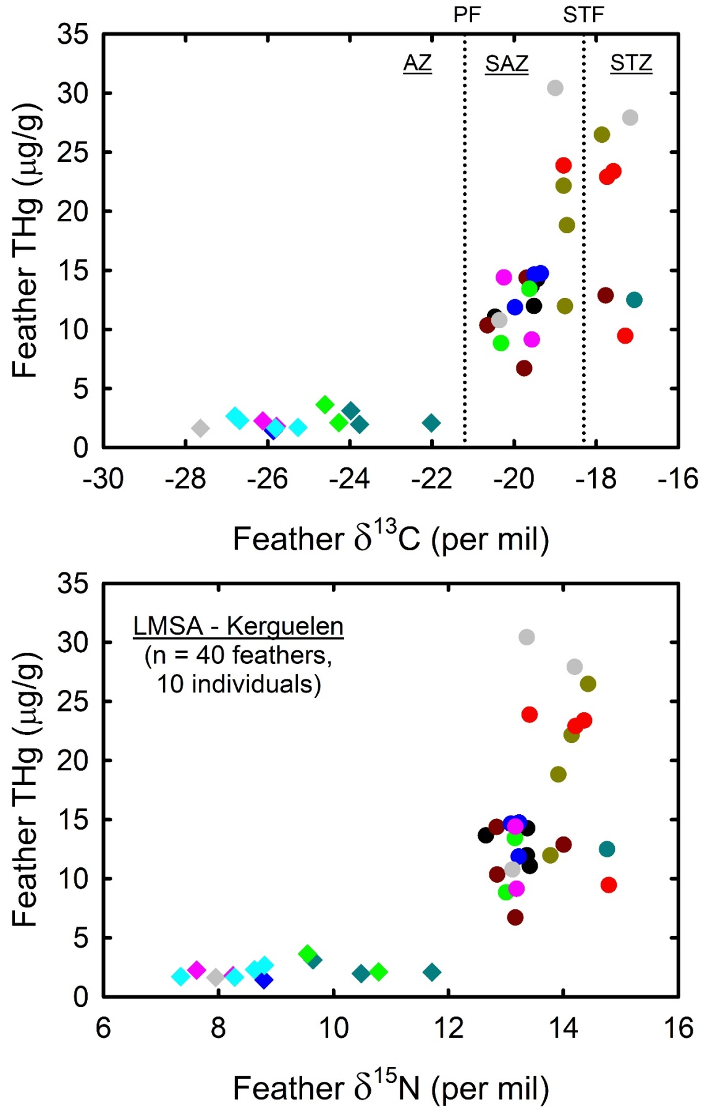

Figure 5

Table 1. Review of total mercury (THg) concentrations in body feathers of adult albatrosses. All the existing literature was reviewed up to date (December 2017). A few data were deleted due to various problems, including (i) too small sample sizes (n <5; Ochoa-acuña et al., 2002; Shinsuke et al., 2003), (ii) taxonomic uncertainties (e.g. the wandering albatross species complex; Thompson and Furness, 1989b; Thompson et al., 1993), and (iii) geographical uncertainties together with or without other feather types than body feathers (e.g. North Pacific and flight feathers; Honda et al., 1989; Kim et al., 1996; Vo et al., 2011). Values are means ± SD with ranges in parentheses
Taxa | Location | Individuals (n) | THg (µg/g) | References
Diomedea spp.
Wandering albatross | South Georgia | 66 | 19.59 ± 10.12 (5.44 - 73.42) | Thompson et al., 1993
 |  | 14 | 27.43 ± 8.14 (15.40 – 45.36) | Anderson et al., 2009
 |  | 34 | 20.14 ± 7.64 (8.09 – 39.82) | Tavares et al., 2013
 |  | 10 | 20.31 ± 5.88 (14.69 – 29.97) | This study
 | Prince Edward | 29 | 24.83 ± 12.35 (11.84 - 58.58) | Thompson et al., 1993
 |  | 12 | 24.80 ± 8.61 (11.87-41.95) | This study
 | Crozet | 165 | 22.14 ± 10.30 (5.86 - 94.72) | Bustamante et al., 2016
 |  | 12 | 23.75 ± 6.84 (13.79-38.30) | This study
 | Kerguelen | 12 | 16.59 ± 3.78 (9.84 - 24.13) | Carraviéri et al., 2014b; this study
Antipodean albatross | Antipodes | 15 | 21.87 ± 9.27 (9.22 - 41.93) | This study
Gibson's albatross | Auckland | 15 | 29.50 ± 8.17 (16.85 - 50.09) | This study
Amsterdam albatross | Amsterdam | 18 | 34.60 ± 12.50 (18.57-70.63) | This study
Tristan albatross | Gough | 59 | 30.2 ± 15.6 | Thompson et al., 1990
 |  | 27 | 28.00 ± 14.31 (10.80 - 65.50) | Thompson et al., 1993
 |  | 12 | 24.96 ± 6.85 (15.74-35.74) | This study
Southern royal albatross | Campbell | 22 | 11.52 ± 13.86 (1.95 - 45.46) | Thompson et al., 1993
 | Auckland | 15 | 11.78 ± 8.14 (2.33 - 27.57) | This study
Northern royal albatross | Chatham | 20 | 11.40 ± 6.46 (3.50 - 26.27) | This study
Phoebastria spp.
Black-footed albatross | Midway | 17 | 19.60 ± 1.75 | Burger and Gochfeld, 2000a,b
Laysan albatross | Midway | 13 | 3.46 ± 0.39 | Burger and Gochfeld, 2000a,b
 |  | 10 | 1.86 ± 0.35 | Burger and Gochfeld, 2000c
Large Thalassarche spp.
Shy albatross | Tasmania | 8 | 7.42 ± 2.82 (5.26-13.12) | This study
White-capped albatross | Auckland | 31 | 11.99 ± 4.67 (3.87 - 20.80) | This study
Salvin's albatross | Snares | 15 | 5.59 ± 3.36 (2.04-15.60) | This study
 | Bounty | 16 | 7.39 ± 4.96 (2.68-22.16) | This study
Chatham albatross | Chatham | 11 | 11.46 ± 6.65 (2.32 - 23.10) | This study
Small Thalassarche spp.
Black-browed albatross | Falklands | 30 | 2.68 ± 1.22 (1.00 – 6.64) | Thompson et al., 1993
 | South Georgia | 20 | 4.57 ± 1.98 (1.41 – 9.14) | Thompson et al., 1993
 |  | 16 | 5.39 ± 2.05 | Becker et al., 2002
 |  | 16 | 8.35 ± 2.63 (4.24 – 12.97) | Anderson et al., 2009
 |  | 10 | 6.86 ± 2.87 (4.31 – 12.76) | This study
 | Kerguelen | 33 | 4.07 ± 1.78 (1.71 - 7.75) | Carraviéri et al., 2014b; this study
 | Heard | 8 | 9.93 ± 6.61 (2.60-19.63) | This study
Campbell albatross | Campbell | 35 | 10.06 ± 4.40 (3.52 - 19.54) | Thompson et al., 1993
 |  | 20 | 12.03 ± 5.33 (3.59 - 22.31) | This study
Southern Buller's albatross | Snares | 15 | 4.32 ± 0.96 (2.69 - 6.31) | This study
Northern Buller's albatross | Chatham | 20 | 4.62 ± 3.53 (2.18 - 16.11) | This study
Atlantic yellow-nosed albatross | Gough | 10 | 4.22 ± 1.68 (2.27-7.97) | Becker et al., 2016
 |  | 12 | 3.82 ± 1.14 (2.12-5.40) | This study
Indian yellow-nosed albatross | Prince Edward | 10 | 5.88 ± 2.63 (2.43-11.84) | This study
 | Amsterdam | 20 | 3.96 ± 1.57 (1.93-8.69) | This study
Grey-headed albatross | South Georgia | 34 | 4.20 ± 2.27 (1.22 - 11.00) | Thompson et al., 1993
 |  | 19 | 8.93 ± 2.85 | Becker et al., 2002
 |  | 15 | 9.50 ± 2.84 (4.34 – 13.24) | Anderson et al., 2009
 |  | 10 | 7.35 ± 7.57 (2.12 – 28.25) | This study
 | Prince Edward | 11 | 7.12 ± 3.21 (3.00-14.07) | This study
 | Campbell | 30 | 6.91 ± 2.40 (3.10 - 13.63) | Thompson et al., 1993
 |  | 20 | 9.50 ± 3.11 (3.79-15.53) | This study
Phoebetria spp.
Sooty albatross | Gough | 7 | 9.4 ± 3.9 | Thompson and Furness, 1989b
 |  | 40 | 6.7 ± 4.2 | Thompson et al., 1990
 |  | 32 | 6.16 ± 4.23 (1.42 - 16.13) | Thompson et al., 1993
 |  | 5 | 17.69 ± 3.64 (13.72 - 23.00) | Becker et al., 2016
 |  | 13 | 13.67 ± 4.84 (1.76 - 20.09) | This study
 | Prince Edward | 14 | 21.86 ± 7.04 (8.78-32.97) | This study
 | Crozet | 12 | 21.32 ± 8.58 (7.41-35.36) | This study
 | Amsterdam | 22 | 24.92 ± 5.49 (14.37-36.37) | This study
Light-mantled albatross | South Georgia | 11 | 9.08 ± 6.36 (1.90 - 19.18) | This study
 | Prince Edward | 7 | 9.61 ± 6.65 (2.55-19.84) | This study
 | Crozet | 10 | 11.84 ± 7.38 (2.02-20.59) | This study
 | Kerguelen | 16 | 9.47 ± 3.78 (2.31 - 14.22) | Carraviéri et al., 2014b; this study

Table 2. GAMM results for feather THg concentrations as a function of covariates for the optimal model (516 sampled individuals from 35 populations). Variance components plus their SD are shown for random effects; edf indicates the estimated degrees of freedom for the smooth terms

Effect | Estimate | SD | t-test | edf | F-test | p
Fixed effects
Intercept | 3.177 | 0.168 | 18.902 |  |  | < 0.001
Phylogeny | -0.341 | 0.058 | -5.842 |  |  | < 0.001
s(δ¹³C) |  |  |  | 2.738 | 10.26 | < 0.001
s(δ¹⁵N) |  |  |  | 7.385 | 14.15 | < 0.001
Random effects
Population | 0.159 | 0.399
Residual | 0.167 | 0.408

Table 3. Feather δ¹³C and δ¹⁵N values and total mercury (THg) concentrations in relation to albatross moulting zones (according to the estimated isotopic positions of oceanic fronts in Jaeger et al., 2010). Stables isotopes and THg were measured on four different body feathers per individual bird. Kruskal-Wallis H tests were performed to compare moulting zones and species. Significant statistics (p < 0.05) are highlighted in bold. Values are means ± SD

 | Grey-headed albatross | Sooty albatross | Light-mantled albatross | Kruskal-Wallis
 | Prince Edward | Gough | Kerguelen | H tests
 | (n = 11) | (n = 13) | (n = 10)
Antarctic Zone
Feathers (n) | 8 | 9 | 13
Feather δ¹³C (‰) | -22.2 ± 0.6 | -22.5 ± 0.4 | -25.3 ± 1.5 | H = 17.3, p < 0.0001
Feather δ¹⁵N (‰) | 11.0 ± 1.1 | 8.7 ± 0.7 | 9.1 ± 1.3 | H = 12.2, p = 0.002
Feather THg (µg/g dry mass) | 4.5 ± 1.2 | 4.6 ± 2.8 | 2.2 ± 0.6 | H = 14.8, p = 0.001
Subantarctic Zone
Feathers (n) | 25 | 34 | 20
Feather δ¹³C (‰) | -19.7 ± 0.7 | -19.0 ± 0.4 | -19.6 ± 0.6 | H = 21.6, p < 0.0001
Feather δ¹⁵N (‰) | 11.6 ± 1.6 | 13.4 ± 0.7 | 13.3 ± 0.4 | H = 21.6, p < 0.0001
Feather THg (µg/g dry mass) | 11.9 ± 7.3 | 14.7 ± 3.9 | 14.4 ± 5.6 | H = 7.0, p = 0.031
Subtropical Zone
Feathers (n) | 11 | 9 | 7
Feather δ¹³C (‰) | -17.2 ± 0.5 | -17.8 ± 0.3 | -17.5 ± 0.3 | H = 7.4, p = 0.025
Feather δ¹⁵N (‰) | 12.3 ± 1.1 | 14.2 ± 0.5 | 14.4 ± 0.3 | H = 12.9, p = 0.002
Feather THg (µg/g dry mass) | 8.8 ± 2.7 | 14.0 ± 4.2 | 19.4 ± 7.5 | H = 11.7, p = 0.003
Kruskal-Wallis H tests
Feather δ¹³C (‰) | H = 34.2, p < 0.0001 | H = 36.2, p < 0.0001 | H = 32.6, p < 0.0001
Feather δ¹⁵N (‰) | H = 4.3, p = 0.116 | H = 29.9, p < 0.0001 | H = 32.4, p < 0.0001
Feather THg (µg/g dry mass) | H = 14.01, p = 0.001 | H = 19.5, p < 0.0001 | H = 26.6, p < 0.0001
All three oceanic zones
Feathers (n) | 44 | 52 | 40
Feather δ¹³C (‰) | -19.5 ± 1.8 | -19.4 ± 1.6 | -21.1 ± 3.2 | H = 8.2, p = 0.016
Feather δ¹⁵N (‰) | 11.7 ± 1.4 | 12.7 ± 2.0 | 12.1 ± 2.3 | H = 14.2, p = 0.001
Feather THg (µg/g dry mass) | 9.8 ± 6.3 | 12.8 ± 5.3 | 11.3 ± 8.3 | H = 8.9, p = 0.012

Annex
Table S1. Conservation status, breeding frequency, sampling sites, stable isotope values (δ¹³C and δ¹⁵N) and total mercury (THg) concentrations in body feathers of breeding albatrosses from the Southern Ocean and fringing subtropical waters. Values are means ± SD
Taxa | Populations | IUCN Red List | Breeding | Breeding | Oceanographic | Individuals | δ¹³C | δ¹⁵N | THg
 | (Fig. 2) | (2017) | frequency | location | zone | (n) | (‰) | (‰) | (µg/g dry mass)
Diomedea spp.
Wandering albatross D. exulans | WA-SG | Vulnerable | biennial | South Georgia | Antarctic | 10 | -17.4 ± 1.1 | 15.4 ± 0.6 | 20.3 ± 5.9 (14.7 – 30.0)
 | WA-PE |  |  | Prince Edward | Subantarctic | 12 | -17.5 ± 1.0 | 15.4 ± 0.7 | 24.8 ± 8.6 (11.9-42.0)
 | WA-Cro |  |  | Crozet | Subantarctic | 12 | -17.1 ± 0.7 | 15.7 ± 0.7 | 23.7 ± 6.8 (13.8-38.3)
 | WA-Ker |  |  | Kerguelen | Subantarctic | 12 | -16.8 ± 0.6 | 15.8 ± 0.8 | 16.6 ± 3.8 (9.8-24.1)
Antipodean albatross D. antipodensis antipodensis | AnA-Ant | Vulnerable | biennial | Antipodes | Subantarctic | 15 | -16.8 ± 0.6 | 15.3 ± 1.3 | 21.9 ± 9.3 (9.2 - 41.9)
Gibson's albatross D. antipodensis gibsoni | GA-Auc | Vulnerable | biennial | Auckland | Subantarctic | 15 | -16.0 ± 0.6 | 16.4 ± 0.7 | 29.5 ± 8.2 (16.9 - 50.1)
Amsterdam albatross D. amsterdamensis | AA-Ams | Critically Endangered | biennial | Amsterdam | Subtropical | 18 | -16.2 ± 0.4 | 16.7 ± 0.6 | 34.6 ± 12.5 (18.6-70.6)
Tristan albatross D. dabbenena | TA-Gou | Critically Endangered | biennial | Gough | Subantarctic | 12 | -16.4 ± 0.5 | 16.5 ± 0.7 | 25.0 ± 6.9 (15.7-35.7)
Southern royal albatross D. epomophora | SRA-Auc | Vulnerable | biennial | Auckland | Subantarctic | 15 | -16.0 ± 1.1 | 17.1 ± 1.5 | 11.8 ± 8.1 (2.3 - 27.6)
Northern royal albatross D. sanfordi | NRA-Cha | Endangered | biennial | Chatham | Subtropical | 20 | -14.7 ± 1.0 | 19.6 ± 1.7 | 11.4 ± 6.5 (3.5 - 26.3)
Large Thalassarche spp.
Shy albatross T. cauta | ShA-Tas | Near Threatened | annual | Tasmania | Subtropical | 8 | -17.4 ± 0.3 | 16.9 ± 0.4 | 7.4 ± 2.8 (5.3-13.1)
White-capped albatross T. steadi | WCA-Auc | Near Threatened | annual | Auckland | Subantarctic | 31 | -15.8 ± 1.3 | 16.6 ± 1.1 | 12.0 ± 4.7 (3.9 - 20.8)
Salvin's albatross T. salvini | SaA-Sna | Vulnerable | annual | Snares | Subantarctic | 15 | -15.0 ± 0.9 | 19.3 ± 2.4 | 5.6 ± 3.4 (2.0-15.6)
 | SaA-Bou |  |  | Bounty | Subantarctic | 16 | -15.1 ± 0.4 | 19.8 ± 1.1 | 7.4 ± 5.0 (2.7-22.2)
Chatham albatross T. eremita | ChA-Cha | Vulnerable | annual | Chatham | Subtropical | 11 | -16.0 ± 0.5 | 17.5 ± 3.5 | 11.5 ± 6.6 (2.3 - 23.1)
Small Thalassarche spp.
Black-browed albatross T. melanophris | BBA-SG | Near Threatened | annual | South Georgia | Antarctic | 10 | -15.3 ± 1.7 | 15.4 ± 1.8 | 6.9 ± 2.9 (4.3 – 12.8)
 | BBA-Ker |  |  | Kerguelen | Subantarctic | 33 | -17.1 ± 0.7 | 15.5 ± 0.6 | 4.1 ± 1.8 (1.7-7.7)
 | BBA-Hea |  |  | Heard | Antarctic | 8 | -17.7 ± 0.3 | 14.9 ± 0.9 | 9.9 ± 6.6 (2.6-19.6)
Campbell albatross T. impavida | CA-Cam | Vulnerable | annual | Campbell | Subantarctic | 20 | -16.8 ± 0.9 | 15.7 ± 2.0 | 12.0 ± 5.3 (3.6 - 22.3)
Southern Buller's albatross T. bulleri bulleri | SBA-Sna | Near Threatened | annual | Snares | Subantarctic | 15 | -16.3 ± 0.2 | 20.1 ± 0.5 | 4.3 ± 1.0 (2.7 - 6.3)
Northern Buller's albatross T. bulleri platei | NBA-Cha | Near Threatened | annual | Chatham | Subtropical | 20 | -15.9 ± 0.3 | 20.1 ± 0.6 | 4.6 ± 3.5 (2.2 - 16.1)
Atlantic yellow-nosed albatross T. chlororhynchos | AYNA-Gou | Endangered | annual | Gough | Subantarctic | 12 | -15.6 ± 0.4 | 15.8 ± 0.5 | 3.8 ± 1.1 (2.1-5.4)
Indian yellow-nosed albatross T. carteri | IYNA-PE | Endangered | annual | Prince Edward | Subantarctic | 10 | -15.5 ± 0.5 | 15.1 ± 0.7 | 5.9 ± 2.6 (2.4-11.8)
 | IYNA-Ams |  |  | Amsterdam | Subtropical | 20 | -16.9 ± 0.5 | 15.5 ± 0.8 | 4.0 ± 1.6 (1.9-8.7)
Grey-headed albatross T. chrysostoma | GHA-SG | Endangered | biennial | South Georgia | Antarctic | 10 | -19.2 ± 1.8 | 10.7 ± 0.8 | 7.3 ± 7.6 (2.1 – 28.3)
 | GHA-PE |  |  | Prince Edward | Subantarctic | 11 | -19.5 ± 1.9 | 11.7 ± 1.5 | 7.1 ± 3.2 (3.0-14.1)
 | GHA-Cam |  |  | Campbell | Subantarctic | 20 | -17.7 ± 1.3 | 11.6 ± 3.1 | 9.5 ± 3.1 (3.8-15.5)
Phoebetria spp.
Sooty albatross P. fusca | SA-Gou | Endangered | biennial | Gough | Subantarctic | 13 | -19.2 ± 1.4 | 12.8 ± 2.0 | 13.7 ± 4.8 (1.8 - 20.1)
 | SA-PE |  |  | Prince Edward | Subantarctic | 14 | -17.2 ± 0.8 | 14.4 ± 0.9 | 21.9 ± 7.0 (8.8-33.0)
 | SA-Cro |  |  | Crozet | Subantarctic | 12 | -17.3 ± 1.0 | 14.0 ± 1.2 | 21.3 ± 8.6 (7.4-35.4)
 | SA-Ams |  |  | Amsterdam | Subtropical | 22 | -16.6 ± 0.5 | 15.4 ± 0.8 | 24.9 ± 5.5 (14.4-36.4)
Light-mantled albatross P. palpebrata | LMSA-SG | Near Threatened | biennial | South Georgia | Antarctic | 11 | -20.6 ± 2.3 | 11.8 ± 2.0 | 9.1 ± 6.4 (1.9 - 19.2)
 | LMSA-PE |  |  | Prince Edward | Subantarctic | 7 | -19.9 ± 2.5 | 12.1 ± 2.0 | 9.6 ± 6.6 (2.6-19.8)
 | LMSA-Cro |  |  | Crozet | Subantarctic | 10 | -20.5 ± 2.1 | 11.9 ± 2.1 | 11.8 ± 7.4 (2.0-20.6)
 | LMSA-Ker |  |  | Kerguelen | Subantarctic | 16 | -19.8 ± 2.4 | 12.9 ± 1.6 | 9.5 ± 3.8 (2.3-14.2)

