A practical guide to the use of success/failure statistics in the estimation of prospect risk
Frank J. Peel and John R. V. Brooks
National Oceanography Centre, University of Southampton Waterfront Campus, European Way, Southampton SO14 3ZH, United Kingdom
Introduction
Obtaining an estimate for the chance of success is an important part of the decision to drill or not to drill a prospect. There are many different methods used to obtain such an estimate (see, for example, White, 1993; Rose, 1987, 1992, 2001). These may involve weighing the strength of geological evidence for the essential components of the hydrocarbon system, and multiplying these to obtain an overall chance of success. They may involve observing seismic attributes (e.g. Forrest et al., 2010) and combining these with a geological prior chance to derive an updated chance of success (e.g. Newendorp, 1972) using Bayesian logic (Bayes, 1763) or other methods. Other tools include use of the Sherman Kent Scale (Kent, 1964), developed by the CIA to translate verbal descriptions of likelihood into numerical probability, the solicitation of expert judgments (Hora, 2007), and aggregating the estimates of a set of individuals within a group to produce a more robust estimate (Hogarth, 1978), known as a “wisdom of crowds” approach (Surowiecki, 2004). The probability of a future outcome, obtained from such methods of rational analysis, is known as inductive probability.
One of the most basic (and potentially most powerful tools) in the armory of methods used to estimate the chance of future prospect success is the statistical analysis of past rates of success or failure, either of prospects as a whole (successes vs. dry holes), or of a component of the hydrocarbon system. Baddeley et al. (2004) discuss the difference between statistical probability obtained by look-back methods and inductive probability derived from look-forward logic. For example, if we ascertain that cross-fault seal has failed in 6 out of a set of 60 tested prospects within a particular play fairway, the statistical historical success rate for that component of the prospect (0.9) could be used as a guide to our expectation of the likelihood of success of cross-fault seal in future well tests.
If we have good information on our prospect, and a good understanding of the geological factors which influence its chance of success, we may use the statistical probability as a check (but not a hard constraint) on our rational (inductive) estimate of that chance of success. For example, we may have information that indicates that the chance of cross-fault seal is better in our prospect than it was in the prospects tested in the past.
However, if we do not have the luxury of good data on our undrilled prospect, or we do not yet understand the geological factors which control the chance of success of its component parts, we may have to come up with an estimate of that chance based on past statistics alone.
As noted by the Securities and Exchange Commission (2008), “Past performance does not guarantee future results”: this is true in many fields, from investment to hydrocarbon exploration, and this warning particularly needs to be borne in mind when we use the results from previous exploration wells to constrain our estimate of the chance of success of an undrilled exploration prospect.
Publically available literature contains little practical guidance as to how we should use the statistics from existing well data to guide prospect risking. Existing publications tend to focus on a comparison of predicted pre-drill chance of success with actual success rate (e.g. Allais, 1956; Rose, 1987, 1992, 2001; Alexander & Lohr, 1998; Ofstad et al., 2000, Harper, 2000,) or comparing discovered volumes vs. predicted prospective resource (e.g. Rose, 1987, Capen, 1992, Ofstad et al., 2000a,b,c, Fosvold et al., 2000). While these look back studies provide very valuable lessons about past performance, they are less helpful in suggesting how and when to use past well data to estimate the chance of success of a new prospect. It is our experience that many geoscientists in the petroleum exploration business simply equate past success rate to expected future chance of success – if they consider the past success/failure statistics at all.
There is a well-established mathematical reason why, even where we want to use past statistics to inform our estimate of future chance, we cannot simply equate the frequency of past success to the expected chance of future success. Laplace (1774) demonstrated that if we have knowledge of a set of n tests, of which 100% were successful, we can calculate the most likely chance of success that would generate this result, and it is not 100%. This result has not been explicitly applied to the problem of prospect risking in the petroleum exploration business. More significantly, his result has not been developed into a “exploration-friendly” consideration of how to estimate future chance of success of a prospect based on a data set which includes some failures as well as successes.
This brief article sets out some simple guidelines as to when and where a statistics-based risk approach may be valuable, where it may be misleading, and how best to use small data sets.
Although we should always look at the statistics of previous well results, and should always consider the lessons that can be drawn from those wells, there are common pitfalls. We will describe conditions in which the set of past tests should be representative of the remaining future opportunities, and the conditions in which we should expect future success rate to be different from the past statistics (e.g. due to creaming or to the effect of prospect-specific information)
Even where the set of past tests is appropriately representative of the remaining opportunities, the historic success rate is not equivalent to the expected future chance, especially for small data sets, as shown by the coin-in-a-bag example described above. We set out a method for estimating the most appropriate future chance based on small (n<10) data sets.
Definition of terms
The definitions used in this article are consistent with the usage in Peel and Brooks (in press) and Peel and White (in press) to which the reader is directed for further clarification.
Chance of geological success (Pg) of a prospect. A prospect model defines the geological conditions envisaged in the success case (e.g. trap type, age and nature of the reservoir, etc.) and a numerical range of the parameters such as reservoir thickness, porosity, hydrocarbon column height, etc.) that the success case is expected to deliver. The chance of success of a prospect is the current opinion, based on the knowledge and data currently available, that the geological model applies, and that the value of the parameters that exist in the subsurface is correctly represented by the ranges defined in the prospect model. We use the notation Pg to represent the chance of geological success of a prospect, following Rose (1987, 1992, 2001); other notations are also used in the literature (see Peel and Brooks, in press)
There are many methods which can be used to estimate Pg (e.g. Megill, 1977; Rose, 1987, 1992; White, 1993), many of which involve consideration of a diverse range of geological data and knowledge as well as past statistics. In this article we focus only on the use of past performance statistics with the aim of better understanding how to use them; this does not imply that we do not recognize the value of the other inputs and methods.
Geological success (of a prospect, or of a risk component of a prospect). Geological success means that the geological model defined as the prospect success case exists in the subsurface; the general geological description is valid, and the actual value of the components falls within prognosed range. For the prospect as a whole, success means that all these components combine to give rise to a hydrocarbon accumulation that falls within the prognosed volume range. We can consider the component elements separately, so that a well may test a successful outcome for (say) the reservoir model, even if another component fails and the prospect as a whole is not a success.
It is common to produce statistics that consider both the historical success rates of prospect as a whole (e.g. Rose 1987; Harper, 2000) and of the individual key geological components of the prospect (e.g. Ofstad et al. 2000c).
Estimating future probability from past statistics
If the only information we have to base our estimate of the chance of future success on is the past statistics (Figure 1), there is a rigorous method for calculating the odds, and it is quite non-intuitive. There are many circumstances in which the frequency of past success is not a good approximation of the chance of future success. If our data set consists of 10 wells, of which 9 were successes, we might intuitively think that the appropriate chance of success would be 9/10 = 0.9, but this is not correct (the best estimate is in fact 0.833). If our data set consists of 3 wells, of which 3 were successes, we might think the appropriate chance of success would be 3/3 = 1, but this also is not correct (the best estimate is 0.804). It is more intuitive if we consider a data set consisting of only 1 well, which was a success: the past success rate is 1/1, but any experienced explorer knows that one good result does not prove that the next well will work (the best estimate is 0.67). The method we use to obtain these best estimates is set out below.
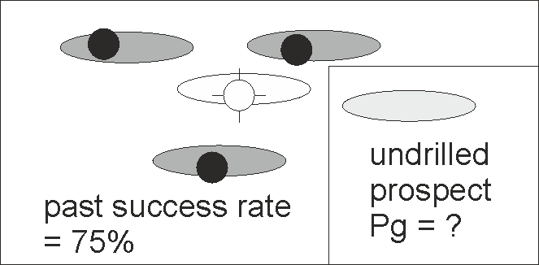
Figure 1. Problem: if all the information we have to go on is the raw success/failure statistics of an analogous set of wells, how do we translate the number (75%) representing the frequency of past success into a go-forward prediction of the chance of success of an undrilled prospect?

The reason for this difference between past frequency and future chance is that we are not trying to find the proportion of past success or failure; we are, instead, trying to find the most likely chance of success that would deliver that proportion, and this is not the same number.
This can be illustrated by a question used in interviews for financial traders (http://www.glassdoor.co.uk/Interview); a variant was used as a Car Talk® puzzler (http://www.cartalk.com/content). : “There are 3 coins in a bag. Coin 1 has tails on both sides, coin 2 has head on one side and tail on the other side, and coin 3 has heads on both sides. I pick one coin from the bag and toss it. I get heads. What is the chance that the same coin will land heads if I toss it again?”
In this example, we know that each coin has a different probability of landing heads-up (0, 0.5 and 1.0) but we do not know which coin we have selected, so we do not know what the probability is for that coin. We can use the one test result to come up with a best estimate of that probability.
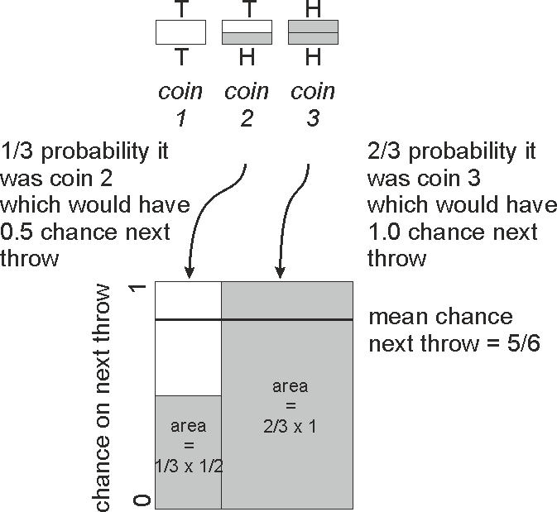
Figure 2 graphical solution of the 3-coin problem: reverse-estimating the go-forward probability from one observation.

We know one result of one trial of the coin, and 100% of our trials found a head, but this does not mean that we can apply that same historic success rate as the chance of success for the next throw. A simple “frequentist” approach (i.e. using the frequency of past success) would suggest past rate = 1.0 = prediction of future chance – but it is intuitively obvious that this result is false. A more appropriate “probabilist” approach reverse-estimates that chance from the information we have (Figure 1). We know the range of possible chances for the three coins – 0, 0.5 and 1.0 – but we do not know which coin we have. The coins in the bag have six faces. 1/3 of the heads lie on coin 2, and 2/3 on coin 3. The likelihood that we selected coin 1 is zero (it has no head), the likelihood it is coin 2 is 1/3, and the likelihood it is coin 3 is 2/3. To obtain the go-forward chance of a head, we calculate the mean chance from the two coins – 1/3 x 0.5 + 2/3 x 1.0 = 5/6. The important lessons of this exercise for petroleum exploration are that:
- past success rate is not numerically equivalent to predicted future chance;
(ii) it is possible to estimate that future chance using relatively basic logic and simple arithmetic.
Estimation of Pg from small success/failure data sets
We can apply a similar approach to the real-world situation of estimating the chance of success of a future prospect test, using only the knowledge of the results of previously tested prospects in the same play. We first make the assumption that, in the absence of prospect-specific information, each of the drilled prospects had the same pre-drill chance of success, and the undrilled prospect has the same chance of success. We do not know what that chance of success was/is, but we have a record of past success rate, and we can use simple arithmetic to back-calculate what chance of success would be most likely to have generated the observed results.
This problem is not new, nor is it unique to petroleum exploration; it was first described by Price in the preface to Bayes (1763). Laplace (1774) considered the same question in a classic analysis known as the Sunrise Theorem. This addressed the following question: what would you estimate the chance of the sun rising successfully tomorrow to be, if the only information that you had available was that the sun has risen every day of your life so far (n days)? To answer this, he assumed that every day had the same chance of success, P_{sunrise}. For each possible value of the probability, he calculated the chance that this particular value could give rise to the observation of n successive successful sunrises. From this, he calculated the mean value probability P_{sunrise} that gives rise to the observed sequence: P_{sunrise} =(n+1)/n+2) .
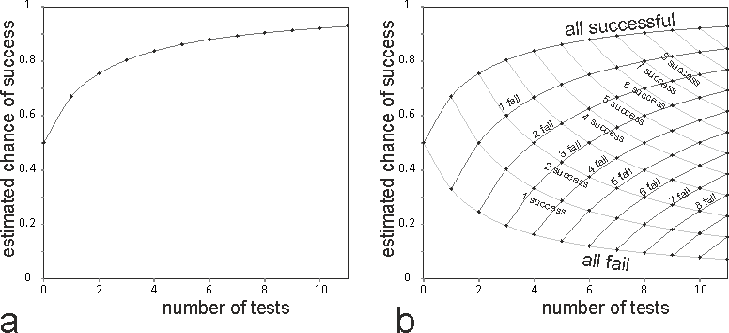
Figure 3 a, application of Laplace (1774) Sunrise Problem, estimating the mean chance of success from the observation of a succession of 1 to 11 successful results; b, application of the Rule of Succession to estimate the mean chance of success based on a series of 1 to 11 results, including success and failure outcomes.

Applying this to petroleum exploration, we can use the Sunrise Theorem to calculate the mean chance of prospect success, Pg, that would give rise to an uninterrupted string of n successes: Pg=(n+1)/n+2). If we have no other information on which to base an inductive estimate, this mean chance is the appropriate estimate of Pg to use for our next prospect. The results are shown in Figure 3a, and tabulated in the first column of Table 1.
Laplace (1774) went on to develop the more general Rule of Succession, which considers the mean chance that generates s successes out of n trials, obtaining the solution Pmean = (s+1)/(n+2). An alternate, graphical method of deriving the same value is shown in the Appendix; it is included because this derivation may be more intuitive to our readers.
Applying this to petroleum exploration , we can calculate the mean chance of success, Pg, that gives rise to s successes out of a data set of n tests, Pg =(s+1)/(n+2). Again, if we have no other information on which to base an inductive estimate, this mean chance is the appropriate estimate of Pg to use for our next prospect. The results are shown in Figure 3b and in Table 1.
We suggest that the results shown in table 1 can be used by exploration geoscientists as a simple method to translate past statistics into an estimate of Pg, where this is appropriate, and that this should be used in place of a simple frequency approach.
This approach can be used for Pg, the chance of success of the prospect as a whole, if the only information we have is that the historical data set consists of dry holes vs. hydrocarbon discoveries. The same approach can also be used to obtain estimates of the chance of success of one or more of the independent risk components (such as charge, reservoir, trap and seal) that are multiplied together to derive the overall Pg value. For example, we may have sound inductive probability estimates derived from geological data for charge , trap, and seal, but if the only information available for reservoir is that the reservoir is absent in 1 out of 10 well tests, we should use Table 1 to obtain an estimate of the chance of reservoir presence as 0.83, (or calculate this value using the Rule of Succession).
The main assumptions implicit to this approach are the same as those that constrain the general binomial probability formula: it depends on (i) the trials being independent, (ii) that there are only two possible outcomes of each trial (in the petroleum exploration world, these are success vs. failure), and (iii) that the prior probability of success is the same for each trial. We know that no two exploration prospects are the same, and so we know that assumption (iii) is unlikely to be true in the petroleum exploration world; however, there are many situations in which we know so little about the details of the geology that the method may be a useful first step in the process of risking a prospect; and there are some situations where we know so little that it is the only method available to us.
The calculated mean probability shown in Table 1 can be compared with the simple frequency (= s/n) for the same n tests, as shown in Table 2.
Table 3 shows a comparison of the calculated mean Pg using the Rule of Succession with the values that are obtained simply by taking the past frequency of success cases (=s/n). The comparison shows that for larger data sets (n>8), the chance predicted by the two methods is similar (difference less than 0.1), and probably either method is an acceptable approximation for the purpose of estimating prospect risk. However, for smaller data sets, especially those consisting of mostly successes or mostly failures, the difference is considerable, and the unmodified past frequency is not an acceptable approximation of future probability.
Example: estimating the chance of a salt weld sealing
Using look back statistics to estimate chance of success may be particularly important in situations where we have historical well data , but very limited information on some aspect of the prospect, or we have weak understanding of the geological factors which determine the chance of success. As a result, it may be difficult to create an inductive estimate based on sound local observations and geological reasoning, but possible to derive a valid estimate based on the past performance statistics. 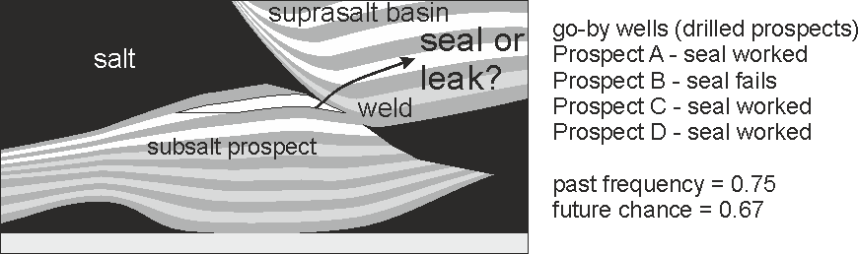
Figure 4. Use of limited well statistics to estimate the chance of a component of prospect risk (the chance of a salt weld sealing).

A situation in which this commonly arises is in the risking of subsalt prospects, where a critical part of the trap is poorly imaged. One such situation is shown schematically in Figure 4, showing a subsalt prospect which depends on a salt weld to seal. Given the difficulty of imaging the critical region, coupled with the current poor understanding of what conditions enable a salt weld to seal or allow it to leak, we may be unable to create a strong case for the chance of seal success based on local direct information, and a small data set of success/failure statistics may be the only tool available to guide our risk estimate. In the case shown in Figure 4, our analog data consists of only four tests, which we believe are similar enough to our prospect to use for comparison: three cases in which we know a similar salt weld has worked as a sealing interface (prospects A, C and D) and one in which we believe that the weld interface failed to seal (prospect B).From this limited information, we know the frequency of past success (s/n = 0.75) and we can use table 1 to look up the mean probability which would give rise to this outcome (P(seal) = 0.67).
Thus if we wish to use the past statistics as a guide to future chance, we should use the chance of success of the seal component as P(seal) = 0.67 Combining this probability by multiplication with the chance estimated for other independent risk components (such as charge, trap and seal) in the normal way allows us to calculate the overall chance of success (Pg).
Conditions in which look back statistics, converted to an estimate of future chance, may be appropriate as a guide to future expectation
Past performance statistics should be used with caution because there are many circumstances in which they are not appropriate as an input to estimating future chance. When considering whether past statistics are a valid constraint on future chance of success, we suggest that the following conditions shuld be considered:
- All the information available to us should indicate that existing drilled prospects for which we have the statistics are good analogs for the undrilled prospects: they should test the same play, same geological model, same trap type, etc. and we know of no reason why the remaining opportunities should be worse or better.
- The drilled prospects for which we have the statistics should be valid tests, e.g. drilled within apparent closure, in a reasonable location, in a part of the prospect where we would expect the reservoir to exist if the geological model is correct, etc.
- The wells were drilled using the same state of knowledge (for the drilled prospects) that we have now for the undrilled ones, in other words we are not acting under a disadvantage that the previous drillers did not face, nor do we have major targetting advantages that were not available when the previous set of prospects were chosen for drilling. New technology may give us the ability to radically improve the expected chance of success for the prospects we choose to drill.
- The prospect we are interested in risking does not represent the “dregs” of a play that has been effectively cherry-picked by the wells already drilled. The best, most obvious prospects with the highest perceived chance of success naturally tend to be tested first, if conditions allow. If the remaining prospects lie within the same pot of opportunities, and they represent the ones that were not previously deemed attractive drilling candidates. If the selection of well tests was made on the basis of prospect volume, the success/failure statistics may be a valid reflection of future chance; but if the previous selection included a consideration of risk, future chance of success is likely to be worse than historical performance.
The most favorable conditions for using prospect success/failure statistics apply when an area which has been extensively explored abuts against an area which has for some reason been protected from exploration – whether due to geopolitical imperatives (disputes, embargos, conflicts, change in tax conditions, etc.), technological constraints (e.g. water depth which was previously inoperable), or other reason. If we believe the geology is the same on both sides, and there is no known factor which would make the undrilled acreage better or worse, then the past statistics are probably appropriate for use in estimating Pg for prospects in the undrilled region.
. 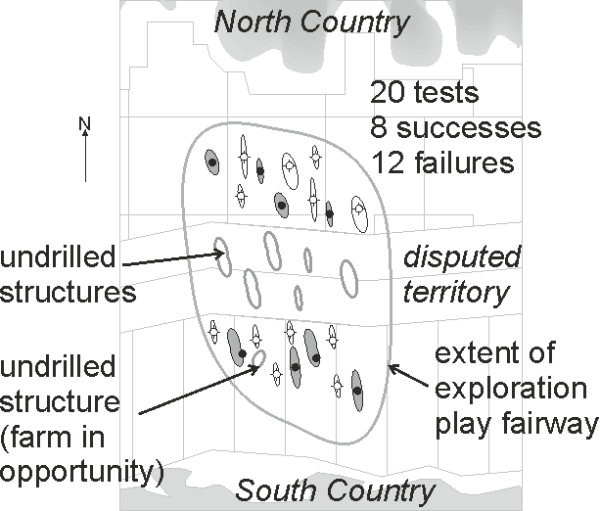
Figure 5. Illustration of scenarios in which past statistics may be a valid indication of future performance (undrilled prospects in disputed territory) and where they should be viewed with caution (a farm in in an extensively drilled block)

Figure 5 shows a schematic situation which illustrates these principles. There has been intense drilling in the territorial waters of two countries, with 20 tested prospects in the same play delivering 8 successes. There has been no drilling in the disputed region. The historic success rate is 0.4, and this is a large enough sample size that the past frequency and the probabilistic prediction give the same result; expected chance of success of the next prospect, based only on these data, is 0.4.
In the disputed region, we expect the geology and prospectivity to be the same as in the tested areas. In the absence of any other geological information to refine our estimate, the past statistics are probably a good indication of the expected average Pg for the undrilled prospects in the disputed region.
Another exploration opportunity is available: the option to farm in to a prospect in South Country waters. Even in the absence of other geological data, we would be unwise to apply the historical success rate as the expected Pg of this prospect, on the basis that the) prospects with highest Pg in the block have probably already been drilled (and we would ask why the operator wishes to farm it out). Our estimated Pg for this farm in opportunity should be significantly lower than the historic frequency, unless we can demonstrate that previous selection was made dominantly on the basis of prospect volume, not of risk.
Case Study – Cambodia-Thailand OCA (Overlapping Claims Area)
The Gulf of Thailand is a prolific petroleum province of SE Asia (Ridd et al., 2011). Exploration drilling has been largely confined to the Thai side of the border due to a long-standing territorial dispute between Thailand and Cambodia. Exploration success rate on the Thai side is reported to be about 40% (Polahan, 1986). The Pattani Basin (e.g. Bustina & Chonchawalita, 1995; Jardine, 1997) has proven particularly successful, and this basin straddles the boundary between Thai waters and a contested area known as OCA (Overlapping Claims Area) in which little exploration activity has occurred (Figure 6).
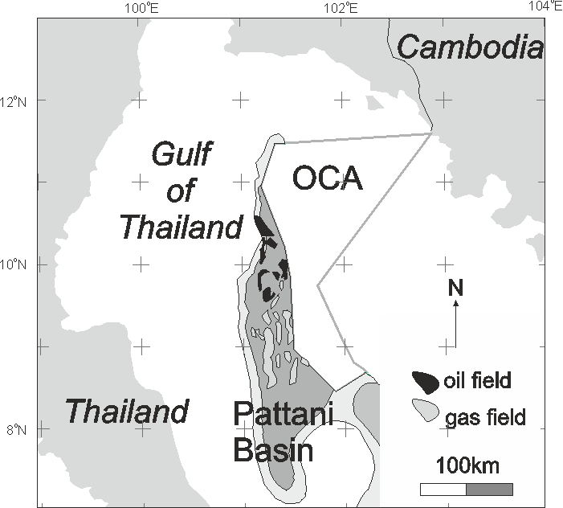
Figure 6. Location of the OCA (Overlapping Claim Area) in the northern Gulf of Thailand, which has remained essentially unexplored while the adjacent portion of the Pattani Basin which lies in Thai-controlled waters has been extensively drilled. Map compiled from a variety of publically available sources.
It is clear that the Pattani Basin continues into the OCA, but it is not clear from publically available data how far it extends. This is a good example of a case where the historical success frequency in the Thai part of the basin is an appropriate guide to the expected Pg of prospects which may be identified in the OCA part of the basin; the prospects in the OCA have not been “cherry picked”; additionally there is very little available geological data on which to base an estimate of Pg in the OCA, so the past success frequency is the best method available to us. Therefore as a starting point we could estimate the chance of success of a prospect in the OCA portion of the Pattani Basin as 0.4. This estimate could be refined if we had access to more specific historic success data on the Pattani Basin, or if geological or geophysical information or were to become available specific to the OCA.
Case study – the Western Atwater Fold belt, Gulf of Mexico
The Lower Miocene anticline play of the Western Atwater Fold Belt (Figure 7) is a good test case because the results are well documented (e.g. Moore et al., 2001, and industry press releases), because it contains a set of large structures which are well defined (e.g. Dias et al, 2010) and all of these have now been tested with at least one well. The study area contains 10 large structures, 4 of which were successes in the Lower Miocene, found to contain major oil fields, the rest of which were not success cases according to the pre-drill success case model, (but note that some of these found hydrocarbons at other stratigraphic levels, or found dry gas in place of the oil prognosed in the success case model).
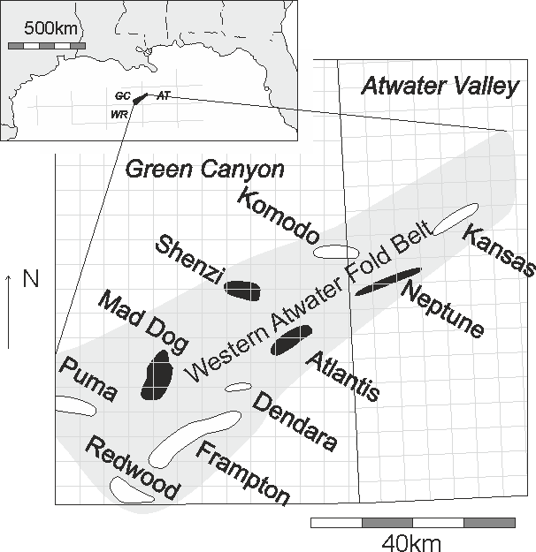
Figure 7. Outline map of the frontal fold trend of the Western Atwater Fold Belt, Gulf of Mexico (grey outline on main map) showing the major structural traps with their original prospect names, with outlines taken from publications (Moore et al., 2001, Dias et al., 2010) and press releases. Geological success cases at Lower Miocene level are shown in solid black (Neptune, Atlantis, Mad Dog and Shenzi oil fields); failure cases at Lower Miocene level are shown in white. Note that some of these failure cases encountered oil at different stratigraphic levels, or encountered dry gas in place of prognosed oil.

Figure 8 shows the sequence of results of the first well on each structure, and the chance of success that we would predict for the next well if this were the only information available to us. Initially, there is a major difference between historical success rate (grey curve) and the go-forward Pg predicted using the Rule of Succession (black curve). But as more wells are drilled, and the sample size increases, the difference diminishes to near-negligible levels.
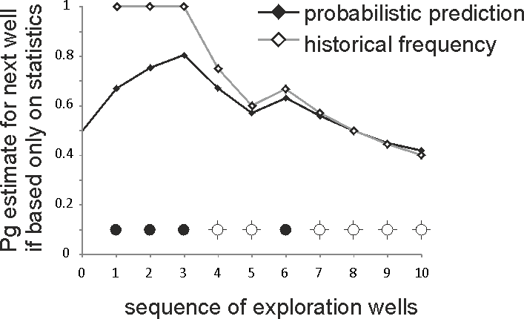
Figure 8. Sequence of drilling results for the first well testing a structure in Lower Miocene play of the the Western Atwater Fold Belt, showing a comparison of a prediction of the chance of success of the next well, based on unmodified past frequency (open diamonds, grey line) compared to the probabilistic prediction using the Modified Sunrise method (black diamonds, black line). Black circles = geological success, dry hole symbol (open circles with cross) = predrill geological model was not a success; note that some of these failure cases encountered hydrocarbons at other stratigraphic levels (e.g. Puma), or encountered dry gas in place of the prognosed oil (e.g. Frampton).

At the end of the sequence of drilling 10 prospects, both methods have converged on a go-forward prediction of Pg = 0.4: but is this representative of what we might expect on a go-forward basis, in other words, would this be an appropriate Pg to use for the next prospect? On the basis of publically available maps, (e.g. Dias et al., 2010) we can say that this is definitely not the case, because all the obvious major anticlinal structures (the “big bumps”) within this footprint have been drilled. Any new prospect in the same play would not look like the existing success/failure data set, which tests all the major anticlinal closures (in contrast, any new prospect in the same general play would have to be deep, or subtle, or have low relief closure).
. Therefore, if we do not have access to any geological evidence to the contrary, we would expect any new prospect defined in the same play to have a different (and probably significantly lower) chance of success, not represented by the existing historic data. This is a good example where past statistics are not a good guide to future performance.
Sense check
So far we have set out how to obtain the most appropriate estimate of Pg based only on the local success/failure statistics within the same play as the undrilled prospect.
However, it would be a mistake to only take local success/failure data within the play into consideration; our judgement should also take into consideration all relevant data from around the global. This may be particularly important if our local data is not compelling (e.g., it is sparse or of questionable reliability or relevance), but we have a good global data set which informs our judgement.
Clearly, if the local data are abundant and of high relevance to our prospect, our estimate of the chance of success should be dominantly based on that local data; but we need a method for constraining the local estimate with global data. Figure 9 shows a simple nomogram method which could facilitate this task.
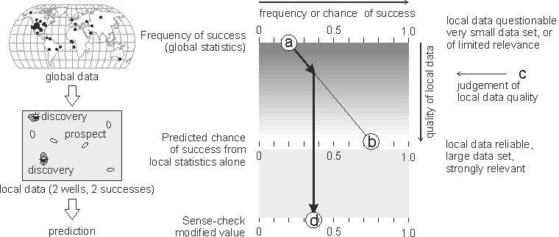
Figure 9 Simple nomogram used as a sense check to moderate statistical prediction based on limited local data. See article text for explanation. Inset map of global stratigraphic trap data is from Binns (2006).

The upper part of the plot is a crossplot of the apparent frequency (or apparent chance) of success (on the x-axis), against the quality of the local data (on the y-axis). The frequency of success from global data (point a) and the predicted chance of success from local data alone (point b) are posted at the top and bottom of this chart. We make a judgement of the quality of the local data, relative to the global data (point c). The intersection with line a-b gives a sense-checked estimate of the local chance of success (point d), so that if the local data are strong (abundant, high quality) , the prediction will be close to the local data, but if the local data are weak (spares, poor quality) the prediction will fall closer to the global value.
As an example, we can consider the chance of success of the lateral trapping component of a prospect which is a stratigraphic trap. In this notional example, there are only two local tests in the play, both successful; using the method set out previously, we would predict a chance of success (point b in figure 9) from these statistics of 0.75. We would, however be concerned that this estimate was based on a very small sample.
If we consult a global data set describing the success rates of stratigraphic traps using a much larger data set (e.g. Binns, 2006) we might discover that the global success rate for the type of trap edge seen in our prospect is only 0.2.
We would then make a judgement of the relative quality of the local vs. the global data (point c in Figure 9), and in this example, we might judge that the sense-checked chance of success (point d) should fall in the range 0.35 to 0.4, significantly lower than the estimate we would obtain using only the local data.
This method may not be strictly correct, in that a rigorous combination of global data and local information may require Bayesian or other methods of computation, but we consider that it is an efficient method which should be appropriate for most prospects.

Conclusions
Past success/failure frequency can provide a valuable tool for predicting future chance of success, but the raw frequency should be modified arithmetically in order to translate it into a prediction, particularly where the sample size is small or where it consists mostly (or entirely) of successes or failures.
The appropriate conversion can be simply calculated and it is presented here as a table for values of n (sample size) up to 11. For larger sample sizes, the difference between simple past frequency and the calculated future chance is small, and while it would be advisable to use the corrected value, calculated using the Rule of Succession, the difference (<0.05) probably falls within an acceptable margin of error.
Past performance statistics may be used as a guide for predicting the chance of success of the prospect as a whole (Pg) or the chance of success of an individual component of prospect risk.
Past success/failure statistics may provide a valid method for estimating future Pg if the data set consists of samples which we believe are analogous to the undrilled prospects, and if they do not come from a pool of opportunities which has been selectively “cherry picked” by the well tests. Common scenarios in which such conditions may apply include the new release of acreage which has previously been undrillable (due to technical or political reasons) adjacent to acreage from which the sample is taken.
Acknowledgements
The authors gratefully acknowledge support for Frank Peel by NERC, the UK Natural Environment Research Council. The authors are grateful to William Hill, Gary Prost and Dale Leckie for constructive reviews which greatly improved the article.
Appendix: method used to calculate Table 1
The chance that an event of probability Pg will deliver s successes out of n trials is given by the general binomial probability formula, as derived by Isaac Newton:
P(outcome|Pg)= P(s out of n) = n!/[s!(n-s)!] * Pg^{s}(1-Pg)^{(n-s)}
For each value of n and s on table 1, the mean value of Pg which gives rise to the observed outcome was calculated as shown in Figure 10, by dividing the area under the curve Pg* P(outcome|Pg) by the area under the curve P(outcome|Pg). The results obtained by this graphical method are equivalent to those calculated using the Rule of Succession.
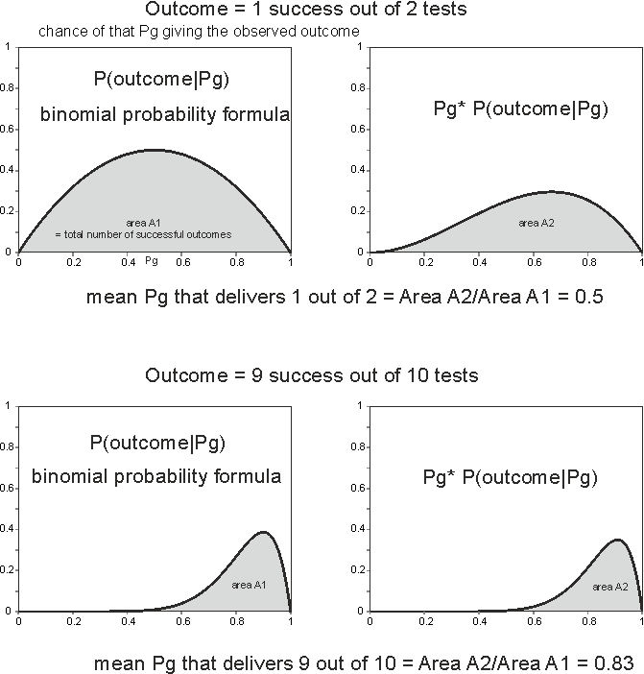
Figure 10. Basis of calculation of the table of predicted Pg from past success/failure frequency data
References
Alexander, J. A. and J.R. Lohr, 1998, Risk analysis: lessons learned: SPE 49030: Society of Petroleum Engineers Annual Meeting, New Orleans
Allais, M., 1956, Évaluation des Perspectives Économiques de la Recherche Minière sur de Grands Espaces - Application au Sahara Algérien: Revue de l'Industrie Minérale, Paris, January, p. 329-383.
Baddeley, M. C., Curtis, A. and Wood, R., 2004, An introduction to prior information derived from probabilistic judgements: elicitation of knowledge, cognitive bias and herding: in: A. Curtis and Wood, R., eds., Geological Prior Information: Informing Science and Engineering, Geological Society, London, Special Publications, no. 239, p. 15-27.
Bayes, T., 1763, An Essay toward solving a Problem in the Doctrine of Chances: Philosophical Transactions of the Royal Society of London, no. 53, p. 370–418 doi:10.1098/rstl.1763.0053
Binns, P.E., 2006, Evaluating subtle stratigraphic traps, prospect to portfolio: in: M.R. Allen, Goffey, G.P., Morgan, R.K. & Walker, I.M., eds., The deliberate search for the stratigraphic trap, Geological Society, London, Special Publications, no. 254, p. 7-26.
Bustina, R.M., and A.Chonchawalita, 1995, Formation and Tectonic Evolution of the Pattani Basin, Gulf of Thailand: International Geology Review, v 37, no. 10, p. 866-892
Capen, E.C., 1992, Dealing with exploration uncertainties: in: Steinmetz, R., ed., The Business of Petroleum Exploration: AAPG Treatise of Petroleum Geology - Handbook of Petroleum Geology, p. 29-61
Dias, T. A., D L. Tett., and M.T. Croasdaile, 2010, Evidence for a Hydrodynamic Aquifer in the Lower Miocene Sands of the Mad Dog Field, Gulf of Mexico: Search and Discovery Article #10221 (2010), Posted January 25, 2010, Adapted from extended abstract from AAPG Convention, Denver, Colorado, June 7-10, 2009.
Forrest, M., R. Roden, and R. Holeywell, 2010, Risking seismic amplitude anomaly prospects based on database trends: The Leading Edge, May 2010, v. 29, p. 570-574.
Fosvold, L., M. Thomsen, M. Brown, L. Kullerud., N. Ofstad,and K. Heggland, 2000, Volumes before and after exploration drilling: results from the project: Evaluation of Norwegian Wildcat Wells (Article 2): Norwegian Petroleum Society Special Publications, no. 9, p. 33-46
Harper, F.G., 2000, Prediction accuracy in petroleum prospect assessment: a 15 year retrospective in BP: Norwegian Petroleum Society Special Publications, no. 9, p. 15-21.
Hogarth, R. M., 1978, A note on aggregating opinions: Organizational Behavior and Human Performance, v. 21, p. 40-46.
Hora, S.C., 2007, Eliciting probabilities from experts: in: W. Edwards, Miles, R.F., and Winterfield, D. v., eds., Advances in Decision Analysis: from foundations to applications, Cambridge, Cambridge University Press, p. 129-153.
Jardine, E., 1997, Dual Petroleum Systems Governing the Prolific Pattani Basin Offshore Thailand: in: Indonesian Petroleum Association, Proceedings of the Petroleum Systems of SE Asia and Australasia Conference, Jakarta, p. 351-363
Kent, S., 1964, Words of estimative probability: in D.P Steurey, ed., 1994, Sherman Kent and the Board of National Estimates: collected essays, Washington, D.C., Center for the study of intelligence, https://www.cia.gov/library/center-for-the-study-of-intelligence/csi-publications/books-and-monographs/sherman-kent-and-the-board-of-national-estimates-collected-essays
Laplace, P-S.,1774, Mémoire sur la probabilité des causes par les événements: Mémoires de l'Académie Royale des Sciences de Paris, Tome VI, p. 621–656.
Megill, R.E., 1977, An introduction to exploration risk analysis: Tulsa, OK., PennWell, 273 p.
Moore, M.G., G.M. Apps, and F.J. Peel, 2001, The Petroleum System of the Western Atwater Foldbelt in the Ultra Deep Water Gulf of Mexico: Gulf Coast Section Society of SEPM Foundation, 21st Annual Bob F. Perkins Research Conference, December 2-5, Houston, Texas.
Newendorp, P. D., 1972, Bayesian Analysis - A Method for Updating Risk Estimates: Journal of Petroleum Technology, v. 24, p. 193-198. doi:10.2118/3463-PA
Ofstad, K., E-J. Kittilsen and P. Alexander-Marrack, eds., 2000, Improving the Exploration Process by Learning from the Past: Norwegian Petroleum Society (NPF) Special Publication no. 9, ISBN 0-444-50155-0
Ofstad, K., L. Kullerud, and D. Helliksen, 2000, Evaluation of Norwegian wildcat wells (Article 1): Norwegian Petroleum Society Special Publications, no. 9, p. 23-31
Ofstad, K., A. Øvretveit., L. Kullerud., and K. Heggland., 2000, Probability of discovery and the reasons for dry wells: results from the project: Evaluation of Norwegian Wildcat Wells (Article 3): Norwegian Petroleum Society Special Publications, no. 9, p. 47-55
Peel, F.J. and J.R.V. Brooks, in press, What to expect when you’re prospecting: how new information changes our estimate of the chance of success of a prospect: AAPG Bulletin
Peel, F.J., and White, J, in press, Do technical studies reduce subsurface risk in hydrocarbon exploration - and if not, how do they add value? in: Hirst, P., and Bowman, M., eds., The Value of Outcrop Studies in Reducing Subsurface Uncertainty and Risk in Hydrocarbon Exploration, Development and Production, Geological Society, London, Special PublicationsPolahan, P., 1986. Oil Potential In The Gulf Of Thailand: Offshore Technology Conference, Houston Texas. doi:10.4043/5179-MS
Ridd, M.F., A.J. Barber, and M.J. Crow, 2011, The Geology of Thailand: Geological Society of London, 640p, ISBN 978-1-86239-319-6
Rose, P.R., 1987, Dealing with Risk and Uncertainty in Exploration: How can we improve? AAPG Bulletin, v. 71, no. 1, p. 1-16.
Rose, P. R., 1992, Chance of success and its use in petroleum exploration, in R. Steinmetz, ed., The Business of Petroleum Exploration: AAPG Treatise of Petroleum Geology, Handbook of Petroleum Geology, p. 71–86.
Rose, P.R., 2001, Risk Analysis and Management of Petroleum Exploration Ventures: AAPG Methods in Exploration No. 12, 178p
Securities and Exchange Commission, 2008; Invest Wisely: An Introduction to Mutual Funds, (July 2, 2008), http://sec.gov/investor/pubs/inwsmf.htm
Surowiecki, J., 2004, The wisdom of crowds : why the many are smarter than the few and how collective wisdom shapes business, economies, societies, and nations: New York, Doubleday, 296 p.
White, D. A. 1993, Geologic risking guide for prospects and plays: AAPG Bulletin, v. 77, p. 2048–64.

Tables

 |  | number of failures
 |  | 0 | 1 | 2 | 3 | 4 | 5 | 6 | 7 | 8 | 9 | 10 | 11
n = number of tests | 0 | 0.50
 | 1 | 0.67 | 0.33
 | 2 | 0.75 | 0.50 | 0.25
 | 3 | 0.80 | 0.60 | 0.40 | 0.20
 | 4 | 0.84 | 0.67 | 0.50 | 0.33 | 0.16
 | 5 | 0.86 | 0.71 | 0.57 | 0.43 | 0.29 | 0.14
 | 6 | 0.88 | 0.75 | 0.63 | 0.50 | 0.38 | 0.25 | 0.12
 | 7 | 0.89 | 0.78 | 0.67 | 0.56 | 0.44 | 0.33 | 0.22 | 0.11
 | 8 | 0.90 | 0.80 | 0.70 | 0.60 | 0.50 | 0.40 | 0.30 | 0.20 | 0.10
 | 9 | 0.91 | 0.82 | 0.73 | 0.64 | 0.55 | 0.45 | 0.36 | 0.27 | 0.18 | 0.09
 | 10 | 0.92 | 0.83 | 0.75 | 0.67 | 0.58 | 0.50 | 0.42 | 0.33 | 0.25 | 0.17 | 0.08
 | 11 | 0.93 | 0.85 | 0.77 | 0.69 | 0.62 | 0.54 | 0.46 | 0.39 | 0.31 | 0.23 | 0.15 | 0.07
 | 20 | 0.96 | 0.91 | 0.86 | 0.82 | 0.77 | 0.73 | 0.68 | 0.64 | 0.59 | 0.55 | 0.50 | 0.45

Table 1. The calculated mean probability of success, using the Rule of Succession, that delivers an observed number of failures out of a set of n tests.
 |  | number of failures
 |  | 0 | 1 | 2 | 3 | 4 | 5 | 6 | 7 | 8 | 9 | 10 | 11
n = number of tests | 0 | 1
 | 1 | 1 | 0.00
 | 2 | 1 | 0.50 | 0.00
 | 3 | 1 | 0.67 | 0.33 | 0.00
 | 4 | 1 | 0.75 | 0.50 | 0.25 | 0.00
 | 5 | 1 | 0.80 | 0.60 | 0.40 | 0.20 | 0.00
 | 6 | 1 | 0.83 | 0.67 | 0.50 | 0.33 | 0.17 | 0.00
 | 7 | 1 | 0.86 | 0.71 | 0.57 | 0.43 | 0.29 | 0.14 | 0.00
 | 8 | 1 | 0.88 | 0.75 | 0.63 | 0.50 | 0.38 | 0.25 | 0.13 | 0.00
 | 9 | 1 | 0.89 | 0.78 | 0.67 | 0.56 | 0.44 | 0.33 | 0.22 | 0.11 | 0.00
 | 10 | 1 | 0.90 | 0.80 | 0.70 | 0.60 | 0.50 | 0.40 | 0.30 | 0.20 | 0.10 | 0.00
 | 11 | 1 | 0.91 | 0.82 | 0.73 | 0.64 | 0.55 | 0.45 | 0.36 | 0.27 | 0.18 | 0.09 | 0.00
 | 20 | 1 | 0.95 | 0.90 | 0.85 | 0.80 | 0.75 | 0.70 | 0.65 | 0.60 | 0.55 | 0.50 | 0.45

Table 2. Past success rate as a frequency, for the same set of n tests. This is shown for comparison, we do not recommend using past frequency as a proxy for future probability
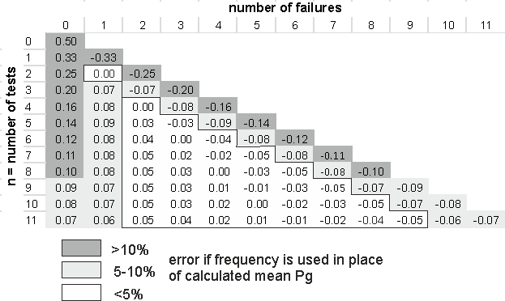
Table 3. Difference between Pg prediction using the Rule of Succession (table 1), compared to simple frequency. Positive numbers denote that the simple frequency is greater than the appropriately calculated mean Pg.

Authors
FRANK J. PEEL ~ National Oceanography Centre, Southampton, United Kingdom Frank.peel@noc.ac.uk
Frank Peel received his doctorate from the University of Oxford. He was a structural geologist and senior technical advisor at BP and BHP from 1985 to 2013. He joined the National Oceanography Centre in 2013; research interests include salt tectonics, gravity-driven deformation, fluid flow, and exploration risk. He is a recipient of the Matson Award of AAPG.
JOHN R.V. BROOKS, CBE ~ University of Southampton, United Kingdom jrvbrooks@supanet.com
John Brooks received his doctorate from the University of Kingston. As Director of Exploration and Licensing of the UK DoE, he was responsible for regulating UK petroleum licensing rounds. His company, Brookwood Petroleum, provides advice to international governments establishing petroleum licensing rounds, and as Senior Visiting Research Fellow, he mentors students at Southampton. He is past president, European Region AAPG.

