Foraging range and habitat associations of non-breeding Tristan Albatrosses: overlap with fisheries and implications for conservation

Timothy A Reid¹, Ross M Wanless^{1,2*}, Geoff M Hilton³, Richard A Phillips⁴, Peter G Ryan¹
¹Percy FitzPatrick Institute, DST/NRF Centre of Excellence, University of Cape Town, Rondebosch 7701, South Africa

²Seabird Division, BirdLife South Africa, PO Box 7119, Roggebaai, 8012, South Africa
³Royal Society for the Protection of Birds, The Lodge, Sandy, Bedfordshire SG19 2DL, UK
(Current address: Wildfowl and Wetlands Trust, Slimbridge, Gloucestershire, GL2 7BT, UK)
⁴British Antarctic Survey, Natural Environment Research Council, High Cross, Madingley Road, Cambridge CB3 0ET, UK
*corresponding author gsp@birdlife.org

Abstract
The Tristan Albatross Diomedea dabbanena is Critically Endangered; >99% of adults breed at Gough island, central South Atlantic Ocean, where chicks are threatened by introduced predators. At sea they mostly remain within the South Atlantic Ocean, where they are threatened by incidental capture in longline fisheries. Conservation measures to reduce seabird mortality in pelagic longline fisheries are confined largely to fishing effort south of 25°S. This covers the core range of breeding Tristan Albatrosses, but the distribution of non-breeding adults and immature birds is unknown. We tracked 14 non-breeding adult Tristan Albatrosses from Gough Island for up to three years, from 2004-2006, using geolocating loggers. All birds remained in the South Atlantic or southern Indian Oceans, and showed distributions centred on the Sub-Tropical Convergence. They used the south-west Atlantic during the austral summer, and the south-east Atlantic and Indian Oceans as far east as Australia during the austral winter. Foraging effort was concentrated in areas of upwelling and increased productivity. The distribution of the tracked birds overlapped with a range of pelagic longline fisheries, especially off southern Africa. Of particular concern was that two birds spent several months off the coast of Namibia and adjacent high seas north of 25˚S, where currently there are no regulations to prevent seabird bycatch during pelagic longline fishing operations.

Keywords: Atlantic Ocean, Indian Ocean, longline, bycatch, Diomedea dabbanena, Namibia

Introduction
Of all the groups of birds in the world, seabirds are the most threatened (Croxall et al. 2012). Albatrosses are particularly at risk, with 17 of the 22 species listed as threatened by the International Union for the Conservation of Nature (IUCN) (BirdLife International 2012). Seabirds face a range of threats, including fisheries mortality at sea, depletion of prey by fisheries, habitat destruction (either at sea or on land) and predation by introduced mammals at breeding islands (Moors and Atkinson 1984; Tuck et al. 2003; Cuthbert et al. 2005; Wanless et al. 2009; Zydelis et al. 2009; Finkelstein et al. 2010). Marine threats are particularly difficult to study, given the limited monitoring of many fishing fleets and the resultant paucity of reliable data on bird bycatch. In addition, many species of seabird range over vast areas and are thus likely to encounter multiple threats at sea in a variety of management jurisdictions (both national Exclusive Economic Zones (EEZs) and high seas areas) and to interact with fleets that vary widely in terms of compliance with conservation measures where these are in place.
The Tristan Albatross Diomedea dabbanena breeds almost exclusively on Gough Island in the central South Atlantic Ocean. It is classified as Critically Endangered by IUCN because of population declines caused by mortality on longlines and predation of chicks by introduced mice Mus musculus (Wanless et al. 2007, 2009, BirdLife International 2012). The population is estimated to be decreasing by almost 3% per year, with annual mortality from longline fishing estimated to be around 250 individuals (Wanless et al. 2009). Tristan Albatrosses have been killed by pelagic longline fisheries off Brazil (Olmos 1997; Cuthbert et al. 2005) and southern Africa (Petersen et al. 2009). A recent assessment conducted under the auspices of the International Commission for the Conservation of Atlantic Tunas (ICCAT) concluded that the Tristan Albatross was one of the species most at risk from longline fishing within the ICCAT area of jurisdiction (Tuck et al. 2011). A qualitative risk assessment for seabirds in the area managed by the Indian Ocean Tuna Commission (IOTC) came to a similar conclusion in terms of the threat to Tristan Albatrosses from fishing in the Indian Ocean (Baker and Wanless 2010).
Identifying the main foraging areas of the Tristan Albatross is complicated because at sea they are difficult to distinguish from other great albatrosses Diomedea spp.; indeed, separation from Wandering Albatross D. exulans requires measurements of birds in the hand (Cuthbert et al. 2003; Ryan 2007). The only published assessment of their foraging range is derived from tracking data for breeding birds in 2000. In that study, birds remained predominantly in the central South Atlantic, though some travelled as far as South America and South Africa (Cuthbert et al. 2005). However, foraging ranges of adult albatrosses can be substantially larger in the nonbreeding period, when they are not constrained to return to a central location to incubate or provision their chick (BirdLife International 2004; Phillips et al. 2005; Weimerskirch et al. 2012). Given the ongoing threat to this Critically Endangered species, it is imperative to better understand their movement patterns and habitat use during all life-cycle stages. Here we present new information on the distribution of non-breeding Tristan Albatrosses in relation to longline fishing effort and environmental characteristics.

Methods
Tristan Albatrosses currently breed at two sites in the South Atlantic Ocean. Some 1200 pairs breed at Gough Island (40º19’S, 9 º56’W) and a few pairs at Inaccessible Island (37 º18’S, 12 º40’W), where on average <1 chick fledges each year (Wanless et al. 2009). Global Location Sensor (GLS) loggers (British Antarctic Survey, Cambridge, UK), often referred to as geolocators, were attached to leg bands on 43 Tristan Albatrosses breeding on Gough Island. Devices were ground-truthed for two weeks at the colony, and then fitted to adults feeding large chicks in August and September 2004. The devices weighed 9 g, equivalent to <0.2% of the weight of a mature Tristan Albatross (>7 kg), well below the load that might be expected to affect foraging behaviour (Phillips et al. 2003; Passos et al. 2010).
GLS loggers measured light intensity every minute and recorded the maximum in each 10 minute period. Downloaded light data were processed to estimate the time of sunrise, sunset and hence local midday relative to GMT/UTC, and daylength. From these parameters, it is possible to estimate latitude and longitude. However, there are inaccuracies in positions derived this way due to factors such as cloud cover, shading of the light sensor by feathers, or rapid movements by flying birds. Positions are accurate to roughly 200 km, except around the equinoxes when latitudinal errors increase (Phillips et al. 2004). An iterative speed filter was used to identify unlikely locations (McConnell et al. 1992). For this, an average was taken over five positions, and those positions that required a maximum average speed of >80 km/hr (Weimerskirch et al. 1993), were filtered using the tripEstimation package (version 0.0-37). To estimate the areas used most frequently, we applied kernel smoothing to the filtered positions using the ks package (version 1.8.12) in R. Most frequently used areas were presented as Percentage Volume Contours, such that 50% contours show the most dense 50% of all locations (Tancell et al. 2013). All statistical analyses were conducted in R (R Development Core Team (2012); version 2.15.0).
Devices deployed in late 2004 were retrieved during the 2006 breeding season, and hence the study included the end of the 2004 breeding period, the entire sabbatical year in 2005, and the start of the 2006 breeding period. Based on the GLS positional data, none of the study birds appeared to breed during 2005 (there was no researcher on the island that breeding season to confirm their absence from the breeding colony). Breeding/non-breeding activity was classed based on known breeding history and movement patterns (e.g. birds regularly attending the island were assumed to be breeding). Only data from the non-breeding period (including both failed and successful breeders at the previous attempt) are presented here. Data for breeding birds suggested the use of similar areas to those described in Cuthbert et al. (2005).

Longline fishing effort distribution
Longline fishing effort data are presented here at the finest spatial resolution available. Quarterly data at a 5x5º resolution over five years (2001-2006) were obtained from ICCAT for the Atlantic Ocean (http://www.iccat.es/en/accesingdb.htm), and monthly data for the Indian Ocean were obtained from the IOTC (http://www.iotc.org/English/data/databases.php#dl).

Modelling effects of environmental conditions
To test how non-breeding Tristan Albatrosses were distributed in relation to environmental conditions we followed the approach of Aarts et al. (2008) and Wakefield et al. (2011). Tracking data are presence only, so we created pseudo-absences in order to examine habitat preferences using logistic regressions, where records of birds were given a value of one, and pseudo-absences a value of zero. Pseudo-absence data are derived from positions chosen from areas available to the population (Aarts et al. 2008). Choice of pseudo-absence position is important, and overcomplicating models of possible areas can lead to poor prediction (Wisz and Guisan 2009). In this study, possible pseudo-absences were confined to areas to which the study birds could realistically move. Because non-breeders are not constrained to return to their nests, this was considered to be the maximum extent of the area used during this study, i.e. from 15-60ºS in the Atlantic Ocean, and 30-60ºS in the Indian Ocean; no birds visited the Pacific Ocean. During summer (November-April), all birds remained within the Atlantic Ocean. Thus, pseudo-absences were randomly chosen from within these spatio-temporal constraints. We generated 100 points/bird/month throughout the year, giving 4,085 presences and 15,535 absences.
Monthly Sea Surface Temperature (SST) and Aqua Modis chlorophyll-A (chl-A) in mg.m⁻³ at 4 km resolution were downloaded from SeaWifs via http://oceancolor.gsfc.nasa.gov/, and monthly mean Sea Level Anomaly (SLA) data from Aviso at http://www.aviso.oceanobs.com at a 0.333x0.333º grid scale. Variables chosen were ones that have previously been demonstrated to correlate with distributions of other seabird species (e.g. Phillips et al. 2006; Wakefield et al. 2011). We modelled the tracking data using a Generalised Additive Mixed Model (GAMM) using the mgcv (version 1.7-13) package in R. Individual bird identity was treated as a random effect. Fixed effects were latitude and longitude as interacting terms, SST, chl-A, water depth and mean SSA. We took a Bayesian view that all variables chosen for fixed effects were components of the world, and therefore should be presented, rather than using any form of model selection to narrow the suite of variables (Bolker 2008). This was considered appropriate as the model was descriptive rather than predictive.

Results
Of the 43 GLS loggers deployed, 35 (81%) were retrieved, but data were obtained from only 15 devices (the others failed to download data). Fourteen contained data on non-breeding movements (13 post-breeding and 1 late failure), while one only contained data for the breeding period. The core areas (i.e., 50% kernels) of most birds were between ~25ºS to ~45ºS, year-round. Most positions were around the Subtropical Convergence and farther north, typically in waters of 10-20ºC (range 0-24ºC; Fig. 1). Distributions were largely centred in oceanic waters (>3000 m deep).
Non-breeding adult Tristan Albatrosses ranged across the Atlantic and Indian Oceans, encompassing half the globe from the east coast of South America (50˚ W) to the Great Australian Bight (130˚E). However, most locations (86%) were in the Atlantic Ocean (west of 20ºE), and only two birds ranged well into the Indian Ocean. Non-breeding adults occurred predominantly in the south-west Atlantic from January to March (Fig. 2 a,b,c), shifting to the south-east Atlantic during March-May (Fig. 2 c,d,e). During the austral winter (May-September), most time was spent in the south-east Atlantic off South Africa (Fig. 2 e-i) and eastward into the Indian Ocean to ~40ºE (Fig 3. b-f). Two birds moved to Namibia in late-March and remained there until June, with one of these returning during August (Fig. 2 c-f, h). In April, two individuals (14% of tracked birds) began moving to south-west Australia, arriving in June. They returned westward, against the prevailing winds, in September (Fig. 3), resulting in their winter foraging ranges being predominantly in the Indian Ocean. In spring (October), prior to the onset of breeding, adults started to return to the south-west Atlantic (Fig 2 j), and all birds were in this areas in November (Fig. 2 k). By December, immediately before breeding commenced, all tracked birds were concentrated in the central South Atlantic around Gough Island (Fig. 2 k).
Tristan Albatross distributions overlapped with high levels of longline fishing effort during April- August off South Africa, where birds spent most of their time in areas of eddies and mixing associated with the Agulhas Current (Fig. 2 d-f, Fig. 3 b-d, Table 1). The intensity of fishing effort in the areas used by nonbreeding Tristan Albatross during this study was greater in the Indian Ocean than in the Atlantic Ocean, with a maximum of 2.76 million hooks set during a month in a single 5x5˚ block in the Indian Ocean, compared with an average of 1.1 million hooks set over three months during 2001-2006 in the block with the greatest effort in the Atlantic Ocean. Most overlap between adult Tristan Albatrosses and longline fishing effort occurred during winter (quarters 2 and 3; Table 2); during quarter 3, all tracked birds visited a 5x5º square in which fishing effort had averaged >500,000 hooks.year⁻¹ from 2001-2006.
The GAMMs comparing presences and pseudo-absences suggested that Tristan Albatross were significantly more likely to occur in the south-west or south-east Atlantic Ocean or off south-west Australia (edf=27.0; F=58.7; p<0.01). They preferred waters ~3,000-5,000 m deep with surface temperatures of 15-20ºC (Fig. 4a; edf=5.9; F=15.5; p<0.01), enhanced chlorophyll-A concentrations (Fig. 4b; edf=1.0; F=6.0; p=0.01), and avoided shelf waters (Fig. 4c; edf=4.1; F=4.3; p<0.01). Mean sea level anomaly had less influence on their distribution, except for a weak tendency to favour areas with reduced mean SLA (Fig. 4d; edf=1.0; F=4.3; p=0.04). However, when mean SLA was examined in isolation, tracked Tristan Albatrosses were least likely to visit areas where there was no mean sea level anomaly. The overall model had an adjusted r² of 0.26.

Discussion
Overlap with breeding birds and other species
The ranges of non-breeding Tristan Albatrosses were substantially greater than those of breeding adults (Cuthbert et al. 2005; Fig. 5), which are required to return regularly to Gough Island to incubate or to provision their chick. Breeding birds remain predominantly in waters of the central South Atlantic Ocean around Tristan da Cunha and Gough islands, with east-west movements largely confined to the area from 15ºE to 50ºW (Cuthbert et al. 2005). Although non-breeders spent most of their time in the South Atlantic Ocean, there was little overlap in their distribution with the core areas used by breeders (in the central Atlantic), suggesting spatial niche partitioning between adults of different status. Generally, Tristan Albatrosses occur in subtropical waters or around the Sub-tropical Convergence, rather than in more southerly waters. While there was some overlap with Wandering Albatrosses from more their more southerly colonies on South Georgia, the Prince Edward Islands, Iles Crozet and Kerguelen (Prince et al. 1992; Weimerskirch et al. 1993; Nel et al. 2002; Birdlife International 2004), Tristan Albatrosses foraged predominantly to the north of adult Wandering Albatrosses, and were more likely to overlap with female and non-breeding Wandering Albatrosses than with breeding males.
Non-breeding movements
Non-breeding Tristan Albatrosses move extensively throughout two southern ocean basins. The areas they utilise off both South America and southern Africa are associated with highly productive eddies and mixing zones (Figs 6 and 7). There were clear seasonal patterns to their movements, with all tracked birds concentrating in the south-west Atlantic during the austral summer, but travelling eastward and dispersing more widely during the austral winter, mostly to the south-east Atlantic and south-west Indian Ocean off South Africa. However, two birds moved to waters off northern Namibia and two to southern Australia. It is important to note that although we present results from 2005 only, the limited tracking data available for non-breeding birds in 2004 and 2006 showed a broadly similar pattern.
Overlap with oceanography
Our analyses indicate that although Tristan Albatrosses tend to concentrate in productive areas at frontal zones and around eddies, their overall distribution includes waters that vary widely in terms of primary productivity. There are several possible explanations. Tristan Albatrosses may be able to get sufficient food to meet their energetic requirements, while avoiding competition, by remaining in slightly lower quality areas. Alternatively, there may be a mismatch between chlorophyll-A measured by satellite imagery (which is at the lowest trophic level) and the distributions of the higher trophic-level organisms that Tristan Albatrosses are likely to target (fish and squid, Imber 1992). In addition, the GLS data used in the modelling are inherently imprecise, which means that habitat can only be described at broad spatial scales. In order to investigate habitat preferences more closely, more accurate tracking data from GPS loggers or satellite-tags would be required.
During the austral summer, non-breeding Tristan Albatrosses occurred predominantly in the southwest Atlantic Ocean between 30-45ºS and 0-50ºW. This area is influenced by a number of strong oceanographic features, including the subtropical convergence between the Brazil/Malvinas (Falklands) Confluence (Fig. 6), that result in eddies and vertical mixing that enhance local production (Fig. 6b, c). This area has consistently high productivity in summer and low productivity in winter (Figs 6b and 7b; Wainer et al. 2000), supporting the conclusion that its importance to seabirds is likely to vary seasonally. It is a key foraging area for other marine predators in summer, including Black-browed Albatrosses Thalassarche melanophris (Wakefield et al. 2011) and White-chinned Petrels Procellaria aequinoctialis (Phillips et al. 2006) from South Georgia, Southern Elephant Seals Mirounga leonina from Argentina (Campagna et al. 2006), and migrant Cory’s Calonectris diomedea (Dias et al. 2011), Sooty Puffinus griseus (Hedd et al. 2012) and Manx P. puffinus (Guilford et al. 2009) shearwaters.
Despite the high productivity in summer, this area experiences relatively low pelagic longline fishing effort in this season, limiting the risk to Tristan Albatrosses. Most seabird bycatch in longline fisheries off Uruguay and southern Brazil occurs in winter, and the apparent paucity of Tristan Albatrosses in these waters in winter may explain their scarcity in bycatch records from these fisheries (Bugoni et al. 2008; Jimenez et al 2009). Other fisheries that can impact seabrds, such as demersal longlining and trawling, do not occur in these deep, offshore waters. In winter, when the southwest Atlantic is less productive (Wainer et al. 2000), Tristan Albatrosses dispersed more widely. Most tracked birds concentrated to the south and west of South Africa in areas associated with the Agulhas and Benguela currents (Fig 7c; Stramma and England 1999), and two birds visited sub-Antarctic and Antarctic waters to ~55ºS during April-May and August.
Overlap with fisheries
All the non-breeding Tristan Albatrosses visited areas of high fishing effort in winter, particularly off southern Africa and in the Indian Ocean. Fortunately, their catch rate in this region appears to be fairly low provided appropriate mitigation measures (e.g. setting only between nautical dusk and dawn, mandatory use of bird scaring lines, etc.). Petersen et al. (2009) recorded only three Tristan Albatrosses killed, 0.3% of birds returned to port by fishery observers in the South African large pelagic longline fishery between 1998 and 2005. And since 2005, no further mortalities of this species have been recorded in this fishery. Until recently, appropriate mitigation has not been required in high seas fisheries in this region, but ICCAT and the IOTC will soon require vessels operating south of 25ºS to use two mitigation measures for all longline sets, from a choice of three possible measures: bird scaring lines, night setting, or line weighting (ICCAT 2011, IOTC 2012). The CCSBT requires vessels catching southern bluefin tuna Thunnus maccoyi to use the conservation measures of the relevant ocean in which they operate. Thus, Tristan Albatrosses will be afforded some protection from longline bycatch across their longitudinal range, but only south of 25°S.
Two Tristan Albatrosses (14% of tracked birds) spent approximately four months off the coast of Namibia, north of 25ºS, where neither ICCAT nor the government of Namibia require any measures to reduce seabird bycatch in tuna longline operations. This suggests that an appreciable proportion of non-breeding Tristan Albatrosses remain at risk from pelagic longline fishing off Namibia. Seabird bycatch on pelagic longliners occurs in these waters (Anderson et al. 2011), so it is imperative that ICCAT and the government of Namibia afford protection for this Critically Endangered species by extending the area of application of the ICCAT conservation measure (Recommendation 11-09). Our results suggest that current ICCAT seabird conservation measures should be extended north from 25ºS to 15ºS in the area from 0ºE to the Namibian coast. This would also benefit a other species susceptible to mortality in longline fisheries in the region including Spectacled Procellaria conspicillata and White-chinned P. aequinoctialis petrels, and Atlantic Yellow-nosed Thalassarche chlororhynchos and Shy/White-capped T. cauta/steadi albatrosses (Camphuysen and van der Meer 2000).

Acknowledgments
Andrea Angel, Marie-Helene Burle, John Cooper and Johnny Wilson assisted with deployment and retrieval of devices. Phil Taylor of BirdLife International kindly supplied cleaned and vetted longline fishing effort data from the ICCAT area of competence.

References
Aarts G, MacKenzie M, McConnell B, Fedak M, Mathiopoulus J (2008) Estimating space-use and habitat preference from telemetry data. Ecography 31: 140-160.
ACAP (2011) ICCAT Commission meeting adopts a supplemental seabird recommendation in the South Atlantic. Downloaded from http://www.acap.aq/latest-news/iccat-commission-meeting-adopts-a-supplemental-seabird-recommendation-in-the-south-atlantic on 14 May 2012.
Afanasyev V (2004) A miniature daylight level and activity data recorder for tracking animals over long periods. Memoirs of the National Institute of Polar Research, Special Issue 58, 227-233.
Anderson ORJ, Small CJ, Croxall JP, Dunn EK, Sullivan BJ, Yates O, Black A (2011) Global seabird bycatch in longline fisheries. Endangered Species Research 14: 91-106.
Baker GB, Wanless RM (2010) Level 1 Risk Assessment of Indian Ocean seabirds susceptible to bycatch in longline fishing operations. Presented to the 6th session of the Indian Ocean Tuna Commission's Working Party on Ecosystems and Bycatch, Victoria, Seychelles, 27-30 October 2010, IOTC-2010-WPEB-24.
BirdLife International (2004) Tracking ocean wanderers: the global distribution of albatrosses and petrels., In Results form the Global Procellariiform Tracking Workshop, 1-5 September 2003. BirdLife International: Cambridge (UK), Gordon's Bay, South Africa.
BirdLife International (2012) Threatened Birds of the World. www.birdlife.org
Bolker BM (2008) Ecological Models and Data in R. Princeton University Press, New Jersey.
Bugoni L, Mancini PL, Monteiro DS, Nascimento L, Neves T (2008) Seabird bycatch in the Brazilian pelagic longline fishery and a review of capture rates in the southwestern Atlantic Ocean. Endangered Species Research 5: 137-147.
Campagna C, Piolo AR, Marin MR, Lewis M, Fernandez T (2006) Southern elephant seal trajectories, fronts and eddies in the Brazil/Malvinas Confluence. Deep Sea Research I 53: 1907-1924.
Camphuysen CJ, van der Meer J (2000) Notes on the distribution of the spectacled petrel Procellaria conspicillata in the South Atlantic Ocean. Atlantic Seabirds 2: 13-18
Croxall JP, Butchart SHM, Lascelles B, Stattersfield AJ, Sullivan B, Symes A, Taylor P (2012) Seabird conservation status, threats and priority actions: a global assessment. Bird Conservation International 22: 1-34.
Cuthbert RJ, Phillips RA, Ryan PG (2003) Separating Tristan Albatrosses and Wandering Albatrosses using morphometric measurements. Waterbirds 26: 338-344.
Cuthbert RJ, Hilton G, Ryan PG, Tuck G, (2005) At-sea distribution of the Tristan Albatross Diomedea dabbenena and potential interactions with pelagic longline fishing in the South Atlantic Ocean. Biological Conservation 121: 345-355.
Dias MP, Granadeiro JP, Phillips RA, Alonso H Catry P. (2011) Breaking the routine: individual Cory’s shearwaters shift winter destinations between hemispheres and across ocean basins. Proceedings of the Royal Society Series B 278: 1786-1793.
Finkelstein ME, Doak DF, Nakagawa M, Sievert PR, Klavitter J (2010) Assessment of demographic risk factors and management priorities: impacts on juveniles substantially affect population viability of a long-lived seabird. Animal Conservation 13: 148-156.
Guilford T, Meade J, Willis J, Phillips RA, Boyle D, Roberts S, Collett M, Freeman R, Perrins CM (2009) Migration and stopover in a small pelagic seabird, the Manx Shearwater Puffinus puffinus: insights from machine learning. Proceedings of the Royal Society, Series B 276, 1215-1223.
Hedd A, Montevecchi WA, Otley H, Phillips RA, Fifield DA (2012) Trans‐equatorial migration and habitat use of sooty shearwaters Puffinus griseus from the South Atlantic during the nonbreeding season. Marine Ecology Progress Series 449, 277-290.
ICCAT (2011) Supplemental recommendation by ICCAT on reducing incidental bycatch of seabirds in ICCAT longline fisheries. Recommendations adopted at the 2011 Commission meeting, International Commission for the Conservation of Atlantic Tunas. ICCAT circular 5058/2011, Madrid, Spain: 82 pp.
Imber MJ (1992) Cephalopods eaten by wandering albatrosses (Diomedea exulans L.) breeding at six circumpolar localities. Journal of the Royal Society of New Zealand 22, 243-263.
IOTC (2012) Report of the sixteenth session of the Indian Ocean Tuna Commission. Fremantle, Australia, 22–26 April 2012. IOTC–2012–S16–R[E]: 130 pp.
Jimenez S, Domingo A, Brazeiro A (2009) Seabird bycatch in the southwest Atlantic: interaction with the Uruguayan pelagic longline fishery. Polar Biology 32, 187-196.
Klaer NL (2009) Estimates of total seabird bycatch by ICCAT pelagic longline fisheries in recent years, In Unpublished report SCRS/2009/075 to ICCAT Intersessional Working Group on Ecosystems and Bycatch. pp. 1-13.
McConnell BJ, Chambers C, Fedak MA (1992) Foraging ecology of southern elephant seals in relation to the bathymetry and productivity of the Southern Ocean. Antarctic Science 4: 393-398.
Miller KA (2007) Climate variability and tropical tuna: Management challenges for highly migratory fish stocks. Marine Policy 31: 56-70.
Moors PJ Atkinson IAE (1984) Predation on seabirds by introduced animals and factors affecting its severity., In Status and conservation of the world's seabirds. In: Croxall JP, Evans PGH, Schreiber RW (eds), International Council for Bird Preservation, Technical Publication No.2, Cambridge, UK, pp. 667-690.
Nel DC, Ryan PG, Nel JL, Klages NTW, Wilson RP, Robertson G, Tuck GN (2002) Foraging interactions between wandering albatrosses Diomedea exulans breeding on Marion Island and long-line fisheries in the southern Indian Ocean. Ibis 144: E141-154.
Neves T, Olmos F (1997) Albatross mortality in fisheries off the coast of Brazil, In The Albatross: Biology and Conservation. In: Robertson G, Gales R. Surrey Beatty and Sons, Chipping Norton, pp. 214-219.
Olmos F (1997) Seabirds attending bottom long-line fishing off southeastern Brazil. Ibis 139: 685-691.
Passos C, Navarro J, Giudici A, González-Solís J (2010) Effects of extra mass on the pelagic behavior of a seabird. Auk 127: 100-107.
Petersen SL, Honig MB, Ryan PG, Underhill LG (2009) Seabird bycatch in the pelagic longline fishery off southern Africa. African Journal of Marine Science 31: 191-204.
Phillips RA, Xavier JC, Croxall JP (2003) Effects of satellite transmitters on albatrosses and petrels. The Auk 120: 1082-1090.
Phillips RA, Silk JRD, Croxall JP, Afanasyev V, Briggs DR (2004) Accuracy of geolocation estimates for flying seabirds. Marine Ecology Progress Series 266: 265-272.
Phillips RA, Silk JRD, Croxall JP, Afanasyev V, Bennett VJ (2005) Summer distribution and migration of nonbreeding albatrosses: individual consistencies and implications for conservation. Ecology 86: 2386-2396.
Phillips RA, Silk, JRD, Croxall JP Afanasyev V. (2006) Year-round distribution of white-chinned petrels from South Georgia: relationships with oceanography and fisheries. Biological Conservation 129: 336-347.
Prince PA, Wood AG, Barton T, Croxall JP (1992) Satellite tracking of wandering albatrosses (Diomedea exulans) in the South Atlantic. Antarctic Science 4: 31-36.
R Development Core Team (2012) R: A language and environment for statistical computing. R Foundation for Statistical Computing, Vienna, Austria. ISBN 3-900051-07-0, URL http://www.R-project.org/.
Reid TA, Hindell MA (2000) Coarse-scale relationships between seabirds and zooplankton off south-eastern Tasmania. Marine and Freshwater Research 51: 789-798.
Ryan PG (2005) Tristan Albatross Diomedea dabbenena, In Roberts Birds of Southern Africa, VII Edition. Hockey PAR, Dean WRJ, Ryan PG. The Trustees of the John Voelker Bird Book Fund, Cape Town, p. 643.
Ryan PG (2007) A field guide to the animals and plants of Tristan da Cunha and Gough Island. Pisces Publications, Newbury.
Stramma L, England M. (1999) On the water masses and mean circulation of the South Atlantic Ocean. Journal of Geophysical Research 104: 20863-20883.
Tancell C, Phillips RA, Xavier JC, Tarling GA, Sutherland WJ (2013) Comparison of methods for determining key marine areas from tracking data. Marine Biology 160: 15-26.
Thomson RB, Wanless RM, Tuck GN (2009) Modelling the impact of fishery bycatch on Tristan albatross of Gough Island, pp. 1-30, Unpublished report SCRS/2009/078 to ICCAT Intersessional Working Group on Ecosystems and Bycatch.
Tuck GN, Phillips RA, Small C, Thomson RB, Klaer N, Taylor F, Wanless RM, Arrizabalaga H. (2011) An assessment of seabird-fishery interactions in the Atlantic Ocean. ICES Journal of Marine Science 68: 1628-1637.
Tuck GN, Polacheck T, Bulman CM (2003) Spatio-temporal trends of longline fishing effort in the Southern Ocean and implications for seabird bycatch. Biological Conservation 114: 1-27.
Wainer I, Gent P, Goni G. (2000) Annual cycle of the Brazil-Malvinas confluence region in the National Center for Atmospheric Research Climate Science Model. Journal of Geophysical Research 105: 26167-26177.
Wakefield ED, Phillips RA, Trathan PN, Arata J, Gales R, Huin N, Robertson G, Waugh SM, Weimerskirch H, Matthiopoulus J. (2011) Habitat preference, accessibility, and competition limit the global distribution of the black-browed albatross. Ecological Monographs 81: 141-167.
Wanless RM, Angel A, Cuthbert RJ, Hilton GM, Ryan PG (2007) Can predation by invasive mice drive seabird extinctions? Biology Letters 3: 241-244.
Wanless RM, Ryan PG, Altwegg R, Angel A, Cooper J, Cuthbert R, Hilton GM (2009) From both sides: dire demographic consequences of carnivorous mice and longlining for the Critically Endangered Tristan albatrosses on Gough Island. Biological Conservation 142: 1710-1718.
Weimerskirch H, Salamolard M, Sarrazin F, Jouventin P (1993) Foraging strategies of wandering albatrosses through the breeding season: a study using satellite telemetry. The Auk 110: 325-342.
Weimerskirch H, Louzao M, de Grissac S, Delord K (2012) Changes in wind pattern alter albatross distribution and life-history traits. Science 335: 211-214.
Wisz MS, Guisan A (2009) Do pseudo-absence strategies influence species distribution models and their predictions? An information-theoretic approach based on simulated data. BMC Ecology 9:8.
Zydelis R, Wallace BP, Gilman EL, Werner TB (2009) Conservation of marine megafauna through minimization of fisheries bycatch. Conservation Biology 23: 608-616.

Table 1. Overlap of tracked non-breeding Tristan Albatrosses and longline fishing in the South Atlantic and Indian Oceans. ICCAT = International Commission for the Conservation of Atlantic Tuna; IOTC = Indian Ocean Tuna Commission. Number of tracked birds = number of individuals in that year quarter. Blocks with fishing effort=number of 5x5º squares which had some fishing effort during the quarter in 2001-2006; blocks with high fishing effort = number of 5x5º squares where an annual average of greater than 500,000 hooks was set during 2001-2006; number of birds visiting a block with high effort =number of individual Tristan Albatrosses that visited a square where >500,000 hooks were set each year. % tracked birds visiting a square with high effort = the percentage of total tracked individuals that visited a square with >500,000 hooks per year (note that in Quarter 3 two birds visited squares with >500,000 hooks set in both the Atlantic and Indian Oceans).
 |  | Quarter
 |  | 1 | 2 | 3 | 4
 | Number of tracked birds | 14 | 13 | 11 | 7
ICCAT | Blocks with fishing effort | 100 | 100 | 100 | 100
 | Blocks with high fishing effort | 3 | 2 | 1 | 2
 | Number of birds visiting a block with high effort | 0 | 8 | 4 | 0
IOTC | Blocks with fishing effort | 141 | 141 | 148 | 148
 | Blocks with high fishing effort | 23 | 23 | 49 | 46
 | Number of birds visiting a block with high effort | 0 | 0 | 9 | 1
 | %tracked birds visiting block with high effort | 0 | 62 | 100 | 14

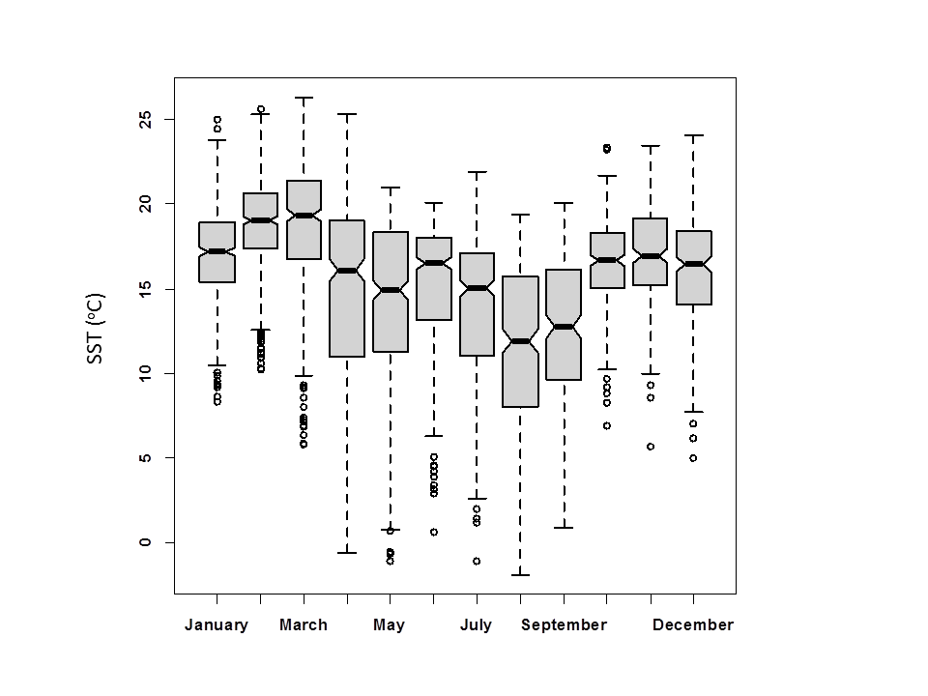
Fig. 1. Variation in sea surface temperature encountered by nonbreeding Tristan Albatrosses by month during 2005. The box shows the 25% and 75% quartiles (the inner quartiles), the notch occurs at +/- 1.58 * IQR/sqrt(n) where IQR is the inner quartile range and n is the number of observations in that month. Whiskers are drawn at 1.5 * IQR beyond the inner quartiles.

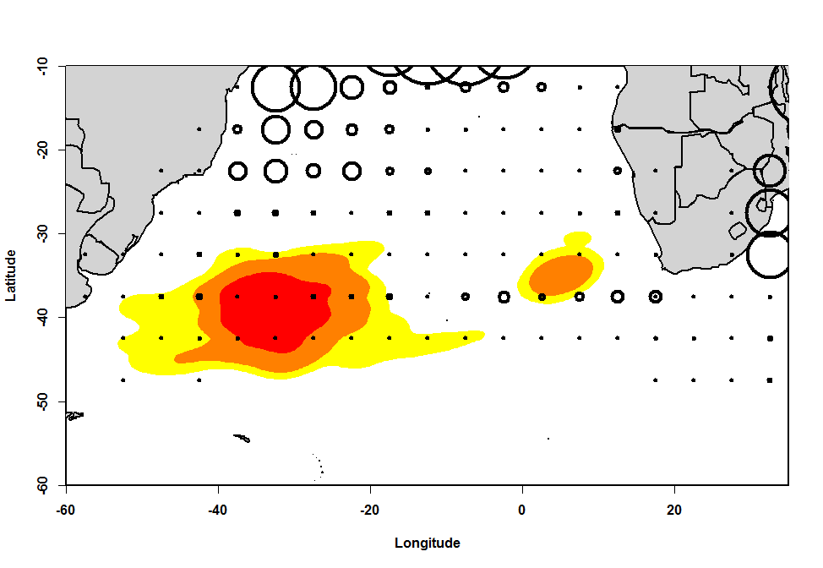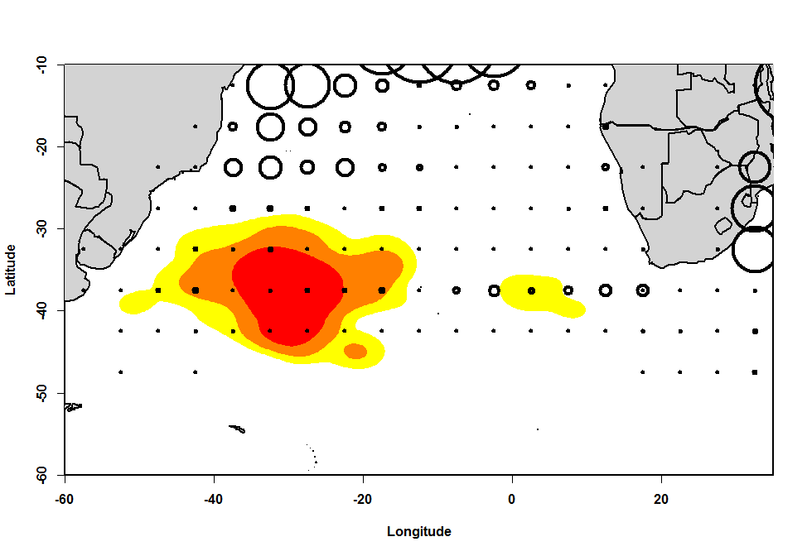
- January b. February
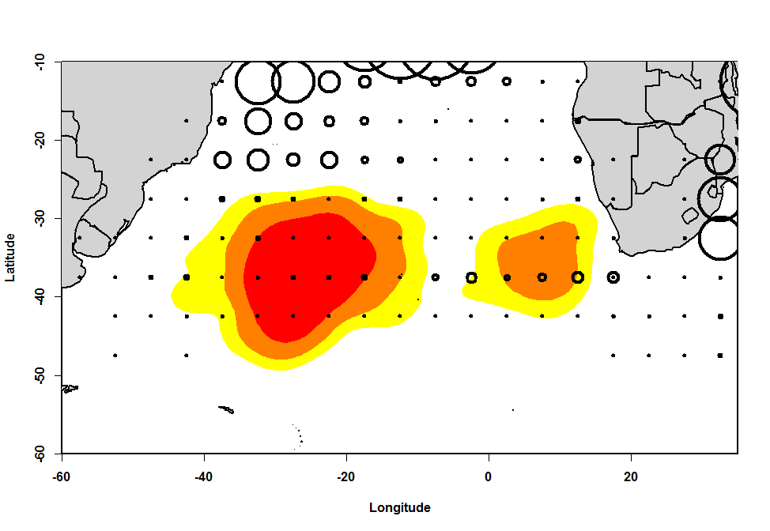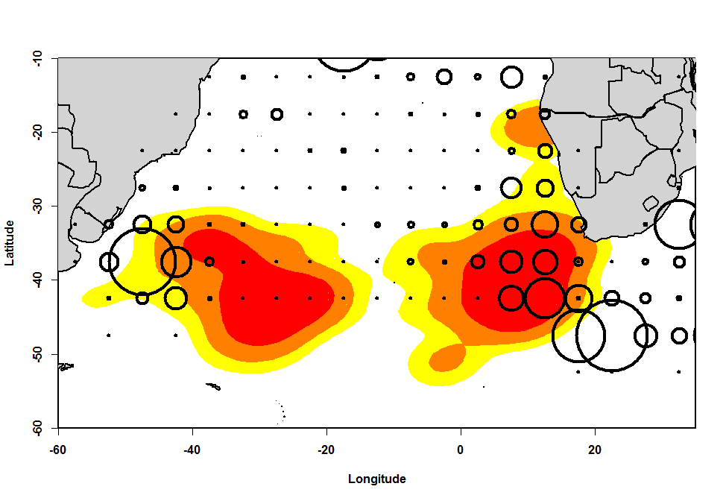
- March d. April
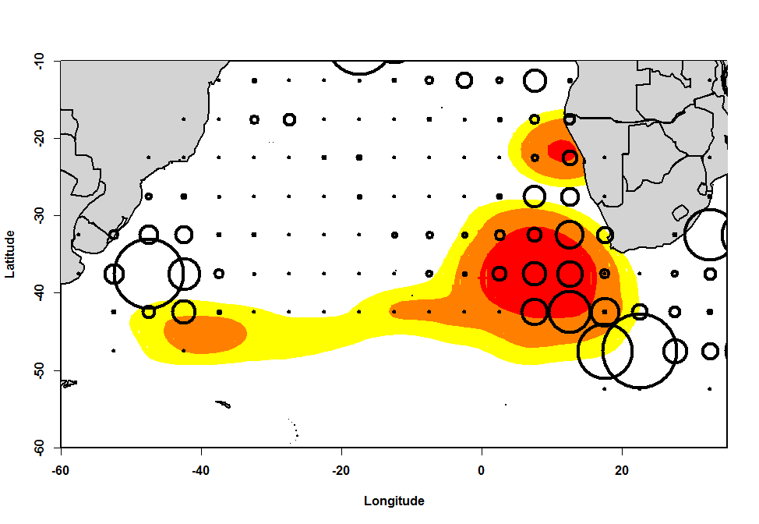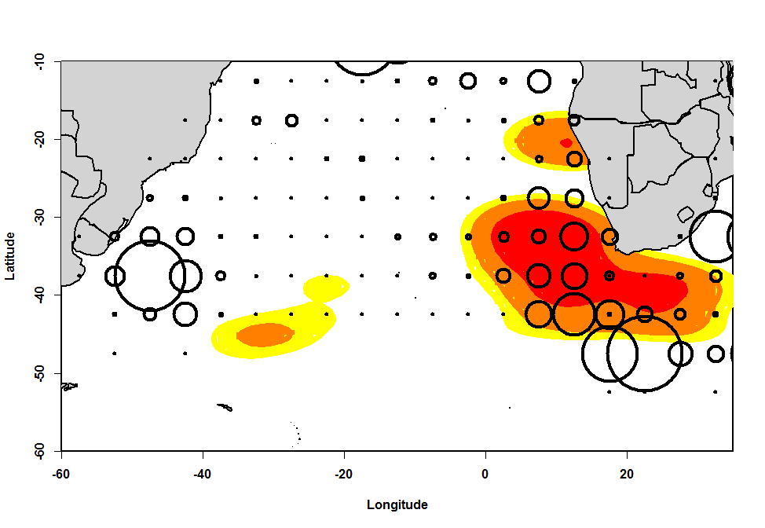
e. May f. June
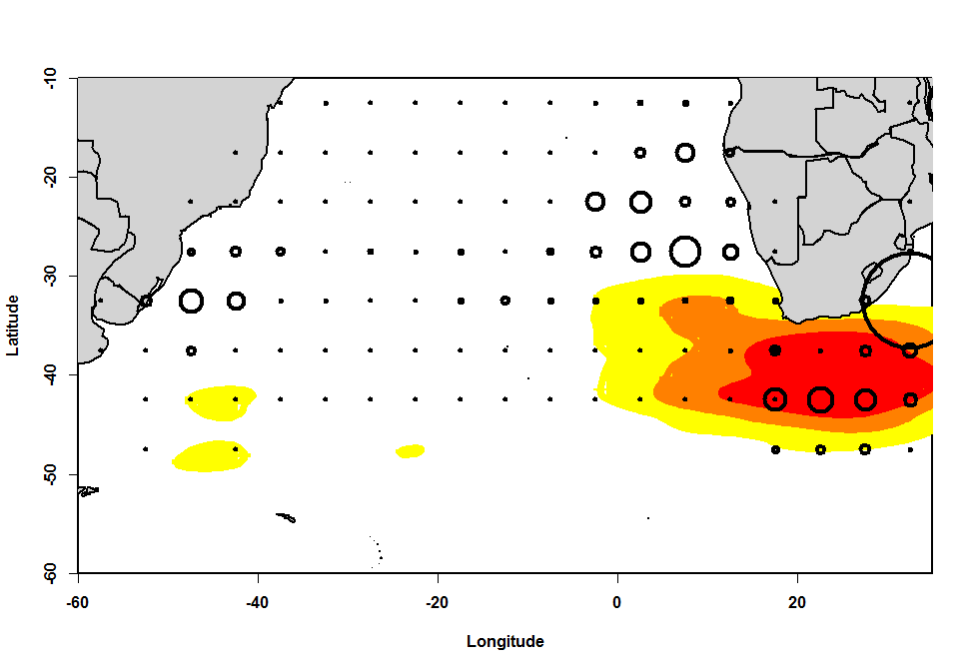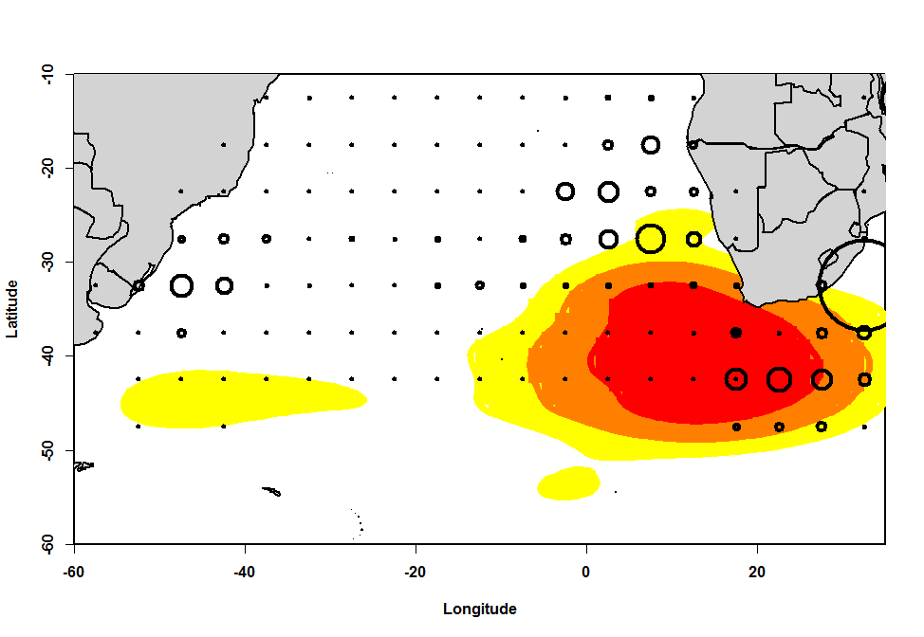
g. July h. August
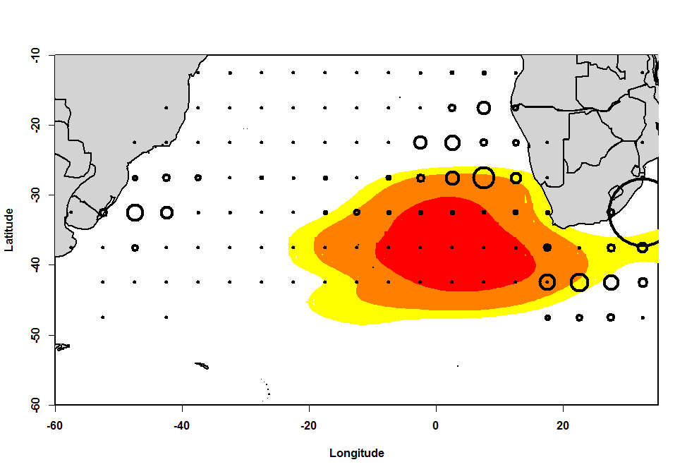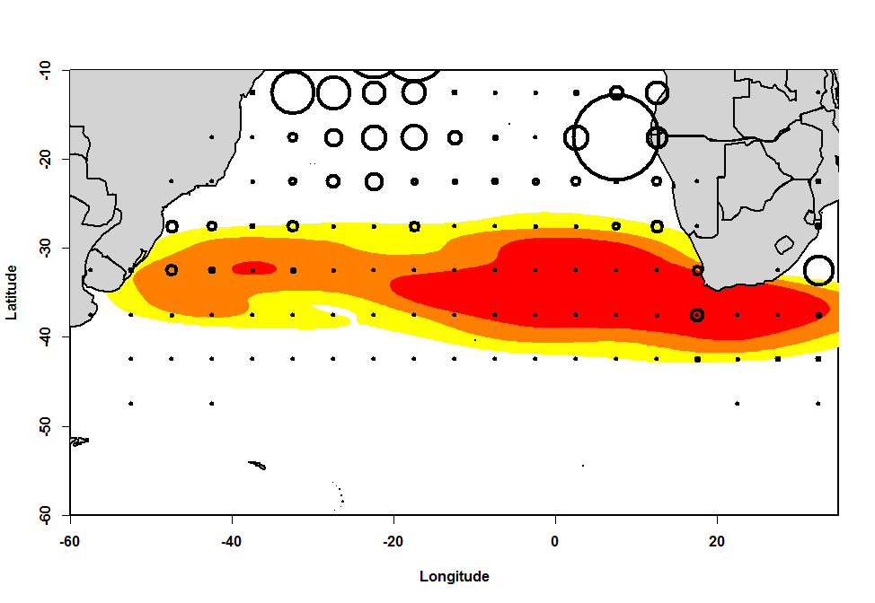
- September j. October
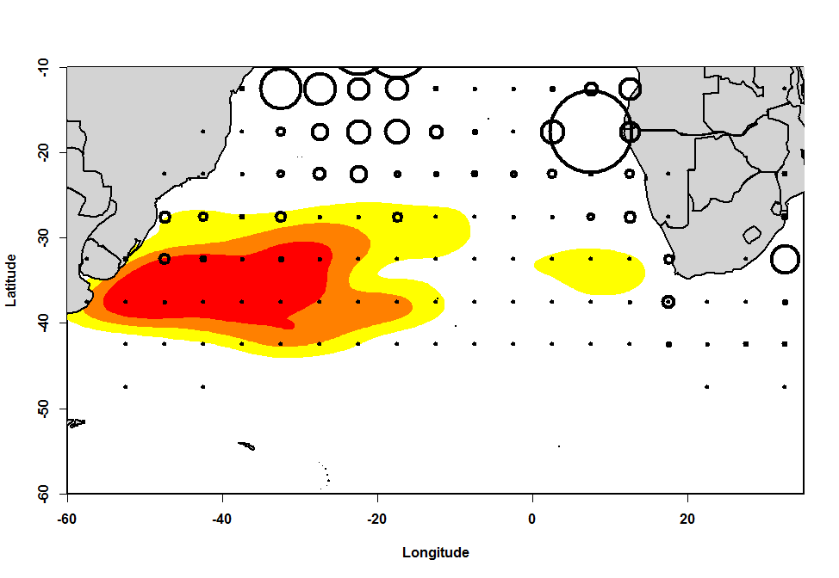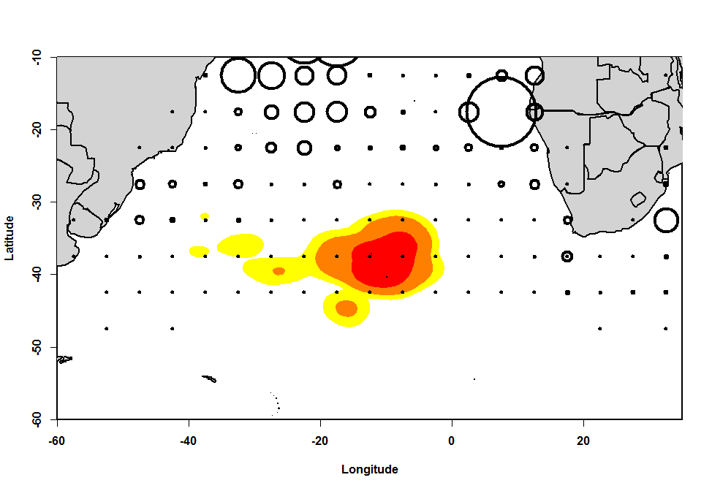
k. November l. December
Fig. 2. Kernel plots (50, 75 and 90% isopleths) of non-breeding adult Tristan Albatross distribution within the South Atlantic Ocean in 2005, overlaid on fishing effort by pelagic longliners fishing for tuna and other billfishes (Red=50%, Orange=75%, Yellow=90%). Fishing effort is mean quarterly number of hooks set within 5x5º blocks for the period of 2001-2006, with circles proportional to the number of hooks set (maximum number of hook set in quarter 1: 1.0 million, quarter 2: 1.0 million, quarter 3: 0.6 million, quarter 4: 1.1 million)..

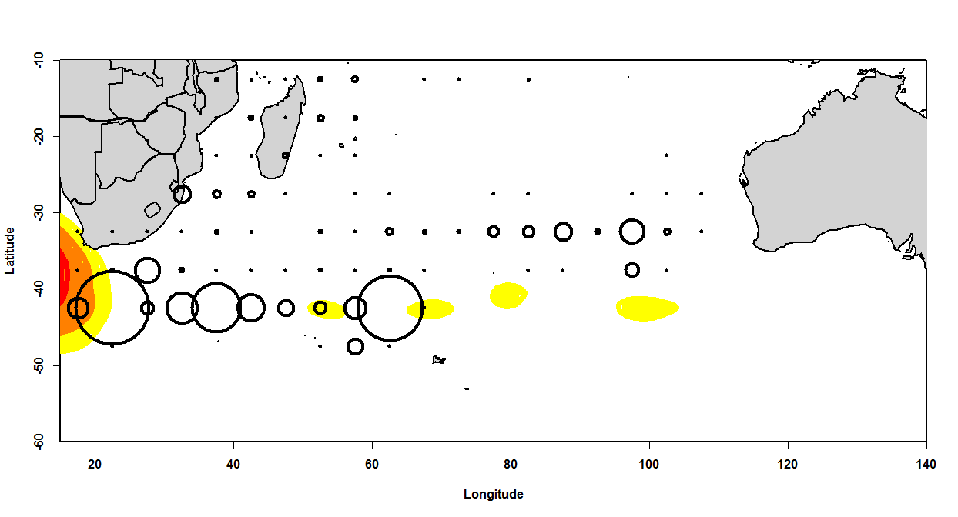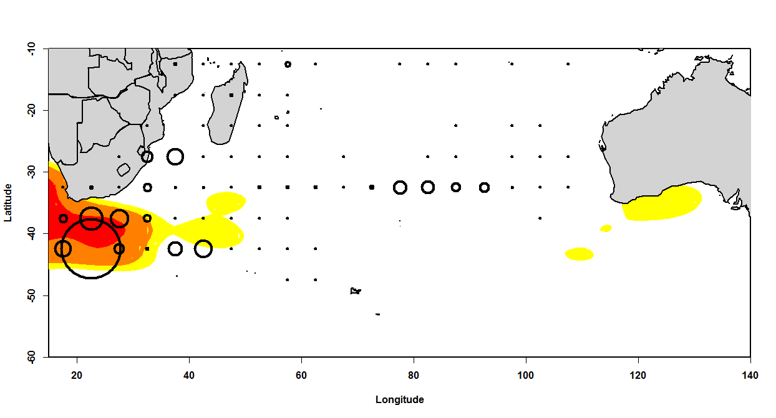
- May b. June
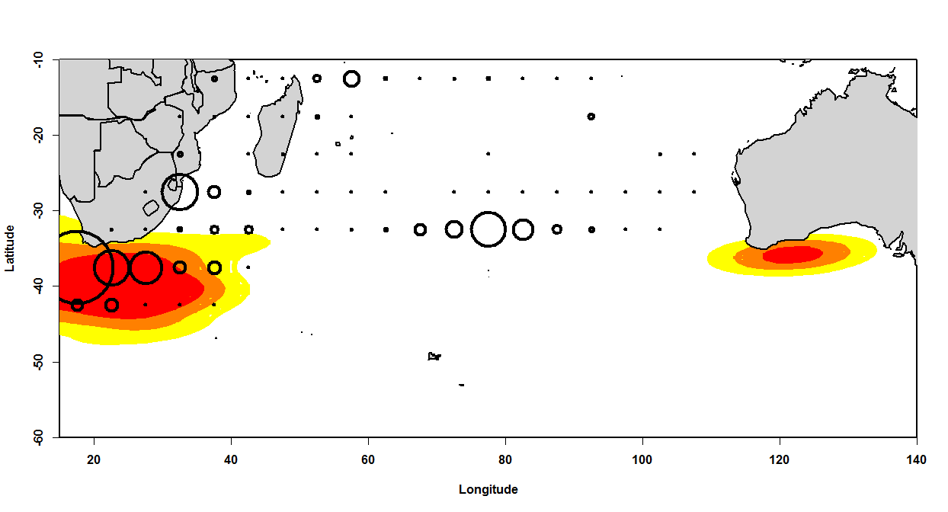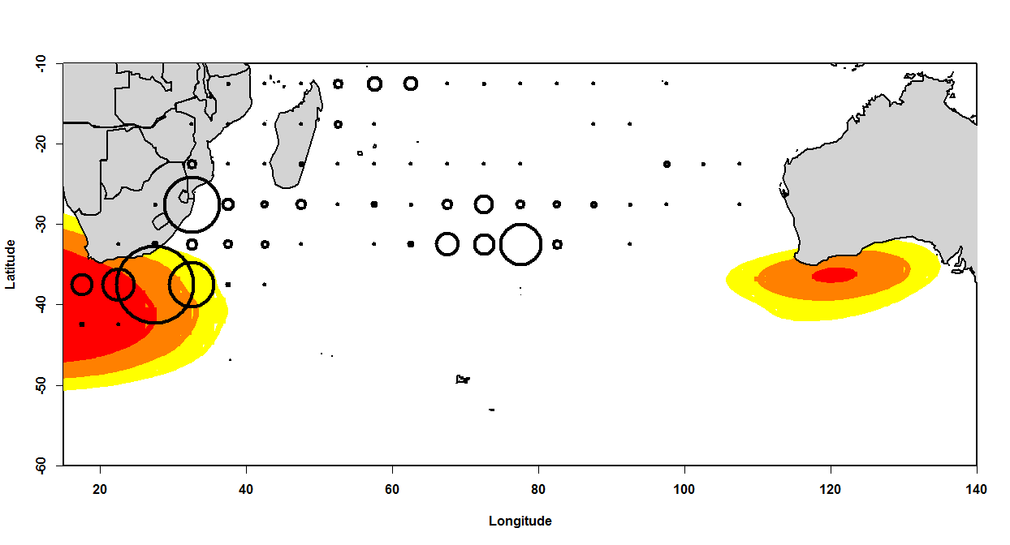
- July d. August
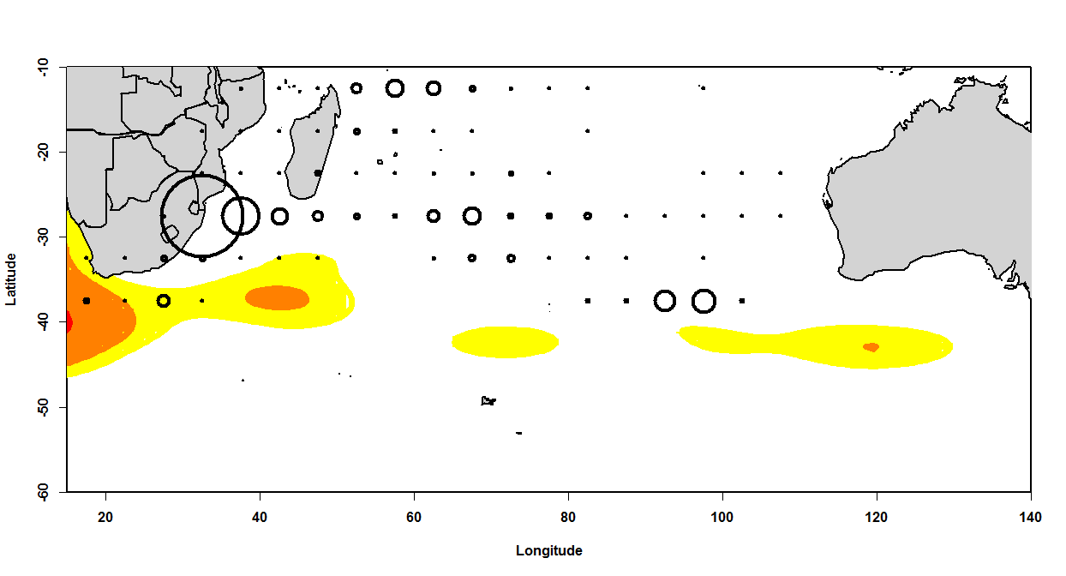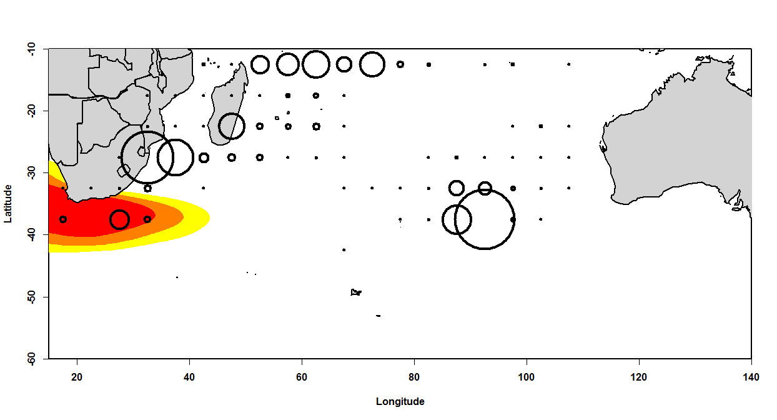
e. September f. October
Fig. 3. Kernel plots (50,75 and 90% isopleths) of non-breeding adult Tristan Albatross distributions within the Indian Ocean in 2005 (Red=50%, Orange=75%, Yellow=90%), overlaid on fishing effort by pelagic longliners targeting tuna and other billfish. Fishing effort is total hooks set monthly within 5x5º blocks (maximum number of hooks set in a block during a month in observation period: 2.8 million)..

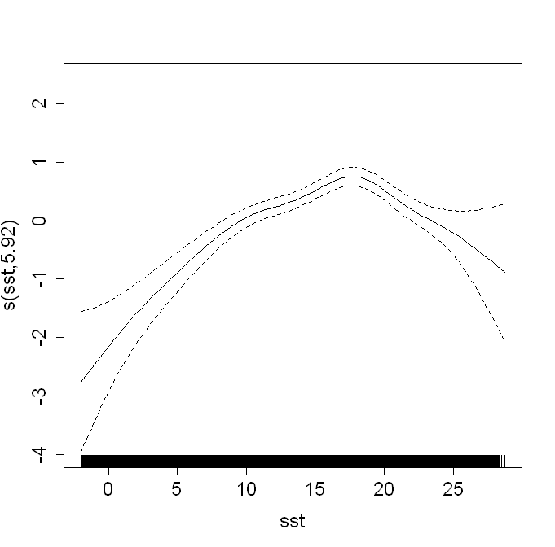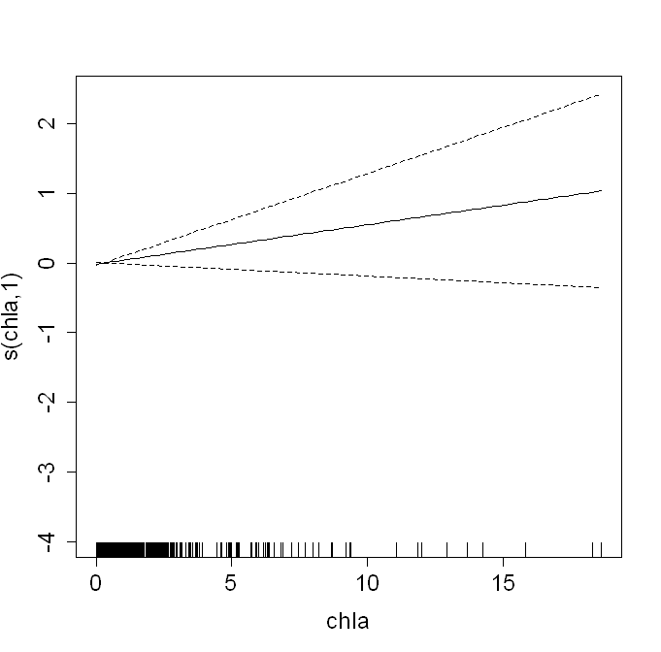
a. b.
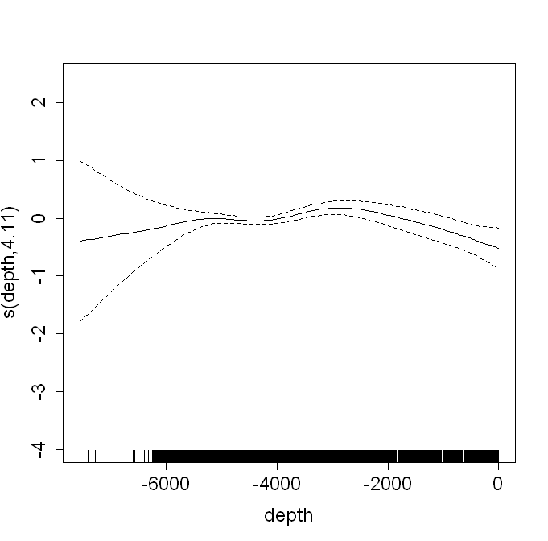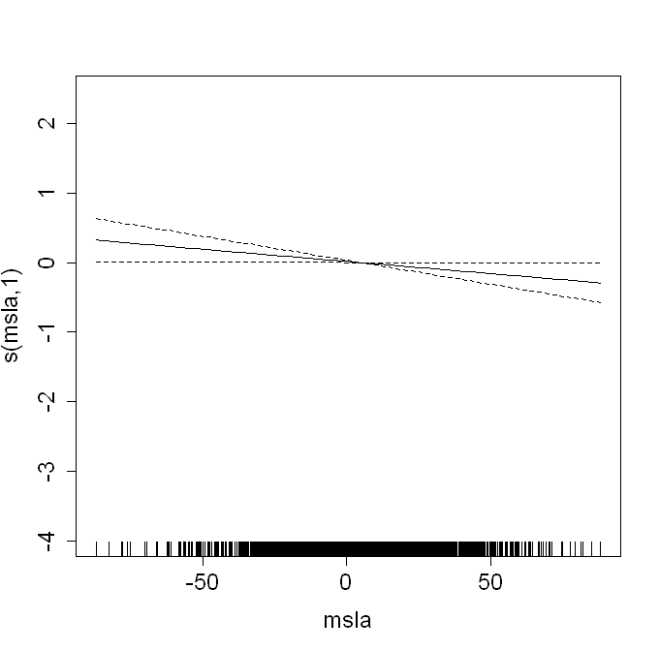
c. d.

Fig. 4. Plots of some fixed effects of model of non-breeding Tristan Albatrosses during 2005. The y-axis show the partial residuals once the effect of other variables has been removed. a. SST (ºC), b. Chl-A (mg m⁻³), c. depth (m), d. mean SLA (cm).
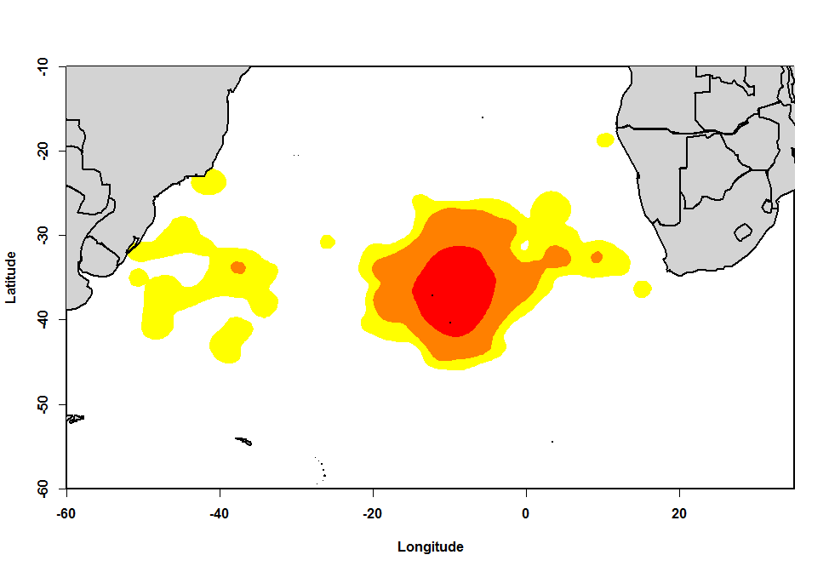
Fig. 5. Kernel plots (50,75 and 90% isopleths) of breeding adult Tristan Albatross tracked during 2004-6 (Red=50%, Orange=75%, Yellow=90%)

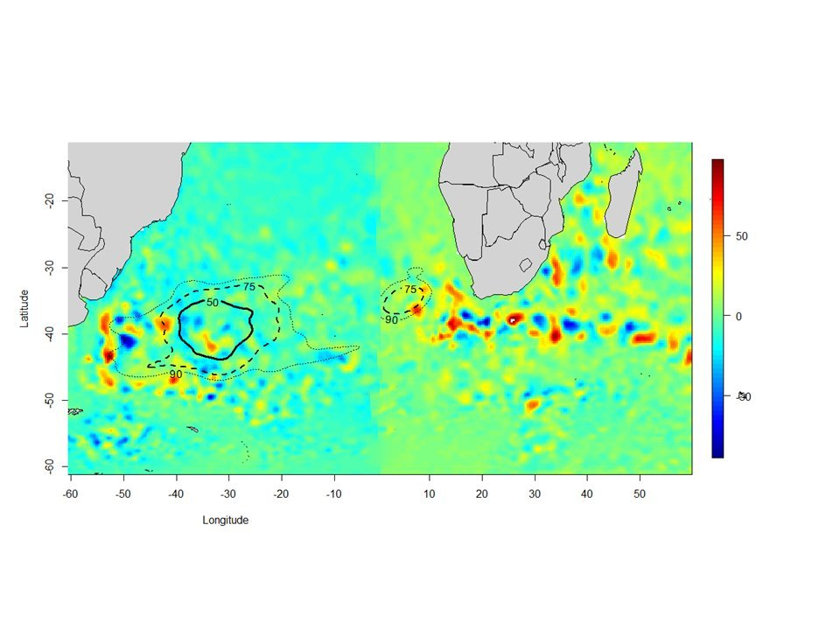
Fig 6. Kernel plots of non-breeding adult Tristan Albatrosses during January 2005 overlaid on mean SLA (cm) in Atlantic SW Indian oceans. (Solid line=50%; dashed line=75%; dotted line=90%)

c. d.
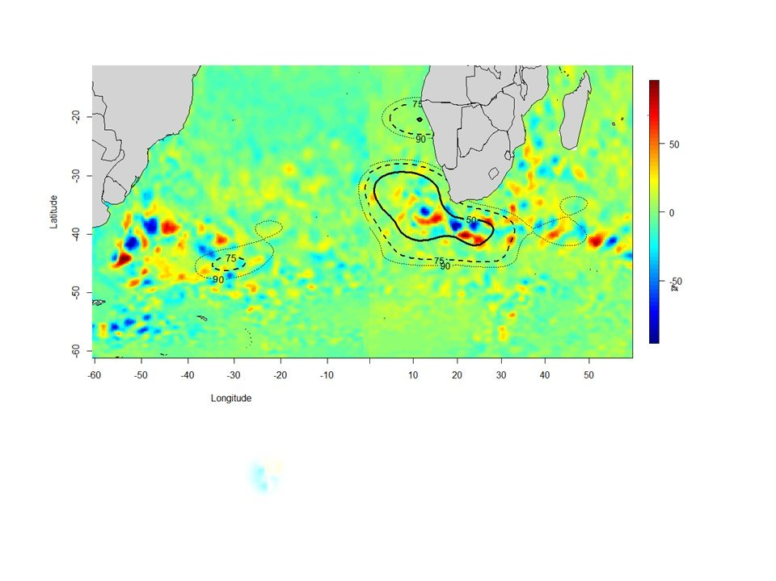
Fig. 7. Kernel plots of non-breeding Tristan Albatrosses in the South Atlantic Ocean during June 2005overlaid on mean SLA (cm) in Atlantic and SW Indian oceans (Solid line=50%; dashed line=75%; dotted line=90%).

