Migration strategies of the Yelkouan Shearwater Puffinus yelkouan

ANDRÉ F. RAINE¹*, JOHN J. BORG², HELEN RAINE³ & RICHARD A. PHILLIPS⁴
¹ Kaua’i Endangered Seabird Recovery Project, 3900 Hanapepe Rd, Hanapepe, Kaua’i 96716 – email: mkazuni@yahoo.co.uk
² National Museum of Natural History, Mdina, Malta – email: diomedea@onvol.net
³ BirdLife Malta, 57/28 Triq Abate Rigord, Ta’Xbiex XBX1120, Malta – email: helenleach2002@yahoo.co.uk
⁴ British Antarctic Survey, Natural Environment Research Council, High Cross, Madingley Road, Cambridge CB3 0ET, UK. –email: raphil@bas.ac.uk

Short Title: Migration strategies of Yelkouan Shearwaters

Abstract
Although the Yelkouan Shearwater Puffinus yelkouan is listed as Near Threatened with many populations in serious decline, there is little detailed information on the location of key foraging areas during the non-breeding season. To address this knowledge gap, adult Yelkouan Shearwaters at a breeding colony in Malta were fitted with geolocators in two consecutive years. Of the 13 birds tracked (two of which were tracked in both years), the majority (n = 10; 76.9%) migrated in June-July to spend most of the non-breeding period in the Black Sea (n = 5), Aegean Sea (n = 2), Black and Aegean seas (n = 2), or Black and Adriatic seas (n = 1). The final three birds remained within the central Mediterranean and did not move beyond 500km of the breeding colony. There was considerable variation among individuals in terms of timing of the outward and return migrations, duration and location of periods of residency in different areas, and migration routes. However, migration patterns (including routes and areas visited) were very consistent in the two individuals tracked in consecutive years. All birds returned in November or December to waters closer to the breeding colony, concentrating between the north African coast and the southern Adriatic. This study has identified key areas during the non-breeding season for Yelkouan Shearwaters from Malta which are also likely to be important for other populations. Given the continuing decline of this species throughout its range, this represents an essential step for improving international conservation efforts. At-sea threats in the wintering regions include by-catch in long-line and trawl fisheries, impacts of over-fishing, illegal hunting (particularly in Maltese waters), ingestion of plastics, pollution and the potential impact of off-shore wind farms. These threats need to be addressed urgently in the areas identified by this study to prevent further declines.

INTRODUCTION

The Yelkouan Shearwater is a medium-sized Puffinus shearwater endemic to the Mediterranean. It was previously considered to be part of the Manx Shearwater Puffinus puffinus species complex, but was elevated to species status (along with the Balearic Shearwater Puffinus mauretanicus) after taxonomic revision based on both genetic and morphological traits (Heidrich et al. 1998; Sangster et al. 2002). In recent years, populations of the Yelkouan Shearwater have declined, or disappeared entirely, throughout its range with the result that it was up-listed in 2008 to ‘Near Threatened’ in the World Conservation Union (IUCN) Red List (IUCN 2010). There is now further discussion and gathering momentum to up-list this species to ‘Vulnerable’ based on continuing declines throughout its range due to a wide range of threats. The current global population is estimated at between 10,815 and 53,574 breeding pairs, mainly concentrated in Malta, Italy, Greece, France, Croatia and Turkey (Bourgeois and Vidal 2008).

Approximately 10% of the global population is found in Malta, which holds an estimated 1,660 to 1,980 pairs (Borg et al. 2010; Raine 2012). The Maltese population is found predominantly on the south and south-west coast of both Malta and Gozo, where it typically breeds on inaccessible cliffs and amongst boulder scree, with the largest concentration of breeding birds located at Rdum tal-Madonna on the north-east coast of Malta (Raine et al. 2009; Borg et al. 2010). Mating and courtship take place in January and February, with laying and incubation spanning March and April (Borg et al. 2010). The last chicks fledge by the end of July, after which colonies are deserted. Birds have been recorded returning to the colonies as early as mid-October to begin preparing nest sites for the following breeding season (Borg et al. 2002).

There are a number of major threats facing the Yelkouan Shearwater, including predation by introduced species (particularly rats Rattus rattus and feral cats Felis catus), fisheries by-catch, illegal hunting (shearwaters are shot by poachers in Malta for sport or trophies), human disturbance, light and noise pollution, and habitat destruction (Bourgeois and Vidal 2008; Raine et al. 2009; Borg et al. 2010; Oppel et al. 2011; Bonnaud et al. 2012). Threats within breeding colonies are relatively well-known and can be addressed (although this can be resource intensive), whereas those at sea are less understood, in large part because of the limited information on the location and characteristics of key marine habitats. Nevertheless, recent research suggests that for birds from Malta, marine threats are now considered to be some of the main factors contributing to population decline as long as on-going management actions at the colonies (such as controlling introduced predators and human impacts) remain in place (Oppel et al. 2011).

The purpose of this study was therefore to identify key marine areas for adult Maltese Yelkouan Shearwaters during the non-breeding period, when their movements and distribution were poorly known – which would then help guide international conservation efforts in these areas. With recent advances in microtechnology, deployment of tracking devices has become an increasingly important tool for identifying key areas used by seabirds both during and outside the breeding season (Burger and Shaffer 2008). In the case of this study, birds were tracked using geolocators, which are cheap, easy to attach, remain on the bird for months or years, provide locations with a mean error of c. 185km (Phillips et al. 2004), and have been used successfully on numerous species of seabird ranging in size from terns to albatrosses (Phillips et al. 2005; Guilford et al. 2009; Egevang et al. 2010; Landers et al. 2011). These devices are also lightweight and have had no discernible short-term impacts in previous studies of shearwaters (Igual et al. 2005; Catry et al. 2009).

METHODS

Birds were selected from a colony at Rdum tal-Madonna, located on the north-east coast of Malta (35°59'N, 14°22'E). With between 398 and 602 pairs, it is the largest colony in the Maltese islands and holds approximately one third of the Maltese population (Borg et al. 2010). The main colony is located along a 1km stretch of limestone cliffs, and birds nest mainly in deep burrows (often with communal entrances) on the cliff face. Access to much of the colony was very difficult due to the terrain, and only two areas (a narrow ledge and a small cave) were visited with sufficient regularity to allow geolocator deployment and recovery. At both sites, the vast majority of breeding birds had been ringed and recaptured on multiple occasions in monitoring that began in the mid-1970s and intensified as part of the EU LIFE Yelkouan Shearwater Project (http://www.lifeshearwaterproject.org.mt/) between 2007 and 2010. The locations of burrow entrances were therefore known, increasing the likelihood of recapture of birds fitted with loggers.
A total of 26 geolocators (MK14; British Antarctic Survey) were deployed on adult Yelkouan Shearwaters in June to early July in 2008 (13 loggers), and 2009 (13 loggers). Geolocators were fitted to birds in the last few weeks prior to departure from the colony at the end of the breeding season. Two individuals were tracked for two years, and the remainder for a single year. Geolocators were only fitted to known breeders, mainly those recorded as successful breeders in several previous seasons.

Geolocators were fitted to the metal identification ring using UV resistant cable ties, after trials with a variety of attachment methods proved this to be the most effective and unobtrusive method available. All devices were calibrated for one week prior to deployment, and two additional loggers were left at a fixed, known location (which was outside, in an area with no nearby artificial lights and with an unobstructed view of the horizon) for calibration purposes over the entire study period. Each device weighed <2g, equating to 0.5% of the average weight of the birds that were tagged (Yelkouan weights 396.4g ± 41.5g). All tagged birds were sexed using a combination of morphological measurements, vocalizations and, in the majority of cases, physical evidence of either egg laying (such as a swollen cloaca) or a cloacal protuberance.

Loggers were recovered in the following breeding seasons, and data downloaded and analysed using TransEdit and BirdTracker software (British Antarctic Survey, Cambridge), according to established methods (Phillips et al. 2004). Briefly, the timing of sunrise and sunset was determined using a light threshold value of 10; longitude was then derived from the timing of local midday/midnight with respect to Greenwich Mean Time and day of the year, and latitude from the length of daylight/darkness using an angle of elevation of -4.7° based on calibration data from fixed locations. Locations derived from light curves with obvious interruptions around dawn or dusk were excluded from the analysis, as were those from periods close to the equinox (when latitude estimation is unreliable), and any others that were far inland and obviously erroneous.

Given the inherent error in geolocation of c. 185km (Phillips et al. 2004), and the maximum foraging range of 280km for Yelkouan Shearwaters from Malta fitted with GPS loggers during the breeding season (Raine, Borg and Raine, unpublished data), a buffer of 500km radius was used to define the waters around the colony, following the approach used in several previous studies of seabirds (Guilford et al. 2009; Landers et al. 2011). For the purposes of this paper, this buffer area is described as the ‘central Mediterranean’.

In order to identify key areas occupied during the nonbreeding period, kernel density maps were generated for all valid locations in each two month period from the time of chick fledging to egg laying (July to February, inclusive). Kernel analyses were performed using Hawth’s Analysis Tools in a European Albers Equal Area Conic projection with a cell size of 50 km and a search radius of 200 km (Phillips et al. 2005). There was a high level of consistency in timing of migration and distribution of the same individuals tracked in consecutive years (see below). Given the lack of evidence for an effect of year, data from birds tracked once were pooled in kernel analyses, along with data from the first season only for the two birds tracked in consecutive years. Throughout the paper, means are provided ± SD.

RESULTS

Geolocator retrieval
Of the 26 geolocators deployed in total in June-July in the two field seasons, 18 (69.2%) were retrieved, 15 (83.3%) of which provided data. Seven of these datasets were from winter 2008/09 and eight from 2009/10, and consisted of 3 males and 10 females (with two of the females tracked in both years). With so few tagged males in the sample, a comparison of migration patterns between sexes could not be undertaken. Visual inspections showed no adverse physical affects due to the attachment of the tags, and all birds went on to successfully raise young in the breeding season when tags were recovered. There was no significant difference between the weights of the small sample of birds weighed when devices were recovered, and untagged controls (tagged (n=9): 397.8g ± 35.3g, untagged (n=15): 394.0g ± 27.1g, Mann-Whitney U=65.5, p=0.46).

The mean duration of deployment for the 15 loggers with useable data was 295.1 ± 51.0 days (range 207-362 days). These provided a total of 6525 locations during the nonbreeding period (July to February), of which 1272 (19.5%), 411 (6.3%) and 258 (4.0%), respectively, were excluded because of proximity to equinox, poor-quality light curves, or they were very far inland. After excluding these erroneous points, there were a total of 4584 validated locations (70.3% of the total) available for analysis.

Migration patterns
Of the 15 tracks (relating to 13 birds), 12 (80.0%) left the central Mediterranean on the 6th July ± 13.7 days (range: 25th June – 9th August) and arrived in their main nonbreeding quarters on the 12th July ± 14.7 days (range: 26th June – 10th August). Birds returned to the central Mediterranean on the 6th December ± 19.8 days (range: 1st November – 31st December). Summary details of the timing of migration and location of the main nonbreeding areas of each individual bird are presented in Table 1.

Several distinct phases were evident in the movements of the tracked birds, illustrated by changes in the location of the kernel density contours (Figure 1). Birds used several different regions during the immediate post-breeding period in July to August, with birds traveling to the Black, and to a lesser extent, the Aegean Sea. One bird moved to the Adriatic Sea and three remained within the central Mediterranean (Figure 1). Distances from the colony to these areas were: 320-340km to the coast of Tunisia and Libya; 800km and 1,020km, respectively, to the central and to the most distant location in the Adriatic Sea; 1,020km to the central Aegean Sea, and; 2,000km and 2,400km to the central and most distant location, respectively, in the Black Sea. Although the overall distribution was broadly similar in September to October, use of the Aegean and Adriatic seas had declined. In November to December, most birds returned to the central Mediterranean, there was little use of the Aegean Sea, and only a minority was still present in the Black Sea. By January to February, all tracked birds had returned to central Mediterranean waters, ranging from the Tunisian and Libyan coasts to southern Italy, including the southern Adriatic Sea.

The 10 individuals that left the central Mediterranean during the immediate post-breeding period spent an average of 148.6 ± 22.0 days in their main nonbreeding grounds (Table 1). Eight spent several months in the Black Sea, including six that remained there for the full duration of the period away from the central Mediterranean. The average amount of time spent in the Black Sea was 129.1 ± 41.8 days (range: 36-209 days), during which time the majority of fixes came from the eastern portion of this enclosed sea. Four birds spent some of the nonbreeding season in the Aegean Sea (as opposed to simply being in transit), of which two remained there for the duration of their time away from the central Mediterranean. The average residency time in the Aegean Sea was 92.7 ± 31.5 days (range: 53-106 days), excluding birds in transit.

Individual migration patterns were highly variable (Figure 2). Five birds flew directly from the central Mediterranean to the Black Sea, passing through the Dardanelles and Bosphorus, and remained in the Black Sea until their return to Maltese waters in November or December (e.g. Figure 2a). Two flew directly to the Aegean Sea where they remained for the duration of the non-breeding season (e.g. Figure 2b). Three alternated between the Black and Aegean Seas, migrating to the Black Sea first then heading back into the Aegean (or in one case the Aegean and the Sea of Marmara) for between 50 and 83 days, then returning to the Black Sea for several weeks before returning to the central Mediterranean (e.g. Figure 3c). A single bird migrated first to the Adriatic Sea, where it remained for 81 days, before continuing on to the Black Sea (Figure 2d). Finally, three birds spent the entire non-breeding period within 500km of Malta, utilising waters between the North African coast (specifically Tunisia and Libya) and the southern Adriatic Sea (e.g. Figure 2e).

Two individual females were tagged in consecutive years. Both followed the same migration pattern and utilised the same areas in the post- and pre-breeding periods in both years, indicating a high degree of regional site fidelity (Figure 3). In addition, the timing of their movements was very consistent, with differences in dates of outward and return migration, arrival and departure from the Black Sea (and for one bird also the Aegean Sea) of 0-8 days in both nonbreeding seasons, which was much less than the general variation among birds (Table 1).

DISCUSSION

This study presents the first tracking data, using geolocators, for adult Yelkouan Shearwaters from Malta during the nonbreeding period. Although less accurate than satellite-transmitters, the data were more than sufficient for determining the timing of movements and for identifying key areas where non-breeding birds concentrated. Indeed, the alternative approach of using satellite-transmitters is problematic, not only because deployment durations are relatively short if devices are taped to feathers (and harnesses can cause high mortality in seabirds; Phillips et al. 2003), but also because radio interference in the Mediterranean region results in fixes that are sporadic and of lower quality than elsewhere (Raine et al. 2011a). Deployment of geolocators did not appear to have adverse effects; instrumented birds had similar weights when recaptured to controls, there was no sign of injury to the leg, and all tracked birds successfully raised chicks in the breeding season following recovery. Although eight (29.6%) of the original sample were not recaptured, not only do adults appear in general to have low over-winter survival (Oppel et al. 2011), but several were from a cave where recapture was more difficult because of the dispersed nature of the nests and swift disappearance of birds after landing into rocky scree.

Among the key results of this study included the substantial variation among, and the high level of consistency within, individuals in terms of timing of movements and distribution. Of the 15 birds tracked, three (20%) remained resident in the central Mediterranean between the Tunisian and Libyan coasts and the south coast of Italy, i.e. in waters within 500km of the colony. In contrast, the vast majority of birds were long-distance migrants, moving eastwards after chick fledging in July to the Black Sea and/or the Aegean Sea, in some cases alternating between these two regions. A single bird spent the initial post-breeding period in the Adriatic Sea before moving to the Black Sea for the remainder of the winter. By early to late December, all birds had returned to the central Mediterranean, using the area from the North African coast (particularly of Tunisia and Libya) to the southern Adriatic, where they remained until the start of the breeding season in March. This relatively early return appeared to be related to the seasonal increase in marine productivity in waters near the colony, which presumably allows birds to feed successfully and provides opportunities for visits to land to maintain and defend the burrow, and to renew the pair bond.

Eight (61.5%) of the thirteen birds tracked from Malta used the Black Sea, in all cases for several months of the non-breeding period. There are also three international ring recoveries of Yelkouan Shearwaters from Malta; (i) an adult ringed at Rdum tal-Madonna in May 1979 and recovered off Greece in June 1982, (ii) a chick ringed at Rdum tal-Madonna in June 1972 and recovered three years later in August in the Black Sea, and (iii) a chick ringed at Rdum tal-Madonna in July 1977 and recovered in the Black Sea in June of the following year (Borg et al. 2002). Therefore, the tracking and ringing recoveries together confirm the importance of the Black Sea for the majority of Yelkouan Shearwaters from Maltese colonies during the nonbreeding period.

Juvenile Yelkouan Shearwaters tracked using satellite-transmitters for several weeks after fledging also travelled to some of these areas, but not to the Black Sea; however, deployment durations in that study were relatively short and there have been ring recoveries of sub-adults in the Black Sea, so there is no reason to suppose that young birds do not move there later in the autumn (Raine et al. 2011a). Indeed, in that study many of the juveniles headed in the direction of the Black Sea and were last tracked into the Aegean before the satellite tags stopped transmitting.

Although migration patterns were highly variable among individuals, of the two birds that were tracked in consecutive years, both followed the same routes, used the same areas, and were highly consistent in the timing of movements. Such results seem to be typical of most seabirds (Croxall et al. 2005; Phillips et al. 2005; Guilford et al. 2011), although there are exceptions (Dias et al. 2011). Although variability in migration strategies among individuals exposes the population as a whole to a wider range of threats, under a scenario of natural or anthropogenic environmental variation (for example in relation to climate or fishing effort) such diversity may offer an advantage in that a proportion of birds will be isolated from any deterioration in conditions that affects a specific region or operates for a limited time (Phillips et al. 2009).

This eastwards migration of Maltese Yelkouan Shearwaters to the Aegean, Black and Adriatic seas is similar to that recorded for a small proportion of Yelkouan Shearwaters from French breeding populations (Militao et al 2012). Of seven birds recovered with geolocators from the Hyeres Islands (Porquerolles and Port-Cros, France), three migrated to the Black or Aegean Seas, while the four others remained within the western Mediterranean. It is interesting that a much larger proportion of French than Maltese birds (57% vs. 20%) remained in the vicinity of their breeding grounds, presumably reflecting a combination of differences in local resource abundance and the levels of intra- and inter-specific competition. The eastwards migration of many Yelkouan shearwaters is in stark contrast to the patterns shown for the two other shearwaters that breed in the Meditteranean, Balearic Puffinus mauretanicus and Cory’s Shearwater Calonectris diomedea, both of which migrate westwards to spend the non-breeding season in the Atlantic Ocean (Ristow et al. 2000; Guilford et al. 2012; Militao et al. 2012). Initial tracking of newly fledged Cory’s Shearwaters suggests that Maltese populations of this species show a similar pattern, migrating in a westerly direction into the Atlantic (Raine et al. 2011b).

The Aegean, Black and Adriatic Seas are also considered to be important feeding areas for Yelkouan Shearwaters based on at-sea observations (Nanikov 2001; Bourgeois and Vidal 2008). However, the age, status (breeding or nonbreeding) and proportion of birds in each area that originated from different colonies was unknown. This study has shown that a proportion of the birds visiting these areas are in fact breeding adults from Maltese colonies. The Black Sea in particular is known to hold large numbers of Yelkouan Shearwaters, which are regularly counted transiting through the Bosphorus between the Black Sea and the Sea of Marmara (Elliot 1970; Nankinov 2001), apparently following the movement of their fish prey (Nankinov 2001).

The Maltese Yelkouan Shearwaters tracked during this study first pass through the Dardanelles and Bosphorus in late June and early July, which coincides with high counts of this species in the Bosphorus (Nanikov 2001). That several of the tracked birds moved back and forth between the Aegean and Black Seas during the non-breeding season is also in line with the complex patterns of bird movements in both directions described for this area, possibly revolving around the migrations of prey populations (particularly anchovy) between the two seas (Nanikov 2001). From our study and that by Militao et al (2012), it is clear that the birds using the Aegean, Dardanelles, Bosphorus and Black seas include Yelkouan Shearwaters from a number of different breeding populations from throughout the Mediterranean region.

Three of the 13 birds tracked (23.1%) remained within a 500km radius of Malta throughout the nonbreeding season. This was unexpected; although some of these waters, including the northern Tyrrhenian Sea, marine areas west of Sicily, and off the coast of Algeria, Tunisia and Malta, were known to be used heavily by Yelkouan Shearwaters during the breeding season (Bourgeois and Vidal 2008; Borg et al 2010; Raine, Borg, Raine unpublished data), their importance at other times of the year had not been recognised. However, it confirms the suggestion by Borg et al. (2002) that a small number of Yelkouan remain within territorial waters during the non-breeding season. Furthermore, all of the tracked birds concentrated in this area in January and February in the lead-up to the breeding season, so this is clearly a key region for Maltese birds.

In an effort to identify the environmental drivers underlying the observed movement patterns, the within-season changes in bird distribution were examined in relation to the oceanography of the region, including bathymetry, sea surface temperature and chlorophyll a concentrations (Figure 4). If oceanographic conditions during the initial post-breeding dispersal period in July-August 2008 are compared with Yelkouan Shearwater distribution during the same period (Figures 1a and 4), the clearest habitat association was for birds that used waters off the coasts of Tunisia and western Libya, which are relatively shallow, warm, and highly productive. However, other tracked birds used (i) the southeast Adriatic Sea and the Aegean Sea, which are also shallow but not particularly productive, and relatively cold in the case of the Aegean Sea, and (ii) the Black Sea, where productivity is higher on average than most of the central and eastern Mediterranean, but the water is relatively deep and of moderate temperature (Figures 1 and 4). Based on remote-sensed data, the seasonal trend in both study years was for a gradual decline in sea surface temperature and increase in productivity (chlorophyll a concentration) within the Black Sea, and the central and eastern Mediterranean, including the Adriatic and Aegean seas from July to February (data not shown). With the exception of the Tunisian and Libyan coast, marine productivity is relatively low in much of the central Mediterranean from July to October, and it may be the increase in production from November onwards that encouraged the tracked birds to return to the vicinity of the colony by December, despite this being several months in advance of breeding.

Although there was little evidence of strong habitat association by the tracked birds in terms of a particular bathymetric, sea surface temperature or productivity regime, it can be assumed nevertheless that such a mobile species would only migrate to the Black Sea if assured of a high density of prey. Yelkouan Shearwaters predominantly eat small fish, including European Anchovy Engraulis encrasicolus, Sardine Sardina pilchardus and members of the Scombridae family (Nanikov 2001; Bourgeois et al. 2011), and the Aegean, Black and Adriatic seas all hold large stocks of these species (Daskalov 2002; Somarakis et al. 2002; Tirelli et al. 2006; Cingolani et al. 2007; Ozturk 2009). It is therefore intuitive that Maltese birds which leave the central Mediterranean during the non-breeding period do so either because their prey occur in higher densities or are more readily available elsewhere, or there is less intra- or inter-specific competition. In the Adriatic Sea, European Anchovy spawn from March to October, during which time they inhabit shallow waters of <30m (Tirelli et al. 2006), which would make them easy prey for diving shearwaters. In contrast, anchovy move to deeper waters in the winter (Tirelli et al. 2006), which would tend to make them inaccessible. This seasonal vertical migration broadly coincides with the movements of at least one tagged bird, which spent the first 2.5 months of the nonbreeding period in the Adriatic Sea, possibly to exploit spawning anchovy, before moving on to the Black Sea in mid-September.

The concentration of the tracked birds in the Black, Aegean, Adriatic and central Mediterranean seas should serve to focus attention on marine conservation in what are likely to be key areas not only for Yelkouan Shearwaters from Malta, but also those from other colonies during the nonbreeding season. Recent conservation work at the Rdum tal-Madonna colony, including the control of introduced predators (particularly rats), an education campaign to reduce human disturbance, and the cessation of ferreting and the deliberate killing of nesting birds, have resulted in a high breeding success rate (Borg et al. 2010; Raine et al. 2011c). However, unaddressed threats at sea can serve to negate the benefits of conservation efforts on land. One of the principal threats to shearwaters, and indeed to a wide range of seabirds, is by-catch in fisheries (Hall et al. 2000; Belda and Sanchez 2001; Cooper et al. 2003; Lewison et al. 2005; Gilman et al. 2005). By-catch of seabirds, including Yelkouan Shearwaters, and other species (such as sea turtles and cetaceans) has been recorded in all of the main areas utilised in the non-breeding season by Maltese birds (Cooper et al. 2003; Casale et al. 2004; Darmanin et al. 2010). Furthermore, the central Mediterranean and Aegean seas are known hotspots for pelagic longline fishing (Stergiou et al. 2002; Lewison et al. 2005); here, obtaining better data on bycatch rates, improvements to bycatch mitigation, and implementation of observer programmes to assess compliance should be considered as top priorities for conservation.

A number of other at-sea threats to Yelkouan Shearwaters have also been identified. These include the impact from bioaccumulation of the high level of contaminants in the Mediterranean basin (Bacci 1987; Roscales et al. 2010; Bourgeois et al. 2011) and the over-exploitation of fish stocks leading to the collapse of populations of prey species (Furness 2003). The latter is a serious concern within the Black Sea (Kideys 1994; Prodanov et al. 1997; Zaitsev and Mamaev 1997; Daskalov 2002), as well as in the Aegean and wider Mediterranean region (Lleonart and Maynou 2003; Ozturk 2009). For birds that remain in Maltese waters outside the breeding season, illegal hunting at sea for trophies or sport is also a serious conservation issue (Raine and Temuge 2009, 2010). Ingestion of plastics and other marine debris (Ryan 1988; Derraik 2002; Aliani et al. 2003), the impact of invasive species on the food chain (Kideys 1994; Zaitsev and Mamaev 1997), direct pollution events (Zaitsev and Mamaev 1997; Ozturk 2009) and the potential threat from off-shore wind farms (Raine et al. 2010) may also have a detrimental impact on adult survival during the non-breeding season. Considering these risks, development of appropriate management responses within the context of the areas identified in this study will be critical for the long-term survival of the Yelkouan Shearwater.

ACKNOWLEDGEMENTS

This study was made possible through the EU LIFE Yelkouan Shearwater Project (http://www.lifeshearwaterproject.org.mt/). The authors would also like to thank Nicholas Barbara, Geoffrey Saliba and Tolga Temuge from BirdLife Malta, all of the fieldworkers who took part in this project - in particular Nadja Tschovikov and Matthew Borg Cardona - as well as colleagues from SPEA (Sociedade Portuguesa para o Estudo das Aves), particularly Ivan Ramirez, and the RSPB (Royal Society for the Protection of Birds) who provided advice and assistance throughout the project’s duration, and Andrew Fleming for access and provision of the remote-sensed oceanographic data. The authors would also like to thank all of the project partners and funding agencies, as well as the two anonymous reviewers who provided comments on the first submission of this paper.

REFERENCES

Aliani S, Griffa A, Molcard A (2003) Floating debris in the Ligurian Sea, north-western Mediterranean. Mar Pollut Bull 46:1142-1149.

Bacci E (1989) Mercury in the Mediterranean. Mar Pollut Bull 20:317–338.

Belda EJ, Sanchez A (2001) Seabird mortality on longline fisheries in the western Mediterranean: factors affecting bycatch and proposed mitigating measures. Biol Cons 98:357-363.

Bonnaud, E, Berger G, Bourgeois K, Legrand J, Vidal E (2012) Predation by cats could lead to the extinction of the Mediterranean endemic Yelkouan Shearwater Puffinus yelkouan at a major breeding site. Ibis 154: 566-577.

Borg JJ, Raine H, Raine A, Barbara N (2010) Protecting Malta's wind chaser: The EU LIFE Yelkouan Shearwater project report. BirdLife Malta, Malta.

Borg JJ, Sultana J, Coleiro C (2002) Pre-breeding movements and early nest visits by Levantine Shearwater Puffinus yelkouan in Malta. Il-Merill 30:20-23.

Bourgeois K, Vidal E (2008) The endemic Mediterranean yelkouan shearwater Puffinus yelkouan: distribution, threats and a plea for more data. Oryx 42: 187-194.

Bourgeois K, Vorenger J, Faulquier L, Legrand J, Vidal E (2011) Diet and contamination of the Yelkouan Shearwater Puffinus yelkouan in the Hyeres archipelago, Mediterranean Basin, France. J Ornithol 152: 947–953.

Burger AE, Shaffer SA (2008) Application of tracking and data-logging technology in research and conservation of seabirds. Auk 125(2): 253-264.

Casale P, Laurent L, De Metrio G (2004) Incidental capture of marine turtles by the Italian trawl fishery in the north Adriatic Sea. Biol Conserv 119:287-295.

Catry T, Ramos JA, Le Corre M, Phillips RA (2009) Movements, at-sea distribution and behaviour of a tropical pelagic seabird: the wedge-tailed shearwater in the western Indian Ocean. Mar Ecol-Prog Ser 391:231-242.

Cingolani N, Giannetti G, Arneri E (1996) Anchovy fisheries in the Adriatic Sea. Sci Mar 60(Supl. 2):269-277.

Cooper J, Baccetti N, Belda EJ, Borg JJ, Oro D, Papaconstantinou C, Sanchez A (2003) Seabird mortality from long-line fishing in the Mediterranean Sea and Macaronesian waters: a review and a way forward. Sci Mar 67:57–64.

Croxall JP, Silk JRD, Phillips RA, Afanasyev V, Briggs DR (2005) Global circumnavigations: tracking year-round ranges of non-breeding albatrosses. Science 307:249-250.

Darmanin M, Caruana R, Dimech M (2010) Report on studies to investigate seabird by-catch by Maltese fishers. Capture Fisheries Branch, Ministry for Resources and Rural Affairs, Malta.

Daskalov GM (2011) Overfishing drives a trophic cascade in the Black Sea. Mar Ecol-Prog Ser 225:53-63.

Derraik JGB (2002) The pollution of the marine environment by plastic debris: a review. Mar Pollut Bull 44:842-852.

Dias MP, Granadeiro JP, Phillips RA, Alonso H, Catry P (2011) Breaking the routine: individual Cory’s shearwaters shift winter destinations between hemispheres and across ocean basins. P Roy Soc Lond B 278:1786-1793.

Egevang C, Stenhouse IJ, Phillips RA, Petersen A, Fox JW, Silk JRD (2010) Tracking of Arctic terns Sterna paradisaea reveals longest animal migration. Proc Nat Acad Sci 107(5):2078-2081.

Falk K, Møller S (1995) Satellite tracking of high-Arctic Northern Fulmars. Polar Biol 15:495-502.

Furness RW (2003) Impacts of fisheries on seabird communities. Sci Mar 67 (Suppl. 2):33–45.

Gilman E, Brothers H, Kobayashi DR (2006) Principles and approaches to abate seabird by-catch in longline fisheries. Fish & Fisheries 6:35–49.

Guilford T, Meade J, Willis J, Phillips RA, Boyle D, Roberts S, Collett M, Freeman R, Perrins CM (2009) Migration and stopover in a small pelagic seabird, the Manx Shearwater Puffinus puffinus: insights from machine learning. Proc R Soc B 276:1215-1223.

Guilford T, Freeman R, Boyle D, Dean B, Kirk H, Phillips RA, Perrins CM (2011) A dispersive migration in the Atlantic Puffin and its implications for migratory navigation. PLoS ONE 6(7):e21336. doi:10.1371/journal.pone.0021336

Gutierrez R, Figuerola J (1995) Wintering distribution of the Balearic Shearwater (Puffinus yelkouan mauretanicus, Lowe 1921) off the Northeastern coast of Spain. Ardeola 42(2):161-166.

Hall MA, Alverson DL, Metuzals KI (2000) By-catch: Problems and solutions. Mar Pollut Bull 41(1-6):204-219.

Harris MP, Daunt F, Newell M, Phillips RA, Wanless S (2010) Wintering areas of adult Atlantic puffins Fratercula arctica from a North Sea colony as revealed by geolocation technology. Mar Biol 157:827–836.

Heidrich P, Amengual J, Wink M (1998) Phylogenetic relationships in Mediterranean and North Atlantic shearwaters (Aves : Procellariidae) based on nucleotide sequences of mtDNA. Biochem Syst Ecol 26:145-170.

Igual JM, Forero MG, Tavecchia G, Gonzalez-Solis J, Martinez-Abrain A, Hobson KA, Ruiz X, Oro D (2005) Short-term effects of data-loggers on Cory’s shearwater (Calonectris diomedea). Mar Biol 146:619-624.

Ismar SMH, Phillips RA, Rayner MJ, Hauber ME (2011) Geolocation tracking of the annual migration of adult Australasian Gannets (Morus serrator) breeding in New Zealand. Wilson J Ornith 123(1):121–125.

IUCN. 2010. IUCN Red List of Threatened Species. Version 2010.4. <www.iucnredlist.org>. Accessed 14 June 2011

Landers TJ, Rayner MJ, Phillips RA, Hauber ME (2011) Dynamics of seasonal movements by a trans-Pacific migrant, the Westland Petrel. Condor 113(1):71-79.

Lewison RL, Nel DC, Taylor F, Croxall JP, Rivera KS (2005) Large-scale approach to seabird bycatch. Mar Ornith 33:1–5.

Lleonart J, Maynou F (2003) Fish stock assessments in the Mediterranean: state of the art. Sci Mar 67 (Suppl. 1):37–49.

Militão T, Bourgeois K, Roscales JL, González-Solís J (2012) Individual migratory patterns of two threatened seabirds revealed using stable isotope and geolocation analyses. Diversity and Distributions. doi: 10.1111/j.1472-4642.2012.00916.x

Nankinov DN (2001) Migration, seasonal and spatial distribution of Manx Shearwater, Puffinus puffinus in the Black Sea basin. Proc Instit Ocean, Varna 3:170-179.

Oppel S, Raine AF, Borg JJ, Raine H, Bonnaud E, Bourgeois K, Breton AR (2011) Is the Yelkouan shearwater Puffinus yelkouan threatened by low adult survival probabilities? Biol Cons 114:2255-2263.

Ozturk B (2009) Marine protected areas in the high seas of the Aegean and Eastern Mediterranean Seas, some proposals. J Black Sea/Med Env 15:69-82.

Peron C, Delord K, Phillips RA, Charbonnier Y, Marteau C, Louzao M, Weimerskirch H (2010) Seasonal variation in oceanographic habitat and behaviour of white-chinned petrels Procellaria aequinoctialis from Kerguelen Island. Mar Ecol Prog Ser 416:267-284.

Phillips RA, Xavier JC, Croxall JP (2003) Effects of satellite transmitters on albatrosses and petrels. Auk 120(4):1082-1090.

Phillips RA, Silk JRD, Croxall JP, Afanasyev V, Briggs DR (2004) Accuracy of geolocation estimates for flying seabirds. Mar Ecol Prog Ser 266:265-272.

Phillips RA, Silk JRD, Croxall JP, Afanasyev V, Bennett VJ (2005) Summer distribution and migration of nonbreeding albatrosses: individual consistencies and implications for conservation. Ecology 81:2386-2396.

Phillips RA, Bearhop S, McGill RAR, Dawson DA (2009) Stable isotopes reveal individual variation in migration strategies and habitat preferences in a suite of seabirds during the nonbreeding period. Oecologia 160:95-806.

Pinet P, Jaquemet S, Pinaud D, Weimerskirch H, Phillips RA, Le Corre M (2011) Migration, wintering distribution and habitat use of an endangered tropical seabird, Barau’s petrel Pterodroma baraui. Mar Ecol Prog Ser 423:291-302.

Priddel D, Carlile N, Fullagar P, Hutton I, O’Neill L (2006) Decline in the distribution and abundance of flesh-footed shearwaters (Puffinus carneipes) on Lord Howe Island, Australia. Biol Cons 128:412-424.

Raine AF (2012) A photographic guide to the birds of Malta. Langford Press, UK.

Raine AF, Temuge T (2009) 2008 Illegal Hunting Report. BirdLife Malta, Malta.

Raine AF, Temuge T (2010) 2009 Illegal Hunting Report. BirdLife Malta, Malta.

Raine AF, Sultana J, Gillings S (2009) Malta Breeding Bird Atlas 2008. BirdLife Malta, Malta.

Raine A, Raine H, Meirinho A, Borg JJ (2010) Rafting behaviour of Yelkouan Shearwater Puffinus yelkouan breeding at Rdum tal-Madonna, Malta. Il-Merill 32:26-30.

Raine AF, Raine H, Borg JJ & Meirinho A (2011a) Post-fledging dispersal of Maltese Yelkouan Shearwaters Puffinus yelkouan. Ringing & Migration 26(2):94-100.

Raine, AF Borg JJ, Raine H (2011b) First description of post-fledging migration of Maltese Cory's Shearwaters Calonectris diomedea diomedea. Ringing & Migration 26(2): 114-117.

Raine AF, Borg JJ, Raine H (2011c) Report on Key Targets 2007-2010 – Report to EU LIFE Unit. BirdLife Malta, Malta.

Rayner MJ, Hauber ME, Steeves TE, Lawrence HA, Thompson DR, Sagar PM, Bury SJ, Landers TJ, Phillips RA, Ranjard L, Shaffer SA (2010) Contemporary and historical separation of transequatorial migration between genetically distinct seabird populations. Nature Commun 2:332.

Ristow D, Berthold P, Hashimi D, Querner U (2000) Satellite tracking of Cory’s Shearwater migration. Condor 102:696-699.
Roscales JL, Muῇoz-Arnanz J, González-Solís J, Jiménez J (2010) Geographical PCB and DDT patterns in shearwaters Calonectris sp.) breeding across the NE Atlantic and the Mediterranean Archipelagos. Env Sci Tech 44:2328–2334.

Sangster G, Knox AG, Helbig AJ, Parkin DT (2002) Taxonomic recommendations for European birds. Ibis 144:153-159.

Shaffer SA, Tremblay Y, Welmerskirch H, Scott D, Thompson DR, Sagar PM, Moller H, Taylor GA, Foley DG, Block BA, Costa DP (2006) Migratory shearwaters integrate oceanic resources across the Pacific Ocean in an endless summer. PNAS 103(34):12799-12802.

Somarakis S, Draopoulos P, Filippou V (2002) Distribution and abundance of larval fish in the northern Aegean Sea-eastern Mediterranean-in relation to early summer oceanographic conditions. J Plankton Res 24(4):339-357.

Stergiou KI, Christou ED, Georgopoulos D, Zenetos A, Souvermezoglu C (1997) The Hellenic Seas: physics, checmistry, biology and fisheries. Oceanogr Mar Biol Annu Rev 35:415-538.

Stergiou KI, Moutopoulos DK, Erzini K, (2002) Gill net and longlines fisheries in Cyclades waters (Aegean Sea): species composition and gear competition. Fish Res 57:25-37.

Tirelli V, Borme D, Tulli F, Cigar M, Fonda Umani S, Brandt SB (2006) Energy density of anchovy Engraulis encrasicolus L.in the Adriatic Sea. J Fish Biol 68:982–989.

Zaitsev Y, Mamaev V (1997) Marine biological diversity in the Black Sea – A study of change and decline. United Nations Publications, New York.
Table 1. Summary data for Yelkouan Shearwaters from Malta tracked using geolocators during the nonbreeding period in 2008 and 2009. Superscripts ¹ and ² indicate birds tracked in two consecutive years.
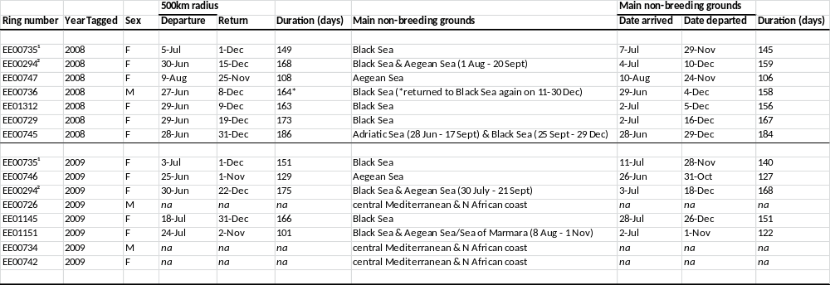
FIGURE LEGENDS

Figure 1. Seasonal changes in distribution of Yelkouan Shearwaters (n=15) from Malta tracked during the non-breeding season (July-February) in 2008 and 2009.

Figure 2. Distribution of five representative Yelkouan Shearwaters from Malta tracked using geolocators during the non-breeding season in 2008 and 2009. Maps illustrate main non-breeding migration strategies (a) Black Sea only, (b) Aegean Sea & central Mediterranean, (c) Black & Aegean Sea, (d) Adriatic & Black Sea, (e) central Mediterranean and Adriatic Sea. Different colours represent different periods: July-August (red), September-October (green), November-December (blue) and January-February (yellow).

Figure 3. Migration patterns of two Yelkouan Shearwaters, (a) EE00735 and (b) EE00294, tracked in July 2008 to February 2009 (blue tracks) and July 2009 to February 2010 (orange tracks).

Figure 4. Oceanography of the study region, (a) bathymetry, (b) chlorophyll a concentration in mg m⁻³ in July-August 2008, and (c) sea surface temperature in °C in July-August 2008. The maps show bathymetry is at 30 arcsecond resolution (General Bathymetric Chart of the Oceans, GEBCO_08 Grid available at http://www.gebco.net), and a 2-monthly composite of remote-sensed chlorophyll a concentrations in mg m⁻³ at 4km resolution (Aqua MODIS grids available from http://oceancolor.gsfc.nasa.gov) and of sea surface temperature in °C (Aqua MODIS night-time data sets available from http://poet.jpl.nasa.gov).

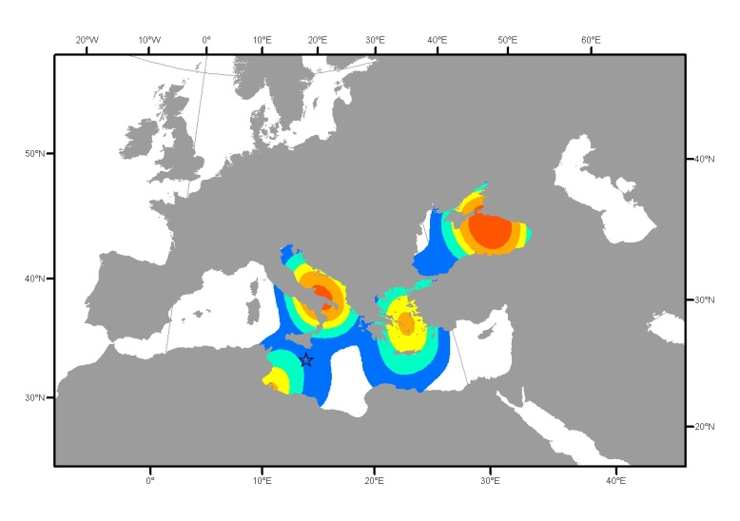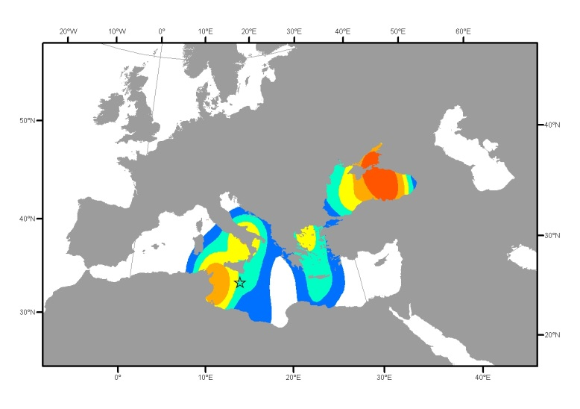
a) July-August b) September-October

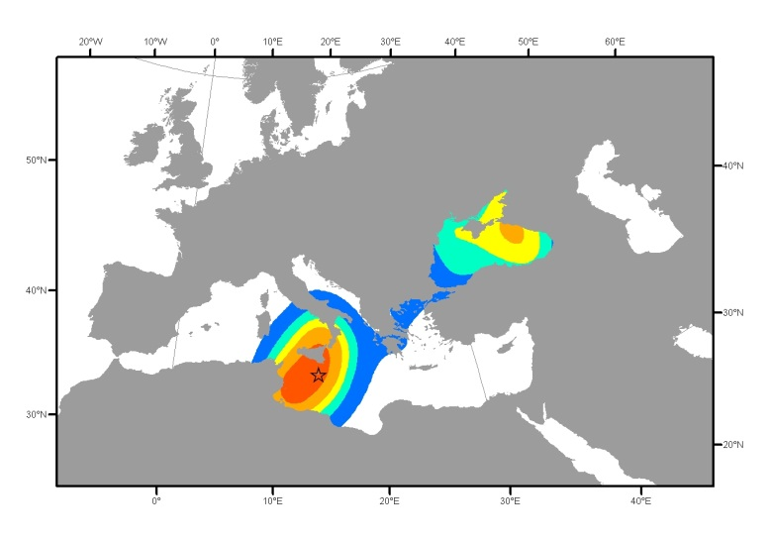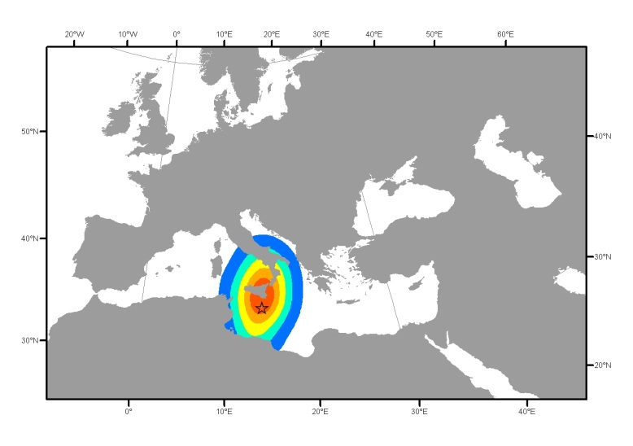
c) November-December d) January-February

Figure 1. Seasonal changes in distribution of Yelkouan Shearwaters (n=15) from Malta tracked during the non-breeding season (July-February) in 2008 and 2009. Star indicates location of Malta. Kernels presented are 20%, 40%, 60%, 80% and 95% respectively, with land masses placed above kernel layers to allow better visualisation of migration patterns.

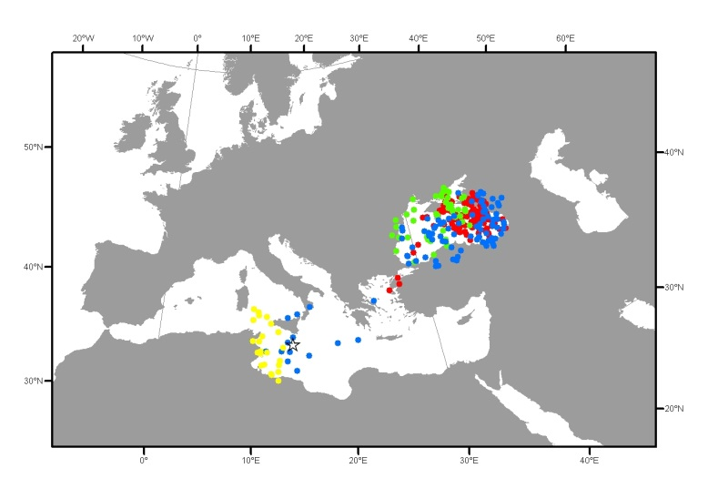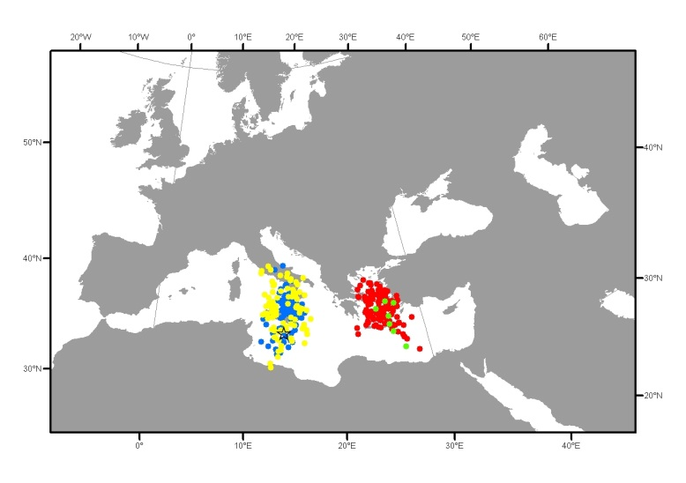
(a) EE00729, 23rd June 2008-16th January 2009 (b) EE00746, 9th June 2009-3rd June 2010
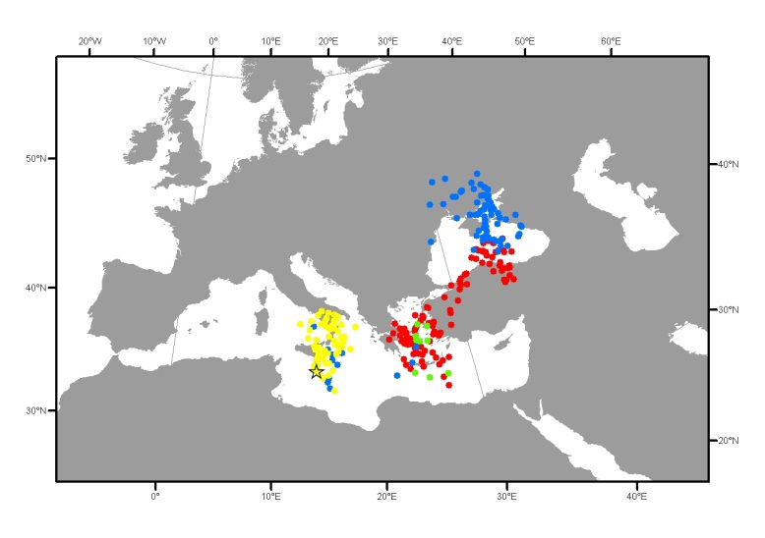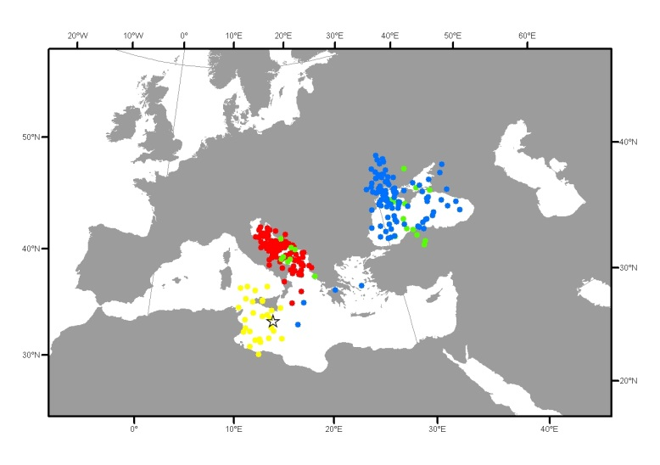
(c) EE00294, 9th June 2009-6th June 2010 (d) EE00745, 23rd June 2008-2nd March 2009
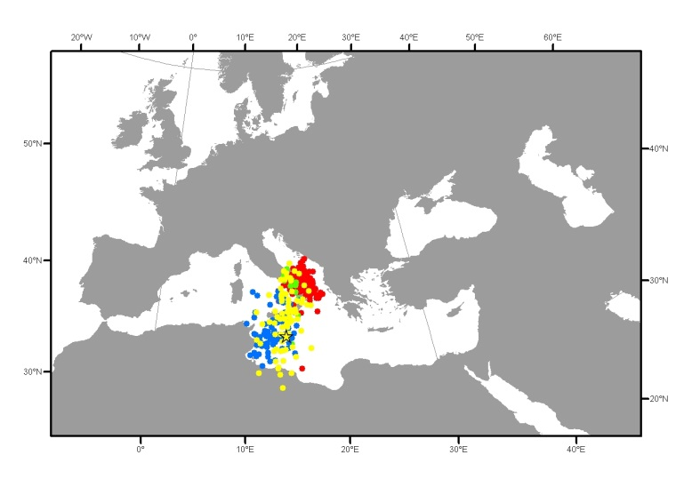
(e) EE00726, 18th June 2009-1st April 2010
Figure 2. Distribution of five representative Yelkouan Shearwaters from Malta tracked using geolocators during the non-breeding season in 2008 and 2009. Maps illustrate main non-breeding migration strategies (a) Black Sea only, (b) Aegean Sea & central Mediterranean, (c) Black & Aegean Sea, (d) Adriatic & Black Sea, (e) central Mediterranean and Adriatic Sea. Different colours represent different periods: July-August (red), September-October (green), November-December (blue) and January-February (yellow).

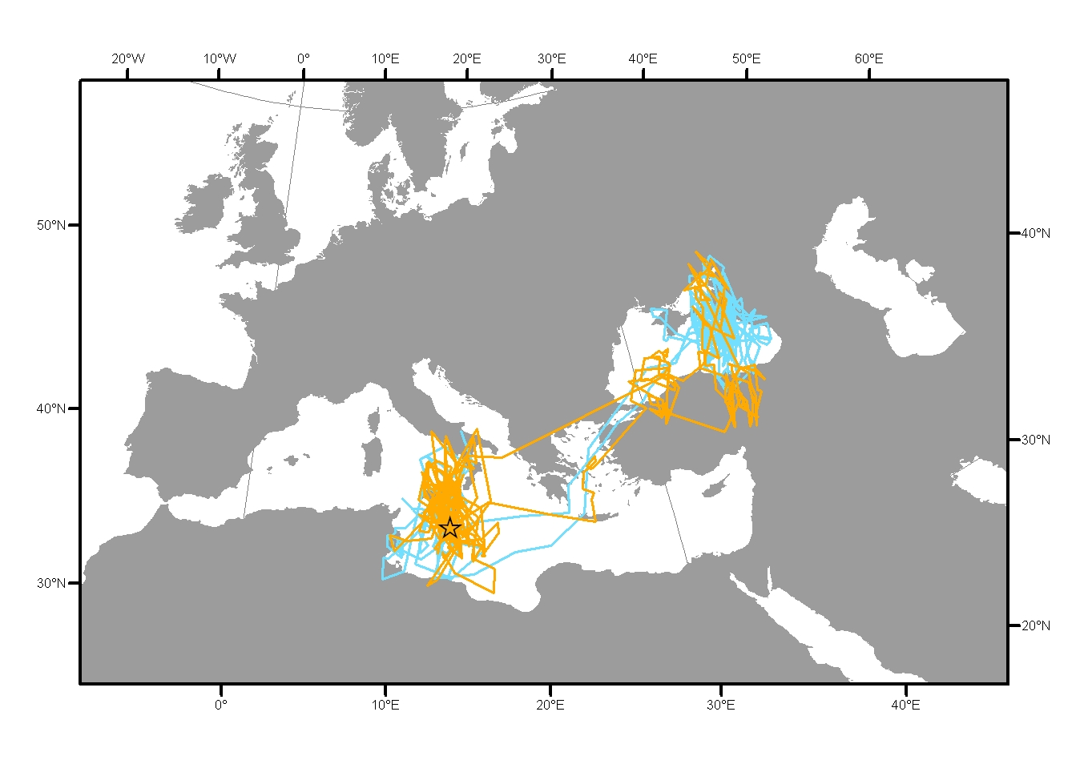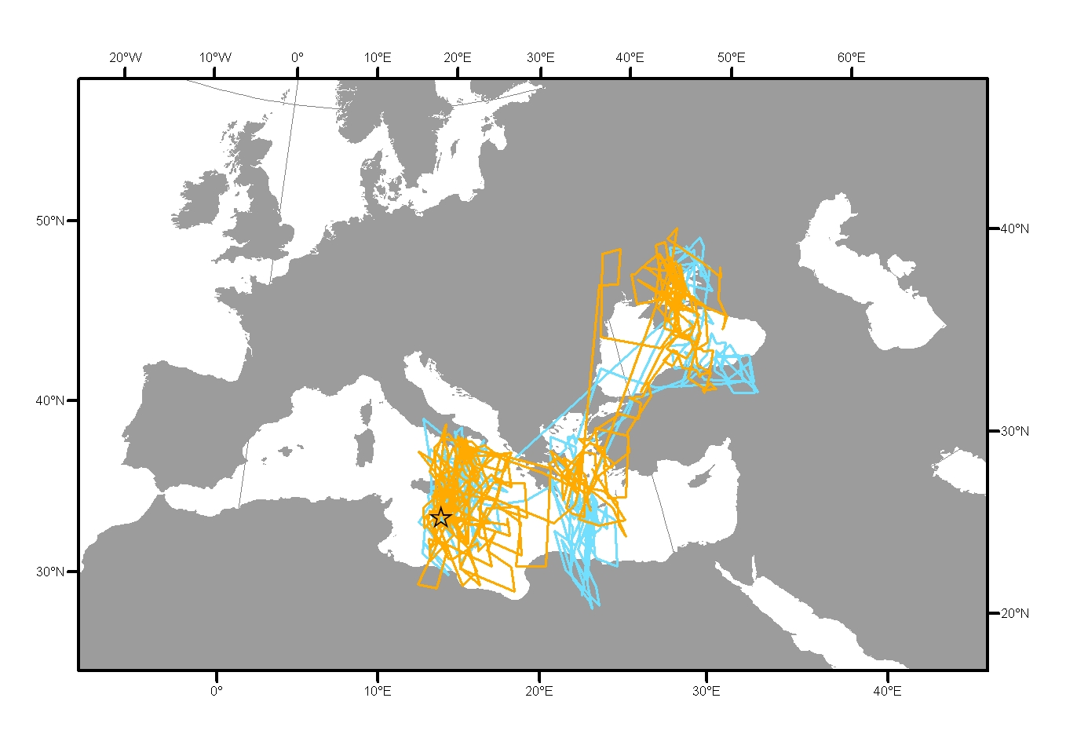
Figure 3. Migration patterns of two Yelkouan Shearwaters, (a) EE00735 and (b) EE00294, tracked in July 2008 to February 2009 (blue tracks) and July 2009 to February 2010 (orange tracks).
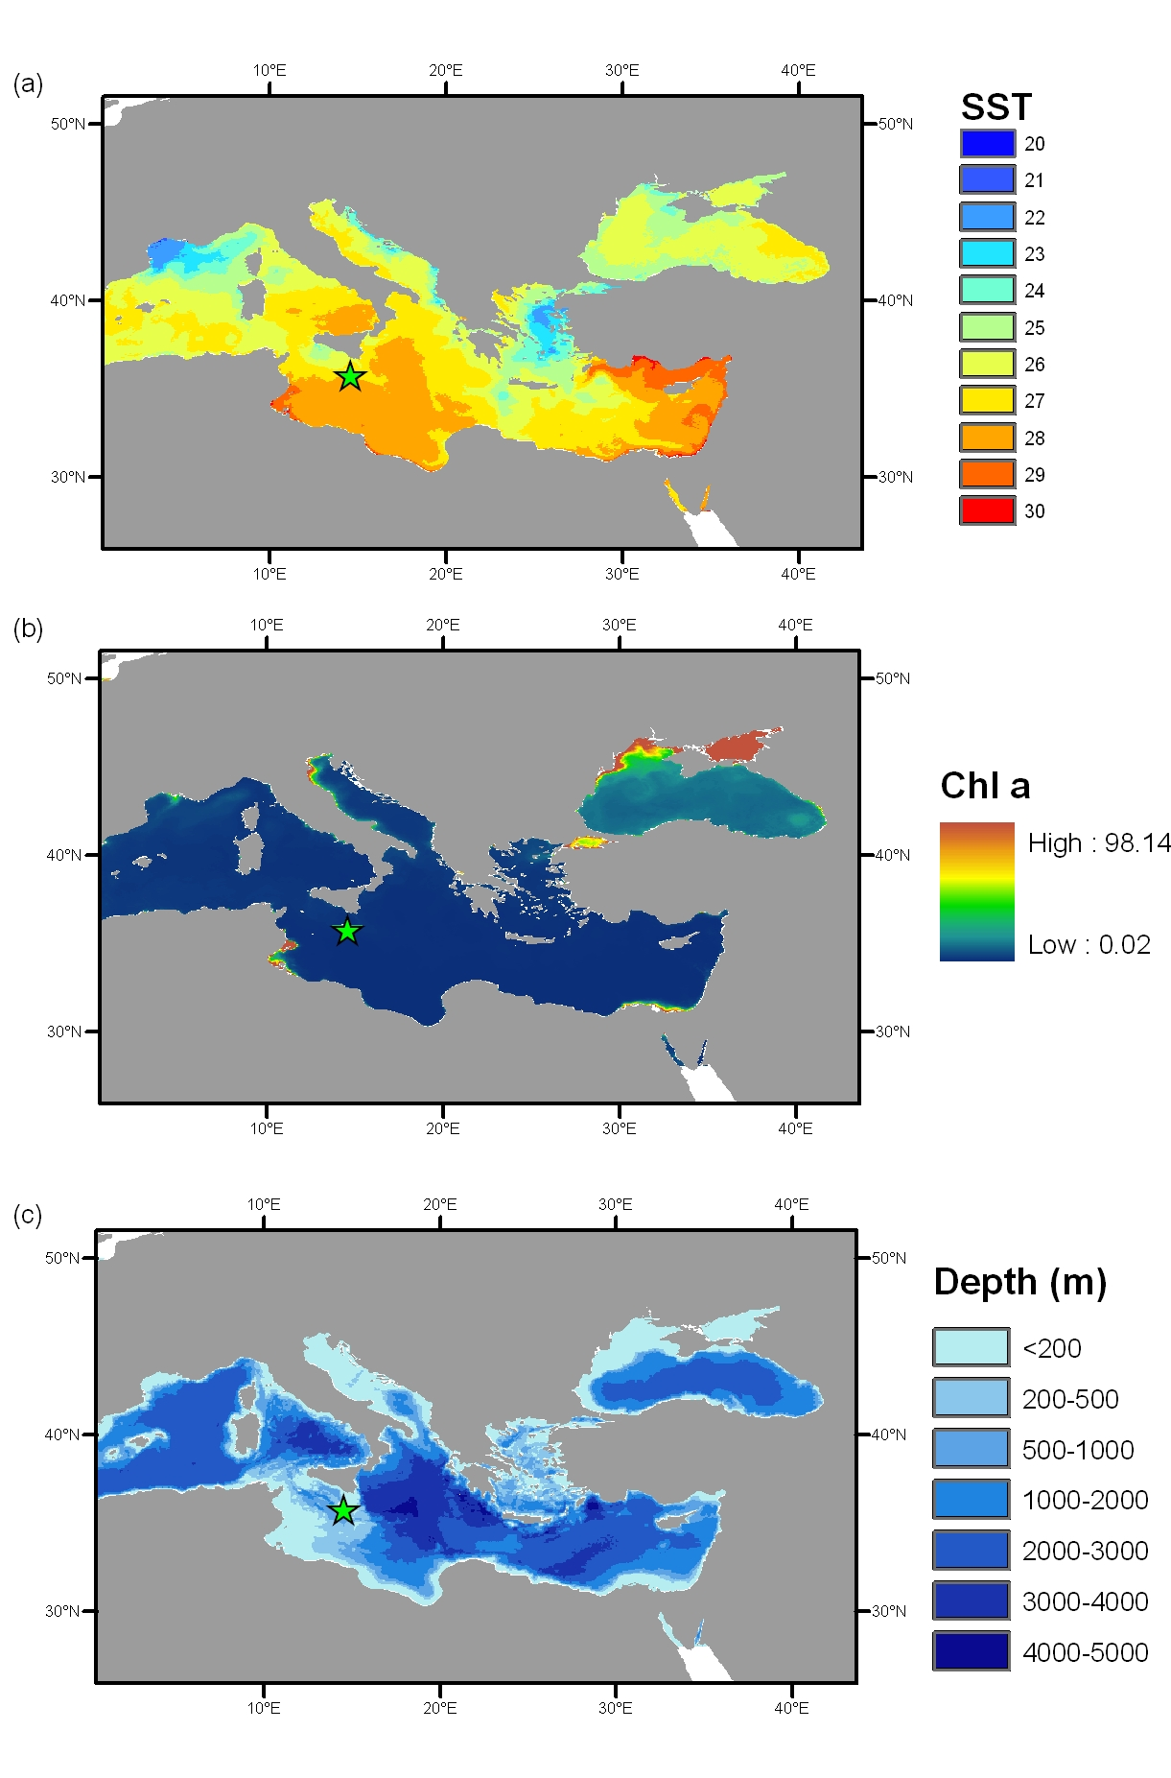
Figure 4. Oceanography of the study region, (a) bathymetry, (b) chlorophyll a concentration in mg m⁻³ in July-August 2008, and (c) sea surface temperature in °C in July-August 2008. See text for details of changes in chlorophyll a concentration and sea surface temperature between September and February.

