Author postprint 17 August 2006

Exploration of Ellsworth Subglacial Lake: a concept paper on the development, organisation and execution of an experiment to explore, measure and sample the environment of a West Antarctic subglacial lake

The Lake Ellsworth Consortium

(Members of the Lake Ellsworth Consortium, as on 15 August 2006, in alphabetical order: Behar, A., Bentley, M., Blake, D., Christoffersen, P., Cockell, C., Corr, H., Cullen, D.C., Edwards, H., Ellery, A., Ellis-Evans, C., Griffiths, G., Hindmarsh, R., Hodgson, D.A., King, E., Lamb, H., Lane, L., Makinson, K., Mowlem, M., Parnell, J., Pearce, D.A., Priscu, J., Rivera, A., Sephton, M.A., Siegert*, M.J., Sims, M.R., Smith, A.M., Tranter, M., Wadham, J.L., Wilson, G., Woodward, J.)

*to whom correspondence should be addressed (Martin J. Siegert, Email: m.j.siegert@ed.ac.uk., School of GeoSciences, University of Edinburgh, Grant Institute, West Mains Road, Edinburgh EH9 3JW, UK)

Abstract

Antarctic subglacial lakes have, over the past few years, been hypothesised to house unique forms of life and hold detailed sedimentary records of past climate change. Testing this hypothesis requires in-situ examinations. The direct measurement of subglacial lakes has been considered ever since the largest and best-known lake, named Lake Vostok, was identified as having a deep water-column. The Subglacial Antarctic Lake Environments programme (SALE), set up by the Scientific Committee on Antarctic Research (SCAR) to oversee subglacial lakes research, state that prior exploration of smaller lakes would be a “prudent way forward”. One hundred and forty five subglacial lakes are known to exist in Antarctica, but one lake in West Antarctica, officially named Ellsworth Subglacial Lake (referred to hereafter as Lake Ellsworth), stands out as a candidate for early exploration. A consortium of over twenty scientists from seven countries and fourteen institutions has been assembled to plan the exploration of Lake Ellsworth. An eight-year programme is envisaged: three years for a geophysical survey, two years for equipment development and testing, one year for field planning and operation, and two years for sample analysis and data interpretation. The science experiment is simple in concept but complex in execution. Lake Ellsworth will be accessed using hot water drilling. Once lake access is achieved, a probe will be lowered down the borehole and into the lake. The probe will contain a series of instruments to measure biological, chemical and physical characteristics of the lake water and sediments, and will utilise a tether to the ice surface through which power, communication and data will be transmitted. The probe will pass through the water column to the lake floor. The probe will then be pulled up and out of the lake, measuring its environment continually as this is done. Once at the ice surface, any water samples collected will be taken from the probe for laboratory analysis (to take place over subsequent years). The duration of the science mission, from deployment of the probe to its retrieval, is likely to take between 24 and 36 hours. Measurements to be taken by the probe will provide data about the following: depth, pressure, conductivity and temperature; pH levels; biomolecules (using life marker chips); anions (using a chemical analyzer); visualization of the environment (using cameras and light sources); dissolved gases (using chromatography); and morphology of the lake floor and sediment structures (using sonar). After the probe has been retrieved, a sediment corer may be dropped into the lake to recover material from the lake floor. Finally, if time permits, a thermistor string may be left in the lake water to take time-dependent measurements of the lake’s water column over subsequent years. Given that the comprehensive geophysical survey of the lake will take place in two seasons during 2007-9, a two-year instrument and logistic development phase from 2008 (after the lake’s bathymetry has been assessed) makes it possible that the exploration of Lake Ellsworth could take place at the beginning of the next decade.

1. Introduction

Following the discovery that Subglacial Lake Vostok in East Antarctica has a water column over 500 m deep (Kapitsa et al., 1996), there has been widespread scientific and media interest in exploring Antarctic subglacial lake environments (Siegert et al., 2001). Such exploration is driven by the hypotheses that Antarctic subglacial lakes host unique forms of life and hold detailed sedimentary records of past climate change. Testing these hypotheses requires in-situ measurement and sampling. Large lakes in central East Antarctica, such as Lake Vostok, are unlikely to be measured and sampled directly in the foreseeable future due to their remote location and lack of detailed comprehension (Siegert, 2002) (although Russian Scientists plan to penetrate the existing Vostok borehole into Lake Vostok during 2008/9 and extract refrozen lake water). One hundred and forty five subglacial lakes known in Antarctica (Figure 1), but one lake in West Antarctica, officially named Ellsworth Subglacial Lake (Siegert et al., 2004), stands out as a candidate for early exploration for the following reasons:
- Lake Ellsworth (79°S, 90.5°W), being only ~10 km long, can be characterised meaningfully in a short period using seismic and radar surveying (see Figure 2);
- the lake is logistically accessible through both UK and US scientific field operations and through the commercial operator Antarctic Logistics and Expeditions;
- Lake Ellsworth is representative of other subglacial Antarctic lakes, in terms of pressure and temperature conditions;
- the sediments accumulated across the floor of the lake may yield a record of West Antarctic ice sheet history,
- Lake Ellsworth is located ~20 km from an ice divide, which means that drilling from the ice surface into the lake would not be complicated by ice flow;
- the ice sheet surface over the lake is ~2000 m above sea level, which is more than a kilometre lower than the ice surface over the vast majority of East Antarctic subglacial lakes (altitude related problems often encountered by scientists at the centre of the East Antarctic Ice Sheet will not, therefore, be as much of an issue during the study of this lake);
- subglacial access and sampling has precedent in West Antarctica, but not in East Antarctica.
This paper describes the concept behind the exploration of Subglacial Lake Ellsworth. The two scientific goals of the project (which are also the goals of subglacial lake exploration in general, see Priscu et al., 2003) are (1) to measure and comprehend life in this extreme environment, and (2) to collect and assess any climate records that exist in the lake floor sediments.

1.1. Background to Lake Ellsworth
Subglacial Lake Ellsworth is a 10 km long, 2-4 km wide, lake underneath between 3240 and 3320 km of ice near the Ellsworth Mountains in West Antarctica (Figure 2; Siegert et al., 2004). The ice sheet over the lake is ~20 km from the ice divide and its elevation is ~2 km above sea level, which makes the lake surface over 1.25 km beneath sea level. Although, prior to 2004, only one radio-echo sounding (RES) transect has crossed the lake (Figure 2), several have been collected by the British Antarctic Survey (BAS) in 2004-5 and Chilean glaciologists during January 2006. These RES data show the lake to occupy a deep, distinct topographic hollow, which appears similar to an over-deepened section of an ancient fjord.

1.2. Planning and meetings to date
An initial group of eight scientists met at BAS on 26th April 2004 to assess the feasibility of a subglacial lake exploration programme. Following the identification of key exploration roles, an expanded group of sixteen members met subsequently at the University of Bristol on 1st September 2004 to develop the project further. A third meeting took place at BAS on 8th March 2005 to develop a concept document that detailed how the exploration of Lake Ellsworth will be realised. This paper derives from that concept document. Agenda and minutes of these meetings are available from the project’s website (www.ggy.bris.ac.uk/ellsworth). As a consequence of the meetings held to date, a consortium of over 30 scientists from seven nations and fourteen institutions has been assembled to undertake the proposed programme of activity detailed herein.

1.3. Purpose of this paper
This paper provides brief details of the likely requirements of a subglacial lake exploration programme (with specific attention paid to the requirements on Lake Ellsworth). It is important to note that the underlying theme of the proposed project is to undertake ‘first access’ of a subglacial lake environment and to explore this environment in a simple, efficient and cost-effective manner. Despite this low cost approach no compromise is expected when it comes to contamination of the subglacial environment. More expensive and complex experiments may follow if this initial project is successful, but such experiments are not discussed in this document.

2. international COLLABORATION AND THE INTERNATIONAL polar year
The Scientific Committee on Antarctic Research (SCAR) commissioned a group of specialists (now a Scientific Research Programme, SRP) named SALE (Subglacial Antarctic Lake Environments) to “consider and recommend mechanisms for the international coordination of a subglacial lake exploration program” (Priscu et al. 2003). Details of the SALE project can be found on its website: http://salepo.tamu.edu/scar_sale. It should be noted that SCAR has no money to fund research. Consequently, its scientific research programmes will not undertake research themselves. Instead, these programmes have been configured to facilitate research and encourage international cooperation through workshops and symposia. Funding for projects within a SCAR SRP must be sought by national funding agencies.
A proposal to undertake a comprehensive geophysical survey of Lake Ellsworth (including RES, seismic surveying and a variety of surface measurements) has been funded through the UK Natural environment Research Council’s Antarctic Funding Initiative (NERC-AFI). The survey is planned in two seasons during the years of the International Polar Year (IPY) 2007-9 (www.ipy.org). The Lake Ellsworth geophysical campaign is a recognised project of the larger Subglacial Antarctic Lake Environments (SALE) programme, which is officially endorsed by the IPY. Data collected during the IPY will supplement those acquired in 1978, in 2004-5, and in January 2006. As a consequence of these geophysical results, Lake Ellsworth and its subglacial catchment will be characterised at a sub-km resolution, which will make planning purposeful direct measurement and sampling possible. Further integration of various international research proposals related to subglacial lakes research into the Lake Ellsworth programme is possible via both the IPY and SALE, and within the project’s own management. Such integration will be encouraged at the international workshop on subglacial lake environments, organised by SALE in Grenoble, April 2006.
SALE is a fully endorsed programme of the IPY, and involves numerous projects concerning subglacial lakes from a variety of nations, including the exploration of Lake Ellsworth. SALE will assist the Lake Ellsworth project in terms of environmental planning, data management and dissemination of results.

3. Website and media interest
Even though the project is in its planning stages, there has been considerable public and media interest in plans to explore Lake Ellsworth. Details of this interest, and the project in general, can be found from the project website (www.ggy.bris.ac.uk/ellsworth), constructed to help schools and colleges follow the progress of work, and to assist the media in understanding the proposed research.

4. Structure of the project and objectives
The exploration of Lake Ellsworth requires a multidisciplinary approach. A considerable level of management is required to integrate the various project elements. Currently the project is being managed by a steering committee, and through an ongoing series of project meetings. The project is arranged in four phases each with distinct objectives, which are outlined below (Figure 3).
It should be noted that a considerable group (in terms of size and breadth of expertise) has been put together to undertake the exploration of Lake Ellsworth. We are collectively known as the ‘Lake Ellsworth Consortium’. Given the long-term nature of the project, requiring instrument development, fieldwork and laboratory analysis, publications arising from the direct measurement and sampling of the lake will be authored by the ‘Lake Ellsworth Consortium’, rather than by individuals.

4.1. Phase 1: geophysical exploration
The first phase of the project involves the measurement of the size and shape of Lake Ellsworth, the flow of the ice sheet over the lake, and the subglacial topography surrounding the lake. This part of the project, which has been funded by the UK NERC-AFI programme and must take place before direct exploration (as it will be essential for fieldwork planning and, later, interpretation of data), and will take place during the forthcoming IPY. The objectives of this first phase of the project are as follows (see also Section 5):
- To undertake a comprehensive geophysical survey of Lake Ellsworth and its locale.
- To reveal the water depth of the lake (i.e. lake bathymetry).
- To measure the sediment thickness and structure across the lake’s floor.
- To comprehend the wider topography around the lake and quantify the dimensions and morphology of the lake’s drainage basin.

4.2. Phase 2: Instrument and logistic development
The second phase of the project involves assembling equipment and logistics necessary to undertake the physical exploration of Lake Ellsworth. In this phase the following objectives are required:
- To build, assemble and test instruments to detect life in the lake, to measure the physical and chemical properties of the lake’s water and to sample the lake water and sediment (Section 6);
- To construct and test a probe to house the instruments and to allow communication between the probe and the ice surface by which data may be sent back to the ice surface (Section 7);
- To build and test a hot-water drill and organise field logistics (Section 8).

Phase 2 of the project will also require the following objective, if climate records are to be recovered:
- To acquire and test a sediment corer, capable of extracting a 2 m core (or longer) from the floor of Lake Ellsworth (Section 11).

Contamination of subglacial lake environments as a consequence of the lake access experiment must not occur. Hot water drilling has been used on numerous occasions to reach the base of the West Antarctic ice sheet (e.g. Englehardt et al. 1990). The use of hot-water drilling in this project means that all the contamination controls used previously to study the ice sheet base, and surface lakes in Antarctica, will be employed for experiments in Lake Ellsworth. Further assistance on this important issue will be sought from the SCAR-SALE scientific research project prior to fieldwork.

4.3. Phase 3: Fieldwork
Once the necessary equipment has been built and tested, we will be in a position to undertake exploration fieldwork. To allow direct measurement and sampling of the lake, the following objective is required:
- To use a hot water drill to gain access to the lake from the ice-sheet surface.
We anticipate a 30 cm wide borehole is required (to pass equipment through), which can be held open for 24-36 hours (giving a short window of little more than a day for the actual exploration). Prior to lake entry, 400 m of water within the borehole will be taken out to ensure borehole water does not enter the lake (as the base of the borehole will be at greater pressure than the water within the lake).

Once lake access is achieved, the following objective is required:
- To deploy a probe into the lake capable of measuring the lake’s biological, chemical and physical environment.
The probe will be lowered through the water column to the lake floor. Recordings made on this journey could be used to plan sampling on its return up the water column (recordings will also be made on its return journey). The probe will then be retrieved.

Subsequent to the deployment and retrieval of the lake-water probe and if lake access is ensured for an appropriate length of time, the following objective is required:
- To deploy a sediment corer into the lake to retrieve a 2 m (or longer) sediment core.

In addition, a probable third experiment involves the installation of a permanent station into the lake. No details of such an experiment are provided in this document, but such work is undertaken commonly within Antarctic surface lakes covered by thin ice.

4.4. Phase 4: Data analysis and interpretation

Data acquired by the probe will comprise direct measurements and, possibly, samples. The following four objectives are required to assess these data in order to meet the project’s goals. The first involves direct measurements, the second and third involve samples of water and sediment and the fourth involves the analysis of sedimentary records.
- To assess data sent by the probe in real-time to the ice surface, to comprehend the physical and chemical structure of the lake, and to ascertain the abundance, distribution and diversity of microbial life in the water column and water-sediment interface.
- To conduct microbiological examination of lake water and sediment in a laboratory (Section 9);
- To undertake geochemical analysis of water and sediment (Section 10).
- To conduct sedimentological laboratory analysis of the lake floor sediment core (Section 11).
If a permanent station is deployed, a means by which data can be stored, retrieved and disseminated will be needed (and will probably require returning to the field site in years subsequent to the exploratory mission).

4.5. Project components
The following seven sections provide a ‘concept’ of the requirements of each phase of the project. The first is the geophysical survey (Section 5). Second is the instrument development for the probe (Section 6). Third is the probe development (Section 7). Fourth is the hot-water drilling and fieldwork (Section 8). Fifth is the biological analysis of water samples (Section 9). Sixth is the geochemical analysis of water samples (Section 10). Seventh is the sedimentological analysis of lake-floor deposits (Section 11).

5. Geophysical survey

This component of the project involves the geophysical exploration of Lake Ellsworth. Fieldwork will take place during the IPY 2007-9 and involves RES of the ice base, seismic surveying of the lake floor, GPS monitoring of ice flow and a series of other ice surface glaciological measurements. Following the fieldwork, numerical modelling will be used to quantify water flow within the lake, ice flow over the lake, and the distribution and rates of melting and freezing at the lake-ice interface. When the fieldwork is completed, the following eleven questions will be answered: (i). What is the water depth of the lake? (ii). What is the topographic setting of the lake? (iii). What is the sediment thickness across the lake floor? (iv). Are the sediments layered? (v). How does the ice sheet flow over the lake? (vi). What is the roughness of the bed around the lake? (vii). What are the rates of subglacial melting and freezing over the lake? (viii). Does the lake have detectable tides? (ix). How is the lake water circulation configured? (x). Where does the melt-water originate? (xi). What is the geothermal setting of the lake?

The outcome of this element of the project will be a detailed characterisation of the subglacial lake and its physiography and the identification of the most appropriate drilling site for direct exploratory research.

6. Instrument development

6.1. Background
Developing the instrumentation for the probe (Section 7) is focused on measuring the physical and chemical properties of the lake water and identifying life within the lake. Consequently, the following key considerations guide the choice of instrumentation.
- The experiment should be thought of, in the first instance, as a ‘demonstration project’, and should not aim to accomplish everything that might be possible in subglacial lakes exploration. Some selectivity is therefore required within the instrument specification and design. Once subglacial lake access is achieved and this in situ experiment completed, it may well be appropriate to develop more sophisticated experiments and instrumentation afterwards.
- All instrument items need to be depth (pressure)-rated to 4-5 km of water (corresponding to the likely pressure of Lake Ellsworth).
- The number of items requiring significant development needs to be kept to a minimum, to avoid the project becoming unreasonably expensive, overly ambitious, and difficult to accomplish within the timeframe of the project.
- Instruments need to be miniaturised to fit a casing of <20 cm diameter (the drill hole will be ~30 cm wide). Pressure-protected instruments may need confining to a 15 cm diameter. It should be noted that some instruments (e.g. Raman spectroscopy) could be deployed from the surface using fibre optic cable to connect to the lake water.
- The first measure of success will be to demonstrate measurements in the lake water. Sample return is very attractive, but will be a bonus, and so should have a lower priority than direct measurements.

6.2. Basic instrumentation
The following comprise essential characteristics of the probe’s array of instruments:
- A basic off-the-shelf (OTS) camera/light system and a custom-built CCD (charge - coupled device) system with photon-level resolution, and UV light source, to detect fluorescence/bioluminescence.
- A water filter system, as life detection will be more efficient if the material within the water is concentrated. Multiple filter devices are required to deploy at different water depths.
- Measurement of ions within the lake water will be made but only using equipment that is OTS.
- Two sonar devices (top and bottom of probe) are needed to allow depth-to-probe and water-depth measurements.
- If a sampling capability is adopted the simplest option is a series of sampling chambers/cavities which may be switched to recover water from the target environment. It should be noted that sample will be limited in volume to a few hundred ml, and that degassing of samples on return to the surface is inevitable.

6.3. Detection of life
Defining the equipment needed to detect life within the lake water is critical to the success of the experiment. The following make up the possibilities defined at present:
- An obvious generic marker of active terrestrial life is the molecule adenosine triphosphate (ATP) that is present in all cells. Enzyme-based bioluminescence reagents and technology to detect ATP levels is well established in other applications. This will require re-packaging into appropriate reaction chambers pre-dosed with reagents and filled in situ with filtered and cell-lysed water samples. The reaction chambers will be imaged by the photon-counting camera to detect the resultant emitted ATP depended bioluminescence. At present 4 measurements (3 at various water depths and one in sediment) are envisaged.
- Endogenous fluorescence will be measured using a UV light source, optical filters and optical detector. If necessary we may measure fluorescence after addition of fluorescent dyes specific to certain cell components.
- Raman spectroscopy could be deployed (from the ice surface) on (i) filtered particulate organic material, and (ii) a surface-enhanced resonance Raman spectroscopy (SERRS) surface, exposed to extract organics from solution. Deployment into sediment may also be possible using a fibre optic probe.
- Life Marker Chip (an appropriately packaged antibody micro-array device currently under development for life and organics detection for planetary exploration – specifically for Martian exploration), using readily available antibodies, is high risk (in terms of the timescale for development) and expensive in terms of development resources. If it can be developed, such equipment would be central to the project’s life-detection goal. However, the first three life/organics detection devices, if used in tandem, would result in a multi-pronged approach to the problem. The fourth would be a bonus if it can be developed in time. We note that deployment of this technology will require in situ sample preparation, which may be non trivial.
- Analysis of filtered material from lake water and sediments for recognisable biological particles using traditional microscopy (LM, SEM etc.).

7. Probe development

The probe development will require two elements: (a) The construction of electronics to ensure data from the probe’s instruments are transferred to the ice surface, and (b) the building of the probe case and tether (capable of withstanding appropriate pressure of the borehole and the lake’s water column).

7.1. Probe electronics
It is anticipated that the probe will draw power and data through its tether, which will be necessarily highly robust. This will be a potential single point failure mode as the Dante II robot (designed to explore active volcano craters) failed when its winch-deployed rappelling tether snagged and fractured on its maiden descent in 1994. The power distribution bus should be isolated from the data distribution bus in separate wiring harnesses.
The probe will have a small cross-section due to the narrowness of the borehole of <30 cm diameter – similar to sondes used in petroleum wireline logging. The penetrometer shell should be of semi-monocoque construction with thermally isolated internal equipment spaces. Although aluminium alloy may be suitable for the probe structure, wireline logging sondes are generally constructed from titanium alloy. Indeed, the probe may potentially be constructed from compartmentalised segments connected together through standard interfaces at the deployment site as in wireline logging making transport and packaging of the probe easier.
The probe must house the service support subsystems and the relevant scientific instruments. The probe electronics should be housed within the probe connected through each segment by electrical interfaces and a suitable ‘bus’ architecture (e.g. CANbus). The internal circuitry may be optimised to minimise the length of the wiring harness. Circuit paths should be short with electronics packaged into circuit board stacks linked through an integrating backplane. The electronics comprises:
  - Power microelectronics based on CMOS ASICs (application-specific integrated circuits) for switching voltage regulation and overcurrent protection of onboard devices (an alternative to ASICs is a field programmable gate array (FPGA)).
  - Control and data handling microelectronics (a microcontroller including internal multiple ADC channels) for the storage of telemetry and scientific data and mission sequencing. A transputer (or other co-processors) may be employed to perform image processing (which have been deployed on Surrey Satellite technology Ltd. micro-sats). Lossless data compression methods may be employed to reduce data rates.
Onboard microprocessors will enable limited data manipulation on the vehicle; will manage data storage and transmission to the surface command station; will control onboard systems; and will calculate attitude from inertial and magnetometer sensors. Attitude data can be combined topside with the sonar images to provide accurate positioning information vital in the measurement of the small currents expected in the subglacial lake.
Although it is anticipated that onboard power will be supplied through a tether, backup primary Li-thionyl batteries designed for a significant period of operation at low temperatures should be included for redundancy. This depends on the duration within the target waters (unknown) and the time for descent and ascent (~20 hours). Conductive fins will be required to radiate battery power dissipation. The tether link should provide sufficient capacity to support the telemetered data rate; e.g. 500 kilobytes per second (kbps) depending on the scientific instrument polling rate and data density (e.g. imaging).
Onboard instrumentation should employ dedicated on-chip signal conditioning electronics to allow efficient interfacing to the databus. However, the requirement for minimal volume overhead suggests that tight scientific payload integration into a single system is required to eliminate modular boxes with electrical connectors. This architectural trade-off will require critical examination.
Some bulky scientific instruments may be deployed from the ice surface and exploit the tether using fibre optic cabling (IR Raman spectroscopy is currently being considered for such deployment, and such an approach may also be suitable for optrodes).

7.2. Probe casing
The probe concept consists of a negatively buoyant cylindrical vehicle with no propulsive capability. It is essentially a hollow cavity which allows the accommodation of scientific instruments and supporting subsystems. The centre of mass of the probe should be close to the nose, forward of the centre of pressure, to ensure stability during the descent. Thermal control may be achieved through an inside layer of carbon foam or silicon aerogel with a thermal capacity of 300 W/cm² (multi-layer insulation is likely to be too thick within the limited diameter). Thermal isolation straps may be constructed from low thermally conductive glass fibre reinforced epoxy.
The probe will be lowered under its own weight into the borehole and subsequently to the subglacial lake. The predicted borehole diameter at retrieval limits the vehicle width to less than 200 mm. Length is relatively unconstrained and will be varied to accommodate the required instrumentation and systems. The diameter limit has the most profound effect on the area available for tip mounted instruments; i.e. imaging sonar, conductivity-temperature-depth (CTD) instrument, water sampler tube, sediment corer / sampler, video camera and light, as shown in Figure 4). Water sampling and pumping for analysis can be positioned elsewhere on the vehicle.
Movable surfaces / covers are a possible consideration but are currently avoided by the use of a fixed cage at the rear of the vehicle which guides the cable away from the sonar and encourages the vehicle to centre itself into the borehole for retrieval. A fixed cowl (not shown) protects the tip mounted instrumentation. The generation and use of hot water for both lake entrance and exit is possible but requires further investigation.
At a maximum depth of 4 km below an estimated 3.4 km thick ice sheet, the probe will experience an ambient pressure of ~370 bar. Systems that are not resistant to this loading will be placed in a pressure resistant cylinder (see Figure 4). Pressure tolerant devices that need to be isolated from water will be housed in an oil filled pressure balanced cylinder with diaphragms to enable differential expansion. This cylinder will have a greater useable diameter due to its thinner sidewalls. All other devices can be exposed to the environment directly or in free flooded areas of the vehicle.
Standard oceanographic CTD cable with optical fibre and dual conductor link (e.g. A303950, Rochester Cables) can be used to lower and retrieve the probe. Four km of 11 mm diameter cable weighs ~2900 kg (~1300 kg in water). Using this cable the maximum probe weight is ~4500kg. This cable can be used to transmit ~100W (@300v) to the probe; a similar power is dissipated in transit.
Trade studies are required to compare power strategies (including raising the voltage, using different conductors or supplying onboard batteries). Primary communication will be via optical fibre, with a modem backup using the cable conductors. The backup system will not be able to transmit high rate video.
Substantial equipment will be required at the surface including a suitable winch (~3 tonnes), power generator, optical and conductor communications link processing, data storage and visualisation with integrated command and control. Testing and verification of components, systems and the integrated vehicle can be undertaken both in the pressure test facility at the National Oceanography Centre Southampton (NOCS), and on field trials in perennially ice covered lakes such as Citadel Bastion Lake (Southern Alexander Island), where solutes and life are in very low concentrations and are, thus, likely to provide for the development and testing of the sensory capability of the probe.

8. Drilling, logistics and fieldwork

8.1. Background
Exploration of Lake Ellsworth will be undertaken during the 2012/13 or 2013/14 season. Hot water drilling equipment will weigh approximately 36 tonnes. A total of 200 drums of fuel will be needed to make 2 entries into the subglacial lake. The lake is at a depth of 3400 metres. A minimum of 18 personnel are needed on site during the continuous drilling phase (6 per shift) to maintain and operate the drill, and for the deployment of probes into the lake. Staff will need to be on site for a period of 10 weeks, 5 weeks to set-up the equipment, 3 weeks to drill two holes and 2 weeks to decommission.

8.2. Hot water drilling equipment
The hot water drill will require a hose with a minimum bore of 1.5” to carry 4.5 litres per second of hot water. The temperature of the water will be up to 90°C at the surface, reducing to 55°C at a depth of 3400 m, thus providing the 1.7 MW needed to melt and maintain the hole. The water will be heated by commercially available heat exchanger units, and pumped using diesel powered units at up to 2200 psi.
Initially the drill will melt a 36 cm diameter hole but once drilling has ceased, refreezing will reduce the diameter to about 20 cm after 36 hours. Drilling such a hole through 3400m will require approximately 50 hours, and will use around 12,000 litres (60 drums) of fuel, assuming no problems. Experience suggests that further reaming of the hole, if needed, will consume approximately 6,000 litres of fuel per day.
The pressure loss within the hose is expected to be less than 2000 psi from the ice surface to the lake ceiling. As the top 300-400 m of the hole is air filled, the hose must be supported using additional strength members, or integral strength member bonded to the hose. A drilling winch capable of handling the hose and additional load of the probe is required.
Biological filtering, using a modular cartridge filter system to remove all bacteria and many viruses (down to 0.045 micron) from the water used during drilling, is required to minimise contamination of the lake water. The filtration plant will be designed to provide the required flow rate and water quality. Prefilters will remove the larger particulate. This system is expected to fit easily in to an airfreight container. Using data from ice cores from the Antarctic Ice Sheet, we can obtain a full analysis of the anticipated dust loading and ionic concentrations for the entire ice column. First estimates suggest that one filter change every 2-3 days (assuming entirely dusty glacial ice) will easily maintain the filtration standards. A more comprehensive analysis of the ice core data would confirm the frequency of the filter changes. If all viruses must be removed then reverse osmosis is required, removing salts and ions as well as viruses. Either system would ideally be housed in small shipping container together with the prefiltering system.

8.3. Access and fieldwork
To overcome as many of the logistical problems as possible delivery of equipment, materials and personnel to the drill site, will use chartered aircraft (using Antarctic Logistics and Expeditions). There will be a heavy lift from Chile to the Patriot Hills ice runway, with onward carriage by tractor train (in collaboration with Chilean scientists). All field activities and arrangements will be organised with the assistance of BAS project members, including transportation, tents, clothing, field equipment, communication systems and food.

8.4 Fieldwork analysis
The probe will deliver information concerning physical, chemical and biological properties of the lake’s water column. Appropriate scientific expertise will be present in the field to (1) manage the probe’s sampling strategy, and (2) interpret the probe’s results to comprehend the environment of Lake Ellsworth. Data collected by the probe will be recorded on site and made available to project members in the first instance, and the international scientific community via SALE. If samples are recovered, it may be possible to undertake first analysis on site. The bulk of material recovered will be packaged into sterile containers and transferred to laboratories where detailed analysis can take place.

9. Biological ANALYSIS

9.1. Background
Microorganisms have been found in some of the most extreme environments on Earth; some organisms thrive in ice, others flourish in boiling water, acids, water-cores of nuclear reactors, salt crystals and toxic waste (Rothschild and Mancinelli, 2001). Lake Ellsworth has the potential to be one of the most extreme environments on Earth with combined stresses of high pressure (>400 atmospheres), low temperature (near the freezing point), permanent darkness and probably oligotrophic (low nutrient) conditions. The identification of significant subglacial bacterial activity in some subglacial environments (e.g. Miteva et al., 2004, Foght et al., 2004), as well as work on permafrost communities, shows that life can survive and grow in low temperature glacial systems. Above Lake Vostok all of the accreted ice samples between 3541 and 3611 m contained both prokaryotic and eukaryotic microorganisms (Priscu et al. 1999). In addition, viable microorganisms have been recovered from one million year old Antarctic permafrost (Kochkina et al., 2001), which makes it likely that prolonged preservation of viable microorganisms is possible in Antarctic ice-bound habitats. Thus, existing data suggest that the Antarctic ice sheet may at least provide a source of microorganisms for the lake and possibly an environment for their growth.

9.2. Does Lake Ellsworth contain life?
Members of the microbial world encompass the three domains of life, the Bacteria, the Archaea and the lower Eukarya. About 4,200 prokaryotic species have been described out of an estimated 10⁵ to 10⁶ prokaryotic species on Earth. The overlying ice core at Lake Vostok is known to contain the full diversity of microbial life: algae, diatoms, bacteria, fungi, yeasts and actinomycetes (Ellis-Evans and Wynn-Williams, 1996). A combination of microscopy, biochemical and molecular biological techniques will be studied in ‘clean’ laboratory facilities to determine the abundance, distribution, and diversity of microorganisms in the lake. We will use standard microbial quantification techniques such as nucleic acid staining (SYTO 9, acridine orange) to obtain microbial numbers. Techniques such as FISH (Fluorescent In-situ Hybridisation) will be used to determine the phylogenetic groups of the organisms.

9.3. Where is life located within the subglacial lake?
Such a unique environment is expected to harbour significant chemical gradients, including even oxygen from gas hydrates released from ice. Microbial life in Lake Ellsworth may, therefore, be pelagic, associated with sediment particles, distributed along gradients, in accretion ice or in overlying meteoric ice. The identification of viable organisms along with a determination of the elemental composition of the surrounding media will provide clues to potential biogeochemical activity and the sources of energy and carbon that would be necessary to sustain metabolically active populations.

9.4. What are the characteristics of Lake Ellsworth communities?
While the mere presence of life in itself would be a major scientific discovery, we might expect such organisms to possess special or unique adaptations to this hostile environment. Analysis of the physiological potential using a metagenomic approach and energetics through biochemical pathways of returned samples, will help to gain a fuller understanding of the role of Lake Ellsworth microbes in biogeochemical cycling and the functioning and control of the ecosystem. FISH, CARD-FISH (Catalyzed Reporter Deposition FISH) and similar methods (Table 1) will be used to determine the phylogenetic characteristics of the communities.

9.5 Techniques
The following four laboratory techniques are available to investigate microorganisms within samples retrieved. (1) Microscopy; fluorescent and electron microscopy (used with specific gene probes). (2) Biochemistry (biogeochemical cycling). In the absence of light, the microorganisms within Ellsworth must be using either organics or inorganic redox couples to gather energy. We will use gene probes available for different biogeochemical activities to assay the water/samples for the presence of biogeochemical activity. This will include probes for iron cycling (reduction and oxidation), nitrate cycling, manganese reduction and other pathways of dissimilatory metal reduction and oxidation. (3) Molecular biology; genomic DNA (using gene probes coupled with FISH - Fluorescent in-situ hybridisation) will be extracted from material obtained and used to construct a metagenomic library to screen for novel physiologies. (4) Infrared Raman (used to detect biomolecules); could reside at a surface station with the sensor head residing in the probe.

10. Geochemical experiments

The aims of this Section are to first detail the expected geochemistry of the lake water, and then assess the various measurements and analyses required to quantify the lake’s physical and chemical environments (including measurement/sampling strategies and prioritisation of laboratory experiments).

10.1. Background: Expected bulk geochemistry of Lake Ellsworth
Let us assume that the dimensions of Lake Ellsworth are 10 km × 10 km × 250 m; then the volume of water is 25 km³. Let us then assume that the melting into the lake equals freezing out of the lake, so that the lake volume is in steady state, and that melting occurs over 50% of the lake at a rate of 10 cm/yr. The annual input of melt to the lake is therefore 10 km × 10 km × 0.5 × 10 cm/yr or 5 × 10⁻³ km³/yr.
The residence time of water is 25/5 × 10⁻³ yrs or 5 kyr. Assuming the age of Lake Ellsworth to be 400 kyr, there will have been 80 renewals of water.
Assuming also that all the solute from the melting ice stays in the lake, since ~0.1% is incorporated into accretion ice. The chemical composition of the lake is therefore 80 times that of the average incoming ice melt chemistry, if no other sources or sinks of ions occurs.
Let us assume finally that the chemistry of ice melt is equivalent to the average chemistry recorded in the Byrd Ice Core, which gives the expected chemistry of lake water in Table 2.
The inferred concentrations of Ca²⁺, Mg²⁺, Na⁺, K⁺ SO₄²⁻ and HCO₃⁻ are probably on the low side, since these ions are generated from interactions between glacial flour and ice melt. We guess that concentrations may be up to a factor of 3-5 higher, putting these concentrations similar to those estimated for Lake Vostok.
The inferred concentrations of H⁺, NH₄⁺ and NO₃⁻ are probably too high, since glacial flour uses up H⁺ in chemical weathering actions, and microbial activity will remove NH₄⁺ and NO₃⁻ (microbial activity may also change levels of SO₄²⁻ and HCO₃⁻). We guess that the pH of the water will be about 6 and that NO₃⁻ and NH₄⁺ concentrations will be around 1 µeq/l, similar to those in Lake Vostok (Siegert et al. 2003).

10.2. Experiment sampling strategy
Given the short but intensive duration of the field experiment (24-36 hours), it is essential to formulate a measurement and sampling strategy to acquire appropriate real-time data and quantities of the lake water to ensure its geochemistry can be characterised appropriately. Our three-stage plan for exploration is as follows. (1) Once in the lake, lower the probe continuously to the lake floor taking measurements of lake’s physical environment. (2) At the lake floor, collect sediments, deploy life marker sensors into sediment, scrutinise physical-lake data. (3) On the basis of an analysis of data to this point, a sampling strategy should be developed for the return journey up the water column. In this way we can be confident of acquiring data from the most interesting material in the water column. It should be noted that we also intend to sample and analyse ice above the lake (extracted by hot water coring), as this comprises the likely ‘input’ to the lake system.

10.3. Physical environment
Comprehension of the physical environment (flow, temperature, conductivity, density, pH, oxygen saturation etc.) is likely to be one of the first results of the programme. The analysis involves data emplacement within a 3-D context (the broad 3-D physiography having been established from earlier geophysics (Section 5)).
Questions that can be answered include: Is the lake thermally and/or chemically stratified? What is the rate of water flow? Is the water saline (and does a thermohaline circulation occur)? Does water flow through hydrothermal action? A short period of post-fieldwork processing will be required, in conjunction with 3D visualisation of the lake system.
Sonar may provide fascinating imagery of the lake floor (if side-scan is used), and would complement seismic results of water depths acquired in 2006-7.

10.4. Geochemical environment from laboratory analyses
Assuming that sufficient water is sampled, a strategy to utilise the samples most effectively is required. In the following tables, measurements of various components are prioritised and the minimum amount needed for the measurement is indicated. The first procedure for all samples is to separate water from particulates. Analysis of filtered particulates will reveal the following results: particulate concentration, size frequency, lithology, mineralogy and provenance, and the particulate’s contribution to solute. Having established the particulate content of lake water, experiments of the water itself can be conducted, with a priority given in Table 3.

10.5. Lake-floor sediments
A strategy for analysis of small volumes of lake-floor sediments, acquired by the probe, is requires in a similar way to the lake water. A prioritisation of experiments, with amount of material required for each, is given in Table 4.

11. Geological experiments

11.1. Background
Sediment in Lake Ellsworth will come from two primary sources, namely mineral dust (plus other particulate matter such as propogules, micro-meteorites) from the overlying ice, and sub-glacially-eroded sediment. The dust component is likely to be volumetrically very small, whilst the sub-glacially eroded component is likely to be substantially greater but more spatially restricted to the edges of the lake.
These sediments are likely to be easily sampled using a gravity corer. Subsequent to successful probe deployment, it is feasible that a sediment corer could be dropped to the lake floor to sample and retrieve the sediments.
Retrieval of a shallow (~3m) sediment core has several potential benefits to understanding the lake’s environment, its biota and its long-term history. In ultra-oligotrophic (extreme nutrient-poor) lakes the sediment-water interface is one of the most likely niches for life to exist and so a sample of this environment is necessary to fully test hypotheses of life in the lake. For example in most Antarctic surface lakes the vast majority of biodiversity resides in the sediment. Further, sediments within a short core are likely to contain a potentially long (e.g. tens of thousands of years) history of environmental conditions within the lake, including any records of life such as preserved organic remains (biomolecules etc). If no life is found in the water column then the sediments may show if life ever existed in the lake.
The sediments provide the potential for answering the question of how life got to, and evolved within, the lake. In particular if a sediment core can sample the transition between pre-glacial sediments and those deposited in the lake then the development of the lake and its life may be tracked through time.
Depending on its length, a sediment core from Lake Ellsworth could address three issues concerning the glacial history of West Antarctica: (1) the record of West Antarctic Ice Sheet (WAIS) evolution, particularly the transition to full ice sheet conditions; (2) the timing and duration of periods of WAIS collapse, and (3) the variations in lake ‘climate’ introduced by glacial-interglacial variations in the ice sheet above.

11.2. Sediment Core
A cable-operated gravity corer suitable for deployment through a hot water drilled hole has already been developed. A version of the corer could be built for retrieving sediment from Lake Ellsworth and could also be fitted with a percussion head to enable deeper penetration of the sediments. Of particular importance to the construction of the corer will be knowledge of the sediment thickness and water depth: both of which are scientific objectives of the proposed Geophysical Exploration of the lake (Section 5). Table 5 lists the various sedimentological measurements that could be made on a sediment core from the floor of Lake Ellsworth, and the scientific results that may follow. In particular, magneto-stratigraphy of the core may be essential to understanding the age of sedimentary material recovered from the floor of Lake Ellsworth (several details of the potential use of magneto-stratigraphy are expanded below).
A ‘U-channel’ cut from the split core half (2.5×2.5 cm × length of core), is required for magneto-stratigraphy analysis, but this will be non-destructive and will not modify the sample. All the material will be available for further study post magnetic measurements. It is probably best if the U-channel is cut before the core has the chance to come into any unknown magnetic fields. The coring barrel will be magnetic but this can be compensated for. Exposure to stray magnetic fields from engines, ships, steel objects, etc can modify or overprint the magnetic signal and this can prevent the success of magnetic studies. Shields for U-channels are available to prevent this during transport.
If the core is quite condensed (i.e. the sediments are old), the first experiment will be to test whether the Brunhes/Matuyama Boundary (780,000 years ago) can be detected. Assuming the record is complete, it may also be possible to pick up younger field excursions but it would be difficult to work with these unless there is some independent chronology to integrate with. However, the bonus of being proximal to the South Pole is that we can easily detect polarity from inclination records alone.
It should also be possible to recover a secular variation and field intensity record. It is not known whether the secular variation will help with dating as the location is so close to the pole and azimuthal orientation is likely to be absent. However, such a record has never been taken so close to the South Pole, which makes its acquisition important scientifically. Several other geochronological techniques available in sedimentology may be used to establish a time control on the lake-floor core.

12. SUMMARY AND Timetable of activities
The exploration of Lake Ellsworth requires a multidisciplinary effort of considerable size. The scientific justification is based on two important goals: (1) to measure and comprehend life in this extreme environment, and (2) to collect and assess the historical record contained in the lake floor sediments. A multi-staged approach is required to achieve these goals. First, a detailed characterisation of the lake’s physiography is required from geophysical measurements. A comprehensive survey of the lake will take place between 2007 and 2009. Subsequently, the specific details of the lake exploration mission will be determined. The project also requires the assembly of scientific equipment to detect life in the lake’s water and sediment, and to measure the chemical and physical environment of the lake. The necessary instruments will be held within a probe, fed into the lake via a borehole melted by a hot-water drill. The borehole, ~30 cm wide and 3400 m deep, will be kept open for around 24 hours, in which time the probe must be deployed and retrieved. After the probe is taken out of the lake (possibly with samples) a gravity core will be sent down to recover a short (~3 m) sedimentary core. Finally, if time permits, a permanent thermistor string may be put into the lake, and the borehole sealed. Analysis of data and samples will take place in laboratories during the months following the fieldwork. It is possible to plan the physical exploration of Lake Ellsworth to take place during the Austral summer of 20012/13, providing: (1) geophysical exploration of Lake Ellsworth is successfully completed in 2007/8 and 2008/9, and results are interpreted immediately after fieldwork; (2) funds to develop the instruments, probe and drill are available following the first geophysical results of water depth, at the beginning of 2008, giving four years to build and test equipment; and (3) logistic support for deep hot water drilling at Lake Ellsworth is in place four years after the initial IPY period. In this case, the 8-year timetable of activity for exploration is outlined in Table 6.

References CITED

Ellis-Evans, J.C., and Wynn-Williams, D. Antarctica: A great lake under the ice. 1996. Nature, 381: 644-646.
Engelhardt, H., Humphrey, N., Kamb, B. and Fahnestock, M. 1990. Physical conditions at the base of a fast moving Antarctic ice stream. Science, 248, 57-59.
Foght, J., Aislabie, J., Turner, S., Brown, C.E., Ryburn, J., Saul, D.J. and Lawson, W. 2004. ,Culturable bacteria in subglacial sediments and ice from two Southern Hemisphere glaciers. Microbial Ecology, 47, 329-340.
Kapitsa, A., Ridley, J.K., Robin, G. de Q., Siegert, M.J., and Zotikov, I. 1996. Large deep freshwater lake beneath the ice of central East Antarctica. Nature, 381: 684-686.
Kochkina, G.A., Ivanushkina, N.E., Karasev, S.G., Gavrish, E.Y., Gurina, L.V., Evtushenko, L.I., Spirina, E.V., Vorob'eva, E.A., Gilichinskii, D.A., Ozerskaya, S.M. 2001. Survival of micromycetes and actinobacteria under conditions of long-term natural cryopreservation. Microbiology, 70, 356-364.
Miteva, V.I., Sheridan, P. P. and Brenchley, J.E. 2004. Phylogenetic and physiological diversity of microorganisms isolated from a deep Greenland glacier ice core, Applied and Environ. Microbiol., 70, pp. 202-213.
Priscu, J.C., Bell, R.E., Bulat, S.A., Ellis-Evans, J.C., Kennicutt, M.C. II., Lukin, V.V., Petit, J.R., Powell, R.D., Siegert, M.J. and Tabacco, I.E. 2003. An international plan for Antarctic subglacial lake exploration. Polar Geography. 27(1), 69-83.
Rothschild, L.J. and Mancinelli, R.L. 2001. Life in extreme environments. Nature, 409, 1092-110.
Siegert, M.J., Ellis-Evans, J.C., Tranter, M., Mayer, C., Petit, J.-R., Salamatin, A. and Priscu, J.C. 2001. Physical, chemical and biological processes in Lake Vostok and other Antarctic subglacial lakes. Nature, 414, 603-609.
Siegert, M.J., Tranter, M., Ellis-Evans, C.J., Priscu, J.C. & Lyons, W.B. 2003. The hydrochemistry of Lake Vostok and the potential for life in Antarctic subglacial lakes. Hydrological Processes. 17, 795-814.
Siegert M.J., Hindmarsh, R., Corr H., Smith, A., Woodward, J., King, E., Payne, A.J., Joughin, I. 2004. Subglacial Lake Ellsworth: a candidate for in situ exploration in West Antarctica. Geophysical Research Letters, 31 (23), L23403, 10.1029/2004GL021477.
Siegert, M.J. Which are the most suitable Antarctic subglacial lakes for exploration? 2002. Polar Geography, 26, 134-146.
Siegert, M.J., Carter S., Tabacco, I and Popov, S., Blankenship, D. 2005. A revised inventory of Antarctic subglacial lakes. Antarctic Science. 17 (3), 453-460.

Method | Phylogenetic analysis? | Comments
Microscopy (LM, SEM) |  | Preliminary examination of filtered material from the water column and of the sediment for recognisable life forms
Nucleic acid staining | No | Determination of total cell numbers in lake sediments
FISH, CARD-FISH | YES | Fluorescent In-situ Hybridisation and catalyzed reporter deposition-FISH can be used to determine phylogenetic groups of organisms an their metabolic activity.
Lipid analysis | Yes | Can be used both for total cell number determinations and phylogenetic identification of groups of organism in sediments. Nb. the technique does not work for Archaea and gram+ bacteria.
PCR of functional genes | Gives information on functional groups, which may relate to phylogeny. | Determination of major biogeochemical pathways operating in lake or potentially operating.
Genomic analysis | Yes

Table 1. Some of the techniques that can be applied to detect life in sediments returned from Lake Ellsworth.

Units: µeq/l | H⁺ | pH | Ca²⁺ | Mg²⁺ | Na⁺ | K⁺ | NH₄⁺ | Cl⁻ | SO₄²⁻ | NO₃⁻ | HCO₃⁻
Average Byrd Ice Core | 1.8 | 5.7 | ~1.0 | 0.4 | 1.5 | 0.05 | 0.13 | 2.0 | 1.0 | 0.7 | ~1.2
Inferred Lake Ellsworth | <140 | >3.9 | >80 | 30 | 120 | 1 | <10 | 160 | 80 | <50 | >100
Lake Ellsworth (including contribution from glacial flour) | ~10 | ~6 | ~420 | ~90 | 120 | 3 | 1 | 160 | 240 | 1 | 240

Table 2. Expected bulk chemical composition of water in Lake Ellsworth

Species | Min volume for  analysis (ml) | Cumulative min  volume (ml)
Major cations and anions  Ca²⁺, Mg²⁺, Na⁺, K⁺, SO₄²⁻ and Cl⁻ | 2 | 2
DIC/DOC | 5 | 7
Nutrients ( NO₃⁻, NH₄⁺ and PO₄³⁻, DON and DOP) | 10 | 17
δ¹³C – DIC, δ¹⁸O – H₂O, | 8 | 25
If anoxic, Fe, Mn, HS⁻ | 5 | 30
CTD and DOX | Water column profile
Should attempt to measure O₂, CO₂ , CH₄ and N₂ in the gases in the head space above the water samples

Table 3. Some of the geochemical analyses that can be applied to the water collected from Lake Ellsworth.

Species | Min weight of sediment (g) | Cumulative min weight (g)
Grain size distribution | 0.1 | 0.1
CHNOS | 0.1 | 0.2
SEM/EDAX | 0.1 | 0.3
Mineralogy / provenance | 1 | 1.3
Sequential extraction for nutrients and Fe | 10 | 11.3
Sulphides | 5 | 16.3
X-ray lamination* | Whole core scanner
Magneto-stratigraphy** | U-channel or whole core scanner
*X-ray analysis required use of all material in the sediment core, but will destroy none.
** Magneto-stratigraphy, see Section 11.2.

Table 4. Some of the sedimentological analyses that can be applied to small sediment samples collected from Lake Ellsworth by the probe.

Measurement technique | Result | Comments
Magneto-stratigraphy (see section 11.2) | Age of sediment, e.g. by using magnetic polarity timescale | May be crucial as the most likely way to date the sediment.
¹⁰Be, ³He etc | Could estimate timing of isolation of lake by ice using cosmogenic isotopes | Dependent on sample size available
Other radioactive  isotopes | Presence of isotopes with variety of half-lives helps constrain flux of ice/sediment from surface and/or timing of isolation of site (e.g. presence of ¹⁴C (t_{1/2}=5600 yrs) would be v. difficult to explain without fairly recent exposure or contamination. | Could test ice flow models.
U-Th dating | Age of sediment | Requires presence of carbonate precipitate in closed system (may not be. present because of high pressure and low T (high pCO₂ therefore high acidity). Upper age limit of c. 0.5 Ma.
Grain size | Sediment flux/source origin  Possibly info on age if grain size follows glacial cycles
SEM | Source of sediment | Distinguish aeolian (dust) vs subglacial transport of grains
XRD, XRF | Mineralogy of sediment | Itrax high-resolution XRF and X-radiography core scanning (sampled at 200 micron intervals)
Nd-Sr | Provenance of sediment
Extraterrestrial material (imaging?) | Long-term averages of meteorites etc, testing of hypotheses of links between extraterrestrial flux and climate change
Carbonate isotopes | Environmental conditions in lake | Requires presence of carbonate precipitate in closed system (difficult), but might find ikaite (cf calcite or aragonite)
Oxygen isotope analysis of penecontemporaneous minerals | Comparison to marine oxygen isotope stratigraphy – ice flow model could give the age offset
Organic geochemistry | Biomolecule recognition | Molecular constituents or fossils of organisms reveal their presence and mode of living
Sedimentology (pre-glacial marine sediment vs subglacial lake sediment) | Determination of whether the West Antarctic Ice Sheet has ever collapsed | If multiple West Antarctic ice sheet collapses are found in sediments, this raises interesting question of how life in basin adjusts from marine environment to re-glaciation on each occasion  Question of sediment scouring becomes important if Lake Ellsworth is shallow
 | Assessment of how (and when) the West Antarctic Ice Sheet developed
Analysis of gas hydrates | Gas composition | If gas hydrates are present a gas-tight system will be deployed in order to facilitate gas capture and later analysis
Bedrock sample | Local geology | Highly dependent on sediment thickness [possible, but unlikely that a bedrock sample could be retrieved with a gravity corer]

Table 5. Some of the analyses that can be applied to a 2 m (or longer) sediment core from Lake Ellsworth.

Project | 2007/8 | 2008/9 | 2009/10 | 2010/11 | 2011/12 | 2012/13 | 2013/14
Phase 1:  Geophysical survey | Fieldwork I | Fieldwork II | Modelling
Phase 2: Instrument development
Phase 2:
Probe development
Phase 2 and 3:  Hot-water drill and fieldwork |  |  |  |  |  | Fieldwork
Phase 4:  Biological analysis |  |  |  |  |  | Fieldwork | Laboratory
Phase 4:  Geochemical analysis |  |  |  |  |  | Fieldwork | Laboratory
Phase 4:  Sediment analysis |  |  |  |  |  | Fieldwork | Laboratory

Table 6. Timetable for the exploration of Subglacial Lake Ellsworth. Grey boxes indicate planning phases, red boxes are when fieldwork takes place, blue boxes denote computer and laboratory analyses.

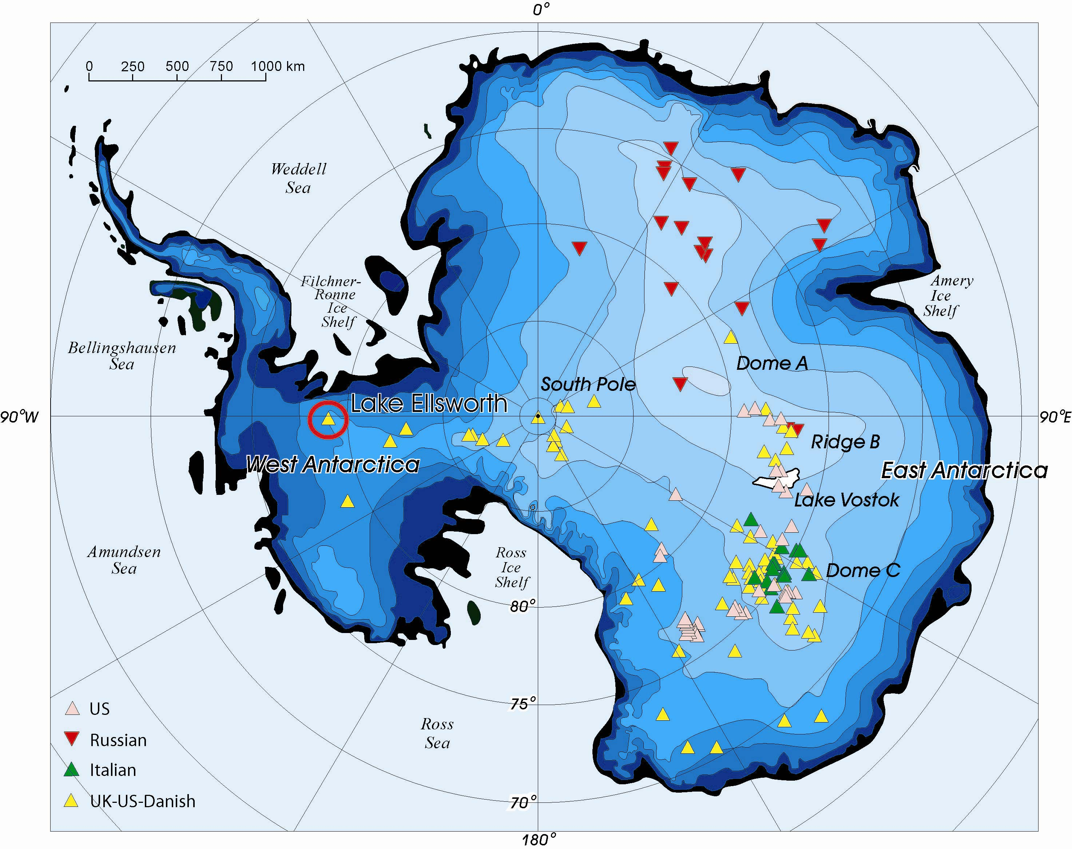

Figure 1. The location of 145 Antarctic subglacial lakes (Siegert et al., 2005). Lake Ellsworth is circled.

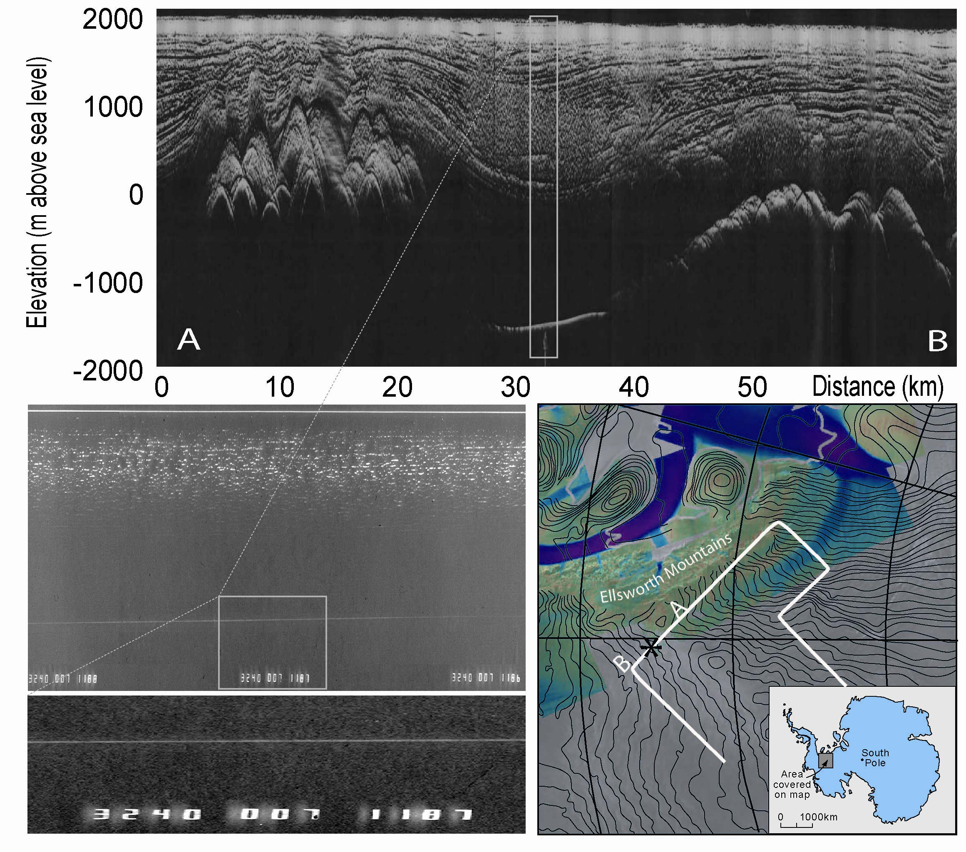

Figure 2. Radio Echo Sounding (RES) data from Lake Ellsworth. The lake is located by the bright flat reflector between 28 and 38 km in AB. The insets show magnified sections of the RES data (demonstrating the mirror-like reflection indicative of a subglacial lake) and the location of the lake. Adapted from Siegert et al. (2004).

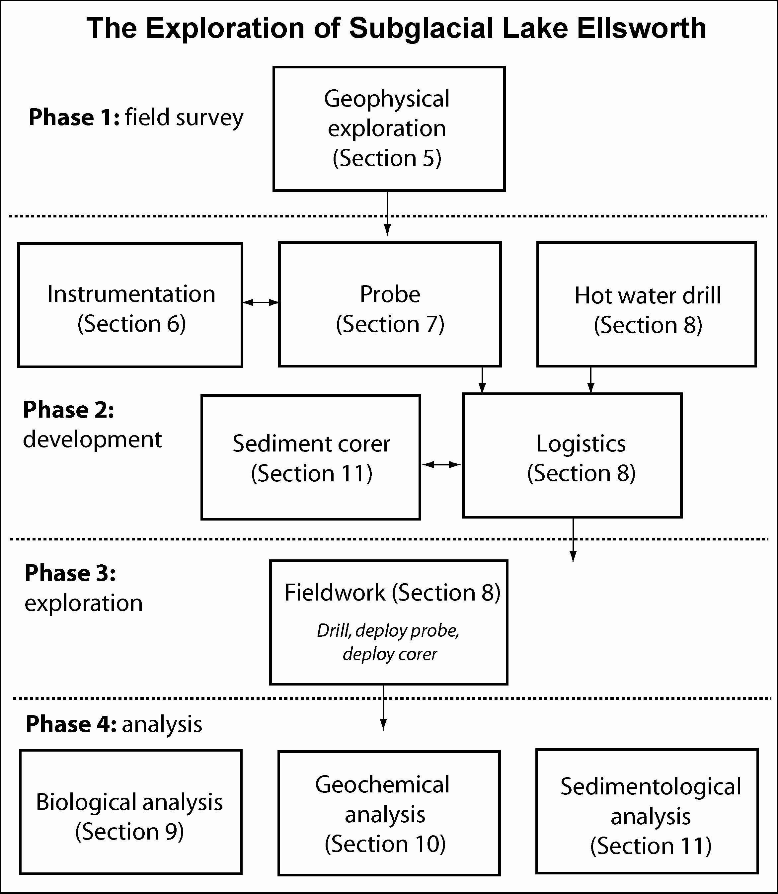

Figure 3. Structure of the project.

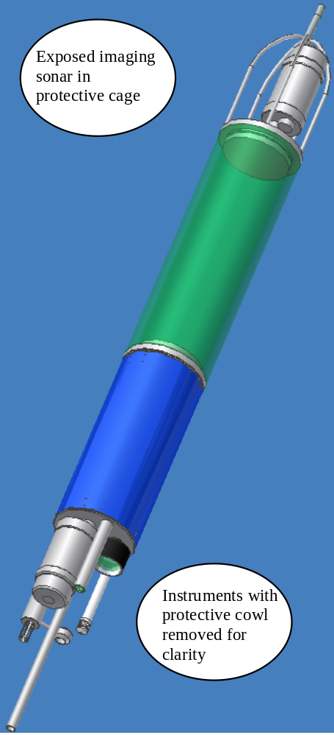

Figure 4. Example of probe casing.

